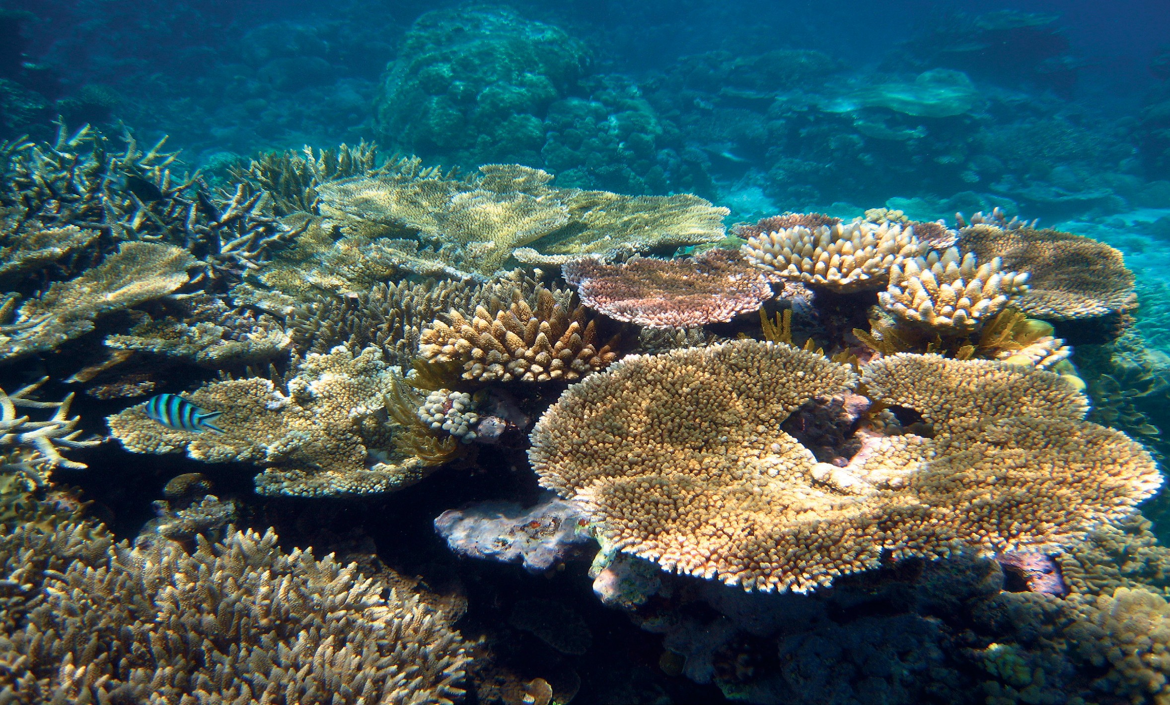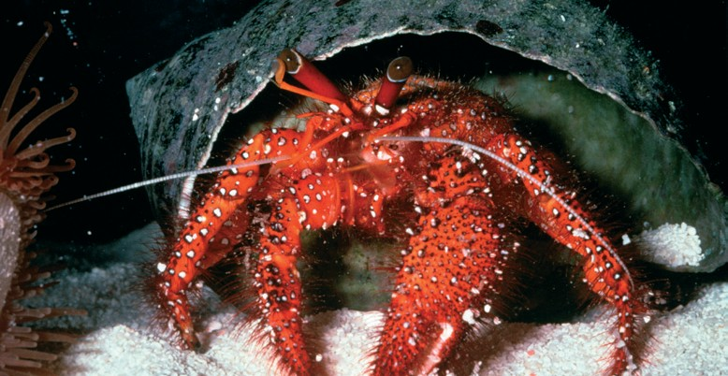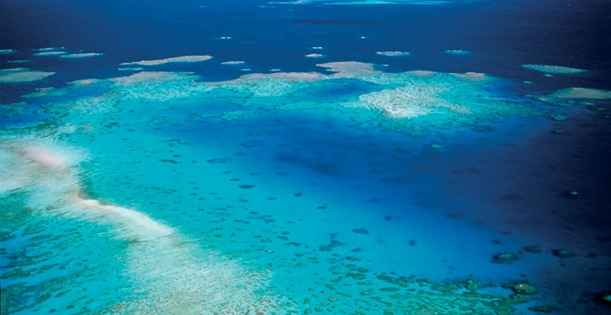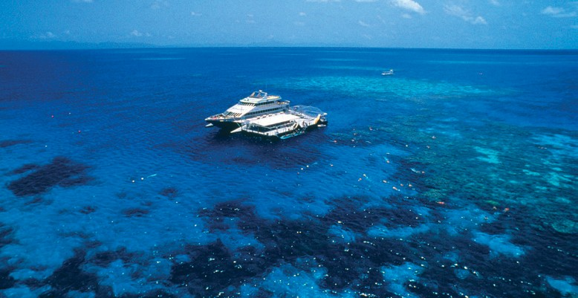

**Reef 2050 Plan— Implementation Strategy**



Edition 2

DECEMBER 2015

2 / Reef 2050 Plan − Implementation Strategy

**© Commonwealth of Australia, 2015.**



*Reef 2050 Plan* − *Implementation Strategy, Edition 2* is licensed by the Commonwealth of Australia for use under a Creative Commons By Attribution 4.0 Australia licence with the exception of the Coat of Arms of the Commonwealth of Australia, the logo of the agency responsible for publishing the report, content supplied by third parties, and any images depicting people. F[or licence conditions see: http://creativecommons.org/licenses/by/4.0/](http://creativecommons.org/licenses/by/4.0/)

This report should be attributed as ‘*Reef 2050 Plan* − *Implementation Strategy, Edition 2*, Commonwealth of Australia 2015’.

The Commonwealth of Australia has made all reasonable efforts to identify content supplied by third parties using the following format ‘© Copyright, [name of third party] ’.

**Disclaimer**

The views and opinions expressed in this publication are those of the authors and do not necessarily reflect those of the Australian Government or the Minister for the Environment.

Aboriginal and Torres Strait Islander peoples are the Traditional Owners of the Great Barrier Reef area and have a continuing connection to their land and sea country.

# Acknowledgements

This document was prepared by the Australian Government Department of the Environment, the Great Barrier Reef Marine Park Authority and the Queensland Government.

## Abbreviations and acronyms

AMSA Australian Maritime Safety Authority

DAF Queensland Department of Agriculture and Fisheries

DILGP Queensland Department of Infrastructure, Local Government and Planning

DNRM Queensland Department of Natural Resources and Mines

DOE Australian Government Department of the Environment

DPC Queensland Department of the Premier and Cabinet

DSD Queensland Department of State Development

DTMR Queensland Department of Transport and Main Roads

EHP Queensland Department of Environment and Heritage Protection

GBRMPA Great Barrier Reef Marine Park Authority

Industry The industry stakeholder body responsible for an action under the Reef 2050 Plan

Ministerial Forum The Great Barrier Reef Ministerial Forum. A forum comprised of two ministers each

from the Australian and Queensland governments with responsibility for matters

relating to the environment and marine parks, science, tourism and/or natural resource management.

NPSR Queensland Department of National Parks, Sport and Racing

PM&C Australian Government Department of the Prime Minister and Cabinet

QLD The State of Queensland, the Queensland Government

The Plan The Reef 2050 Plan

The Reef The Great Barrier Reef

# Contents

Executive Summary 6

Introduction and Purpose 9

Key Achievements 10

The Prioritisation Process 14

Implementation 16

Next steps 19

Appendix A: Ongoing and Completed Actions 20

Appendix B: Immediate Priority Actions 24

# Executive Summary

The Reef 2050 Plan sets out the way in which the Australian and Queensland governments will manage, protect and improve the condition of the Great Barrier Reef for current and future generations. Progress since the plan was released in March 2015 has been substantial and it is important that this momentum continues. A collaborative effort with Traditional Owners, local government, industry and the community is critical for successful delivery of the Plan ensuring that the best available science and expertise underpins decision making.

This is the start of a long-term strategy to turn around the health of the Reef, and it will be challenging.

Updates to the Reef 2050 Plan implementation strategy are released every six months. This second edition highlights implementation successes since the release of the Plan in March 2015, outlines priorities for implementation from December 2015 to June 2016 and describes key strategies for coordination and efficient delivery of Reef 2050 Plan commitments.

The Strategy draws heavily on advice from the Reef 2050 Advisory Committee and the Independent Expert Panel.

Since the release of the first Reef 2050 Plan Implementation Strategy in May 2015, the Australian and Queensland governments, in conjunction with stakeholders, have progressed implementing the Reef 2050 Plan actions. To date, 16 actions under the Plan have been completed or are being implemented on an on going basis. Highlights include:

##### passing legislation and regulation to reduce the impacts of ports and dredging which:

* bans the sea-based disposal of capital dredge material in the World Heritage Area
* prohibits new port developments in the World Heritage Area
* restricts port development to within current port limits
* limits major capital dredging to four priority ports
* mandates strategic master planning at the four priority ports
  + finalising an investment baseline outlining all current federal, state, and local government expenditure as well as private and philanthropic investment in the Reef
  + appointing and convening the Independent Expert Panel and Reef 2050 Advisory Committee to solicit community, industry and scientific advice on plan implementation
  + establishing the Reef Integrated Monitoring and Reporting Program Steering Group and releasing a strategy for delivering the Integrated Monitoring and Reporting Program
  + establishing three net free fishing zones in Cairns, Mackay and Keppel Bay
  + releasing the interim report from Great Barrier Reef Water Science Taskforce, which was established to provide advice on the best approach to meeting the water quality targets.

The Reef 2050 Plan actions build on 40 years of management and foundational activities delivered to manage and protect the Reef.

A prioritisation process was undertaken to determine the immediate, medium and future priority actions for the Plan. The prioritisation process identified 97 immediate priority actions, 26 medium priority actions and 28 future priority actions.

Of the 97 immediate priorities, 62 actions are already prioritised and fully funded with clear timeframes for implementation. This includes actions to improve water quality, further improve port management (eg through port master planning and management of maintenance dredging), development of regional waterway health partnerships and a range of other actions.

To help support delivery of actions in addition to the funding already committed, the Australian and Queensland governments are developing an investment framework, and significant progress has been made. Part of this includes exploring mechanisms for diversification of investment sources, with opportunities for private and philanthropic investment to support implementation of the Plan. This has begun with an initial focus on the Reef Trust and the release of the *Partnerships for the Reef* document.

The third edition of the Implementation Strategy will be released in mid-2016 as part of the Reef 2050 Plan Annual Report. This will include a full status report on all actions under the Reef 2050 Plan.

# Background

The Reef 2050 Plan was adopted by the Australian and Queensland governments in March 2015 to ensure protection of the Outstanding Universal Value of the Great Barrier Reef World Heritage Area. One of the Reef 2050 Plan’s strengths is that it spans state and national jurisdictions – the first time a comprehensive plan

across environmental, social and economic themes for the Reef has been developed. It builds on the strong joint management arrangements established over the last four decades, and outlines the Australian and Queensland government’s commitments to improve the Reef ’s health.

The Plan was developed using the best available science and includes actions, targets, objectives and outcomes for the Reef across seven themes – ecosystem health, biodiversity, water quality, heritage, community benefits, economic benefits and governance (see Figure 1). There are over 130 specific actions across these themes which are to be implemented between now and 2020.

The Reef 2050 Plan is an ambitious new model for strategic long-term planning. A key principle outlined in the Plan is adopting a partnership approach to management, where decisions continue to support a wide range of sustainable economic, social and cultural activities opportunities, and management is cooperative and fosters stewardship and strong community support. This partnership approach is central to taking on the challenge of implementing the Reef 2050 Plan.

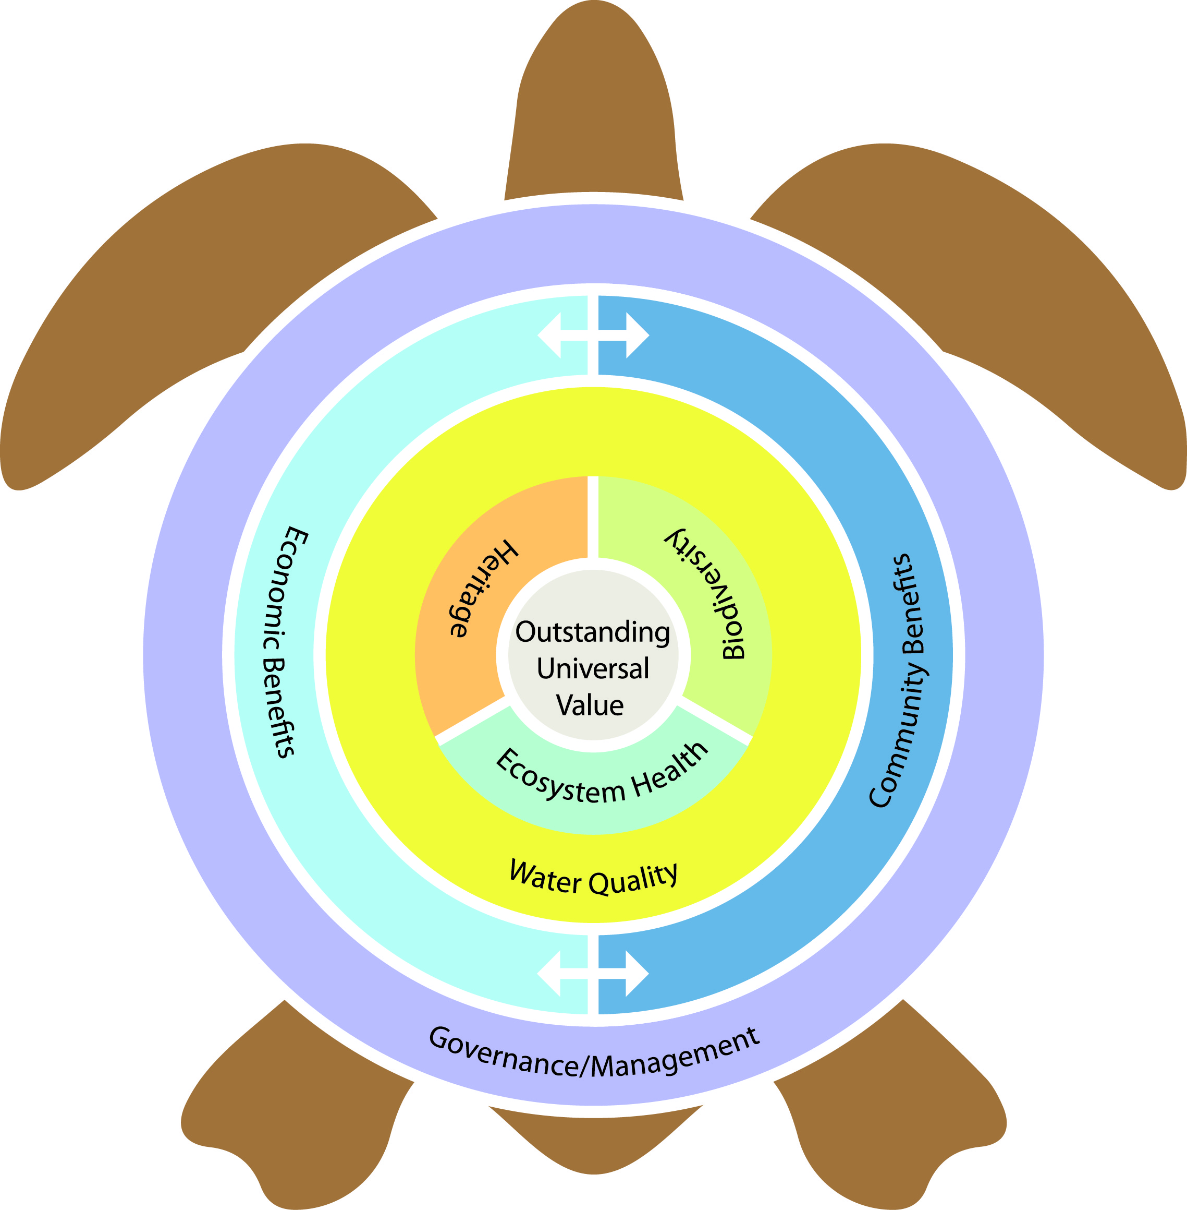

Figure 1. Developed by the Reef 2050 Advisory Committee: Themes of the Reef 2050 Plan and their contribution to the Outstanding Universal Value of the Great Barrier Reef World Heritage Area.

# Introduction and Purpose

The Reef 2050 Plan requires an overarching Implementation Strategy to be prepared, to provide transparency and accountability in its implementation. The first Implementation Strategy was released in May 2015 and provided an overview of governance arrangements, the Integrated Monitoring and Reporting Program and priority actions for 2015.

The Implementation Strategy is a rolling document, revised every six months to capture new priority actions, and report broadly on implementation progress.

This is the second edition of the Implementation Strategy.

The purpose of this strategy is to:

1. highlight implementation successes since the release of the Plan
2. outline priorities for implementation from December 2015 to June 2015
3. describe key strategies for coordination and efficient delivery of Reef 2050 Plan commitments.

# Key Achievements

The momentum generated through the release of the Reef 2050 Plan continues, and there are a number of key achievements.

### Engaging with Science and the Community

* Continuing our partnership approach

We are delivering on our commitment to implement the Plan through a partnership approach, and have established and actively engaged with Traditional Owners, science, industry and the community to seek their advice on implementation.

* Committee of community and industry interests
* Independent panel of scientific experts convened
* Integrated Monitoring Steering Group convened

### Enabling Sustainable Ports

* Banned the sea-based disposal of capital dredge material in World Heritage Area

The Reef 2050 Advisory Committee (GA2) has been established, and is chaired by the Honourable Penelope Wensley AC, former Governor of Queensland. The Committee met three times in 2015 and was actively involved in prioritising the actions under the Plan, policy development and providing insight from Traditional Owners, community, local government, research organisations, conservation groups and industry.

An Independent Expert Panel (GA3) has been established to provide scientific and expert advice related to the Great Barrier Reef. Former Australian Chief Scientist, Professor Ian Chubb AC was appointed as the inaugural Chair, and the group met twice in 2015 to provide advice on Reef Trust investments and implementation of the Reef 2050 Plan.

An Integrated Monitoring and Reporting Program Steering Group (GA4) comprising representatives from government and research institutions has been established. The Committee met twice this year and one of their key achievements was the release of a strategy for developing the Integrated Monitoring and Reporting Program.

The Great Barrier Reef Marine Park Regulations were amended to implement the ban on the disposal of capital dredge material in the

Great Barrier Reef Marine Park (WQA18). The ban applies to all past and present permits and future applications for capital dredge disposal.

* No new ports in the World Heritage Area allowed
* Port development restricted to within current port limits
* Restrictions in place for capital dredging
* Townsville and Gladstone sea dumping agreements in place

The Queensland Government passed the Sustainable Ports Development Bill 2015 which enacts key port-related commitments under the

Reef 2050 Plan (EHA21, EHA25, WQA14, WQA18, WQA19). The

Act extends the ban on the disposal of capital dredge material to the remainder of the World Heritage Area, restricts new port development to within current port limits and prohibits major capital dredging for the development of new or expansion of existing port facilities outside the four priority ports of Gladstone, Abbot Point, Townsville and

Hay Point/Mackay.

The Reef 2050 Plan is already having a positive impact on environmental assessments. For example, the Townsville and Gladstone ports entered into agreements that require consideration of the objectives and relevant actions in the Reef 2050 Plan in developing a program of research and monitoring for disposal of maintenance dredged material, and investigation of opportunities to avoid or reduce disposal at sea. The Australian Government is working closely with port operators in implementing the Reef 2050 Plan objectives through established regulatory processes.

### Investment

* + Completed investment baseline Substantial progress is being made towards the phased development

of the Reef 2050 Plan investment framework (GA13). Phase one, the development of an investment baseline, was released in June 2015. The investment baseline provides a picture of Reef investment and work being undertaken by both government and non-government sectors in Reef management. This work is critical to managing co-investment in the Plan; it will help us to ensure future investment activities complement existing work and are directed towards the most pressing threats.

* + Completed prioritisation of Reef 2050 Plan actions

Phase two involved prioritising the Plan’s 139 actions to help ensure appropriate and timely resourcing for the plan. Significant input from the Reef 2050 Advisory Committee and Independent Expert Panel was sought during the prioritisation process and the outcomes inform the priority actions listed in this plan.

* + Exploring funding diversification Phase three is underway and involves examining a range of options available

to diversify investment sources. Initial work has focused on Reef Trust, and already outcomes are being realised.

* + $2 million co-investment project to restore wetlands

A pilot project has been brokered which will see $2 million from private investors matched, dollar for dollar, with $2 million of Australian Government Reef Trust funding to undertake wetland restoration and repair in priority areas. The project has been developed by Greening Australia, in partnership with Birdlife Australia, Conservation Volunteers Australia and Wetland Care Australia. This is the first Reef Trust project supported by private investment.

* + Reef Trust ‘Partnerships for the Reef ’ released

The recent release of the Reef Trust’s ‘Partnerships for the Reef ’ publication will provide a catalyst for discussion with interested investors and partners, and showcases opportunities for private investment in the Great Barrier Reef. It aims to encourage further partnerships and collaboration, like the Greening Australia pilot project.

* + Interim report from Great Barrier Reef Water Science Taskforce released

The Great Barrier Reef Water Science Taskforce (GA6) was established to provide advice on the best approach to meeting the water quality targets. It released its interim report in December 2015. A final report is due by May 2016.

### Improving Monitoring and Reporting

* Reef Integrated Monitoring and Reporting Program Strategy released

The Reef Integrated Monitoring and Reporting Strategy has been released, outlining the scope and principles for the development of the Reef Integrated Monitoring and Reporting Program (GA15) as well as overarching timeframes for delivery. The strategy’s objectives are to:

* enable the early detection of trends and changes in the Reef ’s environment
* inform the assessment of key threats and future risks and drive adaptive management
* inform the evaluation of management effectiveness
* ensure investments are focused on actions that will effectively deliver measurable results
* inform regional stakeholders and the national and international communities on whether the Reef 2050 Plan is on track to addressing key threats and delivering its vision.
  + GBR Report Card 2014 released The Great Barrier Report Card 2014 (released in September 2015)

shows landholders are continuing to help protect the Great Barrier Reef by reducing pollutant loads entering the reef, but accelerated change is needed to achieve the targets. Successive report cards show that since

2009 improved farming practices have resulted in modelled annual average pollutant load reductions for sediment (12 per cent), particulate nitrogen

(11.5 per cent), particulate phosphorus (14.5 per cent), dissolved inorganic nitrogen (17 per cent) and pesticides (30.5 per cent).

* + Mackay Whitsundays Healthy Rivers to Reef Report Card 2014 released

The development of regional report cards at major ports and centres in priority Reef catchments is a key action under the Reef 2050 Plan (EBA16) to communicate waterway health in an open and transparent manner

using independent science in terms of environment, social, economic and cultural factors. It allows all stakeholders to have confidence in the efforts to maintain and improve the health of their catchments and the Reef.

The Queensland Government announced $6 million over four years to support regional waterway partnerships.

* + Extra $600k to deliver Gladstone Healthy Harbour Partnership

The Australian Government also announced a further investment of

$600,000 for the Gladstone Healthy Harbour Partnership. Regional stakeholders from industry, local government and the community are also investing partners. The Gladstone Healthy Harbour report card will be released shortly.

* + Establishment of a Wet Tropics Healthy Waterways Partnership underway

The development of a report card partnership program for the Wet Tropics region is currently underway.

### Delivering On-Ground Action

##### Continuing to support on-ground programmes

##### Delivered marine debris events with community

##### New net-free fishing zones in place

##### Interim compliance programme commenced

##### Over $70 million in new Reef Trust

##### investments announced

On-ground action continues to be delivered for the Reef through government programmes, community stewardship actions and private investment.

GBRMPA, in partnership with the Australian Marine Debris Initiative, Tangaroa Blue Foundation, Eco Barge Clean Seas Inc and Reef Guardian Councils, and supported by Reef Trust, delivered the first annual Great Barrier Reef Clean-up project (EHA27). Over 900 volunteers removed 10 tonnes of rubbish from across the Reef catchment, islands, creeks and beaches. Data collected from the clean-ups is entered into the Australian Marine Debris database to advise future management and reduction plans with local communities and government.

The Queensland Government has delivered on its commitment to implement three new net-free fishing zones for Trinity Bay, Cairns; St Helen’s Beach-Cape Hillsborough, north of Mackay; and Yeppoon-Keppel Bay-Fitzroy River, Capricorn Coast (BA6). These were established by regulation and came into effect on 1 November 2015.

The Queensland Government is establishing a targeted compliance programme, in close consultation with key industry bodies, to help improve water quality in the Great Barrier Reef lagoon. Officers will work with farmers to meet their legislative obligations including regulated standards to reduce the loss of nutrients, pesticides and sediment as a priority in the Wet Tropics and Burdekin regions. The main focus is on support and education.

Reef Trust continues to deliver on ground, with two new Phases of investment announced in 2015 (EHA14, WQA14). Investments include helping sugarcane farmers improve land management practices, reducing erosion in grazing lands and managing the impact of erosion in gullies surrounding the Great Barrier Reef catchments, improving water quality in the grains, diary and horticulture

industries and helping to control crown-of-thorns starfish outbreaks on high value tourism reefs.

##### Vessel monitoring to improve compliance

GBRMPA and DAF established a Vessel Monitoring System in the East Coast Otter Trawl Fishery zone to reduce the ecological impact of fishing activities. The programme has proven to be successful, with major declines in trawling offences since the implementation of the approach was initiated. Implementation of a Vessel Monitoring System across all sectors of Queensland commercial fisheries is currently under review.

##### Delivering a strategic approach to crown-of-thorns starfish control

GBRMPA has adopted a holistic response to crown-of-thorns starfish management including strategically targeted culling, research to improve control method efficiency and increased investment in improving water quality (EHA12). Supported by Reef Trust funding, GBRMPA is providing strategic oversight of the crown-of-thorns starfish control program from 2015–2018 and has contracted the Reef and Rainforest Research Centre (RRRC) to coordinate the tactical on-water crown-of-thorns starfish cull activities.

The Joint Field Management Program is providing ongoing crown-of-thorns starfish surveillance to inform control activities. The Program has surveyed over 1,450 kilometres of reef, enabling the control divers to concentrate culling activities to specific areas.

# The Prioritisation Process

Over the second half of 2015, the 139 actions in the Reef 2050 Plan were prioritised by the Reef 2050 Advisory Committee, Independent Expert Panel and government agencies. This work formed Phase two of the Reef 2050 Plan Investment Framework and was important to ensure investment is appropriately targeted to implementing priority actions in the Plan.

The prioritisation process highlighted some of the challenges involved in implementing the Reef 2050 Plan. Some actions are more clearly articulated than others, particularly ones which build on established programmes and activities such as Reef Water Quality Protection Plan, the Joint Field Management Program, the Reef Guardian Stewardship Program and the Reef Trust. Other actions outline new approaches and ideas that need further definition, planning and consultation to get right.

All of the actions in the Plan are important. The prioritisation activity focussed on sequencing and sorting actions into the following categories:

* *Immediate Priority* **−** implementation of actions to commence by December 2016.
* *Medium-term Priority* **−** implementation of actions to commence by June 2018.
* *Long-term Priority* **−** implementation of actions to commence by June 2020.
* The activity considered interdependencies between actions (*does action X need to be completed before action Y can be commenced?*), how critical particular actions were to achieving Reef 2050 Plan targets and the capacity and resources available to undertake the work. This approach was driven by the Reef 2050 Advisory Committee and endorsed by the Independent Expert Panel.

Some actions were separated into component parts and the total number of actions examined rose from 139 to

Sixty-two actions were identified as already prioritised as they were either already complete or they were underway, fully funded and had a clear timeframe for completion.

Through the prioritisation process, a further 35 actions were classed as immediate priorities (to commence by December 2016), 26 actions were classed as medium priorities (to commence by June 2018) and 28 actions were classed as future priorities (to commence by June 2020).

Already prioritised

* + 62 actions
  + Already completed, or fully funded and clear timeframes for delivery

Immediate priority

* + 35 actions
  + Commence by December 2016

Medium term priority

* + 26 actions
  + Commence by June 2018

Future priority

* + 28 actions
  + Commence by June 2020

The Reef 2050 Advisory Committee grouped immediate priority actions based on common themes and/

or objectives. By grouping like with like, related actions can be considered together, ensuring an efficient and coordinated approach to their delivery. Fourteen groupings were identified for the immediate priorities and will aid in implementation of the actions. They are:

* Traditional Owners
* Sustainable Ports
* Integrated Monitoring and Reporting Program
* Investment
* Water Quality
* Shipping
* Coastal Ecosystem Protection
* Planning and Development
* Communications and Outreach
* Policy and Guidance
* Marine Biodiversity
* Sustainable Fishing
* Historic Heritage
* Completed or Ongoing.

Immediate priority actions are listed in Appendix A and B.

In providing advice on the prioritisation of actions, the Reef 2050 Advisory Committee noted:

* additional funding is required to implement the Plan and achieve its outcomes and targets, acknowledging that this investment would need to come from a variety of sources
* an adaptive approach to prioritisation will be required to respond to emerging priorities and issues
* there is a need to continue to consider actions classified as medium/future priorities, especially in the context of delivery and sequencing of related actions
* a single lead body/organisation should be identified for each action, noting that leads will not always be government agencies.

The Independent Expert Panel endorsed the criteria used to prioritise actions and agreed the process undertaken was robust. The Panel agreed with the first three recommendations of the Committee above, also noting that while additional resources are likely to be required, the magnitude of investment required has not been calculated and is not a simple figure to estimate at this point.

Appendix A outlines ongoing and completed actions and Appendix B identifies other immediate priority actions identified in the prioritisation process to commence by December 2016.

# Implementation

As a result of the prioritisation process, over 60 per cent of the actions in the Reef 2050 Plan were identified as immediate priority, to commence by December 2016. From here, the Australian and Queensland governments will continue to develop strategies to implement these immediate priority actions in partnership with Traditional Owners and stakeholders. Implementation will be dependent upon a strong partnership approach with industry, local government and the community to develop appropriate and effective implementation pathways.

In addition to ongoing foundation activities across all themes, over the next six months there are five key areas for implementation: Traditional Owner engagement, sustainable ports, investment, Integrated Monitoring and Reporting Program and water quality.

### Water Quality

* Reef Trust next phases of investment and public/ private partnerships
* Continued implementation of the Reef Water Quality Protection Plan
* Qld Government Water Science

Taskforce recommendations

### Traditional Owner Engagement

* Targeted consultation
* Specific implementation plan

### **Key areas for implementation**

### Sustainable Ports

* + Port master planning
  + Maintenance dredging strategy

### Integrated Monitoring and Reporting Program

* + - Design of programme
    - Existing monitoring and reporting to continue
    - Immediate priority gaps to be filled

Investment

* Reef 2050 Investment Framework
* Reef Trust Innovative Financial Mechanisms Panel
* Great Barrier Reef Water Science Taskforce advice

The following section provides further detail on the five key areas and their implementation pathways.

### Traditional Owners Engagement – Implementation pathway

##### There are around 20 Traditional Owner specific actions within the Reef 2050 Plan, spanning across all of the Plan’s themes. This recognises that Traditional Owners have connections and a role to play in all aspects of Reef management, whether they be environmental, social or economic.

##### The implementation of the priority Traditional Owner actions in the Reef 2050 Plan will be planned through the development of a Specific Implementation Plan (refer to GA12). This will enable consultation with the Traditional Owners of the Great Barrier Reef and develop a way forward for the Traditional Owner actions. Medium and future priorities could also be considered through this approach.

##### A key aspect of developing this specific implementation plan is effective engagement with Traditional Owner communities from across the Great Barrier Reef. The Gidarjil Development Corporation based in Bundaberg has been engaged by the Australian Government to lead this project and work with other Indigenous organisations to develop an Indigenous implementation plan early to mid 2016. The project will be delivered in consultation with contributing agencies including the Queensland Department of Aboriginal and Torres Strait Islander Partnerships, GBRMPA and the Queensland Department of National Parks, Sport and Racing.

### Sustainable Ports – Implementation pathway

##### The *Sustainable Ports Development Act 2015* is now in place, achieving a number of the key port-related commitments in the Reef 2050 Plan. Building on this foundation, the Queensland Government is focused on furthering the sustainability of ports through better strategic planning. The Queensland Government is leading master planning for the priority ports of Gladstone, Abbot Point, Townsville and Hay Point/Mackay, and the development of a state wide maintenance dredging strategy.

##### Port master planning for the Port of Gladstone is advancing and will commence for the ports of Abbot Point and Townsville in 2016 and for the ports of Hay Point/Mackay in 2017. Master planning will ensure:

* the Outstanding Universal Value of the Great Barrier Reef World Heritage Area is an intrinsic consideration in future port development, management and governance
* optimisation of the use of existing infrastructure at the long-established major ports
* transparent decision making
* meaningful engagement with stakeholders.

##### The Queensland Government will work closely with port authorities, local governments and other key stakeholders. An important part of port master planning processes will be full public consultation.

##### In addition to master planning underway, the Queensland Department of Transport and Main Roads is developing a State wide coordinated Maintenance Dredging Strategy, and has engaged consultants to develop the Strategy. It is intended that workshops with relevant stakeholders will be held in January 2016 and that the Strategy to be completed in 2016.

### Investment – Implementation pathway

##### In 2016 an investment framework will be developed to underpin successful delivery of the Reef 2050 Plan. The current range of organisations and streams of investment supporting the Reef demonstrates the breadth of commitment to securing its long-term health. Ongoing support from such stakeholders is critical to achieving the Plan’s shared targets, objectives and outcomes. A partnership approach to implementation is a key principle outlined in the Plan.

##### The investment framework will build on the significant amount of work already completed in this area. This includes the investment baseline, prioritisation process and initial work on diversifying investment sources.

##### A Reef Trust Innovative Financial Mechanisms Panel will be established, supporting the work to diversify investment sources. The Panel will provide a forum for experts from key financial organisations to engage with government, offer expert opinion and evaluate a range of conservation financing mechanisms which could be piloted for the Great Barrier Reef.

##### The Queensland Government’s GBR Water Science Taskforce has been established to advise on how to achieve the water quality targets in the Reef 2050 Plan and priorities for investment of Queensland Government Reef funding. The final report of the Taskforce is due in May 2016 and will inform the investment framework.

##### The investment framework will be developed in a consultative manner with ongoing advice sought from both the Independent Expert Panel and Reef 2050 Advisory Committee as well as other stakeholders from the business, financial and philanthropic sectors.

### Integrated Monitoring and Reporting Program – Implementation pathway

##### GBRMPA is collaborating with experts from government, science, industry and community to develop and implement the Reef Integrated Monitoring and Reporting Program, which will build on existing monitoring and reporting arrangements.

##### The Reef Integrated Monitoring and Reporting Program Strategy has been finalised, outlining the programme’s vision, scope and key components.

##### The Reef Integrated Monitoring and Reporting Program Steering Group has been established to guide the programme’s development and operation. Working groups have also been established to develop three key components of the programme: programme design and implementation; synthesis and reporting; and data management and systems. In 2016 these groups will focus on the delivery of tasks required to establish the programme, including:

* identification of key indicators for each of the Reef 2050 Plan’s seven themes
* alignment of existing monitoring and reporting products
* the development of Reef-wide data management systems.

##### Work has already commenced on identifying monitoring gaps critical to the delivery of the Reef 2050 Plan, and in 2016 monitoring to address priority gaps will begin.

##### The Australian Government has invested $8 million to develop the program, which builds upon significant existing investment in monitoring and reporting. This includes the Paddock to Reef program (approximately

##### $8 million per year co-funded by the Queensland and Australian Government), and $6 million over four years invested by the Queensland Government to support regional Healthy Waterways Report Cards.

### Water Quality – Implementation pathway

Water Quality is recognised as one of the continuing high priority threats to the health of the Reef. Consistent with this, 21 of the 24 Water Quality actions have been categorised as immediate priority. These actions will largely be implemented through existing mechanisms, the Reef Water Quality Protection Plan and the Reef Trust. A key factor influencing the implementation of Reef Water Quality Protection Plan actions in the short term will be the report and recommendations from the Queensland Government Great Barrier Reef Water Science Taskforce, due in May 2016.

The Reef Water Quality Protection Plan is a collaborative Australian and Queensland government plan of coordinated actions and partnerships aimed at improving the quality of water entering the Reef. To help achieve Reef Water Quality Protection Plan’s goals and objectives, three priority work areas are being implemented:

* Prioritising investment and knowledge **−** prioritising, coordinating and integrating programs to maximise reef water quality outcomes.
* Responding to the challenge **−** landholders adopting management systems that maximise reef water quality improvements while maintaining and enhancing resilience, business performance and environmental outcomes. Government policies and programmes that support Reef Water Quality Protection Plan goals and targets are being maintained.
* Evaluating performance **−** the efficiency and effectiveness of Reef Water Quality Protection Plan is being measured through monitoring, evaluation and reporting.

The Reef Trust will continue to implement water quality projects from its first two phases of investment and begin implementation of phase three investments, including erosion control in priority grazing regions and improving fertiliser use efficiency on sugar cane farms. A fourth phase of investments, scheduled for

announcement in mid 2016, will be developed in consultation with the Independent Expert Panel, other key scientists and stakeholders.

# Next steps

The Australian and Queensland governments, together with our industry, community and science partners will continue to implement immediate priority actions under the Plan. The Reef 2050 Annual Report, to be released in mid-2016, will capture progress against all actions and outline key contextual information surrounding the achievement of the Plan’s vision. The annual report will describe progress toward achieving the targets and objectives of the Reef 2050 Plan, which will progressively become more comprehensive as the Reef Integrated Monitoring and Reporting Program is implemented. Annual reports will be approved by the Ministerial Forum, and made publicly available.

# Appendix A: Ongoing and Completed Actions

The following immediate priority actions have been completed, or are in place with ongoing elements.

|  |  |  |  |  |
| --- | --- | --- | --- | --- |
| **Reef 2050 Plan Action** | | **Reporting**  **Lead** | **Status** | **Outcomes** |
| EHA11 | Maintain the Great Barrier Reef Marine Park and Great Barrier Reef Coast Marine Park Zoning Plans and enhance compliance. | GBRMPA | * In place | Maintaining the Great Barrier Reef Marine Park and Great Barrier Reef Coast Marine Park Zoning Plans is ongoing, and will continue to be jointly managed by GBRMPA and the Queensland Government.  The Marine Park is protected and managed under the Great Barrier Reef Marine Park Zoning Plan 2003 (Cwlth) and the Great Barrier Reef Coast Zoning Plan 2004 (Qld). The zoning plans take into account World Heritage values, protect biodiversity and provide for a range of ecologically sustainable recreational, commercial and research opportunities and for the continuation of traditional activities. For more information about zoning visit:  [www.gbrmpa.gov.au/zoning-permits-and-plans/zoning](http://www.gbrmpa.gov.au/zoning-permits-and-plans/zoning)  Compliance management is undertaken cooperatively by the Joint Field Management Program which brings together Queensland agencies, GBRMPA and other Commonwealth agencies. GBRMPA undertakes communication and education to encourage compliance with Marine Park management principles and legislation. For more information about compliance visit:  [www.gbrmpa.gov.au/managing-the-reef/how-the-reefs-managed/](http://www.gbrmpa.gov.au/managing-the-reef/how-the-reefs-managed/) field-management-of-the-great-barrier-reef-marine-park/ Compliance-management |
| EHA27 | Implement on-ground activities to reduce  the volume of debris generated in or entering the World Heritage Area, and undertake education and awareness raising activities to minimise the source and occurrence of marine debris. | GBRMPA | * In place | GBRMPA, in partnership with the Australian Marine Debris Initiative, Tangaroa Blue Foundation, Eco Barge Clean Seas Inc and Reef Guardian Councils, and supported by Reef Trust, delivered the first annual Great Barrier Reef Clean-up project in October 2015. The clean-up aimed to reduce marine debris in the Great Barrier Reef lagoon and raise awareness about marine debris within local communities.  On-ground actions were held along the Queensland coast, with over 900 volunteers. More than 55,000 items were collected weighing more than 10 tonnes, and over 350 bags of rubbish were removed from across the Reef catchment, islands, creeks and beaches. Combined with other clean-up activities, an excess of 20 tonnes of marine debris is estimated to have been removed.  Data collected from the clean-ups is entered into the Australian Marine Debris database to advise future management and reduction plans with local communities and government.  Further information is available at:  [www.gbrmpa.gov.au/managing-the-reef/threats-to-the-reef/](http://www.gbrmpa.gov.au/managing-the-reef/threats-to-the-reef/) marine-debris |

|  |  |  |  |  |
| --- | --- | --- | --- | --- |
| **Reef 2050 Plan Action** | | **Reporting**  **Lead** | **Status** | **Outcomes** |
| EHA21 | Protect greenfield sites by restricting significant new port development within and adjoining the World Heritage Area to within existing port limits fixed in regulation under the Transport Infrastructure  Act 1994 (Qld). | DSD | * Complete | The sustainable ports legislation was passed by the Queensland Parliament on Thursday 12 November 2015 putting into effect the Government’s key port-related commitments in the Reef 2050 Plan. The new port laws will:   * restrict new port development in and adjoining the Great Barrie Reef World Heritage Area to within current port limits and outside Commonwealth and state marine parks * stop development of new ports in the Great Barrier Reef World Heritage Area and limit capital dredging for the expansion of existing port facilities * prevent the sea-based disposal of port-related capital dredge spoil material within the Great Barrier Reef World Heritage Area * mandate that capital dredged material generated at the priority ports be beneficially reused or disposed of on land where it is environmentally safe to do so.   Master planning processes are already underway at Gladstone and starts in the first quarter of 2016 at Abbot Point, in the second quarter of 2016 in Townsville and in 2017 at Hay Point/Mackay.  In June 2015 the Great Barrier Reef Marine Park Regulation 1983 amendment to ban disposal of capital dredge material in the Great Barrier Reef Marine Park took effect. |
| EHA25 | Ensure Great Barrier Reef ports  planning incorporates evidence-based measures to support protection, restoration and management of coastal ecosystems that contribute to Reef health and resilience. | DSD | * Complete |
| WQA14 | Restrict capital dredging for the development  of new or expansion of existing port facilities to within the regulated port limits of Gladstone, Hay Point/Mackay, Abbot  Point, and Townsville. | DSD | * Complete |
| WQA18 | In 2015 legislate to ban sea-based disposal of capital dredge material in the Great Barrier Reef Marine Park and in the balance of the Great Barrier Reef World Heritage Area from port related capital  dredging material. | DSD | * Complete |
| WQA19 | Mandate the beneficial reuse of port related capital dredge spoil, such as land reclamation in port development areas, or disposal on land where it is environmentally safe to do so. | DSD | * Complete |

|  |  |  |  |  |
| --- | --- | --- | --- | --- |
| **Reef 2050 Plan Action** | | **Reporting**  **Lead** | **Status** | **Outcomes** |
| BA6 | Establish three net-free fishing zones in north and central Queensland: Trinity Bay, Cairns; St Helen’s Beach-Cape Hillsborough, north  of Mackay; and Yeppoon-Keppel Bay-Fitzroy River, Capricorn Coast. | DAF | * Complete | The Queensland Government has delivered on its commitment to implement three new net-free fishing zones for Trinity Bay, Cairns; St Helen’s Beach-Cape Hillsborough, north of Mackay; and Yeppoon-Keppel Bay-Fitzroy River, Capricorn Coast. These were established by regulation and came into effect on 1 November 2015. A $10 million finance scheme has been established to assist the commercial net fishing industry adjust to the changes and minimise the shift of commercial effort that may be displaced by the introduction of the zones to other areas or other fisheries.  [www.business.qld.gov.au/industry/fisheries/commercial-fishing/](http://www.business.qld.gov.au/industry/fisheries/commercial-fishing/) net-free-zones |
| GA1 | Convene an intergovernmental operational committee comprising senior officials from the Australian, including the Great Barrier Reef Marine Park Authority, and Queensland governments to oversee implementation of the Plan, facilitate coordination of Reef related activities and report annually to the Great Barrier Reef  Ministerial Forum. | DOE | * Complete | The role of the Standing Committee of Officials has been augmented to take on board these tasks. The Committee meets twice a year to advise the Ministerial Forum. They have provided advice on implementation of the Plan and will continue to do so in the future. Their role is captured in the Great Barrier Reef Intergovernmental Agreement:  [www.environment.gov.au/system/files/pages/7a85531d-9086-4c22-b](http://www.environment.gov.au/system/files/pages/7a85531d-9086-4c22-b) dca-282491321e46/files/gbr-iga-2015.pdf |
| GA2 | Convene and support a multi-sectoral Reef advisory committee to facilitate engagement with industry and the broader community regarding the implementation and review of the Plan. | EHP | * Complete | The Reef 2050 Advisory Committee has been established, has met three times and has provided advice to the Ministerial Forum on implementation of the Plan. More information about the Committee, its membership and communiqués from their meetings can be found at:  [www.environment.gov.au/marine/gbr/reef2050/advisory-bodies](http://www.environment.gov.au/marine/gbr/reef2050/advisory-bodies)  The Committee will have an ongoing role in advising on the implementation of the Reef 2050 Plan, and will next meet in April 2016. |
| GA3 | Convene an independent expert panel with  an independent chair to advise the Intergovernmental  Operational Committee regarding the implementation and review of the Plan and associated Integrated Monitoring and Reporting Program. | DOE | * Complete | The Independent Expert Panel has been established and will play an important ongoing role in ensuring that management and policy decisions are based on the best available science. The Panel has met twice to provide advice on implementation of the Plan, as well as Reef Trust investment priorities, and will meet again in April 2016. For more information on the Panel visit:  [www.environment.gov.au/marine/gbr/reef2050/advisory-bodies](http://www.environment.gov.au/marine/gbr/reef2050/advisory-bodies) |

|  |  |  |  |  |
| --- | --- | --- | --- | --- |
| **Reef 2050 Plan Action** | | **Reporting**  **Lead** | **Status** | **Outcomes** |
| GA4 | Convene a network to review, coordinate and align monitoring and reporting activities to inform the development and operation of an Integrated Monitoring and Reporting Program. | GBRMPA | * Complete | The Reef Integrated Monitoring and Reporting Program Steering Group has been established to guide the development and operation of the Program for the Reef 2050 Plan. The Steering Group met twice this year and one of their key achievements was the release of a strategy for developing the Integrated Monitoring and Reporting Program, which can be accessed at:  <http://elibrary.gbrmpa.gov.au/jspui/handle/11017/2977> |
| GA5 | Adopt an approach of continuous improvement as part of adaptive management of the World Heritage Area. | GBRMPA | * In place | This action represents an ongoing approach to the management of the Reef, which has been adopted by both the Australian and Queensland governments. The Integrated Monitoring and Reporting Program, being developed by GBRMPA in partnership with Traditional Owners and stakeholders, will play a key role in improving the effectiveness of our adaptive management approach. |
| GA6 | As a priority the Queensland Government will consult with an advisory taskforce on:   * the best possible approach to achieving the 2025 targets for pollution run-off into the Great Barrier Reef * the effectiveness and cost of robust regulations, a   market-based trading mechanism, or a combination of both, in reducing  pollution run-off — to report within a year of commencement. | EHP | * Complete | A Great Barrier Reef Water Science Taskforce dedicated to providing advice to the government about how they may be able to meet the ambitious 2025 water quality targets. The taskforce is expertise based and will harness a wide range of knowledge about catchment and land management practices impacting reef water quality. The taskforce has met three times this year, and their communiqués can be found at:  [www.gbr.qld.gov.au/priorities/](http://www.gbr.qld.gov.au/priorities/) |
| GA8 | Update the *Great Barrier Reef Intergovernmental Agreement*  *2009* to explicitly include outstanding universal value. | DOE | * Complete | The Great Barrier Reef Intergovernmental Agreement was updated in June 2015, and has been signed by the Prime Minister of Australian and Premier of Queensland. The Agreement can be found at:  [www.environment.gov.au/system/files/pages/7a85531d-9086-4c22-b](http://www.environment.gov.au/system/files/pages/7a85531d-9086-4c22-b) dca-282491321e46/files/gbr-iga-2015.pdf |
| GA9 | Adopt the Reef 2050 Long-Term Sustainability Plan as a schedule to the *Great Barrier Reef Intergovernmental*  *Agreement 2009*. | DOE | * Complete |

# Appendix B: Immediate Priority Actions

The following sections list all of the immediate priority actions identified in the prioritisation process, which are to commence by December 2016. The Australian and Queensland governments are working with delivery partners to define implementation pathways, including milestones for implementation, timeframes and reporting requirements. A full report on implementation progress against all actions within the Reef 2050 Plan will be presented in the annual report, due for release in mid 2016.

## Ecosystem health

#### Reef 2050 Plan Action

EHA1 Acknowledge Traditional Owners in new and existing policy and plans.

EHA2 Incorporate and prioritise Traditional Owner’s planning into existing and future ecosystem policy and programmes.

EHA4 Develop further agreements with Traditional Owners addressing management of ecosystems within their traditional estates.

#### Lead agencies/partners

**(**lead reporting agency in **bold)**

**GBRMPA**, Traditional Owners, AG, QG

**GBRMPA**, Traditional Owners, AG, QG

**GBRMPA**, Traditional Owners, AG, QG

#### Groupings

Traditional Owners

Traditional Owners

Traditional Owners

EHA6 Further develop regionally relevant standards for ecosystem health (desired state, critical thresholds and health indicators) that inform and support the Integrated Monitoring and Reporting Program.

EHA7 Prioritise functional ecosystems critical to Reef health in each region for their protection, restoration and management.

**GBRMPA** Monitoring and Reporting

**GBRMPA**, AG, QG, Local Govt Coastal Ecosystem Protection

EHA8 Develop a net benefit policy to restore ecosystem health, improve the condition of values and manage financial contributions to that recovery.

**GBRMPA**, AG, QG, LGAQ,

NRMs, Industry

Policy and Guidance

EHA12 Reduce crown-of-thorns starfish outbreaks by continuing to improve water quality and undertaking a targeted control program as needed. Improve integration and effectiveness of crown-of-thorns starfish research

and management.

EHA14 Implement ecosystem health initiatives through the Reef Trust Investment Strategy.

**GBRMPA**, DoE, QG, AMPTO Marine Biodiversity

**DOE**, QG, Industry, LG Investment

EHA15 Improve mapping, modelling and monitoring of Reef ecosystems important to inform planning, assessment and decision-making.

**GBRMPA**, AIMS, QG, NRMS, LGAQ

Monitoring and Reporting

EHA16 Address key knowledge gaps identified in the Great Barrier Reef Outlook Report 2014 through the National Environmental Science Programme.

EHA18 Avoid, mitigate or offset impacts on marine and coastal ecosystems to achieve a net benefit for Reef resilience and ecosystem health.

**DOE**, QG Investment

**GBRMPA**, QG, Industry Policy and Guidance

#### Reef 2050 Plan Action

EHA19 Develop guidelines for assessing cumulative impacts (including climate change pressures) on Matters of National Environmental Significance including ecosystem and heritage values in the Great Barrier Reef World Heritage Area.

#### Lead agencies/partners

##### **(**lead reporting agency in **bold)**

**GBRMPA**, QG, AG, LGAQ,

Industry

#### Groupings

Policy and Guidance

EHA20 Strengthen the Queensland Government’s vegetation management legislation to protect remnant and

high value regrowth native vegetation, including in riparian zones.

EHA22 Protect the Fitzroy Delta, including North Curtis Island and Keppel Bay through:

* extension and strengthened conservation zoning in the Great Barrier Reef Coast Marine Park
* extension of the existing Fish Habitat area
* establishment of a new net-free zone under fisheries legislation
* additional protections in associated inter-tidal and terrestrial areas.

EHA23 Implement coastal planning laws based on the best available science, which take into account expected sea level rise, protect ecologically significant areas such as wetlands, prohibit new development in high-hazard greenfield areas and protect the Great Barrier Reef World Heritage Area.

EHA24 Work with local councils to build their capacity to effectively implement coastal planning laws and policies to protect the Reef.

EHA26 Maintain and improve response plans and adequate response capacity for shipping and other incidents.

EHA29 Establish condition and resilience indicators for coral reefs, seagrass, islands, estuaries, shoals and interreefal shelf habitats.

EHA30 Incorporate condition and resilience indicators for ecosystem health in the Integrated Monitoring and Reporting Program.

EHA31 Communicate the findings of the Great Barrier Reef Coastal Ecosystem Assessment Framework- basin assessments and encourage their use in determining priorities for protecting and restoring coastal ecosystems and in taking actions likely to improve Great Barrier Reef health and resilience.

**DNRM**, other QG Policy and Guidance

**NPSR**, other QG Coastal Ecosystem Protection

**DILGP**, EHP, GBRMPA Planning & Development

**DILGP**, EHP, GBRMPA Planning & Development

**GBRMPA**, AMSA, QG, Industry Shipping

**GBRMP**A, AG, QG Monitoring and Reporting

**GBRMPA**,QG Monitoring and Reporting

**GBRMPA**, QG Communications and Outreach

## Biodiversity

#### Reef 2050 Plan Action

BA2 Work with Traditional Owner groups to identify biocultural resources within their sea country and develop plans of management for conservation and use of those resources.

#### Lead agencies/partners

(lead reporting agency in **bold**)

**GBRMPA**, Traditional Owners, QC

#### Groupings

Traditional Owners

BA3 Improve Traditional Owner engagement to strengthen participation in decision making at all levels relating to the conservation and cultural use of biodiversity.

BA5 Further develop and implement dugong and turtle protection plans using the Reef Trust and associated initiatives.

BA8 Maintain and enhance a marine animal stranding response programme.

BA9 Identify key habitat types that support foraging for marine turtles within the GBR World Heritage Area. The first five years will focus on flatback turtles.

BA13 Continue to protect and manage -key habitat areas for dugong.

BA14 Implement further actions to reduce human-related causes of dugong mortality such as vessel strike and net entanglement.

BA15 Reduce cumulative impacts on coastal dolphin populations and their supporting habitats especially Australian humpback and snubfin dolphins.

**GBRMPA**, QG Traditional Owners

**DOE**, QG, PMC, GBRMPA, LG Investment

**EHP**, NPSR Marine Biodiversity

**EHP**, GBRMPA, NPSR Coastal Ecosystem Protection

**GBRMPA**, QG, AG Coastal Ecosystem Protection

**EHP**, other QG, GBRMPA Marine Biodiversity

**GBRMPA**, QG, AG Marine Biodiversity

BA17 Identify the key indicator species and populations including fisheries species, to inform refinement of targets and for inclusion in the Integrated Monitoring and Reporting Program.

**GBRMPA**, QG, commercial and recreational fishers

Monitoring and Reporting

BA22 Continue implementation of the Raine Island Recovery project.

BA23 Review the regulatory structure of fishing to ensure the sustainability of Queensland’s fisheries.

**EHP**, NPSR, AG, GBRMPA Marine Biodiversity

**DAF** Sustainable Fishing

## Heritage

#### Reef 2050 Plan Action

HA1 Build capacity for the involvement of Traditional Owners and community members in cooperative management, planning and impact assessment.

HA3 Improve engagement processes for assessment of cultural heritage values to inform decision making.

HA4 Update the Great Barrier Reef Marine Park Heritage Strategy 2005 to more comprehensively address Indigenous and non-Indigenous heritage.

HA6 Facilitate robust consideration of heritage values in planning processes, including development and associated activities.

#### Lead agencies/partners

**(**lead reporting agency in **bold)**

**GBRMPA**, Traditional owners, AG, QG, NRMs, industry

**GBRMPA**, Traditional Owners, AG, QG

**GBRMPA**, Traditional Owners, EHP

**EHP**, other QG, AG, GBRMPA,

Ports Australia, NRMs, Traditional Owners

#### Groupings

Traditional Owners

Communications and Outreach

Policy and Guidance

Planning and Development

HA9 Update existing conservation management plans for historic shipwrecks—the SS *Yongala* (1911), *Gothenburg* (1875), and SS *Llewellyn* (1919).

HA10 Complete and implement conservation management plans for key historic shipwrecks—HMS *Pandora* (1791), HMCS *Mermaid* (1829) and *Foam* (1893).

**EHP**, NPSR, GBRMPA Historic Heritage

**EHP**, NPSR, GBRMPA Historic Heritage

## Water Quality

#### Reef 2050 Plan Action

WQA1 By 2018, review and update the Reef Water Quality Protection Plan and its targets.

WQA2 Continue improvement in water quality from broadscale land use through implementation of Reef Water Quality Protection Plan 2013 actions.

#### Lead agencies/partners

##### **(**lead reporting agency in **bold)**

**EHP**, other QG, AG, GBRMPA,

Partners

**EHP**, other QG,AG, GBRMPA,

Industry, NRMs

#### Groupings

Reef Water Quality Protection Plan

Reef Water Quality Protection Plan

WQA3 Pending the outcome of the review of regulation and market-based mechanisms to improve water quality, require farmers to be accredited to best management practice guidelines or to operate under an Environmental Risk Management Plan.

WQA4 Implement innovative management approaches through the Reef Trust for improving water quality.

**EHP**, other QG Reef Water Quality Protection Plan

**DOE**, QG, LG Investment

WQA5 Increase use of cost-effective measures to improve water quality from broadscale land use, urban, industrial and port activities.

**EHP**, other QG, Industry, service providers, LG

Reef Water Quality Protection Plan

WQA6 Establish an agreed performance-based voluntary reporting framework across agriculture, urban, ports and industry to measure management efforts to achieve best management practice and to inform regional report cards.

**EHP**, other QG, Industry, LG Monitoring and Reporting

WQA7 Finalise and implement plans (Water Quality Improvement Plans - Healthy Waters Management Plans) for Reef catchments and key coastal areas, identifying implementation priorities for protection of the Reef.

WQA8 Increase industry participation in regional water quality improvement initiatives and partnerships aimed at managing, monitoring and reporting of water quality. These should build on existing initiatives such as:

* Fitzroy Partnership for River Health
* Gladstone Healthy Harbour Partnership
* Mackay Whitsunday Healthy Rivers to Reef Partnership.

**DOE**, QG, NRMs, GBRMPA,

AG, Industry, LG

**EHP**, other QG, industry, NRMs, GBRMPA, LG

Reef Water Quality Protection Plan

Reef Water Quality Protection Plan

WQA9 Review and update water quality objectives and Great Barrier Reef Marine Park Authority Water Quality Guidelines at Reef-wide and regionally relevant scales based on scientifically verified monitoring and research.

WQA12 Implement best practice stormwater management

(e.g. erosion and sediment control, water sensitive urban design and capture of gross pollutants) for new development in coastal catchments.

**GBRMPA**, QG, Industry, LG Policy and Guidance

**EHP**, other QG, LG, industry Planning and Development

WQA13 Build capacity for local government and industry to improve water quality management in urban areas.

**DILGP**, other QG, AG, LG, LGAQ, GBRMPA

Planning and Development

#### Reef 2050 Plan Action

WQA15 Develop and implement a dredging management strategy that includes:

* an examination and, where appropriate, a potential pilot program to evaluate different treatment and re-use options for managing dredge material
* measures to address dredging related impacts on Reef water quality and ecosystem health
* a ‘code of practice’ for port related dredging activities.

WQA16 Develop a state-wide coordinated maintenance dredging strategy which:

* identifies each port’s historical dredging volumes and likely future requirements and limits
* identifies appropriate environmental windows to avoid coral spawning, seagrass recruitment, turtle breeding, and weather events
* examines opportunities for the beneficial reuse of dredge material or on land disposal from maintenance activities
* establishes requirements for risk-based monitoring programmes.

WQA17 Understand the port sediment characteristics and risks at the four major ports and how they interact and

contribute to broader catchment contributions within the World Heritage Area.

#### Lead agencies/partners

**(**lead reporting agency in **bold)**

**DTMR**, other QG, Ports Australia, GBRMPA, AG, Industry, QRC

**DTMR**, other QG, AG, industry, GBRMPA

**Queensland Ports Association**, GBRMPA, QG, AG

#### Groupings

Sustainable Ports

Sustainable Ports

Sustainable Ports

WQA20 The Queensland Government will require all proponents of new dredging works to demonstrate their project is commercially viable prior to commencement.

WQA21 The Queensland Government will not support

trans-shipping operations that adversely affect the Great Barrier Reef marine park.

WQA22 Support on-land disposal or land reclamation for dredge material at Abbot Point.

**DSD**, other QG Sustainable Ports

**DTMR**, other QG Shipping

**DSD**, other QG Sustainable Ports

WQA23 Expand ‘nested’ integrated water quality monitoring and report card programs at major ports and activity centres

(e.g. Gladstone), in priority catchments (e.g. Mackay Whitsundays) and Reef-wide, to guide local adaptive management frameworks and actions.

**EHP**, other QG, industry, LG, NRMs, GBRMPA

Monitoring and Reporting

## Community benefits

#### Reef 2050 Plan Action

CBA1 Review current mechanisms and processes to improve benefits to Traditional Owners engaged in sea country management.

CBA3 Develop collaborative working arrangements with Traditional Owners which establish mutual trust and build Indigenous capacity.

#### Lead agencies/partners

**(**lead reporting agency in **bold)**

**GBRMPA**, traditional owners, LG, QG, AG

**GBRMPA**, AG, QG, Traditional Owners, LG

#### Groupings

Traditional Owners

Traditional Owners

CBA4 Ensure the impact on Reef health and resilience is considered in planning and developing coastal hazard responses to ensure any negative impacts are avoided then mitigated.

**EHP**, other QG, LG, GBRMPA Coastal Ecosystem Protection

CBA5 Ensure community benefits derived from the Reef are considered in local and State-level policy and planning instruments and development and management decisions.

CBA7 Ensure the aesthetic values of the reefs, islands and the coast are considered and protected through planning and development decisions.

**DILGP**, other QG, LGAQ, LG, NRMs

**DILGP**, other QG, GBRMPA, LGAQ, LG

Planning and Development

Planning and Development

CBA9 In the revision of climate change adaptation strategies recognise and avoid adverse impacts on coastal ecosystems essential for Reef health and resilience.

CBA10 Develop and implement plans of management in areas of the Great Barrier Reef Marine Park that have high growth for recreation and other uses.

**EHP**, GBRMPA, AG, LG Coastal Ecosystem Protection

**GBRMPA**, other QG, Policy and Guidance

CBA11 Strengthen programs to understand and promote the:

* Reef ’s values and the community benefits they provide
* threats to the values of the Reef and what people can do to address them
* implications of climate change for the Reef and coastal ecosystems
* ole of the Reef, coastal ecosystems and physical coastal processes in protecting communities from extreme weather events
* opportunities to contribute or play a role in protecting and managing the Reef.

**GBRMPA**, AMPTO, LGAQ,

industry, QG

Communications and Outreach

## Economic benefits

#### Reef 2050 Plan Action

#### Lead agencies/partners

##### **(**lead reporting agency in **bold)**

#### Groupings

EBA3 Introduce a guideline for port master planning for the ports of Gladstone, Hay Point/Mackay, Abbot Point and Townsville that optimises infrastructure and considers operational, economic, environmental and social relationships as well as supply chains and surrounding land issues.

EBA4 Adopt the best practice principles identified in the Gladstone Independent Review Reports and integrate into port planning and development.

EBA7 Consider development of a new vessel class which ensures bulk goods carriers travelling in the World Heritage Area meet stringent safety standards.

**DSD**, AG, QG, GBRMPA Sustainable Ports

**DSD**, other QG, AG, GBRMPA Sustainable Ports

**DTMR**, AG, industry Shipping

EBA8 Fully vet 100 per cent of bulk carriers traversing the Great Barrier Reef to an appropriate standard by an independent industry endorsed ship-vetting provider.

EBA9 Encourage industry adoption of vessel assessment activities and approval processes that incorporate key crew competency evaluations to help ensure safe operations and compliance with regional and port requirements.

**Queensland Ports Association**, DTMR, DOE, AMSA

**Queensland Ports Association**, AG, QG, AMSA

Shipping

Shipping

EBA10 Support the North-east Shipping Management Group on environment protection measures, preparedness and response protective measures, management of major anchorages, and stakeholder engagement.

EBA11 Continue to refine and improve guidance and procedural requirements for avoiding, mitigating and offsetting impacts to the Reef from industry activities using standardised policies, procedures and guidelines.

EBA13 Support the uptake of sustainable practices by Reef dependent and Reef associated industries to limit impacts on the Reef ’s outstanding universal value.

EBA15 Recognise tourism-related fishing, particularly charter fishing, as a distinct fishing activity through the development of an action plan which:

* identifies fisheries resources with tourism-related potential at a detailed regional level
* develops mechanisms to enable charter fishing to operate on a sustainable basis.

**AMSA**, AG, QG, GBRMPA Shipping

**GBRMPA**, QG, DOE Policy and Guidance

**GBRMPA**, QG, AG Policy and Guidance

**DAF**, other QG Sustainable Fishing

EBA16 Continue to engage in and support the Gladstone Healthy Harbour Partnership, Mackay Whitsunday Healthy Rivers to Reef Partnership and Fitzroy Partnership for River Health.

**EHP**, GBRMPA, other QG, AG LG

Monitoring and Reporting

## Governance

#### Reef 2050 Plan Action

#### Lead agencies/partners

##### **(**lead reporting agency in **bold)**

#### Groupings

GA7 (a) When reviewing relevant agreements, policies, plans, strategies and programs ensure they support the Plan’s outcomes and targets. For example:

(a) fund and support ongoing joint field management activities

GA7 (b) (b) create a Great Barrier Reef Plan Register with all management plans recorded to simplifying understanding of management arrangements

GA7 (c) (c) develop a policy guideline for decision makers on how to take into account the vision, outcomes, objectives and targets in this Plan in relevant decision making.

GA11 Improve Traditional Owner participation in governance arrangements for protection and management of

the Reef.

GA12 Prioritise and develop specific implementation plans and reporting protocols addressing the Plan’s targets and actions in consultation with the community.

GA13 Develop an investment baseline and associated framework strategy to inform the future delivery of actions under the Plan.

GA14 Develop, implement and maintain mechanisms and policies to enhance investment in delivering on-ground activities based on good science and evidence that support the Plan’s outcomes and targets, and which contribute to a net benefit policy to ensure the outstanding universal value and integrity of the Reef is maintained or enhanced.

GA15 Develop, implement, and operate an Integrated Monitoring and Reporting program to facilitate adaptive management for the Reef.

**GBRMPA**, NPSR Investment

**GBRMPA**, NPSR Communications and Outreach

**DOE**, all agencies Policy and Guidance

**GBRMPA**, DOE, QG Traditional Owners

**DOE**, QG, industry, LG, NRMs Traditional Owners

**DOE**, QG, GBRMPA, Partners Investment

**DOE**, QG, GBRMPA, Partners Investment

**GBRMPA**, QG, AG, Partners Monitoring and Reporting

BIO487.1215

**environment**.gov.au/reef2050

