



Reef 2050 Plan Review Options

Final Report September 2017

Christian Roth, Jane Addison, Ken Anthony, Allan Dale, Rachel Eberhard, Alistair Hobday, Nerida Horner, Diane Jarvis, Frederieke Kroon, Samantha Stone-Jovicich and Terry Walshe

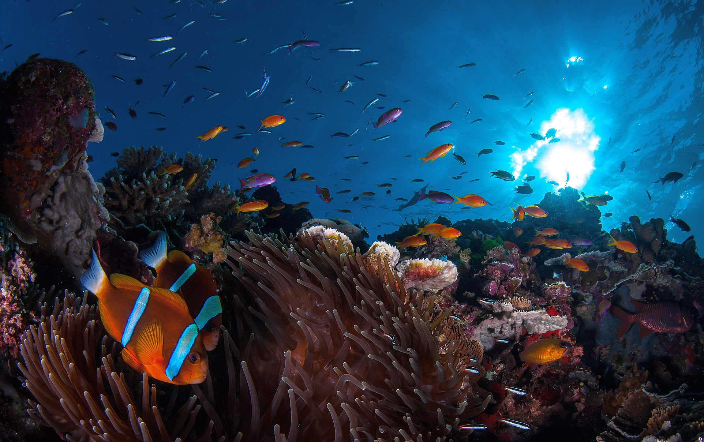

Citation

Roth CH, Addison J, Anthony K, Dale A, Eberhard R, Hobday A, Horner NJ, Jarvis D, Kroon K, Stone-Jovicich S and Walshe T (2017) Reef 2050 Plan Review Options. Final Report submitted to the Department of the Environment and Energy. CSIRO, Australia.

Copyright

© Commonwealth Scientific and Industrial Research Organisation 2017. To the extent permitted by law, all rights are reserved and no part of this publication covered by copyright may be reproduced or copied in any form or by any means except with the written permission of CSIRO.

Important disclaimer

CSIRO advises that the information contained in this publication comprises general statements based on scientific research. The reader is advised and needs to be aware that such information may be incomplete or unable to be used in any specific situation. No reliance or actions must therefore be made on that information without seeking prior expert professional, scientific and technical advice. To the extent permitted by law, CSIRO (including its employees and consultants) excludes all liability to any person for any consequences, including but not limited to all losses, damages, costs, expenses and any other compensation, arising directly or indirectly from using this publication (in part or in whole) and any information or material contained in it.

CSIRO is committed to providing web accessible content wherever possible. If you are having difficulties with accessing this document please contact [csiroenquiries@csiro.au](mailto:csiroenquiries@csiro.au).

Cover Image

©Matt Curnock

Contents

Acknowledgments 4

1 Introduction 7

2 Approach Taken 8

3 Key Findings 9

3.1 Summary of Gap Analysis and Key Informant Interviews 9

3.2 Summary of Trajectories Analysis 15

3.3 Options Framework and Stakeholder Feedback 20

4 Recommendations for the Midterm Review 23

4.1 Recommendations 23

4.2 Preferred Midterm Review Option 26

5 Appendices 28

5.1 Overview of Midterm Review Options 28

5.2 Concepts for Foundational Activities in Preparation for 2020 Review 31

Acknowledgments

We gratefully acknowledge the funding received from the Commonwealth Department for the Environment and Energy, the Australian Institute of Marine Sciences (AIMS), CSIRO, and James Cook University (JCU).

The study was conducted through a collaborative partnership between the following team of subject matter experts:

Jane Addison (JCU)

Ken Anthony (AIMS)

Allan Dale JCU)

Rachel Eberhard (Eberhard Consulting)

Alistair Hobday (CSIRO)

Nerida Horner (CSIRO)

Diane Jarvis (JCU)

Frederieke Kroon AIMS)

Samantha Stone-Jovicich (CSIRO)

Christian Roth (CSIRO; Team Leader)

Terry Walshe (AIMS)

The study team also wishes to acknowledge and thank the following individuals for their support and input:

Scott Crawford (NNQ Dry Tropics)

Dorean Erhart (LGAQ)

Duane Frazer (NAILSMA)

Melissa George (NAILSMA)

Margaret Gooch (JCU)

Rosemary Hill (CSIRO)

Sue Sargent (Burnett Local Marine Advisory Committee)

Stephan Schnierer (Southern Cross University)

Bob Speirs (NRM consultant)

Carole Sweatman (Terrain)

Leah Talbot (CSIRO)

Di Tarte (Marine Ecosystem Policy Advisors)

Michael Winer (Cape York Institute)

We are also grateful to the project’s Steering Committee, including Britta Schaffelke (AIMS), Craig James (CSIRO) and Iain Gordon (JCU), for their oversight and review of the reports.

Finally, we would like to thank the Reef 2050 Plan Joint Implementation Team for their guidance, the seamless engagement and their willing and ongoing involvement with all aspects of this study.

Executive Summary

In preparation for the 2018 midterm review of Reef 2050 Plan, the Reef 2050 Plan Joint Implementation Team commissioned an expert consortium from CSIRO, the Australian Institute of Marine Sciences, James Cook University and Eberhard Consulting to provide advice on review options. This report provides a summary of the analysis undertaken to underpin the recommendations on scope and process of the midterm review, as well as providing recommendations on additional steps for the Joint Team to consider in preparation for the 2020 review. This report is supplemented by a separate Appendix Report that provides a more detailed account of the analysis undertaken.

The study was conducted in close liaison with the Reef 2050 Plan Joint Implementation Team over a period from June to August 2017. The approach taken comprised a set of analytical activities, including a gap analysis to identify areas of the current Reef 2050 Plan that need to be updated, targeted interviews to capture perspectives of key informants, and an analysis of possible future change trajectories. Insights from these steps were used to develop an options framework to guide a transparent and robust choice of review alternatives in an engagement with key stakeholders. This was then followed by a synthesis into a set of recommendations determining the scope and process for the midterm review, as well as an outline of a set of foundational activities proposed in preparation for the 2020 review.

Responding to the impacts of climate change is clearly the most significant gap in the Reef 2050 Plan that emerges from the analysis presented in this report. In addition, given the continued urgency to step up actions to improve water quality, it may be necessary to consider additional approaches in the midterm review to accelerate progress in water quality improvements towards targets. At the same time, the analysis also points to an urgent need to strengthen the human dimensions elements of the Reef 2050 Plan. Work is needed to build community acceptance of proactive reef restoration actions, potentially including assisted coral migration, engineering solutions to coral management and heat management, and a range of other new interventions using emerging technologies. Additional work is also required to understand and meet the rights and interests of Traditional Owner, and Aboriginal and Torres Strait Islander people more broadly. These imperatives are consistent with advice from the RIMReP, IEP and RAC received by the Joint Team.

However, while new adaptation actions are urgently needed as part of the Reef 2050 Plan, the changing nature of the GBR, highlighted by the recent mass coral bleaching events of 2016 and 2017 also requires a significant rethink. Whether the Reef 2050 Plan’s current overarching goal of ***maintaining and*** ***enhancing the GBR’s*** ***Outstanding Universal Values*** (OUV) throughout the entire World Heritage Area needs to be reframed to one that emphasises ***preserving the*** ***ecological function of GBR ecosystems*** in a changing climate has emerged as a key question. Maintaining and enhancing OUV, as presently articulated in the Reef 2050 Plan, may no longer be realistic.

Biodiversity and ecosystem health have potentially changed in parts of the GBR post the 2016 and 2017 bleaching events, and the frequency of such events is likely to increase. While the concept of shifting the focus to preserving ecological function is generally accepted by informed stakeholders (e.g. as per the recent communiques from the IEP and RAC), it is unrealistic to assume that a midterm review process could easily articulate what this shift means in terms of changes to targets, short term and intermediate outcomes.

These headline findings, together with other insights from the synthesis, lead to the following recommendations:

**Recommendation 1***That the Joint Implementation Team should lead a pragmatic and timely midterm review process that:*

1. *incorporates ‘no regrets’ climate change adaptation actions into the Reef 2050 Plan;*
2. *considers additional approaches to accelerate progress in water quality improvements towards targets;*
3. *explores options to reflect the importance of human dimensions in Reef 2050 Plan actions (building on the recently revised Reef 2050 WQIP 2017); but also*
4. *commits to developing more substantial adaptation strategies and actions to be incorporated in the 2020 review.*

**Recommendation 2***That the 2020 review process:*

1. *revises the Reef 2050 Plan targets and outcome statements (and potentially the overarching goal);*
2. *develops robust program logics that articulate how strategies and actions will meet the revised targets; and*
3. *commences a set of foundational activities (12-18 months duration) to provide the necessary information base and social licence to enable a substantive restructure and rewrite of the plan in 2020.*

**Recommendation 3**  
*Pursue greater policy influence and coordination of areas that sit outside of the Reef 2050 Plan but threaten to undermine efforts to sustain the values of the GBR. Priority policy areas include emissions reduction, agricultural and land use intensification and major development project assessments. Greater capacity to assess cumulative impacts can underpin Reef 2050 Plan and inform related policy arenas.*

**Recommendation 4***The proposed procurement of services to support engagement of Traditional Owners is a promising start to addressing the need to embed meaningful engagement with Traditional Owners to allow their aspirations and commitments in the Reef 2050 Plan to be met. Traditional Owner engagement should build on this work to build a partnership approach to underpin the midterm and 2020 review processes.*

# Introduction

The Great Barrier Reef (GBR) provides significant social, economic and environmental values and benefits for Australia. These unique values are at risk from climate change, land-use, coastal developments, unsustainable fishing and Crown of Thorns Starfish (CoTS) outbreaks. Greenhouse gas emissions (GHG) directly impact the reef through global warming, increased severity of storms and ocean acidification. Australia can play an important role in limiting the global rise of GHG emissions despite producing low total emissions in absolute terms.

The coral bleaching events of 2016 and 2017 are a game changer because they were of unprecedented severity and beyond the control of current environmental management and policy alone. Given the extensive loss of corals and live reef habitats in the northern and central sections of the GBR have experienced dramatic changes. The capacity and timeframes for recovery from these changes are difficult to predict. The coral bleaching impacts are exacerbated by the current outbreak of CoTS, and recent cyclones. The cumulative impacts of these disturbances have implications for government responses, specifically: what values can feasibly be protected and at what level, and what are the suite of options for climate adaptation that can help to effectively build reef resilience?

These responses face significant technological and policy challenges. Rates of long-term ocean warming are increasing and are likely to drive an increased frequency and severity of coral bleaching events. More innovative approaches to accelerate natural rates of reef recovery between events through targeted protection and proactive reef restoration activities are needed. Better water quality is also critical to support ecosystem resilience and the Reef’s ability to withstand climate and other shocks. At present rates of water quality improvement, it is unlikely that the necessary water quality targets will be achieved quickly enough.

As a result, the fate of the GBR continues to attract high international and domestic public and political interest. The deteriorating condition of the GBR due to bleaching and other stressors is now widely acknowledged, warranting significant policy adjustments.

The Reef 2050 Long-Term Sustainability Plan (Reef 2050 Plan hereafter) was launched by the Australian and Queensland Governments in 2015 in response to the complex challenge of maintaining the Outstanding Universal Values that define its status as a World Heritage property. The Reef 2050 Plan is built on an innovative adaptive management framework, in recognition of its 35-year forward strategy and the need for continuous coordination between the Australian and Queensland Governments. Consequently, there is provision for it to undergo 5-yearly reviews during its implementation. The first of these reviews is planned for 2020. However, a provision was made for a midterm review in 2018 to verify that the Reef 2050 Plan was on track following its initial implementation period, and allow for the incorporation of the revised Reef Water Quality Protection Plan in 2017.

In preparation for the 2018 midterm review of the Reef 2050 Plan, the Joint Implementation Team (Department of the Environment and Energy through Reef Branch and GBRMPA, and the Office of the Great Barrier Reef, Queensland Department of Environment and Heritage Protection) commissioned an expert consortium from CSIRO, the Australian Institute of Marine Sciences (AIMS), James Cook University (JCU) and Eberhard Consulting to provide advice on options for the scope of the midterm review.

This report provides a summary of the analyses undertaken to underpin the recommendations on scope and process of the midterm review, as well as providing recommendations on additional steps for the Joint Team to consider in preparation for the 2020 review. This report is supplemented by a separate Appendix Report that provides a more detailed account of the analyses undertaken.

Policy action on climate change mitigation, through the reduction of greenhouse gas emissions in the context of the Paris Accord, is beyond the policy scope of the Reef 2050 Plan. Action on climate change mitigation is therefore not a direct subject of this scoping project.

# Approach Taken

This scoping study was conducted in close liaison with the Reef 2050 Plan Joint Implementation Team over a period from June to August 2017. The approach taken is summarised in Figure 1. In general terms it comprised the following main steps:

1. A set of analytical activities, including:

* Step 1: Gap analysis to identify areas of the current Reef 2050 Plan that need to be updated, based on the Plan’s themes
* Step 2: Targeted interviews to capture perspectives of key informants with deep experience in relation to engagement and management in the GBR
* Step 3: Defining possible future climate change trajectories (upper and lower ranges), that provide the upper and lower bounds for the midterm review scope
* Step 4: Based on the results obtained in Steps 1 to 3, development of an options framework to guide a transparent and robust choice of review alternatives.

1. Step 5: Using the options framework, engagement with key stakeholders to elicit their perspectives on the scope of the review, and to obtain input on preferred engagement processes and timelines. The primary mode of stakeholder engagement was through the Reef 2050 Plan advisory bodies, i.e. the RIMReP Steering Committee, the Independent Expert Panel (IEP) and the Reef Advisory Committee (RAC).
2. Step 6: Synthesis of steps 1 to 5 into a set of recommendations determining the scope and process for the midterm review, as well as developing the outline of a set of foundational activities proposed in preparation for the 2020 review.

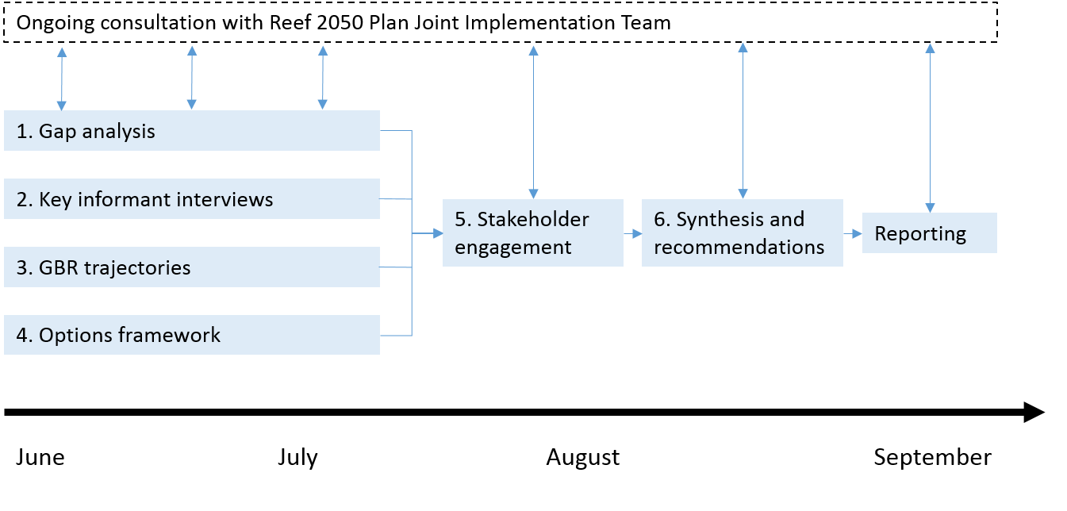

**Figure 1.** Approach taken by study team to guide options for the midterm review of the Reef 2050 Plan.

# Key Findings

## Summary of Gap Analysis and Key Informant Interviews

The gap analysis was structured into sections consistent with Reef 2050 Plan themes. This approach reflected the advice given during the project inception meeting that the review process should accept the pre-existing Reef 2050 Plan goal and outcome statements. That is, the analysis was targeted towards the following themes: ecosystem health, biodiversity, heritage, water quality, community and economic benefits, governance and implementation, and monitoring/evaluation/reporting. Traditional owner perspectives were also given particular focus, as requested during the inception meeting.

Identified literature consisted of a mixture of peer reviewed and non-peer reviewed material, with the latter including publicly available meeting minutes with key stakeholder groups (IEP, RAC) and GBRMPA reports. A detailed account of the gap analysis and the literature cited is provided in a separate Appendix Report. Here we provide the key insights and implications to help determine the scope and of the midterm review, and what additional steps may be required in preparation for the 2020 review.

#### Ecosystem Health and Biodiversity

Under current and projected climate and use scenarios, a more realistic understanding of the consequences of cumulative impacts for GBR ecosystem health and biodiversity needs to be developed. A key challenge for the midterm review will be to re-assess the scope for specific on-the-ground actions under Reef 2050 Plan to enhance ecological resilience and protect biodiversity. Without such understanding, tolerance thresholds for vulnerable species can be exceeded with consequences for habitats, dependant species and people. Actions to improve water quality, reduce fishing pressures and control CoTS all take pressures off the Reef’s biodiversity and ecosystems. However, they cannot fully compensate for the ecological resilience lost to climate change impacts. In other words, GBR policy and management under climate change will be working against a ceiling of resilience that cannot be overcome by pulling harder on conventional management levers. The cumulative impacts management framework developed by GBRMPA to support the Reef 2050 Plan is a start to addressing this gap, but needs to be developed further using model analyses that assess how key species will respond to multiple stressors under different plausible scenarios.

The Reef 2050 Plan is vague on how the achievement of environmental targets for water quality will translate to the protection of biodiversity. While improved water quality can provide some resilience support, e.g. by reducing the likelihood of coral disease and enhancing bleaching tolerance, and potentially reducing the likelihood of environmental triggers of primary CoTS outbreaks, an understanding of the ecological consequences of achieving or not achieving specific water quality targets is lacking. Here, the Review should assess more specifically the biodiversity consequences of exceeding thresholds for water quality tolerance, versus what actions would be required to stay on the safe side of those thresholds given their dynamics in time and space.

Recent coral bleaching events in the northern GBR demonstrate that areas under minimal human influence are now also vulnerable. Here ecosystem resilience could already be overwhelmed by pressures from global drivers. If so, conventional management actions will have limited capacity to compensate for lost resilience. This raises a potentially contentious question for the review. If Outstanding Universal Values (OUV) and biodiversity of the GBR as we know it cannot be sustained under continued or worsened climate change, what version of the GBR can?

The main implication of the above analysis is that the Reef 2050 Plan will require a substantive overhaul to not only accommodate climate change actions, but to possibly review and reformulate its overarching goal statement. This is because it is likely that the vision for the Reef 2050 Plan can no longer be achieved in its original formulation, unless the world implements stronger mitigation actions to reduce GHG emissions (see section 3.2). Recognising that maintaining or even enhancing the original OUV as stated in the Reef 2050 Plan is possibly no longer realistic and replacing OUV by a new statement on preserving reef ecological function, entails a substantive assessment, which is beyond the scope of the midterm review and will need to form a main focus of the 2020 review. The main reason is that the underpinning science to determine what the new goal statements and related intermediate and short term outcomes and targets might entail is still highly uncertain. This is compounded by uncertainty regarding what people would want from an altered ecosystem. This requires a clear formulation of objectives against what the ecosystem would in fact be able to deliver given management and desired stakeholder outcomes.

Hence, the midterm review might have to focus on what immediate, no regrets actions (e.g. as identified in the recent GBR Summit) can be incorporated in the Reef 2050 Plan, relegating the task of a major revision of the Plan into the 2020 review. The 2020 review would need to be underpinned by a suite of foundational actions that better defines a set of revised ecological thresholds, targets and ensuing outcomes. In the interim, in addition to identifying and incorporating immediate and no–regrets actions, the midterm review could also assess whether climate adaptation should become a specific theme of the revised Reef 2050 Plan. Here, one option could be for the Plan’s Principles in decision making to be updated to account for the uncertainty of future scenarios, the role of global drivers in influencing management outcomes, and the possibility of exploring emerging technologies in supporting the resilience of key species and habitats/ecosystems.

#### Heritage

A review of the available documentation indicates that little focus is being directed at the Heritage theme compared to some of the other themes within the Reef 2050 Plan; such as the impact of the recent bleaching events, and issues relating to the water quality theme, are receiving most of the attention.

Documents produced by the IEP have made reference to the need to work with people on the ground, including Aboriginal and Torres Strait Islander Traditional Owners and people, and other groups, to consolidate information as it becomes available and to ensure that data collection methods are comparable and robust. The IEP have also noted that Traditional Owners, and others, should be better supported to deliver on-ground actions that will benefit the reef; including being eligible for financial support for activities consistent with a revised plan.

The most obvious opportunities to improve the implementation of the actions under the Heritage theme within the current plan, and to improve the plan itself, fall within three broad categories:

* Developing the capacity of Traditional Owners and the Indigenous community to deliver their actions under the Reef 2050 Plan.
* Continue to support new innovations emerging in RIMReP that help bring traditional owner perspectives to the monitoring program.
* Identify funding requirements, and sources for this funding.

#### Water Quality

The Reef WQ Plan 2013 has recently been updated into the draft Reef 2050 WQIP 2017-2022. The updated Plan contains (i) revised water quality targets for each of the 35 major GBR catchments; (ii) a basic program logic that links actions to outcomes, and (iii) an investment strategy. The Reef 2050 WQIP is nested within the Reef 2050 Plan.

Three main opportunities to improve the Reef 2050 WQIP are being proposed:

1. Better reflect the urgency of, and scale of change required to achieve the water quality targets, as recommended by the GBR Taskforce and others;
2. Specifically link and quantify the actions and outcomes with progress towards, and achieving, the water quality targets; and
3. Specifically link the proposed ‘minimum practice standards everywhere’ with the best management practise programs in agricultural land uses.

Beyond that, targets, actions and investment strategies outlined in the water quality improvement plans for the six NRM regions in the GBR catchments, need to be clearly nested within the Reef 2050 WQIP specifically, and the Reef 2050 Plan in general. This could contribute to a strengthening of the program logic for water quality improvement across the Reef 2050 Plan, the Reef 2050 WQIP and the regional WQIPs, linking the outcome and targets with measurable actions needed to achieve these targets. This will ensure consistent messaging and increased effectiveness in investment. This would also enable a better balance between the main pollutant source of concern to the Reef (i.e. agricultural land uses) and the actions outlined for pollutant sources in the Reef 2050 Plan.

Given the continued urgency to step up actions to improve water quality, it may be necessary to consider additional approaches in the midterm review to accelerate progress in water quality improvements towards targets, including potential improvements to current policies and incentives, as well as potential changes to current agricultural land use. Based on international experience and Australia’s unique potential, this may include:

* Harmonisation of Federal and State Acts, regulations and policies to improve the protection of GBR ecosystems from land-based pollution;
* Implementation of effective legislative and regulatory instruments governing agricultural land uses and management in GBR catchments; and
* Retirement of agricultural land in high-risk areas.

#### Community and Economic Benefits

Consideration of human dimensions in future planning, assessment and monitoring of the GBR is a new concept, even though GBR policy makers, managers and partners have long recognised that maintaining the health of the GBR, both now and into the future, will rely on mobilising the energy, motivation and aspirations of key individuals and sectors of society (particularly within GBR catchments). In particular, to improve the health of the GBR, policy makers and managers need to understand and monitor: (a) people’s relationship with the GBR, including the values associated with different components of the GBR; (b) the range of factors influencing behaviours that affect the GBR (positively or negatively); (c) the role of GBR decision-makers, including users, managers, partners, communities and industry in affecting change; (d) equity and inclusion of multiple perspectives; and (e) the adaptive capacity of industries and communities who depend on the GBR for the economic, social, or cultural values it provides.

The human dimensions of the GBR include the social, cultural, institutional, economic and governance factors that shape people’s relationship with the GBR. These relationships are diverse and range from, for example, residents from outside the GBR who believe that the GBR is one of the world’s most precious natural assets even if they have not physically visited the area themselves, to the decisions and practices of individual land managers, GBR users and enterprises that have some association with the GBR. The relationships also include collective actions by industries, communities and governments, and how these influence GBR resilience.

People’s relationship with the GBR is also influenced by attitudes towards, and perceptions of the GBR and its management. These have changed considerably over time, and will no doubt change again in the future. Attitudes and perceptions are shaped by culture, societal norms, context and circumstances, including personal experiences, word-of-mouth, and print media. Traditional Owners and Aboriginal and Torres Strait Islander people more broadly have had the longest association with the GBR, and their attitudes and perceptions have been relatively constant over millennia as custodians and sustainable users of the GBR and its resources. By contrast, non-Indigenous attitudes and perceptions are varied and can change relatively quickly, especially for those new to the GBR and its catchment.

A key emerging implication for Reef 2050 Plan is the need to consider the balance between regarding human dimensions as an asset (to help manage and protect the Reef) versus a pressure (as resources users of the Reef and connected ecosystems)*.* While there are some targets and actions in the Reef 2050 Plan that do seek to directly invest effort in building the health of the human dimension of the GBR socio-ecological system, there remains an over-arching logic that generally sees key aspects of the human dimension as a risk to OUV. While actions related to physically doing something to improve biophysical OUV should be outlined in the Reef 2050 Plan(e.g. building more effective wetlands to improve water quality), specific policy or investment to improve the resilience of individuals, communities and regions (the primary feature of the human dimension) and resultant indicators should be logically embedded within the human dimensions sections of the Reef 2050 Plan beyond the midterm and 2020 review points.

Key consequent implications for the Reef 2050 Plan midterm review include the need to:

* Further emphasise the non-market values of the GBR to better understand the trade-offs needed to manage different ecosystem services
* In conjunction with the RIMReP design, enable development, implementation and reporting of a program underpinning the monitoring of human dimensions of the GBR
* Commence an engagement process to determine priority strategies for improving the condition of the GBR human dimensions based on earlier benchmarking and monitoring of the health of key human dimension clusters
* Ensure there is specific consideration of the wider human dimension issues within any engagement associated with the midterm review and a shift in emphasis from just seeing human dimensions as a threat to GBR OUV, enabling a much wider set of strategies and actions required to improve the overall health of the GBR socio-ecological system; and
* As part of a foundational action in the lead up to the 2020 review of the Reef 2050 Plan, we need to better understand the following:

1. How can we build the resilience of reef-dependent and reef-related enterprises and communities to expected/unexpected environmental change while improving environmental protection (e.g. though new practices, business models, risk management, adaptive capacity or technologies)?
2. How do we better engage and partner with place based communities and sectors to improve reef stewardship and enhance economic and social benefits?
3. What new policy instruments, models of collaboration and management are required to improve the effectiveness and adaptability of the wider system of governance affecting the reef in a changing environmental and socio-economic context?

#### Governance and Implementation

The gap analysis has built on recently completed work applying a Governance System Analysis that identifies governance (in the sense of policy) subdomains that present a high, medium, or low risk of failure to produce positive outcomes for GBR. This approach importantly determined that several “whole of system” governance problems could undermine GBR outcomes, and that these will require further consideration in the review of the Reef 2050 Plan. The two primary ones comprise:

1. ***Competing policy challenges:*** In the future, the Reef 2050 Plan Joint Implementation Team should continue working across government(s) with agencies responsible for non-GBR policy areas that present the greatest risk to the achievement of Reef Plan outcomes. The priority subdomains requiring some level of urgent attention include: (i) greenhouse gas emission management; (ii) ecosystem service policy and delivery; (iii) development in Northern Australia; (iv) assessment of major development projects, and (v) vegetation planning and management.
2. ***Strengthening policy alignment and delivery within the Reef 2050 Plan:***The Reef 2050 Planis a keystone arrangement with integrative potential to influence policy domains relevant to the entire GBR system. This ability did not exist in 2013 and has rapidly evolved from previous bilateral and partnership arrangements focussed initially on strategising and coordinating efforts to achieve GBR water quality targets. The formation of these new arrangements in the Reef 2050 Plan, with strong coordinated government efforts, engagement systems and knowledge integration platforms, is a significant and bold innovation. Due to its infancy, however, the following characteristics need strengthening: (i) more cohesive target setting and strategy development within Reef 2050 Plan; (ii) more cohesive trilateralism between the Commonwealth, State and Local governments; (iii) the strengthening of formal partnership arrangements and delivery systems associated with development and delivery of the Reef 2050 Plan; (v) the reduction of internal institutional overlaps; and (vi) improved science priority setting; (vii) ongoing strengthening of monitoring and reporting arrangements via RIMReP; and (viii) revamping the purpose/focus of the Reef Trust concept.

Recognising the above risks, key implications for the Reef 2050 Plan midterm and 2020 review processes include the need to:

* Further strengthen mechanisms supporting internal government and bilateral coordination about approaches to manage the highest risk competing policy issues
* Ensure there is specific consideration of wider policy alignment and delivery issues already identified through the governance system benchmarking undertaken by JCU within any engagement associated with the midterm review.

#### Indigenous Perspectives

In the absence of a formalised Indigenous Regional Advisory Committee (IRAC) meeting during the project, the consortium drew on Traditional Owner views articulated in recent National Environmental Science Program (NESP) and Commonwealth funded work on developing implementation strategies for Traditional Owners actions in the Reef 2050 Plan (i.e. the Gidarjil Report). Targeted discussions (including the review of gap analysis materials) were also held with the Cape York Institute (Michael Winer), NAILSMA (Melissa George and Duane Fraser), Stephan Schnierer (IEP) and Rosemary Hill (CSIRO).

With no clear mechanisms for implementing the fragmented actions outlined in the Reef 2050 Plan, Traditional Owner concern about Federal and State commitment to their interests has again begun to emerge. In response, some preliminary work was conducted through the National Environment Science Program’s GBR Water Quality Hub to explore Traditional Owner views and interests in implementation of the Indigenous actions in the Reef 2050 Plan. This resulted in the articulation of an *Indigenous Implementation Plan* which was developed to support and guide implementation of the Traditional Owner led actions in the Reef 2050 Plan.

Drawing on broad consultation with Traditional Owners, the *Indigenous Implementation Plan* highlights general findings and identified three focus areas as implementation priorities:

* Coordination;
* Cultural heritage; and
* Business capacity

These key areas were considered to intersect with the majority of the Traditional Owner actions in the Reef 2050 Plan, and for each of these three priorities, the *Implementation Plan* articulated the known challenges and opportunities, proposed a pathway to address those challenges and identified the results expected from implementation. The implementation of these priorities was considered by Traditional Owners to be important to progress meeting of the Indigenous targets and objectives in the Reef 2050 Plan.

The Australian government has now progressed towards the procurement of a (likely community-based) service organisation that could: (i) set the framework for engaging, coordinating and reporting on the implementation of Traditional Owner-related actions from the Reef 2050 Plan; and (ii) provide an opportunity to engage Traditional Owners in the midterm review of the Reef 2050 Plan. This approach aims to test the best approach to policy framing around ongoing Reef management. There are currently no clear linkages between this approach and the existing IRAC framework (which has no formal role related to the Reef 2050 Plan), but explicit consideration of these linkages might well emerge from the processes being established.

Based on these developments since the completion of the Reef 2050 Plan, a number of key headline considerations have been proposed by Traditional Owners consulted as part of this gap analysis:

* Further strengthening of local, sub-regional and regional Indigenous land and sea management organisations (needs to be Traditional Owner-driven)
* Developing partnership frameworks for recognising and partnering Traditional Owners at the whole of GBR level (and associated regional, sub-regional and local scales)
* Increased support for open engagement with information and knowledge generation.

The main implications for the midterm review at this point are:

1. A stronger level of bilateralism in the procurement of services to determine the framework for engaging, coordinating and reporting on the implementation of Traditional Owner-related actions from the Reef 2050 Plan
2. The use of the resultant framework and engagement structures to undertake detailed Traditional Owner partnership in the review of the Reef 2050 Plan and the progression of agreed actions.

#### Monitoring, Reporting and Review

The gap analysis found that current Reef 2050 Plan reporting is in a weak position to inform the midterm review. In part this is because the narrow scope of most of the progress reports produced under the Reef 2050 Plan means they are limited in their ability to inform the review on how well the Reef 2050 Plan is tracking towards protecting the Reef.

In the first instance, there is a need to redefine the scope of what monitoring and evaluation needs to include. The evaluation of actions and conditions of the Reef needs to be built on an assessment of the missing links and weak points between the 2050 outcomes, 2020 targets, 2035 objectives and 2015-2020 actions. This would serve as a foundation to develop a comprehensive program logic, or impact pathways, required for strengthening the design and implementation of the monitoring, evaluation and reporting of the Plan. Ideally, this would be informed by an assessment of how progress reporting has been conducted to date – i.e. how effective it has been in tracking progress against outcomes, rather than just whether actions have been completed or not.

Furthermore, consideration needs to be given to processes for undertaking the review of the monitoring, evaluation and reporting program of Reef 2050 Plan. This necessitates an engagement with the groups that have been recently involved in planning of monitoring for the Reef 2050 Plan (e.g. RIMReP Steering Committee and Working Groups). There is a lot to be learned from the challenges, bottlenecks, and successes experienced by those directly engaged in the various Reef monitoring programs. Building on the programs’ participants’ and other key stakeholders’ perspectives and recommendations, as well as on lessons learned from similar efforts in other regions, is critical to building a monitoring, evaluation and reporting system in the Reef that enables appropriate and fit-for-purpose tracking whilst supporting adaptive management.

The comprehensiveness of the Reef 2050 Plan – that it cuts across a wide range of themes and scales – presents a significant challenge for monitoring and evaluation. This is a primary concern of the RIMReP design process. Given existing and likely future funding constraints, the ongoing review and evaluation of Reef 2050 Plan needs to build on reporting through RIMReP in a way that enables identification of priority areas for M&E and reporting, with an adaptive mechanism incorporated that enables regular revision as new areas of concern and/or promising pathways to impact emerge.

#### Perspectives of Key Informants

Semi-structured interviews to triangulate some of the above findings, as well as to capture cross-cutting and overarching perspectives of the Reef 2050 Plan, were conducted with ten key informants. These were selected for their deep experience in relation to engagement and management in the GBR, and comprised of experts in natural resource management, community engagement, indigenous perspectives, local government, and marine conservation.

Individuals interviewed provided a number of key overarching observations. All agreed that the Reef 2050 Plan is an appropriate framework to build upon, recognising that it is work in progress. A general issue is that in its present form, the plan represents a hybrid between a strategy and an operational plan, and that moving forward, operational actions should be eliminated and the Reef 2050 Plan elevated into a strategy document. This in particular is in recognition that the reach of Reef 2050 Plan themes and actions goes beyond the Great Barrier Reef Marine Park and into catchments and that this reach varies across the whole of GBR region, hence making it challenging to be systematically addressed.

Beyond these overarching perspectives and comments, the results of the interviews largely align with the insights extracted from the gap analysis and comprise the following headline implications for the review of the Reef 2050 Plan:

1. A need to broaden the scope of the Reef 2050 Plan to include climate adaptation actions, including reef restoration measures
2. Strive to a greater level of regionalisation of actions, recognising that pressures vary spatially, and that stakeholder aspirations and capabilities also vary
3. Underpin the review by a good stakeholder engagement process to improve understanding of needs and preferences and to improve social acceptability of outcomes. Of particular importance is an appropriate Traditional Owner engagement process
4. As part of the engagement process, elicit a more coherent link between actions and Reef 2050 Plan outcomes and map cause-and-effect pathways (Program Logic). This will:

* Guide the specification of targets and prioritisation of actions (including regionalisation, where appropriate)
* Tighten the resourcing of actions
* Provide a clear foundation for an M&E framework and reporting

1. Explore governance options to harmonise policy domains and reduce Reef 2050 Plan delivery risks
2. Explore and include additional actions to improve GBR resilience (e.g. stepped up water quality improvement and CoTs control).

## Summary of Trajectories Analysis

Recent warming events and cyclones on the GBR have severely impacted reef ecosystems and dependent livelihoods and industries. These events have been superimposed on impacts from regional and local pressures from catchment land-use, coastal developments, fishing and CoTS outbreaks. The trajectory of continued global change is uncertain, and so consideration of alternative futures (scenarios) is one way of preparing for an uncertain future. For example, if the world met the Paris Agreement’s highest aspiration (< 1.5°C warming above preindustrial levels), then continued climate change would be limited but not insignificant. This possible future would provide scope for the Reef 2050 Plan to support the natural resilience of GBR ecosystems and thereby to sustain their values. Conversely, in a future world that warmed > 2°C, the capacity of the Plan to deliver outcomes despite investments and efforts would be compromised.

To develop the change trajectories we first synthesise existing scientific knowledge around likely change scenarios and place these in the context of the GBR. The change scenarios can be regarded as pessimistic versus optimistic bookends in two dimensions of change: global climate vs regional and local socio-economic drivers (Figure 2). These bookends serve as logical bounds for the scope of the Reef 2050 Plan midterm review process as they can help triangulate the management and policy strategies that might be most relevant and effective given a set of plausible scenarios, the relative likelihood of which will become increasingly apparent over time. We do not commit to a specific scenario or trajectory here, but instead adopt a language of likelihood, consequence, risk and opportunities associated with each possible future.

To project the changes that might emerge under these scenarios, recent trends in drivers and pressures and critical responses by key GBR ecosystems were first reviewed. The GBR is influenced by a suite of pressures with multiple natural and anthropogenic drivers (Figure 3). The growing influence from climate change - a global driver that exerts a set of pressures outside of direct GBR management and policy control - occurs in addition to pressures driven by regional and local activities that do have management and policy levers. Such partitioning of drivers will support the discussion of how different future scenarios (trajectories) will likely influence the Reef in the near and medium term future and help a midterm review identify policy options that might represent sound solutions and aspirations.

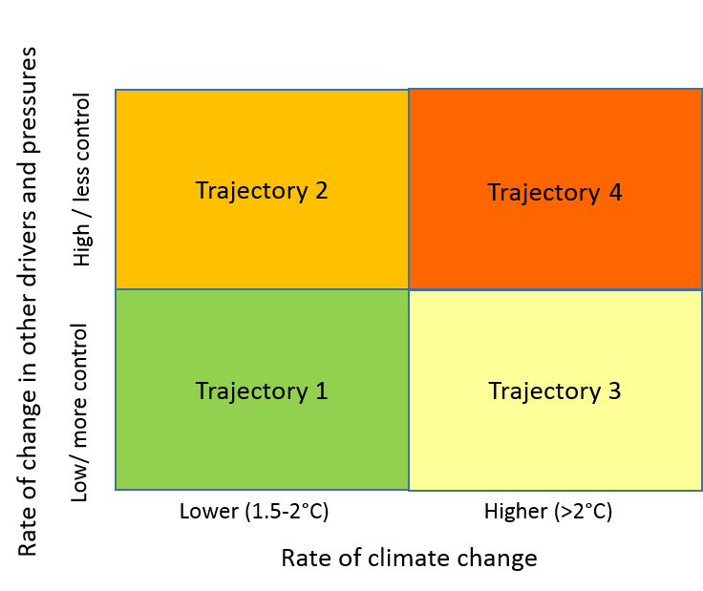

**Figure 2**. Generalised GBR change trajectories. The trajectories considered are based on the rate of climate change and the rate of change in the other regional and local drivers and associated pressures. The rate of climate change is not under direct control of GBR decision makers, however, the rates of change in the other regional and local drivers and consequent pressures are more responsive to governance and management decisions.

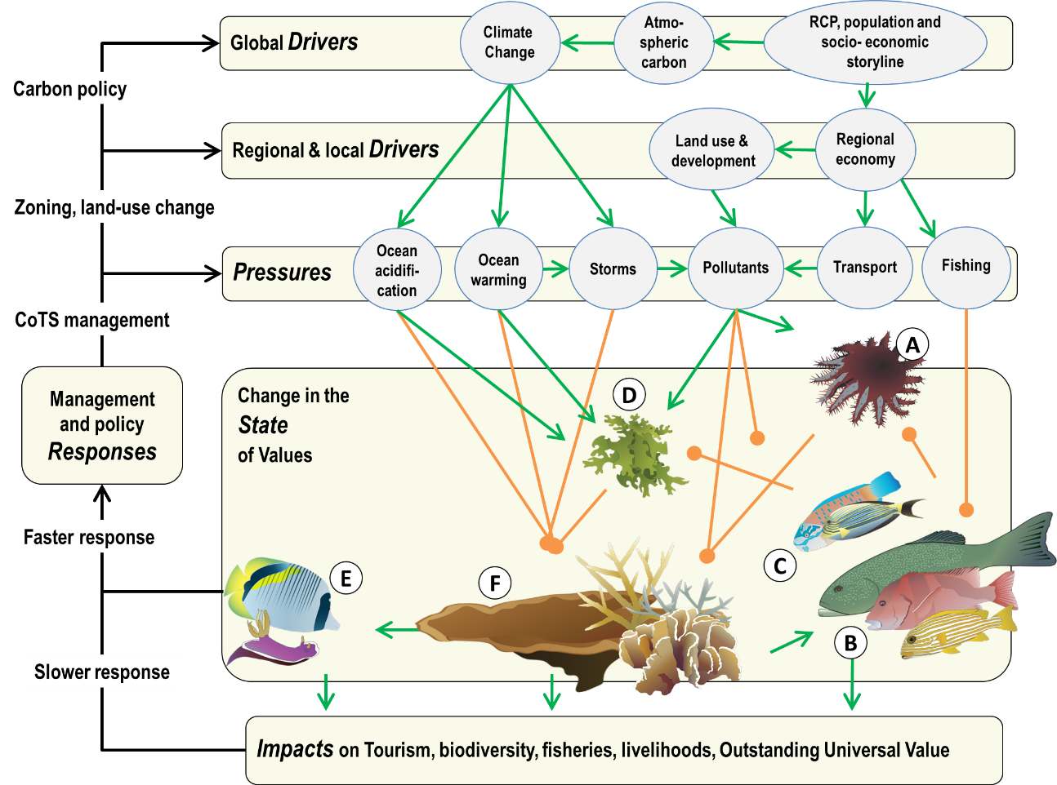

**Figure 3.** Simplified conceptual model of global, regional and local environmental influences on key functional groups on coral reefs. The model is structured within a drivers-pressures-state-impacts-responses framework. Sharp (*green*) and blunt (*orange*) arrows indicate positive and negative influences, respectively. Management and policy responses are a subset of examples only to guide review options under varying trajectories (scenarios). Organisms shown: (A) Crown-of-thorns-starfish, (B) predatory fish, (C) herbivorous fish, (D) macroalgae, (E) coral-associated fish and invertebrates, and (F) reef-building, habitat-forming corals. Modified from Anthony (2016).

Impacts on the Reef and their sources, local and regional drivers and activities occurring outside of the GBR Region (e.g. land-use) are included in our analysis. Scientific knowledge has been summarized to construct qualitative change trajectories based on storyline methods used by IPCC working groups. The GBR region considered for these change scenarios includes the entire management region covered by the Great Barrier Reef Marine Park Act (1975) and the GBR World Heritage Area. This area includes the offshore deep reefs at the edge of the Continental shelf, through to the coastal mangroves, and within the reef proper, both coral and non-coral habitats, including seagrasses and mangroves.

Since 1981, the set of drivers of change on the GBR has changed from primarily regional and local to increasingly global. Conservatively, mean sea surface temperatures of coral reef waters have warmed 0.2 - 0.3⁰C over the past three decades. The implications of such seemingly minor warming for the temperature dynamics and consequent stress on the Reef has been demonstrated by severe bleaching events in 1998, 2002 and more recently in 2016 and 2017. In the 2012 study of decadal coral decline, coral bleaching accounted on average for 10% of the observed coral loss, while cyclones and CoTS accounted for the rest in near equal proportions. A similar analysis for the past 2-3 years on the GBR would attribute most of the severe coral loss in the northern and central regions to coral bleaching as the key proximal factor, and to a combination of a prolonged ENSO event and global warming as distal factors.

The rapid increase in the importance of severe and climate events is illustrated by the increase in warm water records for the GBR region. Since 1985 (just after a major El Nino), the GBR region has seen most warming events in recent years, with 50% of the region experiencing the warmest monthly temperatures since 2005, particularly in the northern portion of the GBR (Figure 4).

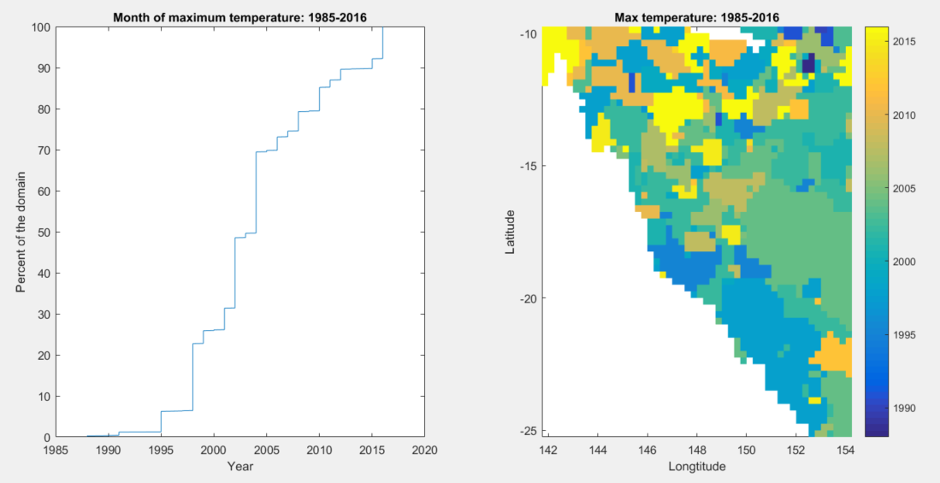

**Figure 4**. Temporal (a) and spatial distribution (b) of warm water records in the GBR region based on NOAA’s Optimal Interpolation Sea Surface Temperature analysis (https://www.ncdc.noaa.gov/oisst).

These patterns show that even with rapid warming since 2005 over the whole region, there is spatial variation. This variation in environmental change means that some regions have not warmed as rapidly or as recently as others. This spatial variation is also evident (although limited by model resolution) in projections. A key implication is that there are strong spatial signals that need to be take into account when considering approaches to prioritise future reef management interventions and reef restoration measures. Understanding the cause of this spatial variation could allow decision-makers to allocate different interventions to different parts of the reef, based on relative expected differences in warming. For example, the southern section of the GBR might be a temporary climate refuge.

Under the most aggressive carbon mitigation scenario (Representative Concentration Pathway, RCP, 2.6) which corresponds to the 1.5°C target, the world is set to warm another 0.5 degree Celsius in the coming decades**.** AsGBR surface waters warm at around 70% of global surface air warming, this translates into a projected 0.4°C additional warming. Recent studies indicate that this could mean exceedance of critical bleaching thresholds. Even if the Paris Agreement delivers on this aspirational target, atmospheric carbon will continue to increase in coming decades, driving more frequent and severe coral bleaching events, stronger storms and continued ocean acidification. Under an unmitigated emissions scenario (RCP 8.5), climate change could add >1.0°C to the current average temperature of tropical ocean surface waters already by 2050, thereby exceeding the threshold for annual mass coral bleaching under non-El Niño conditions.

Monthly sea surface temperature (SST) projections, based on the CSIRO 10km downscaled climate model (and approximating a business as usual global warming scenario ~RCP 8.5), for the four regions of the GBR are shown in Figure 5. If for example, we are interested in when a warm threshold (e.g. 30°C) is exceeded, this analysis indicates the threshold SST would be first (left end of red bar) and then always exceeded for each of the four zones (right end of red bar). According to this model, this example threshold will be exceeded in the north before the south. Temporary exceedance, the period of time when some years’ months are above the threshold might allow some recovery in subsequent cooler years. This represents an adaptation window. Beyond this time, after permanent exceedance – there will be no respite for many genotypes.

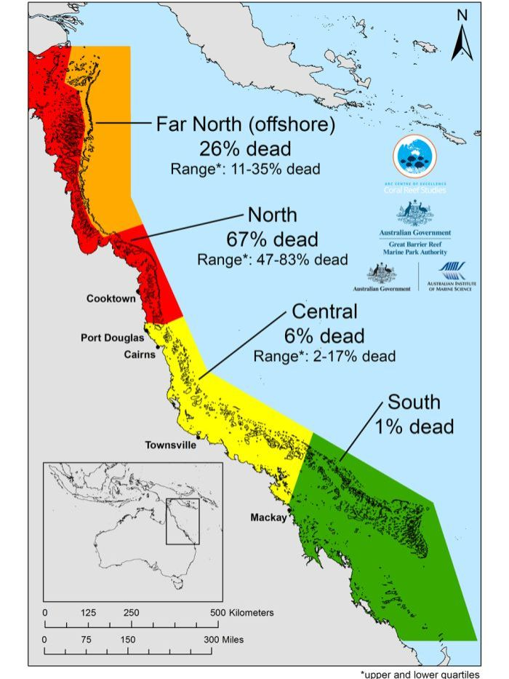**C:\Data\CSIRO projects\GBR Roth et al\FutureTrajectory\TrajectoryFigure.tif**

**Figure 5**. Extent and distribution of bleaching and coral mortality in 2016 (left panel) and projected monthly sea surface temperatures in each of four GBR regions (right panel) showing projected summer temperatures (red) and winter temperatures (blue). The numbers shown under each zone in the right panel show the year of the first and last exceedance (thereafter exceeded every year) (Source: Left: GBR map - http://www.abc.net.au/news/image/8073002-3x4-700x933.jpg ; right; Zhang and Hobday – unpublished).

Just as there will be temporal variability and thus an opportunity for adaptation, there is also spatial variability in the distribution of GBR pressures. For example, not all parts of the GBR are equally prone to cyclone damage (Figure 6). The central part of the GBR is a cyclone hot spot and the far north and south are relative cyclone refugia. In the context of the Reef 2050 Plan review this potentially means that management strategies for such cyclone refugia, especially if coinciding with reduced bleaching risk, means less acute stress and improved opportunities to support resilience. The type of patterns shown in Figure 6 can also be seen as an initial base from which to spatially target and prioritise future interventions. Such mapping could also be attempted for the other pressures, such as CoTS and sediment load. Collectively, such maps could identify locations on the reef (both impacted and not impacted) to target interventions. Interventions could be tested in areas currently impacted that may be transportable to more pristine sites in the future. Thus, rapid learning could result from careful selection of sites to test interventions and examine how biodiversity values respond.

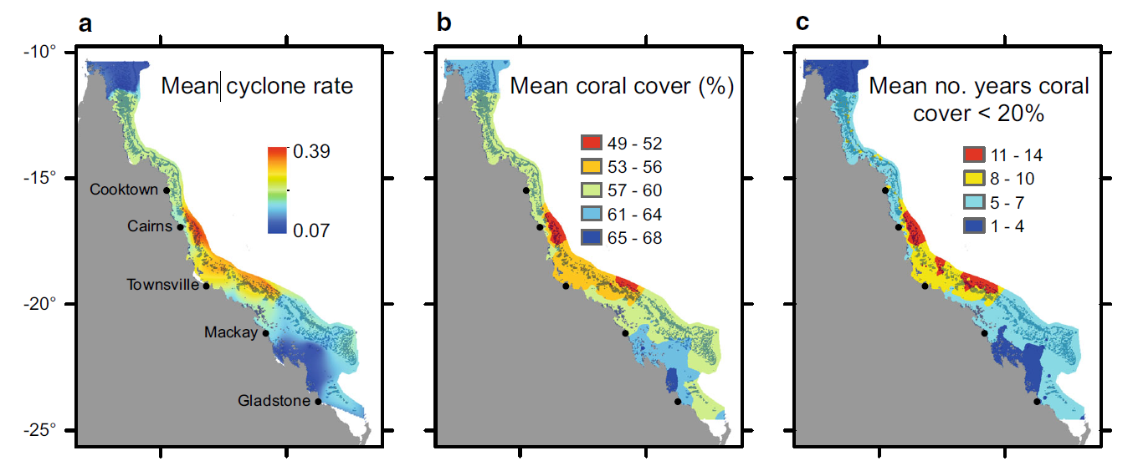

**Figure 6.** Estimated distribution of risks from cyclone damage on the GBR. Risk maps are produced by combining 1970–2011 regional cyclone statistics with synthetic cyclone tracks (simulations with physical forcing). Left panel: Mean annual cyclone rate; Centre: mean coral cover (*Acropora* assemblages) if cyclones were the only disturbance, and Right: predicted time window where *Acropora* cover was less than 20%. Source: Wolff et al. 2016

#### Summary of the Trajectories

Four trajectories of change have emerged from the analysis (Figure 2). These are combinations of fast and slow projected rates of global climate change and contrasting changes in regional and local drivers and pressures. This set of scenarios thus provide possible corners on the environmental and socio-economic landscape by 2050. They are summarised as follows (see also Appendix Report, Section 3 for full details):

* Trajectory 1 represents global carbon mitigation coupled with effective regional and local action. Globally, the trajectory follows the Representative Concentration Pathway (RCP) 2.6 aspired to by the Paris Climate Agreement to keep global warming < 2°C above preindustrial levels, and possibly to ~ 1.5°C. Regionally and locally, Trajectory 1 reflects efforts to effectively reduce cumulative impact from land-use, transport and coastal and urban developments. It offers opportunities to sustain ecosystem values that produce goods and services, support reef-dependent livelihoods, and to maintain the GBR’s Outstanding Universal Value.
* Trajectory 2 represents global mitigation (as under Trajectory 1) but regional and local status quo. Here, economic and social drivers stimulating suboptimal land-use management and practices, combined with an escalation of ship traffic, coastal development and fishing pressures, will lead to continued cumulative impacts from regional/local sources on GBR values.
* Trajectory 3 follows an unmitigated global carbon emission path (RCP 8.5), but with effective regional and local action. Run-away climate change under this scenario is predicted to compromise ecosystem resilience as pressures from ocean warming, acidification and storms are projected to intensify (Anthony 2016). As GBR waters warm at around 70% of the global warming rate, GBR surface waters could warm another 1.0 - 1.5°C by 2050. The capacity for regional and local management effort to sustain reef values will deteriorate decade by decade, driving a shift towards strategies for human adaptation as well attempts to support ecosystem resilience.
* Trajectory 4 is characterised by global run-away climate change coupled with regional and local status quo. This is an outlook that points clearly to a deteriorated GBR. Global run-away climate change and local/regional economic and social behaviours will lead to escalated cumulative impacts on the system. The environmental tolerance of species that support key ecosystem functions (e.g. reef, seagrass mangrove foundations and habitats) and ecosystem services (tourism and fisheries) risk being lost despite attempts at regional environmental management and policy. Actions to support Reef values and livelihoods become constrained to smaller scales and using adaptation measures to manage altered or new ecosystems.

Climate change is predicted to be (and already shows signs of being) the strongest driver of ecological change on the GBR. Therefore, Trajectories 3 and 4 represent pathways to increasingly compromised GBR values despite ramped up investments in regional and local management and policy (Trajectory 4). In contrast, reduced climate change under Trajectories 1 and 2 represent opportunities to support GBR resilience. However, an additional 0.5 ○C of global warming is locked in under the most optimistic carbon emissions path (RCP 2.6), and realisation of this pathway will depend on global commitments to meet emission targets. Therefore, regional and local management and policy have strong roles to play to sustain GBR values under Trajectories 1 and 2. This is relevant in justifying continued relevance of the Reef 2050 Plan.

## Options Framework and Stakeholder Feedback

On the basis of the gap analyses, insights from key informants, and trajectories work, we developed an options framework to provide a canvas for capturing stakeholder perspectives on how the midterm review should be conducted. The framework was mainly utilised to elicit stakeholder perspectives during a workshop with the RAC. The framework comprises of a table populated with a suite of categories describing areas of potential focus for the midterm review, with varying degrees of emphasis. The first draft of the options table was reviewed through a workshop process with Joint Team representatives on the 20th July 2017. Feedback from Joint Team representatives helped to condense the table and refine the options for each category. As presented in Figure 7, the revised table had nine categories for consideration by stakeholders:

* 1. The structure of Reef 2050 Plan
  2. Embedding climate change
  3. Revision of Reef 2050 Plan targets
  4. Geographic specificity of targets and actions (regionalisation)
  5. Innovation and experimentation
  6. Repair and restoration of marine systems
  7. Cause and effect rationale linking actions to targets and outcomes
  8. Breadth of policy co-ordination across government portfolios
  9. Traditional Owner and stakeholder engagement

Under each category, several options were made available across a spectrum representing different degrees of change from the current plan. Options ranged from relatively minor changes (at the top of the table in Figure 7) to more substantial changes (at the bottom of the table in Figure 7). More substantial changes would require greater time, resources and scientific support.

The revised options table was then presented to the Reef 2050 Plan stakeholder bodies (RIMReP, RAC, IEP) for feedback. Stakeholders in these groups were invited to select or comment on what they considered to be an appropriate level under each element.

The process of selecting a preferred option for each category required stakeholders to consider the implications of each choice. Stakeholders were encouraged to consider the credibility, insight and cost of the midterm review in their deliberations. Among the many factors that shape perceptions of credibility and insight, we highlighted:

* + Prospects for success or failure in meeting reef 2050 Plan targets
  + Capacity for learning and adaptive response
  + Capacity to demonstrate good custodianship under climate change
  + Stakeholder acceptability of midterm review outcomes.

The options table was used as a process to collate stakeholder feedback on how the midterm review should be conducted. Neither a consensus view nor a definitive prescription on approach were sought. In choosing options within the table, stakeholders developed an understanding of trade-offs and dependencies between the different categories. For example, selecting options for more significant change in some categories, such as revision of targets or regionalising targets, would require more significant change in other elements, such as Traditional Owner and stakeholder engagement. Additional insights from stakeholders provided critical input to determining a sensible and informed approach to the midterm review.

In summary, there were two main perspectives underpinning contrasting advice from Reef 2050 Plan stakeholder groups. The scientific community (as represented by RIMReP and IEP) had a clear preference for accelerating a major plan review process. In contrast, RAC members had a strong preference for ‘getting on with action’ and using the midterm review to strategically update actions, deferring a more comprehensive review until 2020.

Based on existing Traditional Owner related work and targeted discussions, there is equally a need to move quickly on establishing strong strategies for meaningful Traditional Owner engagement in the midterm review (i.e. through the current Commonwealth procurement arrangements). For this to be pursued, prior and informed consent would need to be in place before the more detailed 2020 end review process.

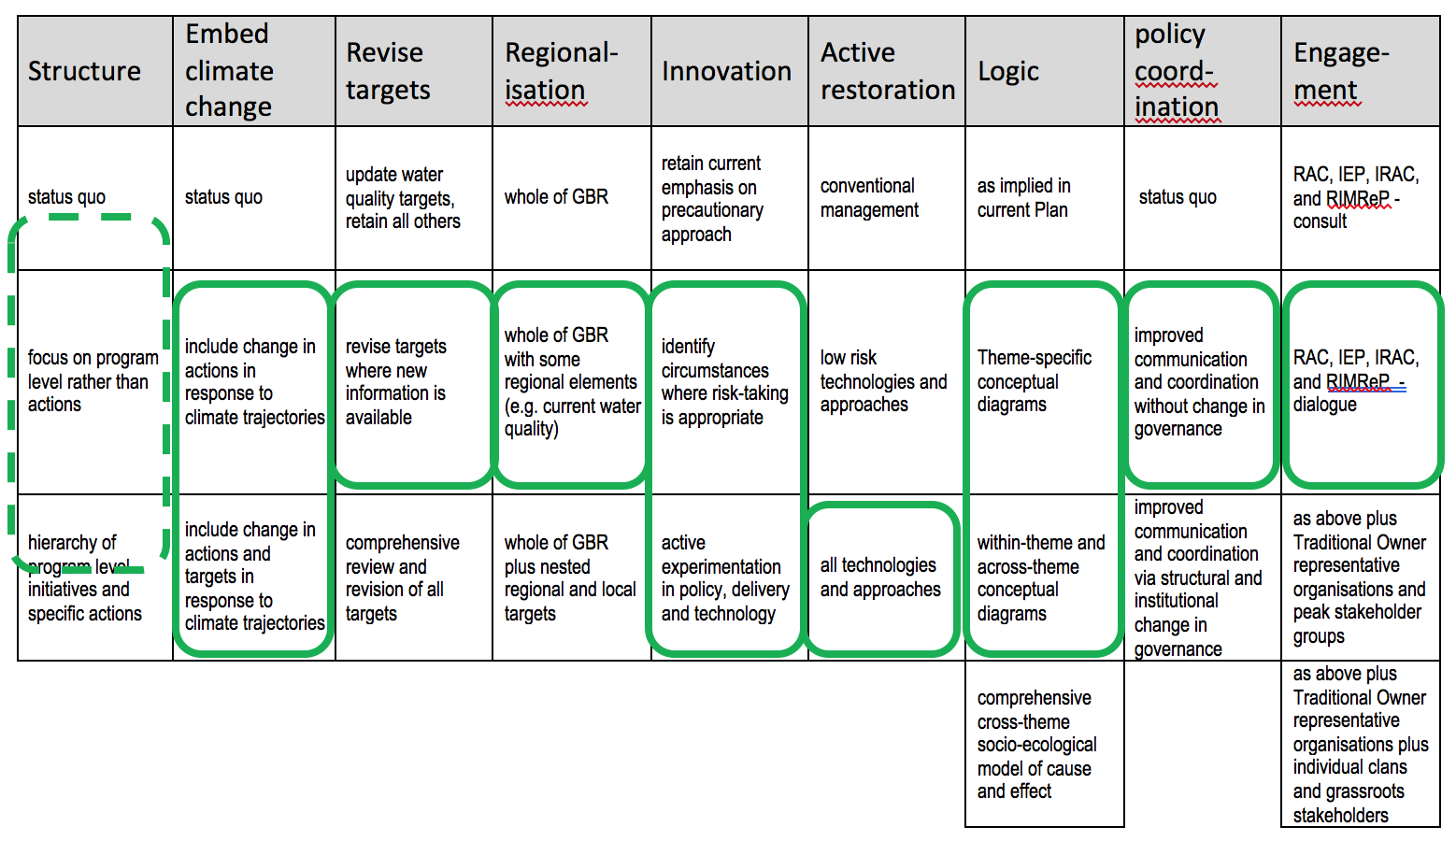

**Figure 7.** RAC preferences summarised against the options table. The green border indicates where responses from RAC members converged during the workshop with RAC.

# Recommendations for the Midterm Review

## Recommendations

Responding to the impacts of climate change is clearly the most significant gap in the Reef 2050 Plan that emerges from the analysis presented in this report. In addition, given the continued urgency to step up actions to improve water quality, it may be necessary to consider additional approaches in the midterm review to accelerate progress in water quality improvements towards targets. At the same time, the analysis also points to an urgent need to strengthen the human dimensions elements of the Reef 2050 Plan to build community acceptance of active restoration actions (potentially including assisted migration, engineering solutions and new interventions using emerging technologies) and meet growing Traditional Owner, and Aboriginal and Torres Strait Islander people more broadly, rights and interests. These imperatives are consistent with advice from the RIMReP, IEP and RAC received by the Joint Team.

However, while new adaptation actions are urgently needed as part of the Reef 2050 Plan, the changing nature of the GBR, highlighted by the recent mass coral bleaching events of 2016 and 2017 also requires a significant rethink. Whether the Reef 2050 Plan’s current overarching goal of ***maintaining and*** ***enhancing the GBR’s*** ***Outstanding Universal Values*** (OUV) throughout the entire World Heritage Area needs to be reframed to one that emphasises ***preserving the*** ***ecological function of GBR ecosystems*** in a changing climate has emerged as a key question. Maintaining and enhancing OUV, as presently articulated in the Reef 2050 Plan, may no longer be realistic.

Biodiversity and ecosystem health have potentially changed in parts of the GBR post the 2016 and 2017 bleaching events, and the frequency of such events is likely to increase. While the concept of shifting the focus to preserving ecological function is generally accepted by informed stakeholders (e.g. as per the recent communiques from the IEP and RAC), it is unrealistic to assume that a midterm review process could easily articulate what this shift means in terms of changes to targets, short term and intermediate outcomes.

**Recommendation 1***That the Joint Implementation Team should lead a pragmatic and timely midterm review process that:*

1. *incorporates ‘no regrets’ climate change adaptation actions into the Reef 2050 Plan;*
2. *consider additional approaches to accelerate progress in water quality improvements towards targets;*
3. *explores options to reflect the importance of human dimensions in Reef 2050 Plan actions (building on the draft Reef 2050 WQIP 2017); but also*
4. *commits to developing more substantial adaptation strategies and actions to be incorporated in the 2020 review.*

Based on the results of this analysis, stakeholder feedback and discussions with the Joint Implementation Team, we recommend that the midterm review is based on Option 2 (of 3 options presented to the Joint Implementation Team). This involves taking a pragmatic approach to accommodate immediate, no regrets actions and embed the human dimension into the Reef 2050 Plan, while continuing existing stakeholder engagement avenues (i.e. scheduledmeetings of RIMReP, IEP, RAC and IRAC; GBR synthesis workshop in November 2017).

A more detailed description of the steps, timelines and consultation elements of Option 2 is provided in section 4.2 of this report. Timing of Option 2 (start in September; preliminary results for briefing GBR Ministerial Forum in December; finalisation of revised Reef 2050 Plan before March) also allows the midterm review to provide additional guidance to the final design of RIMReP.

Notwithstanding this focus on an initial incorporation of climate adaptation and broader resilience actions primarily into the Ecosystem Health and Biodiversity themes of the Reef 2050 Plan, there remains an equal urgency in better understanding implications of climate change for the future of the GBR, in particular in relation to how this affects the current goal of the Reef 2050 Plan (maintaining and enhancing the GBR’s OUV). This could be addressed by initiating a set of foundational actions aimed at providing the necessary base information to facilitate a seamless, timely, and comprehensive revision of the Reef 2050 Plan in 2020. Doing so will also require a better understanding of what it will take for both governments to build a more substantive social licence (across the community) for taking stronger GBR adaptation actions.

There are a suite of known and supported ‘no regrets’ climate adaptation actions that can readily be incorporated into the Reef 2050 Plan and implemented under its existing framework. A range of such actions were identified at the recent Reef Summit held by the GBRMPA in May 2017. These encompass measures that enhance GBR resilience in order to ‘buy time’ in the adaptation window (while global emissions reductions are implemented) and could include (but are not limited to):

* + A set of measures to reduce the impact of the current CoTS wave
  + Stepped up marine management options – better enforcement of compliance
  + Additional water quality improvement measures
  + Adjustment of GBRMPA’s regulatory framework to facilitate recovery actions.

In addition to the no regrets options identified at the Reef Summit, a science consortium (AIMS, CSIRO, the Great Barrier Reef Foundation, several universities and GBRMPA) has begun scoping a more comprehensive approach to reef restoration and adaptation. This 10-year Reef Restoration and Adaptation Program (RRAP) will be built around two fundamental strategies – technologies and processes deployed at ecologically relevant scale to (i) enhance recovery after disturbance, and (ii) to reduce exposure to, and impacts of, disturbance, including accelerating temperature tolerance in corals. Initial applications will likely focus on reefs of high ecological or economic value. A twelve month design phase of RRAP is currently being discussed with the Federal Government and likely to commence in 2017. The 2020 review could capitalise on results of this RRAP design phase. In other words, there is not a strong case to do any major program logic development during the midterm review in relation to adaptation and restoration, in anticipation of the results of the RRAP becoming available for the 2020 review.

As in section 3, greater recognition of the social and economic dimensions of actions within the Reef 2050 Plan can improve effectiveness of the Plan, through understanding drivers of agricultural practice change, learnings from engagements with marine industries, ie tourism and fisheries, and community acceptance of emerging reef restoration technologies. There are a number of ways the midterm review could approach this. In the first instance, the review could draw on the thinking that has emerged from the design of the two Major Integrated Projects (MIPs) and other projects funded by the Queensland Government (e.g. Cane Changer Project; Project RP20 in the Burdekin), as well as capturing initial lessons learnt from NESP-funded projects (e.g. Project 25 - Engaging with farmers and demonstrating water quality outcomes to create confidence in on-farm decision-making).

**Recommendation 2***That the 2020 review process:*

1. *revises the Reef 2050 Plan targets and outcome statements (and potentially the overarching goal);*
2. *develops robust program logics that articulate how strategies and actions will meet the revised targets; and*
3. *commences a set of foundational activities (12-18 months duration) to provide the necessary information base and social licence to enable a substantive restructure and rewrite of the plan in 2020.*

Climate change has already changed the GBR and climate change impacts are expected to increase. The challenge to maintain the values and function of the GBR is complex and will require sophisticated approaches to better understand how actions in the catchments and marine environment will interact with climate change impacts to determine the health of GBR ecosystems. More effective management requires greater attention to the logic of identifying actions, and responding to changes as they occur. Given the expected differences in climate risks along the GBR lagoon (refer section 3), spatial aspects of management will also be important. Efforts could, for example, be focussed on areas of particular value (environmental, economic, social, cultural).

The recently completed draft Reef 2050 Water Quality Improvement Plan (Reef 2050 WQIP) includes revised, regional water quality targets and articulates additional actions supported by a more explicit program logic and greater recognition of the human dimensions (social, economic etc.) of practice change. However, at the time of writing, the associated investment plan was not yet available so has not been assessed here (although the likelihood that current initiatives are insufficient to meet water quality targets is widely acknowledged). The revised Reef 2050 WQIP should be incorporated into the Reef 2050 Plan as part of the midterm review.

The draft Reef 2050 WQIP demonstrates an approach that has adopted regional-specific targets, supported by program logics and recognises the importance of the landholders and other natural resource managers to affect practice change. The 2020 review process should build on this experience by incorporating revised targets (at appropriate scales), robust program logics and embedding important human dimensions (social, economic etc.). For example, community engagement is required to build acceptance (social license) of active restoration efforts proposed for the marine park (potentially including heat tolerant coral and engineering solutions such as cold water pumping).

Stakeholder feedback and our analysis supports the commencement of the substantial foundational work required to enable this to be achieved as part of the 2020 review process. Early progress in this area will also assist the design of the RIMReP.

Based on our gap analysis, our preliminary analysis of GBR trajectories in section 3.2, and recommendations made by IEP and RAC, it is proposed that the foundational activities comprise the following:

1. Developing a more refined understanding of change trajectories of the GBR, in particular how climate change impacts and other cumulative impacts will play our spatially.
2. Integrating a better understanding of ecological thresholds required to preserve ecosystem function into a framework to inform a revised set of ecosystem targets.
3. Building on activities 1 and 2, scoping a program (RRAP) to develop and deploy restoration technologies and adaptation responses at scale across the GBR.
4. Broadening the understanding and integration of human dimensions (particularly those related to community and economic and systemic governance improvements) to improve GBR outcomes and underpin a more effective delivery of Reef 2050 Plan interventions.
5. In conjunction with activities 1 to 4, development of a more consistent set of theme-based program logics, in conjunction with a more meaningful Traditional Owner and stakeholder engagement process, offering the base to more explicitly prioritise actions.

Each of these foundational activities is elaborated further in section 5.2 of the Appendix.

**Recommendation 3**  
*Pursue greater policy influence and coordination of areas that sit outside of the Reef 2050 Plan but threaten to undermine efforts to sustain the values of the GBR. Priority policy areas include emissions reduction, agricultural and land use intensification and major development project assessments. Greater capacity to assess cumulative impacts can underpin Reef 2050 Plan and inform related policy arenas.*

Managing the risks of local development pressures (land use change and intensification) and global greenhouse gas emissions reduction are both needed for the long-term health of the GBR and its social and economic benefits. Recent policy initiatives to address the impacts of proposed additional ports and the management of offsets demonstrate a more integrated approach to GBR policy.

A more sophisticated approach to monitoring and modelling the cumulative impacts of multiple pressures on the multiple values of the GBR would enable better informed decisions about, for example, major projects, agricultural intensification and coastal land use change. Substantial progress has been made in recent years (e.g. the eReefs platform) and this can be further developed to improve the capacity of decision-makers to understand trade-offs involved in complex policy decisions. Such capacity would also underpin a stronger Reef 2050 Plan (as outlined above) and management of multiple stressors in the GBR itself.

**Recommendation 4***The proposed procurement of services to support engagement of Traditional Owners is a promising start to addressing the need to embed meaningful engagement with Traditional Owners to allow their aspirations and commitments in the Reef 2050 Plan to be met. Traditional Owner engagement should build on this work to build a partnership approach to underpin the midterm and 2020 review processes.*

In the context of all of the Reef 2050 Plan’s themes, a clear challenge to emerge from this study is the lack of meaningful engagement with Traditional Owners, who despite now having legal recognition of rights to manage at least one third of the GBR catchments, until now have not had a significant voice. While conceptually, engagement with Traditional Owners might draw on new approaches in the marine (e.g. TUMRAs) and catchment (e.g. Major Integrated Projects), from a rights-based and process perspective, there are significant differences in what constitutes an appropriate engagement process. This is compounded by constraints in the capacity of Traditional Owners institutions to be genuinely engaged. The Commonwealth’s planned procurement of services to support the delivery of Traditional Owner aspirations and commitments in the Reef 2050 Plan is an important opportunity to commence this process. The resultant engagement structures should support Traditional Owner engagement and partnerships in the midterm and subsequent reviews of the Reef 2050 Plan and the progression of agreed actions.

## Preferred Midterm Review Option

Following feedback from the Joint Implementation Team on the three options outlined in Appendix section 5.1 and a subsequent revision, the preferred option proposed under Recommendation 6 is summarised in Figure 8 and described below. Note that some elements of this option require further development and clarification, such as technical support public comment process.



**Figure 8.** Proposed timing and steps of the midterm review

The steps below outline the current recommendation 6 for further consideration by the Joint Team:

1. The Joint Team confirms the scope and timeframes of the midterm review including arrangements for technical support. The Joint Team leads review of existing Reef 2050 Plan actions including:
   1. Culling completed/redundant actions
   2. Simplifying where relevant
   3. Incorporating the revised Reef 2050 WQIP
   4. Identifying new actions to be incorporated e.g. ‘innovation challenge’.
2. A first draft of ‘no regrets’ actions for reef resilience under climate change is identified. This could be led by the Joint Team with technical support, or commissioned as a rapid desktop review. It is recommended that both ecological and social science skills and knowledge inform this process. First draft actions can be drawn from this report (gap analysis & trajectories), Reef Summit report, IEP and RAC advice and other existing documentation.
3. There is strong public interest in GBR policy. One option is to allow a public comment process to run in parallel with the midterm review process, allowing feedback to be collated against targeted questions, rather than feedback on the draft revised plan.
4. The RAC and IEP are scheduled to meet in late October so could review draft proposed climate adaptation and associated human dimensions actions then.
5. The Reef Water Quality Synthesis workshop, which engages a wider group of water quality scientists and stakeholders, is scheduled for late November 2017. The workshop could incorporate ‘mini-workshops’ for review and input to draft revised actions. This step could be led by the Joint Team or technical support.
6. Proposed changes to the Reef 2050 Plan would be consolidated and finalised in December, led by the Joint Team, including strategies and actions, front matter and associated communications materials.
7. The revised plan would be finalised early in 2018, allowing wider policy engagement around emerging priorities.
8. Foundational work to support the 2020 review process should start as soon as practicable.
9. Noting the procurement process underway to support Traditional Owner engagement in Reef 2050 Plan, may provide opportunities for better supporting Traditional Owner engagement.

In summary, under this option, the midterm review will:

* Review and update existing actions (remove redundant ones, potentially simplify or reword some);
* Incorporate new ‘no regrets’ actions for reef resilience under climate change, such as CoTS, foundation for reef restoration etc. These will be new actions incorporated under relevant existing themes, not any new themes.
* Not change targets, objectives, outcome or vision statements.
* Document the rationale for the new actions, but not attempt to develop program logics or theory of change (these should be done as part of the 2020 review process, involving a comprehensive review of actions, targets, and potentially the plan structure and vision).

# Appendices

## Overview of Midterm Review Options

The project brief for this work required the development of options for the midterm review of the Reef 2050 Plan, to seek advice and input to these options from the Reef 2050 Plan Joint Implementation Team, stakeholders and experts. The brief specified a minimum of three options, of which at least one should outline how the midterm review could be undertaken internally by the Joint Team.

Based on the gap analysis and trajectories work, a decision framework with review options for 9 aspects of the Reef 2050 Plan was developed and reviewed by stakeholders. The process and feedback are described in section 3.3. At the end of July 2017, Ministers announced that the midterm review would be brought forward in response to the recent coral bleaching events. The need to develop review options was accelerated as a result.

**Table 3.** Scope of review elements mapped against the options framework provided in Figure 7.

|  |  |  |  |  |
| --- | --- | --- | --- | --- |
| **Review components** | **Option 1** | **Option 2** | **Option 3** | **looking to** |
| **MinFo Dec** | **MinFo Mar** | **MinFo Jun** | **2020** |
| **Plan structure** | rapid review existing actions  + climate adaptation actions | + review structure + new targets (?) | + new targets | revise plan structure incl. vision & objectives |
| **Climate change adaptation** | identify no regrets actions | + prioritisation framework | + design process to implement (?) | substantial prioritisation process (triage) |
| **Targets** | update WQ targets | + COTS + climate adaptation (?) | + Ecosystem health + biodiversity + some human dimensions (!?) | detailed work on next generation targets |
| **Regionalisation of delivery** | regional WQ targets | + some e.g. COTS, climate (?)  conceptualise process | + design process | refocus to regionalised targets and delivery |
| **Innovation** | status quo | + review international policy options, & practitioner learnings from NRM | + potential to incorporate actions arising from reviews & MIPs | substantial review of policy options & embedding innovation/experimentation |
| **"Restoration"** | no regrets actions | + feasability of new technologies |  | embed substantial restoration strategy |
| **Logics** | logics for no regrets climate change & restoration action | + high level logic to inform review of current plan & new actions | scope DSS to support 2020 review | decision support system to evaluate tradeoffs, revise objectives, support adaptation |
| **Policy coordination** | commit to greater coordination in priority areas e.g. emmissions & N. Aust. | + some policy coordination, link GBRMPA review | + 2nd governance benchmark process to support policy coordination | embed ongoing governance review process |
| **TO engagement** | link to TO engagement structure tender | + incorporate actions arising from tender (?) | + TO engagement (?) | respond to TO engagement process |
| **Stakeholder engagement** | engage existing R2050 groups (RAC, IEP, RIMREP) | + science + practitioner engagement in review process |  | comprehensive stakeholder engagement for restoration agenda |
| steps to the right are in addition to steps on left ie Option 3 = option 1 + option 2 + option 3 | | | |  |

Three options were presented to the Joint Team on the 10th August. The differences between the three options are summarised in Table 3, with further detail and timelines following. All options assumed recommendations would include substantive work that needs to be done for 2020 review e.g. climate trajectories, decision support via RIMReP2, prioritisation in marine, regionalisation of delivery strategies. Note, however, that while option 2 forms the basis of the approach recommended in this report, details have been revised following further development and feedback from the Joint Team.

#### Option 1: ‘just add climate change’

#### 

* Revised plan prepared for the Ministerial Forum in December 2017 (drafted by the end of October)
* ‘no regrets’ climate adaptation & restoration actions incorporated
* Revised Reef 2050 WQIP incorporated
* Potentially build the logic of ‘no regrets’ climate change actions
* Limited engagement (existing Reef 2050 Plan groups)
* Estimated technical support c. $100K
* Commencement of procurement to support Traditional Owner engagement.

#### Option 2 – ‘lay the foundations’

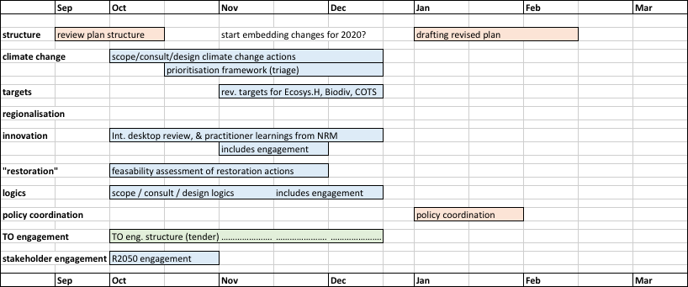

* Revised plan prepared for the Ministerial Forum in March 2018 (technical component complete by the end of December)
* Better climate response
* Add logics, some new targets, policy review and learnings, policy coordination
* First steps in feasibility of ‘restoration’ actions, prioritisation frameworks
* Limited engagement (existing Reef 2050 Plan groups)
* Estimated technical support c. $250-300K

#### Option 3 – ‘lay stronger foundations’

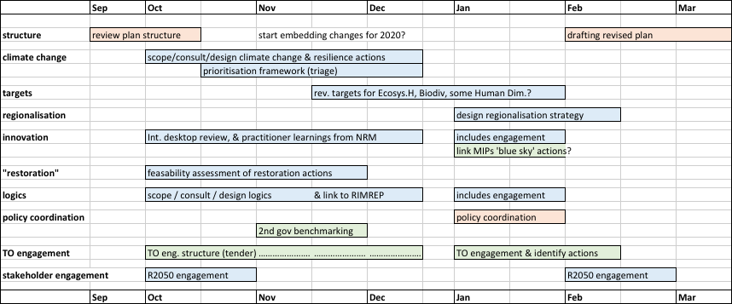

* Revised plan prepared for the Ministerial Forum in June 2018 (technical complete by the end of March)
* Better climate response, logics, new targets, policy coordination
* Further with feasibility of restoration actions, prioritisation frameworks e.g. links RIMReP, policy review and learnings link to MIPs, governance benchmarking
* Better engagement (incl. follow on from TO tender)
* Est. technical support c. $450-500K

## Concepts for Foundational Activities in Preparation for 2020 Review

The results of the gap analysis, the GBR change trajectories and the stakeholder feedback summarised in section 3 clearly indicate that the Reef 2050 Plan will require a substantial review. As outlined in section 4, this is beyond the scope of the midterm review. To provide a solid platform for a detailed review in 2020 we propose five foundational activities, outlined in this section.

In general terms, the necessary scientific capability and skills largely resides within the consortium partners, but it is recognised that there are instances where there will be a need to access a wider range of capability in other research organisations. This is especially the case for Foundational Activity 3.

It is also important to note that while the five foundational activities outlined in the following are portrayed as discrete actions, in reality **there are very strong cross-linkages between all of them**, and hence they need to be seen as a package. It is also important to recognise that these are more broadly recognised foundational activities (eg in recent GBR Summit), with value beyond the 2020 review and as such they will need coordinated approaches to get them implemented.

#### Foundational Activity 1: Future GBR change trajectories

***Issue and problem statement***

In this study, we only were able to conduct a very limited analysis of climate change projections affecting ocean temperatures. However, climate change is also affecting the hydrologic response of catchments as well as marine environments. Changes in rainfall and temperature will increasingly affect river discharge and pollutant loads. While the question how the land-ocean interactions might play out is understood at a conceptual level, the spatial and temporal patterns of these changes across the GBR are largely unknown. These patterns have critical implications for the effective and efficient management of scarce resources.

The Australian and Queensland Governments are currently investing substantial resources into improving the GBR’s resilience. However, the spatial targeting, the level of investment and choice of actions and strategies is largely based on historic and current trends, and does not take into account future change trajectories. Depending on the degree to which international mitigation efforts under the Paris Agreement are successful, the implications for GBR ecosystem health and coral survival will vary significantly in time and space. Key questions arising from the above that will impinge on the mix of GBR policy interventions are:

* Will the current spatial prioritisation of land-based actions to improve water quality be aimed at the most relevant catchments into the future? Will the mix of interventions and their level of resourcing still be appropriate?
* How will different scenarios of land use change either materially deteriorate or help accelerate improved resilience? What are the related policy implications?
* Where and which reefs would be the initial targets of ‘no regrets’ protection and rehabilitation interventions to be included in the Reef 2050 Plan?

***Proposed approach and timelines***

Nested modelling frameworks (e.g. Catchment Source and eReefs) or whole-of-systems models (e.g. Atlantis; Climate Change Models) constitute the primary tools to explore the likely array of change trajectories and to subject these scenarios to a range of policy responses. Definition and choice of scenarios would need to be stakeholder driven. It is likely that a staged process would need to be undertaken:

* 6-12 months: using existing modelling platforms coupled to qualitative or conceptual frameworks to produce an initial iteration of scenarios analyses, to feed into the 2020 review of Reef 2050 Plan;
* 2-3 years: developing and applying a fully connected land-ocean, socio-ecological systems model of the GBR to explicitly link social, institutional and economic drivers to biophysical (climate) and ecological responses, to feed into the development of an overarching GBR Decision Support System (as an evolution of RIMReP.

***Outcomes for the 2020 review***

* Explicit incorporation of climate change into the Reef 2050 Plan, at relevant spatial and temporal scales, leading to greater confidence in appropriateness of targeting and funding of resilience related actions in the Reef 2050 Plan (also a critical input into Foundational Activity 3);
* Evidence–based, positive engagement with stakeholders informed by a robust information base, retaining a strong case for continued investment into and GBR resilience;
* No regrets actions to reduce the impact of the past and possible future bleaching events on the economic viability of the GRB tourism industry explicitly included and appropriately targeted in the Reef 2050 Plan.

#### Foundational Activity 2: Framework for managing altered ecosystems

***Issue and problem statement***

Given future climate projections, the ambition of maintaining OUV as stated in the Reef 2050 Plan is likely no longer realistic. The OUV aspiration therefore needs to be replaced by pragmatic goals of preserving key ecosystem functions that can underpin essential GBR values. Such a reformulation of goals is beyond the scope of the midterm review and will need to form the main focus of the 2020 review. The opportunity will be to identify achievable, albeit less ambitious, outcomes for Reef and people. The challenge will be to identify what key ecosystem functions, key processes and species need to be supported to maximise the Reef’s resilience, values and services in the face of risk and uncertainty.

In light of the possibility that the world will not adhere strictly to the most optimistic warming path, further analysis in preparation for the 2020 review should explore whether possible compromises should be made in the characterisations of ecosystem health, diversity and OUV while still achieving against some objectives and producing the best possible outcomes within management control. This could mean new aspirations to altered ecosystems that still perform key functions and support key ecosystem services such as tourism and fisheries, but where some climate sensitive species, and potentially some locations, cannot be accommodated. Three questions at the core of this challenge are:

1. How will OUV and identified values will change under climate change despite local and regional management actions?
2. What species will be resilient to climate change and can be further sustained by management strategies and policies?
3. What management strategies and policies should be put in place for altered GBR ecosystem to best deliver values (including habitats that support biodiversity) and produce ecosystem services? This will require insight into the environmental boundaries (thresholds) within which these ecosystem can be kept resilient.

***Proposed approach and timelines***

Understanding what species will be at risk and what species can be supported under different change scenarios will require model analyses that integrate environmental drivers and pressures with ecosystem impacts and responses (see DPSIR framework under change scenarios). Such analyses can be achieved by combining, and further developing, models available in Australian science organisations (e.g. Atlantis, ReefMod, eReefs, CoCoNet). The objectives of these analyses should be to (1) assess the risks of losing key species (e.g. foundational or habitat-forming) under different change scenarios, and (2) understand environmental and ecological thresholds for shifts to undesirable ecosystem states.

* 6-12 months: synthesise predicted risks to key species and ecosystems over time for different change scenarios. Use as a basis for assessing changes in OUV formulation and develop new goals statement for 2018 review;
* 2-3 years: integrate models to produce a fuller understanding of how GBR ecosystems are likely to change under different trajectories. Couple quantitative environmental and ecological models within the DPSIR framework to interrogate how different ecosystems can best be supported by management strategies/policies to sustain key values and provide ecosystem services by 2050.

***Outcomes for the 2020 review***

* Realistic understanding of what the Reef 2050 Plan can deliver for GBR ecosystems under different change scenarios. If altered GBR ecosystems need to be embraced, the review can be proactive in setting management objectives. Key input into Foundational Activity 3;
* Pragmatic incorporation of resilience information (species thresholds, risk of ecosystem shifts) in Reef 2050 Plan to guide where management and policy best can support diverse and productive ecosystems under climate change;
* Critical input to progressing RIMReP towards a more comprehensive Decision Support System (medium term);
* Informed investments in new interventions (in combination with conventional ones) to support critical species – critical input into Foundational Action 3.

#### Foundational Activity 3: Reef Restoration and Adaptation Program

***Issue and problem being addressed***

Climate change is now a key driver of ecological change on the GBR. Recent severe coral bleaching episodes in areas relatively unaffected by human activities indicate that conventional management and policy approaches alone may no longer be sufficient to sustain reef resilience and safeguard biodiversity. This calls for the consideration of new interventions under Reef 2050 Plan that complement conventional approaches. The development of such new interventions is time-critical and will require multi-institutional partnerships and wide stakeholder consultation.

Continued ocean warming will challenge the thermal tolerance of sensitive species, including reef- and habitat-building ones. The loss of functional species to climate change will flow on to cause impacts on biodiversity, ecological resilience and ultimately Reef ecosystem services. To sustain critical species and the ecosystem functions they underpin may require interventions that go beyond the conventional management toolset.

A consortium comprising AIMS, CSIRO, JCU, UQ , QUT, GBRMPA and GBRF has started initial work on defining the scope of what is likely to entail a very ambitious 10-year research program requiring an investment in the order of $500 M over ten years.

Several key questions have arisen that require better definition in order to design such a program:

* Can key species be climate-hardened to the extent that they can continue to serve critical services under projected climate change scenarios?
* If so what species should be targeted and where?
* Are there engineering solutions that can locally alter (cool, shade,…) the environment of high value reefs?
* Which of these interventions should be on the table and what criteria and strategies should be used for their development and subsequent deployment?
* What are the engagement and risk assessment steps required to elicit social acceptance (links to Foundational Activity 4)?
* How can any of these interventions be deployed at scale and cost effectively?

***Proposed approach and timelines***

Here we only propose a 12-month definition phase of this ambitious program. Development of a more detailed design of the program is a prerequisite to developing a strong business case that would provide the rationale for investment by governments, research organisations and philanthropic donors.

The above consortium will engage in a series of structured technical workshops and activities to inform the design of three main program components:

* Program Design and Validation – Identifies the likely product scaling and delivery concepts and then enables improved scoping of the underpinning R&D program requirements.
* Stakeholder and Partner Engagement - This includes commencing the process to build the social licence for what is being proposed.
* Governance and Coordination Development - The program aims to deliver a “toolkit” of methods, with many potential candidate concepts and pathways to delivery, all with different degrees of uncertainty and risk. This necessitates a need to make continuous trade-off decisions such as the breadth (number of concepts progressed in parallel) versus depth (effort applied to each idea) of investment. This process will be aided by a transparent/fit-for- purpose decision support tool/method.

***Outcomes for the 2020 review***

* The opportunity to consider management and policy options that can break through the resilience ceiling imposed by climate change;
* Expanded strategy options for securing key species and the ecosystem functions and services they provide;
* Proactive engagement and consultation with GBR stakeholders and the public around the adoption of new and potentially necessary interventions to protect the Reef;
* A business case to support investment into RRAP by government, research organisations and philanthropic donors.

#### Foundational Activity 4: Broadening the understanding and integration of human dimensions to improve GBR outcomes

***Issue and problem statement***

The Reef 2050 Plan identifies four major threats to the GBR: climate change, land-based runoff, coastal land use change, and direct use. Underpinning all these pressures are humans – their behaviours and the knowledge, values, relationships, and other social (including economic and cultural) dimensions that impact the natural resources and ecosystems of the GBR catchments and the Reef. The degradation of the GBR is thus largely a social problem. As such, improving outcomes for GBR, particularly associated with water quality and ecosystem health, relies on a better understanding of the ‘human dimension’ and the multiple ways in which people affect the Reef.

To date, efforts to enhance understanding and integration of the ‘human dimension’ into GBR-related policies, plans and management actions have focused on: eliciting the general beliefs and values of individuals and communities as they relate to the GBR, the acknowledgement of the unique relationship that Traditional Owners’ have with the GBR, and governance (i.e. decision-making structures and processes supporting Reef 2050 Plan). The initial focus in these areas has provided valuable insights, and it is important that this work continues, particularly in regards to their integration. However, enhancing the resilience of the GBR requires going beyond policy and management interventions focused on changing (or integrating, such as in the case of Traditional Owners) values and practices on the land and in the GBR. Embedding a human dimensions perspective into supporting practice change (particularly in agriculture), such as in the draft Reef 2050 WQIP, is needed.

The GBR is being impacted by people in a range of ways, from direct actions taken on the land/in the catchments (e.g. land use/management) and the marine environment (e.g. fishing) to indirect influences (e.g. policies, insurance premiums, market signals and incentives). While there is understanding of some of the key actors (for example, sugarcane farmers, mining industries) and how their behaviours are affecting the Reef (e.g. contributing to increased sedimentation), the interlinked ways in which actors living in the GBR and beyond (such as UNESCO and international tourists) are affecting the Reef are not well understood. It is therefore difficult to know which policy levers may provide the most benefit in delivering improvements to key GBR values.

Key questions in the context of the 2020 review of Reef 2050 Plan are thus:

1. How can we build the resilience of reef-dependent and reef-related enterprises and communities to expected/unexpected environmental change while improving environmental protection (e.g. though new practices, business models, risk management, adaptive capacity or technologies)?
2. How do we better engage and partner with place based communities and sectors to improve reef stewardship and enhance economic and social benefits?
3. What new policy instruments, models of collaboration and management are required to improve the effectiveness and adaptability of reef governance in a changing environmental and socio-economic context?

***Proposed approach and timelines***

Bringing together experts and policymakers to identify shared, scientifically-informed and politically relevant actions that will lead to social change. This will be underpinned by the development of a strong program logic in foundational activity 5 that will allow their incorporation of ‘owned’ stakeholder actions and commitments to change into the Reef 2050 Plan.

* 1-6 months: retrospective review and evaluation of what has worked and why in NRM program delivery (eg Reef Programme; Reef Trust), and what the factors of successful practice and institutional change are, to feed into the 2020 review of Reef 2050 Plan. This review and evaluation would need to include an assessment of additionality (that is, whether environmental improvements were additional to what would have occurred otherwise), value for money/efficiency and effectiveness in terms of delivering both social/behavioural change on top of the delivery of required environmental outcomes
* 7-18 months: building on review and evaluation, co-design with the Qld and Federal government, stakeholder groups and traditional owners, a set of proposed pragmatic strategies/actions. These strategies/actions would also help revise the current foundational actions, activities, strategies in the current Reef 2050 Plan, and provide new ones that are current gaps.

***Outcomes for the 2020 review***

* Key input into Foundational Activity 5 by providing the base for a well-designed stakeholder engagement process to elicit a stronger program logic;
* Better link between actions in the Reef 2050 Plan and desired outcomes, making Reef 2050 Plan more credible and achieving greater stakeholder buy-in and co-investment;
* A set of more robust policy and investment program design principles leading to greater cost effectiveness of Government programs in achieving practice change outcomes, in particular for water quality;
* Reduced risk of governance constraints impeding meaningful stakeholder engagement, catalysing greater industry and community resource mobilisation; and
* Social licence to progress with reef restoration measures.

#### Foundational Activity 5: Program logics and regionalisation

***Issue and problem statement***

The Reef 2050 Plan places a strong emphasis on adaptive management. That emphasis is especially salient in the context of uncertainty around the pace and magnitude of future climate change. However, the prospects for adaptive change are limited in the absence of a clear logic linking actions to targets, outcomes and goals.

The links between actions and outcomes in the Reef 2050 Plan are vaguely described. Making these links explicit helps managers and stakeholders understand:

* The extent to which targets, outcomes and goals are realistic or aspirational,
* The need for (or redundancy of) additional action,
* Priorities in implementation and investment, and
* Priorities for monitoring.

In short, a coherent and explicit account of the logic linking actions and outcomes underpins effective adaptive management.

Under this foundational activity, several threads of the proposed foundational activities 1 to 4 come together in development of a clear logic linking actions to targets, outcomes and goals. The figure below is a scenario tree that includes a subset of important factors that shape outcomes for ecosystem health and biodiversity. Uncertain nodes, where we have limited control, are shown as circles. Squares show decision nodes, where we can control which branch of the tree we follow. Branches terminate in scenario specific outcomes, shown as triangles, which vary according to the preceding path.

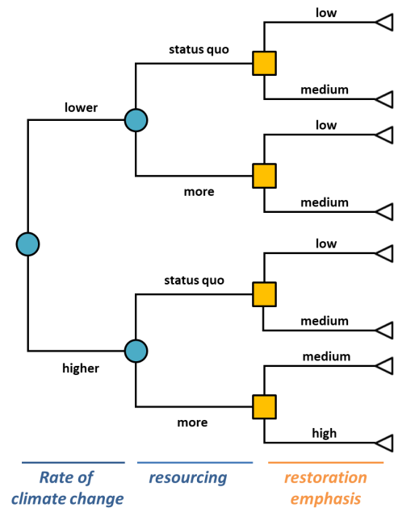In the first instance, estimated outcomes can be based on a coarse understanding of links among biophysical and human behavioural predictors. A key source of uncertainty is climate trajectory***.*** If the rate of climate change is at the lower end of the range of plausible trajectories, and the level of resourcing committed by the public and private sectors in the future is greater than the status quo, then relatively ambitious targets may be appropriate.

Setting targets involves thinking through the relative likelihood of each uncertain branch being realised, the pay-off of alternative actions (including the emphasis placed on restoration) and the merits of targets built around worst case or best case scenarios. Where outcomes are considered unrealistic, the logic of a scenario tree can be used in a first cut assessment of where and how we might invest efforts to steer events towards more desirable outcomes.

The approach can be extended to a setting where we consider regional targets using (a) spatial predictions of threats under alternative climate trajectories (using outputs from Foundational Activity 1), and (b) an understanding of how human communities and their values, aspirations, practices and behaviours vary throughout the GBR (Foundational Activity 4).

***Proposed approach and timelines***

* 1-6 months: Build preliminary first cut logic linking biodiversity and ecosystem health actions to key targets based on a simple scenario tree. Include regional variants for selected values, where appropriate.
* 7-12 months: Stakeholder engagement using scenario analysis, documenting preferred outcomes and their sensitivity to factors within management control and those beyond management control. Again, include regional analyses for selected values.
* 13-18 months: Detailed logic linking actions and consensus targets for a subset of key values.
* 18-24 months: Application of detailed logic to inform priorities for action, investment and monitoring.

***Outcomes for the 2020 review***

* A sound basis for revisiting targets, objectives and outcomes under climate change uncertainty.
* Regional targets for key values that account for how human and ecological values vary in their exposure to climate-related threats.
* An explicit framework to guide stakeholder engagement in the exploration of and commitment to desired GBR end-status (futures).

|  |  |  |
| --- | --- | --- |
|  | | |
| CONTACT US  t 1300 363 400  +61 3 9545 2176  e csiroenquiries@csiro.au  w www.csiro.au  At CSIRO, we do the  extraordinary every day  We innovate for tomorrow and help improve today – for our customers, all Australians and the world.  Our innovations contribute billions of dollars to the Australian economy  every year. As the largest patent holder  in the nation, our vast wealth of intellectual property has led to more  than 150 spin-off companies.  With more than 5,000 experts and a burning desire to get things done, we are Australia’s catalyst for innovation.  CSIRO. WE IMAGINE. WE COLLABORATE.  WE INNOVATE. |  | For further information    **CSIRO Key contact**  Dr Christian Roth  **t** +61 7 3833 5732  **e** Christian.Roth@csiro.au    **JCU Key contact**  Prof Allan Dale  **t** +61 418 736 422  **e** Allan.Dale@jcu.edu.au  **AIMS Key contact**  Dr Richard Brinkman  **t** +61 7 4753 4374 **e** R.Brinkman@aims.gov.au |
| ` |  |  |