

EPBC Act referral guideline for the endangered northern quoll Dasyurus hallucatus

EPBC Act Policy Statement

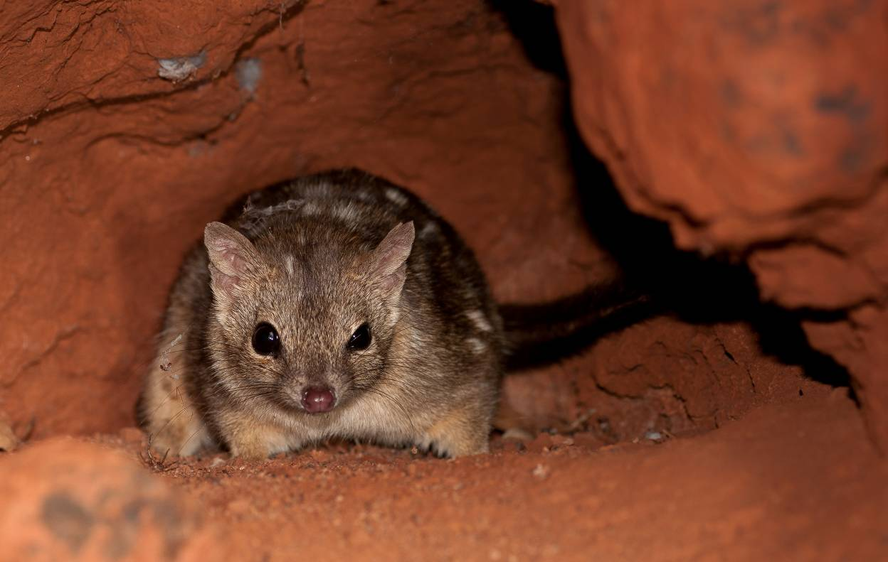

January 2016

© Copyright Commonwealth of Australia, 2016.


The ‘EPBC Act referral guideline for the endangered northern quoll’ is licensed by the Commonwealth of Australia for use under a Creative Commons Attribution 4.0 Australia licence, with the exception of the Coat of Arms of the Commonwealth of Australia, the logo of the agency responsible for publishing the report, content supplied by third parties, and any images depicting people. For licence conditions see: http://creativecommons.org/licenses/by/4.0

This report should be attributed as ‘EPBC Act referral guideline for the endangered northern quoll, Commonwealth of Australia, 2016’.

The Commonwealth of Australia has made all reasonable efforts to identify content supplied by third parties using the following format ‘© Copyright, [name of third party]’.

Disclaimer

While reasonable efforts hav e been made to ensure that the contents of this publication are factually correct, the Commonwealth does not accept responsibility for the accuracy or completeness of the contents, and shall not be liable for any loss or damage that may be occasioned directly or indirectly through the use of, or reliance on, the contents of this publication.

Front page image: © Copyright, Henry Cook.

Guideline summary
The northern quoll Dasyurus hallucatus is an iconic and widely distributed Australian endemic mammal which has a history of extirpation and population decline. The northern quoll has undergone a rapid decline from cumulative effects of inappropriate fire regimes, predation, habitat loss and in particular, invasion of its habitat by cane toads (Rhinella marina). To bolster the northern quoll’s chance of survival and its recovery, all populations require protection from the following threatening processes: inappropriate fire regimes (and subsequent predation by introduced animals after fire), invasive species and the removal, degradation and fragmentation of habitat resulting from development actions (primarily mining) and pastoralism. This referral guideline assists proponents by outlining likely habitats critical to the survival of the northern quoll and populations important for its long term survival. In addition it outlines survey and mitigation expectations and clarifies what is likely to constitute a significant impact on the northern quoll. This guideline should be read in its entirety in order to make a robust assessment of likely significant impacts on the northern quoll, however the following points and the diagram in Figure 1 summarise the guideline:

- Undertaking surveys for the northern quoll is essential for informing decision making. The nature and context of your action will dictate the level of survey effort expected.
- Remote activated cameras and scat searches are the recommended detection technique and greater effort will be required for projects that will impact on habitat critical to the survival of the northern quoll.
- The loss of habitat critical to the survival of a northern quoll population is likely to result in a significant impact and referral to the Australian Government Environment Minister is recommended.
- Targeted surveys are required when habitat critical to the survival of the northern quoll is proposed to be cleared or indirectly impacted.
- Populations important for the long term survival of the northern quoll are more important for the species’ recovery. To minimise the risk of a significant impact on the species, actions need to avoid these important populations or be linked to substantial and ongoing mitigation measures.
- Actions unlikely to result in a significant impact on the northern quoll include those that:
  - Are informed by surveys consistent with this guideline
  - Avoid clearing habitat critical to the survival of the northern quoll
  - Maintain dispersal opportunities to populations important for the long-term survival of the northern quoll
  - Are planned and designed to avoid and or minimise both direct and indirect mortality to the northern quoll population and
  - Have in place proven, monitored and adaptive management measures to control impacts from fire, pastoralism, and invasive species, particularly cane toads, feral cats and weeds.

Figure 1: Summary of the EPBC Act referral guideline for the northern quoll.

NO

YES or UNSURE
NO

NO

NO

YES or UNSURE
YES
Have you undertaken a reconnaissance survey for northern quoll using the recommended methods (see Section 5)?
Could your action have a significant impact on a northern quoll population (see Section 6)?
Review the impact mitigation options and apply to your project as appropriate (Section 7). Prioritise impact avoidance over impact minimisation.
Could the impacts of your action affect habitat for the northern quoll (see Section 4)?
Could the impacts of your action occur within the modelled distribution of the northern quoll (see section 3)?
REFERRAL NOT RECOMMENDED
Low risk of resulting in significant impact
After applying mitigation for the relevant impacts, is your action still likely to have a significant impact on a northern quoll population? (See section 8)
REFERRAL NOT RECOMMENDED
Low risk of resulting in significant impact
Undertake targeted surveys for the northern quoll to inform your mitigation measures and reduce the significance of your impact (section 5)
Familiarise yourself with the EPBC Act approvals process, Significant Impact Guidelines 1.1 and the ecology of the northern quoll (see Preamble and Section 1 and 2).
REFERRAL GENERALLY NOT RECOMMENDED
Important however to consider indirect impacts that may result from large scale actions outside the species modelled distribution (see section 6)
REFERRAL RECOMMENDED
High risk of resulting in significant impact

REFERRAL NOT RECOMMENDED
Low risk of resulting in significant impact
REFERRAL MAY BE REQUIRED

You may decide to refer for legal certainty or contact the department
REFERRAL RECOMMENDED
High risk of resulting in significant impact

YES
UNCERTAIN
NO
YES or UNSURE

Introduction
This guideline is general in nature and does not remove your obligation to consider whether you need to make a referral to the Australian Government Environment Minister (hereafter the Minister) under the EPBC Act. Although this guideline provides information to help you decide whether to refer your action, the possible impacts of your proposed action will depend on the particular circumstances of that action. These circumstances may include the proximity of the action to habitat, direct and indirect impacts, and impact avoidance and mitigation measures.
Although this guideline has been developed using the most up-to-date scientific information available at the time of writing, a referral will be assessed by the Department of the Environment (hereafter the Department) on the basis of the most up-to-date scientific information available at the time of referral, which may build upon the information reflected in this guideline.
Relationship to Local and State Government Frameworks
This guideline does not provide guidance on requirements under state and local government laws. Information on Queensland (Qld), Northern Territory (NT) or Western Australia (WA) and local government laws can be obtained from the Qld Department of Environment and Heritage Protection, NT Department of Land Resource Management, WA Department of Parks and Wildlife and local councils in or near the proposed project area.
Wherever possible, this guideline has been prepared in a manner that allows for alignment of definitions and assessment processes with those required under the relevant State/Territory and local Government frameworks. This should allow the information gathered for local and State/Territory assessment purposes to be appropriate for decision-making under the EPBC Act, with little or no modification. Despite best efforts, the Department recognises that some inconsistency may occur due to differences in jurisdictions’ decision-making processes.
The objectives of this guideline
The objectives of this guideline are to:
- Promote avoidance and or mitigation of impacts on the northern quoll;
- Promote a clear, consistent and transparent approach for making decisions on whether an action is likely to result in a significant impact on the northern quoll;
- Promote streamlined decision-making and approval processes; and
- Promote the recovery of the northern quoll.
How to use this guideline
This guideline is designed to be read from the perspective of a person proposing to take an action that may have a significant impact on the northern quoll. Many parts of this guideline contain information that requires a developed understanding of the EPBC Act assessment process, the ecology of the northern quoll, as well as broader ecological concepts. Some proponents may need to seek assistance from suitably qualified or experienced people when applying them to a particular action. There is an expectation that the self-assessment process would be carried out by (or be informed by) people with a reasonable level of knowledge and experience in these matters.
Prior to reading this guideline, you must be familiar with the Significant Impact Guidelines 1.1 – Matters of National Environmental Significance, which explain the concept of a ‘significant impact’.
This guideline applies in areas where the northern quoll, or northern quoll habitat, occurs in Qld, NT and WA. If you propose to take an action that will have or is likely to have a significant impact on the northern quoll, you must refer the proposed action to the Minister prior to commencing the action. The Minister will then decide within 20 business days whether assessment is required under the EPBC Act. When making a decision on whether a proposed action requires assessment, the Minister must consider all relevant information and act in a manner consistent with natural justice and procedural fairness obligations.
An action that will have or is likely to have a significant impact on the northern quoll must not commence until it has been approved by the Minister. Substantial penalties apply for undertaking such an action without Commonwealth approval (civil penalties up to $8.5 million or criminal penalties including up to seven years imprisonment). More information on the referral, assessment and approval process is available at www.environment.gov.au/epbc/assessments/index.html. Information on compliance and enforcement of the EPBC Act can be found at www.environment.gov.au/epbc/compliance/index.html.
If you are uncertain about the need to refer, you may refer your proposed action for legal certainty, or contact the Department to discuss your proposed action by emailing epbc.referrals@environment.gov.au.
Possible exceptions to the need to refer
Certain actions are exempt from the requirement for assessment and approval under the EPBC Act. These include lawful continuations of land use that started before 16 July 2000 or actions that were legally authorised before 16 July 2000 (Sections 43A and 43B of the EPBC Act).There are several criteria that must be satisfied to rely on any such exemptions. More information on exemptions under the EPBC Act is available at www.environment.gov.au/epbc/publications/exemptions.html.

1. What is the northern quoll?
The northern quoll is a nocturnal, carnivorous marsupial and the smallest of Australia’s four quoll species. Northern quolls are sedentary with a moderately large home range of about 35 hectares, reproducing once per year. Northern quolls have an average of seven young per breeding season but have a short lifespan, with most females only surviving one or two breeding seasons. The intense physical effort applied by male northern quolls in roving during the breeding season appears to cause their physiological decline and a near-complete annual male die-off. This life history makes them highly susceptible to local extinction.

Further background information on the biology and ecology of the northern quoll across its range is provided in the Department’s Species Profile and Threats database profile and in the national recovery plan (Hill and Ward 2010).

2. What does the northern quoll need to survive and recover?
The northern quoll has been in gradual decline in population density and distribution for the last 50 years. Studies have showed declines in northern quoll populations before cane toads (Rhinella marina) arrived in Far North Queensland and Kakadu National Park and more recent studies show declines in the northern quoll in the northern Kimberley where cane toads have not yet reached. Immediately following colonisation of an area by cane toads the northern quoll population rapidly declines due to poisoning from consuming cane toads. The decline has been sequential from Queensland west towards the Kimberley. Over the last 10 years this decline has resulted in the virtual extirpation of the species from former main strongholds in the Northern Territory. In the next 10 years it is projected that a similar near-extirpation will occur in the largest remaining major stronghold, the north Kimberley (Woinarski et al 2014).

The national recovery objective for the northern quoll is to minimise the rate of decline of the northern quoll in Australia, and ensure that viable populations remain in each of the major regions of distribution into the future (Hill and Ward 2010). The recovery actions proposed in the recovery plan emphasise protecting key populations from colonization by cane toads and cats (especially through quarantine of offshore islands); fostering recovery of populations that have collapsed following cane toad arrival; managing secure populations (including captive and translocated); identifying and managing the threats to the northern quoll in the absence of cane toads; raising public awareness and native support of northern quoll in the absence of cane toads; raising public awareness and active support of northern quolls; and enhancement of cane toad management, including quarantine (Hill and Ward 2010).

A variety of stakeholders including the Australian government, state governments, universities and not-for-profit organisations across the species’ range are undertaking research or conservation actions under the national recovery plan for the northern quoll (Hill and Ward 2010). Since inception of the plan, research has been undertaken to improve knowledge of the species’ ecology, population demographics and genetics and the impacts of fire. Work has also been done to secure the species survival by translocation to offshore islands in the NT and WA. Governments continue to implement biosecurity enforcement at coastal ports to prevent cane toad spread and support research into training northern quolls to avoid cane toads. Long-term population monitoring has also commenced in Western Australia’s Pilbara region (Woinarski et al 2014).

These actions need to be complemented by best-practice planning for development proposals to bolster the species’ chance of survival and recovery.

3. Could the impacts of your action occur within the modelled distribution of northern quoll?
The northern quoll occurs in four regional populations across Qld, the NT and WA. In Qld, the species habitat occurs from the south-east to the Gulf of Carpentaria. In the NT, it occurs in the Top End and in WA, it occurs in the Pilbara, Little Sandy Desert and Kimberley regions. The northern quoll occurs both on the mainland and some offshore islands (refer to maps 1-5). In WA, island populations include Adolphus, Augustus, Bigge, Boongaree, Capstan, Storr, Dolphin, Hidden, Koolan, Purrungku, Uwins and Wollaston Islands (see Map 5). In the NT, northern quoll populations occur on Astell, Channel, Groote Eylandt, Inglis, Low, Marchinbar, Northeast, Pobassoo and Vanderlin islands as well as on two unnamed islands near Groote Eylandt (see Map 5).

The distribution maps presented in this document were based on the best available information at the time of publication. For the most up-to-date report of whether northern quoll may occur in your project area, use the Protected Matters Search Tool.
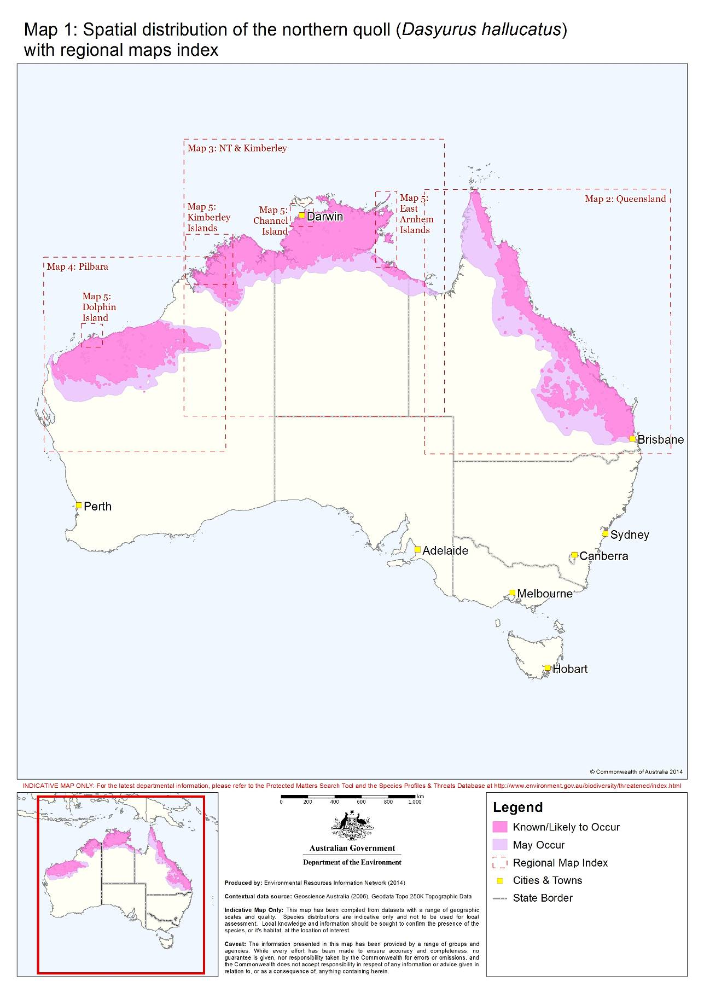
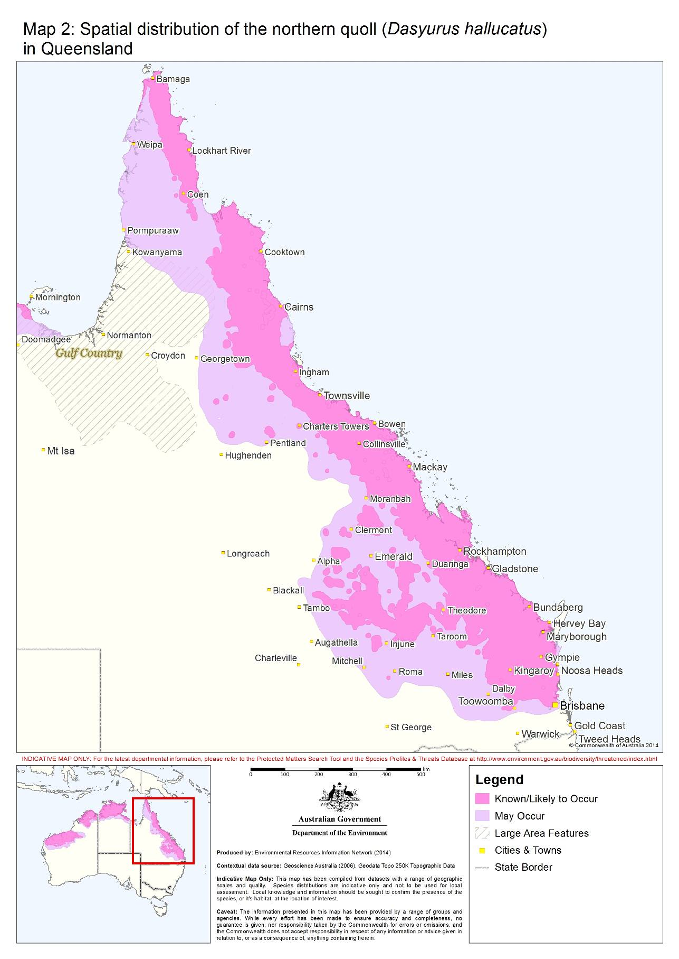

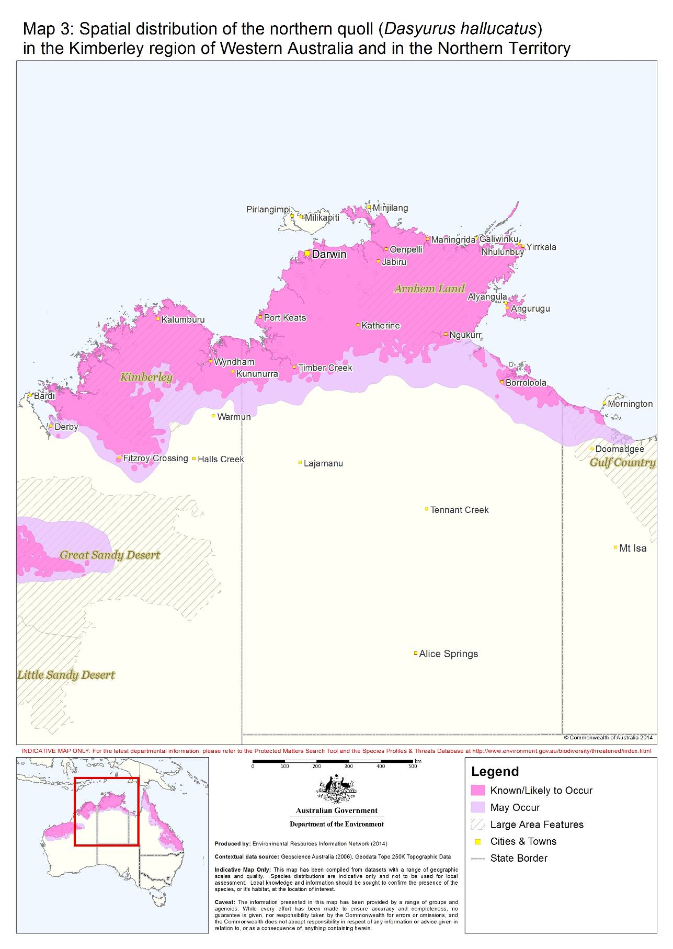

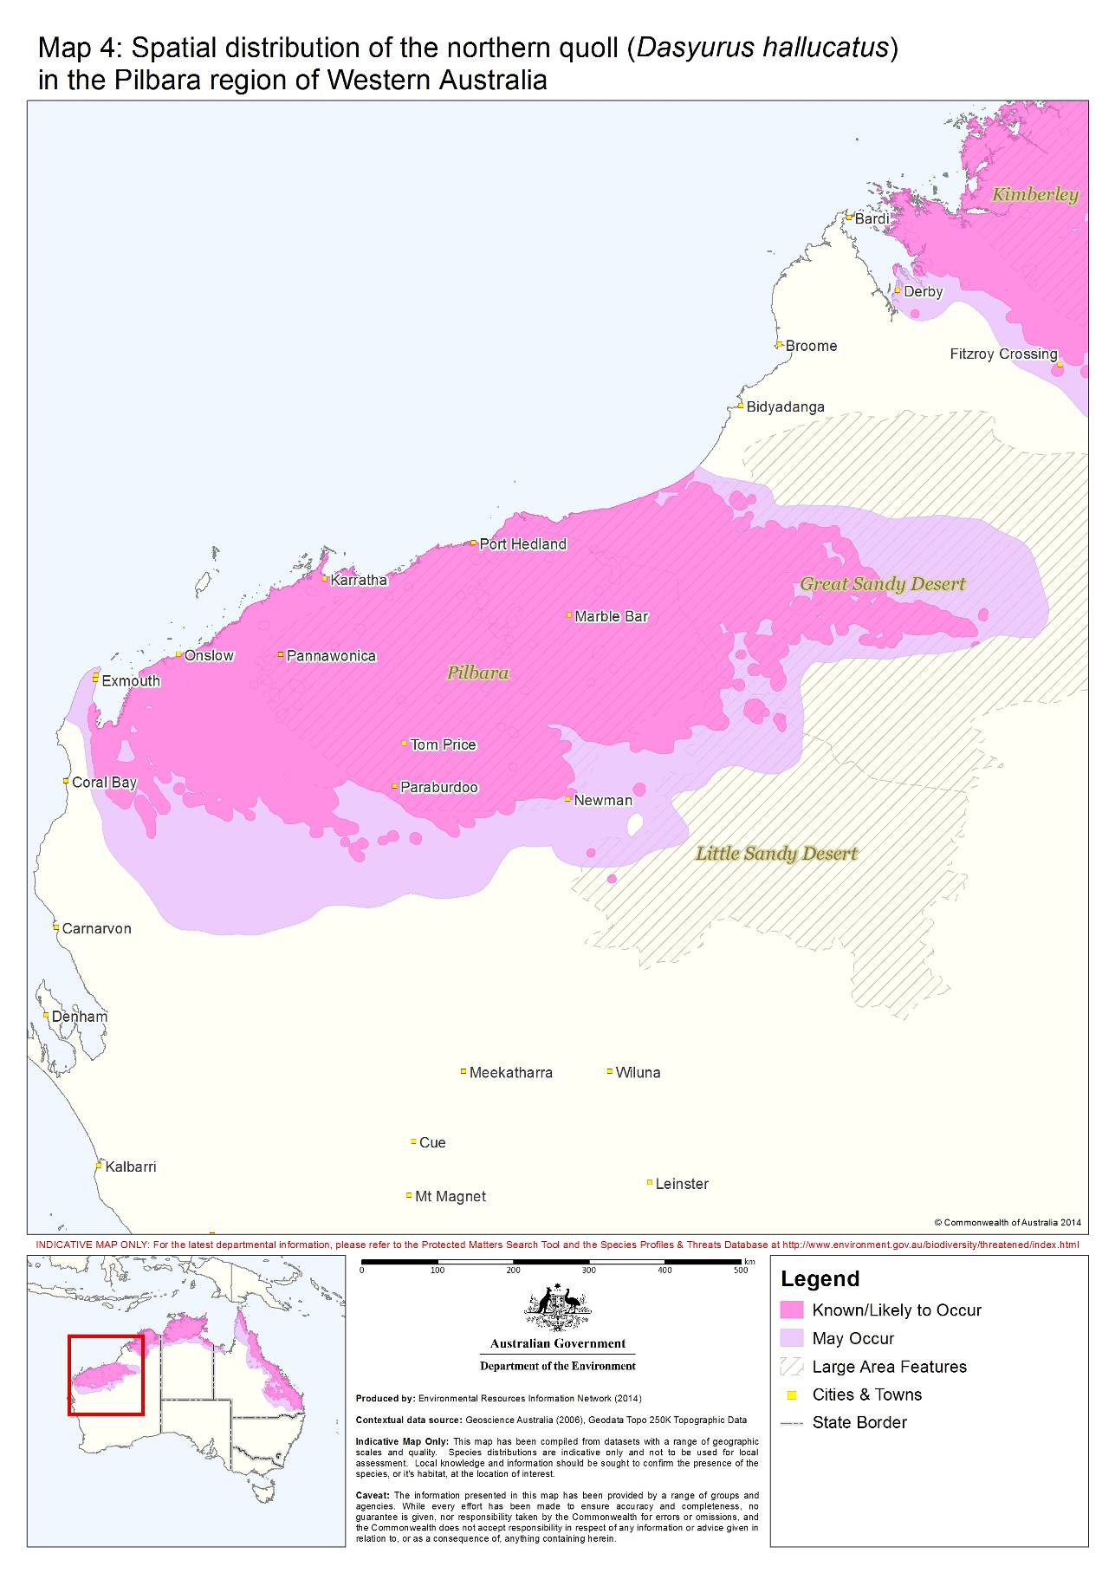

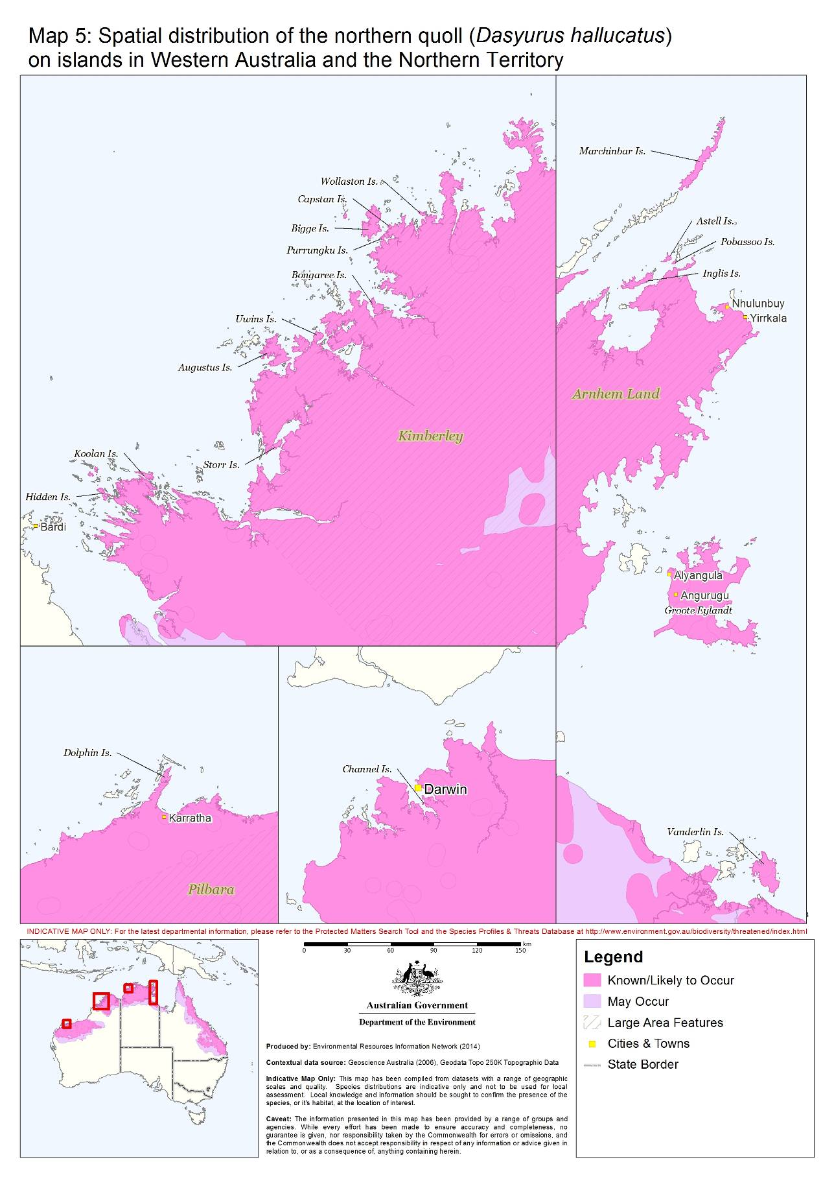
4. Could the impacts of your action affect habitat for the northern quoll?
The northern quoll occupies a variety of habitats across its current range including rocky areas, eucalypt forest and woodlands, dry rainforests and vine thickets, sandy lowlands and beaches, shrublands, grasslands and deserts. Habitat usually includes some form of rocky area or structurally diverse woodland or forest used for shelter purposes with surrounding vegetated habitats used for foraging and dispersal. Shelter habitat is important for breeding and refuge from fire and/or predation. Little is understood about the characteristics of foraging or dispersal habitat for the northern quoll. However, on current knowledge, foraging or dispersal habitat is recognised to be any land comprising predominantly native vegetation in the immediate area (i.e. within 1 km) of shelter habitat, quoll records or land comprising predominately native vegetation that is connected to shelter habitat within the range of the species.

Further information on northern quoll habitat is provided in the northern quoll profile in the Species Profile and Threats database.

5. Have you surveyed for northern quoll using the recommended methods?
For the purposes of referral and assessment under the EPBC Act it is recommended that surveys for northern quoll involve an initial reconnaissance survey to identify presence of northern quoll, habitat critical to the survival of the species and populations important for the long-term survival of the northern quoll.

Habitat critical to the survival of the northern quoll

This is habitat within the modelled distribution of the northern quoll (refer to maps 1-5) which provides shelter for breeding, refuge from fire / or predation and potential poisoning from cane toads. Habitat critical to the survival usually occurs in the form of:

- off shore islands where the northern quoll is known to exist
- rocky habitats such as ranges, escarpments, mesas, gorges, breakaways, boulder fields, major drainage lines or treed creek lines
- structurally diverse woodland or forest areas containing large diameter trees, termite mounds or hollow logs

Dispersal and foraging habitat associated with or connecting populations important for the long-term survival of the northern quoll is also considered habitat critical to the survival of the northern quoll.

Populations important for the long-term survival of the northern quoll

These are populations which are:

- high density quoll populations, which occur in refuge-rich habitat critical to the survival of the species, including where cane toads are present
- occurring in habitat that is free of cane toads and unlikely to support cane toads upon arrival i.e. granite habitats in WA, populations surrounded by desert and without permanent water; and
- subject to ongoing conservation or research actions i.e. populations being monitored by government agencies or universities or subject to reintroductions or translocation.

A high density population may be characterised by numerous camera triggers of multiple individuals across multiple cameras and or traps on the site. A low density population may be characterised by infrequent captures of one or two individuals confined to one or two traps or where no trapping has identified a northern quoll but latrine evidence remains. Detailed population modelling is not needed to make this assessment. If appropriate survey effort is carried out the department expects proponents to be able to make the determination of whether the population is of high or low density.

Justification for populations important for the long-term survival of the northern quoll

Modelling of cane toad invasion suggests that artificial water bodies increase landscape connectivity for cane toads in semi-arid areas, providing dry season refuges and creating ‘invasion hubs’ from which toads can disperse after rainfall (Tingley et al 2013; Florance et al 2011). Research also indicates that higher quoll numbers and high quality habitat may result in learned aversion traits which likely contribute to northern quoll persistence in cane toad affected areas (Ujvari et al 2013).

Reconnaissance survey

A reconnaissance survey can be conducted at any time of the year but should be undertaken in the early planning stages of the project. The reconnaissance survey should both attempt to detect the northern quoll and assess the suitability of habitat for northern quolls. Suitable habitat should be mapped during the survey and habitat areas calculated. Data collected should describe the habitat quality including information on vegetation, potential sheltering sites, fire history, presence of introduced predators, grazing history and landscape connectivity and condition (Example data sheet at Appendix A). The recommended approach for the detection component of a reconnaissance survey is using arrays of motion-sensitive cameras in combination with lures or baits together with active scat searches. This can be bolstered by using a combination of other effective techniques such hair tubes, detection dogs or spotlighting where appropriate (See Table 1).

Whether a reconnaissance survey may be all that is necessary for an action will depend on the presence of habitat critical to the survival of the quoll, the survey effort applied and the particular circumstances of your action (refer to Figure 2).

Figure 2: Survey decision making

OPTION 2
NO

UNCERTAIN
NO

YES

YES
OPTION 1
YES
NO

YES
YES
Is there evidence of northern quolls or habitat critical to the survival of the northern quoll in the study area (section 5)?
Are you avoiding significant impacts to habitat critical to the survival of the northern quoll by retaining habitat and implementing buffers and mitigation safeguards (sections 6 and 7)?
Undertake a reconnaissance survey of potential habitat using remote cameras and latrine searches. This can be done at anytime of the year but is recommended to be undertaken in accordance with the guidance in Table 1.
Undertake targeted surveys using Elliot or cage trapping in accordance with Table 1.

Undertake targeted surveys applying a refined and more targeted use of remote cameras and other supplementary techniques in accordance with Table 1.
Will your action involve impacts within the modelled distribution of the northern quoll (see maps 2-5)?
High risk of uncertainty in decision making and likely to receive a request for further information if a referral is made.

NO

No surveys required

Targeted surveys will inform significant impact decision making and any potential offset calculations.

Despite this is the population in your study area likely to be a population important for the long term survival of the northern quoll (section 5)?

No further surveys likely to be required

TARGETED SURVEYS RECOMMENDED

Your action is likely to impact habitat critical to the survival of the northern quoll or result in direct mortality to the species therefore the Department requires information to inform whether the population is important for the long term survival of the northern quoll.
Uncertainty about significant impacts still likely to exist.

Targeted survey

Generally speaking, targeted surveys puts you in the best place for a streamlined assessment of your proposed action and for achieving the assessment decision and outcomes you are seeking if you choose to refer your action.

It is important to consider the types and extent of habitat as well as the threats specific to your region when designing a targeted survey. Targeted survey can involve a trapping program, preferably using wire cage traps or Elliott traps (either medium or large size) or involve a more refined remote camera survey which allows for remote capture-recapture population estimates (Hohnen et al 2013). Either approach is adequate as long as the data can provide information which is needed for decision making when impacts on the northern quoll are likely (see section 6). Where the terrain is difficult to access or where quolls are difficult to detect, motion sensitive cameras may be a more suitable targeted survey technique. Some questions that are likely to be of particular interest to the department during the referral decision-making process if you decide to refer include:

- What is the size and relative density of the northern quoll population in the study area?
- Is it likely to be a population important for the long-term recovery of the northern quoll?
- In which parts of the study area do northern quolls appear to be sheltering in? Is the area rich in refuges?
- Is it likely to be a permanent or transient (dispersal/mating) population?
- Which habitats in the study area appear important for dispersal?
- How are these areas of dispersal habitat likely to be used?
- What threats are currently operating in the study area?
- In which habitats in the study area should monitoring occur?

Guidance provided in Table 1 should be considered for both reconnaissance and targeted surveys.

Table 1: Survey recommendations

Consideration | Guidance
Informed project siting and monitoring | Careful survey configuration to address project impact and non-impact zones.
Other state and territory guidelines | - In WA, conformity with state survey guidelines, statements and operating procedures is recommended (EPA 2004: DEC 2011, EPA and DEC 2010)  - In Qld, conformity with state survey guidelines is recommended noting that camera trapping is recommended over cage trapping (Eyre et al 2014).
Timing | -Targeted cage or Elliot trapping programs are to be undertaken between April and September to avoid disturbance when females have large or denned pouch young.  -Remote cameras can be used at any time of the year but preferably when northern quolls are likely to be active and more detectable, i.e. before male die-off. This will depend on the location of your action.
Animal welfare | -Surveys conducted by a suitably qualified person or group of persons with demonstrated skill in mammal surveys  -Traps cleared within 2 hours of sunrise and have adequate shade cover during the day  -Traps closed during the day to eliminate by-catch and potential heat stress issues.  -Remote cameras should not be baited with food rewards for longer than five consecutive nights to prevent impacts on normal animal behaviour. Scent lures with no associated food reward may be useful, for example burley oil.
Detectability | -In Western Australia, traps set for seven consecutive nights unless two or more individuals are caught twice, in which case the traps should be closed after four nights of trapping  -Where possible, undertake repeat sampling in habitat critical to the survival of the northern quoll.
Site coverage | - Cameras should cover all habitat types i.e. shelter and foraging and dispersal habitat. Targeted surveys should then be based on these results. When trapping is used, effort should be concentrated in areas of habitat critical to the survival of the species. In the Northern Territory, if wire cage or Elliot traps are used they should be set for a minimum of four nights and at as many sites as possible.
Supplementary survey methods | Survey techniques such as latrine searches, employment of detection dogs or hair tubes are recommended for use with remote cameras or trapping to improve detection probability.
Effective baiting | Traps baited with sardines or a bolus mix of oats and peanut butter (honey optional), chicken wings and / or diced bacon.
Survey design and effort | Trapping: For a targeted survey, trapping effort will depend on the context of your action with the majority of effort targeted within habitat critical to the survival of the northern quoll. As northern quolls frequently live in linear rocky habitats, particularly in WA, population monitoring is undertaken using trapping transects rather than grids, however in Qld, grids may be more appropriate. If trapping is used, transects or grids should be configured to achieve optimal cover of the sites. Two parallel lines of 25 traps each should be laid across broader habitat types such as breakaways or granite outcrops in WA.  Cameras: Transects of ten baited remote motion sensor cameras spaced at least 100 m intervals for four nights is recommended.  For linear habitat critical to the survival of the species (e.g. gorges, major drainage lines, breakaways less than 100 m wide), 1 camera per 100 linear metres is recommended. When using remote cameras for targeted survey they must be deployed to enable estimates of population size, habitat use and importance (Hohnen et al 2010).
Contribution to knowledge building | -Where possible, samples and location data should be provided to institutes and individuals with ongoing research programs with the aim of increasing genetic and spatial knowledge of the northern quoll.  -In WA, tissue samples (ear clippings) should be collected and sent to the WA Museum with the following details: Weight, sex, pes length (left hind foot measurement), tail diameter / circumference, crown length, reproductive condition, presence/absence of bite marks and parasites, locality (GPS coordinate in lat and long), collector’s name and date.  -In Qld, hair samples consisting of at least 50 hairs and their follicles can be pulled from each quoll and placed in a small clipseal bag, and refrigerated before sending to the University of the Sunshine Coast, Sippy Downs, Quoll Research Program as soon as possible. Information accompanying each sample should include lat/long, date, weight, sex and reproductive condition.

6. Could your action have a significant impact on the northern quoll?

Under the EPBC Act an action will require approval from the Minister if the action has, will have, or is likely to have, a significant impact on a matter of national environmental significance. The self-assessment criteria in the Significant Impact Guidelines 1.1 can be used as a framework to help identify significant impacts on the northern quoll. Applicable terms in these criteria include impacts on populations important for the long term survival of the species, and habitat critical to the survival of the species (see section 5 for definitions of these terms).

Actions which are likely to have a significant impact on the northern quoll are those that:

- Result in the loss of habitat critical to the survival of the northern quoll

- Decrease the size of a population important for the long-term survival of the northern quoll and therefore interfere with the recovery of the species.

- Introduce inappropriate fire regimes or grazing activities (i.e. increasing the risk of late dry season high intensity fires to the area) that substantially degrade habitat critical to the survival of the northern quoll or decrease the size of a population important for the long term survival of the species.

- Fragment a population important for the long term survival into two or more populations.

- Result in invasive species or increases of them that are harmful to the northern quoll becoming established in its habitat, namely cane toads, feral cats, red foxes or exotic grasses which increase fire risk. This includes actions which have inadequate quarantine measures in place for movements between the mainland and offshore islands where northern quolls occur.

If your action may, will or is likely to result in any of these, it is recommended that you seek to avoid and or mitigate these impacts (see section 7) so that your risk of significant impacts is minimal.

7. Are the measures you propose to mitigate your impacts the best available and likely to reduce the significance of the impacts?
Mitigation has the principal aim of avoiding significant impacts and should be applied in a hierarchical order:
1. Avoid impacts – preserve populations and habitat to avoid further loss.
2. Mitigate impacts – prevent habitat degradation and retain habitat function.
3. Monitor effectiveness of mitigation – ensure mitigation is effective and feeds back into an adaptive management plan.

Table 2 outlines the main threats to the northern quoll, their impacts and some relevant mitigation advice. The magnitude, evidence base, effort and duration of any mitigation measures will essentially determine the level to which they abate the threat and reduce impacts to an acceptable or beneficial level. It is not intended to be exhaustive or prescriptive. These threats may vary in presence or degree across the species range. They should not be considered to be in any hierarchical order. Table 3 provides regionally based mitigation objectives to help guide proponents in avoiding and mitigating impacts given that the type and magnitude of threats can vary across the species range. All actions should be planned with these regional objectives in mind so you can demonstrate your action is not acting inconsistently with the recovery of the northern quoll. Non-conformance with these objectives may increase the likelihood of a significant impact occurring.

Table 2: Key threats, impacts and mitigation

Threats and key impacts | Mitigation
Habitat clearing, modification or land use change  - Direct mortality  - Displacement  - Introduction of invasive species  - Alteration of groundwater or surface water processes | - Relocate the project.  - Design the project to avoid and protect habitat critical to the survival of the species.  - Reconfigure the project to remove threatening processes.  - Retain movement corridors and put in place natural buffers.  - Rehabilitate disturbed habitats.  - Maintain habitat to reduce edge effects.  - Avoid activities such as rock blasting or heavy machinery operation during the breeding season.  - Educate mine site personnel about northern quoll ecology on site.
Urbanisation  - Domestic animals  - Secondary poisoning from domestic rodent control  - Road kill and misadventure  - Persecution | - Relocate new urban development projects in or immediately adjacent to quoll habitat.  - Promote the use of first generation rodenticides in new and existing settlements.  - Roads through quoll habitat must incorporate fenced fauna underpasses.  - Support community initiatives to raise awareness of quolls and how to live with them.
Introduction and increases of invasive species  E.g. cane toads, gamba grass, feral cats and pigs, wild dogs, fox and cattle  - Direct mortality  - Habitat degradation  - Competition  - Increased fire risk  - Habitat displacement  - Direct predation  - Disease e.g. Toxoplasmosis | - Implement quarantine protocols.  - Install a staging facility for the storage and inspection of equipment/goods. The staging facility should be surrounded by a toad-proof barrier/fence (including no gaps under doors), and should include shelter sites for toads that can be easily and regularly inspected. For island developments, the staging facility should be on the mainland (e.g. Broome, Derby, Wyndham, Darwin, Gove and Borroloola) and be located at the wharf from where goods are shipped out to the site.  - Prescribe and apply a holding period (at least 48 hours) before equipment is used on-site or shipped to site, to allow time for toads/pests to emerge.  - Install a wash down facility. The wash down facility should comprise high pressure water or steam devices. Cane toad traps should be installed surrounding the wash down and staging facilities and checked regularly (see http://www.frogwatch.org.au for more information on cane toad traps).  - Develop and facilitate educational programs for staff and contractors about quarantine protocols and associated risks involved with invasive species.  - Implement a no fill policy for the life of the project e.g. no introduction of material from offsite such as soil or vegetation.  - Control and (where possible) eradicate weeds with a high priority for habitat-modifying weeds.  - Remove and spray high priority weeds e.g. gamba grass (Andropogon gayanus).  - Manage fuel loads of weeds to reduce risk of high fire intensity.  - Close artificial water bodies created during mining activity.  - Rehabilitate borrow pits so that they do not hold water.  - Ensure that railways or other linear infrastructure do not impede sheet water flow and, where possible, close or modify artificial water bodies used for pastoral purposes so that their refuge value for cane toads is reduced.  - Control feral animal abundance such as feral cats, pigs and wild dogs in an integrated manner.  - Control feral animals through localised live trapping, shooting and baiting. The most likely direct and indirect benefit to the northern quoll is through effective control of feral cats, but – where this involves baiting – it must be preceded by trials that assess extent of non-target impacts on the northern quoll.  - Implement and enforce a no cat and no dog policy for developments with accommodation facilities  - Educate and train staff and public in any no cat and dog policy and ensure signage is displayed.  - Remove and or mange sites such as tips and dump sites which attract feral cats and dogs and provide hideouts for these species. Ensure all food wastes are disposed of appropriately and that staff do not feed feral animals or wildlife.  - Modify existing habitat to make it less suitable for cats e.g. reduce fragmentation by rehabilitating tracks and clearings and making it more structurally complex with shelter and escape sites.
Pastoralism  - Habitat degradation  - Inappropriate fire regimes  - Promoting cane toads | - Maintain current site conditions e.g. disturbance regimes, grazing and vegetation structure.  - Maintain appropriate grazing regimes to avoid high fuel levels and high intensity dry season fires.  - Consider use of enclosed tanks instead of open dams to prevent toads using dams as dry season water sources.  - Close or modify artificial water bodies used for pastoral purposes so that their refuge value for cane toads is reduced.
Traffic  - Direct mortality  - Habitat fragmentation | - Retain quoll movement corridors.  - Control and manage traffic levels to minimise habitat fragmentation and road kills.  - Consider a ‘no driving at night’ policy.  - Educate project staff.  - Ensure no entry into conservation areas with signage (except for necessary environmental management and monitoring).  - Prevent unauthorised off track driving with signage and penalties. Control / management of traffic is particularly important during the breeding season when there is increased movement of males.  - Reduce and enforce speed limits in the vicinity of quoll habitat with signage and penalties.  - Fence underpasses where appropriate to funnel movement to safer areas.  - Report and record road kills
Inappropriate fire regimes  - Increased predation risk  - Loss of denning habitat | - Manage fires to reduce incidence, extent and severity to levels appropriate to retain or restore optimal northern quoll habitat. Contact relevant government agency to understand the preferred burning regime for northern quoll. Construct fire control lines to facilitate access to control fire fronts.  - Educate and train staff about equipment and procedures to act on unexpected fire events.

Table 3. Regional mitigation objectives

Region | Mitigation objective
Queensland | - Protect persisting populations and reduce impacts on breeding habitats.  - Minimise risk of high intensity fire to these populations.
Pilbara | - Implement quarantine measures between Broome and Port Hedland to reduce the magnitude of predicted cane toad invasion.  - Manage new and existing artificial water points and creation of permanent pools on pastoral and mining leases.  - Manage pastoral and mining leases to reduce the risk of extensive hot fires and overgrazing, which reduces ground cover and hence shelter for northern quolls, exacerbating predation by cats.  - Protect quoll populations on offshore islands from the introduction of cats (and potentially cane toads) through strict quarantine measures.  - Limit destruction of key breeding habitat, such as high quality gorges and rocky ridges.
Kimberley | - Contribute to existing or new programs to halt the westward spread of cane toads. i.e. toad aversion baiting programs in areas not yet invaded by toads.  - Manage pastoral leases and mining lands to reduce the risk of extensive hot fires and overgrazing, which reduces ground cover and hence shelter for northern quolls from predation by cats.  - Protect northern quoll populations on offshore islands from the introduction of cats (and potentially cane toads) through strict quarantine measures.
Northern Territory | - Protect remaining northern quoll populations including those on offshore islands and ensure strict quarantine measures to avoid further toad infestation on offshore islands.  - Ensure appropriate land management (i.e. reducing high fuel loads through weed control and feral animal control).
Offshore Islands | - Restrict facilitation of cane toads and cats through stringent onshore biosecurity measures. Maintain habitat on islands to ensure persistence.

Bushfire hazard-reduction techniques conducted in accordance with state or territory law are typically exempt from EPBC Act approval requirements. The Act generally does not restrict responses required to manage bushfire emergencies, nor does it regulate measures taken to fight fires. Further information is available in the factsheet ‘Bushfire management and national environmental law’ (www.environment.gov.au/resource/bushfire-management-and-national-environment-law).
A new action that introduces an increased risk of high-intensity fire causing northern quoll mortality in habitat critical to the survival of the northern quoll may however have a significant impact and require a referral. For example, a new development next to or within northern quoll habitat could increase the risk of high-intensity fire in the habitat. This could be mitigated by the adoption of a fire prevention plan which is implemented for the life of the action. Such a plan should also include a workforce and community education component.

8. Could your action require approval from the Minister?
As the person proposing the action, it is your responsibility to decide whether or not to refer your action. If you believe your action carries a high risk of having a significant impact on the northern quoll you should refer the action to the Minister. If you are uncertain whether your action will have a significant impact on the northern quoll you should also refer your action to the Minister or contact the Department to discuss the uncertainties.
IMPORTANT NOTE

It is unlikely that your action will require a referral if you:

- Undertake surveys consistent with these guidelines to inform decision making
- Avoid clearing habitat critical to the survival of the northern quoll and any impacts to populations important for the long-term survival of the northern quoll
- Maintain dispersal opportunities between populations important for the long-term recovery of the northern quoll
- Design your action and infrastructure to avoid and or minimise both direct and indirect mortality to northern quoll
- Put in place stringent, monitored and adaptive management measures to control impacts from fire, pastoralism, and invasive species particularly cane toads, weeds and feral cats.

Furthermore, proponents that apply surveys consistent with these guidelines and use effort and evidence-based modelling will be in a position to provide evidence that northern quolls or habitat critical to the survival of the species do not occur on site or are unlikely to occupy the site into the future. If such evidence is available, the proposed actions are unlikely to have a significant impact on the northern quoll.

If your action is inconsistent with above guidance it is likely to have a significant impact on the northern quoll and will require approval from the Minister.

It is uncertain whether large scale actions that do not affect habitat critical to the survival of the northern quoll, such as mining exploration works or large scale irrigation works that alter groundwater or surface water processes, are likely to have a significant impact. They may be likely to have a significant impact if they increase the risk of cane toads spreading into new areas of northern quoll habitat. It is recommended that proponents refer such actions.

9. How can I manage northern quolls on site?
To manage northern quolls in and around your area of operations and ensure the mitigation measures put in place are effective, populations should be actively monitored. Monitoring is best designed on a case-by-case basis, however it should adopt the recommended methods for a targeted survey (section 4) and consider the following:

- Monitoring design should ensure that there is adequate statistical power to detect change
- Monitoring sites should be established in shelter habitat outside of direct impact zones, within impact zones and in rehabilitated areas (original impact areas).
- Control sites should be established in similar habitat types which occur outside of any impact areas.
- Monitoring should seek to include all representative habitat types.
- Monitoring should involve the mark and recapture of individuals through trapping or a well designed remote camera program e.g. using trail camera derived images numbered tags, tattoos, or ear notching (ethics clearance is required for these procedures).
- Survey effort should be similar to that used during the targeted survey in both the impact and control sites.
- Pre-impact baseline survey data should be collected.
- Post-construction monitoring should take place annually for the first two years and then once every three years after that for the life of the project.
- Wherever possible, monitoring programs should be designed to provide evidence of the effectiveness of any management actions undertaken to mitigate impacts or aimed at enhancing habitat quality.
- In WA, monitoring programs should employ methodologies used in the regional monitoring program undertaken by the Department of Parks and Wildlife.
- All monitoring protocols and data should be made available, preferably on the company’s website.

Key references
Department of Environment and Conservation (2011). Standard Operating Prodecure 5.2: Remote operation of cameras http://www.dpaw.wa.gov.au/plants-and-animals/96-monitoring/standards/99-standard-operating-procedures\

Environmental Protection Authority and Department of Environment and Conservation (EPA and DEC) (2010). Technical Guide - Terrestrial Vertebrate Fauna Surveys for Environmental Impact Assessment (eds B.M. Hyder, J. Dell and M.A Cowan). Perth, Western Australia. http://www.epa.wa.gov.au/EPADocLib/3281_Faunatechnicalguide.pdf

Environment Protection Authority (EPA) (2004). Terrestrial Fauna Surveys
for Environmental Impact Assessment in Western Australia. Guidance Statement 56.
http://www.epa.wa.gov.au/EPADocLib/1850_GS56.pdf

Eyre, T.J, Ferguson, D.J, Hourigan, C.L, Smith, G.C, Mathieson, M.T, Kelly, A.L, Venz, M.F, Hogan, L.D and Rowland, J. (2014). Terrestrial Vertebrate Fauna Survey Assessment Guidelines for Queensland. Department of Science, Information Technology, Innovation and the Arts, Queensland Government, Brisbane. https://www.qld.gov.au/environment/assets/documents/plants-animals/biodiversity/fauna-survey-guidelines.pdf

Florance, D., Webb, J. K., Dempster, T., Kearney, M. R., Worthing, A., and Letnic, M. (2011). Excluding access to invasion hubs can contain the spread of an invasive vertebrate. Proceedings of the Royal Society B: Biological Sciences, 278(1720), 2900-2908. http://rspb.royalsocietypublishing.org/content/278/1720/2900.abstract

Hill, B.M. and, Ward S.J. (2010). National Recovery Plan for the Northern Quoll Dasyurus hallucatus. Department of Natural Resources, Environment, the Arts and Sport, Darwin. https://www.environment.gov.au/resource/national-recovery-plan-northern-quoll-dasyurus-hallucatus

Hohnen, R, Ashby, J, Tuft, K, and McGregor, H. (2013). Individual identification of northern quolls (Dasyurus hallucatus) using remote cameras. Australian Mammalogy 35, 131–135. http://www.publish.csiro.au/paper/AM12015

Tingley, R., Phillips, B. L., Letnic, M., Brown, G. P., Shine, R., and Baird, S. J. (2013). Identifying optimal barriers to halt the invasion of cane toads Rhinella marina in arid Australia. Journal of Applied Ecology, 50(1), 129-137. http://onlinelibrary.wiley.com/doi/10.1111/1365-2664.12021/abstract

Ujvari, B., Oakwood, M. and Madsen, T. (2013). Queensland northern quolls are not immune to cane toad toxin. Wildlife Research, 40 (3), 228-231. http://www.publish.csiro.au/?paper=WR13011

Woinarski, J, Burbidge, A and Harrison, P. (2014). Action Plan for Australian Mammals 2012. CSIRO Publishing. http://www.publish.csiro.au/pid/7010.htm

Woinarski, J.C.Z., Oakwood, M, Winter, J, Burnett, S, Milne, D, Foster, P, Myles , H, and Holmes, B. (2008). Surviving the toads: patterns of persistence of the northern quoll Dasyurus hallucatus in Queensland. Report submitted to the Natural Heritage Trust Strategic Reserve Program. http://lrm.nt.gov.au/__data/assets/pdf_file/0015/17502/qld_quolls_finalreport.pdf

Appendix A
PILBARA NORTHERN QUOLL DATA SHEET – Habitat Survey
Site name: |  | Recorder/s:
Date: | Time: | Contact email:
GPS datum: |  | GPS Accuracy:
GPS Co-ords: |  | Height above sea level:
Please consider a 50m x 50m patch for all questions. Many of these categories are derived from: National Committee on Soil and Terrain (2009) ‘Australian Soil and Land Survey Field Handbook’, CSIRO Publishing, Melbourne

1. LANDFORM ELEMENT

Morphological type 13
C Crest F Flat
U Upper slope V Open depression (vale)
M Mid slope D Closed depression
L Lower slope H Hillock
S Simple slope R Ridge

2. ROCK OUTCROP
TYPE (e.g. granite)
Abundance 101
0 No bedrock exposed
1 Very slightly rocky <2%
2 Slightly rocky 2-10%
3 Rocky 10-20%
4 Very rocky 20-50%
5 Rockland >50%

3. SOIL

Colour
R Red Y Yellow
O Orange G Grey
B Brown D Dark

Type 116
1 Clay 5 Coarse sand
2 Fine silt 6 Fine gravel
3 Coarse silt 7 Coarse gravel
4 Fine sand 8 None; rock only

4. GROUND COVER
% Cover Leaf Litter

% Cover Bare Ground
(including litter, rock cover
and bare soil, excluding live vegetation)

5. COARSE FRAGMENTS ON THE SURFACE
Rock Abundance 97
0 No coarse fragments 0
1 Very slightly; very few <2%
2 Slightly; few 2%-10%
3 No qualifier; common 10%-20%
4 Moderately; many 20%-50%
5 Very; abundant 50%-90%
6 Extremely; very abundant >90%

Rock Size 99
3 Gravelly >60 mm
4 Cobbly; or cobbles 60-200 mm
5 Stony; stones 200-600 mm
6 Bouldery; or boulders 600 mm-2 m
7 Large boulders >2 m

6. LAND SURFACE

Disturbance of site 88
0 No effective disturbance
1 No effective disturbance except grazing by hoofed animals
2 Limited clearing
3 Extensive clearing
8 Highly disturbed, e.g. mining, urban

7. EVIDENCE OF RECENT FIRE

Frequency Intensity
0 Long unburnt 0 No damage
1 Several years since burn 1 Minor
2 Burnt before last rainfall 2 Some defoliated
3 Burnt after last rainfall 3 Most defoliated 4 Unknown

Distance to nearest unburnt patch ( >5 ha)
1 <100 m 2 100-500 m
3 500m – 1 km 4 >1 km

Patchiness, % of area burnt:

8. NEARBY WATER BODIES
R River
1 Permanent S Soak/spring
2 Seasonal C Creek
3 Ephemeral P Pool
B Bore / windmill / dam
Distance (m):

9. EVIDENCE OF FERAL / INTRODUCED SPECIES
(please list)

Please collect any cat, dingo or quoll scats
Place into an envelope (not plastic),
label with collector’s name, date, species, GPS location
and lodge with DPaW for dietary analysis.

10. SITE PHOTOS (please attach)

Photo number:

Direction facing:

11. VEGETATIVE GROWTH STAGE

1 Early regeneration
2 Advanced regeneration
3 Mature vegetation
4 Senescent phase

12. NATIVE FIG (FICUS) PRESENCE

0 Absent
1 1–10 plants
2 > 10 plants
13. VEGETATION

Please tick 1 box in each row, and record dominant species where known |  |  | Absent | Isolated  <2% | Very sparse  2–10% | Sparse  10–30% | Mid-Dense  30–70% | Dense  70–100%
TREES | Dominant species
TREES | > 30 m
TREES | 10–30 m
TREES | <10 m
MALLEES | Dominant species
MALLEES | Over 8 m
MALLEES | Under 8m
SHRUBS | Dominant species
SHRUBS | Over 2 m
SHRUBS | 1–2 m
SHRUBS | Under 1 m
HERBS & SEDGES | Dominant species
GRASSES | Dominant species
GRASSES | Hummock | 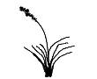
GRASSES | Tussock
GRASSES | Bunch

SITE MAP
Showing relevant landforms, vegetation types, creeks, landmarks etc as well as an indication of trap/camera placement
TOP VIEW

SIDE VIEW

It is recommended that proponents in WA undertake habitat assessments that will help inform the current research and monitoring program for nnorthern quoll in the Pilbara. This information will also be important for the assessment of referrals under the EPBC Act. See Appendix A for the recommended habitat assessment approach.
In NT there are no specific survey protocols for the northern quoll, any surveys for northern quolls are recommended to conform to the guidance in this policy.
Breeding can occur at slightly different times throughout Australia. This specification is for the Pilbara population. Pouch young have been recorded at the following times for different locations; Koolan Is, WA: Jul- Sep, Groote Eylendt, NT: Jul – Oct, Little Nourlangie Rock, NT: Jul – Sep, Mitchell Plateau, WA: Jun-Sep, Mornington, WA: Jun – Dec, Pilbara, WA: Aug – Oct
These are some important considerations for the welfare of northern quolls during surveys however the DoE does not govern the ethics of fauna surveys and approval should be sought from the relevant state agencies prior to any surveys for northern quoll.
A suitably qualified person is an individual, group of individuals or organisation approved by a state agency and or animal ethics committee to undertake the specific survey.
In Qld, quolls have been observed not to spend as much time at a scent lure as they do a food reward lure. This can make a difference if working to identify individualal quolls from spot patterns.

