

Environment Protection and Biodiversity Conservation Act 1999

Draft referral guidelines for the endangered Macquarie perch, Macquaria australasica

© Commonwealth of Australia 2011
This work is copyright. You may download, display, print and reproduce this material in unaltered form only (retaining this notice) for your personal, non-commercial use or use within your organisation. Apart from any use as permitted under the Copyright Act 1968, all other rights are reserved. Requests and inquiries concerning reproduction and rights should be addressed to Commonwealth Copyright Administration, Attorney General’s Department, Robert Garran Offices, National Circuit, Barton ACT 2600 or posted at www.ag.gov.au/cca.

Disclaimer
The contents of this document have been compiled using a range of source materials and is valid as at May 2011. The Australian Government is not liable for any loss or damage that may be occasioned directly or indirectly through the use of reliance on the contents of the document.

Important notice
Please note that these guidelines are general in nature and do not remove your obligation to consider whether you need to make a referral to the federal environment minister under the Environment Protection and Biodiversity Conservation Act 1999 (EPBC Act). While these guidelines provide information to help you decide whether to refer your action, the possible impacts of your proposal will depend on the particular circumstances of the action. These circumstances may include issues such as the precise location, mitigation measures and indirect impacts.

These guidelines were made on the basis of the best information available at the time of writing. However, the impacts of proposals will be assessed by the department on the basis of the best information available at that point in time, which may differ from the information on which this guideline is based.

These guidelines do not provide guidance on requirements under state and local government laws. Information on state, territory and local government council laws can be obtained from the New South Wales Office of Environment and Heritage; the Victorian Department of Sustainability and Environment; the Australian Capital Territory Department of the Environment, Climate Change, Energy and Water; and the local councils in or near the proposed project area.

How to use these guidelines
These guidelines are intended to assist you in determining whether your action needs to be referred to the Australian Government Department of Sustainability, Environment, Water, Population and Communities (the department). These guidelines should be read in conjunction with the EPBC Act Policy Statement 1.1 Significant Impact Guidelines – Matters of National Environmental Significance.

These guidelines apply to the Macquarie perch, Macquaria australasica, anywhere it may occur in Australia. The Macquarie perch is listed as an endangered species under the EPBC Act. Listed threatened species and ecological communities are matters of national environmental significance under the EPBC Act.

If you plan to undertake an action that has, will have or is likely to have a significant impact on the Macquarie perch you must refer the proposal to the minister before commencing. The minister will then decide, within 20 business days, whether assessment is required under the EPBC Act. The potential significance of each action is judged on a case-by-case basis. Substantial penalties apply for undertaking an action, to which the EPBC Act applies, without approval (civil penalties up to $5.5 million or criminal penalties including up to seven years imprisonment). More information on referral, assessment and compliance is available at www.environment.gov.au/epbc/.

A national recovery plan for the Macquarie perch is in development at the time of writing. The federal environment minister must not make a decision which is inconsistent with a national recovery plan.

The decision tree in Figure 1 and the rest of these guidelines are designed to assist you in determining whether your proposed action needs to be referred. You may also refer your proposed action if you are uncertain about the need to refer, or if you think the proposal would not have significant impacts on matters of national environmental significance, but would like legal certainty.

Possible exceptions to the need to refer
Certain actions are exempt from the requirement of assessment and approval under the EPBC Act. These include lawful continuations of land use that started before 16 July 2000, or actions that were legally authorised before 16 July 2000. There are a number of criteria that must be satisfied to rely on any such exemptions. More information on exemptions under the EPBC Act is available at www.environment.gov.au/epbc/publications/exemptions.html.
Figure 1: Decision making

YES
NO

YES or UNSURE

YES
NO
Have you surveyed for the Macquarie perch using the recommended methods (see Section 4)?
NO
or
UNSURE
REFERRAL RECOMMENDED
High risk of resulting in significant impact**
Assume your project may impact on the Macquarie perch (see Section 5).
NO

Could your action impact on the Macquarie perch (see Section 5)?
Is your impact mitigation best practice so that it may reduce the significance of your impacts on the Macquarie perch (see Section 6)?
Could the impacts of your action affect any Macquarie perch habitat (see Section 3) or individuals?
REFERRAL MAY NOT BE REQUIRED*

Low risk that your action will result in a significant impact on the Macquarie perch (see Section 7)**
Uncertainty whether your action will result in a significant impact on the Macquarie perch (see Section 7)***
High risk that your action will result in a significant impact on the Macquarie perch (see Section 7)**
REFERRAL RECOMMENDED
OR CONTACT THE DEPARTMENT

REFERRAL RECOMMENDED

Could the impacts of your action occur within the modelled distribution of the Macquarie perch (see section 2)?
YES or UNSURE
REFERRAL MAY NOT BE REQUIRED*
Low risk of resulting in significant impact**
YES or UNSURE
NO

REFERRAL MAY NOT BE REQUIRED*
Low risk of resulting in significant impact**
Could your action require a referral to the federal environment minister for significant impacts on the Macquarie perch (see Section 7)?
REFERRAL MAY NOT BE REQUIRED*
Low risk of resulting in significant impact**
* Although it would appear a referral may not be required, you may still refer your proposed action if unsure, or if you think the proposal would not have significant impacts on matters of national environmental significance, but would like legal certainty. An example may be when other matters of national environmental significance, in addition to the Macquarie perch, are potentially affected.
** Risk is the chance of something happening that will have a [significant] impact on objectives [e.g. protecting matters of national environmental significance] (adapted from Australian / New Zealand Risk Management Standard 4360: 2004).
*** If you are uncertain about the need to refer then you may also contact the Department to discuss your action by emailing epbc.referrals@environment.gov.au
1. What is known about the Macquarie perch?

Macquarie perch are a moderate sized fish with an elongate-oval body which is laterally compressed. In the Murray-Darling Basin they vary from almost black or dark silvery grey to bluish grey or green-brown above, paler to off-white below, often with a yellowish tinge. Fish from the Shoalhaven and Hawkesbury River systems are blotched with grey-brown, buff and dark grey patches over the head and body.

Sexual maturity is reached after two years for males and three years for females. Spawning occurs from October to December, using increasing water temperatures and late spring/early summer flows as cues to commence spawning. Macquarie perch in reservoirs undertake migrations into inflowing rivers to spawn. Spawning occurs at the foot of pools, in shallow water flowing over a bed of boulders, cobbles or gravel. Eggs sink into cracks in the substrate or drift downstream and lodge amongst gravel and cobble in riffles.

Relevant background information on the biology and ecology of Macquarie perch is provided in the department’s Species Profile and Threats (SPRAT) database.

2. Could the impacts of your action occur within the modelled distribution of Macquarie perch?

The Murray-Darling form of the Macquarie perch is found in waterways of Victoria, New South Wales and the Australian Capital Territory. The eastern form is confined to the Hawkesbury-Nepean and Shoalhaven river systems (see Map 1).

In Victoria, small discrete populations remain in the upper reaches of the Mitta Mitta, Ovens, Broken, Campaspe and Goulburn Rivers. A larger, apparently self-sustaining translocated population exists in the Yarra River in Victoria. The Macquarie perch is also known to persist within the Eildon Reservoir, situated on the Goulburn River.

In New South Wales and the ACT, the Macquarie perch occurs in the Lachlan, Murrumbidgee, Paddys and Cotter Rivers. It is also found in low numbers in the Mongarlowe River, likely as the result of a translocation from the Murray-Darling Basin. Other populations exist in the Cataract Dam in the Nepean River catchment, Georges River near Campbelltown, and the Burrinjuck, Cotter (Murrumbidgee) and Wyangala impoundments. The Googong Reservoir population is believed to be effectively extinct. A breeding population in the Queanbeyan River upstream of the Googong Reservoir exists due to a translocation of individuals from the reservoir past a natural barrier.

The map presented in this document, indicating catchments in which waterways may support the Macquarie perch, is based on the best available information at the time of publication and remains a static product. For the most up-to-date report of whether the Macquarie perch may occur in your project area, always use the Protected Matters Search Tool.
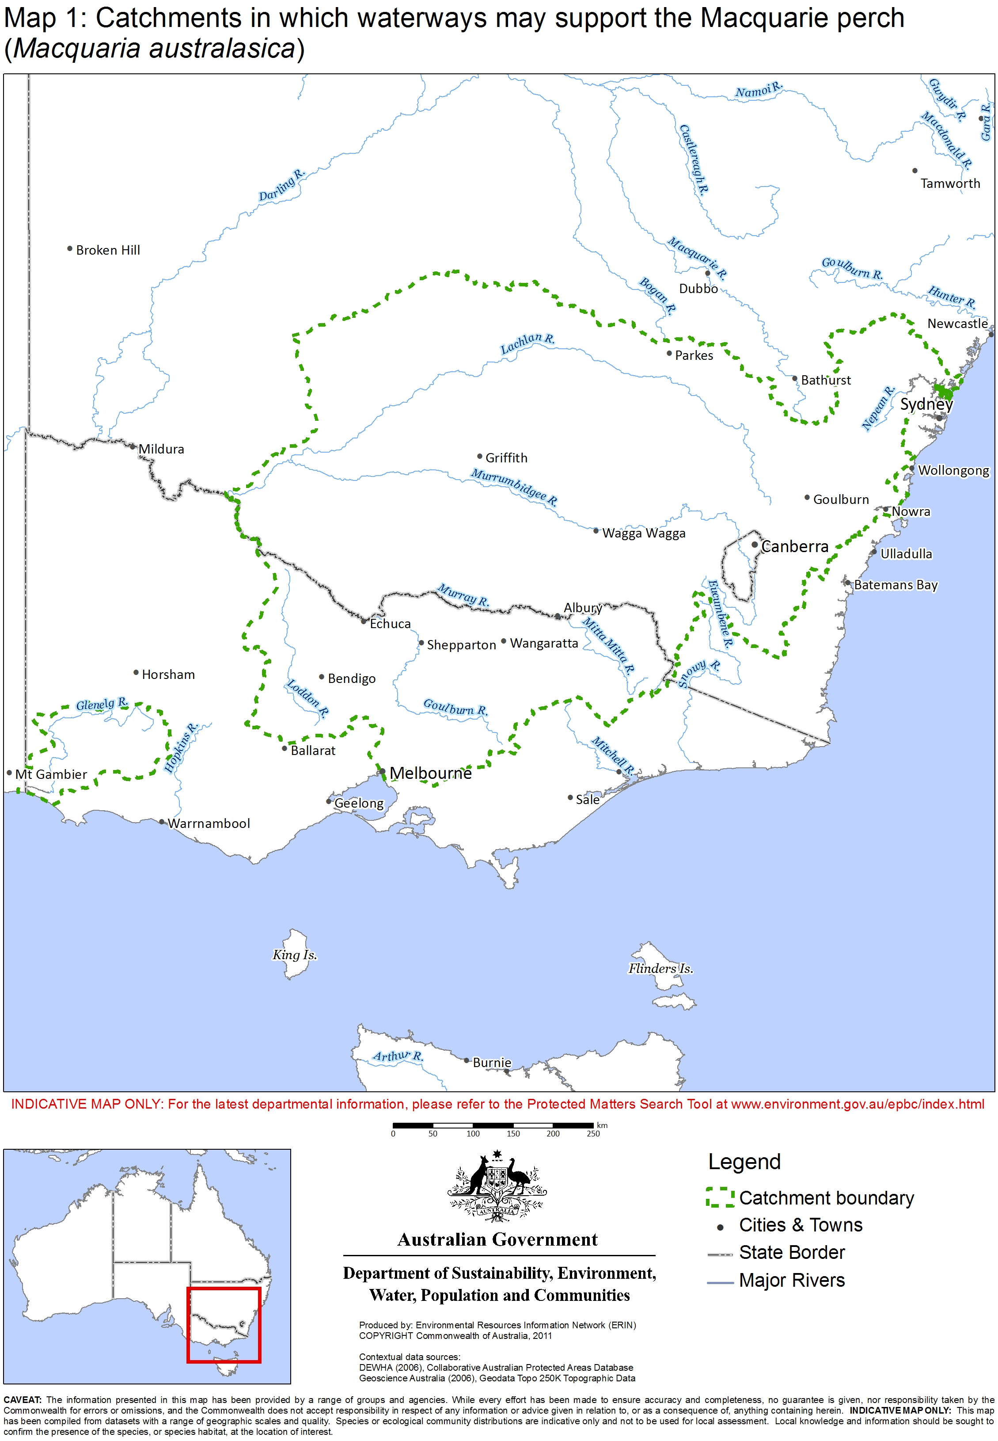
3. Could the impacts of your action affect habitat for the Macquarie perch?

Macquarie perch are a riverine schooling species preferring deep rocky holes with ample cover. They are most abundant above 200 metres altitude. Macquarie perch require shallow cobble or gravel riffle areas for breeding, with water depths of 20 to 90 cm and water velocity of 0.3 to 0.6 metres per second.

The most viable populations of Macquarie perch remain in the upper reaches of river catchments where siltation loads are reduced and deep holes, interspersed with shallow riffles, are undisturbed. Silt creates unfavourable conditions for the eggs by filling deep holes and settling on the river bottom, blanketing rocky substrates and filling small spaces between the gravel and cobbles.

4. Have you surveyed for Macquarie perch using the recommended methods?

A guide to conducting surveys for the Macquarie perch in areas of suitable habitat is outlined below. Surveys should:
- be conducted by a suitably qualified person with demonstrated skill in fish surveys
- maximise the chance of detecting the species
- account for uncertainty and error (such as false presences and absences).

The following survey methods are recommended for presence/absence surveys. Where it is not possible to conduct surveys in this manner, failure to detect the Macquarie perch should not be considered indicative of its absence.

Is the habitat suitable?

Before surveying, you should determine the suitability of the habitat. Potential habitat indicators include:
- Presence of deep rocky pools
- Presence of clear water interspersed with riffles
- Presence of slow to fast flowing water bodies, and
- Presence of ample cover from rocks, overhanging banks, logs, branches, emergent and submergent macrophytes (water plants), trailing bank vegetation, stumps, and clay banks.

Survey recommendations

Survey methods can vary with the proposal scale, likely impacts, seasonality and particular survey area attributes. Habitat assessment may provide further indication of the species likely presence. Survey guidelines are outlined in Table 1.

Table 1: Survey guidelines for detecting the Macquarie perch

Timing | Recommended survey period: March – September  Exclusion period: Throughout breeding season of October to mid January. Surveys conducted during this period may disrupt the breeding cycle of the species and could have a significant impact on the Macquarie perch.
Desktop survey | A search of relevant literature and Commonwealth and state / territory databases and maps will provide an indication of whether the species has been previously recorded on a particular site, and the overall likelihood of the species occurring in the area.  Consider known habitat requirements, characteristics of the site, proximity of local records, and stocking history. Contact regional fisheries and anglers for local information.
Field survey methods and effort | Macquarie perch are difficult to survey as they are a furtive, nocturnal species. Methods which do not enmesh fish but which collect an adequate sample size are limited. Sampling for rare fauna is particularly problematic, and so sampling methods which target abundant life phases or return higher catch per unit effort are preferred. Sampling should target preferred habitat, for example emergent macrophytes (water plants which grow from the sediment to above the water surface) and areas where banks are undercut. Further guidance on the application of the survey methods below can be found in the Survey guidelines for Australia’s threatened fish.  Recommended survey methods for Macquarie perch include:  - Boat electrofishing in lakes/dams and large rivers.  - Backpack electrofishing in smaller streams less than ~1.5 m depth.  - Fyke nets can successfully capture large numbers of juvenile Macquarie perch but do not always collect a representative sample of adult fish. Fyke nets should be equal to or less than 9 mm mesh to prevent mortalities.  - To prevent drowning of trapped non-target mammals (such as platypus), fyke nets should be set partially out of the water to create an air space.  - Snorkelling can be conducted in clear streams for juveniles. Effort employed will depend on the area being surveyed. Focus on areas of habitat not suitable for backpack electrofishing. Visibility can be established prior to starting with the use of a black number/letter on a white board. Observations involve counts and estimations of fish length to nearest 10 mm, relayed to a shore-based assistant.  - Catch-and-release angling by skilled anglers using lures with barbless hooks during February-April could also be considered.

5. Could your action impact on the Macquarie perch?

Potential direct and indirect impacts on the Macquarie perch should be considered when determining whether to refer your action. You should consider referring your action if there is a real chance or possibility that it will have a significant impact on Macquarie perch. The self-assessment criteria used to judge significant impacts for endangered species are listed in the significant impact guidelines 1.1.

Section 7 provides more tailored guidance for when one or more of these criteria may trigger the need to refer your action for impacts on the Macquarie perch.

6. Is your impact mitigation best practice so that it may reduce the significance of your impacts?

Mitigation has the principle aim of avoiding significant impacts and should be applied in a hierarchical order:
1. Avoid impacts – preserve populations and habitat to avoid further loss.
2. Mitigate impacts – prevent habitat degradation and retain habitat function.
3. Monitor effectiveness of mitigation – ensure mitigation is effective and feeds back into an adaptive management plan.

Table 2 outlines the main threats to the Macquarie perch, their impacts and mitigation. It is not intended to be exhaustive or prescriptive.
Table 2: Primary threats, impacts and mitigation

Threat | Impact | Mitigation
Habitat loss, degradation and modification | - Loss of riffle breeding habitat from inundation or sediment.  - Loss of deep holes due to filling with sediment.  - Deterioration of water quality from introduction of pollutants and biocides.  - Disruption of spawning cues, preventing breeding, through changed thermal regimes.  - Reduced primary productivity and food availability through impaired light penetration from suspended sediment. | - Minimise drawdown of dams and weirs.  - Create habitat (for example artificial devices, replanting of in-stream vegetation).  - Appropriate design (multi-level take off, remixing) and maintenance to address thermal pollution and minimise risk of sedimentation.  - At most 1–1.5ºC divergence of median thermal range within waterway.  - Maintain riparian buffer of stream.  - Include devices to prevent harm to or taking of fish with water extracted for irrigation.  - Incorporate ramping up/down protocols.  - Develop a detailed spill and contamination plan.
Fragmentation and isolation of populations | - Increased risk of extinction of isolated populations.  - Reduced opportunity for recolonisation.  - Reduced gene flow leading to inbreeding. | - Design roadways/operation to avoid barrier effects.  - Design and monitor fishways in consultation with fishway experts, addressing upstream and downstream movement requirements of fish.  - Repair damaged/ineffective weirs and fishways. Irreparable barriers must be removed.
River regulation and irrigation | - Loss of breeding cues.  - Reduced ability of prespawning adults to migrate upstream. | - Maintain environmental flow requirements of system.  - Maintain flows to limit deposition of sediments.  - Allow passage of higher flows for recruitment.
Introduced predators / competitors and disease | - Competition from exotic fish species, particularly European carp (Cyprinus carpio), redfin perch (Perca fluviatilis), rainbow trout (Oncorhynchus mykiss), and brown trout (Salmo trutta).  - Fatalities from the waterborne Epizootic Haematopoietic Necrosis Virus (EHNV). | - Restrict all flows and fish transfers between areas of suspected virus sources and clean ecosystems.  - Develop and implement hatchery operation controls.  - Develop and implement an invasive species management plan and alien fish strategy.  - Develop and implement a biosecurity plan (including auditing component) that establishes protocols to minimise risks of disease transmission.
Recreational and commercial fisheries | - Translocation of introduced fish, diseases and parasites as anglers move from one fishing site to another within Macquarie perch habitat.  - Loss of individuals – Macquarie perch spawning aggregations are particularly susceptible to fishing. | - Restrict fishing in high risk areas where translocation is an issue (individuals and viruses).  - Set appropriate recreational fishing regulations for the taking of Macquarie perch. Possessing Macquarie perch is illegal in NSW and the ACT. Taking of Macquarie perch is also illegal in most of Victoria. A closed season, bag limits and possession limits apply where recreational angling is permitted in Victoria.

7. Could your action require a referral to the federal environment minister for significant impacts on the Macquarie perch?

As the person proposing the action it is your responsibility to decide whether or not to refer your action. If you believe your action is at high risk of having a significant impact on a population of the Macquarie perch or the species as a whole you should refer the action to the federal environment minister. If you are uncertain whether your action will have a significant impact on the Macquarie perch you may also refer your action or contact the department. Table 3 provides general guidance on what, in the department’s view, may be at high and low risk of requiring a referral to the department as well as providing some guidance on uncertainty.

Table 3: Referral guidelines
High risk of significant impacts: referral recommended
- Sediment discharge, especially during spawning (October to mid January), including sediment caused by riparian clearing.
- Degradation of water quality (e.g. fertiliser or pesticide pollution) outside the Australian and New Zealand guidelines for fresh and marine water quality.
- Activities that could introduce disease or disease carriers (e.g. introduction of redfin perch).
- Prevention of fish movement: temporary barriers between October and February, permanent barriers, or draw-down.
- Cessation of seasonal surface flows (for example harvesting floodplain water).
- Disruption to riffle maintenance flows.
- Any change to thermal regimes during the breeding season.
- Change to thermal regimes beyond ± 2ºC outside the breeding season.
- Possibility of introducing predatory or competitive non-endemic species.
- Removal of in-stream cover, rocks, logs, overhangs or emergent macrophytes (water plants which grow from the sediment to above the water surface) in known habitat. Significance will depend on the amount removed.
Uncertainty: referral recommended or contact the department
- Reduced connectivity between habitat areas leading to reduced potential for gene exchange.
Low risk of significant impacts: referral may not be required but you may refer for legal certainty
- No direct or indirect impacts on Macquarie perch populations or habitat.
- Actions whose impacts occur outside catchments supporting the Macquarie perch.

8. Where can you get more information?

The SPRAT profile for this species provides the biological and ecological context for survey guidelines, significant impact guidance and mitigation measures. It can be accessed at www.environment.gov.au/cgi-bin/sprat/public/sprat.pl.

Other EPBC Act policy statements are available to help you understand the EPBC Act and your obligations. They are available from the department’s website at www.environment.gov.au/epbc/guidelines-policies.html or by contacting the community information unit by email: ciu@environment.gov.au or by phone: 1800 803 772. The department can provide assistance in ensuring your action complies with the EPBC Act, especially when contacted early in the planning process.

The Protected Matters Search Tool can provide a good starting point for determining the likelihood of having matters of national environmental significance in your area. State and territory government agencies may also hold relevant information including habitat and species distribution information.

When considering whether or not your action will have a significant impact on the Macquarie perch, it is relevant to consider all adverse impacts from the action, including direct, indirect and offsite impacts such as downstream or downwind impacts, upstream impacts and facilitated impacts (impacts that result from further actions, which are made possible or facilitated by the action).

