

Environment Protection and Biodiversity Conservation Act 1999

Draft referral guidelines for four threatened Tasmanian burrowing crayfish:

Burnie burrowing crayfish (vulnerable)
Central north burrowing crayfish (endangered)
Mount Arthur burrowing crayfish (vulnerable)
Scottsdale burrowing crayfish (endangered)

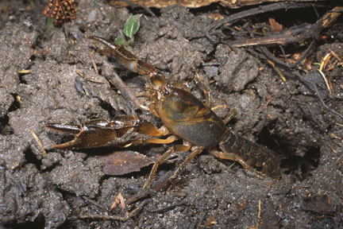

© Commonwealth of Australia 2011
This work is copyright. You may download, display, print and reproduce this material in unaltered form only (retaining this notice) for your personal, non-commercial use or use within your organisation. Apart from any use as permitted under the Copyright Act 1968, all other rights are reserved. Requests and inquiries concerning reproduction and rights should be addressed to Commonwealth Copyright Administration, Attorney General’s Department, Robert Garran Offices, National Circuit, Barton ACT 2600 or posted at www.ag.gov.au/cca.

Disclaimer
The contents of this document have been compiled using a range of source materials and is valid as at April 2011. The Australian Government is not liable for any loss or damage that may be occasioned directly or indirectly through the use of reliance on the contents of the document.

Front page photograph: Burnie burrowing crayfish. Photograph by Steve Wilson.
Important notice
Please note that these guidelines are general in nature and do not remove your obligation to consider whether you need to make a referral to the federal environment minister under the Environment Protection and Biodiversity Conservation Act 1999 (EPBC Act). While these guidelines provide information to help you decide whether to refer your action, the possible impacts of your proposal will depend on the particular circumstances of the action. These circumstances may include issues such as the precise location, mitigation measures, and indirect impacts.

These guidelines were made on the basis of the best information available at the time of writing. However, the impacts of proposals will be assessed by the department on the basis of the best information available at that point in time, which may differ from the information on which this guideline is based.

These guidelines do not provide guidance on requirements under state and local government laws. Information on Tasmanian and local government council laws can be obtained from the Tasmanian Department of Primary Industries, Parks, Water and Environment; and the local councils in or near the proposed project area.

How to use these guidelines
These guidelines are intended to assist you in determining whether your action needs to be referred to the Australian Government Department of Sustainability, Environment, Water, Population and Communities (the department). These guidelines should be read in conjunction with the EPBC Act Policy Statement 1.1 Significant Impact Guidelines – Matters of National Environmental Significance.

These guidelines apply to the Burnie burrowing crayfish (Engaeus yabbimunna), central north burrowing crayfish (E. granulatus), Mount Arthur burrowing crayfish (E. orramakunna) and Scottsdale burrowing crayfish (E. spinicaudatus), hereafter referred to collectively as burrowing crayfish, anywhere they may occur in Australia. These crayfish are listed as threatened species under the EPBC Act as follows:
- Burnie burrowing crayfish: vulnerable
- Central north burrowing crayfish: endangered
- Mount Arthur burrowing crayfish: vulnerable
- Scottsdale burrowing crayfish: endangered.

Listed threatened species and ecological communities are matters of national environmental significance under the EPBC Act. If you plan to undertake an action that has, will have or is likely to have a significant impact on burrowing crayfish you must refer the proposal to the minister before commencing. The minister will then decide, within 20 business days, whether assessment is required under the EPBC Act. The potential significance of each action is judged on a case-by-case basis. Substantial penalties apply for undertaking an action, to which the EPBC Act applies, without approval (civil penalties up to $5.5 million or criminal penalties including up to seven years imprisonment). More information on referral, assessment and compliance is available at www.environment.gov.au/epbc/.

The decision tree in Figure 1 and the rest of these guidelines are designed to assist you in determining whether your proposed action needs to be referred. You may also refer your proposed action if you are uncertain about the need to refer, or if you think the proposal would not have significant impacts on matters of national environmental significance, but would like legal certainty.

Possible exceptions to the need to refer
Certain actions are exempt from the requirement of assessment and approval under the EPBC Act. These include lawful continuations of land use that started before 16 July 2000, or actions that were legally authorised before 16 July 2000. There are a number of criteria that must be satisfied to rely on any such exemptions. More information on exemptions under the EPBC Act is available at www.environment.gov.au/epbc/publications/exemptions.html.
Figure 1: Decision making

YES
NO

YES or UNSURE

YES
NO
Have you surveyed for burrowing crayfish using the recommended methods (see Section 4)?
NO
or
UNSURE
REFERRAL RECOMMENDED
High risk of resulting in significant impact**
Assume your project may impact on an important population of burrowing crayfish (see Section 5) or the species as a whole (Section 6).
NO

Could your action impact on an important population of burrowing crayfish (see Section 5) or the species as a whole (Section 6)?
Is your impact mitigation best practice so that it may reduce the significance of your impacts on burrowing crayfish (see Section 7)?
Could the impacts of your action affect any burrowing crayfish habitat (see Section 3) or individuals?
REFERRAL MAY NOT BE REQUIRED*

Low risk that your action will result in a significant impact on burrowing crayfish (see Section 8)**
Uncertainty whether your action will result in a significant impact on burrowing crayfish (see Section 8)***
High risk that your action will result in a significant impact on burrowing crayfish (see Section 8)**
REFERRAL RECOMMENDED
OR CONTACT THE DEPARTMENT

REFERRAL RECOMMENDED

Could the impacts of your action occur within the modelled distribution of the burrowing crayfish (see section 2)?
YES or UNSURE
REFERRAL MAY NOT BE REQUIRED*
Low risk of resulting in significant impact**
YES or UNSURE
NO

REFERRAL MAY NOT BE REQUIRED*
Low risk of resulting in significant impact**
Could your action require a referral to the federal environment minister for significant impacts on burrowing crayfish (see Section 8)?
REFERRAL MAY NOT BE REQUIRED*
Low risk of resulting in significant impact**
* Although it would appear a referral may not be required, you may still refer your proposed action if unsure, or if you think the proposal would not have significant impacts on matters of national environmental significance, but would like legal certainty. An example may be when other matters of national environmental significance, in addition to burrowing crayfish, are potentially affected.
** Risk is the chance of something happening that will have a [significant] impact on objectives [eg protecting matters of national environmental significance] (adapted from Australian / New Zealand Risk Management Standard 4360: 2004).
*** If you are uncertain about the need to refer then you may also contact the Department to discuss your action by emailing epbc.referrals@environment.gov.au
1. What is known about burrowing crayfish?

Burrowing crayfish are medium to large invertebrates that live in burrow systems. Depending on the species, burrows may be located in stream beds, connected to the water table, or be dependant on surface runoff. The burrows typically have ‘chimneys’ of pelleted soil at the burrow entrance. Burrowing crayfish are omnivorous, feeding on decaying organic matter (for example, rotting vegetation) but also occasionally eating meat such as small worms or grubs. During the breeding season (in most cases spring through to early summer) adult females carry eggs or new hatchlings under the tail.

Relevant background information on the biology and ecology of burrowing crayfish is provided in the department’s Species Profile and Threats (SPRAT) database.

2. Could the impacts of your action occur within the modelled distribution of burrowing crayfish?

Mount Arthur burrowing crayfish
The distribution of the Mount Arthur burrowing crayfish is centred on Mount Arthur in north-east Tasmania. The species extends to near Lilydale, Nabowla and south Springfield, and is also found near Launceston (see Map 1).

Scottsdale burrowing crayfish
The Scottsdale burrowing crayfish has a small distribution north-east of Scottsdale (see Map 2). The species has considerable overlap with other crayfish from the Engaeus genus.

Burnie burrowing crayfish
The Burnie burrowing crayfish is known only from Burnie and the area immediately to the west (see Map 3).

Central north burrowing crayfish
The central north burrowing crayfish only occurs in central north Tasmania. The species is found in a triangular area running southwest from Port Sorell to the Railton area and north to Quoiba, near Devonport (see Map 4). The species’ distribution is restricted and fragmented, with limited connectivity between populations.

The distribution maps presented in this document are based on the best available information at the time of publication and remain a static product. For the most up-to-date report of whether burrowing crayfish may occur in your project area, always use the Protected Matters Search Tool.
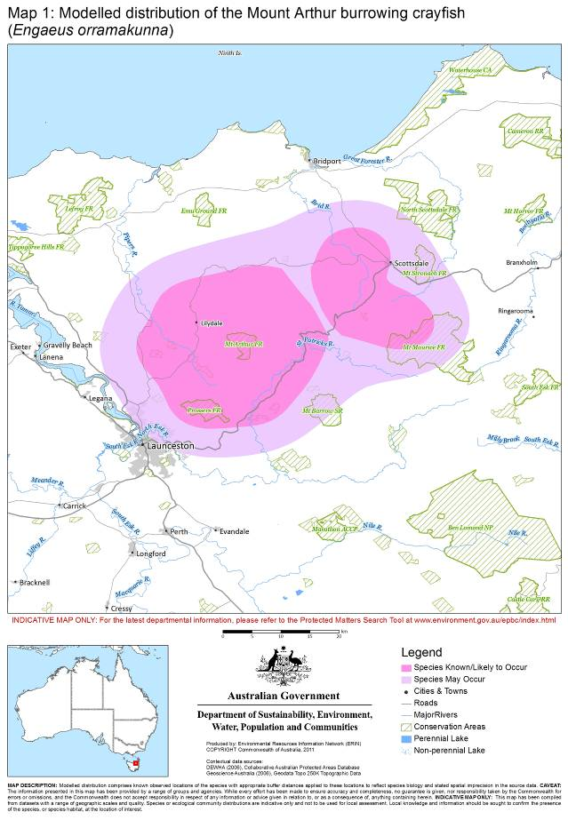
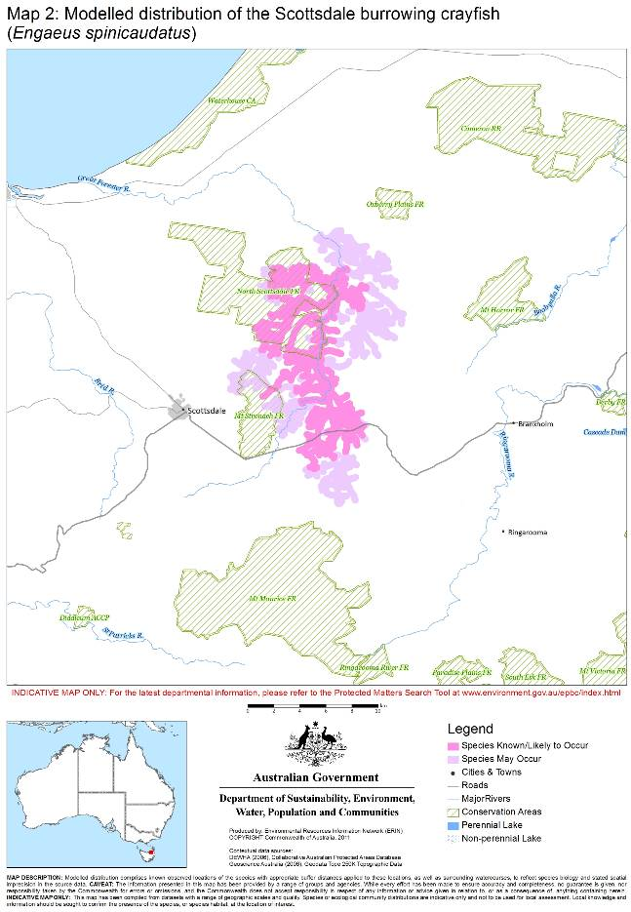
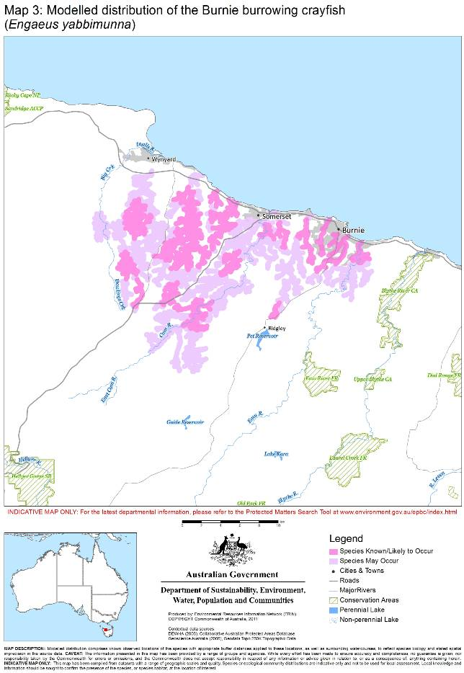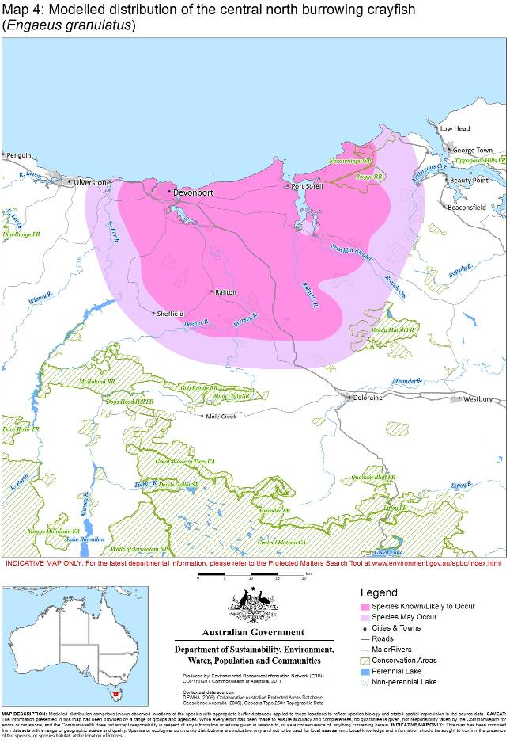3. Could the impacts of your action affect habitat for burrowing crayfish?

Burrowing crayfish are found in seeps, stream banks, swamps, wet forests and peaty areas. Specific habitats for the four species are set out below.

Burnie burrowing crayfish
Burnie burrowing crayfish occupy ferny, deep soil gullies and flats, with an understorey dominated by tree ferns. They are also found alongside small unimpacted waterways.

Central north burrowing crayfish
Central north burrowing crayfish are found in close proximity to streams and springs, largely on floodplains, in areas where the soil is high in organic matter. They are associated with riparian vegetation, usually tea tree swamp and remnants, but can also be associated with exotic weeds and grasses if aquatic conditions are suitable.

Mount Arthur burrowing crayfish
Mount Arthur burrowing crayfish occur in ferny, deep soil gullies and flats in wet sclerophyll forest, rainforest or plantations. The understorey is dominated by tree ferns.

Scottsdale burrowing crayfish
Scottsdale burrowing crayfish are found in sedgeland plains and scrub on peat/organic soils with impeded drainage.

4. Have you surveyed for burrowing crayfish using the recommended methods?

The following survey methods are recommended for presence / absence surveys. Where it is not possible to conduct surveys in this manner, failure to detect burrowing crayfish should not be considered indicative of their absence.

Surveys should:
- maximise the chance of detecting the species
- determine the context of the site within the broader landscape
- account for uncertainty and error (such as false presences and absences), and
- be conducted by a suitably qualified person with experience in burrowing crayfish surveys, or in consultation with burrowing crayfish experts.

Visual search
The first step in surveying for burrowing crayfish is a visual search to locate burrows within suitable habitat. Presence of burrows in suitable habitat indicates the presence of burrowing crayfish. The recommended minimum search effort is 1 hour per hectare.

Species distribution
In areas where only one burrowing crayfish species occurs, the presence of crayfish burrows confirms the presence of that species. However, in some areas, more than one crayfish species may be present (that is, the species occur together). If your action occurs in an area of overlapping distributions, further investigation is required once burrows have been located.

Burrow excavation
Where distributions of threatened and non-threatened burrowing crayfish overlap, burrows should be excavated to determine the species present at the site. The first step in this process is habitat stratification. Where two species of burrowing crayfish occur together they are usually found in different microhabitats; these are often determined by soil moisture and drainage, and are reflected in the soil type, vegetation, and so on. In each microhabitat type, burrows should be excavated until a burrowing crayfish is found. The crayfish should be identified to species level in the field and released on-site. Once a crayfish has been identified, the remaining burrows in that microhabitat type can be assumed to contain the same species and no further excavation of burrows is required in that microhabitat.

Burrow excavation surveys must be designed and implemented in a way that minimises the disturbance to habitat at the site (consult burrowing crayfish expert). Appropriate hygiene controls should also be maintained to avoid the spread of pathogens such as chytrid fungus and phytophthora (see for example the Keeping It Clean field hygiene manual).

5. Could your action impact on an important population of burrowing crayfish?

This policy defines ‘important populations’ in relation to the EPBC Act. The definition of an important population as described in this policy is not intended to inform judgements under other legislation.

Important populations are one consideration when assessing impacts on threatened species as they are important for future conservation, dispersal, maintaining population viability and supporting gene flow. If your action is likely to have a significant impact on an important population of one of these species you should refer the action.

For the purposes of assessment under the EPBC Act, an important population is defined as:
- Any occurrence of the endangered central north or Scottsdale burrowing crayfish
- Any occurrence of the vulnerable Mount Arthur or Burnie burrowing crayfish which meets all the following criteria:
  - A distance of 10 m or less between burrows
  - 20 or more burrows within a 10 m x 10 m area
  - Active (evidence of fresh burrowing) and
  - Occurs in relatively undisturbed habitat.
The flowchart below can assist you to determine if your action could impact on an important population.

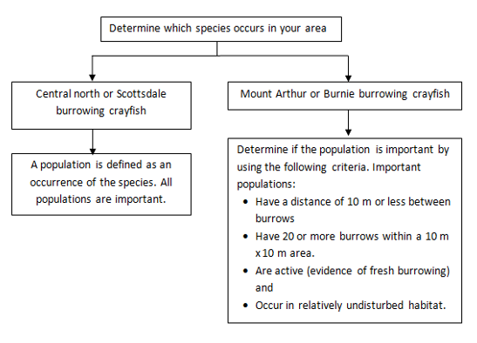

6. Could your action impact on the species as a whole?

Potential impacts on populations should be considered when determining whether to refer your action. However, you should also refer your action if it is likely to have a significant impact on a species as a whole. The criteria for significant impacts on the species as a whole differ for endangered and vulnerable species. The specific criteria for each can be found in the Significant impact guidelines 1.1.

Section 8 provides guidance for when one or more of these criteria may trigger the need to refer your action.

7. Is your impact mitigation best practice so that it may reduce the significance of your impacts?

Mitigation has the principle aim of avoiding significant impacts and should be applied in a hierarchical order:
1. Avoid impacts – preserve important populations and habitat to avoid further loss.
2. Mitigate impacts – prevent habitat degradation and retain habitat function.
3. Monitor effectiveness of mitigation – ensure mitigation is effective and feeds back into an adaptive management plan.

Table 1 outlines the main threats to burrowing crayfish, their impacts and mitigation. It is not intended to be exhaustive or prescriptive.

Table 1: Primary threats, impacts and mitigation

Threat | Impact | Mitigation
Water: reduced quality and quantity  - Changes to the water table caused by altered hydrology regimes (such as extraction and drainage)  - Reduction in surface flows  - Reduced water quality, including sedimentation from road construction, nutrient loads from fertilisers and chemicals such as biocides. | - Degradation of habitat  - Loss of colonies  - Reduced recruitment | - Design developments to avoid land occupied by colonies.  - Avoid ploughing or machinery use on land occupied by colonies.  - Avoid drainage or other processes that lower the water table.  - Avoid changes in surface flows or drainage patterns in key habitat and colony areas.  - Fence colonies to protect them from soil compaction and churning from stock.  - Maintain ANZECC water quality parameters. Control polluted runoff by controlled application measures and use of aquatic habitat-friendly chemicals. Use appropriate road design and sediment controls.  - Implement appropriate fire regimes in Scottsdale burrowing crayfish habitat.  - Attach management agreements/covenants to the land title where colonies occur.  - Use signage to raise awareness of the presence of crayfish burrows and sensitivity of the habitat.  - Implement weed and rubbish control programs to limit degradation of natural riparian vegetation.  - Restore disturbed habitat with native vegetation.
Direct disturbance and fragmentation  - Soil compaction from stock and machinery  - Churning or ploughing of soil from stock and machinery  - Loss of burrows from construction activities, linear infrastructure, forestry or agricultural operations | - Loss of habitat  - Loss of colonies  - Reduced population size  - Increased extinction risk to species  - Reduced gene flow between colonies/populations  - Reduced ability to recolonise disturbed sites
Fire | - Destruction of peat habitats caused by fire in peat layer
Invasive species | - Competition from the introduced common yabby Cherax destructor

8. Could your action require a referral to the federal environment minister for significant impacts on burrowing crayfish?

The referral guidelines below apply to all occurrences of the endangered central north burrowing crayfish and Scottsdale burrowing crayfish.

For the vulnerable Mount Arthur burrowing crayfish and Burnie burrowing crayfish, the referral guidelines apply to important populations of the species (see Section 5).

As the person proposing the action it is your responsibility to decide whether or not to refer your action. If you believe your action is at high risk of having a significant impact on burrowing crayfish you should refer the action to the federal environment minister. If you are uncertain whether your action will have a significant impact on burrowing crayfish you may also refer your action or contact the department. Table 2 provides general guidance on what, in the department’s view, may be at high and low risk of requiring a referral to the department as well as providing some guidance on uncertainty.

Table 2: Referral guidelines
High risk of significant impacts on burrowing crayfish: referral recommended
- Alteration to the water table, drainage patterns or surface flows: permanent or long-term change (increase or decrease) outside of the natural annual variation.
- Water quality outside of parameters in the ANZECC guidelines.
- Soil compaction, churning or ploughing occurring in burrow areas.
- Clearing or loss of individual burrows.
- Fire in peat habitats during dry periods.
Uncertainty of impacts on burrowing crayfish: referral recommended or contact the department
- Possibility for introduction of the common yabby.
- Clearing or fragmentation of vegetation around areas of suitable burrowing crayfish habitat. This can have implications for water quality degradation, increased sedimentation, changes in extent and frequency of hydrological inflows to aquatic habitat, disturbance of connective colony tunnels etc.
Low risk of significant impacts on burrowing crayfish: referral may not be required but you may refer for legal certainty
- Actions with impacts that do not occur within the distribution of the species.
- Actions that will not directly or indirectly affect burrowing crayfish important populations.
9. Where can you get more information?

The SPRAT profile for this species provides the biological and ecological context for survey guidelines, mitigation measures and significant impact guidance. It can be accessed at www.environment.gov.au/cgi-bin/sprat/public/sprat.pl.

Other EPBC Act policy statements are available to help you understand the EPBC Act and your obligations. They are available from the department’s website at www.environment.gov.au/epbc/guidelines-policies.html or by contacting the community information unit by email: ciu@environment.gov.au or by phone: 1800 803 772. The department can provide assistance in ensuring your action complies with the EPBC Act, especially when contacted early in the planning process.

The Protected Matters Search Tool can provide a good starting point for determining the likelihood of having matters of national environmental significance in your area. State and territory government agencies may also hold relevant information including habitat and species distribution information.

.

When considering whether or not your action will have a significant impact on burrowing crayfish, it is relevant to consider all adverse impacts from the action, including direct, indirect and offsite impacts such as downstream or downwind impacts, upstream impacts and facilitated impacts (impacts that result from further actions, which are made possible or facilitated by the action).
Habitat stratification: separating habitat types on the basis of internally consistent characteristics that distinguish them from other types.
Microhabitat: specialised habitat within the broader ecosystem in which a species is found. Small-scale variations in physical features of the landscape result in localised differences in temperature, soil type, vegetation cover, water etc.
Surface flows are particularly important in Mount Arthur burrowing crayfish habitat.

