

Referral guideline for the vulnerable water mouse Xeromys myoides

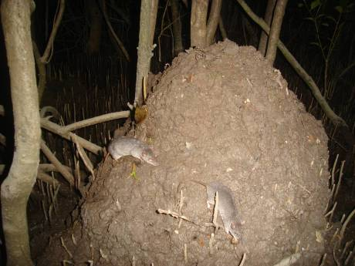

December 2015

Acknowledgements
The Department of the Environment would like to thank the following people for their valued expert advice or publications for use in the development of this referral guideline: Steve Van Dyck, Heather Janetzki, John Woinarski, Ian Gynther, Derek Ball, Tina Ball, Simon Ward, Rod Hobson, Mark Breitfuss, Nina Kaluza, John McLachlin Karr, Andrew Tapsell, Tanya Russell and Stephanie Kiem.

© Copyright Commonwealth of Australia, 2015.


The ‘Referral guideline for the vulnerable water mouse’ is licensed by the Commonwealth of Australia for use under a Creative Commons By Attribution 4.0 licence, with the exception of the Coat of Arms of the Commonwealth of Australia, the logo of the agency responsible for publishing the report, content supplied by third parties, and any images depicting people. For licence conditions see: http://creativecommons.org/licenses/by/4.0/

This report should be attributed as ‘Referral guideline for the vulnerable water mouse, Commonwealth of Australia, 2015’.

The Commonwealth of Australia has made all reasonable efforts to identify content supplied by third parties using the following format ‘© Copyright, [name of third party]’.

Disclaimer
While reasonable efforts have been made to ensure that the contents of this publication are factually correct, the Commonwealth does not accept responsibility for the accuracy or completeness of the contents, and shall not be liable for any loss or damage that may be occasioned directly or indirectly through the use of, or reliance on, the contents of this publication.

Front page image: © Copyright Nina Kaluza, University of Queensland

Summary
The water mouse is listed as Vulnerable on the threatened species list under the Environment Protection and Biodiversity Conservation Act 1999 (EPBC Act). It is a nocturnal rodent that inhabits mangrove communities and associated saltmarsh, sedgelands and clay pans, as well as coastal heathlands and freshwater wetlands. Where these habitats have intact hydrology, active nest sites and prey resources, they are habitat critical to the survival of the water mouse. This habitat is threatened by urban and industrial development and by unsympathetic agricultural practices where it continues to be cleared or degraded by changes in hydrology. Of parallel concern is the growing evidence of foxes predating on water mice and habitat degradation by feral pigs. Cats are also considered likely predators. Modelling under global sea level rise scenarios has predicted water mouse extirpation in c.50 years assuming ongoing predation and habitat loss from urbanisation.
The national recovery objective for the water mouse is to improve its conservation status and habitat through habitat protection, reduction of threats, research and increasing public participation in recovery activities (DERM 2010). Actions interfering with water mouse recovery are highly likely to have a significant impact and will require referral to the Department prior to any commencement of the action.
This guideline contains ecological information important for decision-making, advice about undertaking surveys and mitigation standards.
The following points and the diagram in Figure 1 summarise this guideline:
- The water mouse is one single nationally important population
- Fundamental to avoiding significant impacts on the nationally important water mouse population are:
- protecting habitat critical to the survival of the water mouse
- avoiding any adverse effects to habitat critical to the survival of the water mouse and
- retaining dispersal opportunities for the water mouse
- Proponents proposing actions in suitable water mouse habitat are encouraged to undertake targeted surveys for the water mouse, applying the primary survey techniques outlined in this guideline
- Proponents proposing actions in habitat that is already known to be critical to the survival of the water mouse should adopt less invasive survey approaches and instead focus on mitigation measures and field studies verifying habitat, hydrology and connectivity to improve effectiveness of the mitigation measures
- Referral to the Department is likely to be required when habitat critical to the survival of the water mouse is adversely affected
- Adopting the standards in section 6 of this guideline will assist in avoiding adverse effects on habitat critical to the survival of the water mouse.
- Referral to the Department is unlikely to be required if the standards in section 6 are met.

Figure 1 Summary of the referral decision-making process

YES
YES
NO
NO or UNSURE

YES
NO
NO
NO
YES
YES
CONSIDER UNDERTAKING SURVEYS OTHERWISE REFERRAL IS LIKELY TO BE REQUIRED
High risk of a significant impact on the water mouse.

Is your action proposed within, adjacent to or nearby habitat critical to the survival of the water mouse and could result in direct or indirect impacts to that habitat (maps and section 2)?
Have you undertaken surveys for the water mouse using the recommended methods (section 4)?
Familiarise yourself with the water mouse and its recovery needs (section 1).

Familiarise yourself with the EPBC Act approvals process and the Significant Impact Guidelines 1.1 (see Preamble).
Apply the standards to avoid adverse effects to habitat critical to the survival of the water mouse (section 5 and 6).

REFERRAL UNLIKELY TO BE REQUIRED
Low risk of a significant impact on the water mouse

REFERRAL LIKELY TO BE REQUIRED

High risk of a significant impact on the water mouse

Will your action affect any suitable habitat for the water mouse either directly or indirectly (maps 1-5 and section 3)?
REFERRAL UNLIKELY TO BE REQUIRED

Low risk of a significant impact on the water mouse
Is the habitat critical to the survival of the water mouse (section 2)?
Preamble
Important notice
Please note that this Guideline is general in nature. It does not remove your obligation to consider whether you need to make a referral to the Minister for the Environment (the Minister) under the Environment Protection and Biodiversity Conservation Act 1999 (Cth) (the EPBC Act). While this guideline provides information to help you decide whether to refer a proposed action, the possible impacts of the proposed action will depend on the circumstances of the action. These circumstances may include the proximity of the action to habitat, indirect impacts and impact avoidance and mitigation measures.
This Guideline does not provide guidance on requirements under state, territory or local government laws.
Actions that will have or are likely to have a significant impact on the water mouse
If you propose to take an action that will have or is likely to have a significant impact on the water mouse, you must refer the proposed action to the Minister prior to commencing the action. The Minister will then decide within 20 business days whether assessment is required under the EPBC Act. When making a decision on whether a proposed action requires assessment, the Minister must consider all relevant information and act in a manner consistent with natural justice and procedural fairness obligations. An action that is determined to be a controlled action, as it will have or is likely to have a significant impact on the water mouse, must not commence until the Minister makes an approval decision. Substantial penalties apply for undertaking such an action without Commonwealth approval (civil penalties up to $8.5 million or criminal penalties including up to seven years imprisonment).
More information on the referral, assessment and approval process is available at www.environment.gov.au/epbc/assessments/index.html. Information on compliance and enforcement of the EPBC Act can be found at www.environment.gov.au/epbc/compliance/index.html. If you are uncertain about the need to refer, you may refer your proposed action for legal certainty, or contact the Department to discuss your proposed action by emailing epbc.referrals@environment.gov.au.
How to use this Guideline
This Guideline is designed to be read from the perspective of a person or party proposing to take an action that may have a significant impact on the water mouse. Parts of the Guideline contain information that requires a developed understanding of the EPBC Act assessment process and the ecology of the water mouse, as well as broader ecological concepts. Some proponents may need to seek assistance from suitably qualified or experienced people when applying them to a particular action. There is an expectation that the self-assessment process would be carried out by (or be informed by) people with a reasonable level of knowledge and experience in these matters.
This Guideline should be read in conjunction with the Significant Impact Guidelines 1.1 - Matters of National Environmental Significance (Significant Impact Guidelines), which explain the concept of a ‘significant impact’. The Significant Impact Guidelines can be found on the Department’s website at www.environment.gov.au/epbc/publications/nes-guidelines.html.
Information base for this Guideline
This Guideline has been developed using the scientific knowledge of species experts who attended a workshop for the species in 2009 as well as publications and other available information outlined for this species in the Department’s Species Profile and Threats Database (SPRAT; see the profile for the water mouse).
Although this Guideline has been developed based on the most up-to-date scientific information available at the time of writing, a referral will be assessed by the Department on the basis of the most up-to-date scientific information available at the time of referral, which may build upon the information reflected in this Guideline or the species SPRAT profile.

Section 1: What is known about the water mouse and what does it need to recover?
The water mouse is a small, unmistakable mouse with a unique behaviour and ecology. The water mouse is one single national important population which extends along the coastline from south east Queensland to the Northern Territory (Benfer et al 2014). The overall recovery objective for the national water mouse population is to improve its conservation status and habitat through habitat protection, reduction of threats to the species and its habitat, research and increasing public participation in recovery activities (DERM 2010).
The following information summarises research and conservation action since development and adoption of the national recovery plan for the water mouse in 2010. Most of the research and conservation action has been focused in south-east Queensland with new sub-populations discovered in the Foreshores area, Gladstone harbour and adjacent Curtis Island, and important information gathered about population size and threats (in particular predation by foxes) in the Maroochy River and Great Sandy Strait (Kaluza 2012).
There has also been increased public participation and education in the south-east Queensland through collaboration between multiple organisations, which has built an improved understanding of water mouse ecology. Signage at important sites has been installed and a monitoring methodology has been developed for south-east Queensland sites (Kaluza 2012). It is, however, premature to assess the extent to which any actions have resulted in a benefit to the species’ conservation status (Woinarski et al 2014).
Sub-populations are being monitored and protected in the Gladstone harbour and offshore Curtis Island. On Bribie Island there has been an assessment of the water mouses status which identified a probable past decline in this sub-population due to habitat loss and highlighted the potentially serious impacts of changes in hydrology on this species (Gynther 2011). In the Mackay region, sub-populations continue to be monitored by the Queensland Parks and Wildlife Service and habitat and distribution are reasonably well understood.
In the Northern Territory, knowledge of water mouse distribution and habitat requirements remain incomplete. In the Top End of the Northern Territory and including suitable habitats westwards into the Kimberley region of Western Australia and east into far northern Queensland, significant knowledge gaps exist regarding the species’ presence, mainly given the remoteness of habitat and the difficulties to field workers posed by the presence of saltwater crocodiles.
Building on a suite of detailed water mouse research through the 1990s and early in the 2000s, a recently published study has confirmed the importance of certain habitat variables and structure and landscape complementation for the water mouse (Russell and Hale 2009). There has also been modelling under global sea level rise scenarios which has predicted water mouse extirpation in c.50 years assuming ongoing predation and habitat loss from urbanisation (Trail et al 2011).
Habitat loss, fragmentation and degradation through changed hydrology and expression of acid sulphate soils and the serious threat from feral predators, particularly foxes, remain the most severe threats to the water mouse (Russell and Hale 2009, Kaluza 2012, Woinarksi et al 2014).
Section 2: Is your action proposed within, adjacent to or nearby habitat critical to the survival of the water mouse and could it result in direct or indirect impacts to that habitat?
Habitat critical to the survival of the water mouse includes all mangrove communities, intertidal communities, and coastal freshwater wetlands with one or more of the following features:
- Intact hydrology
- Prey resources (Crustaceans, marine polyclads and marine pulmonates and bivalves)
- Active water mouse nest structures and/or
- A defined supralittoral bank that could enable the construction of nests.
Habitat critical to survival of the water mouse may not have all of these features and importantly they may not be obvious to the inexperienced observer (see section 4 on importance of surveys for the water mouse).
Direct or indirect impacts on this habitat may result from vegetation clearing, drainage works, filling, excavating, increased freshwater surface run off, on shore dredge disposal, bunding, cattle grazing, chemical spraying, recreational vehicle activities, weed or feral animal invasion or potential flooding in, adjacent to or nearby this habitat.
Section 3: Will your action affect any suitable habitat for the water mouse either directly or indirectly?
The water mouse has been recorded in three regions of coastal Australia. Between these regions there is potential for further discoveries and increased knowledge of habitat critical to the survival of the water mouse (see Maps 1-5).
The water mouse primarily forages at night in the intertidal zone, particularly amongst mangroves, at low tide, preying on crustaceans, molluscs and flatworms. It nests either in muddy tunnels in banks, mud nests including termite-like mounds and mud ramps built within the buttress roots of mangroves or in tree hollows during high tides. Its habitat can differ within and across regions but it essentially depends on mangrove communities and associated saltmarsh, sedgelands and clay pans, as well as coastal heathlands and freshwater wetlands (see Figure 2).
If your action may affect any suitable water mouse habitat then targeted surveys should be undertaken to confirm if habitat to be affected is habitat critical to the survival of the water mouse. Further habitat information that could help with planning surveys for the water mouse is provided in the Department’s SPRAT profile for the water mouse.

Map 1 Indicative distribution of the water mouse in Australia
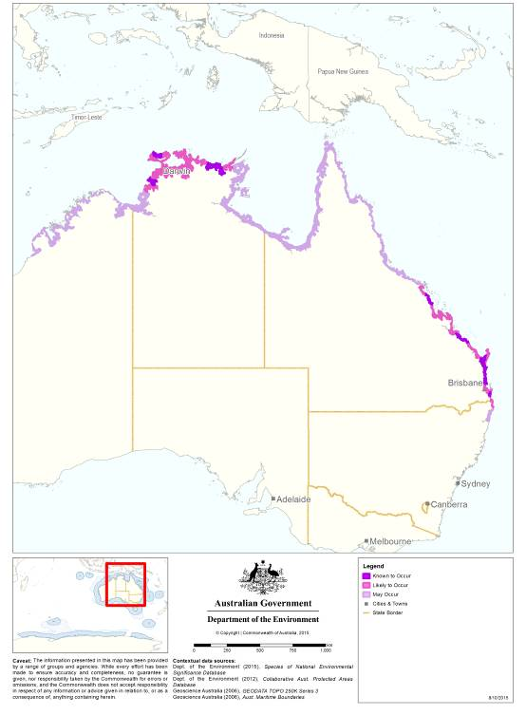

Map 2 Indicative distribution of the water mouse in south-east Queensland
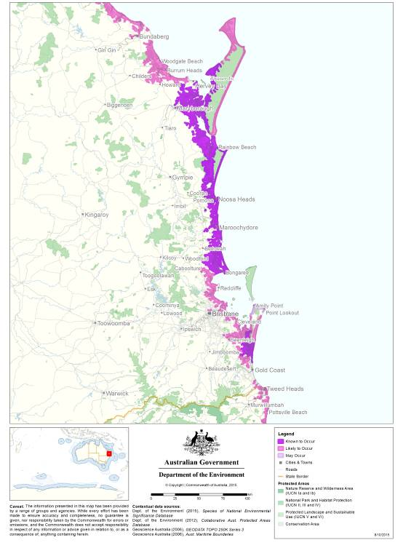

Map 3 Indicative distribution of the water mouse between Wide Bay and Shoalwater Bay, Queensland
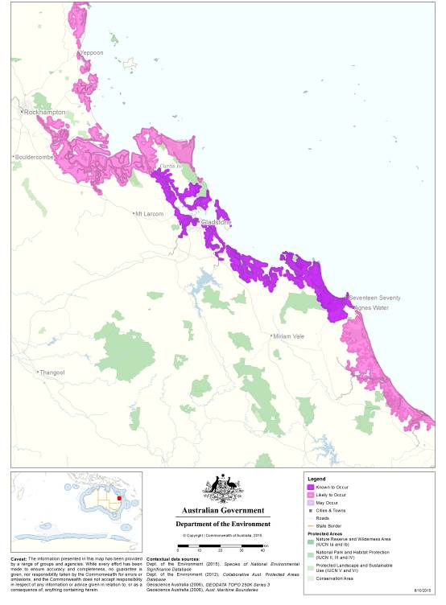

Map 4 Indicative distribution of the water mouse around Mackay, Queensland
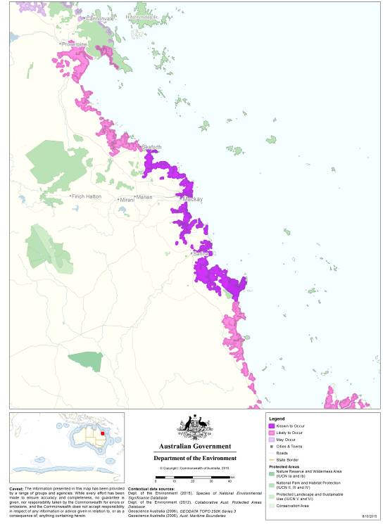

Map 5 Indicative distribution of the water mouse in the Northern Territory
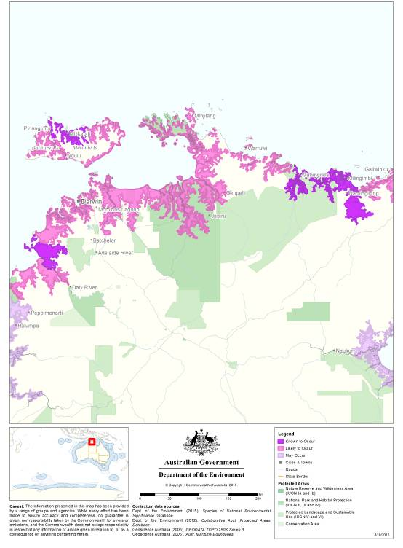

Figure 2 Suitable water mouse habitats
Supralittoral zone
Raised nests built near the base of Ceriops tagal and Bruguiera spp. are characteristic of habitats in central south Queensland and Northern Territory. Nests inside hollow trees are common in south east Queensland.

hwm
lwm
Littoral zone
Sublittoral zone
The water mouse is known to nest in the supralittoral bank in south east Queensland.

Freshwater wetlands adjacent to the littoral zone usually occur as Eucalyptus, Corymbia, Casuarina or Melaleuca woodlands.

Free standing nest mounds built by the water mouse occur in Juncus sedgelands and Sporobolus grasslands in south east Queensland and Northern Territory as well as in mangrove communities in south east Queensland.

The littoral zone is the most productive area for the water mouse. Mangrove communities provide a variety of microhabitat features important to the water mouse including:
tidal pools
channels
crab holes
pneumatophores
crevices in bark and around roots
hollows
standing and fallen timber
suspended drifts of twigs and leaves and
driftwood.
These microhabitats vary according to the community structure.

Section 4: Have you undertaken surveys for the water mouse using the recommended methods?
Proponents proposing actions in, adjacent to or nearby habitat that is already known to be critical to the survival of the water mouse should adopt less invasive surveys for the water mouse by using remote movement-activated cameras and active searching to confirm extant status. Camera surveys should target activity at nest mounds, nests in trees, tree hollows or in supralittoral banks.
In circumstances where the water mouse has previously been confirmed to occur at a site, additional effort should be placed on field studies verifying the hydrology and connectivity of the study site and detailing the habitat. This will assist with the design and improve the effectiveness of proposed mitigation measures.
Where nest presence and persistence is unknown but suitable habitat is present, targeted surveys are recommended to determine the likelihood of water mouse presence. The recommended approach for conducting surveys for the water mouse is outlined below. Surveys should:
- Be conducted by a suitably qualified person with the requisite approvals and experience in mammal surveys in tidal wetlands
- Account for tidal variability at the site of investigation
- Maximise the chance of detecting the species
- Determine the context of the site within the broader landscape, and
- Account for uncertainty and error.
It is recommended that all primary survey techniques are undertaken, either with or without the use of supplementary survey techniques.

Primary survey techniques
Habitat assessment, daytime searches for nesting sites and evidence of foraging and Elliott or camera trapping are the most reliable methods for detecting the presence of the water mouse. Surveyors should examine satellite imagery or aerial photographs and topographical maps before commencing a habitat assessment or trapping program. This will help to identify elevated, dry supralittoral areas within mangrove communities which may support active nest structures, allowing these areas to be targeted.
Habitat assessment
A habitat assessment should record all notable habitat features in the study area including vegetation types and species, presence of predator and prey species, supralittoral banks, trees with hollow trunks, as well as any areas of disturbance.
Daytime searching
Daytime searches should include transect style searches, with spacing appropriate to the type and density of vegetation community being assessed, and involve one to two hours spent looking for nesting structures or water mouse prey remains for every one hectare of intertidal or supralittoral water mouse habitat.
Elliott trapping
Elliott trapping (Size A) must be carried out at night. Elliott trapping is the most reliable method for confirming presence of water mouse and if necessary, estimating population density. Elliott traps should be baited with pilchards cut in half, mullet pieces or commercial cat food. The minimum survey effort required to trap the water mouse is 100 trap-nights per hectare of suitable water mouse habitat. Special care and attention is required to ensure traps are not left open during the incoming tide so as to avoid drowning water mice.
Camera trapping
Camera trapping when carried out effectively can also be a reliable method for confirming presence of the water mouse³. Assuming it is carried out effectively it can replace the need for Elliot trapping especially when daytime searching has identified potential nesting sites or when the water mouse has previously been identified to occur at the study site. Camera trapping should follow the guidance for targeted camera surveys outlined in the Queensland government’s terrestrial vertebrate fauna guidelines (Eyre et al 2014).
Supplementary survey techniques
To increase the certainty of presence or absence of water mouse on site, primary survey techniques can be supplemented by spotlighting, hair tubing and pitfall trapping in non tidal habitats. Given the cryptic nature of this species, when in suitable habitat and primary methods have failed to detect the species, supplementary methods should also be adopted to provide a comprehensive assessment.
Please refer to the SPRAT database for additional details on primary and secondary survey techniques including regional considerations for the various survey techniques.
Section 5: Are you likely to adversely affect habitat critical to the survival of the water mouse?
Adversely affecting habitat critical to the survival of the national water mouse population will require referral to the Department.
Adverse impacts on habitat critical to the survival of the water mouse are likely to result from any activity in, nearby or adjacent to habitat critical to the survival of the water mouse that:

- Clears habitat critical to the survival of the water mouse
- Changes freshwater inflows so that they no longer demonstrate their natural or ambient magnitude and variation
- Affects prey abundance and density
- Increases potential for acid sulphate soil exposure or impact
- Introduces cattle grazing or recreational vehicle use that affects soil surface attributes
- Introduces chemical use that adversely affects prey resources or foraging activity
- Fragments habitat and restricts water mouse dispersal
- Reduces foraging effectiveness by the water mouse
- Changes tides from their natural or ambient volume, frequency or duration
- Changes water quality from their natural or ambient sediment, nutrient, salinity and toxicant loads
- Changes fire regime from their natural or ambient magnitude and frequency, or
- Changes weed and feral animal levels that result in increased population density or extent.
Section 6: How do I avoid and or mitigate adverse effects on habitat critical to the survival of the water mouse?
The adoption of the standards described below will likely ensure adverse effects on habitat critical to the survival of the water mouse are avoided. As a result, referral under the EPBC Act is unlikely to be required if the mitigation standards outlined below are properly implemented.
Any action in, nearby, adjacent to or adjoining habitat critical to the survival of the water mouse should ensure:
- Buffers of natural vegetation of at least 50 m from habitat critical to the survival of the water mouse are implemented
- Protection of this habitat should ensure the mangrove and sedge/saltmarsh zones are preserved and protected by the abutting zone of vegetation or the defined supralittoral bank is protected
- Existing hydrology (including any appropriate flood regime, as well as water flow and quality) is maintained
- Foxes, cats and pigs are controlled and managed
- Supralittoral and intertidal habitat corridors are retained and connectivity exists between an array of habitat types
- Any fresh water run-off is captured to avoid degradation to habitat critical to the survival of the water mouse, including on prey abundance due to changes in salinity
- The spread and invasion of noxious weeds is controlled and managed
- Nearby or adjacent construction management practices includes plant and personnel wash down, quarantine, material treatment and material import limits
- Fencing and signage is implemented to avoid degradation of habitat critical to the survival of the water mouse, i.e. through cattle grazing or vehicle access.

References

Benfer, David, Baker, Andrew M., Ball, Tina, Gynther, Ian, Janetzki, Heather, and Fuller, Susan (2014). Conservation genetics of the water mouse, Xeromys myoides Thomas, 1889. Australian Journal of Zoology 62, 382–392.

Department of Environment and Resource Management [DERM] (2010). National recovery plan for the water mouse (false water rat) Xeromys myoides. Report to Department of Sustainability, Environment, Water, Population and Communities, Canberra. DERM, Brisbane.

Eyre TJ, Ferguson DJ, Hourigan CL, Smith GC, Mathieson MT, Kelly, AL, Venz MF, Hogan, LD & Rowland, J (2014). Terrestrial Vertebrate Fauna Survey Assessment Guidelines for Queensland. Department of Science, Information Technology, Innovation and the Arts, Queensland Government, Brisbane.

Gynther, Ian C (2011). Distribution and ecology of the water mouse 'Xeromys myoides' on Bribie Island, South-Eastern Queensland. Royal Society of Queensland.

Kaluza, Nina (2012). Reports on field surveys for the water mouse in the sunshine coast region, University of Queensland.

Russell, Tanya L. and Hale, Peter T (2009). Conservation of the false water rat (Xeromys myoides) depends on landscape complementation. Australian Mammalogy, 31 (2). pp. 81-87.

Traill, L. W., Perhans, K., Lovelock, C. E., Prohaska, A., McFallan, S., Rhodes, J. R. and Wilson, K. A (2011). Managing for change: wetland transitions under sea-level rise and outcomes for threatened species. Diversity and Distributions, 17: 1225–1233.

Woinarski, J., Burbidge, A., & Harrison, P (2014). Action Plan for Australian Mammals 2012, CSIRO Publishing.

