National Landcare Program - Regional Land Partnerships MERI framework

**Introduction and Purpose of the Framework**

The Australian Government is committed to demonstrating and accounting for intermediate and long term outcomes and improvements from its natural resource management (NRM) investments. Monitoring and reporting on progress and improvement is an essential element of effective program management.

The purpose of this Monitoring, Evaluation, Reporting and Improvement (MERI) framework is to outline the MERI approach for Regional Land Partnerships, under the second phase of the National Landcare Program. This MERI Framework has been developed jointly by the Department of the Environment and Energy and the Department of Agriculture and Water Resources (the Departments) to ensure:

* service providers understand their reporting obligations and establish effective systems to capture and report the required information on project progress and achievements;
* service providers understand their obligations to identify and provide access to sites and project information for targeted monitoring if required;
* the Australian Government can track and report on the program’s progress in delivering funding, activities, outcomes and expenditure;
* information collected in the administration of the program is used effectively by funding recipients and the Australian Government, to inform the review and future design and delivery of projects and programs; and
* there is accountability from service providers and the Australian Government for public expenditure.

This framework builds on the original National Landcare Program [Monitoring and Reporting plan](http://www.nrm.gov.au/system/files/resources/bd84784f-d97b-4856-8bba-6b4356ceb0b5/files/nlp-monitoring-reporting-plan.pdf) and is based on the [Australian Government’s Natural Resource Management Monitoring, Evaluation, Reporting and Improvement Framework](http://nrmonline.nrm.gov.au/downloads/mql:2338/content).

**MERI approach for phase two of the National Landcare Program**

The MERI approach will be implemented in accordance with the [Australian Government’s Natural Resource Management Monitoring, Evaluation, Reporting and Improvement Framework](http://nrmonline.nrm.gov.au/downloads/mql:2338/content), and will support the evaluation of progress towards achieving the outcomes of phase two of the National Landcare Program.

The MERI approach for phase two of the National Landcare Program will support the key principles of the framework by:

* Assessing the performance of NRM interventions by implementing monitoring that encompasses a range of temporal and spatial scales;
* Incorporating multiple lines of quantitative and qualitative evidence about the state (i.e. condition) and trend of identified NRM assets and the impact of program investment in an effort to describe what the program has achieved and how the achievements were accomplished;
* Establishing and fostering constructive partnership among state and territory governments, service providers and research institutions in the design and implementation of long term monitoring;
* Delivering meaningful evaluations that are recognised by stakeholders as being well informed, relevant, timely, and are clearly and concisely presented; and
* Establishing effective evaluation methods and feedback loops from evaluation to policy makers and operational staff to inform program changes and improvements.

The methods to meet these principles are set out under each of the MERI headings below.

**Monitoring**

Program monitoring will be informed by the evaluation plan and rely on multiple lines of evidence. Monitoring will be carried out at the two levels specified in the [Australian Government’s Natural Resource Management Monitoring, Evaluation, Reporting and Improvement Framework](http://nrmonline.nrm.gov.au/downloads/mql:2338/content): asset monitoring and program performance monitoring. These are required over a range of spatial and temporal scales to achieve this, as shown in Figure 1.

Asset monitoring refers to a process of continually assessing the state of, and change over time, in NRM assets. The relatively short time period of the Regional Land Partnerships means that monitoring will be required outside the Regional Land Partnerships cycle to determine its long term impacts.

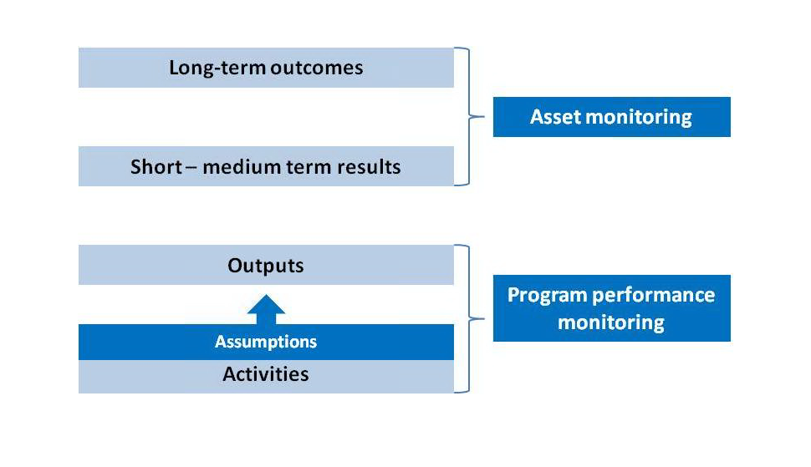

Figure 1: Proposed levels of asset monitoring

**Long-term outcomes monitoring**

Long-term outcomes monitoring will be carried out beyond the program cycle to determine the success of the program and the impact of interventions on sites, nationally. The delivery of this component of monitoring will be developed through a separate monitoring procurement process. Service providers are required to provide third parties, contracted by the Departments, access to works sites to deliver program monitoring. Projects selected for monitoring will be notified by the Departments. Selection of a project for independent monitoring would not reduce a service provider’s responsibilities for project monitoring.

**Short – medium term results monitoring:**

Short – medium term results monitoring (targeted monitoring) will be carried out on selected projects to determine the social, economic and environmental outcomes. Efforts will be made to get national coverage for targeted monitoring. The approach and delivery of this component of monitoring will be developed through a separate monitoring procurement process. Service providers are required to provide third parties, contracted by the Departments, access to works sites to deliver program monitoring. Service providers with projects selected for monitoring will be notified by the Departments. Selection of a project for independent monitoring would not reduce a service provider’s responsibilities for project monitoring.

Service providers may be contracted to monitor the impacts of their interventions over the life of the project. Monitoring methods may not be prescribed by the Departments but baseline data and specific types of information would be required to support program evaluations. Service providers are likely to be required to provide an analysis of what this monitoring is showing at the midterm and end of project report.

Service providers may be contracted to classify Threatened Ecological Community (TEC) project sites pre and post works. This classification process would follow the prescribed method in the conservation advice for the relevant community to allow the Departments to report on condition change at TEC sites.

**Outputs and Activity Monitoring:**

This level of program performance monitoring will be informed by project reporting and the data specified in the evaluation plan. Progress of projects and the program in meeting targets for undertaking activities and delivering outputs will be monitored along with the administration of the program by the Departments.

**Evaluation**

Evaluation will provide transparency and accountability while assessing program performance and establishing how well the program is delivering against key performance indicators and program outcomes. The evaluation will include an exploration of what is and is not working well and identify improvements to program structure, processes and delivery approaches for adoption during the life of the program and in future program design. An evaluation plan is currently in development.

***Evaluation principles***

The [Australian Government’s Natural Resource Management Monitoring, Evaluation, Reporting and Improvement Framework](http://nrmonline.nrm.gov.au/downloads/mql:2338/content) describes MERI as ‘a continuous cycle of participation and communication rather than a single evaluation and event. MERI promotes learning and adaptive management in response to progressive monitoring and evaluation which enables improvement in program design and achievement of desired outcomes’. This adaptive management cycle is shown in Figure 2.

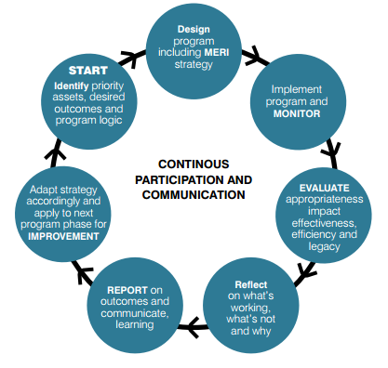

Figure 2: Conceptual diagram of the MERI adaptive management cycle (Australian Government, 2009)

The program will use this adaptive management cycle to address the following evaluation principles:

* ‘integrated’ into the design of the program;
* ‘fit-for-purpose’ proportional to the program;
* ‘timely’ to support and inform decision making processes;
* ‘evidence-based’ using best available data;
* ‘independent’ at an appropriate degree;
* ‘transparent’ and widely communicated; and
* ‘outcomes-focussed’ on the difference the program is making.

***Program Logic***

Consistent with the [Australian Government’s Natural Resource Management Monitoring, Evaluation, Reporting and Improvement Framework](http://nrmonline.nrm.gov.au/downloads/mql:2338/content), Regional Land Partnerships uses a theory of change program logic hierarchy approach to describe how the program will improve Australia’s natural environment and natural resources. The program logics and sub logics show the links between services delivered by service providers and program outcomes and can be found [here](http://www.nrm.gov.au/regional-land-partnerships/program-logic).

***Evaluation products***

The Evaluation will be informed by service providers’ project monitoring and reporting. The following evaluations and reports are required:

**Annual (financial year) progress reports:** A simple, easy to understand annual progress report produced by the Departments at the end of each financial year. The annual progress report would utilise key performance indicators to measure and report on progress towards the achievement of intermediate and program level outcomes and provide a basic evaluation of progress towards outcomes. The information in the annual progress reports would be collated from service provider reports in the Department’s Monitoring, Evaluation, Reporting and Improvement Tool (MERIT).

**Comprehensive mid-term performance evaluation:** A comprehensive program evaluation will take place in 2021. For this evaluation, the Departments will use Regional Land Partnerships service providers’ information to make findings about program progress which will be used to implement program improvements and inform future program design. The evaluation will include evaluation of processes, progress towards (and projected achievement of) outcomes and economic components.

**End-of-program performance evaluation:** The Departments will conduct an end-of-program evaluation in 2023. This evaluation will revisit the mid-term performance evaluations and incorporate new information to provide a closing evaluation of overall program performance of processes, achievement of outcomes and economics. The findings will be used to inform future program delivery and will be informed by service provider reporting, targeted and long-term monitoring.

**Reporting**

***Service Provider Reporting***

Under a procurement approach, service providers will be required to report to the Departments to demonstrate that a milestone had been completed before a payment can be made. This reporting would focus on the delivery of the service, and not on the impact of that action. Reporting requirements include progress reporting, containing, as a minimum:

1. Outputs delivered;
2. Spatial reporting and photographs of intervention locations;
3. Confirmation that the project is being conducted as defined in the MERI Plan;
4. Reporting of any notifiable work health and safety incidents;
5. For one of the progress reports – Project progress highlighting key achievement and/or issues;
6. For one of the progress reports – any proposed adaptive management actions; and

Mid and end of Project outcomes reporting against the Project’s short and medium term outcomes as set out in the MERI Plan, by summarising the state of change detected between the baseline established by the Service Provider at the commencement of the Project and follow up monitoring. For Projects under three years only short term outcomes are required.

Service providers will be required to report through the MERIT online reporting tool. Specific timing and details of reporting will be specified through contracts. Reporting will inform program evaluations and Departmental reporting.

In addition, the Departments will contract service providers to monitor and report on the impact of selected NRM projects. Further information on this is provided above in relation to asset monitoring.

***Departmental Reporting***

To ensure transparency, the Departments will deliver the reports shown under the evaluation heading. These reports will be informed by data gathered under the monitoring plan. Reports summarising the findings of any contracted monitoring services will also be made public.

**Improvement**

The Departments are committed to promoting a learning culture in the delivery of the program. All components of the program will include a capacity to review, learn and adapt. By adopting a continuous improvement, adaptive management approach, service providers and program managers will better understand what is working well, what is not, and how the program can be improved. This will lead to greater effectiveness and efficiency, and ultimately, better delivery of project and program outcomes.

Program level evaluations will be designed to provide findings that drive program improvement for implementation during the program and to inform future program design. Recommendations for improvements will be made at multiple scales and for different components of the program, depending on the focus of the evaluation.