

Regional Land Partnerships

Regional Land Partnerships outcomes

Outcome 1: Ramsar Wetlands
By 2023, there is a restoration of, and reduction in threats to, the ecological character of Ramsar sites through the implementation of priority actions.

Outcome 2: Threatened Species
By 2023, the trajectory of species targeted under the Threatened Species Strategy, and other EPBC Act priority species, is stabilised or improved.

Outcome 3: World Heritage
By 2023, invasive species management has reduced threats to the natural heritage Outstanding Universal Value of World Heritage properties through the implementation of priority actions.

Outcome 4: Threatened Ecological Communities
By 2023, the implementation of priority actions is leading to an improvement in the condition of EPBC Act listed threatened ecological communities.

Outcome 5: Land Management Practices
By 2023, there will be increased awareness and adoption of land management practices that improve and protect the condition of soil, biodiversity and vegetation.

Outcome 6: Climate and Markets
By 2023, there is an increase in the capacity of agriculture systems to adapt to significant changes in climate and market demands for information on provenance and sustainable production.

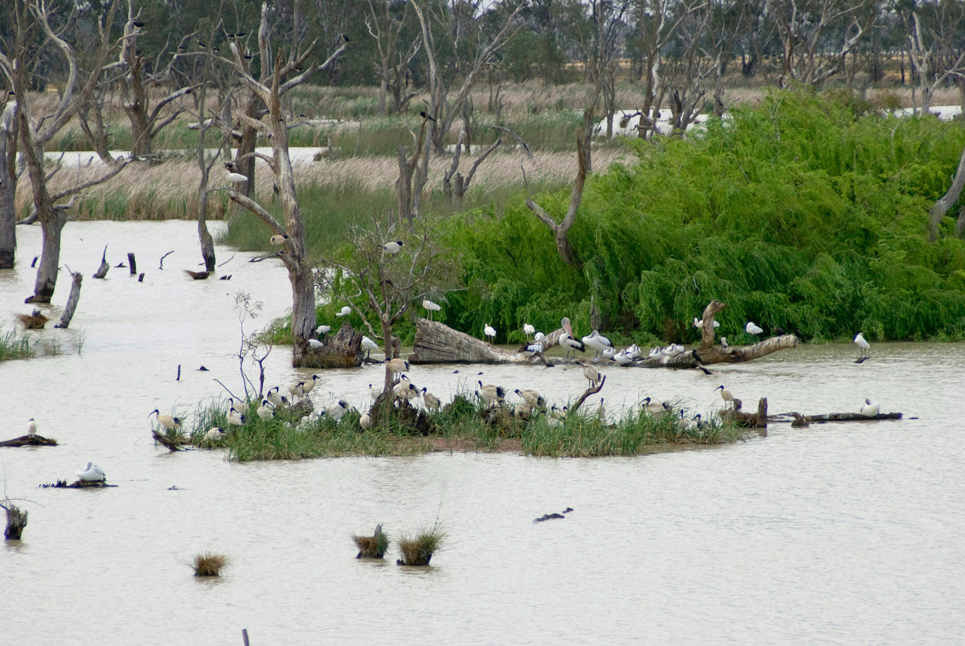
Photo: Cecilia Burke

As at 30 June 2021
- 225 projects in 54 management units across Australia
- 93% of projects recorded ‘significant’ or ‘satisfactory’ progress toward their medium-term outcomes
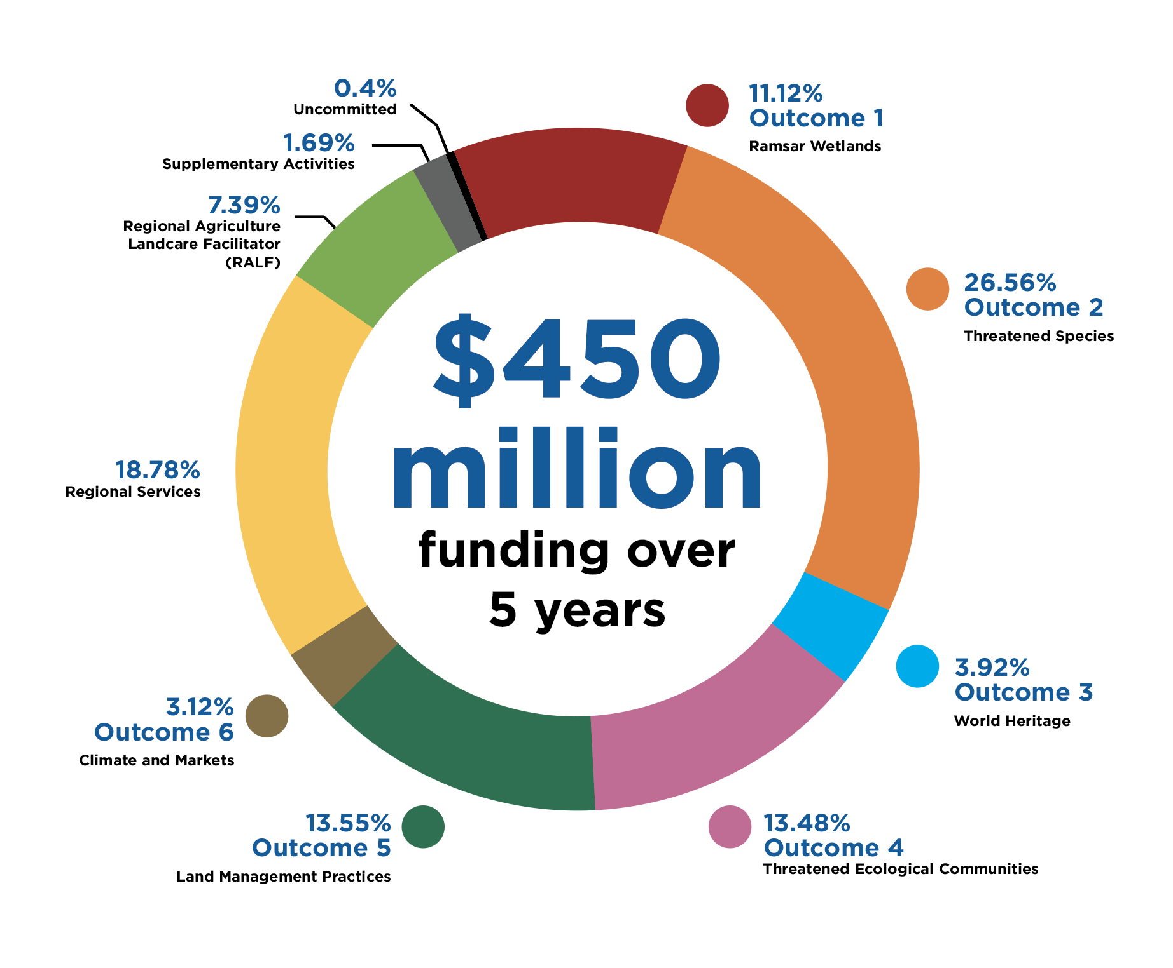

Includes investment in
- 25 Ramsar wetlands*
- 58 threatened species*
- 8 World Heritage properties*
- 20 threatened ecological communities*
- 54 Regional Agriculture Landcare Facilitator positions
- 54 Natural Resource Management Plans
- Community engagement and communications
- Project design and monitoring
- Governance
- Work health and safety

*Figures based on primary investment priorities

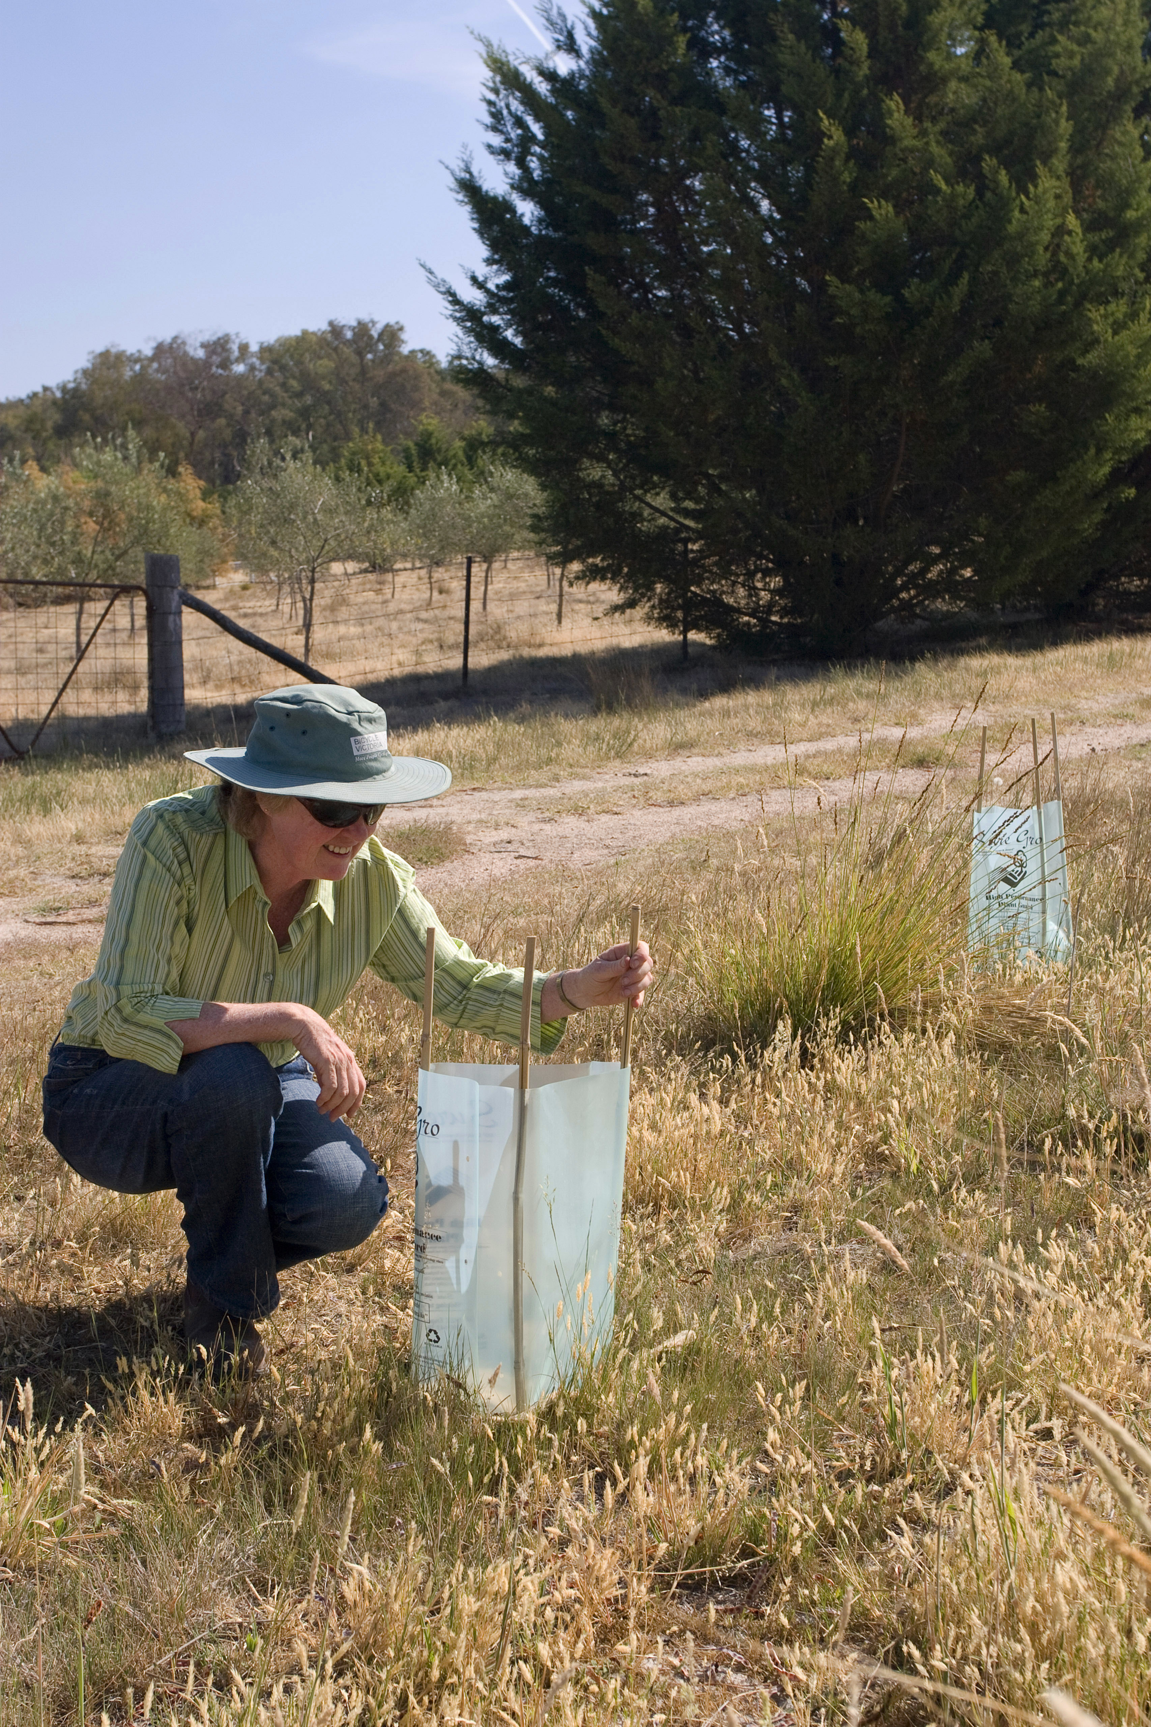
Photo: John Baker

Achievements after the first 3 years
- 3,594 ha habitat revegetated and maintained
- 1,010 ha riparian and aquatic areas remediated
- 16.9 million ha treated for pest animals
- 440,462 ha treated for weeds
- 1.9 million ha treated by fire management actions
- 2,388 groups engaged
- 3,626 plans and agreements developed
- 4,403 communication materials published
- 7,700 community and stakeholder engagement activities

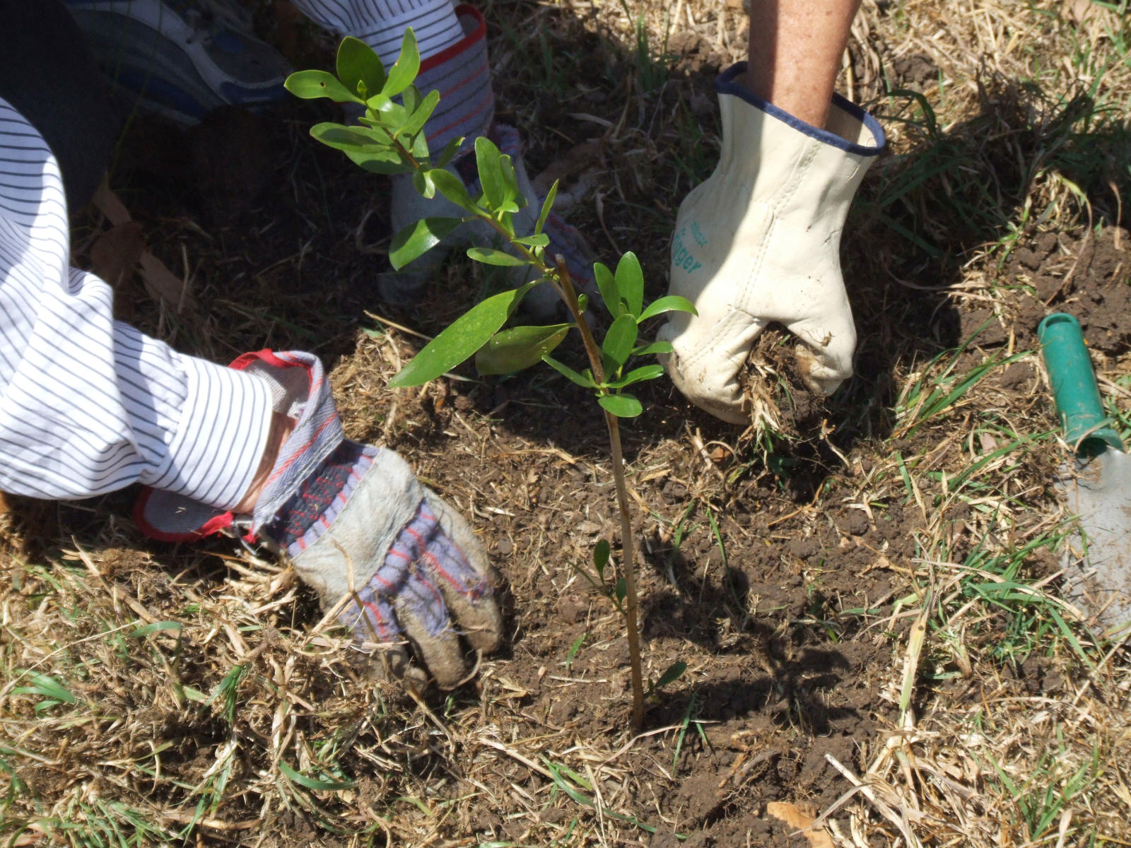
Photo: Georgia Curry

Regional Land Partnerships

Case studies across the 6 outcomes

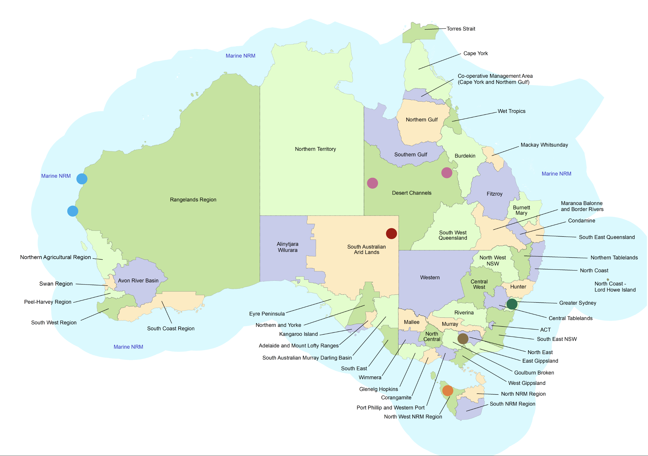

Ramsar Wetlands, project site
Managing feral animals and weeds, especially after floods, is critical to maintaining the value of the Coongie Lakes Ramsar site.

Pest control across 50,000 ha and weed control works across 12,100 ha is aiming to improve the trajectory of the Dusky Hopping-mouse, Crest-tailed Mulgara and Night Parrot.
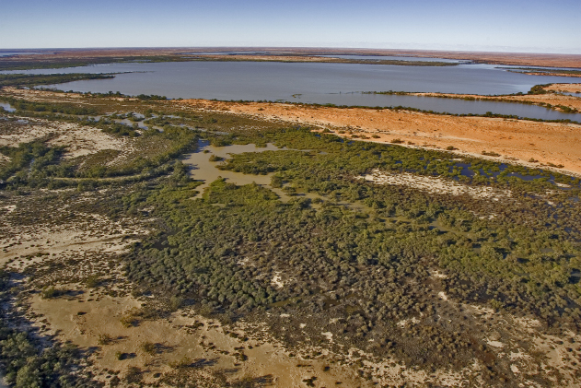
Photo: Paul Wainwright

Threatened Species, project site
Giant Freshwater Crayfish are iconic and endemic to Tasmania.

Landholders are being supported to improve river habitat quality and connectivity over a total of 12 km.

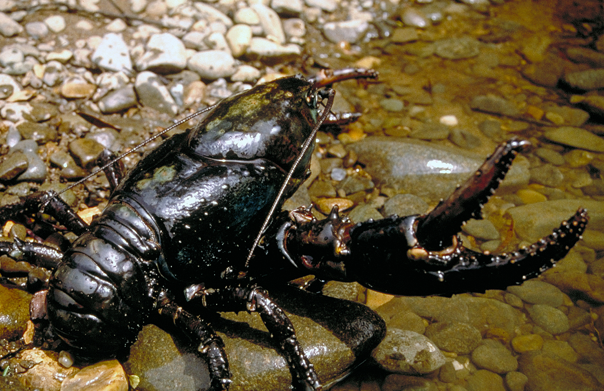
Photo: Laurie Goldsworthy

World Heritage, project site
Ningaloo Coast and Shark Bay are World Heritage properties known for their natural beauty and significant habitat for biological diversity.

Invasive species management is reducing threats such as feral cats, foxes and invasive weeds. Initial weed management control work has been undertaken across 18,628 ha, along with 14,443 ha of initial pest animal control activities.

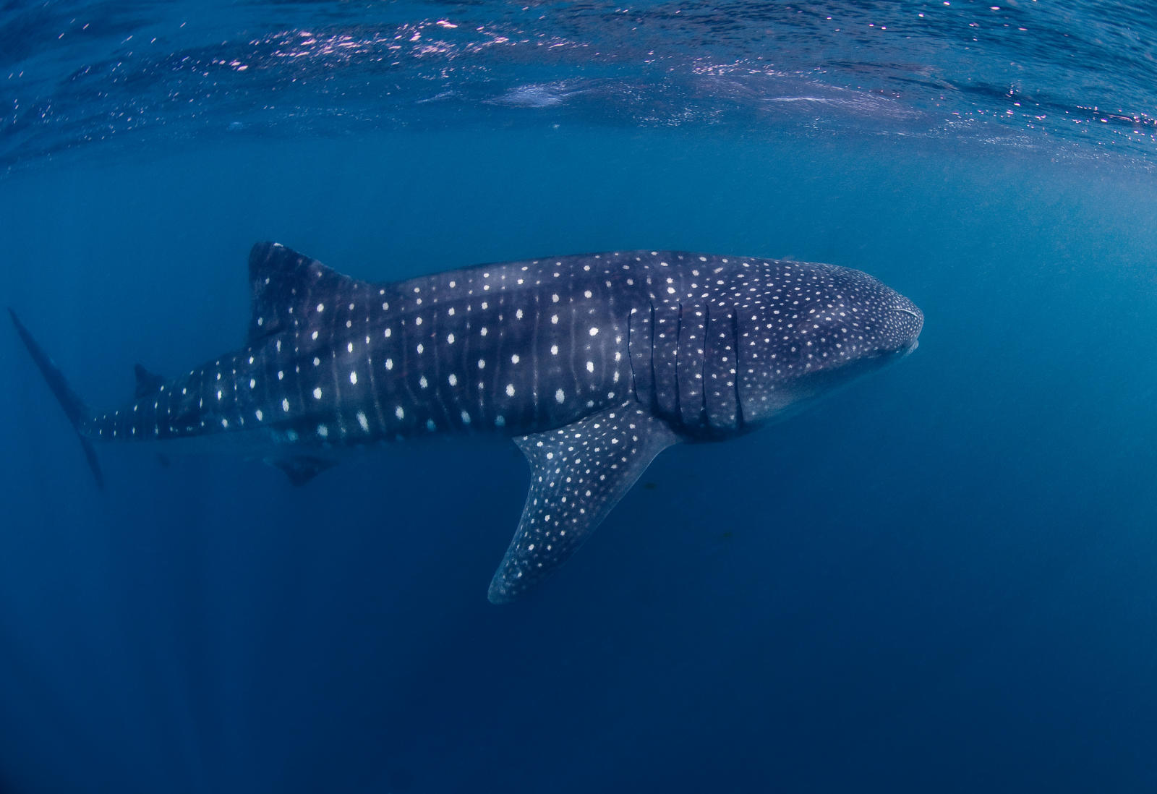
Photo: Erik Schlogl

Threatened Ecological Communities, project site
The condition of 30 priority springs is being improved by reducing threats such as feral pigs.

Management plans are being created to aid monitoring regimes to improve condition in sections of the Great Artesian Basin.

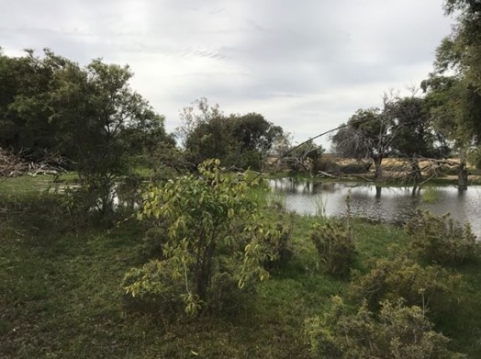
Photo: Desert Channels Queensland Incorporated

Land Management Practices, project site
Farmers are being empowered to access new markets by marketing their produce using sustainability credentials.

Social research is helping to clarify what consumers want to know regarding how food is produced, its provenance and its traceability.
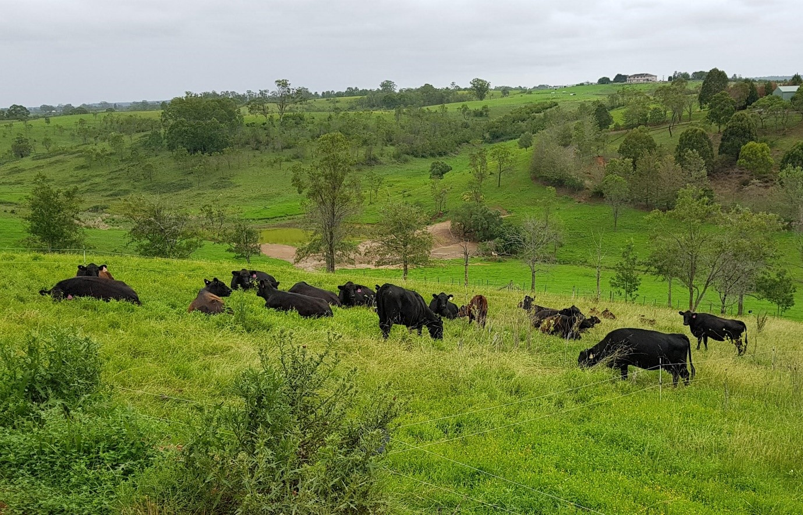
Photo: Local Land Services

Climate and Markets, project site
Over 200 land managers are having the opportunity to improve their knowledge and skills in adapting businesses to changing climates and markets, through field days, communication materials, training and one-on-one technical advice.

Performance modelling and mapping of projected climate change impacts are being made available to support planning for agriculture.
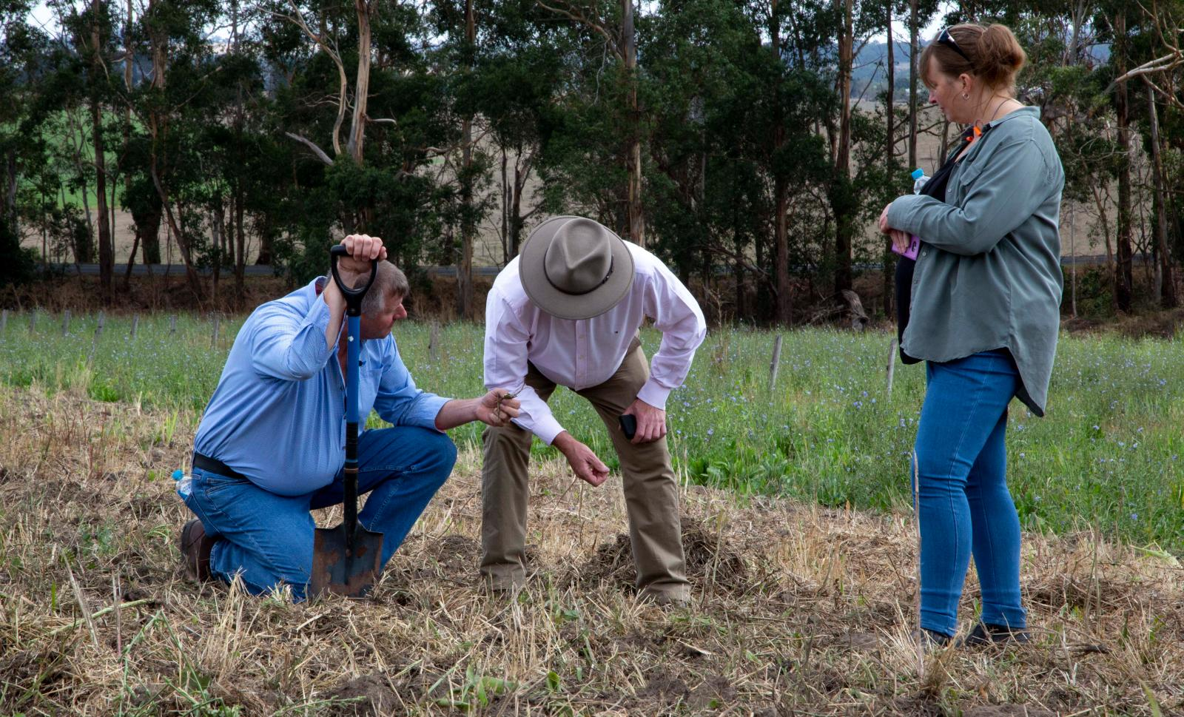
Photo: Department of Agriculture, Water and the Environment

Regional Land Partnerships

Achievement snapshot by outcome as at 30 June 2021

Outcome 1: Ramsar Wetlands
$50.057 million | 25 projects across  25 Ramsar wetlands* | 94% of quantifiable short-term  outcomes achieved
98,701 ha covered by  practice change | 331 ha riparian and aquatic  areas remediated | 397 ha habitat revegetated and maintained
2.38 million ha treated  for pest animals | 175,573 ha treated  for weeds | 605 community and stakeholder  engagement activities

Outcome 2: Threatened Species
$119.532 million | 92 projects across  58 threatened species* | 89% of quantifiable short-term  outcomes achieved
168,447 ha of habitat treated  for weeds | 10.4 million ha treated  for pest animals | 17 feral-free enclosures
2,105 ha of habitat revegetated and maintained | 475 ha of riparian and aquatic habitat remediated | 2,390 community and  stakeholder engagement  activities

Outcome 3: World Heritage
$17.635 million | 11 projects across  8 World Heritage properties* | 97% of quantifiable short-term  outcomes achieved
47,300 ha of habitat  treated for weeds | 622,863 ha treated for  pest animals | 58,265 ha treated by  fire management actions
240,000 ha covered  by plan | 343 community and stakeholder engagement activities | 379 groups engaged

Outcome 4: Threatened Ecological Communities
$60.638 million | 31 projects across  20 threatened ecological  communities* | 94% of quantifiable short-term outcomes achieved
48,987 ha treated for weeds | 200 ha riparian and  aquatic habitat remediated | 959 ha revegetated and  maintained
442,752 ha treated for  pest animals | 7,548 ha feral-free enclosures | 1,264 community and  stakeholder engagement  activities

Outcome 5: Land Management Practices
$60.987 million | 48 projects | 98% of quantifiable short-term outcomes achieved
1,542 plans and agreements | 347 sites for  improved practices | 302 groups engaged
3.049 million ha treated  for pest animals | 112,986 ha covered  by practice change | 2,304 community and  stakeholder engagement  activities

Outcome 6: Climate and Markets
$14.022 million | 18 projects | 92% of quantifiable short-term outcomes achieved
177 plans and  agreements | 158 sites for  improved practices | 280 groups  engaged
362 communication  materials | 316 one-on-one training  sessions and  20 on-ground trials | 451 field days, conferences,  seminars and workshops
*Figures based on primary investment priorities

