REGULATORY COST SAVINGS UNDER THE ONE-STOP SHOP FOR ENVIRONMENTAL APPROVALS

September 2014

Contents

Overview 1

Introduction 1

Background 2

Overview of the current regulatory environment 2

Objectives of the One-Stop Shop 4

Operation of the One-Stop Shop 5

Assurance framework 6

Performance assurance 6

Outcomes assurance 7

Savings for business from the One-Stop Shop 7

Method for calculating savings under the One-Stop Shop 8

Administrative savings 9

Pre-referral stage 10

Referral stage 10

Assessment processes 10

Approvals processes 10

Post approval stage 10

Delay savings 11

Total savings for business 12

Limitations 12

Conclusion 13

Attachments: 13

**REGULATORY COST SAVINGS UNDER THE**

**ONE-STOP SHOP FOR ENVIRONMENTAL APPROVALS**

# Overview

The Australian Government is committed to reducing regulatory costs for business, individuals and community organisations. The One-Stop Shop for environmental approvals is expected to result in regulatory savings to business of over $426 million a year.

This document is intended to explain regulatory cost savings under the One-Stop Shop and:

* Provide a summary of the One-Stop Shop for environmental approvals in Australia and changes to the current regulatory environment.
* Explain the method for calculating savings to business from the One-Stop Shop. Broader benefits to the Australian economy have not been assessed and are beyond the scope of this document.

# Introduction

Duplication between state and territory environmental assessment and approval processes and the Australian Government’s *Environment Protection and Biodiversity Conservation Act 1999* (Cth) (EPBC Act)has been recognised as costly by the Productivity Commission[1] and the Council of Australian Governments.[2]

The current regulatory process has resulted in unnecessary duplication and delays for business, resulting in:

* Administrative costs for example completing two separate application forms. Administrative cost savings for business under the One-Stop Shop are estimated at $9 million.
* Delay costs for example waiting for an Australian Government project approval after a state or territory project approval. Delay cost savings for business under the One-Stop Shop are estimated at $417 million.

The One-Stop Shop will result in streamlined decisions on projects, lower costs for business and high environmental standards being maintained.

A three-stage approach was taken to implementing the One-Stop Shop:

1. Memoranda of Understanding with each state and territory, agreed in 2013.
2. Assessment Bilateral Agreements with each state and territory, which are in the process of being agreed with all states and territories.
3. Approval bilateral agreements and accreditation of relevant state and territory environmental assessment and approval processes.

Where a state or territory process is accredited and an approval bilateral agreement is in place, business will deal with the state or territory government as the primary regulator for environmental approvals in Australia. States and territories will need to meet national standards for Matters of National Environmental Significance.

The One-Stop Shop will result in two key areas of savings for business: reduced administrative costs and reduced delay costs. The One-Stop Shop is also expected to strengthen environmental outcomes for Matters of National Environmental Significance, and allow the Australian Government to take a more strategic role in environmental protection.

# Background

The EPBC Act has provided for approval bilateral agreements since it commenced on 16 July 2000.[3] In November 1997 the Council of Australian Governments agreed in principle to the Heads of Agreement on Roles and Responsibilities for the Environment which was subsequently signed by the heads of all governments and the Australian Local Government Association. As part of the agreement, the states and territories and the Australian Government agreed to more effective environmental assessment and approval processes, including a national partnership based on minimising unnecessary duplication and overlap between governments. The parties agreed to provide for bilateral agreements which would enable accreditation of state and territory processes and, in appropriate cases, state and territory decisions under Australian Government legislation.

The EPBC Act is the Australian Government's primary piece of environmental legislation administered by the Australian Government Department of the Environment. The Act provides a national scheme of environment and heritage protection and biodiversity conservation, and enables the Australian Government to regulate development proposals in relation to Matters of National Environmental Significance. Matters of National Environmental Significance include threatened species, national heritage places, world heritage properties and nuclear actions.

States and territories have responsibility for matters of state and local significance, although many state and territory matters are also listed under the EPBC Act. This has resulted in significant overlap in environmental regulation in Australia. The Government is now implementing the efficiencies envisaged when the EPBC Act was introduced.

## Overview of the current regulatory environment

Currently, proponents submit an application to a state or territory government for an environmental approval for their project. If the project is likely to have a significant impact on a Matters of National Environmental Significance, a separate application (referral) to the Australian Government is required under the EPBC Act. This means a proponent is required to complete two separate application forms.

Under the EPBC Act, the Australian Government Department of the Environment currently receives approximately 420 referrals each year, of which approximately 134 require further assessment and approval. A range of proponents refer their activities (e.g. governments, companies and individuals) from a range of different industries (e.g. mining, infrastructure, commercial and residential) (see **Figure 1**).

**Figure 1: Types of projects referred under the EPBC Act between 1 July 2007 and 30 June 2013**

Based on the information provided in the EPBC Act referral, the Australian Government Environment Minister may determine that the project will have a significant impact on a Matters of National Environmental Significance (i.e. that it is a controlled action) and require further assessment under the EPBC Act. If this occurs, the Government may require further assessment documentation to be prepared. This can be in addition and separate to assessment documentation required by the state or territory government.

When the assessment is complete, the Australian Government Environment Minister considers the assessment documentation and makes a decision on whether to approve the project. This may be in addition to project approvals which are already granted by the state or territory government and can include additional conditions of approval. In the past five years, 384 projects have been approved by the Australian Government under the EPBC Act.

Australian Government project approval is typically granted after a state or territory government approval. In some cases, Australian Government approval has been granted years after state or territory government approval. There are a number of reasons why this can happen. For example, the Australian Government may have required additional information or time to consider impacts to Matters of National Environmental Significance or the proponent may have submitted a request to vary its project. **Figure 2** is an example of the duplicative processes proponents have to go through under current regulatory arrangements.

**Figure 2: Example of current regulatory arrangements**

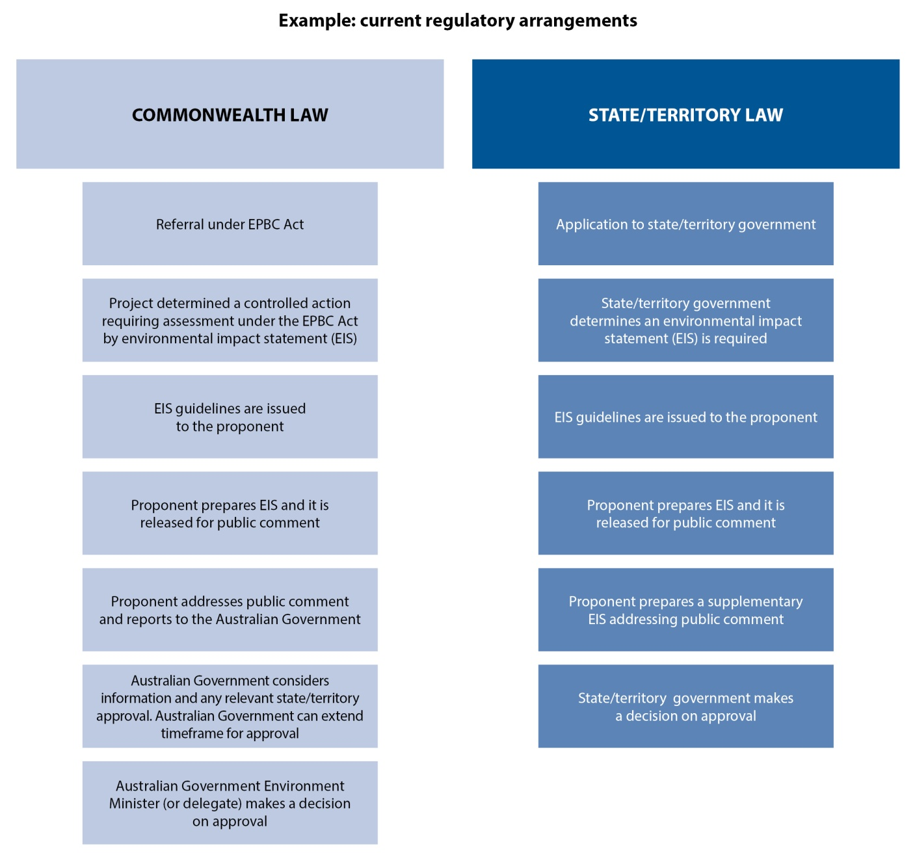

In recent years the Australian Government has been working with states and territories to streamline the environmental assessment and approval process. For example, the Australian Government has been working toward consistent and complementary approval conditions with state and territory governments that are not unnecessarily duplicative. In addition, there have been assessment bilateral agreements and/or one-off accreditations under the EPBC Act in place with all states and territories. Assessment bilateral agreements and one-off accreditations only require one assessment process to be undertaken by the state or territory government, but a separate approval is still required by the Australian Government. Approval bilateral agreements are the next step in further streamlining environmental regulation in Australia.

# Objectives of the One-Stop Shop

The objectives of the One-Stop Shop are:

* Increased business efficiency: dealing with one regulator instead of two will lead to increased investment and savings for business by reducing administrative costs and project delays.
* Maintain environmental standards: states and territories will need to meet the Australian Government’s strict environmental standards based on the requirements of the EPBC Act.
* Strengthen environmental outcomes: through environmental information sharing and strategic approaches to environmental protection.
* Strong assurance: to give confidence the outcomes of the One-Stop Shop are being achieved.
* Durable reform: checks and balances are in place to provide a stable regulatory system and flexible mechanisms exist to resolve issues.

# Operation of the One-Stop Shop

Approval bilateral agreements allow a state or territory to conduct an environmental assessment and approval process that satisfies both state and territory and Australian Government requirements. Where a project is covered by the One-Stop Shop, the Australian Government will no longer have a role in project assessment and approval. This will remove a substantial amount of duplication, as shown in **Figure 3**.

**Figure 3: Example of removing duplication under the One-Stop Shop** 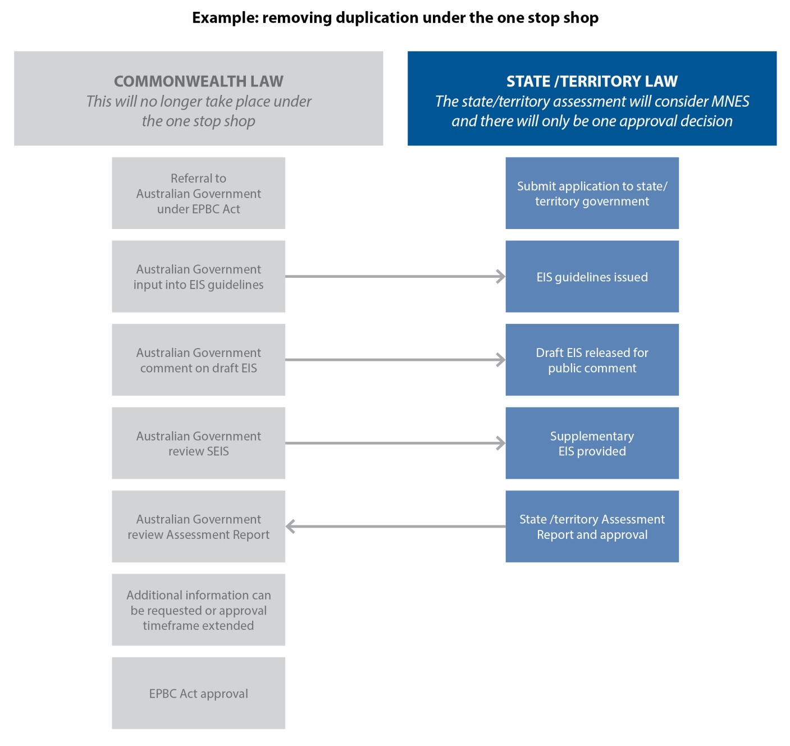

Approval bilateral agreements will include a list of state and territory processes that will be covered by the One-Stop Shop. For projects that fall under these processes, a separate Australian Government assessment or approval will not be required as the state or territory process will have incorporated both state or territory and Australian Government requirements. Approval decisions, and any attached conditions, made by a state or territory will be enforceable under the relevant laws of that state or territory.

An assurance framework has been developed to ensure the successful operation of the One‑Stop Shop.

## Assurance framework

The assurance framework will provide a cooperative approach to support stable and durable arrangements that achieve good outcomes for business and the environment. The balance between regulatory burden and environmental benefits under the One-Stop Shop will be supported by an assurance framework (see **figure 4**).

There are three core elements to the assurance framework:

* 1. National environmental standards that states and territories are required to meet to be accredited
  2. Performance assurance to ensure commitments are met under approval bilateral agreements
  3. Outcomes assurance to ensure good outcomes for business and the environment.

**Figure 4: Example of removing duplication under the One-Stop Shop**

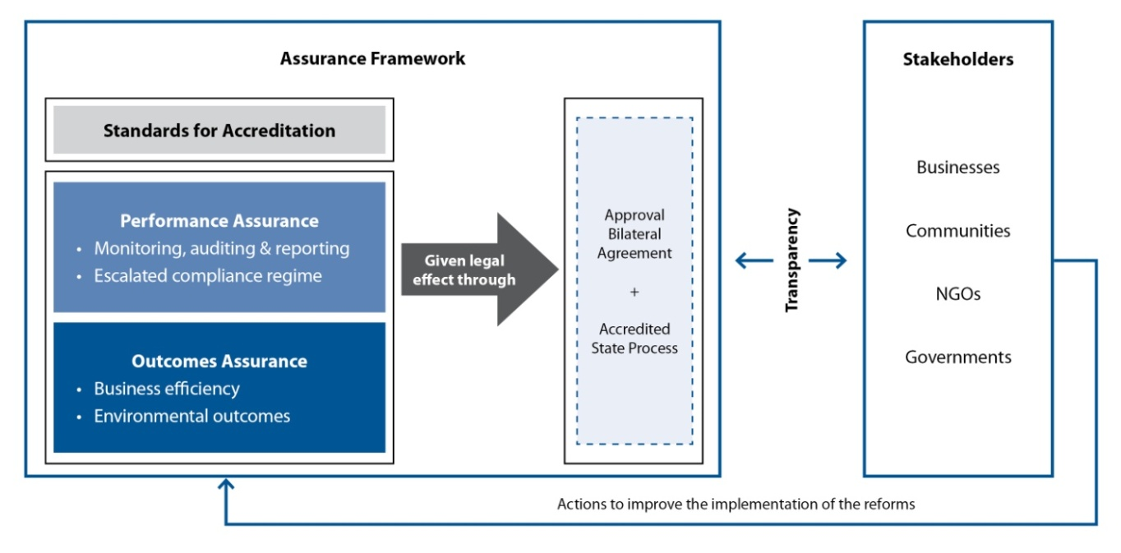

## Performance assurance

The Australian Government will work collaboratively with the states and territories to ensure that commitments are met under approval bilateral agreements. Performance assurance includes evaluation or audits against state and territory commitments in the bilateral agreements, transitional and five yearly reviews of agreements, reporting mechanisms to enable the Australian Government to fulfil its reporting obligations under the EPBC Act and international reporting obligations, and ongoing monitoring and continuous improvement mechanisms.

An escalated dispute resolution process will be put in place to resolve any issues between the Australian Government and the state or territory. Most issues are expected to be resolved through this process. In exceptional circumstances, the Australian Government Environment Minister will be able to call-in the assessment and/or approval of a project if states and territories are not meeting national standards.

Transparency of decisions and provision of information will ensure that the broader community is part of the ongoing monitoring process for approval bilateral agreements. States and territories will be accountable to the community and business, as well as the Australian Government.

## Outcomes assurance

The Australian Government will work collaboratively with the states and territories to ensure that the One-Stop Shop leads to business efficiency and good environmental outcomes. The outcomes achieved through the One-Stop Shop will be measured to track the operation and effectiveness of approval bilateral agreements.

A fundamental objective of outcomes assurance is transparent and accessible environmental information and data that can be used by business, governments and the community. The One-Stop Shop will increase sharing of environmental information between. Transparent and accessible environmental information will improve our collective ability to understand and sustainably manage our environment.

The Australian Government is committed to improving environmental standards over time cooperatively with the states and territories. Continuous improvement will be a key feature of agreements with state and territory governments and will involve cooperation in environmental information and greater use of strategic approaches to environmental protection, including strategic assessments.

The strategic approaches committed to under the One-Stop Shop reform (such as commitments to prioritise and increase use of strategic assessments) will allow for environmental planning earlier in the process and address cumulative impacts on the environment.

# Savings for business from the One-Stop Shop

The One-Stop Shop will result in significant savings for business. It will also provide more certainty for investors with a simpler, transparent and more predictable national regulatory system. This certainty is good for Australia’s domestic and international investment reputation.

**Table 1** shows the number of referrals, assessments and the median and maximum time taken for major projects to be approved by the Australian Government after the state or territory government for a range of sectors. It demonstrates some of the administrative and delay costs that could be avoided under the One-Stop Shop. Not all delays can be attributed to the Australian Government, but a streamlined system will help to minimise these types of delays.

**Table 1: Referral and approval statistics under the EPBC Act over the past 5 years   
(1 July 2008 – 30 June 2013)**

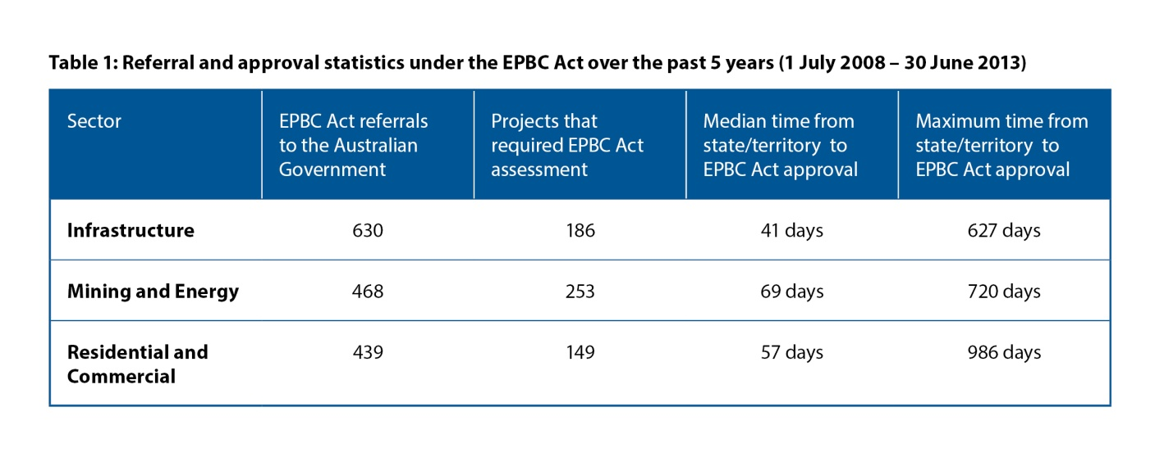

Different analyses demonstrate that the One-Stop Shop will have positive flow-on effects on the broader economy, in addition to the direct cost savings to business. Comprehensive modelling, undertaken for the Minerals Council of Australia, shows that reducing approval delays would result in a much higher rate of economic growth in Australia. The cumulative gains over the next 12 years from reducing delays are estimated to be worth $120 billion in real GDP.

The Minerals Council of Australia’s report[4] uses broad long-term economic modelling and includes both direct and indirect savings to business and flow on impacts for the Australian economy. It considers a broad range of impacts including indirect impacts such as future investment rates, the level of employment, and mineral exports. The greater the reduction in the average timeline for approvals, the larger the increase in mineral exports, investment and employment, and therefore the higher the average growth rate of national income

Under the Minerals Council of Australia’s model, if approval timelines were reduced by one year, over 69,000 additional jobs would be created across the entire economy by 2025. Most of the jobs created are outside the minerals mining sector.

This analysis focuses on the direct cost savings of the One-Stop Shop reform to business. The Australian Government measures the regulatory impact of all new Government policies. Calculating the cost or savings from regulatory or deregulatory activities assists the Government in keeping the Australian economy as efficient, flexible and responsive as possible.

The Regulatory Burden Measurement Framework is the Australian Government’s framework for calculating savings to business arising from policies that impact the regulatory burden on business.The Department has developed a tailored method for calculating savings to business arising from the One-Stop Shop, based on real project data. The Department’s method has been developed using the Government’s Regulatory Burden Measurement Framework.

## Method for calculating savings under the One-Stop Shop

The Department’s method for calculating savings from the One-Stop Shop consists of two broad steps:

1. Identifying expected changes for business under the One-Stop Shop
2. Estimating the value of the changes.

The Department’s method for calculating savings is detailed at **Attachment A**.

Savings for business under the One-Stop Shop are likely to be realised in two main areas: administrative savings and delay savings.

* *Administrative savings* are any costs incurred by regulated entities primarily to demonstrate compliance with regulation. The One-Stop Shop will result in administrative savings by allowing business to deal with one point of contact, one assessment and approval process and one regulator.
* *Delay savings* are expenses incurred through delayed approvals. ‘Delay’ includes any expected changes to timeframes from streamlining the approval process under the One-Stop Shop. The major benefit to business from the reforms is expected to be achieved through reduced delay costs.

Assumptions used to derive the estimates of the potential change in administrative costs and delay costs are based on information from published and unpublished sources, and were developed in consultation with officers from the Australian Government Department of the Environment, the Australian Government Office of Best Practice Regulation and business. In particular, assumptions were made about the estimated time spent on an activity (at each stage of the Australian Government assessment and approval process) combined with Australian Bureau of Statistics earnings data. In some cases, assumptions were made about the percentage of proponents who would have undertaken certain activities based on the experiences of assessment officers (e.g. making pre-referral contact with both the state or territory and the Australian Government).

The method and assumptions used to calculate the One-Stop Shop savings contribution to the Government’s deregulation target were developed in consultation with peak industry groups. The method was revised based on feedback received during this consultation. Industry groups generally support the method used to calculate savings.

## Administrative savings

The main changes generating administrative savings under the One-Stop Shop are that business will:

* Not have pre-referral contact with the Australian Government
* Not have to prepare a separate application form for the Australian Government
* Avoid costs associated with providing additional information on Matters of National Environmental Significance later in the assessment and approval stage and additional public consultation processes associated with this information, as all requirements will be well understood upfront
* Not have contact with the Australian Government during the assessment period
* Report to only the state or territory in the post-approval stage.

For administrative savings, each stage of the environmental assessment and approval process under the EPBC Act was considered separately. Over 300 projects from the Department’s databases were examined to identify and calculate administrative savings.

### Pre-referral stage

Administrative cost savings at the pre-referral stage are likely to be modest. Most project proponents do not make pre-referral contact with the Australian Government. Where they do, it may involve a telephone call or e-mail for advice on completing an application for referral. For a small number of proposals, proponents seek a pre-referral face-to-face meeting in Canberra or a site visit.

### Referral stage

Savings at the Australian Government referral stage may be more significant. While project proponents will still have to prepare information on Matters of National Environmental Significance, there will be a saving by not completing two application forms for two levels of government.

In 2012-13, the department received 439 referrals for consideration. Of these, 341 projects were non-government projects. Under the Regulatory Burden Measurement Framework government projects are excluded.

### Assessment processes

Most proponents prepare one report to satisfy Australian Government and state or territory assessment and approval requirements. Proponents will continue to prepare assessment documentation and undertake public consultation under the One-Stop Shop in a manner that meets national standards. But savings may occur where proponents currently prepare separate state or territory and Australian Government assessment documentation or undertake separate state or territory and Australian Government consultation processes (e.g. where the proponent refers a project to the Australian Government after the state or territory has already assessed a project).

### Approvals processes

Under the current regulatory system, proponents may be asked by the Australian Government to provide more information on Matters of National Environmental Significance after a state or territory assessment has been completed.

### Post approval stage

Currently, proponents are subject to two sets of approval conditions, project auditing and compliance functions. For example, a proponent may have to prepare additional or different management plans for the Commonwealth that are also required for the same protected matter by the State.

Under the One-Stop Shop, proponents will be aware of all information requirements early in the process, enabling them to prepare and submit information on Matters of National Environmental Significance once. This will reduce the cost of submitting additional information to governments and may reduce the cost of collecting information by allowing all information to be collected at the same time (e.g. in one field season).

## Delay savings

Reduced delays to business are the major benefit of the One-Stop Shop. Reduced delay is given a dollar value by analysing the impact on the present value of a project’s future expenses and revenues. Delay costs are difficult to estimate because they depend on many factors which can be specific to each project. Approval processes also vary between states and territories which can affect on how time is calculated.

Delay savings are essentially measured by comparing the current assessment and approval timeframes to expected timeframes under the One-Stop Shop. Estimates of delay costs are based on:

* Projects which were assessed by environmental impact statement, public environment report or under an assessment bilateral agreement or accredited process. These projects are most likely to have been subject to two approval decisions and benefit from a One-Stop Shop. Projects assessed by another method, for example preliminary documentation or on referral information, have been excluded.
* Projects which have been approved over the past three years (between 1 July 2010 and 30 June 2013). Departmental analysis suggests these three years are representative of the previous ten years and are therefore suitable for the Government’s Regulatory Burden Measurement Framework. A number of projects with relatively high value were approved in 2010-11as a result of a boom in the mining and energy sector. Projects from this year have been weighted to represent a ‘once in a ten year’ peak.

In some cases, state or territory in-principle approval can provide certainty for business to make a final investment decision on a project, and has been considered as the relevant point of state or territory approval.

Projects that are undertaken by the Australian Government or on Australian Government Lands, and are located in the Commonwealth Marine Area are not included because these will not be covered by the One-Stop Shop. Projects that were discontinued after approval are also excluded from delay cost calculations. Under the Regulatory Burden Measurement Framework, projects in which a Government is the proponent are also excluded since they are not businesses, community organisations or individuals. This removes a range of infrastructure projects. However, projects undertaken by Government Business Enterprises (e.g. corporatised energy asset owners, even if wholly owned by government) are included as businesses under the Regulatory Burden Measurement Framework.

Using the criteria above, 52 projects from the Department’s databases were used to calculate the One-Stop Shop’s delay cost savings. Note this is a much smaller set of projects than were used to calculate administrative costs.

The approval timeframe was broken down into three components to assist consideration of how timeframes would be expected to change under a One-Stop Shop:

* The expected timeframe for an approval decision by the Australian Government after a state or territory approval (typically 30-40 business days)
* Extensions by the Australian Government to the expected timeframe, for example to obtain more information on Matters of National Environmental Significance or for more time to consider information
* A late decision by the Australian Government.

Under the EPBC Act, the Australian Government Minister can extend the standard time allowed for an Australian Government decision for various reasons, including where further information is required from the proponent and where the proponent requests a variation to the project. These are commonly known as ‘stop the clock’ extensions. Some of the reasons for these ‘stop the clock’ extensions may still be relevant for approvals under the One-Stop Shop because the state or territory is likely to have to undertake the same process or the delay is attributable to the proponent or state or territory government (e.g. a legal appeals process).

All projects approved over a three year period to 30 June 2013 were filtered using the exclusion criteria given above. The remaining 52 projects were individually analysed to determine the number of days delay which would have been avoided had the project been approved under the One-Stop Shop. For each project, the impact of its delay on the estimated net present value is determined and divided by the project lifespan.

## Total savings for business

Administrative savings of $9 million and delay savings of $417 million were combined to determine the total savings to business that could be expected under the One-Stop Shop.

The One-Stop Shop is estimated to save business over $426 million a year.

## Limitations

Deregulation savings estimates are conservative and based on evidence obtained from past approvals.

Total savings will depend on the extent to which state and territory legislation can be accredited. The Australian Government is working to accredit as many state and territory processes as possible. The total savings estimate in this regulatory impact analysis is based on achieving EPBC Act accreditation for those state and territory processes that are either confirmed or expected as at 30 June 2014. The Department anticipates that the accredited processes are likely to capture the majority of large scale, capital intensive projects. These projects have the greatest cost impact when administrative or delay costs are incurred.

There are a number of factors that may influence the estimate that have not been directly accounted for in the calculations, due to an absence of reliable data, leading to an estimate which is inherently conservative:

* Factors that would increase the estimate:
  1. Potential increased savings to projects assessed by preliminary documentation have not been included.
  2. Potential increased savings in the post approval stage have also not been included.
  3. The value of increased investment certainty has not been estimated.
  4. The broader economic benefits of government projects (such as road infrastructure) are not captured because they are excluded under the Regulatory Burden Measurement Framework.

## Conclusion

Unnecessary duplication exists under current arrangements and is well recognised by business and governments.

The One-Stop Shop will simplify and reduce duplication in the environmental assessment and approvals process. It will result in earlier decisions on projects and reduced costs for business. High environmental standards will be maintained and appropriate checks and balances exist through an assurance framework.

Once the One-Stop Shop is in place, business will deal with the state or territory government as the primary regulator for environmental approvals in Australia. The Australian Government will no longer have a role in assessment and approval of these projects.

The One-Stop Shop is expected to provide economic benefits to business of over $426 million a year.

# Attachments:

**Attachment A:** Method for calculating savings (detailed)

**ATTACHMENT A**

**Method for calculating savings from the One-Stop Shop**

**Step 1 - real project data from the Department’s databases was interrogated**

The Department maintains a database that contains records of project referrals, assessments and approvals. Information on projects is also available in files maintained by the Department.

The Department interrogated data for EPBC Act projects over the past ten years and identified:

* the average number and type of referrals received each year
* projects where the proponent was a government
* how many projects required further assessment and approval under the *environment Protection and Biodiversity Conservation Act 1999* (Cth) (EPBC Act)
* the type of assessment required by the state or territory and by the Australian Government (e.g. environmental impact statement)
* the number and type of projects approved under the EPBC Act and the date of approval
* the date of state or territory approval for projects.

**Step 2 - assumptions applied based on changes expected under the One-Stop Shop**

A number of assumptions were made to identify changes that could be expected if projects were assessed and approved under the One-Stop Shop.

The two main assumptions are:

1. Environmental standards remain unchanged. Any action currently requiring assessment and approval under the EPBC Act will be assessed and approved by the state or territory, to the same standard, under the One-Stop Shop. The proposed approval bilateral agreements:
   1. will retain the level of protection provided for Matters of National Environmental Significance under the EPBC Act
   2. are not expected to reduce the quality of information required of project proponents;
   3. will not change the requirement for adequate assessment of the impacts of actions on Matters of National Environmental Significance under the EPBC Act.
   4. will not change the ‘avoid, mitigate, offset’ hierarchy of principles guiding the assessment and approval of actions.

Projects would be assessed under current approval processes if the One-Stop Shop did not proceed.

**Step 3 - two areas of potential savings were identified**

The Department identified two types of savings that are expected to be realised through the One-Stop Shop:

1. Administrative savings – reduced duplication in administrative activities by interacting with only one regulator.
2. Delay savings – reduced time delay from requiring a second approval by the Australian Government after a state or territory.

**Administrative savings**

Some of the types of administrative savings are that proponents will:

* not have pre-referral contact with the Australian Government
* not have to prepare a separate referral form for the Australian Government
* avoid costs associated with providing additional information on Matters of National Environmental Significance later in the assessment and approval stage and additional public consultation processes associated with this information, as all requirements will be well understood upfront
* not have contact with the Australian Government during the assessment period
* report only to the state or territory government in the post-approval stage.

A number of assumptions were made to calculate administrative savings:

* On average, the number of referrals in future years will remain the same. This is supported by 10 years of project data.
* Estimates were made about the time spent on each administrative activity (at each stage of the Australian Government assessment and approval process) combined with Australian Bureau of Statistics earnings data and the percentage of proponents who would have undertaken certain activities. These assumptions were based on the experiences of assessment officers and feedback from peak industry groups (e.g. the cost of pre-referral contact with both the state or territory and the Australian Government).
* There will be no increase in state and territory administrative requirements under the One-Stop Shop, as these will remain the same as those currently required by state or territory government processes.

**Delay savings**

A reduction in project delays is expected to be the major cost saving for business under the One-Stop Shop. Savings are realised because a second approval would not be required from the Australian Government, allowing projects to obtain earlier approval and make earlier project and investment decisions. Delay savings are measured by comparing the current assessment and approval timeframes to expected timeframes under the One-Stop Shop.

A number of assumptions were made to calculate delay savings:

* the scope of projects that would be covered by the One-Stop Shop is based on those state and territory processes that are either confirmed or expected as at 30 June 2014. The Department anticipates that the accredited processes are likely to capture the majority of large scale, capital intensive projects. These projects have the greatest cost impact when administrative or delay costs are incurred.
* The last three years of project data is a representative sample of a 10 year period with the year 2010-11 a 1-in-10 year peak based on Departmental data. This is supported by 10 years of project data.
* Projects which were assessed by environmental impact statement, public environment report or under an assessment bilateral agreement or accredited process are most likely to have been subject to two approval decisions and benefit from a One-Stop Shop.
* State or territory in-principle approval can provide certainty for business to make a final investment decision on a project, and has been considered as the relevant point of state or territory approval in some cases.
* There will be no increase in state and territory approval timeframes under the One-Stop Shop, as state and territory governments will continue to make approval decisions according to existing processes and statutory timeframes
* There are two points in state or territory processes where there may be a delay cost for a proponent: final investment decision and commencement of work.

**Step 4 - calculate administrative savings**

The Department calculated the average number of referrals received each year. Consistent with the Australian Government’s Regulatory Burden Measurement Framework projects with government proponents were removed. This resulted in an average of over 300 referrals being received each year under the EPBC Act.

Administrative savings were calculated for each stage of the environmental assessment and approval process separately. These savings were developed in consultation with peak industry groups. The following areas of saving were identified:

**Pre-referral**

* Proponents will no longer need to engage with the Australian Government before lodging an application.
* Savings include travel and preparing for pre-referral meetings, and liaising with the Australian Government.

**Referral**

* Proponents will no longer have to complete an Australian Government referral form or seek expert advice on Australian Government processes. In addition, the proponent will not have to liaise with the Australian Government during the referral stage.

**Assessment**

* Proponents will only have to seek expert advice on one assessment, with all information provided upfront with one consultation period. In addition, the proponent will not have to liaise with the Australian Government during the assessment stage.

**Approval**

* Proponents will no longer have to prepare additional information for the Australian Government at the approval stage as this will be considered as part of the state or territory assessment and approval process. Some proponents will also no longer have to undertake additional public consultation.

**Post approval**

* Proponents will only be subject to one set of approval conditions, project auditing and post‑approval site visits, and will no longer need to liaise with the Australian Government on post approval requirements.

The expected savings for each stage of the process were combined to calculate the total annual expected administrative savings under the One-Stop Shop, of approximately **$9 million** a year.

**Step 5 – calculate delay savings**

To calculate delay savings, a subset of projects were identified for detailed analysis according to the following criteria:

* Projects where the state or territory decision preceded the Australian Government approval decision between 1 July 2010 and 30 June 2013.
* Projects which were assessed by environmental impact statement, public environment report or under an assessment bilateral agreement or accredited process. These projects are most likely to have been subject to two approval decisions and benefit from a One‑Stop Shop. Projects assessed by another method, for example preliminary documentation or on referral information, have been excluded.
* Each project was investigated to determine how many days delay can be attributed to the Australian Government. Projects that are undertaken by the Australian Government or on Australian Government Lands, or are undertaken solely in a Commonwealth Marine Area are not included.
* Projects undertaken by state, territory and governments are also excluded. In some cases, state or territory in-principle approval can provide certainty for business to make a final investment decision on a project, and has been considered as the relevant point of state or territory approval.

The year 2010-2011 has been adjusted to take into account the mining boom associated with liquefied natural gas to coal seam gas developments in that year. This is considered likely to be a ‘once every ten years’ peak and has been weighted accordingly. We have assumed that the future profile of projects requiring assessment and approval under the EPBC Act would be broadly similar to the past ten years.

Using the criteria above, 52 projects were used to calculate delay costs according to the method below. This is a much smaller set of projects than were used to calculate administrative costs as it focuses on large projects most likely to experience delays that would likely be accredited under a One-Stop Shop.

The approval timeframe was broken down into three components (A, B and C) to assist consideration of how timeframes would be expected to change under a One-Stop Shop:

* **A** - the expected timeframe for an approval decision by the Australian Government after a state or territory approval (typically 30-40 business days)
* **B** - extensions by the Australian Government to the expected timeframe, for example to obtain more information on Matters of National Environmental Significance or for more time to consider information
* **C** - a late decision by the Australian Government.

Figure 1 shows how A, B and C have been used to calculate delay costs.

**Figure 1: Calculating delay costs**

**Calculating A**

The expected timeframe for an Australian Government decision (A) is the time between the state or territory approval decision on a project and when the Australian could reasonably be expected to approve the project. This is often 30-40 business days which is the time allowed under the EPBC Act for the Australian Government to make a decision on a project once a state or territory has approved a project or once final assessment documentation is received from the proponent.

**Calculating B**

Extensions to Australian Government timeframes (B) is calculated as the length of time the Australian Government extended an approval decision for a project, after the state or territory made an approval decision. For example:

* 1. where the Minister required more time to make an approval decision, or
  2. where the Minister required additional information on matters of national environmental significance to make a decision to approve a project.

There are some circumstances where extensions to timeframes are not included in savings calculation as they are attributable to the proponent or the state or territory government. For example:

* 1. where a proponent has requested a variation to a project, or
  2. where there are appeals to a state or territory government approval that has delayed an Australian Government approval.

This is because these types of delays are still expected to occur under the One-Stop Shop   
(e.g. under a One-Stop Shop a proponent is still likely to vary a project for reasons such as engineering constraints).

The Department has investigated each individual project to calculate the appropriate amount of time to be included in ‘B’ based on the above considerations.

**Calculating C**

Non-statutory delays to an Australian Government decision (C) is calculated as the length of time the Australian Government exceeded a statutory due date under the EPBC Act to make an approval decision. For example, if the Australian Government made a decision 10 days after the date due for a project approval the value of C for that project is 10 days. The total amount of ‘C’ is included in the method as late decisions by the Australian Government would no longer occur under the One-Stop Shop.

**Total delay**

The total delay for each project was calculated by combining A, B and C. An example case study is shown at Figure 2.

**Figure 2: calculating project delays**

**Putting a value on delay**

The cost of a delay for each project was calculated using the project’s estimated net present value which was obtained from publicly available sources. In some cases net present value is published by proponents. Otherwise, this has been estimated based on data and/or assumptions about capital expenditure, expected returns and project life (including construction time). Time savings have been combined with net present value estimates for each project to determine the expected change in net present value under the One-Stop Shop. The change in present value is based on a discount rate of 8%, being an average of the weighted average cost of capital for the kinds of projects affected (primarily in the resources and energy sectors).

Total delay savings expected under the One-Stop Shop are **$417 million** a year**.  
  
Step 6 – total savings to business under the One-Stop Shop**

Administrative and delay savings were combined to calculate the total economic benefits to business under the One-Stop Shop. Business is expected to save **$426 million** a year under the reform.

1. Productivity Commission 2013, *Major Project Development Assessment Processes,* Research Report, Canberra.
2. COAG Meeting Communique, 19 August 2011.
3. *Environment Protection and Biodiversity Conservation Act 1999 (Cth)* s 45.
4. BAEconomic (July 2014) *The economic gains from streamlining the process of resource projects approval*