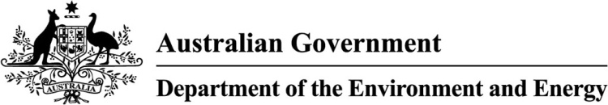

A Decade of Donations for the Environment

The Register of Environmental Organisations (REO) Report

September 2019

© Commonwealth of Australia, 2019.

A Decade of Donations for the Environment, The Register of Environmental Organisations Report

is licensed by the Commonwealth of Australia for use under a Creative Commons Attribution 4.0 International licence with the exception of the Coat of Arms of the Commonwealth of Australia, the logo of the agency responsible for publishing the report, content supplied by third parties, and any images depicting people. For licence conditions see <https://creativecommons.org/licenses/by/4.0/>

This report should be attributed as A Decade of Donations for the Environment, The Register of Environmental Organisations Report, Commonwealth of Australia 2019’.

The Commonwealth of Australia has made all reasonable efforts to identify content supplied by third parties using the following format ‘© Copyright, [name of third party] ’.

Disclaimer

The views and opinions expressed in this publication are those of the authors and do not necessarily reflect those of the Australian Government or the Minister for the Environment and the Minister for Energy

The Register of Environmental Organisations

The Register of Environmental Organisations (REO) allows environmental organisations to seek tax-deductible donations.

The REO is currently administered by the Department of the Environment and Energy in consultation with the Australian Taxation Office (ATO).

Environmental organisations on the REO must provide the Department with statistical information about the donations made to the public fund on an annual basis.

The Department has produced this report in partnership with the Australian Environmental Grantmakers Network (AEGN). The Department kindly acknowledges the contribution of the AEGN, including: insight into the philanthropic sector to inform drafting for this audience, AEGN environmental organisation data, data analysis, and promotion of the report.

Australian Environmental Grantmakers Network

The AEGN is a vibrant diverse network of people connected by a shared passion and purpose. They work with philanthropists who value the environment and have an active commitment to see it protected, preserved and thriving.

Their vision for the future is one where the power of science converges with Aboriginal and Torres Strait Islander people’s millennia of experience to guide the wellbeing of the land. They believe that deep and lasting change can be catalysed when philanthropy combines with excellent science and influential changemakers.

The AEGN helps its members prioritise their philanthropy decision making to create real impact and bring about lasting change. They recognise good decisions rely upon good information.

With this, the AEGN partnered with the Department of the Environment and Energy to produce this publication as a means of supporting the information needs of funders, members and the wider community.

Contents

The Register of Environmental Organisations 1

Australian Environmental Grantmakers Network 1

ABBREVIATIONS 3

EXECUTIVE SUMMARY 4

Headline statistics 4

Where does the data come from? 4

Aboriginal Artwork on the cover 5

1. INTRODUCTION 5

The Register of Environmental Organisations 5

Rationale for report 5

About the datasets 6

Data quality 6

New arrangements for the Register of Environmental Organisations 7

1. VALUE OF DONATIONS MADE TO ENVIRONMENTAL ORGANISATIONS 7

Number of environmental organisations 7

Figure 2.1 Number of organisations listed on REO by FY 7

Figure 2.2 Number of organisations on the REO that submitted an ASR 8

Total donations ($) 8

Figure 2.3 Total donations made to organisations on the REO 8

Figure 2.4 Total donations made to organisations on the REO by money and property 9

Figure 2.5 Total donations grouped by the amount of donations received by organisations ($) 9

Figure 2.6 Total donations grouped by the amount of donations received by organisations (%) 10

1. NUMBER OF DONATIONS MADE TO ENVIRONMENTAL ORGANISATIONS 10

Figure 3.1 Total count of donations made to organisations on the REO 11

Figure 3.2 Number of money and property donations made to organisations on the REO (%) 11

Figure 3.3 Median number of donations made to organisations on the REO 12

Figure 3.4 Number of donations made to organisations on the REO, grouped by band 12

Figure 3.5 Percentage of total donations for organisations who received >500 donations 13

1. THE SIZE OF ORGANISATIONS ON THE REO 13

Figure 4.1 Size of organisations on the REO (2018) by revenue 14

Figure 4.2 Size of organisations on the REO (2018) by FTE employees 14

Figure 4.3 Number of FTE employees working for organisations on the REO (2018) 15

1. WHERE ORGANISATIONS ON THE REO are OPERATING 15

Figure 5.1 Organisations operating in each jurisdiction (table format) 15

Figure 5.2 Organisations operating in each jurisdiction (graph format) 16

1. WHAT Donations are being SPENT ON 16

Figure 6.1 Total expenditure of organisations on the REO by category ($) 17

Figure 6.2 Total expenditure of organisations on the REO by category (%) 17

Figure 6.3 Total expenditure in Australia and Overseas of organisations on the REO 18

1. ISSUES ORGANISATIONS ON THE REO are WORKING ON 18

Figure 7.1 Issues that organisations on the REO were working on (2015) ranked from most to least common 18

Figure 7.2 Issues that organisations on the REO are working on (2019) ranked from most to least common 20

1. INDIGENOUS LAND AND SEA MANAGEMENT 20
2. SUMMARY OF REO DATA FOR 2018 REPORTING PERIOD 21
3. CONCLUSIONS 22

ABBREVIATIONS

|  |  |
| --- | --- |
| ABN | Australian Business Number |
| ABR | Australian Business Register |
| ACNC | Australian Charities and Not-for-profits Commission |
| AEGN | Australian Environmental Grantmakers Network |
| ASR | Annual Statistical Return |
| ATO | Australian Taxation Office |
| DGR | Deductible Gift Recipient |
| FTE | Full Time Equivalent |
| FY | Financial Year |
| ITA Act | Income Tax Assessment Act 1997 (Cth) |
| REO | The Register of Environmental Organisations |

EXECUTIVE SUMMARY

This report provides detailed analysis of the donations made to organisations listed on the REO to benefit the natural environment. It uses the following datasets:

* REO Annual Statistical Return (ASR) information for the reporting period of 2009 to 2018.
* AEGN data catalogue, captured through desktop research and survey responses from organisations listed on the REO in 2015 and 2019.
* Australian Charities and Not-for-profits Commission (ACNC) data, where organisations on the REO are also listed as charities with the ACNC.

Combined, these datasets provide useful trends in the value, number and use of donations directed to benefit the natural environment over time.

Headline statistics

* There are 639 organisations on the REO. Of these 510 (81 per cent) are registered charities with the ACNC.
* Organisations on the REO collected over $2.2 billion in total donations (since establishment in 1992).
* Organisations on the REO collected over $1.4 billion in total donations for the last decade (2009 to 2018 reporting period).
* Organisations on the REO collected over $183.8 million in total donations for the 2018 reporting period.
* The amount of donations collected has remained relatively static over the decade, peaking in 2018.
* A small number of organisations on the REO collect the majority of donations.
* For the decade, the number of donations has declined while the size of donations, and total donations, has been increased.
* Most organisations on the REO are classified as small (58 per cent), based on revenue reported to the ACNC.
* Most organisations on the REO have less than 25 full time equivalent (FTE) employees (95 per cent).
* Based on the AEGN survey data, the majority of organisations on the REO work on biodiversity issues. An increasing number work on climate and energy related issues (increasing in ranking from around 6th most common in 2015 to 3rd most common in 2019).

Where does the data come from?

Environmental organisations on the REO must provide the Department with statistical information about the donations made to the public fund on an annual basis.

This report also analyses data from the AEGN data catalogue, captured through desktop research and survey responses from organisations listed on the REO.

Data on charities has been obtained from the [ACNC’s website](http://www.australiancharities.acnc.gov.au). Specifically the ACNC 2017 dataset (latest reporting period available, data as at 14 May 2019) has been used for the purposes of this report.

Together these datasets provide useful trends in the value, number and use of donations directed to benefit the natural environment over time. This data has been de-identified and aggregated for the purposes of this report.

Aboriginal Artwork on the cover

The artwork by Jordan Lovegrove, a young Ngarrindjeri man, of Dreamtime Creative, shows the REO’s principle purpose of protection and enhancement of the natural environment.

* The large meeting place in the middle represents the organisations listed on the Register of Environmental organisations.
* The different coloured backgrounds represent different regions and environments around Australia, while the animal illustrations represent the wildlife.
* The pathway going through the different regions shows the REO caring for the environment through protection, enhancement and provision of information or education about the natural environment.

1. INTRODUCTION

The Register of Environmental Organisations

The REO was established in 1992 to remove the need for amendments to the [Income Tax Assessment Act 1997 (Cth)](https://www.legislation.gov.au/Details/C2014C00160/Html/Volume_1) (ITA Act) every time an environmental organisation was granted tax-deductible status. The REO is a Commonwealth tax deductibility scheme for environmental organisations enabled under the ITA Act. It allows eligible organisations to be endorsed as Deductible Gift Recipients (DGR) by the ATO.

Having DGR status means donations made to organisations on the REO may be tax deductible for the donor, helping environmental organisations receive financial support from the community.

Gifts made to a public fund on the REO are made deductible by item 6.1.1 of subsection 30-55(1) of the ITA Act and the requirements for the admission of organisations as prescribed in Subdivision 30-E of the ITA Act.

To be eligible for entry to the REO, organisations must have a principal purpose of either:

* the protection and enhancement of the natural environment or of a significant aspect of the natural environment, or
* the provision of information or education, or the carrying on of research, about the natural environment or a significant aspect of the natural environment.

DGR Status through the REO is separate from an organisation’s status as a ‘charity’ and eligibility for tax concessions, which are administered by the [ACNC](http://www.acnc.gov.au/) and the ATO.

Organisations on the REO that are also registered charities are required to report to both the Department and the ACNC.

Rationale for report

Before this report, there has been no detailed public information released on donations made to organisations on the REO.

The AEGN, research institutions and other groups have highlighted the value of releasing an aggregated version of the data, similar to the approach adopted by the ACNC on charities.

Philanthropic organisations are interested in understanding where donations are being directed to help them in determining their priorities for allocating funding to maximise their impact.

This report promotes the work being done by organisations to benefit the natural environment. It provides an analysis of donations received by organisations and expenditure of organisations on the REO.

For government, release of this aggregated data aligns with the open data agenda[1].

About the datasets

This report uses the following datasets:

* REO statistical information reported by environmental organisations to the Department. Data includes the number of organisations on the register; total donations; and other information reported in ASRs.
  1. ASR information received by 5 July 2019 has been used in this report, with a focus on data from 2009 to 2018.
  2. Data has been released in a de-identified and aggregated form only to comply with legal and privacy requirements.
* AEGN directory of environmental organisations, captured through desktop research and survey responses from organisations listed on the REO in 2015 and 2019.
* ACNC data, for organisations on the REO that are also listed as charities with the ACNC.
  1. The ACNC 2017 dataset on Data.gov.au was used in this report.
  2. The data used was compared on 18 July 2019, identifying organisations on both registers, using 2017 ACNC data and 2018 REO data.

Data quality

Data for organisations that failed to provide an ASR for some reporting periods has not been counted in the analysis. Information requested in the ASR has also changed over the decade, limiting the data analysis possible. Some data for the 2013 Financial Year (FY) is missing due to difficulties in accessing electronic files for this period.

Data that was self-reported by organisations, may also contain some errors. Some questions in the ASR were not answered by all organisations, which may decrease the accuracy of findings. Further errors may have been introduced when recording information from ASRs.

Values relating to the 2018 reporting period are understated in the report, as not all organisations had submitted a 2018 ASR. At the time of writing, 12 per cent were outstanding.

ASR data anomalies have been listed under figures in this report.

As not all organisations on the REO responded to surveys undertaken by the AEGN, this data represents a sample only. Survey questions and the sample size are listed under the individual figures in the report.

Despite these limitations the coverage of data means the datasets provide the most accurate, and complete information, available to date about organisations on the REO.

Consumer Price Index has not been accounted for in representing the value of money over time in the report.

New arrangements for the Register of Environmental Organisations

The Government has announced changes to DGR tax arrangements. From 1 July 2020, non-government DGRs, including those on the REO, will be required to register as charities with the ACNC. The Commissioner of Taxation will have the power to exempt DGRs from the requirement to register as a charity in certain circumstances. DGRs will no longer be required to have a public fund. From 1 July 2020, the administration of the REO will also transfer to the ATO and ACNC.

1. VALUE OF DONATIONS MADE TO ENVIRONMENTAL ORGANISATIONS

This section summarises the number of environmental organisations listed on the REO and overall value in donations ($), made to environmental organisations over time.

Number of environmental organisations

There are currently 639 organisations listed on the REO. Of these, 516 (or 81 per cent) are registered charities with the ACNC. The list of organisations on the REO is available from the Department’s website.

Figure 2.1 shows the number of organisations on the REO from 2009 to 2018. The number of organisations increases over time with a slight decrease in 2013.

### Figure 2.1 Number of organisations listed on REO by FY

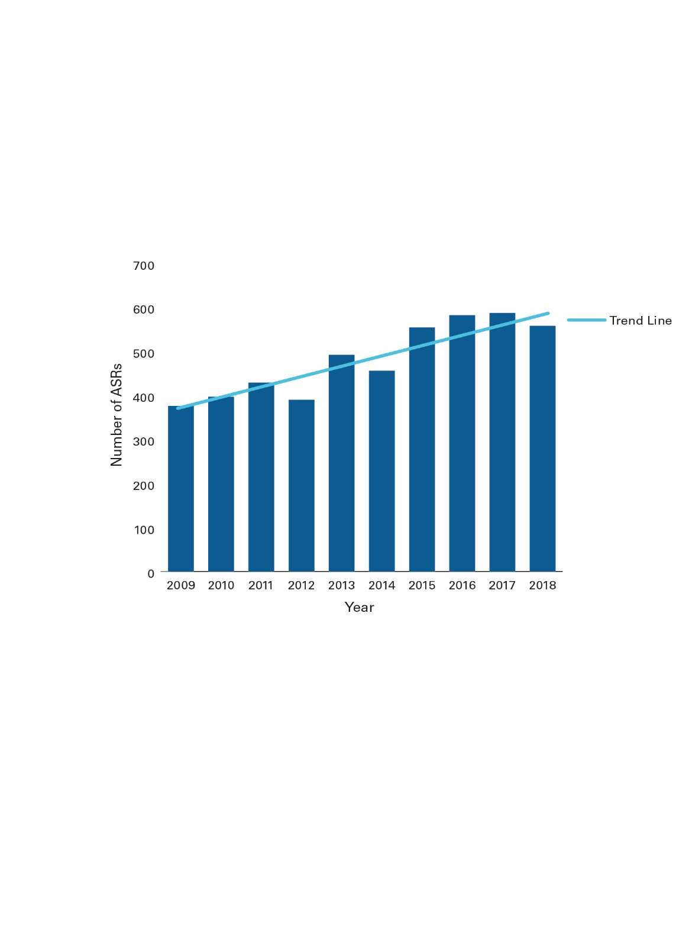

Figure 2.2 provides a breakdown of the number of organisations that submitted ASRs each year between 2009 and 2018. ASRs for 2018 were still being received at the time of writing this report.

### Figure 2.2 Number of organisations on the REO that submitted an ASR

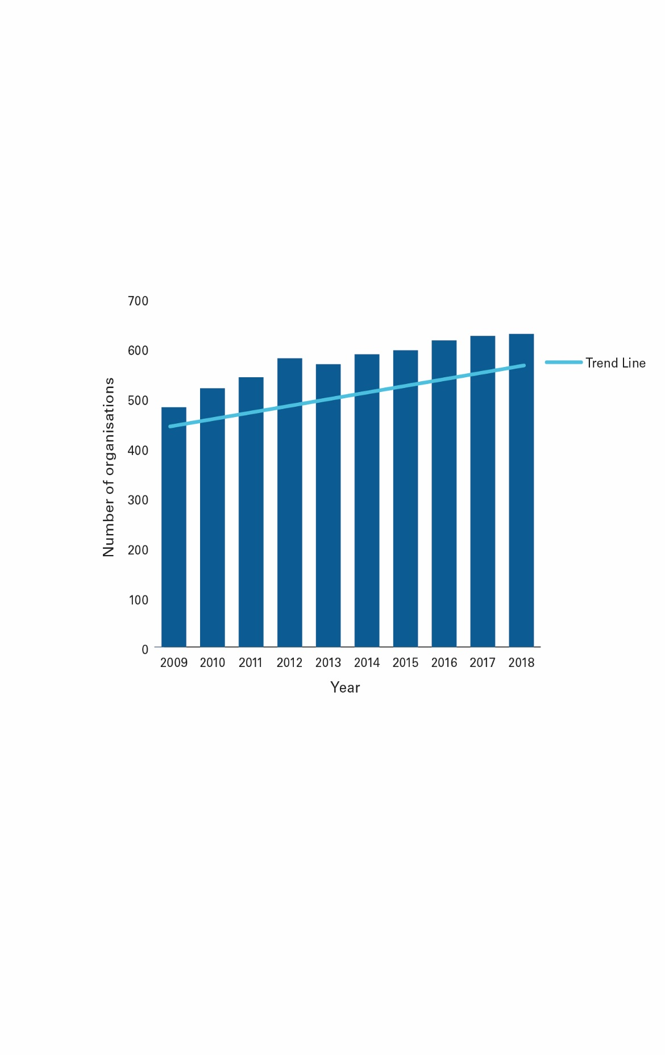

Total donations ($)

Total donations made to organisations on the REO, since its introduction in 1992, is over $2.2 billion. In the last decade (from 2009 to 2018), organisations reported collecting over $1.4 billion in donations.

### Figure 2.3 Total donations made to organisations on the REO

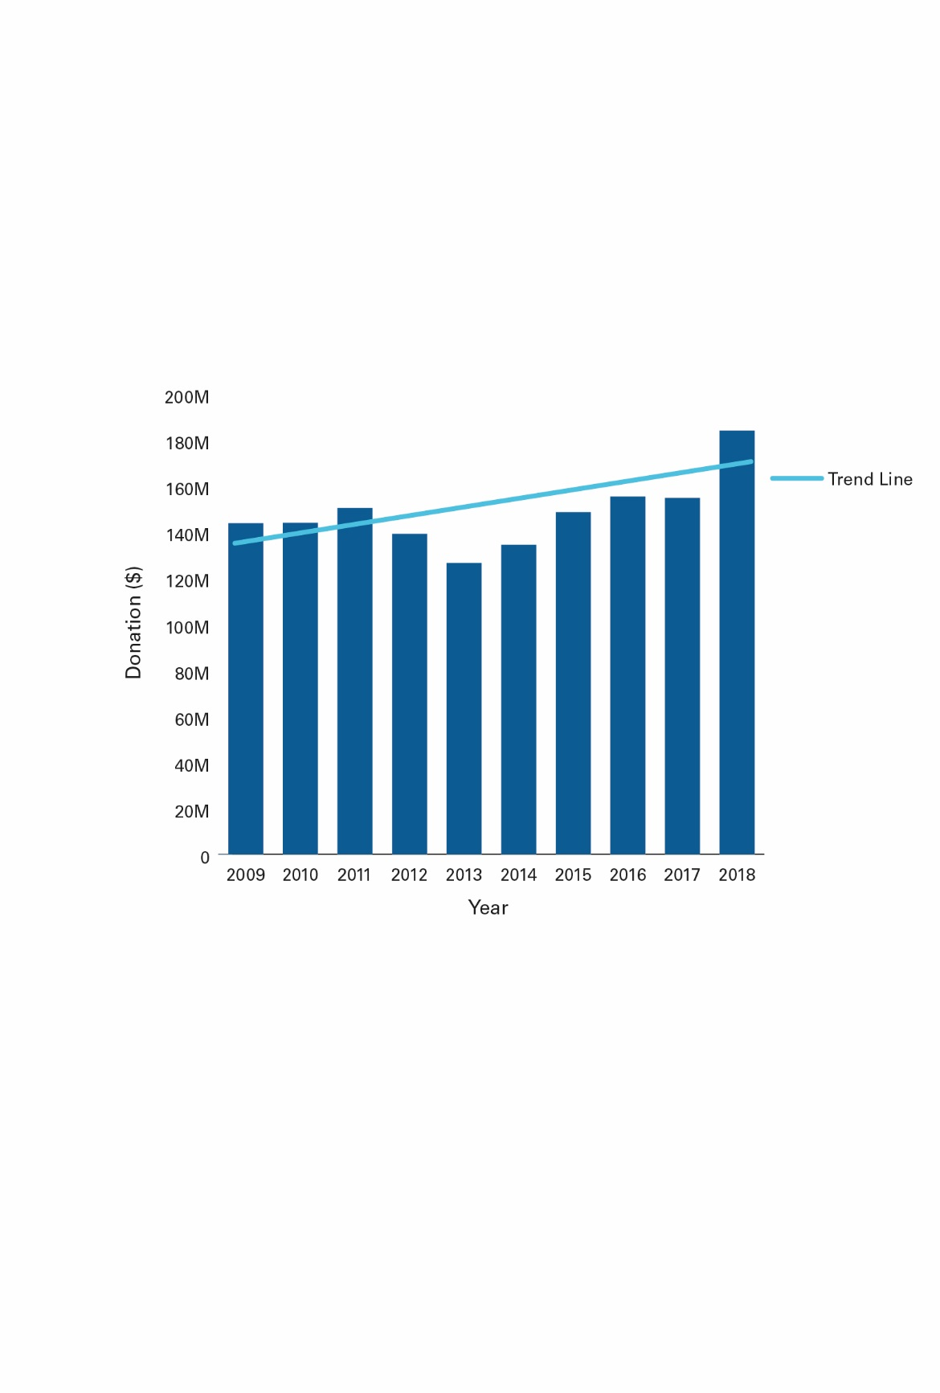

Figure 2.4 provides a further breakdown of donations, split by donations of money and property.

Property donations consistently represent a small component of overall donations for each year over the decade. The largest value in property donations occurred in 2010, at a combined reported value of $10.8 million. Donations of property allow environmental organisations to do important conservation work.

As the breakdown between money and property was not available for 2013, total donations has been represented as ‘money’ in this figure.

### Figure 2.4 Total donations made to organisations on the REO by money and property

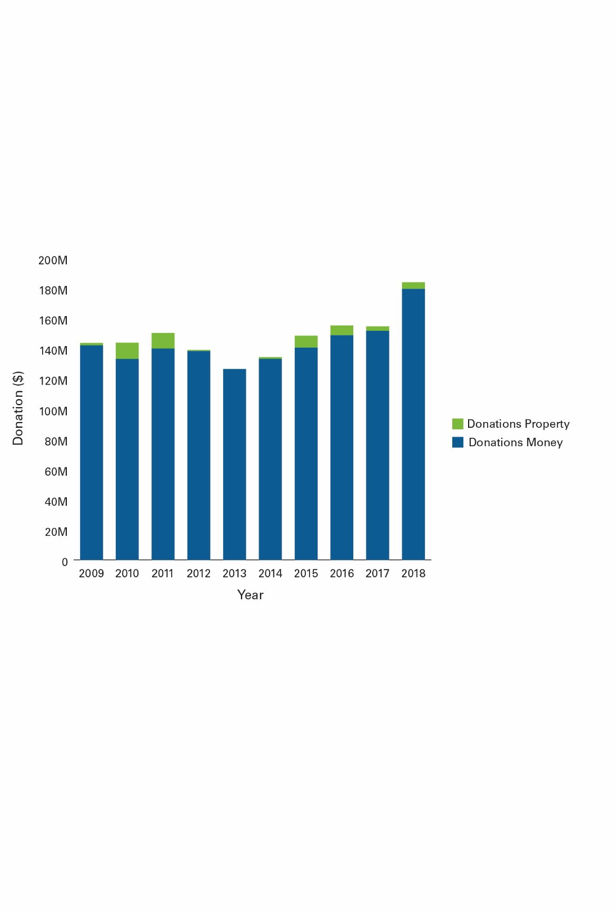

Figure 2.5 shows that the largest ‘share’ of total donations each year is received by organisations that received in excess of $2 million in donations.

### Figure 2.5 Total donations grouped by the amount of donations received by organisations ($)

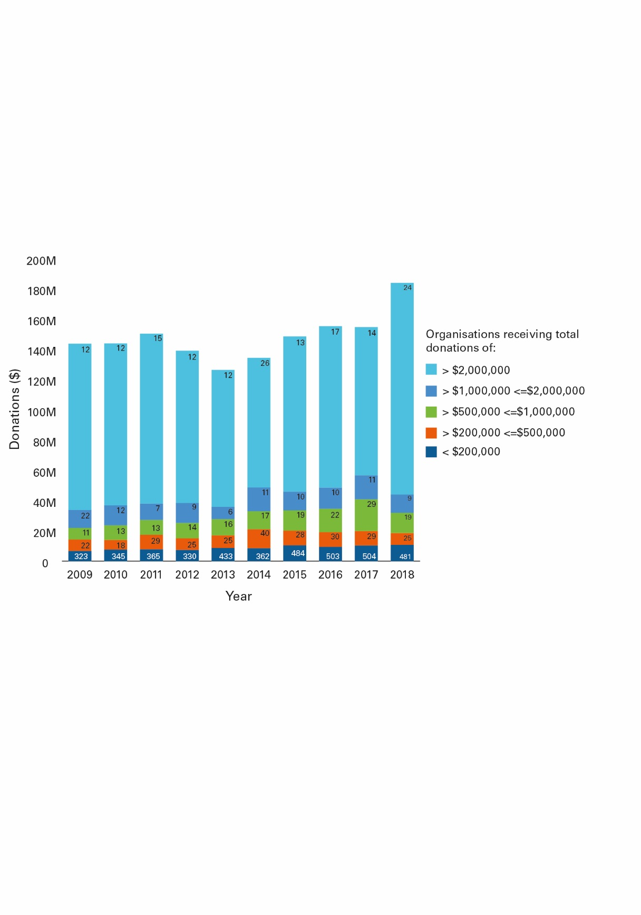

In 2018, 24 organisations each received more than $2 million in total donations, making up 76 percent of total donations.

Figure 2.6 shows the majority of organisations on the REO eceive less than $200,000 in donations each year. This trend has been consistent over the decade.

For 2018, of the 558 organisations that submitted an ASR, 481 (or 86 per cent) of organisations reported less than $200,000 in total donations and 24 (or 4.3 per cent) organisations, reported greater than $2 million in donations. As shown is figure 2.5, the 24 organisations made up 76 percent of total donations.

### Figure 2.6 Total donations grouped by the amount of donations received by organisations (%)

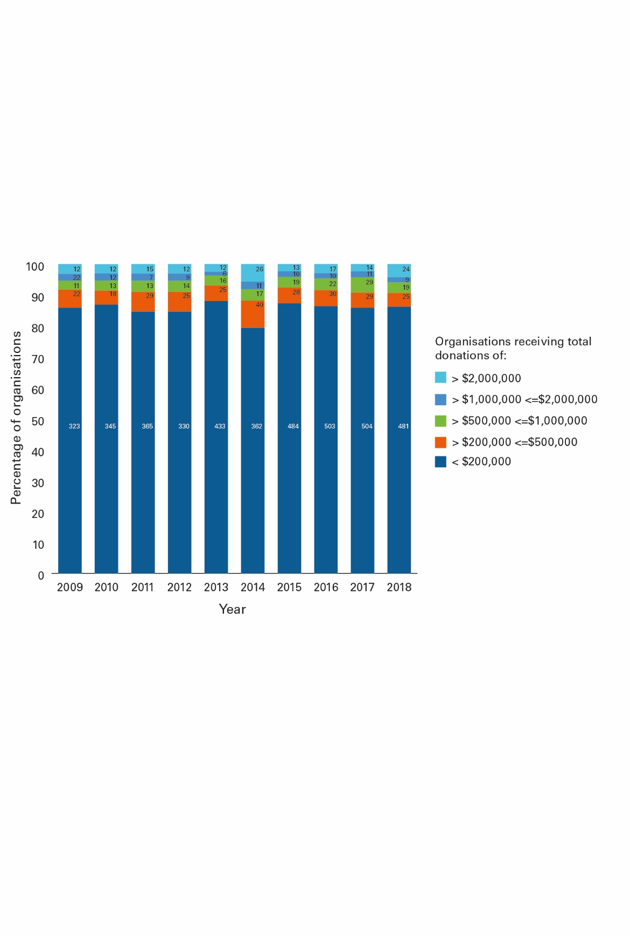

|  |  |  |  |  |  |  |  |  |  |  |
| --- | --- | --- | --- | --- | --- | --- | --- | --- | --- | --- |
|  | 2009 | 2010 | 2011 | 2012 | 2013 | 2014 | 2015 | 2016 | 2017 | 2018 |
| > $2,000,000 | 3.19% | 3.02% | 3.08% | 3.08% | 2.44% | 5.70% | 2.35% | 2.92% | 2.39% | 4.30% |
| > $1,000,000 <= $2,000,000 | 2.13% | 2.27% | 2.31% | 2.31% | 1.22% | 2.41% | 1.81% | 1.72% | 1.87% | 1.61% |
| > $500,000 <= $1,000,000 | 2.93% | 3.27% | 3.59% | 3.59% | 3.25% | 3.73% | 3.43% | 3.78% | 4.94% | 3.41% |
| > $200,000 <= $500,000 | 5.85% | 4.53% | 6.41% | 6.41% | 5.08% | 8.77% | 5.05% | 5.15% | 4.94% | 4.48% |
| < $200,000 | 85.90% | 86.90% | 84.62% | 84.62% | 88.01% | 79.39% | 87.36% | 86.43% | 85.86% | 86.20% |

1. NUMBER OF DONATIONS MADE TO ENVIRONMENTAL ORGANISATIONS

This section summarises the number of donations (count) made to environmental organisations from 2009 to 2018.

Over the decade, over 16.3 million donations have been made to organisations on the REO. This number is understated with no data available for 2013 FY.

Figure 3.1 provides a breakdown of the number of donations reported for each year over the decade. The number of donations made to organisations on the REO has declined over the decade.

### Figure 3.1 Total count of donations made to organisations on the REO

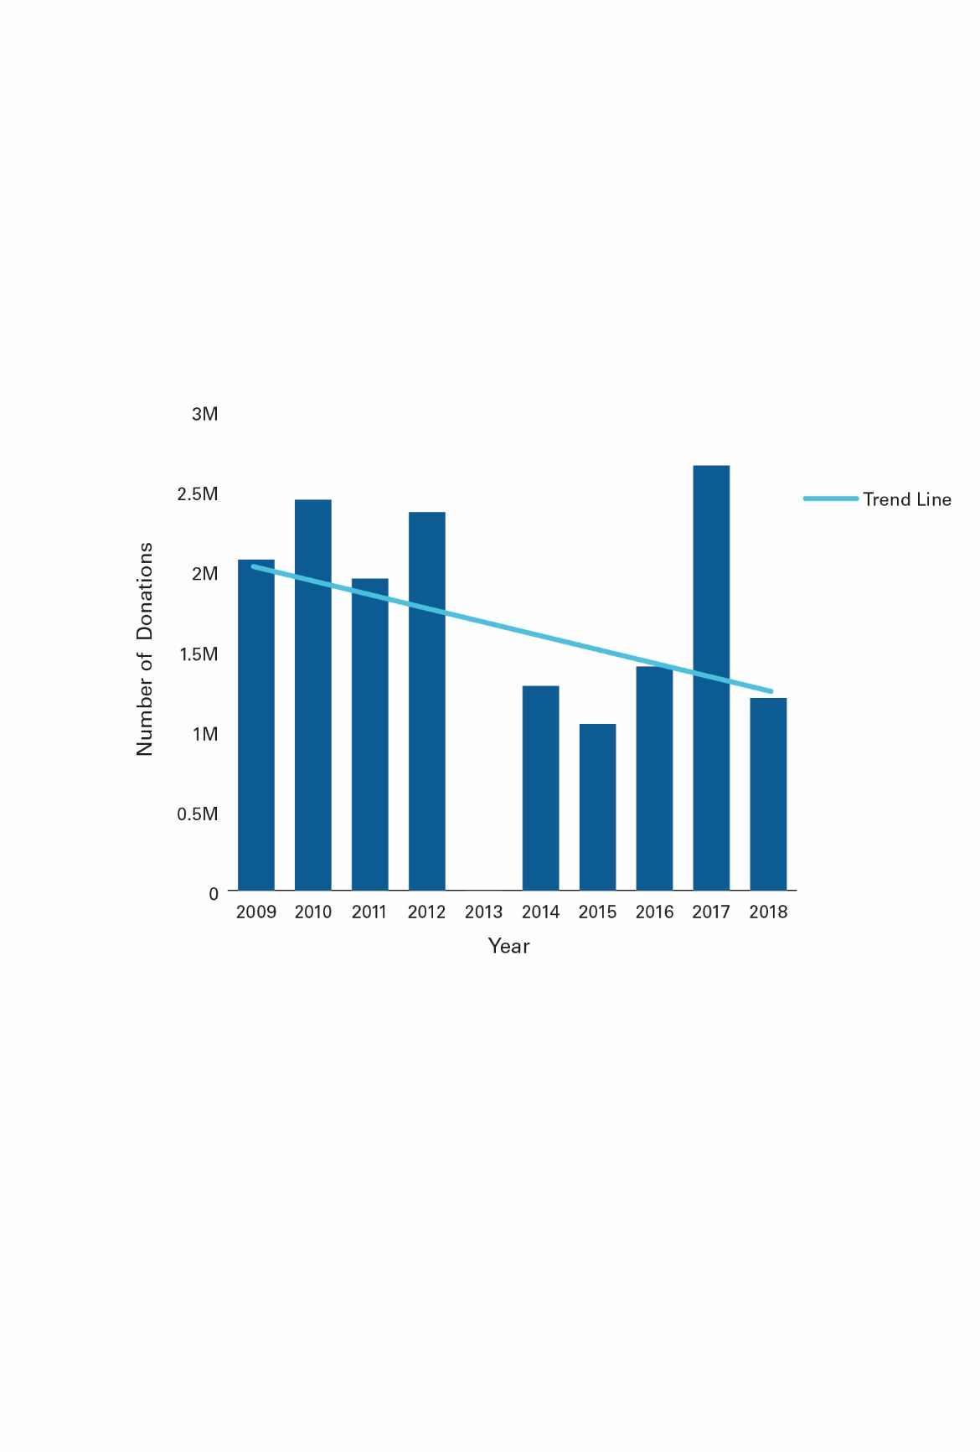

Figure 3.2 provides a breakdown of the percentage split between the number of donations (money) and number of donations (property). Over the decade organisations have received mostly ‘money’ donations, with the number of ‘property’ donations representing a very small percentage of the overall number of donations. No data was available for the 2013.

### Figure 3.2 Number of money and property donations made to organisations on the REO (%)

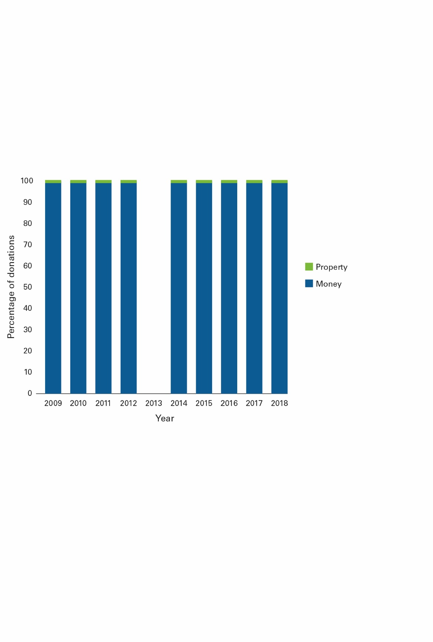

Figure 3.3 provides the derived median number of donations made to all organisations on the REO, by year. This has been calculated by comparing the total donations reported per year, where at least one donation was made. The derived median number of donations has remained relatively consistent over the decade, ranging from 17 to 25 donations per organisation, per year. The trend line is upward. No data was available for 2013.

### Figure 3.3 Median number of donations made to organisations on the REO

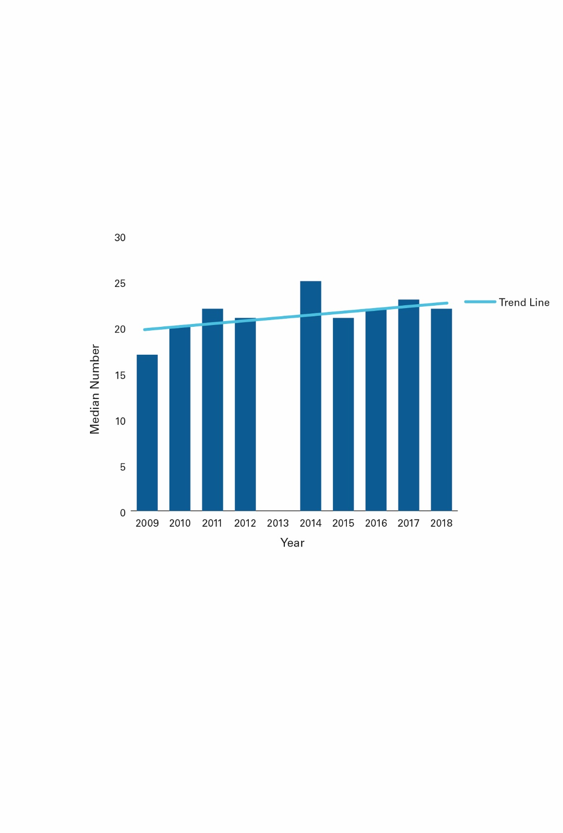

Figure 3.4 groups organisations into bands based on the number of donations received. This shows that the majority of organisations received less than 120 donations per year. This trend is consistent over the decade. The figure also shows, that a relatively small number of organisations receive the highest number of donations. Again, this trend was consistent over the decade.

In 2009, 82 per cent (or 311 of 376) of organisations that provided an ASR had less than 120 donations, with 31 organisations (or 8.24 per cent) reporting greater than 500 donations. By 2018, this had increased with 10.75 per cent of organisations reporting more than 500 donations.

### Figure 3.4 Number of donations made to organisations on the REO, grouped by band

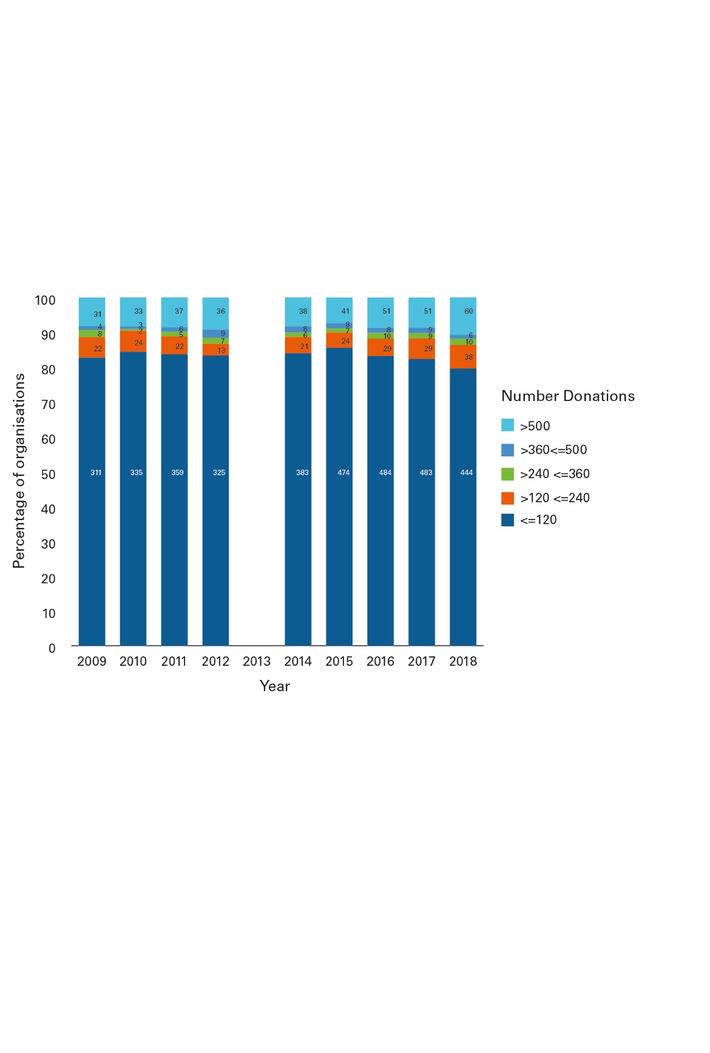

|  |  |  |  |  |  |  |  |  |  |  |
| --- | --- | --- | --- | --- | --- | --- | --- | --- | --- | --- |
|  | 2009 | 2010 | 2011 | 2012 | 2013 | 2014 | 2015 | 2016 | 2017 | 2018 |
| > 500 | 8.24% | 8.31% | 8.62% | 9.23% |  | 8.33% | 7.40% | 8.76% | 8.69% | 10.75% |
| > 360 <= 500 | 1.06% | 0.76% | 1.17% | 2.31% |  | 1.75% | 1.44% | 1.37% | 1.53% | 1.08% |
| > 240 <= 360 | 2.13% | 0.50% | 1.40% | 1.79% |  | 1.32% | 1.26% | 1.72% | 1.53% | 1.79% |
| > 120 <= 240 | 5.85% | 6.05% | 5.13% | 3.33% |  | 4.61% | 4.33% | 4.98% | 5.96% | 6.81% |
| <= 120 | 82.71% | 84.38% | 83.68% | 83.33% |  | 83.99% | 85.56% | 83.16% | 82.28% | 79.57% |

Figure 3.5 shows the percentage of total donations to organisations that reported receiving more than 500 donations. The data has remained relatively consistent over the decade, showing about 60 per cent of total donations were received by organisations that received more than 500 donations.

When considering figure 3.4 with the below figure, this percentage was the highest in 2018, with 10.7 per cent of organisations that submitted an ASR receiving 79 per cent of total donations

### Figure 3.5 Percentage of total donations for organisations who received >500 donations

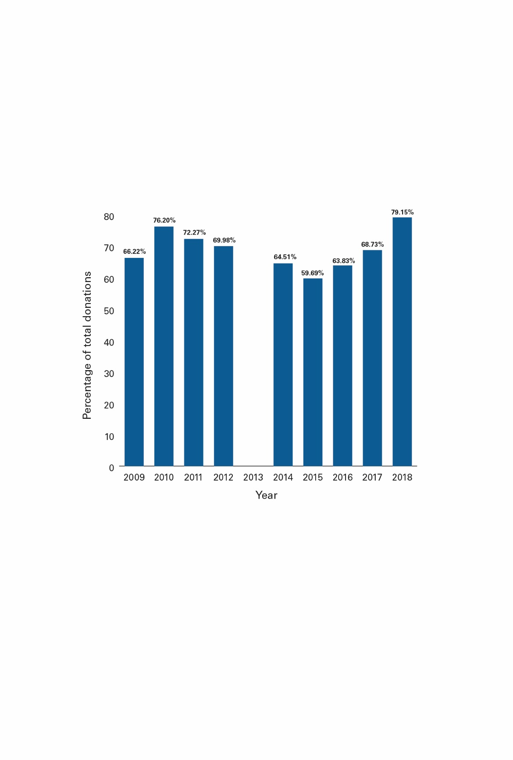

1. THE SIZE OF ORGANISATIONS ON THE REO

This section provides an indication of the size of organisations on the REO, by comparing the 2018 REO dataset against the 2017 ACNC revenue data (for those organisations listed on both registers (74 per cent of organisations).

The size categories defined by the ACNC have been adopted for the purposes of this report.

Based on this sample, most organisations on the REO are small.

* 58 per cent were small (total revenue $50,000 to less than $250,000).
* 22 per cent were medium (total revenue $250,000 to less than $1 million).
* 20 per cent were large (total revenue $1 million to less than $10 million).

The following figure shows a count of organisations that fall within the donation value groupings, small, medium and large, and their respective revenue, as a percentage of total revenue for the sample.

### Figure 4.1 Size of organisations on the REO (2018) by revenue

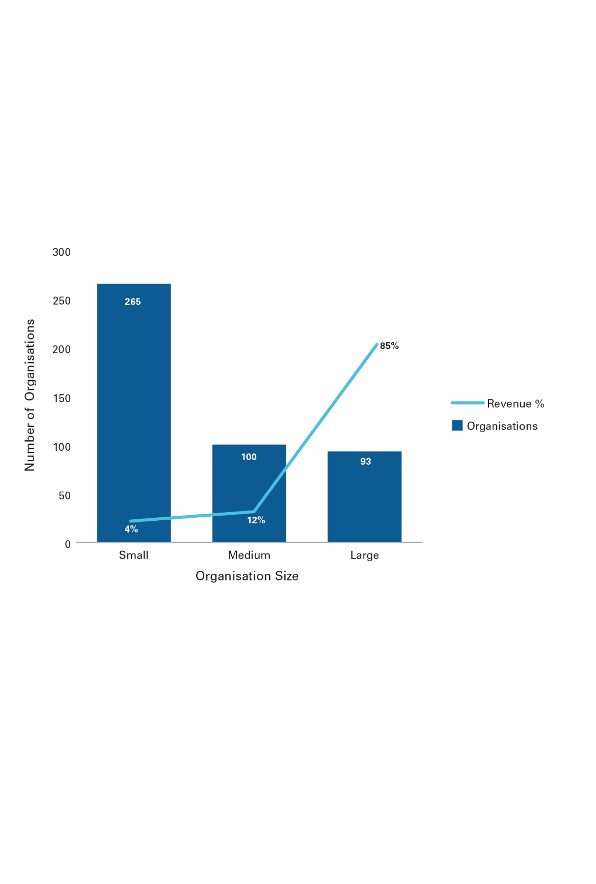

© Copyright, ACNC

The number of FTE employees working for organisations on the REO is another factor that shows the size and characteristics of these organisations. Again, the 2017 ACNC data has been used to provide an indication of the FTE employees working for organisations on the REO.

Figure 4.2 shows that organisations on the REO predominately have a small number of FTE employees (less than 25 FTE employees), with only one organisation having more than 100 FTE employees. In the sample, 55 per cent of REO organisations reported no paid staff.

For the sample size (466), 96 per cent (or 446) of organisations, had less than 25 FTE employees.

### Figure 4.2 Size of organisations on the REO (2018) by FTE employees

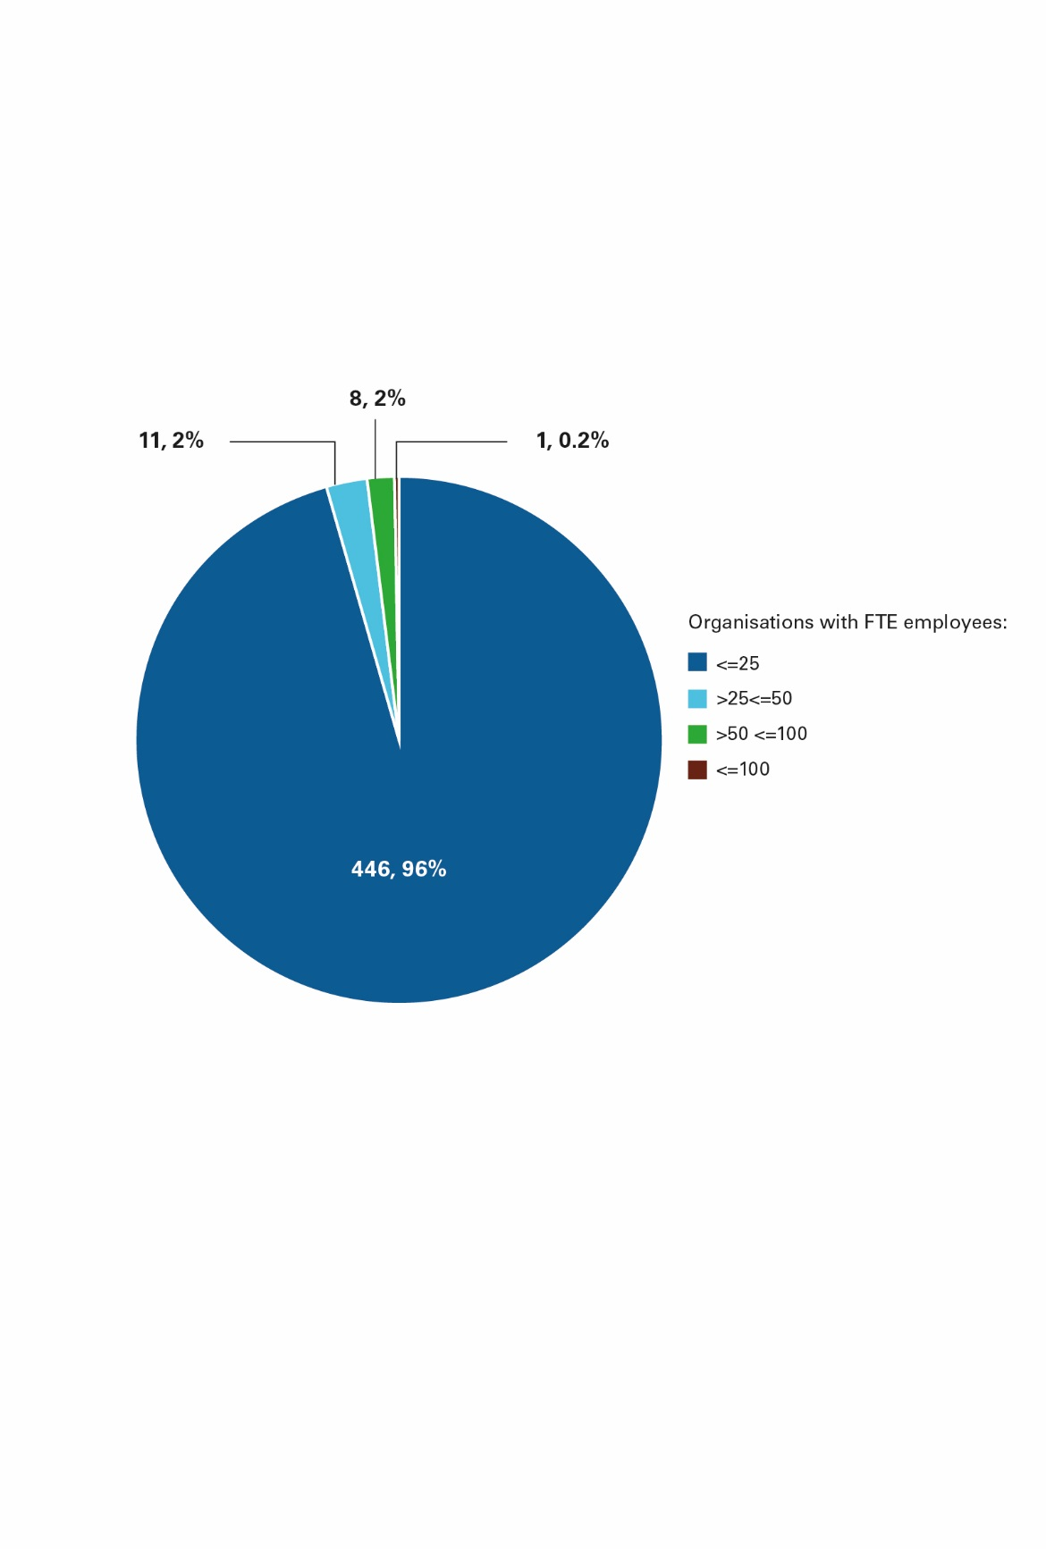

© Copyright, ACNC

There are 2036 FTE employees working for the 466 organisations. Figure 4.3 shows that approximately half are working for organisations who have less 25 FTE employees.

### Figure 4.3 Number of FTE employees working for organisations on the REO (2018)

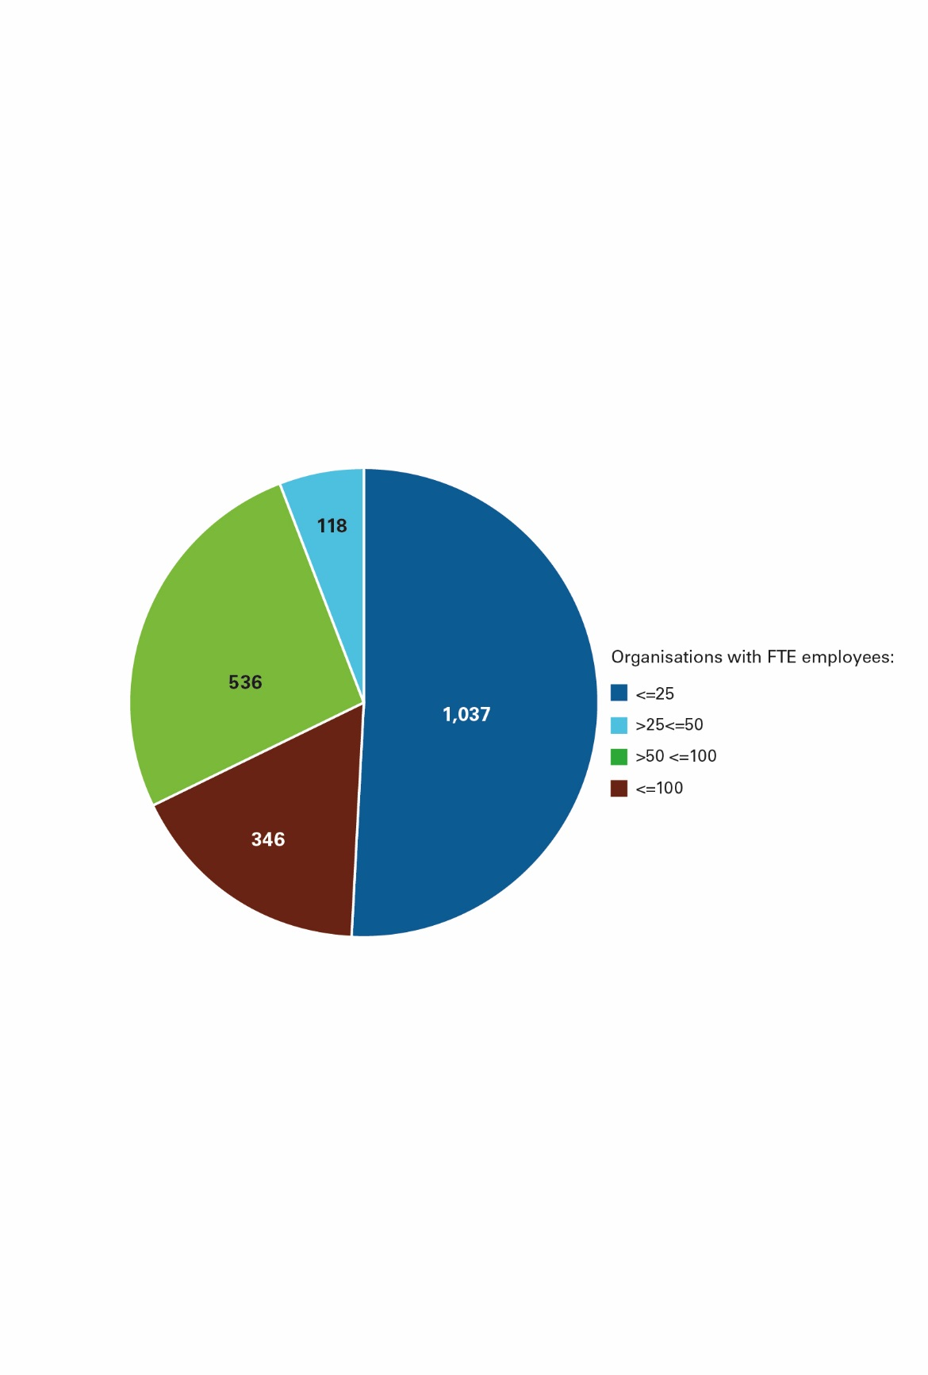

© Copyright, ACNC

1. WHERE ORGANISATIONS ON THE REO are OPERATING

Organisations on the REO can operate in multiple jurisdictions. An indication of where organisations on the REO are operating has been determined by comparing the REO 2018 dataset against the ACNC 2017 dataset (for the 74 per cent of organisations on both registers).

Figure 5.1 and 5.2 shows that over 50 per cent of organisations in the sample operate in New South Wales, Victoria and Queensland.

### Figure 5.1 Organisations operating in each jurisdiction (table format)

|  |  |
| --- | --- |
| Operating in | Total organisations |
| NSW | 208 |
| VIC | 196 |
| QLD | 185 |
| WA | 126 |
| SA | 120 |
| TAS | 101 |
| ACT | 97 |
| NT | 78 |
| Overseas | 68 |

© Copyright, ACNC

### 

### Figure 5.2 Organisations operating in each jurisdiction (graph format)

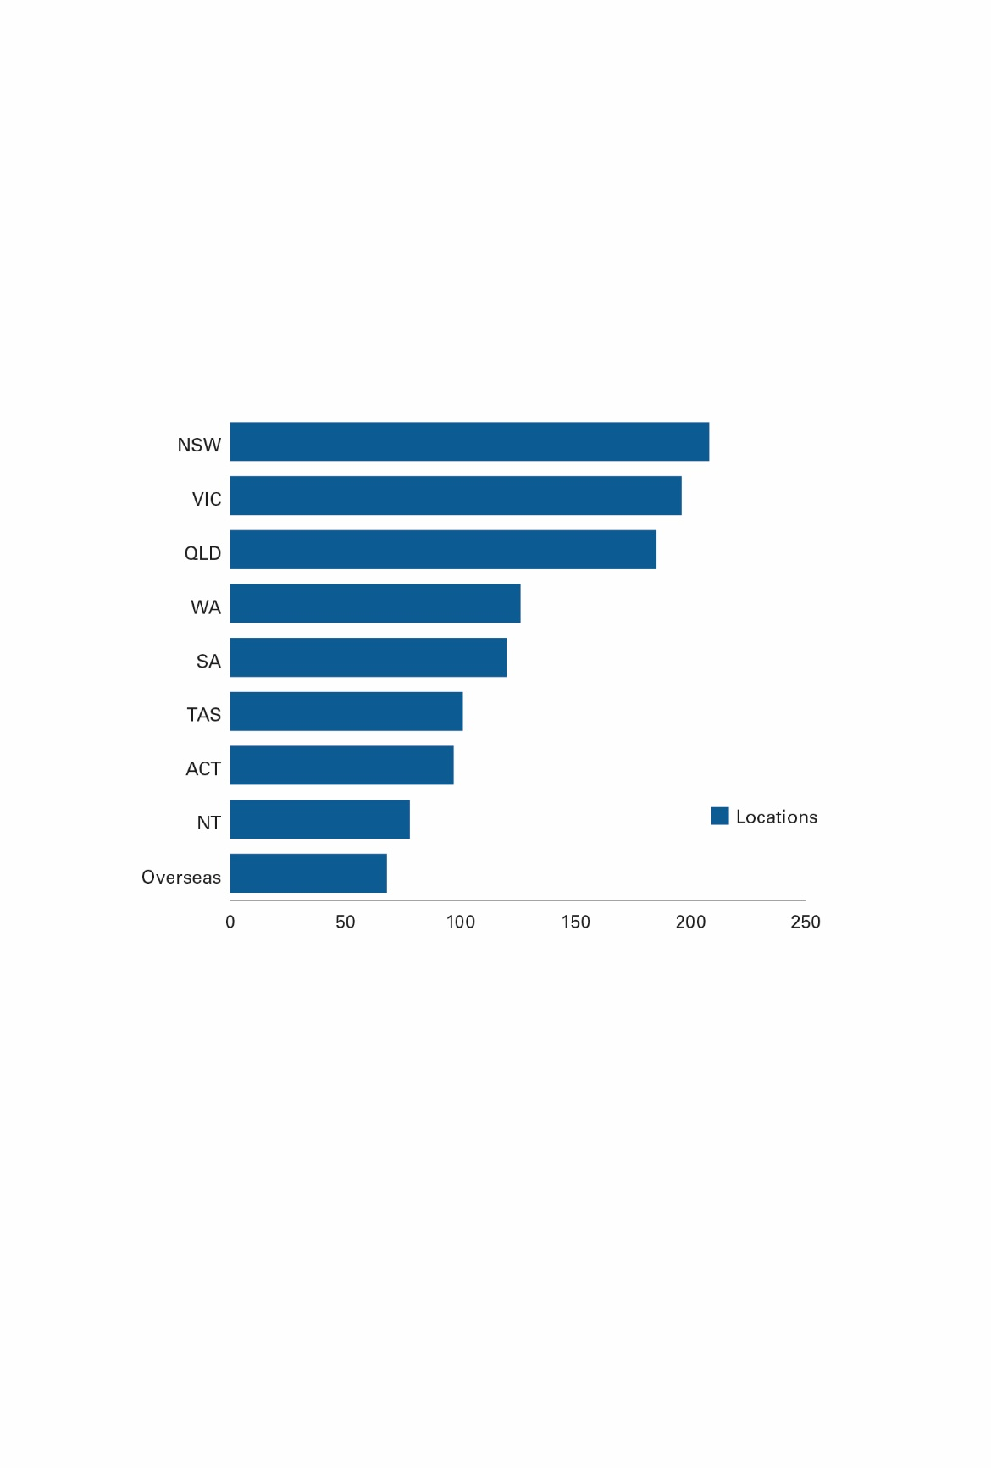

© Copyright, ACNC

1. WHAT Donations are being SPENT ON

This section summarises expenditure by organisations on the REO by category, for 2017 and 2018. Changes in data collected on expenditure categories has limited the ability to make comparisons of this data across the decade.

Figure 6.1 below shows the breakdown of total expenditure by category for the 2017 and 2018 reporting period. For 2018, expenditure on on-ground environmental activities was the highest ($45.2 million), followed by expenditure on staff ($41.5 million).

### Figure 6.1 Total expenditure of organisations on the REO by category ($)

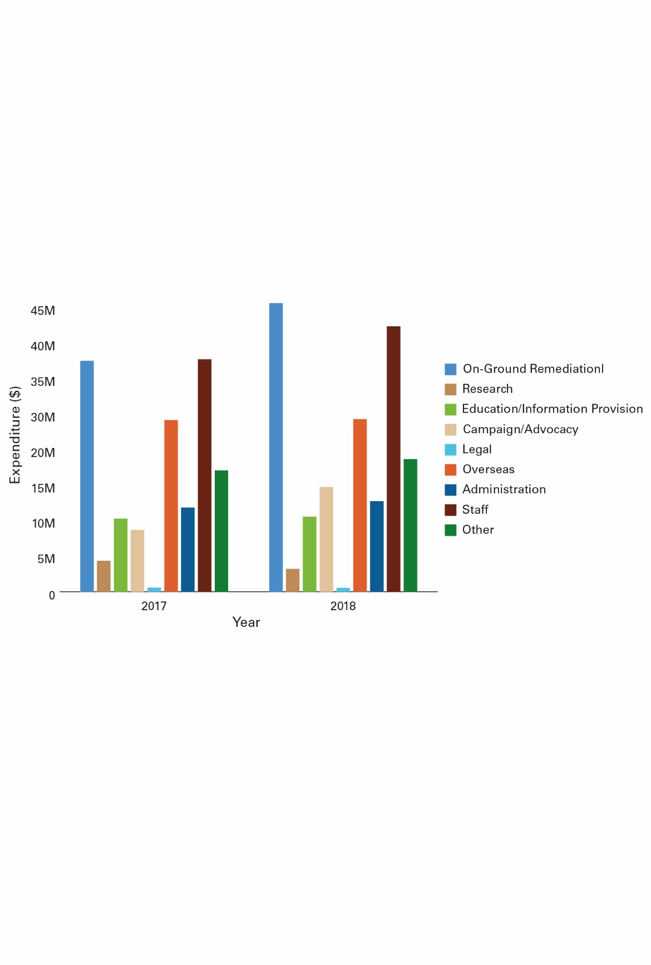

Figure 6.2 below shows the same breakdown of total expenditure by category as a percentage rather than a dollar value.

### Figure 6.2 Total expenditure of organisations on the REO by category (%)

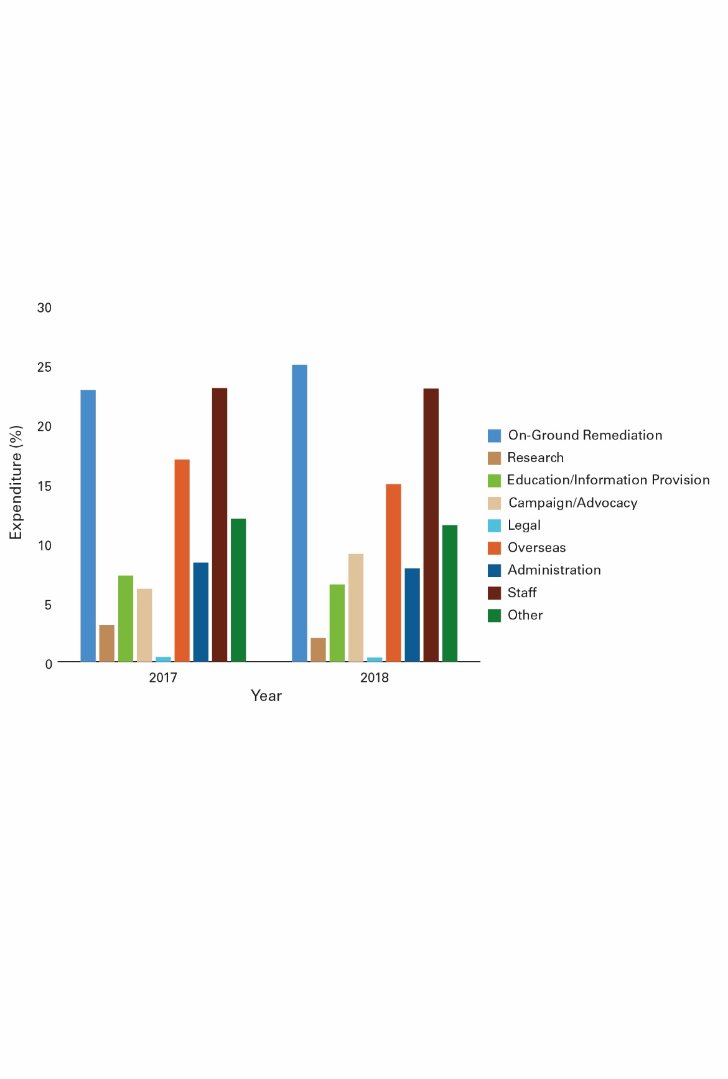

Figure 6.3 shows that the majority of expenditure occurs in Australia, with a small component being directed to environmental projects overseas. 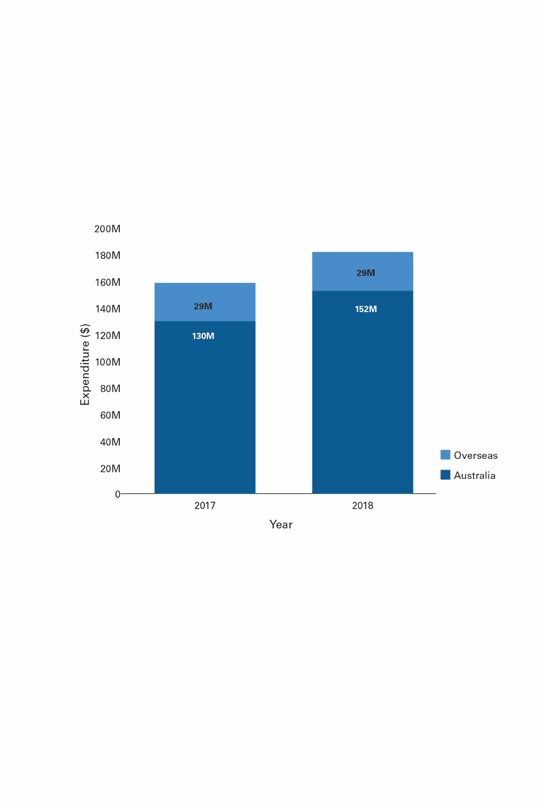

### Figure 6.3 Total expenditure in Australia and Overseas of organisations on the REO

1. ISSUES ORGANISATIONS ON THE REO are WORKING ON

This section explores the issues that environmental organisations directed donations towards. The analysis is based on AEGN catalogue data collected through surveying organisations on the REO in 2015 and 2019.

There are limitations in the accuracy of this data, including the 2015 data being supplemented by desktop research, rather than organisations reporting this information. Further limitations may include differing interpretation of these categories and the relatively small sample size in 2019.

Yet, in the absence of specific reporting on issues, the data provides a useful insight into where environmental organisations are focusing their efforts.

In 2015 the AEGN carried out a survey to identify the issues that environmental organisations were working on. The responses provided were supplemented with desktop research at that time, with a total sample size of 529 organisations from the REO.

### Figure 7.1 Issues that organisations on the REO were working on (2015) ranked from most to least common

|  |  |
| --- | --- |
| Ranking | Issue |
| 1 – Most common | Biodiversity |
| 2 | Water |
| 3 | Sustainable agriculture and food systems |
| 4 | Marine |
| 5 | Sustainable cities |
| 6 | Climate and energy |
| 7 | Sustainable economy |
| 8 | Indigenous land and sea management |
| 9 – Least common | Toxics |

© Copyright, AEGN

In March 2019, the AEGN carried out a similar survey (to the above), to which 211 organisations on the REO provided a response. The survey collected information on the types of ‘issues’ organisations were working on. Organisations were presented with the below list, allowing multiple issues to be selected.

In comparing the 2019 survey results with the 2015 results above, ‘biodiversity’ has remained the most common issue organisations have identified as working on. A key change, has been the increase in organisations working on ‘climate and energy’ related issues.

### Figure 7.2 Issues that organisations on the REO are working on (2019) ranked from most to least common

| Ranking | Issue |
| --- | --- |
| 1 – Most common | Biodiversity |
| 2 | Water |
| 3 | Climate and energy |
| 4 | Marine |
| 5 | Sustainable agriculture and food systems |
| 6 | Indigenous land and sea management |
| 7 | Sustainable cities |
| 8 | Sustainable economy |
| 9 – Least common | Toxics |

© Copyright, AEGN

1. INDIGENOUS LAND AND SEA MANAGEMENT

The AEGN survey data presented in Figure 7.2 shows that more than a quarter of the organisations on the REO that responded to the survey (211 organisations) are supporting Indigenous land and sea management activities.

Indigenous land and sea management activities are an integral part of Australia’s on-ground environmental and biodiversity protection efforts. Through their connection to and care for Country, Aboriginal and Torres Strait Islander people are vital partners in sustaining our environment.

Hundreds of Indigenous land and sea management ranger groups are working to address pressing environmental issues across the Australian continent, from broad-scale landscape restoration to specific species recovery programs, undertaking feral animal and plant control, carbon abatement, research and monitoring.

Sites include, but are not limited to, 67 million hectares of land and sea protected within 75 Indigenous Protected Areas[2] declared as part of Australia’s National Reserve System, and managed according to the standards of the International Union for the Conservation of Nature’s Protected Area Management Categories. There are currently also 11 Indigenous Protected Area consultation projects.

While there is no definitive list of Indigenous land and sea management organisations, two sources provide an insight into these organisations:

* The Australian Government funds many, but not all organisations undertaking Indigenous land and sea management activities through their Indigenous Protected Areas and Indigenous Rangers programs. This comprises 88 organisations[3], supporting 123 groups of Indigenous rangers[4]. These organisations are listed on the National Indigenous Australians Agency’s website. Most state and territory governments also provide funding to support groups of Indigenous rangers.
* The AEGN maintains a Directory of Environmental non-government organisations working in Australia. The Directory includes 148 organisations that support Indigenous land and sea management (identified though an AEGN desktop audit). Over half of these organisations are registered charities with a sub type Public Benevolent Institutions (PBI). Only a small number (10) of these organisations are on the REO.

There are two common reasons for organisations that do land and sea management work not being listed on the REO:

1. Indigenous land and sea management is one activity amongst other services provided.

Many of the Indigenous land and sea management work is undertaken by organisations such as Indigenous or Torres Strait Islander Land Councils or Local Councils whose remit is far broader than environmental protection. Registration as a PBI charity acknowledges their primary role of relieving the suffering of their Indigenous constituents. Indigenous Land Councils, for example, began as part of the Land Rights movement.

1. Organisations for which Indigenous land and sea management is their single or main focus have motivations beyond environmental protection for undertaking their work.

Even where Indigenous land and sea management work is the single or main focus of an organisation, the motivation of Traditional Owners initiating the organisation is broader than just environmental reasons. Traditional Owners are usually motivated by a desire to see their whole country protected, including environmental and cultural elements and also to maintain and strengthen the connection to Country of their people.

Finally, many of the organisations undertaking environmental work in Indigenous land and sea management (including 44 per cent of the organisations funded for this work by the Australian Government) do not have charity or DGR status. These organisations generally do not operate beyond activities funded by the Government.

1. SUMMARY OF REO DATA FOR 2018 REPORTING PERIOD

There were 628 organisations on the REO that were required to report for 2018. At the time of writing this report, 558 (or 89 per cent) of the 628 organisations provided an ASR.

* The 558 organisations reported total donations of $183.86 million.
  1. This was the highest annual total donations reported for the past decade.
  2. This consisted of $179.5 million in money donations and $4.3 million in property donations.
* The total number of donations reported by the 558 organisations was just over 1.2 million.
  1. This number was significantly below the previous year which was over 2.6 million.
  2. While the number of donations was down from the previous year, the total donations collected increased from $154 million in 2017 to $179 million in 2018.
* Analysis of the data shows that a small number of organisations collected the majority of total donations.
  1. 481 organisations (or 86 per cent) reported less than $20,000 in total donations
  2. 24 organisations (or 4.3 per cent) reported greater than $2 million in donations
* Similarly, a small number of organisations received the majority of the number of donations.
  1. 440 organisations (or 79 per cent) reported less than 120 donations
  2. 60 organisations (or 10.75 per cent) reported more than 500 donations. These organisations collected 79 per cent of total donations.

1. CONCLUSIONS

This is the first report that shares aggregated information reported by organisations on the REO. Combined with other datasets, it provides useful trends and insights into the value, number and use of donations over time for interested audiences.

The report highlights the generous donations being made to environmental organisations to support them in addressing Australia’s environmental challenges.

Publication of the report also promotes the important work undertaken by organisations on the REO.

A healthy environment underpins Australia’s economy and the health and wellbeing of our communities. The intrinsic value of our unique environment, and all that it does to sustain our existence, is important to all Australians.

Responsibility for sustainable development and environmental stewardship for current and future generations is shared across the community. Governments, businesses, Indigenous organisations, philanthropists, research and not-for-profit organisations and communities all have a role in this vital undertaking.

1. [https://pmc.gov.au/public-data/open-dat](https://pmc.gov.au/public-data/open-data)a
2. <https://www.niaa.gov.au/indigenous-affairs/environment/indigenous-protected-areas-ipas>
3. <https://www.niaa.gov.au/indigenous-affairs/environment/project-funding-indigenous-land-and-sea-management>
4. <https://www.niaa.gov.au/indigenous-affairs/environment/indigenous-rangers-working-country>