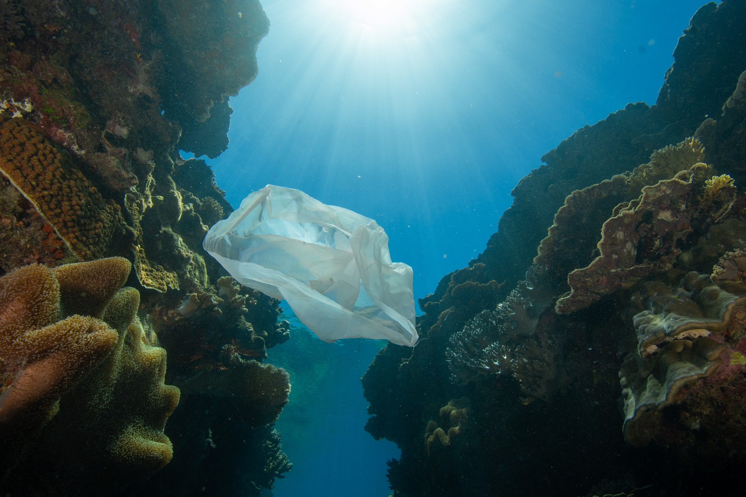

Report to the Minister for the Environment the Hon. Sussan Ley MP

January – June 2021

Submitted | 20th July 2021

**A note from The Hon. Warren Entsch MP**

Minister as you know this year is an incredibly important time for increasing global ambition on reducing emissions and addressing climate change. In April this year we saw positive global cooperation through President Biden’s Leader’s Summit on Climate. As nations continue to ratchet up their Nationally Determined Contributions for the 2030 period and make commitments to firm net zero timeframes—this is cause for great optimism, as well as introspection.

Many of our closest allies, trading partners and other international peers have increased their commitments in recent times. This growing cohort now represents the majority of total global emissions. The expectation of these nations will be that others who currently remain without long-term and strengthened interim targets will come to Glasgow negotiations ready, willing and with comparable commitments in hand.

While climate diplomacy is important, it is just one element in this equation. It bears repeating that there is substantial economic opportunity in transitioning world economies to a decarbonised future. The economic benefits arising from decarbonisation are further supported by the scientific imperative to undertake these changes at pace in order to avoid the worst of climate impacts.

The science tells us that this current decade is a crucial time for tangible and expeditious efforts to reduce global emissions. Collective reductions made now are a down payment for reduced warming in the decades ahead. Without sufficient global action the Great Barrier Reef continues to face a concerning long-term future. Scientific projections indicate a substantial decline in shallow water coral cover as sea surface temperatures continue on their upward trajectory.

Coral reefs worldwide are on the frontline of climate change impacts. This is not surprising given over the last 50 years more than 90 per cent of the warming that has occurred on Earth has been absorbed by our oceans. While this summer our sea surface temperatures were subdued somewhat—with help from the recent La Niña event—we’ve managed to avoid another mass coral bleaching. But such periods of fortuitous weather are not evidence for a reversal in global warming trends.

Scientists are becoming ever more certain about the growing pace of warming, its impact, and its ability to outstrip the adaptive capacity of ecosystems more generally. As such, governments around the world should continue supporting avenues of scientific research for all possible adaptation measures. However, it is also vitally important to recognise the fundamental role that climate change mitigation plays in sustainably addressing and minimising these challenges into the future.

It is clear to me that in order for Australia to maintain its credibility as the best reef managers in the world, we must dovetail our world class management efforts and adaptation measures with an equally robust climate mitigation strategy. As I have said many times, getting to net zero emissions by 2050 is critically important, and ideally it would happen even sooner. For the Reef’s long-term sustainability, global efforts to reduce greenhouse gas emissions must accelerate.

The good news is that the latest analysis on global commitments suggests that 71 per cent of global emissions are now covered by net zero targets. While more policies are required to solidify these ambitious targets, optimistic scenarios continue to illustrate that the world is inching closer to limiting warming to just 2 degrees Celsius. It also suggests that 1.5 degrees is not yet a lost cause, although the window of opportunity to secure this level of reduced warming is closing rapidly.

As COP26 in November draws closer, climate policy is receiving renewed focus and it is my hope that Australia will not go to the UN climate summit empty handed. As such, I continue to make the case for new long-term and stronger interim emissions reduction commitments to Minister Taylor and other senior colleagues. I believe these are reasonable expectations and I fear that without such commitments we will likely leave our trade exposed to carbon border adjustments. As you know, I have written on this subject at some length and I suspect we may find ourselves corralled by these climate tariffs in years to come.

In its response, Australia is making investments in leveraging technology to reduce emissions and this is an important part of the solution. By supporting efforts in research and development we can enable emissions reductions in hard to abate sectors. While Australia has indicated its preference is to reach net zero emissions by 2050, my preference is that Australia formally commit to this long-term target and increase efforts in the near term to secure a viable trajectory to decarbonisation.

All nations face the shared challenge of climate change, so all nations must translate ambition into action if we are to succeed. There appears to be a growing consensus among nations about how governments should proceed. This course is already being charted by the G7 and other leading nations—Australia must reflect on its own position, relative to the emerging consensus. In doing so we should acknowledge that effective global climate change mitigation is in our national interest, particularly given we’re one of the nations who stands to gain the most from tempered warming in the long run. Reasons abound, not least of which relate to the health of the Great Barrier Reef and our broader environment.

Past arguments have presented a false choice between economy or environment, but this antiquated view does not reflect the true nature of just how interconnected and interdependent these areas are. The science illustrates very clearly why we ought to undertake accelerated changes to reach net zero emissions by 2050 at the latest. The economics tells us that it is not only viable to do so, but it is in fact advantageous. The technology (that is commercially available today) shows us we can enable decarbonisation across large portions of our economy with relative ease.

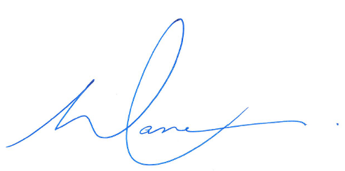

**The Hon Warren Entsch MP**

**Special Envoy for the Great Barrier Reef**

### Current Status of the Great Barrier Reef

We’ve managed to get through this summer relatively unscathed, in fact conditions have been cooler than average in many areas largely owing to the La Niña event we have experienced. While there have been some incidents of coral bleaching across the Great Barrier Reef this summer, these have been restricted to low levels of hard coral bleaching across scattered individual colonies.

Above average rainfall across the Reef catchment would typically have some greater implications for water quality issues, with increased flood plumes for example. However, flood levels across waterways near the Reef remained relatively subdued. Water quality indicators and trends more broadly across the catchment are improving or remaining stable. However, most water quality metrics still presently exceed guideline values, but broadly speaking water quality is getting better.

In January the Great Barrier Reef faced Tropical Cyclone Kimi, it was the only cyclone to pose a threat to the Reef during this year’s season. However, the risk of widespread damage to the Reef was assessed as very low. Very little damage actually occurred and with these cumulative low levels of stressors across the Reef, it has actually meant conditions have broadly been more favourable for coral recovery, which is great news.

Crown-of-thorns starfish (COTS) management continues throughout the Great Barrier Reef Marine Park to protect coral on high-value reefs from starfish predation. The current culling operations are concentrated on reefs in the Central and Southern management regions where numbers of adult COTS are highest. Culling operations continue on individual reefs until COTS numbers are reduced to levels that are sustainable for coral growth and recovery.

Reconnaissance and surveillance of COTS populations and coral cover is being conducted on reefs within all management regions to inform COTS Control Program strategic planning and to maximise the efficiency and effectiveness of program operations. These reconnaissance surveys are conducted in partnership with the Reef Joint Field Management Program, the Australian Institute of Marine Science and the tourism industry.

2020 was the equal hottest year on record globally, and while conditions have been more favourable locally—in the absence of the La Niña event, 2020 may have very likely been the warmest year on record. We should be grateful for the reprieve for coral reef ecosystems this summer but cannot allow ourselves to be lulled into a false sense of security, as temperatures trend upward the pressures on the Reef are still ample.

*The Reef Snapshot – Summer 2020-21,* recently published by GBRMPA, AIMS & CSIRO had this to say on the matter: *“Climate Change is the greatest threat to the Reef. It influences weather patterns and the ocean’s temperature, pH level and currents, as well as intensifying the effects of other threats. Climate change is escalating, and the Reef is already experiencing the consequences of this. Unfortunately, the events that cause disturbances on the Reef are becoming more frequent, leaving less time for coral recovery.”*

It is the recovery window between these acute stressor events, (i.e. cyclones, bleaching, COTS outbreaks, etc.) that is central to preserving the Great Barrier Reef in the long-term. Historically the probability of recurrent bleaching events was not nearly as prevalent as it is today and as it is likely to be into the future. The same can be said for cyclones with respect to their intensity, it is clear key threats to the health of the Reef are being driven by a warming climate.

### Central Queensland Coal Project — Impact on the Great Barrier Reef

Minister as you will recall we have previously discussed the matter of the proposed Central Queensland Coal project proposed by Clive Palmer. I have expressed to you and your staff that I hold a very strong opposition to this project as the Special Envoy for the Great Barrier Reef. In my view it is entirely inappropriate for the mine to proceed, particularly given its proximity to and the unacceptable risk it poses to the Great Barrier Reef and other nearby habitats.

The Queensland Government has finalised its assessment process and found that there were significant deficiencies in the proposal in areas of avoidance, mitigation, management, and measurement leading to a lack of confidence that adverse impacts would be adequately addressed. It also noted that the proposal lacks substance regarding baseline data and scientific evidence to demonstrate the effectiveness of proposed strategies to mitigate impacts to surrounding and downstream environments.

Following the Queensland Government’s recommended rejection and having reviewed the Environmental Impact Assessment myself, I do not believe there is any rationale for the Federal Government to override the Queensland Government’s recommendation. I do look forward to you finalising your deliberations from a federal perspective and I trust you will arrive at a similar conclusion.

### Marine Tourism Update

Gareth Phillips the CEO of the Association of Marine Park Tourism Operators (AMPTO), recently provided me with an update on the current status of the marine tourism industry. While there have been some improvements, the industry remains in a relatively bleak position.

Industry consultation by AMPTO suggests that many marine tourism operators are running with passenger numbers in the range of between 30% - 60% of pre-COVID-19 levels. The industry remains financially hamstrung from the impacts of COVID-19 and the associated international border closures, as well as the new dynamic nature of rapid interstate border closures.

However, recent easing of capacity restrictions has been welcomed by the industry and it has assisted with improving financial viability and translated to each trip to the marine park becoming more viable. But again, borders remain pivotal to overall financial viability of operators.

AMPTO believes that ongoing, sporadic border closures are eroding customer confidence and are adding to the already complex purchasing decisions of consumers as well as inhibiting businesses ability to plan strategically and operationally.

The Federal Government’s $3.2 million funding for in-water conservation and monitoring program in partnership with marine tourism operators has been a resounding success. AMPTO has expressed its thanks to Minister Ley and the government for the initiative which at the time of writing has resulted in the following:

* 692 activity days
* 119 vessel activations
* 4,815 days of employment enabled
* 1,055 reef sites monitored
* 2,141 reef health monitoring reports submitted
* 2,350 hours of reef stewardship activity resulting in:
  + 1,081 COTS culled
  + 63,149 Drupella snails removed, and
  + 22,212 coral fragments planted

The recent UNESCO draft decision has caused major concern for the marine tourism industry and there is a sense that bookings may be impacted. The final decision by UNESCO is due not long after the submission of this report.

**UNESCO draft decision on the Great Barrier Reef World Heritage listing**

Minister, as you are aware the recently announced draft recommendation from UNESCO to the World Heritage Committee to list the Great Barrier Reef as ‘in danger’ is a concerning and unexpected development. This draft decision flies in the face of assurances that our officials were given only a matter of weeks prior to UNESCO’s recent draft recommendation.

It is greatly concerning that this decision appears to have been based solely on a desktop evaluation. While I am the first person to acknowledge the great risk climate change poses to our Great Barrier Reef—we must ask the question whether UNESCO is assessing world heritage sites equally or if the Reef has been singled out on this occasion.

If UNESCO wishes to view their assessment of world heritage sites through a climate change lens, it is my understanding that there are 82 other sites that are also facing significant risk from climate change. Question must be asked, what is occurring with the listing status of these other world heritage sites? Will UNESCO alter the listing of these other climate vulnerable world heritage sites as well or will they focus only on the Great Barrier Reef?

The draft UNESCO recommendation as it stands, undermines the hard work of our scientific institutes, our management authorities, and their people who work and do all they can to protect the Reef through our word class management efforts. The advice that I’ve received through our premiere scientific agencies is that this decision is based on the realities of climate change and the pressures it places on the Reef. However, the manner in which the draft decision was reached raises questions about matters of process.

There is no doubt the Great Barrier Reef, like all coral reef ecosystems, is under serious threat from future climate change driven warming. But as I have been reliably informed, UNESCO doesn’t yet have a proper and formal climate change policy framework in which to assess its listed properties.

### Regional Development Australia – Tropical North Update on the FNQ Regional Plastics Project Feasibility Study

RDATN has indicated to me that the progress of the feasibility study has now transitioned to the next stage where a business case is now in development. These preparations are now underway in anticipation for Queensland opening the Recycling Modernisation Fund grant rounds.

The Recycling Modernisation Fund requires co-investment from a project proponent, there has been an expression of interest process to identify a private sector proponent with RDATN receiving several submissions. It would be a bit premature to detail much more in this report, except to say RDATN is positive about the project’s prospects and its ability to provide a blueprint for similar regions.

RDATN also presented the Replicable Template at the RDA National Forum in Canberra on 17th of June 2021. The template which has been a core element of the initial feasibility study, is key to enabling other local governments and RDAs to assess the viability of a recycling industry in their respective regions.

# Communications and Engagement

### Significant meetings and public engagement

|  |  |
| --- | --- |
|  |  |
| 28th of January | AMPTO CEO – Gareth Phillips |
|  |  |
| 4th of February | Minister Taylor |
|  |  |
| 8th of February | Minister Tehan & AMPTO CEO – Gareth Phillips |
|  |  |
| 9th of February | Port Douglas Recycling |
|  |  |
| 17th of February | Minister Taylor |
|  |  |
| 22nd of February | Coalition for Conservation CEO - Cristina Talacko |
|  |  |
| 24th of February | Great Barrier Reef Foundation CEO – Anna Marsden |
|  |  |
| 25th of February | Minister Ley |
|  |  |
| 7th & 8th of March | Treasurer |
|  |  |
| 15th of March | Deputy Prime Minister & AMPTO CEO – Gareth Phillips |
|  |  |
| 15th of March | Minister Tehan & AMPTO CEO – Gareth Phillips |
|  |  |
| 16th of March | Minister Ley & AMPTO CEO – Gareth Phillips |
|  |  |
| 17th of March | Minister Ley representative & RDATN Chair David Kempton. |
|  |  |
| 17th of March | Blueprint Institute |
|  |  |
| 17th of March | Virtual Event – Waste Management & Marine Health Coalition for Conservation – Webinar |
|  |  |
| 18th of March | Citizen’s Climate Lobby – Maree Nutt |
|  |  |
| 23rd of March | Teleconference – Panel UK/USA/Canada – Climate Change Hosted by Coalition for Conservation |
|  |  |
| 23rd of March | Beyond Zero Emissions |
|  |  |
| 23rd of March | GBRMPA CEO – Josh Thomas |
|  |  |
| 25th of March  29th of March  28th of April  29th of April  12th of May  12th of May  12th of May  17th of May  19th of May  25th of May  2nd of June  10th of June  16th of June  22nd of June | Coalition for Conservation CEO – Christina Talacko  RRRC & GBRF COTS event  RRRC – Tropical Water Quality Conference  Wet Tropics Management Authority Chair – Leslie Sheriffs  Coalition for Conservation CEO – Christina Talacko  NAIF CEO – Chris Wade  Blueprint Institute  AMPTO CEO – Gareth Phillips  Citizens of the Great Barrier Reef CEO – Andy Ridley  Minister Ley  AIMS – Hon. Penelope Wensley AC, Dr Paul Hardisty, Dr John Chappell, Mr David Smith  Department of Agriculture, Water and the Environment Secretary: Andrew Metcalfe and GBRMPA CEO Josh Thomas.  Minister Ley  GBRMPA Chair – Dr Ian Poiner |
|  |  |

Cover Photo: Stuart Ireland – Calypso Productions

# Appendix

### Media Releases:

22nd of February 2021 [Joint Media Release: In-water conservation and monitoring kicks off on the   
Great Barrier Reef](https://minister.awe.gov.au/ley/media-releases/joint-media-release-water-conservation-and-monitoring-kicks-great-barrier-reef)

27th of February 2021 [Joint Media Release: Reef partnership to plant 100,000 corals off Cairns and Port Douglas](https://minister.awe.gov.au/ley/media-releases/reef-partnership-plant-100000-corals-cairns-port-douglas)

30th of March 2021 [Joint Media Release: $4.9 million to back Traditional Owners of reef protection](https://minister.awe.gov.au/ley/media-releases/49-million-back-traditional-owners-reef-protection)

23rd of April 2021 [Media Release: Morrison Government announces $100 million initiative to protect our oceans](https://www.warrenentsch.com.au/morrison-government-announces-100-million-initiative-to-protect-our-oceans/)

7th of May 2021 [Media Release: $30 million investment to improve reef water quality](https://minister.awe.gov.au/ley/media-releases/30m-investment-improve-reef-water-quality)

12th of May 2021 [Media Release: Morrison Government to invest $19.3 million to support stage one construction of the Daintree Microgrid project](https://www.warrenentsch.com.au/morrison-government-to-invest-19-3m-to-support-stage-one-construction-of-the-daintree-microgrid-project/)

12th of May 2021 [Media Release: Tackling the ghostly killers in our oceans](https://www.warrenentsch.com.au/tackling-the-ghostly-killers-in-our-oceans/)

27th of May 2021 [Joint Media Release: Great Barrier Reef fleet expands in Townsville](https://minister.awe.gov.au/ley/media-releases/great-barrier-reef-fleet-expands-townsville)

31st of May 2021 [Reef permit application fee waived until 2022](https://www.warrenentsch.com.au/reef-permit-application-fee-waived-until-2022/)

### Opinion Pieces:

7th of March 2021 – The Guardian Australia:  
[*Getting to net zero isn’t all pain and expense – there are huge opportunities for Australia*](https://www.theguardian.com/commentisfree/2021/mar/07/getting-to-net-zero-isnt-all-pain-and-expense-there-are-huge-opportunities-for-australia)

24th of June 2021 – Sydney Morning Herald & The Age:

[*The National Party’s allergy to net zero – by a worried Liberal*](https://www.smh.com.au/politics/federal/the-national-party-s-allergy-to-net-zero-by-a-worried-liberal-20210623-p583it.html)