# Australian and global Synthetic Greenhouse Gas Emissions

Australia’s National  
Science Agency

Bronwyn L. Dunse, Nada Derek, Paul J. Fraser, Cathy M. Trudinger and Paul B. Krummel

CSIRO Oceans and Atmosphere, Climate Science Centre

June 2021

Report prepared for the Australian Government Department of Agriculture, Water and the Environment

**CSIRO Oceans and Atmosphere, Climate Science Centre**

**Citation**

Dunse, BL, Derek, N, Fraser, PJ, Trudinger, CM & Krummel, PB 2021. ‘Australian and global Synthetic Greenhouse Gas Emissions’. Report prepared for the Australian Government Department of Agriculture, Water and the Environment, CSIRO Oceans and Atmosphere, Climate Science Centre, Aspendale, Australia, vi, 49 p.

**Copyright**

© Commonwealth Scientific and Industrial Research Organisation 2020. To the extent permitted by law, all rights are reserved, and no part of this publication covered by copyright may be reproduced or copied in any form or by any means except with the written permission of CSIRO.

**Important disclaimer**

CSIRO advises that the information contained in this publication comprises general statements based on scientific research. The reader is advised, and needs to be aware, that such information may be incomplete or unable to be used in any specific situation. No reliance or actions must therefore be made on that information without seeking prior expert professional, scientific and technical advice. To the extent permitted by law, CSIRO (including its employees and consultants) excludes all liability to any person for any consequences, including but not limited to all losses, damages, costs, expenses and any other compensation, arising directly or indirectly from using this publication (in part or in whole) and any information or material contained in it.

CSIRO is committed to providing web accessible content wherever possible. If you are having difficulties with accessing this document, please contact [csiroenquiries@csiro.au](mailto:csiroenquiries@csiro.au).

**Acknowledgments**

The authors would like to thank the Cape Grim staff for the maintenance and operation of the AGAGE (Advanced Global Atmospheric Gases Experiment) instruments at Cape Grim and for the collection of the Cape Grim Air Archive; Dr DJ Ivy (MIT USA), Dr BR Miller (SIO USA and NOAA USA), Dr DE Oram (UEA UK) and the late Mr LW, Porter (BoM) for gas chromatography-mass spectrometry analyses of the Cape Grim Air Archive; Dr AJ, Manning and Dr A Redington (UKMO) for synthetic greenhouse gas (SGG) emissions calculations (NAME-InTEM); Dr H Wang (Georgia Institute of Technology, USA) and Dr M Rigby (U. Bristol UK) for SGG emissions calculations (AGAGE 12-box model); Mr M Hunstone and Mr M Straton (Department, of Industry, Science, Energy and Resources) and Ms A Gabriel (Department of Agriculture, Water and the Environment) for SGG import and emissions data; Mr S Walsh (EPA Victoria) for Port Phillip carbon monoxide emission and concentration data; CSIRO, BoM, NASA/Massachusetts Institute of Technology, Department of Agriculture, Water and the Environment and RRA (Refrigerant Reclaim Australia) for funding in support of the Cape Grim AGAGE program.

Contents

Executive summary iii

Introduction 1

1 HFCs, PFCs, sulfur hexafluoride, nitrogen trifluoride, sulfuryl fluoride and trifluoromethyl sulfur pentafluoride measured at Cape Grim, Tasmania 3

2 Australian HFC, PFC and sulfur hexafluoride imports, banks and emissions 9

3 Australian HFC, PFC, sulfur hexafluoride and sulfuryl fluoride emissions from atmospheric data 15

3.1 HFC, sulfur hexafluoride and sulfuryl fluoride emissions 15

3.2 PFC-14 emissions 17

3.3 Other PFC emissions 22

4 Comparisons of *Inventory* and CSIRO emission estimates 23

4.1 HFC-134a 24

4.2 HFC-125 25

4.3 HFC-143a 26

4.4 HFC-32 27

4.5 HFC-152a 28

4.6 HFC-23 29

4.7 HFC-227ea 30

4.8 HFC-236fa, 31

4.9 HFC-245fa 32

4.10 HFC-365mfc 33

4.11 Total HFCs 34

4.12 Sulfur hexafluoride 35

4.13 Sulfuryl fluoride 36

4.14 Total HFC, PFC and sulfur hexafluoride emissions 37

References 42

**Tables**

Table 1. Concentrations (2017-2020) and growth rates (2019-2020) for HFCs, PFCs, sulfur hexafluoride, nitrogen trifluoride, sulfuryl fluoride and trifluoromethyl sulfur pentafluoride measured *in situ* at Cape Grim, Tasmania or on air samples collected at Cape Grim (Krummel *et al*. 2014; CSIRO unpublished Cape Grim Air Archive data). 5

Table 2. Australian HFC, PFC, sulfur hexafluoride imports (tonnes; calendar years 2019, 2020); PCE = pre-charged equipment. 9

Table 3. Australian HFC, PFC and sulfur hexafluorideemissions (available from the UNFCCC website). HFC-23 emissions in 1995 from HCFC-22 production in Sydney. Note GWPs used are AR4. 13

Table 4. Australian HFC, PFC, sulfur hexafluoride and sulfuryl fluoride emissions (tonnes, 2005-2019) from atmospheric data, collected at Cape Grim, Tasmania - emissions calculated by interspecies correlation (ISC) and from the InTEM inversion model (InTEM 2019). The emissions are 3-year running averages, i.e. ‘2010’ = average of 2009, 2010, 2011 emissions 16

Table 5. Australian PFC-14, PFC-116, PFC-218, PFC-318 emissions (t: tonnes) and PFC-14, PFC-116 emission factors (g/t aluminium, 2005-2018) derived from atmospheric observations – remote (Portland, Pt Henry, Bell Bay) (3-yr averages, e.g. 2019 = average of 2018, 2019, 2020), using the TAPM and InTEM models, directly, at Kurri Kurri. 21

**Figures**

Figure 1. *In situ* observations of PFCs, HFCs, sulfur hexafluoride, nitrogen trifluoride, sulfuryl fluoride and trifluoromethyl sulfur pentafluoride (1998 – 2020) showing baseline monthly mean data (dark green, Medusa; purple, ADS; blue, ECD) and total data (light green, Medusa; pink, ADS; blue, ECD). 8

Figure 2. Australian HFC, PFC and sulfur hexafluoride emissions (M tonne CO2-e) in the Inventory (DISER 2021). Dashed lines are exponential and linear best fits. 12

Figure 3. Australian HFC-32, -125, -134a, -143a, -152a, -365mfc, sulfur hexafluoride and sulfuryl fluoride emissions (NGA, orange: DISER 2021) compared to emissions calculated from Cape Grim data by interspecies correlation (ISC, blue) and from the UK Met. Office InTEM inversion model (light blue). The data shown in red are emissions from the refrigerant bank (Brodribb & McCann 2015). 17

Figure 4. Monthly-mean PFC-14 concentrations observed *in situ* at Cape Grim (dark blue), 2004-2020 PFC-14 pollution episodes (light blue), typically lasting up to 12 hours in duration, are also seen at Cape Grim (Mühle *et al.* 2010). 18

Figure 5. Australian emissions of PFC-14 as recorded in the National Inventory Report 2019 (NGA: DISER 2021) and as obtained from TAPM, NAME and InTEM. 19

Figure 6. Australian PFC-14 emission factors as reported in the National Inventory Report 2019 (NGA: DISER 2021) and as derived from atmospheric measurements at Cape Grim using TAPM/InTEM (2019=2018 values). The grey band is the average (±1 sd) emission factor derived from TAPM/InTEM. The Kurri Kurri emission factor is based on direct PFC-14 measurements made at the Kurri Kurri smelter in 2009 (Fraser *et al.* 2013). 20

Figure 7. Australian PFC-116 emissions from the National Inventory Report 2019 (DISER, 2021) and Australian PFC-116, PFC-218 and PFC-318 emissions from TAPM and ISC. 22

Figure 18. Australian emissions of HFCs estimated from atmospheric data (ISC/InTEM) measured at Cape Grim, and in the Inventory (DISER 2021), expressed in units of M tonne CO2-e. 34

Figure 19. Australian and global sulfur hexafluoride imports and emissions (tonnes) from Cape Grim data using ISC and InTEM (Ganesan *et al.* 2014; Rigby *et al.* 2014) and from the Inventory (NGA: DISER 2021). 35

Figure 20. Australian sulfuryl fluoride emissions (tonnes), scaled from SE Australian emissions based on grain production, derived from Cape Grim *in situ* data, using ISC and InTEM techniques; global emissions (tonnes) are from Rigby *et al.* 2014; Rigby, unpublished data. 36

Figure 21. Australian HFC, PFC, sulfur hexafluoride emissions calculated from Cape Grim observations (ISC/InTEM) and the Inventory (available at the NGA website) in M tonne CO2-e. 38

Figure 22. Global HFC, PFC, sulfur hexafluoride and nitrogen trifluoride emissions (left: k tonnes; right: M tonnes CO2-e) from global AGAGE atmospheric measurements. 38

**Figures and Tables**

Figure 8. and Table 6. Australian HFC-134a *Inventory* emissions compared to CSIRO emissions (InTEM). 24

Figure 9. and Table 7. Australian HFC-125 *Inventory* emissions compared to CSIRO emissions (InTEM). 25

Figure 10. and Table 8. Australian HFC-143a *Inventory* emissions compared to CSIRO emissions (InTEM). 26

Figure 11 and Table 9. Australian HFC-32 *Inventory* emissions compared to CSIRO emissions (InTEM). 27

Figure 12 and Table 10 Australian HFC-152a *Inventory* emissions compared to CSIRO emissions (InTEM) 28

Figure 13 and Table 11 Australian HFC-23 *Inventory* emissions compared to CSIRO emissions (InTEM) 29

Figure 14 and Table 12 Australian HFC-227ea *Inventory* emissions compared to CSIRO emissions (ISC). 30

Figure 15 and Table 13 Australian HFC-236fa *Inventory* emissions compared to CSIRO emissions (ISC) 31

Figure 16 and Table 14 Australian HFC-245fa *Inventory* emissions compared to CSIRO emissions (ISC). 32

Figure 17 and Table 15 Australian HFC-365mfc *Inventory* emissions compared to CSIRO emissions (InTEM). 33

## Executive summary

CSIRO monitors and reports annually on Synthetic Greenhouse Gases (SGGs) in the background atmosphere at Cape Grim. This reporting of atmospheric concentrations, temporal trends and estimated emissions of synthetic greenhouse gases is part of the Advanced Global Atmospheric Gases Experiment (AGAGE) program.

Observations from the Cape Grim monitoring station have been used as a proxy for Australian emissions for over 25 years (Fraser *et al*. 2016). Cape Grim trace gas records contain information on background levels and regional pollution events. These pollution events are largely of Melbourne origin and can be scaled to represent Australian emissions.

**Concentrations** measured at Cape Grim (ppt) are reported to the end of **2020**. CSIRO and The Australian National Inventory(*Inventory*) **emission estimates** (tonnes) are available up to **2019**.

The SGGs covered are eleven hydrofluorocarbons or HFCs (-23, -32, -125, -134a, -143a, -152a, -227ea, -236fa, -245fa, -365mfc, -43-10mee), nine perfluorocarbons or PFCs (-14, -116, -218, -c318, -31-10, -41-12, -51-14, -61-16, -71-18), sulfur hexafluoride, nitrogen trifluoride, trifluoromethyl sulfur pentafluoride and sulfuryl fluoride.

Apart from trifluoromethyl sulfur pentafluoride and sulfuryl fluoride, the monitored SGGs are covered by Australia’s emission reduction targets under the Kyoto Protocol (2013-2020) and the Paris Agreement (2021-2030). Both the Kyoto Protocol and the Paris Agreement are legally binding instruments under the United Nations Framework Convention on Climate Change (UNFCCC). HFCs are also being phased down by the Montreal Protocol on Substances that Deplete the Ozone Layer.

Atmospheric concentrations measured at Cape Grim

All of the HFCs listed above, the first four PFCs listed above, sulfur hexafluoride and sulfuryl fluoride, show increasing concentrations in the background atmosphere at Cape Grim, which is consistent with global background atmospheric changes.

* Significantly increased concentrations from 2019 to 2020 are seen in HFC-134a, HFC-125, HFC-143a, HFC-32, HFC-23, sulfur hexafluoride and sulfuryl fluoride.
* Total HFCs are growing at 6.9% per year, total anthropogenic PFCs at 1.9% per year, sulfur hexafluoride at 3.2% per year and sulfuryl fluorideat 3.0% per year (2019-2020).

Global estimated emissions

Global SGG emissions have been calculated using background SGG observations at a number of AGAGE stations in the Northern and Southern Hemispheres up to 2019. These emissions are derived using the AGAGE 12-box global model of atmospheric chemistry and transport (Rigby *et al*., 2013).

* Total global estimated emissions of HFC, PFC, sulfur hexafluoride and nitrogen trifluoride have risen from about 30 k tonnes per year in the late-1970s to around 553 k tonnes per year in 2019.

Australian emissions of all synthetic greenhouse gases

The Australian National *Inventory* estimates significant Australian annual emissions of HFCs, PFCs and sulfur hexafluoride as part of Australia’s international reporting commitments under the UN Framework Convention on Climate Change.

The *Inventory* emissions calculations for HFCs have been revised using CSIRO data to calibrate leakage rates, however there are still some differences between estimations in the *Inventory* and those estimated by CSIRO from atmospheric concentrations, which will be further investigated in the future.

* Total Australian HFC, PFC and sulfur hexafluoride emissions in the *Inventory* have grown from 2400 tonnes in 2005 to 4693 tonnes in 2019 (5% per year)
* Total Australian HFC, PFC and sulfur hexafluoride emissions based on CSIRO data have grown from 1,723 tonnes in 2005 to a peak of 3,239 tonnes in 2015, dropping to 2,986 tonnes in 2019. Overall, CSIRO estimates total HFC emissions are growing at 4% per year.
* CSIRO and *Inventory* estimates of total HFC, PFC and sulfur hexafluoride compare better from 2005 to 2010 (compared to later years) with an average difference of approximately 12%. After 2010, the *Inventory* and CSIRO total HFC, PFC and sulfur hexafluoride estimates diverge with the *Inventory* emission estimates higher than CSIRO estimates.
* CSIRO estimates suggest that Australian total HFC, PFC and sulfur hexafluoride emissions peaked in 2015 and are now in decline, with a small increase from 2018 to 2019.

Australian HFC emissions

Australian total HFC emissions based on CSIRO data, increased from 2018 to 2019 by 8%.

* Increases in emissions were seen in all of the major HFCs, except HFC-152a (no change)
  + Increases seen were HFC-134a (8%), HFC-143a (3%), HFC-152a (22%), HFC-32 (18%), HFC-125 (6%) and HFC-23 (25%).
* Increases in emissions were seen in all of the minor HFCs, except HFC-236fa (no change)
  + Increases seen were HFC-227ea (21%), HFC-245fa (60%), and HFC-365mfc (25%).
  + A few episodes of HFC-43-10mee have been detected, but not enough to estimate emissions.
* Total HFC emissions estimated by the *Inventory* have grown from 2165 tonnes in 2005 to 4653 tonnes in 2019 (6% per year)
* Total HFC emissions based on CSIRO data have grown from 1,524 tonnes in 2005 to a peak of 3,133 tonnes in 2015, dropping to 2,864 tonnes in 2019. Overall, CSIRO total HFC emissions are growing at 5% per year.
* Total HFC emissions in 2019 (CSIRO) are about 46% lower than total HFCs in the *Inventory*, with the discrepancy shared fairly equally between the major HFCs.
* CSIRO and *Inventory* estimates of total HFCs compare better from 2005 to 2010 (compared to later years) with an average difference of approximately 13%. After 2010 the *Inventory* and CSIRO total HFC estimates diverge with *Inventory* emission estimates higher than CSIRO estimates.
* CSIRO estimates suggest that Australian total HFC emissions peaked in 2015 and are now in decline, however with a small increase from 2018 to 2019.

Australian sulfur hexafluoride and sulfuryl fluoride emissions

* Australian Sulfur hexafluoride emissions estimated in the *Inventory* are 8.6 tonnes in 2005, decreasing to 6.0 tonnes in 2019, an overall decrease of about 3% per year.
* CSIRO estimates of sulfur hexafluoride were 72 tonnes in 2005, decreasing to 17 tonnes in 2019, an overall decrease of about 10% per year.
* *Inventory* emissions are significantly lower than CSIRO emissions estimates. Sulfur hexafluoride emissions in the inventory average 5 tonnes per year over the last 10 years, about a factor of 4 lower than CSIRO estimates (ISC) over the same period (20 tonnes per year).
* CSIRO (ISC), Australian sulfuryl fluoride emissions averaged 13 tonnes/yr from 2005-2009, but then increased to 163 tonnes in 2014. This may reflect a change in grain fumigation practices away from using methyl bromide and phosphine. By 2019, emissions had declined to 85 tonnes.

Australian PFC emissions

Due to instrumental problems at Cape Grim in late 2019 and throughout 2020 causing poor precision in the PFC-14 data, we are unable to update the CSIRO emission estimates of PFC-14 and PFC-116 to 2019 (the estimate from 2018 is used in the totals for 2019).

* Total Australian PFC emissions in the *Inventory* have declined from 226 tonnes in 2005 to 35 tonnes in 2019 (12% per year). Note: this total uses the PFC-14 and PFC-116 emission estimate for 2018 in place of 2019 due to the poor precision in 2019.
* Cape Grim observations show that Australian emissions of PFC-218 (ISC) vary from 6-8 tonnes over the last 5 years, with current (2019) emissions for PFC-218 about 6 tonnes.
* Cape Grim observations show that Australian emissions of PFC-318 (ISC) vary from 7-10 tonnes over the last 5 years with current emissions of 10 tonnes.

**This page was left blank intentionally**

## Introduction

Hydrofluorocarbons (HFCs), perfluorocarbons (PFCs), sulfur hexafluoride (SF6) and nitrogen trifluoride (NF3) are potent greenhouse gases (GHGs), collectively described as synthetic GHGs (SGGs). SGGs are covered by Australia’s emission reduction targets under the Kyoto Protocol (2013-2020) and the Paris Agreement (2021-2030). Both the Kyoto Protocol and the Paris Agreement are legally binding instruments under the United Nations Framework Convention on Climate Change (UNFCCC).

HFCs are used extensively in Australia, largely in air conditioning and refrigeration, initially as ‘ozone-friendly’ replacements for chlorofluorocarbons (CFCs) and hydrochlorofluorocarbons (HCFCs). Minor uses of HFCs in Australia are as aerosol propellants, including metered dose inhalers (MDIs), as foam blowing agents, solvents, in fire extinguishers and others.

* Increasing HFC emissions are seen as a significant driver of climate change over the next 50 years (Velders *et al.* 2007, 2009, 2012, 2014, 2015; Estrada *et al.* 2013; Harris & Wuebbles, 2014; Myhre & Shindell 2014; Rigby *et al.* 2014; Montzka & Velders 2018). The Kigali Amendment to the Montreal Protocol entered into force 1 January 2019 and mandates a phase-down schedule for HFC production and consumption. With global adherence to this Amendment, radiative forcing from HFCs is expected to reduce from 0.22-0.25 W m-2 in the baseline scenario from Velders *et al.* 2015 to 0.13 W m-2 in 2050 (Montzka & Velders 2018).

Perfluorocarbons are a by-product of the production of aluminium in Australia and overseas and, in addition, are used overseas in the electronics industry during the manufacture of integrated circuits and plasma screens. Refrigeration represents a very minor use of PFCs in Australia and overseas.

Sulfur hexafluoride is used extensively in the electricity distribution industry, both in Australia and overseas, for dielectric insulation and current interruption in circuit breakers, switchgear, and other electrical equipment, and as a cover gas in metal production, for example magnesium.

Nitrogen trifluoride is used internationally in the semi-conductor production industry, initially as a replacement for PFCs. DoEE (2019) has identified a small amount of specialty electronic components manufacturing, consuming around 20 kg of nitrogen trifluoride, which is destroyed in the process. Negligible amounts of electronics cooling fluids containing nitrogen trifluoride are consumed in Australia.

Sulfuryl fluoride (SO2F2) and trifluoromethyl sulfur pentafluoride (CF3SF5) are potent synthetic greenhouse gases that are not part of the Kyoto Protocol/Paris Agreement suite of SGGs. Sulfuryl fluoride use in Australia is growing, largely as a replacement for phosphine (PH3) and methyl bromide in grain fumigation at the farm level and at regional grain storage locations. While global emissions have been detected at Cape Grim, it is unlikely that trifluoromethyl sulfur pentafluoride is imported into Australia.

Australia’s mandated HFC production and import phase down began on 1 January 2018 and will reach an 85% reduction in 2036. In early 2010, the Australian Government made a commitment, in light of the Kyoto Protocol/Doha Amendment, to reduce its total GHG emissions by 5 per cent below 2000 levels by 2020. The Australian GHG emission reduction target for implementation post-2020 is 26%-28% reduction from 2005 emissions by 2030. This includes the commitment to phase down Australian HFC imports by 85% by 2036 under the Montreal Protocol. There are no global or Australian targets to phase-down sulfuryl fluoride or trifluoromethyl sulfur pentafluoride emissions, as these gases are not controlled in the Kyoto Protocol, or the subsequent Paris Agreement, due to their relatively low emissions.

The Australian National Inventory reported a total of 518.9 million tonnes (Mt) CO2-e emitted from all GHG sources in 2019 (including land-use change), which was a decrease from 2018 emissions (527.2 Mt) of 1.6% (DISER 2021). HFC emissions were estimated to be 10.4 Mt (10,445 k tonnes) CO2-e (AR4) in 2019, 13% higher than 2018 emissions, while the sum of HFC, PFC and sulfur hexafluoride emissions was 10.9 Mt (10,885 k tonnes, Table 3) CO2-e, 13% above 2018 emissions. Although the total emission of Kyoto Protocol SGGs is only 2% of total Australian greenhouse gas emissions (DISER 2021), it is the fastest growing emissions sector (on a percentage basis) in the *Australian National GHG Inventory* (referred to subsequently as the *Inventory*).

In this Report, we estimate Australian emissions of HFCs, PFCs, sulfur hexafluoride and sulfuryl fluoride derived by inter-species correlation (ISC), inverse and forward atmospheric modelling techniques, using Cape Grim atmospheric observations. These so-called ‘top-down’ estimates are compared to estimates of HFCs, PFCs and sulfur hexafluoride emissions submitted by the Australian Government to the UNFCCC (DISER 2021), based on Intergovernmental Panel on Climate Change (IPCC)-recommended ‘bottom-up’ methodologies (modified for Australian conditions where better data is available) for estimating national GHG. Australian HFC, PFC and sulfur hexafluoride emissions are compared to global emissions estimated from AGAGE (Advanced Global Atmospheric Gases Experiment; Prinn *et al.* 2000 2018; Rigby *et al.* 2014 and updates) atmospheric observations.

Cape Grim *in situ* measurements of nitrogen trifluoride commenced in February 2015 and trifluoromethyl sulfur pentafluoride in late-2010. Preliminary inspections of the data suggest that there are no significant Australian emissions of these species.

## HFCs, PFCs, sulfur hexafluoride, nitrogen trifluoride, sulfuryl fluoride and trifluoromethyl sulfur pentafluoride measured at Cape Grim, Tasmania

Concentrations of HFCs, PFCs, sulfur hexafluoride, nitrogen trifluoride, sulfuryl fluoride and trifluoromethyl sulfur pentafluoride have been measured *in situ* in the Southern Hemisphere atmosphere at Cape Grim, Tasmania, as part of the AGAGE program (Prinn *et al.* 2000, 2018) and/or in the Cape Grim Air Archive (1978-2019) at CSIRO (Aspendale), at the Scripps Institution for Oceanography (SIO, USA), and on a sub-set of the Cape Grim Air Archive at the University of East Anglia (UEA, UK) (Fraser *et al.* 2016). Other flask air samples from Cape Grim have been analysed at CSIRO, at SIO, at UEA and at the University of Heidelberg (Germany). The SGGs have been measured by CSIRO *in situ* in the atmosphere (baseline and non-baseline) at Cape Grim, Tasmania, since the late-1990s (HFCs, PFC-116: CF3CF3) and the mid-2000s (other PFCs, sulfur hexafluoride, sulfuryl fluoride).Nitrogen trifluoride (up to 2013) and trifluoromethyl sulfur pentafluoride (up to 2008) have beenmeasured on the Cape Grim Air Archive. *In situ* measurements of nitrogen trifluoride and trifluoromethyl sulfur pentafluoridebecame available - February 2015 for nitrogen trifluoride and recently calibrated trifluoromethyl sulfur pentafluoride going back to late 2010). These data are used, in conjunction with similar data collected from other Northern and Southern Hemispheric sites, to estimate global and regional concentration trends, atmospheric lifetimes, emissions and radiative forcings for these species. Key references for each species are listed in Appendix A.

The abundances and trends of HFCs, PFCs, sulfur hexafluoride, nitrogen trifluoride, sulfuryl fluoride and trifluoromethyl sulfur pentafluoride in the global background atmosphere, as measured at Cape Grim, Tasmania, or in the Cape Grim air archive, are shown in Table 1 (2017-2020) and Figure 1 (1998-2020).

The major HFC in the background atmosphere at Cape Grim is HFC-134a (106.6 ppt in 2020), followed by HFC-23 (32.9 ppt), HFC-125 (30.9 ppt), HFC-143a (24.8 ppt), HFC-32 (21.2 ppt) and HFC-152a (4.8 ppt).

* The HFC-134a growth rate of 5.5ppt for 2019-2020 has remained steady compared to 2018-2019.
* The HFC-23 growth rate of 1.28 ppt for 2019-2020 has increased compared to 2018-2019 (1.22 ppt).
* The HFC-143a growth rate of 1.6 ppt for 2019-2020 has remained steady compared to 2018-2019.
* The HFC-125 growth rate of 3.2 ppt/yr for 2019-2020 has increased compared to 2018-2019 (3.0 ppt).
* The HFC-152a growth rate of 0.083 ppt (2019-2020) has increased compared to 2018-2019 (0.076 ppt).
* The HFC-32 growth rate of 3.1 ppt for 2019-2020 has increased compared to 2018-2019 (2.9 ppt).

The annual growth in total HFCs of 15 ppt/yr (or 6.9%/yr) for 2019-2020 is the same as for 2018-2019. Total fluorine from HFCs reached 842 ppt in 2020 and grew at 6.8%/yr during 2019-2020.

The cumulative concentration of the minor HFCs (HFC-245fa, HFC-227ea, HFC-236fa, HFC-365mfc, HFC-4310mee) is 6.2 ppt (2020), 2.7% of the total HFC concentration in the background atmosphere (227 ppt, 2020). The minor HFCs are growing in the background atmosphere with a cumulative annual growth rate of 0.4 ppt (2019-2020).

Table 1. Concentrations (2017-2020) and growth rates (2019-2020) for HFCs, PFCs, sulfur hexafluoride, nitrogen trifluoride, sulfuryl fluoride and trifluoromethyl sulfur pentafluoride measured *in situ* at Cape Grim, Tasmania or on air samples collected at Cape Grim (Krummel *et al*. 2014; CSIRO unpublished Cape Grim Air Archive data).

|  |  |  |  |  |  |  |  |  |  |  |  |  |  |  |  |  |  |  |  |  |  |  |  |  |
| --- | --- | --- | --- | --- | --- | --- | --- | --- | --- | --- | --- | --- | --- | --- | --- | --- | --- | --- | --- | --- | --- | --- | --- | --- |
| **Species** | **Concentration** | | | | | **Growth** | | | | | **Species** | | | **Concentration** | | | | | | **Growth** | | | | |
|  | **ppt** | | | | | **ppt/yr** | | **%/yr** |  | | | **ppt** | | | | | | **ppt/yr** | | | **%/yr** | |
|  | **2017** | **2018** | **2019** | **2020** | **2019-2020** | | | | |  | | | **2017** | | **2019** | **2019** | **2020** | | **2019-2020** | | | | |
| HFCs |  |  |  |  |  | |  | | | PFCs | | |  | |  |  |  | |  | | |  | |
| HFC-134a | 89.4 | 95.6 | 101.1 | 106.6 | 5.5 | | 5.3 | | | PFC-14 | | | 83.1 | | 84.0 | 84.9 | 85.8 | | 0.93 | | | 1.1 | |
| HFC-23 | 29.2 | 30.4 | 31.6 | 32.9 | 1.28 | | 4.0 | | | PFC-14(a)1 | | | 49.0 | | 49.9 | 50.8 | 51.7 | | 0.93 | | | 1.8 | |
| HFC-143a | 19.9 | 21.6 | 23.2 | 24.8 | 1.6 | | 6.5 | | | PFC-116 | | | 4.6 | | 4.7 | 4.8 | 4.9 | | 0.093 | | | 1.9 | |
| HFC-125 | 21.7 | 24.7 | 27.7 | 30.9 | 3.2 | | 10.9 | | | PFC-318 | | | 1.6 | | 1.6 | 1.7 | 1.8 | | 0.061 | | | 3.5 | |
| HFC-32 | 12.5 | 15.2 | 18.1 | 21.2 | 3.1 | | 15.8 | | | PFC-218 | | | 0.64 | | 0.66 | 0.68 | 0.70 | | 0.017 | | | 2.5 | |
| HFC-152a | 4.5 | 4.7 | 4.8 | 4.8 | 0.083 | | 1.7 | | | PFC-5114 | | | 0.31 | | 0.31 | 0.32 | 0.32 | | 0.004 | | | 1.3 | |
| HFC-245fa | 2.3 | 2.5 | 2.7 | 2.9 | 0.21 | | 7.3 | | | PFC-3110 | | | 0.19 | | 0.19 | 0.20 | 0.21 | | 0.011 | | | 5.6 | |
| HFC-227ea | 1.3 | 1.4 | 1.5 | 1.7 | 0.14 | | 9.0 | | | PFC-41122 | | | 0.12 | | 0.12 | 0.12 | 0.12 | | 0.0 | | | 0.0 | |
| HFC-365mfc | 0.94 | 1.00 | 1.04 | 1.06 | 0.028 | | 2.7 | | | PFC-61162 | | | 0.12 | | 0.12 | 0.12 | 0.12 | | 0.0 | | | 0.0 | |
| HFC-43-10mee | 0.26 | 0.27 | 0.28 | 0.29 | 0.009 | | 3.4 | | | PFC-71182 | | | 0.09 | | 0.09 | 0.09 | 0.09 | | 0.0 | | | 0.0 | |
| HFC-236fa | 0.16 | 0.17 | 0.19 | 0.20 | 0.015 | | 7.6 | | | total PFCs | | | 90.7 | | 91.8 | 92.9 | 94.0 | | 1.1 | | | 1.2 | |
| total HFCs | 182 | 197 | 212 | 227 | 15 | | 6.9 | | | total PFC(a) | | | 56.6 | | 57.7 | 58.8 | 59.9 | | 1.1 | | | 1.9 | |
| HFC fluorine | 676 | 732 | 786 | 842 | 55 | | 6.8 | | | PFC fluorine | | | 389 | | 394 | 399 | 404 | | 5.1 | | | 1.3 | |
| sulfur hexafluoride | 9.0 | 9.4 | 9.7 | 10.0 | 0.31 | | 3.2 | | | nitrogen trifluoride | | | 1.5 | | 1.7 | 1.9 | 2.1 | | 0.23 | | | 11.4 | |
| sulfuryl fluoride | 2.2 | 2.3 | 2.4 | 2.4 | 0.07 | | 3.0 | | | total fluorine | | | 1126 | | 1190 | 1252 | 1314 | | 63 | | | 4.9 | |
| trifluoromethyl sulfur pentafluoride | 0.17 | 0.17 | 0.17 | 0.17 | -0.001 | | -0.397 | | |  | | |  | |  |  |  | |  | | |  | |

1 PFC-14 (a) = CF4 (anthropogenic) = total CF4 – natural CF4 (= 34.1 ppt, Trudinger *et al*. 2016)

2 extrapolated from 2011 data (Ivy *et al*. 2012)

3 estimated from Cape Grim and global data; assumed = 2011-2012 growth rate (Arnold *et al*. 2013)

HFC replacement chemicals (HFC-1234yf – CF3CFCH2, HFC-1234ze - CF3CHCHF) have been detected in urban and background atmospheres in Europe (Switzerland: Dubendorf and Jungfraujoch, Vollmer *et al*. 2015) since 2013-2014 at the sub-ppt level and have recently been detected at Cape Grim.

The total PFC concentration in the background atmosphere at Cape Grim from anthropogenic and natural sources is 94 ppt (2020), currently growing at 1.1 ppt/yr (1.2%/yr). The total anthropogenic PFC concentration in the background atmosphere is 59.9 ppt growing at 1.9%/yr. Note: instrumental problems for PFC-14 developed in late 2019 and continued through 2020 causing poor precision in the PFC-14 data (see Figure 4). The annual mean concentration for 2020 will be reviewed in the next report.

* The major PFC in the background atmosphere is PFC-14 (CF4: 85.8 ppt in 2020, about 40% of which is naturally-occurring), followed by PFC-116 (4.9 ppt), PFC-318 (1.8 ppt), PFC-218 (0.7 ppt), PFC-5114 (0.32 ppt) and PFC-3110 (0.21 ppt).
* The cumulative concentration of three minor PFCs (PFC-4112, PFC-6116, PFC-7118) observed at Cape Grim is 0.33 ppt (2020, extrapolated from 2011 data).

The annual rate of increase of PFC-14 in the atmosphere from anthropogenic and natural sources increased to 0.93 ppt (2019-2020) from 0.84 ppt in 2018-2019, 0.14 ppt higher than the decadal average annual increase of 0.79 ppt (2011-2020). The anthropogenic component (from aluminium production and the electronics industries) of atmospheric PFC-14 is growing at 1.8%/yr.

* The annual rate of increase of PFC-116 (CF3CF3) is 0.093 ppt (2019-2020), slightly higher than the decadal average annual increase (0.085 ppt, 2011-2020).
* The PFC-218 annual increase (0.017 ppt, 2019-2020) is equal to the decadal annual average (0.017 ppt, 2011-2020).
* The PFC-318 annual increase (0.061 ppt, 2019-2020) is slightly higher than the decadal average annual increase (0.053 ppt, 2011-2020).
* The minor PFCs (PFC-3110, PFC-4112, PFC-5114, PFC-6116, PFC-7118) are growing in the background atmosphere with a cumulative annual growth rate likely to be of the order 0.01-0.02 ppt (2013-2020). Total fluorine from PFCs reached 404 ppt in 2020, growing at 1.3%/yr (2019-2020).

Annual mean sulfur hexafluoride levels reached 10.0 ppt in 2020 at Cape Grim, growing at 0.31 ppt/yr (3.2%/yr, 2019-2020), slightly lower than the 2018-2019 annual average growth rate and close to the decadal annual average growth rate 0.32 ppt/yr (2011-2020).

Annual mean sulfuryl fluoride levels reached 2.4 ppt in 2020 at Cape Grim, growing at 0.07 ppt/yr (3%/yr), lower than the decadal average growth rate (0.09 ppt/yr, 2011-2020).

Trifluoromethyl sulfur pentafluoride stopped growing in the Cape Grim atmosphere in 2007 (0.16 ppt), as seen in UEA Cape Grim Air Archive measurements (Sturges *et al.* 2012), following 3M’s decision to cease PFOS production. *In situ* measurements at Cape Grim have recently been calibrated (SIO-14 scale) and show annual mean concentrations of 0.17 ppt in 2020. The current measurement precision is (±0.004 ppt, 1 standard deviation).

* If there is no further production/release of trifluoromethyl sulfur pentafluoride, its concentration in the atmosphere should remain effectively constant due to its very long atmospheric lifetime (800 yr).
* With zero emissions, atmospheric concentrations should decline by only 0.05% (<0.001 ppt)/yr. Given the uncertainty in the measurements, a longer record is required to define a possible trend in this species.

Nitrogen trifluoride is growing rapidly in the background atmosphere. The mean concentration of nitrogen trifluoride is 1.9 ppt for 2019 and 2.1 ppt for 2020, growing at 0.23 ppt/yr (11%/yr).

Following the inclusion of nitrogen trifluoride through the Doha Amendment to the Kyoto Protocol in 2012 and into the post-Kyoto Protocol ‘basket’ of GHGs (Paris Agreement), it is anticipated that the current rapid growth rate will decline as alternatives are introduced into the semiconductor manufacturing industry.

Figure 1. *In situ* observations of PFCs, HFCs, sulfur hexafluoride, nitrogen trifluoride, sulfuryl fluoride and trifluoromethyl sulfur pentafluoride (1998 – 2020) showing baseline monthly mean data (dark green, Medusa; purple, ADS; blue, ECD) and total data (light green, Medusa; pink, ADS; blue, ECD).

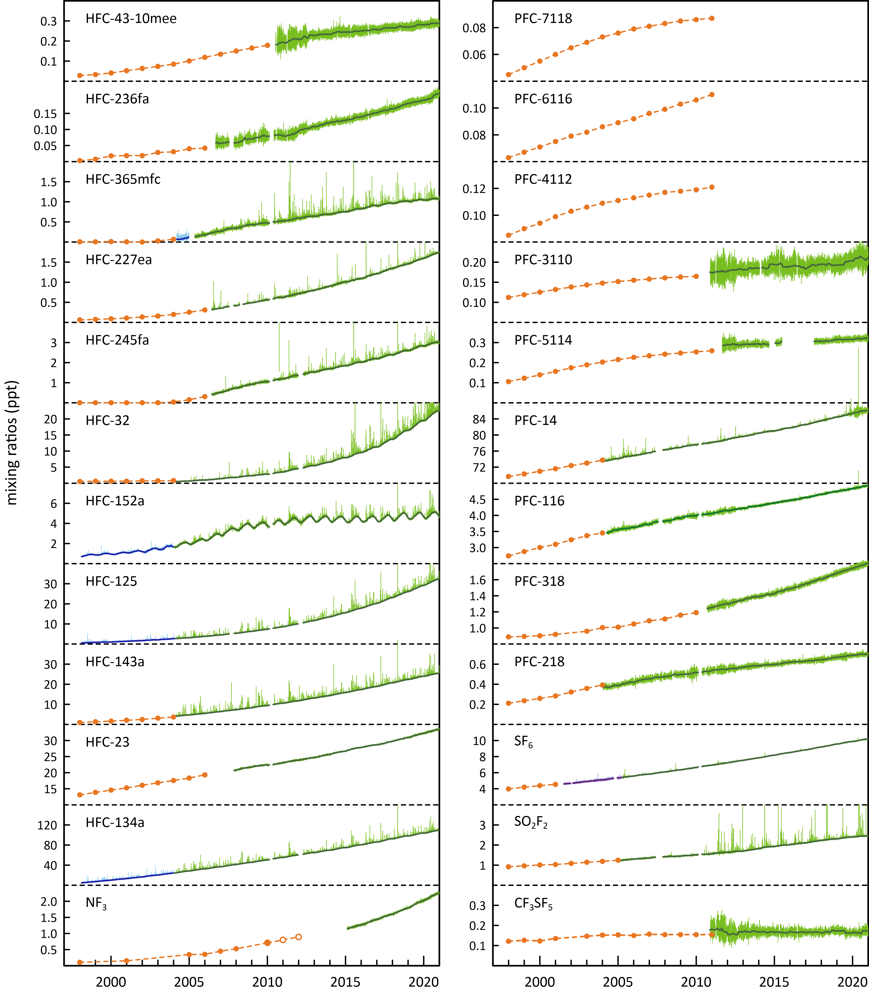

## Australian HFC, PFC and sulfur hexafluoride imports, banks and emissions

HFCs and sulfur hexafluoride are not manufactured in Australia and estimates of Australian HFC and sulfur hexafluoride emissions, reported annually to the UNFCCC (Table 3), are based on import data (Table 2). HFCs and sulfur hexafluoride are imported as bulk chemicals or in pre-charged equipment (PCE), leading to estimates of ‘banks’ of HFCs and sulfur hexafluoride stored in equipment or products such as refrigerators, air conditioners, fire extinguishers, foams, aerosols and electrical equipment. Only small amounts of PFCs are imported into Australia (Table 2) and these are not considered to be a significant source of PFC emissions; Australian PFC emissions are assumed to originate almost exclusively from aluminium production (Table 5).

Table 2. Australian HFC, PFC, sulfur hexafluoride imports (tonnes; calendar years 2019, 2020); PCE = pre-charged equipment.

|  |  |  |  |  |  |  |  |  |  |  |  |  |  |  |
| --- | --- | --- | --- | --- | --- | --- | --- | --- | --- | --- | --- | --- | --- | --- |
| Species | Bulk | | PCE | | bulk | | Total | | Total | | Total  Imports | | Total Imp-Exp | |
|  | Imports | | Imports | | Exports | | Imports | | Imp-Exp | | Mt CO2-e | | Mt CO2-e | |
|  | 2019 | 2020 | 2019 | 2020 | 2019 | 2020 | 2019 | 2020 | 2019 | 2020 | 2019 | 2020 | 2019 | 2020 |
| HFC-23 | 0.01 |  | 2.4 | 0.03 |  |  | 2.4 | 0.03 | 2.4 | 0.03 | 0.04 | 0.00 | 0.04 | 0.00 |
| HFC-32 | 567 | 442 | 1585 | 1728 |  |  | 2152 | 2171 | 2152 | 2171 | 1.5 | 1.5 | 1.5 | 1.5 |
| HFC-125 | 917 | 752 | 709 | 566 |  |  | 1626 | 1319 | 1626 | 1319 | 5.7 | 4.6 | 5.7 | 4.6 |
| HFC-134 |  |  |  | 0.001 |  |  |  | 0.001 |  | 0.001 |  | 0.00 |  | 0.00 |
| HFC-134a | 1520 | 1496 | 903 | 790 |  |  | 2423 | 2286 | 2423 | 2286 | 3.5 | 3.3 | 3.5 | 3.3 |
| HFC-143a | 439 | 427 | 10 | 7.9 |  |  | 449 | 434 | 449 | 434 | 2.0 | 1.9 | 2.0 | 1.9 |
| HFC-152a |  | 1.4 | 34 | 36 |  |  | 34 | 38 | 34 | 38 | 0.00 | 0.00 | 0.00 | 0.00 |
| HFC-227ea | 8.6 | 34 | 0.47 | 1.7 | 0.48 |  | 9 | 36 | 9 | 36 | 0.03 | 0.12 | 0.03 | 0.12 |
| HFC-236fa |  |  | 0.05 |  |  |  | 0.05 |  | 0.05 |  | 0.00 |  | 0.00 |  |
| HFC-245ca |  |  |  | 0.01 |  |  |  | 0.01 |  | 0.01 |  | 0.00 |  | 0.00 |
| HFC-245fa | 45 | 30 | 0.01 | 0.02 | 3.6 |  | 45 | 30 | 41 | 30 | 0.05 | 0.03 | 0.03 | 0.03 |
| HFC-365mfc | 46 | 31 |  |  | 3.7 |  | 46 | 31 | 42 | 31 | 0.04 | 0.02 | 0.03 | 0.02 |
| HFC-43-10mee |  | 0.2 | 0.004 | 0.002 |  |  | 0.004 | 0.22 | 0 | 0.22 | 0 | 0.00 | 0 | 0.00 |
| **total HFCs** | **3542** | **3214** | **3245** | **3130** | **7.9** |  | **6787** | **6345** | **6779** | **6345** | **13** | **11** | **13** | **11** |
| PFC-14 | 0.05 | 0.02 | 0.01 | 0.003 |  |  | 0.06 | 0.03 | 0.06 | 0.03 | 0 | 0.00 | 0 | 0.00 |
| PFC-116 |  |  | 0.02 | 0.02 |  |  | 0.02 | 0.02 | 0.02 | 0.02 | 0 | 0.00 | 0 | 0.00 |
| PFC-218 |  |  | 0.23 |  |  |  | 0.23 |  | 0.23 |  | 0 |  | 0 |  |
| PFC-318 | 0.03 | 0.01 |  |  |  |  | 0.03 | 0.01 | 0.03 | 0.01 | 0 | 0.00 | 0 | 0.00 |
| PFC-5-1-14 |  | 0.44 |  |  |  |  |  | 0.44 |  | 0.44 |  | 0.00 |  | 0.00 |
| **total PFCs** | **0.08** | **0.47** | **0.26** | **0.02** |  |  | **0.35** | **0.49** | **0.35** | **0.49** | **0.003** | **0.005** | **0.00** | **0.00** |
| SF6 | 6.0 | 10.9 | 18.4 | 84.4 | 0.29 |  | 24 | 24 | 24 | 95 | 0.56 | 0.56 | 0.55 | 2.2 |
| **total HFCs, PFCs, SF6** | **3548** | **3548** | **3263** | **3215** | **8.1** |  | **6811** | **6369** | **6803** | **6441** | **13** | **12** | **13** | **14** |

Australia’s mandated HFC production and import phase down began on 1 January 2018. HFC imports in 2020 were 6787 metric tonnes (both bulk and in pre-charged equipment), 7% lower than imports in 2019. HFC imports had previously grown by 10% per year over the period 2008-2017.

PFC imports in 2019 and 2020 were about 0.35 and 0.49 tonnes respectively. Sulfur hexafluoride (SF6) imports in 2020 were 95 tonnes, substantially higher than 2019 imports. Sulfur hexafluoride imports vary significantly year-to-year. Thirty-four (34) tonnes of sulfur hexafluoride were re-exported in 2016, but close to none exported from 2017 to 2020.

The *National Greenhouse Gas Inventory* (NGGI: ageis.climatechange.gov.au) published in 2021 contains estimates of Australian emissions of HFC-23, HFC-32, HFC-125, HFC-134 (CHF2CHF2, not measured currently at Cape Grim), HFC-134a, HFC-143a, HFC-152a, HFC-227ea, HFC-236fa, HFC-4310mee, PFC-14, PFC-116 and sulfur hexafluoride, up to 2019, which form part of the *National Inventory Report 2019* (DISER, 2021). The *Inventory* is the Australian government submission to the UNFCCC and which forms a part of the *Australian National Greenhouse Accounts* (NGA). Note the annual emissions in the NGGI and in the *National Inventory Report* are for fiscal years, i.e. ‘2013’ emissions are emissions for July 2012 to June 2013.

Australian HFC emissions (Table 3) reported to the UNFCCC are based on HFCs imported as bulk HFCs or in pre-charged equipment (PCE) (Table2), the estimated ‘banks’ of HFCs stored in equipment or products and appropriate application-dependent emission factors from those ‘banks’, which allow for estimation of emissions during the lifetime of the application, and from initial charging/re-charging of equipment and equipment disposal.

In the *National Inventory Report 2019* (DISER 2021), two significant changes have been implemented for determining Australian estimated HFC emissions in the *Inventory*.

* The first change involved revised base leakage rates for refrigeration and air-conditioning that were adopted based on latest available country-specific expert assessment (Expert Group 2018).
* The second change involved revising the indexing leak rates to include growth in the national HFC bank. For more detail on the *Inventory* recalculations see DISER (2021).

Australian estimated HFC *Inventory* emissions were about 140 tonnes in 1995, rising to 4,653 tonnes (10445 CO2-e ktonnes) in 2019. HFC-134a emissions increased by about 278 tonnes (13%) from 2018 to 2019, all other HFCs by about 240 tonnes (13%). Emissions of total HFCs (in CO2-e terms) in 2019 were 13% higher than in 2018.

In the Australian GHG emission inventory, PFC (PFC-14, PFC-116) emissions only arise from aluminium production, with total PFC emissions in 2019 of 35 tonnes (DISER, 2021).

* About 0.35-0.49 tonnes of PFCs (PFC-14, PFC-116) were imported into Australia in 2019-2020 as refrigerant blends in bulk and PCE (Table 2). It is not clear whether these PFC imports are included in estimating Australian PFC emissions – if they are, they are very small compared to PFC emissions from the aluminium industry (35 tonnes in 2019, Table 3).
* PFC emissions in the *Inventory* fell from 37 tonnes in 2012 to 24 tonnes in 2013 due to the closure of the Kurri Kurri smelter in NSW and from 24 tonnes in 2014 to 22 tonnes in 2015 due to the closure of the Point Henry smelter in Victoria.
* PFC emissions in the *Inventory* in 2019 are about 17% higher compared to 2018. This increase is due to the PFC-116 emission factor from DISER (2021) which has increased and a slight increase in aluminium production.

Australian sulfur hexafluoride emissions are (62%) from the electricity supply and distribution network, with 38% from electrical supply equipment manufacture. Emissions (1975-2019) are estimated as leakages from sulfur hexafluoride ‘banks’ in the electricity supply and distribution network and leakages from Australian manufacture of electricity supply equipment, using a combination of default IPCC and Australian-specific emissions factors (DISER 2021).

* An Australian-specific base emission factor (0.0089 t/t) has been estimated for 2010 (DISER 2021) and then scaled in subsequent years by the estimates of Australian sulfur hexafluoride emissions from Cape Grim atmospheric observations (DISER, 2021). The 2010 emission factor (0.0089 t/t) is based on emission estimates from 15 utilities (the major consumers of sulfur hexafluoride in Australia) using their own data on sulfur hexafluoride consumption (consumption = emissions, not defaulting to the IPCC method). The 2018 and 2019 emission factors (after scaling of Cape Grim data) are 0.0040 tonne sulfur hexafluoride per tonne sulfur hexafluoride banked (DISER 2021).
* The sulfur hexafluoride emission factors assumed for Australian equipment manufacture (0.085 t/t, 1996-2019) are IPCC default factors for Europe.
* Australian sulfur hexafluoride emissions from tracer gas studies, eye surgery etc. have been estimated at 0.0008 tonne of sulfur hexafluoride per person per year. (DISER 2021).
* In total, Australian emissions of sulfur hexafluoride in 2019 (electrical equipment and other uses) was estimated at 6 tonnes.

The quantity of sulfuryl fluoride imported each year into Australia depends, in part, on the annual grain harvest. Before 2007, Australian sulfuryl fluoride imports were significantly less than 50 tonnes per year, reaching levels of imports (~150 tonnes per year) by 2011-12, continuing at about this level until 2015-16, with 2016-17 imports higher due to a record grain harvest (M. Stein, A-Gas, personal communication).

* Mühle *et al*. (2009) estimate that approximately two-thirds of sulfuryl fluoride used in fumigation escapes to the atmosphere, so current Australian sulfuryl fluoride emissions are likely to be about 100 tonnes per year (~0.5 M tonnes CO2-e)

The HFC, PFC and sulfur hexafluoride contributions to total emissions from this sector in the Inventory are shown in Figure 2. The significant effect on total emissions in 2005-2006 due to reduced PFC emissions (the Kurri Kurri aluminium smelter upgrade) can be clearly seen. Prior to the significant reduction in PFC emissions at Kurri Kurri in 2005, Australian HFC/PFC/sulfur hexafluoride emissions grew at about 12%/yr (Figure 2). After the Kurri Kurri upgrade, these combined emissions grew at about 4%/yr. The Australian Kyoto Protocol/Paris Agreement-SGG emissions are 97% HFCs, 2% PFCs and 1% sulfur hexafluoride.

Figure 2. Australian HFC, PFC and sulfur hexafluoride emissions (M tonne CO2-e) in the Inventory (DISER 2021). Dashed lines are exponential and linear best fits.

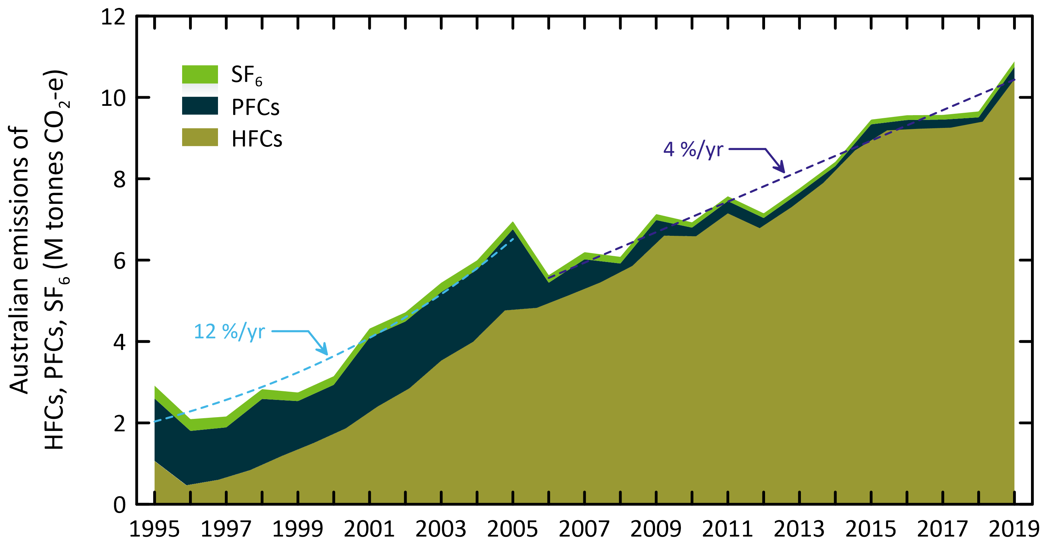

Table 3. Australian HFC, PFC and sulfur hexafluorideemissions ([available from the UNFCCC website](https://unfccc.int/ghg-inventories-annex-i-parties/2020)). HFC-23 emissions in 1995 from HCFC-22 production in Sydney. Note GWPs used are AR4.

|  |  |  |  |  |  |  |  |  |  |  |  |  |  |  |  |  |  |  |
| --- | --- | --- | --- | --- | --- | --- | --- | --- | --- | --- | --- | --- | --- | --- | --- | --- | --- | --- |
| Year | HFC-134a | HFC-125 | HFC-143a | HFC-32 | HFC-245fa | HFC-152a | HFC-365mfc | HFC-23 | HFC-227ea | HFC-236fa | HFC-134 | HFC-43-10mee | total HFCs | PFC-14 | PFC-116 | total PFCs | SF6 | total HFC,PFC,SF6 |
|  | tonnes | | | | | | | | | | | | | | | | | |
| 1995 | 55 | 19 | 1.9 | 1.1 | 0 | 0 | 0 | 61 | 0.7 | 0.0 | 0.0 | 0.0 | 140 | 171 | 22 | 193 | 14 | 346 |
| 1996 | 137 | 48 | 4.6 | 2.7 | 0 | 0 | 0 | 0.0 | 1.6 | 0.0 | 0.1 | 0.0 | 194 | 157 | 20 | 178 | 13 | 385 |
| 1997 | 232 | 81 | 7.8 | 4.5 | 0 | 0 | 0 | 0.0 | 2.7 | 0.0 | 0.1 | 0.1 | 328 | 137 | 18 | 155 | 12 | 494 |
| 1998 | 325 | 114 | 11 | 6.3 | 0 | 0 | 0 | 0.0 | 3.9 | 0.0 | 0.1 | 0.1 | 460 | 185 | 24 | 209 | 11 | 679 |
| 1999 | 489 | 171 | 16 | 9.4 | 0 | 0 | 0 | 0.1 | 5.8 | 0.0 | 0.2 | 0.1 | 692 | 127 | 16 | 143 | 9.3 | 844 |
| 2000 | 577 | 202 | 19 | 11 | 0 | 0 | 0 | 0.1 | 6.8 | 0.0 | 0.2 | 0.2 | 816 | 143 | 19 | 162 | 9.3 | 987 |
| 2001 | 804 | 281 | 27 | 16 | 0 | 0 | 0 | 0.1 | 10 | 0.0 | 0.3 | 0.2 | 1137 | 201 | 26 | 227 | 9.6 | 1374 |
| 2002 | 967 | 338 | 32 | 19 | 0 | 0 | 0 | 0.1 | 11 | 0.0 | 0.4 | 0.3 | 1369 | 193 | 25 | 218 | 9.9 | 1596 |
| 2003 | 1236 | 432 | 41 | 24 | 0 | 0 | 0 | 0.2 | 15 | 0.0 | 0.5 | 0.4 | 1749 | 188 | 24 | 212 | 10.0 | 1971 |
| 2004 | 1417 | 496 | 47 | 27 | 0 | 0 | 0 | 0.2 | 17 | 0.0 | 0.6 | 0.4 | 2006 | 191 | 25 | 216 | 10.1 | 2232 |
| 2005 | 1356 | 330 | 353 | 28 | 30 | 26 | 8 | 0 | 14 | 19 | 0.6 | 0 | 2165 | 200 | 26 | 226 | 8.6 | 2400 |
| 2006 | 1359 | 318 | 341 | 46 | 32 | 29 | 23 | 0 | 12 | 5.2 | 0.7 | 0 | 2166 | 77 | 10 | 87 | 8.2 | 2261 |
| 2007 | 1306 | 364 | 345 | 84 | 28 | 37 | 25 | 37 | 14 | 4.5 | 0.7 | 0 | 2244 | 65 | 8.4 | 73 | 7.7 | 2325 |
| 2008 | 1257 | 391 | 344 | 88 | 21 | 33 | 37 | 38 | 17 | 4.3 | 0.8 | 0 | 2231 | 50 | 6.4 | 56 | 7.2 | 2294 |
| 2009 | 1494 | 483 | 432 | 118 | 24 | 36 | 47 | 39 | 28 | 4.8 | 0.9 | 0 | 2707 | 40 | 4.9 | 45 | 6.4 | 2758 |
| 2010 | 1495 | 481 | 416 | 137 | 31 | 41 | 61 | 35 | 28 | 5.7 | 1.2 | 0 | 2730 | 32 | 3.5 | 36 | 5.7 | 2772 |
| 2011 | 1735 | 544 | 413 | 170 | 47 | 46 | 64 | 38 | 25 | 5.3 | 1.3 | 0 | 3089 | 35 | 3.8 | 38 | 5.2 | 3132 |
| 2012 | 1538 | 496 | 435 | 167 | 46 | 63 | 58 | 37 | 16 | 4.3 | 1.3 | 0 | 2861 | 34 | 3.7 | 37 | 5.0 | 2904 |
| 2013 | 1561 | 563 | 506 | 175 | 52 | 66 | 57 | 42 | 36 | 3.3 | 1.5 | 0 | 3064 | 22 | 2.4 | 24 | 4.7 | 3093 |
| 2014 | 1844 | 698 | 477 | 294 | 74 | 69 | 56 | 31 | 29 | 2.4 | 1.5 | 0 | 3576 | 22 | 2.4 | 24 | 4.6 | 3605 |
| 2015 | 2145 | 789 | 516 | 338 | 90 | 78 | 63 | 35 | 32 | 2.6 | 1.7 | 0 | 4090 | 19 | 2.3 | 22 | 5.1 | 4117 |
| 2016 | 2232 | 798 | 496 | 356 | 93 | 82 | 61 | 35 | 24 | 3.4 | 2.0 | 0 | 4180 | 26 | 2.9 | 29 | 5.1 | 4214 |
| 2017 | 2194 | 764 | 511 | 335 | 85 | 93 | 59 | 43 | 28 | 4.6 | 4.0 | 0 | 4121 | 18 | 5.6 | 24 | 5.1 | 4150 |
| 2018 | 2199 | 766 | 513 | 336 | 85 | 93 | 59 | 43 | 28 | 4.7 | 4.0 | 0 | 4131 | 26 | 3.3 | 30 | 6.4 | 4167 |
| 2019 | 2477 | 862 | 577 | 378 | 96 | 105 | 66 | 49 | 31 | 5.2 | 4.5 | 0 | 4653 | 25 | 9.9 | 35 | 6.0 | 4693 |

|  |  |  |  |  |  |  |  |  |  |  |  |  |  |  |  |  |  |  |
| --- | --- | --- | --- | --- | --- | --- | --- | --- | --- | --- | --- | --- | --- | --- | --- | --- | --- | --- |
| Year | HFC-134a | HFC-125 | HFC-143a | HFC-32 | HFC-245fa | HFC-152a | HFC-365mfc | HFC-23 | HFC-227ea | HFC-236fa | HFC-134 | HFC-43-10mee | total HFCs | PFC-14 | PFC-116 | total PFCs | SF6 | total HFC,PFC,SF6 |
|  | kt CO2-e | | | | | | | | | | | | | | | | | |
| 1995 | 79 | 68 | 8.3 | 0.7 |  |  |  | 909 | 2.1 | 0.0 | 0.0 | 0.0 | 1067 | 1261 | 270 | 1531 | 316 | 2914 |
| 1996 | 196 | 168 | 21 | 1.8 |  |  |  | 0.3 | 5.3 | 0.0 | 0.1 | 0.1 | 393 | 1161 | 249 | 1410 | 289 | 2092 |
| 1997 | 331 | 283 | 35 | 3.0 |  |  |  | 0.4 | 8.9 | 0.0 | 0.1 | 0.1 | 662 | 1011 | 217 | 1228 | 267 | 2157 |
| 1998 | 464 | 398 | 49 | 4.2 |  |  |  | 0.6 | 12 | 0.0 | 0.1 | 0.2 | 928 | 1367 | 293 | 1661 | 240 | 2829 |
| 1999 | 699 | 598 | 73 | 6.4 |  |  |  | 0.9 | 19 | 0.0 | 0.2 | 0.2 | 1397 | 938 | 201 | 1139 | 211 | 2747 |
| 2000 | 825 | 706 | 86 | 7.5 |  |  |  | 1.1 | 22 | 0.0 | 0.2 | 0.3 | 1648 | 1060 | 227 | 1287 | 212 | 3147 |
| 2001 | 1149 | 984 | 120 | 10 |  |  |  | 1.5 | 31 | 0.0 | 0.3 | 0.4 | 2297 | 1484 | 318 | 1802 | 219 | 4317 |
| 2002 | 1383 | 1184 | 145 | 13 |  |  |  | 1.8 | 37 | 0.0 | 0.4 | 0.5 | 2764 | 1423 | 305 | 1728 | 225 | 4717 |
| 2003 | 1767 | 1512 | 185 | 16 |  |  |  | 2.3 | 47 | 0.0 | 0.5 | 0.6 | 3531 | 1387 | 297 | 1684 | 229 | 5444 |
| 2004 | 2027 | 1735 | 212 | 18 |  |  |  | 2.6 | 54 | 0.0 | 0.6 | 0.7 | 4050 | 1411 | 303 | 1714 | 231 | 5994 |
| 2005 | 1940 | 1155 | 1580 | 19 | 31 | 3.2 | 6.0 | 0 | 45 | 190 | 0.6 | 0 | 4969 | 1475 | 316 | 1792 | 196 | 6957 |
| 2006 | 1943 | 1113 | 1523 | 31 | 33 | 3.7 | 18 | 0 | 40 | 51 | 0.7 | 0 | 4757 | 566 | 121 | 687 | 186 | 5630 |
| 2007 | 1867 | 1275 | 1542 | 56 | 29 | 4.5 | 20 | 555 | 45 | 44 | 0.7 | 0 | 5438 | 480 | 103 | 583 | 175 | 6196 |
| 2008 | 1798 | 1367 | 1536 | 59 | 22 | 4.1 | 29 | 560 | 54 | 42 | 0.9 | 0 | 5473 | 366 | 78 | 445 | 163 | 6080 |
| 2009 | 2137 | 1690 | 1933 | 79 | 25 | 4.4 | 37 | 584 | 90 | 47 | 1.0 | 0 | 6626 | 299 | 60 | 359 | 147 | 7132 |
| 2010 | 2138 | 1682 | 1857 | 92 | 32 | 5.1 | 48 | 514 | 90 | 56 | 1.3 | 0 | 6516 | 240 | 43 | 283 | 130 | 6929 |
| 2011 | 2481 | 1906 | 1844 | 115 | 49 | 5.7 | 51 | 565 | 81 | 52 | 1.5 | 0 | 7150 | 255 | 46 | 301 | 118 | 7569 |
| 2012 | 2199 | 1735 | 1943 | 112 | 47 | 8 | 46 | 553 | 53 | 42 | 1.5 | 0 | 6740 | 250 | 45 | 295 | 115 | 7150 |
| 2013 | 2233 | 1972 | 2263 | 118 | 54 | 8 | 45 | 622 | 116 | 32 | 1.7 | 0 | 7464 | 163 | 29 | 192 | 108 | 7764 |
| 2014 | 2637 | 2442 | 2134 | 199 | 77 | 9 | 44 | 460 | 92 | 23 | 1.6 | 0 | 8118 | 163 | 29 | 193 | 106 | 8416 |
| 2015 | 3067 | 2763 | 2307 | 228 | 93 | 10 | 50 | 519 | 103 | 26 | 1.9 | 0 | 9167 | 143 | 28 | 171 | 116 | 9454 |
| 2016 | 3191 | 2794 | 2216 | 240 | 96 | 10 | 48 | 511 | 77 | 33 | 2.2 | 0 | 9219 | 189 | 36 | 225 | 117 | 9561 |
| 2017 | 3138 | 2674 | 2286 | 226 | 88 | 12 | 47 | 642 | 90 | 46 | 4.4 | 0 | 9251 | 135 | 68 | 203 | 115 | 9569 |
| 2018 | 3145 | 2680 | 2291 | 226 | 88 | 12 | 47 | 644 | 90 | 46 | 4.4 | 0 | 9273 | 196 | 40 | 236 | 145 | 9655 |
| 2019 | 3542 | 3019 | 2581 | 255 | 99 | 13 | 53 | 725 | 101 | 51 | 5.0 | 0 | 10445 | 182 | 121 | 303 | 137 | 10885 |

## Australian HFC, PFC, sulfur hexafluoride and sulfuryl fluoride emissions from atmospheric data

### HFC, sulfur hexafluoride and sulfuryl fluoride emissions

CSIRO estimates emissions of a number of greenhouse and ozone depleting trace gases from the Melbourne/Port Phillip region (Dunse *et al.* 2001, 2005; Dunse, 2002; Greally *et al.* 2007; Stohl *et al.* 2009; Fraser *et al.* 2014b, 2016; Simmonds *et al.* 2016), utilising *in situ* high frequency measurements from the Cape Grim Baseline Air Pollution Station in Tasmania and employing the interspecies correlation (ISC) technique with co-incident carbon monoxide (CO) measurements or inverse modelling (InTEM). Melbourne HFC, PFC-116 and sulfur hexafluoride emissions have been calculated, by ISC from Cape Grim data (2004-2019, Krummel *et al.* 2014 and unpublished data) and presented as 3-year running averages (2005-2019; Table 4, Figure 3). The HFC, PFC-116 and sulfur hexafluoride emissions are derived from Melbourne emissions, scaled to Australian emissions on a population basis. For details of calculations and assumptions, see Appendix A.

Table 4. Australian HFC, PFC, sulfur hexafluoride and sulfuryl fluoride emissions (tonnes, 2005-2019) from atmospheric data, collected at Cape Grim, Tasmania - emissions calculated by interspecies correlation (ISC) and from the InTEM inversion model (InTEM 2019). The emissions are 3-year running averages, i.e. ‘2010’ = average of 2009, 2010, 2011 emissions

|  |  |  |  |  |  |  |  |  |  |  |  |  |  |
| --- | --- | --- | --- | --- | --- | --- | --- | --- | --- | --- | --- | --- | --- |
| Refrigerant | 2005 | 2007 | 2009 | 2010 | 2011 | 2012 | 2013 | 2014 | 2015 | 2016 | 2017 | 2018 | 2019 |
| HFC-32 | 23±22 | 60±30 | 90±40 | 100±50 | 120±50 | 120±50 | 110±50 | 140±50 | 190±60 | 230±80 | 240±80 | 220±80 | 260±110 |
| HFC-125 | 200±70 | 310±100 | 370±150 | 400±140 | 400±130 | 400±140 | 460±130 | 510±130 | 550±140 | 570±150 | 530±160 | 530±180 | 560±200 |
| HFC-134a | 950±300 | 1430±370 | 1320±400 | 1300±400 | 1250±400 | 1230±410 | 1290±370 | 1470±380 | 1710±400 | 1620±410 | 1430±400 | 1360±420 | 1470±490 |
| HFC-143a | 190±70 | 310±100 | 320±120 | 340±120 | 360±120 | 370±120 | 360±110 | 350±110 | 400±100 | 430±110 | 390±110 | 370±120 | 380±130 |
| HFC-23a | 40±110 | 40±110 | 60±100 | 70±90 | 50±80 | 40±60 | 40±60 | 40±60 | 40±60 | 30±60 | 40±50 | 40±70 | 50±90 |
| HFC-152a | 30±30 | 60±40 | 40±50 | 50±40 | 40±40 | 40±40 | 50±40 | 70±30 | 90±30 | 80±40 | 70±30 | 60±30 | 60±40 |
| HFC-227ea | 19±12 | 18±8 | 29±11 | 26±10 | 23±8 | 17±6 | 32±11 | 24±8 | 24±9 | 15±5 | 16±5 | 14±4 | 17±5 |
| HFC-236fa | 22±15 | 6±3 | 5±2 | 5±2 | 4±2 | 4±1 | 3±1 | 2±1 | 2±1 | 2±1 | 2±1 | 2±1 | 2±1 |
| HFC-245fa | 41±23 | 36±14 | 29±11 | 29±10 | 39±14 | 41±14 | 45±15 | 65±22 | 73±24 | 60±20 | 47±16 | 25±8 | 40±13 |
| HFC-365mfc | 9±4 | 33±14 | 54±19 | 55±20 | 55±20 | 52±18 | 50±17 | 52±18 | 53±18 | 43±14 | 35±11 | 20±6 | 25±8 |
| Major HFCsb | 1363±315 | 2110±395 | 2100±445 | 2140±445 | 2130±440 | 2120±450 | 2220±410 | 2470±420 | 2850±440 | 2850±455 | 2590±450 | 2480±480 | 2670±555 |
| Total HFCs | 1524±340 | 2302±415 | 2317±460 | 2375±455 | 2342±450 | 2314±460 | 2440±415 | 2723±425 | 3133±445 | 3080±465 | 2800±455 | 2641±485 | 2864±565 |
| k tonnes CO2-e | 3847±1735 | 5333±1805 | 5783±1755 | 6094±1620 | 5824±1490 | 5667±1290 | 5954±1235 | 6352±1240 | 7107±1250 | 7010±1285 | 6556±1195 | 6310±1455 | 6821±1760 |
| SF6 (tonnes) | 72±28 | 39±14 | 30±12 | 24±9 | 23±8 | 22±7 | 22±7 | 18±6 | 21±7 | 18±6 | 20±7 | 16±5 | 17±5 |
| k tonnes CO2-e | 1649±636 | 882±325 | 693±267 | 558±196 | 528±183 | 498±168 | 495±163 | 405±134 | 471±158 | 411±138 | 457±152 | 366±118 | 385±125 |
| total PFCsc (tonnes) | 127±15 | 114±20 | 100±20 | 97±15 | 106±15 | 92±15 | 80±10 | 77±10 | 86±15 | 128±35 | 115±35 | 104±25 | 105±25 |
| k tonnes CO2-e | 1038±185 | 1473±760 | 1245±800 | 1223±770 | 1239±720 | 1085±590 | 941±520 | 908±550 | 958±655 | 1054±695 | 974±700 | 1557±370 | 1570±370 |
| Total HFCs, PFCs, SF6 |  |  |  |  |  |  |  |  |  |  |  |  |  |
| total (tonnes) | 1723±340 | 2455±415 | 2447±460 | 2496±455 | 2471±450 | 2427±460 | 2542±420 | 2818±425 | 3239±445 | 3226±465 | 2935±455 | 2761±485 | 2986±565 |
| k tonnes CO2-e | 8450±1650 | 8502±1705 | 8794±1755 | 7951±1600 | 8043±1530 | 7748±1375 | 7882±1305 | 8245±1350 | 8720±1420 | 8059±1360 | 7278±1280 | 7263±1180 | 8297±1405 |
| SO2F2d(tonnes) | 8±6 | 13±9 | 21±13 | 67±40 | 85±52 | 69±42 | 75±45 | 163±96 | 150±89 | 146±86 | 102±61 | 76±45 | 85±51 |
| k tonnes CO2-e | 42±28 | 66±46 | 103±67 | 335±201 | 425±262 | 346±212 | 377±227 | 813±482 | 748±445 | 728±429 | 511±303 | 380±226 | 425±254 |

a assumed = 2008 emissions b includes HFC-32, HFC-125, HFC-134a, HFC-143a 2 from Table 5 d unregulated

Figure 3. Australian HFC-32, -125, -134a, -143a, -152a, -365mfc, sulfur hexafluoride and sulfuryl fluoride emissions (NGA, orange: DISER 2021) compared to emissions calculated from Cape Grim data by interspecies correlation (ISC, blue) and from the UK Met. Office InTEM inversion model (light blue). The data shown in red are emissions from the refrigerant bank (Brodribb & McCann 2015).

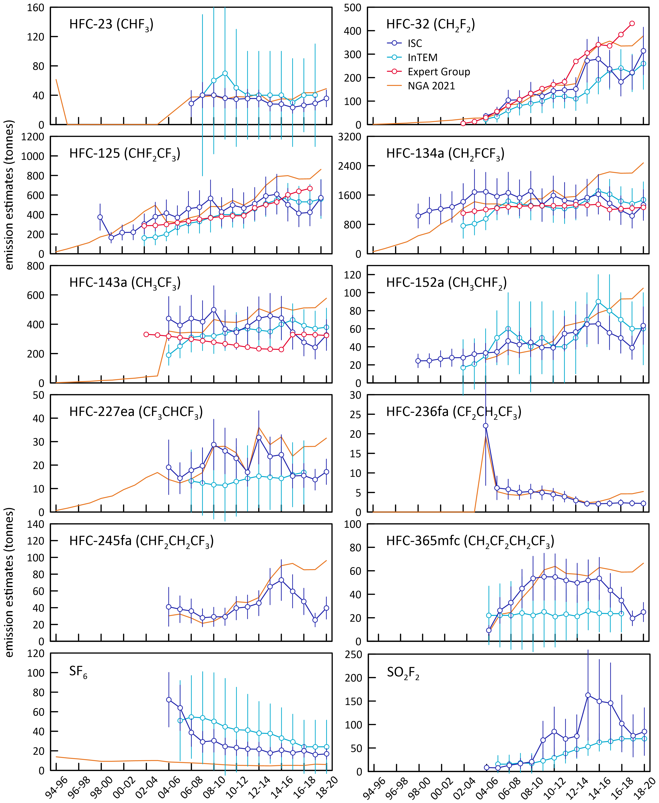

### PFC-14 emissions

SE Australian emissions of PFC-14 (CF4) are evident in the PFC-14 data collected at Cape Grim (Figure 4). The year-to-year variability of the number and intensity of PFC-14 episodes seen at Cape Grim is large, so 3-year averaging is used when deriving PFC emissions from these data. Unfortunately, instrumental problems developed in late 2019 and continued through 2020 causing poor precision in the PFC-14 data (see Figure 4). As a result, we are unable to update the emission estimates of PFC-14 to 2019 (the latest annual emission available from these data is for 2018). Where required, for some plots and calculations, the 2018 value of PFC-14 will be used for 2019.

Detailed analysis of these PFC-14 pollution episodes shows the Cape Grim PFC-14 pollution episodes originate largely from southern Victoria from the Portland smelter and previously the Point Henry smelter before it closed in 2014, with some contribution from Bell Bay, Tasmania.

The Cape Grim PFC-14 pollution episode data have been used to estimate PFC-14 emissions from these SE Australian smelters. A regional transport model (TAPM – The Air Pollution Model; Hurley, 2008; Hurley *et al.* 2008) is used to calculate emissions in which PFC-14 is released into the model atmosphere from the Point Henry, Portland and Bell Bay locations. For a more detailed description of TAPM see Appendix A.

The NAME transport and InTEM inversion models are used to derive PFC emissions. The current InTEM model domain used to derive emissions is called VextT and incorporates all of Victoria and Tasmania as well as southern and south western New South Wales and eastern South Australia. This domain contains the aluminium smelters at Portland, Point Henry and Bell Bay.

Figure 4. Monthly-mean PFC-14 concentrations observed *in situ* at Cape Grim (dark blue), 2004-2020 PFC-14 pollution episodes (light blue), typically lasting up to 12 hours in duration, are also seen at Cape Grim (Mühle *et al.* 2010).

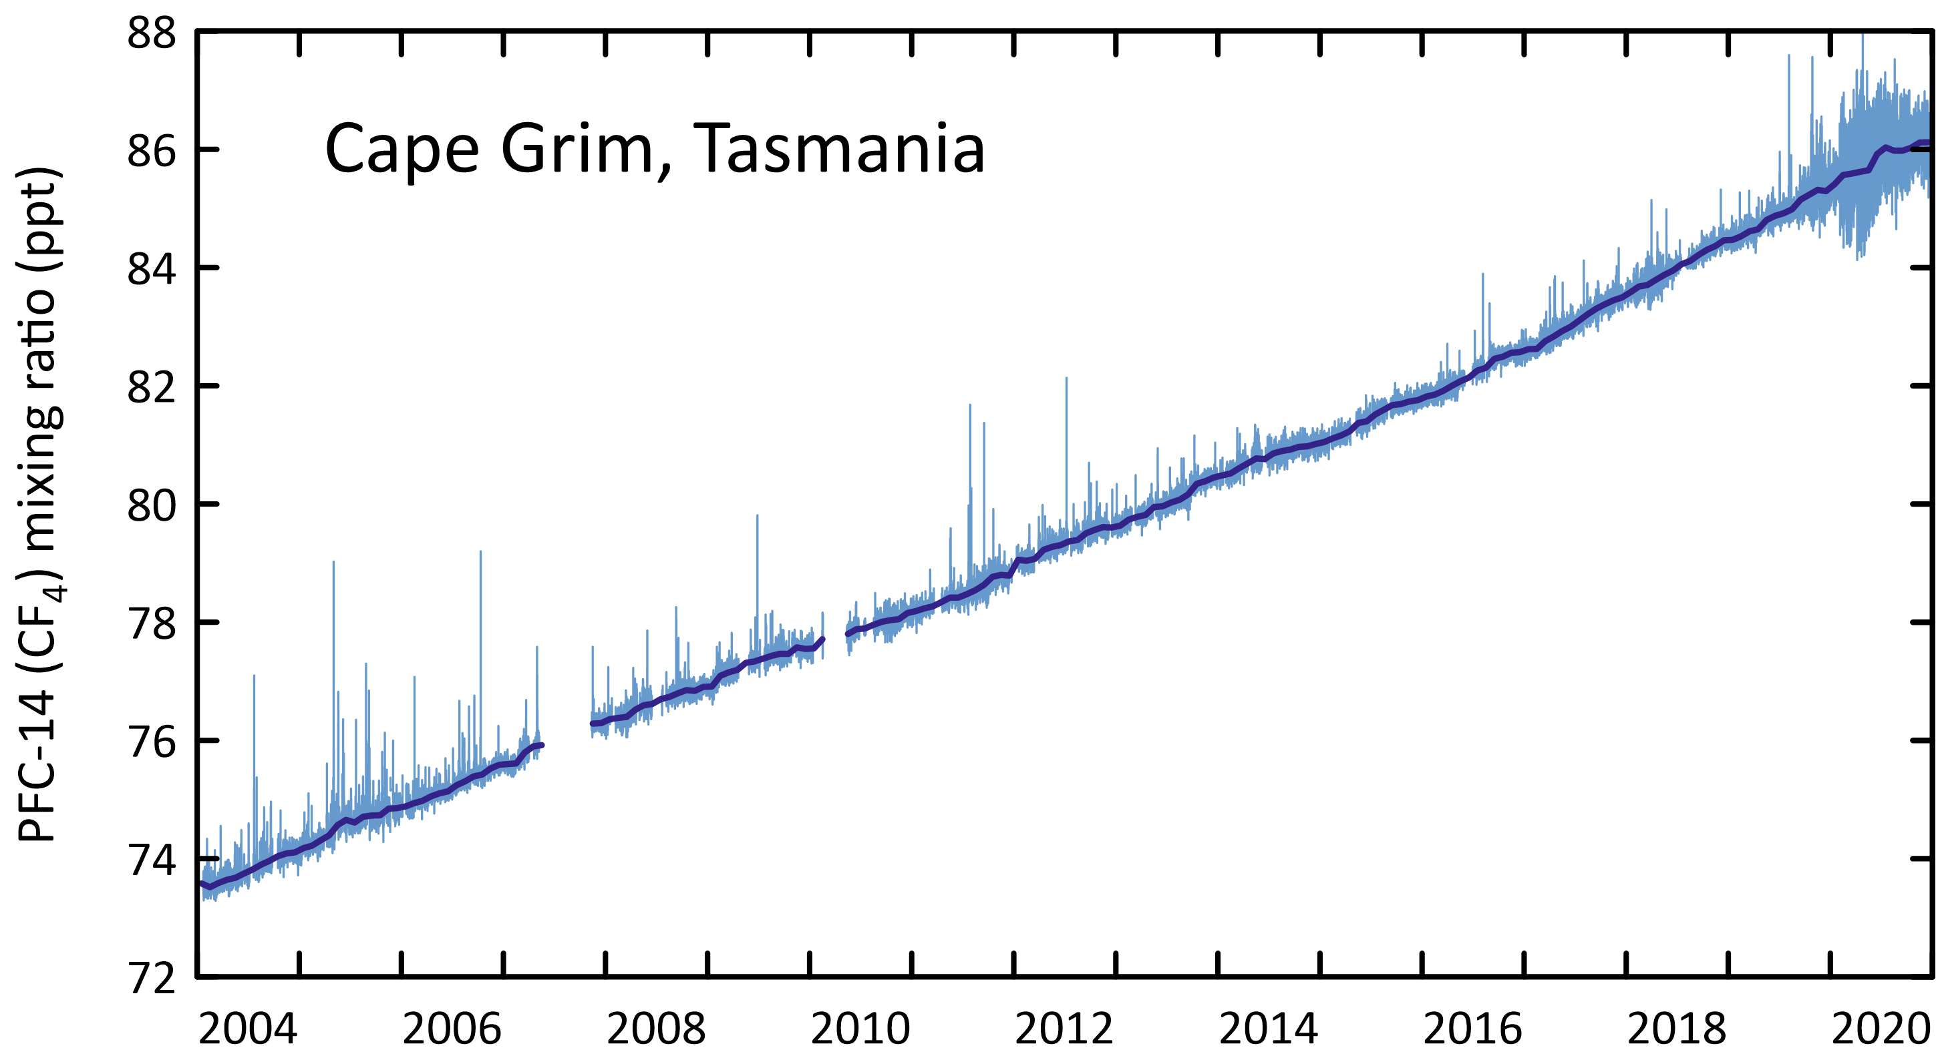

The TAPM and InTEM estimates of regional PFC-14 emissions are scaled to derive Australian emissions on an aluminium production basis. For example, if the PFC-14 emissions derived for the SE Australian smelters, which account for about 35% of Australia’s aluminium production, are assumed to be representative of all Australian aluminium production, then Australian PFC‑14 emissions from aluminium production can be derived and compared to emissions in the *National Inventory Report 2019* (DISER 2021) (Figure 5). The emissions calculated for the Point Henry, Portland and Bell Bay smelters are shown in Table 5. Australian PFC-14 emission factors as reported in the *National Inventory Report 2019* (DISER 2021) and as derived from atmospheric measurements at Cape Grim using InTEM/TAPM (to 2017) and TAPM (to 2018) modelling are shown in Figure 6. More detail on the PFC-14 emissions can be found in Appendix A

* PFC-14 emissions estimated using TAPM have averaged around 75 tonnes for the last 6 years. PFC-14 emissions from the Inventory range from 20-30 tonnes per year over the same period.
* Over the period 2009-2018, total PFC-14 emissions in the *Inventory* are about 62% lower than PFC-14 emissions estimated from Cape Grim data (TAPM).
* The fraction of Australian PFC-14 emission seen at Cape Grim has declined significantly since the closure of the Point Henry smelter in 2014.
* The 2016 increase in the PFC-14 TAPM emissions is largely due to increases seen at the Bell Bay smelter. This increase isn’t seen in the InTEM estimates.
* Based on atmospheric data, global emissions of PFC-14 were 14 k tonnes in 2018 (Rigby *et al.* 2014 and Rigby, unpublished data). Australian emissions are therefore estimated to be about 0.6% of global emissions based on TAPM data, and 0.2% based on *Inventory* data. The only significant PFC-14 source in Australia is aluminium production, whereas globally the semiconductor production industry is also a significant source of PFC-14 emissions.

Figure 5. Australian emissions of PFC-14 as recorded in the National Inventory Report 2019 (NGA: DISER 2021) and as obtained from TAPM, NAME and InTEM.

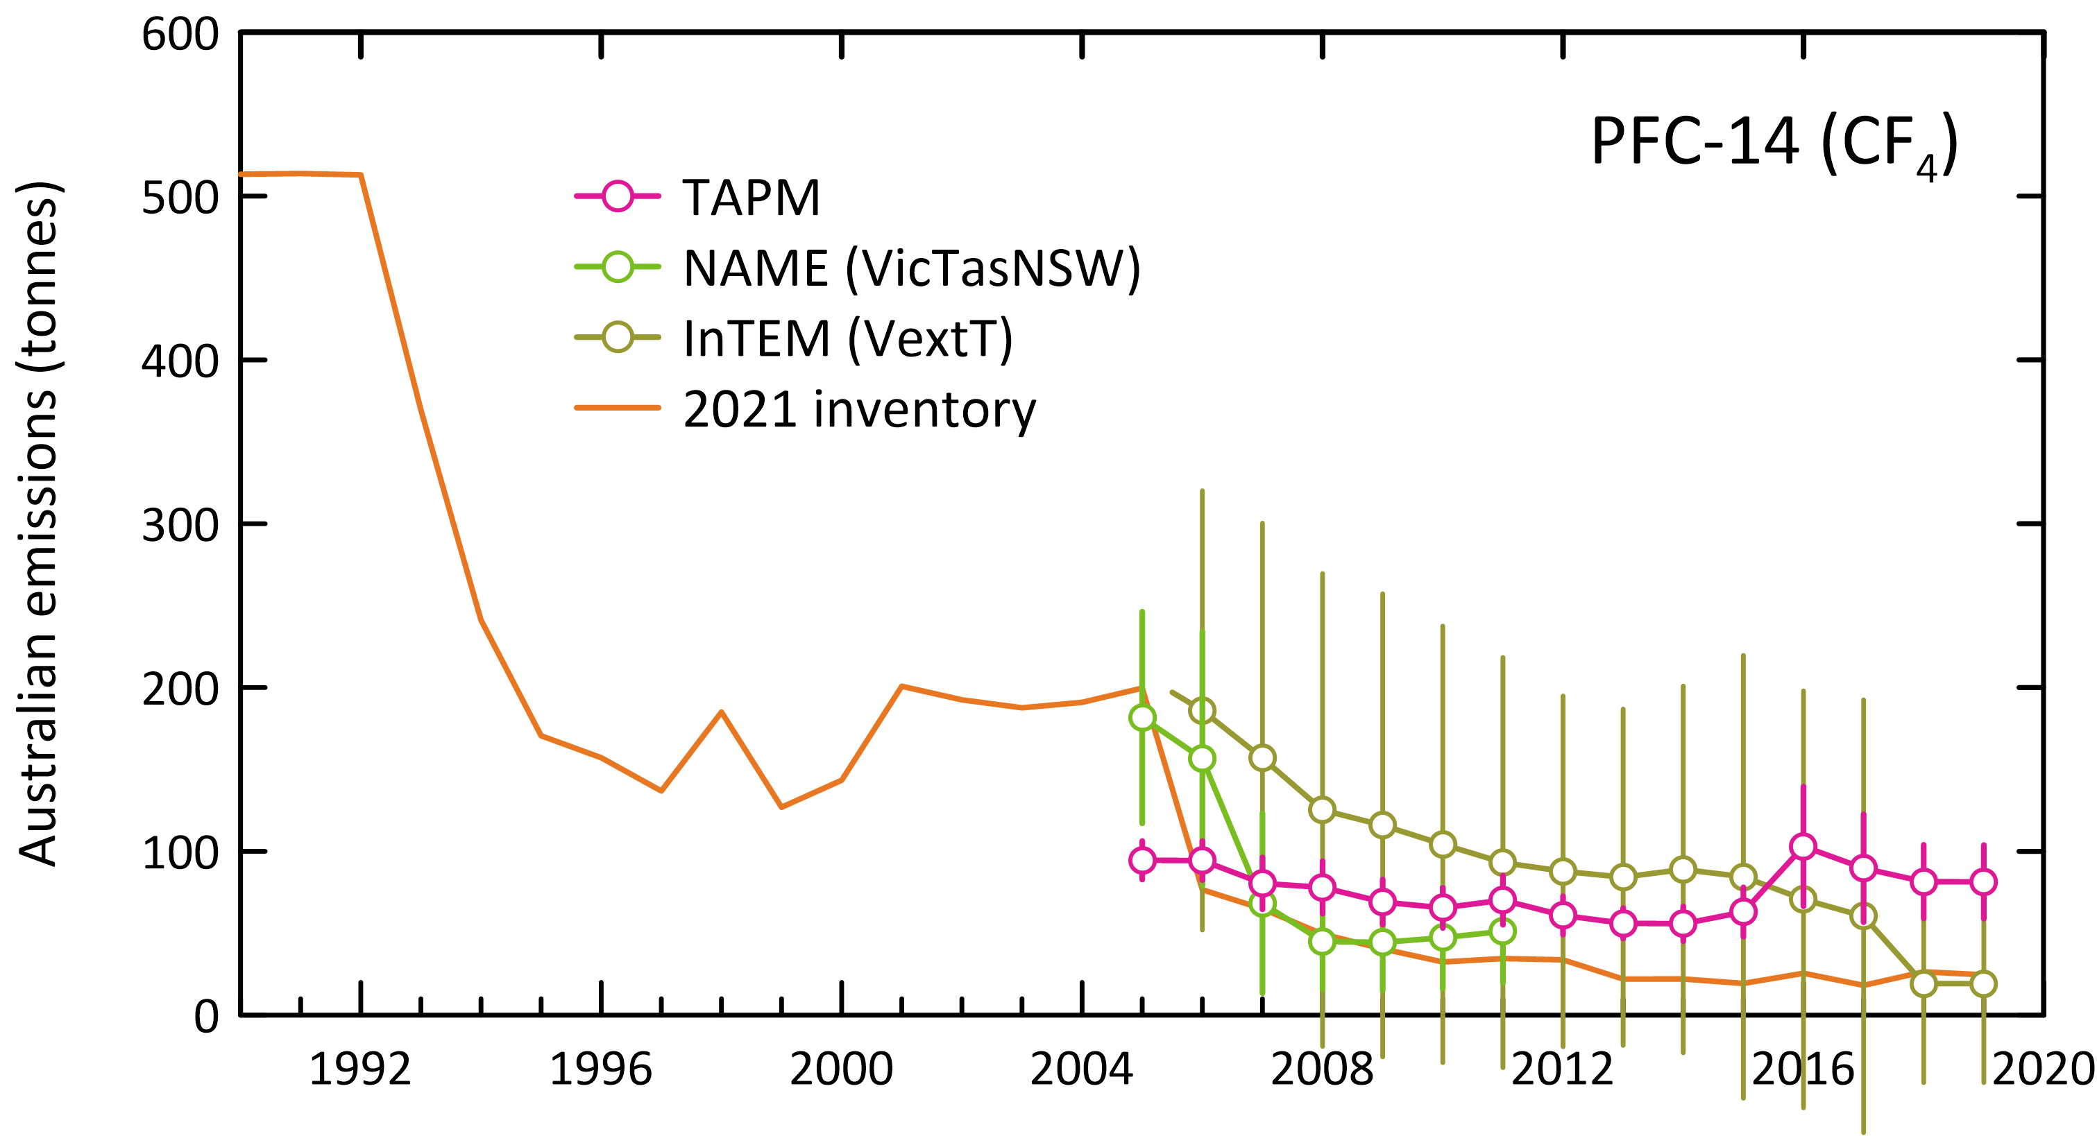

Figure 6. Australian PFC-14 emission factors as reported in the National Inventory Report 2019 (NGA: DISER 2021) and as derived from atmospheric measurements at Cape Grim using TAPM/InTEM (2019=2018 values). The grey band is the average (±1 sd) emission factor derived from TAPM/InTEM. The Kurri Kurri emission factor is based on direct PFC-14 measurements made at the Kurri Kurri smelter in 2009 (Fraser *et al.* 2013).

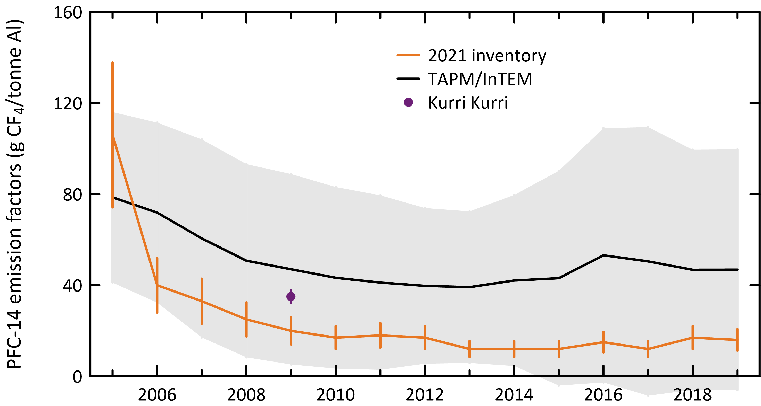

Table 5. Australian PFC-14, PFC-116, PFC-218, PFC-318 emissions (t: tonnes) and PFC-14, PFC-116 emission factors (g/t aluminium, 2005-2018) derived from atmospheric observations – remote (Portland, Pt Henry, Bell Bay) (3-yr averages, e.g. 2019 = average of 2018, 2019, 2020), using the TAPM and InTEM models, directly, at Kurri Kurri.

|  |  |  |  |  |  |  |  |  |  |  |  |  |  |  |  |
| --- | --- | --- | --- | --- | --- | --- | --- | --- | --- | --- | --- | --- | --- | --- | --- |
| Refrigerant | 2005 | 2006 | 2007 | 2008 | 2009 | 2010 | 2011 | 2012 | 2013 | 2014 | 2015 | 2016 | 2017 | 2018 | 2019 |
| **TAPM emissions (tonnes)** |  |  |  |  |  |  |  |  |  |  |  |  |  |  |  |
| Portland | 18±3 | 18±4 | 14±4 | 15±5 | 12±4 | 12±3 | 12±4 | 10±3 | 10±2 | 12±3 | 15±4 | 18±6 | 11±3 | 12±3 |  |
| Pt Henry1 | 12±2 | 11±2 | 10±2 | 10±2 | 9±2 | 8±2 | 9±3 | 8±2 | 8±2 | 4±1 |  |  |  |  |  |
| Bell Bay | 5±1 | 5±1 | 6±3 | 4±2 | 3±2 | 3±2 | 3±2 | 4±2 | 4±2 | 4±2 | 4±2 | 12±9 | 13±8 | 13±6 |  |
| Australia2 | 95±12 | 94±12 | 80±16 | 78±16 | 69±14 | 65±12 | 70±15 | 61±12 | 56±9 | 56±11 | 63±15 | 103±37 | 90±33 | 82±22 |  |
| **InTEM emissions (tonnes)** |  |  |  |  |  |  |  |  |  |  |  |  |  |  |  |
| PFC-14 | 208±124 | 186±134 | 157±143 | 125±144 | 116±141 | 104±133 | 93±125 | 88±107 | 84±103 | 89±112 | 84±135 | 71±127 | 60±132 | 60±132 |  |
| PFC-116 | 62±65 | 57±66 | 41±68 | 29±72 | 27±80 | 32±79 | 36±71 | 30±55 | 24±43 | 25±44 | 31±51 | 30±48 | 30±49 | 30±49 |  |
| PFC-218 | 16±33 | 18±36 | 20±42 | 28±46 | 35±50 | 39±49 | 36±46 | 28±39 | 21±33 | 16±30 | 15±29 | 13±26 | 12±26 | 12±26 |  |
| **ISC emissions (tonnes)** |  |  |  |  |  |  |  |  |  |  |  |  |  |  |  |
| PFC-218 | 7±3 | 6±3 | 9±4 | 6±3 | 7±3 | 12±5 | 13±5 | 11±4 | 7±3 | 7±3 | 8±3 | 7±2 | 6±2 | 6±2 | 6±2 |
| PFC-318 | 17±11c | 17±11c | 17±11c | 17±11c | 17±11 | 13±5 | 16±6 | 14±5 | 11±4 | 8±3 | 8±3 | 8±3 | 10±3 | 9±3 | 10±3 |
| **Total PFC emissions ISC** | **95±12** | **94±12** | **80±16** | **78±16** | **69±14** | **65±12** | **70±15** | **61±12** | **56±9** | **56±11** | **63±15** | **103±37** | **90±33** | **82±22** |  |
| CO2-e (k tonnes) | 1044±145 | 1041±145 | 941±165 | 897±165 | 832±155 | 801±115 | 881±135 | 763±105 | 664±85 | 631±90 | 701±120 | 1027±275 | 930±250 | 839±170 |  |
| CO2-e (M tonnes) | 1.04±0.15 | 1.04±0.15 | 0.94±0.17 | 0.90±0.17 | 0.83±0.16 | 0.80±0.12 | 0.88±0.14 | 0.76±0.11 | 0.66±0.09 | 0.63±0.09 | 0.70±0.12 | 1.03±0.28 | 0.93±0.25 | 0.84±0.17 |  |
| PFC emission factors |  |  |  |  |  |  |  |  |  |  |  |  |  |  |  |
| Portland, Victoria | 52±10 | 52±11 | 40±12 | 42±15 | 37±12 | 39±11 | 40±13 | 34±10 | 32±8 | 39±10 | 51±13 | 63±20 | 52±16 | 39±11 |  |
| Pt Henry, Victoria | 63±12 | 60±11 | 52±11 | 51±9 | 48±10 | 40±11 | 45±13 | 43±11 | 42±8 | 38±8 |  |  |  |  |  |
| Bell Bay, Tasmania | 31±8 | 30±8 | 32±19 | 22±12 | 19±11 | 19±11 | 19±11 | 19±11 | 19±11 | 19±11 | 19±11 | 63±47 | 69±43 | 71±32 |  |
| Australia (TAPM)3 | 48±10 | 48±10 | 41±14 | 38±12 | 35±11 | 33±11 | 35±13 | 32±11 | 31±9 | 32±10 | 35±12 | 63±34 | 61±29 | 55±22 |  |
| Australia (InTEM)4 | 109±65 | 96±69 | 80±73 | 63±73 | 59±72 | 54±69 | 48±64 | 47±58 | 47±58 | 52±65 | 51±82 | 43±78 | 40±88 | 38±84 |  |
| TAPM/InTEM average | 79±37 | 72±40 | 61±43 | 51±42 | 47±42 | 43±40 | 41±38 | 40±34 | 39±33 | 42±38 | 43±47 | 53±56 | 50±59 | 47±53 |  |
| Kurri Kurri |  |  |  |  | 35±3d |  |  |  |  |  |  |  |  |  |  |

1 Pt Henry closure in July 2014

2 Australian emissions scaled from Portland, Pt Henry, Bell Bay emissions by aluminium production

3 TAPM (Portland, Pt Henry, Bell Bay average emissions)/aluminium production

4 InTEM (VextT) emissions/aluminium production

a Australian emissions scaled from Portland, Pt Henry, Bell Bay, Kurri Kurri, Tomago emissions by aluminium production

b C2F6/CF4 = 0.1, Kim *et al.* (2014) c assumed = 2009 emissions d emission factor for 2009 (Fraser *et al.* 2013)

### Other PFC emissions

Figure 7 shows the Australian PFC-116 emissions from the *National Inventory Report 2019*, derived from PFC-14 emissions (TAPM) assuming a PFC-116/PFC-14 mass emission factor of 0.10±0.01, based on atmospheric observation at Aspendale on the Pt Henry/Portland PFC plumes and on direct measurements on the Kurri Kurri exhaust stack (Fraser *et al.* 2013; Kim *et al.* 2014). The overall agreement between the *Inventory* and the TAPM estimates is reasonably good with average emissions for TAPM 7 tonnes/yr for 2009-2018 and 3.5 tonnes per year for the Inventory for the same period. PFC-116 emissions are unable to be updated to 2019 due to the instrumental problems discussed in Section 3.2.

Cape Grim observations show that Australian emissions of PFC-218 (ISC) vary from 6-8 tonnes over the last 5 years, with current (2019) emissions for PFC-218 about 6 tonnes. PFC-318 emissions (ISC) vary from 7-10 tonnes over the last 5 years with current emissions of 10 tonnes. There are no significant Australian imports identified for these PFCs. Globally PFC-218 and PFC-318 are used in the electronics industry (etching), in refrigeration, in fire suppression and in medical applications.

Figure 7. Australian PFC-116 emissions from the National Inventory Report 2019 (DISER, 2021) and Australian PFC-116, PFC-218 and PFC-318 emissions from TAPM and ISC.

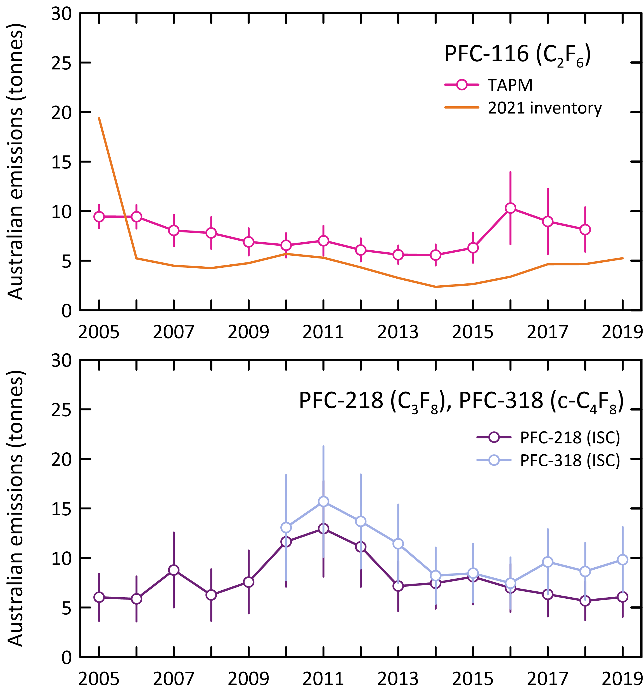

## Comparisons of *Inventory* and CSIRO emission estimates

As mentioned in section 2, the HFC *Inventory* estimates for 2005-2019 have been revised in the *National Inventory Report 2019* (DISER, 2021). Two significant changes have been implemented for determining HFC emissions in the Inventory. Recalculations in the *Inventory* have greatly improved agreement between CSIRO and *Inventory* estimates (Figure 3).

* The first change involved revised base leakage rates for refrigeration and air-conditioning that were adopted based on latest available country-specific expert assessment (Expert Group 2018).
* The second change involved revising the indexing leak rates to include growth in the national HFC bank. For more detail on the *Inventory* recalculations see DISER (2021).
* Hereafter, any reference to the *Inventory* is referring to the latest inventory: *National Inventory Report 2019* (DISER, 2021) which provides emission estimates up to 2019.

The Department of Industry, Science, Energy and Resources, which produces the *Inventory*, has indicated that it will be reviewing its methodology in future to further reduce differences between the Inventory and Cape Grim emission estimates.

### HFC-134a

* The major HFC emitted into the Australian environment is HFC-134a, with *Inventory* estimates in 2019 determined to be 2,477 tonnes (Table 3, Table 6, Figure 8).
* CSIRO estimates of HFC-134a in 2019 were 1,470 tonnes, 50% lower than reported in the *Inventory*.
* CSIRO and *Inventory* estimates compare better from 2005 to 2015 (compared to later years) with an average difference of approximately 16% for HFC-134a however the *Inventory* and CSIRO estimates diverge after 2015 with *Inventory* emission estimates higher than CSIRO estimates.
* CSIRO estimates suggest that Australian emissions of HFC-134a peaked in 2015 at 1,710 tonnes and are now in decline, with a small increase from 2018 to 2019.
* The *Inventory* overall shows increasing emissions through to 2019, with emissions growing by 4% per year (2005-2019).
* Based on atmospheric data, global emissions of HFC-134a were 238 k tonnes in 2019 (Rigby *et al.* 2014 and Rigby, unpublished data). Australian emissions are therefore estimated to be about 0.6% of global emissions based on Cape Grim data, and 1% based on *Inventory* data.

Figure 8. and Table 6. Australian HFC-134a *Inventory* emissions compared to CSIRO emissions (InTEM).

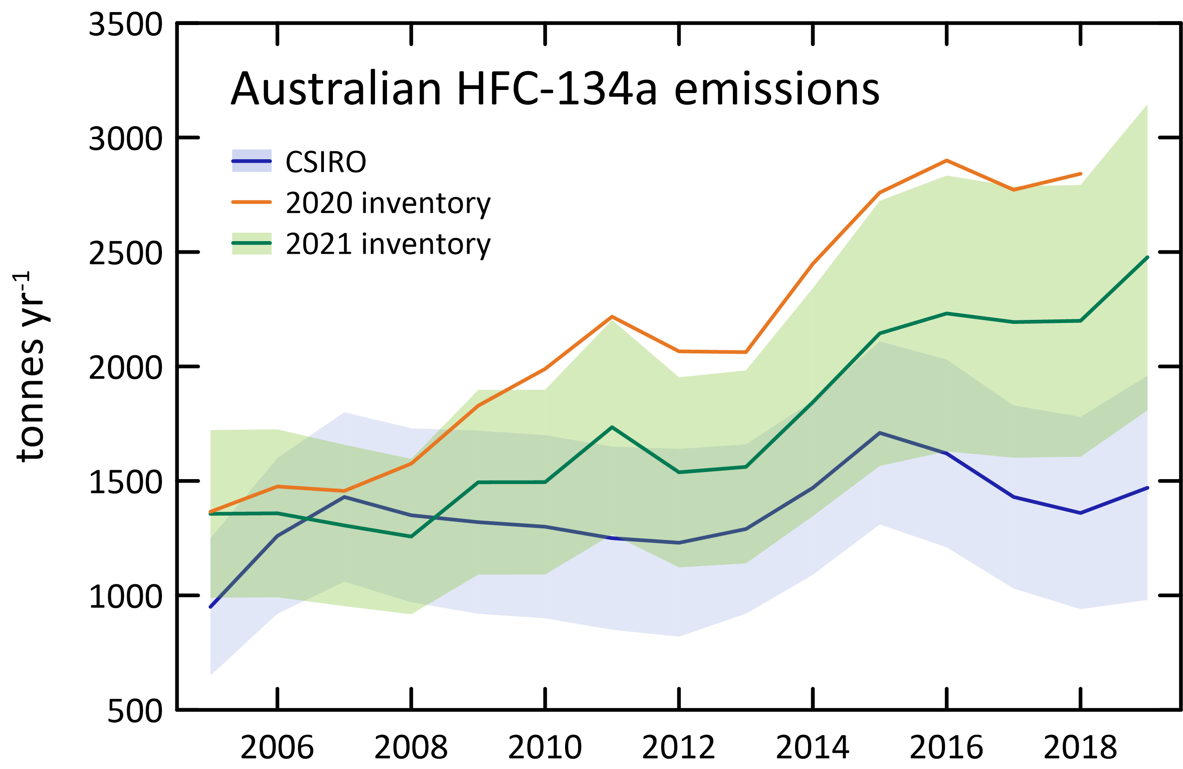

|  |  |  |
| --- | --- | --- |
|  | CSIRO | 2021 inventory |
| 2005 | 950 | 1356 |
| 2006 | 1260 | 1359 |
| 2007 | 1430 | 1306 |
| 2008 | 1350 | 1257 |
| 2009 | 1320 | 1494 |
| 2010 | 1300 | 1495 |
| 2011 | 1250 | 1735 |
| 2012 | 1230 | 1538 |
| 2013 | 1290 | 1561 |
| 2014 | 1470 | 1844 |
| 2015 | 1710 | 2145 |
| 2016 | 1620 | 2232 |
| 2017 | 1430 | 2194 |
| 2018 | 1360 | 2199 |
| 2019 | 1470 | 2477 |

### 

### HFC-125

The next major HFC emitted into the Australian environment is HFC-125 with current (2019) emissions estimated to be about 862 tonnes in the *Inventory* (Table 3, and Table 7 and Figure 9).

* CSIRO estimates of HFC-125 in 2019 were 560 tonnes, 35% lower than reported in the *Inventory*.
* CSIRO and *Inventory* estimates compare better from 2005 to 2015 (compared to later years) with an average difference of approximately 26% for HFC-125, however after 2015, the *Inventory* and CSIRO estimates diverge with the *Inventory* emission estimates higher than CSIRO estimates.
* CSIRO estimates suggest that Australian emissions of HFC-125 peaked in 2016 at 570 tonnes and are now in decline, with a small increase from 2018 to 2019.
* The *Inventory* overall shows increasing emissions through to 2019, with emissions growing by 7% per year (2005-2019).
* The revised *Inventory* estimates better reflect the year to year variability of the use of individual HFCs and the difference in magnitude between the CSIRO estimates and the *Inventory* estimates has been reduced.
* CSIRO emissions estimates suggest a stabilisation of emissions following a rapid increase in HFC-125 emissions which occurred from 2012-2016 (42%) likely due to the popularity of HFC-125 in newer air-conditioning systems as part of the refrigerant blend R410A.
* Based on atmospheric data, global emissions of HFC-125 were 88 k tonnes in 2019 (Rigby *et al.* 2014 and Rigby unpublished data). Australian emissions are therefore estimated to be 0.6% of global emissions based on CSIRO data, and 1% based on *Inventory* data.

Figure 9. and Table 7. Australian HFC-125 *Inventory* emissions compared to CSIRO emissions (InTEM).

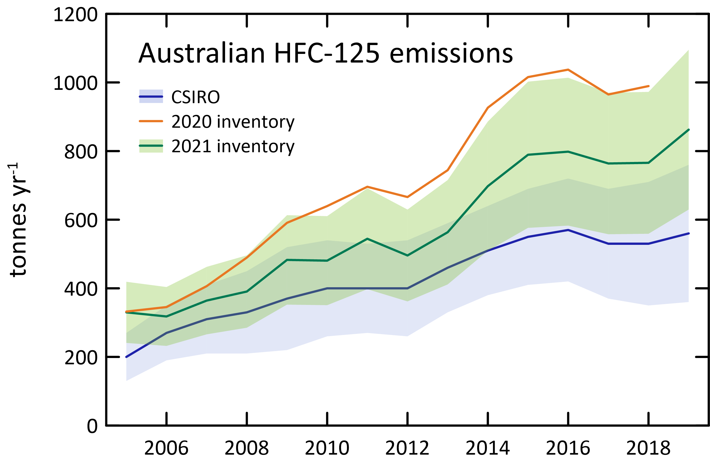

|  |  |  |
| --- | --- | --- |
|  | CSIRO | 2021 inventory |
| 2005 | 200 | 330 |
| 2006 | 270 | 318 |
| 2007 | 310 | 364 |
| 2008 | 330 | 391 |
| 2009 | 370 | 483 |
| 2010 | 400 | 481 |
| 2011 | 400 | 544 |
| 2012 | 400 | 496 |
| 2013 | 460 | 563 |
| 2014 | 510 | 698 |
| 2015 | 550 | 789 |
| 2016 | 570 | 798 |
| 2017 | 530 | 764 |
| 2018 | 530 | 766 |
| 2019 | 560 | 862 |

### HFC-143a

* According to the *Inventory* (Table 3, Table 8, Figure 10), the next major HFC emitted into the Australian environment is HFC-143a with current (2019) emissions of 577 tonnes.
* CSIRO estimates of HFC-143a emissions in 2019 were 380 tonnes, 34% lower than reported in the *Inventory*.
* CSIRO and *Inventory* estimates have an average difference of approximately 26% for HFC-143a over the full record (2005-2019).
* After 2015, the *Inventory* and CSIRO estimates diverge with the *Inventory* emission estimates maintaining a mostly upward trend.
* CSIRO estimates suggest that Australian emissions of HFC-143a peaked in 2016 at 430 tonnes and are now in decline, with a small increase from 2018 to 2019.
* The *Inventory* shows fairly stable emissions from 2013 to 2018, with peak emissions of 577 tonnes in 2019. Emissions of HFC-143a grew by 3.5% per year (2005-2019).
* Based on atmospheric data, global emissions of HFC-143a were 30 k tonnes in 2019 (Rigby *et al.* 2014 and Rigby unpublished data). Australian emissions are therefore estimated to be 1.3% of global emissions based on CSIRO data, and 1.9% based on *Inventory* data.

Figure 10. and Table 8. Australian HFC-143a *Inventory* emissions compared to CSIRO emissions (InTEM).

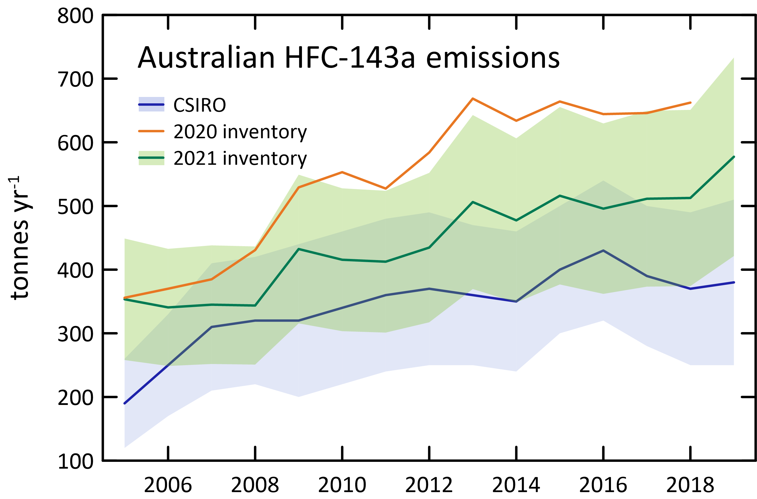

|  |  |  |
| --- | --- | --- |
|  | CSIRO | 2021 inventory |
| 2005 | 190 | 353 |
| 2006 | 250 | 341 |
| 2007 | 310 | 345 |
| 2008 | 320 | 344 |
| 2009 | 320 | 432 |
| 2010 | 340 | 416 |
| 2011 | 360 | 413 |
| 2012 | 370 | 435 |
| 2013 | 360 | 506 |
| 2014 | 350 | 477 |
| 2015 | 400 | 516 |
| 2016 | 430 | 496 |
| 2017 | 390 | 511 |
| 2018 | 370 | 513 |
| 2019 | 380 | 577 |

### 

### HFC-32

* According to the *Inventory* (Table 3, Table 9, Figure 11), the next major HFC emitted into the Australian environment is HFC-32 with current (2019) emissions of 378 tonnes.
* CSIRO estimates of HFC-32 in 2019 were 260 tonnes, 31% lower than reported in the *Inventory*.
* CSIRO and *Inventory* estimates compare better from 2005 to 2012 (compared to later years) with an average difference of approximately 26% for HFC-32
* After 2012, the *Inventory* and CSIRO estimates diverge, although both the *Inventory* and CSIRO emission estimates maintain a mostly upward trend.
* There was a rapid increase in HFC-32 emissions which occurred from 2013-2016 (around 100%) likely due to the popularity of HFC-32 in newer air-conditioning systems on its own and as part of the refrigerant blend R410A.
* Based on atmospheric data, global emissions of HFC-32 were 63 k tonnes in 2019 (Rigby *et al.* 2014 and Rigby unpublished data). Australian emissions are therefore estimated to be 0.4% of global emissions based on CSIRO data, and 0.6% based on *Inventory* data.

Figure 11 and Table 9. Australian HFC-32 *Inventory* emissions compared to CSIRO emissions (InTEM).

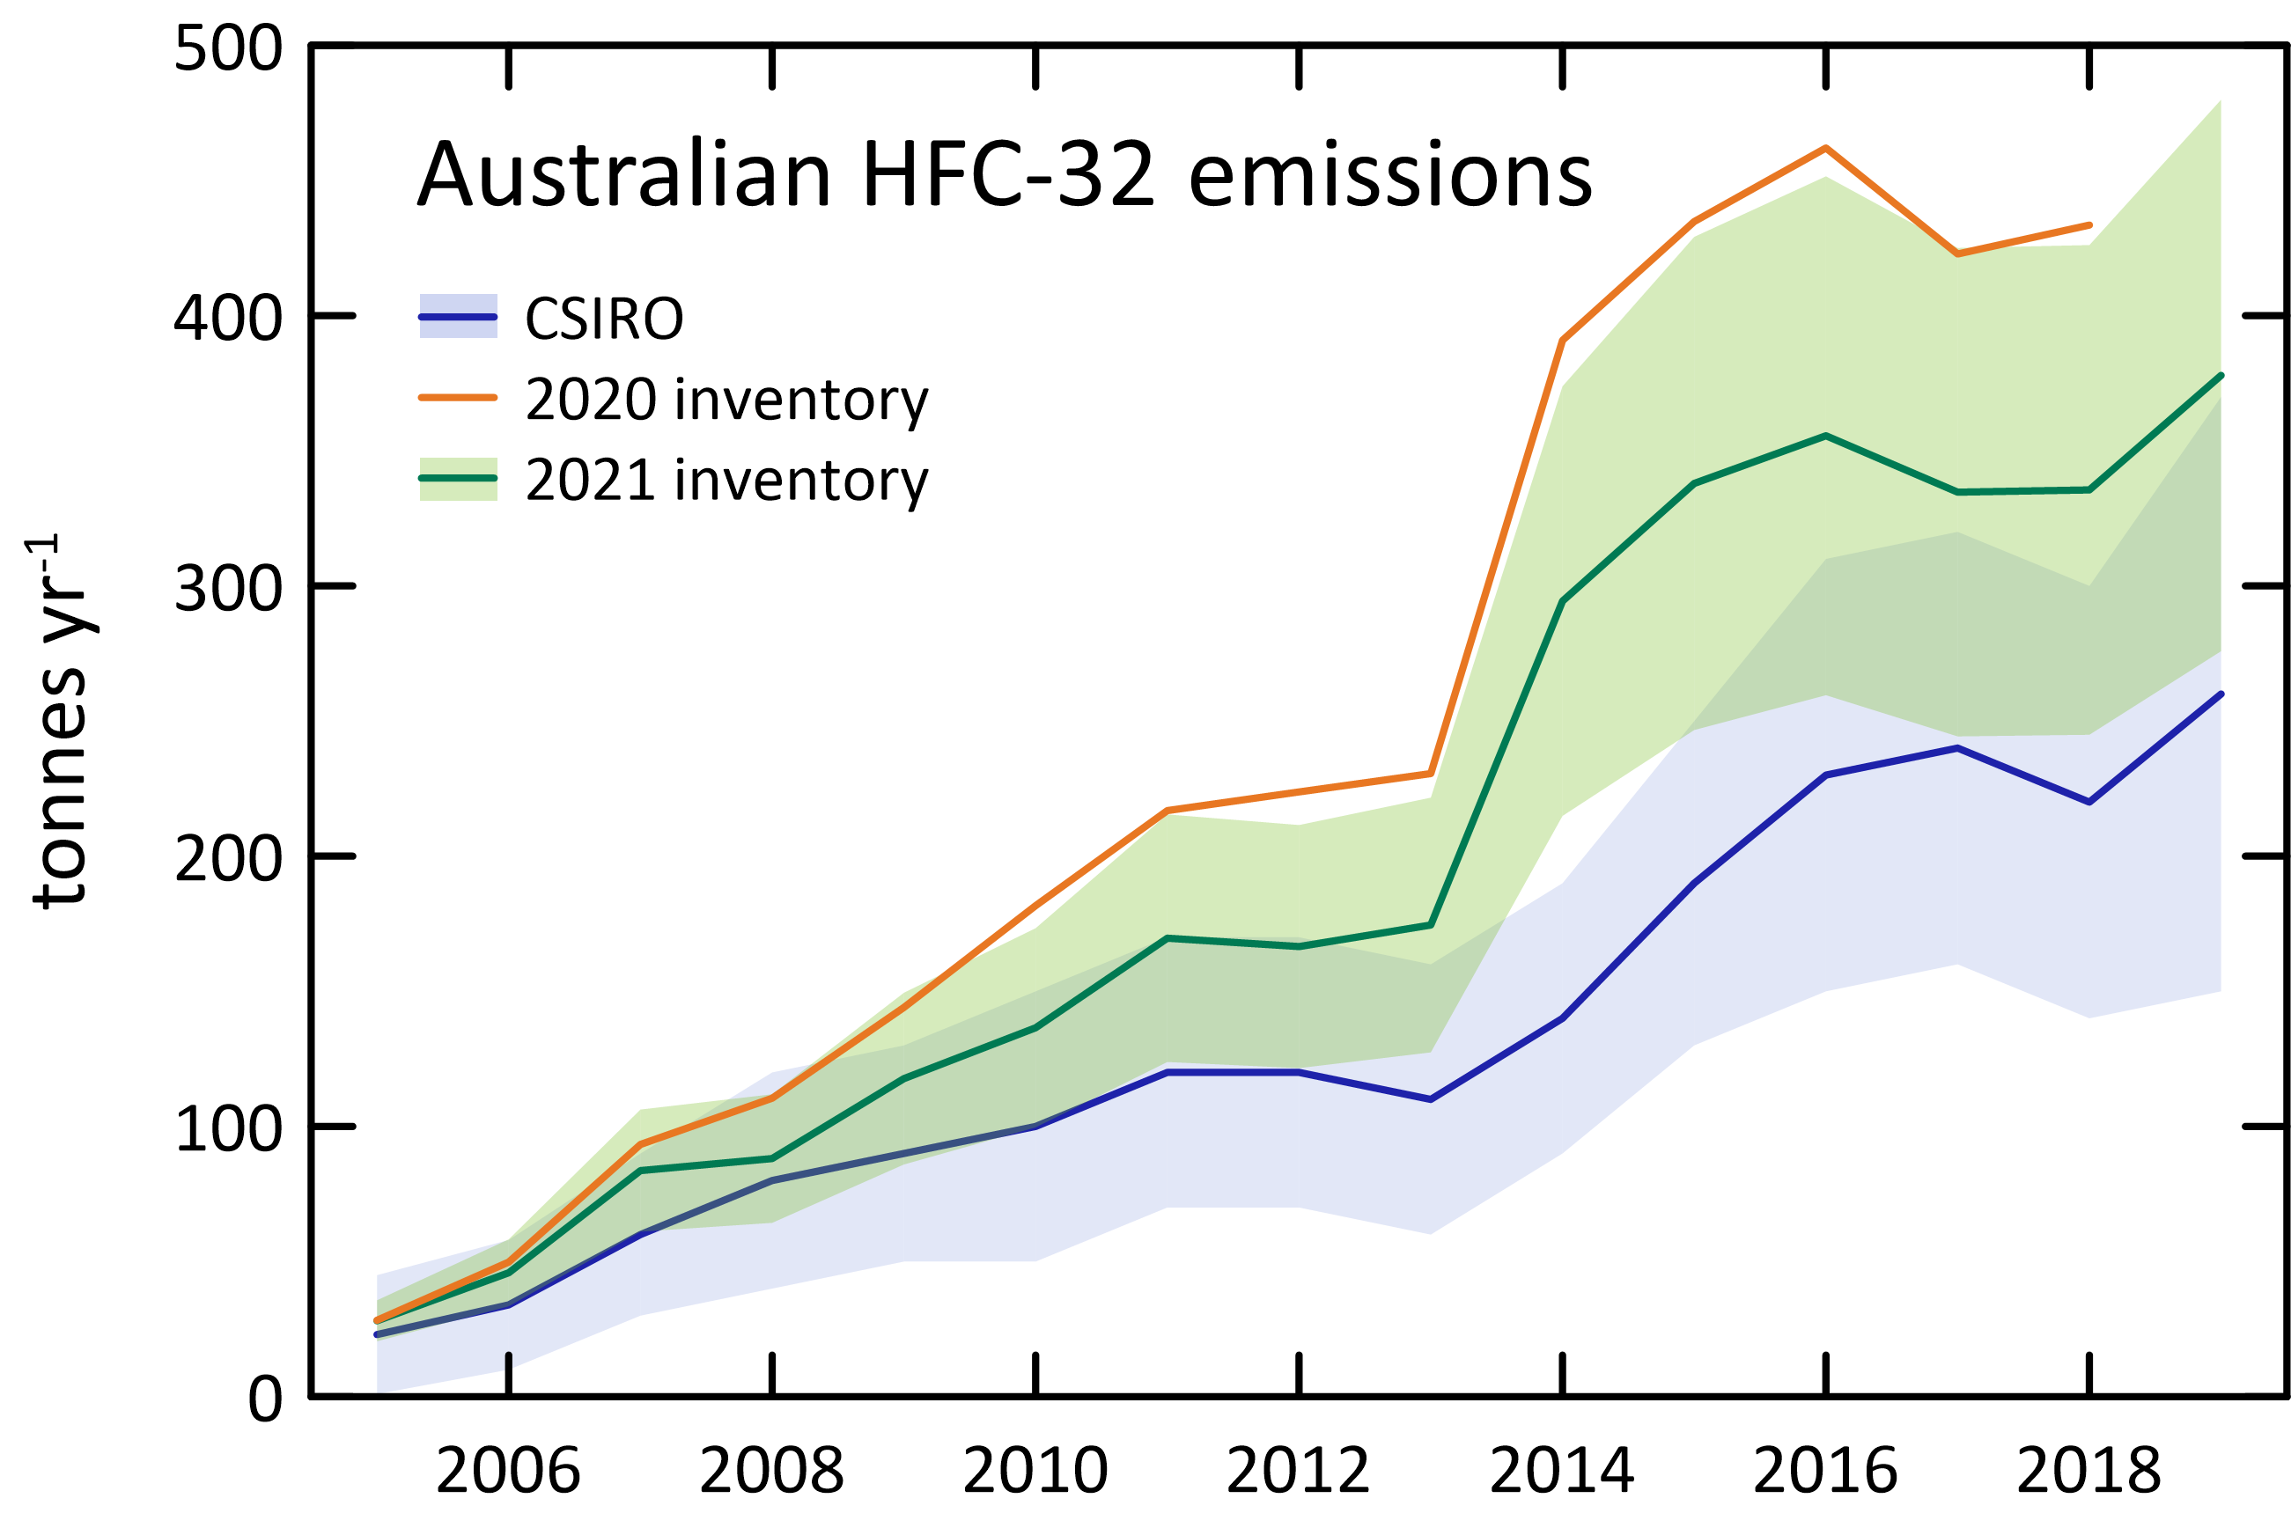

|  |  |  |
| --- | --- | --- |
|  | CSIRO | 2021 inventory |
| 2005 | 23 | 28 |
| 2006 | 34 | 46 |
| 2007 | 60 | 84 |
| 2008 | 80 | 88 |
| 2009 | 90 | 118 |
| 2010 | 100 | 137 |
| 2011 | 120 | 170 |
| 2012 | 120 | 167 |
| 2013 | 110 | 175 |
| 2014 | 140 | 294 |
| 2015 | 190 | 338 |
| 2016 | 230 | 356 |
| 2017 | 240 | 335 |
| 2018 | 220 | 336 |
| 2019 | 260 | 378 |

### HFC-152a

* Estimates of HFC-152a emissions have been included in the *Inventory* for the last 3 years, with current (2019) emissions of 105 tonnes (Table 3, Table 10, Figure 12)
* The primary uses for HFC-152a are as an aerosol propellant, as an alternative to CFC-11 and CFC-12 in foam expansion and as a component of some refrigerant blends.
* CSIRO estimates of HFC-152a in 2019 were 60 tonnes, 54% lower than reported in the *Inventory*.
* CSIRO and *Inventory* estimates compare better from 2005 to 2016 (compared to later years) with an average difference of approximately 24% for HFC-152a, however, *Inventory* and CSIRO estimates diverge after 2016, with the *Inventory* emission estimates higher than CSIRO estimates.
* CSIRO estimates suggest that Australian emissions of HFC-152a peaked in 2015 at 90 tonnes and are now in decline.
* The *Inventory* overall shows increasing emissions through to 2019, with emissions growing by 10% per year (2005-2019).
* Based on atmospheric data, global emissions of HFC-152a were 57 k tonnes in 2019 (Rigby *et al.* 2014 and Rigby unpublished data). Australian emissions are therefore estimated to be 0.1% of global emissions based on CSIRO data, and 0.2% based on *Inventory* data.

Figure 12 and Table 10 Australian HFC-152a *Inventory* emissions compared to CSIRO emissions (InTEM)

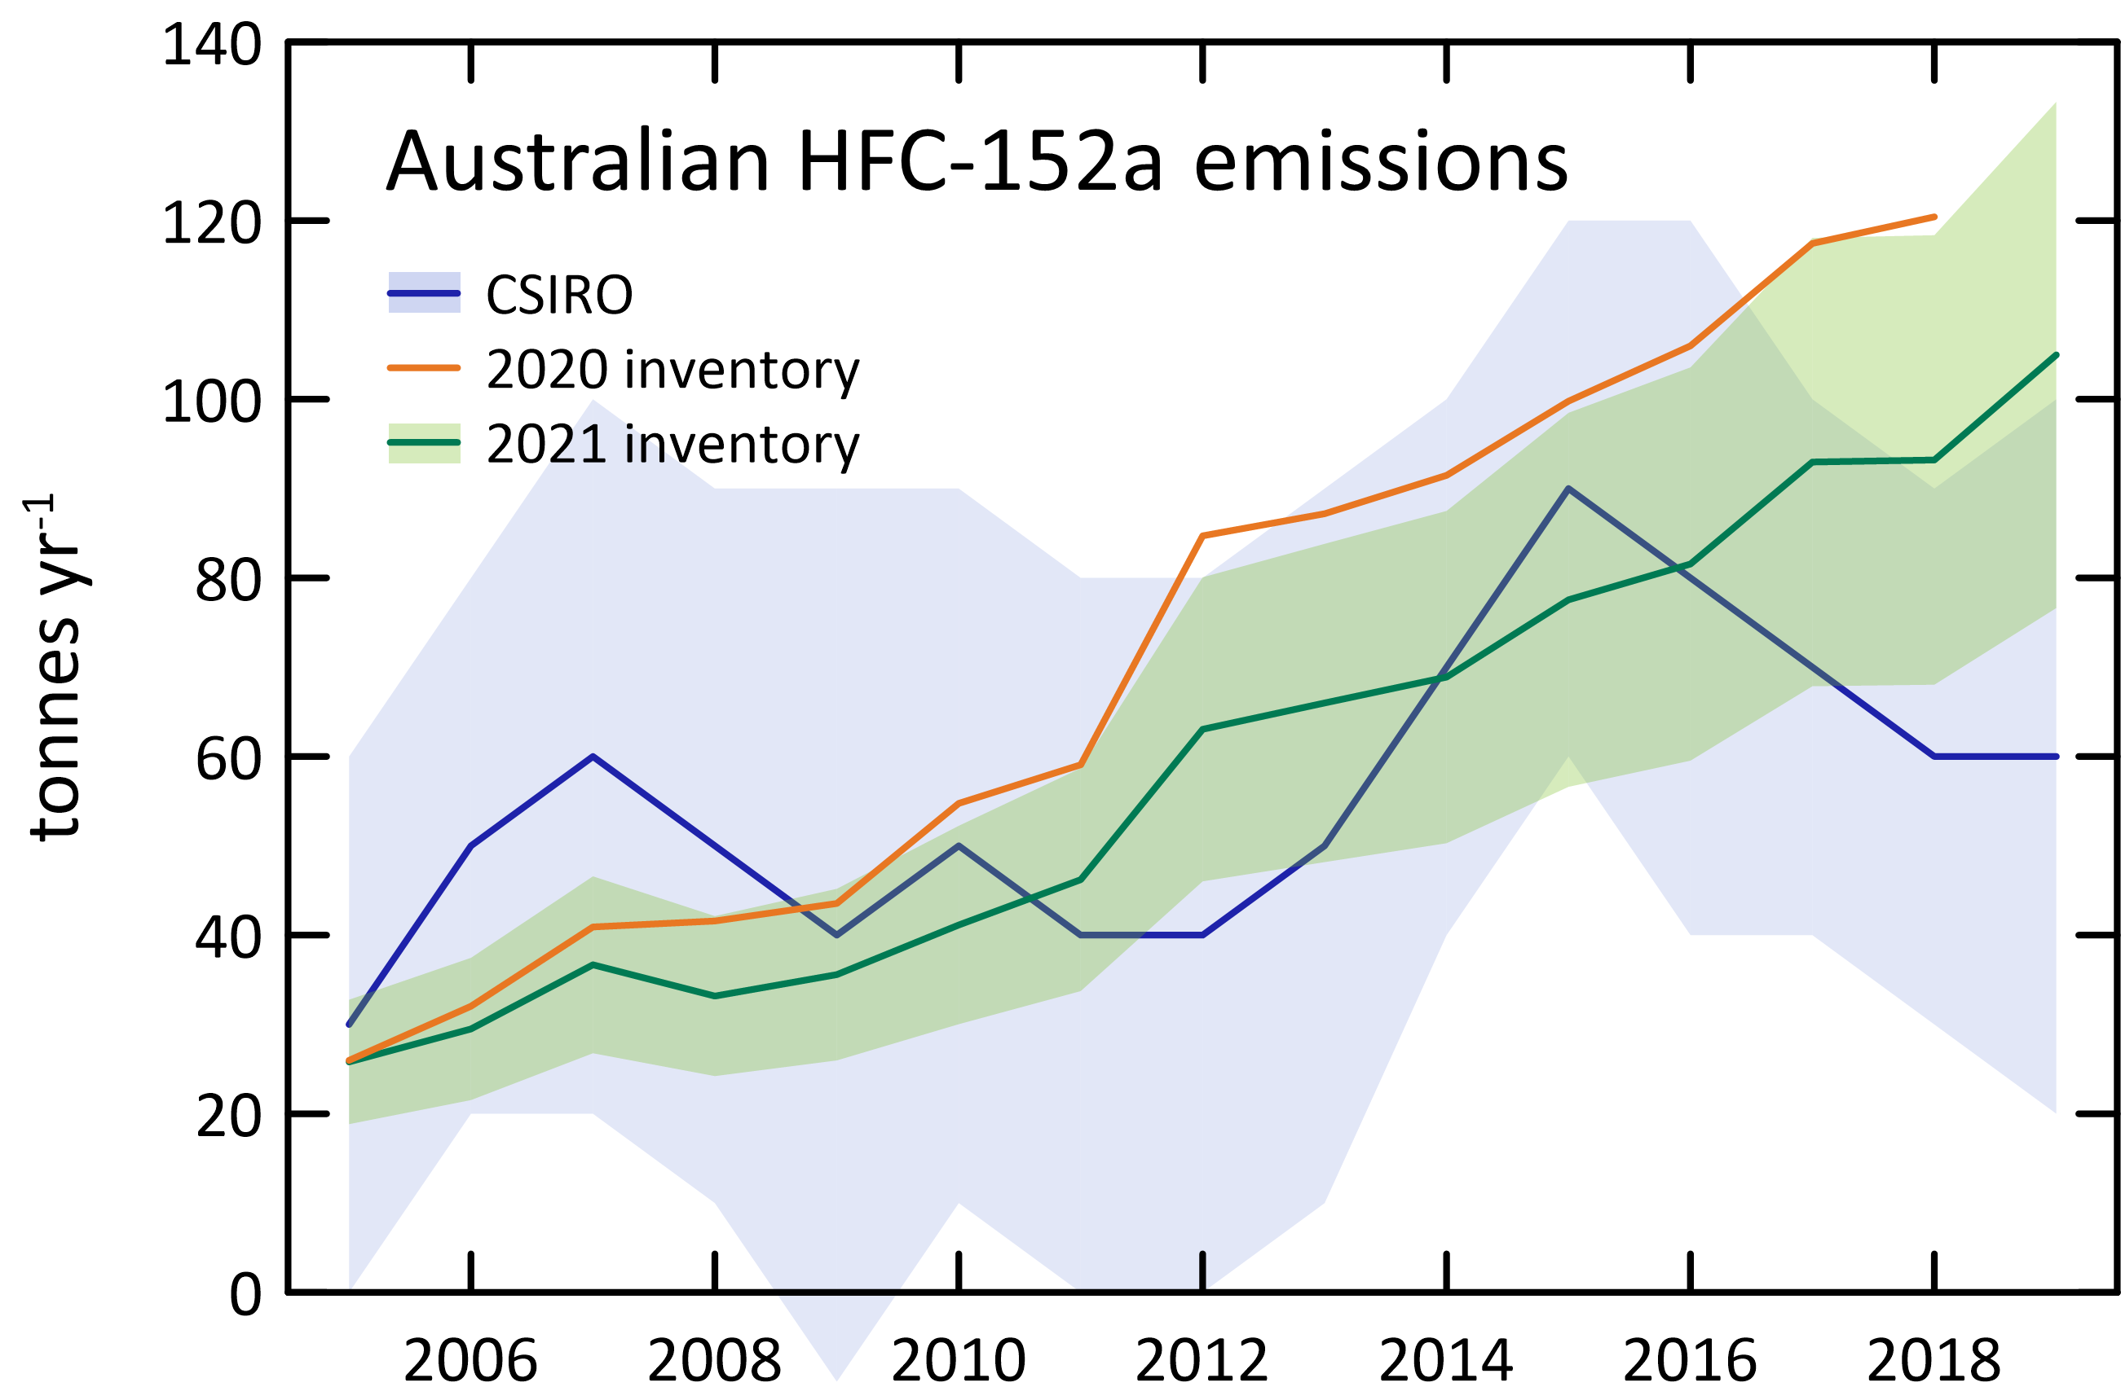

|  |  |  |
| --- | --- | --- |
|  | CSIRO | 2021 inventory |
| 2005 | 30 | 26 |
| 2006 | 50 | 29 |
| 2007 | 60 | 37 |
| 2008 | 50 | 33 |
| 2009 | 40 | 36 |
| 2010 | 50 | 41 |
| 2011 | 40 | 46 |
| 2012 | 40 | 63 |
| 2013 | 50 | 66 |
| 2014 | 70 | 69 |
| 2015 | 90 | 78 |
| 2016 | 80 | 82 |
| 2017 | 70 | 93 |
| 2018 | 60 | 93 |
| 2019 | 60 | 105 |

### HFC-23

The HFC-23 emission estimate for 2019 in the *Inventory* is 49 tonnes. The origin of Australian HFC-23 emissions is unknown. HFC-23 is a component of the R-508 series of refrigerants and a fire extinguishing agent, but significant imports of R-508 refrigerants into Australia have not been recorded.

* CSIRO estimates of HFC-23 in 2019 were 50 tonnes, only 2% higher than reported in the *Inventory*.
* CSIRO and *Inventory* estimates compare well for the whole record from 2005 to 2019 with an average difference of approximately 16% for HFC-23.
* Although global emissions of HFC-23 are on the increase (Stanley *et al.* 2020), in Australia we see stable emissions of HFC-23 since around 2012 for both CSIRO and Inventory estimates, with a slight increase in emissions from 2018 to 2019.
* Based on atmospheric data, global emissions of HFC-23 were 17 k tonnes in 2019 (Rigby *et al.* 2014 and Rigby, unpublished data). Australian emissions are therefore estimated to be about 0.3% of global emissions based on Cape Grim data, and 3% based on *Inventory* data
* Aspendale atmospheric data on HFC-23 (unpublished) show a significant, but small concentration maximum in the direction NE of Aspendale (as do HFC-134a, HFC-32, HFC-125 etc.). This suggests that HFC-23 is in the general mix of refrigerant/firefighting emissions from Melbourne, but has not been identified, in any significant amounts, in any Australian imports. One possible explanation is that HFC-23 is present in refrigerant blends as a contaminant.

Figure 13 and Table 11 Australian HFC-23 *Inventory* emissions compared to CSIRO emissions (InTEM)

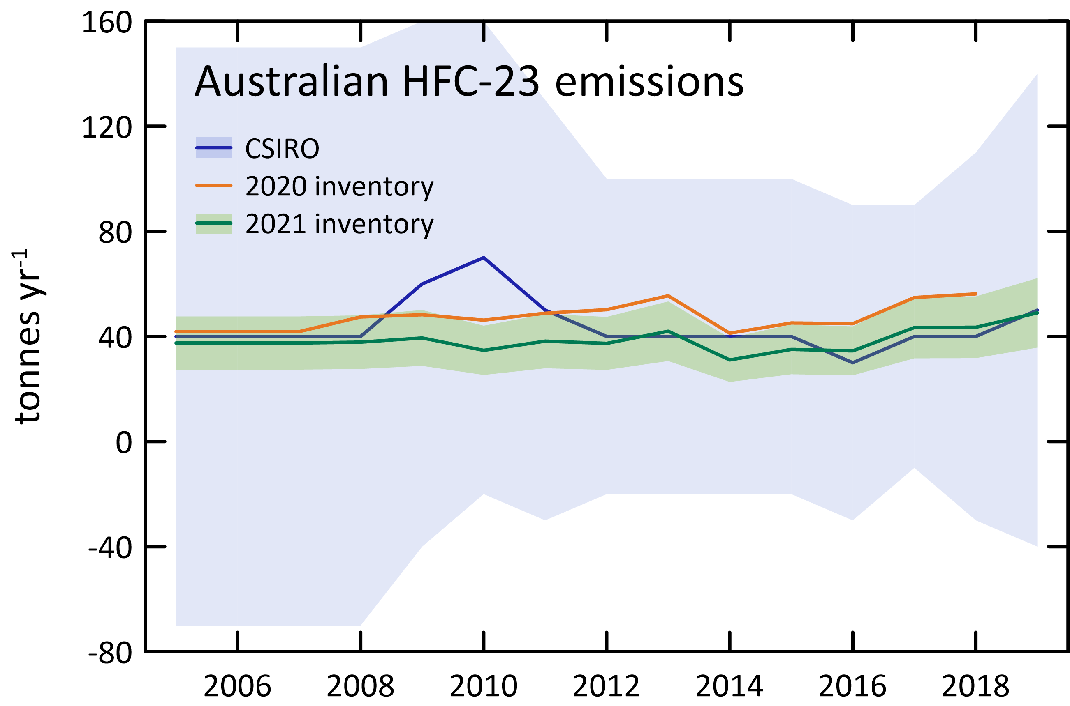

|  |  |  |
| --- | --- | --- |
|  | CSIRO | 2021 inventory |
| 2005 | 40 | 37 |
| 2006 | 40 | 37 |
| 2007 | 40 | 37 |
| 2008 | 40 | 38 |
| 2009 | 60 | 39 |
| 2010 | 70 | 35 |
| 2011 | 50 | 38 |
| 2012 | 40 | 37 |
| 2013 | 40 | 42 |
| 2014 | 40 | 31 |
| 2015 | 40 | 35 |
| 2016 | 30 | 35 |
| 2017 | 40 | 43 |
| 2018 | 40 | 43 |
| 2019 | 50 | 49 |

### HFC-227ea

* HFC-227ea emissions are estimated in the *Inventory* to be 31 tonnes in 2019 (Table 3, Table 12, Figure 14). HFC-227ea is a gaseous fire suppression agent used as a replacement for Halon 1301.
* CSIRO estimates of HFC-227ea in 2019 were 17 tonnes, 58% lower than reported in the *Inventory*.
* CSIRO and *Inventory* estimates compare better from 2005 to 2016 (compared to later years) with an average difference of approximately 18% for HFC-227ea however *Inventory* and CSIRO estimates diverge after 2016, with *Inventory* emission estimates higher than CSIRO estimates.
* Both CSIRO and *Inventory* estimates suggest that Australian emissions of HFC-227ea peaked in 2013 at around 32-36 tonnes.
* Based on atmospheric data, global emissions of HFC-227ea were 5.6 k tonnes in 2019 (Rigby *et al.* 2014 and Rigby, unpublished data). Australian emissions are therefore estimated to be about 0.3% of global emissions based on CSIRO data and 0.6% based on *Inventory* data.

Figure 14 and Table 12 Australian HFC-227ea *Inventory* emissions compared to CSIRO emissions (ISC).

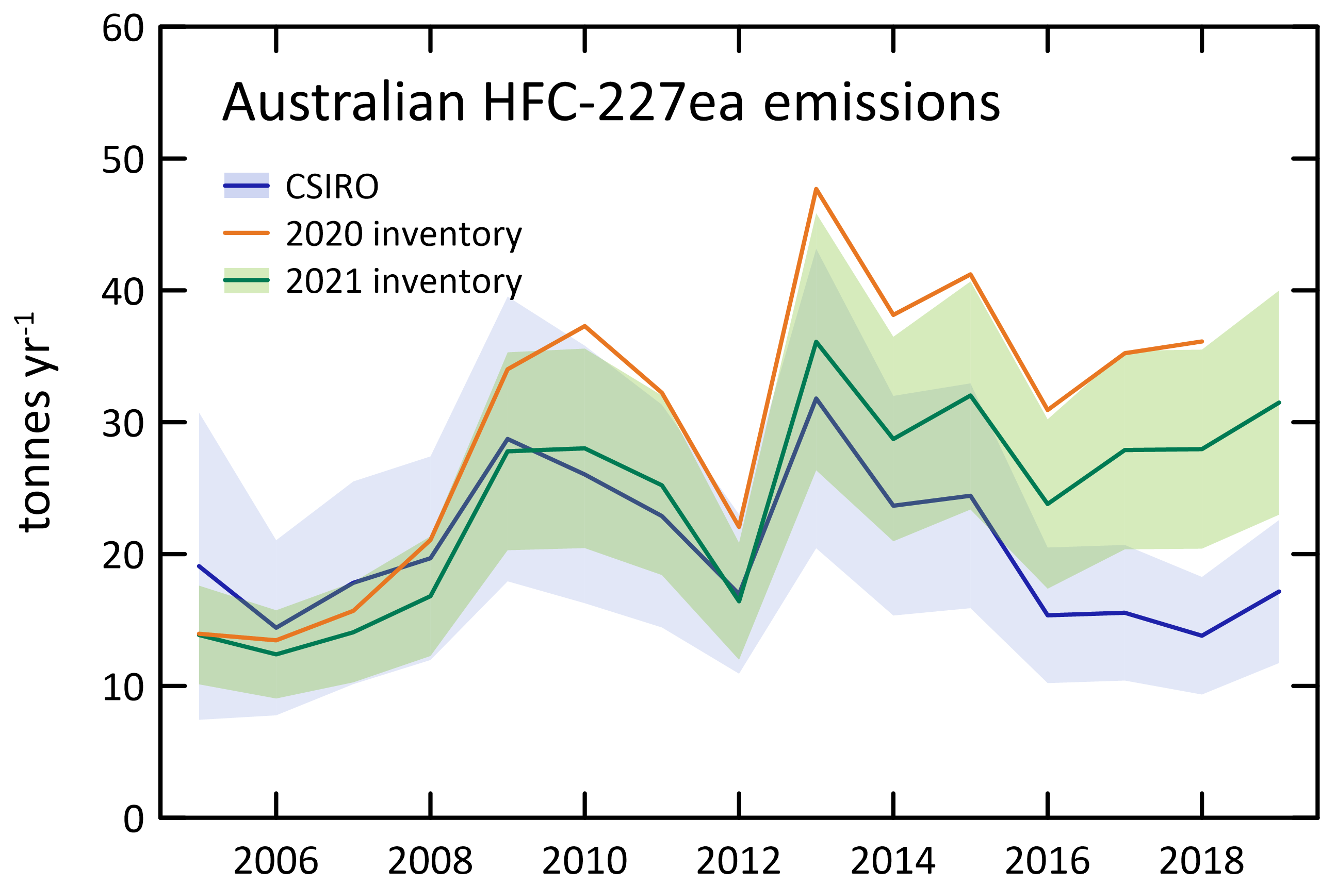

|  |  |  |
| --- | --- | --- |
|  | CSIRO | 2021 inventory |
| 2005 | 19 | 14 |
| 2006 | 14 | 12 |
| 2007 | 18 | 14 |
| 2008 | 20 | 17 |
| 2009 | 29 | 28 |
| 2010 | 26 | 28 |
| 2011 | 23 | 25 |
| 2012 | 17 | 16 |
| 2013 | 32 | 36 |
| 2014 | 24 | 29 |
| 2015 | 24 | 32 |
| 2016 | 15 | 24 |
| 2017 | 16 | 28 |
| 2018 | 14 | 28 |
| 2019 | 17 | 31 |

### HFC-236fa,

HFC-236ea emissions are estimated in the *Inventory* to be 5 tonnes in 2019 (Table 3, Table 13, Figure 15). HFC-236fa is a clean agent fire suppressant used as a replacement for Halon 1211 in portable fire extinguisher applications.

* CSIRO estimates of HFC-236fa emissions in 2019 were 2 tonnes, 85% lower than reported in the *Inventory*.
* CSIRO and *Inventory* estimates compare better from 2005 to 2016 (compared to later years) with an average difference of approximately 18% for HFC-236fa
* After 2016, the *Inventory* and CSIRO estimates diverge, with both the CSIRO and *Inventory* emission estimates remaining steady at 2 and 5 tonnes respectively from 2017 to 2019.
* Based on atmospheric data, global emissions of HFC-236fa were 0.39 k tonnes in 2019 (Rigby *et al.* 2014 and Rigby, unpublished data). Australian emissions are therefore estimated to be about 0.5% of global emissions based on CSIRO data and 1.3% based on *Inventory* data.

Figure 15 and Table 13 Australian HFC-236fa *Inventory* emissions compared to CSIRO emissions (ISC)

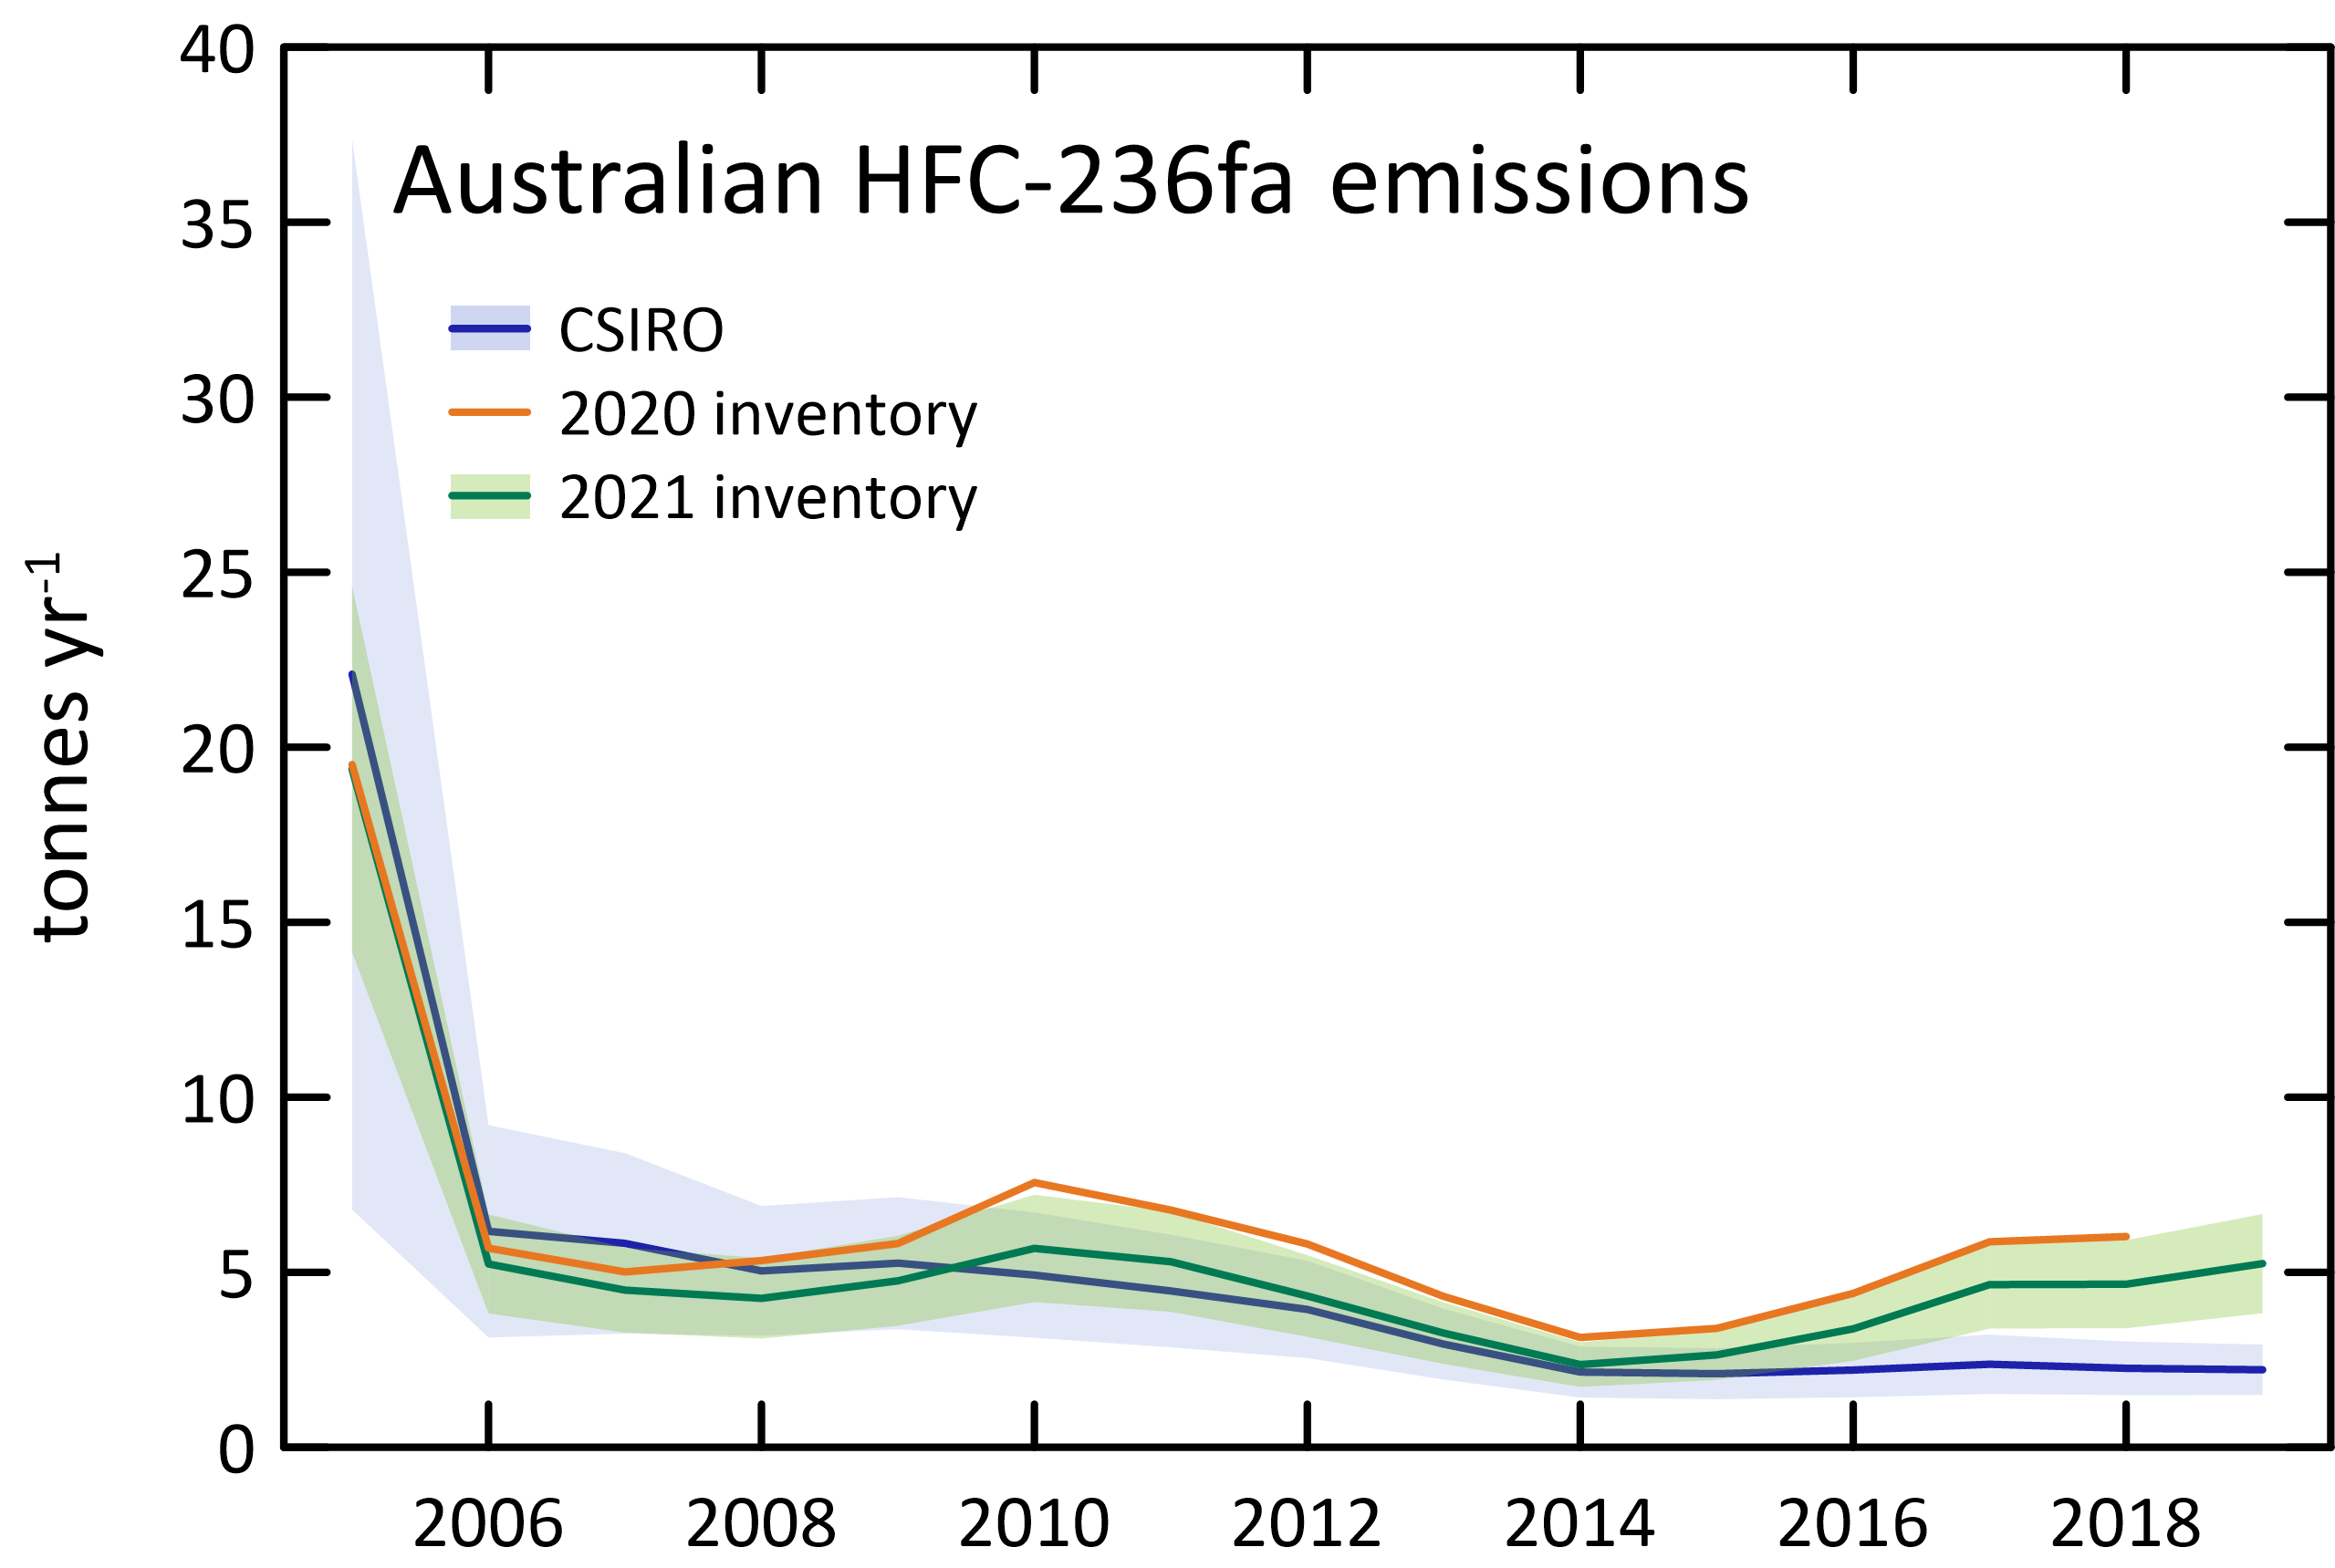

|  |  |  |
| --- | --- | --- |
|  | CSIRO | 2021 inventory |
| 2005 | 22 | 19 |
| 2006 | 6 | 5 |
| 2007 | 6 | 4 |
| 2008 | 5 | 4 |
| 2009 | 5 | 5 |
| 2010 | 5 | 6 |
| 2011 | 4 | 5 |
| 2012 | 4 | 4 |
| 2013 | 3 | 3 |
| 2014 | 2 | 2 |
| 2015 | 2 | 3 |
| 2016 | 2 | 3 |
| 2017 | 2 | 5 |
| 2018 | 2 | 5 |
| 2019 | 2 | 5 |

### HFC-245fa

* HFC-245fa emissions are estimated in the *Inventory* to be 96 tonnes in 2019 (Table 3, Table 14, Figure 16). HFC-245fa is used as a blowing agent for plastic foam insulation and is used as a replacement for HCFC-141b.
* CSIRO estimates of HFC-245fa emissions in 2019 were 40 tonnes, 82% lower than reported in the *Inventory*.
* CSIRO and *Inventory* estimates compare better from 2005 to 2014 (compared to later years) with an average difference of approximately 18% for HFC-245fa
* After 2014, the *Inventory* and CSIRO estimates diverge, with the *Inventory* emission estimates following an upward trend and the CSIRO estimates show a sharp decline.
* Based on atmospheric data, global emissions of HFC-245fa were 14 k tonnes in 2019 (Rigby *et al.* 2014 and Rigby, unpublished data). Australian emissions are therefore estimated to be about 0.3% of global emissions based on CSIRO data and 0.7% based on *Inventory* data
* Imports of HFC-245fa are in decline from peak imports of 290 tonnes in 2009 to 30 tonnes in 2020.

Figure 16 and Table 14 Australian HFC-245fa *Inventory* emissions compared to CSIRO emissions (ISC).

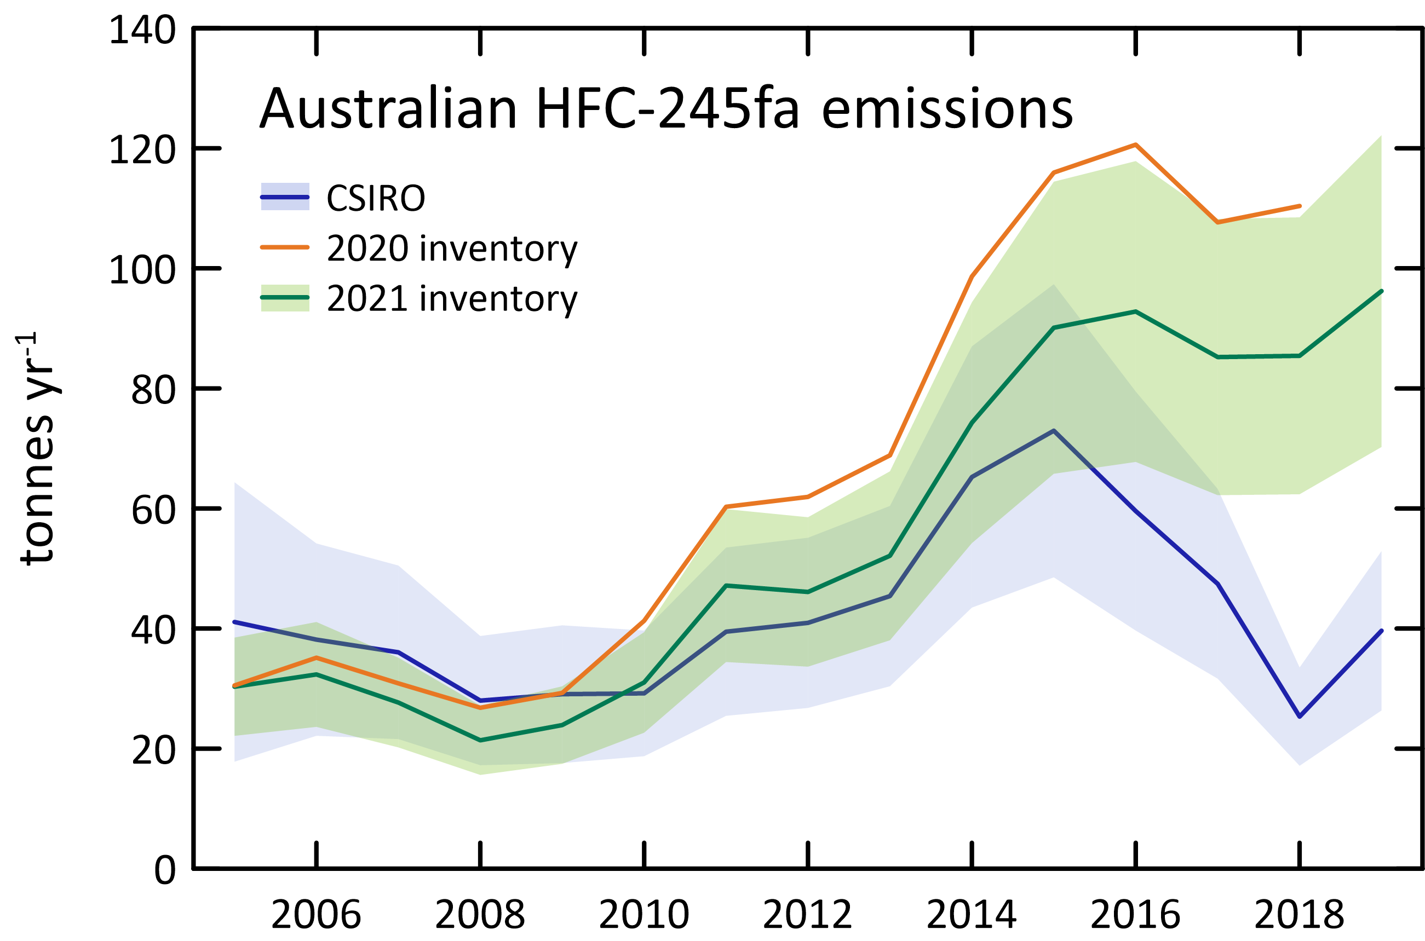

|  |  |  |
| --- | --- | --- |
|  | CSIRO | 2021 inventory |
| 2005 | 41 | 30 |
| 2006 | 38 | 32 |
| 2007 | 36 | 28 |
| 2008 | 28 | 21 |
| 2009 | 29 | 24 |
| 2010 | 29 | 31 |
| 2011 | 39 | 47 |
| 2012 | 41 | 46 |
| 2013 | 45 | 52 |
| 2014 | 65 | 74 |
| 2015 | 73 | 90 |
| 2016 | 60 | 93 |
| 2017 | 47 | 85 |
| 2018 | 25 | 85 |
| 2019 | 40 | 96 |

### HFC-365mfc

HFC-365mfc emissions are estimated in the *Inventory* to be 66 tonnes in 2019 (Table 3, Table 15, Figure 17). HFC-365mfc is used as a blowing agent for plastic foam insulation and is a replacement for HCFC-141b.

* CSIRO estimates of HFC-365mfc emissions in 2019 were 25 tonnes, 90% lower than reported in the *Inventory*.
* CSIRO and *Inventory* estimates compare better from 2005 to 2015 (compared to later years) with an average difference of approximately 15% for HFC-365mfc.
* After 2015, the *Inventory* and CSIRO estimates diverge, with the *Inventory* emission estimates following an upward trend and the CSIRO estimates show a sharp decline.
* Based on atmospheric data, global emissions of HFC-365mfc were 4.5 k tonnes in 2019 (Rigby *et al.* 2014 and Rigby, unpublished data). Australian emissions are therefore estimated to be about 0.6% of global emissions based on CSIRO data and 1.5% based on *Inventory* data
* Imports of HFC-365mfc have declined from peak imports of 250 tonnes in 2011 to 31 tonnes in 2020.

Figure 17 and Table 15 Australian HFC-365mfc *Inventory* emissions compared to CSIRO emissions (InTEM).

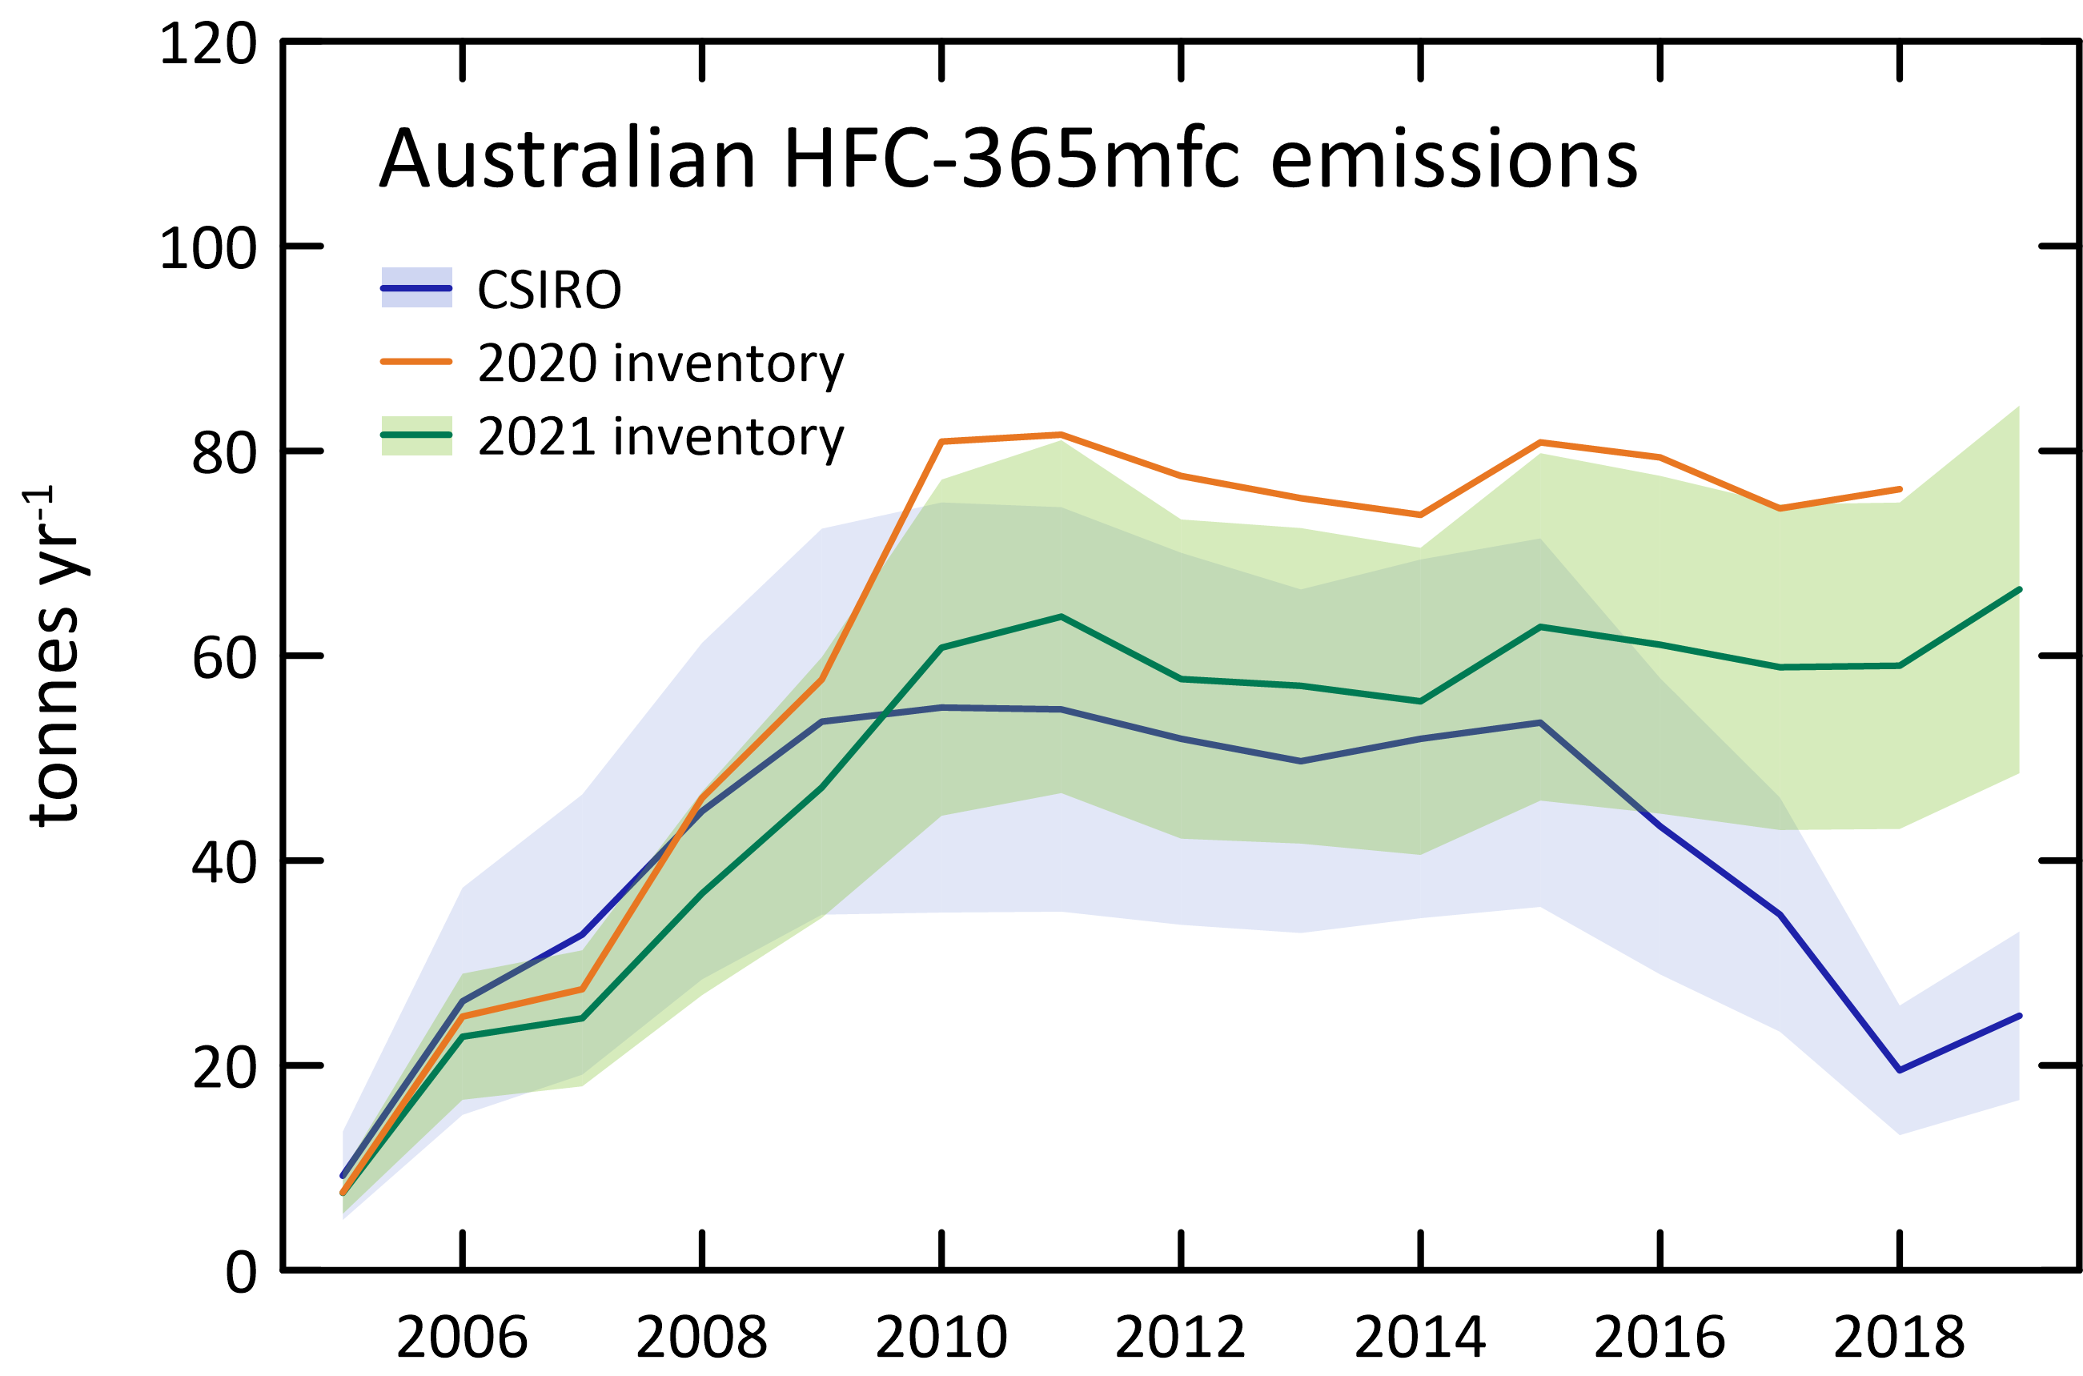

|  |  |  |
| --- | --- | --- |
|  | CSIRO | 2021 inventory |
| 2005 | 9 | 8 |
| 2006 | 26 | 23 |
| 2007 | 33 | 25 |
| 2008 | 45 | 37 |
| 2009 | 54 | 47 |
| 2010 | 55 | 61 |
| 2011 | 55 | 64 |
| 2012 | 52 | 58 |
| 2013 | 50 | 57 |
| 2014 | 52 | 56 |
| 2015 | 53 | 63 |
| 2016 | 43 | 61 |
| 2017 | 35 | 59 |
| 2018 | 20 | 59 |
| 2019 | 25 | 66 |

### 

### Total HFCs

Total HFCs in the *Inventory* have grown from 2165 tonnes in 2005 to 4653 tonnes in 2019 (6% per year) (Table 3, Figure 18).

* Total HFC emissions based on CSIRO data have grown from 1,524 tonnes in 2005 to a peak of 3,133 tonnes in 2015, dropping to 2,864 tonnes in 2019. Overall, CSIRO total HFC emissions are growing at 5% per year.
* Total HFC emissions in 2019 (CSIRO) are about 46% lower than total HFCs in the *Inventory*, with the discrepancy shared fairly equally between the major HFCs.
* CSIRO and *Inventory* estimates of total HFCs compare better from 2005 to 2010 (compared to later years) with an average difference of approximately 13%. After 2010 the *Inventory* and CSIRO total HFC estimates diverge with *Inventory* emission estimates higher than CSIRO estimates.
* CSIRO estimates suggest that Australian total HFC emissions peaked in 2015 and are now in decline, with a small increase from 2018 to 2019.
* Based on atmospheric data, global total HFC emissions were 528 k tonnes in 2019 (Rigby *et al.* 2014 and Rigby unpublished data). Australian emissions are therefore estimated to be 0.5% of global emissions based on CSIRO data, and 0.9% based on *Inventory* data.

Figure 18. Australian emissions of HFCs estimated from atmospheric data (ISC/InTEM) measured at Cape Grim, and in the Inventory (DISER 2021), expressed in units of M tonne CO2-e.

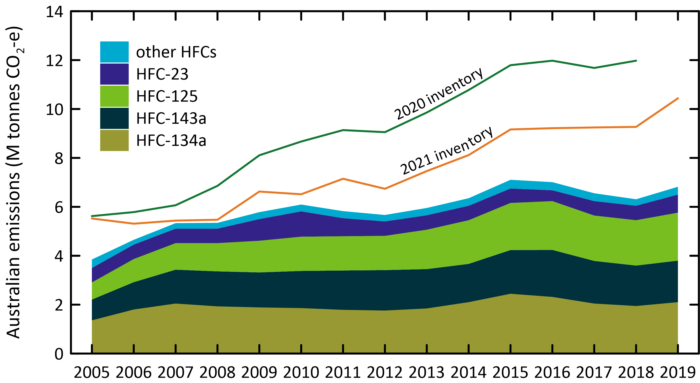

### 

### Sulfur hexafluoride

Australian Sulfur hexafluoride emissions in the *Inventory* are 6 tonnes in 2019, down slightly on 6.4 tonnes in 2019 (Table 3, Figure 3, Figure 19).

* CSIRO estimates of sulfur hexafluoride emissions are 72 tonnes in 2005, decreasing to 17 tonnes in 2019, an overall decrease of about 10% per year.
* *Inventory* emissions are significantly lower than CSIRO emissions estimates. Sulfur hexafluoride emissions in the inventory average 5 tonnes per year over the last 10 years, about a factor of 4 lower than CSIRO estimates (ISC) over the same period (20 tonnes per year).
* The Australian sulfur hexafluoride emissions from atmospheric data and in the Inventory, and sulfur hexafluoride import data, are shown in Figure 19.
* Global sulfur hexafluoride emissions have been increasing steadily from about 3 k tonnes per year in the late-1970s to 9 k tonnes per year in 2019 (an increase of around 0.15 k tonnes/yr) (Rigby *et al.* 2014, Rigby, unpublished data). Australian emissions are estimated to be about 0.2% of global emissions (ISC), but < 0.1% based on the *Inventory* data. It would be unusual for Australian emissions of a widely used industrial chemical to be <0.1% of global emissions.

Figure 19. Australian and global sulfur hexafluoride imports and emissions (tonnes) from Cape Grim data using ISC and InTEM (Ganesan *et al.* 2014; Rigby *et al.* 2014) and from the Inventory (NGA: DISER 2021).

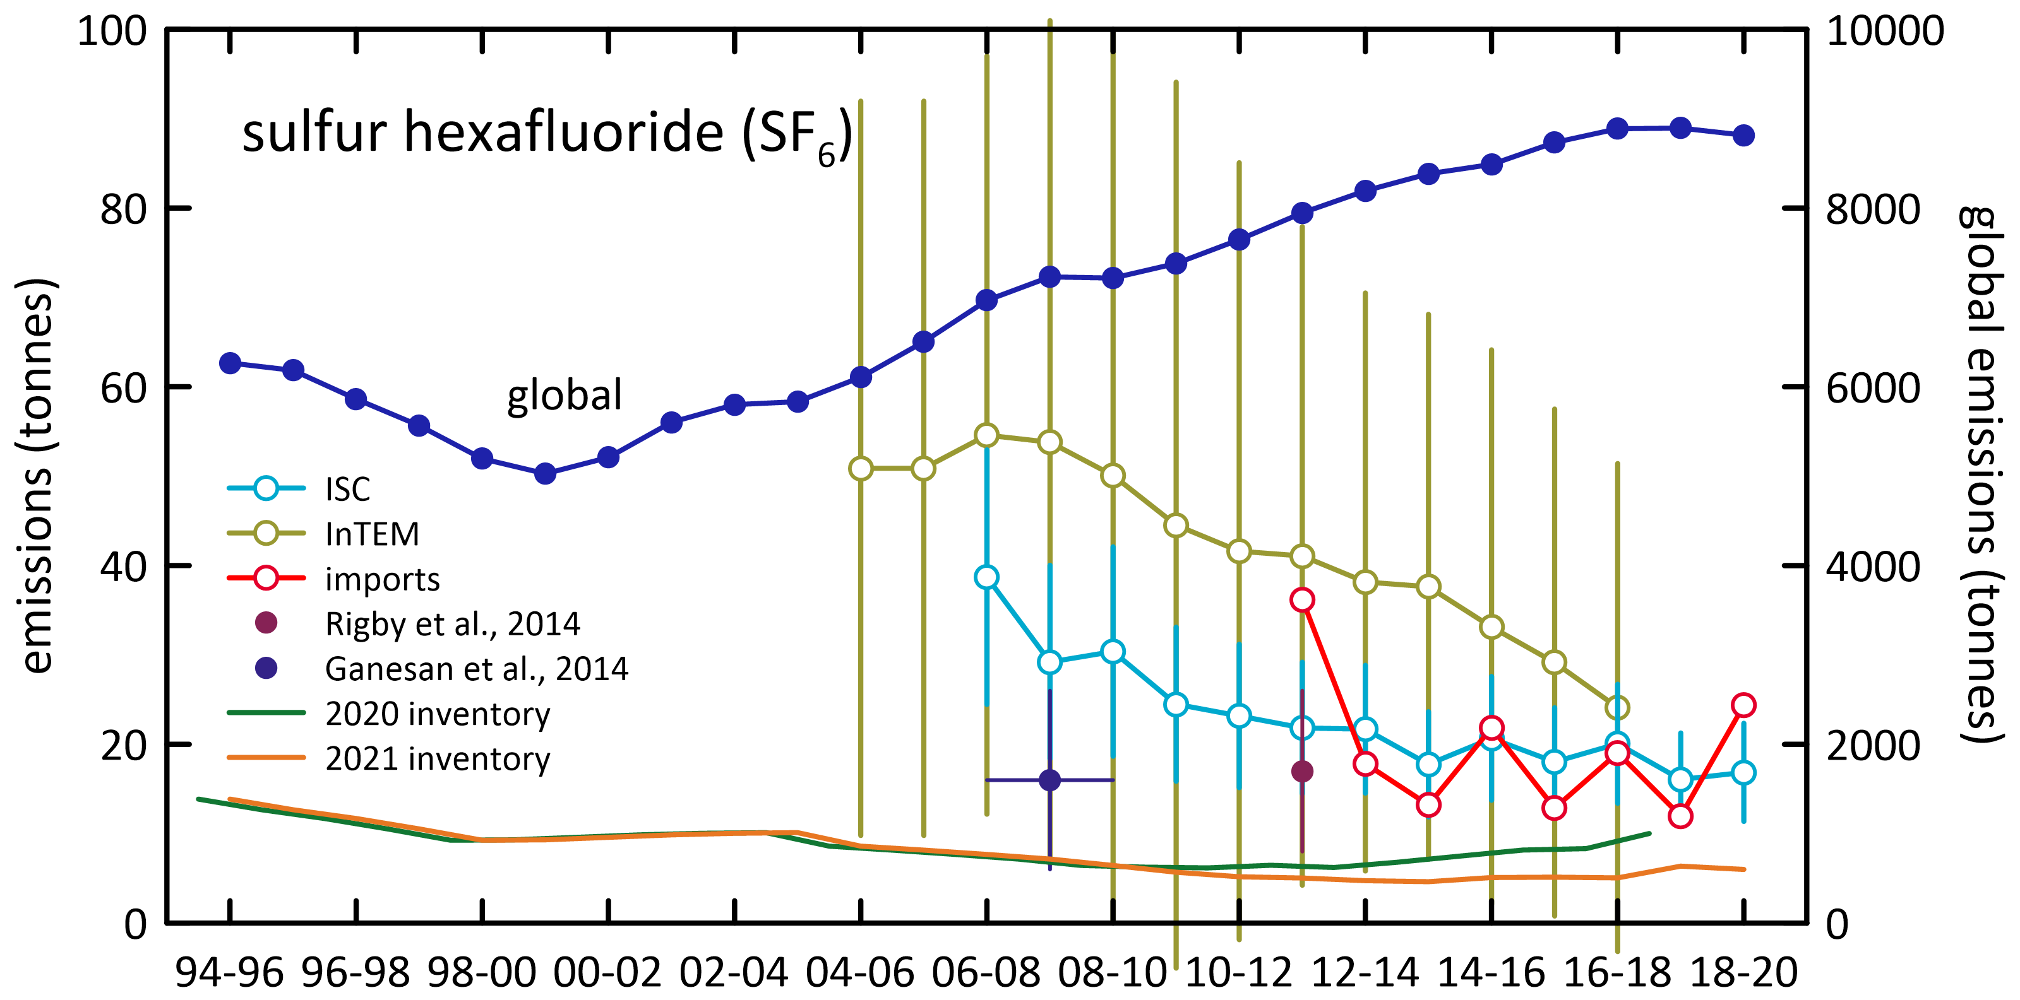

### 

### Sulfuryl fluoride

CSIRO (ISC), Australian sulfuryl fluoride emissions averaged 13 tonnes/yr from 2005-2009, but then increased to 163 tonnes in 2014 (Table 4, Figure 20). This may reflect a change in grain fumigation practices away from using methyl bromide and phosphine. By 2019, emissions had declined to 85 tonnes.

* Global sulfuryl fluoride emissions were around 1 k tonne per year in the late-1970s, reaching a peak of around 2.9 k tonnes per year in 2013 and has remained at an average 2.9 ktonnes for the last 5 years (Rigby *et al.* 2014 and Rigby, unpublished data).
* There is significant year to year variability in emissions, presumably due to the global demand for sulfuryl fluoride being dependant on, in part, variable global grain production.
* Australia is responsible for 3% of global wheat production, but 10-15% of wheat exports. Sulfuryl fluoride emissions are more closely related to wheat production (grain storage in Australia’s interior) than to wheat export (grain storage at export ports, fumigated with methyl bromide).
* In CO2-e terms, sulfuryl fluoride emissions reached 425 k tonnes CO2-e in 2019.

Figure 20. Australian sulfuryl fluoride emissions (tonnes), scaled from SE Australian emissions based on grain production, derived from Cape Grim *in situ* data, using ISC and InTEM techniques; global emissions (tonnes) are from Rigby *et al.* 2014; Rigby, unpublished data.

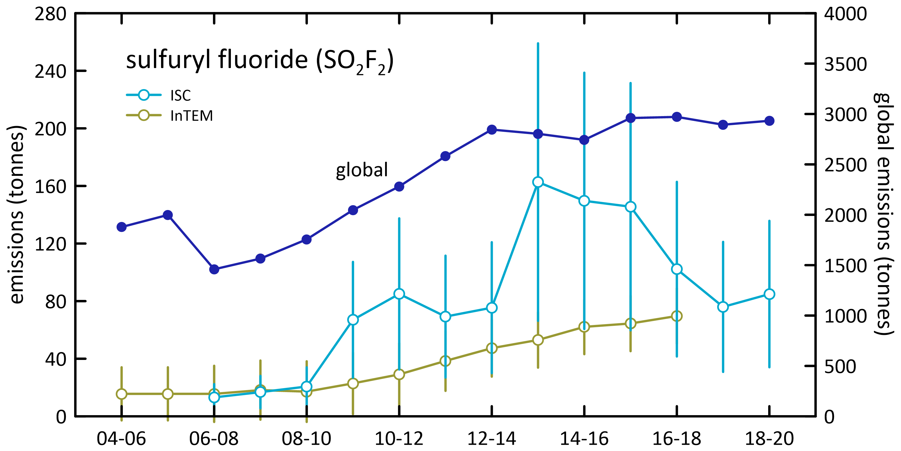

### 

### Total HFC, PFC and sulfur hexafluoride emissions

Total HFC, PFC and sulfur hexafluoride emissions in CO2-e from Cape Grim data and the *Inventory* are shown in Table 3, Table 4 and Figure 21.

* Total Australian HFC, PFC and sulfur hexafluoride emissions in the *Inventory* have grown from 2400 tonnes in 2005 to 4693 tonnes in 2019 (5% per year)
* Total Australian HFC, PFC and sulfur hexafluoride emissions based on CSIRO data have grown from 1,723 tonnes in 2005 to a peak of 3,239 tonnes in 2015, dropping to 2,986 tonnes in 2019. Overall, CSIRO total HFC emissions are growing at 4% per year.
* CSIRO and *Inventory* estimates of total HFC, PFC and sulfur hexafluoride compare better from 2005 to 2010 (compared to later years) with an average difference of approximately 12%. After 2010, the *Inventory* and CSIRO total HFC, PFC and sulfur hexafluoride estimates diverge with the *Inventory* emission estimates higher than CSIRO estimates.
* CSIRO estimates suggest that Australian total HFC, PFC and sulfur hexafluoride emissions peaked in 2015 and are now in decline, with a small increase from 2018 to 2019.
* For 2019, total Australian HFC, PFC and sulfur hexafluoride emissions in the *Inventory* are 10.8 M tonnes CO2-e, 26% higher than estimates based on CSIRO data of 8.3 M tonnes CO2-e.
* Based on atmospheric data, global total HFC, PFC and sulfur hexafluoride emissions were 556 k tonnes in 2019 (Rigby *et al.* 2014 and Rigby unpublished data). Australian emissions are therefore estimated to be 0.5% of global emissions based on CSIRO data, and 0.8% based on *Inventory* data.
* For PFCs and sulfur hexafluoride, the atmospheric data give higher estimates of emissions than in the *Inventory*. For HFCs, the atmospheric data give lower estimates of emissions than the *Inventory*.
* Global emissions of nitrogen trifluoride (controlled by the UNFCCC since 2013) have been estimated from AGAGE global data (including Cape Grim data) by inverse modelling up to 2019. Nitrogen trifluoride emissions were first observed in the mid-1990s, growing at 0.09 k tonnes/yr since 1995 to 2.8 k tonnes in 2019.
* Total global HFC, PFC, sulfur hexafluoride and nitrogen trifluoride emissions have risen (13 k tonnes/yr, largely HFCs) from about 30 k tonnes per year in the late-1970s to around 553 k tonnes per year in 2018 (Figure 22; Rigby *et al.* 2014 and Rigby, unpublished data).

Figure 21. Australian HFC, PFC, sulfur hexafluoride emissions calculated from Cape Grim observations (ISC/InTEM) and the Inventory ([available at the NGA website](https://ageis.climatechange.gov.au)) in M tonne CO2-e.

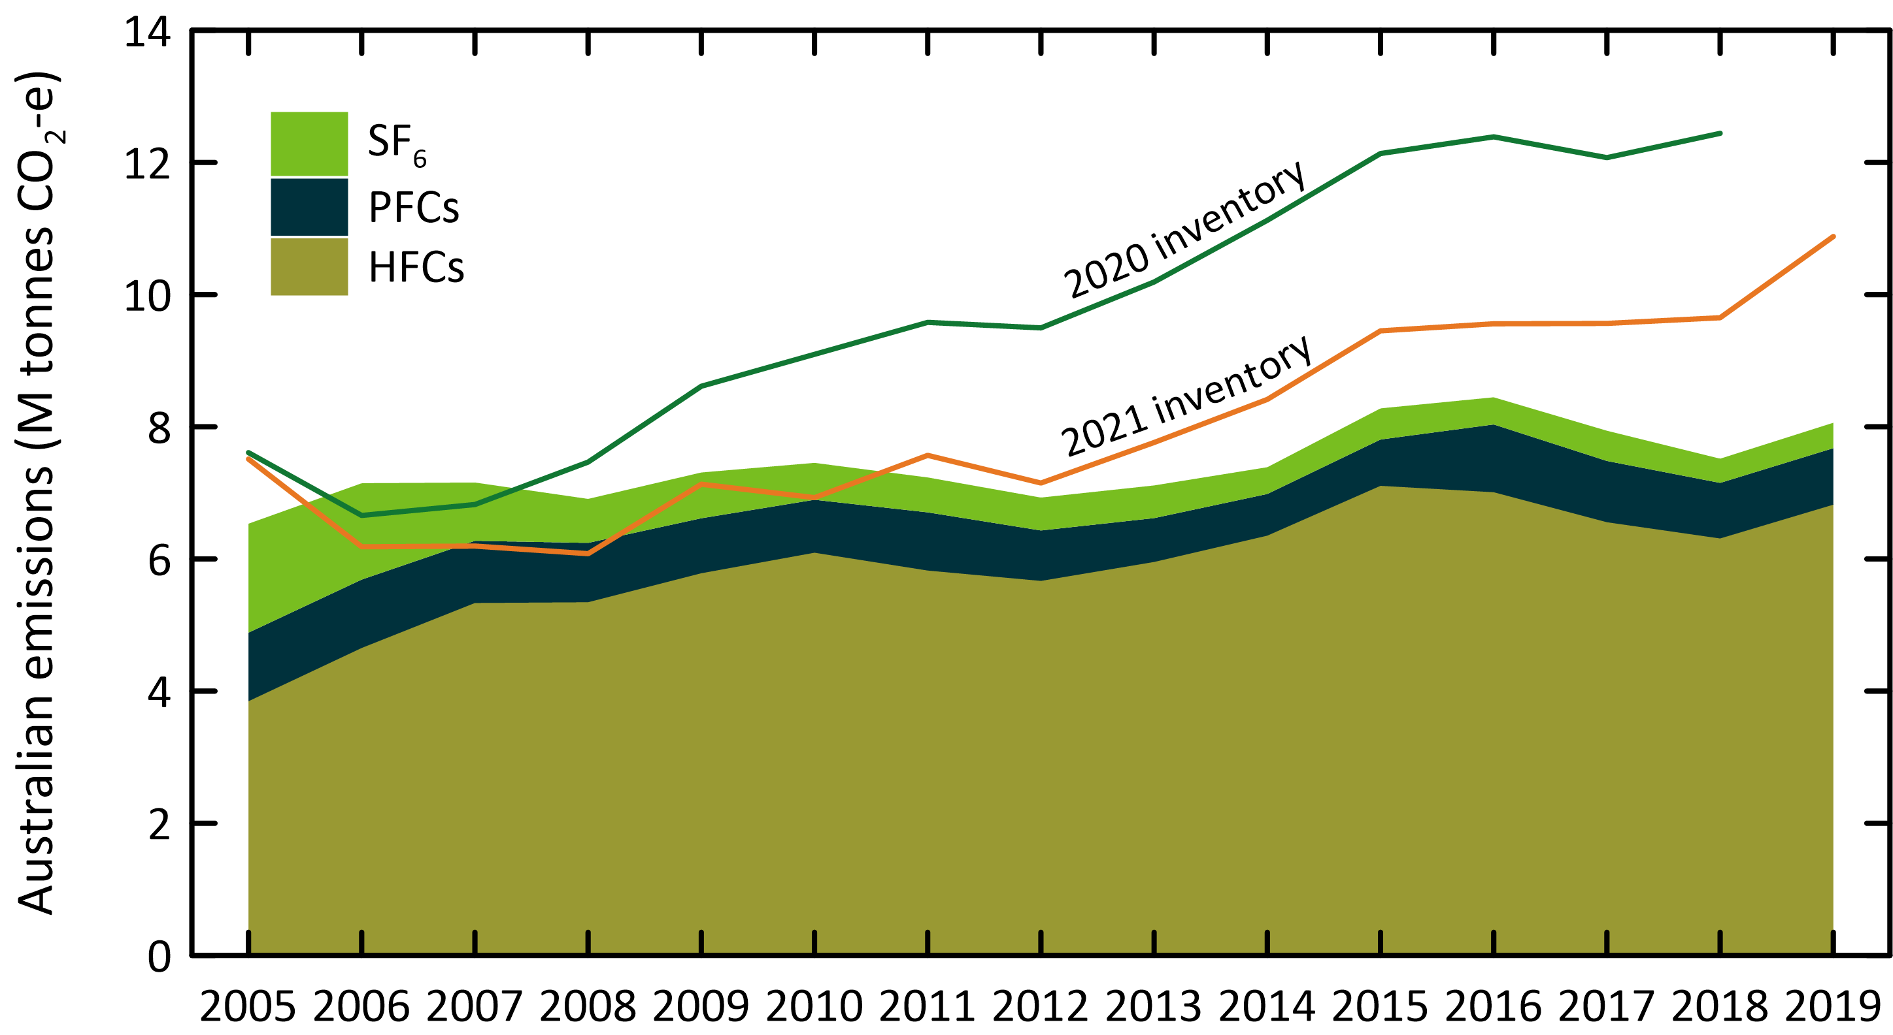

Figure 22. Global HFC, PFC, sulfur hexafluoride and nitrogen trifluoride emissions (left: k tonnes; right: M tonnes CO2-e) from global AGAGE atmospheric measurements.

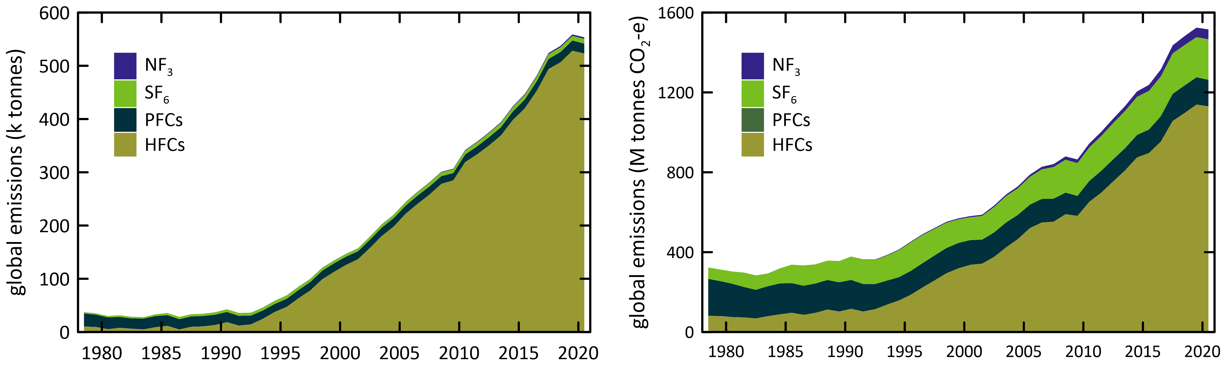

Appendix A

Key references

**HFCs** Oram *et al*. 1996, 1998; Oram 1999; O’Doherty *et al*. 2004, 2009, 2014; Greally *et al*. 2007; Stohl *et al*. 2009; Miller *et al*. 2010; Vollmer *et al*. 2011; Arnold *et al*. 2014; Fraser *et al*. 2014a 2016; Krummel *et al*. 2014; Rigby *et al*. 2014; Fortems-Cheney *et al*. 2015; Lunt *et al*. 2015; Simmonds *et al*. 2015, 2016, 2017, 2018; Meinshausen *et al*. 2017; Leedham Elvidge *et al*. 2018; Liang *et al*. 2017; Montzka & Velders 2018; Li *et al*. 2019; Yao *et al*. 2019; Stanley *et al*. 2020

**PFCs** Oram 1999; Fraser *et al.* 2007, 2011, 2013, 2016; Mühle *et al.* 2010; Ivy 2012; Ivy *et al.* 2012; Laube *et al.* 2012; Oram *et al.* 2012; Kim *et al.* 2014; Krummel *et al.* 2014; Rigby *et al.* 2014; Wong *et al.* 2015; Trudinger *et al.* 2016; Meinshausen *et al.* 2017; Leedham Elvidge *et al.* 2018; Droste *et al.* 2018; Engel & Rigby 2018; Li *et al.* 2019

**SF6** Maiss *et al.* 1996; Oram 1999; Fraser *et al.* 2004, 2014a, 2016; Levin *et al.* 2010; Rigby *et al.* 2010, 2014; Sturges *et al*. 2012; Ganesan *et al.* 2014; Krummel *et al.* 2014; Meinshausen *et al.* 2017; Leedham Elvidge *et al.* 2018; Engel & Rigby 2018

**NF3** Weiss *et al.* 2008; Arnold *et al.* 2013; Rigby *et al.* 2014; Meinshausen *et al.* 2017

**SO2F2** Mühle *et al.* 2009; Krummel *et al.* 2014; Meinshausen *et al.* 2017

**CF3SF5** Sturges *et al.* 2012

Methods and Assumptions

NOAA air mass back trajectory analyses (Draxler & Hess 1997) are used to ensure that the pollution events at Cape Grim used to derive Port Phillip emissions are imbedded in air masses that only pass over the Port Phillip region and do not include other possible high carbon monoxide source regions, in particular the Latrobe Valley, or high carbon monoxide emission events (biomass burning).

Cape Grim sulfuryl fluoride measurements commenced in 2004, but significant pollution episodes (as selected for ISC calculations) were not observed at Cape Grim until 2010. These pollution episodes are used to calculate SE Australian (largely Victorian) sulfuryl fluoride emissions by ISC. Grain exported from Victorian grain terminals, or produced in Victoria, accounts for about 10-20% of Australia’s grain production/exports (National Transport Commission, 2008; ABARES 2018) and thus possibly 10-20% of Australia’s emissions of sulfuryl fluoride. SE Australian sulfuryl fluorideemissions calculated from Cape Grim data by ISC are scaled to Australian emissions by this factor (i.e. multiplied by 7.0±2.1) (Table 4, Figure 3). SE Australian sulfuryl fluoride emissions from InTEM use a scale factor (2.6) based on grain production to derive Australian emissions. Australian emissions (ISC/InTEM) of sulfuryl fluoride averaged about 81 tonnes/yr (407 k tonnes CO2-e) over the period 2011-2018, some 2%-3% of global emissions (see above), similar to Australia’s fraction of global grain production (~2%). Australian sulfuryl fluoride imports are currently around 150 tonnes per year (M. Stein, A-Gas, personal communication).

NAME and InTEM

The NAME (Numerical Atmospheric Dispersion Modelling Environment) particle dispersion model coupled to the InTEM (Inversion Technique for Emission Modelling) inversion model (O’Doherty *et al.* 2009; Manning *et al.* 2003, 2011; Redington & Manning 2018) is used to calculate HFC, PFC, sulfur hexafluoride and sulfuryl fluoride emissions. NAME is a Lagrangian particle dispersion model driven by 3-dimensional wind fields from numerical weather predictions models. NAME has a horizontal resolution (grid boxes 40 km x 40 km) and a minimum boundary layer height of 100 M, NAME operates in a backward mode, so, for example, it identifies, within a 3-hour period at Cape Grim, which grid boxes in the prescribed domain impact on Cape Grim in the previous 12 days. NAME releases 33,000 particles at Cape Grim over the 3-hour period and the resultant 12-day integrated concentrations in each of the domain boxes are calculated. Operating NAME in the backward mode is numerically very efficient and is a very close approximation to the forward running mode, which is what is used to identify emission sources impacting on Cape Grim. In the inverse calculation, InTEM identifies pollution episode data at Cape Grim, and starts with randomly-generated emission maps and searches for the emission map that leads to a modelled pollution time series that most accurately mimics the observations. The inversion method assumes that baseline air enters the inversion domain regardless of direction i.e. it assumes that sources outside the specified domain do not impact significantly on Cape Grim. For the current InTEM inversions (VextT), emissions were scaled from a domain that includes Victoria and Tasmania as well as southern and south western New South Wales and eastern South Australia. Emissions referred to as NAME in the report use a different domain that incorporates all of Victoria, Tasmania and New South Wales.

TAPM

A regional transport model (TAPM – The Air Pollution Model; Hurley 2008; Hurley *et al.* 2008) is used to calculate emissions in which PFC-14 is released into the model atmosphere from the Point Henry, Portland and Bell Bay locations, with annual emissions that are varied, so that the resultant PFC pollution episodes seen at Cape Grim in the model are a best-fit match to observations. The emissions are constant in any one year, varied year-by-year. Smelter-specific emission factors are calculated from the emissions by dividing by the smelter-specific annual aluminium production (Fraser *et al.* 2007, 2011).

Scaling

PFC-14 emissions are the TAPM-InTEM average from Table 5. Australian PFC-116 emissions are from InTEM scaled by aluminium production; Australian PFC-218 and PFC-318 emissions are from InTEM and ISC scaled by population; Australian sulfuryl fluoride emissions are from ISC and InTEM estimates of SE Australian emissions scaled by grain production.

In the ISC calculations of HFC and sulfur hexafluoride emissions, Australian emissions are scaled from Melbourne/Port Phillip emissions on a population basis (5.4, Australia/Port Phillip); for the InTEM inversions, Australian emissions are also scaled on a population basis. Australian sulfuryl fluoride emissions from ISC and InTEM are scaled on a grain production basis. Australian PFC-218 and PFC-318 emissions are from and ISC and scaled by population.

PFC-14

The Australian emissions derived from atmospheric data prior to 2006, using TAPM or InTEM (VextT) are likely to be underestimated due to the very significant PFC-14 emissions from a single pot-line (#1) at Kurri Kurri, which accounted for nearly half of all Australian PFC emissions from aluminium smelting in 2005. The potline was upgraded in 2006 and this accounts for the dramatic drop in PFC-14 emissions from 2005 to 2006 in the *National Inventory Report*. The large PFC emissions prior to 2006 are not seen in the TAPM estimates of emissions, as they are based on Bell Bay/Pt Henry/Portland data. The NAME inversion, based on the Vic/Tas/NSW domain, uses all pollution episode data, including any Kurri Kurri- or Tomago-affected data that may have impacted on Cape Grim (the Kurri Kurri and Tomago smelters are located in the Hunter Valley, NSW). This is why the Australian PFC-14 estimates in 2005 (182 tonnes) based on the NAME (Vic/Tas/NSW) emissions are significantly greater than the TAPM estimates for 2005 (95 tonnes) (see Figure 5).

## References

Arnold, T, Harth, CM, Mühle, J, Manning, AJ, Salameh, PK, Kim, J, Ivy, DJ, Steele, LP, Petrenko, VV, Severinghaus, JP, Baggenstos, D & Weiss, RF 2013. ‘[Nitrogen trifluoride global emissions estimated from updated atmospheric measurements](https://doi.org/10.1073/pnas.1212346110)’, *PNAS* 110(6), pp. 2029-2034.

Arnold, T, Ivy, DJ, Harth, CM, Vollmer, MK, Mühle, J, Salameh, PK, Steele, LP, Krummel, PB, Wang, RHJ, Young, D, Lunder, CR, Hermansen, O, Rhee, TS, Kim, J, Reimann, S, O**’**Doherty, S, Fraser, PJ, Simmonds, PG, Prinn, RG & Weiss, RF 2014. ‘[HFC-43-10mee atmospheric abundances and global emission estimates](https://doi.org/10.1002/2013GL059143)’. *Geophys. Res. Lett*. 41(6), pp. 2228-2235.

Brodribb, P & McCann, M 2015. [*Assessment of environmental impacts from the Ozone Protection and Synthetic Greenhouse Gas Management Act 1989*](https://www.environment.gov.au/protection/ozone/legislation), Expert Group, Canberra, ACT, Australia, for the DoE, April 2015.

DoEE 2019, [*National Inventory Report 2017*](https://www.industry.gov.au/data-and-publications/national-inventory-reports), Volume 1,Australian Government Department of the Environment and Energy, Commonwealth of Australia, May 2019, 359 pp

DISER 2020, [*National Inventory Report 2018*](https://www.industry.gov.au/data-and-publications/national-inventory-reports),Volume 1,Australian Government Department of Industry, Science, Energy and Resources, Commonwealth of Australia, May 2020, 386 pp.

DISER 2021, [*National Inventory Report 2019*](https://www.industry.gov.au/data-and-publications/national-inventory-reports),Volume 1,Australian Government Department of Industry, Science, Energy and Resources, Commonwealth of Australia, April 2021, 404 pp.

Draxler, RR & Hess, GD 1997. ‘[Description of the HYSPLIT_4 Modeling System (pdf 389 kb)](https://www.arl.noaa.gov/documents/reports/arl-224.pdf)’. NOAA Technical Memorandum ERL ARL-224, 31 p., NOAA, Colorado, USA.

Droste, E, Adcock, KE, Ashfold, MJ, Chou, C, Fraser, PJ, Gooch, LJ, Hind, AJ, Langenfelds, RL, Leedham Elvidge, EC, O’Doherty, S, Oram, DE, Ou-Yang, C-F, Reeves, CE, Sturges, WT & Laube, JC 2018. ‘[Long-term trends and emissions of seven perfluorocarbon compounds in the southern and northern hemisphere (pdf 44 kb)](https://meetingorganizer.copernicus.org/EGU2018/EGU2018-8926.pdf)’. EGU General Assembly 2018, 8-13 April 2018, Vienna, Austria, European Geosciences Union, Munich, Germany. *Geophy. Res. Abstracts* 20, EGU2018-8926.

Dunse, BL, LP, Steele, PJ, Fraser & Wilson, SR 2001. ‘An analysis of Melbourne pollution episodes observed at Cape Grim from 1995-1998’. In *Baseline Atmospheric Program (Australia) 1997-98*, Tindale, NW, Derek, N & Francey, RJ (eds.), Bureau of Meteorology and CSIRO Atmospheric Research, Melbourne, Australia, pp. 34-42.

Dunse, BL 2002. ‘[Investigation of urban emissions of trace gases by use of atmospheric measurements and a high-resolution atmospheric transport model](https://ro.uow.edu.au/theses/1159/)’. *PhD thesis*, University of Wollongong, Wollongong, NSW, Australia.

Dunse, BL, Steele, LP, Wilson, SR, Fraser, PJ & Krummel, PB 2005. ‘[Trace gas emissions from Melbourne, Australia, based on AGAGE observations at Cape Grim, Tasmania](https://doi.org/10.1016/j.atmosenv.2005.07.014), 1995-2000’. *Atmos. Environ*. 39(34), pp. 6334-6344.

Dunse, BL, Derek, N, Fraser, PJ, Krummel PB & Steele, LP 2018. ‘Australian and global HFC, PFC, sulfur hexafluoride nitrogen trifluoride and sulfuryl fluoride emissions’. Report prepared for Australian Government Department of the Environment and Energy. CSIRO Oceans and Atmosphere, Aspendale, Australia, iv, 33 p.

Dunse, BL, Derek, N, Fraser, PJ, Krummel PB & Steele, LP 2019 ‘Australian and global HFC, PFC, sulfur hexafluoride nitrogen trifluoride and sulfuryl fluoride emissions’. Report prepared for Australian Government Department of the Environment and Energy. CSIRO Oceans and Atmosphere, Aspendale, Australia, iv, 33 p.

Engel, A & Rigby M (Lead Authors), Burkholder, JB, Fernandez, RP, Froidevaux, L, Hall, BD, Hossaini, R, Saito, T, Vollmer, MK & Yao, B 2018. ‘Update on Ozone-Depleting Substances (ODSs) and Other Gases of Interest to the Montreal Protocol’, Chapter 1 in [*Scientific Assessment of Ozone Depletion: 2018*](https://csl.noaa.gov/assessments/ozone/), Global Ozone Research and Monitoring Project – Report No. 58, pp. 1.1-1.87. World Meteorological Organization, Geneva, Switzerland

Estrada, F, Perron, P & Martínez-López, B 2013. ‘[Statistically derived contributions of diverse human influences to twentieth-century temperature changes](https://doi.org/10.1038/ngeo1999)’. *Nature Geosci.* 6(11), pp. 1050-1055.

Fortems-Cheiney, A, Saunois, M, Pison, I, Chevallier, F, Bousquet, P, Cressot, C, Montzka, S, Fraser, P, Vollmer, M, Simmonds, P, Young, D, O'Doherty, S, Weiss, R, Artuso, F, Barletta, B, Blake, D, Li, S, Lunder, C, Miller, B, Park, S, Prinn, R, Saito, T, Steele, P & Yokouchi, Y 2015. ‘[Increase in HFC-134a emissions in response to the success of the Montreal Protocol](https://doi.org/10.1002/2015JD023741)’. J. *Geophys. Res*. 120, 11728-11742.

Fraser, PJ, Porter, LW, Baly, SB, Krummel, PB, Dunse, BL, Steele, LP, Derek, N, Langenfelds, RL, Levin, I, Oram, DE, Elkins, JW, Vollmer, MK & Weiss, RF 2004. ‘Sulfur hexafluoride at Cape Grim: long term trends and regional emissions’. In *Baseline Atmospheric Program (Australia) 2001-2002*, Cainey, JM. Derek, N & Krummel, PB (eds.), Bureau of Meteorology and CSIRO Atmospheric Research, Melbourne, Australia, 18-23.

Fraser, P, C, Trudinger, B, Dunse, P, Krummel, P, Steele, D, Etheridge, N, Derek, L, Porter & Miller, B 2007. ‘PFC emissions from global and Australian aluminium production’. In *Proceedings of the 9th Australasian Aluminium Smelting Technology Conference and Workshops*, Skyllas-Kazacos, M & Welch, B (eds.), 4-9 November 2007, Terrigal, Australia, School of Chemical Engineering, UNSW, Sydney, ISBN:9780733425561, ©2007.

Fraser, P, Dunse, B, Steele, LP, Krummel, PB & Derek, N 2011. ‘Perfluorocarbon (PFC) emissions from Australian aluminium smelters, 2005-2009’. In *Proceedings of the 10th Australasian Aluminium Smelting Technology Conference*, 9-14 October, 2011, Launceston, Australia, Welch, B, Stephens, G, Metson, J & Skyllos-Kazacos,M (eds.), School of Chemical Engineering, UNSW, Sydney, ISBN:9780733430541, 14 pp., ©2011

Fraser, P, Steele, P & Cooksey, MA 2013. ‘[PFC and CO2 emissions from an aluminium smelter measured using integrated stack sampling, GC-MS and GC-FID](https://link.springer.com/book/10.1007/978-3-319-65136-1).’ *Light Metals 2013*, Sadler, B (ed.), Wiley/TMS 2013, pp. 871-876.

Fraser, PJ, Krummel, PB, Steele, LP, Trudinger, CM, Etheridge, DM, Derek, N, O’Doherty, S, Simmonds, PG, Miller, BR, Mühle, J, Weiss, RF, Oram, DE, Prinn RG & Wang, RHJ 2014a. ‘Equivalent effective stratospheric chlorine from Cape Grim Air Archive, Antarctic firn and AGAGE global measurements of ozone depleting substances’. In *Baseline Atmospheric Program (Australia) 2009-2010*, Derek N, Krummel, PB & Cleland, SJ (eds.) pp. 17-23. Australian Bureau of Meteorology and CSIRO Marine and Atmospheric Research, Melbourne, Australia.

Fraser, PJ, Dunse, BL, Manning, AJ, Wang, RHJ, Krummel, PB, Steele, LP, Porter, LW, Allison, C, O’Doherty, S, Simmonds, PG, Mühle, J & Prinn, RG 2014b. ‘[Australian carbon tetrachloride (CCl4) emissions in a global context](https://doi.org/10.1071/EN13171)’. *Environ. Chem*. 11, pp. 77-88.

Fraser, PJ, LP, Steele, GI, Pearman, S, Coram, N, Derek, RL, Langenfelds & Krummel, PB 2016. ‘Non-carbon dioxide greenhouse gases at Cape Grim: a 40 year odyssey’. In *Baseline Atmospheric Program (Australia) History and Recollections, 40th Anniversary Special Edition,* Derek, N, Krummel, PB & Cleland, SJ (eds.), pp. 45-76. Bureau of Meteorology/CSIRO Oceans and Atmosphere, ISSN:0155-6959.

Ganesan, AL, Rigby, M, Zammit-Mangion, A, Manning, AJ, Prinn, RG, Fraser, PJ, Harth, CM, Kim, K-R, Krummel, PB, Li, S, Mühle, J, O'Doherty, SJ, Park, S, Salameh, PK, Steele, LP & Weiss, RF 2014. ‘[Characterization of uncertainties in trace gas inversions using hierarchical Bayesian methods](https://doi.org/10.5194/acp-14-3855-2014)’. *Atmos. Chem. Phys.* 14(8), pp. 3855-3864.

Greally, BR, Manning, AJ, Reimann, S, McCulloch, A, Huang, J, Dunse, BL, Simmonds, PG, Prinn, RG, Fraser, PJ, Cunnold, DM, O'Doherty, S, Porter, LW, Stemmler, K, Vollmer, MK, Lunder, CR, Schmidbauer, N, Hermansen, O, Arduini, J, Salameh, PK, Krummel, PB, Wang, RHJ, Folini, D, Weiss, RF, Maione, M, Nickless, G, Stordal, F & Derwent, RG 2007. ‘[Observations of 1,1-difluoroethane (HFC-152a) at AGAGE and SOGE monitoring stations in 1994-2004 and derived global and regional emission estimates](https://doi.org/10.1029/2006JD007527)’. *J. Geophys. Res*. 112, D06308.

Harris, NRP & Wuebbles, DJ (Lead Authors), Daniel, JS, Hu, J, Kuijpers, LJM, Law, KS, Prather, MJ & Schofield, R 2014. ‘Scenarios, Information, and Options for Policy Makers’. Chapter 5 in [*Scientific Assessment of Ozone Depletion: 2014*](https://csl.noaa.gov/assessments/ozone/), Global Ozone and Monitoring Project – Report no. 55, pp. 5.1-5.58, WMO, Geneva, Switzerland.

Hurley, PJ 2008. [TAPM. V4 - user manual](https://doi.org/10.4225/08/586d39da69eee). Report No. 5, 36 p. CSIRO Marine and Atmospheric Research, Aspendale, Victoria.

Hurley, PJ, Edwards, MC & Luhar, AK 2008. [TAPM V4. Part 2 - summary of some verification studies](https://doi.org/10.4225/08/585c171cd58c3). Report No. 26, 31 p. CSIRO Marine and Atmospheric Research, Aspendale, Victoria.

Ivy, DJ, ‘[Trends and inferred emissions of atmospheric high molecular weight perfluorcarbons](https://dspace.mit.edu/handle/1721.1/78537)’. *PhD thesis*, MIT, Cambridge, Massachusetts, USA, 2012.

Ivy, DJ, Arnold, T, Harth, CM, Steele, LP, Mühle, J, Rigby, M, Salameh, PK, Leist, M, Krummel, PB, Fraser, PJ, Weiss, RF & Prinn, RG 2012. ‘[Atmospheric histories and growth trends of the high molecular weight perfluorocarbons: C4F10, C5F12, C6F14, C7F16 and C8F18](https://doi.org/10.5194/acp-12-4313-2012)’. *Atmos. Chem. Phys.* 12(9), pp. 4313-4325.

Kim, J, Fraser, PJ, Li, S, Mühle, J, Ganesan, AL, Krummel, PB, Steele, LP, Park, S, Kim, S-K, Park, M-K, Arnold, T, Harth, CM, Salameh, PK, Prinn, RG, Weiss, RF & Kim, K-R 2014. ‘[Quantifying aluminium and semiconductor industry perfluorocarbon emissions from atmospheric measurements](https://doi.org/10.1002/2014GL059783)’. *Geophys. Res. Lett*. 41(13), pp. 4787-4794.

Krummel, PB, Fraser, PJ, Steele, LP, Derek, N, Rickard, C, Ward, J, Somerville, NT, Cleland, SJ, Dunse, BL, Langenfelds, RL, Baly, SB & Leist, M 2014. ‘The AGAGE *in situ* program for non-CO2 greenhouse gases at Cape Grim, 2009-2010’. In *Baseline Atmospheric Program (Australia) 2009-2010*, Derek, N, Krummel, PB & Cleland, SJ (eds.), pp. 55-70. Australian Bureau of Meteorology and CSIRO Marine and Atmospheric Research, Melbourne, Australia

Laube, JC, C, Hogan, MJ, Newland, FS, Mani, PJ, Fraser, CAM, Brenninkmeijer, Martinerie, P, Oram, DE, Röckmann, T, Schwander, J, Witrant, E, Mills, GP, Reeves, CE & Sturges, WT 2012. ‘[Distributions, long term trends and emissions of four perfluorocarbons in remote parts of the atmosphere and firn air](https://doi.org/10.5194/acp-12-4081-2012)’. *Atmos. Chem. Phys.* 12, pp. 4081-4090.

Leedham Elvidge, E, Bönisch, H, Brenninkmeijer, CAM, Engel, A, Fraser, PJ, Gallacher, E, Langenfelds, R, Mühle, J, Oram, DE, Ray, EA, Ridley, AR, Röckmann, T, Sturges, WT, Weiss, RF & Laube, JC 2018. ‘[Evaluation of stratospheric age-of-air from CF4, C2F6, C3F8, CHF3, HFC-125, HFC-227ea and SF6; implications for the calculations of halocarbon lifetimes, fractional release factors and ozone depletion potentials](https://doi.org/10.5194/acp-18-3369-2018)’. *Atmos. Chem. Phys*. 18, pp. 3369-3385.

Levin, I, Naegler, T, Heinz, R, Osusko, D, Cuevas, E, Engel, A, Ilmberger, J, Langenfelds, RL, Neininger, B, v Rohden, C, Steele, LP, Weller, R, Worthy, DE & Zimov, SA 2010. ‘[The global SF6 source inferred from long-term high precision atmospheric measurements and its comparison with emission inventories](https://doi.org/10.5194/acp-10-2655-2010)’. *Atmos. Chem. Phys.* 10, pp. 2655-2662.

Li, P, Mühle, J, Montzka, SA, Oram, DE, Miller, BR, Weiss, RF, Fraser, PJ & Tanhua, T 2019. ‘[Atmospheric histories, growth rates and solubilities in seawater and other natural waters of the potential transient tracers HCFC-22, HCFC-141b, HCFC-142b, HFC-134a, HFC-125, HFC-23, PFC-14 and PFC-116](https://doi.org/10.5194/os-15-33-2019)’. *Ocean Sci.* 15, pp. 33-60.

Liang, Q, Chipperfield, MP, Flemimg, EL, Abraham, NL, Braesicke, P, Burkholder, JB, Daniel, JS, Dhmosa, S, Fraser, PJ, Hardiman, SC, Jackman, CH, Kinnison, DE, Krummel, PB, Montzka, SA, Morgenstern, O, McCulloch, A, Mühle, J, Newman, PA, Orkin, VL, Pitari, G, Prinn, RG, Rigby, M, Razanov, E, Stenke, A, Tummon, F, Velders, GJM, Visioni, D & Weiss, RF 2017. ‘[Deriving global OH abundance and atmospheric lifetimes for long-lived gases: a search for CH3CCl3 alternatives](https://doi.org/10.1002/2017JD026926)’. *J. Geophys. Res.* 122, pp. 11914-11933.

Lunt, MF, Rigby, M, Ganesan, AL, Manning, AJ, Prinn, RG, O'Doherty, S, Mühle, J, Harth, CM, Salameh, PK, Arnold, T, Weiss, RF, Saito, T, Yokouchi, Y, Krummel, PB, Steele, LP, Fraser, PJ, Li, S, Park, S, Reimann, S, Vollmer, MK, Lunder, C, Hermansen, O, Schmidbauer, N, Maione, M, Arduini,J, Young, D & Simmonds, PG, 2015. ‘[Reconciling reported and unreported HFC emissions with atmospheric observations](https://doi.org/10.1073/pnas.1420247112)’. *Proc. Natl. Acad. Sci*. 112(19), pp. 5927-5931.

Maiss, M, Steele, LP, Francey, RJ, Fraser, PJ, Langenfelds, RL, Trivett, NBA & Levin, I 1996. ‘[Sulfur hexafluoride – a powerful new atmospheric tracer](https://doi.org/10.1016/1352-2310(95)00425-4)’. *Atmos. Environ.* 30 (10/11), pp. 1621-1629.

Manning, AJ, Ryall, DB Derwent, , RG, Simmonds, PG & O'Doherty, S 2003. ‘[Estimating European od ozone depleting and greenhouse gases using observations and a modelling back-attribution technique](https://doi.org/10.1029/2002JD002312)’. *J.* *Geophys. Res*. 108(D14), 4405, 2003

Manning, AJ, O'Doherty, S, Jones, AR, Simmonds, PG & Derwent, RG 2011. ‘[Estimating UK methane and nitrous oxide emissions from 1990 to 2007 using an inversion modeling approach](https://doi.org/10.1029/2010JD014763)’. *J.* *Geophys. Res*. 116, D02305, 2011.

Meinshausen, M, Vogel, E, Nauels, A, Lorbacher, K, Meinshausen, N, Etheridge, D, Fraser, P, Montzka, S, Rayner, P, Trudinger, C, Krummel, P, Beyerle, U, Canadell, P, Daniel, J, Enting, I, Law, R, Lunder, C, O'Doherty, S, Prinn, R, Reimann, S, Rubino, M, Velders, G, Vollmer, M, Wang, R & Weiss, R 2017. ‘[Historical greenhouse gas concentrations for climate modelling (CMIP6)](https://doi.org/10.5194/gmd-10-2057-2017)’, *Geosci. Model Dev.*, 10(5), 2015-2116.

Miller, BR, Rigby, M, Kuijpers, LJM, Krummel, PB, Steele, LP, Leist, M, Fraser, PJ, McCulloch, A, Harth, C, Salameh, P, Mühle, J, Weiss, RF, Prinn, RG, Wang, RHJ, O'Doherty, S, Greally, BR & Simmonds, PG 2010. ‘[HFC-23 (CHF3) emission trend response to HCFC-22 (CHClF2) production and recent HFC-23 emissions abatement measures](https://doi.org/10.5194/acp-10-7875-2010)’. *Atmos. Chem. Phys.*, 10(16), pp. 7875-7890.

Montzka, SA & Velders, GJM (Lead authors), Krummel, PB, Mühle, J, Orkin, VL, Park, S, Walter-Terronini, H & Shah, N 2018. ‘Hydrofluorocarbons (HFCs)’, Chapter 2 in [*Scientific Assessment of Ozone Depletion: 2018*](https://csl.noaa.gov/assessments/ozone/), World Meteorological Organization, Global Ozone Research and Monitoring Project – Report No. 58, 67 pp., Geneva, Switzerland

Mühle, J, Huang, J, Weiss, RF, Prinn, RG, Miller, BR, Salameh, PK, Harth, CM, Fraser, PJ, Porter, LW, Greally, BR, O'Doherty, S, Simmonds, PG, Krummel, PB & Steele, LP 2009. ‘[Sulfuryl fluoride in the global atmosphere](https://doi.org/10.1029/2008JD011162)’. *J.* *Geophys. Res*., 114, D05306.

Mühle, J, Ganesan, AL, Miller, BR, Salameh, PK, Harth, CM, Greally, BR, Rigby, M, Porter, LW, Steele, LP, Trudinger, CM, Krummel, PB, O'Doherty, S, Fraser, PJ, Simmonds, PG, Prinn, RG & Weiss, RF 2010. ‘[Perfluorocarbons in the global atmosphere: tetrafluoromethane, hexafluoroethane and octofluoropropane](https://doi.org/10.5194/acp-10-5145-2010)’. *Atmos. Chem. Phys*.10(11), pp. 5145-5164.

Myhre, G & Shindell, D (Lead autors) Breon, F-M, Collins, W, Fuglestvedt, J, Huang, J, Koch, D, Lamarque, J-F, Lee, D, Mendoza, B, Nakajima, T, Robock, A, Stephens, G, Takemura, T & Zhang, H 2014. ‘Anthropogenic and Natural Radiative Forcing’, Chapter 8 in [*Climate Change 2013 – The Physical Science Basis*](https://www.ipcc.ch/report/ar5/wg1/), Working Group I Contribution to the Fifth Assessment Report of the Intergovernmental Panel on Climate Change, Stocker, TF, Qin, D, Plattner, G-K, Tignor, M, Allen, SK, Boschung, J, Nauels, A, Xia, Y, Bex, V & Midgley, P (eds.), Cambridge University Press, Cambridge, UK and New York, NY, USA, pp. 659-740.

O'Doherty, S, Cunnold, DM, Manning, A, Miller, BR, Wang, RHJ, Krummel, PB, Fraser, PJ, Simmonds, PG, McCulloch, A, Weiss, RF, Salameh, P, Porter, LW, Prinn, RG, Huang, J, Sturrock, G, Ryall, D, Derwent, RG & Montzka, SA 2004. ‘[Rapid growth of hydrofluorocarbon 134a and hydrochlorofluorocarbons 141b, 142b, and 22 from Advanced Global Atmospheric Gases Experiment (AGAGE) observations at Cape Grim, Tasmania, and Mace Head, Ireland](https://doi.org/10.1029/2003JD004277)’. *J.* *Geophys. Res*., 109, D06310.

O'Doherty, S, Cunnold, DM, Miller, BR, Mühle, J, McCulloch, A, Simmonds, PG, Manning, AJ, Reimann, S, Vollmer, MK, Greally, BR, Prinn, RG, Fraser, PJ, Steele, LP, Krummel, PB, Dunse, BL, Porter, LW, Lunder, CR, Schmidbauer, N, Hermansen, O, Salameh, PK, Harth, CM, Wang, RHJ & Weiss, RF 2009. ‘[Global and regional emissions of HFC-125 (CHF2CF3) from *in situ* and air archive observations at AGAGE and SOGE observatories](https://doi.org/10.1029/2009JD012184.)’. *J.* *Geophys. Res*. 114, D23304.

O'Doherty, S, Rigby, M, Mühle, J, Ivy, DJ, Miller, BR, Young, D, Simmonds, PG, Reimann, S, Vollmer, MK, Krummel, PB, Fraser, PJ, Steele, LP, Dunse, B, Salameh, PK, Harth, CM, Arnold, T, Weiss, RF, Kim, J, Park, S, Li, S, Lunder, C, Hermansen, O, Schmidbauer, N, Zhou, LX, Yao, B, Wang, RHJ, Manning, AJ & Prinn, RG 2014. ‘[Global emissions of HFC-143a (CH3CF3) and HFC-32 (CH2F2) from *in situ* and air archive atmospheric observations](https://doi.org/10.5194/acp-14-9249-2014)’. *Atmos. Chem. Phys.*, 14(17), pp. 9249-9258.

Oram, DE, Reeves, CE, Sturges, WT, Penkett, SA, Fraser, PJ & Langenfelds, RL 1996. ‘[Recent tropospheric growth rate and distribution of HFC-134a (CF3CH2F)](https://doi.org/10.1029/96GL01862)’. *Geophys. Res. Lett.,* 23(15), 1949-1952.

Oram, DE, Sturges, WT, Penkett, SA, McCulloch, A & Fraser, PJ 1998. ‘[Growth of fluoroform (CHF3, HFC-23) in the background atmosphere](https://doi.org/10.1029/97GL03483)’, *Geophys. Res. Lett.,* 25(1), pp. 35-38.

Oram, DE, 1999. ‘Trends in long-lived anthropogenic halocarbons in the Southern Hemisphere and model calculations of global emissions’. *PhD thesis*, University of East Anglia, Norwich, UK.

Oram, DE, Mani, FS, Laube, JC, Newland, MJ, Reeves, CE, Sturges, WT, Penkett, SA, Brenninkmeijer, CAM, Röckmann, T & Fraser, PJ 2012. ‘[Long-term tropospheric trend of octafluorocyclobutane (c-C4F8 or PFC-318)](https://doi.org/10.5194/acp-12-261-2012)’. *Atmos. Chem. Phys*. 12(1), pp. 261-269.

Prinn, RG, Weiss, RF, Fraser, PJ, Simmonds, PG, Cunnold, DM, Alyea, FN, O'Doherty, S, Salameh, P, Miller, BR, Huang, J, Wang, RHJ, Hartley, DE, Harth, C, Steele, LP, Sturrock, G, Midgley, PM & McCulloch, A 2000. ‘[A history of chemically and radiatively important gases in air deduced from ALE/GAGE/AGAGE](https://doi.org/10.1029/2000JD900141)’. *J. Geophys. Res*. 105(D14), pp. 17751-17792.

Prinn, RG, Weiss, RF, Arduini, J, Arnold, T, DeWitt, HL, Fraser, PJ, Ganesan, AL, Gasore, J, Harth, CM, Hermansen, O, Kim, J, Krummel, PB, Li, S, Loh, ZM, Lunder, CR, Maione, M, Manning, AJ, Miller, BR, Mitrevski, B, Mühle, J, O’Doherty, S, Park, S, Reimann, S, Rigby, M, Saito, T, Salameh, PK, Schmidt, R, Simmonds, PG, Steele, LP, Vollmer, MK, Wang, RH, Yao, B, Yokouchi, Y, Young, D & Zhou, L 2018. ‘[History of chemically and radiatively important atmospheric gases from the Advanced Global Atmospheric Gases Experiment (AGAGE)](https://doi.org/10.5194/essd-10-985-2018)’. *Earth Sys. Sci. Data* 10, pp.985-1018.

Redington, A & Manning, A 2018. ‘InTEM inversion modelling: Australia’, UK Met Office, October 2018, 18 pp.

Rigby, M, Mühle, J, Miller, BR, Prinn, RG, Krummel, PB, Steele, LP, Fraser, PJ, Salameh, PK, Harth, CM, Weiss, RF, Greally, BR, O'Doherty, S, Simmonds, PG, Vollmer, MK, Reimann, S, Kim, J, Kim, K- Wang, RHJ, Olivier, JGJ, Dlugokencky, EJ, Dutton, GS, Hall, BD & Elkins, JW 2010. ‘[History of atmospheric SF6 from 1973 to 2008](https://doi.org/10.5194/acp-10-10305-2010)’. *Atmos. Chem. Phys*. 10(21), pp. 10305-10320.

Rigby, M, Prinn, RG, O'Doherty, S, Miller, BR, Ivy, D, Mühle, J, Harth, CM, Salameh, PK, Arnold, T, Weiss, RF, Krummel, PB, Steele, LP, Fraser, PJ, Young, D & Simmonds, PG, 2014. ‘[Recent and future trends in synthetic greenhouse gas radiative forcing](https://doi.org/10.1002/2013GL059099)’. *Geophys. Res. Lett*. 41(7), pp. 2623-2630.

Simmonds, PG, Derwent, RG, Manning, AJ, McCulloch, A & O’Doherty, S 2015. ‘[USA emissions estimates of HFC-152a, HFC-134a, HFC-143a and HFC-32 based on *in situ* observations at Mace Head](https://doi.org/10.1016/j.atmosenv.2015.01.010)’. *Atmos. Environ*. 104, pp. 27-38.

Simmonds, PG, Rigby, M, Manning, AJ, Lunt, MF, O’Doherty, S, McCulloch, A, Fraser, PJ, Henne, S, Vollmer, MK, Mühle, J, Weiss, RF, Salameh, PK, Young, D, Reimann, S, Wenger, A, Arnold, T, Harth, CM, Krummel, PB, Steele, LP, Dunse, BL, Miller, BR, Lunde, CR, Hermansen, O, Schmidbauer, N, Saito, T, Yokouchi, Y, Park, S, Li, S, Yao, B, Zhou, LX, Arduini, J, Maione, M, Wang, RHJ, Ivy, D & Prinn, RG 2016. ‘[Global and regional emissions estimates of 1,1-difluoroethane (HFC-152a, CH3CHF2) from *in situ* and air archive observations](https://doi.org/10.5194/acp-16-365-2016)’. *Atmos. Chem. Phys*. 16, pp. 365-382.

Simmonds, PG, Rigby, M, McCulloch, A, Young, D, Mühle, J, Weiss, RF, Salameh, PK, Harth, CM, Krummel, PB, Fraser, PJ, Steele, LP, Manning, AJ, Wang, RHJ, Prinn, RG & O’Doherty, S 2017. ‘[Changing trends and emissions of hydrochlorofluorocarbons (HCFCs) and their hydrofluorocarbon (HFCs) replacements](https://doi.org/10.5194/acp-17-4641-2017)’. *Atmos. Chem. Phys*. 17, pp. 4641-4655.

Simmonds, PG, Rigby, M, McCulloch, A, Vollmer, MK, Henne, S, Mühle, J, Miller, BR, O’Doherty, S, Manning, AJ, Krummel, PB, Fraser, PJ, Young, D, Weiss, RF, Salameh, PK, Harth, CM, Reimann, S, Trudinger, CM, Steele, LP, Wang, RHJ, Ivy, D, Prinn, RG, Mitrevski, B & Etheridge, DM 2018. ‘[Recent increases in the growth rate and emissions of HFC-23 (CHF3) and the link to HCFC-22 (CHClF2) production](https://doi.org/10.5194/acp-18-4153-2018)’. *Atmos. Chem. Phys*. 18, pp. 4153-4169.

Stanley, KM, Say, D, Mühle, J, Harth, CM, Krummel, PB, Young, D, O’Doherty, SJ, Salameh, PK, Simmonds, PG, Weiss, RF, Prinn, RG, Fraser, PJ & Rigby, M 2020. ‘[Increase in global emissions of HFC-23 despite near-total expected reductions](https://doi.org/10.1038/s41467-019-13899-4)’. *Nat. Comm*. 11(397)

Stohl, A, Seibert, P, Arduini, J, Eckhardt, S, Fraser, P, Greally, B, Lunder, C, Maione, M, Mühle, J, O’Doherty, S, Prinn R, Reimann, S, Saito, T, Schmidbauer, N, Simmonds, P, Vollmer, M, Weiss, R & Yokouchi, Y 2009. ‘[An analytical inversion method for determining regional and global emissions of greenhouse gases: sensitivity studies and application to halocarbons](https://doi.org/10.5194/acp-9-1597-200)’. *Atmos. Chem. Phys.* 9(5), pp. 1597-1620.

Sturges, WT, Oram, DE, Laube, JC, Reeves, CE, Newland, MJ, Hogan, C, Martinerie, P, Witrant, E, Brenninkmeijer, CAM, Schuck, TJ & Fraser, PJ 2012. ‘[Emissions halted of the potent greenhouse gas CF3SF5](https://doi.org/10.5194/acp-12-3653-2012)’. *Atmos. Chem. Phys*. 12(8), pp. 3653-3658.

Trudinger, CM, Fraser, PJ, Etheridge, DM, Sturges, WT, Vollmer, MK, Rigby, M, Martinerie, P, Mühle, J, Whorton, DR, Krummel, PB, Steele, LP, Miller, BR, Laube, J, Mani, FS, Rayner, PJ, Harth, CM, Witrant, E, Blunier, T, Schwander, J, O’Doherty, S & Battle, M 2016. ‘[Atmospheric abundance and global emissions of perfluorocarbons CF4, C2F6 and C3F8 since 1800 inferred from ice core, firn, air archive and *in situ* measurements](https://doi.org/10.5194/acp-16-11733-2016)’. *Atmos. Chem. Phys.* 16, pp. 11733-11754.

Velders, GJM, Anderson, SO, Daniel, JS, Fahey, DW & McFarland, M 2007. ‘[The importance of the Montreal Protocol in protecting climate](https://doi.org/10.1073/pnas.0610328104.)’. *Proc. Natl. Acad. Sci*. 104(12), pp. 4814-4819.

Velders, GJM, Fahey, DW, Daniel, JS, McFarland, M & Anderson, SO. 2009. ‘[The large contribution of projected HFC emissions to future climate forcing](https://doi.org/10.1073/pnas.0902817106)’. *Proc. Natl. Acad. Sci*. 106, pp. 10949-10954.

Velders, GJM, Ravishankara, AR, Miller, MK, Molina, MJ, Alcamo, J, Daniel, JS, Fahey, DW, Montzka, SA & Reimann, S 2012. ‘[Preserving Montreal Protocol climate benefits by limiting HFCs](https://doi.org/10.1126/science.1216414)’. *Science*, 335(6071), pp. 922–923.

Velders, GJM, Solomon, S & Daniel, JS 2014. ‘[Growth of climate change commitments from HFC banks and emissions](https://doi.org/10.5194/acp-14-4563-2014)’. *Atmos. Chem. Phys*. 14(9), pp. 4563-4572.

Velders, GJM, Fahey, DW, Daniel, JS, Anderson, SO & McFarland, M 2015. ‘[Future atmospheric abundances and climate forcings from scenarios of global and regional hydrofluorocarbon (HFC) emissions](https://doi.org/10.1016/j.atmosenv.2015.10.071)’, *Atmos. Environ*. 123, pp. 200-209.

Vollmer, MK, Miller, BR, Rigby, M, Reimann, S, Mühle, J, Krummel, PB, O’Doherty, S, Kim, J, Rhee, T-S, Weiss, RF, Fraser, PJ, Simmonds, PG, Salameh, PK, Harth, CM, Wang, RHJ, Steele, LP, Young, D, Lunder, CR, Hermansen, O, Ivy, D, Arnold, T, Schmidbauer, N, Kim, K-R, Greally, BR, Hill, M, Leist, M, Wenger, A & Prinn, RG 2011. ‘[Atmospheric histories and global emissions of the anthropogenic hydrofluorocarbons (HFCs) HFC-365mfc, HFC-245fa, HFC-227ea and HFC-236fa](https://doi.org/10.1029/2010JD015309.)*, J. Geophys. Res*. 116, D08304.

Vollmer, M, Reimann, S, Hill, M & Brunner, D, 2015. ‘[First observations of the fourth generation synthetic halocarbons HFC-1234yf, HFC-1234ze(E) and HCFC-1233zd(E) in the atmosphere](https://doi.org/10.1021/es505123x)’. *Environ. Sci. Technol*. 49(5), pp. 2703-2708.

Weiss, RF, Mühle, J, Salameh, PK & Harth, CM 2008. ‘[Nitrogen trifluoride in the global atmosphere](https://doi.org/10.1029/2008GL035913)’. *Geophys. Res. Lett*. 35, L20821.

Wong, D, Fraser, P, Lavoie, P & Kim, J 2015. ‘[PFC emissions from detected versus nondetected anode effects in the aluminum industry](https://doi.org/10.1007/s11837-014-1265-8)’. *JOM* 67(2), 342-353, 2015.

Yao, B, Fang, XK, Vollmer, MK, Reimann, S, Chen, LQ, Fang, SX & Prinn, RG 2019. ‘[China's hydrofluorocarbon emissions for 2011-2017 inferred from atmospheric measurements](https://doi.org/10.1021/acs.estlett.9b00319)’. *Environ. Sci. Technol. Lett.* 6(8), pp. 479-86.

|  |
| --- |
| **As Australia’s national science agency and innovation catalyst, CSIRO is solving the greatest challenges through innovative science and technology.**  **CSIRO. Unlocking a better future for everyone.**  **Contact** **us**  1300 363 400 +61 3 9545 2176 [csiroenquiries@csiro.au](mailto:csiroenquiries@csiro.au) www.csiro.au  **For further information  Oceans & Atmosphere – Climate Science Centre**  Paul Fraser +61 3 9239 4526 paul.fraser@csiro.au  <https://www.csiro.au/en/Research/OandA> |
| **Oceans & Atmosphere – Climate Science Centre**  Bronwyn Dunse +61 3 9239 4617 bronwyn.dunse@csiro.au  <https://www.csiro.au/en/Research/OandA>  **Oceans & Atmosphere – Climate Science Centre**  Paul Krummel +61 3 9239 4568 paul.krummel@csiro.au  <https://www.csiro.au/en/Research/OandA> |