Report onto the Warrego River flow into the Darling: April - June 2019
Prepared for the Commonwealth Environmental Water Office as part of ongoing monitoring

DOCUMENT TRACKING
Project Name | Report onto the Warrego River flow into the Darling: April - June 2019
Project Number | 12248
Project Manager | Mark Southwell
Prepared by | Peter Hancock, Mark Southwell
Reviewed by | Mark Southwell
Approved by | Mark Southwell
Status | Final
Version Number | 2
Last saved on | 13 November 2019
This report should be cited as ‘Eco Logical Australia 2019. Report onto the Warrego River flow into the Darling: April - June 2019. Prepared for Commonwealth Environmental Water Office.’

Disclaimer
This document may only be used for the purpose for which it was commissioned and in accordance with the contract between Eco Logical Australia Pty Ltd and Commonwealth Environmental Water Office. The scope of services was defined in consultation with Commonwealth Environmental Water Office, by time and budgetary constraints imposed by the client, and the availability of reports and other data on the subject area. Changes to available information, legislation and schedules are made on an ongoing basis and readers should obtain up to date information. Eco Logical Australia Pty Ltd accepts no liability or responsibility whatsoever for or in respect of any use of or reliance upon this report and its supporting material by any third party. Information provided is not intended to be a substitute for site specific assessment or legal advice in relation to any matter. Unauthorised use of this report in any form is prohibited.
Template 2.8.1

Executive Summary
Introduction
This report describes the flow event that occurred in the Warrego and Darling rivers in March to June 2019. It focusses on flows through the Toorale National Park and downstream into the Darling River. The hydrology of the Warrego is complex and flows from the Warrego usually only reach the Darling when it is very wet.
This report has been prepared as part of series of monitoring and evaluation reports on the Warrego/Darling junction selected area monitoring site. This report mainly focusses on flows through the Toorale National Park and downstream into the Darling River, because these flows can be affected by the operation of water infrastructure at Toorale. This report has been prepared as a further contribution to inform future decisions on the management of infrastructure at Toorale, and to respond to high level of community interest. It uses data from rainfall and flow gauges within the Queensland and NSW networks, satellite images, and spreadsheet models of flow through Toorale.
Ex tropical cyclone Trevor
The Warrego catchment is at the north-west corner of the Murray-Darling Basin (Figure E1). The Warrego catchment has been described as ‘inland delta’ with ‘complex hydrology’. Rainfall from ex cyclone Trevor occurred over the catchment in late March 2019, at a time when the Warrego catchment was extremely dry following an ‘intense and ongoing rainfall deficiency’, as the rainfall to March 2019 was amongst the lowest 1% on record3 (Figure E2). This rainfall event was centred in the channel country to the west of the Murray-Darling Basin, where there was significant flooding (Figure E3). The edge of this rainfall event also caused significant inflow to the Warrego River upstream of Cunnamulla in Queensland. The volume of flow that moved down the Warrego River and over Cunnamulla Weir totalled 318 GL.
After flowing over Cunnamulla Weir, the flow passed into a complex system of channels (Figure E4). Some of these channels returned flow to the Warrego River, while others terminated on the flat, dry floodplain. Additionally, around 30% (96 GL) flowed west from just downstream of Cunnamulla into the Cuttaburra Creek system.
The next flow gauge on the Warrego River downstream of Cunnamulla Weir is at Barringun, just downstream of the New South Wales/Queensland border. A volume of 52 GL passed Barringun during the event, which is 15% of the volume that passed over Cunnamulla Weir. At the time it was not clear whether any of the flow would reach the downstream end of the Warrego River at Toorale National Park and join the Darling. For example, on 18 April 2019, WaterNSW reported that ‘hopes of these flows reaching the Darling and providing some relief for drought-ravaged communities between Louth and Menindee remain small’.
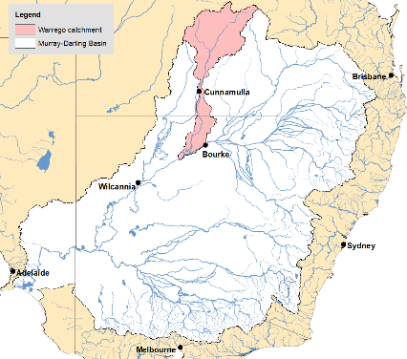
Figure E1: The Warrego catchment (Bureau of Meteorology)
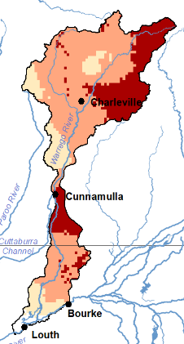  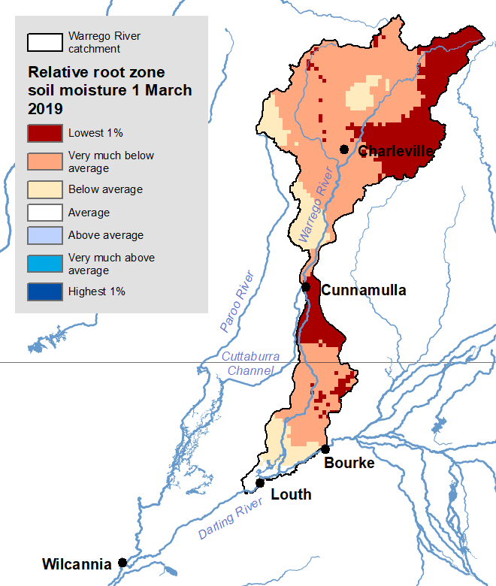 | 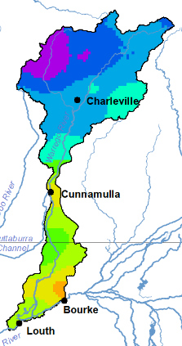  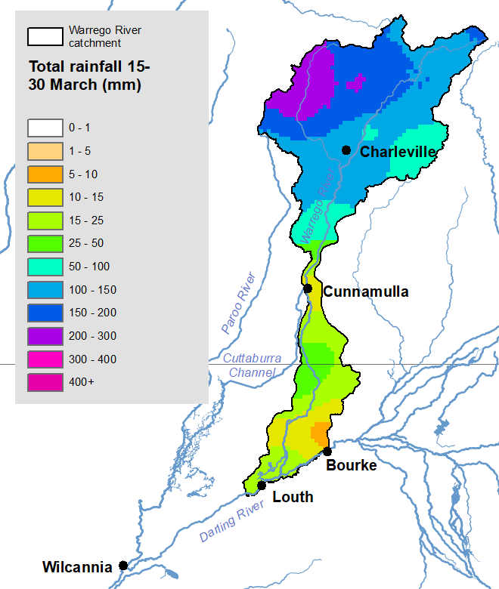
Figure E2. Relative root zone moisture in the Warrego catchment on 1 March 2019 (Bureau of Meteorology) | Figure E3. Total rainfall in the Warrego from ex cyclone Trevor (15-30 March 2019) (Bureau of Meteorology)
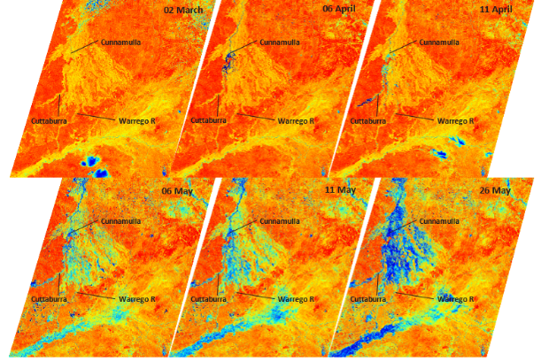
Figure E4: Sentinel imagery viewed using the moisture Index showing the progression of the flow event down the Warrego during March -May 2019. Imagery accessed from https://apps.sentinel-hub.com/sentinel-playground/
The arrival of the Warrego River flow at the next gauge downstream at Fords Bridge coincided with local rainfall, including 72 mm at Toorale, and some follow-up rainfall. This local rainfall added to the flow in the Warrego, and also resulted in a small brief flow in the Darling River that passed Louth but did not reach Tilpa. The volume of water that passed Fords Bridge was 33.1 GL, about 10% of the volume at Cunnamulla. This volume at Fords Bridge has an average recurrence interval of about two years. Then the flow reached Toorale National Park.
Flow through Toorale National Park
Before the flow entered the Toorale National Park, the Commonwealth Environmental Water Office and NSW National Parks agreed that the priority was to pass flows to the Darling River to protect native fish and replenish drought refuges, in accordance with the management strategy².
The regulating pipes on Boera and Booka Dams were opened to pass as much flow downstream as possible. The gates were left open for most of the flow event (40 days) to maximise throughflow to the Darling River. Even with the pipes fully opened, inflows to Boera Dam exceeded outflows for around 30 days in April-May, during which time some water flowed out onto the Western Floodplain (Figures E5). At the end of the flow event, the pipe openings were managed to maintain the water level of Boera Dam at around 2 metres to provide water for local stock and domestic needs and to provide an important drought refuge.

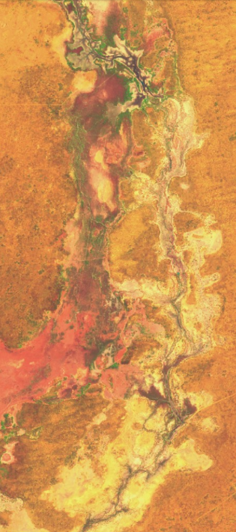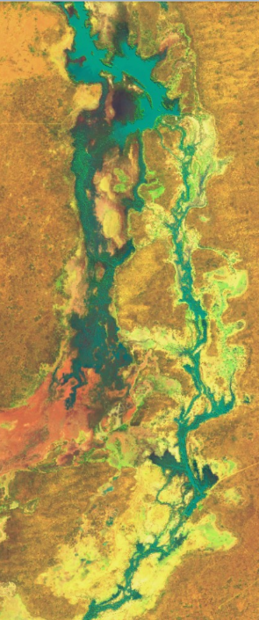
Figure E5 – Satellite image of the top of Western Floodplain, 19 April 2019, before flow (left) and 11 May 2019, with flows in the river and on the Western Floodplain (right)
Of the 33.1 GL that flowed past Fords Bridge during this flow event, around 25.4 GL flowed past Dicks Dam, the most downstream gauging station on the Warrego River. The river distance between the two flow gauges is around 75 km, and some loss would be expected between the gauges. However, the Warrego does not have a defined river channel through Toorale – even at flows of 600 ML/d flow is spread between the main channel and numerous secondary channels, and this spreading increases at greater flows. It is estimated that around 5 GL left the Warrego and remained on the floodplain and in the complex river channel network of the Warrego River between Fords Bridge and Dicks Dam. Around 700 hectares of the Western Floodplain shown in Figure E6 (which is a few percent of the total area of the Western Floodplain) was inundated. About three quarters of the volume of water that passed Fords Bridge was subsequently recorded at Dicks Dam.
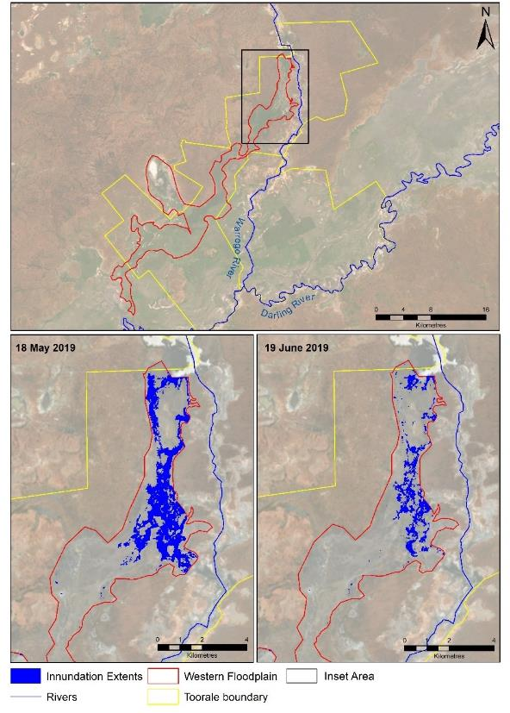
Figure E6: Inundation extent of the Western Floodplain measured on the 18 May and 19 June 2019.
Some water returned to the Warrego River and flowed back into the Darling through a breach in the embankment between the Western Floodplain and Warrego River (Figure E7) near Booka Dam. The flow through Toorale was also impeded initially by the passing capacity of pipes in Peebles Dam and water backed up and flowed into Ross Billabong on the eastern side of the Warrego. Most of this water subsequently drained back into Peebles Dam where it then passed to the Darling River. These floodplain flows would have reduced the peak of the flow in the Warrego River and into the Darling but likely extended the duration of the flow.
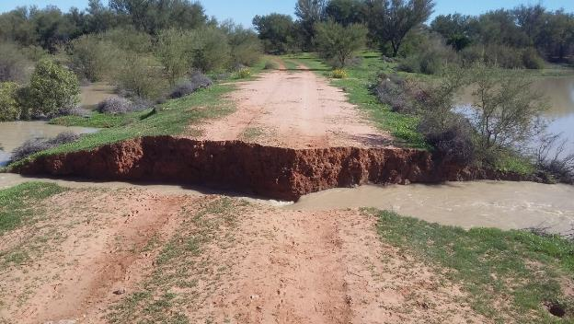
Western Floodplain
Warrego River
Figure E7: Breach in the eastern embankment between the Western Floodplain (right) and Warrego River (left)

If Boera Dam did not exist as a regulatory structure, some additional flow (around 5GL) would have made it to the Darling River. Some of the additional flow that would have passed Boera Dam would have remained in waterholes within the complex channel network of the lower Warrego River at Toorale, and there would have been some seepage from this flow into the river bed of the Darling.
Flow down the Darling River
With the addition of some upstream flows in the Darling from localised rainfall, the total event volume that flowed past Louth on the Darling River was 23.9 GL. The flow in the Darling River passed Wilcannia, and ended near the boundary of Tintinallogy Station, upstream of Lake Wetherell, around 590 river kms below Louth. Analysis of the loss rates of this flow during these very dry conditions were in the range of 2.04 – 5.45 GL/ 100 km, with losses greatest in the reach between Louth and Tilpa. These are consistent with the loss rates of other flows down the Barwon-Darling in recent times.
Under the proposed management conditions at Toorale, the increased flows from the Warrego River to the Darling would have increased the flow at Louth to 29 GL during this event. Under the loss scenarios investigated in this report, up to 3 GL is estimated to have made it to Lake Wetherell. This represents a maximum of 1.5% of the capacity of the lake. Given the dry bed of Lake Wetherell, it is likely that no water would have been available for use in the Darling River downstream of the Menindee Lakes.
From an environmental perspective, the flows into the Darling provided great benefit by wetting the system after an extended dry period following the Northern Connectivity Event and other flows in 2018. The flow filled up pools, connected reaches of river and improved water quality. Some connectivity along the river system was achieved. Whilst the size of the Warrego flow was not unusual, what was unusual was that the Warrego flow occurred when the Darling River had ceased to flow for an extended period. The Warrego River typically contributes relatively small volumes to the Darling during periods compared with other northern tributaries from the west of the Great Dividing Range, which are often flowing into the Barwon-Darling during periods when the Lower Warrego is connected to the Darling (Figure E8).
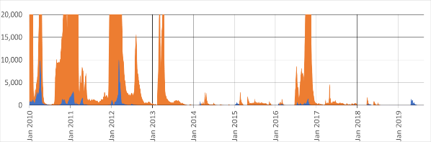
Flow (ML/d)
Flow following ex-cyclone Trevor
Figure E8: Darling River flows at Bourke (orange, truncated to 20,000 ML/d) compared to Warrego flows (blue). Source: DPIE Environment, Energy and Science

The Toorale Water Infrastructure Project
The Toorale Water Infrastructure Project is currently revising flow management infrastructure in the National Park. The current two pipe structure at the Boera Dam is proposed for replacement by a three gate structure that will pass at least 1,400 ML/d, and even more if the gates are fully opened, depending of water levels upstream and downstream. If the three gate structure had been constructed and were operated during the recent flow event, the result would have been very similar to if the dams did not exist. That is, the majority of the flow would have passed from the Warrego into the Darling, with a small volume making it to Lake Wetherell. Nevertheless, modifications to the Toorale infrastructure will provide greater flexibility to share water between the Warrego and Darling rivers, depending on relative environmental need. The current management strategy for the structures at Toorale will be revised to take account of new knowledge, such as in the Barwon-Darling Long Term Watering Plan, currently being prepared by NSW. Further information on the Toorale Water Infrastructure Project is publicly available.

Contents
Executive Summary ii
1. Introduction 1
2. Scope of Works 6
3. April flow event down the Warrego River to the Darling River 6
3.1 Localised rainfall around Toorale 11
4. Current flow management structure at Boera Dam 11
5. Boera Dam operation during the April-June flow event 12
6. How far downstream would the water have reached with the larger capacity gates at Boera? 14
7. Summary 16
8. References 17
Appendix 1. 19

Figures
Figure 1: 24 month relative rainfall for the two years from March 2017 to February (Source BOM 2019) 2
Figure 2: Total rainfall in the Warrego Catchment during March, April and May 2019. 3
Figure 3. Toorale National Park showing key components of water infrastructure 4
Figure 4: Regulating gates on Boera Dam 5
Figure 5: Breach in the eastern embankment between the Western Floodplain (right) and Warrego River (left) 5
Figure 6: Flow data from gauging stations upstream, at, and downstream of Toorale, and calculated daily flow into Boera Dam. Estimated flow into Boera dam is calculated from for Fords Bridge combined assuming a loss of 4.8 GL/100km. 8
Figure 7: Upper Warrego and Paroo River catchments. Green polygons represent the Toorale National Park and State Conservation area 7
Figure 8: Flows down the Warrego River and Cuttaburra channel during the March-May 2019. 9
Figure 9: Sentinel imagery viewed using the moisture Index showing the progression of the flow event down the Warrego during March -May 2019. Imagery accessed from https://apps.sentinel-hub.com/sentinel-playground/ 10
Figure 10: The distribution of Warrego River flows to Barwon-Darling inflows 11
Figure 11: Inundation extent of the Western Floodplain measured on the 18 May and 19 June 2019. 13
Figure 12. Darling River downstream of Toorale showing key locations and their river distance downstream from Louth. 15

Tables
Table 1. Distances measured downstream from Louth, and the total volume of water remaining from the rainfall event near Cunnamulla. 14
Table 2: Water loss recorded along various reaches downstream from Louth during the April-June 2019 flow event 14
Table 3: Estimated volumes at locations on the Darling River under the 3 gate solution at Toorale. Scenario A represents losses based on flow terminating at Tintinallogy property boundary. Scenario B represents losses recorded at Wilcannia. See text for descriptions 16

Introduction
Rainfall in the northern Murray-Darling Basin has been well below average since 2016, and in parts of the Warrego and Paroo catchments rainfall totals for the two years prior to March 2019 were amongst the lowest 1% on record (Figure 1; BOM 2019). The prolonged period of extremely low rainfall led to very low stream flow and water storage that have reduced rivers to isolated pools, and creeks to dry channels.
Between 26 and 30 March 2019, more than 200 mm of rain fell on the upper Warrego catchment near Cunnamulla, and this was complemented by a further 100 mm a month later, on 22-27 April (Figure 2). These rainfall events were influenced by ex-tropical cyclone Trevor and filled the main channels of the Warrego and Paroo Rivers, saturated the floodplains, and filled adjacent wetlands. Despite the flooding, most of this water was lost through evaporation, soil infiltration, or to the floodplain, and only a small amount of water flowed down into the Darling River in May and June (BOM 2019). As occurs in most years, flow in the Paroo broke out of the main channel and remained the floodplain around Currawinya National Park (BOM 2019).
At the downstream end of the Warrego catchment, the Warrego River flows through Toorale National Park and State Conservation Area (‘Toorale’). Over the last 150 years, the hydrology of the Warrego River within Toorale has been highly modified. Six dams have been constructed to provide stock and domestic water supply, irrigate the Western Floodplain to improve pasture growth, and more recently to provide water storage for irrigated agriculture (Figure 3). Since the establishment of Toorale NP and SCA in 2008, the dams on the Warrego River have been operated to their licence conditions either to allow water to flow downstream to the Darling River, or to promote water flowing onto the Western Floodplain. These decisions have been based around the Commonwealth Environmental Water Office’s (CEWO) long-term watering strategy for Toorale.
Toorale’s high biodiversity values contribute significantly to the National Reserve System as it protects some of the most poorly reserved bioregions in NSW: The Darling Riverine Plans and Mulga Lands (NSW OEH 2018) and monitoring from the Long Term Intervention monitoring (LTIM) project suggests that both the Western Floodplain and River channel are important for maintaining regional biodiversity (Commonwealth of Australia 2018). In managing flows through Toorale, these values need to be considered against downstream needs within the Darling River. To allow more flexibility to manage these needs, the State and Federal Government have been working to modify several of the dam structures through the Toorale Water Infrastructure Project. Amongst the proposed changes are an increase in the ability to pass water through Boera Dam, at the upstream end of the Warrego River at Toorale (Figure 4). Currently under the two-pipe solution, up to around 600 ML/d is able to be passed downstream. This would increase to over 1,400 ML/d under the new three gate proposal.
When inflows exceed outflows through Boera Dam or the regulating gates are shut, water is diverted either onto the Western Floodplain, or around the dam wall via the Eastern Bywash and back into the Warrego River. Generally, water on the Western Floodplain is kept from re-entering the Warrego River by an embankment. However, during the April-June flow event in 2019, this embankment was breached (seemingly, shortly before 15 April), allowing water from the floodplain to re-enter the Warrego River upstream of Booka Dam (Figure 5). Without this breech, much more water would have remained on the Western Floodplain during the event.
Through Toorale, the Warrego River resembles a complex network of channels, rather than a single dominant channel. While water is conveyed through one or two primary channels, most of the time, even at relatively low discharges, water is spread across a number of channels in the channel network (Appendix 1). Analysis undertaken for the LTIM project suggests that during a flow of around 600 ML/d, 60% of the total flow is carried in smaller secondary channels (Commonwealth of Australia 2017). This is a response to the fine sediments that make up these channels, and the flatness of the landscape.
Peebles Dam occurs on the Warrego River near the downstream end of Toorale. Although the pipes through this dam are now permanently open, if inflows are great enough and the dam fills, water backs up and overflows into Ross Billabong, becoming stored on the floodplain. However, in the April-June flow event this loss was only temporary, and water returned to Peebles Dam and continued down the Warrego into Dicks Dam.
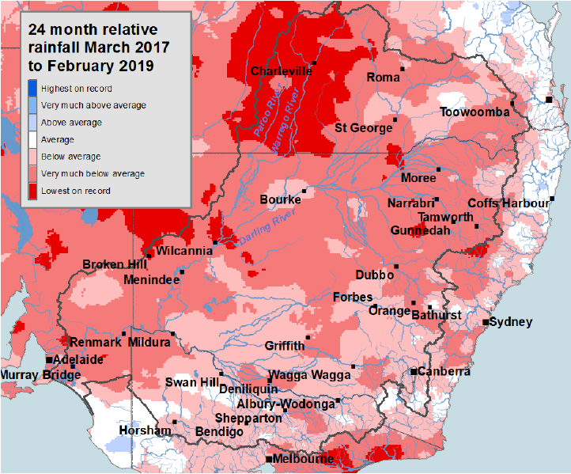
Figure 1: 24 month relative rainfall for the two years from March 2017 to February (Source BOM 2019)

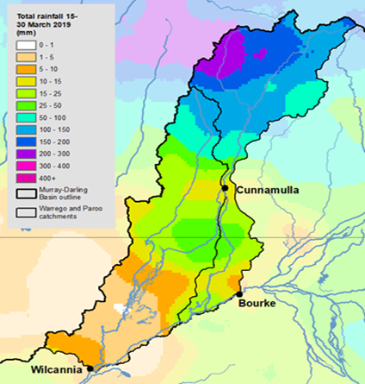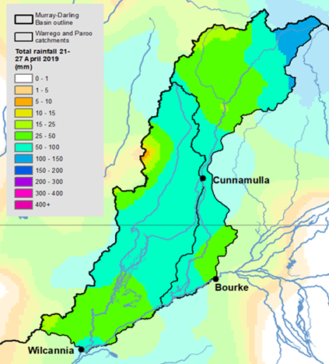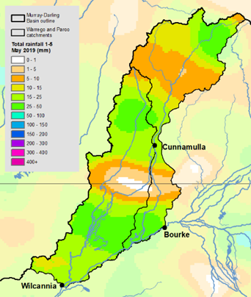
Figure 2: Total rainfall in the Warrego Catchment during March, April and May 2019.

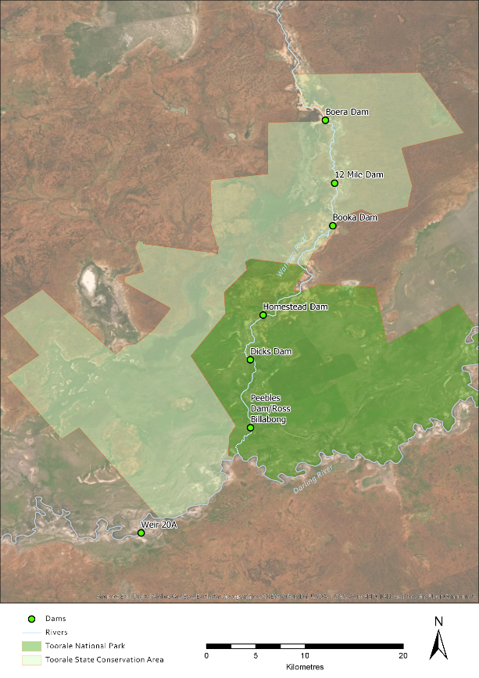
Figure 3. Toorale National Park showing key components of water infrastructure
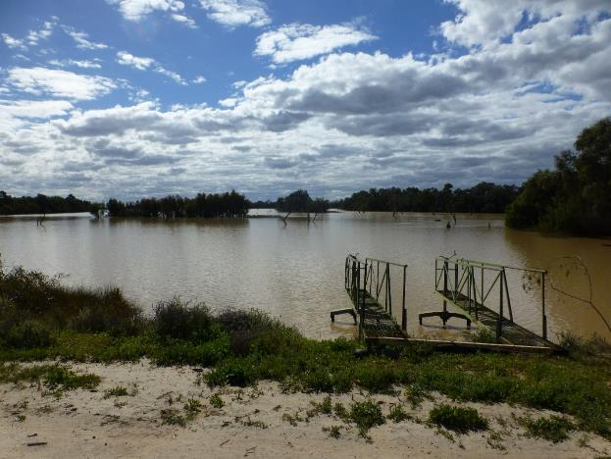
Figure 4: Regulating gates on Boera Dam
Figure 5: Breach in the eastern embankment between the Western Floodplain (right) and Warrego River (left)

Scope of Works
The limited capacity of Boera Dam to pass water under the current two pipe arrangement, restricts the ability to control water deliver to downstream users and the environment. During dry periods, when water delivery becomes a priority, the environmental water managers wish to have more control over the volume of water they can either send downstream to achieve environmental benefits in the Darling River or divert over the Western Floodplain. Increasing the gate capacity of Boera Dam as per the three-gate proposal is one way to achieve this.
Using the April-May 2019 flow event as an example, the CEWO wishes to compare how far downstream in the Darling, the water would have travelled if the Boera Dam regulating structures had an increased capacity under the three-gate solution instead of the current two pipe arrangement. Specifically, the CEWO are interested in whether the water would have reached Lake Wetherell, the upper-most of the Menindee Lakes. This flow event is also broadly considered by several other reports produced by the Bureau of Meteorology (BOM 2019), and the Murray Darling Basin Authority (MDBA 2019a).

April flow event down the Warrego River to the Darling River
Data used in this report was downloaded from the WaterNSW real-time water data website (https://realtimedata.waternsw.com.au/) on the 22 August 2019. Approximately 318 GL flowed over the Cunnamulla Weir between 3 April and 31 May 2019, and into the Warrego River. Around 96 GL of this water passed through the Cuttaburra Creek system to the west, with the remainder continuing downstream in the Warrego River (Figure 6). However, from 7 April to 31 May, only 53 GL had reached Barringun, and 33 GL reached Fords Bridge and continued into Boera Dam. Flow at Dicks Dam commenced on 23 April after local rain on 22-24 April (72 mm at Toorale), combined with releases from Boera Dam. Sporadic local rain continued until 4 May, and flow persisted until 14 June, with 25.4 GL passing through Dicks Dam and into the Darling River. The Louth gauge on the Darling River recorded 23.3 GL between 10 April and 30 June, of which the majority was water entering from the Warrego system. A flow spike at this gauge around the 4 May (Figure 7) suggests an input of water from upstream in the Darling, but is likely to be less than 900 ML, given that 916 ML was recorded at Weir 19A upstream.
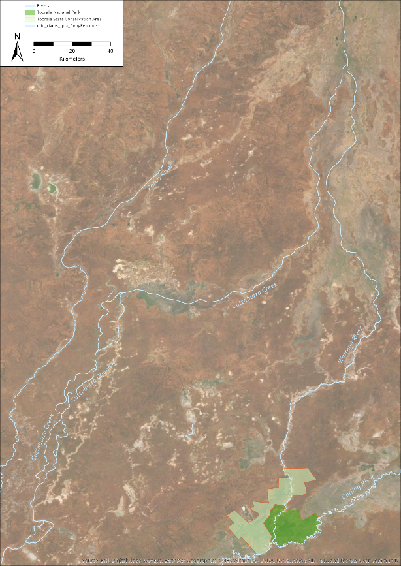
Fords Bridge
Barringun
Cunnamulla
Figure 6: Upper Warrego and Paroo River catchments. Green polygons represent the Toorale National Park and State Conservation area

Figure 7: Flow data from gauging stations upstream, at, and downstream of Toorale, and calculated daily flow into Boera Dam. Estimated flow into Boera Dam is calculated from for Fords Bridge combined assuming a loss of 4.8 GL/100km.

A large amount of the water that flowed through the Warrego Catchment was lost to soil infiltration and vegetation uptake as indicated by Sentinel 2 satellite analysis of moisture indices. At the start of the event on 6 April just after a large flow pulse had moved through Cunnamulla (Figure 8) water is clearly visible in the drainage channels past the Cunnamulla Weir, the majority of which flowed into the Cuttaburra channel by 11 April onwards (Figure 9). Flows through the Cuttaburra channel, were much higher than through the lower catchment of the Warrego (Figure 8). Flows reaching the lower Warrego catchment spread throughout the distributary channels with only a smaller proportion of the flow reaching the Darling River through the lower Warrego system. While relatively large volumes of water remained in the Warrego Channel network between Cunnamulla and Fords Bridge, it is likely that the large extent of moisture noted in the sentinel images during May shown in Figure 9 was also influenced by regional rainfall (Figure 2).
In a broader context, the 2019 Warrego River flow event was unusual in that it constituted between a quarter to a third of the flow in the Darling River below the confluence for the year. In most years, Warrego inflows make up less than 10% of Darling flows (Figure 10), with Warrego flows making up less than 2% of Darling River inflows every second year. Thus, it is only on rare occasions when the Warrego inflows make a substantial proportional contribution to Darling River flows downstream of the confluence.

Figure 8: Flows down the Warrego River and Cuttaburra channel during the March-May 2019.

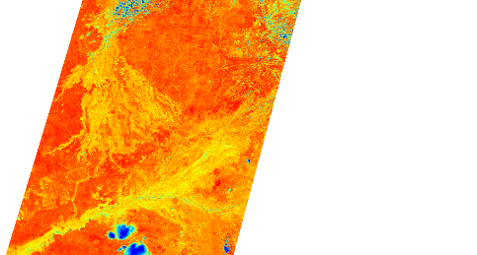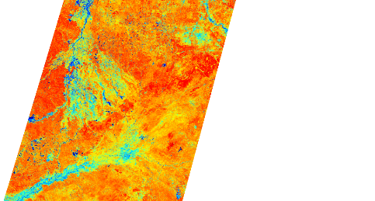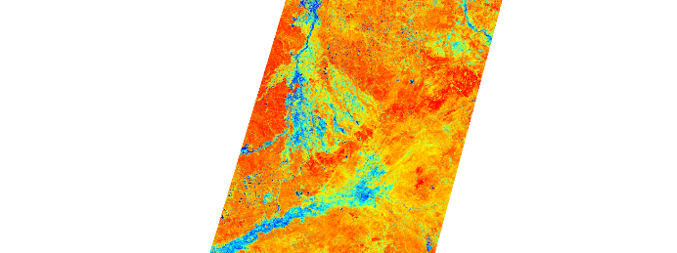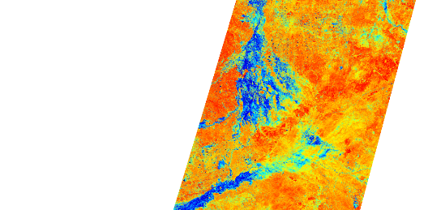
Cunnamulla
Warrego R
Cuttaburra
Cunnamulla
Warrego R
Cuttaburra
Cunnamulla
Warrego R
Cuttaburra
Cunnamulla
Warrego R
Cuttaburra
Cunnamulla
Warrego R
Cuttaburra
Cunnamulla
Warrego R
Cuttaburra
02 March
06 April
11 April
06 May
11 May
26 May
Figure 9: Sentinel imagery viewed using the moisture Index showing the progression of the flow event down the Warrego during March -May 2019. Imagery accessed from https://apps.sentinel-hub.com/sentinel-playground/

Figure 10: The distribution of Warrego River flows to Barwon-Darling inflows. Source: MDBA

Localised rainfall around Toorale
Flows at Toorale were supplemented by sporadic local rainfall near Bourke in April and May. At Gundabooka, 25.2 mm fell from 23-25 April, and a further 10.2 mm fell from 3-5 May 2019. There was 72 mm at Toorale between 22 and 24 April, while 85 mm fell at Gundabooka on 22-23 April, and another 17 mm fell on 2-3 May. Bourke received 36 mm in late April, and another 31.4 mm on 3-4 May. Local reports suggest that 80-100 mm of rain fell in the Darling catchment upstream of Toorale but downstream of Bourke which contributed to flows in the Darling River.

Current flow management structure at Boera Dam
Boera Dam is the main structure regulating the flow of water through Toorale National Park and downstream into the Darling River. Boera Dam receives water from the Warrego River, and has a capacity to store approximately 1.5 GL. The dam is currently fitted with 2 x 1200 mm grated pipes which, when completely open, allow around 600 ML/d to flow through to the Warrego River. When the dam is full and the gates are closed, water entering Boera Dam is either pushed out through the Western Bywash and onto the Western Floodplain, or through the Eastern Bywash and back around into the Warrego River. Opening the gates gives some control over how much water is let down into the Warrego River, and how much is diverted to the Western Floodplain. However, this ability to direct water is limited when flows entering Boera exceed the outlet pipe capacity.

Boera Dam operation during the April-June flow event
Currently, the gates at Boera have a limited capacity to allow large flows through to the Warrego River. Even with the gates open, once Boera Dam is full (capacity 1.5 GL), any flows greater than around 600 ML/d, raise the level of the dam and flow onto the Western Floodplain or through the Eastern Bywash and into the Warrego River below the dam. During the April-June flow event, the gates at Boera Dam were open for the equivalent of 40 days, or 77% of the flow duration. The gates were fully opened as water moved into Boera Dam on the 22 April 2019 and remained open until Boera Dam fell back below the Western Floodplain connection level. One gate was then closed on the 28th May, before both gates were closed on the 1 June 2019. One gate was then partially opened over the period 6 – 14th June 2019 to allow water to flow down the lower Warrego River and maintain Boera Dam at around 2m on the gauge.
Approximately 33.1 GL flowed from the Warrego River past Fords Bridge. Assuming that losses in the 50 km of Warrego River between Fords Bridge and Boera Dam are similar to those that occurred downstream (approx. 4.8 GL/100 km between Louth and Wilcannia), an estimated 30.7 GL reached Boera Dam (Figure 6).
Of the 30.7 GL that flowed into Boera Dam, 25.4 GL flowed past Dicks Dam, the most downstream gauging station on the Warrego System at Toorale (Figure 3). The difference between the total volume entering Boera Dam, and the volume measured at Dicks Dam was 5.2 GL. This is the volume that is assumed to have remained within Toorale either on the Western Floodplain within pools in the complex channel network between Boera and Dicks Dam (Appendix 1). During this event a maximum of 705 ha of the Western Floodplain was inundated and was restricted to the top third of the floodplain (Figure 11).
Assuming the volume stored in Boera below the 2.26 m level required to overflow onto the Western Floodplain is 760 ML based of modelled volume/height relationships (ELA 2017), approximately 4.5 GL flowed to the Western Floodplain or was otherwise retained on Toorale. A further 25.4 GL continued downstream through Dicks Dam and into the Darling River, so that by Louth, 23.9 GL remained.
Figure 11: Inundation extent of the Western Floodplain measured on the 18 May and 19 June 2019.

How far downstream would the water have reached with the larger capacity gates at Boera?
Of the rain that fell in the upper Warrego in March 2019, 23.9 GL eventually made it into the Darling River at Louth, 14.8 GL passed Tilpa, and 3.1 GL reached Wilcannia. The water continued downstream as far as the upstream boundary of the property Tintinallogy (MDBA 2019b), between Wilcannia and Lake Wetherell.
There are various datasets and estimates for the river distances along the Darling. All calculations used here utilise the most up to date spatial dataset, being the NSW Spatial Services Hydro Line Dataset (NSW Spatial Services, 2017) with distances being measured in Arc Pro based upon this data. The river distance between Louth and Wilcannia is 438 km, between Louth and the Tintinallogy station boundary is 590 km, and the total distance between Louth and Lake Wetherell is 688 km (Table 1, Figure 12).
Loss rates were calculated for each reach based on the amount of water recorded at the downstream end of the reach, and also where the flow terminated at Tintinallogy boundary (Table 2). These suggest that loss rates were higher in the Louth to Tilpa reach (5.45 GL/100 km) and reduced downstream to 2.04 GL/100 km in the Wilcannia to Tintinallogy boundary reach (Table 2). Average losses for the reach were calculated at 4.75 GL/100 km based on flows recorded at Wilcannia, and 4.05 GL/100 km based on the total length of flow from Louth to the Tintinallogy property boundary. These loss rates are consistent with observations from other flow events down the Barwon-Darling River in recent times.
Table 1. Distances measured downstream from Louth, and the total volume of water remaining from the rainfall event near Cunnamulla.
Location | Distance from Louth (km) (NSW Spatial Services) | Total volume measured at gauge (GL)
Louth | 0 | 23.9
Tilpa | 167 | 15
Wilcannia | 438 | 3.1
Tintinallogy Station boundary | 590 | 0
Tintinallogy Station | 598 | 0
Lake Wetherell | 688 | 0

Table 2: Water loss recorded along various reaches downstream from Louth during the April-June 2019 flow event
Reach | Reach length (km) | Volume lost | loss per 100 km
Louth - Tilpa | 167 | 9.1 | 5.45
Tilpa - Wilcannia | 271 | 11.9 | 4.39
Wilcannia - Tintinallogy Boundary | 152 | 3.1 | 2.04
Louth - Wilcannia | 438 | 20.8 | 4.75
Louth - Tintinallogy boundary | 590 | 23.9 | 4.05

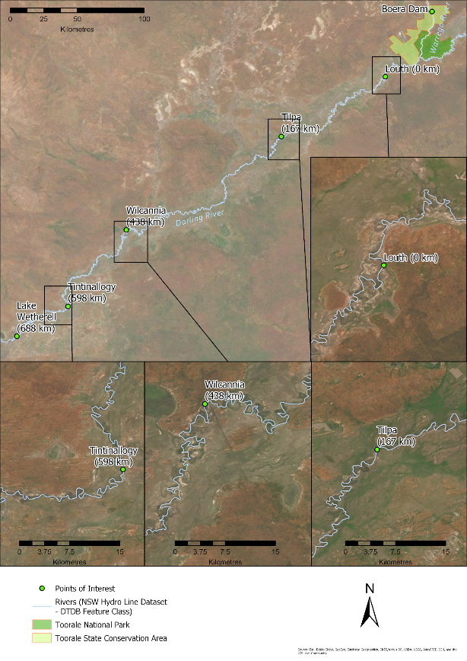
Figure 12: Darling River downstream of Toorale showing key locations and their river distance downstream from Louth.
Towards the end of the flow event, the gates at Boera Dam were closed to preserve water level in the dam for stock and domestic use. Under the three-gate proposal and assuming the gates were open for the same proportion of time during the flow event, none of the water would have been diverted to the Western Floodplain within Toorale, given that inflows to Boera Dam remained below the maximum capacity of the proposed three-gate solution. This means that approximately 30.7 GL would have passed through Boera Dam.
During the April-June flow event down the Darling, water reached as far downstream as Tintinallogy under the current two gate solution. Under the three gate solution and assuming all the water leaving Boera Dam (i.e. 30.7 GL) flowed into Dicks Dam, then around 29 GL would have reached Louth. This is 5 GL more than actually reached Louth during the April-June flow event. Estimates of the increased volumes at each location below Louth with this increased inflow are presented in Table 3. Two scenarios were tested - Scenario A used the differential losses presented in Table 2, and included the loss calculated for the Wilcannia to Tintinallogy boundary reach which was used to calculate the additional flow between Wilcannia and Lake Wetherell. This scenario is based on the observation that the flow event made it to the Tintinallogy boundary reported in MDBA (2019b). Scenario B used the differential losses presented in Table 2 but used the loss rate calculated for the Tilpa to Wilcannia reach for all reaches below Tilpa. This scenario is based on the flow data reported by Water NSW. Under scenario A, with the reduced losses below Wilcannia, 3 GL is calculated to have made it to Lake Wetherell. This volume represents around 1.4% of the storage capacity of the lake and losses from water seeping into the dry lake bed would be high. Under scenario B, around 1 GL would have made it to the Tintinallogy boundary, and this would have terminated around 50 km downstream. No water would have reached Lake Wetherell under this scenario.
Table 3: Estimated volumes at locations on the Darling River under the three gate solution at Toorale. Scenario A represents losses based on flow terminating at Tintinallogy property boundary. Scenario B represents losses recorded at Wilcannia. See text for descriptions
Location | Volume (GL)
 | Scenario A | Scenario B
Tilpa | 20 | 20
Wilcannia | 8 | 8
Tintinallogy Boundary | 5 | 1
Lake Wetherell | 3 | 0

Summary
The flow event that occurred down the Warrego and Darling Rivers in March to June 2019, originated from ex cyclonic rainfall in the upper Warrego catchment, and broke an extended period of no flow in both rivers. Below Cunnamulla on the Warrego River the majority of flow moved down the Cuttaburra Creek system and out onto the Warrego Floodplain, with only around 15% (52 GL) of the flow making it to Barringun, the next downstream gauge on the Warrego River. Of this, 33.1 GL passed Fords Bridge upstream of Toorale National Park and State Conservation Area. The current infrastructure on Boera Dam within Toorale was opened to capacity and the majority of the flow event (25.4 GL) moved through the dam and into the Darling River. The other 7.7 GL remained on the Western Floodplain or in the channel network between Fords Bridge and Dicks Dam, upstream of the Warrego-Darling River confluence. The water from the Warrego River increased flows in the Darling River downstream of the confluence, and water flowed around 600 km downstream, ending at Tintinallogy Station below Wilcannia.
The Toorale Water Infrastructure Project is currently revising flow management infrastructure in the National Park. The current two pipe structure at the Boera Dam is proposed for replacement by a three gate structure that will pass at least 1,400 ML/d, and even more if the gates are fully opened, depending of water levels upstream and downstream. Estimates of the change in flow volumes and travel distance under the proposed three gate solution at Boera Dam suggest that an additional 5 GL of water would have flowed from the Warrego River to the Darling River under the proposed management conditions during the 2019 flow event, and little to no water would have flowed onto the Western Floodplain. Depending on which loss rates are used, up to 3 GL is estimated to have made it to Lake Wetherell. This represents a maximum of 1.5% of the capacity of the lake. Given the dry bed of Lake Wetherell, it is likely that no water would have been available for use in the Darling River downstream of the Menindee Lakes.

References
Bureau of Meteorology (BOM) 2019. Flows in the Warrego and Paroo. Water Focus Report – Autumn 2019. Accessed at http://www.bom.gov.au/water/focus/documents/Flows-in-the-Warrego-and-Paroo-Autumn-2019.pdf
Commonwealth of Australia. 2017. Commonwealth Water Office Long Term Intervention Monitoring Project Junction of the Warrego and Darling rivers Selected Area: 2016-17 Evaluation Report, Canberra.
Commonwealth of Australia. 2018. Commonwealth Environmental Water Office Long Term Intervention Monitoring Project Junction of the Warrego and Darling rivers Selected Area: 2017-18 Evaluation Report, Canberra.
Commonwealth Environmental Water Office 2018. Portfolio Management Plan for the Northern Intersecting Streams. Attachment C.
ELA 2017. Toorale Western Floodplain inundation modelling report, Report prepared for the Commonwealth Environmental Water Office.
Murray-Darling Basin Authority (MDBA) 2019a. Monitoring ‘first flush’ flows in the Namoi, Macquarie and Warrego Rivers. Accessed at https://www.mdba.gov.au/sites/default/files/pubs/monitoring-flows-namoi-macquarie-warrego-18-oct-2019.pdf
Murray-Darling Basin Authority (MDBA) 2019b. ‘River Murray Weekly Report’ for the week ending Wednesday 24 July 2019. Accessed at https://www.mdba.gov.au/sites/default/files/weeklyreports/River-Murray-Operations-Weekly-Report-24-July-2019.pdf
NSW OEH 2018. Toorale National Park and State Conservation Area Draft Plan of Management. Sydney.
WaterNSW 2019. 18 April 2019 Warrego inflows reach NSW, no respite for Darling. accessed at https://www.waternsw.com.au/about/newsroom/2019/warrego-inflows-reach-nsw,-no-respite-for-darling.

Appendix 1.
Hydrology (channel) appendix from the 2016-17 Annual LTIM report (Commonwealth of Australia 2017; provided in .pdf)



This flow event is also described in reports published by the Bureau of Meteorology - Bureau of Meteorology 2019. Flows in the Warrego and Paroo. Water Focus Report – Autumn 2019 and the report published by the Murray Darling Basin Authority – Monitoring ‘first flush’ flows in the Namoi, Macquarie and Warrego Rivers
CEWO website
Bureau of Meteorology, ‘Flows in the Warrego and Paroo’, Water Focus Report - Autumn 2019
Volumes provided through the report were calculated using flows on the day the data were downloaded.
WaterNSW 18 April 2019 Warrego inflows reach NSW, no respite for Darling
Bureau of Meteorology, ‘Flows in the Warrego and Paroo’, Water Focus Report - Autumn 2019
https://www.environment.nsw.gov.au/topics/water/water-for-the-environment/planning-and-reporting/toorale-water-infrastructure-project

