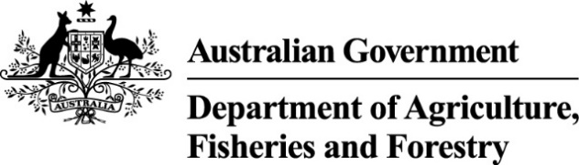

Exports work instruction

Requesting Authorised Officer assessment using the Plant Exports Management System
Direction to authorised officers
This is official instructional material of the Department of Agriculture, Fisheries and Forestry (the department). Failure to comply with it may result in a breach of relevant legislation and/or the code of conduct under section 13(5) of the Public Service Act 1999.

Purpose of this document
This document details the procedure to request Authorised Officer (AO) assessment using the Plant Exports Management System (PEMS).
__________________________________________________________________________________
In this document
This document contains the following topics:
Purpose of this document 1
Policy statement 2
Roles and responsibilities 2
How do I request AO assessment? 2
Section 1: Request assessment 3
Section 2: Pay for Assessment 12
Contact information 19
Related material 19
Document information 19
Version history 20

Policy statement
The policy, definitions and legislation related to this work instruction can be found in the Department policy: Management of third party plant exports authorised officers.

Roles and responsibilities
The following table outlines the roles and responsibilities undertaken when requesting AO assessment.
Role | Responsibility
Applicant | Requesting assessment through PEMS.

How do I request AO assessment?
Persons wanting to be assessed in their chosen AO job function/s must lodge their request online through PEMS.
Important: Only complete the assessment request if you are ready to be assessed.

Section 1: Request assessment
The following table outlines how to request assessment.
Step | Action | Graphic
1. | Go to https://online.agriculture.gov.au/selfservice  Note: The log in page will display. | 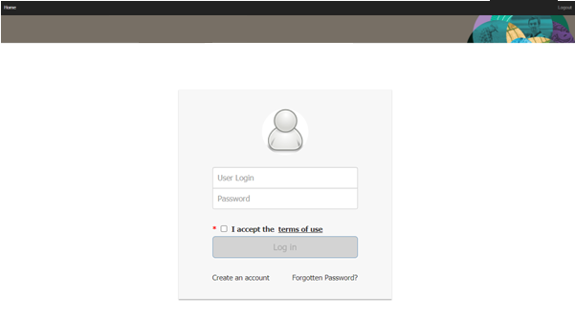
2. | - Enter your Username and Password.  Note: This information will have been circulated to you via email following registration.  - Check the I accept the terms of use box.  - Select Log in. | 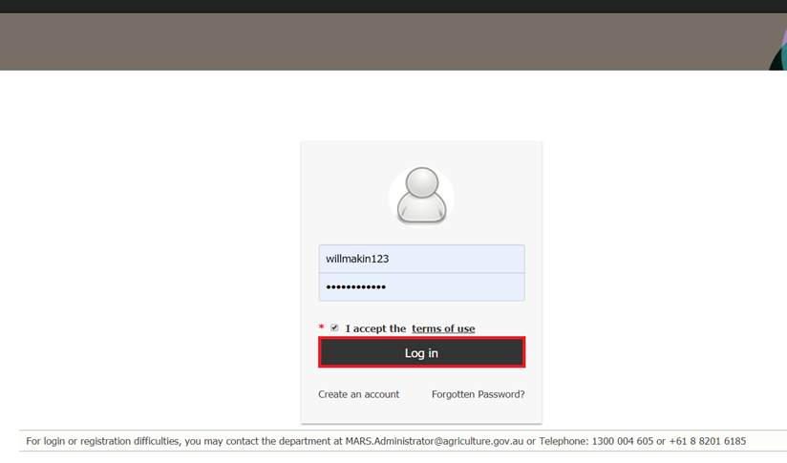
3. | Select the PEMS button to enter the PEMS home page.  Note: You will not be able to complete this step until your access has been approved by the department. | 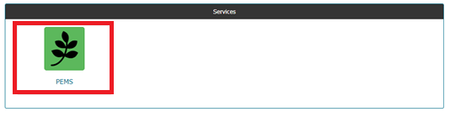
4. | Select Open under the Actions column. | 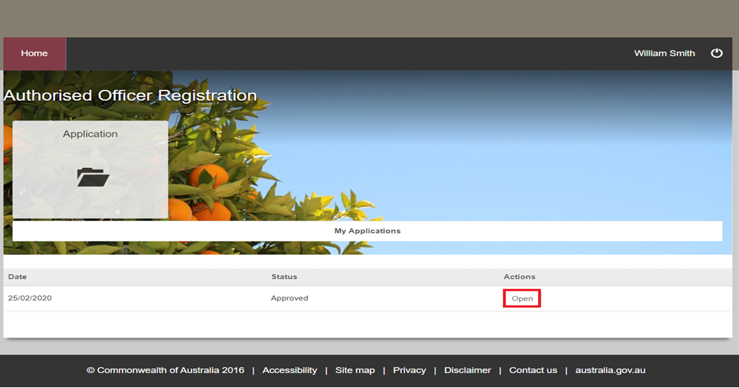
5. | Select the Training & Assessment tab. | 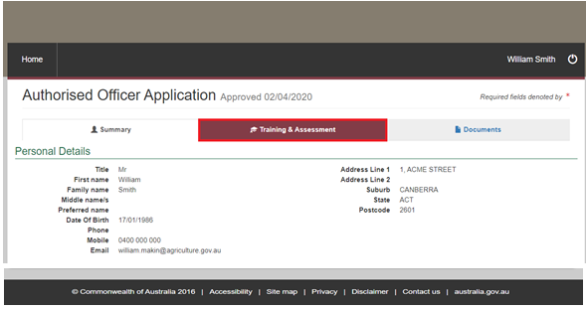
6. | Select Request next to the heading Assessment. | 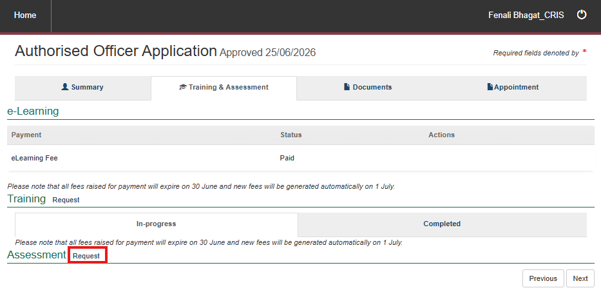
7. | Do you have an Establishment Number?  Important: If you are selecting Grain Storage Assets and Management Standard (GSAMS) job function/s, you must enter an Establishment Number. | 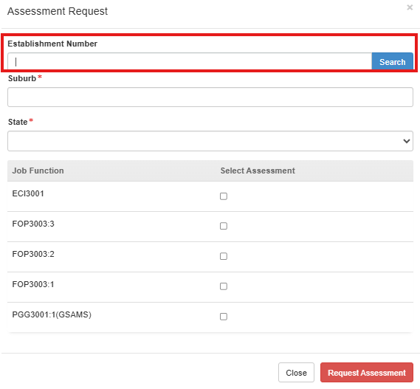
  If… | Then…
  yes | - enter the number  - select Search  - note the information that pre-populates  - continue to Step 8.
  no | go to Step 10.
8. | Enter your suburb and state. | 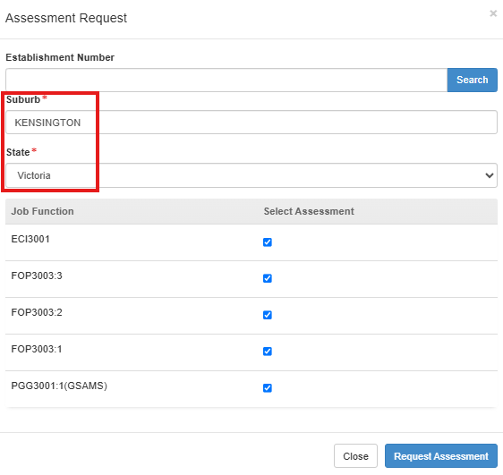
9. | Check the boxes for the assessment you want to request. | 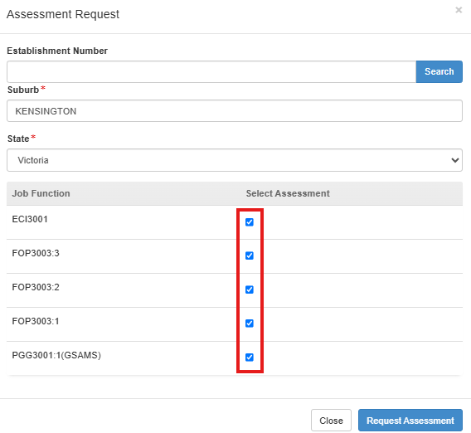
10. | - Select Request Assessment.  - Continue to Section 2: Pay for assessment.  Important: Your assessment request will not be submitted until you pay for assessment.

Section 2: Pay for Assessment
The following table outlines how to pay for assessment.
Step | Action | Graphic
1. | Note the details of your assessment request/s and the status of Awaiting Payment.  Note: Your assessment will not be scheduled until payment has been made.
2. | Select Pay Now under the Actions column. | 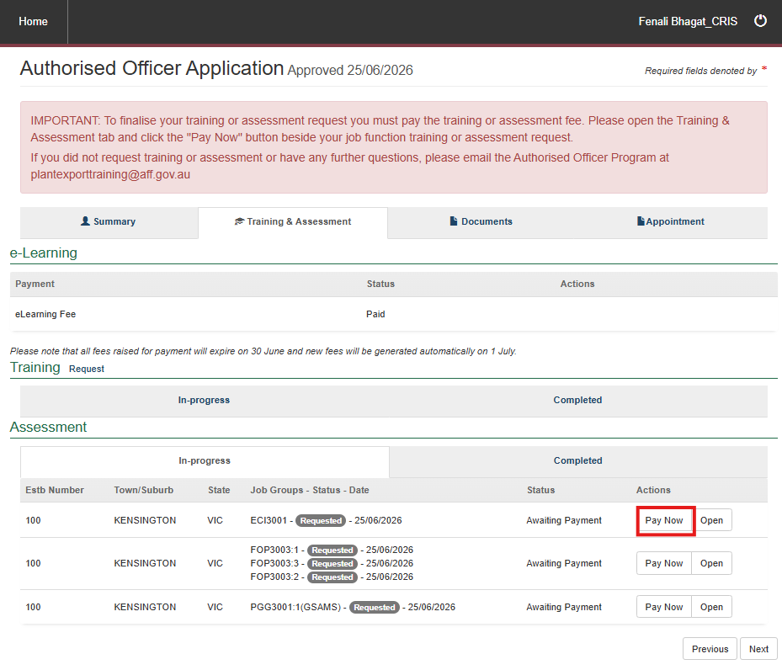
3. | - Review the details of the Service Summary.  - Select Next. | 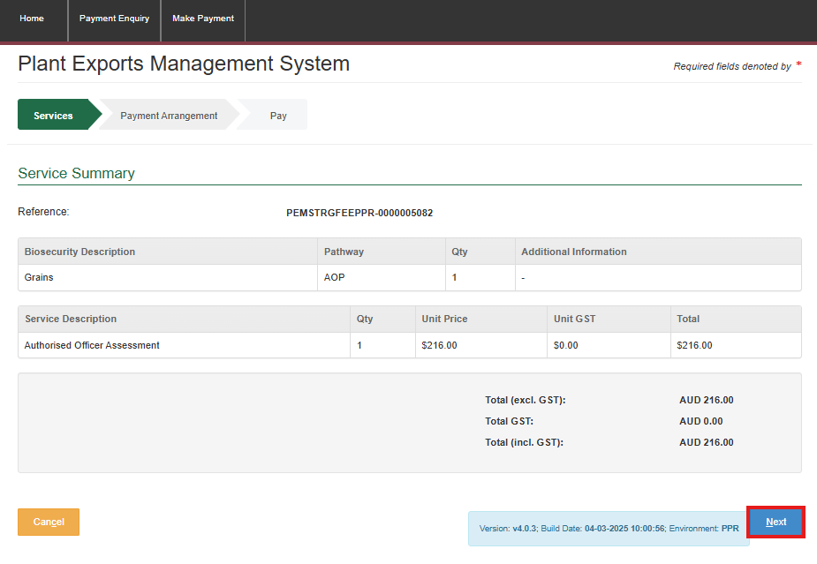
4. | - Select No to the question Do you have an Account Number?  - Select Continue to Payment.  Note: Selecting Yes will delay processing as the payment may not correctly link to your account. | 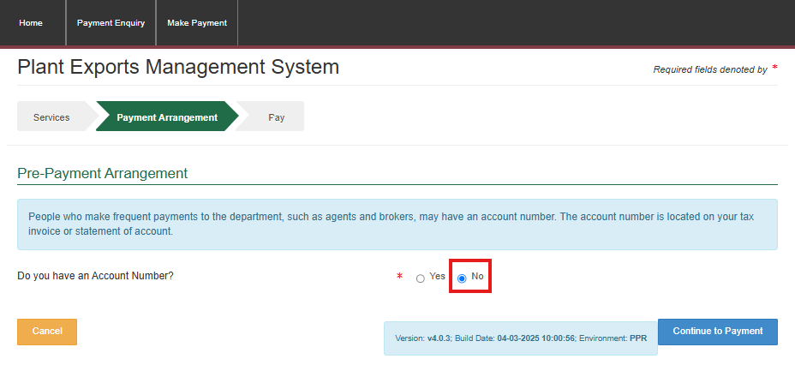
5. | - Enter your payment details.  - Select Pay Now. | 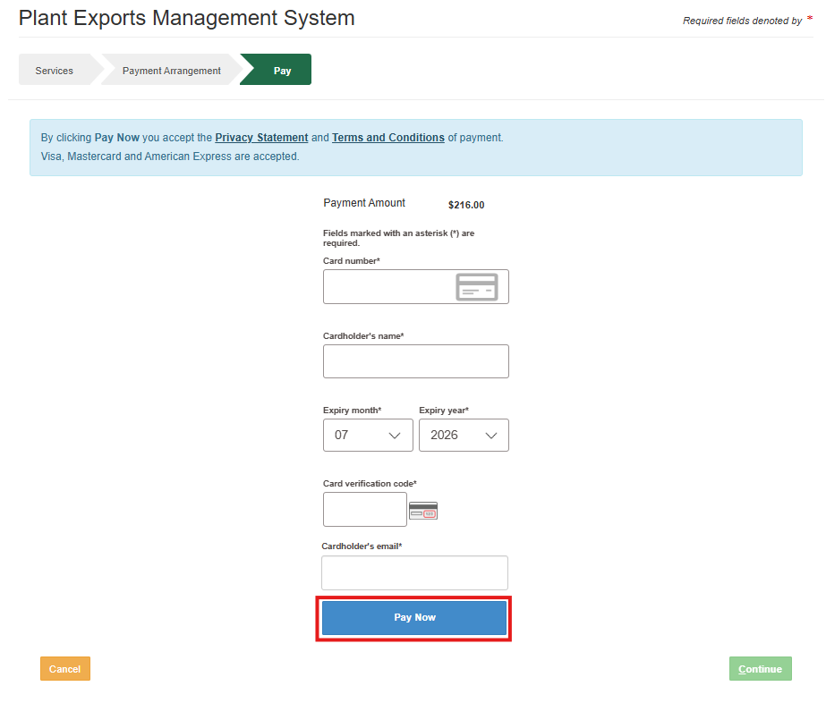
6. | - Note the Payment Confirmation screen.  - Select Continue. | 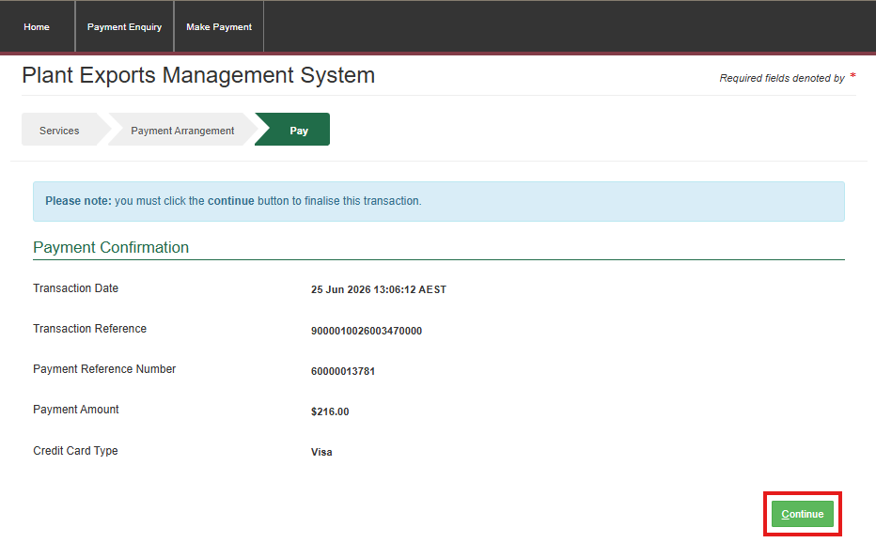
7. | - Note the changed status of your assesment to Payment Confirmed in the Status column.  - End of procedure.  Notes:  - You will receive an email receipt from the department.  - A departmental Plant Export Assessor will contact you to arrange a suitable date and time for your assesment to be delivered. | 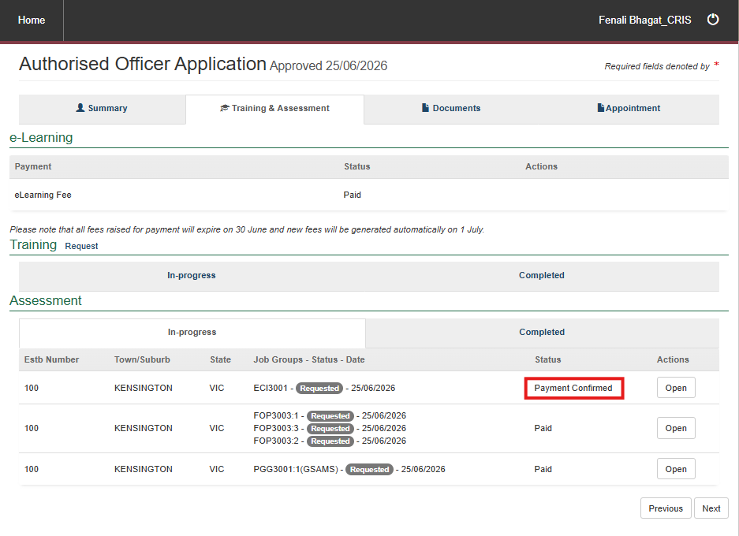

Contact information
- Authorised Officer Program: PlantExportTraining@aff.gov.au
- Authorised Officer Hotline: 1800851305

Related material
The following related material is available online:
- Authorised Officer webpage
- Department policy: Management of third party plant exports authorised officers
- Exports work instruction: Applying to become an Authorised Officer using the Plant Exports Management System
- Exports work instruction: Requesting Authorised Officer eLearning using the Plant Exports Management System
- Exports work instruction: Requesting Authorised Officer training using the Plant Exports Management System
- Exports work instruction: Requesting an Authorised Officer Instrument of Appointment using the Plant Exports Management System
- Exports reference: Requesting additional job functions in the Plant Exports Management System
- Plant Exports Management System
- Plant Export Operations Manual
- Exports reference: Plant Exports Management System Authorised Officer user guide
- Exports reference: Table of authorised officer job functions
- Fees and charges
- Privacy Policy.

Document information
The following table contains administrative metadata.
Instructional Material Library document ID | IMLS-9-7545
Instructional material owner | Director, Authorised Officer Program
Risk rating | Low
Review period | Due for review within 4 years of the most recent approved date.

Version history
The following table details the published date and amendment details for this document.
Version | Date published | Date last approved | Review type | Summary of review
1.0 | 6/07/2020 | 6/07/2020 | New document | First publication of this work instruction.
2.0 | 6/08/2020 | 6/08/2020 | Minor change | Re-title of the WI: Requesting Authorised Officer training using the Plant Export Management System.
3.0 | 22/04/2021 | 22/04/2021 | Major change | Updates for the commencement of the Export Control Act 2020 and associated Export Control (Plants and Plant Products) Rules 2021.
4.0 | 6/05/2024 | 6/05/2024 | Minor change | Updated department logo, IM template and screengrabs.
5 | 13/07/2026 | 13/07/2026 | Major change | Updated to reflect revised AO fees.

