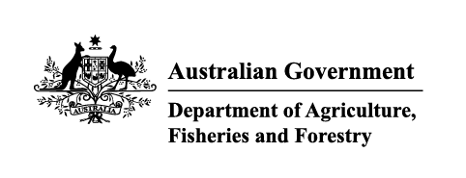
Exports work instruction

Requesting Authorised Officer eLearning using the Plant Exports Management System
Direction to authorised officers
This is official instructional material of the Department of Agriculture, Fisheries and Forestry (the department). Failure to comply with it may result in a breach of relevant legislation and/or the code of conduct under section 13(5) of the Public Service Act 1999.

Purpose of this document
This document details the procedure to request and pay for Authorised Officer (AO) eLearning using the Plant Exports Management System (PEMS).
__________________________________________________________________________________
Contents
Purpose of this document 1
Policy statement 2
Roles and responsibilities 2
How do I request access to the AO eLearning? 2
Section 1: Requesting and paying for eLearning 3
Contact information 12
Related material 12
Document information 12
Version history 13

Policy statement
The policy, definitions and legislation related to this work instruction can be found in the Exports Policy: Management of third party plant exports authorised officers.

Roles and responsibilities
The following table outlines the roles and responsibilities undertaken when requesting AO training.
Role | Responsibility
Applicant | - Requesting eLearning through PEMS.  - Paying all applicable fees and charges.

How do I request access to the AO eLearning?
Persons wanting to access the eLearning for their chosen AO job function/s must lodge their request online through PEMS.

Section 1: Requesting and paying for eLearning
The following table outlines how to request access to, and pay for, AO eLearning.
Step | Action | Graphic
1. | Go to https://online.agriculture.gov.au/selfservice  Note: The log in page will display. | 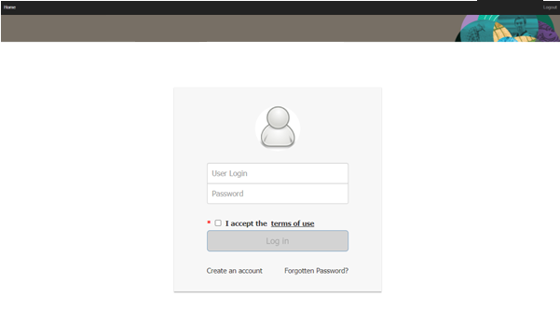
2. | - Enter your Username and Password.  - Check the I accept the terms of use box.  - Click ‘Log in’. | 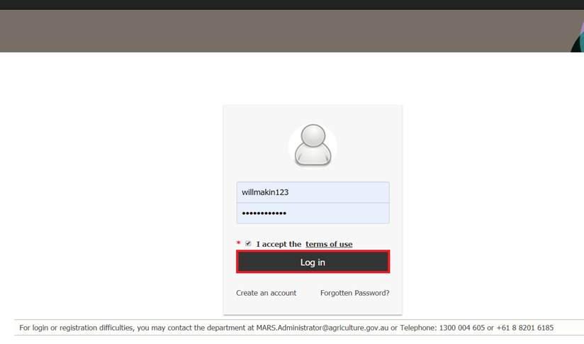
3. | Select the PEMS button to enter the PEMS home page. | 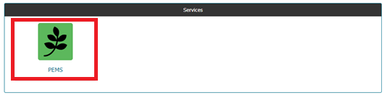
4. | Click ‘Open’ under the Actions column. | 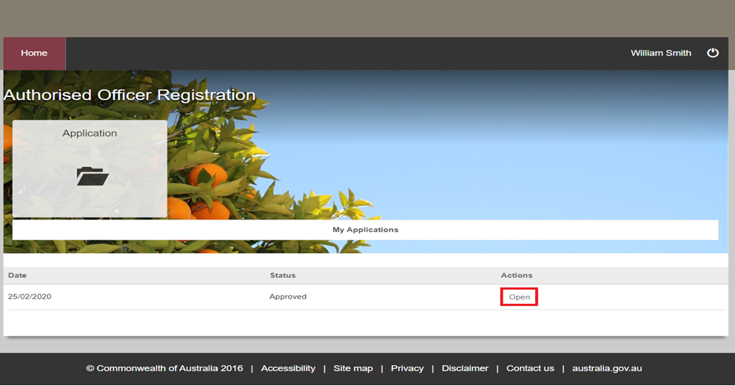
5. | Select the Training and Assessment tab. | 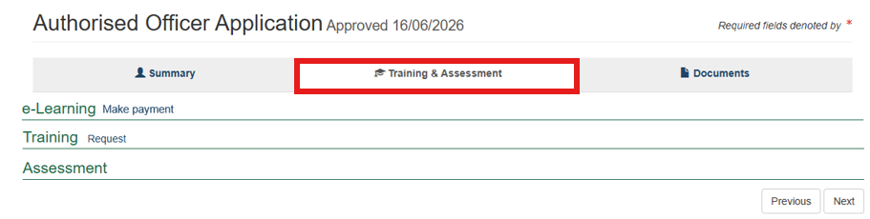
6. | Select Make Payment next to the e-Learning heading. | 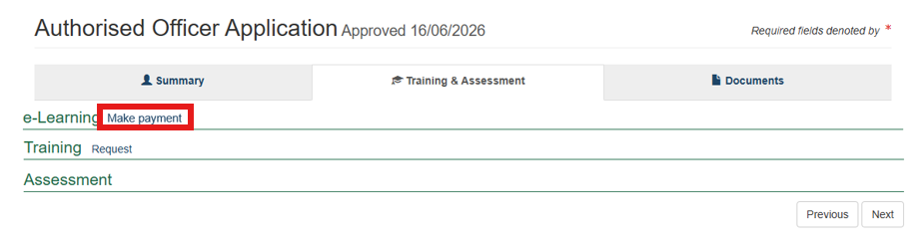
7. | Click ‘Pay Now’ under the Actions heading. | 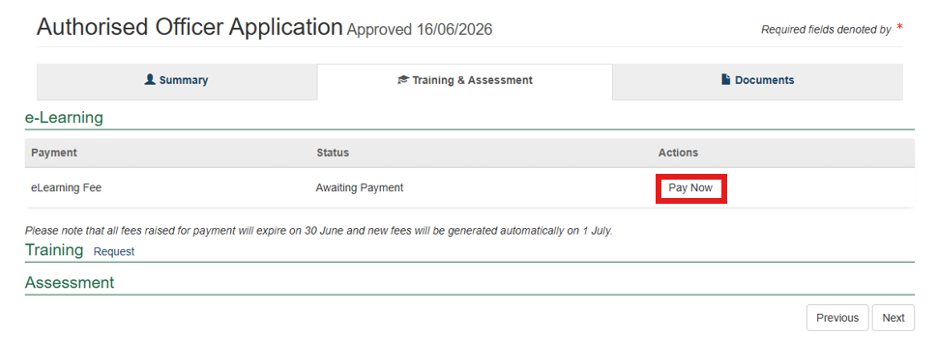
8. | - Review the details of the Service Summary.  - Click ‘Next’. | 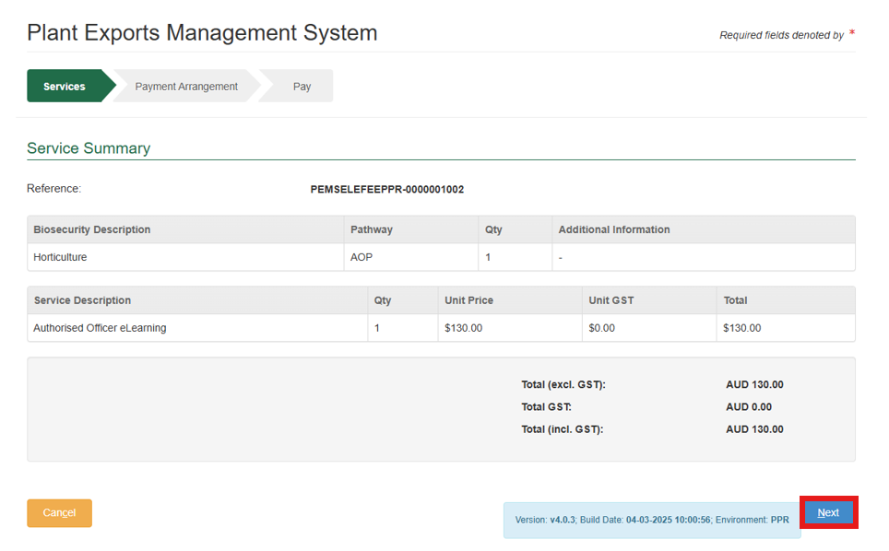
9. | - Select ‘No’ in response to the question Do you have an Account Number?  - Click ‘Continue to Payment’.  Note: Selecting ‘Yes’ will delay processing as the payment may not correctly link to your account. | 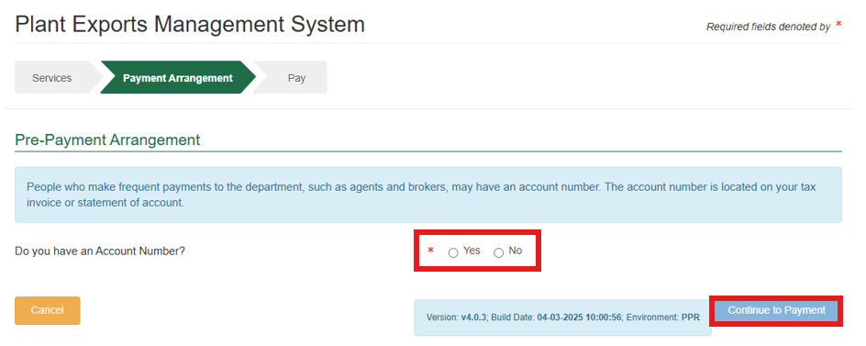
10. | - Enter the required payment details.  - Click ‘Pay Now’. | 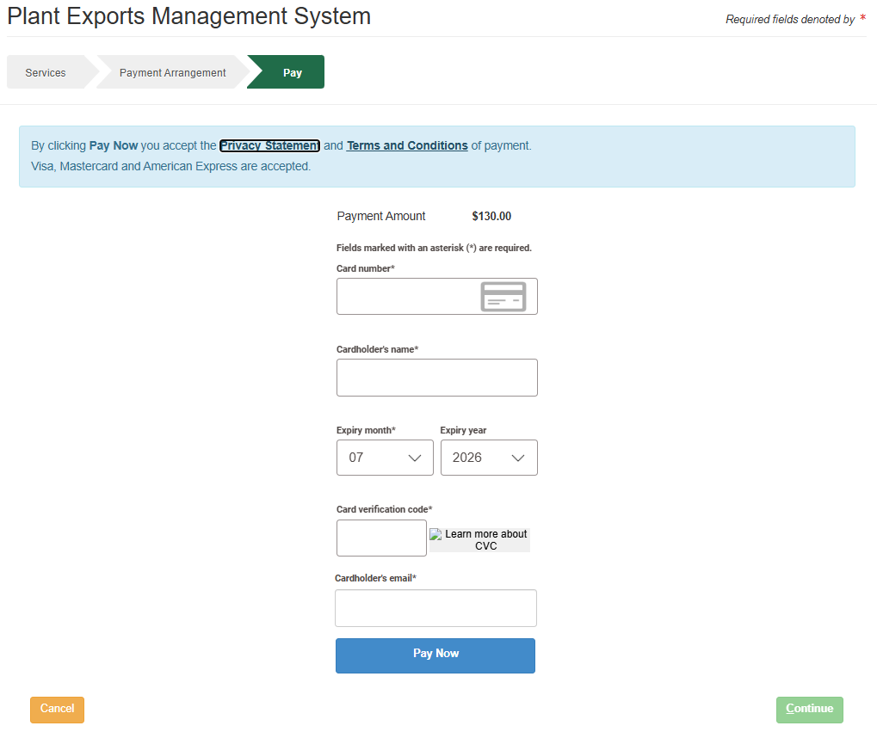
11. | - Note your payment confirmation.  - Click ‘Continue’. | 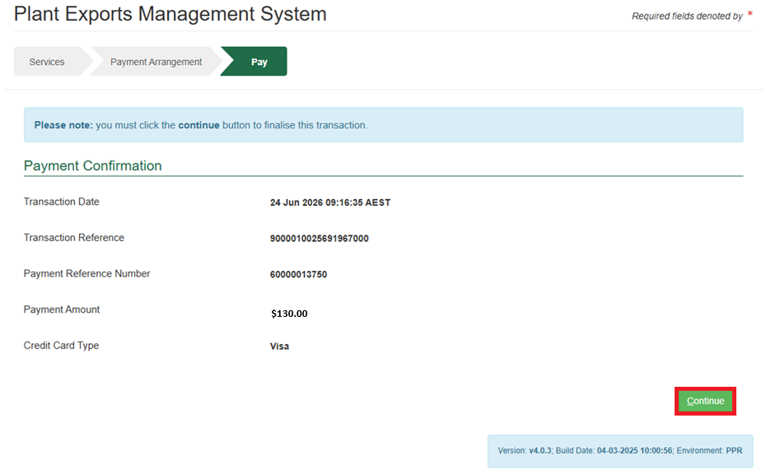
12. | Confirm the payment has successfully processed and the status displays as Paid.  Note: The status may take a few hours to update from Payment Confirmed to Paid. | 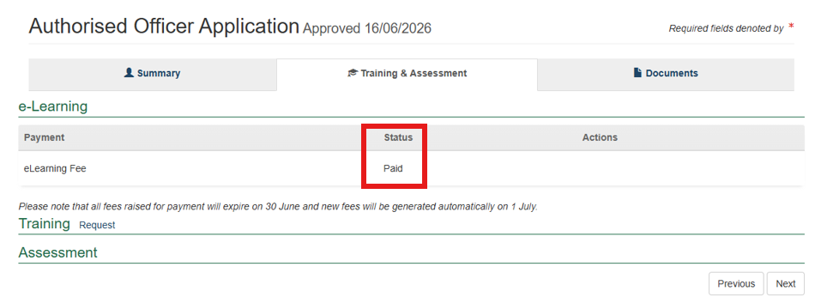

Contact information
- Authorised Officer Program: PlantExportTraining@aff.gov.au
- Authorised Officer Hotline: 1800851305.

Related material
The following related material is available online:
- Authorised Officer webpage
- Exports Policy: Management of third party plant exports authorised officers
- Exports work instruction: Applying to become an Authorised Officer using the Plant Exports Management System
- Exports work instruction: Requesting Authorised Officer training using the Plant Exports Management System
- Exports work instruction: Requesting Authorised Officer assessment using the Plant Exports Management System
- Exports work instruction: Requesting an Authorised Officer Instrument of Appointment using the Plant Exports Management System
- Exports work instruction: Requesting additional job functions in the Plant Exports Management System
- Exports work instruction: Requesting to remove job functions in the Plant Exports Management System
- Plant Exports Management System
- Plant Export Operations Manual
- Exports reference: Plant Exports Management System Authorised officer user guide
- Exports reference: Table of authorised officer job functions
- Fees and charges
- Privacy Policy.

Document information
The following table contains administrative metadata.
Instructional Material Library document ID | IMLS-9-11622
Instructional material owner | Director, Authorised Officer Program
Risk rating | Low
Review period | Due for review within 4 years of the most recent approved date.

Version history
The following table details the published date and amendment details for this document.
Version | Date published | Date last approved | Review type | Summary of review
1 | 26/08/2026 | 26/08/2030 | New Document | First publication of this work instruction.

