Resources for Implementing the National Food Waste Strategy

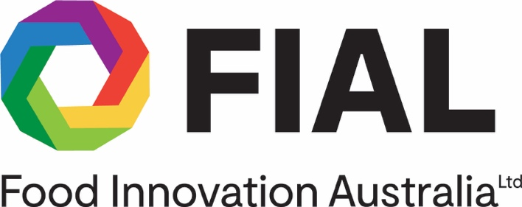


Preface

Resources for Implementing the National Food Waste Strategy has been compiled by Food Innovation Australia Limited (FIAL) under contract to the Australian Government Department of Agriculture, Water and the Environment to provide information for governments and industries across the food value chain seeking to reduce food waste. Links to source references and key websites are highlighted in the document.

Resources for Implementing the National Food Waste Strategy serves as an initial Australian compilation of relevant information and will contribute to the expanding knowledge bank developed by the Fight Food Waste Cooperative Research Centre (FFW CRC) and CSIRO.

FIAL recognises the considerable commitment and input to this document from members of the National Food Waste Steering Committee:

- AgriFutures Australia
- Australian Food and Grocery Council
- Australian Hotels Association
- Australian Institute of Packaging
- Australian Retailers Association
- Centre for Supply Chain and Logistics, Deakin University
- CSIRO Agriculture and Food
- Fight Food Waste Cooperative Research Centre
- OzHarvest
- National Farmers' Federation
- National Waste and Recycling Industry Council
- Refrigerants Australia
- Rural Research & Development Corporations

FIAL also gratefully acknowledges contributions from officers from State and Territory governments and the Australian Local Government Association in reviewing drafts and providing additional references for inclusion.

Food Innovation Australia Ltd. (ABN 50 164 124 609) make no express or implied guarantees, representations or warranties in relation to the strategies, material or information provided. Readers should not act solely on the basis of Resources for Implementing the National Food Waste Strategy (which includes generalised strategies) and should consider other factors including those specifically relevant to individual circumstances before implementing or using any of the Strategies.

Table of Contents

Preface i
Table of Contents ii
Tables and figures iv
1. The National Food Waste Strategy 1
1.1 Dimensions of the Food Recovery Challenge 1
1.2 Australia’s Commitments 2
1.2.1 Halving food waste 2
1.2.2 Fostering the circular economy 2
1.3 Context 3
1.3.1 International 3
1.3.2 Drivers and causes of food waste 5
2. Initial Implementation of the National Food Waste Strategy 8
2.1 Appointing an independent organisation to drive early implementation 8
2.2 Establishing the baseline 9
2.3 Destinations of food waste in each sector 11
2.4 Understanding potential financial return 12
2.5 Researching Options 14
3. Moving forward on implementing the Strategy 16
3.1 Principles to guide decision-making and prioritise action 16
3.2 Applying the balanced scorecard approach 17
3.3 Priority areas and implementation mechanisms to drive change 18
3.4 Increasing awareness through communication and engagement 19
3.5 Working with the food value chain to prioritise actions 21
3.5.1 Matching potential interventions to the food value chain 21
3.5.2 Establishing a Voluntary Commitment Program 23
3.5.3 Co-Design of cross-sector, product category and commodity action plans 25
3.5.4 State, Territory and Local Governments 26
4. Monitoring and Evaluating Progress on Food Waste Reduction and Recovery. 28
4.1 Inputs to developing a MERI framework 28
4.2 National reporting on food waste and loss 30
4.2.1 Regular reporting and the Food Waste Index 30
4.2.2 Reapplication of the Baseline Methodology 31
4.3 Adaptive management 31
5. Works cited 32
6. Appendices 34
Appendix 1 Summary of Drivers of Food Waste by Supply Chain Stage (USA) 34
Appendix 2: Information on policy levers, solutions and 20 habits of food waste reduction leaders 36

Tables and figures

Table 1: Drivers for food waste in Australia Adapted from (Commonwealth of Australia, 2017) 5
Table 2: A summary of destinations for food waste and surplus, quantified by sector (kT) (Arcadis, 2019) 11
Table 3: Fight Food Waste CRC; Research program goals and key activities (CRC, 2018) 15
Table 4: Principles to inform program design, decision-making and reporting 16
Table 5: The five priority areas for implementation (Commonwealth of Australia, 2017) 18
Table 6: Review-Plan-Do Approach 25
Table 7: Good practice criteria for evaluation (OECD, 2010) 29

Figure 1: A Circular Economy for Food Feedback (Global, 2019) 3
Figure 2: UN Sustainable Development Goals 4
Figure 3: Food loss and waste GHG CO2e as a country 2011/12 (FAO, 2017) 4
Figure 4: National Food Waste Baseline Study - Food Waste by Sector (Arcadis, 2019) 9
Figure 5: Interpretation of National Baseline Report data (Cosier, 2019) 9
Figure 6: Food waste by sector by jurisdiction (Arcadis, 2019) 10
Figure 7: Interpretation from National Baseline Report (Arcadis, 2019) 12
Figure 8: Example of a marginal cost abatement curve for food waste reduction alternatives (ReFED, 2016) 14
Figure 9: "Australian Dairy Industry Sustainability Summary Scorecard” (Dairy Australia Limited, 2018) 18
Figure 10: How to reduce food waste (Marsh, 2013) 20
Figure 11: Focus areas of three primary change agents 22
Figure 12: Impact of the Courtauld Commitment 25
Figure 13: State government food waste focus areas 28
Figure 14: Adaptive management framework (Building with Nature Guideline) 32
Figure 15: The many solutions to food loss and waste (Fisher, 2017) 37

The National Food Waste Strategy

1.1 Dimensions of the Food Recovery Challenge

Australia generated food waste estimated to be at least 7.3 million tonnes in 2016-17 (Arcadis, 2019). Food waste occurs at every point of the food value chain, from farms to households. The scale of food waste is immense. The economic cost, estimated to be $20 billion a year, is primarily borne by families and the natural environment (Commonwealth of Australia, 2017). Perversely, some five million Australians were at times unable to purchase food (Foodbank, 2019).

Food waste sent to landfill in Australia contributes an estimated 7.6 million tonnes of CO₂ equivalent greenhouse gas emissions, over the life of its decay. Wasted food is a misuse of all the greenhouse gases involved in its production on farm, in processing or manufacturing, in transport and distribution and across the wholesale and retail sectors involved in the food value chain.

Food waste is also a waste of the water, energy and arable land resources which went into its production, all of which will become scarcer with climate change. For example, in Melbourne, the amount of irrigation water required to produce vegetables is
475 litres per person per day (Melbourne, 2016), but around 25 per cent of all vegetable production never leaves the farm (Arcadis, 2019).

Food production can also contribute to water pollution and eutrophication, particularly due to seepage of nutrients, such as manures, fertilisers and pesticides into the broader environment. The growing demand for resource intensive foods, such as meat and dairy products, increases the environmental impact. Producing more food per unit of input will result in less land clearing, less impact on soil, and reduced water and other inputs (e.g. fertiliser, pesticides), enabling people to afford more sustainably produced food.

Food loss results in an inefficient use of bio-resources across the food chain. This ‘wasted’ food can be recovered and diverted to create high value ingredients, bioproducts and biomaterials. A more efficient use of resources improves the economy through better supply chains and even creating new industries.

By wasting food, all of the resources that went into growing, producing, processing and transporting that food are also wasted, resulting in potentially needless environmental impact.

1.2 Australia’s Commitments

1.2.1 Halving food waste

The National Food Waste Strategy Halving Australia’s Food Waste by 2030 (the Strategy) was launched in November 2017. The Strategy documents Australia’s commitment to halve food waste and aligns to the United Nation’s Sustainable Development Goal Target 12.3.

The National Food Waste Strategy (Commonwealth of Australia, 2017) defines food waste as:
- Solid or liquid food that is intended for human consumption and is generated across the entire supply and consumption chain
- Food that does not reach the consumer or reaches the consumer but thrown away. This includes edible food, the parts of food that can be consumed but are disposed of, and inedible food, the parts of food that are not consumed because they are either unable to be consumed or are considered undesirable (such as seeds, bones, coffee grounds, skins, or peels)
- Food that is imported into, and disposed of, in Australia
- Food that is produced or manufactured for export but does not leave Australia.
This definition excludes food that is produced or manufactured in Australia and is exported and may become waste in another country.

1.2.2 Fostering the circular economy

Worldwide countries are moving to activate a circular economy. A circular economy is based on the principles of designing out waste and pollution, keeping products and materials in use, and regenerating natural systems (Ellen Mcarthur Foundation , 2019).

A circular economy for the food value chain, as illustrated in Figure 1, retains the value of food in the economy for as long as possible, reducing the unsustainable depletion of natural resources and impacts on the environment. A circular economy has economic benefits, creating new industries, markets and products, and leading to new revenue streams and creation of jobs (Commonwealth of Australia, 2017).
Australia’s National Waste Policy (2018) reflects five principles to advance a circular economy.

- Avoid waste:
- Prioritise waste avoidance, encourage efficient use, reuse and repair
- Design products so waste is minimised, they are made to last and we can more easily recover materials.
- Improve resource recovery:
- Improve material collection systems and processes for recycling
- Improve the quality of recycled material we produce.
- Increase use of recycled material and build demand and markets for recycled products.
- Better manage material flows to benefit human health, the environment and the economy.
- Improve information to support innovation, guide investment and enable informed consumer decisions (Commonwealth of Australia, 2018)

Figure 1: A Circular Economy for Food Feedback (Global, 2019)

1.3 Context

1.3.1 International

The United Nation’s Sustainable Development Goals (SDGs) were developed in 2015. They specify targets for 2030 across 17 priority areas as an urgent call for action by all countries - developed and developing - in a global partnership. The SDGs set out tangible steps for achieving global posterity and a sustainable future for our planet, while leaving no-one behind.

SDG 12, Responsible Production and Consumption covers land, water and food. Other related SDGs such as SDG 2 Zero Hunger, SDG 13 Climate Action, and SDG 15 Life on the Land provide additional direction regarding food waste.

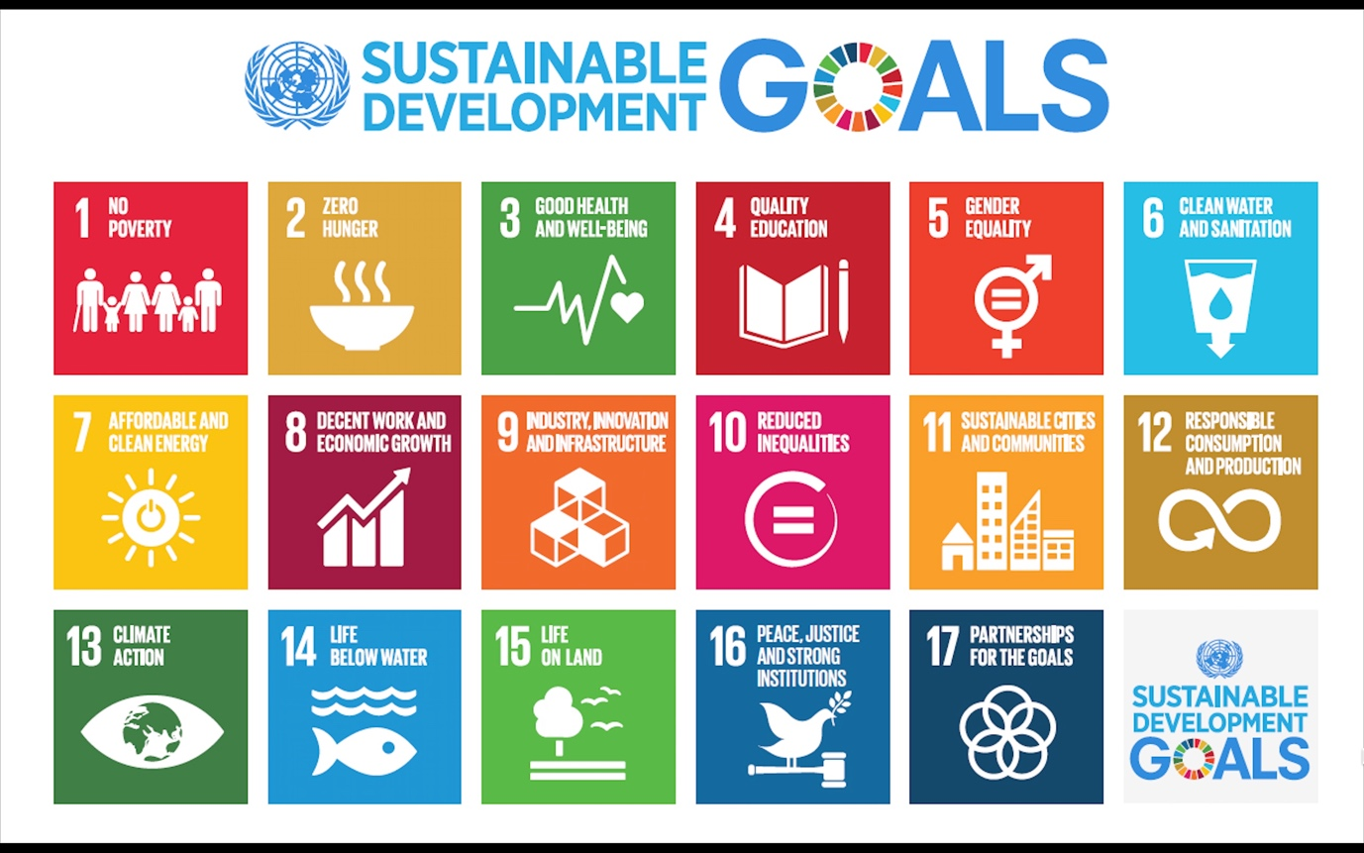
Figure 2: UN Sustainable Development Goals
SDG Target 12.3 focusses in on food waste - by 2030 halve per capita global food waste at the retail and consumer levels and reduce food losses along the production and supply chains, including post-harvest losses.

The scale of the problem across the globe is immense. If food loss and waste were a country it would be third largest emitter of greenhouse gases after the USA and China (FAO, 2017).

Figure 3: Food loss and waste GHG CO2e as a country 2011/12 (FAO, 2017)
Countries across the world are defining how the SDGs translate into priorities and action within their societies. Developed countries, such as those in the European Union, North America, the UK and Australia, are pursuing multi-faceted food waste reduction programs across the food value chain. Links to international food waste reduction programs and case studies are highlighted in the references. One example is the US consortium, ReFED.
In the USA ReFED is a collaboration of over 30 business, non-profit, foundation, and government leaders committed to reducing food waste. ReFED seeks to unlock new philanthropic and investment capital, along with technology, business, and policy innovation, which is projected to catalyse tens of thousands of new jobs, recover billions of meals annually for the hungry, and reduce national water use and greenhouse gas emissions.
ReFED was formed in early 2015 to create a Roadmap to Reduce U.S. Food Waste, the first ever national economic study and action plan driven by a multi-stakeholder group committed to tackling food waste at scale. The US Roadmap is designed to fill the gap between awareness and action by creating transparency in waste flows, costs, and opportunities from a more efficient food system achieved by preventing, recovering, and recycling food waste (ReFED, 2016). Progress with the ReFED Roadmap illustrates opportunities in analysing alternative solutions and considerations for industries and governments in choosing and implementing actions.
In 2018, Food Innovation Australia Limited (FIAL) researched international food waste reduction practices and produced a report (FIAL, Food Waste Visit Report , May 2018). A key finding was that, in the US, there is a clear differentiation between food loss, from farm to retail stores and food waste, in retail, food service and households. Conceptualising the problem in this way has facilitated solutions to recover the food lost. Another key finding was that the initial stage in reducing food waste internationally often involved raising awareness of the scale of the problem across the food value chain, which stimulated interest in taking action.

1.3.2 Drivers and causes of food waste

The National Food Waste Strategy identified drivers for food waste in Australia. These are augmented below:

Table 1: Drivers for food waste in Australia Adapted from (Commonwealth of Australia, 2017)
Primary production | - Product loss due to pests and diseases or weather  - Stock that is damaged or discarded during production, packing or handling  - Fall in market prices making it unprofitable to harvest  - Overproduction due to inability to meet contracted produce specifications, such as quality or size or physical appearance (cosmetic quality) of a crop  - Changes in consumer tastes and preferences  - Lack of adequate storage facilities (e.g. pest and waterproof grain silos; inadequate cold storage)  - Spillage or contamination
Processing and manufacturing | - Product damaged during handling or not meeting customer specifications  - Spoilage due to contamination or inadequate temperature control  - Excessive trimming of vegetable parts  - Excessive discarded animal or fish and seafood parts  - Changes in production or over-production due to customer demand; or high supply contract penalty clauses  - Equipment failure  - Spillage on conveyor belts and transfer points  - Waste from production line changeovers  - Inefficient inventory management  - Damage to packaging resulting in food unfit for sale  - Removal of plastic packaging in response to community pressure resulting in shortened expiry dates due to the loss of moisture and air, carbon dioxide or ethylene barrier properties  - Forecasting inaccuracies  - Storage practices  - Quality control practices  - Machinery failures.
Distribution | - Spoilage due to inadequate temperature control in transport and storage  - Damage due to improper handling, poor logistics infrastructure or inadequate packaging systems  - Delays in transit with resultant impact on residual shelf-life and ability to sell food before it reaches its expiry date  - Rejection of date coded food deliveries resulting in disposal or donations to charity  - Minimum Life on Receipt (MLOR) practices at retailers  - Delivery standards not being met (re-work)  - Rail, road networks delays
Retail | - Poor demand forecasting and stock management, including over ordering, improper stock rotation, storage and handling practices  - Product damage resulting from inadequate packaging systems  - Ineffective or failing chiller and frozen food cabinets in-store  - Produce no longer meets quality standards  - Last minute order changes that can leave suppliers with excess product  - Limited or no access to facilities to recycle or repurpose food waste  - No agreements in place with food rescue and relief organisations to allow for the donation of surplus food to those in need  - Removal of plastic packaging in response to community pressure resulting in shortened expiry dates  - Promotional compliance; or poor promotional planning and execution
Hospitality and food service | - Poor demand forecasting and stock management, storage, and handling practices  - Spoilage due to inadequate temperature control in kitchens  - Over production (preparation and cooking of food) leading to kitchen waste  - Over-portioning of food (leading to customer plate waste)  - Limited or no access to facilities to recycle or repurpose food waste  - No agreements in place with food rescue and relief organisations to allow for the donation of surplus food to those in need
Households | - Lack of awareness of wasting food (throwing away food remains an unconscious behaviour)  - Confusion over ‘use-by’ and ‘best-before’ date labelling  - Poor home economics and cooking skills  - Lack of awareness of how to store food in the home - e.g. what perishable food items should be stored in the fridge (e.g. most fresh produce) and which shouldn’t (e.g. bread, bananas)  - Over-purchasing of food that is then thrown away (poor pre-shop planning and home food inventory management)  - Increased pressure to reduce packaging resulting in over-portioning of food (leading to plate waste)  - Limited knowledge of how to safely repurpose or store food leftovers  - Undervaluing food and the environmental impacts related to its production  - Limited or no access to food waste collection systems

The National Food Waste Baseline Report identified more insights into the drivers for food waste in Australia. An example is the numerous drivers of wasted fruit and vegetables. These drivers accord with overseas findings, categorised broadly as on-farm damage, market forces, cosmetic quality standards, perishability, processing and transport losses (Arcadis, 2019).

Another example is in manufacturing. Food processors early in the supply and consumption chain typically have higher levels of food waste due to the presence of inedible and unavoidable food wastes, such as peels, bones, pits and nut shells. These streams also tend to be relatively homogenous and uncontaminated, which supports high levels of resource recovery. Manufacturers later in the supply and consumption chain may be directly consumable and less perishable, supporting higher levels of food donation (Arcadis, 2019).

The highly influential role of retailers reported above in the US, is also applicable to Australia. Supermarket brands are considered by Arcadis as the most influential stakeholder in the entire food value chain. This influence occurs through factors such as product and packaging specifications and design, cosmetic standards, product quality standards and business practices supporting the determination of food expiry dates, the provision (or not) of clear food preparation and storage guidance on-pack, demand forecasting, minimum orders and stocking (in-store availability and inventory management) practices and metrics (Arcadis, 2019). More broadly retailers directly affect household consumption patterns and wastage rates, particularly with new services, such as prepared meals and on-line shopping; or through the potential to use sales promotions that can lead to more household food waste (e.g. buy one, get one free offers on perishable food items).

International studies have categorised the drivers for food waste as technological, institutional – including business, economy, legislation and policies – and social- incorporating consumer behaviours and lifestyles (EU, 2014).

In the US, research has identified the drivers of food waste along the food value chain from farms to households. Farmers are challenged to grow exactly the right amount and rigorously manage their crops to match market demand, allowing for risks such as weather or disease. Also, the market price at the time of harvest may be so low that farmers chose to leave their crops in the paddock. Food safety scares and labour shortages may also result in crops not being harvested (Gunders, 2012). See Appendix 1 for a summary of US food waste causes by supply chain sector.

Post-harvest, the main loss of food is culling or ‘grade-out’, where produce is selected based on specifications. In processing, food losses occur through trimming edible and inedible portions. Distribution losses are associated with problems in the cold-chain, poor demand and ordering contract management (Gunders, 2012).

Given the pivotal role supermarkets play in supplying food to Australian consumers, and their influence both up and down the supply chain, retailers are a key sector for reducing food waste. Causes of food waste in the retail sector include overstocking displays to avoid running out of stock, wasteful cosmetic quality standards, poor handling and storage practices, substandard packaging, and date label confusion amongst in-store staff. An overall lack of awareness and undervaluing of food affects households as does confusion over label dates and spoilage (Gunders, 2012).

Initial Implementation of the National Food Waste Strategy

2.1 Appointing an independent organisation to drive early implementation

The Strategy recognised the need for an organisation that was independent of government to be a central point for coordination and facilitation of activities. The government appointed Food Innovation Australia Limited (FIAL) in November 2017, for 24 months, to work with stakeholders across the food value chain.
FIAL was established as the Australian Government's Food and Agribusiness Growth Centre to grow the Australian share of food in the global marketplace. FIAL’s role is to drive value, innovation and competitiveness across the food and agribusiness sectors. This Australian Government investment, the Industry Growth Centres Initiative, is funded until 2021.

2.2 Establishing the baseline

The Strategy committed to undertaking an initial baseline study. The National Food Waste Baseline Report compiles data about food waste generation, along the value chain, for 2016-2017. The Report attributes roughly one-third of total food waste to households, another third to primary production and a quarter to manufacturing. The methodology for the baseline adapts the international World Resources Institute (WRI) Food Loss and Waste Accounting and Reporting Standard.

Figure 4: National Food Waste Baseline Study - Food Waste by Sector (Arcadis, 2019)

Overview of waste sources for each sector of the value chain by state

The sources of food waste in each state and territory vary according to population and types of primary production and manufacturing in each jurisdiction.

Figure 6: Food waste by sector by jurisdiction (Arcadis, 2019)

Baseline methodology and limitations

The methodology used to develop the initial baseline is repeatable and is intended to be used as a tool for monitoring and evaluating progress in implementing the Roadmap. As the first attempt to compile food loss and waste information across the sectors of the food value chain in Australia, the Report lists assumptions and limitations for each sector. Despite these data limitations (particularly in the transport, retail and hospitality sectors), the information compiled establishes a useful starting point for future data gathering and analysis.

Additional data about food waste and recovery in Australia will become available through information gathered from the signatories to the voluntary commitment program. Improved understanding of the causes, drivers, generation and destinations for food waste will evolve as more and better data becomes available. Improved information about food traceability, enabled with new technologies, will expand the current sector-focused analysis, enhancing understanding on the movement of key commodities along the food value chain. Hotspots analysis can provide insights into where food waste is generated and how it may be reduced for the traced commodity. Better data is central for reducing food waste into the future.

2.3 Destinations of food waste in each sector

The baseline analysed the current destinations for food waste generated by each sector. The table below, extracted from the Baseline, shows these destinations.

Table 2: A summary of destinations for food waste and surplus, quantified by sector (kT) (Arcadis, 2019)
Figure 7: Interpretation from National Baseline Report (Arcadis, 2019)

2.4 Understanding potential financial return

Champions 12.3 is a global partnership of executives from governments, businesses, international organisations, research institutions, farmer groups, and civil society. It is dedicated to inspiring ambition, mobilising action, and accelerating progress toward achieving SDG Target 12.3 by 2030. A fundamental condition of membership to Champions 12.3 is transparency. All members must ‘target, measure and act’, publish their baselines and report the progress they are making to reduce food waste.
In 2017 Champions 12.3 released The Business Case for Reducing Food Loss and Waste. This Study found there is a robust business case for countries, cities, and companies to reduce food loss and waste through setting targets, measuring progress and taking action. For companies the median benefit-cost ratio was 14:1 (Champions 12.3, 2017).
Results from this study show the greatest returns on investment were achieved in the following main areas:
- The closer the food waste occurred to the ’fork’ - reflecting the higher value of food at the consumption end of the value chain - highlighted the vital importance of packaging to extend shelf life
- Where businesses implemented food waste reduction activities, which did not require a significant capital investment
- Where businesses had not previously undertaken food waste reduction measures (Champions 12.3, 2017).
Food repurposing and value-added processing has been assessed by CSIRO and Hort Innovation in the form of a regional food waste hub concept. (Cristiana Ambiel, 2019). The preliminary estimate of annual revenue for this food repurposing hub, from the sale of the manufactured ingredients (from food waste and virgin food inputs), was $66.4M with an annual operating cost estimate of $45.8M. The cash-flow and profitability analysis of the venture indicated the hub Net Present Value of $93.1M over a 15-year life span with a 3-year payback period on an initial ~$25M investment. Processing capacity is estimated at up to 200,000 to 300,000 tonnes per annum. However, smaller, modular units, may require less initial capital and may process lower volumes of waste. Strong local and export markets for output food product were identified. A full comprehensive pre-feasibility study is available that provides a ROI and CBA. Food must be consolidated from farms or packing houses before it is processed in these regional food hubs. This cost was considered an externality of this project.

In the US ReFed developed the following criteria to guide investment and focus effort:

- Data Availability – Quantifiable data from one or more credible sources
- Cost Effectiveness – A positive or near-breakeven economic value to society
- Scalability – Potential to achieve significant waste diversion volume
- Feasibility – Identify stakeholders who can implement the solution without major changes to technology or policy (ReFED, 2016)
ReFed, 2016 has applied these criteria, an assessment of economic value per tonne and landfill diversion potential to develop a marginal cost abatement curve of 50 solutions to reduce food waste:
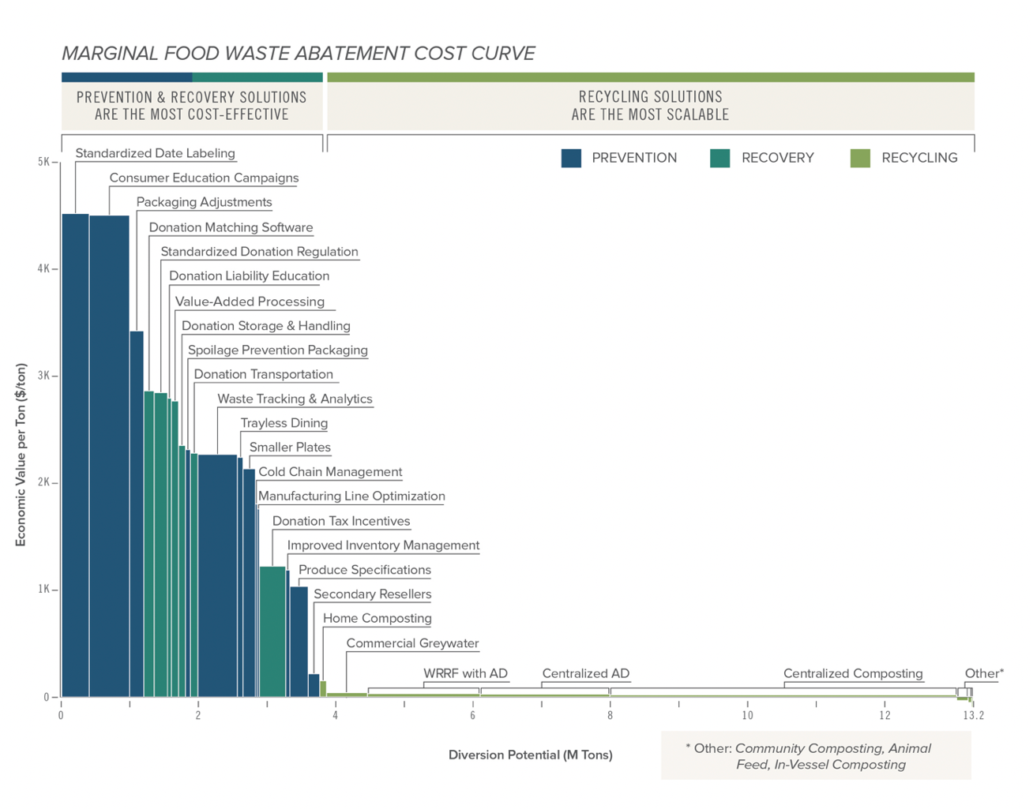
Figure 8: Example of a marginal cost abatement curve for food waste reduction alternatives (ReFED, 2016)

2.5 Researching Options

The FFW CRC has been established by the Australian Government to provide solutions to reduce food waste throughout the food value chain, transform unavoidable waste into innovative high value co-products and to engage with industry and consumers to raise awareness and deliver behaviour change. Establishment of this CRC aligns with the Australian Government’s Growth Centre’s research goals, as recommended in the Sector Competitiveness Plan to enhance industry-research collaboration and commercialisation (FIAL, Sector Competitiveness Plan, 2019).

The FFW CRC and participant partners will deliver the following outcomes:

- New sources of revenue and market growth for food companies
- Less waste of resources through the food value chain from grower through to consumer
- Less waste ending up in landfill and more donated surplus food to feed Australians who may otherwise go hungry (CRC, 2018).

Main programs and sub programs

The FFW CRC has prioritised three primary program areas: REDUCE, TRANSFORM and ENGAGE. Goals were identified and activities nominated for research into reducing food waste and increasing the redistribution of surplus food to food rescue organisations.

Within each program there are sub-programs of research and applied projects. Most of the individual projects are led by one or more industry partners, which fund and actively participate in project design, development and application/implementation. Partner organisations are listed on the FFW CRC’s website. The goals and key activities of each program are listed below.

Table 3: Fight Food Waste CRC; Research program goals and key activities (CRC, 2018)
Reducing Supply Chain Losses
To reduce food loss (pre-consumer) and waste (post-consumer) throughout the food value chain from grower to consumers
- Map resource flows, waste and root cause analysis
- Review functions and consumer perceptions of packaging and processing
- Investigate product specific supply chains and identify opportunities
- Investigate methods to increase food donation and measure its social impact
Transforming Waste Resources
To provide knowledge and innovative technologies to extract more economic value from the food production process, diversify revenue sources along the value chain and make businesses more sustainable (both economically and environmentally).
- Identify and prioritise valuable products from waste streams
- Identify technology gaps and process limitations in waste transformation
- Deliver a tool kit for optimising technology and feedstock combination choice
- Conduct socio-economic assessment of alternative policy settings
Engagement, Training and Behavioural Change
To engage with industry and consumers to deliver behavioural change by educating future professionals through skills dissemination and skills training within industry; and facilitating household and business behaviour change.
- Educate future industry professionals
- Disseminate industry and skills training
- Develop household and business behaviour change instruments

An important FFW CRC initiative will be to develop and report a regular national food waste index to complement the Baseline methodology. The Index will be calculated from data provided by signatories to the voluntary commitment, States and Territories, food rescue and relief organisations, academic researchers and others. Details of this project are yet to be determined. Emergent international good practice examples (e.g. The WRAP/WRI ATLAS database) will be available to the FFW CRC for project development and implementation.

Unlike many CRCs, access to the FFW CRC’s world-class researchers is also available to help small and medium enterprises (SMEs) tackle their food waste challenges. The FFW CRC, FIAL and The Queensland Department of Agriculture and Fisheries (QDAF) is running a grant program for SME’s to gain access to the CRC’s researchers and knowledge, through a new SME Solutions Centre, launched in August 2019.

Research on food waste and recovery is also being conducted by the states, including the state-wide food waste baseline investigations and decision-making matrix of Sustainability Victoria, and by CSIRO, such as Fruit and Vegetable Losses and pre-feasibility studies for regional food processing hubs.

Moving forward on implementing the Strategy

3.1 Principles to guide decision-making and prioritise action

The following principles provide direction on preferred outcomes and operational methods to inform program design, decision-making and reporting.

Table 4: Principles to inform program design, decision-making and reporting
Principles to drive good outcomes
Prevent food waste | Preventing the generation of food waste is the fundamental objective.
Move up the food recovery hierarchy | Look for opportunities to avoid, reduce, reuse, recycle and recover/valorise food will reduce overall food waste. Create co-benefits and the potential to develop new and valuable co-products from different food waste streams.
Apply a circular economy approach | Use the principles of the circular economy – design out waste and pollution, keep products and materials in use, and regenerate natural systems - when designing initiatives.
Facilitate food rescue and relief | Work with the whole food value chain and food rescue and relief organisations to maximise redistribution of safe surplus food to those in need, to help achieve future food security, public health and nutritional goals, and reduce hunger.
Make wasting food a socially unacceptable thing to do | Change social norms. Move wasting / throwing away food from an unconscious behaviour to a conscious behaviour as a major driver of increased awareness and behaviour change (for consumers and industry).
Principles to promote best practice in food waste reduction initiatives:
Co-design with Industry | Developing food waste reduction initiatives with industry will increase relevance, buy-in and accountability. Applying co-design facilitates flexibility in the adaptive management cycle.
Seek the best Return on Investment (ROI) | Assessing the ROI for proposed initiatives will help to prove the business case for action and ensure efficient and effective translation of actions into bottom line and societal benefits.
Take a food system’s perspective | Delivering better practice requires a food system’s view of opportunities available for food recovery - both within the production and consumption system and across the food value chain.
Create initiatives to realise multiple benefits for supply chain partners and collaborators | Actively seek out win-win solutions to maximise triple bottom line benefits across the food value chain - at the same time as balancing value chain and investment risk.  Co-investors in a solution realise a proportionate co-benefit from food waste reduction initiatives.

3.2 Applying the balanced scorecard approach

The concept of a balanced scorecard was developed by Dr Robert Kaplan and Dr David Norton in 1992 and published in the Harvard Business Review. Since then it has been applied by companies, not-for-profits and organisations to track progress across elements of financial and sustainability performance, customer satisfaction, internal processes and learning and growth.

The balanced scorecard (BSC) is a strategic planning and management system that organisations use to:
- Communicate what they are trying to accomplish
- Align the day-to-day work that everyone is doing with strategy
- Prioritise projects, products, and services
- Measure and monitor progress towards strategic targets (Institute, 2019).

The balanced scorecard approach has been used in Australia by the horticultural and dairy industries to compare performance and track sustainability performance.
Horticulture Australia Limited (HAL) commissioned Access Economics (2010) to undertake research to produce a balanced scorecard to compare the performance of the Australian horticultural industry against other agricultural industries across a range of economic, environmental and social parameters.
Having a tool such as the balanced scorecard will help HAL to better promote the Australian horticultural industry, increase public awareness, be prepared for future challenges and secure continuous support through Government (Access Economics Pty Ltd, 2010).
The Australian Dairy Industry’s Sustainability Report 2018 also applies a balanced scorecard approach to report progress across the industry’s triple bottom line. They have mapped their industry goals against the UN’s SDGs and documented annual progress on their goals against specified targets, initially for 2020 and now extended until 2030.

Reducing environmental impact | 8 | Improve nutrient, land and water management | 8.1 | 90% of stock excluded from waterways | 73% |  | 76% |  | No data | 90%
Reducing environmental impact | 8 | Improve nutrient, land and water management | 8.2 | 80% of farmers implement nutrient management plans | 30% |  | 58% |  | No data | 80%
Reducing environmental impact | 8 | Improve nutrient, land and water management | 8.3 | 80% of dairy farms with irrigation have implemented some level of irrigation automation | 47% |  | 54% |  | No data | 80%
Reducing environmental impact | 8 | Improve nutrient, land and water management | 8.4 | 80% of dairy farms managing some land for conservation and biodiversity | 47% |  | 45% |  | 81% | 80%
Reducing environmental impact | 8 | Improve nutrient, land and water management | 8.5 | Where relevant, all dairy farmers actively managing noxious weeds
Reducing environmental impact | 8 | Improve nutrient, land and water management |  | Noxious weeds identified as major land issue | 37% |  | 29% |  | No data | Under review
Reducing environmental impact | 8 | Improve nutrient, land and water management |  | Actively managing noxious weeds where a problem | 28% |  | 28% |  | No data | 100%
Reducing environmental impact | 8 | Improve nutrient, land and water management | 8.6 | 100% of farmers have practices to recycle water on farm | 50% |  | 75% |  | No data | 100%
Reducing environmental impact | 9 | Reduce consumptive water intensity of dairy companies by 20% | 9.1 | Reduce the consumptive water use intensity of dairy companies by 20% (on 2010/11 levels) (litres/litre of milk processed) | 1.75 | 1.56 | 1.58 | 1.62 | 1.85 | 1.4
Reducing environmental impact | 10 | Reduce greenhouse gas emissions intensity by 30% | 10.1 | 30% reduction in GHG emissions intensity on 2010/11 levels measured by a direct measurement of dairy companies emissions | 178.7 | 153.6 | 152.5 | 140 | 159.6 | 125.8
Reducing environmental impact |  |  | 10.2 | Farm emissions abatement actions | Under review |  |  |  |  | Under review
Reducing environmental impact | 11 | Reduce waste to landfill by 40% | 11.1a | 40% reduction in dairy company waste to landfill on 2010/11 levels | 2.69 | 1.63 | 1.45 | 1.39 | 1.32 | 1.61
Reducing environmental impact | 11 | Reduce waste to landfill by 40% | 11.1b | Dairy companies: Signatories to Australian 9 Packaging Covenant (APC) |  | 9 | 8 | 8 | >15 | All Dairy companies
Reducing environmental impact | 11 | Reduce waste to landfill by 40% | 11.2 | Farm level waste reduction | Under review |  |  |  |  | Under review
Figure 9: "Australian Dairy Industry Sustainability Summary Scorecard” (Dairy Australia Limited, 2018)

3.3 Priority areas and implementation mechanisms to drive change

The Strategy identified four priority areas for action. Additionally, the recent stocktake of Australian food waste initiatives found infrastructure to be an additional tool used by state and local governments to reduce the disposal of food waste. These five priority areas for action are summarised in Table 5 below.

Table 5: The five priority areas for implementation (Commonwealth of Australia, 2017)
Priority | Outcome | Focus
Policy support | Policies are supportive of food waste avoidance, reduction and repurposing | Establishing a National Food Waste Baseline and methodology to measure progress against goals  Identifying areas to target investment  Establishing a voluntary commitment to reduce food waste  Enabling legislation to better support food waste reduction and repurposing
Business improvements | Improvement and adoption of technologies, processes and actions to avoid and reduce food waste | Identifying areas for improvement  Supporting technology adoption  Encouraging collaboration  Normalising food waste considerations into business practices
Market development | Development of markets to support the repurposing of food waste | Identifying food waste composition and nutritional value to develop new markets  Encourage innovation  Connecting food waste sources to users
Behaviour change | Practices and attitudes towards avoiding and reducing food waste are adopted and sustained | Changing consumer behaviour  Engaging the workforce on food waste
Infrastructure | Application of technology and engineered solutions and equipment to process and distribute food waste | Investment in land and equipment to sort, process and transport food waste  Critical food rescue infrastructure (distribution centres, logistics)

International good practice guidelines to reducing food waste have identified additional policy levers that governments can use to reduce food waste; synthesised critical success factors that deliver leadership on food waste reduction in the agrifood industry to suggest ‘20 habits of food loss and waste reduction leaders’; and proposed solutions to food waste that businesses across the food value chain can adopt. Slides describing these findings are appended at Appendix 2.

3.4 Increasing awareness through communication and engagement

Early engagement across the entire food value chain, from primary producers through to individual consumers, raises awareness of food loss and waste and the opportunities for food recovery. Industry and consumer engagement around food recovery programs and the activities of peak industry bodies and governments, is fundamental to sharing knowledge about where food waste occurs, and what can be done to reduce it.

Internationally, web-hubs, such as Further with Food serve as a clearing house for up-to-date information on reducing food loss and waste. They provide information on understanding the issue, help with finding resources and provide links to events and training.

In the UK, WRAP developed Food waste messages for maximum impact – how to engage your residents in prevention and collections (WRAP, 2013), providing best practice and targeted information backed by up data from householder surveys for local governments and other partners to use to reduce household food waste and improve the effectiveness of their household food waste collections. The WRAP guidance includes principles for communicating with consumers and suggested methods for different placement of information, e.g. posters for the kitchen and bin tags announcing the launch of a new collections service (Marsh, 2013).

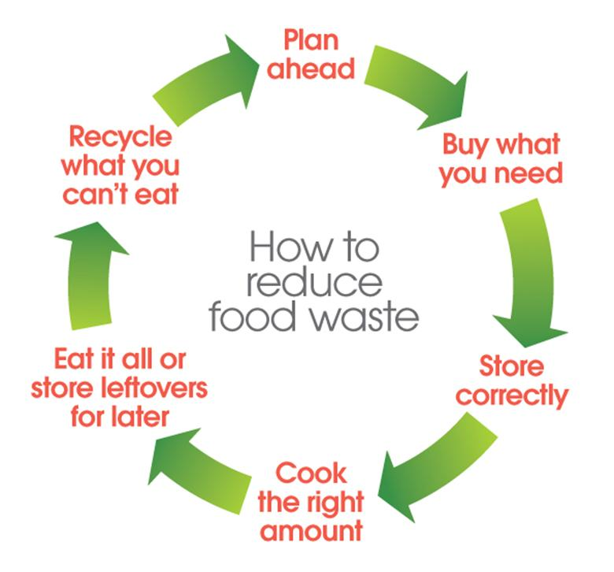
Figure 10: How to reduce food waste (Marsh, 2013)
The FIAL international review (FIAL, Food Waste Visit Report , May 2018) illustrates the value of raising awareness of the scale of food waste as an initial step towards behaviour change and food waste prevention. Using awareness, education and behaviour change campaigns to inform and motivate the consumer by making it as easy as possible to reduce the amount of food that they waste is critically important, given the fact that by the time food reaches the home it has achieved its highest economic value and has consumed the vast majority of the resources required to produce, transport, sell and use it. As such, consumer-facing behaviour change campaigns can play a significant role in preventing household food waste in Australia.

Another successful example of national outreach was the 2017 ABC TV documentary series The War on Waste, as it delivered key messages on waste reduction to millions of Australian households.

The FFW CRC is currently establishing itself as a central communication platform and ’one-stop-shop’ for information on reducing food waste. Through its ENGAGE program, it will highlight emergent research results across the FFW CRC’s three programs of REDUCE, TRANSFORM and ENGAGE, share the stories of food waste from across Australia and globally, and provide a direct contact for industry with specific food waste opportunities.

3.5 Working with the food value chain to prioritise actions

3.5.1 Matching potential interventions to the food value chain

Understanding the sources of food loss and waste in each sector of the food value chain is a fundamental first step in choosing an intervention that is likely to be effective in reducing food waste. FIAL’s analysis below matches potential interventions with sectors. While the primary focus of states, territories and local government areas (LGA’s) programs and investment is on food waste in the retail-consumer end of the value chain, voluntary commitments have been shown to be the most appropriate way of engaging with large retailers, their manufacturing suppliers and primary producers. For important elements of the food value chain, such as transport and logistics and food rescue and relief, taking a cross-sectoral action planning approach may lead to better understanding and outcomes. During implementation, opportunities for cross-sectoral action plans for other commodities or product categories may emerge.

Householders have a dual role in the reduction of food waste. As part of the broader community, they are interested in managing their food better to lower their food bills or use some of these savings to invest in healthier, better quality food (trading up). Annual food waste costs in households vary from $2200 to $3800 (Commonwealth of Australia, 2017), so there remains considerable potential to help educate Australian households to better manage their food and waste less of it.

The other role of consumers is more pervasive and less understood. Householders, as the final consumer of food, are also the ultimate arbiter of expectations related to food quality and standards. Expectations about the required shape and size of fruits and vegetables is an example where consumer preferences may drive the creation of food waste on farm. Similarly, community demands to reduce plastic food packaging has the potential to have a detrimental impact on food waste.

Matching potential Interventions/to  Value chain sectors | Primary  Production | Manufacturing | Wholesale | Retail | Hospitality /Food Service | Institutions | Households
Cross-Sector action plans | Food Rescue Sector
Cross-Sector action plans |  | Transport and Logistics
Focus of Voluntary Commitment programs | (Targeted companies) |  |  |  | (Targeted companies) | (Targeted companies)
Usual Focus of States, Territories and LGAs’ programs
Figure 11: Focus areas of three primary change agents

3.5.2 Establishing a Voluntary Commitment Program

A tried and tested implementation vehicle to reduce food waste is to establish a voluntary commitment program. By joining the program, signatories pledge to set targets, quantify their food waste, agree future activities to reduce food waste and maximise the potential to donate surplus food to food rescue organisations. This Target, Measure, Act approach has been successful in the UK in gaining involvement from agri-food businesses to reduce their food waste; and from national governments, local government and NGOs to deliver their policy and strategy objectives (see text box on Courtauld Commitment below).

Signatories report on progress against an agreed program of actions in reducing their food waste. This transparent monitoring and reporting against agreed individual and collective actions provides much needed evidence to track progress against collective food waste reduction targets and a trajectory to be agreed with signatory organisations.

Voluntary ‘Commitments,’ ‘Agreements’, ‘Covenants,’ or ‘Codes’ have been developed worldwide to improve the management and transparency of challenging environmental issues, such as the Australian Packaging Covenant and New Zealand’s voluntary corporate greenhouse gas reporting. The Waste and Resources Action Program (WRAP) in the UK has been implementing a voluntary food waste commitment program, called the Courtauld Commitment since 2005.

More broadly, Champions 12.3 is a form of voluntary commitment, with members committing to quantify and drive food waste reduction throughout their own organisations and their suppliers.

Voluntary commitments or codes have a number of common elements:

- A set of non-legislatively required commitments, with a clear statement of objectives, expectations, obligations and ground rules, usually set in a pre-competitive working environment.
- Agreements by one or more individuals or organisations, with the explicit commitment of leaders and collective ‘buy-in’ from members.
- Designed to influence, shape, control or benchmark behaviours, with a regular flow of information
- Applied in a consistent manner or reaching a consistent outcome (Affairs, 2010)
- Some form of public/private partnership or commitment that drives forward government policy goals at the same time as generating tangible and intangible business benefits for participating companies/organisations.
- Co-funded, sometimes across government departments or as a grouping of private sector interests; or, sometimes through a mix of public and private sector funding. In some cases, government funding is provided to kick-start voluntary commitments, but with an expectation that the private sector contributes to the funding at a later stage.
- Clearly defined timeframe, trajectory and end goal, a set of realistic but stretching targets (both at sector-level and at the level of individual participants/signatories), and a clear membership and governance structure to drive collaborative action (May, 2018).
- Annual public reporting of collective progress with case studies to showcase individual or collective actions taken to achieve the stated objectives of the voluntary commitment.
- Some form of incentive, such as recognition (by government or consumers of the merits of voluntary action and private sector leadership), including access to government policy-makers or opportunities to identify regulatory barriers to greater implementation or impact, access to grants, research funding and innovation programs; and information on what works.
- Some form of accountability, indirectly through diminished market reputation, or directly through governance measures, such as legislation or regulation, levies or taxes, or compliance.
In mid-2018 the EU REFRESH Policy Working Group held a workshop to share the learnings from four pilot voluntary agreements in Hungary, the Netherlands, Spain and Germany. The voluntary agreements varied in complexity, but all participants emphasised the value of VAs in providing a platform for collaboration across government, research organisations, NGOs and businesses across the food value chain. The need to articulate the ‘why’ for business involvement was another common observation. In particular, the Netherlands found that a strong involvement of government was critical to foster the initiation of a VA (Refresh, 2018).
The Courtauld Commitment is designed to bring together organisations across the food system to make food & drink production and consumption more sustainable. At its heart is a 14-year history of commitment to identify priorities, develop solutions and implement changes to cut the carbon, water, natural resources and waste associated with the production and consumption of food. The Courtauld Commitment 2025 has a collective ambition to achieve by 2025, relative to 2015:
- A 20% per person reduction in food and drink waste in the UK
- A 20% per person reduction in Greenhouse Gas (GHG) emissions associated with production and consumption of food and drink in the UK
- A reduction in impact associated with water use and water stress in the food supply chain (WRAP, 2018).

At the end of 2018, 170 organisations from farm to fork were engaged with the Commitment, as partners working to deliver on the UK’s Food Waste Reduction Roadmap to Target, Measure and Act (WRAP , 2019). The UK Roadmap is focussed towards businesses through inviting them to:
Target: set a food waste reduction target for their business
Measure: in a consistent way and share what they have learnt
Act: by taking action to reduce their own food waste, work in partnership with suppliers and help consumers to reduce their food waste.

3.5.3 Co-Design of cross-sector, product category and commodity action plans

Applying the steps, below, of Review-Plan-Do may be an effective method to identify opportunities and co-design food waste reduction actions for cross-cutting sectors, such as food rescue and relief and transport and logistics. The Co-design approach may also be applicable for key commodities, product categories or cross-cutting issues and solutions (e.g. cold chain optimisation and consistent guidance on food date labelling, storage and use), where there are a broad range of participants operating across the value chain. Here co-design could identify opportunities across the food value chain for commodities to be recovered or diverted into further processing.

Table 6: Review-Plan-Do Approach
Engage Champions | - Identify likely champions and willing participants within targeted sectors to lead the analysis and co-design with their sector, involving relevant industry bodies, such as the National Farmers Federation, the Australian Food and Grocery Council and the FFW CRC.  - Use Voluntary Commitments to highlight leadership and roles in each sector/ for specific commodities or product categories
Understand Current Systems | - Build on the initial baseline for each sector to understand the amount, location and value of current waste generation  - Document existing 'production' systems to understand where food waste emerges  - Ensure requisite data is monitored and captured  - Undertake a system’s review to highlight opportunities for improvement to processes  - Recognise the human dimension in allowing a culture of waste
Develop a fit-for- purpose implementation plan for targeted sectors | - Work together through co-design to develop a fit-for-purpose implementation plan for targeted sector, product categories and key commodities across and the value chain by:  - Developing a clear theory of change, nominating drivers, major activities and outputs to identify key evaluation questions and indicators for monitoring and review  - Assessing the likelihood of intermediate and long-term outcomes delivering the initial and longer-term targets for the sector  - Nominating engagement and voluntary commitment partners and suggesting communication messages
Review Existing Programs | - Understand the specifications of existing programs including focus  - Evaluate existing programs by assessing their effectiveness in reducing food waste and ROI  - Apply the principles to evaluated programs to highlight opportunities to improve, extend or terminate specific initiatives
Co-design Future Initiatives | - Continue and expand effective programs; expansion could include to other similar industries or other locations  - Identify Gaps - using the evaluation of existing programs, sector analysis, targets and emergent FFW CRC research findings, identify opportunities for program development  - Develop new initiatives to fill the gaps; applying the principles for selection and drafting; nominate indicators and ensure monitoring and reporting is embedded in program design  - Compile into an action plan
Implement | - Seize opportunities to expand existing programs and commence new initiatives  - Share learnings and knowledge  - Apply adaptive management framework relevant to the intervention

Stakeholder involvement and Co-design are fundamental for an effective Review-Plan-Do action planning process.

3.5.4 State, Territory and Local Governments

The pivotal role of state and territory governments is through their regulatory responsibility for setting waste management policies in their jurisdictions. Local governments work within this framework to roll out practical and innovative solutions on waste management, reflecting their population, size and location. There are significant differences in the resources and capacity of the over 500 local governments across Australia, which are reflected in how food waste is ranked amongst their priorities for action.

Figure 6 illustrates the source of food waste in each jurisdiction and provides insights for governments wanting to target their waste reduction initiatives. State, territory and some local governments are working to reduce food waste and disposal across sectors closer to the consumption end of the value chain. Their strategies to manage organics in waste streams often include food waste. For more information about the role of governments and specific initiatives in food waste reduction see the Strategy and Table 5.

State and Territory governments have the regulatory responsibility for setting waste management policies in their jurisdictions. Regulatory instruments are a key means to divert disposal of food waste away from landfill. However, the role of states and territories is not confined to a regulatory one. Several state governments are actively managing programs and funding streams to reduce food waste across the food value chain. While legislation varies significantly between jurisdictions, waste reduction initiatives are primarily enabled by the revenue that is gathered from state-based waste levies.

Waste management is a dynamic policy area and jurisdictions are regularly reviewing their waste targets and plans. Several states, territories and some local governments are investigating where to intervene along the supply chain, and, what might be the most effective funding mechanisms to reduce food waste. In other jurisdictions food waste has always been aligned to the broader ‘organics’ category of waste.

Many states, territories and local governments are also funding programs, often through grant processes for communities, businesses or other entities, to take actions known to reduce food waste locally.

Food waste initiatives led by states and territories fit broadly into two categories. One is consumer awareness and education campaigns. The other is investment in infrastructure to divert food waste from landfill into higher value outcomes. These two categories often overlap in geographies where there is a clear focus on food waste reduction. Additionally, several states also provide funding and resources for food businesses, with programs such as ‘Your Business is Food’ operating in NSW and the Commercial Food Waste Incentives program which ran in South Australia from 2013 to 2015.

Taking stock

An initial self-reported stocktake of existing food waste reduction initiatives and investment in each across states and territories was compiled in 2019. Figure 13 below provides a 2019 snapshot analysis of where in the supply chain states and territories food waste initiatives were focused against the five primary areas of delivery of the Strategy. This is not a complete data set but is included to demonstrate the current prioritisation of ‘end of pipe’ waste management over activities further up the food recovery hierarchy.

Figure 13: State government food waste focus areas

Consumer awareness, education and behaviour change campaigns

The most utilised consumer-facing behaviour change campaign is Love Food Hate Waste, which was originally developed in the UK by WRAP and has now been tailored for Australia. It is used by the NSW EPA, Sustainability Victoria and Brisbane City Council. Other jurisdictions have incorporated food and organics messaging into broader waste campaigns, such as the ‘Which Bin’ campaign in South Australia led by Green Industries South Australia (GISA). These household campaigns focus on aligning with FO (Food Organics) or FOGO (Food Organics and Garden Organics) services through promoting correct use of waste bins.

The role of consumer behaviour is fundamental to the effort to reduce food waste in Australia. Table 2 shows 75% of food waste that ends up in landfill comes from households. While there is significant research underway by the FFW CRC to understand the drivers and behaviours contributing to food waste in Australian households, international experience shows raising consumer awareness of food waste and education and advice on how to prevent it are critical to reducing household food waste.

Investment in infrastructure and mainstreaming waste valorisation activities

Food Organics and Garden Organics (FOGO) is one area where there has been significant investment in food waste infrastructure, primarily through grants to local governments provided by state bodies. Combined FOGO collection for households exist in most states, with the greatest uptake in New South Wales (42 councils) and South Australia. FOGO services have typically been implemented in metropolitan areas where there is sufficient organics volume to develop processing infrastructure or in rural and regional councils due to the proximity to end markets for compost (Arcadis, 2019).

Some states have also invested significantly in food waste processing facilities where food otherwise destined for landfill is transformed into either energy through bio digestion or compost. This has largely been achieved through grants and partnerships between governments and private companies. While there are successful examples of private sector infrastructure, government investment helps ensure the viability of these ventures as local markets for compost develop. Also, the significant capital required for bio digestion at scale may be prohibitive without government investment.

Monitoring and Evaluating Progress on Food Waste Reduction and Recovery.

4.1 Inputs to developing a MERI framework

Understanding what needs to be measured, by whom, to make what decision(s) is the essence of an effective Monitoring, Evaluation, Reporting and Improvement (MERI) framework. Many effective MERI frameworks related to the UN SDGs apply the following five good practice criteria for evaluation used by the OECD:

Table 7: Good practice criteria for evaluation (OECD, 2010)
Good Practice Evaluation Criteria | OECD Development Evaluation criteria explanations
Relevance | The extent to which the aid activity is suited to the priorities and policies of the target group, recipient and donor.  In evaluating the relevance of a program or a project, it is useful to consider the following questions:  - To what extent are the objectives of the program still valid?  - Are the activities and outputs of the program consistent with the overall goal and the attainment of its objectives?  - Are the activities and outputs of the program consistent with the intended impacts and effects?
Efficiency | Efficiency measures the outputs -- qualitative and quantitative -- in relation to the inputs. It is an economic term which signifies that the aid uses the least costly resources possible in order to achieve the desired results.  This generally requires comparing alternative approaches to achieving the same outputs, to see whether the most efficient process has been adopted.  When evaluating the efficiency of a program or a project, it is useful to consider the following questions:  - Were activities cost-efficient?  - Were objectives achieved on time?  - Was the program or project implemented in the most efficient way compared to alternatives?
Effectiveness | A measure of the extent to which an aid activity attains its objectives.  In evaluating the effectiveness of a program or a project, it is useful to consider the following questions:  - To what extent were the objectives achieved / are likely to be achieved?  - What were the major factors influencing the achievement or non-achievement of the objectives?
Impact | The positive and negative changes produced by a development intervention, directly or indirectly, intended or unintended.  This involves the main impacts and effects resulting from the activity on the local social, economic, environmental and other development indicators. The examination should be concerned with both intended and unintended results and must also  include the positive and negative impact of external factors, such as changes in terms of trade and financial conditions.  When evaluating the impact of a program or a project, it is useful to consider the following questions:  - What has happened as a result of the program or project?  - What real difference has the activity made to the beneficiaries?  - How many people have been affected?
Sustainability | Sustainability is concerned with measuring whether the benefits of an activity are likely to continue after donor funding has been withdrawn. Projects need to be environmentally as well as financially sustainable.  When evaluating the sustainability of a program or a project, it is useful to consider the following questions:  - To what extent did the benefits of a program or project continue after donor funding ceased?  - What were the major factors which influenced the achievement or non-achievement of sustainability of the program or project?

Given the dispersed nature of current initiatives to reduce food waste, it is likely each program or intervention will apply their own MERI approach. For example, in the FFW CRC each individual project has an ‘impact’ assessment and engagement plan. These all collate to provide insights on the effectiveness of the three FFW CRC programs and total FFW CRC impact.

‘Bottom-up’ planning for a cross sector action plan or for applying the voluntary commitment may include co-design of a bespoke program-theory. Funnell and Rogers (2011) define a program theory as:

An explicit theory or model of how an intervention, such as project, a program, a strategy, an initiative or a policy contributes to a chain of immediate results and finally to the intended or observed outcomes. A program theory ideally has two components: a theory of change and a theory of action. The theory of change is about the central processes or drivers by which change comes about… The theory of action explains how the program, or the interventions are constructed to activate these theories of change (Funnell, 2011).

Co-design of a program theory is essential to ensure that all responsible participants collectively understand their system, share the same model for taking action and appreciate and agree the nominated indicators for monitoring, evaluation and reporting. Program theories can be applied at any scale to illustrate what information is required to evaluate progress, inform adaptive management and target future actions.

Embedding monitoring and reporting in program theories, including nominating appropriate indicators, will ensure the right data is available at the right time to feed into the overall MERI framework.

4.2 National reporting on food waste and loss

The 2016-2017 Baseline Report was a first attempt to document the extent and nature of food waste and loss in Australia. It establishes a reference point for assessing progress to highlight opportunities for improvement in data and potential areas for intervention.

Using a balanced scorecard approach for recording effort on reducing food loss and waste will provide clarity about where action is underway and where there are gaps for targeting future effort.

4.2.1 Regular reporting and the Food Waste Index

The Fight Food Waste CRC is proposing to compile a regular national Food Waste Index.

Information from specified monitoring and reporting programs, from voluntary commitment participants and from states and territories waste data, will provide inputs to the FFW CRC to calculate a national Food Waste Index.

Working with states and self-nominating local governments, to understand their drivers, goals, timing and any interim or long-term targets for food waste reduction, would provide additional evidence to illustrate improvements across the country. States and territories and some local governments may wish to adopt and report on specific targets for food waste reduction in their jurisdiction in the context of their overall strategies for the management of organics and waste in general.

4.2.2 Reapplication of the Baseline Methodology

With improved information gathered from participants in the voluntary commitment, focussed data gathering by some states, territories and local governments and through the FFW CRC, inputs to the baseline methodology may be enhanced for future reapplication.

4.3 Adaptive management

Adaptive management encourages reflective practice by decision-makers and managers undertaking agreed actions to reduce food waste. It builds-in opportunities to monitor, take stock, adapt and improve the outcomes of programs. Implementation of the oadmap is structured to facilitate active review of existing programs, applying learnings to improve them, before moving to continue or extend delivery. Being clear about expectations, criteria for assessment and timing ensures adaptive management focusses on what matters about reducing food waste.

The diagram below illustrates an adaptive management cycle tied to monitoring and evaluation.

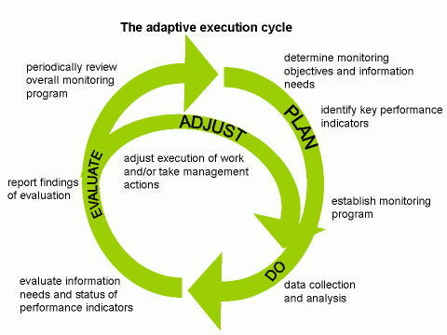
Figure 14: Adaptive management framework (Building with Nature Guideline)

Works cited

12.3, S. C. (2017). The Business Case for Reducing Food Loss and Waste .
Access Economics Pty Ltd. (2010). Horticulture Balanced Scorecard . sydney : Horticulture Australia Limited (HAL) .
Affairs, O. O. (2010, Septermber 03 ). About Voluntary Codes . Retrieved from strategis.ic.gc.ca/eic/site/oca-bc.nsf/eng/ca00963.html
Arcadis. (2019). National Food Waste Baseline Study.
Australia, C. o. (2015). Reef 2050 Long Term Sustainability Plan . Australian government .
Australia, C. o. (2018 ). National Waste Policy . Canberra : Commonwealth of Australia .
Australia, Commonwealth of. (2017). National Food Waste Strategy: Halving Australia's Food Waste by 2030. Canberra: Commonwealth of Australia.
CRC, C. F. (2018). Fight Food Waste: Cooperative Research Centre. Retrieved from fightfoodwastecrc.com.au: https://www.google.com/url?sa=t&rct=j&q=&esrc=s&source=web&cd=1&ved=2ahUKEwiEi5Ki9vXgAhUQ6nMBHePhC4AQFjAAegQIChAB&url=https%3A%2F%2Ffightfoodwastecrc.com.au%2F&usg=AOvVaw1yefP3704cwx0SBIFidyl7
Cristiana Ambiel, A. A.-F. (2019). Mapping of Australian fruit and vegetable losses pre-retail. CSIRO .
Dairy Australia Limited. (2019). 2018 Dairy Sustainability Report . Melbourne : Dairy Australia .
Ellen Mcarthur Foundation . (2019). Ellen Macarthur Foundation/ Circular Economy. Retrieved from https://www.ellenmacarthurfoundation.org/circular-economy/what-is-the-circular-economy
EU, F. (2014). Drivers of current food waste generation, threats of future increases and opportunities for reduction. Bologna: European Union.
FAO. (2017). Climate Analysis Indicators Tool. United Nations Food and Agriculture Organisation.
FIAL. (2019). Sector Competitiveness Plan .
FIAL. (May 2018). Food Waste Visit Report .
Fisher, K. (2017, November 21). Collaborating to improve efficiency along the whole value chain. WRAP2025. UK : WRAP .
Foodbank. (2018). Foodbank Hunger Report 2018.
Funnell, S. a. (2011). Purposeful Program Theory: Effective Use of Theories of Change and Logic Models. Wiley and Sons.
Global, F. (2019). Feedback Global Knowledge Hub . Retrieved from https://feedbackglobal.org/knowledge-hub/
Gunders, D. (2012). WASTED: How America is Losing up to 40 percent of its Food from Farm to Fork to Landfill. NRDC.
Institute, B. S. (2019). About the Balanced Score Card . Retrieved from Balanced Scorecard Institute: Strategy Management Group: balancedscorecard.org
Marsh, E. (2013, July). Food waste messages for maximum impact – how to engage your residents in [food waste] prevention and collections . Retrieved from wrap.org.uk: https://wrap.org.uk
May, S. (2018). Investigating International Models for Reducing Food Waste. Winston Churchill Memorial Trust.
Melbourne, U. o. (2016). Infograpahic:how much water we eat. Retrieved from https://research.unimelb.edu.au/foodprint-melbourne/publications/how-much-water-is-needed-to-grow-melbournes-food
OECD. (2010). DAC Quality Standards for Development Evaluation . Retrieved from OECD Quality Standards for Development Evaluation : http://www.oecd.org/dataoecd/29/21/2754804.pdf
Program, W. W. (2019, March 17). Courtnauld Commitment. Retrieved from WRAP.
ReFED. (2016). A roadmap to reduce U.S. food waste by 20 percent.
Refresh. (2018, June 19). Voluntary Agreements as a policy instrument for food waste reduction . Retrieved from EU-Refresh.org: https://eu-refresh.org/sites/default/files/MINUTES_REFRESH-Policy-Working-Group-on-VAs.pdf
Sheane, R. &. (2019). Food Loss and Waste Sector Guidelines – Turkey and Greece . EBRD (Unpublished).
WRAP. (2018). Courtnauld 2025 2017-2018 Review . WRAP.

6. Appendices

Appendix 1 Summary of Drivers of Food Waste by Supply Chain Stage (USA)

 | Potential remedies
Harvest
Weather/disease. Natural phenomena harm crops and lead to excess planting to hedge against this risk.  Market conditions. A crop’s price at time of harvest may not warrant the labor and transport costs required to bring the product to market.  Buyer quality standards. Selective harvest for minimum quality standards and shelf life leads to crops’ being left in the field.  Labor shortages. Where harvest timing is critical, a labor shortage leads to lower harvest rate.  Food safety scares. Public fear related to food safety for specific products can lead to huge losses. | Revision of quality standards to encompass wider array of appearances  Expansion of secondary markets for items with cosmetic damage  Farm-level food recovery via paid “concurrent picking” Regulatory measures that incentivize complete harvest  Regional food networks, leading to less transport and likely less culling for short-lived and damaged products
Processing
Trimming. This includes removal of both edible portions (peels, skin, fat) and inedible portions (bones, pits, etc.).  Processing efficiency. While most operations are quite efficient, some steps may lose more food than necessary. | Reengineering production processes and product designs  Secondary uses for trimmings and peels where not already being employed
Distribution
Improper handling. Various kinds of mishandling, such as deliveries needing refrigeration that sit too long on the loading dock, can damage products.  Inconsistent refrigeration. Truck breakdowns and other mishaps can lead to spoilage due to lack of refrigeration.  Rejected shipments. By the time a shipment is rejected, its contents have a shorter shelf life and may be difficult to sell before spoiling. | Proper training for handling and storage  Online solutions to facilitate sale or donation of rejected shipments
PAGE 21 | Wasted: How America Is Losing Up to 40 Percent of Its Food from Farm to Fork to Landfill
Drivers | Potential remedies
Retail: in-store
Food displays. excessive products may be displayed in  order to create the effect of abundance, which is believed to increase sales. There can also be overstocking, over-trimming, and improper stock rotation.  Ready-made food. Increases in this perishable category lead to greater discards at end of day.  Label dates. Products that pass their “sell by” dates are removed from shelves.  Pack size too large. Inflexible pack sizes lead to stores’ ordering more than they expect to sell.  Discarded product. The passing of holidays, promotion expiration, a high failure rate for new food products, and damaged packaging all lead to discarded product.  Low staffing. With tight staffing, there is less labor to prepare food on-site and therefore less flexibility in repurposing minimally damaged products. | Item-level analyses to identify opportunities to reduce SKUs or change ordering patterns  Discount offerings for out-of-date promotional items or slightly damaged goods.  Product display redesign using platforms and other props to make produce bins appear more full  Increased donations  Allowing prepared foods to run out near closing; more repurposing of foods.
retail: beyond store
Upstream  Cosmetic standards. Aesthetic requirements imposed by the market lead to non-harvest and culling of edible produce upstream.  Rejected shipments. By the time a shipment is rejected, its contents have a shorter shelf life and may be difficult to sell before spoiling.  Contract terms. Rigid contract terms can cause growers to overplant to make sure contracts are fulfilled.  Downstream  impulse/bulk promotions. Marketing and bulk promotions can lead consumers to purchase unnecessary goods that ultimately are not eaten once in the home. | Upstream  Increased flexibility in contract terms and grading standards  Experimental offerings of lower-cosmetic-grade produce to determine viability  Realigned promotions that discount blemished or soon-to- expire goods, or offer half off instead of 2-for-1 deals, etc.  Downstream  Consumer education on food quality and expiration (“sell by” dates, blemishes, and so on)  Closed dating codes on product so customers are not confused by “sell by” dates.
PAGE 22 | Wasted: How America Is Losing Up to 40 Percent of Its Food from Farm to Fork to Landfill
Drivers | Potential remedies
Food service
Large and inflexible portions. Diners often do not eat everything on their plate due to quantity and dislike of side items.  Expansive menu options. extended menus complicate inventory management and require more ingredients to be kept on hand.  Unexpected sales fluctuations. Bad weather and other unpredictable factors make inventory planning difficult.  Rigid management. Managers of chain restaurants are often unable to adjust for local demand or creatively use inventory.  Fast-food time limits. Items such as French fries, chicken nuggets, and burgers are discarded after a designated elapsed time after preparation.  School lunch timing. Schools may not provide enough time for lunch, may schedule lunch too early in day, or may schedule it before recess so that kids are not hungry. | Limited menu choices, use of specials to flush inventory, planning for food repurposing  Flexible portioning by allowing half-orders or by providing smaller portions with optional free refills, choice of side dishes  Training and encouragement of better menu management through certifications, associations, and culinary schools  Waste audits to understand patterns of excess  Staff engagement through rewards or incentives to participate in waste reduction  Encouragement for diners to take home leftovers with low- impact containers  Education about liability protection for business managers and owners
Households
Lack of awareness. Low prices discourage frugality, and little education has led to a lack of awareness about food waste among the majority of consumers.
Confusion over date labels. Multiple dates, inconsistent usage, and lack of education around date labels cause consumers to discard food prematurely.
Spoilage. Food spoils in homes due to improper or suboptimal storage, poor visibility in refrigerators, partially used ingredients, and misjudged food needs.
Impulse and bulk purchases. Promotions encouraging purchases of unusual or bulk products result in consumers’ buying foods outside their typical needs, and these foods can then get discarded.
Poor planning. Consumers may overbuy because they fail to plan meals, fail to use a shopping list, inaccurately estimate what is needed for meal preparation, or decide on impromptu restaurant meals.
Overpreparation. Preparing more food than needed can lead to waste unless leftovers are saved and consumed.

Appendix 2: Information on policy levers, solutions and 20 habits of food waste reduction leaders

Note: The information below has been extracted from international sources to provide additional insights on reducing food waste from various perspectives.

Figure 15: The many solutions to food loss and waste (Fisher, 2017)

Figure 16: Policy Levers (Sheane, Barthel and Schreiber, 2019)

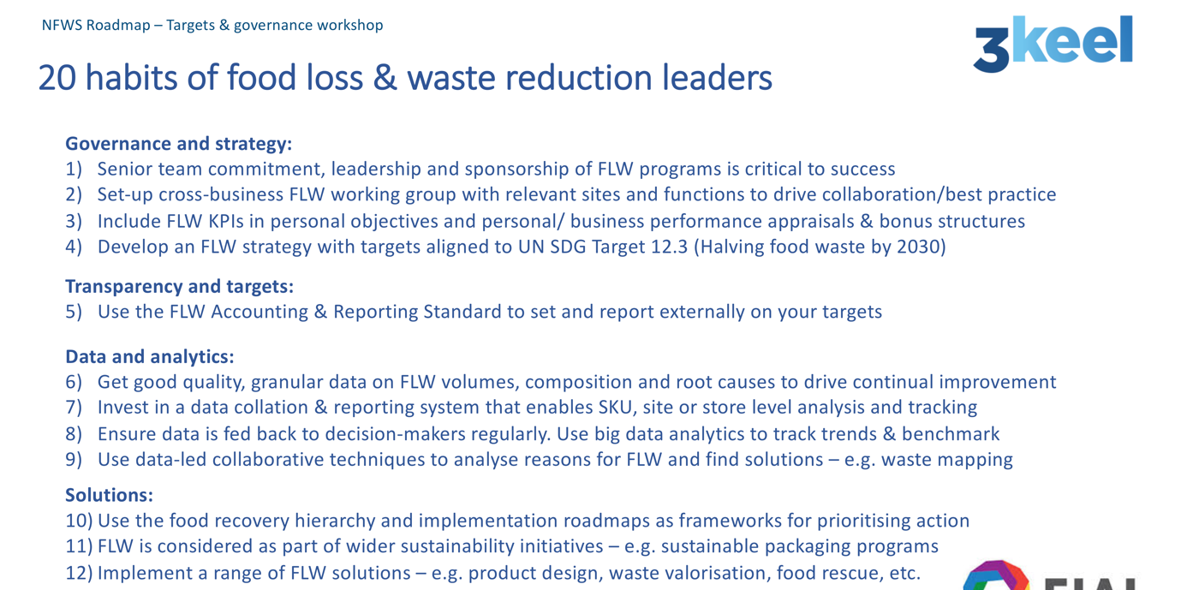

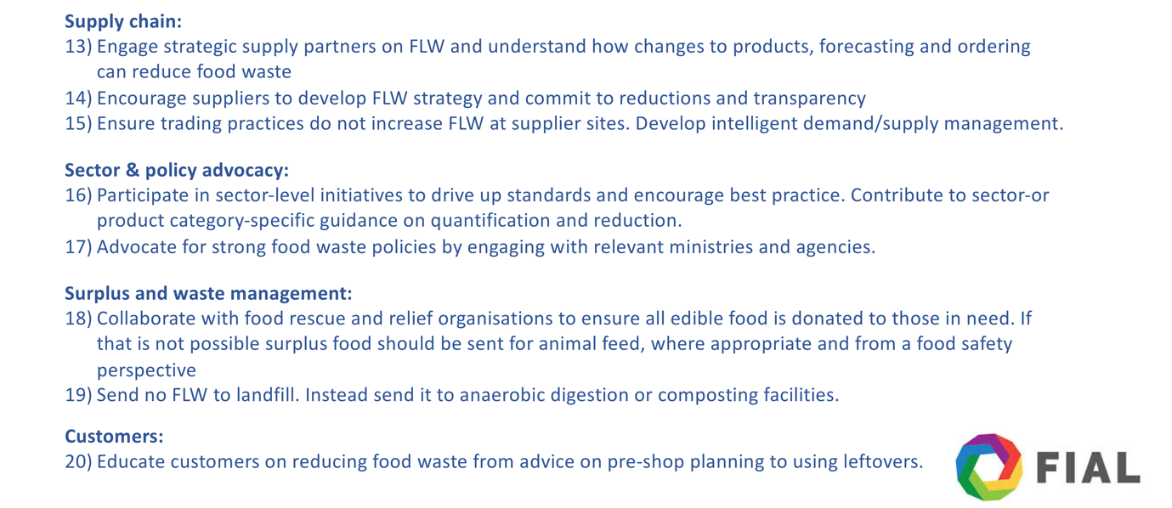

Figure 17: 20 habits of food loss and waste reduction leaders (Sheane, Barthel and Schreiber, 2019)

For example, the Sustainability Scorecard developed as part of the UK government-funded SIGMA Project, which adapted the balanced scorecard approach to help measure the triple bottom line performance of organisations. NOTE: SIGMA stands for: Sustainability – Integrated Guidelines for Management.
Please see: https://furtherwithfood.org
Please see: Food waste messages for maximum impact – how to engage your residents in [food waste] prevention and collections

