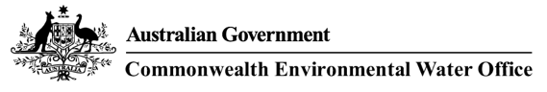

Restoring Our Rivers
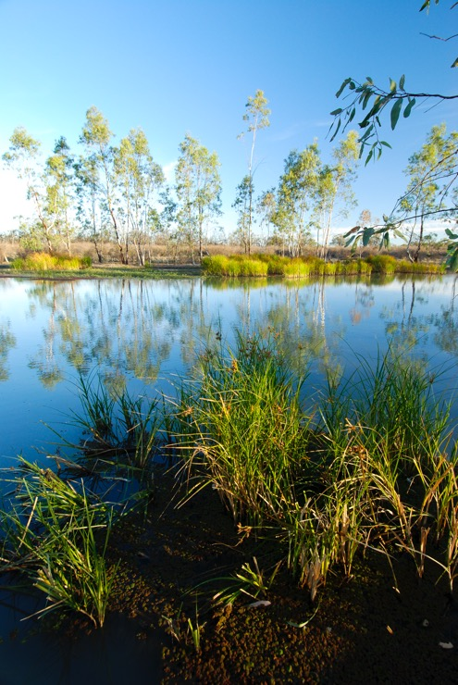
Murray river national park, katarapko section, South Australia (Bill Doyle)

Table of Contents

The role of the Commonwealth Environmental Water Holder 4
Working in partnership 5
Localism relies on local knowledge and experience 6
Outcomes demonstrated through monitoring and evaluation 7
Protecting and restoring our rivers, wetlands and floodplains 8
2014–15 Outcomes Snapshot 11

THE ROLE
of the Commonwealth Environmental Water Holder

Water dedicated to improving the health of our rivers, floodplains and wetlands and the wide diversity of life they support is known as environmental water.
The Commonwealth Environmental Water Holder’s substantial water entitlements and allocations have been acquired through the Australian Government’s investment in water-saving infrastructure and water buybacks throughout the irrigation districts of the Murray-Darling Basin, as part of national water reforms (as per the Water Act 2007 and the Murray-Darling Basin Plan).
Commonwealth water often supplements the environmental water delivered locally by State water holders and managers and their local delivery partners. Over the past five years, over 4,000 gigalitres of Commonwealth water has been delivered to the environment.
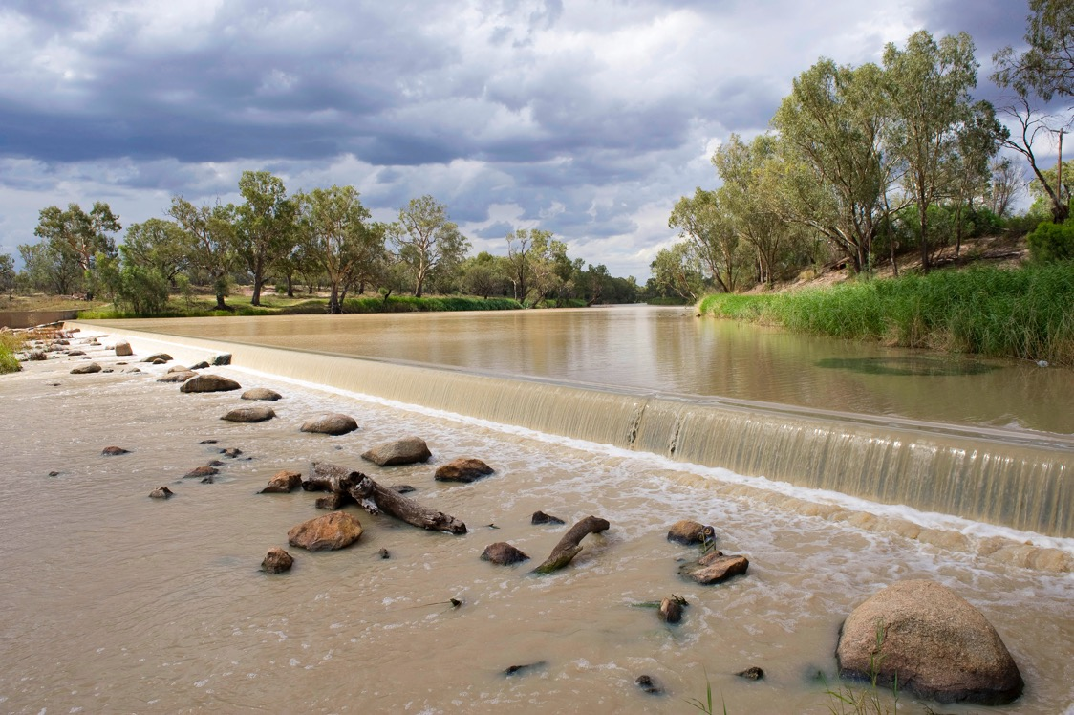
Weir on the Barwon River, NSW (Arthur Mostead)

working
in partnership

The Commonwealth Environmental Water Holder makes water available for delivery by State environmental water holders and managers, non-Government organisations, their local delivery partners and river operators.
By delivering the right amount of water at the right time and in the right place, Commonwealth environmental water is helping to restore parts of the Murray-Darling Basin’s natural system that have been impacted by river regulation and infrastructure created for human needs.
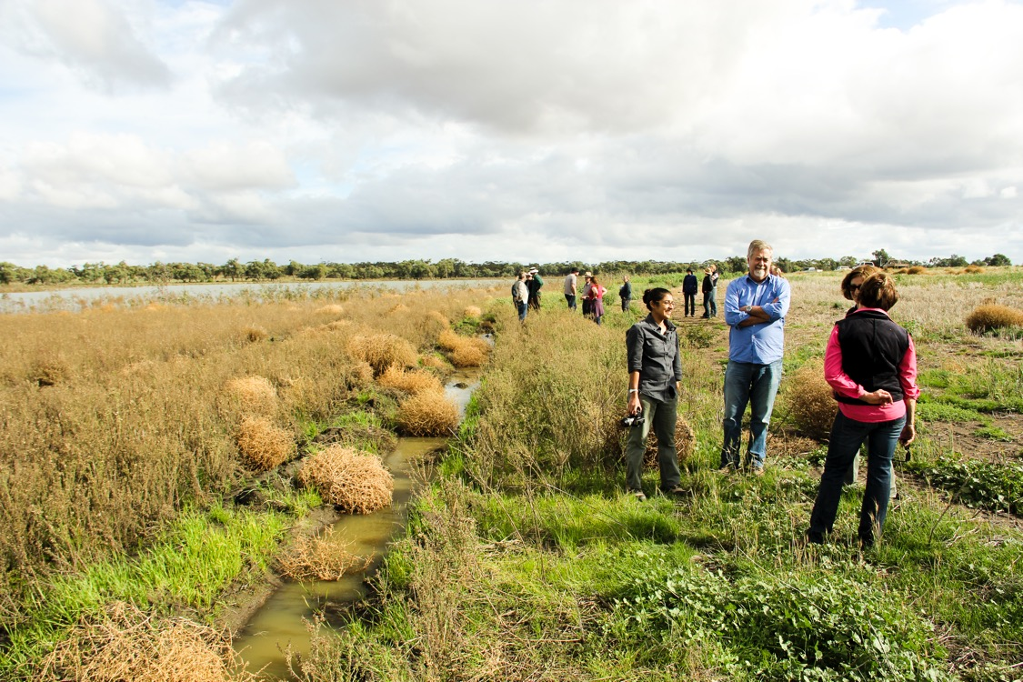Commonwealth Environmental Water Holder David Papps with officers from NSW Office of Environment and Heritage and Landholders at Paika Lake, NSW

Localism
relies on local knowledge and experience

Together with State and local delivery partners, the Commonwealth Environmental Water Holder seeks advice from environmental water advisory groups and we regularly attend community forums within the catchments.
The Commonwealth Environmental Water Office also has six local engagement officers working alongside State and local land and water management officers, providing outreach to local communities throughout
the Basin.
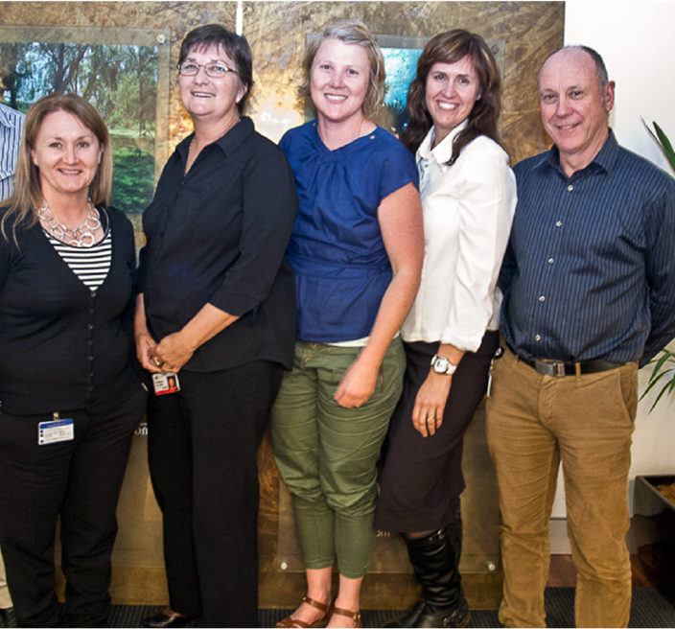
Local engagement officers located throughout the Basin
outcomes
demonstrated through monitoring and evaluation
The Commonwealth Environmental Water Holder commissions scientific monitoring and evaluation to build knowledge about environmental water use and its effectiveness over time.
This work involve teams of experts, including scientists from some of Australia’s leading regional research institutions, and local land and water managers, who are assessing the impacts of environmental water use in the Gwydir, Lachlan, Edward-Wakool, Murrumbidgee, Goulburn, Lower Murray and the Junction of the Warrego and Darling rivers. This five-year monitoring programme complements short-term monitoring projects undertaken since 2010.
Monitoring and evaluating environmental water use is helping to build knowledge about the best way to get positive outcomes, based on what works and what doesn’t work. This ‘adaptive management’ approach helps the Commonwealth Environmental Water Holder make decisions on the Australian Government’s large portfolio of environmental water and its future use.

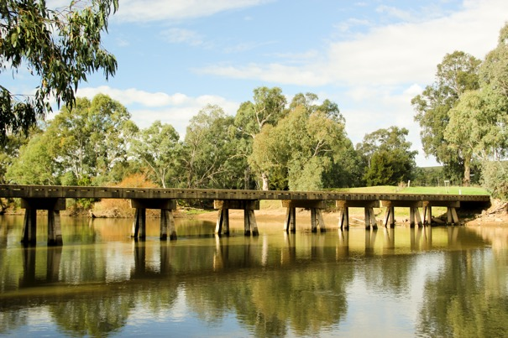
Murrumbidgee, NSW
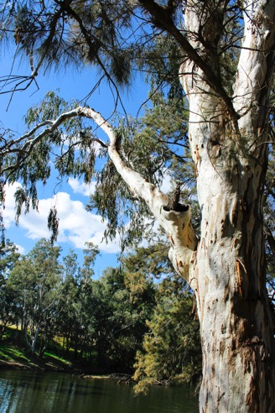
River red gum Burrendong Dam Macquarie River, NSW
protecting
and restoring our rivers, wetlands and floodplains

The Commonwealth Environmental Water Holder makes decisions about the most effective use of water according to the environmental objectives and targets of the Basin Plan – the national framework for managing the range of competing demands for the Basin’s water resources.
Targeted use of Commonwealth environmental water is helping to reestablish the natural variability in river flows, reconnecting rivers with their adjacent floodplains and wetlands, and providing food, habitat and breeding opportunities for native fish, waterbirds and vegetation. It is also reducing the risk of damage to the environment caused by poor water quality and salinity.

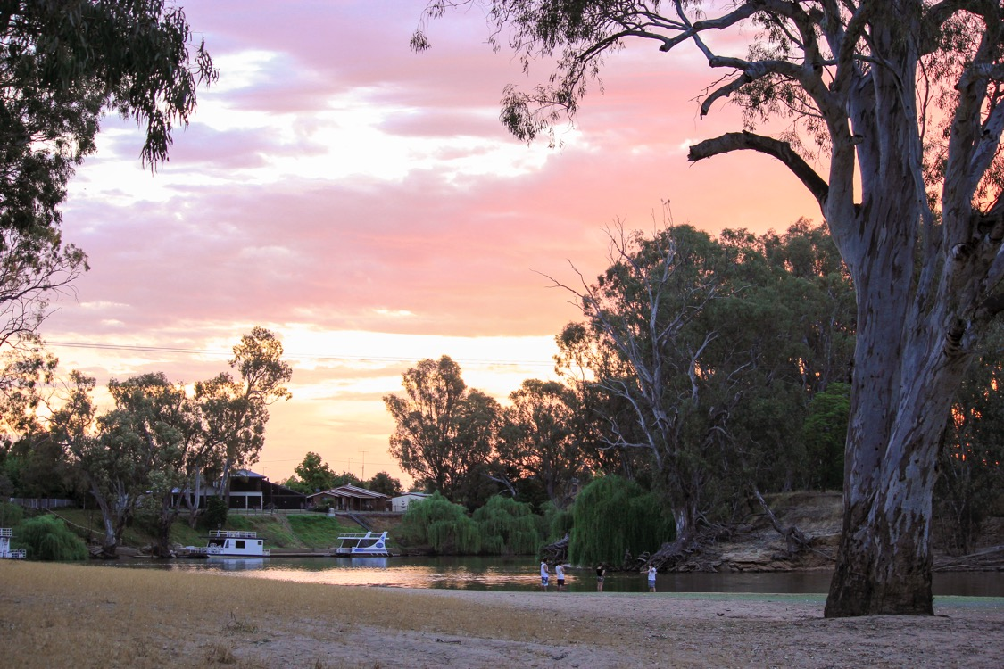
Edward River near Deniliquin, NSW

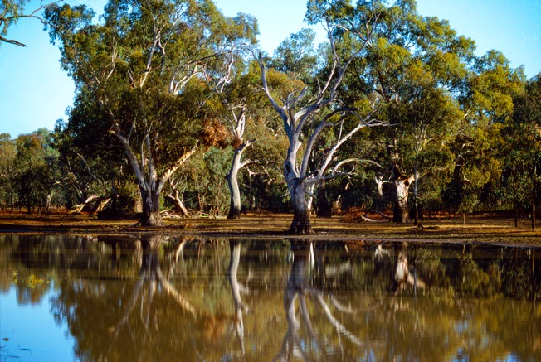
River Red Gums lining a billabong on the Lachlan River near Forbes, NSW

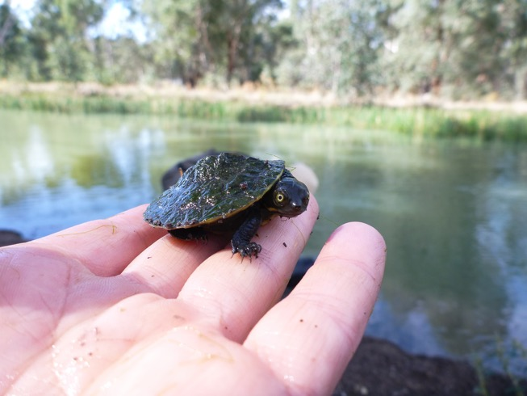
Macquarie River Turtle hatchling Murrumbidgee, NSW (Andrea Fullagar)

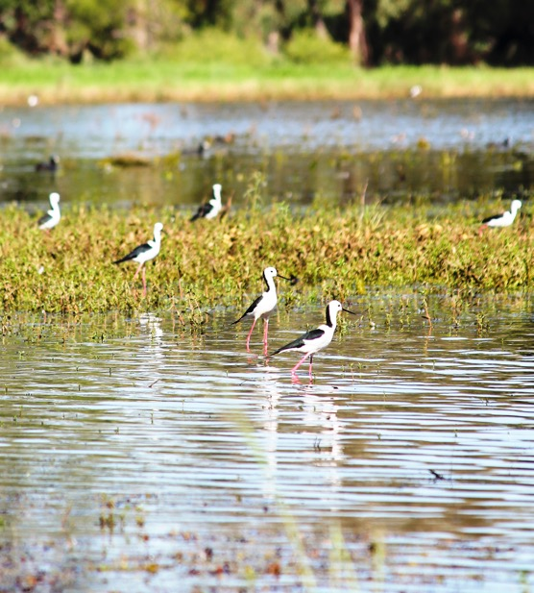
Black Winged Stilts, Gwydir wetlands, NSW

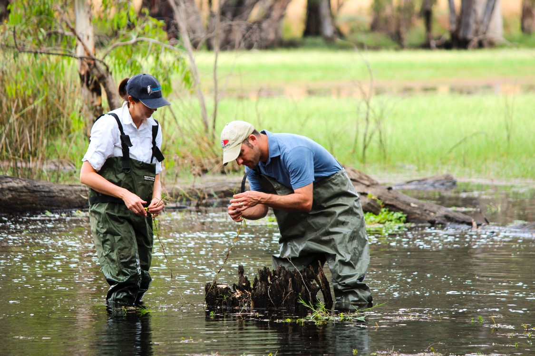
Reedy Lagoon,Gunbower, Victoria
2014–15 Outcomes Snapshot

Commonwealth environmental water contributed to all seven of the 2014–15 Basin annual environmental watering priorities set by the Murray-Darling Basin Authority. This means improved outcomes for native fish, birds, frogs and habitat.
However, redressing environmental decline that has occurred over decades is going to take some time. It will be at least ten years before we can show lasting change and improvements to the health of the rivers, floodplains and wetlands, consistent with the long-term targets of the Murray-Darling Basin Authority’s basin-wide environmental watering strategy.
Full reports on all monitoring activity are available on the publications page of our website www.environment.gov.au/water/cewo
The Murray-Darling Basin Authority and State agencies also invest in a range of complementary monitoring programmes.

Figure 1: Water Supply and Water Delivered
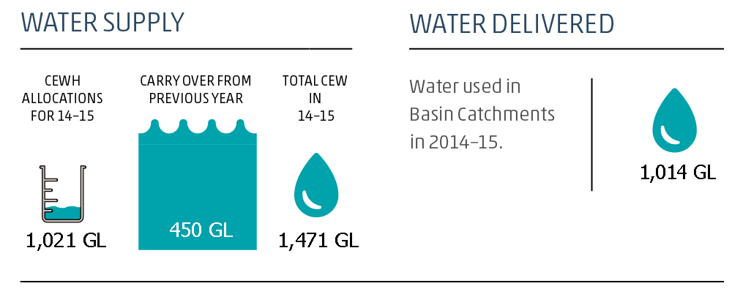

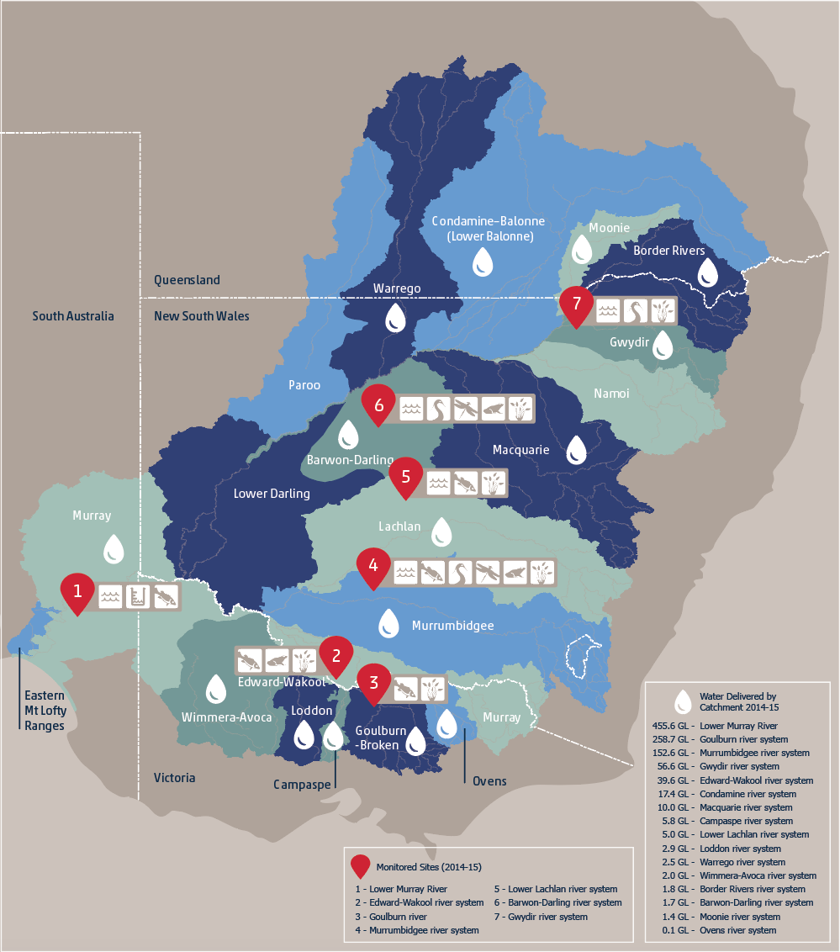

- Lower Murray River
Continuous flows in the Coorong have been critical to protecting estuarine vegetation and fish species from increasing salinity levels. Environmental water contributed significant proportions of the total amount of nutrients exported from the River Murray, Lower Lakes and Murray Mouth. According to modelling, it also helped to prevent the import of over 3,000,000 tonnes of salt through the
Murray Mouth.
Commonwealth environmental water contributed 100 per cent of the flows over the barrages into the Coorong from November 2014 to June 2015. This water contributed to increased water velocity in the main river channel, increasing the occurrence of flowing water habitats, which is important for riverine fish such as Murray Cod.

- Edward-Wakool
Positive outcomes for increased levels of dissolved oxygen in the water, coupled with aquatic vegetation growth, will contribute to the improvement of the system over the longer-term by providing habitat for invertebrates and small bodied fish, and potentially improving riverine productivity.
A native Obscure Galaxias was detected in the river system for the first time in five years of monitoring.
Opportunities for frog reproduction were increased by inundating sedges and grasses along the riverbank and backwaters, especially in Yallakool Creek and the mid-Wakool River. This water created shallow vegetated habitat, allowing frogs to spawn and tadpoles to thrive.
A strong response by aquatic and semi-aquatic plant species was observed in-stream and in wetlands that received environmental water during spring 2014.

- Goulburn
Spring flows resulted in strong golden perch spawning, with eggs and larvae collected in numbers not seen since the 2010 floods. The critically endangered silver perch also spawned following increased flows.
Environmental flows also promoted movement with golden perch moving down the river to spawning areas.
Flows delivered during spring 2015 helped to maintain and improve on the vegetation abundance and diversity in the regions previously inundated during 2014. The resulting growth improved the condition and cover of the native plant species Lesser Joyweed and Creeping Knotweed, both of which prefer wetter habitats.

- Murrumbidgee
Environmental Water was the primary mechanism by which the Murrumbidgee wetlands and floodplains received water during 2014-15. This resulted in improvements in water quality and a reduction in dissolved nutrients (carbon and phosphate) on the floodplain. Return flows in the Lowbidgee Floodplain also contributed to improved water quality across the river red gum wetlands.
Repeat golden perch and critically endangered silver perch spawning events were detected along the river channel between November and December 2014.
Other native fish species such as Murray cod and Australian smelt spawned in the Murrumbidgee River. Results also indicated good larval numbers while invasive species were low in abundance.
There was a boom in native bird breeding following environmental water delivery to the Yanga National Park in early 2015, with hundreds of nankeen night heron, cormorant and darter nests, and 150 Eastern great egret nests recorded, including the first breeding of the internationally recognised Eastern great egrets in the Park since 2011.
Evidence of highly productive microinvertebrate communities (important food for larval fish and filter-feeding waterbirds) were recorded.
Opportunities for frog reproduction were increased with evidence of successful breeding of the vulnerable southern bell frog and the inland banjo frog (the first recorded breeding in the Mid-Murrumbidgee wetlands since 2010).
Wetland-dependent vegetation in Yarradda Lagoon was maintained and improved with significant increases in the coverage of spiny
mud-grass – an important aquatic species known to dominate this wetland in the 1990s.
Diverse aquatic vegetation communities were established throughout the Lowbidgee Floodplain.

- Lower Lachlan
Approximately 80 per cent of the fresh delivered to the Lachlan River during early September 2014 was Commonwealth environmental water, with water levels rising by up to 1.5 metres between Willandra Weir and Booligal. The fresh was sourced from natural tributary inflows which provide flow variability and changes in hydraulic character, which are known to be beneficial to fish.
Larval fish monitoring in the lower Lachlan River indicated that native fish (Murray cod, flat-headed gudgeon, eel-tailed catfish, Australian smelt and carp gudgeon) successfully spawned in the system in spring 2014. With the exception of eel-tailed catfish, these species were also recorded as small individuals, indicating that subsequent conditions supported recruitment of
native fish.
The environmental water delivered in spring 2014 reached the central reed beds of Great Cumbung Swamp, a wetland listed in the Directory of Important Wetlands in Australia.

- Junction of the Warrego and Darling
The connection between the Warrego River and Western Floodplain was increased, providing additional habitat for aquatic animals and allowing for the exchange of organic matter and nutrients.
Environmental water contributed to flows in the Warrego and Darling rivers, breaking periods of low flow and inundating habitats that are important for nutrient cycling within the river channel.
The internationally protected Eastern great egret, black fronted dotteral, grey teal, pink eared duck, herons, brolga, and Australian grebe benefited from the inundation of the Western Floodplain.
Inundation of the Western Floodplain persisted for over eight months and supported a diverse and unique range of microinvertebrates including copepod crustaceans, seed shrimps and round worms.
Barking frog, spotted marsh frog, Peron’s tree frog and desert tree frog also benefited.
Inundation of 37 hectares of key communities on the Western Floodplain, positively influenced plant diversity and cover, supporting the growth of native herb species such as River mint and Slender knotweed.

- Gwydir
Environmental water inundated 6,342 hectares of the Gingham and Gwydir wetlands.
Water delivered down the Mehi River and Carole Creek produced a defined flow pulse that reached the Barwon River, influencing river levels as far downstream as Bourke.
This helped to maintain water quality, facilitate the transport of nutrients, organic matter and aquatic plants and micro-organisms between sites.
Significant increases in waterbird species diversity and total abundance were observed at sites that received water. This included seven species listed under international agreements such as Latham’s snipe, Sharp-tailed sandpiper, Brolgas and Magpie geese. Several species including the plumed whistling-duck and Australasian darter were recorded breeding at a number of sites.
A diverse range of vegetation communities were inundated with increased coverage of native species such as water couch
out-competing weed species such as Lippia.

The Commonwealth Environmental Water Holder acknowledges Australia’s traditional owners and respects their continued connection to water, land and community. We pay our respects to them and their cultures and to their elders both past and present.

© Commonwealth of Australia, 2016

For more information about Commonwealth environmental water, please contact us at:
T: +61 2 6274 1111 or 1800 218 478
E: ewater@environment.gov.au
W: www.environment.gov.au/water/cewo
Twitter: @theCEWH
Postal address: GPO Box 787, Canberra, ACT 2601

