RESTORING and PROTECTING THE
BORDER RIVERS
2016–17

The Commonwealth Environmental Water Holder acknowledges Australia’s traditional owners and respects their continued connection to water, land and community. We pay our respects to them and their cultures and to their elders both past and present.

T: 1800 803 772
E: ewater@environment.gov.au
W: www.environment.gov.au/water/cewo
Twitter: @theCEWH
Postal address:
GPO Box 787, Canberra ACT 2601

Environmental water is dedicated to improving the health of our rivers, floodplains and wetlands
The Border Rivers region contains diverse and rich natural environments that support domestic water use, extensive agriculture and irrigated production, cultural values and practices of local Aboriginal Traditional Owners as well as tourism and recreational activities.
Environmental water is delivered to key locations to support the Border Rivers’ many unique native animals, plants, birds and fish that rely on healthy waterways, creeks and wetlands including nationally significant wetlands.
The Border Rivers region is abundant with native fish in particular, supporting at least 16 species including a number of threatened species such as the Murray cod, silver perch, purple-spotted gudgeon, olive perchlet and eel-tailed catfish.
The Border Rivers’ many billabongs and wetlands, when flooded, support nationally and internationally significant waterbirds including the great egret, brolgas, Australian painted snipe, black-necked storks and magpie geese.
The Morella Watercourse/Boobera Lagoon/Pungbougal Lagoon complex is a nationally significant wetland with the Boobera Lagoon considered to be one of the most important Aboriginal places in eastern Australia. Boobera Lagoon is also one of the few permanent waterbodies in the northern Basin, providing valuable habitat for wildlife during drought.
The lower reaches of the Severn River in Queensland and the Severn River in New South Wales are also significant areas, supporting a large range of native fish and providing refuge pools to these species in times of drought.
Commonwealth environmental water is managed in partnership with state and local delivery partners to improve connections between rivers, floodplains and wetlands, particularly, to those sites that support nationally threatened species under the Environmental Protection and Biodiversity Conservation Act 1999, state-based legislation and wetlands of international or national significance. We are also working toward the achievement of environmental outcomes as outlined in the Basin-wide Environmental Watering Strategy (part of the implementation of the Murray-Darling Basin Plan).

Summary of longer-term outcomes under the Basin-wide Environmental Watering Strategy
Maintain base river flows.
Maintain current extent of river red gum and blackbox communities, along with improvements to condition and greater likelihood of young tree survival. These communities are essential for providing food and habitat for many native animals across the Basin and are culturally significant to local Aboriginal people.
Maintain the extent of non-woody vegetation communities near or in wetlands, streams and on low-lying floodplains and improve the condition of lignum shrubland communities of the lower Border Rivers.
Maintain the current species diversity and increase abundance of waterbirds by supporting breeding opportunities. However, in the Border Rivers Valley, Commonwealth environmental water could be used to improve habitat and foraging opportunities for waterbirds, but is unlikely to significantly contribute to large scale breeding events.
Prevent loss of native fish species by supporting regular recruitment (for short, medium and long-lived species) and increased movement and distribution. This is particularly important in the Macintyre River from Mungindi to the junction of the Severn River in NSW, the floodplain lagoons between Goondiwindi and Boomi, and the Queensland Severn River in Sundown National Park.
Recruitment describes a species’ (like native fish or plants) survival through all life stages. Improved or supported recruitment means that over the long-term a species’ population features a range of ages.

Environmental water use in the Border Rivers to date
Environmental demand and water availability influence Commonwealth environmental water management. Environmental water can be used with the purpose of assisting to ‘avoid damage’ to the environment through to ‘improving’ ecological health depending on how much water is available and the environmental need of the system.
The last three years have seen low water flows to the Border Rivers region. However, small local rainfall events provided a series of small freshes throughout the system in 2014–15 and 2015–16.
While the freshes experienced in the last few years were below the level needed to achieve connectivity with wetlands and floodplains in the lower catchment, small amounts of water have helped maintain an almost continuous flow to the end of the system throughout
2015–16. Murray cod and eel-tailed catfish bred in the Dumarseq River during spring 2015 and there were a good number of large-bodied fish observed in the Severn River (New South Wales), despite the prolonged drier than average period.
A fresh event describes an increase in levels of the river beyond the base flow, but does not fill the river channel or go over the bank.
This year, Commonwealth environmental water may be used to improve in-stream habitat to support threatened fish species in the Dumaresq and Macintyre Rivers. If there is sufficient additional rainfall, Commonwealth environmental water could contribute to improving wetland connectivity and breeding
of threatened fish species in the lower
Macintyre River. If conditions become very
dry again Commonwealth environmental
water may be used to contribute to
drought refuges.

Commonwealth environmental water supply
The water acquired by the Australian Government through investment in more efficient irrigation infrastructure, and other measures, assists with providing some of the river flows needed to restore and protect river systems throughout the Basin’s irrigation districts.
Commonwealth environmental water is
often used to supplement large rainfall
events and environmental water provided
by the New South Wales Office of Environment and Heritage.
Depending on river operating rules,
flow constraints and climatic conditions,
the Commonwealth Environmental Water Holder can agree to:
- use water to meet identified
environmental demands
- hold on to the water and carry it over
for use in the next water year
(‘carryover’)
- trade (sell or buy water) for equal or greater environmental benefit.

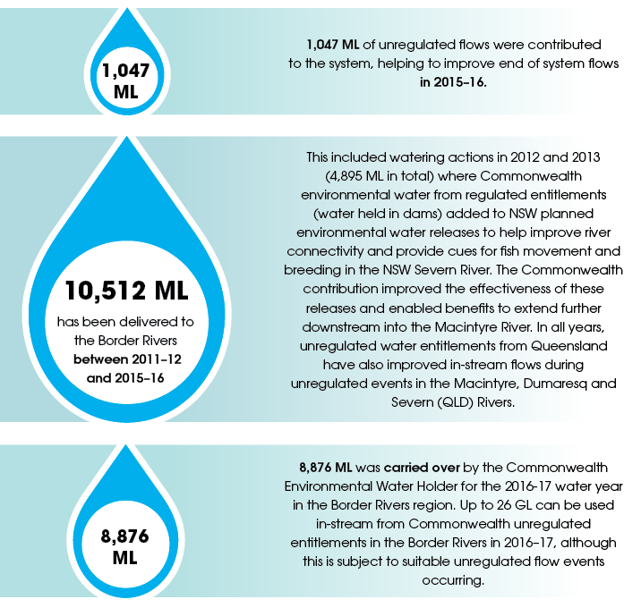

Planned environmental water in the Border Rivers system is water that has been set aside for environmental purposes once the cap (maximum limit) on the extraction amount for consumptive use has been reached. This ensures that water remains in the river system with the sole purpose of servicing the environment.
Unregulated flow is water generally not captured by dams.
Regulated flow is a river flow released from a dam or storage that has been ‘ordered’ by a customer who holds a water entitlement.

Our partners
The best approaches to environmental water management involve local knowledge and the latest science.
Commonwealth environmental water use is planned, delivered and managed in partnership with a number of individuals and organisations in the Border Rivers region, including:
- Queensland Department of Natural Resources and Mines
- Queensland Department of Science, Information Technology and Innovation
- Queensland Department of Agriculture and Fisheries
- New South Wales Office of Environment and Heritage
- New South Wales Department of Primary Industries – Water
- New South Wales Department of Primary Industries – Fisheries
- Local Land Services – Northern Tablelands
- Sunwater
- Queensland Murray-Darling Committee Inc
- WaterNSW
- Eco Logical Australia
- Border Rivers Environmental Water Network
- Border Rivers Food and Fibre
- Murray-Darling Basin Authority

The Commonwealth Environmental Water Office regularly attends community forums, events and committees within the catchments and we are continuing to forge local partnerships that allow community groups, including Aboriginal Traditional Owners, to help shape the regional planning and management of environmental water delivery over the long term.
Please contact your local engagement officer Rosemary Millward to learn more about our work or offer suggestions for the use of environmental water locally.
Rosemary Millward
Local engagement officer –
Goondiwindi, QLD
M: 0418 210 289
E: rosemary.millward@environment.gov.au

BORDER RIVERS
The Border Rivers region is spread across both New South Wales and Queensland with roughly equal area in each state.
The system is based around the Macintyre and Dumaresq rivers, which merge upstream of Boggabilla and continue as the Macintyre River (the Weir River is the only significant tributary downstream of Boggabilla). The Dumaresq River, Macintyre River and the Barwon River (downstream of the junction of the Weir River to Mungindi - the end of the Border Rivers system) forms the border between NSW and Queensland for approximately 470 kilometres. The Macintyre River's main tributary is the NSW Severn River.
Planning for the best use of Commonwealth environmental water to achieve healthy river systems and species must take into account; the water that is currently available and the climate conditions (eg. is it a dry or wet year); how urgently some parts of the system require water to maintain ecological health, and; different environmental watering scenarios based on the considerations above. Commonwealth environmental water, in particular, has a focus to support threatened species and communities under the Environmental Protection and Biodiversity Conservation Act 1999, such as the Murray cod, silver perch, Australian painted snipe and great egret.
In 2016-17 the overall focus for use of Commonwealth environmental water in the main channel of the Border Rivers (Dumaresq and Macintyre rivers) is to provide additional water to the system during unregulated flow events (rainfall) or large regulated flows to help improve the overall ecological health of these river systems and support fish and waterbird habitat. To ensure that the health of some key floodplain locations is maintained (those that are isolated from river flows as a result of resource development) small volumes may be delivered to specific wetlands and/or anabranches in the lower Macintyre floodplain using public and private irrigation infrastructure.
Should the river dry significantly and system connectivity be lost, the focus will shift to supporting basic river health, through a watering action to replenish refuge pools and improve water quality to the end of the system.

Responding to environmental demands
Proposed Commonwealth environmental watering priorities for 2016-17 (taking into account different climate scenarios) are:
River Channels: Across the Border Rivers region there is a moderate to high demand for environmental watering to improve water quality, in-stream habitat and river connectivity (both between river and anabranches/floodplain, as well as along the river) to support native fish movement and breeding.
In the lower Macintyre River there is a high demand for a large fresh of water to improve habitat for native fish and connect the channel to low level wetlands. There is moderate demand for flows from late winter and early summer months in the Dumaresq River to encourage movement and breeding of native fish and to provide access to breeding habitat for key species.
Meeting any of these environmental demands will require additional flows in the system, such as a rainfall event or a large irrigation delivery, to which Commonwealth environmental water would be added to improve outcomes and extend the period of flow. Commonwealth environmental water on its own cannot meet all the demands.
If a prolonged dry period eventuates in 2016-17, Commonwealth environmental water may be required to provide a flow to the end of the Border Rivers system at Mungindi, with other flows if possible, to support drought refuges and improve water quality.
Into the future, other opportunities to provide water to the Border Rivers region may occur if water availability is high or if environmental water holdings (entitlements) are increased within the region.
Anabranches: There is a moderate to high environmental demand to connect anabranches and the river channel to support floodplain vegetation and wetland health and to bring nutrients and carbon into the main river.
The anabranches of the lower Macintyre River have had limited connection to the main river channel since 2013 due to low flows. However, rainfall in June/July 2016 has assisted to improve river flows into a number of anabranches. It is important to note that in order to really maximize the benefit of environmental water in this region, we require a greater understanding about the necessary frequency and protection of in-channel flows to support the anabranches. Therefore, watering in 2016-17 is likely to be targeted to specific anabranches, using infrastructure like pumps, where multiple environmental benefits can be achieved (for example, supporting native fish and maintaining wetland vegetation).
Wetlands: The watering demands of wetlands in the Border River region ranges from low to high. As the wetlands along the Macintyre River, between Goondiwindi and Boomi have not been sufficiently inundated for at least three years there is high environmental demand. These wetlands require filling so that they can reconnect with the main river to improve water and soil quality, support movement of native fish and build the health and resilience of vegetation. There is also a high demand for water in the near stream wetlands in the lower Dumaresq River due to prolonged low flows.
Realistically, it is unlikely that there will be enough Commonwealth environmental water available to meet the demands of the wetlands along the lower Dumaresq River. A contribution to meet the wetland demands in the lower Macintyre River is likely to require using available Commonwealth environmental water holdings in conjunction with an unregulated flow.
Wetlands higher on the floodplain of the Macintyre River, such as the Morella watercourse south of Goondiwindi have a moderate demand for water. These demands will become critical if not met this year. If a large unregulated flow does not eventuate this year, water could potentially be delivered using private infrastructure like pumps, to some wetlands.
Currently wetlands in the NSW Severn River have low demand for water, as these have been watered for the last four years through unregulated flows, irrigation deliveries and the NSW stimulus flows.
A stimulus flow is used to achieve any number of objectives such as to tumble rocks, scour and disturb algae and stimulate in-stream production. It can also allow for water based species to access a greater range of habitats to feed and find shelter.

