

**Review of Goulburn Murray Water (GMW)**

**Water Efficiency Project**

Efficiency Measures Section

Department of Agriculture, Water and the Environment



**Contents**

1. **Executive Summary 2**
2. **Purpose of Report 3**
3. **Project description 3**
4. **Scope and method 5**
5. **Proposal documentation 6**
6. **Analysis 7**

**6.1 Backbone Transformation Project 7**

**6.1.1** Enquiry 1: Are the proposed works likely to generate the proposed water savings 7

**6.1.2** Enquiry 2: Are the costs consistent with the nature of the works 8

**6.1.3** Enquiry 3: What extent does the detailed budget demonstrate appropriate costings that

reflect market realities – including the appropriateness of any contingency costs and

escalations 11

**6.2 Shepparton East Project Delivery (SEP) 14**

**6.2.1** Enquiry 1: Are the proposed works likely to generate the proposed water savings 14

**6.2.2** Enquiry 2: Are the costs consistent with the nature of the works 15

**6.2.3** Enquiry 3: What extent does the detailed budget demonstrate appropriate costings that

reflect market realities – including the appropriateness of any contingency costs and

escalations 17

1. **Conclusions 19**

General 19

Enquiry 1: Are the proposed works likely to generate the proposed water savings 19

Enquiry 2: Are the costs consistent with the nature of the works 20

Enquiry 3: What extent does the detailed budget demonstrate appropriate costings that reflect

market realities – including the appropriateness of any contingency costs and escalations 20

1. **Recommendations 22**

GHD ADVISORY

ii

Review of Goulburn Murray Water (GMW) Water

Efficiency Project

**Schedule of Tables**

Table 1: Budget Estimates by Work Types 4

Table 2: BTP Water Savings across 5 irrigation districts 7

Table 3: BTP Base Cost by Modernisation Type and Irrigation Area 8

Table 4: DELWP Estimated BTP project costs 11

Table 5: Overall BTP project costs 12

Table 6: SEP water savings 14

Table 7: SEP forecast base costs 15

Table 8: SEP summary of costs 17

GHD ADVISORY

iii

Review of Goulburn Murray Water (GMW) Water

Efficiency Project

**Glossary**

|  |  |
| --- | --- |
| Affordability | An assessment of whether proposals can be paid for in terms of resources, cash-flows and funding. |
| BTP | Backbone Transformation Project |
| Base Case | The financial description of the project in terms of costs, revenues, and resulting conclusions. It combines the sensitivity variables to consider the most likely scenario |
| Benchmarking | A comparison of cost of an item or service against the market price for that item or service. Benchmarking is an alternative for “value testing”, the objective of which is to test the actual level of costs of the soft services against the market; this is the other most common alternative to market testing |
| Benefit | Benefit is the measureable improvement that results from an [outcome.](https://www.nzta.govt.nz/planning-and-investment/learning-and-resources/business-case-approach-guidance/supporting-material/glossary/#Outcomes) It answers the question: ‘what value is derived from this outcome |
| Business Case | The document that articulates the rationale for undertaking an investment. |
| Capital expenditure | Capital expenditure (Capex): The initial construction costs of the infrastructure plus any expenditure on the constructed PPP assets that is not an operating expense (Opex). |
| Construction risk | The possibility that during the Design and Construction Phase the actual project costs or construction time will exceed those projected |
| Contingency | Unallocated reserve in the capital expenditure (Capex) budget to cover the cost of any unexpected, but required, capital expenditure. It is covered by contingent or standby funding. |
| Cost-Benefit Analysis | A type of analysis used to compare two or more options for a project or a decision based on economic flows duly adjusted, following some patterns. The CBA is primarily used to assess the socio-economic feasibility or value of the selected project or project under assessment (regardless of the method of procurement). |
| Cost Estimate  Confidence Levels | The accuracy of cost estimates will vary greatly depending on the degree of information available to inform the estimate. Confidence levels covey the likelihood of going over or under the estimate.  For infrastructure projects, it is typical to estimate the P50 and P90 project cost estimates. The P90 cost (for example) is the project cost with sufficient contingency allowance to provide a 90 percent likelihood that the cost will be exceeded. |

GHD ADVISORY

iv

Review of Goulburn Murray Water (GMW) Water

Efficiency Project

|  |  |
| --- | --- |
| Due Diligence | An investigation or review performed to confirm the facts of matter under consideration. |
| ECI Contractor | Early Contractor Involvement or ECI is a method of procurement/delivery for major construction projects. The John Holland Group was appointed in 2017 as the GMW Project’s ECI Contractor to deliver the majority of the Project’s design and construction works. |
| Net present value | NPV is a primary investment decision criterion. NPV is defined as the difference between the present value of a stream of benefits and that of a stream of costs. A positive NPV occurs when the sum of the discounted benefits exceeds the sum of the discounted costs. |
| Risk | The likelihood, measured by its probability that a particular event will occur. |
| SEP | Shepparton East Project |
| Value for Money | Concept is used in any investment decision to be taken by the government to mean that the investment is creating net value to the society (or to the tax payer), and it is tested by cost-benefit techniques  For this project – the VfM measure is the Cost per Megalitre of water savings which is derived from the proposed water savings works. |

GHD ADVISORY

v

Review of Goulburn Murray Water (GMW) Water

Efficiency Project

**This report: has been prepared by GHD for Client and may only be used and relied on by Client for the purpose agreed between GHD and the Client as set out in Section 3 of this report.**

**GHD otherwise disclaims responsibility to any person other than Client arising in connection with this report. GHD also excludes implied warranties and conditions, to the extent legally permissible.**

**The services undertaken by GHD in connection with preparing this report were limited to those specifically detailed in the report and are subject to the scope limitations set out in the report.**

**The opinions, conclusions and any recommendations in this report are based on conditions encountered and information reviewed at the date of preparation of the report. GHD has no responsibility or obligation to update this report to account for events or changes occurring subsequent to the date that the report was prepared.**

**The opinions, conclusions and any recommendations in this report are based on assumptions made by GHD described in this report. GHD disclaims liability arising from any of the assumptions being incorrect.**

**GHD has prepared this report on the basis of information provided by Client and others who provided information to GHD (including Government authorities)], which GHD has not independently verified or checked beyond the agreed scope of work. GHD does not accept liability in connection with such unverified information, including errors and omissions in the report which were caused by errors or omissions in that information.**

**GHD ADVISORY**

**1**

**Review of Goulburn Murray Water (GMW) Water**

**Efficiency Project**

**1. Executive Summary**

The Victorian Government has submitted a proposal encompassing two (2) projects (business cases) for Department of Agriculture, Water and the Environment (the Department), funding consideration through the Murray Darling Basin Plan Water Efficiency Program.

The two projects, the Backbone Transformation Project (BTP) and the Shepparton East Project (SEP) would be delivered under a single funding agreement and would share a common governance model for the works required to deliver the forecast water savings.

The BTP would build upon previous modernisation works undertaken as part of the GMW Connections Project whilst incorporating further asset rationalisation and modernisation with the aim of delivering 14.7 GL of water savings at a total cost of $164.5 million. The SEP would focus on rationalising existing infrastructure and modernising the remaining sections of the water delivery system in Shepparton East, and would aim to deliver 1.2 GL of water savings at a total cost of $13.0 million.

Both projects provide the opportunity for the recovery of water through investment in efficiency measures, which will generate benefits for local and regional communities, reduce the ongoing asset financial liability and achieve environmental enhancements

To support consideration of the investment for the BTP and the SEP, the Department commissioned an independent due diligence assessment of the Victorian Government proposal. This assessment undertaken by GHD Advisory has now been completed across the following three enquiry areas:

* **Enquiry 1:** Are the proposed works likely to generate the proposed water savings?
* **Enquiry 2**: Are the costs consistent with the nature of the works?
* **Enquiry 3**: What extent does the detailed budget demonstrate appropriate costings that reflect market realities – including the appropriateness of any contingency costs and escalations?

Based on data provided, the estimated water savings for both projects have been calculated in accordance with the Victorian Government’s Water Savings Protocol. The BTP estimated water savings are considered to be achievable for the scope and type of water efficiency works proposed. For the SEP, no calculations or evidence of audit were provided in the proposal to enable forecasts water savings to be verified.

With regard to consistency of costs and appropriate costings that reflect market realities, a detailed assessment is provided at Section 7. The Department may wish to consider obtaining additional information from the Victorian Government to reduce the uncertainty of cost risks highlighted in this report and detailed at Section 8.

If funding is approved for the BTP and SEP, the Department may also wish to consider adopting mechanisms to manage cost and water savings risk including (1) flexibility with regards to which sub-projects are delivered across BTP and SEP based on highest value for money and customer acceptance; and (2) the provision of an additional risk allowance which covers the areas of cost risk uncertainty.

GHD ADVISORY

2

Review of Goulburn Murray Water (GMW) Water

Efficiency Project

1. **Purpose of Report**

GHD Pty Ltd was engaged by the Australian Government Department of Agriculture, Water and the Environment (the Department) to provide due diligence and technical advice on the Victorian Government’s proposal for the Goulburn Murray Water (GMW) Water Efficiency Project.

The Department has a requirement for due diligence and technical advice to enable the completion of their own assessments relating to technical feasibility and value for money.

1. **Project description**

The Victorian Government’s proposal comprises two projects, the Backbone Transformation Project (BTP) and the Shepparton East Project (SEP). Business cases have been prepared for both projects in accordance with the Murray Darling Basin Plan Water Efficiency Program. Given the common delivery and governance model these works are proposed to be delivered under a single funding agreement.

**Backbone Transformation Project**

The Backbone Transformation Project (BTP) builds upon previous modernisation works undertaken as part of the GMW Connections Project and provides an opportunity for further asset rationalisation and modernisation. The BTP is made up of Reconfiguration Plans (RPs) across five irrigation districts.

The BTP proposes to treat up to 230 km of channel in the GMID, including up to 149 km of channel rationalisation, up to 81 km of channel automation, up to 694 outlets upgraded and up to 148 outlets rationalised. The BTP aims to provide 14.7 GL of water savings at a total cost of $164.5 million.

**Shepparton East Project**

The Shepparton East Project (SEP) provides an opportunity to modernise the remaining sections of the water delivery system in Shepparton East. The SEP proposes to modernise 21km of high-loss channel, rationalise a further 2.7km of channel, upgrading 174 outlets and rationalising 5 outlets.

The SEP will provide 1.2 GL of water savings at a total cost of $13.0 million. **Scope and Budgets**

The budget estimate has been produced based on concept design solutions for the works and applying unit costs as detailed at Table 1.

GHD ADVISORY

3 Review of Goulburn Murray Water (GMW) Water   
Efficiency Project

**Table 1: Budget Estimates by Work Types**

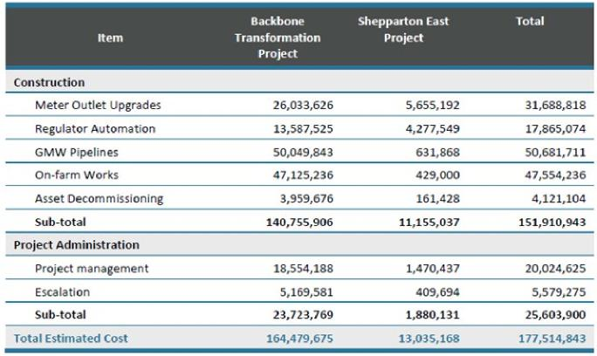

**Governance**

The works are proposed to be delivered under the established governance arrangements from the GMW Connections Project Team. This governance structure was developed as part of the Connections Project Reset Delivery Plan. The governance arrangement includes a Project Control Group (PCG) who assume responsibility for the Project and report directly to the Victorian Government Minister for Water and GMW Board.

**Program**

The works are proposed to commence from October 2020 with works completion by March 2023.

GHD ADVISORY

4

Review of Goulburn Murray Water (GMW) Water

Efficiency Project

**4. Scope and method**

The Department requested that a desktop due diligence assessment and analysis of the proposal is undertaken to address the following questions:

**Enquiry 1:** Are the proposed works likely to generate the proposed water savings   
**Enquiry 2**: Are the costs consistent with the nature of the works

**Enquiry 3**: What extent does the detailed budget demonstrate appropriate costings that reflect market realities – including the appropriateness of any contingency costs and escalations?

The advice in this report is intended to support decision making by the Department on potential investment in the proposal.

GHD ADVISORY

5 Review of Goulburn Murray Water (GMW) Water

Efficiency Project

**5. Proposal documentation**

The Victorian Government’s proposal is described in the following documents:

▪ DELWP - Submission of Proposal for the Goulburn Murray Water (GMW) Water Efficiency Project (Letter: Andrew Fennessy 27/7/2020)

▪ GMW Water Efficiency Project - Summary

▪ Backbone Transformation Project – Funding Submission (June 2020)

▪ Shepparton East Project Delivery (SEP) Business Case (June 2020)   
Other supporting documentation and files provided for assessment included:

▪ Attachment 1. BTP Water Savings Detailed Estimate.xlsx

▪ Attachment 2. Detailed Budget Calculation Spreadsheet.xlsx

▪ Attachment 3. BTP Cost Assumptions.pdf

▪ Attachment 4. Detailed Project Cost Analysis.pdf

GHD ADVISORY

6 Review of Goulburn Murray Water (GMW) Water

Efficiency Project

**6. Analysis**

**6.1 Backbone Transformation Project**

**6.1.1 Enquiry 1: Are the proposed works likely to generate the proposed water savings**

**6.1.1.1 Business Case Information**

▪ Water savings generated by the BTP have been calculated following the Victorian Government’s Water Savings Protocol for Irrigation Modernisation Projects (‘the Protocol’).

▪ Water savings will be generated as follows:

1. Channel rationalisation: generates water savings by eliminating seepage, leakage and evaporation losses
2. Channel modernisation: generates water savings by improving the control of water levels in channels resulting in a reduction in the volume of water overflowing from the end of the irrigation system (outfall)
3. Meter rationalisation: generates water savings by eliminating water losses due to meter inaccuracy and leakage from old or inefficient meters
4. Meter modernisation: generates water savings by improving meter accuracy and reducing leakage

▪ The BTP aims to achieve 14.7 GL of water savings from a range water savings works across five irrigation districts as detailed at Table 2.

**Table 2: BTP Water Savings across 5 irrigation districts**

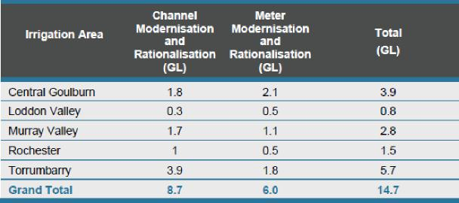

**6.1.1.2 Analysis and Assessment**

▪ A bottom up approach has been used to estimate water savings. The water savings estimates are directly related to the 100 predefined sub-projects for the BTP. Attachment 1: BTP Water Savings Detailed Estimate provides evidence of the detailed water savings calculations and the alignment with the project scope.

▪ The detailed water savings calculations have been audited by an independent consultant who concluded that the water savings estimate has been calculated in accordance with the Protocol.

▪ The proposed water savings works are the same as those undertaken for the Connections project. It is reasonable to expect that water savings from these works will also be achieved from the BTP. However,

GHD ADVISORY

7

Review of Goulburn Murray Water (GMW) Water

Efficiency Project

it is noted that the water savings volume per asset modernised/rationalised is lower than that achieved on the Connections Project, which is attributable to:

1. The channels within the BTP scope being relatively efficient compared to those previously modernised in the GMID
2. Historical water use for the assessment period (which forms part of the meter and outfall water saving) is typically lower that those previously modernised

**6.1.2 Enquiry 2: Are the costs consistent with the nature of the works**

**6.1.2.1 Business Case Information**

* The cost for the works has been estimated for three categories of works, these being; on-farm works, GMW asset works (pipelines, regulators, decommissioning), and meter works. On farm works are to be undertake by agreement with the landowner. The cost estimates are based on preliminary farm designs and historical Connections project rates for these types of works.
* GMW asset works reflects all costs associated with connecting landowners to modernised irrigation systems other than on-farm works and meter costs. The quantity of the GMW asset works has been determined from assessment of works requirements, concept designs (for pipelines) and historical Connections project rates for these types of works. The costs for meter installation have been determined from concept design identifying the number and size of meters to be replaced on each channel and applying a cost estimate for the replacement of each meter. On-farm concept designs also enable the number of rationalised outlets to be identified.
* Detailed at Table 3 is the forecast base cost of the BTP. The base cost comprises detailed design, regulatory approvals, land dealings, and direct construction costs (material, labour, plant, contractor overhead, risk margin and profit margin).

**Table 3: BTP Base Cost by Modernisation Type and Irrigation Area**

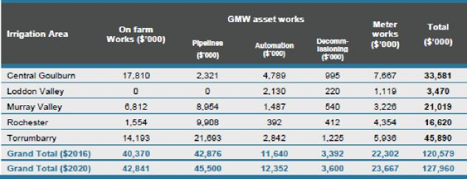

**6.1.2.2 Analysis and Assessment**

* The base costs for the project have been developed from a scope determined from desktop concept development work combined with unit cost rates derived from the Connections Project. The following provides an analysis of the methods and assumptions applied in developing project costs.

**Project identification**

GHD ADVISORY

8 Review of Goulburn Murray Water (GMW) Water   
Efficiency Project

* A list of 100 projects forms the basis for the BTP package of works. There is limited information to substantiate the basis for individual project selection.
* Cost and water savings risks for the GMW Connections Project were (partly) mitigated though a list of alternative sub-projects which could be pursued if difficulties were encountered within in the nominated projects. There is potential that additional projects of equivalent value for money may become limited.
* It appears the current list of BTP projects includes projects which were identified as part of the Connections project but either abandoned or not progressed. It is possible that projects which did not meet the Connections value for money threshold are now being progressed within BTP. Regardless of the level of development of each sub-project, the full development cost of each sub-project is included in the BTP budget.
* There is a risk that costs may be incurred pursuing projects which were abandoned in Connections due to technical issues or difficulties in reaching agreement with landowners.

**Scoping of works and sub-projects**

* Desktop concepts have been developed for each project drawing upon local knowledge, historical usage, expertise from farm design and GMW assets designers.
* The same approach was adopted for the Connections which provided a realistic and reliable basis in which to develop sub-projects through tod detailed design.

**Unit Rates**

* Unit rates for all project works (farm works, GMW assets, meters) have been derived from 2015/16 cost rates and escalated by a number of factors to generate the 2019/20 cost estimate.**.** It is noted that costs have only been escalated over a 3 year period rather than the 4 years period between 2016 and 2020.
* Attachment 2 of the proposal indicates that unit rates for pipelines and on farm works include contingency allowances of 15% and 20%, respectively, (assumed to represent unmeasured items) however meters and regulators do not include any contingency. It is unclear whether there is duplication with the overall project contingency of 10%
* There is no justification of the 2% escalation rate, as the application applies a ‘generic’ escalation rather than element specific escalation. The rate would appear to be low.
* Pipelines represent 30% of project cost – yet no cost information provided in the proposal’s supporting documents. Stated process appears acceptable however no documentation has been sighted by GHD.
* Given the volume of cost data which would have been obtained by GMW Connections for the period 2017 to 2020, it would not be unreasonable to expect that BTP costs are derived from updated unit rates to remove uncertainty associated with the multiplier approach. Alternatively, the business case would benefit if a comparison was made between the costs derived from 2015/16 rates and costs using actual 2020 rates.
* Furthermore, it is possible that some work elements would have experienced larger than expected changes in units rates compared to the 2015/16 unit rates. There is no evidence to show that the work packages have been derived from lessons learned from GMW Connections Project costings.

GHD ADVISORY

9 Review of Goulburn Murray Water (GMW) Water   
Efficiency Project

* From a program perspective, cost accuracy for individual projects is relatively low risk as the overall budget affords some flexibility to manage over and under-runs. However, cost accuracy for individual projects has a greater significance when considering value for money on an individual project basis, which may results in some projects being unnecessarily pursued or removed from scope.
* There is no detail provided in the Business Case or supporting documents on the unit rates for GMW pipelines. GMW pipelines comprise 28% of the total project budget.
* It appears that the project involves self-delivery rather than adopting the ECI delivery model used for Connections. It is not clear where the budget provision exists for this additional Owner’s role and also whether the Owner has the skills, expertise and systems provided by a Tier 1 contractor.
* The water savings spreadsheet provided with the proposal identifies projects where costs have already been incurred. Whether these costs been claimed via the Connections Project and to what extent is there duplication with the cost being claimed for BTP could not be confirmed based on the level of data provided.

**Development Cost**

* The approach used to develop the cost estimates does not completely align with the proposed delivery model which makes it difficult to evaluate whether the costs estimated using a percentage approach accounts for all anticipated activities. Furthermore, it is difficult to ascertain to what extent allowances for risk and uncertainty have been accounted for (or duplicated).
* For example:

1. There is no clear delineation between client costs related to design, approvals roles and design & approvals delivery roles.
2. It is not clear where costs associated with construction are included in the budget
3. There is no contingency allowance for "Operating Costs" (Owners Costs)
4. Pipeline and on-farm unit costs includes unexplained contingency allowances
5. It is not clear where the budget provision exists for the Owner to self-deliver the project and the 14.5% allowance for "Operating Expenditure" does not appear to include this cost.
6. The cost item is based on the approvals process applying the approach applied for the Connections, which significantly reduces approvals costs during the delivery phase of the project. If works are not completed under existing planning provisions, then higher costs would be likely.

GHD ADVISORY

10 Review of Goulburn Murray Water (GMW) Water

Efficiency Project

**6.1.3 Enquiry 3: What extent does the detailed budget demonstrate appropriate costings that**

**reflect market realities – including the appropriateness of any contingency costs and escalations**

**6.1.3.1 Business Case Information**

The estimated cost of the project is $164.5M, as summarised in Table 4.

The Victorian Government has advised that the project estimate has been produced based on concept design solutions for the works and applying unit costs and were subject to independent peer review from Currie & Brown.

**Table 4: DELWP Estimated BTP project costs**

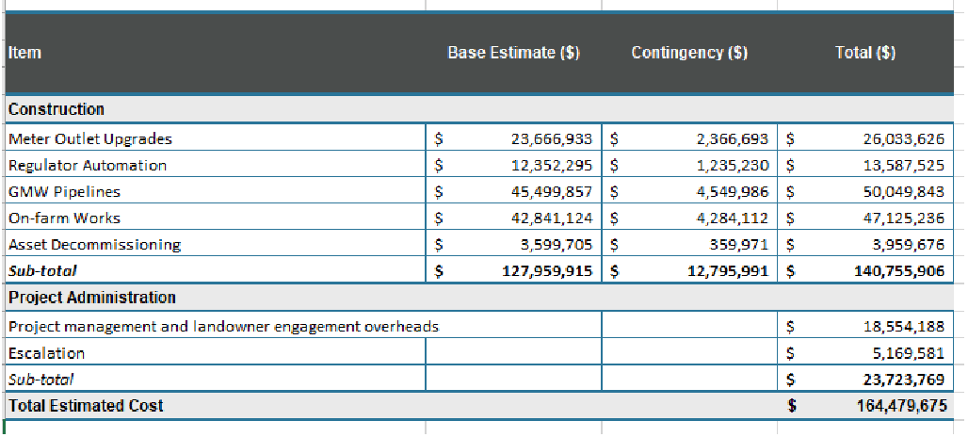

|  |  |
| --- | --- |
| Meter Outlet Upgrades | 14% |
| Regulator Automation | 8% |
| GMW Pipelines | 28% |
| On-farm Works | 26% |
| Asset Decommissioning | 2% |
| Contingency | 8% |
| Project management and landowner engagement overheads | 11% |
| Escalation | 3% |
| **Total Estimated Cost** | 100% |

GHD ADVISORY

11

Review of Goulburn Murray Water (GMW) Water

Efficiency Project

**6.1.3.2 Analysis and Assessment**

The following provides an analysis of the methods and assumptions used to estimate the overall project cost, as summarised in Table 5.

**Table 5: Overall BTP project costs**

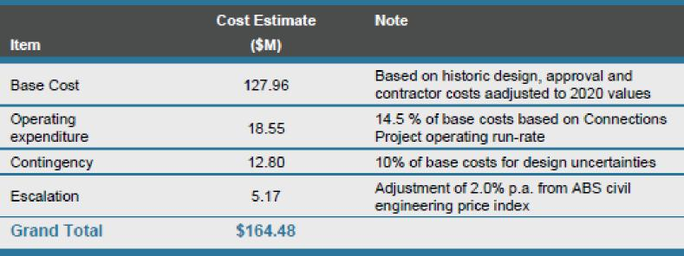

**Base Cost**

* Comments on base cost estimates are provided in Section 6.1.2. **General**
* There has been no confidence level (probabilistic forecasts) specified for the project cost estimates. The Department of Infrastructure, Regional Development and Cities requires a probabilistic cost estimation to be used when seeking funds for projects which exceed $25 million.

**Operating Expenditure (14.5%)**

* This item covers more than operating expenditure and include a range of client side delivery roles. It would appear that a 14.5% allowance is low.
* The Business Cases state that operating costs are for the period 1 October 2020 to 31/10/2022, however the cost is actually based on a percentage of the Base Cost.
* Business Case assumes that operating expenditure will continue at the current run rate. No analysis of resourcing level, evaluation of the project fixed costs and/or re-adjustment applied to justify this statement.
* It is expected that there would be uncertainty in estimating operating expenditure however no provision has been made for this risk.

**Contingency (10%)**

* The adequacy of the 10% project contingency allowance is difficult to assess as it is not clear what level of confidence the project cost is determined for. Furthermore, contingency has been applied inconsistently across project cost items including duplication with unit rates and omissions in elements such as Operating Expenditure.
* The Business Case recognises that a 10% contingency allowance is low by industry standards and has adopted this percentage based on previous project performance.

GHD ADVISORY

12

Review of Goulburn Murray Water (GMW) Water

Efficiency Project

* The ability to manage cost risks relies on a sound sub-project approval process which abandons projects which do not meet predetermined cost thresholds prior to any significant costs being incurred. This proposed gateway approval process provides a suitable cost review mechanism.

**Escalation**

* There are inconsistencies between the Business Case and supporting documents about the application of cost escalation. For example:

1. Attachment 3 - Page 5- fifth dot point: states that 2.0% pa rate used for cost escalation
2. BTP Business Case – Page 9 states a rate of 3.6% was used

* It would appear that the cashflow forecast is biased towards the start of the project (20% of costs proposed in last 10 months of 23 month program appear to be low).

**Program and Resourcing**

* The program appears to be ambitious and is reliant on a rapid commencement of design and procurement to enable construction to commence in January 2021. The program would also appear to rely of production rates achieved during the Connections Project. Achieving previous production assumes that:

1. A relatively large workforce can be mobilised quickly into a regional location
2. Staff are experienced and require minimal training
3. Suitable weather conditions are encountered over the entire program
4. Landowner’s continue to accept the modernisation approaches

* There are inconsistencies between the project dates shown in the business case, which may impact upon Client costs:

1. "Oct 2020 till October 2022 "
2. "Oct 2020 till December 2022"
3. "Oct 2020 till March 2023" **Other**

The Business Case does not make any cost provisions for implementing the reconfiguration statutory powers, such as the additional engagement and legal costs. Another gap in the Business Case is the lack of information relating to the potential impacts associated with COVID-19.

The current pandemic has the potential to significantly impact mobilisation, production rates and also requires additional OH&S resources to administer and implement safe work practices across the workplace. It would be prudent for the project to have considered these impacts and detailed a range of contingency measures.

GHD ADVISORY

13 Review of Goulburn Murray Water (GMW) Water   
Efficiency Project

**6.2 Shepparton East Project Delivery (SEP)**

**6.2.1 Enquiry 1: Are the proposed works likely to generate the proposed water savings**

**6.2.1.1 Business Case Information**

Water savings generated by the SEP have been calculated following the Water Savings Protocol for Irrigation Modernisation Projects (‘the Protocol’). Water savings will be generated as follows:

* Channel rationalisation: generates water savings by eliminating seepage, leakage and evaporation losses
* Channel modernisation: generates water savings by improving the control of water levels in channels resulting in a reduction in the volume of water outfalled
* Meter rationalisation: generates water savings by eliminating meter accuracy losses and leakage
* Meter modernisation: generates water savings by improving meter accuracy and reducing leakage

The BTP aims to achieve 1.248 GL of water savings from a range water savings works across the Shepparton East irrigation area as detailed at Table 6.

**Table 6: SEP water savings**

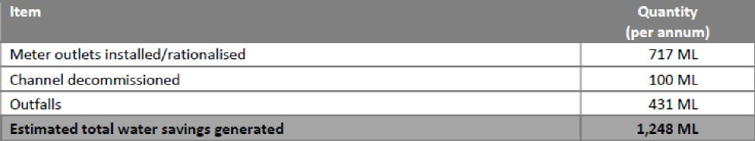

**6.2.1.2 Analysis and Assessment**

* Whilst the Business Case states that water savings have been estimated in accordance with the Protocol, there is no supporting calculations or statement of audit. GHD is unable to verify whether this process has been followed.
* Comments made in Section 6.1.2 are also applicable to SEP.

GHD ADVISORY

14

Review of Goulburn Murray Water (GMW) Water

Efficiency Project

**6.2.2 Enquiry 2: Are the costs consistent with the nature of the works**

**6.2.2.1 Business Case Information**

* The base cost for the proposed SEP works has been estimated using the same scoping process and unit rates applied for the Connections Project (and also used for the BTP Business Case).
* The base cost estimate comprises a build up from scope definition, quantity of works and units rates.
* Table 7 details the forecast base cost of the SEP. The base cost comprises detailed design, regulatory approvals, land dealings, and direct construction costs (material, labour, plant, contractor overhead, risk margin and profit margin).

**Table 7: SEP forecast base costs**

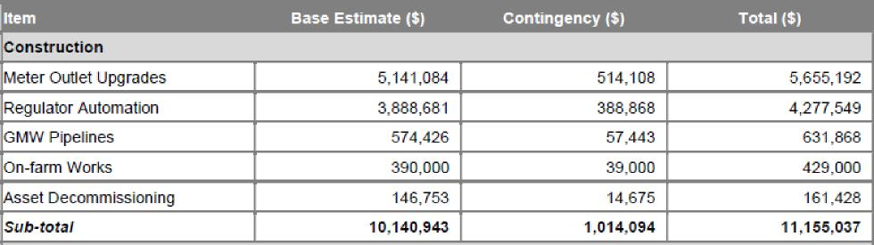

**6.2.2.2 Analysis and Assessment**

**Base Cost**

* The base costs for the project have been developed from a scope determined from desktop concept development work combined with unit cost rates derived from the Connections Project. It is worth noting that previous attempts have been made by the proponent to implement fully piped schemes within this irrigation however these have not succeeded due to issues relating to flow rates and the potential cost impact on customers.

**General**

* It does not appear that the Business Case was informed by any form of community consultation, however it is recognised that this process started in August 2020 (reference). There is potential that aspects of the project may not be well received from customers or the community however as the works are largely associate with modernisation of existing assets (regulators and meters), the impact on the project is expected to be low.
* The current project defines a range of water saving initiatives which are being implement elsewhere across the GMID. Furthermore, the project acknowledges the potential impact of urban encroachment on the irrigation area and has elected not to undertake works in areas where this risk is greatest.
* As the methods used to scope and cost the SEP has applied the same approach as the BTP, the assessment comments made in Section 6.1.2 will also be applicable to the SEP. The following provides an analysis of additional issues by exception.

GHD ADVISORY

15 Review of Goulburn Murray Water (GMW) Water   
Efficiency Project

**Project identification**

* The project identification and scoping appears to have been developed over a considerable period of time as evidenced by previous unsuccessful iterations of the project. The current scope adopts a range of water saving initiatives which are being implemented elsewhere across the GMID and delivery model, and therefore assumes that these processes will also be successful in the Shepparton Area.
* It is unclear whether the SEP is be delivered as one large single package or is to be implemented at separate smaller sub-project, similar in size and complexity to the BTP packages. Delivery of the SEP as a separate package significantly increases the risk of time and cost impacts, should they arise.

**Scoping of works and sub-projects**

* It would appear that there has been little consideration given to the scoping of on-farm works as evidenced by the adoption of a standard cost per property of $30,000 per property and there is no corresponding increase in contingency to represent scope uncertainty.
* Similarly, costs for the D&S pipelines appear to be based on a unit rate rather than developed from concept design as per the BTP works.
* Refer to Section 6.1.2   
  **Unit Rates**
* It is confirmed that the unit rates for regulator, meters and asset decommissioning have been applied consistently for the BTP and the SEP
* Refer to Section 6.1.2

GHD ADVISORY

16 Review of Goulburn Murray Water (GMW) Water

Efficiency Project

**6.2.3 Enquiry 3: What extent does the detailed budget demonstrate appropriate costings that reflect market realities – including the appropriateness of any contingency costs and escalations**

**6.2.3.1 Business Case Information**

* The estimated cost of the project is $13.035M, as summarised in Table 8.

**Table 8: SEP summary of costs**

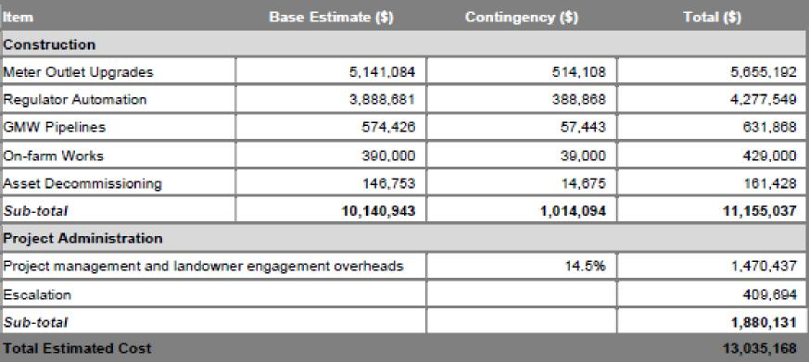

|  |  |
| --- | --- |
| Meter Outlet Upgrades | 39% |
| Regulator Automation | 30% |
| GMW Pipelines | 4% |
| On-farm Works | 3% |
| Asset Decommissioning | 1% |
| Contingency | 8% |
| Project management and landowner engagement overheads | 11% |
| Escalation | 3% |
| **Total Estimated Cost** | 100% |

**6.2.3.2 Analysis and Assessment**

* The following provides an analysis of the methods and assumptions used to estimate the overall project cost.

**Base Cost**

* More than 90% of the cost is associated with meter and regulator upgrade works. These works are inherently lower risk compared to other works elements such as on-farm works, pipelines and channel remediation.
* Comments on base cost estimates are provided in Section 6.1.2 above.

**Escalation**

* Refer to Section 6.1.2

GHD ADVISORY

17

Review of Goulburn Murray Water (GMW) Water

Efficiency Project

**Resourcing**

* Refer to Section 6.1.2

**Program**

* Further to the comments made in Section 6.1.2, previous modernisation proposals within the Shepparton East have encountered difficulties with landowners’ acceptance.
* There does not appear to have been any considerable customer consultation completed to date.
* There may be some resistance to the project which could impact time and cost.

**Other**

* Refer to Section 6.1.2

GHD ADVISORY

18 Review of Goulburn Murray Water (GMW) Water

Efficiency Project

**7. Conclusions**

The following conclusions are made in relation to GHD’s assessment of the business cases and supporting documentation for the Backbone Transformation Project (BTP) and the Shepparton East Project (SEP) against the Department requested areas of assessment:

**General**

▪ The project proposal requests funding under a single agreement however it is unclear whether the BTP and the SEP is to be delivered by the same entity. There would be considerable cost and time risk for the SEP if it were not delivered using the same governance arrangements, management team, delivery team and associated systems (IT, QA, procurement) developed for the BTP.

▪ The primary reason for the low value for money assessment for these projects is due to the lower rate of water savings generated from completing similar works. This reduction in value for money is expected as both projects are targeting parts of the irrigation network which are more efficient than previous projects.

▪ The ability to substitute sub-projects within the BTP and SEP with alternative sub-projects of equivalent value for money is a risk for the project. This risk is higher for the SEP.

▪ The Business Case lacks information relating to the potential impacts associated with COVID-19. The current pandemic has the potential to significantly impact mobilisation, production rates and also requires

additional OH&S resources to administer and implement safe work practices across the workplace.

▪ The program is considered ambitious and also appears to be based on production rates achieved at the peak of the Connections Project.

▪ The program is reliant on remobilising a large workforce with adequate experience. This was previously achieved via a Tier 1 contractor who specialises in logistics and management of large projects. The current project does not propose to use a Tier 1 contractor.

**Enquiry 1: Are the proposed works likely to generate the proposed water savings** BTP

▪ GHD confirms that the water savings for the BTP have been estimated for a defined scope and in accordance with the Victorian Government’s Water Savings Protocol.

▪ The BTP water savings estimate has been subject to peer review from HARC and supporting calculations have been provided to allow for verification.

▪ The BTP water savings are considered to be achievable for the scope and type of water efficiency works proposed on the basis that the method used to estimate water savings has been previously applied, validated and accepted by the Victorian Government and Commonwealth Government.

GHD ADVISORY

19 Review of Goulburn Murray Water (GMW) Water   
Efficiency Project

SEP

* For the SEP, water savings have been estimated in accordance with the Victorian Government’s Water Savings Protocol.
* The proposal states that the water savings estimate has been subject to peer review from HARC however no supporting calculations or evidence of audit to enable this statement to be verified.

**Enquiry 2: Are the costs consistent with the nature of the works**

GHD's level of confidence in the estimated Construction Costs for both BTP and SEP is low to moderate, due to the following:

* There has been no validation of 2016 unit rates undertaken against recent quotes and works
* The escalation rate used for past escalations lacks substantiation. We see a 2% escalation rate as being low. Indices should consider changes in construction materials (HDPE, concrete, steel, pumps), local content and imported products, machinery and equipment, fuel costs, disbursements (accommodation, consumables, hardware), labour
* There is no Base Date specified for the estimate which makes it difficult to assess the period over which cost escalations which have been applied. There appears to be an error in the past cost escalation calculation attributable to lack of clarity around the Base Date.
* Further justification of the cost allowances made for pipelines is required.
* Further justification of the cost allowances made for on-farm works in the SEP is required.

The following elements of the Construction Cost estimate appear adequate for current level of project development and costing:

* The scope of works is clearly defined and developed from concept design work
* Adequate cost contingency has been applied to pipeline works and on-farm works which appropriately reflects the uncertainty in these costs as this stage
* Adequate cost allowances have been made for project development works including design, survey and approvals

**Enquiry 3: What extent does the detailed budget demonstrate appropriate costings that reflect market realities – including the appropriateness of any contingency costs and escalations**

* The Business Case does not state the level of confidence associated with the cost estimates. It is assumed that the Business Case provides a P90 (equivalent) Project Cost estimate. This means that the Commonwealth understands that there is a 10% likelihood that the cost will be exceeded.
* GHD's level of confidence in the assumed P90 Project Cost estimates for both BTP and SEP is low and the resultant P90 Project Cost estimate is also considered low, due to the following:

1. There are inconsistencies between the structure of the cost estimate and anticipated activities based on the stated project delivery method. This makes it difficult to validate cost items.
2. A simplistic deterministic method has been used for estimating contingency allowances. . It is expected that probabilistic method/s would have been applied for a project of this monetary value.

GHD ADVISORY

20 Review of Goulburn Murray Water (GMW) Water   
Efficiency Project

c. There is no Base Date specified for the estimate which makes it difficult to assess the period over which cost escalations have been applied. There appears to be an error in the past cost escalation calculation attributable to lack of clarity around the Base Date, which results in an underestimation of the past cost escalation.

d. The escalation rate used for past escalation lacks substantiation. We see 2% as being low.

e. It is expected that the escalation rate used for past escalations for the BTP and the SEP should be different due to the large difference in mark-up of project infrastructure (i.e. pipeline cost proportion significantly lower for SEP).

▪ We consider the 10% contingency allowance to be on the low end of typical contingency for projects of this nature, for the following reasons:

f. the current 10% is only applicable to the base costs which means there is no contingency on the Operating Expenditure (Owner’s Costs)

g. The proponents justification "the Connections Project has extensive experience in delivering modernisation works and therefore a higher than normal level of confidence in the cost estimates”, is based on an optimistic view that all previous assumptions will be applicable in the future. Examples where this may not apply include:

1. Changes to delivery method: self-delivery vs D&C style contract
2. Loss of experienced resources
3. Changes to procurement contracts
4. Environmental factors (i.e. climate, pandemics)

h. Client costs are not related to a specific project duration (a percentage has been applied) and therefore there is no validation of cost allowance versus required levels of resourcing. There is no contingency allowance for Client costs which reflects a lack of consideration to potential client side cost risks.

i. There are inconsistencies between the project dates shown in the business case, which may impact upon Client Costs.

j. The future escalation costs are based on a cashflow sequence and assumed escalation rate. Whilst there is lack of detail regarding the cashflow sequence, the logic and application is appropriate. However, the escalation rate lacks substantiation and would appear to be high particularly in light of the current considerable uncertainty of the domestic economy. [This cost uncertainty may be best managed via mechanisms in the funding agreement and sensible risk allocation, rather speculation of forecast].

GHD ADVISORY

21

Review of Goulburn Murray Water (GMW) Water

Efficiency Project

**8. Recommendations**

It is recommended that:

1. The Department consider obtaining additional information from the Victorian Government to reduce uncertainty in GHD’s assessment of the following cost risks:

* Justification of pipeline cost estimates for all projects within BTP & SEP
* Justification of on farm cost estimates within SEP
* Validation of the units rates and 2% escalation using to estimate the Construction Cost
* Confirmation that the post escalation allowance has been applied for the correct period
* Validation of client costs across the correct project period
* Validation of the 3% future escalation rate
* Confirmation of potential COVID-19 related impacts on project costs and timelines and/or

2. The Department consider mechanisms to manage cost and water savings risk, such as:

* Allowing flexibility with regards to which sub-projects are delivered across BTP and SEP based on highest value for money and customer acceptance.
* The provision of an additional risk allowance which covers the areas of uncertainty identified in Recommendation 1.

GHD ADVISORY

22

Review of Goulburn Murray Water (GMW) Water

Efficiency Project

**GHD**

Advisory



|  |  |
| --- | --- |
|  | [**ghd.com/advisory**](http://ghd.com/advisory) |



Level 7 16 Marcus Clarke Street Canberra ACT 2601 Australia

61 2 6113 3332   
[advisory@ghd.com](mailto:advisory@ghd.com)

© GHD 2020. This document is and shall remain the property of GHD Advisory. The document may only be used for the purpose for which it was commissioned and in accordance with the Terms of Engagement for the commission. Unauthorised use of this document in any form whatsoever is prohibited.

Document4

|  |  |  |  |  |  |  |
| --- | --- | --- | --- | --- | --- | --- |
| Rev.No. | Author | Reviewer  Name Signature | | Approved for Issue  Name Signature Date | | |
| Draft A | S Roach W van Lint |  | 28/8/2020 | L N de Masson |  | 28/8/2020 |
| Draft B | S Roach W van Lint |  | 07/09/2020 | L N de Masson |  | 07/09/2020 |
| Final | S Roach W van Lint |  | 13/09/2020 | L N de Masson |  | 13/09/2020 |

|  |  |
| --- | --- |
|  | [ghd.com/advisory](http://ghd.com/advisory) |