# A review of Pilbara leaf-nosed bat ecology, threats and survey requirements

**Prepared for the Department of Agriculture, Water and Environment**

Bat Call WA Pty Ltd

ABN 26 146 117 839

43 Murray Drive

Hillarys Western Australia 6025

[bullen2@bigpond.com](mailto:bullen2@bigpond.com)

+61 8 9402 1987

+61 488 930 735

Prepared by:

R. D. Bullen – Bat Call WA

May 2021

This document has been prepared to the requirements of Australian Government Department of Agriculture, Water and Environment under Service Contract 2000010844.

© Bat Call WA Pty Ltd 2021

**Ownership of intellectual property rights**

Unless otherwise noted, copyright (and any other intellectual property rights) in this publication is owned by Bat Call WA.

**Creative Commons licence**

All material in this publication is licensed under a [Creative Commons Attribution-Non Commercial-No Derivatives 4.0 International License](https://creativecommons.org/licenses/by-nc-nd/4.0/) except content supplied by third parties, logos and the Commonwealth Coat of Arms.

Inquiries about the licence and any use of this document should be emailed to [copyright@awe.gov.au](mailto:copyright@awe.gov.au).



**Cataloguing data**

This publication (and any material sourced from it) should be attributed as: Bat Call WA 2021, *A review of Pilbara leaf-nosed bat ecology, threats and survey requirements,* report prepared for the Department of Agriculture, Water and the Environment, Canberra, November. CC BY 4.0.

ISBN 978-1-76003-517-4

This publication is available at <https://www.awe.gov.au/environment/epbc/publications>.

Bat Call WA Pty Ltd

43 Murray Drive, Hillarys WA 6025

Telephone 08 9402 1987

Email [bullen2@bigpond.com](mailto:bullen2@bigpond.com)

**Disclaimer**

The views and opinions expressed in this publication do not necessarily represent the views of the Australian Government or the portfolio ministers for the Department of Agriculture, Water and the Environment.

The content of this publication does not constitute advice to any third party. Although due care and skill has been applied in the preparation and compilation of the information and data in this publication, no reliance may be placed on it by any other party. No representation expressed or implied is made as to the currency, accuracy, reliability, completeness or fitness for purpose of the information contained in this publication. The reader should rely on its own inquiries to independently confirm any information and comment on which they may intend to act.

The Commonwealth of Australia, its officers, employees, agents and the other parties involved in creating this report disclaim, to the maximum extent permitted by law, responsibility to any other party for any liability, including liability for negligence and for any loss, damage, injury, expense or cost incurred by any person as a result of accessing, using or relying upon any of the information or data in the publication.

This document is designed to be an additional source of information to the statutory documents. It is not a statutory document or policy statement. If information diverges, the information in the statutory document(s) and policy statement(s) take precedence over this document. This document should be used in parallel with the Significant Impact Guidelines 1.1 – Matters of National Environmental Significance, relevant conservation advices, recovery plans and/or referral guidelines.

**Acknowledgements**

Contributions have been received from a number of colleagues in preparing this report. In particular, I am thankful for contributions from Phil Davidson, Ashleigh Jenkins, Chris Knuckey, Norm McKenzie and Brendan Schembri.

This report was funded by the Department of Agriculture, Water and the Environment.

**Acknowledgement of Country**

We acknowledge the Traditional Custodians of Australia and their continuing connection to land and sea, waters, environment and community. We pay our respects to the Traditional Custodians of the lands we live and work on, their culture, and their Elders past and present.

Contents

1 Objective 1

2 Summary of morphology, ecology and energetics 3

3 Distribution 4

4 Population information 7

5 Habitat 12

5.1 Roosting habitat 12

5.2 Foraging habitat and activity levels 18

5.3 Artificial subterranean roosts intended for PLNB 22

6 Anthropogenic threats 30

6.1 Direct threats 30

6.2 Indirect threats 32

7 Minimum survey requirements 36

7.1 Recommended survey approach 36

7.2 Survey effort guide 38

Glossary 40

References 41

**Tables**

Table 1 Known PLNB roosts in natural caves with accurate recent census counts 10

Table 2 PLNB roosts in historical underground mines with accurate recent census counts 11

Table 3 PLNB foraging habitat types and rating scale 19

Table 4 Bat activity ratings and criteria 20

Table 5 Minimum survey effort for a small project area <500 ha 38

**Figures**

Figure 1 Distribution of permanent diurnal (category 1 or 2) PLNB roosts 5

Figure 2 Cane River Roost colony size estimates, 2011 to 2021 8

Figure 3 The entrance of Cane River Roost 15

Figure 4 The entrance of Ratty Spring Roost, looking south 15

Figure 5 The entrance of Kalgan Creek Roost showing the constriction at the rear 16

Figure 6 Plan view of the first internal chamber of Cane River Roost 16

Figure 7 PLNB foraging habitat compared to nightly activity rating 21

Figure 8 Distance of echolocation records from known roosts by month of detection 22

Figure 9 Distance of echolocation records from known roosts by the number of sites 22

Figure 10 Design of Atlas’ Mt Webber artificial roosts. Sketch provided by Atlas Iron 24

Figure 11 Artificial diurnal PLNB roost conceptual layout – plan 27

Figure 12 Artificial diurnal PLNB roost conceptual layout – side view (section AA) 27

Figure 13 Conceptual portal gate design for PLNB roost – detail 1 28

Figure 14 Conceptual constriction design for PLNB diurnal roost – detail 2 28

## Objective

The Department of Agriculture, Water and the Environment has identified information gaps relating to the Pilbara leaf-nosed bat (Rhinonicteris aurantia, Pilbara form) (PLNB) listed as Vulnerable under the Environment Protection Biodiversity Conservation Act 1999 (EPBC Act). This bat is extant across the Pilbara bioregion of Western Australia and adjoining areas of 2 other bioregions.

This document addresses the following information gaps with regard to the PLNB:

* roosting habitat descriptions, both natural and artificial, and critical habitat definitions
* guidance on mitigation measures for roosts under threat
* information on population dynamics of the species
* guidance on foraging requirements and range.

This study is to provide (where available) current information, data and advice based on publicly available information, Bat Call client information (with the approval of the client) and the author’s experience and personal observations on:

* characteristics of diurnal roosting and breeding sites
* usage of seasonal caves and associated seasonal movements
* guidelines for the development of artificial habitat/roosts for the species – key features such as structure, materials, location
* minimum survey technique requirements – minimum effort, minimum number of nights, etc.
* confirmation of spectrum of visible light that could minimise light impacts to this species (within the limits of available data)
* confirmation or update of the range of humidity and temperature conditions for diurnal roosting and breeding sites necessary for survival, and variation with season.
* maximum levels of noise and vibration from mining-related activities that species can tolerate (this information would be used to determine buffer zones around known roost and breeding sites)
* impact of public access to roosting and breeding sites, and recommendations for controlling public access to known and suspected breeding and roosting sites (that is buffer zones, timing, etc)
* description of habitat critical to the survival of the species particularly in relation to the species-specific gaps (within the limits of available data)
* species-specific gaps
  + improved habitat descriptions and critical habitat definition, including clearer description of microclimates utilised by the species
    - distance PLNB travels from roost site to foraging areas
  + foraging requirements and range
    - definition of a foraging habitat critical to the survival of the PLNB colony (including average size)
  + guidance on mitigation measures (eg buffer zones)
    - information on translocation (viability, necessary conditions)
    - information about the existence of pollutants within roosts and breeding sites and their effects (eg what are those pollutants, and which are the most dangerous).

## Summary of morphology, ecology and energetics

The orange leaf-nosed bat (Rhinonicteris aurantia) is a monotypic species endemic to northern Australia that includes an isolated population with a slightly divergent form, the Pilbara leaf‑nosed bat (PLNB) in the semi-desert Pilbara region of Western Australia. The PLNB’s conservation status is Vulnerable under Commonwealth (EPBC Act) and Western Australian state legislation.

The PLNB is a small 9.5 g (range 8 to 11 g), insectivorous, obligate cave roosting bat with orange, pale yellow, white, pale grey or light brown fur. The morphology of its wings (span of 295 to 320 mm, forearm 45.5 to 48.5 mm), body, tail and small ears are understood and published (e.g. Bullen and McKenzie 2001, McKenzie 2009). Its wingbeat frequency in flight, the physiology of its flight muscles, its basal and resting metabolic rates and its musculo-skeletal mechanical efficiency are understood (Bullen and McKenzie 2002, 2004, Bullen et al. 2014). Its characteristic flight speeds are published. Its minimum level flight speed is 2.8 m/s, its aerobic foraging speed is 5.8 m/s and its sustainable anerobic speed for commuting is 8.5 m/s (Bullen and McKenzie 2016). It does not enter torpor but uses its obligate cave roosting strategy for energy saving.

PLNB are active at the roost all year (Bullen and Reiffer 2020a) and mate during the dry season. Females give birth to single young usually in the mid-wet season months of late-December or January (Woinarski 2014; Bullen 2019). However, parturition has been reported later in the wet season with non-volant young present in a roost in early March (A. Jenkins 2020, pers. comm).

## Distribution

The Pilbara leaf-nosed bat (Rhinonicteris aurantia, Pilbara form) (PLNB) is endemic to Western Australia, and ranges throughout the Pilbara and adjoining regions of the Ashburton, and Little Sandy Desert bioregions. It has been separated from the Kimberley populations by the Great Sandy Desert for many thousands of years (Armstrong 2006; Armstrong and Coles 2007). There are confirmed populations in at least 2 locations in the Ashburton bioregion and one in the Paterson Orogen of the Little Sandy Desert.

Prior to 2012, there were limited numbers of records of the PLNB, and only a few known roosts. Most were in abandoned underground gold and copper mines, although a few were known in natural caves in ironstone (Woinarski 2014, TSSC 2016). In recent years, targeted surveys for a number of project proponents, environmental impact assessments (Cramer et al. 2016) and other general survey effort have produced many new records of occurrence and additional confirmed or suspected roost sites.

Records of occurrence of the PLNB are spread throughout the region with the exception of the north-western area between Karratha and the Fortescue River. It is generally encountered in rocky areas that provide opportunity for roosting, in particular the ironstone Hamersley Range, the ridgelines granite boulder piles and disused mines of the eastern Pilbara. McKenzie and Bullen (2009) and many subsequent surveys also detected the species in several of the flat terrains, in particular along medium and major drainage lines that radiate away from rocky uplands. There is generally a very low chance of detection in flat land systems, except within a few kilometres of the margins adjacent to rocky outcrops that form caves.

Most records of occurrence of the PLNB are of individuals in flight, as detected from recordings of their echolocation calls with bat detectors, either at cave and mine entrances or whilst out foraging in a range of habitats. Several records are of roadkill, which are a result of their low foraging height and curiosity for light sources. Not all detections at cave or mine entrances are indicative of a diurnal roost, since bats will visit structures at night that are not used during the day. However, diurnal roosts are easily recognised because colony members begin to depart their cave or mine (roost) at, or soon after, dusk civil twilight and, except for the coldest winter months, the last individuals arrive back to the roost just prior to the dawn civil twilight (Churchill 1991; Bullen and Reiffer 2020a).

Currently, there are 48 confirmed permanent diurnal categories 1 and 2 roost sites (Figure 1), with 17 known and another 31 yet to be found that are predicted to occur within a 5 km diameter circle on the basis of systematic survey data (Cramer et al. 2016, authors’ unpublished data). Thirty-eight of the known or suspected permanent diurnal roosts are in natural caves in banded iron formations in the Hamersley Ranges and eastern Pilbara and 6 are in disused underground gold and copper mines of the eastern Pilbara. Four are not yet well enough defined and may be in either. Three of the confirmed colonies in natural caves are in the Barlee Range Nature Reserve, south of the Ashburton River, on Mt Vernon station, and in the rocky uplands of the Karlamilyi National Park. There may yet be more roosts remaining to be discovered, but the status of each candidate needs to be confirmed with a suitable method given the tendency of bats to visit other structures after their emergence (DEWHA 2010; Cramer et al. 2016).

Figure Distribution of permanent diurnal (category 1 or 2) PLNB roosts

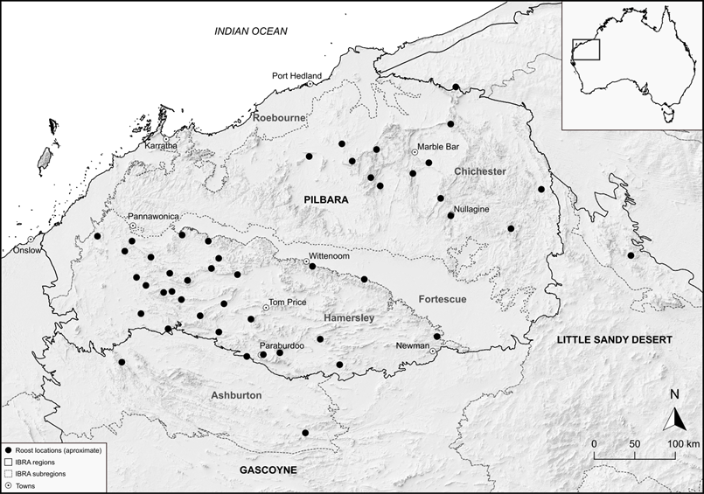

There is some evidence from several long-term monitoring projects and fauna surveys that there is seasonal variation in intra-regional presence. Generally, the PLNB is more commonly encountered within 20 km of its permanent diurnal roosts (Bullen 2013a) but there is an increasing number of records in April and May in areas much more distant (Bullen 2019; authors unpublished data). These records correspond to the more benign months that have lower temperatures than late summer and humidity higher than later in the dry season, and also correspond to the months following the reproductive period that young adult bats might be spreading across the landscape. In some of these cases, the bats may be originating from their maternal roost but in others, the timing of the calls closer to civil twilight, indicates that the bats are roosting opportunistically in non-permanent roost caves (author’s unpublished data).

The extent of occurrence (EOO) is currently approximately 110,000 km2 (Woinarski et al. 2014 quoted with medium reliability; author’s high reliability current data) and is currently stable. Area of occupancy (AOO) in the Pilbara region has been calculated by Woinarski et al. (2014) as under 10 km2. This value is based on the roost area for obligate cave-roosting bats such as the PLNB, that is, species that rely for their daily survival on physiologically protective sites with specific microhabitats during daylight hours of each day. The AOO is best considered as the total area of its roost sites only (excluding foraging habitat), given that AOO can be defined as ‘the smallest area essential at any stage to the survival of existing populations of a taxon’ (IUCN 2001).

Published data on the PLNB’s long-range dispersal ability is scant. Echolocation based records indicate that it can complete round trips of 50 km or longer in a night under favourable conditions (Figure 2). Early genetic work found evidence of male mediated gene flow across the region with some sub-structuring according to bio-subregions and also evidence for limited female movement (Armstrong 2006, 2011). A recent study using Radio Frequency Identification (RFID) technology at roost entrances has confirmed one male movement of 170 km (Bullen and Reiffer 2020b). A more extensive genetic survey is currently underway by the Western Australian Department of Biodiversity, Conservation and Attractions.

## Population information

The size of the PLNB population is currently unknown (TSSC 2016). In early years of research, population size estimates were not possible because the number and location of roosts was poorly known, data on roost fidelity was scant, and counts at roost entrances were often confounded by the species habit of circling in the entrance prior to departing (Bullen and Reiffer 2020a).

However, the reliability of colony size estimates increases as technologies improve. For example:

* In recent years the use of overnight infra-red lit video at known roost entrances has provided a reliable technique for counting the number that fly out and return back inside. This technique provides a running total of bats outside the roost at any time during the night by subtracting the number returned inside from the number that have exited, or out-in. Using this technique, the maximum out-in figure can be taken as the minimum colony size for that census. In practice, this has provided colony headcounts that correlate well with call counts reduced from ultrasonic recordings at the same entrances.
* Two methods have been used to derive colony size estimates from ultrasonic echolocation recordings from Australian Premium Iron Joint Venture Management’s (APIM) Cane River Roost in the West Hamersley Range Conservation Park extension area under EPBC 2009/4706 (within what had been proposed as the West Hamersley Range Conservation Park proposal by CALM/DBCA 2002) (see Figure 2). Initially a ‘Pulse per second per megabits’ (PPS/MB) was used. Later, once a reliable automatic scanning procedure became available, a count of ultrasonic ‘Calls per File’ was used.

Figure Cane River Roost colony size estimates, 2011 to 2021

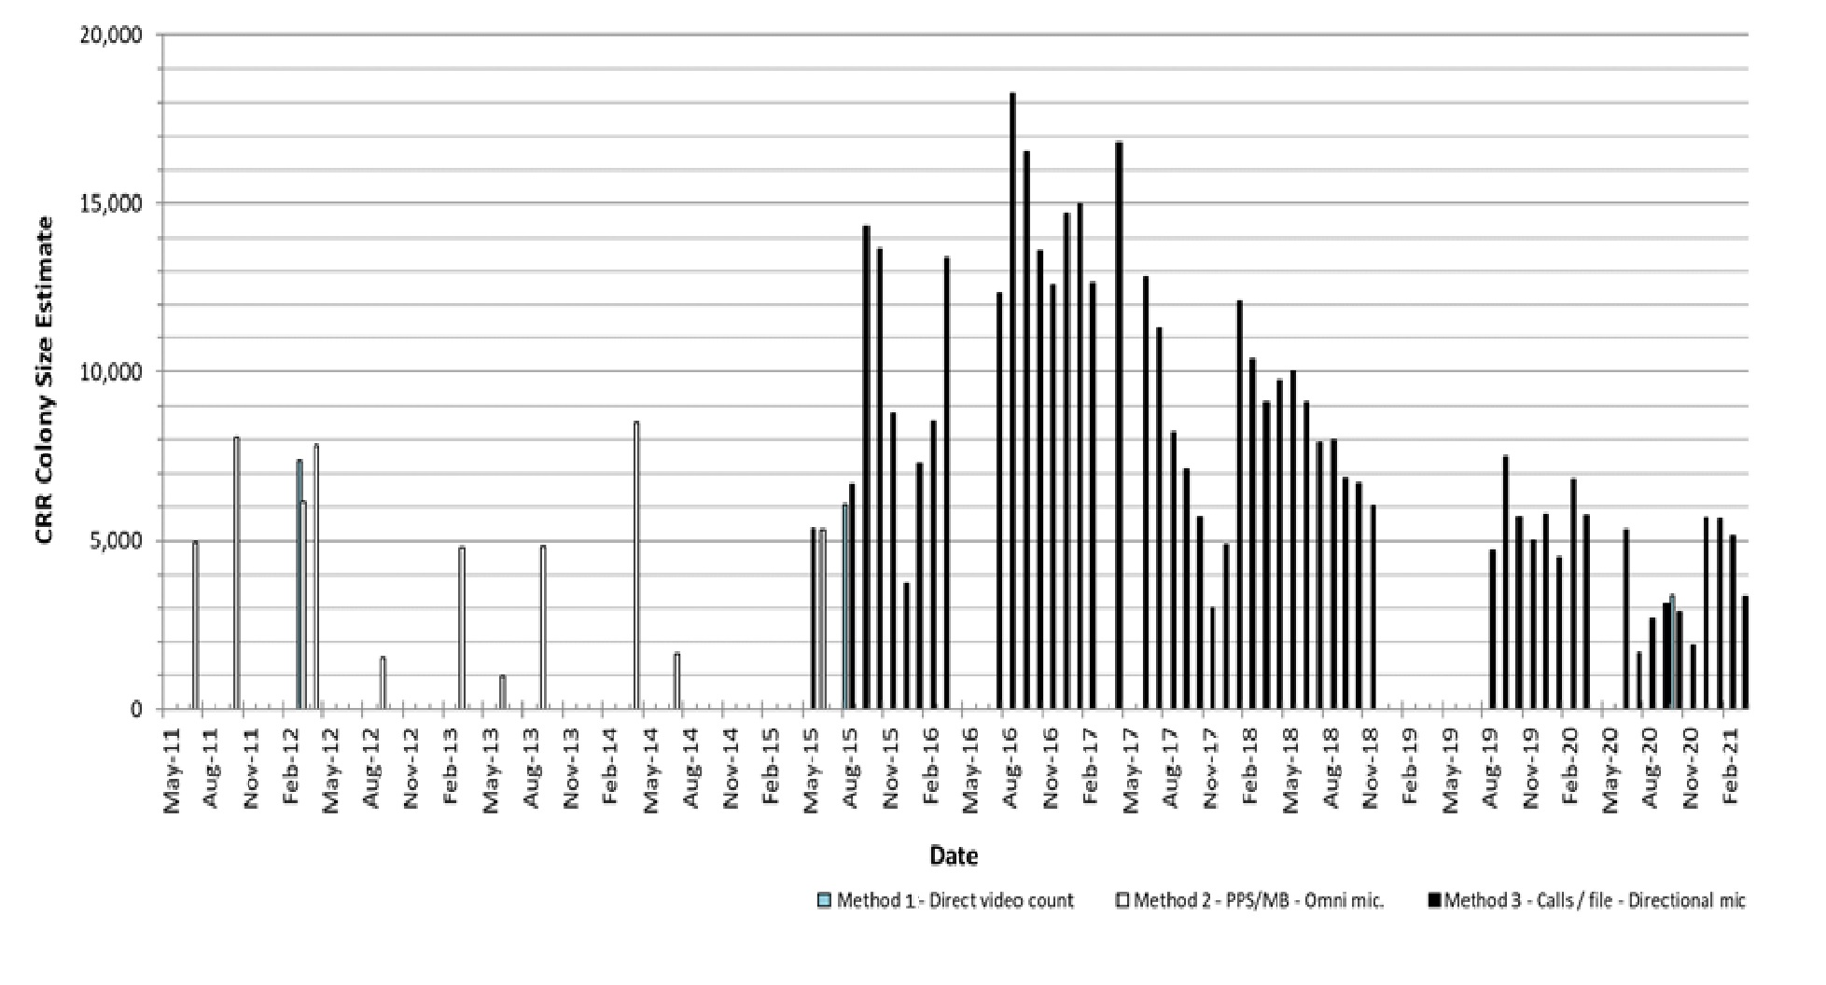

Note: Estimates made using IR-lit-video and the 2 ultrasonic call counting methods: Method 2 – pulse per second/recording size in MB (PPS/MB) and Method 3 – ultrasonic calls per file. Bars for methods 2 and 3 represent monthly averages of nightly totals.

The Cane River Roost colony:

* is in a remote location greater than a kilometre from any proposed future mining activities
* has been quarantined and protected from any anthropogenic interference other than the installation of the monitoring equipment (the microphone is installed in the cave entrance and the majority of the detector and its power source is 50 m distant)
* visits are limited only to experienced ecologists associated with the project.

This example reveals potential determinants of colony size in natural colonies away from human disturbance. One is the natural variation due to climatic effects. The colony has varied from approximately 7,500 in 2011 to a peak of over 12,500 in 2016 and has dropped in recent years to under 5,000. In the 5 years prior to 2011, only the 2010 to 2011 northern wet season received above average rainfall. This was followed by 6 years up to 2016 to 2017 of average or above average rainfall and during this period the colony steadily grew to over 12,500 PLNB. The 3 wet seasons from 2017 to 2018 to 2019 to 2020 were all very dry in the western Hamersleys with well below average rainfall. This pattern of roost decline has been measured at a number of the roosts that have long term monitoring in place and correlates with the low rainfall from 2017 to 2019 generally across the Pilbara and extending to 2020 in the western Hamersleys.

The second potential influence on colony size relates to seasonal variation apparent in the echolocation call count. Continuously recorded data since 2016 show a consistent reduction in activity in the early wet season months of October and November (also apparent in data in Bullen and Reiffer 2020a) compared to the mid-dry season months.

In 2016 the PLNB population was estimated to be 30,000 to 35,000 based on the typical colony sizes available and Bat Call’s general echolocations data library (Bullen 2019). This was shared between the Hamersley and Ashburton (at approximately 22,000) and the eastern Pilbara and Little Sandy Desert (at approximately 11,000). In early 2021 and based on the census data available up to 2020, the population has fallen due to the poor rainfall years and may be in the range of 10,000 to 15,000. Colony census size data are expanded in Tables 1 and 2 for the known colonies where monitoring programs are underway and accurate census values are available.

All known roost sites in abandoned underground mines are covered by mining or exploration leases. Currently the Klondyke Queen, Bow Bells and Lalla Rookh mines are covered by mining company-imposed quarantine zones that limit their activities nearby. The Copper Hills and East Turner River Roost are currently in remote locations on pastoral leases and are rarely visited except by ecologists carrying out surveys. One abandoned mine roost, the Comet near Marble Bar, has sometimes been listed as a PLNB roost. There has been no evidence of a roosting colony since the early 1990s (Hall et al. 1997; Armstrong 2001; Bullen 2017a, J. N. Dunlop pers. comm. 2020).

Table Known PLNB roosts in natural caves with accurate recent census counts

| Project name | Region | Geology | Position in local landform | Entrance orientation | Colony monitoring underway | Approximate colony size in 2020 | Distance to permanent water source (km) |
| --- | --- | --- | --- | --- | --- | --- | --- |
| RTIO Gudai-darri project | Hamersley Range | Brockman BIF | High | North | Yes | 350 | * 3.0 to KBH-12 plunge pool * 5.9 to G-D spring |
| APIM WPIOP Stage 1 project | Hamersley Range | Brockman BIF | High | West | Yes | 5,000 | 1.3 to permanent pool |
| BHP Cattle Gorge project | East Pilbara | BIF, Jaspilite | High | East | Indirectly as roost entrance is not known | n/a | 0.1 to permanent pools |
| n/a | Hamersley Range | Brockman BIF | High | East | Yes | 10 | 0.25 to permanent pool |
| RTIO Hope Downs 5 deposit | Hamersley Range | Brockman BIF | High | South-east | Yes | 75 | * 2.8 from Kalgan Creek, often dry * 8.7 to permanent pool |
| RTIO Paraburdoo project | Hamersley Range | Marra Mamba BIF | High | North | Yes | 500 | 0.7 to permanent pools at Ratty Spring |
| RTIO Brockman 4 project | Hamersley Range | Brockman BIF | High | East | Yes | 100 | * 0.5 to semi- permanent pool * 6.1 to permanent pool |
| Atlas Corunna Downs project | East Pilbara | BIF, Jaspilite | High | North | Yes | 400 **a** | * 0.1 to semi- permanent pool * 5.0 to Coongan river |
| Atlas Mt Webber project | East Pilbara | BIF, Jaspilite | High | West | Yes | 700 **a** | 3.0 to Shaw River pools |

**a** Estimated from ultrasonic call data only.

BIF Banded Iron Formations

Table PLNB roosts in historical underground mines with accurate recent census counts

| Location | Category | Geology | Entrance and underground complex type | Known to contact water table a | Approximate colony size (2020) | Stability of colony size (2020) | Distance to permanent water source (km) |
| --- | --- | --- | --- | --- | --- | --- | --- |
| Bow Bells | 1 | Gold bearing strata | Adit, Shaft and deep tunnel(s) | Yes | 3,750. Combined colony with Klondyke Queen. | Permanent | 5.0 to Copenhagen flooded open pit |
| Copper Hills | 1 | Copper bearing strata | Adit intersecting deep open cut and tunnel complex | Yes | Over 200 based on observation | Permanent | Flooded open cuts within mine |
| East Turner River-Birthday Gift | 2 | Alluvial gold bearing deposit under calcrete cap rock | Adit and tunnel with 2 shallow shafts | Unknown but unlikely | 40 in 2016 | Abandoned in 2019 after 2 dry years | 1.6 to McPhee flooded open pit |
| Klondyke Queen | 3 | Gold bearing strata | Adit, stopes and long tunnel. Deep complex of tunnels probable. | Unknown but thought likely | between 0 and 1,600. Combined colony with Bow Bells | Variable | 8.5 to Copenhagen flooded open pit |
| Lalla Rookh | 1 | Gold bearing strata | Decline and deep tunnels | Yes | Large; >200 | Permanent | 3.5 to Shaw River pools |

**a** Depth of tunnels and shafts to water table in deep mines is unknown but are all thought to be over 20 m.

## Habitat

### Roosting habitat

PLNB roost during the day beyond the twilight zone in caves and underground mines with stable, warm and humid microclimates because of its poor ability to maintain its heat and water balance (Kulzer et al. 1970; Churchill et al. 1988; Jolly 1988; Churchill 1991; Baudinette et al. 2000; Armstrong 2001). Humidity in roosts is maintained by seeps of water and moist wall surfaces in natural caves, and by the flooded lower levels of abandoned mines. Although caves are common in the ironstone terrain and some other landscapes of the Pilbara, most are shallow overhangs, or are shelters or caves not deep enough to support warm, humid microclimates. As a result, the long-term roosting opportunities for the PLNB are restricted to a very small number of locations.

Natural roosting opportunities are limited to those geological formations like Banded Iron Formations (BIF) that provide rocky outcrop, and also have the propensity to erode into sufficiently deep underground structures. The majority of suspected roosts are spread throughout the Hamersley Group ironstone terrain of the Hamersley Basin and other isolated Archean sedimentary ironstones in the eastern Pilbara. In these landscapes, caves typically form:

* in zones of weakness between layers of sedimentary formations (e.g. in Brockman BIF)
* in horseshoe-shaped gullies below hard ferruginous caps (e.g. Marra Mamba Iron Formation)
* below mesa caps (often of Robe Pisolite channel iron deposits and other consolidated rocks sometimes called Canga).

The other confirmed roosts of the PLNB are in dolerite/gabbro formations at the southern edge of the Pilbara (in Barlee Range Nature Reserve of the upper Gascoyne region and on Mt Vernon Station). There is also a possibility that some roosts exist in the deeper spaces amongst granite tor rockpiles in the eastern Pilbara, (Armstrong and Anstee 2000; Armstrong 2001) although recent survey work is yet to identify any.

Roosts of the PLNB have also been located in several types of underground mine. Most are in the ‘greenstone’ ranges in the eastern Pilbara that were the focus of a goldrush beginning in 1888. They typically occupy the deepest and most complex of the underground structures that were excavated to recover gold and copper. Mines with a horizontal adit or angled decline rather than a deep shaft as a main entrance. Roost aggregations form in the lower or most inaccessible levels where humidity is highest.

The PLNB can be detected readily at the entrance to various underground structures if it is present, and these can be categorised according to how the species uses them. Some structures are used during the day on a year-round permanent basis, some are visited only at night for a variety of possible reasons, others are used for at least some proportion of the breeding cycle, and the remainder might provide microclimates suitable for roosting for only part of the year. Given that the different components of the breeding cycle occur over a nine month period—mating occurs in July, parturition in late December or early January following a prolonged gestation period, and young become independent in February and March (Churchill 1995; Armstrong 2001), many roosts that are occupied for much of the year are important for reproduction as well as daily survival. A standardised nomenclature for these different types, based on the considerations of both breeding and daily survival, is provided in the Conservation Advice for the PLNB (TSSC 2016):

#### **Permanent diurnal (categories 1 and 2) roosts**[1]

Category 1 permanent roosts are maternity roosts where seasonal presence of young is proven. These often have large colonies present. Category 2 permanent roosts are occupied year-round but without the proven presence of young. Based on wet season presence, these must also be classed as maternal sites, and these often have smaller colonies present. Both categories are considered as critical habitat that is essential for the daily and long-term survival of the PLNB.

#### **Semi-permanent diurnal (category 3) roosts**

These are used diurnally during some part of the year, but not occupied year-round. They may be used during the breeding cycle and also may facilitate long distance dispersal in the region, particularly in the autumn. They are often associated with a nearby Category 1 or 2 permanent roost as a ‘satellite’ roost, that together make up a colony. They are considered as critical habitat that is essential for the long-term survival of the PLNB.

#### **Nocturnal refuge (category 4)**

These are occupied or entered at night for resting, feeding or other purposes, with perching not a requirement. These are not considered critical habitat but are important for persistence in a local area. Most moderately deep caves and shallow abandoned mines fall into this category.

The PLNB often shares roosts with the Ghost Bat, Macroderma gigas, Finlayson's Cave Bat, Vespadelus finlaysoni, Common Sheath-tailed Bat, Taphozous georgianus, and possibly Hill's Sheath-tailed Bat, Taphozous hilli. Some level of mortality from predation by Ghost Bats occurs when this species is present in the same roost.

#### Characteristics of natural cave PLNB diurnal roosts

There are a number of natural caves within the Pilbara’s Hamersley Range and the eastern Pilbara district that support permanent PLNB diurnal roosts. Examples of these where the cave is known and has been visited, characterised as category 1 or 2, and are currently monitored for PLNB presence are given in Table 1.

The size of the colonies at these roosts varies from just a few permanently roosting at Dalton Creek Roost and Upper Beasley River Roost to many thousands at Cane River Roost. Each of these caves has a common set of characteristics. They are all in BIF of either Brockman, Marra Mamba or BIF-Jaspilite type. All except Ratty Spring Roost are in BIF with an approximately horizontal strata (see Figure 3). Ratty Spring Roost is in Marra Mamba without a clearly defined strata but it has an angular slip plane forming its western wall (Figure 4). Each has an entrance of at least 3 m2 cross section (most much larger) that is high in the landscape and is free of blocking vegetation. There is no pattern to the orientation of the entrances. Each has an entrance tunnel of varying length that funnels down to a much tighter constriction under 1 m2 cross section (Figure 5). There is no commonality in the length of the entrance tunnels that vary from ~10 m at Cane River Roost up to the >200 m long adit/cavern complex at K75W. This is consistent with the published behaviour of the species in the Northern Territory where it tends to roost as far from the cave entrance as possible (Churchill 1991) with cave depths of 500 to 800 m recorded.

Generally, the roost chambers are unknown distances behind the constrictions. Exceptions are MW-AN-27 which has its roost chamber vertically above the entrance chamber, and Cane River Roost which has its roost chamber immediately behind the constriction. These chambers open up to quite large volume chambers such as the Cane River Roost example (Figure 6). This is the only PLNB diurnal roost chamber that has been entered and drawn (by the ecologist that discovered the roost). Its roof height is approximately 2 m. During that entry in 2012, an estimated 8,000 PLNB were seen hanging from the roof and walls. Cane River Roost also has a thick roof above the entrance (which is thought to maintain humidity) and vegetation free portal (Figure 3).

Within chambers, individuals roost approximately 12 cm apart (Jolly 1988). Churchill (2008) reported 10 to 15 cm and B. Schembri reported approximately 14 to 18 cm in Cane River Roost in 2012 that is 30-50 per m2 (pers. comm. 2020). This spacing is consistent with the observed bat colony at Cane River Roost. At the smaller spacing, the approximately 250 m2 Cane River Roost chamber could accommodate approximately 17,500 PLNB. This number is consistent with the maximum colony size estimate of approximately 14,500 at that roost measured in late 2016.

The roof height at 2 m is also significant as it provides protection from predators that enter these caves. Authors unpublished observation and video evidence has confirmed that cats, quolls, pythons and elapid snakes have entered at least some of these roosts, and a large goanna has also been seen high on a wall, well inside an adit similar to K75W.

Figure The entrance of Cane River Roost

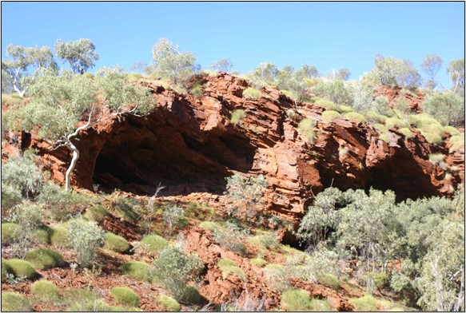

Figure The entrance of Ratty Spring Roost, looking south

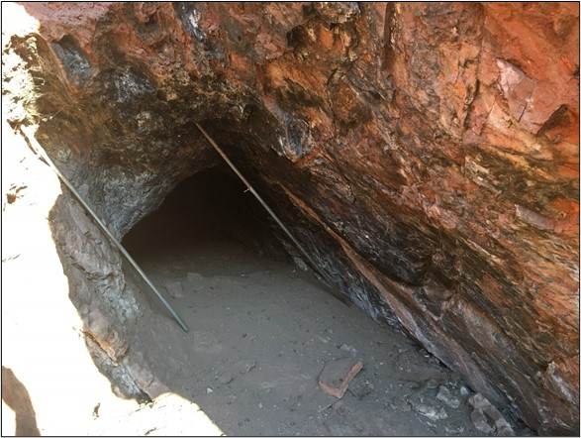

Figure The entrance of Kalgan Creek Roost showing the constriction at the rear

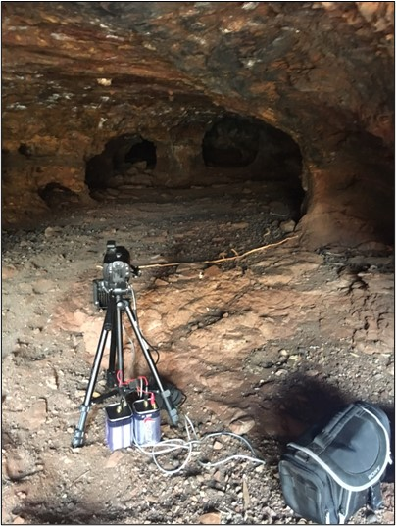

Figure Plan view of the first internal chamber of Cane River Roost

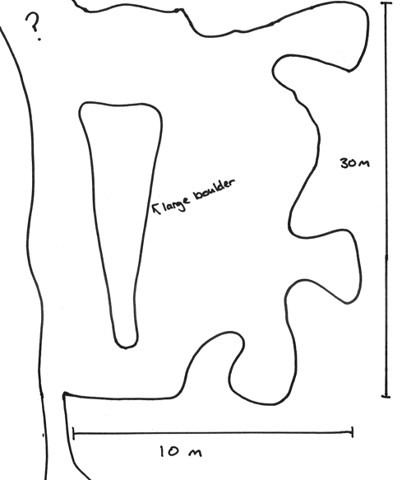

Source: APIM

The roost with a different type of constriction is Mt Webber cave MW-AN-27. This cave has a large double chamber at the level of the entrance and connects to a third chamber above via a 45 cm diameter vertical pipe over 1 m long. The PLNB roost diurnally in the upper chamber in large numbers. There may be a second entrance into the upper chamber at its rear as PLNB are sometimes observed circling in the lower rear chamber after disturbance at the pipe entrance, although these may have already being hanging there prior to the arrival of the observers.

The species is known to require high and stable temperatures and very high humidity within their diurnal roosting chambers. In the Pilbara there are accurate internal microclimate measurements from only one natural roost cave, the K75W cavern, but the data were not from the actual roost site in a side tunnel. Internal temperature and relative humidity in the cavern were measured via a ceiling drill hole in August 2018 as 24.5 to 25.5°C and 98 to 99% respectively. Long term data between November 2018 and October 2019 from the same point gave similar values (30.6°C and 100%). These are consistent with the temperatures published for underground roost locations in the Northern Territory at 29 to 31°C together with very high humidity (Churchill 1991) and a Kimberley cave at Geikie Gorge with values of 27.7 to 28.0°C and 90 to 100% (Armstrong 2000). These data show that humidity must be maintained at close to 100% for diurnal roosting, while the temperature must be stable and as high as possible at the location. These are consistent with the known high-water loss characteristics of the species (Baudinette et al. 2000) that results in desiccation and death if the bat is removed from high humidity for a number of hours.

None of these natural roost caves are known to intersect the water table. It is believed that the natural high humidity values are maintained by water seeping down through the rock above. This is supported in all cases by the common characteristic of being sited in BIF that is cracked both horizontally and vertically, visible in Figure 3 and Figure 4, that would easily allow water to move down through the strata. The single roost in Marra mamba, Ratty Spring Roost, is in strata that is not visibly heavily cracked but is in a faulted line with a clear slip plane that would also allow seepage of water from above. To date, there are no PLNB roosts known, or believed, to be in Robe Pisolite channel iron deposits that are typically not heavily cracked.

An additional feature of all known permanent and natural PLNB roosts is that they are within flying range of a permanent water source, Table 1. The longest linear distance from roost to water source is 8.7 km (from the Kalgan Creek Roost to permanent pools in the nearby creek. This roost also has a satellite ‘category 2’ roost in the ridges between it and those pools that is known to be used in the late dry season when the majority of Kalgan Creek is dry. The next longest distances are 5.9 and 6.1 km from Gudai-Darri K75W Roost to the Gudai-darri spring and Upper Beasley River Roost to the nearest major permanent plunge pool respectively. All other permanent roosts with approximately known locations also have permanent pools withing this distance (author’s unpublished data). Echolocation based surveys at these pools in the late dry season, when little other surface water is available, indicate that the PLNB often visit these pools soon after leaving their roost.

#### Characteristics of PLNB diurnal roosts in abandoned underground mines

In the eastern Pilbara region, there are a number of historical underground hard rock mines dug in the early and mid-20th century that support permanent PLNB diurnal roosts. Examples of these where the mine is known and has been visited, characterised, and are currently monitored for PLNB presence are given in Table 2. The common characteristics of the 3 permanent category 1 roosts (Bow Bells, Copper Hills and Lalla Rookh) are that they are deep and have a complex of tunnels and shafts that intersect the water table. The size of the colonies at these 3 roosts varies but all are large with Bow Bells harbouring many thousand. The other 2 that are not permanent (Klondyke Queen and East Turner River-Birthday Gift), are not known to intersect the water table. These 2 have had diurnally roosting colonies present, but numbers have varied over time depending on season and rainfall patterns. Both have been abandoned as diurnal roosts for periods believed to be associated with drying tunnels, however there is insufficient data to confirm this reason.

There are no temperature and/or humidity data measured in these mines close to the roosting chamber to compare with the cave data referred above, but it is believed that the lower tunnels in these mines do have very high humidity. Data from well within both Bow Bells and Klondyke Queen, but not at the roost chamber, give underground temperatures at a stable 28°C and relative humidity well above ambient level, as high as 80% in the wet season deep in the mine.

As for the natural cave roosts, all known permanent PLNB roosts in historical underground mines are within similar flying ranges of a permanent water source, Table 2. The longest linear distance from roost to water source is 8.5 km from Klondike Queen to a permanent pool at the Copenhagen flooded open pit. This roost is known to be a satellite of the permanent Bow Bells mine roost that lies in the ridges between it and that pool. The next longest distance from a permanent roost are 5.0 km from Bow Bells to the Copenhagen pool and 3.5 km from Lalla Rookh to the Shaw River pools.

There is no consistent layout for these roosts with combinations of adits, declines, stopes, tunnels and shafts being present (Table 2). Due to the nature of the hand-dug mining though, all have tunnels and shafts of regular 2 to 5 m2 cross-sections and all appear to include areas where the PLNB can roost without being directly preyed upon by Ghost Bats.

### Foraging habitat and activity levels

In the early years of research, the PLNB has been observed foraging in a variety of habitats—Triodia hummock grasslands covering low rolling hills and shallow gullies, with scattered Eucalyptus camaldulensis along the creeks (e.g. near Marble Bar, Bamboo Creek, Lalla Rookh and Copper Hills; Armstrong 2001; Armstrong unpublished observations; Churchill et al. 1988); over small watercourses amongst granite boulder terrain and around nearby koppies; over pools and low shrubs in ironstone gorges; and above low shrubs and around pools in gravelly watercourses with Melaleuca leucodendron, such as in Barlee Range Nature Reserve (Armstrong 2001). They are most commonly encountered over small pools of water in rocky gullies and gorges, and at cave or mine adit entrances, and these sites are ideal for detection and monitoring (Table 3).

Extensive surveying using echolocation detectors in recent years has provided a very large data set of PLNB activity at a large variety of sites that show that the PLNB forages very widely and utilises almost all productive and semi-productive habitats. These data allow the various habitat types found in the Pilbara to be scaled as a foraging habitat rating (HR), Table 3 (e.g. Bullen 2014; Bullen 2017b). Further, an activity rating (AR) based on nightly call patterns has also been developed and applied Table 4, that provide a strong correlation with the habitat ratings, Table 4 (Bullen 2019).

Table PLNB foraging habitat types and rating scale

| Habitat Rating (HR) | Description | Habitat type | | |
| --- | --- | --- | --- | --- |
| Plains and low hills | Gullies, ridgelines and mesas | Deep gorges |
| 0 (Poor) | PLNB are unlikely to be detected in these areas. | Bare open ground such as salt pans and clay pans without vegetation | Bare mesa and ridge line tops | n/a |
| 1 (Low) | PLNB are unlikely to forage in these areas but may traverse while crossing to more productive areas. | Open plain with one layer of vegetation structure (excluding scattered trees)  Two layer, not complex, vegetation structure (excluding scattered trees) | Mesa and ridge line tops. Mesa side or long ridge line with simple geology and minimal caves and overhangs present.  Sparse vegetation cover.  Shallow non-incised gullies.  Spinifex cover to gully floor. | n/a |
| 2 (Moderate) | PLNB may occasionally forage in these areas due to presence of suitable vegetation, seasonal water and may also use areas as a flyway. | Two layer, not complex, vegetation structure (excluding scattered trees).  Includes ephemeral watercourse.  Open mine shaft entrance | Mesa side or long ridge line with deeply incised gullies in weathered strata (45º sloping walls).  Caves and overhangs present.  Shrubs in gully base.  Ephemeral watercourse in gully or nearby. | n/a |
| 3 (High) | PLNB are likely to forage in these areas if in range of a roost. They may be detected passing along creek lines, vegetation lines, rock faces or foraging in the most productive areas. | Three-layer, complex vegetation structure.  Includes ephemeral watercourse  Includes mine adit or decline in dry locations. | Mesa side or long ridge line with north facing, deeply incised gullies with vertical walls.  Caves and overhangs present.  Shrubs and thin tree cover in gully base.  Ephemeral watercourse in gully.  Includes mine adit in dry locations. | Dry deeply incised gorge into a ridge or mountain  Complex 3 layer vegetation structure.  Ephemeral water course. |
| 4 (Very high) | PLNB are very likely to forage and/or drink in these areas if in range of a roost. | Includes watercourses and other sites with semi-permanent or permanent surface water (natural or anthropogenic).  Three layers in vegetation structure.  Includes caves entrance or mine adits/declines with water nearby. | Mesa side or long ridge line with south, east or west facing, deeply incised gullies with vertical walls.  Cave entrance or mine adit.  Vegetation is complex.  Semi-permanent or permanent water pools present  Also north facing gullies with permanent water | Wet ‘open’ gorge with hills to the side.  Wet ‘closed’ gorge with one or 2 vertical walls  Complex 3 layer, dense vegetation structure.  Semi-permanent or permanent water pools present |
| 5 (Outside diurnal roost) | PLNB are present permanently and will be detected nightly. | Areas immediately outside a diurnal roost entrance. | Areas immediately outside a diurnal roost entrance. | Areas immediately outside a diurnal roost entrance. |

**n/a** Not applicable

Table Bat activity ratings and criteria

| Bat Activity Rating (AR) | Criteria |
| --- | --- |
| Very Low (AR=0) | Species not detected |
| Low (AR=1) | Species is recorded with call spacing greater than ten minutes. |
| Medium (AR=2) | Species is recorded with call spacing of less than 10 minutes but greater than 2 minutes. This pattern is observed for at least an hour followed by sporadic records for the remainder of the session. |
| High (AR=3) | Species is recorded with call spacing less than 2 minutes apart for at least 2 hours followed by regular records for the remainder of the session. |
| Very High (AR=4) | Species is recorded in very large numbers with call spacing less than 2 minutes apart for over 4 hours followed by regular records for the remainder of the session. |
| Extreme (AR=5) | Species are recorded in high numbers continuously from dusk to dawn at roost entrances |

Note: Activity ratings show a measure of the number of bat passes. They do not directly provide a guide to the usage of the site as a roost, forage location, commute site, etc. or accurate abundance data. However, data may be used to assist in inferring such results.

Figure PLNB foraging habitat compared to nightly activity rating

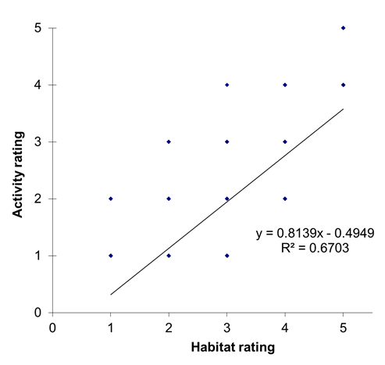

Note that sites with HR=4 that are distant from the roosts and therefore have AR=1 are not included. Source author’s unpublished data.

Another aspect of PLNB foraging is the distance that they fly nightly while foraging. Authors echolocation data from numerous sites across the Pilbara, Figure 8A, indicate that for ten months of the year, PLNB typically forage up to 20 km from their diurnal roost and can occasionally be recorded up to 30 km or more away, Figure 8B. However, during April and May, the authors data base includes an increasing number of detections beyond 30 km from a known permanent roost. These records correspond to the more benign months that have lower temperatures than late summer and higher humidity than later in the dry season. They also correspond to the months following the reproductive period that young adult bats might be spreading across the landscape. In some of these cases the bats may be originating from their maternal roost, but in others the timing of the calls closer to civil twilight indicates that the bats are roosting opportunistically in non-permanent roost caves (author’s unpublished data). Also note a reduced number of records over 10 km in January and February, Figure 8. This is due primarily to the reduction in survey effort during those hot humid months.

Figure Distance of echolocation records from known roosts by month of detection

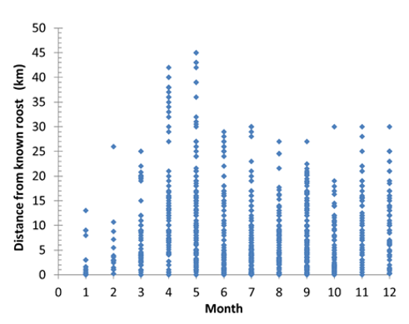

Source: author’s unpublished data

Figure Distance of echolocation records from known roosts by the number of sites

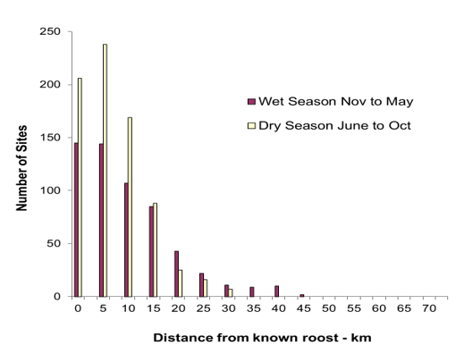

Source: author’s unpublished data

### Artificial subterranean roosts intended for PLNB

Introduction

Destruction of natural roosts should be avoided wherever possible, and creation of artificial habitat should not replace in-situ conservation actions for ghost bats. Furthermore, decision-makers should not sanction the destruction of natural roosts with the expectation that artificial roosts will provide an appropriate, effective or ecologically equivalent offset. Rather, the creation of artificial roosts should be undertaken as a last resort and, as per IUCN guidelines (IUCN/SSC 2014), only if it is a wise application of available resources. Any benefits of artificial roost creation for ghost bats is still to be effectively demonstrated, particularly at scale and duration (that is, number of animals and longevity of use) (L Ruykys).

There are numerous attempts at constructing subterranean roosts for various bat species both in Australia and internationally. The generalised requirements for these have been published (e.g. Thompson 2002; Gleeson and Gleeson 2012, sect. 10) and the details of some of these are available in the literature (e.g. Crimmins et al. 2014; Tobin and Chambers 2017). The approach is to reproduce the characteristics of a natural cave including depth, dimensions and surface finish of ceilings and walls allowing the bats to forage and possibly roost within. To date, this approach has been used in 5 Pilbara locations targeting PLNB and a sixth targeting Ghost Bats. Of the 5 targeting the PLNB, one at BHP’s Cattle Gorge project was intended as a diurnal roost for a semi- or permanent colony and 4 at Atlas Iron’s Mt Webber project were intended as replacement foraging sites with the possibility of providing occasional diurnal roosting as an aspirational requirement. Initially, common cave bats (the 22 g Taphozous spp and/or the 5 g Vespadelus finlaysoni) have been proven to colonise these tunnels soon after construction and in one a colony of Ghost Bats is resident (Wild 2021).

The general internal characteristics that the 5 roosts targeting PLNB were to provide:

* temperature to be maintained between 28 and 32°C
* humidity to be maintained at between 85 and 100%
* temperature and humidity buffering from natural conditions
* appropriate access limitations limiting roosting to the target species in accordance with requirements
* very low daytime light levels.

The designs were also intended to be maintenance free for the life of the structure.

The first built was a single chamber roost targeting diurnally roosting by Ghost Bats at BHP’s Mining Area C (MAC) project in 2016. This was a ‘cut and cover’ modular preform reinforced concrete ‘long-life’ design with an adit 15 m long opening into a chamber of 3 x 3 x 2.4 m (length, width, ceiling height) proportions. Its floor is natural rock and dirt. This roost was not intended for PLNB as it was not designed to create high internal humidity year-round, and the entrance and adit constriction were sized for Ghost Bats.

The second built at BHP’s Cattle Gorge project in 2017 was a double chamber structure intended for diurnal roosting by both PLNB in the upper chamber and Ghost Bats in the lower chamber. It is also a preform concrete ‘long-life’ structure that was buried in the pit during post mining rehabilitation. The adit and lower chamber have dirt floors, and the adit and lower chamber are of similar proportions to MAC. There was no attempt to provide increased humidity other than by rainfall seeping around and through the structure. Above the lower chamber, with access via ceiling holes, is a second chamber intended for the PLNB. This roost has been occupied by Ghost Bats, Taphozous spp and V. finlaysoni bats, but not by diurnally roosting PLNB to date although PLNB have been recorded at the entrance and occasionally inside.

The remaining 4 were built at Atlas Iron’s Mt Webber project in 2018 and 2019 as relatively low-cost technology demonstrators with a limited design life. The aim was to build replacements for foraging caves used by bats including PLNB for night roosting and other short visits. These were of steel construction with adits between 12 and 18 m long opening into a chamber of 4.8 x 2.4 x 2.4 m (Figure 10). These were all buried either in overburden storage areas or in pit rehab sites. The adit and the chamber had dirt floors. There was no attempt to provide increased humidity other than by rainfall seeping around and through the structure. Again, experience with these showed that PLNB were visiting the entrances almost as soon as the sites were commissioned but, to date, no PLNB have taken up diurnal occupation. A confounding aspect of the selected locations is that natural vegetation grew at the entrance of each following rain in 2020 that virtually blocked the passage for bats, thereby requiring regular maintenance to keep the entrances clear.

Figure Design of Atlas’ Mt Webber artificial roosts. Sketch provided by Atlas Iron

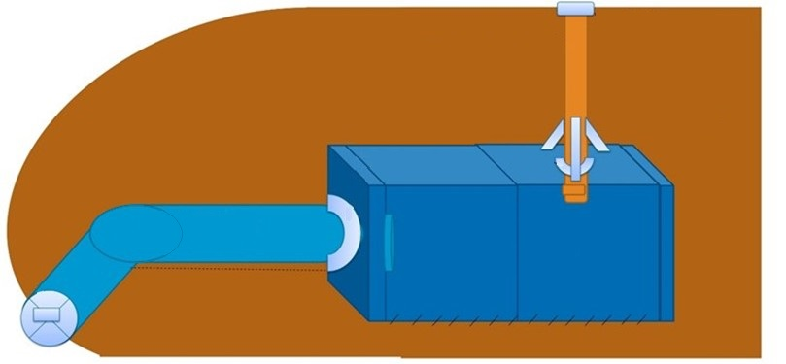

All 6 roost structures were built with a vertical sealable pipe of approximately 300 mm dia. running down from the surface above to allow placement of call recorders and/or cameras within the chamber.

In summary, the current experience with this type of structure has not been promising in that there is no evidence to date of diurnal roosting by PLNB. It follows then that an updated specification for a PLNB artificial roost should be based on:

1. **Design type** – For a replacement permanent roost, the current unpromising experience with buried concrete and steel structures, together with the expectation that these will decay and become unusable withing several hundred years, indicates that an ‘underground hard rock adit/tunnel/shaft complex in carefully selected stable strata’ is the recommended solution.
2. **Design life** – The aspirational life of the artificial roost is considered to be unlimited. However, long-term targets for material selection must be in accordance with current best practice mining and/or construction technology. Therefore, a concrete and steel structure would be expected to be viable for up to 300 years in accordance with appropriate construction codes. In contrast, an underground structure in hard rock geology would be expected to be viable for a considerably longer period.
3. **Location** – Sites that might be considered are:
   1. Adjacent to a waste overburden dump or in a rehabilitated pit site in close proximity to retained caves and remanent foraging habitat, so as to maximise the likelihood of it being utilised and to retain connectivity of roost habitat in the area.
   2. In unmined hard rock strata low in the landscape and where the roost can intersect the water table to maintain high humidity, that is permanently quarantined from mining and not subject to future/ongoing project impacts, particularly habitat removal, but also in consideration of noise, light and vibration impacts.
   3. In a location in unmined hard rock Brockman BIF strata higher in the landscape, to allow water from above to provide the required humidity. It will also be permanently quarantined from mining and not subject to future/ongoing project impacts, particularly habitat removal, but also in consideration of noise, light and vibration impacts.
   4. Within 6 km of a permanent source of surface water to allow possible nightly use by PLNB.
   5. In a geologically stable location that will be maintenance-free for the life of the roost. Matters such as protection from growth of choking vegetation must be addressed.

For a replacement roost and taking into account current experience with concrete/steel structures summarised in requirement 3), a site that meets either point b) or c) and also meeting d) and e) are the recommended alternative solutions.

1. **Overhead rock thickness** – For the higher landscape site where water will percolate down from above after rainfall to maintain high internal humidity, the thickness of the overhead strata at the rear chamber shall be within the range 5 to 10 m. This thickness has been shown to be acceptable for ground water ingress at other locations in Brockman BIF, see section 5.1.4 For the lower landscape site that intersects the water table, overhead rock thickness will be determined by the surrounding geomorphology and the stability of the strata above to protect from localised collapse.
2. The **internal microhabitat requirement** for a PLNB roost cave is to replicate conditions within natural caves proven to be permanent diurnal roosts. For the hard-rock alternatives, internal temperatures will be self-regulating over 12 months between 25 to 31°C. The required internal relative humidity is between 98% and 100%. This is to be achieved by correct placement of the structure in the strata without the need for any long-term maintenance such as piped in water.
3. **Entry is to be by an adit like tunnel** – For low landscape sites, the adit length will be determined by the location of the portal and the depth of the water table. Lengths between 10 and 800 m have been shown to be acceptable to the species. For high landscape sites, this can be any realistic length over 10 m to provide access to the roost chamber. Additional requirements are:
   1. The tunnel shall have a minimum of 90 degrees of bend to eliminate ingress of light, either natural day light, lightning or nearby artificial lighting.
   2. Minimum cross section shall be at least 2 m wide by 2 m high to allow the PLNB to circle within and pass while flying in opposite directions and to better evade predators. It may be any shape.
   3. Orientation of the adit portal is unrestricted.
   4. The portal shall be gated to prevent unauthorised human access and restrict entry by predators. The gate shall be of a design that allows bats of the size of PLNB to pass, but exclude larger predatory species such as Ghost Bats (see Figure 13).
   5. The adit shall contain a constriction point where the adit intersects the inner roost chamber to minimise access to the rear of the structure by predators such as Ghost Bats, pythons and goannas (see Figure 14). The constriction structure may be of any design and is to be permanently fixed in place and have no gaps at the edges. Edge sealing to be in accordance with the target design life. Its opening shall be 400 mm wide by 200 mm high if rectangular or 400 mm in diameter if tubular.
   6. The constriction and gate structures shall be corrosion proof in line with the structure's intended use and life.
   7. The high-landscape tunnel shall slope upwards from the portal to the rear chamber to capture hot and humid air within the rear chamber and also to allow any excess water to drain from the structure without puddling. The slope shall be less than 15 degrees. The low-landscape tunnel shall slope downwards from the portal by approximately 15 degrees to facilitate intersecting the water table.
   8. As much of the adit floor as practicable is to be graded natural waste rock and topsoil to allow natural colonies of insects to develop and to allow natural humidity to develop from the surrounding rock fill.
   9. As much of the adit’s concrete and steel construction material as practicable should be tinted/darkened to minimise the reflection of light along the entrance tunnel during daylight hours.
4. **Rear chamber**:
   1. The rear chamber ceiling shall be at least 500 mm higher than the adit.
   2. Planform is optional but proposed minimum size for a cave chamber is 3 m wide, 3 m long and 2.5 m high. This is deemed an acceptable size to allow a colony of approximately 600 PLNB bats to move freely within and fly circular patterns (author’s unpublished data). Note that a longer but narrower structure with a footprint of similar area is an acceptable alternative. For roosts intended for larger colonies, the available chamber ceiling area shall be calculated by allowing for 70 PLNB per square meter.
   3. Roof structure shall be effectively flat to replicate PLNB roosts in natural caves and have a rough and scored surface finish to allow bats to grip that is similar to the surface finish inside natural caves.
   4. The chamber shall be shaped to minimise predation by Ghost Bats, pythons or goannas should they successfully pass the constriction that is, will have effectively vertical walls over 2 m high and square corners. It may have smooth columns to support the roof.
   5. Design and location shall be naturally ventilated by using the characteristics of the strata. It shall not require artificial ventilation.
   6. Contaminants such as oil or cement dust should be removed from ceiling and walls during construction.
5. **Monitoring conduit** – For both underground hard-rock options, there shall not be a monitoring conduit to the surface above. Placement of monitoring equipment shall be via the entrance tunnel.
6. **Construction material** for the entrance portal, gate and adit constriction should also be selected in consideration of its geotechnical stability (including load bearing capability given depth of burial), design life/longevity, cost effectiveness, and how readily it can be sourced. These features will also be designed to ensure that the entrance remains free and open during life of structure.
7. **Translocation of PLNB** from permanent natural or underground mine roosts is not considered necessary or actually feasible. The data presented in the sections above indicate clearly that the species will easily find the roost as soon as it becomes available (see section 5.2), and, it is clear that the species has a propensity to populate suitable underground structures, as evidenced by the number of abandoned underground mines with colonies.

#### Artificial diurnal PLNB roost conceptual layout

Figure Artificial diurnal PLNB roost conceptual layout – plan

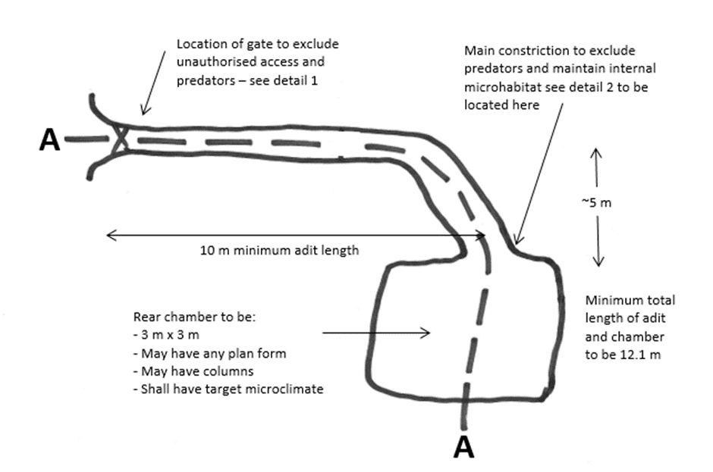

Figure Artificial diurnal PLNB roost conceptual layout – side view (section AA)

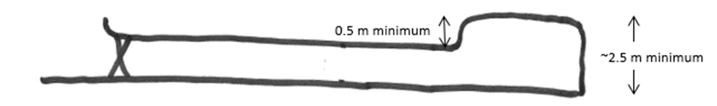

Figure Conceptual portal gate design for PLNB roost – detail 1

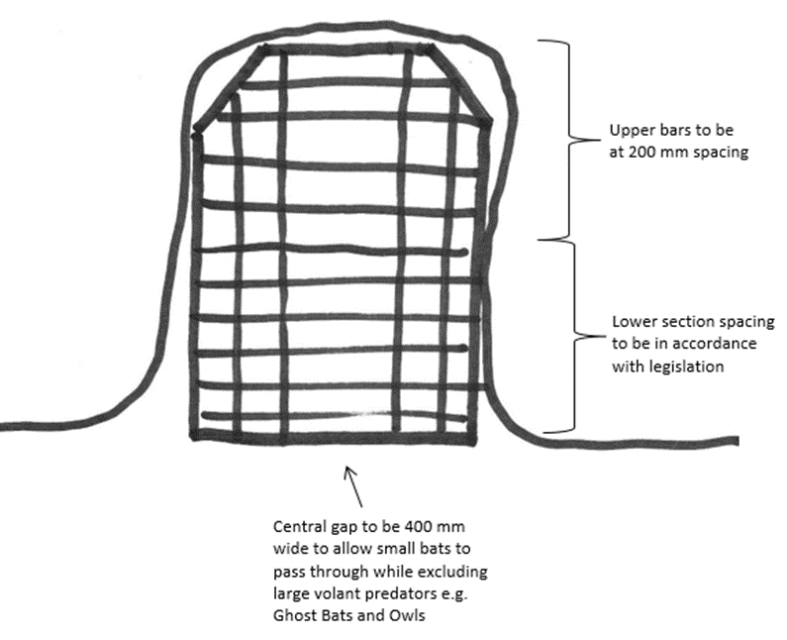

Note: Recommended material is welded 10 mm OD manganese steel construction to provide toughness and corrosion protection. It may also be a solid structure with a built-in constriction cut-out in the centre. Gate to be fixed into adit walls in a manner to allow occasional human entry. Gate to have provision for heavy duty locking/barring apparatus.

Figure Conceptual constriction design for PLNB diurnal roost – detail 2

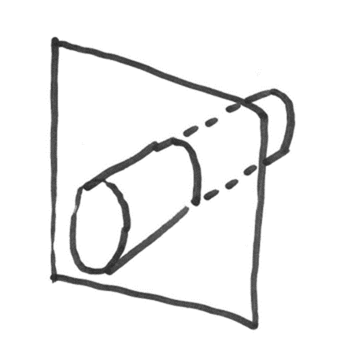

1. Material and construction to be either:
   1. corrosion protected steel plate and steel tube in accordance with target design life
   2. a brick or block wall with a cut-out.
2. Material thickness to support passage of camera or detector equipment for roost monitoring purposes.
3. Tube or cut-out to be located centrally on plate or wall.
4. Tube to be either:
   1. 400 mm dia. and 1 m long
   2. cut-out to be 400 mm by 200 mm.
5. Constriction plate to be shaped to fit adit cross section to facilitate edge sealing.

## Anthropogenic threats

Colonies of PLNB bats are potentially subject to the various broad scale threatening processes recognised for Pilbara fauna including loss of foraging habitat to over-grazing and/or frequent wildfires, promoting predation and competition by exotic species, changed hydrological regimes, and the expansion of mining, agriculture, and tourism. There are also fine scale threats such as destruction of individual roosts. Impacts from these threats can generally be categorised as either direct or indirect.

Direct impacts reduce the diversity and abundance of PLNB in an area through mortality or displacement of individuals or populations. For a given colony these may include:

* loss of the roost sites including caves and old workings
* loss of foraging habitat
* typical nearby mine operational impacts
* changed water regimes such as flooding or dewatering
* exposure to pollutants such as arsenic and/or cyanide in gold mining areas.

The indirect sources potentially causing impacts to Pilbara colonies are:

* introduced species or zoonoses
* sound, vibration, airborne dust and NOx
* increased light
* changed fire regimes.

These impacts can be permanent or temporary, and result in changes to fauna or fauna habitat beyond the immediate project impact development (EPA, 2016a).

### Direct threats

#### Loss of roosts

The most direct impact on a colony would be the loss of its critical diurnal roosting habitat. The increase in iron ore and gold mining in the Pilbara in recent years, if left to develop unchecked, has the potential to destroy or make unusable a significant percentage, possibly the majority, of the natural roost caves. As discussed in section 5.1.4, the majority of the caves are in BIF strata that may be of commercial grade. In addition, the abandoned underground mine roosts are in known gold or copper bearing strata that may be subject to redevelopment. Potential instability and subsequent collapse of historic underground workings is also regarded as a significant threat contributing to the Vulnerable listing status of PLNB (TSSC 2016). Sites such as Bow Bells, Lalla Rookh and Klondyke Queen are already subject to nearby mining activities. To date, there are no known Pilbara roosts, either cave or mine, that have been lost to development due to the protection provided by the Vulnerable listing. The ongoing listing of the species as Vulnerable in state and commonwealth legislation is therefore critical to its long-term persistence.

#### Loss of foraging habitat

Given the typical nightly foraging range of 10 to 20 km, broad-scale, patchy, low intensity anthropogenic changes induced by mining or pastoral projects are unlikely to impact the species significantly. To support this, cases have been documented where large-scale wildfires have had no measurable impact on a roosting colony (e.g. in October 2020, an extensive lightning lit fire east of Marble Bar had no impact on the Bow Bells colony). However, the loss of any permanent pools close to permanent diurnal roosts (see section 5.1.4) may result in roost abandonment and would constitute a direct impact. These pools must therefore be considered critical habitat. Widespread degradation of vegetation biomass in HR 4 and 5 habitats within 20 km of known category 1, 2 and 3 roosts are likely to have a similar outcome.

#### Typical mine operational impacts

Currently the persistence of PLNB roosts adjacent to mining is not well documented. This species is known to be sensitive to disturbances within or in close proximity to roost caves and they will abandon roost caves if disturbed unreasonably (Churchill 2008). Displaced bats are susceptible to death through dehydration, particularly during the dry season. There are currently 4 permanent PLNB roost caves in reasonably close proximity to active large-scale open cut mining operations. These are BHP Cattle Gorge mine at 500 m, Atlas Iron Mt Webber mine at ~ 1 km, Ratty Spring at ~ 1.3 km and Paraburdoo East roost at ~ 2 km. Ongoing monitoring has confirmed that all 4 have remained viable diurnal roosts for the species and remain maternity roost candidates (authors unpublished data). Operational impacts such as noise dust, light and vibration (see section 6.2) are likely to be the primary issues although vehicle collision in heavily travelled areas cannot be ignored.

#### Changed water regimes

Dewatering is the most direct factor likely to impact the PLNB roosts in abandoned mines connected to the water table. Dewatering is sometimes required to access the ore. Impacts due to dewatering may include a reduction in humidity in the workings. Because PLNB roosting is dependent on very humid microclimates (Baudinette et al. 2000) this may cause roosts to be abandoned. An example of abandonment due to loss of underground humidity resulting from natural causes is the East Turner River roost. This was abandoned sometime between 2018 and 2019 during a period of drought in the eastern Pilbara that resulted in the drying of the underground tunnels at that site.

Flooding of mine lower levels is also a possible future threat to PLNB roosts. The regulation of excess water disposal at projects should ensure that this potential threat is addressed. Again, to date there are no known cases of a Pilbara roost being abandoned due to flooding.

#### Exposure to pollutants such as arsenic and/or cyanide

In projects in gold mining areas, cyanide may be used in the leaching of gold from ore and the separation of gold from carbon. The potential for cyanide to impact on the fauna nearby the project area has been identified as an environmental risk. Currently at ‘no discharge’ mine facilities, 50 mg/L WAD (weak acid dissociable) cyanide for solutions accessible to wildlife (e.g. discharge into tailing ponds) is widely recognised by the mining industry as a water quality benchmark for the protection of wildlife (e.g. Donato et al. 2007; Griffiths et al. 2014). This level is derived from observations in both the USA and Australia that bird mortalities tend to occur when the WAD cyanide concentration increases above 50 mg/L (Donato et al. 2007). In recognition of the PLNB Vulnerable listing and the scarcity of data on cyanide lethality to bats, current best practice at gold mines in the Pilbara is to discharge at a peak concentration of WAD cyanide <30 mg/L, a level consistent with a similar mining operation in NSW. It is likely that typical discharges should be much less that this and following volatilisation of cyanide post discharge, that WAD cyanide in the supernatant pools will be lower still. An additional way of protecting the wildlife at tailings dams is to maintain the salinity levels above that which is suitable for drinking (after Griffiths 2013) Authors unpublished data indicate that bats are unlikely to drink water that is moderately saline above 3,200 mg/L total dissolved solids.

Concentrated arsenic in gold mining areas is also a potential direct impact on the PLNB. PLNB forage around, and drink from, various ground water sources that are known to have arsenic (As) concentrations from natural sources. Ground water As levels appear on limited data to be higher in the eastern Pilbara than in the Hamersley Ranges. One such eastern Pilbara source is the Copenhagen open cut south of Marble Bar that has been flooded for a number of years and contains water with measured As concentrations of 560 µg/kg in March 2019 after evapo-concentration over time. Arsenic is deposited in mammal tissue following exposure from a range of natural sources including drinking water and food sources and exists at various levels in all living beings. It remains in some tissues including hair for long periods and can build up to levels that can result in chronic and even acute poisoning. Unfortunately, there are no available data directly relating As to bat poisoning or mortality. PLNB at the Bow Bells/Klondyke Queen colony are exposed to the elevated level at Copenhagen and other ground water sources due to the short distances between the sites. To date, no symptoms of As poisoning have been observed at that colony. As is currently not considered to be a major concern for PLNB colonies unless there is a new source of drinking water with high As levels developed during a project.

A third type of pollution with the potential of impacting PLNB is the practice occasionally employed of disposing of waste oils and other liquids down ore body exploration drill holes. This practice has the potential to pollute ground water and, if near a diurnal roost has the potential to seep into the roosting chamber, potentially causing the bats to abandon. While not believed to be common, best practice indicates that this waste disposal method must be banned at exploration, mining and related projects.

### Indirect threats

#### Introduced species or zoonoses

Currently there are no known impacts from introduced species on the PLNB. One possibility in the future potential introduction of a similar disease to White Nosed Syndrome (WNS) (*Pseudogymnoascus destructans*). WNS is the fungal disease killing bats in their hibernacula in North America. Research indicates the fungus was likely introduced from Europe, possibly by cavers or bat biologists. WNS causes high death rates and fast population declines in the species affected by it, and scientists predict some regional extinction of bat is possible. Studies have also shown that this fungus grows only at cold temperatures (5-20°C) that are much lower than temperatures within PLNB roosts (Verant et al. 2012). Nevertheless, a future similar disease spread in PLNB roosts is possible. Care regarding hygiene should therefore be taken when working at PLNB roost sites.

#### Sound

Being mammals with superior hearing capabilities, it is expected that sound may have an effect on PLNB. In addition to the sound produced by blasting, levels of sound in an active mining area can be high when equipment is operated at close range. Sound Power levels of 120 to 150 dBZ may be generated by various types of equipment such as haul trucks, loaders/excavators, dozers, drill rigs and service trucks. Also, the frequency spectrum of some of this equipment may have high levels in low octave bands below 500 Hz. Sound of this level may be generated between 1 and 10% of the time by mobile equipment or for longer periods in the case of fixed equipment. At close range to the roost entrance, these levels may result in high sound pressure levels exceeding 100 dBZ, e.g. authors calculations show that a loader operating at 200 m may generate an SPL of 101 dBZ for 10% of the time while at 500 m the SPL would be 93 dBZ.

There is a large body of literature on the effects of sound on animals (e.g. see Turina and Barber 2011; Shannon et al. 2016). Most researchers agree that noise can affect an animal’s physiology and behaviour and, if it becomes chronic, noise induced stress can become injurious to an animal’s energy budget, reproductive success and long-term survival. There is a body of evidence that animals can habituate to sound levels below those given above. Further, the sound levels underground in the roost chambers from continuous nearby mining operations, that could be potentially chronic, will be greatly attenuated below levels measured at the roost entrance. There is virtually no research though on the effects of noise on bats emerging from a deep underground roost and experiencing high noise levels for brief periods and then transiting noisy operational areas. The literature suggests that in this type is situation the bats may become accustomed and continue to depart the roost and transit to foraging areas in a typical manner. Very loud continuous noise in excess of 100 dB may alter this result.

Current experience with the PLNB at sites such as those listed in 5.1.4 above, where drill and blast mining as well as heavy machinery operate, suggests that PLNB will habituate to the sound from these types of activities given that a reasonable buffer of several hundred meters from the entrance is observed. But there is no empirical data to fully assess this claim.

#### Inground vibration

The PLNB is known to be subject to disturbance and to move about within the roosts during the day if disturbed (Churchill 2008; Bullen 2013b; Woinarski et al. 2014), using valuable energy reserves. They may even abandon the colony if the disturbance levels were sufficiently high (Churchill 2008; Woinarski et al. 2014). Production blasting in nearby iron-ore mines, if high blast charges are used at distances between 50 to 400 m, will provide levels of vibration above those that available data suggest may disturb the colony. Bullen (2013b) identified an underground vibration limit of 10 – 15 mm/s peak particle velocity (PPV) based on disturbance of the bats in their roost and noted that this is conservative. It also noted that this is lower than the vibration levels that might be expected to damage historical mines and/or cause local collapses, a threshold set currently at 25 or 50 mm/s in the majority of situations. Limited additional international experience is available. An example from Whitecleave Quarry, Devon, UK, is based on impact to human residences. There also remains the possibility that vibration levels at 10 mm/s may cause localised collapse within a roost.

Recent work at various projects has shown that routine mine planning can limit the vibration levels within the colony to 10 mm/s by combining small blast charges with distances as close as 150 m if the exact location of the roost within the strata and the vibration transmission characteristics of the rock are known. Calculations are possible based on the equations from Australian Standards, however the constants relating to the strata can vary the result by as much as +/- 100%. Locating the exact colony site and determining the rock vibration transmission characteristics are not yet commonly carried out or available for a range of PLNB roosts or rock types.

#### Airborne dust and NOx

Insectivorous bats detect prey via sound, both audible and ultrasonic. They also have excellent vision and it is possible that high dust levels could irritate the eyes or reduce vision and affect their ability to capture prey. There is no current data available regarding these effects on Pilbara bats. High dust events are likely at certain mining locations (e.g. crusher, post blasting) possibly also including Nitrogen oxide (NOx) concentrations. The group of gases known as Oxides of Nitrogen or NOx, of which the most common are nitric oxide (NO) and nitrogen dioxide (NO2) are often found as biproducts in nitrate-based explosives. As a result, if best practice dust and NOx suppression strategies (see AEISG 2011) are implemented including using pre-planned blasting limitations (including wind direction limitations) near roosts, the likelihood that the PLNB colonies will be affected is low.

#### Increased light

The presence of artificial lighting for night-time operations may have an impact on PLNB occurring within the vicinity of the light sources. National light pollution guidelines for wildlife including marine turtles, seabirds and migratory shorebirds have recently been published (DAWE 2020) and an appendix for bats is currently being prepared. These guidelines currently recommend best practice lighting designs incorporates 6 design principles to minimise impacts on wildlife:

1. Start with natural darkness and only add light for specific purposes.
2. Use adaptive light controls to manage light timing, intensity and colour.
3. Light only the object or area intended – keep lights close to the ground, directed and shielded to avoid light spill.
4. Use the lowest intensity lighting appropriate for the task.
5. Use non-reflective, dark-coloured surfaces.
6. Use lights with reduced or filtered blue, violet and ultra-violet wavelengths, that is with red biased spectra.

The guidelines also state that ‘the way in which light affects a listed species must be considered when developing management strategies as this will vary on a case by case basis’. Impacts to PLNB due to lighting are currently undocumented, however, the following should be considered.

* The species has persisted 500 m from mining operations at Cattle Gorge, (Biologic 2016) and at other Pilbara projects.
* Excessive light is likely to have an effect on the natural foraging behaviour of PLNB, which is thought to be attracted to light sources (Cramer et al., 2016). However long-term studies at Atlas’ Mt Dove project have shown that PLNB activity is not negatively impacted by artificial illumination and can possibly increase presumably due to increased foraging resources available (C. Knuckey, unpub. Data – cited in Atlas Iron Pty Ltd (2019)). Best practice is to locate the Camp and Plant behind hills so as to not directly illuminate the diurnal roost entrances.
* It is known that Infra-red lighting used in PLNB census work greatly illuminates the PLNB by comparison to the other bat species present (author’s unpublished observations). This feature of their pelage may be a part of the species collision avoidance methodology in that it may assist their seeing oncoming or nearby PLNB flying at high speed. At the roost entrances it is also known that Ghost Bats often prey on PLNB as they depart in the evening (Churchill 2008; authors Pilbara obs.). Illuminating with red biased spectra lighting at roost entrances may therefore result in an increase in PLNB mortality from Ghost Bats.

#### Changed fire regimes

Other than minor changes in insect prey concentrations, no impacts on the PLNB are foreseen from changed fire regimes. The species can and does forage over large areas.

#### Vehicle strike

The species is known to forage close to the ground (Churchill 2008), and mortalities due to vehicle collisions at night have been recorded especially where a projects disturbance footprint intersects Rocky Ridge and Gorge habitat, major drainage lines, or is near diurnal roosts. However, at mining sites, vehicle movements at night are greatly reduced compared with daytime, and are generally limited to in-pit operations. Best practice to minimise impact of wildlife is to employ appropriate speed limits.

## Minimum survey requirements

### Recommended survey approach

Targeted surveys should incorporate a number of strategies, though in almost all situations, the species can be surveyed without the need for capture. Their echolocation call is diagnostic when recorded with the correct equipment, and they have a curiosity for small light sources such as headtorches, which brings them within range of hand-held electronic bat detectors. Ultrasonic detectors are the best means of non-invasive survey. However, the discovery of roost sites within a project will allow the best assessment of whether the species will be affected by a development, given that suitable roost sites are known to be critical habitat. Other activities can also be used to assess roost occupancy or augment an assessment of presence e.g. with census information.

The following points should be noted for this species:

* Their ultra-high echolocation frequency may not be detected particularly well by some detection systems currently available.
* This species is sensitive to disturbance at their roost, and physiologically fragile (declines rapidly from water loss and stress following capture). Cave and mine entrances with roosts should not be repeatedly trapped, since capture might cause individuals to vacate to less suitable roosts nearby.
* Diurnal occupancy of a cave/mine inferred from echolocation data often needs to be confirmed using an alternative non-invasive method such as video od direct observation.
* Bat detectors placed at cave/mine entrances do not directly provide accurate counts of PLNB colonies because of their tendency to fly about at entrances and repeatedly re-enter structures after sunset. An index of activity is the only practical way to assess usage and relative importance of a feature, and this measure will not necessarily correlate with colony size.
* Accurate counts can be obtained using video techniques which can then be used to calibrate call recording histories to give colony size estimate changes over time.

#### Prior to a survey

An important initial step is to determine whether there are known caves and mines in the project area. Information can be sourced from topographical and geological maps, aerial photography, the WA Department of Mines, Industry Regulation and Safety (Minedex and Tengraph), Department of Environment and Conservation and bat researchers. Where appropriate, on-site information on the location of caves and mines can be sourced from local residents and mining companies. A review of available records from the Atlas of Living Australia, Nature Map and the proponents available data base is also warranted, however these sources often have scarce applicable records.

#### Passive ultrasonic detection

A range of potential foraging habitats can be examined by passive detection with unattended recorders placed in the vicinity of mines, caves and rocky outcrops, and in steep-sided rocky gorges containing pools, open watercourses containing ephemeral pools lined with vegetation. Unattended detectors should be left overnight at multiple locations.

#### Active acoustic detection

PLNB in flight can be detected by conducting night transects with a hand-held bat detector in habitats such as deep gullies and gorges, larger watercourses with pools, and along scarps containing caves. Transects should begin at dusk and be of 2 hours minimum duration in total. In some habitats, the likelihood of encountering PLNB can be greater on a transect than at a passive monitoring station, so the use of both is recommended. If possible, Geo-referenced recordings should be made along the track. Systems are available with the ability to assess the bats present in real time.

#### Recommended acoustic detection devices

There are a range of ultrasonic bat detectors currently available. The current industry standard in the Pilbara is to use a full spectrum device recording at a sample rate of at least 384 kHz to ensure that PLNB calls at the high end of the range (>125 kHz) are not clipped by the recorder. Unfortunately, in practice, some systems have been shown to have very low ability to record high frequency bats such as PLNB. Advice on particular systems should be sought from an experienced researcher who is familiar with the system. Alternatively, a new system to be introduced into survey work should be tested against the current industry standard to ensure its suitability to record PLNB. Some systems also offer a range of ultrasonic microphones for bat surveys. Common options are omnidirectional and directional microphones. Omnidirectional microphones are commonly used in general surveys including at cave entrances whereas directional microphones are commonly used inside caves. For general survey work away from caves, the mic should be oriented upwards or towards the feature being surveyed, e.g. a water pool, and preferable at least 1 m off the ground. For targeted work in caves the mic should be oriented towards the feature being recorded, that is across the entrance or directly into the cave or its constriction.

#### Trapping

Harp traps set in watercourses have been successful on some occasions but rarely in cave entrances. Mist nets are unlikely to be useful away from cave entrances because the PLNB can detect them easily and use their echolocation to identify holes big enough to fly through (author’s observations). In most cases, unambiguous detection from echolocation recordings can replace the need for capture, thus avoiding injuries, disruption of behaviour, etc. They may not survive overnight and will not survive during the day if held in bags or cages. Traps and mist nets therefore should be continuously monitored, and bats released immediately.

#### Exploration for caves (potential roosts)

Searches can be conducted for relatively deep caves along mesa outcrops, in gorges, deep gullies flanked by rocky outcrop, and beneath ephemeral waterfalls, with focus given in landscapes composed of Brockman and Marra Mamba banded iron formations. For large project areas in gorge and mesa country, searches could be expected to take several days. It may be economical to use a helicopter or drone to identify the largest caves in one run and follow these up on foot.

#### Roost occupancy determination

If surveys have identified a possible daytime roost via call detection triangulation, or if a relatively deep cave/mine looks suitable as a roost of this species, emergence at dusk can be assessed without entering it and potentially evicting any occupants. The entrance can be recorded from dusk onwards using Infra-red lit video accompanied by a detector to record the signals and confirm the species.

#### Cave entry prohibition protocol

Best practice when surveying for PLNB is to apply a conservative protocol to protect the reproducing females and their young during the most important part of their reproductive cycle. This covers the periods when:

* Gravid females are subject to premature birth due to either capture and handling or repeated flushing the bats from their diurnal roost caves.
* Females carrying newborns are subject to dropping them due to capture or disturbance.
* Non volant young in nurseries are subject to abandonment due to repeated disturbance of the mothers.
* Newly volant young during the early adolescent period are subject to premature abandonment due to repeated disturbance of the mothers and/or young.

For PLNB category 1 and category 2 roost caves, it is recommended that restrictions tighter than Governmental licencing limitations be enforced:

* To minimise impact on pregnant females, successful trapping sessions, that is when PLNB are captured or are present and disturbed, be limited to once per cave during November and early December.
* To negate impact on pregnant and lactating females, and/or newly volant young, no trapping or entry into known roost caves/mines should be carried out from mid-December to mid-February.
* To negate impact on soon to be volant young in nurseries, no entry into the deeper areas of known roost caves should be allowed from late-February to mid-March.
* Trapping and collection in accordance with Governmental licencing limitations be allowed outside these periods.

For PLNB category 3 and 4 caves, it is recommended that normal survey activity in accordance with Governmental licencing limitations be allowed year-round.

### Survey effort guide

Several hours per day may be required to conduct ground-based surveys for caves and mines. Examination of geological maps and aerial photography can be used to reduce the survey area to the most likely areas with gullies, gorges and rocky outcrop. Surveys should be repeated twice, approximately 6 months apart since the species has the potential to be present in some or all seasons. For small study areas, minimum effort is given in Table 5.

Table Minimum survey effort for a small project area <500 ha

| Survey techniques | Total effort | Minimum number of nights |
| --- | --- | --- |
| Unattended bat detectors **a** | 16 detector nights | 4 |
| Attended bat detectors | 8 detector hours | 4 |
| Harp traps (optional) | 8 trap nights | 4 |

**a** Number required dependent on the number of caves/mines; the numbers given here are provided as a guide.

For large baseline or ‘level 2’ survey areas, the probability of detecting PLNB with ultrasonic detectors is high, particularly in the Hamersley Range. The number of detector sites therefore required will be determined by the size of the area and the objective of confirming the presence or absence of a PLNB roost in the area. A guideline for this step is to plan for between 500 to 800 ha per recording site. Two to 4 recording nights should be allocated for each site with the highest habitat rating and the survey should be repeated twice to cover wet and dry seasons. Once the presence of a diurnal roost is indicated, more extensive targeted searching must then follow.

## Glossary

| Term | Definition |
| --- | --- |
| AOO | Area of occupancy |
| APIM | Australian Premium Iron-ore Management |
| AR | PLNB call activity rating |
| As | Arsenic |
| BIF | Banded Iron Formations |
| Category 1 and 2 roost caves | PLNB roost caves with permanent or regular occupancy. All are proven or assumed to be maternity sites and are critical habitat. |
| CT | Civil Twilight: The beginning or ending time of twilight when the geometric centre of the Sun is 6 degrees below the horizon in the morning or evening. Times are taken from Geoscience Australia website. |
| DBCA | Western Australian Department of Biodiversity, Conservations and Attractions. |
| EOO | Extent of occurrence |
| HR | PLNB habitat rating |
| IR lit video | Video recordings made using infra-red lighting |
| NOx | Oxides of nitrogen |
| PLNB | Pilbara leaf-nosed bat (*Rhinonicteris aurantia*, Pilbara form) |
| PPV | Peak Particle Velocity vibration measurement in mm/s |
| RFID | Radio Frequency Identification |
| RTIO | Rio Tinto Iron Ore |
| TSSC | Threatened Species Scientific Committee |
| Ultrasonic call | A sequence of ultrasonic pulses emitted by the bat and recorded during a pass |
| Ultrasonic pulse | A single ultrasonic pulse emitted by a bat for foraging or navigation purposes. |
| WAD | Weak Acid Dissociable cyanide bound to the metals Zn, Cd, Cu, Hg, Ni and Ag. It is liberated at a moderate pH of 4.5 and is potentially toxic to humans and animals. |

## References

AEISG 2011, [Code of Good Practice: Prevention and Management of Blast Generated NOx Gases in Surface Blasting](https://www.aeisg.org.au/aeisg-codes-of-practice/), Australian Explosives Industry and Safety Group, Tweed Heads, NSW.

Armstrong, KN 2000, Roost microclimates of the bat Rhinonicteris aurantius in a limestone cave in Geike Gorge, Western Australia. Australian Mammalogy. 22:69–70.

Armstrong, KN and Anstee, SD 2000, The ghost bat in the Pilbara: 100 years on. Australian Mammalogy. 22:93–101.

Armstrong, KN 2001, The roost habitat and distribution of the orange leaf-nosed bat, Rhinonicteris aurantius, in the Pilbara region of Western Australia. Wildlife Research. 28:95–104.

Armstrong, KN 2006a, Resolving the correct nomenclature of the orange leaf-nosed bat Rhinonicteris aurantia (Gray, 1845) (Hipposideridae). Australian Mammalogy. 28:125–130.

Armstrong, KN 2006b, Phylogeographic structure in Rhinonicteris aurantia (Chiroptera: Hipposideridae): implications for conservation. Acta Chiropterologica. Acta Chiropterologica. 8:63–81.

Armstrong, KN, and Coles, RB 2007, Echolocation call frequency differences between geographic isolates of Rhinonicteris aurantia (Chiroptera: Hipposideridae): implications of nasal chamber size. Journal of Mammalogy, 88(1), 94–104.

Armstrong, KN 2011b, Population genetic assessment of the Pilbara leaf-nosed bat Rhinonicteris aurantia, with a focus on the Goldsworthy group. Unpublished report by Molhar Pty Ltd to BHP Billiton Iron Ore Pty Ltd, 4 April 2011.

Baudinette, RV, Churchill, SK, Christian, KA, Nelson, JE and Hudson, PJ 2000, Energy, water balance and the roost microenvironment in three Australian cave-dwelling bats (Microchiroptera). Journal of Comparative Physiology. B 170:439–446.

Bullen, R and McKenzie, NL 2001, Bat airframe design: flight performance, stability and control in relation to foraging ecology. Australian Journal of Zoology, 49(3), 235–261.

Bullen, RD and McKenzie, NL 2002, Scaling bat wingbeat frequency and amplitude. Journal of experimental biology, 205(17), 2615–2626.

Bullen, RD and McKenzie, NL 2004, Bat flight-muscle mass: implications for foraging strategy. Australian Journal of Zoology, 52(6), 605–622.

Bullen, R 2013a, Pilbara leaf-nosed bat, Rhinonicteris aurantia: Summary of current data on distribution, energetics and threats. Presentation made to Western Australian Department of Environment and Conservation workshop on Pilbara leaf-nosed bats, 25 June 2013

Bullen, R 2013b, Rio Tinto, Koodaideri Orange Leaf-nosed Bat colony; vibration disturbance survey, October 2013. Unpublished report by Bat Call WA Pty Ltd for Biota and Rio Tinto dated November 2013).

Bullen, R 2014, Brockman Mining Australia Pty Ltd Ophthalmia Iron Ore Project Pilbara Leaf-nosed Bat survey March 2014. Unpublished report by Bat Call WA Pty Ltd for Brockman Mining Australia dated April 2014.

Bullen, RD, McKenzie, NL and Cruz-Neto, AP 2014, Aerodynamic power and mechanical efficiency of bat airframes using a quasi-steady model. CEAS Aeronautical Journal, 5(3), 253–264.

Bullen, RD, McKenzie, NL and Cruz-Neto, AP 2016, Characteristic flight speeds in bats. CEAS Aeronautical Journal, 7(4), 621–643.

Bullen, R 2017a, Comet and Alexander historical mines, assessment of Pilbara leaf-nosed and Ghost bat presence and activity, May 2017. Unpublished report by Bat Call WA Pty Ltd for Atlas Iron dated May 2017.

Bullen, R 2017b, API Management, West Pilbara Iron Ore Project, Pilbara Leaf-nosed Bat Cane River Roost Dispersal, August 2015. Unpublished report by Bat Call WA Pty Ltd for API Management dated October 2017.

Bullen, R 2019, Pilbara leaf-nosed bat, Rhinonicteris aurantia: Summary of current data on distribution, energetics and threats. Presentation made to Western Australian Department of Biodiversity, Conservation and Attractions (DBCA) 28 November 2019.

Bullen, RD and Reiffer, S 2020a, Measurement of roost entrance activity of Pilbara leaf-nosed bats (Rhinonicteris aurantia) using passive integrated transponder tags. Australian Mammalogy.

Bullen, RD and Reiffer, S 2020b, A record of movement of a Pilbara leaf-nosed bat between distant diurnal roosts using PIT tags. Australian Mammalogy, 42(1), 119–121.

Calaby, JH and Keith, K 1974, Mammals. In: Fauna survey of the Port Essington District, Cobourg Peninsula, Northern Territory of Australia. CSIRO Division of Wildlife Research Technical Paper. 28:179–208.

Churchill, SK 1991, Distribution, abundance and roost selection of the Orange Horseshoe-bat, Rhinonycteris aurantius, a tropical cave dweller. Wildlife Research. 18:343–353.

Churchill, SK 1994, Diet, prey selection and foraging behaviour of the Orange Horseshoe-bat, Rhinonycteris aurantius. Wildlife Research. 21:115–130.

Churchill, SK 1995, Reproductive ecology of the Orange Horseshoe bat, Rhinonycteris aurantius (Hipposideridae: Chiroptera), a tropical cave dweller. Wildlife Research. 22:687–698.

Churchill, S 2008, Australian Bats., 2nd edn. (Allen and Unwin: Sydney).

Churchill, SK, Helman, PM and Hall, LS 1988, Distribution, populations and status of the Orange Horseshoe Bat, Rhinonicteris aurantius (Chiroptera: Hipposideridae). Australian Mammalogy. 11(1):27–33.

Crimmins, SM, McKann, PC, Szymanski, JA and Thogmartin, WE 2014, Effects of cave gating on population trends at individual hibernacula of the Indiana bat (Myotis sodalis). Acta Chiropterologica, 16(1), 129–137.

DAWE 2020, [National Light Pollution Guidelines for Wildlife Including Marine Turtles, Seabirds and Migratory Shorebirds.](https://www.awe.gov.au/environment/biodiversity/publications/national-light-pollution-guidelines-wildlife) Department of Agriculture, Water and the Environment, Canberra.

DEWHA 2010, [Survey Guidelines for Australia's Threatened Bats. EPBC Act survey guidelines 6.1](http://www.environment.gov.au/epbc/publications/threatened-bats.htm). Department of the Environment, Water, Heritage and the Arts, Canberra.

Dixon, JM 1978, Gould's mammals: Selections from Mammals of Australia by John Gould with modern commentaries by J.M. Dixon. David and Charles, Newton Abbot: England.

Gleeson, J and Gleeson, D 2012, Reducing the impacts of development on wildlife. CSIRO Publishing.

Gould, J 1863, The Mammals of Australia. London, England: published privately.

Griffiths, SR 2013, Activity of insectivorous bats at gold mining water bodies: risks associated with consumption of cyanide bearing waste solutions. Thesis for degree of Master of Philosophy, University of Melbourne.

Griffiths, SR, Donato, DB, Coulson, G and Lumsden, LF 2014, High levels of activity of bats at gold mining water bodies: implications for compliance with the international cyanide management code. Environmental Science and Pollution Research, 21(12), 7263–7275.

Hall, L, Richards, G, McKenzie, N and Dunlop, N 1997, The importance of abandoned mines as habitat for bats. In: Hales, P and D. Lamb, eds. Conservation Outside Nature Reserves. Page(s) 326–333. Centre for Conservation Biology, The University of Queensland, Brisbane.

ICMS 2016, [The international cyanide management code](https://cyanidecode.org/), International Cyanide Management Institute.

IUCN 2001, [IUCN Red List Categories and Criteria: Version 3.1.](https://www.iucnredlist.org/resources/categories-and-criteria) IUCN Species Survival Commission. International Union for Conservation of Nature and Natural Resources, Gland, Switzerland and Cambridge, UK.

Jolly, S 1988, Five colonies of the Orange Horseshoe Bat, Rhinonycteris aurantius (Chiroptera: Hipposideridae), in the Northern Territory. Australian Wildlife Research. 15:41–49.

Jolly, S and Hand, SJ 1995, Orange Leaf-nosed bat Rhinonicteris aurantius. In: Strahan, R, ed. The mammals of Australia – 2nd edition. Page(s) 464–465. Reed, Sydney.

Kulzer, E, Nelson, JE, McKean, JL and Möhres, FP 1970, Untersuchungen über die Temperaturregulation australischer Fledermäuse (Microchiroptera). Zeitschrift fuer Vergleichende Physiologie. 69:426–438.

McKenzie, NL and Bullen, RD 2009, The echolocation calls, habitat relationships, foraging niches and communities of Pilbara microbats. Records of the Western Australian Museum Supplement. 78:123–155.

Parker, SA 1973, An annotated checklist of the native land mammals of the Northern Territory. Records of the South Australian Museum. 16:1–57.

Shannon, G, McKenna, MF, Angeloni, LM, Crooks, KR, Fristrup, KM, Brown, E, Warner, KA, Nelson, MD, White, C, Briggs, J, McFarland, S and Wittemyer, G 2016, A synthesis of two decades of research documenting the effects of noise on wildlife. Biological Reviews 91 (4), pp 982–1005.

Thomson, B 2002, Australian Handbook for the Conservation of Bats in Mines and Artificial Cave-Bat Habitats. Australian Centre for Mining Environmental Research, Victoria, Australia.

Tobin, A and Chambers, CL 2017, Mixed effects of gating subterranean habitat on bats: A review. The Journal of Wildlife Management, 81(7), 1149–1160.

TSSC 2016, [Conservation Advice: Rhinonicteris aurantia (Pilbara form), Pilbara Leaf-nosed Bat](https://www.environment.gov.au/cgi-bin/sprat/public/publicspecies.pl?taxon_id=82790). Threatened Species Scientific Committee, Canberra, Australian Capital Territory

Turina, F and Barber, J 2011, Annotated Bibliography Impacts of noise on wildlife. United States National Parks Service Natural Sounds Program, 2011

Verant, ML, Boyles, JG, Waldrep Jr, W, Wibbelt, G and Blehert, DS 2012, Temperature-dependent growth of Geomyces destructans, the fungus that causes bat white-nose syndrome. PloS one, 7(9), e46280.

Wild, S 2021, Artificial Ghost Bat roosts in the Pilbara. Presentation made to BHP-Curtin Ghost bat workshop, Perth WA, 2 March 2021.

Woinarski, J, Burbidge, A and Harrison, P 2014, The Action Plan for Australian Mammals 2012. CSIRO Publishing, Victoria, Australia.

1. Please note there are slight differences between the definitions of permanency between Priority 2 (Conservation Advice) and Category 2 habitats.