**Department of Agriculture, Water and the Environment**

**Regional Land Partnerships**

**Assurance Framework**

**March 2021**



|  |  |  |  |
| --- | --- | --- | --- |
| **Version reference** | **Alteration description** | **Alteration made by** | **Effective date** |
| V1 | Creation | Department of Agriculture, Water and the Environment | July 2018 |
| V2 | 2021 Review | Department of Agriculture, Water and the Environment | March 2021 |
|  |  |  |  |
|  |  |  |  |
|  |  |  |  |

**Contents**

**1.** **Introduction** 4

1.1 Regional Land Partnerships 4

1.2 Assurance framework 4

1.3 Key principles 5

1.4 Exclusions and limitations 5

**2.** **Approach of the assurance framework** 6

2.1 Strong partnerships 6

2.2 Risk management 6

2.1 Lines of defence 6

**3. Assurance delivery** 8

3.1 Assurance activities 8

3.1 Graduated resolution approach 11

3.2 Evaluation and improvement of the framework 11

**4.** **Further information** 12

4.1 Contact 12

**Glossary** 13

# **Introduction**

## Regional Land Partnerships

The National Landcare Program (NLP) is a key part of the Australian Government’s commitment to conserve, protect and sustainably manage Australia’s biodiversity, ecosystems, environment and heritage through supporting natural resource management. Regional Land Partnerships (RLP) is a major component of the second phase of the NLP.

The Australian Government has allocated $450 million to RLP:

*to protect, conserve and provide for the productive use of Australia’s water, soil, plants and animals and the ecosystems in which they live and interact, in partnership with governments, industry and communities.*

This investment in the environment and the sustainability of Australia’s natural resources is delivered by the Department of Agriculture, Water and the Environment (‘the department’ or ‘we’). The outcomes of RLP investment contribute to addressing our broader departmental objectives.

We engage service providers, through a services agreement to deliver on-ground regional projects and core services under RLP that support Australia’s national priorities for natural resource management. Service providers work with us, other delivery partners and the community to take a long term and strategic approach to natural resource management, while delivering against the national outcomes set out in the NLP.

Projects are supporting efforts for the recovery of species identified under the Threatened Species Strategy, protecting threatened ecological communities and reducing threats to our globally important wetlands and world heritage sites. Projects are also improving on-farm soil, biodiversity and vegetation and increasing the capacity of our farms to adapt to climate change and evolving market demands.

The term of the RLP is from 1 July 2018 to 30 June 2023.

## Assurance framework

This assurance framework (the framework) has been established to support successful delivery of the RLP and has been designed to assist us in meeting our strategic priorities, specifically to:

* deliver policies and programs to support profitable and resilient agri-businesses
* improve the status of threatened species and ecosystems, including in the wake of bushfires
* conserve and maintain Australia’s unique heritage.

The framework was published in 2018 and revised in March 2021. It will remain in place for the duration of the RLP and a further seven years from the completion date of 30 June 2023, as identified in the services agreement between us and service providers. The framework considers risks that would impede the successful delivery of the RLP and provides a range of control measures that effectively consider and manage those risks.

The framework includes processes to review compliance with the services agreements, the effectiveness of governance, project and risk management, RLP controls, and the quality and value for money of on-ground works delivered under the RLP. It also supports accountability and continuous improvement by us and service providers.

The framework is published on the Australian Government’s natural resource management program website at [www.nrm.gov.au](http://www.nrm.gov.au).

## Key principles

The framework takes a risk-based approach to assurance to support delivery of RLP outcomes. We are committed to learning, continually improving and strengthening systems to manage and monitor risk. On this basis, key principles for the assurance requirements have been identified to underpin the framework. Assurance requirements:

* are risk-based, proportionate and evidence-based
* promote accountability and transparency
* encourage and support continuous improvement.

## Exclusions and limitations

The framework has been developed based on the risks and controls for delivery of RLP only. Other areas within the department that are delivering programs using RLP arrangements are responsible for their own assurance requirements. However, they may choose to adopt elements of the framework for their own assurance purposes.

The design and request for tender component of RLP is out of the scope for the framework.

# **Approach of the assurance framework**

## Strong partnerships

The framework recognises the importance of promoting strong, effective relationships between us and service providers, as well as community and industry stakeholders, to successfully deliver RLP outcomes. Assurance obligations of service providers are outlined in section 3 of this framework. A graduated approach to resolving any issues identified in relation to effective and efficient delivery of the services is outlined in section 3.2.

The framework recognises the following key roles and responsibilities for delivery of RLP:

**Service providers** are responsible for delivering core services and project services in accordance with the terms and conditions of their RLP services agreements, as well as reporting on project outcomes outlined in the Monitoring, Evaluation, Reporting and Improvement (MERI) plans. Service providers are also responsible for maintaining their own systems of internal control in order to provide accurate, timely and complete information on the delivery of their projects.

**The department** is accountable for the delivery of RLP in conjunction with service providers. The framework is implemented to provide our executive with a level of assurance that RLP risks are being appropriately managed when delivering RLP outcomes.

Assurance processes provide us with confidence in the successful delivery of RLP. We are working collaboratively with service providers to ensure that commitments under their RLP services agreements are met.

## Risk management

Risk is a key factor in the development of RLP controls and assurance activities within the framework. Effective risk management supports the delivery of RLP outcomes and is done in accordance with our Risk Management Framework. Addressing RLP risks also contributes to addressing our broader strategic and enterprise risks.

## Lines of defence

The framework is based on a four lines of defence model, as outlined below in Figure 1. This model recognises that there are varying levels and sources of assurance within RLP. Each line of defence plays an important role in contributing to the overall level of assurance for successful delivery of the RLP

Each line of defence is proportionate to the potential level of risk. For example, assurance on low-risk matters could be obtained at the first line of defence, whereas assurance for higher risks to RLP may require a second line of defence (or higher)

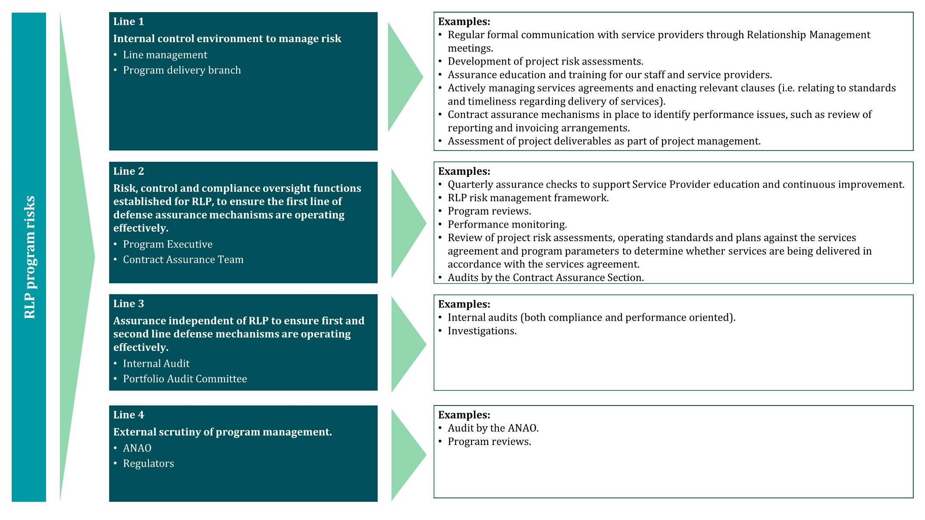**Figure 1: RLP four lines of defence model**

# **3. Assurance delivery**

## Assurance activities

Both us and service providers are responsible for complying with and delivering the assurance activities outlined in Table 1. These assurance activities will enable RLP outcomes to be achieved. This includes contract management, oversight functions and assurance reviews that we carry out, risk assessments and internal controls over delivery of core and project services by the service providers.

Assurance activities are undertaken in line with:

* RLP services agreement, the statement of work, schedules, any attachments or annexures to schedules and any other documents referenced in the services agreement.
* NLP program outcomes.
* departmental and Australian Government policies, including contract management and procurement processes (for example, Commonwealth Procurement Rules).
* applicable legislation, standards, and rules and regulations (for example, the *Environment Protection and Biodiversity Conservation Act 1999).*

Table RLP assurance activities

| **Assurance activity** | **Description** | **Line of defence** |
| --- | --- | --- |
| MERI plan in MERIT | A MERI plan is developed by service providers for each RLP project and submitted online in the MERI Tool (MERIT) before we approve a project work order. The plan is maintained for the duration of the project, enabling us to effectively manage project delivery and identify risk. | Line 1 |
| Performance monitoring and reporting | Service providers monitor and report on project and core service delivery under the RLP services agreement. Monitoring is continuous and reporting takes place quarterly, semesterly and annually depending on the report type. This includes updating MERI plans and risk assessments as needed. | Lines 1 and 2 |
| Project management | Our project managers are responsible for the administration of the services agreements under the RLP. | Line 1 |
| Compliance checks | Our staff or a nominated representative may conduct ad hoc or regular compliance checks to ensure that service providers are complying with the RLP services agreement and schedules. The need for a compliance check may be random or may arise based on the quality and content of the service provider’s MERIT reporting, advice/information received highlighting a potential non-compliance, or if the service provider indicates a possible breach or non-compliance themselves.  Similarly, for Regional Agriculture Landcare Facilitators (RALFs) a compliance check may arise based on the quality and content of their annual reporting or new work plan, advice and information provided through regular meetings with us, or if the RALF indicates a possible breach or non-compliance themselves. | Line 2 |
| Quarterly assurance check (QAC) | QACs occur quarterly across a sample of service providers and projects. The purpose of a QAC is to provide additional assurance that select project services have been delivered. QACs also provide service providers with feedback on the appropriateness of their service delivery evidence and records, as well as any corrective actions that may be needed to comply. | Line 2 |
| Audits | Audits, including desktop and onsite audits, are conducted on a regular basis by experienced and qualified departmental officers or our nominated representative. The scope of audits is informed by the service provider’s obligations and responsibilities under their services agreements and schedules and includes core services, project services and common requirements. | Line 2 |
| Investigations | We may undertake investigations where anomalies are identified in the delivery or provision of services. Matters that may be investigated include breaches of the services agreement or legislation, regulations, allegations of fraud or non-compliance. | Line 2 |
| Program reviews | We undertake regular reviews, monitoring, and evaluation activities for purposes including compliance checks, quality assurance and audit and evaluation of services. | Line 2 |
| Internal audits | We maintain an annual internal audit program, which may include independent internal audit activity over the RLP. Where this occurs and requires participation by service providers, service providers will be notified in writing and are required to comply with the audit as per the conditions of the services agreement. | Line 3 |
| Audits by the Australian National Audit Office (ANAO) | The ANAO conducts regular performance audits and assurance reviews on government programs to determine appropriate governance, compliance and delivery of better practice business functions and processes. | Line 4 |

## Graduated resolution approach

A graduated resolution approach recognises the varying degrees of seriousness and complexity a non-compliance or breach by service providers may have on project delivery. It identifies options to address non-compliance through engagement between us and service providers to rectify or manage on-going delivery of RLP services in accordance with agreed terms. We will work with service providers to ensure their responsibilities and obligations under the services agreement are met.

Applying a graduated approach to resolution in no way limits our rights to directly address any non-compliance or breach by service providers of their responsibilities and obligations under the services agreement.

Outcomes of assurance activities for each line of defence that identify a non-compliance, or non‑alignment, with the outcomes and agreed deliverables of the RLP follow a graduated resolution approach set out below. Resolution depends on the evidence in relation to the issue, the type of matter, such as whether conduct was deliberate or inadvertent, relevant impact/contravention and risk presented, whether there have been previous issues of a similar nature and any steps taken to remedy the matter.

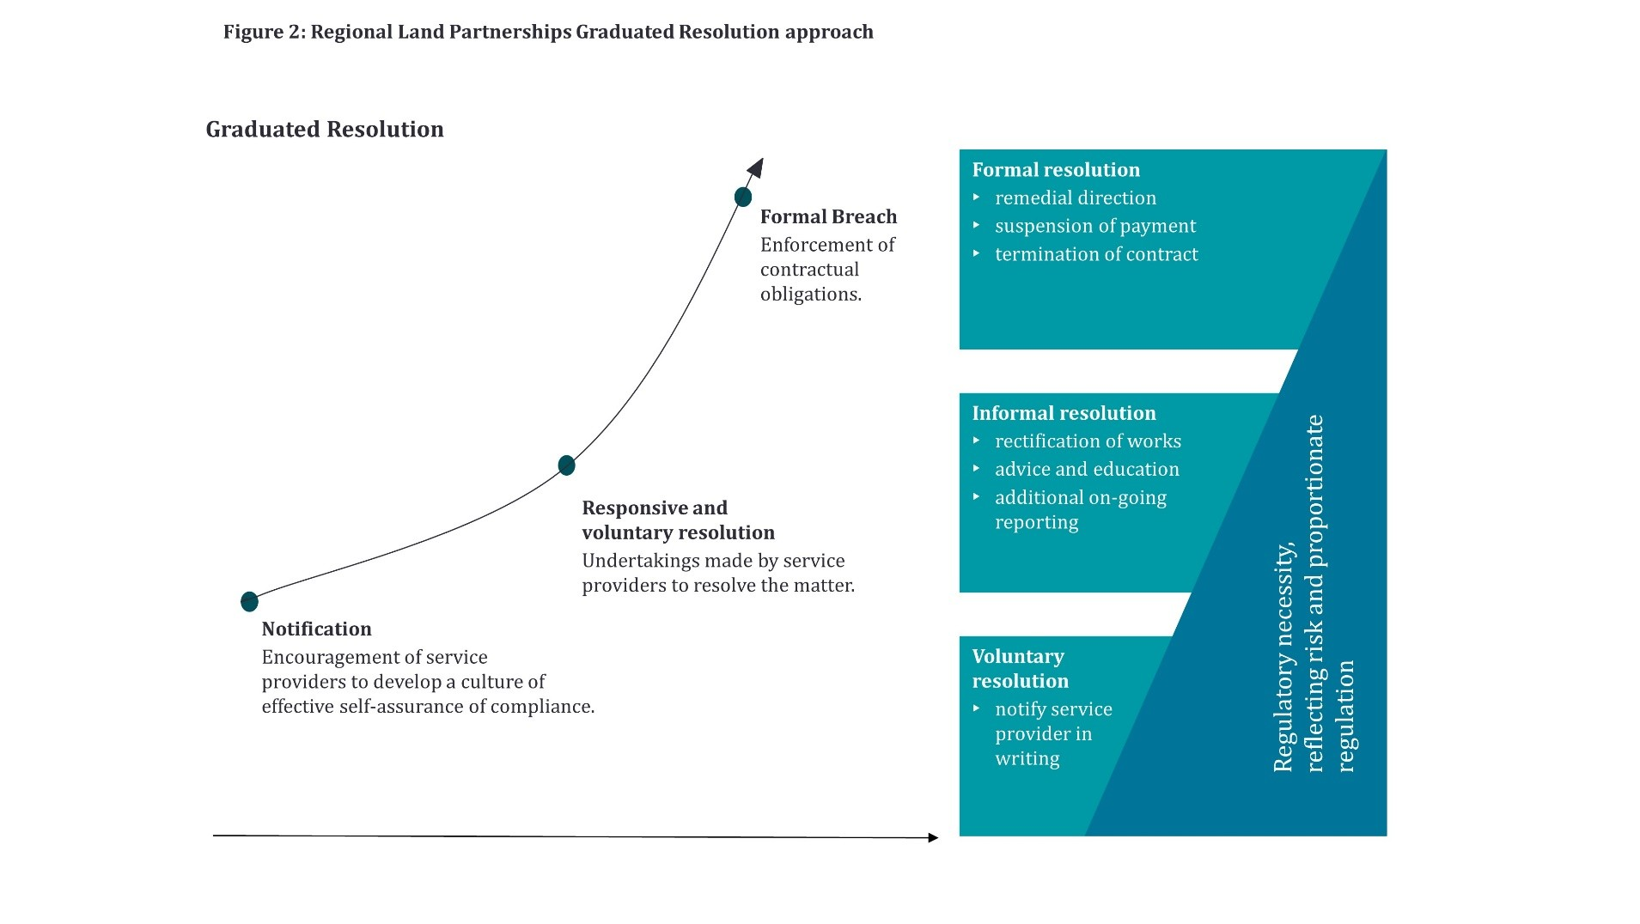

**Figure 2: Graduated resolution approach**

## Evaluation and improvement of the framework

We are committed to a process of continuous improvement. The framework, risks and assurance arrangements will be regularly reviewed, and updates will be made as required.

# **Further information**

## Contact

For further information please contact:

Contract Assurance Section  
E: rlpassurance@awe.gov.au   
T: (02) 6274 1111

# **Glossary**

|  |  |
| --- | --- |
| **Assurance** | Our method of obtaining confidence that the RLP structures and processes are designed, implemented and operating as intended and that there are effective and efficient controls in place to manage risks and achieve RLP outcomes. |
| **Core services** | The services which are intended to support the effective and efficient delivery of projects and other services, functions and responsibilities to be performed under the services agreement. Examples of core services included undertaking communications, coordinating the delivery of projects and MERI and supporting the community to participate in the delivery of projects. |
| **Evaluation and reporting** | Measurement of results to assess the extent to which RLP outcomes are being achieved. This information is also used to improve our approach to managing non-compliance with the services agreement. |
| **Investigations** | An examination or inquiry of detected anomalies in delivery or provision of services. Matters that may be investigated include breaches of the services agreement or legislation, regulations, allegations of fraud or non-compliance. |
| **Internal audit** | An independent and objective assurance activity. We have an annual internal audit program, which from time to time may include RLP. |
| **Project services** | To be provided by the service provider, as described in the statement of work, a project work order or an additional services work order, but does not include any services described as out of scope in the statement of work, a project work order or an additional services work order. |
| **Regional Agriculture Landcare Facilitators** | Individuals who we fund to support farmers, industry and community groups to adopt new and innovative sustainable agriculture practices. |
| **Risk** | An event or situation that could prevent us from delivering RLP and/or broader department outcomes. |
| **Service provider** | An entity that enters into the services agreement with us to provide the services. |
| **Services agreement** | The agreement under which the service provider agrees to provide services to us in exchange for remuneration. |