Appendix 3

Regional Land Partnerships

Evaluation Plan: Outcome 3



By 2023, threats to the Outstanding Universal Value of World Heritage Properties listed for natural heritage have been reduced through the implementation of priority actions

June 2018

# Introduction

The purpose of this evaluation plan is to provide advice on how to prepare to evaluate the Regional Land Partnerships (RLP) program. This plan is tailored specifically to Outcome 3.

The evaluation plan is presented in three main components:

* Program logic
* Program and outcome specific Key Evaluation Questions
* Monitoring plan.

# Evaluation plan

## Program logic

The Outcome 3 program logic forms the basis of this evaluation plan (see Figure 2-1). The purpose of program logic is to describe the anticipated cause-and-effect relationships between project activities, outputs and outcomes or its ‘theory of change’. Program logic also documents the **assumptions** that are critical to the transition from one level of the logic to the next and **indicators** that can be used to measure progress against each level of the logic over time. These two important elements of a logic are explained further below.

Assumptions

Between each level of the logic, assumptions are specified. Assumptions help explain how one level of the logic links to the next. There are generally two types of assumptions:

1. Knowledge-based assumptions that draw on research, literature or previous experience to describe expected changes (e.g. completing management actions in line with best-practice as described in a Threat Abatement Plan will result in a reduction of a given threat).
2. Assumptions that relate to conditions or circumstances that are beyond the control or influence of the project or program (e.g. rainfall is within long-term seasonal averages).

Identifying these assumptions ensures the logic provides a more complete picture of how the actions in a project are expected to contribute to outcomes.

Indicators

Indicators have been identified at each level of the program logic. They provide the evidence-base for project teams and the program as a whole, to demonstrate progress. Indicators can include both quantitative and qualitative measures. The timing and frequency of measuring the indicators is specific to each indicator (see monitoring plan). Some indicators might only be measured at the beginning and end of the project, while others are measured annually, or at multiple points in the delivery of the project (e.g. beginning, mid-point and end). It is important that no single indicator is considered in isolation of others. They should be recorded and reported together in order to give a clear illustration of the extent of project progress.

Key features of Outcome 3

Specific characteristics of the Outcome 3 program logic include:

* At the ‘Short Term Outcome’ level, measures and indicators aim to demonstrate that management actions have resulted in positive biophysical changes within the project area. If there is a reasonable expectation that a bio-physical change can be detected within the life of the project, that change should be measured directly.
* At the ‘Medium Term Outcome’ level, measures and indicators aim to demonstrate that those biophysical changes (measured within the life of the project) have contributed to a reduction in threats to a WH Property’s OUV. There are two tiers of measures/indicators at this level:
  + The Service Provider is expected to report on project-level indicators of threat reduction within the boundaries of their projects – and might expect to see positive changes in one or more of these indicators.
  + The RLP Program lead is expected to report on program-level indicators of threat reduction. This would include: the number (or proportion) of Outcome 3 projects demonstrating positive indicators; and the area (or ideally the proportion of the WH property) covered by RLP projects. Taken together, these two measures will provide an indication of the overall impact of the RLP program on threat reduction within the areas it is investing resources.
* The difference between the measures at the ‘Medium Term Outcome level and the ‘Long-Term Outcome’ level is that the ‘Long-term’ measures ask what contribution the RLP program made to the OUV of WH properties (listed for Natural Heritage values) overall. This requires the RLP program to look beyond the direct investment and measure (via indicators including threat measures) changes in the OUV of WH properties overall. Knowing the overall trend in OUV (or threats to OUV) of WH properties overall enables contribution analysis i.e. what difference has the RLP investment made to the condition of these assets through its investment.

## Key evaluation questions

Key Evaluation Questions (KEQs) represent high-level lines of enquiry to guide an evaluation. KEQs have been prepared for the whole RLP program, across five evaluation themes (effectiveness, appropriateness, impact, efficiency and legacy). Definitions for each of these evaluation criteria are provided in Table 2‑1.

Table 2‑1: RLP program evaluation themes

|  |  |
| --- | --- |
| Evaluation themes | Definition |
| Effectiveness | A measure of the extent to which a program, project or initiative has attained, or is expected to attain, its relevant objectives efficiently and in a sustainable way |
| Appropriateness | A determination made through comparing the program with the needs of the intended beneficiaries using any of the techniques of needs analysis. alternatively, the program could be evaluated in terms of its compliance with process |
| Impact | A change in the condition of biophysical, social, economic and/or institutional assets. an impact may be positive or negative, primary or secondary, short term or long term, direct or indirect, and/or intended or unintended. Impacts are sometimes realised after the formal project is completed |
| Efficiency | The notion of getting the highest value out of program or project resources |
| Legacy | The enduring consequences of past investments, policies or actions that can be captured and/or bequeathed |

KEQs for each outcome

To effectively guide monitoring and evaluation approaches for each of the six RLP outcomes, each KEQ has also been broken down into a series of sub-questions relevant to that outcome. Information and data can be collected specific to the KEQs for each outcome using various monitoring and evaluation methods. The RLP program and Outcome 3-specific Key Evaluation Questions are outlined in Table 2‑2.

The process of developing KEQs at both the program and outcome level was also critical in informing **indicators** (in addition to those identified during the program logic development) that are be included in the monitoring plan.

## Monitoring plan

Monitoring is used to describe an ongoing process of routine data collection. Generating performance data at regular intervals throughout the life of a program is critical for adaptive management and continuous improvement. Monitoring also provides valuable data for evaluation, which can act as a portfolio of evidence to demonstrate a program’s contribution to planned outcomes.

A monitoring plan for Outcome 3 has been prepared as a component of the evaluation plan. It is based on the **indicators** and **assumptions** identified during the program logic and KEQ development processes. The monitoring plan identifies the data that should be collected for each **indicator,** by whom and how often.

The aim of the monitoring plan is to provide clear guidance (timing, method) and accountability for monitoring at both the project and program scale over time. The Outcome 3 monitoring plan is provided in Table 2‑3.

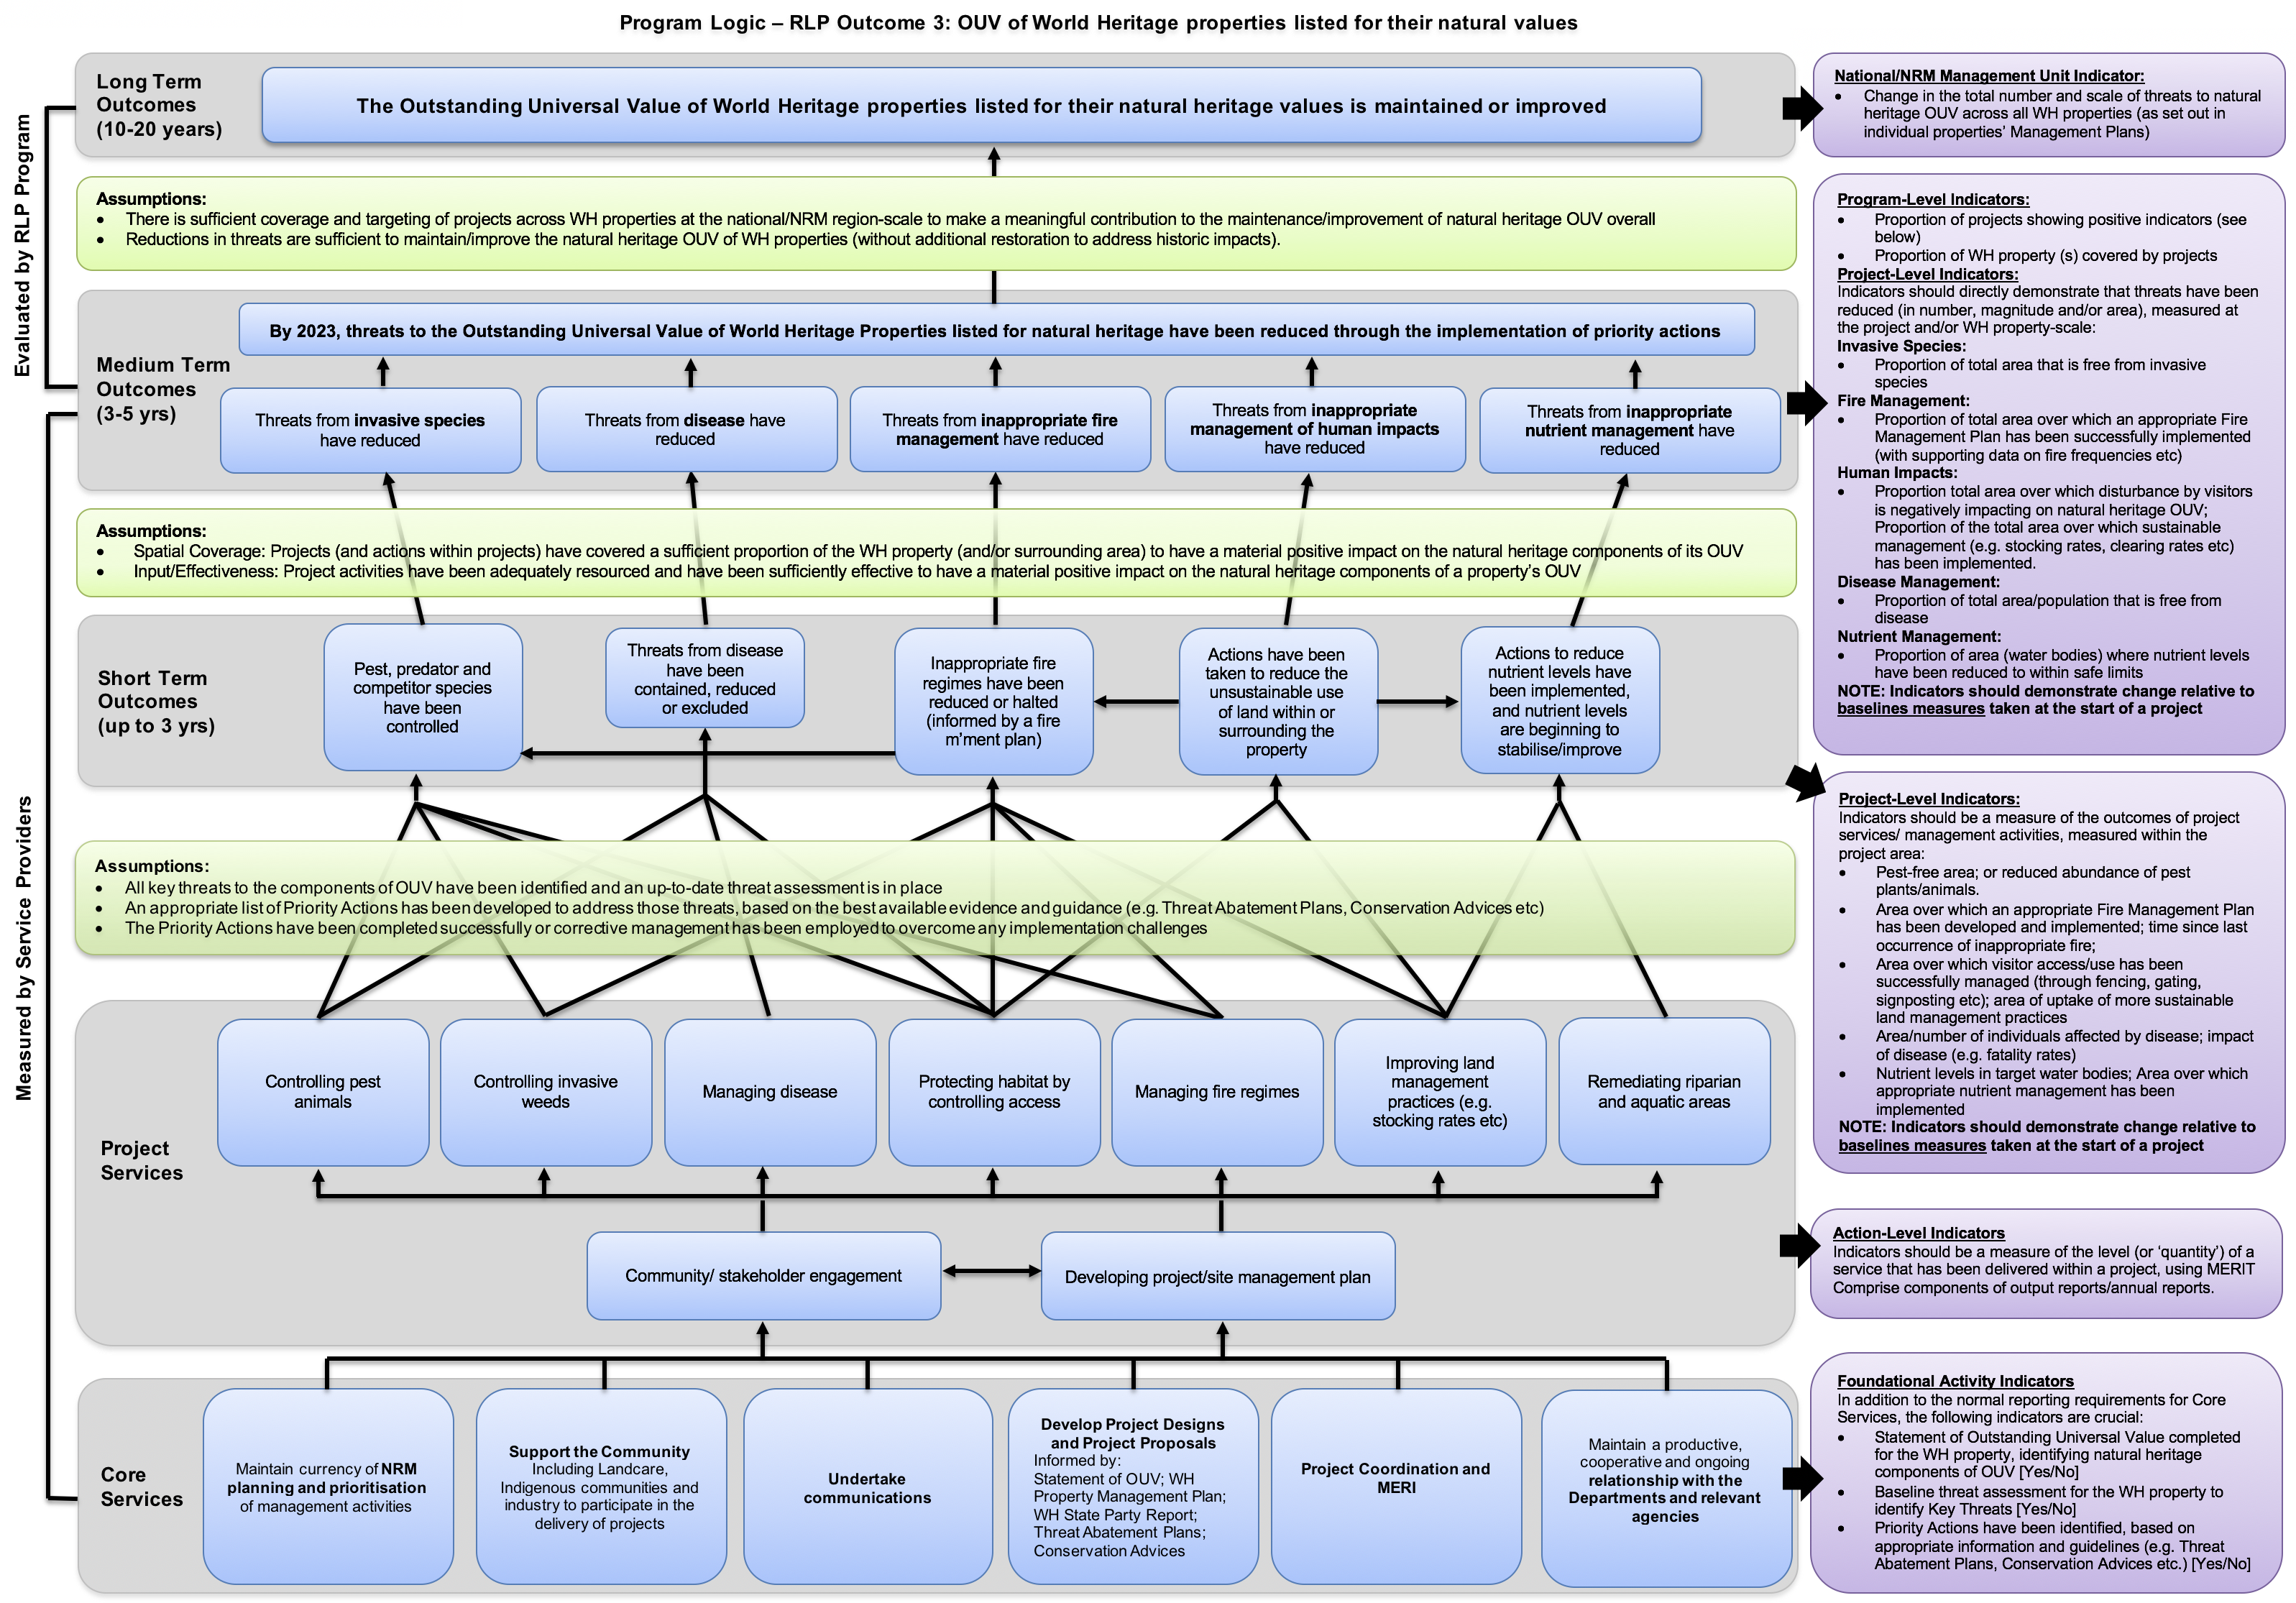

Figure 2‑1: Outcome 3 Program Logic

Table 2‑2: Outcome 3 Key Evaluation Questions

|  |  |  |  |
| --- | --- | --- | --- |
| Evaluation themes | Program Key evaluation Questions | outcome specific Key evaluation Questions | Relevant Level of the Program Logic |
| Effectiveness | * To what extent have the planned outcomes and outputs been achieved? * Are current delivery approaches and funding mechanisms the best way to maximise impact or are there other strategies that might be more effective? (addressed in appropriateness) * To what extent is the programme attaining, or expected to attain, its objectives and outcomes efficiently and in a way that is sustainable? (addressed in efficiency) | To what extent have the **Core Services** (and any associated targets) been achieved?   * Maintain currency of NRM planning and prioritisation of management activities * Support the Community including Landcare, Indigenous communities, industry and farmer/grower groups to participate in the delivery of projects * Undertake communications * Develop Project Designs and Project Proposals * Project coordination and MERI * Maintain a productive, cooperative and ongoing relationship with the Departments | Core Services |
| To what extent have the **Project Services** (and any associated targets) been achieved?   * Foundational activities: Community/stakeholder engagement; Developing project/site management plan * Controlling pest animals * Controlling invasive weeds * Managing disease * Protecting habitat by controlling access * Managing fire regimes * Improving land management practices * Remediating riparian and aquatic areas | Project Services |
| To what extent have the **Short Term Outcomes** (and any associated targets) been achieved?   * Pest, predator and competitor species have been controlled * Threats from disease have been contained, reduced or excluded * Inappropriate fire regimes have been reduced/halted * Actions have been taken to reduce unsustainable use of land within or surrounding the property * Actions to reduce nutrient levels have been implemented, and nutrient levels are beginning to stabilise/improve | Short Term Outcomes |
| Appropriateness | * To what extent is the programme aligned with the needs of the intended beneficiaries? * To what extent is the programme compliant with recognised best practice processes in the field—e.g. the type, level and context of investment and associated activities? | As a delivery approach, were the foundational activities and management actions to reduce threats an appropriate way to:   * Deliver the project given community needs and expectations * Tailor the project to the environmental conditions of each project site, and * Achieve the Medium Term Outcome? | Short Term Outcomes  Medium Term Outcomes |
| To what extent were the on-ground management actions adopted informed by/consistent with:   * + Species Recovery Plans   + Threat Abatement Plans   + Conservation Advices   + WH Property’s statement of OUV   + WH Property’s Management Plan | Short Term Outcomes  Medium Term Outcomes |
| Are there any other methods that should/could have been used? | Short Term Outcomes  Medium Term Outcomes |
| Impact | * In what ways and to what extent has the programme contributed to changing asset condition, management practices, and / or effectiveness of delivery? * What, if any, unanticipated positive or negative changes or other outcomes have resulted? * To what extent were the changes directly or indirectly produced by the programme interventions? | To what extent have the core and project services and short and medium-term outcomes contributed to a reduction in threats to the Outstanding Universal Value of World Heritage properties listed for their natural heritage? | Medium Term Outcomes |
| To what extent have the End of Project outcomes contributed to the Outstanding Universal Value of World Heritage properties being maintained or improved? | Medium Term Outcomes  Long Term Outcomes |
| What, if any, unanticipated positive or negative changes or other outcomes have resulted? | Medium Term Outcomes |
| To what extent were the changes directly or indirectly produced by the programme interventions? | Medium Term Outcomes |
| Efficiency | * To what extent has the programme attained the highest value out of available resources? * How could resources be used more productively and efficiently? * What could be done differently to improve implementation, and thereby maximise impact, at an acceptable and sustainable cost? | To what extent did Outcome 3 projects demonstrate ‘value for money’ through the:   * Implementation of a site selection process which considered the costs and anticipated benefits of works at potential sites * Establishment of partnerships for delivering the project (pooling resources, using local knowledge and experience) * Coordination of the delivery of activities/works (e.g. with other projects, in geographic locations) * Implementation of procurement processes to ensure both quality and quantity from investment, and * Leveraging investment from other sources? | Short Term Outcomes  Medium Term Outcomes |
| How could have resources been used more productively and efficiently? | Short Term Outcomes  Medium Term Outcomes |
| What could be done differently to improve implementation, and thereby maximise impact, at an acceptable and sustainable cost? | Short Term Outcomes  Medium Term Outcomes |
| Legacy | * Will the programme’s impacts continue over time and after the programme ceases? * How should the legacy be managed and by whom? | What evidence is there that the work completed through Outcome 3 will continue to be maintained? | Medium Term Outcomes |
| How likely is it that the outcomes achieved through Outcome 3 will be sustained? | Medium Term Outcomes |

Table 2‑3: Outcome 3 Monitoring Plan

| Level | Outcome/Activity | Indicators | Indicative frequency of reporting | Who is responsible? |
| --- | --- | --- | --- | --- |
| RLP Program Outcomes | | | | |
| Long-term Program Outcomes  (10-20 yrs) | The Outstanding Universal Value of World Heritage properties is maintained or improved | **National/NRM Management Unit Indicator:**   * Change in the total number and scale of threats to natural heritage OUV across all WH properties (as set out in individual property Management Plans) | End of funding cycle and at 10-20 years | DoEE lead for this outcome |
| Medium Term Program Outcomes  (3-5 yrs) | By 2023, threats to the Outstanding Universal Value of World Heritage Properties listed for natural heritage have been reduced through the implementation of priority actions | **Program-Level Indicators:**   * Proportion of projects showing positive indicators (by WH property) * Proportion of WH property (s) covered by projects | End of funding cycle | DoEE lead for this outcome |
| Project Achievements and Progress | | | | |
| Medium Term Outcomes  (3-5 yrs)  Reported in:  Outcome Report 2 | Indicators should directly demonstrate that threats have been reduced (in number, magnitude and/or area), measured at the project and/or WH property-scale: | | | |
| Threats from invasive species have reduced | * Proportion of total area that is free from invasive species | At 3-5 years | Service Provider |
| Threats from disease have reduced | * Proportion of total area/population that is free from disease or change in disease impact (e.g. mortality rates) | At 3-5 years | Service Provider |
| Threats from inappropriate fire management have reduced | * Proportion of the total area over which an appropriate Fire Management Plan has been successfully implemented (with supporting data on fire frequencies etc) | At 3-5 years | Service Provider |
| Threats from inappropriate management of human impacts have reduced | * Proportion of the total area over which disturbance by visitors is negatively impacting on natural heritage OUV; increase in the total area over which sustainable management (e.g. stocking rates, clearing rates etc) has been implemented. | At 3-5 years | Service Provider |
| Threats from inappropriate nutrient management have reduced | * Proportion of area (water bodies) where nutrient levels have been reduced to within safe limits | At 3-5 years | Service Provider |
| Short Term Outcomes  (1-3 yrs)  Reported in:  Outcome Report 1 | Indicators should be a measure of the outcomes of project services/ management activities, measured within the project area: | | | |
| Pest, predator and competitor species have been controlled | * Pest-free area; or reduced abundance of pest plants/animals. | At 1- 3 years | Service Provider |
| Threats from disease have been contained, reduced or excluded | * Area/number of individuals affected by disease; impact of disease (e.g. fatality rates) | At 1-3 years | Service Provider |
| Inappropriate fire regimes have been reduced or halted (informed by a fire m’ment plan) | * Area over which an appropriate Fire Management Plan has been developed and implemented; time since last occurrence of inappropriate fire; | At 2 – 3 years | Service Provider |
| Actions have been taken to reduce the unsustainable use of land within or surrounding the property | * Area over which visitor access/use has been successfully managed (through fencing, gating, signposting etc); area of uptake of more sustainable land management practices | At 2 – 3 years | Service Provider |
| Actions to reduce nutrient levels have been implemented, and nutrient levels are beginning to stabilise/improve | * Nutrient levels in target water bodies; Area over which appropriate nutrient management has been implemented | At 2 – 3 years | Service Provider |
| MERIT services – as per contracts | | | | |
| Services – project and core | Controlling pest animals | * Treatment objective/s – eradication, control etc. * Total treatment area (Ha) * Type of treatment – baiting, exclusion fencing etc. * Number of individuals OR colonies killed / removed | In line with Outputs Reporting requirements | Service Provider |
| Controlling invasive weeds | * Treatment objective/s – eradication, control etc. * Total treatment area (Ha) * Type of treatment * Weed species targeted | In line with Outputs Reporting requirements | Service Provider |
| Managing disease | * Treatment objective/s e.g. eradication, suppression, containment * Area where disease threat is reduced | In line with Outputs Reporting requirements | Service Provider |
| Protecting habitat by controlling access | * Type of structure(s) installed * Number of structures installed * Access control method used (aim of structure) * Area protected by access control structure | In line with Outputs Reporting requirements Annual | Service Provider |
| Managing fire regimes | * Treatment objective/s e.g. less frequent, cooler burns * Area where fire regime has been changed | In line with Outputs Reporting requirements | Service Provider |
| Improving land management practices (e.g. stocking rates etc) | **Management practice change**   * Industry * Area covered by practice change * Number of farming entities adopting this practice change * Area of land directly benefiting from the practice change * Type of agreement mechanism * Area under agreement (ha)   **Livestock management**   * Land management issue being addressed via livestock management * Area managed (ha) * Grazing practice being used   **Erosion management**   * Area (ha) or length of stream or coastline (km) eroding (in this project area) * Area (ha) of erosion being treated * Length of stream/coastline treated (km) * Erosion treatment method   **Fencing**   * Length of fence * Area protected by erected fence * Purpose of fence | In line with Outputs Reporting requirements | Service Provider |
| Remediating riparian and aquatic areas | **Erosion treatment method**   * buffer strips size (length, area)   **Revegetation**  Landscape connectivity via riparian link |  |  |
| Community / stakeholder engagement | * Communities or groups engaged * Purpose of engagement (informing through to collaboration – IAP2) | Throughout project | Service Provider |
| Developing project/site management plan | * Area covered by management plan * Species included in management plan | On Commencement | Service Provider |
| Core services | Maintain currency of **NRM planning and prioritisation** of management activities | * WH Property Management Plan is sufficiently up-to-date to inform the project | On commencement | Project delivery team |
| **Support the Community**  Including Landcare, Indigenous communities and industry to participate in the delivery of projects | * Governance arrangements and structures engage community in the project delivery (e.g. stakeholder reference groups etc.) | Throughout project | Project delivery team |
| **Undertake communications** | * Communications plan for the project developed and implemented | Throughout project | Project delivery team |
| **Develop Project Designs and Project Proposals**  Informed by:  Statement of OUV; WH Property Management Plan; WH State Party Report; Threat Abatement Plans; Conservation Advices | * Baseline assessment of OUV completed [YES/NO] (likely to be part of the process of site designation) * Key threats and restoration opportunities identified and documented in the WH Property Management Plan? [Yes/No] * Priority Actions have been identified and documented, based on appropriate information and guidelines (e.g. Threat Abatement Plans, Conservation Advices etc.) | On commencement | Project delivery team |
| **Project coordination and MERI** | * MERI plan for the project developed (reflecting the program logic and delivery plans) | Throughout project | Project delivery team |
| Maintain a productive, cooperative and ongoing **relationship with the Departments** | * Briefings of Australian government officers with responsibility for this project | Throughout project | Project delivery team |