Appendix 5

Regional Land Partnerships

Evaluation Plan: Outcome 5



By 2023, there is an increase in the awareness and adoption of land management practices that improve and protect the condition of soil, biodiversity and vegetation

June 2018

# Introduction

The purpose of this evaluation plan is to provide advice on how to prepare to evaluate the Regional Land Partnerships (RLP) program. This plan is tailored specifically to Outcome 5.

The evaluation plan is presented in three main components:

* Program logic
* Program and outcome specific Key Evaluation Questions
* Monitoring plan.

# Evaluation plan

## Program logic

The Outcome 5 program logic forms the basis of this evaluation plan (see Figure 2-1). The purpose of program logic is to describe the anticipated cause-and-effect relationships between project activities, outputs and outcomes or its ‘theory of change’. Program logic also documents the **assumptions** that are critical to the transition from one level of the logic to the next and **indicators** that can be used to measure progress against each level of the logic over time. These two important elements of a logic are explained further below.

Assumptions

Between each level of the logic, assumptions are specified. Assumptions help explain how one level of the logic links to the next. There are generally two types of assumptions:

1. Knowledge-based assumptions that draw on research, literature or previous experience to describe expected changes, (e.g. previous projects have found that for every 20 landholders that attend our grazing management workshop, 7 adopt our rotational grazing system that increases summer groundcover)
2. Assumptions that relate to conditions or circumstances that are beyond the control or influence of the project or program (e.g. rainfall is within long-term seasonal averages, prices on export beef markets remain within the range for the last 10 years).

Identifying these assumptions ensures the logic provides a more complete picture of how the actions in a project are expected to contribute to outcomes.

Indicators

Indicators have been identified at each level of the program logic. They provide the evidence-base for project teams and the program as a whole, to demonstrate progress. Indicators can include both quantitative and qualitative measures. The timing and frequency of measuring the indicators is specific to each indicator (see monitoring plan). Some indicators might only be measured at the beginning and end of the project, while others are measured annually, or at multiple points in the delivery of the project (e.g. beginning, mid-point and end). It is important that no single indicator is considered in isolation of others. They should be recorded and reported together in order to give a clear illustration of the extent of project progress.

Key features of Outcome 5

Specific characteristics of the Outcome 5 program logic include:

* Biophysical measures have been included at the ‘Short Term Outcome’ level. However, because these characteristics are only really appropriate to directly measure over a longer timeframe, the monitoring plan for this outcome only specifies that they be measured at the ‘End of Project Outcome’ level. They are included at the ‘Short-Term and Mid-Term’ level, not for direct measurement but to identify the soil, biodiversity or native vegetation management aim of the land management practice change activities that are noted at this level.
* At the ‘Medium Term Outcome’ level, outcomes relating to the practice change continuum should be measured i.e. change in awareness, knowledge, skills, confidence and ultimately adoption of recommended management practices.
* The difference between the measures at the ‘End of project outcome’ level and the ‘Long-term’ level is that the ‘Long-term’ measures ask the RLP program to look beyond the direct investment and measure (via indicators) the trends in condition of the targeted assets i.e. soil, biodiversity and vegetation. Knowing the overall trends in condition enables contribution analysis i.e. what difference has the RLP investment made to the condition of these assets through its investment.
* The differences between what a project would report at the ‘Medium Term Outcome’ level, and what the RLP program would report, are described below:
  + The project would report on changes to biophysical indicators monitored within their project boundary (only)
  + The RLP program would report on changes to biophysical indicators monitored across **all** projects that have received investment. This would provide an aggregated report on the impact of the RLP investment which has direct attribution.

## Key evaluation questions

Key Evaluation Questions (KEQs) represent high-level lines of enquiry to guide an evaluation. KEQs have been prepared for the whole RLP program, across five evaluation themes (effectiveness, appropriateness, impact, efficiency and legacy). Definitions for each of these evaluation criteria are provided in Table 2‑1.

Table 2‑1: RLP program evaluation themes

|  |  |
| --- | --- |
| Evaluation themes | Definition |
| Effectiveness | A measure of the extent to which a program, project or initiative has attained, or is expected to attain, its relevant objectives efficiently and in a sustainable way |
| Appropriateness | A determination made through comparing the program with the needs of the intended beneficiaries using any of the techniques of needs analysis. alternatively, the program could be evaluated in terms of its compliance with process |
| Impact | A change in the condition of biophysical, social, economic and/or institutional assets. an impact may be positive or negative, primary or secondary, short term or long term, direct or indirect, and/or intended or unintended. Impacts are sometimes realised after the formal project is completed |
| Efficiency | The notion of getting the highest value out of program or project resources |
| Legacy | The enduring consequences of past investments, policies or actions that can be captured and/or bequeathed |

KEQs for each outcome

To effectively guide monitoring and evaluation approaches for each of the six RLP outcomes, each KEQ has also been broken down into a series of sub-questions relevant to that outcome. Information and data can be collected specific to the KEQs for each outcome using various monitoring and evaluation methods. The RLP program and Outcome 5 specific Key Evaluation Questions are outlined in Table 2‑2.

The process of developing KEQs at both the program and outcome level was also critical in informing **indicators** (in addition to those identified during the program logic development) that are be included in the monitoring plan.

## Monitoring plan

Monitoring is used to describe an ongoing process of routine data collection. Generating performance data at regular intervals throughout the life of a program is critical for adaptive management and continuous improvement. Monitoring also provides valuable data for evaluation, which can act as a portfolio of evidence to demonstrate a program’s contribution to planned outcomes.

A monitoring plan for Outcome 5 has been prepared as a component of the evaluation plan. It is based on the **indicators** and **assumptions** identified during the program logic and KEQ development processes. The monitoring plan identifies the data that should be collected for each **indicator,** by whom and how often.

The aim of the monitoring plan is to provide clear guidance (timing, method) and accountability for monitoring at both the project and program scale over time. The Outcome 5 monitoring plan is provided in Table 2‑3.

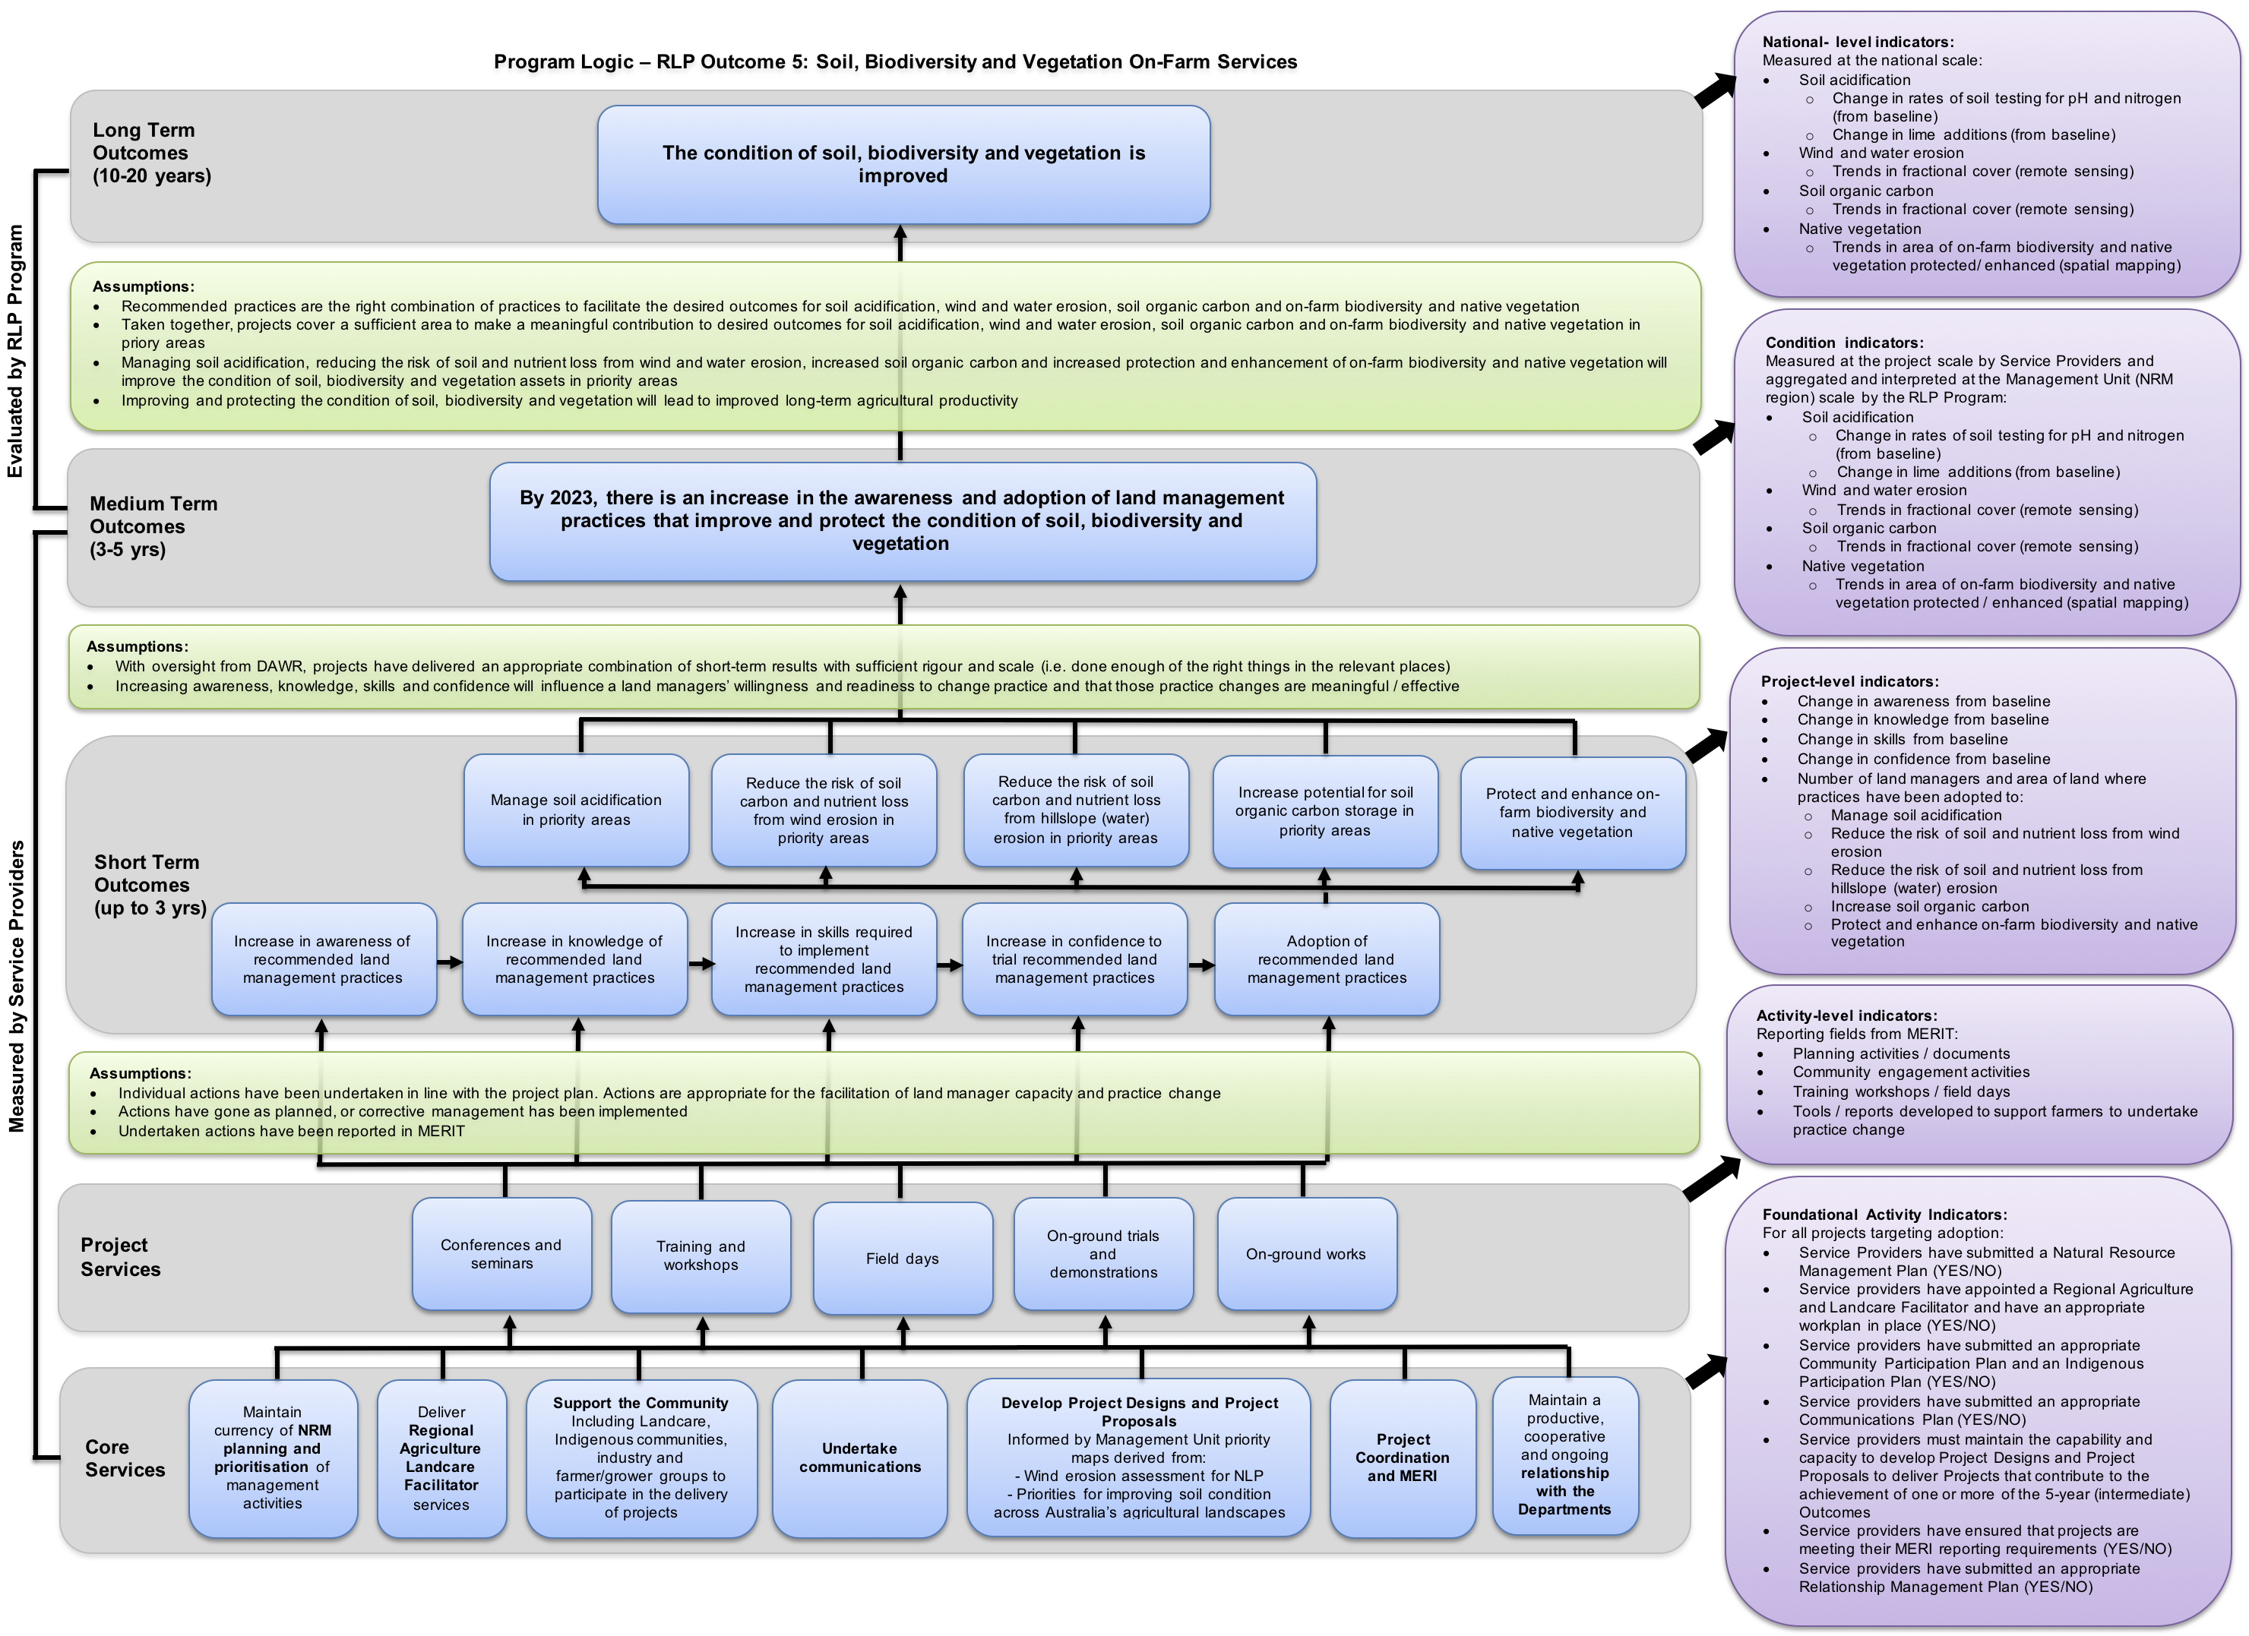

Figure 2‑1: Outcome 5 Program Logic

Table 2‑2: Outcome 5 Key Evaluation Questions

|  |  |  |  |
| --- | --- | --- | --- |
| Evaluation themes | Program Key evaluation Questions | outcome specific Key evaluation Questions | Relevant Level of the Program Logic |
| Effectiveness | * To what extent have the planned outcomes and outputs been achieved? * Are current delivery approaches and funding mechanisms the best way to maximise impact or are there other strategies that might be more effective? (addressed in appropriateness) * To what extent is the programme attaining, or expected to attain, its objectives and outcomes efficiently and in a way that is sustainable? (addressed in efficiency) | To what extent have the **Core Services** (and any associated targets) been achieved?   * Maintain currency of NRM planning and prioritisation of management activities * Deliver Regional Agriculture Landcare Facilitator services * Support the Community including Landcare, Indigenous communities, industry and farmer/grower groups to participate in the delivery of projects * Undertake communications * Develop Project Designs and Project Proposals * Project coordination and MERI * Maintain a productive, cooperative and ongoing relationship with the Departments | Core Services |
| To what extent have the **Project Services** (and any associated targets) been achieved?   * Conferences and seminars * Training and workshops * Field days * On-ground trials and demonstrations * On-ground works | Project Services |
| To what extent have the **Short Term Outcomes** (and any associated targets) been achieved?   * Increase in awareness of recommended land management practices * Increase in knowledge of recommended land management practices * Increase in skills required to implement recommended land management practices * Increase in confidence to trial recommended land management practices * Adoption of recommended land management practices | Short Term Outcomes |
| Appropriateness | * To what extent is the programme aligned with the needs of the intended beneficiaries? * To what extent is the programme compliant with recognised best practice processes in the field—e.g. the type, level and context of investment and associated activities? | As a delivery approach, was community engagement, extension and adoption an appropriate way to:   * Align project delivery with community needs and expectations * Tailor the project to the environmental conditions of each project site, and * Achieve the Medium Term Outcome? | Short Term Outcomes  Medium Term Outcome |
| To what extent were the land management practices adopted consistent with recognised best practice to:   * Manage soil acidification * Reduce the risk of soil carbon and nutrient loss from wind erosion * Reduce the risk of soil carbon and nutrient loss from hillslope (water) erosion * Increase soil organic carbon * Protect and enhance on-farm biodiversity and native vegetation. | Short Term Outcomes  Medium Term Outcome |
| Are there any other methods that should/could have been used? | Short Term Outcomes  Medium Term Outcome |
| Impact | * In what ways and to what extent has the programme contributed to changing asset condition, management practices, and / or effectiveness of delivery? * What, if any, unanticipated positive or negative changes or other outcomes have resulted? * To what extent were the changes directly or indirectly produced by the programme interventions? | To what extent have the core and project services and short and medium-term outcomes contributed to increased awareness and adoption of land management practices that improve and protect the condition of soil, biodiversity and vegetation? | Medium Term Outcomes |
| To what extent has the End of Project outcome contributed to improved condition of soil, biodiversity and vegetation? | Medium Term Outcome  Long Term Outcomes |
| What, if any, unanticipated positive or negative changes or other outcomes have resulted? | Medium Term Outcome |
| To what extent were the changes directly or indirectly produced by the programme interventions? | Medium Term Outcome |
| Efficiency | * To what extent has the programme attained the highest value out of available resources? * How could resources be used more productively and efficiently? * What could be done differently to improve implementation, and thereby maximise impact, at an acceptable and sustainable cost? | To what extent did Outcome 5 projects demonstrate ‘value for money’ through the:   * Implementation of a site selection process which considered the costs and anticipated benefits of works at potential sites * Establishment of partnerships for delivering the project (pooling resources, using local knowledge and experience) * Coordination of the delivery of activities/works (e.g. with other projects, in geographic locations) * Implementation of procurement processes to ensure both quality and quantity from investment, and * Leveraging investment from other sources? | Short Term Outcomes  Medium Term Outcome |
| How could have resources been used more productively and efficiently? | Short Term Outcomes  Medium Term Outcome |
| What could be done differently to improve implementation, and thereby maximise impact, at an acceptable and sustainable cost? | Short Term Outcomes  Medium Term Outcome |
| Legacy | * Will the programme’s impacts continue over time and after the programme ceases? * How should the legacy be managed and by whom? | What evidence is there that the work completed through Outcome 5 will continue to be maintained? | Medium Term Outcome |
| How likely is it that the outcomes achieved through Outcome 5 will be sustained? | Medium Term Outcomes |

Table 2‑3: Outcome 5 monitoring plan

| Level | Outcome/Activity | Indicators | Indicative reporting frequency | Who is responsible? |
| --- | --- | --- | --- | --- |
| RLP Program Outcomes | | | | |
| Long-term Program Outcomes  (10-20 yrs) | The condition of soil, biodiversity and vegetation is improved | Measured at the national scale:  Soil acidification   * Change in rates of soil testing for pH and nitrogen (from baseline) * Change in lime additions (from baseline)   Wind and water erosion   * Trends in fractional cover (remote sensing)   Soil organic carbon   * Trends in fractional cover (remote sensing)   Native vegetation   * Trends in area of on-farm biodiversity and native vegetation protected/ enhanced (spatial mapping) | End of funding cycle and at 10-20 years | DAWR lead for this outcome |
| Medium Term Program Outcomes  (3-5 yrs) | By 2023, there is an increase in the awareness and adoption of land management practices that improve and protect the condition of soil, biodiversity and vegetation | Aggregated and interpreted at the Management Unit (NRM region) scale by the RLP Program:  Soil acidification   * Change in rates of soil testing for pH and nitrogen (from baseline) * Change in lime additions (from baseline)   Wind and water erosion   * Trends in fractional cover (remote sensing)   Soil organic carbon   * Trends in fractional cover (remote sensing)   Native vegetation   * Trends in area of on-farm biodiversity and native vegetation protected / enhanced (spatial mapping) | End of funding cycle | DAWR lead for this outcome |
| Project Achievements and Progress | | | | |
| Medium Term Outcomes  (3-5 yrs)  Reported in:  Outcome Report 2 | By 2023, there is an increase in the awareness and adoption of land management practices that improve and protect the condition of soil, biodiversity and vegetation | Measured at the project scale by Service Providers:  Soil acidification   * Change in rates of soil testing for pH and nitrogen (from baseline) * Change in lime additions (from baseline)   Wind and water erosion   * Trends in fractional cover (remote sensing)   Soil organic carbon   * Trends in fractional cover (remote sensing)   Native vegetation   * Trends in area of on-farm biodiversity and native vegetation protected / enhanced (spatial mapping) | At 3-5 years | Service Provider |
| Short Term Outcomes  (1-3 yrs)  Reported in:  Outcome Report 1 | Increase in awareness of recommended land management practices | Change in awareness from baseline | At 2 – 3 years | Service provider |
| Increase in knowledge of recommended land management practices | Change in knowledge from baseline | At 2 – 3 years | Service provider |
| Increase in skills required to implement recommended land management practices | Change in skills from baseline | At 2 – 3 years | Service provider |
| Increase in confidence to trial recommended land management practices | Change in confidence from baseline | At 2 – 3 years | Service provider |
| Adoption of recommended land management practices | Number of land managers and area of land where practices have been adopted to:   * Manage soil acidification * Reduce the risk of soil and nutrient loss from wind erosion * Reduce the risk of soil and nutrient loss from hillslope (water) erosion * Increase soil organic carbon * Protect and enhance on-farm biodiversity and native vegetation | At 2 – 3 years | Service provider |
| MERIT services – as per contracts | | | | |
| Project Services | Conferences and seminars | Reporting fields from MERIT:   * Community engagement activities * Aim of conference or seminar – improve knowledge, build skills etc. * Measures of change (based on aims) | In line with Outputs Reporting requirements | Service provider |
| Training and workshops | * Training workshops – number run, attendees * Aim of training – improve knowledge, build skills etc. * Measures of change (based on aims) | In line with Outputs Reporting requirements | Service provider |
| Field days | * Field days – number run, attendees * Aim of training – improve knowledge, build skills etc. * Measures of change (based on aims) | In line with Outputs Reporting requirements | Service provider |
| On-ground trials and demonstrations | * On-farm trials – number run, attendees (?) * Aim of trials and demos – improve knowledge, build skills, change practice etc. * Measures of change (based on aims) | In line with Outputs Reporting requirements | Service provider |
| On-ground works | * On-ground works – type, number * Aim of trials and demos – improve knowledge, build skills, change practice etc. * Measures of change (based on aims) | In line with Outputs Reporting requirements | Service provider |
| Core services | Maintain currency of **NRM planning and prioritisation** of management activities | * Service Providers have submitted a Natural Resource Management Plan (YES/NO) | On commencement | Service provider |
| Deliver **Regional Agriculture Landcare Facilitator** services | * Service providers have appointed a Regional Agriculture and Landcare Facilitator and have an appropriate workplan in place(YES/NO) | Throughout project | Service provider |
| **Support the Community**  Including Landcare, Indigenous communities, industry and farmer/grower groups to participate in the delivery of projects | * Service providers have submitted an appropriate Community Participation Plan and an Indigenous Participation Plan (YES/NO) | Throughout project | Service provider |
| **Undertake communications** | * Service providers have prepared and submitted an appropriate Communications Plan (YES/NO) | Throughout project | Service provider |
| **Develop Project Designs and Project Proposals**  Informed by Management Unit priority maps derived from:   * Wind erosion assessment for NLP * Priorities for improving soil condition across Australia’s agricultural landscapes | * Service providers must maintain the capability and capacity to develop Project Designs and Project Proposals to deliver Projects that contribute to the achievement of one or more of the 5-year (intermediate) Outcomes | On commencement | Service provider |
| **Project coordination and MERI** | * Service providers have ensured that projects are meeting their MERI reporting requirements (YES/NO) | Throughout project | Service provider |
| Maintain a productive, cooperative and ongoing **relationship with the Departments** | * Service providers have submitted an appropriate Relationship Management Plan (YES/NO) * Briefings of Australian government officers with responsibility for this project (YES/NO) | Throughout project | Service provider |