Appendix 6

Regional Land Partnerships

Evaluation Plan: Outcome 6



By 2023, there is an increase in the capacity of agriculture systems to adapt to significant change in climate and market demands for information on provenance and sustainable production

June 2018

# Introduction

The purpose of this evaluation plan is to provide advice on how to prepare to evaluate the Regional Land Partnerships (RLP) program. This plan is tailored specifically to Outcome 6.

The evaluation plan is presented in three main components:

* Program logic
* Program and outcome specific Key Evaluation Questions
* Monitoring plan.

# Evaluation plan

## Program logic

The Outcome 6 program logic forms the basis of this evaluation plan (see Figure 2-1). The purpose of program logic is to describe the anticipated cause-and-effect relationships between project activities, outputs and outcomes or its ‘theory of change’. Program logic also documents the **assumptions** that are critical to the transition from one level of the logic to the next and **indicators** that can be used to measure progress against each level of the logic over time. These two important elements of a logic are explained further below.

Assumptions

Between each level of the logic, assumptions are specified. Assumptions help explain how one level of the logic links to the next. There are generally two types of assumptions:

1. Knowledge-based assumptions that draw on research, literature or previous experience to describe expected changes, (e.g. previous projects have found that for every 20 landholders that attend our grazing management workshop, 7 adopt our rotational grazing system that increases summer groundcover)
2. Assumptions that relate to conditions or circumstances that are beyond the control or influence of the project or program (e.g. rainfall is within long-term seasonal averages, prices on export beef markets remain within the range for the last 10 years).

Identifying these assumptions ensures the logic provides a more complete picture of how the actions in a project are expected to contribute to outcomes.

Indicators

Indicators have been identified at each level of the program logic. They provide the evidence-base for project teams and the program as a whole, to demonstrate progress. Indicators can include both quantitative and qualitative measures. The timing and frequency of measuring the indicators is specific to each indicator (see monitoring plan). Some indicators might only be measured at the beginning and end of the project, while others are measured annually, or at multiple points in the delivery of the project (e.g. beginning, mid-point and end). It is important that no single indicator is considered in isolation of others. They should be recorded and reported together in order to give a clear illustration of the extent of project progress.

Key features of Outcome 6

Specific characteristics of the Outcome 6 program logic include:

* At the ‘Short Term Outcome’ level, outcomes relating to the practice change continuum can, and should, be measured i.e. change in awareness, knowledge, skills, confidence and ultimately adoption of recommended management practices.
* The difference between the measures at the ‘Medium Term Outcome’ level and the ‘Long-term’ level is that the ‘Long-term’ measures ask the RLP program to look beyond the direct investment and measure (via indicators) the trends in condition of the targeted assets i.e. soil, biodiversity and vegetation. Knowing the overall trends in condition enables contribution analysis i.e. what difference has the RLP investment made to the condition of these assets through its investment.
* The differences between what a project would report at the ‘Medium Term Outcome’ level, and what the RLP program would report, are described below:
  + The project would report on changes to biophysical indicators monitored within their project boundary (only)
  + The RLP program would report on changes to biophysical indicators monitored across **all** projects that have received investment. This would provide an aggregated report on the impact of the RLP investment which has direct attribution.
* Indicators on farm resilience will be developed by DAWR shortly. It is expected that once available they will be incorporated into relevant project’s monitoring and evaluation plans, and will be measured from that point onwards.

## Key evaluation questions

Key Evaluation Questions (KEQs) represent high-level lines of enquiry to guide an evaluation. KEQs have been prepared for the whole RLP program, across five evaluation themes (effectiveness, appropriateness, impact, efficiency and legacy). Definitions for each of these evaluation criteria are provided in Table 2‑1.

Table ‑: RLP program evaluation themes

|  |  |
| --- | --- |
| Evaluation themes | Definition |
| Effectiveness | A measure of the extent to which a program, project or initiative has attained, or is expected to attain, its relevant objectives efficiently and in a sustainable way |
| Appropriateness | A determination made through comparing the program with the needs of the intended beneficiaries using any of the techniques of needs analysis. alternatively, the program could be evaluated in terms of its compliance with process |
| Impact | A change in the condition of biophysical, social, economic and/or institutional assets. an impact may be positive or negative, primary or secondary, short term or long term, direct or indirect, and/or intended or unintended. Impacts are sometimes realised after the formal project is completed |
| Efficiency | The notion of getting the highest value out of program or project resources |
| Legacy | The enduring consequences of past investments, policies or actions that can be captured and/or bequeathed |

KEQs for each outcome

To effectively guide monitoring and evaluation approaches for each of the six RLP outcomes, each KEQ has also been broken down into a series of sub-questions relevant to that outcome. Information and data can be collected specific to the KEQs for each outcome using various monitoring and evaluation methods. The RLP program and Outcome 6 specific Key Evaluation Questions are outlined in Table 2‑2.

The process of developing KEQs at both the program and outcome level was also critical in informing **indicators** (in addition to those identified during the program logic development) that are be included in the monitoring plan.

## Monitoring plan

Monitoring is used to describe an ongoing process of routine data collection. Generating performance data at regular intervals throughout the life of a program is critical for adaptive management and continuous improvement. Monitoring also provides valuable data for evaluation, which can act as a portfolio of evidence to demonstrate a program’s contribution to planned outcomes.

A monitoring plan for Outcome 6 has been prepared as a component of the evaluation plan. It is based on the **indicators** and **assumptions** identified during the program logic and KEQ development processes. The monitoring plan identifies the data that should be collected for each **indicator,** by whom and how often.

The aim of the monitoring plan is to provide clear guidance (timing, method) and accountability for monitoring at both the project and program scale over time. The Outcome 6 monitoring plan is provided in Table 2‑3.

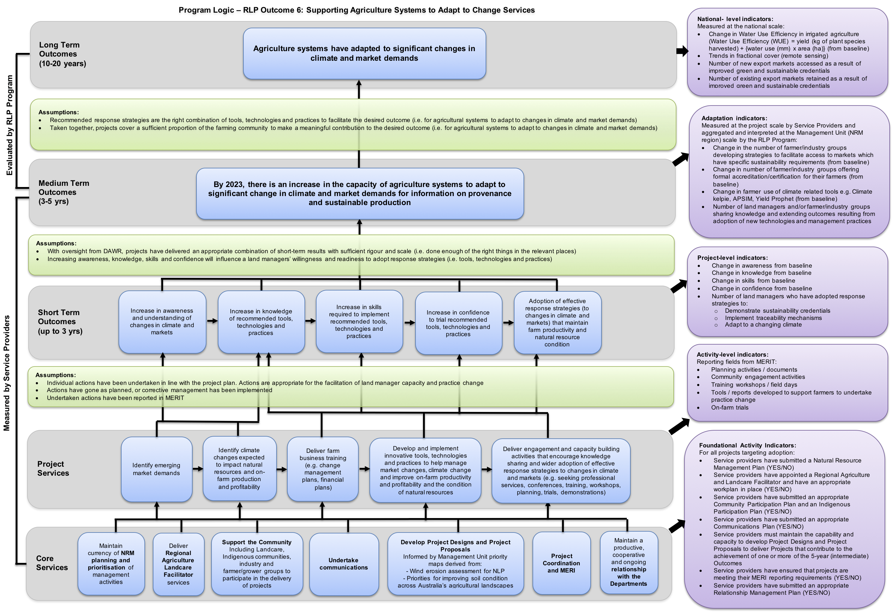

Figure ‑: Outcome 6 Program Logic

Table ‑: Outcome 6 Key Evaluation Questions

|  |  |  |  |
| --- | --- | --- | --- |
| Evaluation themes | Program Key evaluation Questions | outcome specific Key evaluation Questions | Relevant Level of the Program Logic |
| Effectiveness | * To what extent have the planned outcomes and outputs been achieved? * Are current delivery approaches and funding mechanisms the best way to maximise impact or are there other strategies that might be more effective? (addressed in appropriateness) * To what extent is the programme attaining, or expected to attain, its objectives and outcomes efficiently and in a way that is sustainable? (addressed in efficiency) | To what extent have the **Core Services** (and any associated targets) been achieved?   * Maintain currency of NRM planning and prioritisation of management activities * Deliver Regional Agriculture Landcare Facilitator services * Support the Community including Landcare, Indigenous communities, industry and farmer/grower groups to participate in the delivery of projects * Undertake communications * Develop Project Designs and Project Proposals * Project coordination and MERI * Maintain a productive, cooperative and ongoing relationship with the Departments | Core Services |
| To what extent have the **Project Services** (and any associated targets) been achieved?   * Identify emerging market demands * Identify climate changes expected to impact natural resources and on-farm production and profitability * Develop and implement innovative tools, technologies and practices to help manage market changes, climate change and improve on-farm productivity and profitability and the condition of natural resources * Deliver engagement and capacity building activities that encourage knowledge sharing and wider adoption of effective response strategies to changes in climate and markets (e.g. conferences, training, workshops, planning, trials, demonstrations) | Project Services |
| To what extent have the **Short Term Outcomes** (and any associated targets) been achieved?   * Increase in awareness and understanding of changes in climate and markets * Increase in knowledge of recommended tools, technologies and practices * Increase in skills required to implement recommended tools, technologies and practices * Increase in confidence to trial recommended tools, technologies and practices * Adoption of effective response strategies (to changes in climate and markets) that maintain farm productivity and natural resource condition | Short Term Outcomes |
| Appropriateness | * To what extent is the programme aligned with the needs of the intended beneficiaries? * To what extent is the programme compliant with recognised best practice processes in the field—e.g. the type, level and context of investment and associated activities? | As a delivery approach, was research and development, extension and adoption an appropriate way to:   * Align project delivery with community needs and expectations * Tailor the project to the climate, market and environmental conditions of each project site, and * Achieve the Medium Term Outcome? | Short Term Outcomes  Medium Term Outcome |
| To what extent were the response strategies adopted consistent with recognised best practice for capacity building and adaptation within agriculture systems? | Short Term Outcomes  Medium Term Outcome |
| Are there any other methods that should/could have been used? | Short Term Outcomes  Medium Term Outcome |
| Impact | * In what ways and to what extent has the programme contributed to changing asset condition, management practices, and / or effectiveness of delivery? * What, if any, unanticipated positive or negative changes or other outcomes have resulted? * To what extent were the changes directly or indirectly produced by the programme interventions? | To what extent have the core and project services and short and medium-term outcomes contributed to increased capacity of agriculture systems to adapt to significant change in climate and market demands for information on provenance and sustainable production? | Medium Term Outcome |
| To what extent has the End of Project outcome contributed to adaptation of agriculture systems to significant changes in climate and market demands? | Medium Term Outcome  Long Term Outcomes |
| What, if any, unanticipated positive or negative changes or other outcomes have resulted? | Medium Term Outcome |
| To what extent were the changes directly or indirectly produced by the programme interventions? | Medium Term Outcome |
| Efficiency | * To what extent has the programme attained the highest value out of available resources? * How could resources be used more productively and efficiently? * What could be done differently to improve implementation, and thereby maximise impact, at an acceptable and sustainable cost? | To what extent did Outcome 6 projects demonstrate ‘value for money’ through the:   * Implementation of a site selection process which considered the costs and anticipated benefits of works at potential sites * Establishment of partnerships for delivering the project (pooling resources, using local knowledge and experience) * Coordination of the delivery of activities/works (e.g. with other projects, in geographic locations) * Implementation of procurement processes to ensure both quality and quantity from investment, and * Leveraging investment from other sources? | Short Term Outcomes  Medium Term Outcome |
| How could have resources been used more productively and efficiently? | Short Term Outcomes  Medium Term Outcome |
| What could be done differently to improve implementation, and thereby maximise impact, at an acceptable and sustainable cost? | Short Term Outcomes  Medium Term Outcome |
| Legacy | * Will the programme’s impacts continue over time and after the programme ceases? * How should the legacy be managed and by whom? | What evidence is there that the work completed through Outcome 6 will continue to be maintained? | Medium Term Outcome |
| How likely is it that the outcomes achieved through Outcome 6 will be sustained? | Medium Term Outcome |

Table ‑: Outcome 6 monitoring plan

| Level | Outcome/Activity | Indicators | Indicative frequency of reporting | Who is responsible? |
| --- | --- | --- | --- | --- |
| RLP Program Outcomes | | | | |
| Long-term Program Outcomes  (10-20 yrs) | Agriculture systems have adapted to significant changes in climate and market demands | Measured at the national scale:   * Change in Water Use Efficiency in irrigated agriculture (Water Use Efficiency (WUE) = yield (kg of plant species harvested) + {water use (mm) x area (ha)} (from baseline) * Trends in fractional cover (remote sensing) * Number of new export markets accessed as a result of improved green and sustainable credentials * Number of existing export markets retained as a result of improved green and sustainable credentials | End of funding cycle and at 10-20 years | DAWR lead for this outcome |
| Medium Term Program Outcomes  (3-5 yrs) | By 2023, there is an increase in the capacity of agriculture systems to adapt to significant change in climate and market demands for information on provenance and sustainable production | **Adaptation indicators:**  Aggregated and interpreted at the Management Unit (NRM region) scale by the RLP Program:   * Change in the number of farmer/industry groups developing strategies to facilitate access to markets which have specific sustainability requirements (from baseline) * Change in number of farmer/industry groups offering formal accreditation/certification for their farmers (from baseline) * Change in farmer use of climate related tools e.g. Climate kelpie, APSIM, Yield Prophet (from baseline) * Number of land managers and/or farmer/industry groups sharing knowledge and extending outcomes resulting from adoption of new technologies and management practices | End of funding cycle | DAWR lead for this outcome |
| Project Achievements and Progress | | | | |
| Medium Term Outcomes  (3-5 yrs)  Reported in:  Outcome Report 2 | By 2023, there is an increase in the capacity of agriculture systems to adapt to significant change in climate and market demands for information on provenance and sustainable production | **Adaptation indicators:**  Measured at the project scale by Service Providers:   * Change in the number of farmer/industry groups developing strategies to facilitate access to markets which have specific sustainability requirements (from baseline) * Change in number of farmer/industry groups offering formal accreditation/certification for their farmers (from baseline) * Change in farmer use of climate related tools e.g. Climate kelpie, APSIM, Yield Prophet (from baseline) * Number of land managers and/or farmer/industry groups sharing knowledge and extending outcomes resulting from adoption of new technologies and management practices | At 3-5 years | Service provider |
| Short Term Outcomes  (1-3 yrs)  Reported in:  Outcome Report 1 | Increase in awareness and understanding of changes in climate and markets | Change in awareness from baseline | At 2 – 3 years | Service provider |
| Increase in knowledge of recommended tools, technologies and practices | Change in knowledge from baseline | At 2 – 3 years | Service provider |
| Increase in skills required to implement recommended tools, technologies and practices | Change in skills from baseline | At 2 – 3 years | Service provider |
| Increase in confidence to trial recommended tools, technologies and practices | Change in confidence from baseline | At 2 – 3 years | Service provider |
| Adoption of effective response strategies (to changes in climate and markets) that maintain farm productivity and natural resource condition | Number of land managers who have adopted response strategies to:  Demonstrate sustainability credentials  Implement traceability mechanisms  Adapt to a changing climate | At 2 – 3 years | Service provider |
| MERIT services – as per contracts | | | | |
| Project services | Identify emerging market demands | Planning activities / documents reporting on markets and opportunities | In line with Outputs Reporting requirements | Service provider |
| Identify climate changes expected to impact natural resources and on-farm production and profitability | Analyses or reports on climate change impacts on farming  Planning activities focussed on climate impacts on farming | In line with Outputs Reporting requirements | Service provider |
| Deliver farm business training (e.g. change management plans, financial plans) | Training workshops – number run, attendees  Aim of training – improve knowledge, build skills etc.  Measures of change (based on aims) | In line with Outputs Reporting requirements | Service provider |
| Develop and implement innovative tools, technologies and practices to help manage market changes, climate change and improve on-farm productivity and profitability and the condition of natural resources | Tools and technologies developed to support farmers to undertake practice change  Resource materials (reports, extension materials) developed to help farms adopt changes  Adoption/use of tools, technologies and practices aimed at helping farms to adapt to change | In line with Outputs Reporting requirements | Service provider |
| Deliver engagement and capacity building activities that encourage knowledge sharing and wider adoption of effective response strategies to changes in climate and markets (e.g. seeking professional services, conferences, training, workshops, planning, trials, demonstrations) | Community engagement activities  Field days  Training workshops / field days  Conferences or seminar  Numbers of activities, participation  Aims of activities – improve knowledge, build skills etc.  Measures of change (based on aims) | In line with Outputs Reporting requirements | Service provider |
| Core services | Maintain currency of **NRM planning and prioritisation** of management activities | Service Providers have submitted a Natural Resource Management Plan (YES/NO) | On commencement | Service provider |
| Deliver **Regional Agriculture Landcare Facilitator** services | Service providers have appointed a Regional Agriculture and Landcare Facilitator and have an appropriate workplan in place (YES/NO) | Throughout project | Service provider |
| **Support the Community**  Including Landcare, Indigenous communities, industry and farmer/grower groups to participate in the delivery of projects | Service providers have submitted an appropriate Community Participation Plan and an Indigenous Participation Plan (YES/NO) | Throughout project | Service provider |
| **Undertake communications** | Service providers have prepared and submitted an appropriate Communications Plan (YES/NO) | Throughout project | Service provider |
| **Develop Project Designs and Project Proposals**  Informed by Management Unit priority maps derived from:  Wind erosion assessment for NLP  Priorities for improving soil condition across Australia’s agricultural landscapes | Service providers must maintain the capability and capacity to develop Project Designs and Project Proposals to deliver Projects that contribute to the achievement of one or more of the 5-year (intermediate) Outcomes | On commencement | Service provider |
| **Project coordination and MERI** | Service providers have ensured that projects are meeting their MERI reporting requirements (YES/NO) | Throughout project | Service provider |
| Maintain a productive, cooperative and ongoing **relationship with the Departments** | Service providers have submitted an appropriate Relationship Management Plan (YES/NO)  Briefings of Australian government officers with responsibility for this project (YES/NO) | Throughout project | Service provider |