Guide to reporting on program outcomes
Version 1.1, May 2021

© Commonwealth of Australia 2021
Ownership of intellectual property rights
Unless otherwise noted, copyright (and any other intellectual property rights) in this publication is owned by the Commonwealth of Australia (referred to as the Commonwealth).
Creative Commons licence
All material in this publication is licensed under a Creative Commons Attribution 4.0 International Licence except content supplied by third parties, logos and the Commonwealth Coat of Arms.
Inquiries about the licence and any use of this document should be emailed to copyright@awe.gov.au.

Cataloguing data
This publication (and any material sourced from it) should be attributed as: DAWE 2021, Guide to reporting on program outcomes (version 1.1), Department of Agriculture, Water and the Environment, Canberra. May. CC BY 4.0.
ISBN 978-1-76003-413-9
This publication is available at nrm.gov.au/regional-land-partnerships.
Department of Agriculture, Water and the Environment
GPO Box 858 Canberra ACT 2601
Telephone 1800 900 090
Web awe.gov.au
Disclaimer
The Australian Government acting through the Department of Agriculture, Water and the Environment has exercised due care and skill in preparing and compiling the information and data in this publication. Notwithstanding, the Department of Agriculture, Water and the Environment, its employees and advisers disclaim all liability, including liability for negligence and for any loss, damage, injury, expense or cost incurred by any person as a result of accessing, using or relying on any of the information or data in this publication to the maximum extent permitted by law.

Contents
Summary iv
Introduction 1
Purpose of outcome reporting 2
How we use information from service providers 3
Criteria used to assess program progress 4
What service providers need to do 5
Outcome reporting deadlines 6
Support 7
Appendix A: Mid-term reporting process 8
Appendix B: Criteria matrix 9
Appendix C: Key evaluation questions 10
Appendix D: Project dataset summary 11
Appendix E: Program evaluation questions 12
Glossary 14
References 15
Further reading 15

Figures
Figure 1 Components of program-level evaluation for department-funded programs 1
Figure A1 Mid-term review flowchart for Year 3 outcome reporting 8

Tables
Table 1 Program evaluation criteria 4
Table B1 Criteria matrix based on best practise program evaluation criteria 9
Table C1 Key evaluation questions for Regional Land Partnership program 10
Table D1 Project dataset summary questions 11
Table E1 Key evaluation questions, by theme 12

Summary
Reporting on outcomes ensures a complete picture of program performance and effectiveness. This supports the improvement of programs and maximises benefits from government-funded initiatives.
Outcome reporting is also key to informing program-level reviews and evaluation. Information, trends and key lessons from outcome reporting are also used to inform program design. Reporting on outcomes allows us to understand what we have achieved and the difference we have made against program objectives. In contrast, output reporting in isolation provides very limited information on program performance.
The Department of Agriculture, Water and the Environment requires that you, as service providers of government-funded programs, report against short-, medium- and longer-term outcomes. This guide spells out our outcome reporting requirements.

Introduction
Under the Public Governance, Performance and Accountability Rule 2014, projects funded by the Australian Government must be accountable. This requires program managers to track and report on program effectiveness and value for money. Key to this is reporting on the short-, medium- and long-term outcomes of a program. Outcome reporting is also used to inform program improvements, additional program phases and the design of new programs.
This reporting guide outlines:
- the purpose of outcome reporting
- how we use outcome reporting data to assess program effectiveness and improve future program design
- what you, as service providers, need to do
- the outcome reporting assistance the department will provide to you.
Figure 1 is an overview of the monitoring and evaluation elements of the department’s programs and how these elements intersect.
Figure 1 Components of program-level evaluation for department-funded programs
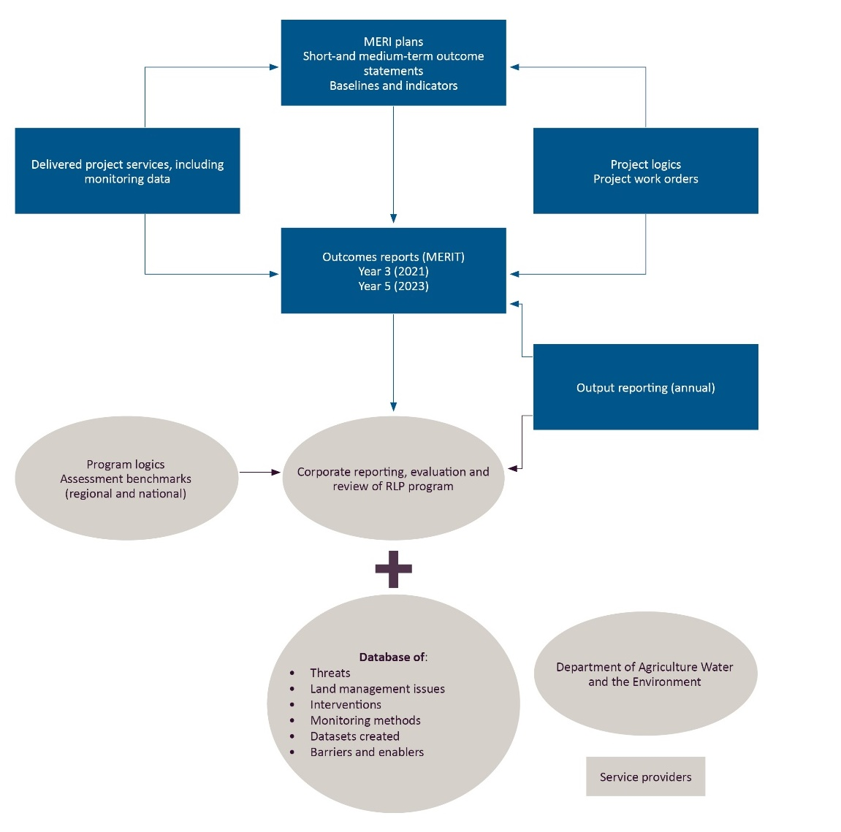
MERI Monitoring, Evaluation, Reporting and Improvement. MERIT Monitoring, Evaluation, Reporting and Improvement Tool. RLP Regional Land Partnerships.

Purpose of outcome reporting
Outcome reporting is essential to understanding how a program has performed. It enables service providers to:
- highlight key achievements
- reflect on key challenges and opportunities for improvement
- highlight factors that have supported or inhibited success.
Good program management relies on outcome reporting data that informs:
- program improvements
- a program’s mid-term review and end of program evaluation.
Program reviews and evaluation contribute to accountability to the public and parliament. They also provide the evidence base to help governments make decisions and set priorities. Outcome reporting informs program direction and design and enhances program effectiveness. This cannot be done through the reporting of outputs alone. Some programs will also be required to report against key evaluation questions. This will further inform our understanding of the program’s performance.
We understand that despite best efforts, not everything goes to plan with projects. It is critical that service providers use outcome reporting to highlight project achievements as well as challenges and lessons. This approach allows for adaptive management and necessary changes during the life of a program.

How we use information from service providers
We will use the data you provided in your outcome reporting to generate:
- a program-wide report
- project-specific reports at the program’s mid- and end points
- any key thematic reports at the program level (as required).
These reports may be made publicly available on the department’s website.
We will analyse outcome reporting data to:
- inform the success of a program and opportunities for improvement
- enable us to report to government on the progress of programs
- allow us to report against our corporate reporting requirements in the department’s annual reports.
Outcome reporting data will also inform key themes or trends for further investigation during a program’s mid-term reviews and end-of-program evaluation.

Criteria used to assess program progress
We will use the criteria listed in Table 1 to review and evaluate a program’s progress and success against its objectives. These criteria are drawn from internationally recognised standards for assessing program performance. They have informed the key evaluation questions that we ask you as part of the outcome reporting requirements. We also use these criteria to guide program reviews and evaluation (for an example of program evaluation questions, see Appendix E).
Table 1 Program evaluation criteria
Evaluation theme | Program-level definition
Effectiveness | A measure of the extent to which a program, project or initiative has attained, or is expected to attain, its relevant objectives efficiently and in a sustainable way.
Appropriateness | A determination made through comparing the program with the needs of the intended beneficiaries using any of the techniques of needs analysis. Alternatively, the program could be evaluated in terms of its compliance with process.
Impact | A change in the condition of biophysical, social, economic and/or institutional assets. An impact may be positive or negative, primary or secondary, short-term or long-term, direct or indirect, and/or intended or unintended. Impacts are sometimes realised after the formal project is completed.
Efficiency | The notion of getting the highest value out of program or project resources.
Legacy | The enduring consequences of past investments, policies or actions that can be captured and/or bequeathed.
Source: OECD DAC (2019)

What service providers need to do
MERIT is our online program management reporting depository. It is designed to guide you through the outcome reporting process. The MERIT outcome forms contain questions on project progress against nominated outcome statements. Outcome statements are defined at the start of projects in individual monitoring, evaluation, reporting and improvement plans (MERI plans). For definitions of short-, medium- and long-term outcomes, see the Glossary.
Terminology will vary slightly between environment and agriculture focused projects and programs to reflect different requirements. General themes, including the need for evidence, remain the same. In most instances, you will be asked to select answers from a drop-down menu. Other questions will require an open text response.
You will be required to answer questions about:
- progress of projects against established baselines for each outcome statement
- the level of achievement of an outcome statement using a criteria matrix (Appendix B)
- key enablers and barriers to the success of their projects.
Depending on the scale or strategic significance of some programs, respondents may be asked to answer a list of key evaluation questions (Appendix C). These questions have been informed by the evaluation criteria (Appendix E).
You will also be required to provide a summary of the evidence you have collected (in the form of dataset summaries and raw data) against baselines to support your claims (Appendix D). For a flowchart of each program’s mid-term outcome reporting, see Appendix A.

Outcome reporting deadlines
Outcome reporting requirements will vary for each service provider, depending on the lifespan of the project.
For example, projects that have a lifespan of 5 years, such as the Regional Land Partnership (RLP) program, would be required to complete 2 outcome reports in MERIT (one at the mid-term point (3 years) and one at the end of the program (5 years). Alternatively, a 2-year project may only be required to complete a single outcome report (at 1 year).
Information on reporting requirements will be detailed in your MERIT plans.
In general, outcome reporting will be due at the end of each financial year (30 June) or towards the end date of each project (see your contract for details).

Support
We will support you throughout the outcome reporting process by providing:
- outcome reporting forms – available in MERIT before the reporting period begins
- our updated MERIT user guide – with a section on completing the outcome reporting form
- online training sessions and support – via the MERI Network GovTeams community
- a helpdesk service – email the MERI Team at MERIT@awe.gov.au

Appendix A: Mid-term reporting process
Figure A1 Mid-term review flowchart for Year 3 outcome reporting
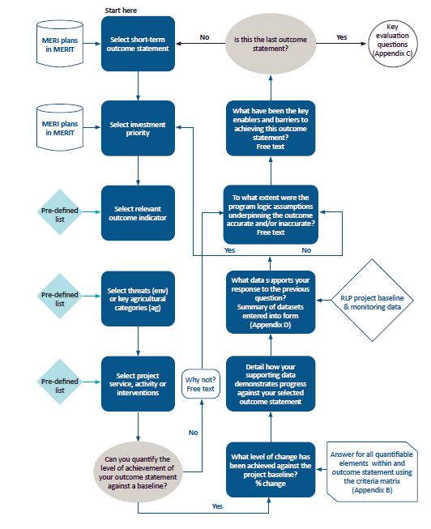
ag Agricultural. env Environmental. MERI Monitoring, Evaluation, Reporting and Improvement. MERIT Monitoring, Evaluation, Reporting and Improvement Tool. RLP Regional Land Partnerships.

Appendix B: Criteria matrix
Table B1 Criteria matrix based on best practise program evaluation criteria
Criteria | Significantly achieved (100 to 76%) | Satisfactorily achieved (75 to 51%) | Partially achieved (50 to 26%) | Inadequately achieved (25 to 1%) | Not achieved (0%)
Effectiveness | ☐ Project has significantly achieved the outputs and targets expected at this point and is on track to achieve expected final outcomes. | ☐ Project has satisfactorily achieved major outputs and targets expected at this point and is on track to achieve most expected final outcomes. | ☐ Project has partially achieved required level of outputs and targets at this point and only has moderate chance of achieving expected final outcomes. | ☐ Project has not adequately achieved outputs and targets expected at this point and is not on track to achieve expected final outcomes to satisfactory level. | ☐ Project has not achieved outputs and targets at this point and will not achieve expected final outcomes.
Efficiency | ☐ Project maximises outcomes from available time and resources. Investment is within budget and funds are being spent as planned. Interventions and governance arrangements maximise efficiency. Staff resources (and skills) are completely appropriate and support maximum efficiency. | ☐ Project generally makes good use of time and resources in all major areas. Investment has sometimes deviated from planned budget, expenditure and/or timelines. Intervention and governance arrangements are generally strong and support good levels of overall efficiency. Staff resources (and skills) good and support overall efficiency, but there is room for improvement. | ☐ Project makes appropriate use of time and resources in some areas. Investment has deviated from budget, and/or planned expenditure; timelines mainly within tolerable limits. Interventions and governance arrangements are moderately satisfactory, but more could be done to improve efficiency. Staff resources (and skills) adequate, but more could be done to improve these. | ☐ Project not making appropriate use of time and resources in at least one major area. Investment has deviated from budget, and/or planned expenditure; timelines beyond tolerable limits. Likely other interventions and/or governance arrangements would better support efficient delivery of outcomes. Staff resources (and skills) inadequate to support intended outcomes. | ☐ Project not making appropriate use of time and resources in several or all major areas. Investment has deviated completely from budget, and/or planned expenditure; timelines beyond tolerable limits. Interventions and/or governance arrangements highly inefficient. Staff resources (and skills) inadequate across several areas to support intended outcomes.
Legacy | ☐ Benefits will endure in all/almost all areas beyond project life. | ☐ Benefits will endure in a large number of major and minor areas beyond the life of the project. | ☐ Benefits will endure in most areas; project does not fail in any major area. | ☐ Benefits achieved are unlikely to endure in at least one major area. | ☐ Few benefits have been achieved and/or these are unlikely to endure in most areas (major and minor).
Appropriateness | ☐ Project and its delivery methods highly appropriate for supporting maximum outcomes, with very little to no need for change. | ☐ Project and delivery methods mostly relevant and appropriate for supporting maximum outcomes, with some change needed. | ☐ Project and delivery methods only partly relevant and appropriate for supporting maximum outcomes. Substantial number of changes required to improve relevance. | ☐ Project and delivery methods largely inappropriate and have affected success of outcomes. Large change in overall approach needed. | ☐ Project and delivery methods not appropriate and have prevented intended outcomes and/or led to unintended negative outcomes. Complete revision of approach needed.

Appendix C: Key evaluation questions
Table C1 Key evaluation questions for Regional Land Partnership program
Key evaluation questions | Answer format
1 To what extent are you progressing towards the medium-term project outcome? | Drop-down (%)
2 How, and to what extent, has the project increased knowledge of best practice natural resource management for the investment priority? | Free text
3 Were the methods/strategies used the best way to achieve/maximise the outcomes or are there other methods/strategies that might be more effective? | Free text
4 To what extent has the project risk assessment and risk management been appropriate and effective? | Free text
5 If your project engages with Traditional Owners, how and by what means has this project improved the capacity of Traditional Owners to lead or assist with the management of the investment priority? | Free text
6 Have there been any unexpected or unintended (positive or negative) changes or other outcomes delivered by this project and what are they? | Free text
7 What elements of the project could be improved to maximise efficiency (and value for money)? | Free text
8 Did this project receive funding from any other sources apart from the RLP program? If yes, please specify and the proportion of funding contributed to the project. | Free text
9 How, and to what extent, has the project achieved desired behavioural change and ongoing commitment among the participating land managers towards the investment priority? | Free text
10 What evidence is there that the outcomes will be maintained? How will they be maintained and by whom? | Free text
11 Is there any additional information or data you wish to provide that you have used to evaluate the success of the project? | Free text

Appendix D: Project dataset summary
This project dataset summary form will be used for several natural resource management programs in MERIT. As a result, some questions will be a repetition of content that is already in the system. Some questions will be prefilled once this form is in MERIT. You will have to answer these questions for each dataset collected for your project.
Table D1 Project dataset summary questions
Category | Question | Answer format
Title | 1 Dataset title | Free text
Background | 2 Project ID | Free text
Background | 3 Project name | Free text
Background | 4 What program does this dataset relate to? | Drop-down menu
Dataset description | 5 What program outcome does this dataset relate to? | Drop-down menu
Dataset description | 6 What primary or secondary investment priority does this dataset relate to? | Drop-down menu
Dataset description | 7 Is this (a) a baseline dataset associated with a project outcome against which change will be measured; (b) a project progress dataset that is tracking change against an established project baseline dataset; or (c) a standalone foundational dataset to inform future management interventions? | Drop-down menu
Dataset description | 8 What types of measurements or observations does the dataset include? | Drop-down menu
Data collection | 9 Identify the methods used to collect the data. | Drop-down menu
Data collection | 10 Describe the method used to collect the data in detail. | Free text
Data collection | 11 Identify any apps used during data collection. | Free text
Data collection | 12 Provide a coordinate centroid for the area surveyed (for biophysical/ecological surveys where an app was not used, and where there are no sensitivities in providing a location). | Latitude and longitude in decimal degrees
Data collection | 13 First collection date | Calendar
Data collection | 14 Last collection date | Calendar, ongoing option
Data collection | 15 Is this data an addition to existing time-series data collected as part of a previous project, or is it being collected as part of a broader or national dataset? | Drop-down menu and free text
Data accessibility | 16 Who developed or collated the dataset? | Drop-down menu
Data accessibility | 17 Has a quality assurance check been undertaken on the data? | Drop-down menu
Data accessibility | 18 Has the data contributed to a publication? | Drop-down menu, including URL hyperlink to publication
Data accessibility | 19 Where is the data held? | Drop-down menu
Data accessibility | 20 For all public datasets, provide the published location. If stored internally by your organisation write ‘stored internally’. | Free text, including URL hyperlink
Data accessibility | 21 What format is the dataset? | Drop-down menu
Data accessibility | 22 Are there any sensitivities in the dataset? | Drop-down menu
Data accessibility | 23 Primary source of data (organisation or individual that owns or maintains the dataset) | Free text
Data accessibility | 24 Dataset custodian (name of contact to obtain access to dataset) | Free text

Appendix E: Program evaluation questions
Table E1 Key evaluation questions, by theme
Evaluation theme | Key evaluation questions | Sub evaluation questions | Relevant level of program logic
Effectiveness | To what extent have the planned outcomes and outputs been achieved? | To what extent have project services (and any associated targets) been delivered? | Actions and outputs  Outcomes
Effectiveness |  | To what extent have the identified outcomes been achieved (based on indicators to support delivery of project services)? | Outcomes
Appropriateness | To what extent is the program aligned with the needs of the intended beneficiaries?  To what extent is the program compliant with process and recognised best practice processes in the field (e.g. the type, level and context of investment and associated activities)? | As a delivery approach, were the foundational activities and management actions an appropriate way to:  - align project delivery with community needs and expectations  - tailor the project to the needs of each site  - achieve identified outcomes? | Short-term outcomes  Medium-term outcomes  Activities
Efficiency | To what extent has the program attained the highest value out of available resources?  How could resources be used more productively and efficiently?  What could be done differently to improve implementation, and thereby maximise outcomes and impact, at an acceptable and sustainable cost? | To what extent did the recovery effort demonstrate ‘value for money’ through the various projects and activities? | Short-term outcomes  Medium-term outcomes
Efficiency |  | How could resources have been used more productively and efficiently? | Short-term outcomes  Medium-term outcomes
Efficiency |  | What could be done differently to improve implementation, and thereby maximise impact, at an acceptable and sustainable cost? | Short-term outcomes  Medium-term outcomes
Legacy | Will the program’s impacts continue over time and after the program ceases?  How should the legacy be managed and by whom? | What evidence is there that the work completed to support identified outcomes will continue to be maintained?  How likely is it that the outcomes achieved through the project services that were delivered will be sustained over time? | Outcomes
Impact | In what ways and to what extent has the program contributed to changing asset conditions, management practices, and/or effectiveness of delivery?  What, if any, unanticipated positive or negative changes or other outcomes have resulted?  To what extent were the changes directly or indirectly produced by the program interventions? | To what extent have the core and project services and short- and medium-term outcomes contributed to the longer-term outcomes? | Medium- to long-term outcomes
Note: Evaluation questions derived from the RMCG Regional Land Partnerships Evaluation Plan (DEE 2018).

Glossary
Term | Definition
baseline | Starting point or reference data (for example, historical conditions) used for comparing the degree of change in a set of results.
benchmark | Desired states of indicators (objectives) used for comparing results in order to gauge effectiveness of NRM project services and investment.
habitat | The environment that supports a species, and particularly those features or attributes that determine where the species occurs.
indicator | A measurement or value that can be used to assess progress towards outcomes.
MERI | Monitoring, Evaluation, Reporting and Improvement
MERIT | Monitoring, Evaluation, Reporting and Improvement Tool, the department’s online program management reporting depository.
metadata | Data describing the monitoring data collected and generated (for example, a date, time and location stamp that sits behind an Excel spreadsheet or photograph).
natural resource management actions | Actions that lead to the protection and improvement of environmental assets such as soils, water, vegetation and biodiversity.
outcomes – short-term, medium-term and long-term | Short-term outcomes (over years 1 to 3)  All projects will have short-term outcomes. Although they represent a relatively short period, these outcomes are vital to the success of projects and programs.  Medium-term outcomes (over years 3 to 5)  For 5-year projects, these outcomes will also be the end-of-program outcomes. All 3- to 5- year projects will have medium-term outcomes, and these are to be reported on by the end date of the project.  Long-term outcomes (year 5 and beyond)  These outcomes are expected to emerge towards the end or well after the life of a project. Indicators will be used to measure progress towards these outcomes to confirm whether they are ‘on track’ to being achieved.
primary or secondary investment focus | The primary focal assets or ecological values being addressed by a project, such as a threatened species or ecological community, Ramsar site or World Heritage site.
project services | Services, activities or outputs being provided by RLP projects. These include biophysical and non-biophysical (human) actions.
RLP | Regional Land Partnership
threats | Pressures, drivers and stressors being addressed by the project.
trajectories | Changes in indicators over time.

References
DEE 2018, Regional Land Partnerships Evaluation Plan, Final Report prepared by RMCG for the Department of the Environment and Energy, Canberra, accessed 12 March 2021.
OECD DAC 2019, Better criteria for better evaluation: Revised evaluation criteria definitions and principles for use (pdf 827kb), OECD/DAC Network on Development Evaluation, Paris, accessed 31 March 2021.

Further reading
Capon, S, Castley, G, Palmer, G, Linke, S, Piccolo, R, Henderson, E, Allely-Ferme, E, Richmond, S & Huijbers, C 2020, A long-term monitoring framework for the Regional Land Partnerships Stage 2: final report, Griffith University, Brisbane, accessed 12 March 2021.
Commonwealth of Australia 2009, NRM MERI Framework, Commonwealth of Australia, Canberra, accessed 12 March 2021.
——2017, Regional Land Partnerships MERI Framework Department of the Environment and Energy and the Department of Agriculture and Water Resources, accessed 12 March 2021.
Department of Finance 2021, Resource management guide: Developing good performance information, Canberra, accessed 12 March 2020.

