# Regional Land Partnerships program outcome reporting guide

Program Delivery Branch



Version 1.1

December 2020

© Commonwealth of Australia 2020

**Ownership of intellectual property rights**

Unless otherwise noted, copyright (and any other intellectual property rights) in this publication is owned by the Commonwealth of Australia (referred to as the Commonwealth).

**Creative Commons licence**

All material in this publication is licensed under a [Creative Commons Attribution 4.0 International Licence](https://creativecommons.org/licenses/by/4.0/legalcode) except content supplied by third parties, logos and the Commonwealth Coat of Arms.

Inquiries about the licence and any use of this document should be emailed to [copyright@awe.gov.au](mailto:copyright@awe.gov.au).



**Cataloguing data**

This publication (and any material sourced from it) should be attributed as: Department of Agriculture, Water and the Environment 2020, *Regional Land Partnerships program outcome reporting guide*, Canberra, CC BY 4.0.

ISBN 978-1-76003-336-1

This publication is available at <http://www.nrm.gov.au/regional-land-partnerships>

Department of Agriculture, Water and the Environment

GPO Box 858 Canberra ACT 2601

Telephone 1800 900 090

Web [awe.gov.au](http://agriculture.gov.au/)

**Disclaimer**

The Australian Government acting through the Department of Agriculture, Water and the Environment has exercised due care and skill in preparing and compiling the information and data in this publication. Notwithstanding, the Department of Agriculture, Water and the Environment, its employees and advisers disclaim all liability, including liability for negligence and for any loss, damage, injury, expense or cost incurred by any person as a result of accessing, using or relying on any of the information or data in this publication to the maximum extent permitted by law.

Contents

Summary 4

Introduction 5

1 Purpose of outcome reporting 7

2 How we use service provider information 8

3 Criteria used to assess program progress 9

4 What service providers need to do 10

5 Outcome reporting deadlines 11

6 Support 12

Appendix A: Mid-term review outcome report flow chart 13

Appendix B: Criteria matrix 14

Appendix C: Key Evaluation Questions 16

Appendix D: Project dataset summary 17

Glossary 19

References 20

**Tables**

Table 1 Regional Land Partnerships program evaluation themes 9

Table 4 Criteria matrix based on the Regional Land Partnerships program evaluation themes 14

Table 3 Key Evaluation Questions that will be asked in the outcome report form 16

Table 2 Project dataset summary questions 17

**Figures**

Figure 1 Components of program level evaluation for the RLP program 6

Figure 2 Outcome reporting support provided to service providers 12

Figure 3 Flowchart of the questions in the mid-term review (2021) outcome report form 13

## Summary

The Regional Land Partnerships (RLP) program supports vital environmental and sustainable agricultural outcomes across Australia. Reporting against these outcomes is essential. It lets the department know how the RLP program is performing. It also captures key achievements, lessons and opportunities for improvement.

Service providers will need to report against their short and medium-term outcome statements via an outcome report form. These forms are available in MERIT as Outcomes Report 1 and Outcomes Report 2. Service providers will need to complete:

* Outcomes Report 1 for short-term outcome statements, due by 29 July 2021
* Outcomes Report 2 for medium-term outcome statements, due by 28 July 2023.

Note: Projects that run for a maximum of three years only need to complete Outcomes Report 1 on the 29th of July 2021, or the 20th business day after the end date for that project work order, whichever occurs first. Projects that run over 3 years need to provide Outcomes Report 1 on the 29th of July 2021 and Outcomes Report 2 on the 28th of July 2023.

The department will support service providers throughout the outcome reporting process.

The data obtained from outcome reporting will be used by the department to inform the success of the program and opportunities for improvement. It will also inform the design of future NRM programs.

## Introduction

The Regional Land Partnerships (RLP) program is a large-scale $450 million investment. It is an Australian Government funded program that runs over 5 years, from 2018 to 2023. The program supports vital environmental and sustainable agricultural outcomes across the country. It is important for projects funded by the program to capture the achievement of short and medium-term outcomes. Natural Resource Management (NRM) service providers are central to this process.

Outcome reporting will help to ensure a more comprehensive picture of the program’s progress. It will capture key lessons and opportunities for improvement. See Figure 1 for an overview of the monitoring and evaluation elements of the program and how they interact.

This reporting guide describes:

* the purpose of outcome reporting
* how we use service provider data to assess program effectiveness and improve future program design
* what service providers need to do and by when
* how service providers will be supported with outcome reporting.

Use this reporting guide in conjunction with the [RLP Evaluation Plan](http://nrm.gov.au/publications/regional-land-partnerships-evaluation-plan).

Figure Components of program level evaluation for the RLP program

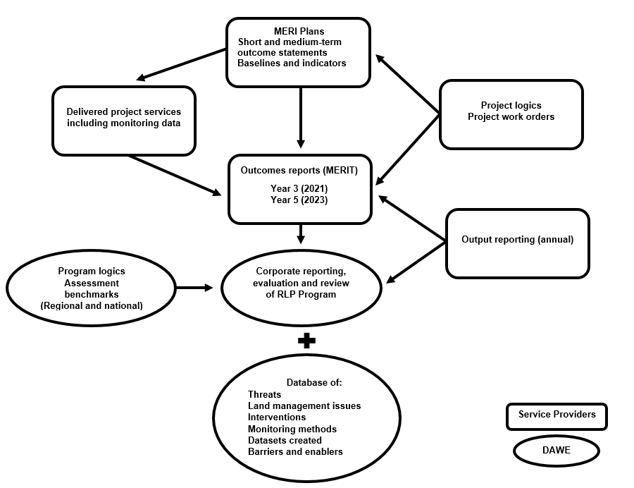

**MERI** Monitoring, Evaluation, Reporting and Improvement. **MERIT** Monitoring, Evaluation, Reporting and Improvement Tool. **DAWE** Department of Agriculture Water and the Environment.

## Purpose of outcome reporting

Outcome reporting is essential for understanding how a program has performed. It allows service providers to highlight key achievements. It also gives service providers a chance to reflect on key challenges and opportunities for improvement. Service providers can also highlight factors that have supported or inhibited success.

All good programs rely on quality data provided through regular reporting. Outcome reporting provides data for a mid-term review (2021) and program evaluation (2023). The department combines this data to inform how a program is tracking against its objectives. Conclusions around program success (or otherwise) can then be drawn by the department.

The department understands that despite best efforts, not everything goes to plan. Service providers should report on the achievements as well as the challenges and lessons from projects. This approach allows for adaptive management during the life of the program. Honest and transparent reporting ensures that sound evidence of what works informs future programs.

## How we use service provider information

The data provided by service providers via outcome reporting will be used to generate the following reports:

* a program-wide report
* program specific reports for each of the [RLP Program’s 6 outcomes](http://nrm.gov.au/regional-land-partnerships/program-logic)
* project specific reports at the program’s mid-point (2021) and endpoint (2023).

These reports will be publicly available on the department’s [website](https://www.awe.gov.au/about/reporting/annual-report).

The department will also synthesise and analyse service provider feedback. This will inform themes or trends for further investigation via the mid-term review and end of program evaluation. This will also:

* inform on the success of the program and opportunities for improvement
* allow the department to report to government on the progress of the program
* allow the department to report against its corporate reporting requirements. These are on natural resource management (NRM) and sustainable agriculture via the [Annual Report](https://www.awe.gov.au/about/reporting/annual-report)
* inform the design of future NRM programs.

## Criteria used to assess program progress

The Department will use the criteria listed in Table 1 to review and evaluate the Program’s progress and successes against its objectives. These criteria are drawn from the [RLP Evaluation Plan](http://nrm.gov.au/publications/regional-land-partnerships-evaluation-plan), which sets out both program and project level definitions. These criteria have been used to design the questions service providers will be asked during outcome reporting.

Table Regional Land Partnerships program evaluation themes

| Evaluation theme | Program-level definition |
| --- | --- |
| Effectiveness | A measure of the extent to which a program, project or initiative has attained, or is expected to attain, its relevant objectives efficiently and in a sustainable way |
| Appropriateness | A determination made through comparing the program with the needs of the intended beneficiaries using any of the techniques of needs analysis. Alternatively, the program could be evaluated in terms of its compliance with process |
| Impact | A change in the condition of biophysical, social, economic and/or institutional assets. An impact may be positive or negative, primary or secondary, short-term or long-term, direct or indirect, and/or intended or unintended. Impacts are sometimes realised after the formal project is completed. |
| Efficiency | The notion of getting the highest value out of program or project resources. |
| Legacy | The enduring consequences of past investments, policies or actions that can be captured and/or bequeathed. |

Source: [Regional Land Partnerships Evaluation Plan](http://nrm.gov.au/publications/regional-land-partnerships-evaluation-plan)

## What service providers need to do

Service providers will be guided in MERIT to complete the outcome report forms (Outcomes Report 1 and Outcomes Report 2). The forms contain a series of questions on project progress towards short and medium-term outcome statements. Outcome statements were defined at the start of projects in individual MERI Plans. Service providers may find it useful to refer to the definition of short, medium and long-term outcomes in the Glossary.

A flow chart (Appendix A) of the mid-term outcome report form (Outcomes Report 1) questions has been developed. The terminology varies slightly between environment and agriculture focused projects to reflect the different requirements. The line of questioning, focus of assessment and need for evidence remains the same. In most instances, service providers will select answers from a drop-down box. Some questions will have an open text response.

In Outcomes Report 1, service providers will answer questions about:

* progress of projects against established baselines for each outcome statement
* quantification of level of achievement of an outcome statement using a criteria matrix (Appendix B)
* key enablers and barriers to the success of their outcome statements
* key evaluation questions (Appendix C).

Service providers will also provide a summary for each dataset collected (Appendix D). This summary will allow the department as RLP Data Stewards to manage data collected by each project. These data summaries will provide the evidence base for reporting on project and program performance.

## Outcome reporting deadlines

Service providers will be required to complete two outcome report forms in MERIT over the life of their projects.

They are:

1. Outcomes Report 1: The mid-term (Year 3) form based on MERI plan short-term outcome statements. This outcome report form is due by **29 July 2021**.
2. Outcomes Report 2: The end of project (Year 5) form based on MERI plan medium-term outcome statements. This outcome report form is due by **28 July 2023**.

Projects that run for a maximum of three years only need to complete Outcomes Report 1 on the 29th of July 2021, or the 20th business day after the end date for that project work order, whichever occurs first. Projects that run over 3 years need to provide Outcomes Report 1 on the 29th of July 2021 and Outcomes Report 2 on the 28th of July 2023.

## Support

Service providers will be supported throughout the outcome reporting process. Support provided is summarised in Figure 2.

Figure Outcome reporting support provided to service providers

## Appendix A: Mid-term review outcome report flow chart

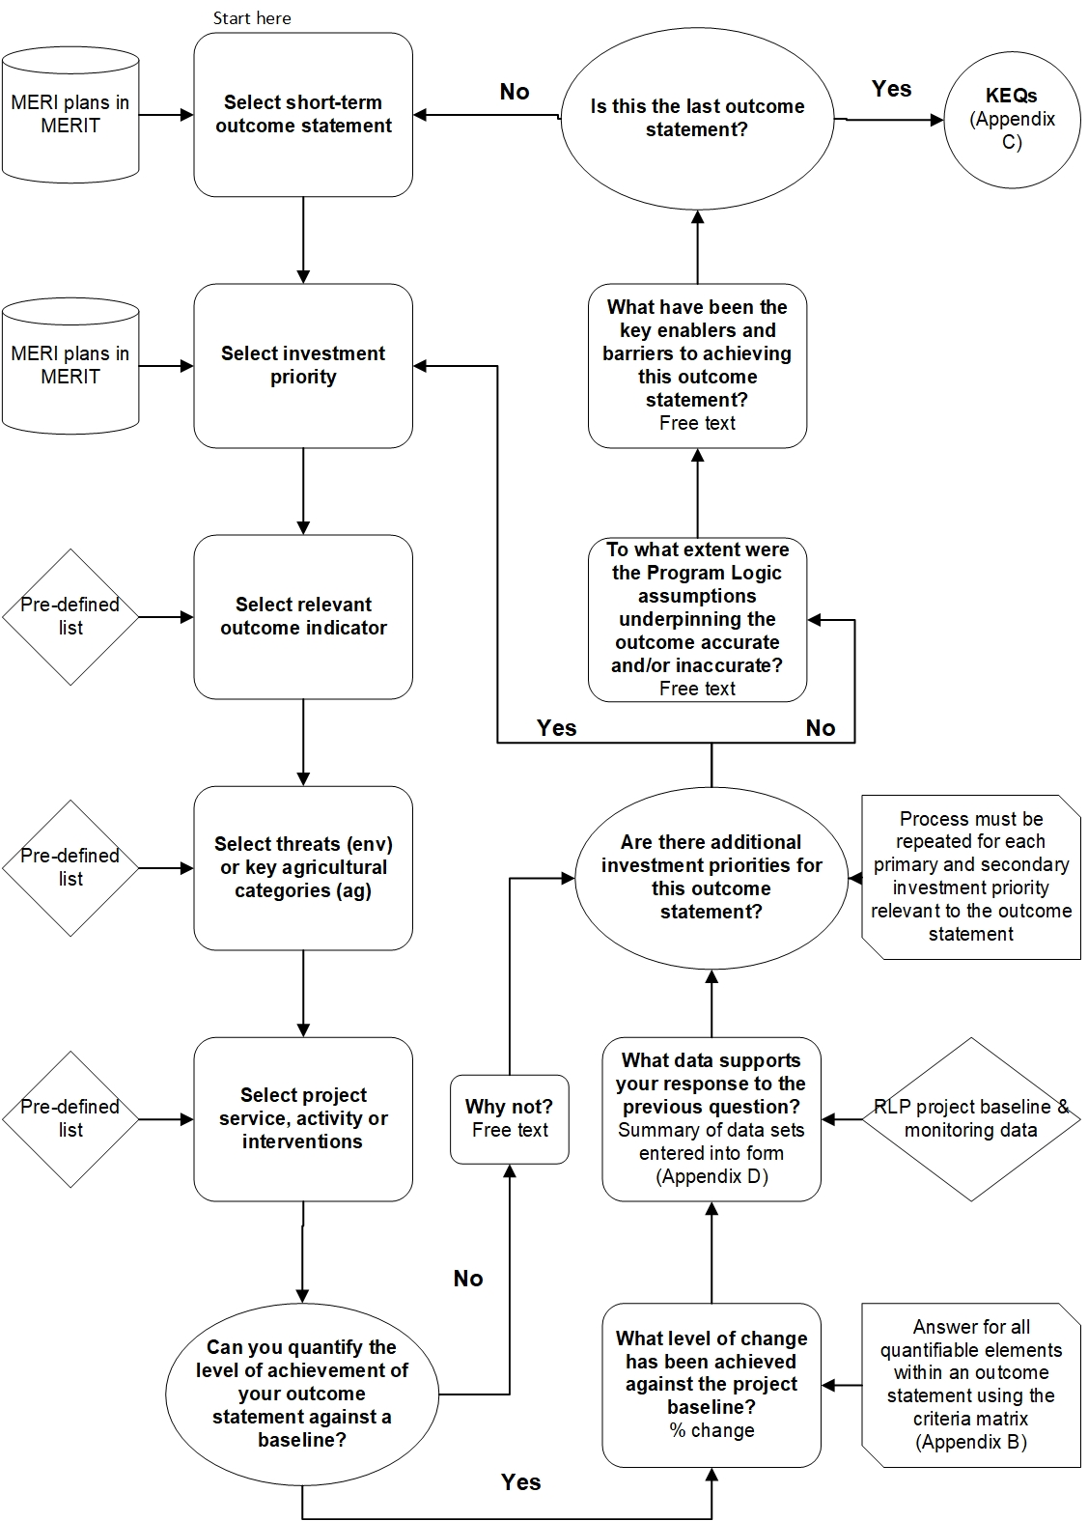Figure Flowchart of the questions in the mid-term review (2021) Outcomes Report 1 form

## Appendix B: Criteria matrix

Table Criteria matrix based on the Regional Land Partnerships program evaluation themes

| Criteria | Significantly achieved 100 – 76% | Satisfactorily achieved 75 – 51% | Partially achieved 50 – 26% | Inadequately achieved 25 – 1% | Not achieved 0% |
| --- | --- | --- | --- | --- | --- |
| **Effectiveness** | The project has significantly achieved the outputs and targets expected at this point in time and is on track to achieve the expected final outcomes. | The project has satisfactorily achieved the major outputs and targets expected at this point in time and is on track to achieve most of the expected final outcomes. | The project has partially achieved the required level of outputs and targets at this point in time and only has a moderate chance of achieving the expected final outcomes. | The project has not adequately achieved the outputs and targets expected at this point in time and is not on track to achieve the expected final outcomes to a satisfactory level. | The project has not achieved the outputs and targets at this point in time and it will not achieve the expected final outcomes. |
| **Efficiency** | The project maximises outcomes from available time and resources. The investment is within budget and funds are being spent as planned. Interventions and governance arrangements maximise efficiency. Staff resources (and skills) are completely appropriate and support maximum efficiency. | The project generally makes very good use of time and resources in all major areas. The investment has sometimes deviated from the planned budget, expenditure and/or timelines. Intervention and governance arrangements are generally strong and support good levels of overall efficiency. Staff resources (and skills) are good and support overall efficiency although there is room for improvement. | The project makes appropriate use of time and resources in some areas. The investment has deviated from the budget, and/or planned expenditure, timelines mainly within tolerable limits. The interventions and governance arrangements are moderately satisfactory, but more could be done to improve efficiency. Staff resources (and skills) are adequate but more could be done to improve these. | The project is not making appropriate use of time and resources in at least one major area. The investment has deviated from the budget, and/or planned expenditure, timelines beyond tolerable limits. It is likely other interventions and/or governance arrangements would better support efficient delivery of outcomes. Staff resources (and skills) are inadequate to support intended outcomes. | The project is not making appropriate use of time and resources in several/all major areas. The investment has deviated completely from the budget, and/or planned expenditure, timelines well beyond tolerable limits. Interventions and/or governance arrangements are highly inefficient. Staff resources (and skills) are inadequate across several areas to support intended outcomes. |
| **Legacy** | The project's benefits will endure in all/almost all areas beyond the project's life. | The project's benefits will endure in a large number of major and minor areas beyond the life of the project. | The project's benefits will endure in most areas; the project does not fail in any major area. | The benefits achieved are unlikely to endure in at least one major area. | Few benefits have been achieved and/or the benefits achieved are unlikely to endure in most areas (major and minor). |
| **Appropriateness** | The project and its delivery methods are highly appropriate for supporting maximum outcomes with very little, to no need for change. | The project and its delivery methods are mostly relevant and appropriate for supporting maximum outcomes, with some change needed. | The project and its delivery methods are only partly relevant and appropriate for supporting maximum outcomes. A substantial number of changes are required to improve relevance. | The project and its delivery methods are largely inappropriate and have largely impacted the success of outcomes. A large change in overall approach is needed. | The project and its delivery methods are not at all appropriate and have prevented intended outcomes and/or led to unintended (negative) outcomes. A complete revision of approach is required. |

## Appendix C: Key Evaluation Questions

Table Key Evaluation Questions that will be asked in the outcome report form

|  | Key Evaluation Question (KEQ) | Answer format |
| --- | --- | --- |
| KEQ 1 | To what extent are you progressing towards the medium-term project outcome? | Drop down (%) |
| KEQ 2 | How, and to what extent has the project increased knowledge of best practice natural resource management for the investment priority? | Free text |
| KEQ 3 | Were the methods/strategies using the best way to achieve/maximise the outcomes or are there other methods/strategies that might be more effective? | Free text |
| KEQ 4 | To what extent has the project risk assessment and risk management been appropriate and effective? | Free text |
| KEQ 5 | If your project engages with Traditional Owners, how and by what means has this project improved the capacity of Traditional Owners to lead or assist with the management of the investment priority? | Free text |
| KEQ 6 | Have there been any unexpected or unintended (positive or negative) changes or other outcomes delivered by this project and what are they? | Free text |
| KEQ 7 | What elements of the project could be improved to maximise efficiency (and value for money)? | Free text |
| KEQ 8 | Did this project receive funding from any other sources apart from the RLP Program? If yes, please specify and the proportion of funding contributed to the project. | Free text |
| KEQ 9 | How, and to what extent has the project achieved desired behavioural change and ongoing commitment among the participating land managers towards the investment priority? | Free text |
| KEQ 10 | What evidence is there that the outcomes will be maintained? How will they be maintained and by whom? | Free text |
| KEQ 11 | Is there any additional information or data you wish to provide that you have used to evaluate the success of the project? | Free text |

## Appendix D: Project dataset summary

Table Project dataset summary questions

|  | Question | Answer format |
| --- | --- | --- |
| 1 | Dataset title | Free text |
| **Background** | | |
| 2 | Project ID | Free text |
| 3 | Project name | Free text |
| 4 | What program does this dataset relate to? | Drop-down list |
| **Dataset description** | | |
| 5 | What program outcome does this dataset relate to? | Drop-down list |
| 6 | What primary or secondary investment priority does this dataset relate to? | Drop-down list |
| 7 | Is this (a) a baseline dataset associated with a project outcome i.e. against which change will be measured, (b) a project progress dataset that is tracking change against an established project baseline dataset, or (c) a standalone foundational dataset to inform future management interventions? | Drop-down list |
| 8 | What types of measurements or observations does the dataset include? | Drop-down list |
| **Data collection** | | |
| 9 | Identify the method(s) used to collect the data | Drop-down list |
| 10 | Describe the method used to collect the data in detail | Free text |
| 11 | Identify any apps used during data collection | Free text |
| 12 | Provide a coordinate centroid for the area surveyed. (For biophysical/ecological surveys where an app was not used, and where there are no sensitivities in providing a location.) | Latitude and longitude in decimal degrees |
| 13 | First collection date | Calendar |
| 14 | Last collection date | Calendar, ongoing option |
| 15 | Is this data an addition to existing time-series data collected as part of a previous project, or is it being collected as part of a broader/national dataset? | Drop-down list and free text |
| **Data accessibility** | | |
| 16 | Who developed/collated the dataset | Drop-down list |
| 17 | Has a quality assurance check been undertaken on the data? | Drop-down list |
| 18 | Has the data contributed to a publication? | Drop-down list including URL hyperlink to publication |
| 19 | Where is the data held? | Drop-down list |
| 20 | For all public datasets, provide the published location. If stored internally by your organisation write ‘stored internally’. | Free text including URL hyperlink |
| 21 | What format is the dataset? | Drop-down list |
| 22 | Are there any sensitivities in the dataset? | Drop-down list |
| 23 | Primary source of data (organisation or individual that owns or maintains the dataset) | Free text |
| 24 | Dataset custodian (name of contact to obtain access to dataset) | Free text |

Service providers will need to answer these questions for each dataset collected for their project.

This project dataset summary form will be used for other natural resource management programs in MERIT. Consequently, some of the questions will be a repetition of what is already present in MERIT. Where MERIT system function allows, some questions will be pre-populated once this form is in MERIT.

## Glossary

| Term | Definition |
| --- | --- |
| Baseline | Starting point or reference data (e.g. historical conditions) against which to assess monitoring results to describe change |
| Benchmark | Desired states of indicators (i.e. objectives) against which to assess monitoring results in order to gauge effectiveness of NRM project services and investment |
| Habitat | The environment that supports a species, and particularly those features or attributes that determine where the species occurs |
| Indicators | Indicators that can be used to assess progress towards outcomes |
| Meta-data | Data describing the monitoring data collected and generated, for example a date, time and location stamp that sits behind an excel spreadsheet or photo. |
| Natural Resource Management actions | Actions that lead to the protection and improvement of environmental assets such as soils, water, vegetation and biodiversity. |
| Primary or secondary investment focus | The primary focal asset(s) or ecological value(s) being addressed by a project, such as a threatened species or ecological community, Ramsar site, World Heritage site, i.e. what is the project doing this for? |
| Project services | Services, activities or outputs being provided by RLP projects including biophysical and non-biophysical (human) actions, i.e. what is the project doing? |
| Threats | The pressures, drivers and stressors being addressed by the project, i.e. why is the project doing this? |
| Trajectories | Changes in indicators over time. |
| Short-term outcome | These are the outcomes achieved over years 1-3. All projects will have short-term outcomes. Even though they are focused on a relatively short period of time, they are vital to the overall success of a project or program as they are the foundation against which successful projects and programs are built. |
| Medium-term outcomes | The outcomes delivered over years 3-5. For 5-year projects, these will also be the end of program outcomes. All 3-5 year projects will have medium term outcomes, and these are to be reported on by the end date of the project. |
| Long-term outcomes | These are the outcomes that are expected to emerge over the longer term, often well after the life of a project. Indicators will be used to measure ‘progress towards these outcomes to confirm if they are ‘on track’ to being achieved. |

## References

Capon S., Castley G., Palmer G., Linke S., Piccolo R., Henderson E., Allely-Ferme E., Richmond S. and Huijbers C. 2020[, A long-term monitoring framework for the Regional Land Partnerships Stage 2: Final Report](http://www.nrm.gov.au/my-project/monitoring-and-reporting/rlp-long-term-monitoring-program), Griffith University, Brisbane.

Commonwealth of Australia 2009, [NRM MERI Framework](http://www.nrm.gov.au/publications/regional-land-partnerships-meri-framework), Commonwealth of Australia, Canberra.

Department of the Environment and Energy 2018, [Regional Land Partnerships Evaluation Plan](http://www.nrm.gov.au/publications/regional-land-partnerships-evaluation-plan), Final Report prepared by RMCG for the Department of the Environment and Energy, Canberra.