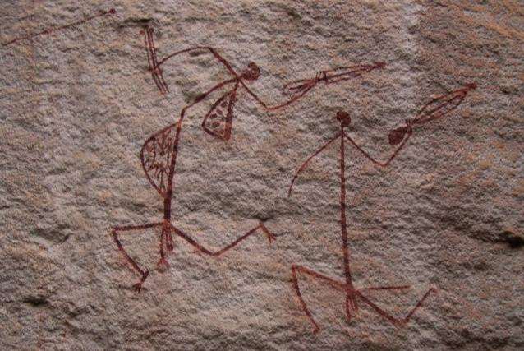
Rock Art Thematic Study

Jo McDonald and Lucia Clayton

26 May 2016
Report to the Department of the Environment
and the Australian Heritage Council

Centre for Rock Art Research and Management, University of WA

Table of Contents
1 Introduction 1
2 Rock art overview 2
2.1 Introduction to rock art 2
2.2 Regional overview of Australian Aboriginal rock art 3
2.2.1 Australian Capital Territory (ACT) 7
2.2.2 New South Wales 7
2.2.3 Northern Territory 14
2.2.4 Queensland 23
2.2.5 South Australia 30
2.2.6 Tasmania 31
2.2.7 Victoria 33
2.2.8 Western Australia 35
2.3 Overview of rock art chronology 44
3 Heritage registers 57
3.1 National Heritage List 57
3.2 Listed heritage places 58
4 Assessment of rock art places 60
4.1 Survey 60
4.2 Assessment Frameworks 61
4.2.1 Thematic framework 61
4.2.2 Typological framework 63
4.2.3 Chronological framework 63
5 Assessment of places 64
5.1 Summary of National Heritage List criteria and framework assessments 81
5.1.1 National Heritage criteria assessment summary 82
5.1.2 Geographic assessment summary 82
5.1.3 Thematic framework assessment summary 86
5.1.4 Typological framework assessment summary 87
5.1.5 Chronological framework assessment summary 87
5.1.6 Summary 87
6 Conclusions 88
7 Recommendations 89
8 References 91
9 Appendices 98
9.1 National Heritage List Criteria 98
9.2 Listed places on the National Heritage List with rock art specified in the criteria. 99
9.3 Heritage places with rock art on the WHL, CHL, NHL and RNE. 103
9.4 Detailed criteria assessment against NHL criteria of proposed rock art places. 109
9.5 Bibliography of shortlisted rock art places 130

Figures
Figure 1: Early map showing the distribution of petroglyphs (Davidson (1936) 2011: Figure 1). 3
Figure 2: Early map showing the distribution of painting sites (Davidson (1936) 2011: Figure 28). 3
Figure 3: Map of Australia with location of 30 major rock art regions indicated (Taçon 2001: Figure 17.1). 4
Figure 4: Major rock art regions in Australia (Morwood 2002: Figure 2.1). 5
Figure 5: Australian Rock Art regions as identified in the present study. 6
Figure 6: Engravings at Devil's Rock (NSW) showing the two culture heroes at the edges of the composition (McDonald 2008: Figure 11.34). 10
Figure 7: Map showing the Keep River and Victoria River District with the main recorded locations with rock art (NT) (McNickle 1991: Figure 2). 15
Figure 8: Location of Wardaman Country and sites mentioned in the text (Clarkson 2007: Figure 4.1). 16
Figure 9: Map of the Keep River study region (NT) (Taçon et al. 2003: Figure 1). 17
Figure 10: Central Australian (NT) rock art sites (from Gunn 2004: Figure 1). 22
Figure 11: Kalkadoon motifs, northwest central Queensland (NT) (Ross et al. 2008: Figure 4). 24
Figure 12: Rock art styles in Victoria (Gunn 1984: Figure 1). 33
Figure 13: Overlay of Pilbara art provinces with Tindale's 1974 socio-linguistic territories 36
Figure 14: Location of Western Desert main rock art provinces. 39
Figure 15: Map of Australia, showing the distribution of Maynard's (1979) styles (Franklin 1991: Figure 1). 46
Figure 16: Anthropomorphs and characteristic fauna in the Murujuga art phases. 52
Figure 17: Map showing location of regions interpreted as containing Pleistocene regional style signatures and other early forms of symbolic behaviour (from Veth et al. 2011: Figure 9.4). 55
Figure 18: Ross’s 2003 relative stylistic sequence for Central Australia (from Smith 2013: Table 7.5). 56

Tables
Table 1: Stratigraphic and direct dates for rock engravings in the arid zone (from Smith 2013: Table 7.2) 50
Table 2: McDonald’s 2014 model (2014: Table 1) with proposed archaeological correlates showing landscape, sea level and climate (after Ward et al. 2013: Table 1) and Murujuga art phases (from Mulvaney 2010). 51
Table 3: Comparative sequences of major rock art subjects and traditions in northern Australia. 54
Table 4: Places listed on the National Heritage List. 58
Table 5: Places on the various heritage registers (identified by Australian Heritage Database (AHDB). 59
Table 6: List of rock art places for assessment against National Heritage criteria proposed by Australian rock art researchers and heritage practitioners. Those sites in red were not identified on previous lists. 62
Table 7: National Heritage criteria, indicators of significance, and assessment frameworks. 66
Table 8: Rock art places short list. Assessment of National Heritage criteria and assessment frameworks (see Appendices for detailed National Heritage criteria assessment and Indicators of significance). 71
Table 9: Rock art sites places shortlist: summary of National Heritage List criteria assessment∞. 80
Table 10: Assessment summary of rock art places already on the National Heritage List. 83
Table 11: Ranked shortlist of 14 rock art sites/places. Summary of National Heritage criteria met. 84
Table 12: Ranked shortlist of rock art places - summary of assessment frameworks. 85

Photographs
Photograph 1: Dingos, macropods and anthropomorphs at Yankee Hat (ACT) (Image source: www.tams.act.gov.au). 7
Photograph 2: Swinton’s Shelter in Warre Warren Aboriginal Place (NSW) (Image courtesy Jo McDonald). 9
Photograph 3: Baiame Shelter (NSW) (Image source: www.environment.nsw.gov.au). 11
Photograph 4: Dancing figures, Mt Gundabooka National Park (NSW) (Somerville 2014: Figure 1). 12
Photograph 5: Rare engraved macropod (lower left) amongst engraved tracks and geometric designs at Mutawintji National Park (NSW) (Image credit: Dinitee Haskard/NSW Government). 13
Photograph 6: Vertical panel at Euriowie (NSW) (http://41.media.tumblr.com_1280.jpg). 13
Photograph 7: Garnawala 1, with the 1990 excavation (David et al. 1994: Figure 8). 16
Photograph 8: Keep River (Weaber Range) (NT) large red and white rock painting of a 'ceremony man' painted in the 1920s by rock-artist Bubble Bubble Dick (Taçon et al. 2003: Figure 5). 17
Photograph 9: Nawarla Gabarnmang rockshelter (NT) (Delannoy et al. 2013: Figure 6; Image © Jean-Jacques Delannoy and the Jawoyn Association). 19
Photograph 10: Contact rock art at Djulirri (NT) (Taçon et al. 2010a: Plate 13). 21
Photograph 11: Caterpillar Dreaming at Udnirr Ingita (Emily Gap NT) (Ross and Davidson 2006: Figure 8). 23
Photograph 12: Repeated circles and tracks, Roma Gorge (NT) (Ross and Davidson 2006: Figure 4). 23
Photograph 13: A section of the main panel at the Palace (Central Qld) (Morwood 1979: Plate 8.1). 26
Photograph 14: Panel of hand stencils in the north Queensland Highlands. Stencilling and engraving are the main rock art techniques in the region (Morwood 2002: Figure 9.2). 27
Photograph 15: Computer enhancement of an anthropomorph from the Kabadul Kula rock art site on Dauan Island, Torres Strait. (Brady 2008: Figure 4). 29
Photograph 16: Petroglyphs at Karolta 1, Olary province, showing the range of motifs found at Panaramitee style sites (Franklin 2011: Figure 2). 31
Photograph 17: Sundown Point petroglyphs (Tasmania) (site 217/2) (Huys 2010: Photo 13). 32
Photograph 18: Bunjil and his two dingo helpers , Bunjil Shelter (Victoria) (Image credit Ken Irwin). 34
Photograph 19: Engraved macropod, Dampier Archipelago (WA) (Image credit Ken Mulvaney). 38
Photograph 20: Karnatukul main panel at Katjarra (WA) (McDonald and Veth 2012b). 41
Photograph 21: Gwion Gwion Figure (WA) (Image ©Mike Donaldson). 42
Photograph 22: Selection of rock art at Walga Rock (WA) (Image source www.cue.wa.gov.au). 44
Photograph 23: Inthanoona (WA) Contact engravings: a) figure shooting, figure with gun, wheeled vehicle and horses (Paterson and Wilson 2009: Figure 5). 53

Introduction
This report was funded through the Australian Government’s Community Heritage and Icons Grants Programme. This Rock Art Thematic Study addresses potential gaps on the National Heritage List. The Australian Heritage Council (Council) considers Indigenous rock art to be a significant part of Australia’s heritage (in addition to its significance for Traditional Owners) and is seeking advice on places with rock art that could be of outstanding heritage value to the nation and on the methodology of comparative assessments for rock art. This Rock Art Thematic Study is to provide Council with an overview of the diversity and distribution of Aboriginal rock art in Australia, and a ranked shortlist of rock art places for consideration of inclusion on the National Heritage List (NHL) in accordance with the National Heritage List criteria.

This thematic study focuses on Aboriginal rock art sites and places not currently included on the National Heritage List. The study includes:
- An overview of the distribution, techniques, conventions, regionalisation and prehistory of Australian Indigenous rock art, and contemporary uses or connections with rock art, using maps to support text, with notes on the limitation of information.
- A ranking of places with Aboriginal rock art for consideration for inclusion on the National Heritage List, and a brief explanation on how and why each place is of outstanding heritage value to the nation, with reference to relevant National Heritage List criteria.
- Comparative information, where appropriate, on the relative significance of places at the national level, when assessed with places with similar heritage attributes, to determine whether the place is likely to meet the National Heritage threshold of outstanding heritage value to the nation.
- Information on each place on the ranking to include:
- Location, approximate boundaries and physical attributes (preferably with maps and diagrams);
- Comparison with other places with similar heritage attributes;
- Information regarding confidentiality, security of the place, and values that require consideration;
- Confidence in the assessment made, including the extent to which information is available and whether supplementary research is required;
- Logistical issues that may impede a full assessment or require additional resources.
- Information on places that might have some potential National Heritage values but are not considered for inclusion on the List, and the reason for this conclusion.

This desktop study cites a number of published and unpublished sources. As part of our assessment process, we have also undertaken a review of past and present federal heritage Registers. This has included consideration of Indigenous Australian rock art places that have been listed on previous and current heritage registers, and the criteria used to assess rock art values at those listed places. Because we know there is a wealth of unpublished and ongoing current research by rock art researchers in Australia, our assessment has also included discussions with Australian rock art practitioners. We have asked these colleagues to nominate the sites that they considered should be included in this ranked shortlist. This report also documents this process. Because this was a desktop study we have not initiated contact with any Aboriginal parties or Corporations: this would be a vital step in any consideration of rock art places identified on this short list.

Rock art overview
One of the main objectives for this Rock Art Thematic Study is to provide an overview of the distribution, techniques, conventions, regionalisation and prehistory of Australian Indigenous rock art. This section details the rock art regions currently defined in Australia, outlining the characteristics of the rock art, including (where possible) techniques, distribution and motifs. The amount of detail for each rock art region varies depending on the amount of publicly available information, and how much published and ongoing research has been undertaken. This overview provides a context for the ranked shortlist of rock art sites, but detailed information on how these meet the National Heritage criteria will be addressed in later sections.
The regional overview is followed by an outline of the currently understood rock art chronology for Australia. Both the regional and chronological overviews provide a framework within which a broad comparative analysis can be undertaken. Australian Aboriginal rock art is extensive and includes extreme and rich diversity. This makes approaching a comparative analysis difficult.

Introduction to rock art
Every culture on earth produces art as an expression of its creative self. This symbolic behaviour takes many forms: body decoration, decoration of habitations, items of material culture, bark paintings, clothing, and rock art. Rock art is a marking of the landscape with imagery that endures for many generations and through the millennia. For many Indigenous cultures around the world, and indeed since the origin of Anatomically Modern Humans, rock art is the only surviving record of both the intentionality of communication and intergenerational knowledge transfer of our earliest symbolic endeavours (McDonald 2006:59).

Regional overview of Australian Aboriginal rock art
It is the diversity of styles and the longevity of the stylistic traditions of rock painting and engraving, rather than their density, that makes Australia the rock art capital of the world (Morwood 2002: 37).
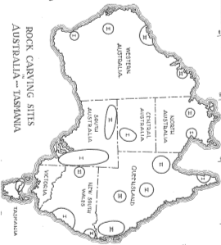
Rock art in Australia over the last century has been identified as falling into a series of rock art style ‘regions’: culture blocs, or language areas or geographic regions which have shared stylistic characteristics. This section provides an introduction to these how rock art regions are characterised. In 1936 Daniel S. Davidson mapped for the first time Australian rock art regions (Figures 1 and 2). These regions were based on site inventories, but it was recognised very early that the art in various different parts of Australia ‘looked very different’. Davidson also defined five design areas for Aboriginal decorative art (portable material culture). Subsequent iterations which have explored rock art regionalism demonstrate further refining of the concept (e.g. Morwood 2002, Taçon 2001) – and also reflect the more focused analyses undertaken by rock art researchers (Figure 3).

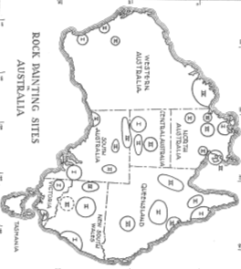
Figure 1: Early map showing the distribution of petroglyphs (Davidson (1936) 2011: Figure 1).

Figure 2: Early map showing the distribution of painting sites (Davidson (1936) 2011: Figure 28).

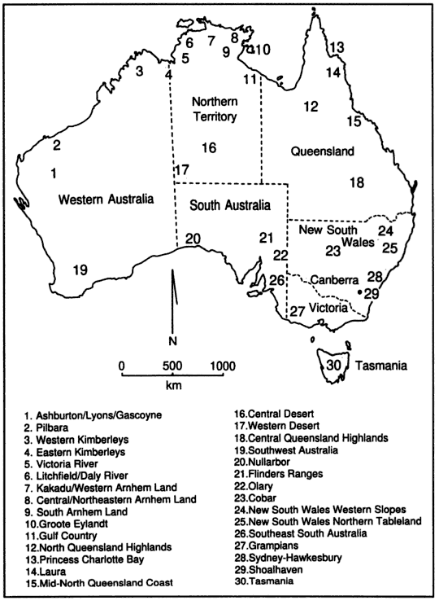

Figure 3: Map of Australia with location of 30 major rock art regions indicated (Taçon 2001: Figure 17.1).

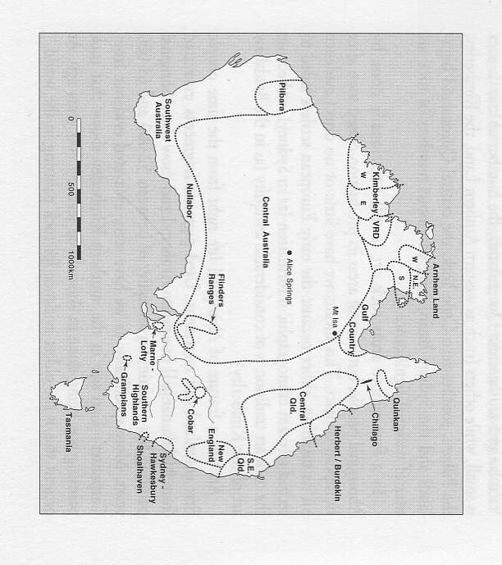

Figure 4: Major rock art regions in Australia (Morwood 2002: Figure 2.1).

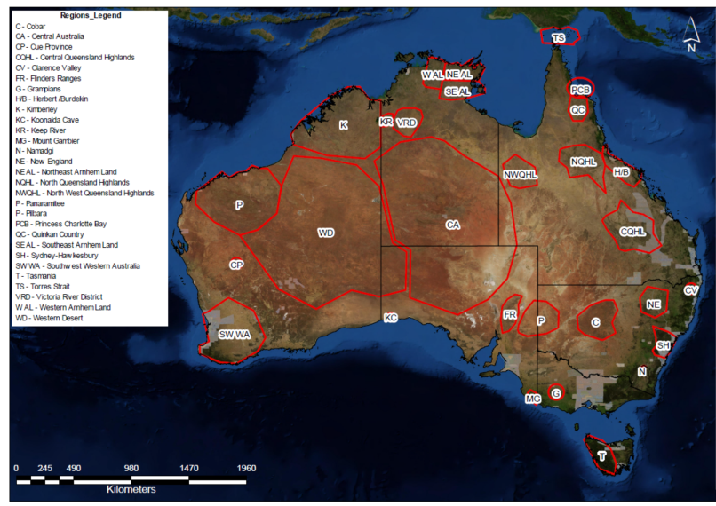
Figure 5: Australian Rock Art regions as identified in the present study.
Many style provinces are now identified by Aboriginal connections to the art (e.g. Quinkan Country) and the refining of culture blocs. For the purposes of this report Australia’s Aboriginal rock art is described based on current political State and Territory boundaries, with a brief description of the rock art regions located in each (Figure 5).

Australian Capital Territory (ACT)
The rock art in the ACT represents a sparse, late Holocene pigment tradition. The sample is small and these are sites in relatively close proximity to each other, in Namadgi National Park and Tidbinbilla Nature Reserve. There are no recorded engraving sites in the ACT. Yankee Hat (Namadgi) is the best-known site (Flood 1980:32). Excavation here revealed it was occupied from c. 3,700 BP until recent times (Rosenfeld et al. 1983).
Yankee Hat is significant at a state level, and is an example of rare rock art in the ACT, where it is of high cultural significance for local Aboriginal custodians. It was previously listed in the Register of the National Estate. The assemblage is small, and the range of motifs restricted. Yankee Hat demonstrates a period of Holocene occupation in the region, but it is not necessarily representative of the wider region or significant at the national level.
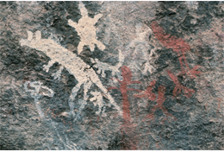
Photograph 1: Dingos, macropods and anthropomorphs at Yankee Hat (ACT) (Image source: www.tams.act.gov.au).

New South Wales
There are four main rock art regions identified in New South Wales: Cobar, New England, Shoalhaven, and the largest – the Sydney-Hawkesbury region. In the west of the State there are a number of dispersed engraving site complexes which represent part of a broader regional arid-zone tradition which transcends state boundaries.

Sydney-Hawkesbury
The coastal Sydney-Hawkesbury Sandstone region covers an area of approximately 17,100 km² (McCarthy 1959; McDonald 1994, 2008a, 2008b). This includes Yengo, Blue Mountains and Wollemi National Parks in the north-west, Ku-Ring-Gai Chase National Park in its centre, and Royal National Park to the south: these Parks include many of the best (known) rock art sites in the region.
Occupation began in the Pleistocene and intensified during the mid- to late- Holocene (Attenbrow 2010; McDonald 2008:80). The rock art consists of sheltered (mostly) pigment art sites and engraving sites on open horizontal platforms which represent a contemporaneous art tradition dating mostly to the mid-late Holocene. The shelter assemblages are larger than those on open platforms: very large site assemblages are scattered across the region.
The predominant engraved motif is the human track, but there is an extensive repertoire of life-sized human figures and land and sea animals. There are two main culture heroes: ‘Daramulan’, and ‘Baiame’, mostly distributed through the centre-north of the region (McDonald 2008a). Daramulan is depicted in the rock art of the Calga Women’s Site, and Baiame has been painted on the wall of Baiame Shelter. Stencilling dominates the pigment art in some parts of the region: but dry pigment drawings and paintings are also common and there are a few engravings found in the rock shelters (McDonald 2008a; Walsh 1989:134). Animals are simply rendered but naturalistic including details such as a joey in the pouch, or dotted pelts on small marsupials (Tasire and Davidson 2015).
Eagle’s Reach is an important rock art site in Wollemi National Park, with painted, engraved and stencilled rock art. One of the significant aspects of the place is the skill and accuracy with which the animals were drawn. Uncommon motifs include a white outline wombat, an eagle, a double-headed human-like figure, and rare animal-headed human beings (Taçon et al. 2007:13-14). There is potential for many more such sites as Wollemi has not been fully surveyed (Taçon et al. 2007). Wollemi National Park is World Heritage listed as part of the Greater Blue Mountains World Heritage Area, but rock art is not included in the recognised values.
In Yengo National Park are more significant rock art places. These include Mount Yengo 1 and 2 and a number of engraving sites along the Boree Track. Yengo 1 and 2 are two adjacent rock art shelters with extensive pigment (stencil and drawing) assemblages, partially buried petroglyphs, and grinding grooves (McDonald 2008a). Excavations revealed that the engravings were probably produced before the shelter was extensively occupied (before 6,000 years ago), while most occupation occurred around 3,000 BP (McDonald 2008a:142).
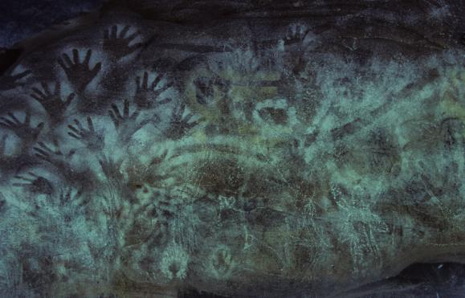
Photograph 2: Swinton’s Shelter in Warre Warren Aboriginal Place (NSW) (Image courtesy Jo McDonald).
Baiame Shelter is outside this Park’s boundaries to the north. Upside Down Man Shelter in Popran National Park and Warre Warren Aboriginal Place are both north of the Hawkesbury River. Ku-ring-gai Chase National Park and Maroota Historic Site are south of the Hawkesbury River. Many of these were previously listed on the Register of the National Estate and are locations which should be considered for National Heritage listing.
Baiame Shelter, which was recently listed on the NSW State Heritage Register, is a small sandstone shelter located just north of Yengo National Park. It has a prominent, 2.5m high, anthropomorphic figure that dominates the shelter wall - a rare painted depiction of Baiame. The red and white drawn Baiame is shown with outstretched elongated arms, has armbands and other body decorations and is associated with stencilled material culture.
Swinton’s Shelter (Photograph 2) is in Warre Warren Aboriginal Place – within Macpherson State Forest (Mangrove Creek). This site is significant due to the extensive evidence for pigment art production: it has the (numerically) largest recorded assemblage in the Sydney region. There are stylistic differences between the rock art assemblages in these various Parks. The engraving repertoire in Ku-ring-Gai Chase has been identified as the epi-centre of the Sydney Basin style (McDonald 1996, 2008a). Warre Warren Aboriginal Place contains a sample of locally representative pigment sites including several that are quite unique, and the sites are of particularly high significance with both scientific and contemporary cultural values (McDonald 1988). The Boree track is located between Mount Yengo and Warre Warren Aboriginal Place. There are a number of significant engravings sites located along the track including Burrragurra and Frying Pan Rock. In Maroota Historic Site, south of Wiseman’s Ferry, is Devil’s Rock – which was considered by Fred McCarthy to be one of most important engraving sites in the Sydney-Hawkesbury region because of its planned composition, with the linking of the Ancestral Beings (McCarthy 1959:213; McDonald 1987).
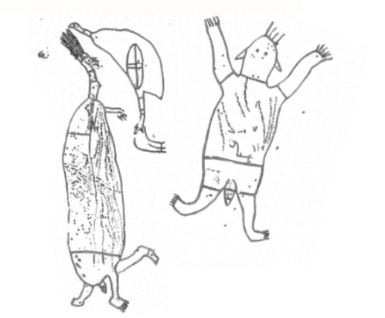
Figure 6: Engravings at Devil's Rock (NSW) showing the two culture heroes at the edges of the composition (McDonald 2008: Figure 11.34).
The Calga Women’s Site is an engraving site which was the centre of a recent Land and Environment Court case brought by Darkinjung Local Aboriginal Land Council. This women’s site (which includes grinding grooves, water holes and an associated stone arrangement) has great contemporary values to Darkinjung LALC and native title claimants of northern Sydney, who identified connections to Dreamtime narratives. The place is part of a wider cultural landscape linked with the surrounding ridgelines, Mount Yengo and Ku-Ring-Gai Chase National Park (Hodgetts 2010:22). It is used today as a teaching and learning place by the Aboriginal community. The appeal against the Rocla’s mining Development Application was upheld by the Land and Environment Court (http://www.abc.net.au/news/2015-11-18/rocla-loss/6950808).
This study has identified a number of shelters and engraved open platform sites in Wollemi National Park, Warre Warren Aboriginal Place, Yengo National Park and Baiame Shelter, which form a representative collection of the unique and outstanding variability of rock art across Northern Sydney. This complex of sites demonstrates not only the principal characteristics of Sydney Basin rock art, but also some of the best preserved and significant pigment and engraving sites. The Sydney-Hawkesbury region is rich in Aboriginal cultural heritage, with a high density of rock art sites. Many have been recorded, some excavated, but there is still high potential for further significant sites to occur in the region. The rock art identified in these various Sydney National Parks, Historic Sites and Aboriginal Places could be assessed for inclusion on the National Heritage List.
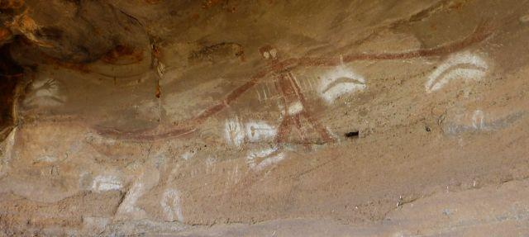
Photograph 3: Baiame Shelter (NSW) (Image source: www.environment.nsw.gov.au).

Cobar Pediplain
The Cobar Pediplain is in the central west of New South Wales. Engraved and painted art is concentrated around permanent water sources (McCarthy 1958:41; Walsh 1988:108). The pigment art consists mostly of small (<30cm) linear monochrome male and female figures: the small ‘dancing men’ are the most distinctive feature of this regional style. Macropods and emus are found along with dingos, fish, tracks, and occasional maze-like figures (Walsh 1988:108). Hand stencils are also numerous.
The Mount Grenfell complex is one of the finest and most extensive concentrations of this art style: one panel extends for 26m and includes superimposed layers of motifs (Walsh 1988:108). Fred McCarthy’s early excavation here returned a date of 1,760 ± 65 years BP (Walsh 1988:108). Mt Gundabooka is associated with a goanna story, related to Baiame narratives (Somerville 2014:405). The place represents a local cultural expression, however the assemblage size and range of motifs is limited compared to other sites in this overview. The place is of high cultural significance and is considered to be of state level significance.
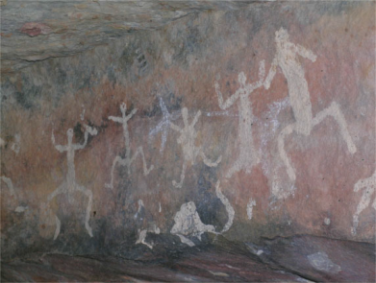

Photograph 4: Dancing figures, Mt Gundabooka National Park (NSW) (Somerville 2014: Figure 1).

Semi-arid Zone Engraving Sites
There are a number of dispersed engraving site complexes in far western NSW, such as Mutawintji, Euriowie and Sturt’s Meadows, which are examples of the arid zone art graphic previously known as Panaramitee (Maynard 1979). These are located on flat boulders, pavements or gorges near more permanent water sources. Distinguished by the prevalence of tracks motifs (bird, macropod and human), and geometrics such as circles, dots, lines, abraded grooves and arcs (see Maynard 1976, 1977), these sites have very few figurative motifs. The style is widespread across arid inland Australia (see Morwood 2002), with regional variability documented (Franklin 2004:4).
Sturts Meadows (previously listed on the Register of the National Estate) covers approximately 3x0.5km on either side of an ephemeral creek. The engravings consist of small pecked motifs that have weathered to the same colour as the original rock surface at the site (Clegg 1987). The very small number of figurative motifs means this site is considered to be one of the oldest Panaramitee-style sites; it is a Panaramitee site par excellence.
Mutawintji (previously listed in the Register of the National Estate) is located in Mutawintji National Park, northeast of Broken Hill. This site complex includes a number of caves and galleries along a series of ridges and hills (McCarthy and Macintosh 1962:253). The site complex is considered an ‘intermediate’ Panaramitee site, between Sturts Meadows (considered the oldest) and Euriowie (the more recent). At Euriowie the engravings are pounded as well as pecked (Flood 1997:207). There are more figurative motifs at this later Panaramitee-style site, including lizards, snakes and birds as well as anthropomorphs, barred circles and other features (Dow 1938:114; Franklin 2004).
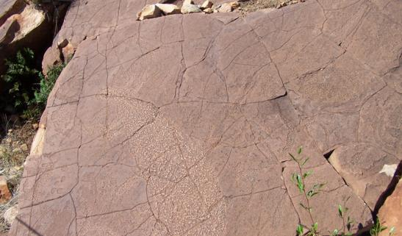
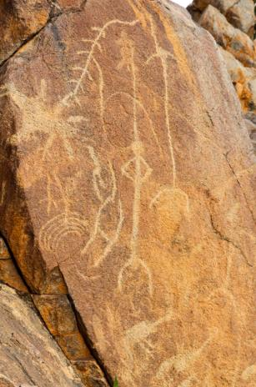
Photograph 5: Rare engraved macropod (lower left) amongst engraved tracks and geometric designs at Mutawintji National Park (NSW) (Image credit: Dinitee Haskard/NSW Government).

Photograph 6: Vertical panel at Euriowie (NSW) (http://41.media.tumblr.com_1280.jpg).

New England
New England rock art is found in the Clarence Valley and the Northern Tablelands (McBryde 1974). Both regions have limited art repertoires of painted black and red goannas and anthropomorphs and white stencilled hands (McBryde 1974:84, 88). Petroglyphs are rare and consist of incised or abraded ‘tally’ marks/ abraded grooves: these are mostly found in sheltered overhangs (McBryde 1974:91). There are no sites that have been identified as potentially meeting the National Heritage criteria in this region.
Other areas of New South Wales have rock art sites beyond these three regions, but on the whole these are more sparsely distributed e.g. Shoalhaven region (Officer 1992) and the Capertee wilderness area (McCarthy 1956).

Northern Territory
Rock art in the Northern Territory is extremely diverse across its various style provinces. The best documented of these are Victoria River District, Wardaman country, Western Southern and North-eastern Arnhem Land, and a number of places across the Central Australian arid zone. Kakadu National Park (which includes parts of Arnhem Land) has a prolific rock art repertoire which is already on the National and World Heritage Lists: it is thus not discussed here.

Victoria River District
This region includes the ‘Land of the Lightning Brothers’ and has a large number of paintings, drawings, stencils and engraving sites (David et al. 1994, 1995; Lewis and McCausland 1987; Lewis and Rose 1988; McNickle 1991:37; Reser 2009). Site distribution correlates with favourable geology and suitable shelters found on various pastoral stations and within Gregory National Park (see Figure 7). Much of the painted art is thought to be late Holocene but the engraved art is estimated to be much older. The numerous engravings (geometric figures, anthropomorphs, birds, mammals and fish, as well as the Panaramitee style) tend to be located away from occupation shelters and were produced by a variety of techniques. The painted rock art is diverse and complex: anthropomorphs, faces, macropods, dingos, birds, and other animals in a simple naturalistic style, as well as the complex ethnographically-described Lightning Brothers paintings.
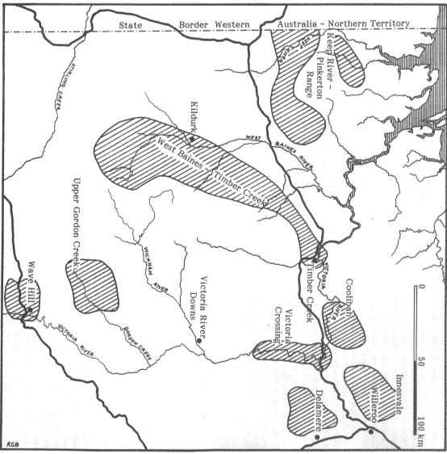
Delamere 3, in the eastern Victoria River District is a large shelter with an assemblage of both painted and engraved art. Images include mammal and reptile quadrupeds, snake-like creatures, anthropomorphs (some holding guns) and a hooked boomerang (McNiven et al. 1992:68). There are hundreds of engravings, including linear or abraded grooves and paired pecked tracks. Major wall painting activity occurred around the time of European contact (McNiven et al. 1992:72). Mennge-ya is another important site in Wardaman Country, a Dreaming Place with large painted striped anthropomorphs (white cockatoos) (Attenbrow et al. 1995; David et al. 1994:246). Garnawala has a number of sandstone outcrops with large galleries of paintings, and with strong connections to the Rainbow Serpent story and the Lightning Brothers, which is reflected in the rock art (David et al. 1994).
Figure 7: Map showing the Keep River and Victoria River District with the main recorded locations with rock art (NT) (McNickle 1991: Figure 2).
The rock art from these sites tends to date to the late Holocene (David et al. 1994:249), although excavations of engraved motifs at Ingaladdi provided minimum dates of 5,000 BP (David et al. 1990:88). It is important to note that rock art in Wardaman Country is seen not so much as art by Wardaman people, but as an expression of the land and of Dreaming-beings which give identity to the land (David et al. 1990:86; Merlan 1989). The Victoria River District is an area rich with significant rock art sites, and there is a high probability that places within the VRD meet the National Heritage criteria. Further investigation of this area is highly recommended to identify these rock art places.
Gregory
National Park
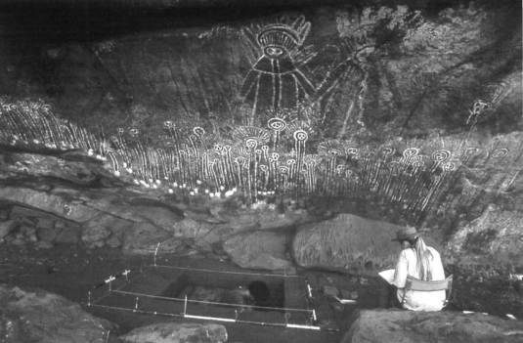
Photograph 7: Garnawala 1, with the 1990 excavation (David et al. 1994: Figure 8).

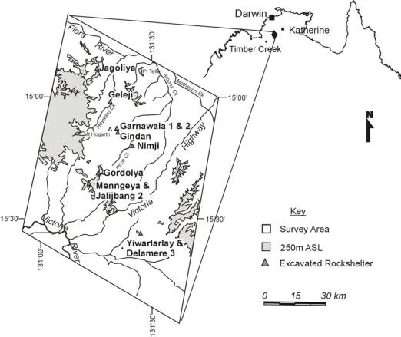
Figure 8: Location of Wardaman Country and sites mentioned in the text (Clarkson 2007: Figure 4.1).

Keep River and Wadeye-Fitzmaurice
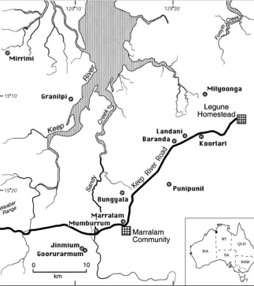
The Keep River and Wadeye-Fitzmaurice regions lie on the coastal plains between the Kimberley and Arnhem Land, distinct from but with links to the east, west and south (Taçon et al. 2003). Early art recorded in these regions includes purple paintings that are stylistically similar to Gwion Gwion figures in the Kimberley (Watchman et al. 2010). Engravings (including cupules and abraded grooves, tracks, geometric and figurative motifs) have no apparent links to nearby areas. The pigment art is diverse and includes object prints, hand stencils, anthropomorphs, zoomorphs and beeswax figures. The Keep River Site Complex was previously listed on the Register of the National Estate. It is recommended here that that site information be assessed to determine whether it meets the National Heritage criteria.

Figure 9: Map of the Keep River study region (NT) (Taçon et al. 2003: Figure 1).

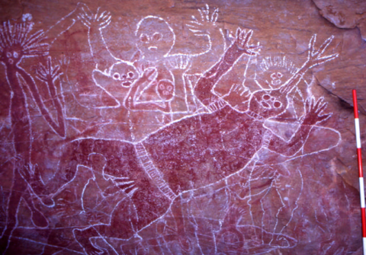

Photograph 8: Keep River (Weaber Range) (NT) large red and white rock painting of a 'ceremony man' painted in the 1920s by rock-artist Bubble Bubble Dick (Taçon et al. 2003: Figure 5).

Arnhem Land
The Arnhem Land Plateau is a vast landscape that has weathered to provide thousands of suitable rock shelters. Biogeographically this region is subdivided into north-eastern, western and southern Arnhem Land (see Figure 5) which have localised variations, but share general stylistic characteristics. World Heritage listed (and subsequently National Heritage listed) Kakadu National Park is located in western and southern Arnhem Land, and is excluded from this assessment. A four-phase sequence for Arnhem Land rock art (Chaloupka 1993) sees rock art being produced from the earliest occupation of this region and subsequent change correlated with broad environmental phases refined by more detailed work on specific phases (Lewis 1988; May et al. 2011; Taçon et al. 1996):
- Pre-estuarine (50,000-8,000 years ago): the earliest date is based on ochre recovered from excavations. The six sub-phases cover dramatic environmental change associated with the Last Glacial Maximum (LGM);
- Estuarine (8,000-4,000 years ago): includes the appearance of paintings representing various animal species that colonised Arnhem Land as the sea level rose to its current level. Includes estuarine fauna and X-ray motifs and early beeswax designs;
- Freshwater (1,500 years ago): with the development of wetlands, motifs include magpie geese, water lilies and material culture;
- Contact art (from c.400 years ago): reflects Aboriginal encounters with outsiders - Macassans and Europeans. Traditional subjects are still produced at this time (e.g. Taçon et al. 2010a).
There are few direct rock art dates from this region apart from beeswax figures which date to the last 4,000 years (Langley and Taçon 2010; Taçon et al. 2010a). Initial rock art production is inferred from the recovery of haematite from a living floor at Malakunanja II (Chaloupka 1993:82). Motifs depicting megafauna and thylacines indicate the potential for antiquity of much of the painted art. Tristan Jones current PhD research aims to date the dynamic action figures of Red Lilly Lagoon: this has demonstrated late Pleistocene/early Holocene antiquity for this style (Jones pers. comm. 2015).
Archaeological excavations have provided early sequences with initial occupation between 50-63,000 cal BP: recent re-excavation of this site has provided additional support for an early occupation phase (Clarkson et al. 2015). The recent work in Jawoyn Country to the south of Kakadu (by Bruno David, Ben Gunn and their French collaborators) has documented the extraordinary site of Nawarla Gabarnmang. Over 4,500 art sites have been documented in Jawoyn country, and the painted rockshelter in Buyhmi clan country has revealed an excavated fragment of a painting which is dated to 28,000 years ago (Bruno David, pers. comm. 2016; David et al. 2013a), as well as demonstrating the extraordinary use and re-use through time of this architectural pavilion-style site (David et al. 2013b; Gunn et al. 2012).
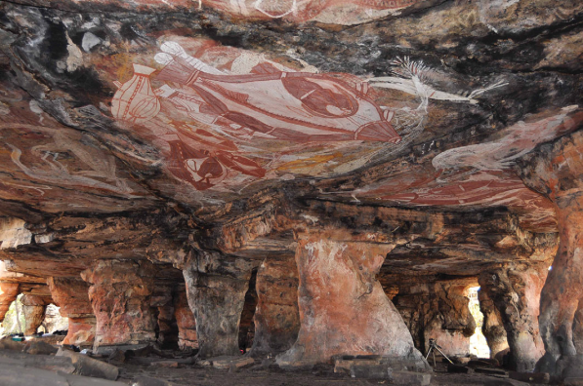
Photograph 9: Nawarla Gabarnmang rockshelter (NT) (Delannoy et al. 2013: Figure 6; Image © Jean-Jacques Delannoy and the Jawoyn Association).

The painted rockshelter at Nawarla Gabarnmang contains hundreds of paintings and intact occupation deposits. The spectacular rock art covers the ceiling as well as the pillars: it is estimated that there are at least 1500 motifs (David pers. comm. 2015). The artwork is dominated by a series of large and dramatic paintings of barramundi in X-ray style (Gunn et al. 2012:56). There are also other bichrome paintings in Jawoyn style, as well as monochrome paintings and stencils, including Dynamic Figures (David et al. 2011; Gunn et al. 2012). The artwork represents the principal characteristics of Arnhem Land rock art in one site complex. Another feature of the painted rockshelter at Nawarla Gabarnmang is the architectural modification that has included the modification of pillars and the removal and the stacking of collapsed blocks (Delannoy et al. 2013). This is a rare example of this type of site activity in Australia.
Excavations so far have revealed one of the earliest securely-dated fragment of ground-edge axe found in the world (at 35,400 ± 410 cal BP; David et al. 2011). Nawarla Gabarnmang also has the first Pleistocene dates for a pictograph in Arnhem Land, dated to 26,913-28,348 cal BP (David et al. 2013), and a cultural sequence that goes back to 45,180±910 cal BP (David et al. 2011) and potentially older (David pers. comm. 2015).
Work by Sally May and Paul Taçon in the Wellington Ranges, has documented several outstanding rock art places, which demonstrate the ongoing production of art through the contact era. Working with local custodians, their research provides the sort of information which allows assessment of rock art places against the National Heritage criteria. The Djulirri complex contains rock art, occupation deposits, burials, stone artefact scatters, grinding stones, Macassan cultural material, and other contact artefacts (Taçon et al. 2010a). The rock art consists of red, yellow and white paintings of grass and hand prints, large naturalistic animals, dynamic human and animal figures, yam-style birds, an early Rainbow Serpent, simple figures, rare female simple figures, a Tasmanian Devil, early X-ray animals and Complete Figure style motifs of the past 3,000-4,000 years, etc. (Taçon et al. 2010a). There are also beeswax figures, including an enormous Rainbow Serpent made of rows of beeswax dots, and a comprehensive body of contact period rock art with numerous depictions of Indonesian and European ships, airplanes, a buggy, a bicycle, firearms, buffalo, human in contact pose (hands on hips), human with contact accessories (e.g. hat), row boat with harpoon, etc. (Taçon et al. 2010a). It is estimated that the cultural deposits at Djulirri may be more than 30,000 years old given the radiocarbon age determinations from the nearby site of Malarrak (Daryl Wesley’s PhD thesis, ANU; Taçon et al. 2010a:6).
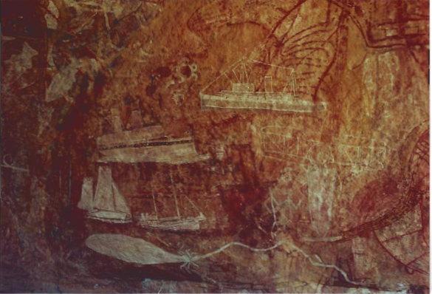
Photograph 10: Contact rock art at Djulirri (NT) (Taçon et al. 2010a: Plate 13).
Nawarla Gabarnmang and Djulirri are two site complexes that highlight the rich Aboriginal cultural heritage present in Western Arnhem Land, and both are considered to meet most, if not all, of the National Heritage List criteria. While both site complexes have rock art styles found in other sites of Arnhem Land, both present features that are unique, or very rare, in Australian rock art, such as the architectural modification of Nawarla Gabarnmang and the extensive body of contact rock art at Djulirri.

Central Australia
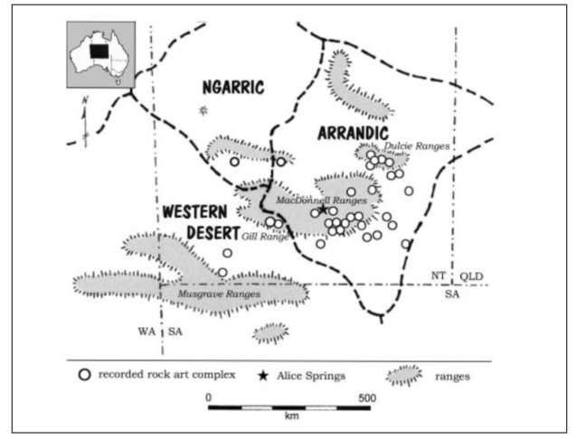
There is not the same extreme intra-regional stylistic variability seen in the arid zone as is found across the tropical northern parts of the Northern Territory. There is a deep time-depth of petroglyph production which shows continuity of graphic tradition into the recent past and various Holocene pictograph and petroglyph sub-provinces (Figure 10). There are strongly documented connections to contemporary Aboriginal groups (Gunn 2011; Mulvaney 2010:114; Ross 2005; Ross and Davidson 2006).

Figure 10: Central Australian (NT) rock art sites (from Gunn 2004: Figure 1).
Demographic changes in the Late Holocene, which resulted in increased territoriality in the better-watered Ranges, is reflected by differentiation between rock art complexes after 1,500 BP (Ross 2013:167). Engraved assemblages reveal distinctive, visually dominant motifs: e.g. the spoked circles at Rainbow Valley, complex pole motifs at Roma Gorge, meandering lines at Ewaninga (Walsh 1988:60), and headdress anthropomorphs at N’Dhala Gorge (Forbes 1982; Ross 2005:226). Recent motifs are hand stencils, handprints and motifs painted in rock shelters and open sites (Ross 2005:227). Udnirr Ingita (Emily Gap) in the MacDonnell Ranges is great significance for the Aranda people. Three very prominent panels here with red ochre parallel vertical lines on a yellow background represent Caterpillar Dreaming (Walsh 1988:166).
Central Australia has a significant body of rock art and a number of places that could potentially be assessed against the National Heritage criteria. Ewaninga is one outstanding example of the desert petroglyph style; N’Dhala Gorge with almost 6,000 motifs is an outstanding example of a regional engraving style with headdress figures, while the striking imagery at Udnirr Ingita includes a particularly distinctive design (Photo 11). Ewaninga and N’dhala Gorge were previously listed on the Register of the National Estate. The Register of the National Estate listings and their values have been assessed to determine whether they meet the National Heritage criteria. Further investigation of Udnirr Ingita needs to be undertaken to determine whether the place meets the National Heritage criteria.

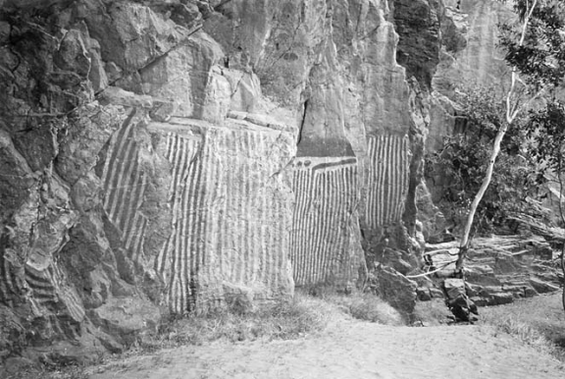
Photograph 11: Caterpillar Dreaming at Udnirr Ingita (Emily Gap NT) (Ross and Davidson 2006: Figure 8).
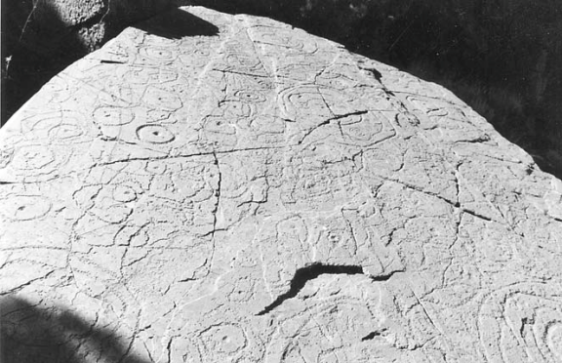
Photograph 12: Repeated circles and tracks, Roma Gorge (NT) (Ross and Davidson 2006: Figure 4).

Queensland
There are numerous rock art regions across Queensland which are documented by varying amounts of research: Torres Strait, Quinkan Country, Chillagoe, Princess Charlotte Bay, the Herbert/Burdekin, northwest Central Queensland, Central Queensland Highlands and southeast Queensland.

Northwest Central Queensland
The northwest Central Queensland style comprises distinctive painted anthropomorphic motifs found amongst the Selwyn, Argylla and Leichhardt Ranges (Davidson 1993:211; Ross 2013:168). Large bichrome ‘Kalkadoon’ figures (Figure 11) are painted on visually dominant vertical locations near reliable water (Ross 2013:168). Art found throughout this region includes animal tracks, mostly macropod and bird tracks, depicted in both the engraved and painted rock art. Accelerator Mass Spectrometry radiocarbon dating of charcoal from one these figures, supported by associated archaeological evidence indicates that this rock art style was produced within the last millennium (Ross 2013:168).
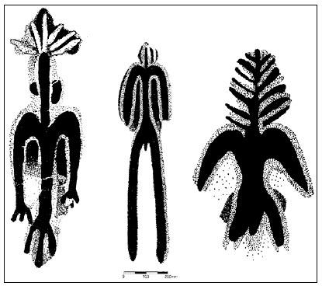
This region contains art that is assessed as likely to have outstanding value to the nation. It is recommended that further investigation be undertaken to compile information on rock art places in the region to allow an assessment of whether the National Heritage criteria are met. The Selwyn Ranges Site was listed on the Register of the National Estate, and it is recommended that the listing information be assessed against the National Heritage criteria.

Figure 11: Anthropomorphic Kalkadoon motifs, northwest central Queensland (NT) (Ross et al. 2008: Figure 4).

Quinkan Country
The Laura rock art region is named after Quinkan spirits, a prominent and distinctive motif in this rock art assemblage (Cole 2011; Cole and Burich 2012; Trezise 1971). This region is characterised by large colourful, figurative paintings of (mostly male) anthropomorphs, zoomorphs (macropods, dingos and echidnas, flying foxes, fish, birds, reptiles), X-ray motifs, plants, tracks and material culture items. The paintings overlie very weathered and patinated geometric engravings, such as those found at Early Man Shelter , dated to 17,000 calibrated years ago (Rosenfeld et al. 1981). Quinkan Country rock art has been nominated for National Heritage listing and is currently being assessed by the Australian Heritage Council. Quinkan Country has not been assessed as part of this thematic study.
Queensland Islands
The rock art of Princess Charlotte Bay (PCB) is some of the better-known rock art found along the Queensland coast and adjacent islands e.g. the Flinders Island Group, Hook Island, Clack Island (a highly significant place in Aboriginal mythology) and Cliff Island (Walsh 1988; Trezise 1969). Stylised motifs are mostly red with white outline and include many marine animals, moth-shaped figures and an elongated torso zoomorphic figure. They are found on almost every available shelter or crevice, even on very low ceilings with difficult access (Walsh 1988:144). Several of these Island groups contain important rock art places of high significance to the Aboriginal community. Further research into the area is recommended to allow assessment of whether National Heritage criteria are met, particularly the Flinders Island group whose Register of the National Estate listing could be assessed against the National Heritage criteria.

Central Queensland Highlands
The rock art of the Central Queensland Highlands is characterised by the predominance of stencilled hands, feet, implements; by simple, geometric painted designs such as grids and zigzags; and by a variety of simple engraved motifs, such as tracks and vulvas (Morwood 2002:210). Morwood developed a three-phase chronology based on relative and absolute dating techniques, looking at superimposition, style, motif subject and associated excavated material (Morwood 2002):
- Phase 1 (>5,000 BP): deeply pecked engravings of geometric motifs and tracks, all near permanent water and associated with stone artefact scatters, a possible variant of the Panaramitee style;
- Phase 2 (5,000-36 BP): stencils, imprints, pictographs and petroglyphs. Motifs mainly consist of vulvas, tracks, grids, zigzags, and ‘ferns’; motifs are repetitively clustered;
- Phase 3 (<140-36 BP): emphasis on white and the depiction of grids. Distinctive motifs appear, such as lizards, tortoises and lizard/grid compositions.
The stencils portray items never observed during the European contact period, and the range of stencilled artefacts is much greater than seen in museum collections (Morwood 2002:165). The stencilled Melo shell pendants indicate that local groups were in contact with far north coastal Queensland (Morwood 2002:166). Rock art has been recorded in Carnarvon National Park, Expedition National Park and Blackdown Tablelands National Park, as well as in intermediate areas between these parks. Within this landscape are some of the best-known rock art sites in Australia: Cathedral Cave, the Art Gallery, The Palace and Kenniff Cave.
Associated with the rock art sites are burials and stone artefact scatters, as well as subsurface occupation deposits (Godwin 2001). Excavations at Kenniff Cave revealed occupation deposits that dated back to 19,500 years ago, the first stratified site in Australia to be dated to the Pleistocene. Excavations at Cathedral Cave dated the engraved rock art to a minimum of 4,000 years ago, and further excavations at Ken’s Cave dated other motifs to 530 BP (Morwood 2002).
Various sites within the Carnarvon Region were previously listed on the Register of the National Estate. It is recommended that the region be considered for listing as a cultural area on the National Heritage List, as it not only consists of a network of sites of a particular cultural bloc as characterised by the Central Queensland rock art, but the rock art sites are linked with the natural environment and broader cultural context.
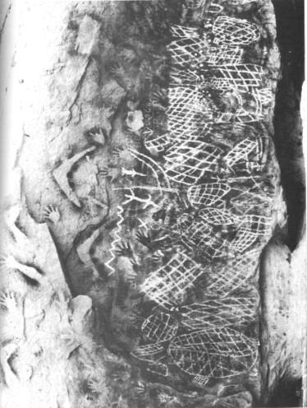
The Palace (previously known as Black’s Palace, but the custodians prefer the name ‘The Palace’) is located west of Carnarvon National Park. This site complex includes burials (Godwin 2001) and an assemblage consisting of a minimum of 9,471 motifs, including 2,271 stencils of hands, feet, axes, and other material culture items (Morwood 1979; Godwin 2001). These include rare hand signal stencils and unusual steel axe stencil stencils where the conventional European handle has been kept (Morwood 2002: Figure 5.8.). There is also a unique example of a composite image of a Rainbow Serpent created by the placement of over 300 stencils to form a single image (CQCHM 2005:27). Art includes 6,895 engraved animal and bird tracks, abraded lines, vulvas, grids, pits and zigzags (Morwood 1979, 2002).

Photograph 13: A section of the main panel at the Palace (Central Qld) (Morwood 1979: Plate 8.1).

The Palace was listed as a Designated Landscape Areas by the Queensland Government, and was also listed on the Register of the National Estate. Rock art sites in the Central Queensland Sandstone Belt have undergone detailed recording and research, with researchers uncovering an extensive occupation record as well as a rich rock art assemblage that provides information on past Aboriginal lifeways, practices and belief systems from the Pleistocene to the Contact period.

North Queensland Highlands
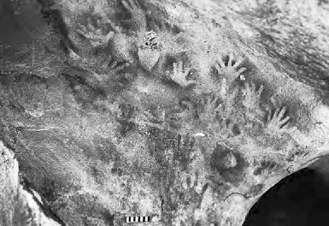
North Queensland Highlands rock art is characterised by the predominance of stencilled hands (adult, child and variations), feet and implements; the painting of simple, geometric designs (grids and zigzags), and hand prints (Morwood 2002:234, Wade and Wallis 2011).
Photograph 14: Panel of hand stencils in the north Queensland Highlands. Stencilling and engraving are the main rock art techniques in the region (Morwood 2002: Figure 9.2).
The earliest surviving rock art comprises deeply pecked engraved circles, radiating lines, arcs, pits and tracks, followed by shallowly pecked circles, arcs and tracks, with more figurative motifs (Morwood 2002:235). Pigment fragments recovered during excavations suggest that pigment art may have been created during the earlier period as well (Morwood 2002:235).
The North Queensland Highlands has had little research in comparison to other Australian rock art provinces (but see Morwood 2002; Wade and Wallis 2011). Further assessment is required to identify the extent and nature of the rock art in the region, and to identify rock art places that meet the National Heritage criteria.

Herbert/Burdekin
The rock art in this area is dominated by non-figurative and highly stylised figures, very different from inland traditions (Walsh 1988). Motifs include painted ladders, asterisks, circles, barred circles, zigzags, and variations of the grid theme in white or red (Walsh 1988:126). Painted shields are recurring motif in the region; they are smaller size than found in material collections, and are usually in monochrome red (Walsh 1988:148). The decorative designs of these painted shields are not duplicated, with as many as 21 variations in one shelter, and the highly stylised elements are arranged in an ordered composition (Hatte 1992; Walsh 1988:148). Most shields are very well preserved suggesting it is a recent motif type; archaeological excavations in one of the largest shield galleries provided a maximum occupation date of 1,455 ± 140 years BP (Walsh 1988:148).
The Herbert/Burdekin contains important rock art places and is highly significant for the Aboriginal community; however further assessment is required to identify whether places meet the National Heritage criteria.

Torres Strait
Rock art in the Torres Strait has been systematically recorded on a number of islands. Brady has recorded 1,281 red, yellow, white, blue, black, mulberry and pink paintings from 56 sites. These are mostly monochrome and bichrome. Motifs include anthropomorphs, zoomorphs, material culture objects, faces/masks, and a large quantity of geometric and abstract images. Most of the art is thought to be a few hundred years old via relative dating techniques using oral traditions, comparisons with earlier observations of images, and excavation data (Brady 2007:339). Distinctive motif forms have been identified in the western Torres Strait assemblage that reveals correlations with scarification designs and designs recorded on decorated objects (Brady 2007:339). These include fish headdresses, snakes, four-pointed star and triangle variants.
Kabadul Kula and Mask Cave are two Torres Strait rock art sites that have been investigated with Torres Strait Islander communities. Kabadul Kula is located on Dauan Island in the Northern Torres Strait, and consists of a large granite boulder with a series of paintings. There is also a low-density stone artefact scatter and marine shell across the ground surface (McNiven et al. 2009:30). There are 56 motifs, including anthropomorphs, zoomorphs, canoes and geometric designs, as well as a number of unidentified motifs (Brady 2005; Brady et al. 2010; McNiven et al. 2004). These have been painted with a brush using red pigment to create outline and linear motifs (Brady 2005; McNiven et al. 2004). There is also a single representation of a dogai, a malevolent spiritual being that takes the form of women, the only representation of a dogai in the region (McNiven et al. 2004:233). Ochre in excavations have dated rock art production to c.1150-1350 years ago, however further investigation is required to test the association more directly (McNiven et al. 2009:37).
Kabadul Kula is one of the most distinctive rock art sites in the Torres Strait, known especially for the large quantity of imagery reflecting the intimate and enduring connection between Torres Strait Islanders and people from Papua New Guinea. It is the largest and most complex rock art site known for the Torres Strait (Brady 2015 pers. comm.; McNiven 2015 pers. Comm.; McNiven et al. 2009). As with much Late Holocene rock art in Australia the art at Kabadul Kula is highly regionalised with the rock art providing significant information about the strong cultural connections between the Torres Strait and Papua New Guinea.

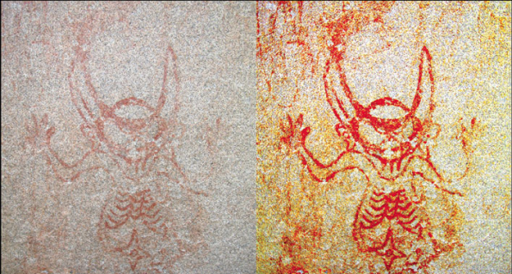
Photograph 15: Computer enhancement of an anthropomorph from the Kabadul Kula rock art site on Dauan Island, Torres Strait. (Brady 2008: Figure 4).
Kabadul Kula has yielded information about long-term changes in artistic traditions, place marking strategies and associated symbolic and socio-religious behaviours and has revealed that people have been living on Dauan for at least 1350 years, which is double the known antiquity of human occupation of the island revealed by previous excavations (McNiven et al. 2009:38). Kabadul Kula is considered a special place, and has strong cultural significance for the entire Dauan community (McNiven et al. 2004:230).
Another significant Torres Strait rock art site is Mask Cave, located on the sacred islet of Pulu in central western Torres Strait. The rock art consists of red pigment motifs including a face/mask and geometric motifs (Brady 2010). There is also a large amount of cultural material on the ground surface, including European contact ceramics, glassware and metal fragments, shell and bone fragments (Brady 2010:153). The face/mask image is unique in Australia and is the southernmost known example of this Papua New Guinean design form (Brady 2010:356). Another highly significant feature of Mask Cave is the presence of Indigenous Australia’s first pottery tradition (McNiven et al. 2006).
The place is potentially of outstanding value to the nation as it has yielded fundamentally new insights into Goemulgaw history and into Islander origins (McNiven et al. 2006:50). The evidence from Torres Strait is beginning to tie Australia to late Holocene developments in Island Melanesia and the wider Pacific as well as mainland New Guinea (Lilley 2006:2). The arrival of pottery-producing Papuans into the region 2600 years ago is linked with the historical extension of the greatest migration events in the ancient world: the Austronesian settlement of Island SE Asia, the Pacific and the Indian Ocean (Brady 2010:462-463; McNiven et al. 2006:75).

South Australia
Rock art in South Australia consists predominantly of petroglyphs, though there is a painted tradition, which continued until recent times (Walsh 1988:62). Ngaut Ngaut rockshelter (as Devon Downs is now known) is a large heritage complex which includes petroglyphs. It was the first stratified rockshelter deposit to be scientifically excavated in Australia (Basedow 1914; Roberts et al. 2015:32). Figurative and non-figurative motifs are engraved into limestone and include tortoise and sun motifs, lines, dots and tracks (Roberts et al. 2015:33).
Koonalda Cave is a well-known limestone cave site 20km south of the Nullarbor Plain. The many finger flutings/grooves in the soft limestone walls have been dated by excavations which reveal that cherts here were mined from 4,000-24,000 years ago (Flood 1997:25; Walsh 1988:52). This site was the first in Australia with evidence of Aboriginal art being produced beyond the natural light zone and the first to show Aboriginal use of the arid zone during the Last Glacial Maximum.
The Olary Province is home to the type-site for the Panaramitee style (Maynard 1979); the arid zone track and circle engraved corpus (McDonald and Veth 2010). The Olary Province includes 26 known Aboriginal rock art sites at Yunta Springs, Panaramitee North and Wharton Hill (Nobbs and Dorn 1993). Mannahill and Karolta are two engraving sites east of the Flinders Ranges (Flood 1997:98). There are also extensive gorges with pecked art in the Flinders Ranges (Hamm in prep.). The engraved motifs are mostly circles, circular designs, animal tracks and concentric circles; tracks include examples of hopping macropods, sitting and walking emus; there are also goannas and squatting anthropomorphs (Walsh 1988:62). Pigment art in the Flinders Ranges is mostly red but also black (e.g. at Yourambilla: Walsh 1988:158).
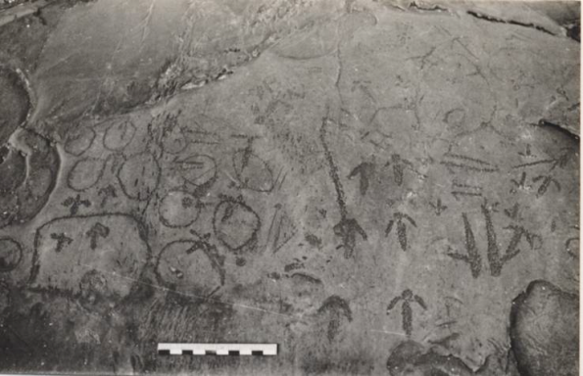
Photograph 16: Petroglyphs at Karolta 1, Olary province, showing the range of motifs found at Panaramitee style sites (Franklin 2011: Figure 2).
Koonalda Cave is included on the National Heritage List. Ngaut Ngaut is highly significant for its Aboriginal custodians. Karolta and Ngaut Ngaut were previously listed on the Register of the National Estate. It is recommended that these listings be compared to the arid zone engraving sites proposed in the current study to determine how they meet the National Heritage criteria.

Tasmania
Tasmanian rock art provides a useful comparison with art from other parts of Australia as Tasmania was cut off from the mainland 8,000 years ago (Morwood 2002:42). The rock art consists mostly of engraving sites, located along the northwest coast, though there are also a number of rockshelters and caves with hand stencils, and ochre has been recovered from Pleistocene deposits in many caves across the region (Cosgrove et al. 2010). Engraving sites share the following common features (Brown 1991:102-103):
- All engraved motifs are within metres of the high water mark and extend only a short distance from the coastline;
- All sites are located adjacent to large shell midden accumulations;
- All engraving sites are near freshwater sources; and,
- Engraved motifs comprise simple design elements – circles, ovals, dots, straight and curved lines, with few complex compositions.
Mt Cameron is Tasmania’s best-known rock art site where the motifs had been engraved on blocks that have fallen off the cliff (Luckman 1950:26). Excavated by Rhys Jones and Harry Lourandos in 1969, samples from material trapped in rubble under the engraved slabs showed that the slabs had a minimum age of 1,350 ± 200 years BP (Walsh 1988:56). The very soft calcareous rock and the very deeply pecked and abraded rock art are thought to be no older than 1,500 years old (Rosenfeld 1999; Walsh 1988:56). Nearby Sundown Point consists of engraved slabs located along the water line, and partially buried under sand (Walsh 1988:58).
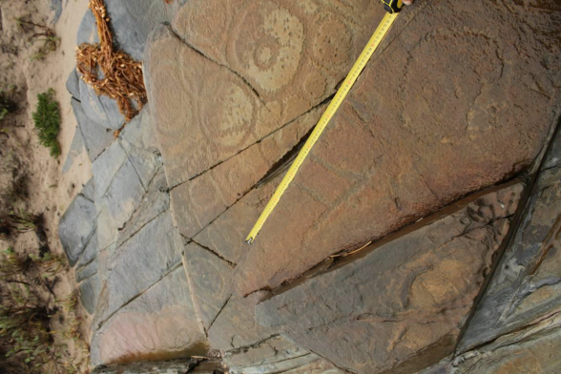
Photograph 17: Sundown Point petroglyphs (Tasmania) (site 217/2) (Huys 2010: Photo 13).
There are three stencil sites located deep inside limestone caves that have no occupation deposit (Cosgrove 1999:369). These have been preliminarily dated to c.11,000 BP (Cosgrove 1999:369). The stencils in Wargata Mina are located 60m from daylight; while a further seven complete arms have been stencilled 1km inside the cave. There are also hand stencils at Ballawinne Cave 20m from the entrance, in complete darkness (Cosgrove 1999:369). There is no identified figurative art (Cosgrove 1999:370).
Other red hand stencils in Tasmania are located in the Derwent region and on the Tasman Peninsula in highly erodible sandstone rock shelters: these stencils are thought to be mid- to late Holocene in age (Brown 1991:101). Mount Cameron West and Sundown Point (previously listed on the REGISTER OF THE NATIONAL ESTATE) are highly significant petroglyph sites at a state level. The stencil rock art sites are also important at a state level as they are examples of rare pigment art in Tasmania. Many sites are included within the Tasmanian Wilderness World Heritage Area.

Victoria
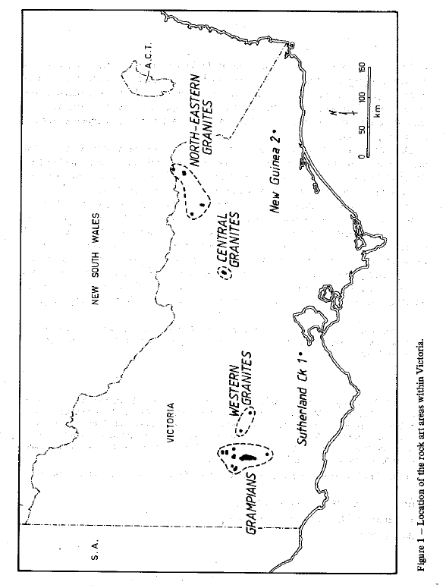
Victoria does not contain extensive rock art regions, but includes several significant concentrations of rock art sites. Almost all of the rock art occurs within the peripheral hills of the Great Dividing Range (Gunn 1984:189). Around 80% of Victorian rock art (120 sites) is located in Gariwerd (the Grampians), half of it within 10km of Glenisla, one of the major rock art sites (Gunn 1984:189, Gunn 2005:37).

Figure 12: Rock art styles in Victoria (Gunn 1984: Figure 1).

Most of this art is painted, although there are two petroglyphs sites: New Guinea 2 and Sutherland Creek (Figure 10; from Gunn 1984:3). The rock art of the Grampians consists mainly of small (<10cm) red painted, linear motifs, mostly geometric figures or stick figures. In the Granites area there are many shared attributes with the Grampians (Gunn 1984:190). Grampians rock art has the following characteristics (Coutts and Lorblanchet 1982:89-90):
- The shelters are always painted;
- There are large shelters in accessible locations, and small sites in remote locations; and,
- Motif range is limited. Anthropomorphs account for 80-90% of the assemblage, with the remainder consisting of geometric motifs and (especially) bird tracks, and only two animals (birds) at Glenisla.
Distinctive motifs that are repeatedly used in the Grampians which distinguishes this area from the north-eastern Granites where there are stylised male anthropomorphs (lizard-men), hand stencils and bar motifs (Coutts and Lorblanchet 1982:91; Gunn 1984:192).
Bunjil’s Shelter is a granite rockshelter with occupation deposits and a scarred tree nearby (Gunn 1983:13). There is an alcove, where Bunjil and two dingos (his helpers) have been depicted in white and red pigment and a series of drawings in red ochre and charcoal (Gunn 1983:19). The depiction of Bunjil and his two dingos is a unique representation of southeastern Aboriginal culture, and is unique in Victoria (Gunn 1983). Bunjil was the supreme God-like figure of most of southeast Australian, the creator who provided for his people (Gunn 1983:2).
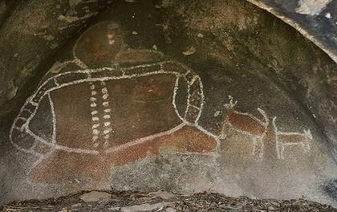
Photograph 18: Bunjil and his two dingo helpers , Bunjil Shelter (Victoria) (Image credit Ken Irwin).
Bunjil shelter was previously listed on the Register of the National Estate and the unique representation of Bunjil and his two dingoes meet some of the National Heritage criteria. This motif presents a unique representation of the stylistic characteristics of Djabwurrung rock art.
Glenisla is a major rock art site: its walls covered with paintings to a height of about 2.7m (Coutts and Lorblanchet 1982:8). The colours used at Glenisla are mostly red, with some yellow and white. The motifs consist of painted bars across most of the shelter wall, linear anthropomorphs, tracks, and birds.
Ochre was found in the earliest layers of the archaeological deposit at Drual (>1,870 BP) and at Glenisla (from at least 1,800 BP), although no direct association was found with the rock art (Coutts and Lorblanchet 1982:92). Due to the fragile nature of the rock art, it is thought to be contemporaneous or younger than the radiocarbon dates recovered from the excavations.
Rock art in the Grampians is currently listed on the National Heritage List. Bunjil’s Shelter, which is outside the listed place, was suggested by the Djabwurrung People to be assessed against the National Heritage criteria, due to the uniqueness of the imagery.

Western Australia
There are a number of rock art regions in Western Australia - the Pilbara, West and East Kimberley and the Western Desert. Rock art is also found in much lower densities elsewhere across the state (e.g. the Murchison and Goldfields) but documentation of this is more limited (cf. Walga Rock: Gunn and Webb 2002). Within these regions there are a number of diverse style provinces.
Pilbara
The Pilbara is possibly the richest engraving region in Australia, with millions of motifs spread across the region. There is, however, considerable variation in concentration, style and subject from one area to another (Wright 1968; McDonald and Veth 2013a). The distinct and better-documented style provinces of the Pilbara are Port Hedland, the Upper Yule River, Cooya Pooya, the eastern Hamersley Gorges and Opthalmia Ranges, Depuch Island and the Dampier Archipelago (Figure 13). Rock art sites are generally associated with water holes and rock pools; some are linked to increase ceremonies (Mulvaney 2010:120).
In coastal areas, including the Dampier Archipelago, Depuch Island and Port Hedland, there are a great number of marine birds and mammals, fish and reptiles (McNickle 1984:6; Mulvaney 2013), although there is also a strong component of terrestrial fauna - mainly macropods, emus and bush turkeys. In the Dampier Archipelago (already National Heritage listed) there are a number of distinctive motifs; Decorative Infill figures, climbing men and the archaic Face, that indicates connections with sites further inland through the Pilbara and across the arid zone (McDonald 2005; Mulvaney 2013).
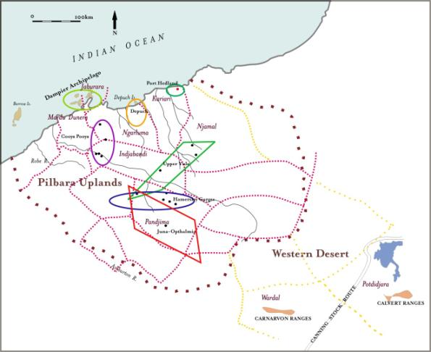
Figure 13: Overlay of Pilbara (WA) art provinces with Tindale's 1974 socio-linguistic territories (McDonald and Veth 2013a: Figure 12).
Depuch Island rock art consists of mostly pecked and some incised petroglyphs; motifs include stick figures, animals, weapons and group scenes (Mulvaney 2010:123). Rock art in Port Hedland consists of engravings of anthropomorphs, turtles, whales and fish, dotted stingray, human tracks, macropods, emus and dingos, as well as material culture including oval decorated shields (McCarthy 1958:20).
Burgess Point, Mourambine Kariyarra 3 and South West Creek 4 are three significant rock art places in Port Hedland: these are included in the present study as the Port Hedland Complex. Burgess Point is a limestone site complex and a midden scatter surrounded by mudflats fringed with mangrove. The art consists of circles, bird and macropod tracks, feet tracks, lines geometric motif, hands, concentric circles, meandering lines, rays, dots, lines, spear thrower, boomerang, bullroarer, spear, Minjiburu, anthropomorphs, lizards, livers, grinding patches, grooves, shields, turtles, stingray, dugong, fish, sea cucumbers and whales; over 500 in total (Zubieta and McDonald 2015). Mourambine Kariyarra 3 is an island site complex with engraved motifs, grinding patches/grooves, shell midden, a potential archaeological deposit, gnamma holes with lids, and man-made structures (Zubieta and McDonald 2015). The site is very well preserved, and is associated with South West Creek 4, 250m northeast, and separated by a small water channel. There are approximately 10,000-20,000 motifs, depicting bird and emu tracks, footprints, circles, concentric circles, meandering lines, phytomoprhs, rays, dots, spearthrowers, lizards, boomerangs, spears, Minjiburu and other anthropomorphs, geometrics, whales, liver, shields, turtles, dugong, fish, fringe, swordfish, grooves and grinding patches (Zubieta and McDonald 2015). There is also a shell midden with Anadara, Terebralia and Melo.
These three Port Hedland sites are in excellent condition, with minimal to no impact overall, especially compared to other sites in the Port Hedland area. The three sites share their importance as containing motifs (Minjiburu) that connect a mythological narrative from the Pilbara coast to the arid interior. The intact archaeological context is of outstanding value in the potential to reveal information on Aboriginal people's responses to sea level changes on the northwest coast of Australia. These sites come together as part of the social and cultural Holocene landscape, and can inform on past lifeways.
In the central and eastern areas of the Pilbara the petroglyphs style are radically different (McNickle 1984; Wright 1968). Anthropomorphs tend to be the dominant motif, though birds, mammals and reptiles are also depicted in the rock art, as well as material culture items, such as boomerangs (McNickle 1984:6). The Woodstock Abydos Protected Reserve is in the inland Pilbara, along the Upper Yule River. This area represents a distinctive rock art style province, with petroglyphs engraved on granite domes. There are over 550 recorded sites in the Woodstock Abydos Reserve, and this represents an archaeological landscape with enormous potential to contribute to our understanding of northwestern Australia’s cultural history. Several major occupation sites were recorded near freshwater sources, with multiple forms of cultural activity, including rock art production, stone tool manufacture, and seed grinding (Brady et al. 2011:70). It contains a unique form of representation, Woodstock figures, interpreted as kurangara figures (Wright 1968). These figures have long flexible limbs ending in forked hands and feet, protruding muzzle, usually one or more antenna-like head decorations, and frequently exaggerated genitalia (McNickle 1984:6).
Woodstock-Abydos has been nominated to the National Heritage List on at least one occasion but has not been included on the Finalised Priority Assessment List. It is strongly recommended that the Aboriginal community be consulted to consider restarting the nomination process, as the place can be demonstrated to meet several National Heritage criteria. There have been several rail corridors which have been constructed through this Reserve in the last decade.
Painted and stencilled rock art in the Pilbara is currently under-recognised. Sites are generally small but there is considerable variety in style and subject (McDonald 2015; Wright 1968). Boomerangs are common, as are anthropomorphic motifs; there are also birds and tally marks, hand stencils, and reptiles (McNickle 1984; Wright 1968). Overall the rock art of the Pilbara is extraordinarily diverse, with a wide range of motifs including anthropomorphs, geometrics, material culture items, and terrestrial and marine animals. Petroglyphs are outlined or fully pecked, abraded, scratched, incised or pounded, and also vary significantly in size.
There are no absolute or relative dates for the regional engraving provinces, except for the micro-erosion technique (Bednarik 1992) and, more recently, through erosion rates calculated from cosmogenic nuclide measurements (Pillans and Fifield 2013), which indicate that the low weathering rates mean that the oldest petroglyphs could be between 27,000-65,000 years old. Various chronological schemas have been devised based on stylistic analysis, motif superimposition and weathering (see Mulvaney 2010; McDonald and Veth 2013:68; McDonald 2014) and the identification of certain species in the art, such as now locally extinct species such as thylacines (Mulvaney 2009). It is assumed that people have been producing art in the Pilbara since the first arrival of people in these parts – around 50,000 years ago.
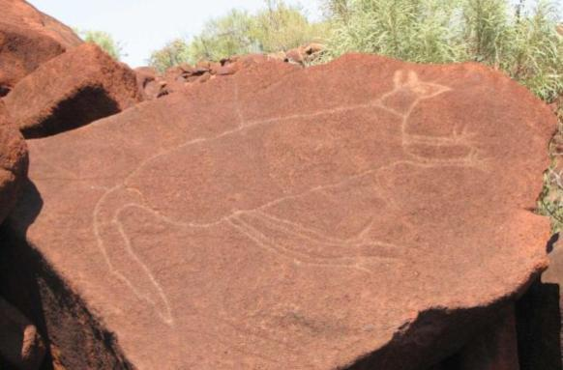

Photograph 19: Engraved macropod, Dampier Archipelago (WA) (Image credit Ken Mulvaney).

Western Desert
The Western Desert is a significant Australian rock art region, with art dispersed over long distances and produced over many millennia, as demonstrated by the range of styles present, differential weathering and superimposition sequences (Jo McDonald CHM 2011:87; McDonald and Veth 2013). Some of this rock art demonstrates long-distance connections between artists of the Pilbara and central Australia ( McDonald and Veth 2006).
Desert areas tend to be thought of as mainly having engraved sites, but there many painted rock art provinces in the Western Desert. Rock art sites are mostly focused in gorge systems which have long-term water abundance (McDonald and Veth 2012a:97). A lot of the rock art is associated domestic activities, but pigment and engraved art is sometimes deployed in sacred and restricted locales (McDonald and Veth 2012a:95).
Figure 14: Location of Western Desert main rock art provinces.
Initial rock art production in the Western Desert, the earliest ‘Panaramitee’ art consisting of relatively homogenous geometric forms, bird and animal tracks, ‘archaic faces’ and ‘climbing men’, most likely was produced during the Pleistocene (McDonald and Veth 2010). This was replaced by subsequent phases of engraved and pigment art that, after the Last Glacial Maximum, further developed their regional character and local graphic vocabularies (McDonald and Veth 2012b:12-13). Snakes and headdress figures occur in significant numbers with localised variability demonstrated between sub-regions (McDonald and Veth 2012b:16).
The Canning Stock Route ARC Rock Art and Jukurrpa Linkage Project revealed this widespread distribution and identified stylistic patterning across this vast landscape (JMcD CHM 2011; McDonald and Veth 2013:69-70): a total of 576 rock art sites were located along or near the Canning Stock Route (JMcD CHM 2011). According to the Martu, pigment art was created by humans and depicts everyday as well as secret/sacred themes, while engravings represent the marks or tracks left behind by creator-beings and are places where the creator beings were literally transmogrified into stone (McDonald and Veth 2012a:7).
The best documented rock art is in the Calvert Ranges (Kaalpi), the Carnarvon Ranges (Katjarra) and the Durba Hills (Jillakurru) (JMcD CHM 2011; McDonald et al. 2014; McDonald and Veth 2012b, 2013). Most of the engraved art has stylistically contemporaneous pigment analogues, but most of the engravings predate the pigment art styles from the region (McDonald and Veth 2013:71).
Dates obtained with a combination of plasma oxidation and Accelerator Mass Spectrometry (AMS) of recent pigment art focused on Jillakurru, Katjarra and Kaalpi. The most recent phases of Western Desert painting were made in the last 1,500 years, and this painting activity matches an increased intensity of site occupation generally (McDonald et al. 2014:200-203).
At Katjarra (Carnarvon Ranges), an area located southwest of Jillakurru and Kaalpi in the Western Desert, many of the rock art sites have ethnographic and ethnohistoric stories (see Kruse 2012; Sackett 2008). There are eight main rock art complexes recorded here so far: Katjarra and Pitjijarri to the north, and Nyingan, Karnatukul, Rubens Rockhole, Warriti, Tjarralang and Wirrili to the south (McDonald and Veth 2012b). Karnatukul – Serpent’s Glen – has a large assemblage of more than 200 motifs in white, red, yellow and black pigment (JMcD CHM 2011:75). The main panel at Karnatukul is of extremely high aesthetic significance, as well as cultural significance (McDonald and Veth 2012b). Most of the motifs are geometric with many snakes, anthropomorphs and bird tracks, with a small number of macropod tracks, lines, lizards, trails, ovals, circular motifs, ferns, etc. (McDonald and Veth 2012b:Figure 2). Karnatukul also has occupation evidence and extensive grinding dishes, showing that the site was used as a major domestic shelter/locale. Early excavation here showed that this was one of the first sites occupied in the Western Desert - 25,000 years ago (O’Connor et al. 1998): more recent excavation have pushed back the earliest occupation to c. 50,000BP (Jo McDonald, pers. comm. 2016).
Rock art at Katjarra appears to have been created mainly during the recent time period – between 4,000 years and the last millennium. There is little heavily patinated engraved art and much of the pigment art appears quite bright and fresh: the most recent phase of art production has been dated to within the last 500-1,000 years (McDonald et al. 2014).

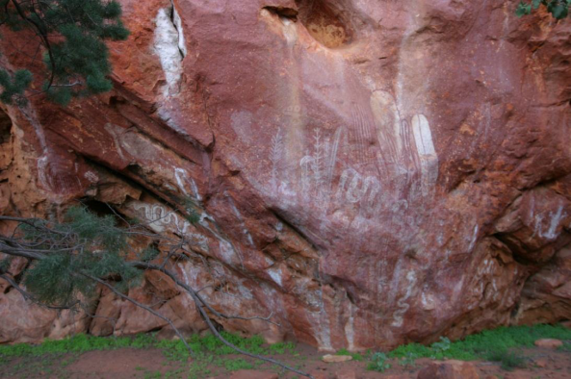
Photograph 20: Karnatukul main panel at Katjarra (WA) (McDonald and Veth 2012b).
Kimberley
The Kimberley region has a large concentration of rock art, much of which is already captured within the West Kimberley National Heritage place. Some basal bedrock here is extremely hard, helping the long-term preservation of the art (Morwood 2002:52). The rock art has been divided into stylistic phases (Morwood 2002:52; Walsh 2000; some of which are thought to be Pleistocene in age (Roberts et al. 1997; although see Aubert 2012 and see http://www.kimberleyfoundation.org.au/rock-art-styles/ ):
- Earliest phase: pecked cupules, handprints and imprints of grass and other thrown objects, followed by large naturalistic figures of infilled animals, including extinct species,;
- Middle phases: Gwion Gwion figures, static polychrome and painted hand; and,
- The most recent phase (the last 4,000 years): the development of the regionally distinctive Wandjina in the northwest and other distinctive local art styles in different language areas.
Gwion Gwion are elongated figures depicted with headdresses and other paraphernalia. As well as carrying boomerangs and dilly bags they are depicted in pairs or dynamic groups. Their distinctive regalia has allowed for the development of a chronology, while the amount of visual detail portrayed means that aspects of the artists’ material culture and ceremonial life can be reconstructed (Morwood 2002: Figure 6.11). A date of 16,400 years BP was obtained by optically stimulated luminescence (OSL) from a mudwasp nest over mulberry pigment (Roberts et al. 1997), has provided an age for this early pigment use, and has been cited as providing for earliest date for spears in Australia, and the earliest date for boomerangs and spear-throwers anywhere in the world (Morwood et al. 1994; Morwood 2002:163; although see Aubert 2012).
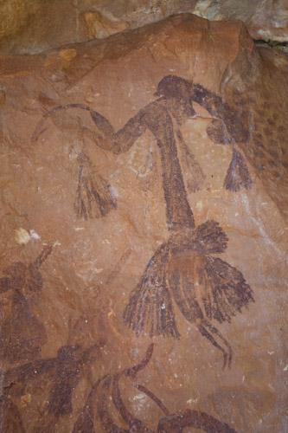

Photograph 21: Gwion Gwion Figure (WA) (Image ©Mike Donaldson).

Wandjinas are large distinctive painted motifs upon which the belief system of the Worroran language group is founded. Sites with Wanjinas are usually found in rock shelters associated with a reliable water source and are named and identifiable according to clan territory (Blundell and Woologoodga 2012). They are considered to be Ancestral Beings personified as clouds, who herald the onset of the wet season each summer. Many Wandjina motifs show signs of having been repainted many times, some in the last hundred years, and some repainting events have been recorded in the last few decades (Crawford 1968). Wandjina figures are often painted in bichrome or polychrome colour combinations on a prepared white background with eyes and noses – but their mouths are never depicted (Ryan and Akerman 1993). Gwion Gwion figures have a wider distribution than the Wandjina art, and may represent broad regional associations across the Bonaparte Gulf with Arnhem Land rock art pre-sea level rise (Chaloupka 1984; Taçon et al. 2003; Mulvaney 2010:110). The West Kimberley is on the National Heritage List. There is very high potential for additional rock art places that meet the National Heritage criteria in the East Kimberley, but further research and assessment is required.

Southwest Western Australia
Rock art sites are relatively rare in the southwest of Western Australia. Kybra, in the far southwestern corner, is an engraving site on a small flat, tabular limestone pavement. This assemblage has 75-100 engravings of predominantly bird and macropod tracks with single meandering lines and arcs (Franklin 2007:67, 71). The engravings at Kybra are a regional variant of the Panaramitee style.
The Murchison Basin has a number of rock art sites (Gunn and Webb 2002:18). Stencils are the predominant motif, with white pigment closer to the Batavia Coast, and red pigment use more prevalent closer to the Wilgie Maya pigment mine (Gunn and Webb 2002:18). In the Cue region, 48 painted rock art sites have been recorded (Gunn and Webb 2002:18). These sites have generally fewer than 30 motifs, predominantly red hand stencils, object stencils and handprints. There are also small, mostly red simple linear paintings, of geometric elements and animal tracks (Gunn and Webb 2002:70-71). Petroglyphs include cupules; some petroglyphs have been painted. Walganha (Walga Rock) on the other hand, has over 988 motifs on a 100m long panel (Gunn and Webb 2002:19). Walganha has an exceptionally high proportion of paintings, very low number of stencils, a greater range of colours, including significantly more white pigment than other sites in its vicinity. The different range of motifs, predominantly linear design and other geometrics is more similar to the Western Desert art found north of Wiluna (Jo McDonald pers. observation). There is a depiction of a ship at Walganha – which is the only contact motif recorded in the Murchison Basin (Gunn and Webb 2002:75). There is debate as to the authorship of this vessel, which has been interpreted to be a rendition of the steamship Xantho (McCarthy 2000). Apparent Arabic script associated with the motif, and its location more than 1000 km from the coast, suggests that this was not depicted by an Aboriginal person during the contact period.
The rock art in this region is considered to be of state heritage significance. Walganha is, considered to be of high cultural and scientific significance.
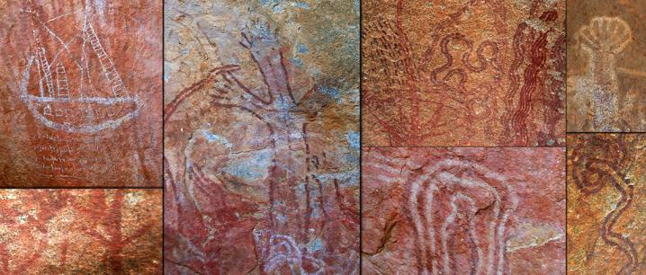
Photograph 22: Selection of rock art at Walga Rock (WA) (Image source www.cue.wa.gov.au).

Overview of rock art chronology
Ever since people began recording rock art in Australia there has been a fascination about how old it might be, and how the art in different parts of the country related to each other. The problem with developing a chronology for Australian rock art is that few absolute dates have been obtained for rock art (Langley and Taçon 2010). Most dates are from associated excavated occupation deposits and regional chronologies. While initial human occupation of Sahul been dated to c.50,000 years ago, achieving reliable contextualised age-determinations for the oldest rock art is still a significant quest. Here we provide a brief overview of the current accepted rock art chronology for Australia.
It is generally recognised that one of the earliest widespread forms of art was cupules and abraded grooves, which were followed by Panaramitee (sensu Maynard 1979) engravings. Cupules, deep circular pecked depressions with no identified functional purpose (i.e. for processing food or ochre), were placed on boulders, rock walls and platforms. Cupules have always been found underlying all other forms of rock art, however a satisfactory maximum age for them is yet to be achieved: it is hoped that the current Kimberley dating project (run out of University of Melbourne) with a focus on understanding the rock chemistry of rock art sites, will be able to further refine our understanding of this art form’s production.
One early sequence for Australian Aboriginal rock art was developed by Fred McCarthy (McCarthy 1956; although see also Davidson 1936). This sequence was based on Sydney and Port Hedland rock art and was not applicable to all Australian rock art. Lesley Maynard’s subsequent three-part pan-continental sequence was devised in the late 1970s, and was an attempt to understand the diversity Australian rock art generally (Maynard 1979). It was an evolutionary model that saw the art styles starting with a pan-continental simple engraved assemblage, and then becoming increasingly complex through time. This model is no longer accepted as there are clear chronological reversals in these phases in many regions: complex art (for instance the Gwion Gwion figures and associated motifs) are clearly older than the Simple Figurative styles that follow. Many researchers have identified shortcomings in the Maynard model – but other than some highly complex alternatives (Bednarik 1992) – few viable pan-continental alternatives have been devised. It is more likely that there are different trajectories in different part of the country – and that continued systematic and fine-grained work will continue to highlight these regional differences.
Superimposition and spatial analyses, and the study of motif subject and style can allow the identification of phases in regional rock art assemblages where absolute dates are not available (e.g. see Chaloupka 1984; McDonald and Veth 2013; Morwood 1979; Mulvaney 2010; Trezise 1971; Walsh 1994). Mulvaney (2010) used style, subject matter and contrast state (degree of weathering of the petroglyph compared to the original rock surface) to develop a sequence for Murujuga rock art.
The Murujuga sequence combines different strands of evidence, including landscape and climate as well as the archaeological context (McDonald 2014; Mulvaney 2010). Mulvaney’s Pleistocene rock art consists of archaic faces, complex geometric figures, stylised terrestrial fauna and concentric circles. The assemblage changes over time both in style and subject matter, and some of these changes are potentially associated with environmental and climatic changes (Table 2 and Table 3). The Murujuga transition to the Holocene is marked by an increase in local stylistic traits and marine animals, followed by distinctive headdresses and material culture and an increased evidence for group behaviours (McDonald 2014; Mulvaney 2010). The last two phases of Murujuga rock art have parallels in Port Hedland and Depuch Island rock art (although these are visually distinctive art provinces), while stylised human figures with exaggerated feet, hands and genitalia are similar to some found in the inland Pilbara (Mulvaney 2010). Across the Pilbara in general, early and more recent engraved rock art retains a largely figurative character with an emphasis on anthropomorphs, in contrast to the Panaramitee-style assemblages found across the arid-zone proper.
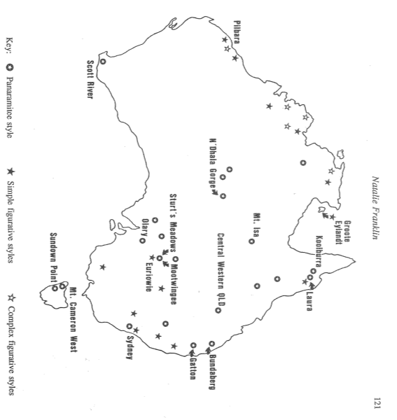
The Western Arnhem Land Plateau rock art sequence was similarly devised in recognition of dramatic environmental changes: sea level rise, development of tidal mangrove swamps, land infilling, and the development of contemporary wetlands. Chronological markers for these phases are reflected in the rock art. Mulvaney (2013:100) has compared this with other sequences (see Table 3), and provided a northern Australia overview (with dates based on direct dates, subject matter, stylistic changes, etc.).
Figure 15: Map of Australia, showing the distribution of Maynard's (1979) styles (Franklin 1991: Figure 1).
A number of researchers (Morwood, McDonald and Veth), have contended that the so-called Panaramitee style - the arid-zone track and geometric repertoire - is best explained by arid-zone open social networks which is consistent with social modelling for Pleistocene hunter-gatherers and early colonisers of the Australian land mass (Balme et al. 2009; McDonald and Veth 2006, 2010; Veth et al. 2011). The increasing regionalism through time - peaking in the widespread use of rock art in the Holocene – is widely understood as the result of the changes in population sizes, changes in social networks and increased territoriality and intensification (sensu Lourandos et al. 2012; and Rosenfeld 1991). Maynard’s sequence has been superseded by more detailed and regionally distinct sequences, most of which have been aligned with occupational evidence found within the archaeological record.
A recent review of the current rock art dating in Australia, compiled a dataset of 432 age-determinations from 92 sites located in all environmental regions (Langley and Taçon 2010). Thirty-seven determinations placed art in the Pleistocene, while the majority of the other ages obtained were younger than 5,000 BP (Langley and Taçon 2010:72). The oldest direct date for paintings in Australia is microstratigraphy - red pigment sandwiched between layers of carbonate and oxalate from Walk-Under Arch Cave in Queensland (29,700 ± 500 BP); a red painted fragment in Carpenter’s Gap 1, WA (between 33,600 ± 500 BP and 42,800 ± 1,850 cal BP) and charcoal drawings in Nawarla Gabarnmang (c. 28,000 cal BP) (David et al. 2013; Langley and Taçon 2010:72; O’Connor and Fankhauser 2001). At Nawarla Gabarnmang the dated art consists of black pigment lines on a tabular piece of roof-fall (David et al. 2013:2494). While these dates inform on the Pleistocene character of some of Australia’s rock art, it provides little information about what people these early people were painting. Gwion Gwion figures in the West Kimberley have been dated to older than 16,400 BP from an overlying mudwasp nest (Morwood 2002:141; although see Aubert 2012). Stylistic similarities between Dynamic figures in the Kimberley and Arnhem Land indicate potential contemporaneity of these stylistic traditions, before 10,000 BP (Morwood 2002:141).
Older dates have been obtained from ochre crayons and other organic remains recovered from excavations: e.g. facetted and use-striated haematite crayons in Arnhem Land have been bracketed by 61,000 ± 13,000 and 45,000 ± 9,000 year old thermo-luminescence ages from Malakunanja II (David et al. 2013:4). However, dates like these cannot be directly associated with the production of rock art as the pigments may have been used for body decoration, painting material items, etc. The oldest known Australian hand stencils (tentatively dated between 19,000-17,000 cal BP) are found in the Chillagoe region, and were obtained through the determination of the chemistry of micro-stratified mineral accretions under- and overlying the pigment stencils (David et al. 2013:7: Since then, the significant early dates from Sulawesi (c. 40,000 year cal BP) indicate that this technique – and red figurative drawing, has likely been practised in the region since the first arrival of people (Aubert et al. 2014).
In Queensland, Andrée Rosenfeld obtained dates of up to 18,200 ± 450 cal BP for deposits overlying engravings at Early Man Shelter (Langley and Taçon 2010:72; see Rosenfeld et al. 1981). The finger flutings at Koonalda Cave in South Australia are more than 10,000 years old. Associated excavated deposits, and incised fragments recovered from the excavation indicate that the finger flutings could indeed be between 22,000-15,000 years old (Morwood 2002:142; Bednarik 2012).
Reliable Australian Pleistocene direct-dates have (so far) been elusive for pigment art and there are still many questions remaining about engraved art of this age. Dating petroglyphs is more complicated and most work has focused on dating various mineral skins that cover both the rock surface and rock art: carbonate layers, desert varnish (varnish micro-laminations), silica skins, oxalate crusts and rock varnish. The difficulty in dating petroglyphs results from the absence of dateable materials related to their actual production, the use of experimental methods (for which the results were subsequently retracted by their authors), or the uncertainties of association (Table 1). For instance, the Sturt’s Meadows calcium carbonate date of 12,300 years ago is for crust covering varnish. This carbonate formed and dates from a wetter-period which followed the presumed dry period when the varnish was formed – which also occurred after the art was produced (Dragovich 1986). In this instance the calcium carbonate did not cover an actual engraving, although the varnish is continuous across the low panels at the site.
Potential depictions of megafauna in Australian rock art are fiercely debated, with arguments including whether these were painted while the animals were still alive, or whether they are a result of collective memory (see Akerman 2009; Akerman and Willing 2009; Gunn et al. 2011; Mulvaney 2013). The absence of uncontested megafaunal-extinction sites overlapping with human occupation creates some of this on-going debate.
Pleistocene dates achieved through stratified dated deposits can only provide a minimum and/or maximum age. Buried engravings at Early Man Shelter, as discussed above, are minimum ages as the deposits eventually covering the engravings (Morwood 2002:261, Rosenfeld et al. 1981) obviously post-date the engraving activity: by how much, we do not know. Excavations at Mickey Springs (Upper Flinders River, Queensland) revealed engravings (seven vertical lines) between charcoal samples dated to between 11,000 - 9,000 BP (Morwood 2002:238), again providing a conservative minimum age of these motifs.

The identification of contact-period rock art is not always as straightforward as the identification of introduced subject matter (Taçon et al., 2012:422). Direct and associated dating, weathering, superimposition, technique, materials and methods (e.g. metal tools for engraving), style, context, Indigenous knowledge and historic photographs and recordings are other ways of identifying contact-period rock art (Taçon et al. 2012:422).

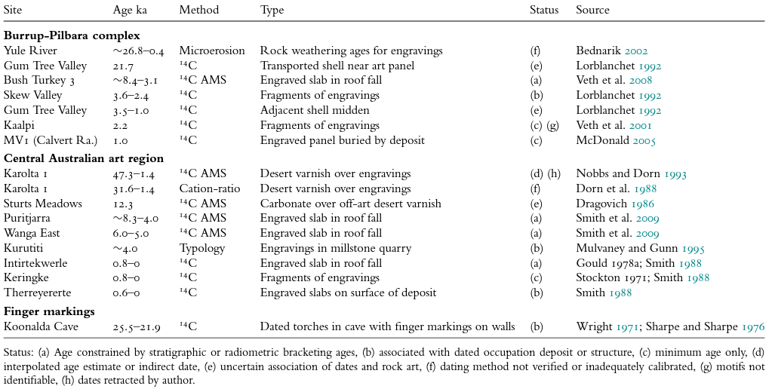
Table 1: Stratigraphic and direct dates for rock engravings in the arid zone (from Smith 2013: Table 7.2)
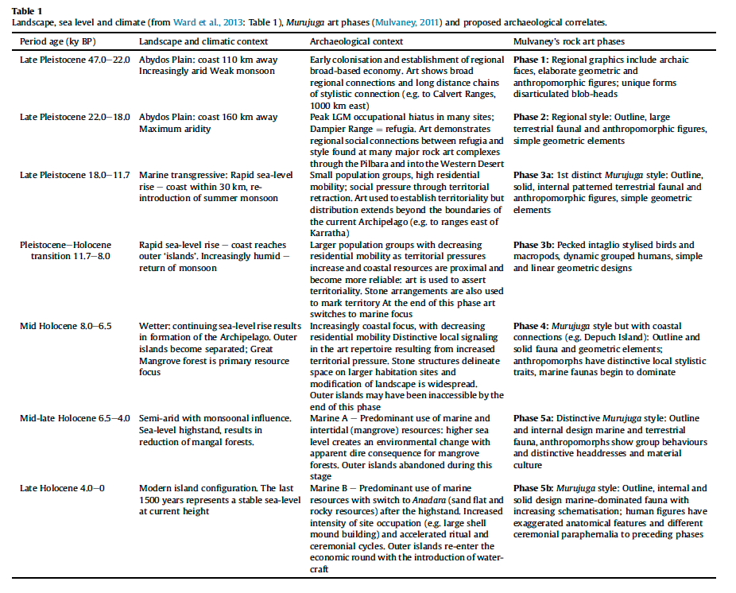
Table 2: McDonald’s 2014 model (2014: Table 1) with proposed archaeological correlates showing landscape, sea level and climate (after Ward et al. 2013: Table 1) and Murujuga art phases (from Mulvaney 2010).

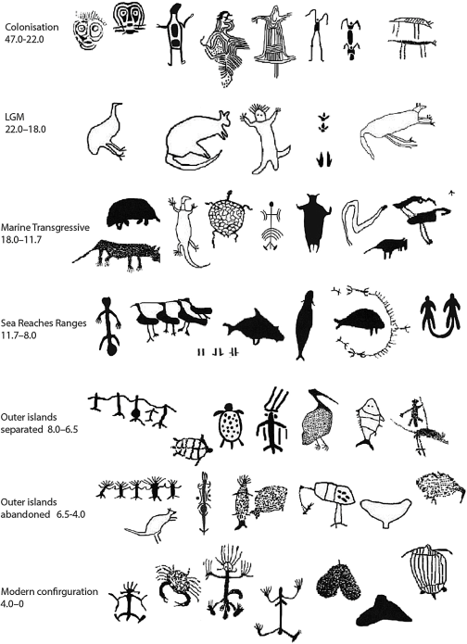
Figure 16: Anthropomorphs and characteristic fauna in the Murujuga art phases (from McDonald 2014: Figure 4).
In the Sydney Basin relatively few contact motifs have been identified, and this is interpreted as reflecting an absence of cross-cultural engagement by Indigenous artists with the outsiders (McDonald 2008b:101). More than half of the recorded contact motifs are of ships, some are incorporated into or among pre-contact subjects; there are also introduced fauna (ponies and cattle), an anthropomorph with a ball and chain and another with a top hat (McDonald 2008b:102). In Sydney it would appear that the arrival of the outsiders coincided with the termination of the Sydney region’s symbolical and artistic culture, in stark contrast to Central Australia (Frederick 1999). In the Centre, a substantial amount of rock art was produced in the latter part of the nineteenth century with artists still living on country well after the arrival of white settlers.
Rock art in the Pilbara continued to be created after contact in specific locations. One of the best documented sites is at Inthanoona (see Photograph 23), a pastoral head station where 20% of the rock art assemblage includes identifiable contact period motifs (see Paterson and Wilson 2009). The post-contact rock art assemblage consisted of the addition of new subjects and adoption of new techniques (e.g. drawing with pencils, using metal implements), the carving of acquired European names and school numbers into totemic sites (Fredericks 1999; Taçon et al. 2012:426). Post-contact rock art was produced at locations associated with the pastoral industry, adjacent to routes opened up by explorers, adjacent to traditional routes along rugged terrain, and in sites at great distances from any European interaction. Interestingly, no contact motifs have been recorded along the Canning Stock Route, nor across the Dampier Archipelago.
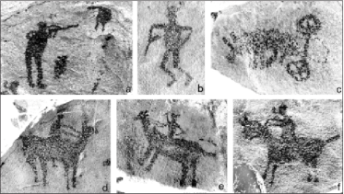
Photograph 23: Inthanoona (WA) Contact engravings: a) figure shooting, figure with gun, wheeled vehicle and horses (Paterson and Wilson 2009: Figure 5).
The Djulirri site in Western Arnhem Land has one of the largest bodies of highly diverse contact imagery with Macassan/Malays, Europeans, Chinese immigrants, ships, motor vehicles, airplanes, horses, sheep, goats, cattle, buffalo, pigs, chickens, pipes, rifles, hand guns, bicycle, and many other subjects painted along with traditional subjects such as native fauna, Ancestral Beings, and depictions of Aboriginal people (Taçon et al. 2010, 2012). Two Indonesian praus have been radiocarbon dated as prior to 1807 AD and 1674 AD by overlying beeswax motifs (Taçon et al. 2010:8). This arrival of the first Macassan trepangers is earlier than previously understood based on historic records (Taçon et al. 2010:8). The beeswax dates overly other images and also provide a chronology for the more recent art sequence at Djulirri (Taçon et al. 2010:8). Contact rock art provides a unique perspective which, along with oral history and written documents, informs on how Aboriginal people mediated contact with outsiders (Taçon et al. 2012:433).
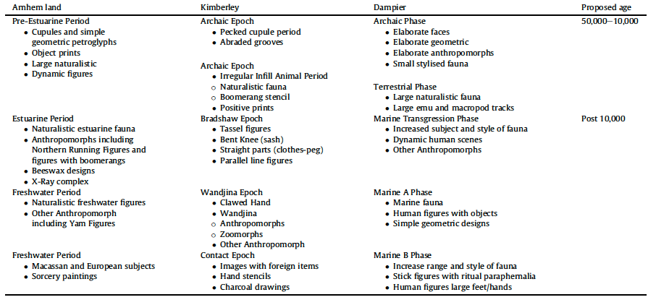
Table 3: Comparative sequences of major rock art subjects and traditions in northern Australia (from Mulvaney 2013: Table 1).
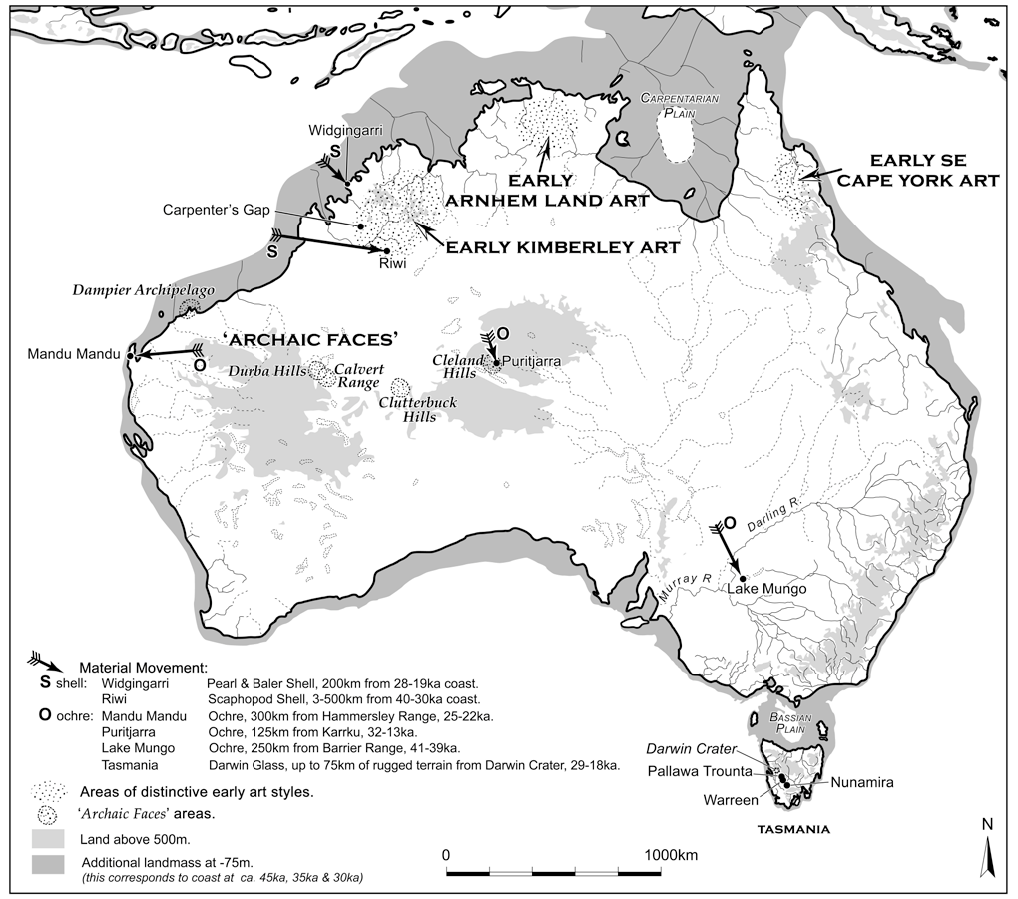
Figure 17: Location of regions with Pleistocene regional style signatures and other early forms of symbolic behaviour (from Veth et al. 2011: Figure 9.4).

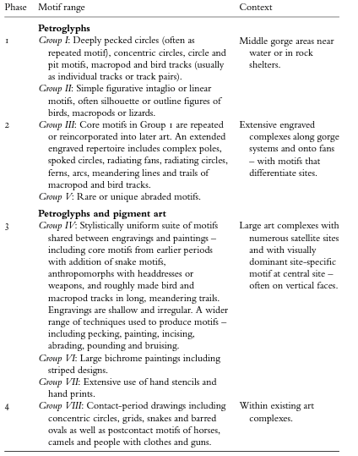
Figure 18: Ross’s 2003 relative stylistic sequence for Central Australia (from Smith 2013: Table 7.5).

Heritage registers
Australian Indigenous cultural heritage is protected by a number of heritage lists and registers that are administered variously by international bodies and federal, state, territory, and local government authorities. These lists protect Indigenous, natural and historic heritage: some lists cover only a single class of heritage.
The heritage lists regulated by Australian authorities are:
- The Commonwealth Heritage List (CHL), National Heritage List (NHL), Register of the National Estate (RNE) (although this affords no protection status) and the Historic Shipwrecks Register (HSR), administered by the Australian Government;
- The State heritage registers, which usually have a separate Indigenous site register, administered by each of the States and Territories;
- Municipal inventories, town planning schemes, and/or local heritage lists, administered by local government authorities.
There are also Australian sites that are identified as having international significance, and these are identified on the World Heritage List (administered by UNESCO).

National Heritage List
The National Heritage List was established in 2003 by the Environment Protection and Biodiversity Conservation Act 1999 (EPBC Act). The National Heritage List includes places considered to be of outstanding significance to the nation. The Australian Government is responsible for protecting places of world and national significance and for ensuring Commonwealth compliance with State heritage and planning laws (EPBC Act 1999, Chapter 5, Part 15, Division 1A, sections 324X-Z ). The National Heritage List contains heritage places with outstanding heritage value to Australia. To be on the National Heritage List, heritage places must have demonstrated heritage values against one or more criteria (see Appendix 8.1).

Listed heritage places
The overriding aim of this Rock Art Thematic Study is to provide Council with a ranked short list of rock art sites/places considered worthy of inclusion on the National Heritage List. To ensure that we considered a comprehensive list of potential candidates for this purpose, we undertook a search of the Australian Heritage Database (AHDB) to identify rock art places currently and previously established as containing outstanding heritage value (through the full variety of heritage instruments).
The National Heritage List has a total of 103 listed heritage places (Table 4). There are thirty places on the National Heritage List which include rock art, although only seven specifically identify rock art in their defined criteria. These seven National Heritage List places are: the Dampier Archipelago, Grampians National Park (Gariwerd), Kakadu National Park, Koonalda Cave, Uluru Kata Tjuta, the Tasmanian Wilderness and the West Kimberley (see Appendix 8.1). Notably, Uluru Kata Tjuta and the Tasmanian Wilderness were also World Heritage listed sites and were retrospectively added to the National Heritage List (https://www.environment. gov.au/system/files/pages/d285fa76-222b-4531-8914-964c55851332/files/ 10568701.pdf).
A total of 331 heritage places with rock art have been previously identified on the World Heritage List, Commonwealth Heritage List, National Heritage List and Register of the National Estate. These have been variously nominated, assessed, emergency listed, etc. (Table 5). These heritage places – and those sites identified by rock art researchers following our written request to nominate suitable places – formed the basis for our more detailed assessment process.

Table 4: Places listed on the National Heritage List.
Class (NHL) | Number of listed | %
Indigenous | 18 | 17.5
Natural | 31 | 30.1
Historic | 54 | 52.4
Total | 103 | 100

Twenty-two of the National Heritage List listed natural places include sites/landscapes with Aboriginal cultural values including significant rock art (e.g. Ku-Ring-Gai Chase National Park). It could be argued that these listed natural heritage places with Indigenous cultural values (40% of all listed) could potentially increase the number of heritage place with rock art that are identified as of outstanding significance to the nation. This would require an additional assessment process and justification: but may in some cases be an economical and appropriate way to broaden the National Heritage List. The fact that the rock art at these places have not been assessed for the relevant National Heritage criteria, means that rock art in these places is not, in fact, explicitly protected by the provisions of the EPBC Act. These already listed places are excluded from our analysis by our Terms of Reference.

Table 5: Places on the various heritage registers (identified by Australian Heritage Database (AHDB).
Class | Number | %
Indigenous | 42 | 9.7
Natural | 135 | 31.1
Historic | 257 | 59.2
Total | 434 | 100
Most (278) of the 313 places with rock art on these previous or other Lists are on the non-statutory Register of the National Estate (see Appendix 8.2). These places are important for the current assessment as they identify sites and places which were assessed as significant by previous heritage legislation/s criteria. It is notable that some of these were assessed to be of national significance; while others were assessed as having local or State significance. These rock art places contribute to our knowledge and understanding of Australian Aboriginal rock art.
Our review has found that rock art sites represent c.9% of the listed types of sites already on the National Heritage List. Historic sites are the best represented category on the National Heritage List (52.4%: Table 4 and Table 5).
This Rock Art Thematic Study aims to provide a more balanced representation of rock art places that meet the National Heritage criteria, with significance based on the Indigenous rock art that fulfils both the criteria – and also the proposed thematic framework.

Assessment of rock art places
Rock art expressions resist clear and precise geographic, technical or conceptual classification. They do not easily submit to static codification or to thematic or geographic distribution. It is difficult to find standardized criteria for their study or cataloguing (Sanz 2005: 50).

The main goal of this Rock Art Thematic Study is to develop a ranked short list of rock art places to be considered for inclusion on the National Heritage List, contextualised by an understanding of Australian rock art more generally. The short list will consist of sites that have sufficient information to determine whether they meet the criteria of outstanding heritage value to the nation. While understanding and appreciating the history of heritage protection given to rock art sites via the various national heritage registers through time, we also considered it vital to contact active rock art researchers, avocational archaeologists, Associations, Aboriginal Parties and Corporations, and other heritage professionals in regards to rock art places that they consider might be candidates for nomination to the National Heritage List.

Survey
Just over 100 rock art Australian rock art researchers were contacted during the course of this study. This group identified 85 rock art places that they considered should be assessed against the National Heritage criteria (Table 6). A number of these rock art places have already been identified (e.g. these were listed on previous registers: see Appendix 8.3), and some represented duplications depending on scale: i.e. style region/site complex/site (e.g. Carnarvon National Park, Carnarvon Gorge; and two specific sites within this locale: the Art Gallery and Cathedral Cave). Some of the identified sites are already on the National Heritage List (e.g. they are located within the West Kimberley) or are already nominated and are in process of assessment (e.g. Quinkan Country): these will not be included in the final shortlist. Unfortunately some of these proposed rock art places have minimal published or grey literature information readily available. Such locations would require additional recording/documentation before assessment of these against the National Heritage criteria of outstanding value to the nation can be made.
The 85 proposed places have been analysed for the overlap with places currently listed or nominated places on the National Heritage List.
Our final matrix of sites for assessment has included places which our research has identified as having potential values for assessment, as well as a gap analysis of where there are major geographic, thematic, typological and chronological gaps in the current National Heritage List rock art sites.

Assessment Frameworks
Assessment of the national heritage values for rock art places requires a national framework to allow rock art to be appropriately judged. This framework should be informed by a comparative analysis of all Aboriginal Australian rock art, as well as the development of a series of themes. In 2005, ICOMOS undertook a comparison of the World Heritage List and the various Tentative Lists to define a global strategy for a credible, representative and balanced World Heritage List for rock art sites/places (Jokilehto et al. 2005). ICOMOS subsequently adopted three complementary frameworks for comparative analysis: typological, chronological-regional and thematic.
The National Heritage List criteria can be envisaged in terms of this thematic framework:
- Typological: importance in the course of Australia’s natural or cultural history; potential to yield information on Australia’s history; importance in demonstrating the principal characteristics of a class of cultural place; endangered aspects of Australia’s history;
- Chronological-regional: uncommon or rare aspects of Australia’s history; importance in demonstrating principal characteristics of a class of cultural place; achievements at a particular period; special association with a community … or as part of Indigenous tradition;
- Thematic: importance in the course of Australia’s cultural history; potential to yield information that will contribute to an understanding of Australia’s cultural history; importance in exhibiting aesthetic characteristics; high degree of technical or creative achievement; special association with a community or person, an important as a part of Indigenous tradition.

Thematic framework
Thematic analyses focus on identifying and describing implicit and explicit ideas within the data, i.e. themes (Guest et al. 2013), which become the categories for analysis (Feredey 2006:4). A thematic framework categorises the relationships between people and things, and allows new aspects and contexts to be included in the National Heritage List. A thematic framework will identify how places can be identified as having outstanding national heritage values. A number of key themes are proposed as being fundamental to understanding Australian rock art and its cultural and scientific significance. These represent a synthesis of research themes suggested by Australian rock art researchers/colleagues, as well as a consideration of the World Heritage themes which are thought to be universally relevant to rock art.
Table 6: List of rock art places for assessment against National Heritage criteria proposed by Australian rock art researchers and heritage practitioners. Note that some sites are within areas already nominated/ or already on the National Heritage List. Those sites in red were not identified on previous lists.
A.C.T. | New South Wales | Northern Territory | Queensland | South Australia | Tasmania | Victoria | Western Australia
Yankee Hat | Eagle’s Reach - Blue Mountains | Martjinbar | Kenniff Cave and The Tombs, Mt Moffat Station | Olary region: Panaramitee Tiverton, Yunta Springs, Karolta | Mt Cameron West | Bunjil’s Shelter | Kybra (DAA Site ID 4882)
 | Ku-ring-gai Chase engravings | Victoria River Downs/ Wardaman Country | Art Gallery and Cathedral Cave, Black's Palace Carnarvon Gorge | Sacred Canyon and Deception Creek/Red Gorge (Flinders) | Sundown Point | Gariwerd | South West Creek 4, Mourambine Kariyarra 3, Burgess Point
 | Upside Down Man Shelter | Helen Springs | Clack Island, Nara Inlet, Hook Island |  |  |  | Canning Stock Route – Jillakurru, Kaalpi, Katjarra
 | Baiame Shelter | Port Keats | Maidenwell |  |  |  | Walga Rock
 | Maroota Historic Site | Mirarr Country | Yindayin (Ship Shelter), Stanley Island |  |  |  | Mitchell and Drysdale Rivers
 | Mt Yengo 1 and 2 | Bullita Pastoral Lease | Expedition National Park |  |  |  | Woodstock Abydos
 | Calga Women's Site | Keep River | Split Rock, Giant Horse, Quinkan Gallery (Laura) |  |  |  | Wanmanna
 | Boree Track | Djulirri | Chalawong (Gatton) |  |  |  | Chichester Ranges
 | Mt Gundabooka | Legune Pastoral lease | Stokes Range NP |  |  |  | Yillikan (Blue Hills)
 | Mootwingee | Sir Edward Pellew Islands | Blackdown Tablelands |  |  |  | Nickol River
 | Sturt's Meadows | Lemmin River | Frank Creek, Dajarra (Mt Isa) |  |  |  | Jack Hills
 | Swinton’s shelter, Warre Warren AP | Spirit Hills pastoral lease | Kabadul Kula (Dauan), Mask Cave (Pulu) |  |  |  | Depuch Island
 |  | Udnirr ingita | Gulf Country
 |  | Timber Creek Area
 |  | McArthur River
 |  | Nawarla Gabarnmang

These themes can be broadly categorised as follows:
- People’s attachment to place: the art of colonising peoples, the development of regional style provinces/culture blocs and of cross-cultural encounters;
- Human lifeways: interactions between humans and environment, material culture, fauna and flora;
- Living traditions: contemporary values, ritual behaviour and spiritual responses; and
- Materiality.
These themes need to be considered within the chronological and typological frameworks, and to be cross-referenced with the National Heritage List criteria for the assessment of rock art places. We will apply this approach to assessing which sites should be short-listed for consideration based on the National Heritage List criteria. Not all identified sites and places have sufficient information available for this type of desktop assessment.

Typological framework
A typological framework is based on categories that have been used for the classification of rock art sites. While ‘rock art’ is a type of cultural heritage, there is diversity within this. The typological framework involves identifying the range of rock art types across Australia. These can be most broadly perceived as:
- pigment (or pictographs) sites (i.e. paintings, drawings, prints, stencilling);
- engravings (petroglyphs, cupules); and,
- other (beeswax figures, stone arrangements, geoglyphs).
Places with rock art can also be categorised into sub-types (e.g. cave sites, open-air sites, rockshelters, outcrops, boulder piles, site complexes, regional art provinces, etc.). The categorisation of rock art sites and their assemblages assists in the identification of patterns in type and distribution, which is indispensable for comparative analyses.

Chronological framework
Australian Aboriginal people represent the world’s most enduring hunter-gatherer tradition. Anatomically modern humans arrived on the continent some 50,000 years ago. While this culture did not remain static or unchanging – hunter-gatherer-fisher culture was in situ across all of Australia (cf. the tip of Cape York where incipient horticulture is recorded) when Europeans arrived from 1606 to the late 1700’s to establish the first penal and settler colonies.
We propose a chronological focus on broad time slices representing major milestones in the human settlement of Australia (Balme et al. 2009; Veth et al. 2009; Moore and Brumm 2009). The following broad chronology is regionally relevant and includes the broad environmental phases that have affected human use of this landmass through time, and which can be identified in archaeological record:
- First settlement and colonisation mode (50,000 - 30,000 years ago);
- Last Ice Age (Last Glacial Maximum: 30,000 - 18,000 years ago)
- Late Pleistocene-Early Holocene intensification (18,000 - 7,000 years ago);
- Mid and Late Holocene (7,000 - 600 years ago); and
- Post contact (600 years ago – present).
These periods provide a chronological framework in which to categorise rock art in Australia. Sites will be coded within these broad time slices. Given that rock art dating is still in its infancy, absolute accuracy in this process is not possible: associated archaeological evidence is required for confident contextualisation.

Assessment of places
The successful comparative analysis required by the Terms of Reference needs a framework for demonstrating that the proposed places meet National Heritage criteria of outstanding national heritage value and demonstrating the relative value of these places on a national scale. It is hoped that the assessment framework developed here will assist with the comparison of rock art places from different Aboriginal cultures and regions from across Australia and through time. This should ensure a valid selection of Aboriginal Australian rock art places with outstanding heritage value to the nation. By synchronising the National Heritage criteria with the WHL themes this process will also provide a mechanism for subsequent assessment of significant Australian places for the WHL. The proposed National Heritage List thematic framework and comparative analysis of rock art places uses these themes to categorise rock art places within each criterion (Table 7).
The selection of places to assess against the National Heritage criteria has involved identifying rock art places that best demonstrate the characteristics identified in the National Heritage List criteria.

This assessment process involves:
- identifying a list of known rock art site/regions which have been previously listed as significant (Appendices 8.1 and 8.2);
- Identifying sites which current rock art researchers consider should be assessed against the National Heritage criteria (Tables 6 and 7);
- Assessing which sites have been recorded in sufficient detail for this desk top study to undertake the assessment required by the Terms of Reference;
- Application of the themes and National Heritage criteria to the identified list of rock art places (Table 8);
- A ranking exercise of the resultant list to identify which sites meet the current gaps in the current National Heritage List;
- Identifying a priority list of sites to be added to the shortlist, identifying which of these require further work before more detailed assessment could be undertaken.

Table 7: National Heritage criteria, indicators of significance, and assessment frameworks.
National Heritage Criteria | Indicators of significance | Chronological and Typological Frameworks | Thematic Framework
a) The place’s importance in the course, or pattern, of Australia’s natural or cultural history | Events that have resulted in important change to the political, economic or social fabric of Indigenous Australia:  - Places where significant events took place.  Economic, political or social processes characteristic of Indigenous Australia, including regional differences, trade routes, social and political networks, and long-distance contacts:  - Places that best demonstrates one or more aspects of Indigenous life;  - Places that best demonstrate economic process and relationships between groups.  Features that best demonstrate a characteristic way of life on one or more periods of Indigenous Australia | Chronological framework:  - Provides broad time periods marked by significant landscape and climate changes that can be recognised in the rock art;  - Cultural blocs/style provinces belonging to particular time periods;  - All time periods apply here.  Typological framework:  - Changes in forms of depiction, both in techniques of production and stylistic changes within each sub-type  - Sub-types representative of certain time periods;  - Sub-types that are associated with short and long distance connections  - All sub-types apply here. | People’s attachment to place: the art of colonising peoples, the development of regional style provinces/culture blocs and of cross-cultural encounters;  Human lifeways: interactions between humans and with environment, material culture, fauna and flora;  Living traditions: contemporary values, ritual behaviour and spiritual responses as demonstrated through rock art.
b) The place’s possession of uncommon, rare or endangered aspects of Australia’s natural or cultural history | This criterion applies to Indigenous ways of life, customs, processes, land-uses, functions or design that were always few in number, or that are now few in number; uncommon or rare aspects of human occupation and activity | Chronological framework:  - Rock art securely dated to the following time periods is currently severely limited:  - First settlement and colonisation  - Last Ice Age  - Early Holocene  - Post contact  Typological framework:  - All sub-types can be considered rare, endangered or uncommon depending on a comparative analysis with other sites in the style province; depending on which time period they were depicted in; subject matter, etc. | People’s attachment to place: The earliest rock art of Australia is an uncommon aspect of Indigenous history as it is difficult to identify with certainty, and because sea-level rise post LGM drowned a huge part of Australia’s landmass.  Human lifeways: The depiction of extinct fauna (particularly megafauna) and flora are examples meeting this criterion.  Living traditions: contemporary values, ritual behaviour and spiritual responses demonstrated through rock art, but no longer practiced.
c) The place’s potential to yield information that will contribute to an understanding of Australia’s natural or cultural history | Potential to contribute to research on Indigenous Australia, including one or more periods in the history of Indigenous Australians, and ways of life or cultures characteristic of Indigenous Australians. | All chronological and typological frameworks are potentially relevant here. | All of the NHL themes have potential to contribute to research on Indigenous Australia. The extreme variety in methodologies and approaches to rock art research has, and currently is, contributing to a greater understanding of Australia’s natural and cultural history.
d) The place’s importance in demonstrating the principal characteristics of:  - A class of Australia’s natural or cultural places, and,  - A class of Australia’s natural or cultural environments | Represent all or the principal characteristics of a:  - Particular design or style of importance in the history of Indigenous Australia;  - Particular technological process of importance;  - Particular way of life of importance;  - Particular land use of importance. | Chronological framework:  - All time periods are of relevance as can contain characteristic styles, processes and ways of life, and represent periods of potential different land use.  Typological framework:  - All sub-types are relevant here, as they each can be part of characteristics styles, used to depict particular designs, be part of technological processes, and form part of a characteristic land use. | People’s attachment to place: rock art may reveal the first people marking the land; present imagery shared between groups at great distances; with regional or local characteristic motifs of each group represented; mark contact between different groups, i.e. with Macassans or Europeans, indicating a period of important cross cultural interaction.  Human lifeways: rock art can present how human groups responded to different landscapes and environmental change, developed unique technology to manage the environment or the natural world.  Living traditions: contemporary values, ritual behaviour and spiritual responses as demonstrated through rock art.
e) The place’s importance in exhibiting particular aesthetic characteristic valued by a community or cultural group | The particular characteristics of an area that inspire or move people; may include spectacular vistas or views, designed places, or combination of natural and cultural features. Includes places important for inspiration in Indigenous Australians. | Chronological framework;  - All time periods are relevant here as they all hold the potential for significant aesthetic characteristics, which change over time.  Typological framework:  - All sub-types are relevant here as they were all used, in potentially different ways, to depict aesthetic characteristics of significance;  - Different groups used different sub-types according to cultural conventions and choices. | People’s attachment to place: some rock art styles have demonstrable aesthetic value; the placement of art reveals information about social dynamics and artistic choices. Landscape placement of rock art can show strong aesthetic value: in colours used, arrangement on a panel, or choices made of depicting certain subject matter.  Materiality of rock art: choices made in the materiality of the rock art reveal aesthetic choices/ technological processes of importance.
f) The place’s importance in demonstrating a high degree of creative or technical achievement at a particular period | The rock art must demonstrate:  - The design, art or craftsmanship must be recognised in relation to the practice or technology of the time;  - The place must reflect the clear intention of the designer and be relatively free of accretions;  - Achievement apparent as built features, designed landscape, assemblage of features, including art sites, resource extraction and processing sites. | Chronological framework:  - All time periods are relevant here as in each period Aboriginal Australian groups depicted rock art of a high degree of creative and technical achievement.  Typological framework:  - All sub-types are relevant, as each was used to depict rock art of a high degree of creative and technical achievement. | People’s attachment to place: some regional styles demonstrate creative achievement, not only with aesthetic value, but as an indication of social and cultural technical achievement.  Materiality of rock art: material items depicted in the rock art represent high technological achievement, in terms of subjects depicted and in the technical creation of the art.  Living traditions: the cross-fertilization of symbolic behaviour for ritual can be found in technical achievement in multiple media.
g) The place’s strong or special association with a particular community or cultural group for social, cultural or spiritual reasons | Strong or special association, an attachment that is usually enduring and contains a deep sense of ownership or connectedness. | Chronological framework:  - Post contact time-frames often generate for Aboriginal people the strongest connection to a rock art site;  - Mid to Late Holocene rock art sites may also be relevant of these sites are recursively activated into belief system connections to the present.  Typological framework:  - All sub-types are relevant. | People’s attachment to place: social behaviour and group dynamics represented in the rock art can have strong social, cultural and/or spiritual connections with the current beliefs and practices of a particular group; cross-cultural encounters may represent recent periods which are in the recent memory of Aboriginal groups.  Living traditions: the rock art continues to play a role in people’s current spiritual and ritual lives; local communities have strong contemporary values for the rock art.
h) The place’s special association with the life or works of a person, or group of persons, or importance in Australia’s natural or cultural history | Special association between the place and the group; the place may have an effect in the philosophy, profession, practice or events. The place must be where the person made the major achievement. | Chronological framework:  - Post contact is the relevant time period as knowledge of person/persons of importance is still passed on. Some rock art artists are still known to people today.  Typological framework:  - All sub-types are relevant | People’s attachment to place: rock art may have a special association with the beliefs and practices of a known person or persons; rock art can record cross-cultural encounters from recent periods.  Living traditions: Rock art which records memories of Aboriginal groups, and of known artists.
i) The place’s importance as part of Indigenous tradition | The Rock art will include:  - Creation beings and spirits, the types of places where they may reside or that contain their essence;  - Places of rites and ceremonies;  - Places where techniques to manipulate land and nature are practiced;  - Places where resources were shared and traded between groups, including specific places on song lines. | Chronological framework:  - The relevant time periods are:  - Mid and Late Holocene  - Post contact  Typological framework:  - All sub-types are potentially relevant here; depending on their connectivity to Aboriginal tradition. | People’s attachment to place: rock art depicts Ancestral Beings and dreamtime sagas, is associated with ritual behaviour, aggregation locales where different groups have met, etc.  Living traditions: Places with rock art where groups still or have recently undertake cultural/spiritual practices; the place is used for educational purposes, etc.

Table 8: Rock art places short list. Assessment of National Heritage criteria and assessment frameworks (see Appendices for detailed National Heritage criteria assessment and Indicators of significance).
Rock Art Place | NH Criteria | Indicators of significance | Chronological and Typological FW | Thematic Framework
Bunjil’s Shelter, VIC | b, c, e, g, i | b) Rare - potentially unique - depiction of Bunjil;  c) Potential to contribute information on cultural characteristics;  e) Unique representation of the stylistic characteristics of Djabwurrung rock art;  g) Strong connection with Djabwurrung People and other south-eastern Aboriginal groups; Bunjil’s Shelter is one of the most significant cultural sites in south-eastern Australia;  i) Bunjil is a creator hero, God-like figure for most of southeast Australia | - Mid-Late Holocene (?), Contact (?);  - Pigment art in rock shelter site | - People’s attachment to place;  - Human lifeways,  - Materiality
Carnarvon National Park, QLD | a, b, c, d, e, g, i | a) The place demonstrates relationships between different groups (social, cultural and economic), reaching the far coast; the rock art illustrates regional differences; the place demonstrates aspects of Holocene Aboriginal lifeways, both secular and sacred;  b) Uncommon stencils of spear-throwers; rare full human body stencil; rare hand signal stencils; rare bichrome figures;  c) Outstanding potential to reveal information on relative and absolute dating of rock art; Aboriginal land use during different time periods; information on material culture and trade networks; Holocene changes in population; distribution of totemic groups; social organisation and ideology, information on changes in and how it was part of a more widespread system;  d) Principal characteristics of Central Qld rock art and of early regional variation of Panaramitee tradition;  e) Outstanding aesthetic qualities of natural environment as context of the rock art; aesthetically striking choices made by artists to place rock art;  g) Carnarvon is sacred landscape of intense spiritual significance to Aboriginal People; some sites used for ceremonial purposes, rituals; burials sites in the area; Munda gara (Rainbow Serpent) storyline runs through the area-possible mythological track;  i) Rock art points to connections with other groups (trade, resources, etc.); Carnarvon is sacred landscape of intense spiritual significance to Aboriginal People; some sites used for ceremonial purposes, rituals, burials sites; Munda gara (Rainbow Serpent0storyline runs through the area-possible mythological track. | - Pleistocene, Early Holocene, Mid-Late Holocene, Contact;  - Rock shelter site complex with pigment (painted and stencilled) and engravings. | - People’s attachment to place;  - Human lifeways,  - Materiality
Djulirri, NT | a, b, c, d, e, f, g, h, i. | a) Long-term use of site points to characteristic way of life during different time periods; motifs show connections with other groups;  b) Only site that displays all Arnhem Land styles; depiction of extinct animals (thylacines, Tasmanian devil); only known bird body stencil in the world; only recorded painting of a bicycle; rare contact paintings; oldest dated depiction of an Indonesian prau in Australia; earliest dated contact rock art in Australia; rare female Simple Figures; many unique styles forms and subjects particular to Wellington range area;  c) Outstanding potential for information on contact period, earlier than previously thought; information on development of Arnhem Land rock art; detailed information on contact period from Aboriginal perspective;  d) Principal characteristics of Arnhem Land rock art, contains imagery representing all major forms and styles from Kakadu National Park and other parts of Arnhem Land;  e) Aesthetically production of large human figures and animals, and some contact period imagery far surpasses anything from any other part of Australia; figures and objects beautifully proportioned, powerfully portrayed with exquisite detail;  f) Some paintings of rifles and ships of the contact period are like scientific diagrams and rival paintings by people of any culture; figures and objects beautifully proportioned, powerfully portrayed with exquisite detail;  g) Djulirri is the most significant site for Ronald Lamilami and his extended family for social, cultural, historical and spiritual reasons, and for other Maung language speakers and neighbouring groups;  h) Site was first photographed by well-known photographer Axel Poignant in 1952; recent art relates to notable British Officers (e.g. Captain Phillip Parker King), well-known buffalo shooters, missionaries, and personalities that passed through the area;  i) The Maung Traditional Owners consider Djulirri a virtual rock art library. | - Pleistocene, early Holocene, Mid-late Holocene, contact;  - Rockshelter site complex: pigment, stencils, engraved, beeswax (other). | - People’s attachment to place;  - Human lifeways,  - Materiality
Eagle’s Reach, NSW | a, b, d, e, f, g, i. | a) Documented relationship between styles and changes in the natural or cultural environment; evidence of developing cosmologies;  b) Unique junction site, where influences from Woronora, Hunter Valley, Kamilaroi country, Wiradjuri country, and central Australia; one of few well-preserved area with lengthy engraved and painted traditions; depiction of unusual themes and images (Daramulan, Baiame, wombats, eagle sand dingos), has a few examples of a rare tradition, style, technique, or method (e.g. Darkingung sub-style);  d) Includes most of the characteristics of a defined tradition; includes a specified minimum number of rock-art sites and a specified minimum number of individual images;  e) Demonstrated Aboriginal interests in art; visitor numbers to the sites/area increasing; has representation of images in published works on rock art;  f) Includes images of outstanding technical quality; outstanding examples of artistic skill and detail; excellent examples of graphic design and composition; exceptionally well preserved;  g) Place is part of the Eagle Ancestor landscape, place of high spiritual significance for several contemporary groups; sites are considered meeting and teaching places, where story-telling, song, dance and ritual ceremony would occur; extensive oral history that relates to landscape, places, sites and images, and numerous contemporary Aboriginal connections;  i) Ethnographic evidence for cosmology and its links to art; ethnographic evidence for intangible values associated with the rock art and/or its landscape setting. | - Mid-late Holocene, contact (?)  - Site complex, pigment, engraved and drawings. | - People’s attachment to place;  - Human lifeways,  - Materiality
Kaalpi and Jillakurru, WA | a, b, c, d, e, f, g, i | a) Rock art spans a considerable time period, many millennia, though there is also recent art; the place demonstrates regional differences in Western Desert rock art; the place presents artistic elements that demonstrate long-range contacts with people in vastly different geographic and cultural areas;  b) Rare examples of thylacines; rare examples of marine motifs in the arid inland of Australia;  c) Potential to reveal information on long-term land use through different time periods by Aboriginal, groups; long-distance connections (e.g. with the VRD and the Pilbara coast) and changes of these over time; development of a distinctive localised rock art style;  d) The place demonstrates the principal characteristics of Western Desert rock art through many millennia;  e) Aesthetic qualities of the rock art and the beauty of the depicted imagery; excellent preservation of pigment art; the aesthetic characteristics of engraved panels of Decorative Infill figures are augmented by the intact natural environment;  f) Exhibits remarkable imagery with ornate depictions decorative infill human figures highlight the creative and technical achievements of artists in the early Holocene;  g) There are ethnographic and ethnohistoric stories about the place; the place is of great significance to the local Aboriginal groups as attested by the knowledge shared by the custodians.  i) The place is of great significance to the Martu and is an important place where people from across the arid zone would camp and potentially depict rock art; Ethnographic evidence for mythological connections and its links to art; Custodian’s evidence for high cultural significance; Anthropological evidence for tangible values associated with the rock art and/or its landscape setting. | - Early-Late Holocene –Pleistocene rock art modelled but not as yet dated;  - Arid zone rock art provinces which include site complexes with many individual pigment and engraved art sites (rock shelters and open sites). | - People’s attachment to place;  - Human lifeways,  - Materiality
Kabadul Kula, Torres Strait | a, b, c, g, i. | a) Important place in Torres Strait Islander history, associated with a nearby battle between Kiwai raiders and local Dauan warriors, who were joined by warriors from Saibai Island and from Mawata on the Papuan coast; evidence of long-distance connections;  b) Only known representation of a dogai (malevolent spirit being with female form) in Torres Strait and Australia; depiction of anthropomorphs with a shield is the only shield known in Torres Strait rock art, and rare insight into existence of shields in the region, not recorded previously in Torres Strait material culture; rare crayfish depiction; rare dugong painting, only one other known in Torres Strait; one of only two insect depictions in Torres Strait; potential unique depiction of a hut; unique motif of dancer with fish headdress;  c) Paintings of canoes can provide information on past trade connections between Torres Strait and the Papuan Gulf; motifs yield valuable information on ceremonies, group/social affiliation, cosmology, recent relationships with neighbouring Kiwai, and fighting magic; potential to yield information on long-term changes in artistic traditions, place marking strategies and associated symbolic and socio-religious behaviours; potential to reveal occupation deposits of considerable antiquity;  g) The site is a ‘special place’ with strong cultural significance for the entire Dauan community; engagement with the site continues with regular visits, and a special dance performed by school children, commemorating dramatic historic events that took place at the site; one of the only sites in Torres Strait linked to oral tradition;  i) One of the only sites in Torres Strait linked to oral tradition; includes an important scene in Dauan history, when Kiwai raiders from Papua New Guinea attacked and were repelled by Dauan warriors and other warriors from Saibai Island and Mawatan warriors from the adjacent coast of PNG. | - Mid-Late Holocene, contact;  - Large boulder, pigment. | - People’s attachment to place;  - Human lifeways,  - Materiality
Katjarra, WA | a, c, d, e, f, g, i. | a) The place presents features that demonstrate characteristic styles of the earliest and more recent Western Desert lifeways and rock art production;  c) Information on recent land use and occupation; extensive and earliest WD occupation evidence at Karnatukul and Wirrili and its diverse rock art assemblage can inform on social and cultural organisation;  d) The place demonstrates the principal characteristics of recent Western Desert rock art;  e) The main panel at Karnatukul is of extremely high aesthetic value as well as cultural significance;  f) Exhibits remarkable imagery with detailed depictions of sacred paraphernalia that highlight the creative and technical achievements of Martu artists in the late Holocene;  g) The place is of great significance to the Aboriginal custodians as attested by their knowledge shared (focal point of Birriliburru Native Title claim);  i) The site complex has been identified as a location visited by the Wati Kutjarra (two men) on their mythical trip through the desert, along with other creative beings; has open and closed mythological sagas. | - Pre LGM, Mid-Late Holocene;  - Rockshelter site complexes, pigment and engraved art. | - People’s attachment to place;  - Human lifeways,  - Materiality
Mask Cave, TS | b, c, g, i. | b) The image of the Face/Mask is the southernmost known example of this otherwise Papua New Guinean design form; painting of the roof of the rockshelter in red is an occurrence unknown elsewhere in Torres Strait or the Cape York Peninsula;  c) Unique position to yield information on Austronesian influences in the Torres Strait region; distinctive link between the rock art and associated cultural material; existence of Indigenous Australia's first pottery tradition, ancient and forgotten trans-Torres Strait pottery tradition; information on possible ancient connections between the central western islands of TS and PNG; has provided new insights into Goemulgaw history and Torres Strait Islander origins;  g) Pulu is a sacred place, revered by the Goemulgal and their neighbours;  i) The Face-Mask is important for its relationship to decorated material culture from SW Papua New Guinea and the Papuan Gulf; circular designs in the rock art are associated with shoulder cicatrices documented from Mer (Eastern Torres Strait), Kiwai Island (SW Papua New Guinea), Mawata village (Papua New Guinea) and at the tip of Cape York Peninsula. | - Mid-Late Holocene, contact (?);  - Rockshelter site, pigment art. | - People’s attachment to place;  - Human lifeways,  - Materiality
Mutawintji, NSW | b, d, g, h, i. | b) Includes numerous hunting and fighting scenes which are practically unknown in other engraving sites in NSW;  d) Demonstrates region variant and principal characteristics of intermediate Panaramitee-style rock art;  g) The place is highly important in relation to Aboriginal culture, land, spiritual, kinship, economic, communication, historical, environmental and survival; one of the most significant sacred places in the far west of New South Wales; a place for ceremonial business, trade connections and other large gatherings; Mutawintji is linked with other culturally important places by creator beings and their tracks: Kurlawirra - an important creator, Wirtuwirtulinya - seven sisters, Ngatji - two water snakes or rainbow serpents, Murlarru and Tharlta and Yuururru - red kangaroo and euro; a powerful place to which access was restricted for some Aboriginal people;  h) Special association with members of the Quayle, Dutton, Tyler-Barrow, Gibson and Bates families; these families have a long history with Mutawintji and with each other - as documented in a report for the Office of the Registrar of the Aboriginal Land Rights Act in 2008;  i) Important ceremonial centre, many people whose ancestral country is a bit further away are also acknowledged as having a long association and knowledge of Mutawintji; the place was used for rain-making ceremonies. | - Pleistocene (?), Early Holocene (?), Mid-Late Holocene (?), Contact (?);  - Site complex with rockshelters, boulders, etc. Engraved art. | - People’s attachment to place;  - Human lifeways,  - Materiality
Nawarla Gabarnmang, NT | a, b, c, d, e, f, g, i. | a) Presence of the oldest ground edge axe fragment known in Australia, and the oldest dated known rock art in Arnhem Land; rock art that shows characteristic way of life of Aboriginal groups during different time periods;  b) Rare example of a rockshelter that has been architecturally modified; rare example of an intact rockshelter with outstanding preservation of the rock art, intact occupation deposits and a natural environment that is untouched; first Pleistocene dates for a pictograph in Arnhem Land dated to 26,913-28,348 cal BP; rare Pleistocene dates for rock at in Australia;  c) Potential to yield information on the late pre-European/early contact period vertebrate fauna of this poorly surveyed region; earliest securely-dated fragment of ground-edge axe from Australia, dated at 35,500 cal BP; first Pleistocene dates for a pictograph in Arnhem Land dated to 26,913-28,348 cal BP; development of a chronology for most of the recent period artwork; potential to yield information on the function of northern x-ray painting; potential to provide information on the age of x-ray paintings in the wider region; information on associated beliefs and rituals; provide information about a large area of northern and northwestern Australia; paint drops from the excavation can provide dating information on the artwork;  d) The place demonstrates the principal characteristics of Arnhem Land rock art; demonstrates the principal characteristics of Jawoyn rock art styles; presents principal characteristics of beeswax figures, a material widely used as a form of rock art throughout the north and northwestern margin of Australia;  e) Aesthetic qualities of the rock art and the beauty of the depicted imagery; a high proportion of the rock art is in outstanding preservation due to the excellent protection from rain and insolation afforded by the horizontal ceiling, and for being out of reach of feral animals; the aesthetic characteristics are augmented by the intact natural environment the rock shelter is located in;  f) Exhibits remarkable imagery with extremely detailed depictions of fauna that highlight the creative and technical achievements of artists at Nawarla Gabarnmang;  g) The place was important for people camping on the way to gatherings; bichrome Jawoyn style figures are related to local mythology;  i) The place is of great significance to the Jawoyn People and is an important place where people from other areas of Arnhem Land would camp and potentially depict rock art; thousands of years of use by Aboriginal people, for both secular and sacred purposes; human presence from at least 45,000 years ago to contact times is a testament to the resilience of Aboriginal tradition, and the longevity of such an important site in Aboriginal tradition. | - Early settlement, Pleistocene, Early Holocene, Mid-Late Holocene, Contact;  - Rockshelter site complex, pigment and engraved art; beeswax (other) | - People’s attachment to place;  - Human lifeways,  - Materiality
Northern Sydney Hawkesbury Region, NSW  Includes documented sites in Yengo NP, Warre Warren AP, Maroota Historic Site, Popran NP (and Ku-ring-Gai Chase NP) | b, c, d, e, g, h, i | b) Rare motifs such as large images of Baiame and Daramulan; rare example of emu nesting with eggs; rare example of kangaroo hunt; rare example of planned compositions with Ancestral Beings on both engraving sites and in rockshelters; rare engravings of female figure in association with ancestral beings; only known example in Sydney Basin rock art where shelter wall has been painted over to either cover existing art or prepare the surface for subsequent art; rare black hand stencils; rare handprints and use of mixed pigments;  c) Occupation deposits and rock art can provide information on Holocene occupation in the region; information on Aboriginal responses to Holocene environmental changes; the rock art styles provide the opportunity to investigate connections between different groups, and the periodisation of the different styles present in the rock art assemblage; stencils have potential to yield information on the people that used the shelter; potential to yield information on cultural practices of which there are no other form of representation in the region;  d) The Northern Sydney Region demonstrates the principal characteristics of Sydney pigment art; the region has the best examples of Sydney pigment art; the place demonstrates the principal characteristics of engraved art in the Sydney Basin;  e) Evocative figures of Baiame and Daramulan (paired and in isolation), dominating surrounding landscapes and art assemblages;  g) Strong and special association with contemporary Aboriginal groups (LALCs and native title claimants); Baiame the most important ancestor and law-maker, connects various significant places in a network of sites; significance as part of network of sacred Aboriginal teaching and story sites; birthing place of Daramulan;  h) Baiame Shelter was highlighted at the first public talk by R. H. Matthews (in 1893), the start of his career in Aboriginal anthropology;  i) Presence of Ancestral Beings, important in Aboriginal tradition; areas used today for teaching significant landscape features; strong women’s association with Calga; association with stone arrangements. | - Holocene;  - Pigment and engraved | - People’s attachment to place;  - Human lifeways,  - Materiality
The Palace, QLD | b, c, d, e, f, g, i. | b) Single largest collection of stencilled art in Australia, possibly worldwide; unique 9m Munda gara (Rainbow Snake) created with 204 individual stencils; unusual steel axe stencils;  c) Information about material culture not available elsewhere; information about Holocene occupation patterns in Central Qld;  d) Principal characteristics of Central Qld rock art sites and burial sites;  e) Aesthetic features of how stencils were combined to create images;  f) High degree of creative achievement in depiction and combination of stencils;  g) Place is of great significance to Aboriginal People in Central Queensland, who are proud of it as a magnificent place of great cultural value;  i) Depiction of 9m Munda Gara, a rainbow serpent-creator being with central role in Central Qld mythology; the place is a burial site. | - Pleistocene (?), early Holocene (?) Mid-Late Holocene, contact;  - Rockshelter site with pigment (painted and stencilled). | - People’s attachment to place;  - Human lifeways,  - Materiality
Port Hedland, WA | b, c, d, g, i. | b) A rare example of an undisturbed complex of ridges, mudflats and beach sites within its archaeological context; distinctive style in the Pilbara region; presence of Minjiburu figures linking this style province with other Pilbara and desert rock art sites, motifs unique to the Port Hedland Harbour; uncommon motifs due to large size (e.g. 9m anthropomorphs);  c) Potential to provide information regarding the antiquity of coastal resource exploitation and the association of shellfish consumption and rock art production; potential to provide information on stylistic changes over time in the rock art; information on aspects of past lifeways not accessible through ethnography and/or museum collections; information on material culture that usually does not survive in the archaeological deposit; shields depicted in the rock art can provide information on social organisation and connections between groups; superimposition of motifs in different degrees of preservation have the potential to provide information on stylistic changes over time in the rock art; can provide information about people’s response to post-Last Glacial Maximum sea level rises;  d) Demonstrates principal characteristics of northwest coastal sites;  g) The Minjiburu Women were the Seven Sisters, ancestral beings whose narrative extends from further east OF the Canning Stock route through the Pilbara upland, Depuch Island, Cape Preston and the Dampier Archipelago; site is important socially, spiritually, educationally and economically to the Kariyarra people; associated thalu site – spiritually significant site;  i) The Minjiburu Women were the Seven Sisters, ancestral beings whose narrative extends from the Canning Stock Route (and further east) to the Pilbara mainland, Depuch Island, Cape Preston and the Dampier Archipelago; site complex is important socially, spiritually, educationally and economically to the Kariyarra people. | - Early Holocene (?), Mid-Late Holocene;  - Open site complexes, engraving and portable art. | - People’s attachment to place;  - Human lifeways,  - Materiality
Sturt’s Meadows, NSW | c, d. | c) The place has potential to contribute information on Panaramitee rock art production, and on connections with other Panaramitee sites in the region;  d) The place demonstrates the principal characteristics of Panaramitee rock art, a style of rock art production that extends across the arid zone and into the boundary areas; the place is considered the Panaramitee site par excellence; relative absence of figurative motifs places this amongst the earliest examples of this style. | - Pleistocene, Early Holocene;  - Open site, engravings. | - People’s attachment to place;  - Human lifeways,  - Materiality

Table 9: Rock art sites places shortlist: summary of National Heritage List criteria assessment∞.
Place | Criteria |  |  |  |  |  |  |  |  | # criteria met
Place | a | b | c | d | e | f | g | h | i
Bunjil’s Shelter (Vic) |  |  |  |  |  |  |  |  |  | 5
Carnarvon National Park (Qld) |  |  |  |  |  |  |  |  |  | 7
Djulirri (NT) |  |  |  |  |  |  |  |  |  | 9
Eagle’s Reach (NSW) |  |  |  |  |  |  |  |  |  | 7
Kaalpi + Jilakurru (WA) |  |  |  |  |  |  |  |  |  | 8
Kabadul Kula (Qld) |  |  |  |  |  |  |  |  |  | 5
Katjarra (Carnarvon Ranges) (WA) |  |  |  |  |  |  |  |  |  | 7
Mask Cave (Qld) |  |  |  |  |  |  |  |  |  | 4
Mutawintji (NSW) |  |  |  |  |  |  |  |  |  | 5
Nawarla Gabarnmang (NT) |  |  |  |  |  |  |  |  |  | 8
Northern Sydney (NSW) |  |  |  |  |  |  |  |  |  | 7
The Palace (Qld) |  |  |  |  |  |  |  |  |  | 7
Port Hedland Complex (WA) |  |  |  |  |  |  |  |  |  | 5
Sturts Meadows (NSW) |  |  |  |  |  |  |  |  |  | 3
∞Green indicates criterion met; red indicates criterion not met.

There are 14 rock art sites/places which have been subject to this more detailed assessment of National Heritage List criteria and the proposed thematic framework (Tables 8 and 9). These 14 sites/places represent the shortlist which is now ranked, first according to number of National Heritage List criteria met (Table 9):
Highest | - Djulirri;
 | - Nawarla Gabarnmang; Kaalpi + Jillakurru;
 | - Carnarvon National Park (incl. The Palace); Katjarra; Northern Sydney Basin (incl. Eagle’s Reach);
 | - Port Hedland Complex; Bunjil’s Shelter; Kabadul Kula; Mutawintji;
 | - Mask Cave; and
Lowest | - Sturts Meadows.
Note that to be listed on the National Heritage List, a site/place only need meet a single National Heritage criterion. This ranking according to multiple criteria is a recognition that multiple criteria provides a more persuasive argument for a place being worthy of listing on the National Heritage List.
Note that the geographically similar Carnarvon National Park and the Palace (site) are combined (based on equality of criteria met), as are the northern Sydney sites with Eagles Reach. These combined entities are now considered for the subsequent analyses.
Next, the Rock Art place shortlist was ranked according to criteria met, chronological coverage, and extent of information publicly available:
- Djulirri (NT);
- Nawarla Gabarnmang (NT);
- Carnarvon National Park (including The Palace) (Qld);
- Northern Sydney Basin (including Eagle’s Reach) (NSW);
- Katjarra, Kaalpi and Jillakurru (WA);
- Port Hedland Complex (WA);
- Kabadul Kula (Qld)
- Mutawintji (NSW);
- Bunjil’s Shelter (Vic);
- Mask Cave, and
- Sturts Meadows.
Note that the Western Desert site complexes of Katjarra, Kaalpi and Jillakurru are now combined as a grouped rock art place based on these assessment criteria.

Summary of National Heritage List criteria and framework assessments
The following tables present a summary of the rock art places currently on the National Heritage List. Table 10 identifies chronological, thematic and geographical gaps. Table 11 indicates how the ranked rock art shortlist (proposed for nomination) meets the National Heritage criteria and Table 12 indicates how the ranked rock art shortlist meets the assessment frameworks.
It is worth noting that to be placed on the National Heritage List, a place only has to meet one National Heritage criterion.
The current rock art places on the National Heritage List generally meet multiple criteria, with highest number of criteria being listed for Uluru-Kata Tjuta (7), the Tasmanian Wilderness (6) and the Dampier Archipelago (5). The Dampier Archipelago, Kakadu and the West Kimberley cover the greatest chronological variability (especially the less-well represented Pleistocene and early Holocene), while also meeting the most themes.
The ranked shortlist of rock art places reflects the rich assemblages they present (Table 11). Djulirri and Nawarla Gabarnmang in the Northern Territory stand out as the two places that meet almost all criteria, as well as being places that cover most chronological periods, but with particular significance in early settlement at Nawarla Gabarnmang and the contact period at Djulirri. The Northern Sydney selected rock art places similarly cover a large number of themes, and criteria; as does the broader Carnarvon National Park in Queensland (including The Palace).
The proposed shortlist contains significantly more engraving sites than found at places already on the National Heritage List, as well as identifying sites/assemblages that include both pigment and engraved art.

National Heritage criteria assessment summary
The identified listing criteria for the seven places with rock art currently on the National Heritage List indicates that just over half of these have been listed as meeting criteria a), c) and e). Some have been listed for b), d), f) and i). None have been listed for g) or h) - except for those which have been retrospectively added because they are on the WHL (Table 10).
Most of the rock art places on the proposed ranked rock art shortlist are assessed as meeting criteria b) and c); with criteria g), d), and i) also being well represented. Few places meet criteria a), f) or h). These findings show that certain criteria are harder to demonstrate for rock art than others: e.g. strong or special association with a particular community or cultural group for social, cultural or spiritual reasons; and special association with the life or works of a person, or group of persons, of importance in Australia's natural or cultural history.

Geographic assessment summary
The main pigment rock art provinces of Tasmania and Victoria are recognised on the National Heritage List. Two of Western Australia’s style-regions are already included on the National Heritage List, as are two from the Northern Territory. All other States and Territories are either not recognised on the National Heritage List or have significant rock art places which are not adequately recognised.

Table 10: Assessment summary of rock art places already on the National Heritage List.
(WHL) Ő | NHL criteria | Dampier Archipelago | Grampians | Kakadu NP | Koonalda Cave | West Kimberley | Uluru K-tjuta | Tasm. wildeness
 | a | √ |  |  | √ | √ | √ | √
iii) | b | √ |  |  |  |  | √ | √ Ő
v) | c | √ |  | √ Ő |  | √ | √ Ő | √
 | d | √ |  |  |  |  | √ | √
 | e |  | √ |  |  | √ | √ | √
 | f | √ |  | √ |  | √
vi) | g |  |  |  |  |  | √ Ő | √ Ő
 | h
 | i |  |  | √ |  | √ | √
50,000-30,000 |  | √ |  | √ |  | √
30,000-18,000 |  | √ |  |  | √ |  |  | √
18,000-7,000  Chronological |  | √ |  | √ |  | √
7,000 600BP |  | √ | √ | √ | √ | √ | √ | √
600BP-now  Typological |  | √ |  | √ |  | √ | √
pigment |  |  | √ | √ |  | √ | √ | √
engraved |  | √
other |  |  |  | √ | √ | √
Attachment  Themes |  | √ | √ | √ | √ | √ | √ | √
Lifeways |  | √ |  | √ |  | √
Traditions |  | √ |  | √ |  | √ | √
Materiality |  | √ |  | √ | √ | √
Geographical |  | WA | VIC | NT | SA | WA | NT | TAS

Table 11: Ranked shortlist of 14 rock art sites/places. Summary of National Heritage criteria met.
NHL criteria | Bunjil’s Shelter (Vic) | Carnarvon National Park (Qld) | Djulirri (NT) | Eagle’s Reach (NSW) | Kaalpi + Jillakurru (WA) | Kabadul Kula (Qld) | Katjarra (WA) | Mask Cave (Qld) | Mutawintji (NSW) | Nawarla Gabarnmang (NT) | Northern Sydney Complex NSW) | The Palace (Qld) | Port Hedland Complex (WA) | Sturts Meadows (NSW)
a |  | ✓ | ✓ | ✓ | ✓ | ✓ | ✓ |  |  | ✓
b | ✓ | ✓ | ✓ | ✓ | ✓ | ✓ |  | ✓ | ✓ | ✓ | ✓ | ✓ | ✓ | ✓
c | ✓ | ✓ | ✓ |  | ✓ | ✓ | ✓ | ✓ |  | ✓ | ✓ | ✓ | ✓ | ✓
d |  | ✓ | ✓ | ✓ | ✓ |  | ✓ |  | ✓ | ✓ | ✓ | ✓ | ✓
e | ✓ | ✓ | ✓ | ✓ |  |  | ✓ |  |  | ✓ | ✓ | ✓
f |  |  | ✓ | ✓ | ✓ |  |  |  |  | ✓ |  | ✓
g | ✓ | ✓ | ✓ | ✓ | ✓ | ✓ | ✓ | ✓ | ✓ | ✓ | ✓ | ✓ | ✓
h |  |  | ✓ |  |  |  |  |  | ✓ |  | ✓
i | ✓ | ✓ | ✓ | ✓ | ✓ | ✓ | ✓ | ✓ | ✓ | ✓ | ✓ | ✓ | ✓

Table 12: Ranked shortlist of rock art places - summary of assessment frameworks.
 | NHL criteria | Bunjil’s Shelter | Carnarvon National Park | Djulirri | Eagle’s Reach | Kaalpi + Jillakurru | Kabadul Kula | Katjarra | Mask Cave | Mutawintji | Nawarla Gabarnmang | Northern Sydney Complex | The Palace | Port Hedland Complex | Sturts Meadows
Chronology | 50-30,000 |  |  | ? |  | ? |  |  |  |  | ✓ |  |  |  | ?
Chronology | 30-18,000 |  |  | ? |  | ? |  | ✓ | ✓ |  | ✓ | ? |  |  | ?
Chronology | 18-7,000 |  | ? | ✓ |  | ✓ |  |  |  | ? | ✓ | ✓ | ? | ? | ✓
Chronology | 7,000-600BP | ? | ✓ | ✓ | ✓? | ✓ | ✓ | ✓ | ✓ | ? | ✓ | ✓ | ✓ | ✓ | ?
Chronology | 600BP-now | ? | ✓ | ✓ | ? | ✓ | ✓ | ✓ |  | ✓ | ✓ | ✓ | ✓
Typology | pigment | ✓ | ✓ | ✓ | ✓ | ✓ | ✓ | ✓ | ✓ | ✓ | ✓ | ✓ | ✓
Typology | engraved |  | ✓ | ✓ | ✓ | ✓ |  | ✓ |  | ✓ | ✓ | ✓ | ✓ | ✓ | ✓
Typology | other |  |  | ✓ |  | ✓ |  | ✓ |  |  | ✓
Themes | Attachment | ✓ | ✓ | ✓ | ✓ | ✓ | ✓ | ✓ | ✓ | ✓ | ✓ | ✓ | ✓ | ✓ | ✓
Themes | Lifeways | ✓ | ✓ | ✓ | ✓ | ✓ | ✓ | ✓ | ✓ | ✓ | ✓ | ✓ | ✓ | ✓
Themes | Traditions | ✓ | ✓ | ✓ | ✓ | ✓ | ✓ | ✓ | ✓ | ✓ | ✓ | ✓ | ✓ | ✓
Themes | Materiality | ✓ | ✓ | ✓ | ✓ | ✓ | ✓ | ✓ | ✓ |  | ✓ | ✓ | ✓ | ✓ | ✓
Geography |  | VIC | QLD | NT | NSW | WA | QLD | WA | QLD | NSW | NT | NSW | QLD | WA | NSW

New South Wales has several strong contenders on the proposed shortlist of rock art places (Sydney Hawkesbury (north) places and Mutawintji) as does Queensland (Carnarvon National Park and the Torres Strait). The National Heritage listing of rock art places from these two States would be a positive outcome.
Additional rock art places in Western Australia (Port Hedland and the Western Desert sites) are identified as strong contenders for future National Heritage listing.
Two of the most significant rock art places identified by this analysis (Djulirri and Nawarla Gabarnmang) are in the Northern Territory. These two sites are arguably part of the same rock art province which has already been acknowledged on the National and World Heritage Lists: Kakadu National Park.
The current National Heritage List is not reflective of the currently known (and well-recorded) distribution of rock art places in Australia. The Northern Territory and Western Australia have more rock art provinces and potentially higher frequency of significant rock art places than (say) Victoria. However, the recognition of significant rock art places located in New South Wales and Queensland would be a positive outcome for the National Heritage List. There is also a lack of adequately recognised rock art places in South Australia (where currently only Koonalda Cave is listed).
The geographic distribution recognised by this study reflects the current state of knowledge of rock art research generally, but also the amount of published information which is readily available for analysis.
It is strongly recommended that certain areas where research has been undertaken, but documentation is hard to obtain, should be targeted for their high potential to contain rock art places that meet the National Heritage List. This list includes areas such as the Victoria River District, greater Arnhem Land and ‘Panaramitee’ sites across the arid zone, the Eastern Kimberley, the Pilbara and many coastal sites and islands across the Top End.

Thematic framework assessment summary
By definition ‘Attachment to Place’ is represented in all of the current National Heritage listings. Lifeways, Living Traditions and Materiality are strong themes in the three regional National Heritage listed properties (Dampier Archipelago, Kimberley and Kakadu). The smaller art provinces/single sites demonstrate less extensive thematic coverage.
The proposed ranked shortlist of rock art places for consideration covers all parts of the thematic framework, with Materiality being perhaps somewhat under-represented (probably as this aspect is less-well studied in Australia generally).

Typological framework assessment summary
- Pigment rock art sites are well represented by the current National Heritage listings;
- The Dampier Archipelago is the only engraved rock art province currently on the National Heritage List;
- Koonalda Cave is the only ‘other’ rock art type listed.
The proposed ranked shortlist of rock art places contains many more rock art places with engravings, and just over half of the places possess both pigment and engraved art. Only two of the short-listed places have ‘other’ types of art (in both cases, beeswax figures) which are highly significant for the dating potential the material contains (the current National Heritage listed properties of Kakadu and West Kimberley are also likely to include this art form, even although this has not been explicitly identified).

Chronological framework assessment summary
Identifying the exact chronology for each listing cannot be precise, given the small number of directly-dated art sites. However, the devised chronological sequences and associated archaeological chronologies indicate that regional listings - or at least large sites/site complexes in the best condition and those selected as the best representative samples of these regions – are likely to present more complete chronological coverage than individual sites.
The country’s oldest rock art sites, and those created in the post-contact era are under-represented in the rock art sites currently on the National Heritage List. The proposed ranked shortlist of rock art places only slightly remedies this gap in the National Heritage List.
The small number of places dated, or potentially dated, to the Pleistocene is a reflection of the current knowledge of rock art dates in Australia. A rare example of securely dated rock art from the earliest known period of rock art production (50,000-30,000BP) is found at Nawarla Gabarnmang (NT). Djulirri, in the Wellington Range (NT), is a rare example of a rock art place with extensive evidence for post-contact rock art production.

Summary
The assessment indicates that:
- The identified shortlist addresses gaps in the geographic distribution of rock art places on the National Heritage List; strong contenders for addition to the National Heritage List are rock art places in Queensland and New South Wales. South Australia remains under-represented in this proposed shortlist;
- The proposed shortlist identifies a number of suitable sites which will fill a typological gap on the current National Heritage List by identifying a number of suitable engraving art provinces/places and places where there are dual media;
- Chronological phases not well represented by the current and proposed short list are the older art styles. Holocene rock art is well represented in most art sites/places; and,
- Rock art places suggested for the proposed shortlist meet a larger number of National Heritage criteria than are currently found in rock art places on the National Heritage List: there are still very few sites which potentially meet criteria f) and h).

Conclusions
The main goal of the Rock Art Thematic Study was to compile a ranked shortlist of rock art places in Australia to be considered for nomination to the National Heritage List. This study analysed places that had been listed in the past on various heritage registers and undertook comparison with rock art sites/places on the current National Heritage List.
Valuable input from rock art researchers and Aboriginal Parties resulted in a list of places that had sufficient accessible information to be assessed against the National Heritage criteria. Fourteen rock art sites/places were identified as having adequate existing site documentation and meeting one or more of the National Heritage List criteria. These rock art sites/places were then assessed to see how they addressed those criteria. The 14 identified sites/places have been grouped into eleven coherent regional rock art places. The resultant eleven rock art sites/places have been ranked according to the number of criteria that they meet (given that multiple criteria may make for a more persuasive listing). This shortlist is also measured in terms of chronological frameworks and thematic frameworks which could be assessed based on the information available.
This study provides an overview of Indigenous rock art regions and chronology in Australia to assist in these comparative analyses. While it has not been possible to provide detailed information on all known rock art places in Australia, the overview has described the general characteristics of all rock art regions in Australia, identifying singular significant and characteristic places.
The chronological overview has included current knowledge of rock art dates in Australia. Direct dates are still limited for most time periods. The overview has provided a framework in which particular rock art places can be situated in the broad framework, where this knowledge is available.

Recommendations

As a result of the present study, the following recommendations are made:
- The ranked short list of rock art sites/places which have been assessed as meeting the National Heritage List criteria as well as fulfilling chronological and thematic frameworks for their inclusion on the National Heritage List includes:
  - Nawarla Gabarnmang (NT);
  - Djulirri (NT);
  - Carnarvon National Park (including The Palace)(Qld);
  - Northern Sydney Basin (including Eagle’s Reach) (NSW);
  - Katjarra, Kaalpi and Jillakurru (Western Desert WA);
  - Port Hedland Complex (WA);
  - Kabadul Kula and Mask Cave (Torres Strait, Qld)
  - Mutawintji and Sturts Meadows (NSW); and
  - Bunjil’s Shelter (Vic).
- The nomination of rock art places to the National Heritage List should be based on style regions instead of single sites identified in isolation. This is because rock art places occur as part of broader cultural landscapes and while there are spectacular examples from most regions-set amongst numerous less spectacular and/or significant places, the cultural landscape needs to be recognised in terms of these significant nodes.
Outstanding rock art places within style regions will provide greater coverage of thematic variability, and chronological representation (the identified individual rock art places in northern Sydney and the Blue Mountains (NSW) are one example of this; the arid zone engraving sites (as represented by Mutawintji and Sturts Meadows (NSW) – and continuing into South Australia into the Olary District) are another example, the Palace within the Carnarvon National Park (Qld) and the Western Desert (WA) rock art provinces are good examples of such meaningful amalgamations;
- Rock art places from New South Wales, Queensland and South Australia represent a significant gap in the current National Heritage List. Rock art places from these parts of Australia should be prioritised in the selection of rock art places for future nomination;
- There are a number of existing National Heritage List places, which have been listed for natural values which could be extended to recognise their outstanding rock art values (the engraving sites in Ku-Ring-Gai Chase National Park is one such example);
- There are rock art places on the National Heritage List which could be extended to include sites which have been identified as have outstanding value. Such places (e.g. Djulirri and Nawarla Gabarnmang), which are part of the broader Arnhem Land style region fall just outside Kakadu NP National Heritage List listing. An extension to the boundaries of the Kakadu National Park listing to include the Wellington Ranges and more meaningfully accommodate these outstanding sites than separate nominations;
- Consultation would be required with the appropriate Aboriginal Parties before further work is undertaken to assess rock art places for consideration in the National Heritage List nomination process.

References
Akerman, K. 2009. ‘Interaction between Humans and Megafauna Depicted in Australian Rock Art?’ Antiquity 83(322): 319.
Akerman, K, and T. Willing. 2009. ‘An Ancient Rock Painting of a Marsupial Lion, Thylacoleo Carnifex, from the Kimberley, Western Australia’. Antiquity Online.
Attenbrow, V.J., B. David and J. Flood 1995. Mennge-ya 1 and the origins of points: new insights into the appearance of points in the semi-arid zone of the Northern Territory. Archaeology in Oceania 30:105–20.
Aubert, M. 2012. ‘A Review of Rock Art Dating in the Kimberley, Western Australia.’ Journal of Archaeological Science 39 (3): 573–77.
Aubert, M., A. Brumm; M. Ramli, T. Sutikna, E. W. Saptomo, B. Hakim, M. J. Morwood, G. D. Van Den Bergh, L. Kinsley, A. Dosseto 2014. Pleistocene cave art from Sulawesi, Indonesia. Nature 514(5721): 223.
Balme, J., I. Davidson, J. McDonald, N. Stern, and P. Veth. 2009. ‘Symbolic Behaviour and the Peopling of the Southern Arc Route to Australia.’ Quaternary International 202 (1–2): 59–68.
Basedow, H. 1914. Aboriginal rock carvings of great antiquity in S.A. J. R. Anthropol. Inst., 44, 195–211.
Bednarik, R. G. 1992. ‘A New Method to Date Petroglyphs’. Archaeometry 34 (2): 279–91.
Brady, Liam M. 2005. ‘Painting Patterns: Torres Strait Region Rock-Art.’ Unpublished PhD Dissertation, Monash University.
———. 2007. ‘A Different Look: Comparative Rock-Art Recording from the Torres Strait Using Computer Enhancement Techniques.’ Australian Aboriginal Studies 2007 (1): 98.
———. 2008. ‘Symbolic Language in Torres Strait, NE Australia: Images from Rock Art, Portable Objects and Human Scars’. Antiquity 82 (316): 336–50.
Brady, L. M., A. Carson, M. Aubert, and J. Reynolds. 2011. Woodstock Abydos National Heritage Listing Project: Archaeological Assessment Vol 1. A Report for Big Island Research Pty Ltd & Pilbara Native Title Service. Eureka Archaeological Research and Consulting, University of Western Australia.
Brown, S. 1991. ‘Art and Tasmanian Prehistory: Evidence for Changing Cultural Traditions in a Changing Environment’. In Rock art and prehistory: papers presented to Symposium G of the AURA Congress, Darwin (Vol. 1988, pp. 96-108).
Chaloupka, G. 1993. Journey in Time: The World’s Longest Continuing Art Tradition: The 50,000 Year Story of the Australian Aboriginal Rock Art of Arnhem Land. [Chatswood, NSW]: Reed.
Clarkson, Chris. 2007. Lithics in the Land of the Lightning Brothers: The Archaeology of Wardaman Country, Northern Territory. ANU E Press.
Clarkson, C. and S. O’Connor. 2015. 'An introduction to stone artefact analysis'. In Paterson, A. and J. Balme (eds) Archaeology in Practice: A Student Guide to Archaeological Analyses, 2nd Edition. Boston: Blackwell, Mass..
Clegg, J. 1987. ‘Style and Tradition at Sturt’s Meadows’. World Archaeology 19 (2): 236–55.
Cole, N. 2011. Rock paintings are stories: Rock art and ethnography in the Laura region, Cape York Peninsula. Rock Art Research 28(1):107–116.
Cole, N., and A. Buhrich. 2012. ‘Endangered Rock Art: Forty Years of Cultural Heritage Management in the Quinkan Region, Cape York Peninsula.’ Australian Archaeology. 75: 66–77.
Cosgrove, R. 1999. ‘Forty-Two Degrees South: The Archaeology of Late Pleistocene Tasmania.’ Journal of World Prehistory 13 (4): 357–402.
Cosgrove, R., J. Field, J. Garvey, J. Brenner-Coltrain, Al. Goede, B. Charles, S. Wroe, A. Pike-Tray, R. Grn, M. Aubert, W. Lees and J. O’Connell. 2010. ‘Overdone Overkill – the Archaeological Perspective on Tasmanian Megafaunal Extinctions’. Journal of Archaeological Science 37 (10): 2486–2503.
Coutts, P.J.F., M. Lorblanchet and L. Cochrane. 1982. ‘Aboriginals and Rock Art in the Grampians, Victoria, Australia’.
CQCHM 2005. Statement concerning the Aboriginal cultural values and places associated with Great Artesian Basin Springs, Queensland. Statement prepared for Dept. of Natural resources and Mines, Queensland.
Crawford, I. M. 1968. The Art of the Wandjina: Aboriginal Cave Paintings in Kimberley, Western Australia. Oxford University Press.
David, B. 1994b. ‘Of Lightning Brothers and White Cockatoos: Dating the Antiquity of Signifying Systems in the Northern Territory, Australia.’ Antiquity 68 (259): 241–51.
David, B., B. Barker, F. Petchey, J-J. Delannoy, J-M. Geneste, C. Rowe, M. Eccleston, L. Lamb, and R. Whear. 2013a. ‘A 28,000 Year Old Excavated Painted Rock from Nawarla Gabarnmang, Northern Australia.’ Journal of Archaeological Science 40 (5): 2493–2501.
David, B., J-M. Geneste, F. Petchey, J-J. Delannoy, B. Barker and M. Eccleston. 2013b. ‘How old are Australia’s pictographs? A Review of Rock Art Dating’. Journal of Archaeological Science 40 (1): 3–10.
David, B., I. McNiven, V.Attenbrow, J. Flood, and J. Collins. 1994a. ‘Of Lightning Brothers and White Cockatoos: Dating the Antiquity of Signifying Systems in the Northern Territory, Australia.’ Antiquity 68 (259): 241–51.
Davidson, D. S. 2011. Aboriginal Australian and Tasmanian Rock Carvings and Paintings & Aboriginal Australian Decorative Art. Modern reprint. Western Australia: Hesperian Press.
Davidson, I. 1993. ‘Archaeology in the Selwyn Ranges’. In People of the Stone Age: Hunter-Gatherers and Early Farmers, edited by G Burenhult, 210–11. University of Queensland Press.
Delannoy, Jean-Jacques, Bruno David, Jean-Michel Geneste, Margaret Katherine, Bryce Barker, Ray L Whear, and Robert G Gunn. 2013. ‘The Social Construction of Caves and Rockshelters: Chauvet Cave (France) and Nawarla Gabarnmang (Australia).’ Antiquity 87 (335): 12–29.
Dow, Edmund B. 1938. ‘Aboriginal Carvings: West Darling District of New South Wales.’ Mankind 2 (5): 101–20.
Feredey, J. and E. M. Cochrane. 2006. ‘Demonstrating Rigor Using Thematic Analysis: A hybrid approach of inductive and deductive coding and theme development. International journal of qualitative methods, 5(1), 80-92.
Flood, J. 1980. The Moth Hunters: Aboriginal Prehistory of the Australian Alps. Australian Institute of Aboriginal Studies.
———.1997. Rock Art of the Dreamtime. Hong Kong: Harper Collins Publishers.
Forbes, S. 1982. ‘Aboriginal Rock Engravings at N’Dhala Gorge’, BLitt Thesis Australian National University, Canberra.
Franklin, N. R. 1991. ‘Explorations of the Panaramitee Style’. In P. Bahn and A. Rosenfeld (ed) Rock Art and Prehistory: Papers presented to Symposium G of the AURA Congress, Darwin, pp. 120-35.
———. 2004. Explorations of Variability in Australian Prehistoric Rock Engravings. Vol. 1318. British Archaeological Reports Limited.
———. 2007. ‘Aboriginal Engravings in the Southwest of Western Australia: Analysis of the Kybra Site’. Records of the Western Australian Museum 24 (1): 65.
Frederick, U. 1999. Drawing in Differences: changing social context of rock art production in Watarrka (Kings Canyon) National Park, central Australia. Archaeology in Oceania 34: 132-144.
Godwin, Luke. 2001. The Bureaucracy, the Law and Blacks Palace: A History of Management of One Site in the Central Queensland Highlands. Aboriginal and Torres Strait Islander Studies Unit, University of Queensland.
Guest, G., K. M. MacQueen, and E. E. Namey. 2012. ‘Introduction to Applied Thematic Analysis. Applied Thematic Analysis. SAGE Publications, Inc.’
Gunn, RG. 1983. ‘Bunjils Cave Aboriginal Rock Art Site (Site 74231/001)’.
———. 1984 ‘The Rock Art Areas of Victoria: An Initial Comparison’. Aboriginal History, 189–202.
———. 2004. ‘The Rock-Art of Central Australia: An Overview.’ Australian Aboriginal Studies 1, 2004: 54-68.
———. 2005. ‘Motif Structure and Australian Aboriginal Rock Art Analysis: An Example from Gariwerd, Victoria’. Rock Art Research: The Journal of the Australian Rock Art Research Association (AURA) 22 (1):35-47).
———. 2011. ‘The Impact of Bushfires and Fuel Reduction Burning on the Preservation of Shelter Rock Art.’ Rock Art Research 28 (1): 53–69.
Gunn, R. G., and R. E. Webb. 2002. ‘Rock Art of the Cue Region, Western Australia. A Report for the Australian Institute for Aboriginal and Torres Strait Islander Studies Canberra, and the Thoo Thoo Warninha Aboriginal Corporation, Cue.’
Gunn, R. G., L.C. Douglas, and R. L. Whear. 2011. ‘What Bird Is That? Identifying a Probable Painting of Genyornis Newtoni in Western Arnhem Land’. Australian Archaeology, 73: 1-12.
Hamm, G. in prep. The Archaeology of the northern Flinders Ranges. PhD Thesis, La Trobe University.
Hatte, L. 1992. ‘Boring Coastal Stuff’: Rock Images of the Townsville District, North Queensland.’ State of the Art, 71–75.
Huys, S. 2010. ‘An Aboriginal Cultural Heritage Assessment of Designated Vehicle Tracks within the Arthur Pieman Conservation Area. Section 1: Main Report. A Report for Tasmanian Parks and Wildlife Service.’ Cultural Heritage Management Australia.
Jo McDonald CHM PTY Ltd. 2011. Rock art recording and dating work along the Canning Stock Route. Report to ARC Linkage Project Colloquium, Perth.
Langley, M. C, and P. S. C. Taçon. 2010. ‘The Age of Australian Rock Art: A Review’. Australian Archaeology 71: 70–73.
Lewis, D., and B. McCausland. 1987. ‘Engraved Human Figures and Faces from Wardaman Country, Eastern Victoria River District, Northern Territory.’
Lewis, D. and D. Rose. 1988. ‘The Shape of the Dreaming: The Cultural Significance of Victoria River Rock Art’. Aboriginal Studies Press, Canberra.
Lourandos, H., B. David, N. Roche, C. Rowe, A. Holden, and S. J. Clarke. 2012. ‘Hay Cave: A 30,000-Year Cultural Sequence from the Mitchell-Palmer Limestone Zone, North Queensland, Australia’. Peopled Landscapes: Archaeological and Biogeographic Approaches to Landscapes 34: 27–63.
Lilley, I. 2006. ‘Archaeology in Oceania: Themes and Issues.’ Archaeology of Oceania: Australia and the Pacific Islands, 1–28.
Luckman, L. E. 1950. ‘The Aboriginal Rock Carvings at Mt. Cameron West, Tasmania, Photographs and Notes on the Excavations.’ In Papers and Proceedings of the Royal Society of Tasmania pp. 25–28.
Maynard, L. 1977. ‘Classification and Terminology in Australian Rock Art’. In (ed) P. J. Ucko Form in Indigenous Rock Art, Prehistory and Material Culture. Australian Institute of Aboriginal Studies, Canberra, 13:387–402.
———. 1979. ‘The Archaeology of Australian Aboriginal Art’. In (ed) S. Mead, Exploring the Visual Art of Oceania, Hawaii, The University Press of Hawaii. 83–110.
McBryde, I. 1974. Aboriginal Prehistory in New England: An Archaeological Survey of Northeastern New South Wales. Sydney, Sydney University Press.
McCarthy, F. D. 1959. ‘Rock Engravings of the Sydney-Hawkesbury District (Part 2): Some Important Ritual Groups in the County of Cumberland’. Records of the Australian Museum 24 (14): 203–15.
———.1956. ‘Rock Engravings of the Sydney-Hawkesbury District (Part 1): Flat Rocks Ridge; a Daruk Ceremonial Ground’. Records of the Australian Museum 24 (5): 37–58.
———.1958. Australian Aboriginal Rock Art. Trustees of the Australian Museum.
McCarthy, F.D. and N. W. G. Macintosh. 1962. The Archaeology of Mootwingee, Western New South Wales. Australian Museum.
McCarthy, M. 2000. ‘The Australian Contact Shipwrecks Program: a Report on the Completion of the First Stage in Western Australia’. Bulletin of the Australian Institute for Maritime Archaeology, 24: 133-135.
McDonald, J. 1988. Warre Warren Aboriginal Place. Archaeological Report to the Forestry Commission of NSW.
———. 1994. ‘Dreamtime Superhighway: Sydney Basin Rock Art and Prehistoric Information Exchange.’ PhD, Canberra: Australian National University.
———. 1998. Shelter art in the Sydney Basin - a space-time continuum: exploring different influences on stylistic change. In C. Chippindale & P. Taçon (eds) Rock Art: New Directions in Archaeology. Cambridge University Press, Cambridge.
———. 1999. Bedrock notions and isochrestic choice: evidence for localised stylistic patterning in the engravings of the Sydney region. Archaeology in Oceania 34(3): 145-160.
———. 2005. Archaic faces to headdresses: The changing role of the rock art across the arid zone. In Veth, P., P. Hiscock & M. Smith (eds.) Desert peoples: archaeological perspectives, pp. 116-141. Blackwell Studies in Global Archaeology, Boston.
———. 2008a. Dreamtime Superhighway: Sydney Basin Rock Art and Prehistoric Information Exchange. Terra Australis 27. ANU EPress, Canberra.
———.2008b. ‘Rock Art and Cross-Cultural Interaction in Sydney: How Did Both Sides Perceive the Other?’’ Strangers on the Shore: Early Coastal Contact in Australia. Canberra, National Museum of Australia.
———. 2006. ‘Rock-Art’. In (eds) J. Balme and A. Paterson, Archaeology in Practice: A Student Guide to Archaeological Analyses. John Wiley & Sons.
———. 2014. ‘I Must Go down to the Seas Again: Or, What Happens When the Sea Comes to You? Murujuga Rock Art as an Environmental Indicator for Australia’s North-West’. Quaternary International.
———. 2015 Detailed recording, photogrammetry and laser scanning of four rock art sites at West Angelas, East Pilbara. Report to Rio Tinto Iron Ore on behalf of Robe River Mining Company. 165 pages. November.
McDonald, J., K. L Steelman, P. Veth, J. Mackey, J. Loewen, C. R. Thurber, and T.P. Guilderson. 2014. ‘Results from the First Intensive Dating Program for Pigment Art in the Australian Arid Zone: Insights into Recent Social Complexity’. Journal of Archaeological Science 46: 195–204.
McDonald, J., and P. Veth 2008. ‘Rock-Art of the Western Desert and Pilbara: Pigment Dates Provide New Perspectives on the Role of Art in the Australian Arid Zone’.
———.2010. ‘Pleistocene Rock Art: A Colonizing Repertoire for Australia’s Earliest Inhabitants.’ In Proceedings of the IFRAO Congress: L’art pléistocène dans le monde / Pleistocene art of the world / Arte pleistoceno en el mundo; Actes du Congrès Ifrao, Tarascon-sur-Ariège, Septembre 2010.
———. 2011a. ‘Information Exchange amongst Hunter-Gatherers of the Western Desert of Australia’. In Information and Its Role in Hunter-Gatherer Bands, edited by Robert Whallon, William A. Lovis, and Robert K. Hitchcock, 221–34. Cotsen Institute of Archaeology Press.
———. 2012a. ‘Western Desert Iconography: Rock Art Mythological Narratives and Graphic Vocabularies’. Diogenes 58 (3): 7–21.
———.2012b. Birriliburu IPA: A report on the archaeological values. Report to Central Desert Native Title Services on behalf of Mungarlu Ngurrarankatja Rirraunkaja. Centre for Rock Research and Management, University of Western Australia.
———. 2013a. ‘Rock Art in Arid Landscapes: Pilbara and Western Desert Petroglyphs’ Australian Archaeology 77: 66-81.
———. 2013b. The Archaeology of Memory: the recursive relationship of Martu rock art and place. Anthropological Forum 23(4): 1-19.
McNickle, H.P. 1984. ‘Variation in Style and Distribution of Rock Engravings in the Pilbara Region’. Rock Art Research 1 (1): 5–24.
———. 1991. A Survey of Rock Art in the Victoria River District, Northern Territory.
McNiven, I. J. 1992. ‘Delamere 3: Further Excavations at Yiwarlarlay (lightning Brothers Site), Northern Territory.’
———.2006. ‘Dauan 4 and the Emergence of Ethnographically-Known Social Arrangements across Torres Strait during the Last 600-800 Years.’ Australian Archaeology, no. 62: 1–12.
McNiven, I.J, L. M. Brady, and A. J. Barham. 2009. ‘Kabadul Kula and the Antiquity of Torres Strait Rock Art.’ Australian Archaeology, no. 69: 29–40.
McNiven, I.J, B. David, L. Brady, and J. Brayer. 2004. ‘Kula Rock-Art Site, Dauan Island, Torres Strait.’ Memoirs of the Queensland Museum, Culture 3 (1): 227.
McNiven, I. J, W. R. Dickinson, B. David, M. Weisler, F. Gnielinski, M. Carter, and U. Zoppi. 2006. ‘Mask Cave: Red‐slipped Pottery and the Australian‐Papuan Settlement of Zenadh Kes (Torres Strait).’ Archaeology in Oceania 41 (2): 49–81.
Merlan, F. 1989. ‘The Interpretive Framework of Wardaman Rock Art: A Preliminary Report.’ Australian Aboriginal Studies, no. 2: 14.
Morwood, M. J. 1979. ‘Art and Stone: Towards a Prehistory of Central-Western Queensland.’ PhD, Australian National University.
———. 2002. Visions from the Past. The Archaeology of Australian Aboriginal Art. Sydney: Allen & Unwin.
Mulvaney, K. 2009. ‘Dating the Dreaming: Extinct Fauna in the Petroglyphs of the Pilbara Region, Western Australia’. Archaeology in Oceania 44.
———. 2010. ‘Murujuga Marni - Dampier Petroglyphs. Shadows in the Landscape Echoes across Time’. University of New England.
———.2013. ‘Iconic Imagery: Pleistocene Rock Art Development across Northern Australia’. Quaternary International 285: 99–110. doi:10.1016/j.quaint.2011.07.020.
Nelson, D., G. Erle, Chaloupka, C. Chippindale, M.S. Alderson, and J.R. Southon. 1995. ‘Radiocarbon Dates for Beeswax Figures in the Prehistoric Rock Art of Northern Australia’. Archaeometry 37 (1): 151–56.
———. 2015. ‘New Surface Exposure Ages for Petroglyphs from the Olary Province, South Australia on JSTOR’. Accessed October 12.
O’Connor, S., and B. Fankhauser. 2001. ‘Art at 40,000 Bp? One Step Closer: An Ochre Covered Rock from Carpenter’s Gap Shelter 1, Kimberley Region, Western Australia’. Histories of Old Ages: Essays in Honour of Rhys Jones, 287–300.
O'Connor, S., P. Veth and C. Campbell. 1998 Serpent's Glen: a Pleistocene archaeological sequence from the Western Desert. Australian Archaeology 46: 12-22.
Paterson, A. and A. Wilson. 2009. ‘Indigenous Perceptions of Contact at Inthanoona, Northwest Western Australia’. Archaeology in Oceania 44 (S1): 99–111. doi:10.1002/j.1834-4453.2009.tb00071.x.
Pillans, B. and L.K. Fifield. 2013. ‘Erosion Rates and Weathering History of Rock Surfaces Associated with Aboriginal Rock Art Engravings (petroglyphs) on Burrup Peninsula, Western Australia, from Cosmogenic Nuclide Measurements’. Quaternary Science Reviews 69: 98–106.
Reser, R.P., 2009. Trade, Change and Dangerous Place: Archaeological Investigations within Victoria River Gorge, Gregory National Park, Northern Territory, Australia. Unpublished PhD thesis, Australian National University, Canberra.
Roberts, R., G.L. Walsh, A. Murray, J. Olley, R. Jones, M.J. Morwood, C. Tuniz, E. Lawson, M. Macphail, D. Bowdery, I. Naumann. ‘Luminescence dating of rock art and past environments using mud-wasp nests in northern Australia’. Nature, 387 (1997), pp. 696–699
Roberts, A., I. Campbell, A. Pring, G. Bell, A. Watchman, R. S. Popelka-Filcoff, C. E. Lenehan, C. T. Gibson, and N. Franklin. 2015. ‘A Multidisciplinary Investigation of a Rock Coating at Ngaut Ngaut (Devon Downs), South Australia.’ Australian Archaeology, no. 80.
Rosenfeld, A. 1991 ‘Panaramitee: Dead or Alive.’ In Bahn, P. and Rosenfeld, A (eds.), Rock Art and Prehistory: Papers Presented to Symposium G of the AURA Congress, Darwin 1988, pp. 136-144. Oxbow Books, Oxford.
———. 1999. ‘Rock Art and Rock Markings.’ Australian Archaeology, 28–33.
Rosenfeld, A., D. Horton and J. Winter. 1981. Early Man in North Queensland : Art and Archaeology in the Laura Area / Andree Rosenfeld, David Horton, John Winter. Terra Australis, 0725-9018 ; 6,
Rosenfeld, A., J. Winston-Gregson, and K. Maskell. 1983. ‘Excavations at Nursery Swamp 2, Gudgenby Nature Reserve, Australian Capital Territory’. Australian Archaeology, 48–58.
Ross, J. 2005. ‘Rock Art of the Red Centre’. In 23◦ S Archaeology and Environmental History of the Southern Desert, edited by M Smith and P Hesse.
———. 2013. ‘A Continent of Nations: The Emergence of New Regionally Distinct Rock Art Styles across Australia’. Quaternary International 285: 161–71.
Ross, J. and I. Davidson. 2006. ‘Rock Art and Ritual: An Archaeological Analysis of Rock Art in Arid Central Australia’. Journal of Archaeological Method and Theory 13 (4): 304–40.
Ross, J., D. Valenzuela, Ma I. Hernández Llosas, L. Briones, and C. M. Santoro. 2008. ‘More than Motifs: the archaeological analysis of rock art in arid regions of the southern hemisphere/ Mas que Motivos: al análisis arqueológico del arte rupestre en regiones áridas del hemisferio sur’. Chungara, 273–94
Ryan, J., and K. Akerman. 1993. Images of Power: Aboriginal Art of the Kimberley. National Gallery of Victoria.
Smith, M. A. 2013. The Archaeology of Australia’s Deserts. Cambridge World Archaeology. Cambridge: Cambridge University Press.
Smith, M. A., A. Watchman, and J. Ross. 2009a. ‘Direct Dating Indicates a Mid-Holocene Age for Archaic Rock Engravings in Arid Central Australia’. Geoarchaeology 24 (2): 191–203.
———. 2009b. ‘Direct Dating Indicates a Mid-Holocene Age for Archaic Rock Engravings in Arid Central Australia’. Geoarchaeology 24 (2): 191–203. doi:10.1002/gea.20262.
Somerville, M. 2014. ‘Developing Relational Understandings of Water through Collaboration with Indigenous Knowledges’. Wiley Interdisciplinary Reviews: Water 1 (4): 401–11.
Taçon, P. S. C. 2001. ‘Australia’. In Handbook of Rock Art Research, edited by David S. Whitley. Rowman & Littlefield.
Taçon, P.S.C, and S. Brockwell. 1995. ‘Arnhem Land Prehistory in Landscape, Stone and Paint’. Antiquity 69 (265): 676–95.
Taçon, P. S. C., M. Langley, S. K. May, R. Lamilami, W. Brennan, and D. Guse. 2010. ‘Ancient Bird Stencils Discovered in Arnhem Land, Northern Territory, Australia.’ Antiquity 84 (324): 416–27.
Taçon, P. S.C. S.B. Hooper, W. Brennan, G. King, M. Kelleher, J. Domicelj, and J. Merson. 2007. Assessment of the Aboriginal Cultural Heritage Values of the Greater Blue Mountains World Heritage Area. A Report for the Department of Environment and Water Resources. Blue Mountains World Heritage Institute’s Natural and Cultural Heritage Program.
Taçon, P. S.C., M. Kelleher, and W. Brennan. 2006. ‘Wollemi Petroglyphs, N.S.W., Australia: An Unusual Assemblage with Rare Motifs.’ Rock Art Research 23 (2): 227–38.
Taçon, P. S. C., K. Mulvaney, S. Ouzman, R. Fullagar, L. Head, and P. Carlton. 2003. ‘Changing Ecological Concerns in Rock-Art Subject Matter of North Australia’s Keep River Region’. Before Farming 2003 (3): 1–14.
Taçon, P.S.C., J. Ross, A. Paterson, and S. May. 2012. ‘Picturing Change and Changing Pictures: Contact Period Rock Art of Australia’. A Companion to Rock Art, 420–36.
Tasire, A.K., and I. Davidson. 2015. ‘A Fine-Grained Analysis of the Macropod Motif in the Rock Art of the Sydney.’ Australian Archaeology 80:48-59.
Trezise, Percy J. 1969. Quinkan Country: Adventures in Search of Aboriginal Cave Paintings in Cape York. Reed.
———. 1971. Rock Art of South-East Cape York. Australian Institute of Aboriginal Studies.
Veth, P., N. Stern, J. McDonald, J. Balme, and I. Davidson. 2011. ‘The Role of Information Exchange in the Colonization of Sahul’. Information and Its Role in Hunter-Gatherer Bands: Ideas, Debates, and Perspectives 5: 203–20.
Wade, V. 2009. ‘Style, Space and Social Interaction’. Unpublished BA(Hons) thesis, Flinders University.
Wade, V, L.A. Wallis & Woolgar Valley Aboriginal Corporation. 2011. ‘Style, Space and Social Interaction: An Archaeological Investigation of Rock Art in Inland North Queensland.’ Australian Archaeology 72: 23-34.
Walsh, G. 1988. Australia’s Greatest Rock Art. EJ Brill-R. Brown Associates, Melbourne.
———. 1994. ‘Bradshaws Ancient Rock Paintings of North-West Australia’.
———. 2000. Bradshaw art of the Kimberley. Toowong: Takarakka Nowan Kas Publications. Kenmore QLD
Watchman, A.L., and R. Jones. 2002. ‘An Independent Confirmation of the 4 Ka Antiquity of a Beeswax Figure in Western Arnhem Land, Northern Australia’. Archaeometry 44 (1): 145–53.
Watchman, A., P. Taçon, R. Fullagar, and L. Head. 2000. ‘Minimum Ages for Pecked Rock Markings from Jinmium, North Western Australia’. Archaeology in Oceania 35 (1): 1–10.
Wright, Bruce J. 1968. Rock Art of the Pilbara, North-West Australia. Occasional Papers in Aboriginal Studies. Canberra: Australian Institute of Aboriginal Studies.
Zubieta, L. and J. McDonald 2015 Port Hedland Rock Art Conservation Project: Stage 1. Report prepared for BHP Billiton Iron Ore Pty Ltd. 282 pages. November

Appendices

National Heritage List Criteria
Criteria | Explanation of criteria – National Heritage List
a | The place has outstanding heritage value to the nation because of the place’s importance in the course, or pattern, of Australia’s natural or cultural history
b | The place has outstanding heritage value to the nation because of the place’s possession of uncommon, rare or endangered aspects of Australia’s natural or cultural history
c | The place has outstanding heritage value to the nation because of the place’s potential to yield information that will contribute to an understanding of Australia’s natural or cultural history
d | The place has outstanding heritage value to the nation because of the place’s importance in demonstrating the principal characteristics of i) a class of Australia’s natural or cultural places, or ii) a class of Australia’s natural or cultural environments
e | The place has outstanding heritage value to the nation because of the place’s importance in exhibiting particular aesthetic characteristic valued by a community or cultural group
f | The place has outstanding heritage value to the nation because of the place’s importance in demonstrating a high degree of creative or technical achievement at a particular period
g | The place has outstanding heritage value to the nation because of the place’s strong or special association with a particular community or cultural group for social, cultural or spiritual reasons
h | The place has outstanding heritage value to the nation because of the place’s special association with the life or works of a person, or group of persons, or importance in Australia’s natural or cultural history
i | The place has outstanding heritage value to the nation because of the place’s importance as part of Indigenous tradition

Listed places on the National Heritage List with rock art specified in the criteria.
Criteria | Dampier Archipelago | Grampians | Kakadu National Park | Koonalda Cave | Tasm. Wilderness (World Heritage values) | West Kimberley | Uluru Kata-tjuta (cultural values not specified)
a | Visual record of the course of Australia's cultural history through Aboriginal responses to rising sea levels; demonstrates long history of contact and shared visual narratives between the coast and the arid inland, exceptional in Australia. |  |  | Role in understanding Pleistocene art, archaeology and occupation; proved survival of Aboriginal people in arid regions during LGM. | Archaeological surveys have revealed an extremely important collection of Aboriginal sites dating to the last Ice Age. These sites show us the distinctive ways Tasmanian Aboriginal people lived, hunted, gathered and adapted to changing climates during the last ice age. | Oldest trace of ochre intentionally applied to a rock surface presently known in Australia, one of the earliest examples on a world scale. | ✔
b | Diversity of engraved human forms and the antiquity of depictions of complex scenes showing human activity, rare at a national level; the high concentrations of engravings are rare at a national level. |  |  |  | Archaeological surveys have revealed an extremely important collection of Aboriginal sites dating to the last Ice Age. These sites show us the distinctive ways Tasmanian Aboriginal people lived, hunted, gathered and adapted to changing climates during the last ice age. |  | ✔
c | Archaeological remains associated with large numbers of engravings with outstanding potential to yield information that will contribute to an understanding of the nation's cultural history; outstanding potential to yield information contributing to an understanding of the long history of connections between the coast and the Western Desert; weathering and super-positioned engravings are an outstanding opportunity to establish a relative chronology of the major style provinces in the Pilbara. |  | Exceptional source of evidence for social and ritual activities associated with hunting and gathering traditions of Aboriginal people from the Pleistocene era until the present day. |  | During the earliest occupation, Tasmanian Aboriginals are believed to have been the most southerly people on earth. The Tasmanian Wilderness contains one of the richest and best preserved collections of Ice Age sites in the world. These represent a unique Tasmanian adaptation to an inhospitable environment based on hunting Bennett’s wallabies. | Outstanding heritage value for the potential to yield information that will contribute to an understanding of climate change and species extinction; early Aboriginal material culture and technology development; interactions between Aboriginal people and outsiders. | ✔
d | Outstanding place where engravings of human forms representative of all the style provinces in the Pilbara are found. |  |  |  | Tasmanian Aboriginals were isolated from the mainland for 8,000 years and developed a unique culture. |  | ✔
e |  | The densest concentration of rock art paintings in Victoria; one of the major rock art regions of south-eastern Australia. |  |  | ✔ | The rock paintings are of both powerful and deep religious significance to Kimberley Aboriginal people; outstanding heritage value as they represent a stunning visual record of an ongoing Aboriginal painting tradition in a substantially unmodified landscape.
f | Exceptional creative diversity when compared with elsewhere in Australia; high degree of creativity, particularly during the Holocene, unusual in Australian engravings. |  | Unique artistic achievement because of the wide range of styles used, the large number and density of sites and the delicate and detailed depiction of a wide range of human figures and identifiable animal species, some extinct. |  |  | One of the longest and most complex painted rock art sequences anywhere in the world, a creative achievement by Kimberley Aboriginal people that has outstanding heritage value to the nation.
g) |  |  |  |  | ✔  |  | ✔
h)
i |  |  | An exceptional source of evidence for social and ritual activities associated with hunting and gathering traditions of Aboriginal people from the Pleistocene era until the present day. |  |  | The painted images on rock and other features are manifestations of the Wanjina and the Wungurr Snake, of outstanding heritage value because of their importance as part of Indigenous tradition. | ✔

Heritage places with rock art on the WHL, CHL, NHL and RNE.
Place name | State | Place ID | Place file number | List | Class
Namadgi Aboriginal Area | ACT | 13275 | 8/01/000/0015 | RNE | Indigenous
Rendezvous Creek Area | ACT | 13280 | 8/01/000/0478 | RNE | Indigenous
Yankee Hat Area | ACT | 13281 | 8/01/000/0479 | RNE | Indigenous
Appletree Aboriginal Area | NSW | 1425 | 1/09/077/0016 | RNE | Indigenous
Balls Head and Whale site | NSW | 2924 | 1/13/027/0037 | RNE | Indigenous
Berry Island Reserve | NSW | 2925 | 1/13/027/0038 | RNE | Indigenous
Berrygill Creek Area | NSW | 431 | 1/02/190/0003 | RNE | Indigenous
Bigga Rock Art Site | NSW | 1064 | 1/08/292/0001 | RNE | Indigenous
Bobadeen Area (Hands On the Rocks Shelter) | NSW | 1360 | 1/09/074/0001 | RNE | Indigenous
Bondi Northern Cliffline | NSW | 2472 |  | RNE | Natural
Bulgandry Aboriginal Site | NSW | 15904 | 1/10/052/0022 | RNE | Indigenous
Bullawa Creek Area | NSW | 438 | 1/02/193/0001 | RNE | Indigenous
Canoelands One Aboriginal Site | NSW | 15878 | 1/13/016/0019 | RNE | Indigenous
Capertee Area | NSW | 831 | 1/07/232/0011 | RNE | Indigenous
Chambigne Site B1 | NSW | 3453 | 1/18/136/0005 | RNE | Indigenous
Corinya Lake Area | NSW | 19554 | 1/03/226/0019 | RNE | Indigenous
Coturandee Nature Reserve, White Cliffs | NSW | 612 | 1/04/372/0009 | RNE | Natural
Coturaundee Nature Reserve | NSW | 612 | 1/04/372/0009 | RNE | Natural
Cubbitch Barta National Estate Area | NSW | 105405 | 1/15/023/0016 | CHL, RNE | Indigenous
Cubbitch Barta National Estate Area | NSW | 100633 | 1/15/023/0016 | RNE | Indigenous
Curracurrang Area | NSW | 3333 | 1/16/035/0001 | RNE | Indigenous
Currarong Rockshelters Area | NSW | 1592 | 1/11/102/0021 | RNE | Indigenous
Daleys Point Area | NSW | 1478 | 1/10/052/0007 | RNE | Indigenous
Devils Rock Maroota | NSW | 2612 | 1/13/016/0007 | RNE | Indigenous
Dharug National Park | NSW | 1475 | 1/10/052/0004 | RNE | Natural
East Cordeaux Area | NSW | 13684 | 1/11/092/0018 | RNE | Indigenous
East Woronora Area | NSW | 13686 | 1/11/092/0024 | RNE | Indigenous
Eastern Waratah Rivulet Area | NSW | 13703 | 1/11/092/0023 | RNE | Indigenous
Euriowie Aboriginal Area (proposed) | NSW | 609 | 1/04/372/0006 | RNE | Indigenous
Finchley Aboriginal Area, Yango Tk, Wollombi | NSW | 1223 | 1/09/060/0013 | RNE | Registered
Foxground Art Site | NSW | 13699 | 1/11/090/0029 | RNE | Indigenous
Gap Hills Area | NSW | 14795 | 1/04/372/0023 | RNE | Indigenous
Gnatilia Creek One Site | NSW | 13697 | 1/11/102/0056 | RNE | Indigenous
Goonoowigall | NSW | 338 | 1/02/155/0003 | RNE | Indigenous
Gravesend Area | NSW | 427 | 1/02/183/0001 | RNE | Indigenous
Hidden Valley Painted Shelter | NSW | 13691 | 1/11/102/0057 | RNE | Indigenous
Howe Aboriginal Area, Somersby | NSW | 1479 | 1/10/052/0008 | RNE | Indigenous
Iona Area | NSW | 14033 | 1/03/226/0001 | RNE | Indigenous
Jackys Creek Area | NSW | 3452 | 1/18/136/0004 | RNE | Indigenous
Kanangra Walls Area | NSW | 13692 | 1/07/236/0011 | RNE | Indigenous
Kellys Bush, Hunters Hill | NSW | 2661 | 1/13/017/0039 | RNE | Historic
Kings Table Area | NSW | 2998 | 1/14/006/0009 | RNE | Indigenous
Ku-ring-gai Chase National Park, Lion, Long and Spectacle Island Nature Reserve | NSW | 105817 | 1/13/016/0003 | NHL, RNE | Natural
Lake Woronora Area | NSW | 13704 | 1/11/092/0022 | RNE | Indigenous
Lapstone Area | NSW | 2999 | 1/14/006/0010 | RNE | Indigenous
Loddon Area Loddon Site 8 | NSW | 13674 | 1/15/053/0026 | RNE | Indigenous
Marma-Bulla Sites Complex | NSW | 19553 | 1/03/226/0018 | RNE | Indigenous
Meadow Glen Area | NSW | 521 | 1/03/226/0002 | RNE | Indigenous
Milbrodale Area | NSW | 1424 | 1/09/077/0014 | RNE | Indigenous
Moonbi Area | NSW | 393 | 1/02/173/0001 | RNE | Indigenous
Mooney Mooney Aboriginal Area. Somersby | NSW | 15906 | 1/10/052/0019 | RNE | Indigenous
Moore Creek Area | NSW | 396 | 1/02/173/0004 | RNE | Indigenous
Mootwingee Historic Site | NSW | 605 | 1/04/372/0002 | RNE | Indigenous
Mount Doris Area (original) | NSW | 525 | 1/03/226/0006 | RNE | Indigenous
Mount Doris Area (revised) | NSW | 19549 | 1/03/226/0006 | RNE | Indigenous
Mount Doris Southern Art Site | NSW | 19962 | 1/03/226/0006 | RNE | Indigenous
Mount Grenfell Historic Site / Proposed Aboriginal Area | NSW | 526 | 1/03/226/0007 | RNE | Indigenous
Mount Kuring-gai Engravings | NSW | 13695 | 1/13/016/0015 | RNE | Indigenous
Mount Manara Protected Archaeological Area | NSW | 584 | 1/04/371/0003 | RNE | Indigenous
Mount Manning Area | NSW | 1476 | 1/10/052/0005 | RNE | Indigenous
Mount Yarrowyck Area | NSW | 363 | 1/02/159/0007 | RNE | Indigenous
Mulgowan Area | NSW | 536 | 1/03/227/0001 | RNE | Indigenous
Narara Area | NSW | 1482 | 1/10/052/0011 | RNE | Indigenous
Neckarboo Range Sites Complex | NSW | 522 | 1/03/226/0003 | RNE | Indigenous
Never Never Mountains Area | NSW | 402 | 1/02/177/0001 | RNE | Indigenous
Nobbys Creek Area | NSW | 3454 | 1/18/136/0006 | RNE | Indigenous
Nobbys Creek Area 1 | NSW | 3449 | 1/18/136/0002 | RNE | Indigenous
Northern Trail Area | NSW | 13683 | 1/11/092/0029 | RNE | Indigenous
Numietta Area | NSW | 907 | 1/07/238/0002 | RNE | Indigenous
Peery National Park, White Cliffs | NSW | 102077 | 1/04/371/0018 | RNE | Natural
Pigeon House Mountain and surrounding area | NSW | 16881 | 1/11/102/0063 | RNE | Indigenous
Royal National Park and Garawarra State Conservation area | NSW | 105893 | 1/16/035/0033 | NHL, RNE | Natural
Smiths Creek Aboriginal Site, Kyogle | NSW | 232 | 1/01/114/0003 | RNE
Staples Lookout Area | NSW | 16037 | 1/10/052/0020 | RNE | Indigenous
Stokes Creek Area | NSW | 13673 | 1/15/053/0025 | RNE | Indigenous
Sturts Meadows Area | NSW | 610 | 1/04/372/0007 | RNE | Indigenous
The Sheep Cave Art Site | NSW | 15797 | 1/09/077/0019 | RNE | Indigenous
The Whale Feast Engraving Site | NSW | 15877 | 1/13/016/0018 | RNE | Indigenous
Upper Copmanhurst Area | NSW | 3420 | 1/18/132/0004 | RNE | Indigenous
Warre Warren Aboriginal Place, Mangrove Mountain | NSW | 15801 | 1/10/052/0018 | RNE | Indigenous
Wedderburn Plateau | NSW | 101502 | 1/15/010/0043 | RNE | Natural
Western Waratah Rivulet Area | NSW | 13701 | 1/11/092/0028 | RNE | Indigenous
Wheeler Heights Area | NSW | 2941 | 1/13/037/0004 | RNE | Indigenous
Wilton Art Site | NSW | 3316 | 1/15/053/0018 | RNE | Indigenous
Woronora Area | NSW | 3336 | 1/16/035/0004 | RNE | Indigenous
Wuttagoona Proposed Aboriginal Area | NSW | 529 | 1/03/226/0008 | RNE | Indigenous
Arafura wetlands and surrounds | NT | 18951 | 7/04/002/0002 | RNE | Indigenous
Barwolla Site 2 | NT | 13730 | 7/03/012/0005 | RNE | Indigenous
Barwolla Site 3 | NT | 13731 | 7/03/012/0006 | RNE | Indigenous
Cannon Hill- Obiri Rock Area’ | NT | 70 | 7/04/001/0002 | RNE | Indigenous
Cleland Hills Aboriginal Area | NT | 147 | 7/07/016/0002 | RNE | Indigenous
Cleland Hills Natural Area | NT | 17368 | 7/07/016/0003 | RNE | Natural
Dananaga Sites Complex | NT | 130 | 7/06/003/0003 | RNE | Indigenous
Deaf Adder Creek Sites Complex | NT | 77 | 7/04/005/0002 | RNE | Indigenous
Delamere Area | NT | 65 | 7/03/016/0002 | RNE | Indigenous
Djalawari Sites 1 to14 | NT | 15059 | 7/06/008/0001 | RNE | Indigenous
Djawumbu - Madjawarna Sites Complex | NT | 74 | 7/04/001/0005 | RNE | Indigenous
Emily and Jessie Gaps Nature Park, Alice Springs | NT | 189 | 7/08/014/0022 | RNE | Indigenous
Ewaninga Rock Carvings Conservation Reserve | NT | 197 | 7/10/002/0002 | RNE | Indigenous
Gordon Creek Sandstone Area | NT | 14775 | 7/05/004/0010 | RNE | Indigenous
Gundururu Cave Yard Aboriginal Rock Art Complex | NT | 15062 | 7/06/008/0005 | RNE | Indigenous
Ingaladdi Sites Complex | NT | 64 | 7/03/016/0001 | RNE | Indigenous
Jalijbang | NT | 18092 | 7/03/016/0011 | RNE | Indigenous
Kakadu National Park | NT | 105688 |  | WHL, CHL, NHL, RNE | Natural
Keep River Sites Complex | NT | 59 | 7/03/015/0002 | RNE | Indigenous
Kintore Caves Nature Park (1979 boundary) | NT | 93 | 7/04/009/0005 | RNE | Indigenous
Koolendong Valley Area, Wadeye | NT | 100826 | 7/03/011/0003 | RNE | Historic
Kurutiti | NT | 13776 | 7/06/010/0001 | RNE | Indigenous
Mandalugi Rock Art Shelters | NT | 15061 | 7/06/008/0003 | RNE | Indigenous
Mount Hogarth Complex | NT | 56 | 7/03/016/0005 | RNE | Indigenous
N'dhala Gorge Nature Park, Alice Springs | NT | 170 | 7/08/014/0005 | RNE | Indigenous
Namagon Djadjan Sites Complex | NT | 76 | 7/04/001/0007 | RNE | Indigenous
Ngarradj Warde Djobkeng Sites Complex | NT | 73 | 7/04/001/0004 | RNE | Indigenous
North South West Island Complex | NT | 13772 | 7/04/016/0014 | RNE | Indigenous
Nourlangie Rock, or Mount Brockman Massif, Jabiru | NT | 75 | 7/04/001/0006 | RNE | Indigenous
Puritjarra Rockshelter and Murantji Rockhole Area | NT | 17674 | 7/07/016/0004 | RNE | Indigenous
Rocky Bar Engraving Site | NT | 102 | 7/04/010/0003 | RNE | Indigenous
Ruined City Sites Complex | NT | 103 | 7/04/010/0004 | RNE | Indigenous
Tarn of Auber | NT | 145 | 7/07/016/0001 | RNE | Indigenous
The Craggy Islands | NT | 13773 | 7/04/016/0013 | RNE | Indigenous
Uluru- Kata Tjuta National Park | NT | 105687 | 7/09/008/0001 | WHL, CHL, NHL, RNE | Natural
Vanderlin Island | NT | 119 | 7/04/016/0004 | RNE | Indigenous
Wallabi Gap Painting Site | NT | 17689 | 7/10/002/0009 | RNE
Watson Island (East) Complex | NT | 13768 | 7/04/016/0018 | RNE | Indigenous
Weaber Range Sites Complex | NT | 58 | 7/03/015/0001 | RNE | Indigenous
West Macdonnell National Park | NT | 106043 | 7/08/013/0005 | NHL, RNE (Indicative) | Natural
Wurdalnguwa | NT | 13765 | 7/04/016/0008 | RNE | Indigenous
Yalangbara Area | NT | 103885 | 7/04/004/0007 | RNE | Indigenous
Anvil Creek Art Sites 1 to 4 | QLD | 18453 | 4/07/282/0021 | RNE | Indigenous
Art Site - Nara Inlet | QLD | 17700 | 4/04/234/0006 | RNE | Indigenous
Bare Hill Area | QLD | 9076 | 4/06/258/0016 | RNE | Indigenous
Bathurst Bay Area | QLD | 9095 | 4/06/270/0004 | RNE | Indigenous
Bathurst Heads | QLD | 9096 | 4/06/270/0004 | RNE | Indigenous
Blacks Palace Reserve | QLD | 8885 | 4/03/207/0001 | RNE | Indigenous
Blackwood Island, Hope Vale | QLD | 9100 | 4/06/270/0004 | RNE | Indigenous
Boundary Shelter | QLD | 17840 | 4/06/258/0023 | RNE | Indigenous
Cape Keerweer | QLD | 16829 | 4/06/270/0025 | RNE | Indigenous
Cape Melville, Hope Vale | QLD | 9102 | 4/06/270/0005 | RNE | Indigenous
Carbine Creek Area | QLD | 9153 | 4/07/282/0002 | RNE | Indigenous
Carnarvon Gorge Art Sites | QLD | 8876 | 4/03/202/0006 | RNE | Indigenous
Carnarvon National Park | QLD | 8872 | 4/03/202/0003 | RNE | Natural
Carnarvon National Park Extension | QLD | 8877 | 4/03/202/0007 | RNE | Indigenous
Castle Rock Site | QLD | 17980 | 4/06/258/0034 | RNE | Indigenous
Cathedral Rock Art Site | QLD | 6023 | 3/00/260/0097 | RNE | Indigenous
Central Highlands Region | QLD | 16115 | 4/03/202/0014 | RNE | Natural
Charmillin Creek Carved Tree | QLD | 18078 | 4/06/255/0014 | RNE | Indigenous
Chillagoe Karst Region | QLD | 105958 | 4/06/258/0038 | NHL, RNE | Natural
Clack Island, Hope Vale | QLD | 9097 | 4/06/270/0004 | RNE | Indigenous
Cuckadoo Site 1 | QLD | 18003 | 4/07/282/0023 | RNE | Indigenous
Cuckadoo Sites 3 and 4 | QLD | 18004 | 4/07/282/0024 | RNE | Indigenous
Denham Island, Hope Vale | QLD | 9101 | 4/06/270/0005 | RNE | Indigenous
Duck Creek Rockshelter | QLD | 14106 | 4/01/072/0011 | RNE | Indigenous
Durham Downs Area | QLD | 13824 | 4/09/170/0007 | RNE | Indigenous
Echidnas Rest Rockshelter | QLD | 17981 | 4/06/258/0033 | RNE | Indigenous
Fern Cave | QLD | 17839 | 4/06/258/0025 | RNE | Indigenous
Flinders Island | QLD | 9098 | 4/06/270/0004 | RNE | Indigenous
Glass House Mountains National Landscape | QLD | 105815 | 4/01/089/0003 | NHL, RNE | Natural
Heifer Creek Art Site | QLD | 13809 | 4/10/131/0002 | RNE | Indigenous
Hervey Range Shelters Area | QLD | 8959 | 4/05/244/0005 | RNE | Indigenous
Hill Inlet | QLD | 17701 | 4/04/234/0008 | RNE | Indigenous
Hillview Art Site | QLD | 14091 | 4/01/072/0014 | RNE | Indigenous
Kenniff Archaeological Site Area | QLD | 8875 | 4/03/202/0005 | RNE | Indigenous
Koolburra Aboriginal Sites | QLD | 9124 | 4/06/270/0026 | RNE | Indigenous
Lawn Hill Creek Area Aboriginal Sites | QLD | 9143 | 4/07/280/0008 | RNE | Indigenous
Lilydale Springs Area | QLD | 9141 | 4/07/287/0009 | RNE | Indigenous
Maidenwell Area | QLD | 8787 | 4/02/114/0002 | RNE | Indigenous
Mitchell Palmer Rivers Karst Belt | QLD | 101505 | 4/06/258/0041 | RNE | Natural
Mount Claro Fauna Area | QLD | 100337 | 4/05/243/0039 | RNE | Natural
Nara Inlet 1 Site | QLD | 17699 | 4/04/234/0005 | RNE | Indigenous
Ngarabullgan | QLD | 106025 | 4/06/258/0039 | NHL, RNE | Indigenous
Pillar Cave | QLD | 17983 | 4/06/258/0030 | RNE | Indigenous
Pinchgut Rockshelter | QLD | 17978 | 4/06/258/0028 | RNE | Indigenous
Quinkan Country | QLD | 106262 | 4/06/270/0001 | NHL, RNE | Indigenous
Robinson Gorge National Park (former) | QLD | 9280 | 4/10/191/0001 | RNE | Natural
Selwyn Ranges Art Site 1 | QLD | 18016 | 4/07/282/0016 | RNE | Indigenous
Selwyn Ranges Art Site 2 | QLD | 18018 | 4/07/282/0019 | RNE | Indigenous
St George River Aboriginal Sites | QLD | 9125 | 4/06/270/0027 | RNE | Indigenous
Stanley Island | QLD | 9099 | 4/06/270/0004 | RNE | Indigenous
The Tombs Shelter Area | QLD | 9185 | 4/09/162/0002 | RNE | Indigenous
Track Shelter | QLD | 17982 | 4/06/258/0031 | RNE | Indigenous
Turtle Rock Area | QLD | 8958 | 4/05/243/0037 | RNE | Indigenous
Walkunder Arch Cave | QLD | 17979 | 4/06/258/0032 | RNE | Indigenous
Walkunder Gallery | QLD | 17984 | 4/06/258/0029 | RNE | Indigenous
Ameroo Hill Sites 1 and 2 | SA | 6028 | 3/00/260/0102 | RNE | Indigenous
Antro Woolshed Painting Site | SA | 6022 | 3/00/260/0096 | RNE | Indigenous
Bimba Hill | SA | 5937 | 3/00/260/0031 | RNE | Indigenous
Blanchetown Historic Reserve | SA | 7884 | 3/10/130/0001 | RNE | Indigenous
Copperlincka Rock Engraving Site | SA | 17659 | 3/00/260/0152 | RNE | Indigenous
De Rose Hill Site | SA | 6040 | 3/00/261/0008 | RNE | Indigenous
Devon Downs Prohibited Area including Ngaut Ngaut Conservation Park | SA | 7875 | 3/10/128/0001 | RNE | Indigenous
Eden Valley Painting Sites | SA | 7597 | 3/09/084/0010 | RNE | Indigenous
Eucolo Creek Engraving Painting Complex | SA | 105207 (CHL) | 3/00/260/0207 | CHL, RNE | Indigenous
Fromms Landing Prohibited Area | SA | 7902 | 3/10/141/0001 | RNE | Indigenous
Hand Print Cave | SA | 6052 | 3/00/261/0019 | RNE | Indigenous
Innamincka Aboriginal Sites | SA | 17858 | 3/00/260/0169 | RNE | Indigenous
Innamincka Historic Reserve | SA | 5932 | 3/00/260/0028 | RNE | Indigenous
Kanmantoo Painting Site | SA | 7586 | 3/09/083/0067 | RNE | Indigenous
Karolta 1 Rock Engraving Site | SA | 17661 | 3/00/260/0154 | RNE | Indigenous
Karolta Site 2 | SA | 6029 | 3/00/260/0103 | RNE | Indigenous
Ketchowla Historic Reserve | SA | 6968 | 3/07/242/0001 | RNE | Indigenous
Koonalda Cave | SA | 106022 | 3/00/261/0001 | NHL, RNE | Indigenous
Mannahill Site | SA | 5929 | 3/00/260/0026 | RNE | Indigenous
Minnitinni Springs Painting and Engraving Site | SA | 6005 | 3/00/260/0083 | RNE | Indigenous
Mount Mctaggart Engraving Site | SA | 6004 | 3/00/260/0082 | RNE | Indigenous
Mt Victoria Painting Sites Areas | SA | 5888 | 3/00/260/0002 | RNE | Indigenous
Mulka Gap Painting Site | SA | 6003 | 3/00/260/0081 | RNE | Indigenous
Mundawertina Well Engraving Site | SA | 6020 | 3/00/260/0094 | RNE | Indigenous
Munyi Site | SA | 5939 | 3/00/260/0033 | RNE | Indigenous
Mystery Bore Engraving Site | SA | 6019 | 3/00/260/0093 | RNE | Indigenous
Nackara Springs Sites | SA | 6988 | 3/07/248/0001 | RNE | Indigenous
Oolarinna Waterhole Site | SA | 5941 | 3/00/260/0035 | RNE | Indigenous
Oulnina Park Engraving Site | SA | 6030 | 3/00/260/0104 | RNE | Indigenous
Panaramatee Sites | SA | 5947 | 3/00/260/0041 | RNE | Indigenous
Pekina Creek Engraving Site | SA | 6987 | 3/07/246/0005 | RNE | Indigenous
Prism Hill Site | SA | 5940 | 3/00/260/0034 | RNE | Indigenous
Pyms Shelter Painting Site | SA | 7598 | 3/09/084/0011 | RNE | Indigenous
Red Gorge Historic Reserve | SA | 5900 | 3/00/260/0007 | RNE | Indigenous
South Para Painting Sites | SA | 7094 | 3/08/101/0014 | RNE | Indigenous
Spine Painted Rockshelter Area | SA | 5889 | 3/00/260/0002 | RNE | Indigenous
Tombstone Hill Area | SA | 5893 | 3/00/260/0002 | RNE | Indigenous
Wild Dog Creek Site | SA | 5928 | 3/00/260/0025 | RNE | Indigenous
Yalpuna Veri Site | SA | 5938 | 3/00/260/0032 | RNE | Indigenous
Yeltacowie Engraving Sites | SA | 5935 | 3/00/260/0029 | RNE | Indigenous
Yudnamutana Hill Mythological Site | SA | 6012 | 3/00/260/0087 | RNE | Indigenous
Ballawinne Cave | TAS | 15828 | 6/04/110/0009 | RNE | Indigenous
Greenes Creek Area | TAS | 12048 | 6/02/031/0030 | RNE | Indigenous
Interview Rock Art Site | TAS | 12065 | 6/02/031/0044 | RNE | Indigenous
Megs Mit Rockshelter | TAS | 14026 | 6/01/082/0024 | RNE | Indigenous
Mount Cameron West Aboriginal Site | TAS | 12007 | 6/02/031/0003 | RNE | Indigenous
Nelson Point Site | TAS | 10067 | 5/08/202/0006 | RNE | Indigenous
Ordnance Point Area | TAS | 12058 | 6/02/031/0037 | RNE | Indigenous
Sundown Point Aboriginal Site | TAS | 12016 | 6/02/031/0011 | RNE | Indigenous
Temma Coastal Area | TAS | 16098 | 6/02/031/0050 | RNE | Indigenous
Billimina Shelter Area | VIC | 3727 | 2/02/128/0004 | RNE | Indigenous
Black Range 6 Art Site | VIC | 4107 | 2/04/168/0005 | RNE | Indigenous
Black Range area | VIC | 4106 | 2/04/168/0005 | RNE | Indigenous
Bunjil's Shelter | VIC | 4132 | 2/04/172/0007 | RNE | Indigenous
Conic Range Area | VIC | 4634 | 2/08/241/0003 | RNE | Indigenous
Grampians National Park (Gariwerd) | VIC | 105852 | 2/03/121/0016 | NHL, RNE | Natural
Langi Ghiran Art Site | VIC | 4008 | 2/03/121/0022 | RNE | Indigenous
Larngibunja Shelter Area | VIC | 3725 | 2/02/128/0002 | RNE | Indigenous
Manja Shelter Area | VIC | 3726 | 2/02/128/0003 | RNE | Indigenous
Mockinya District Art Sites | VIC | 4116 | 2/04/160/0006 | RNE | Indigenous
Mount Gray Site | VIC | 4164 | 2/05/186/0002 | RNE | Indigenous
Mount Pilot Art Site Area | VIC | 4557 | 2/08/230/0029 | RNE | Indigenous
Mount Porcupine Area | VIC | 4631 | 2/08/241/0001 | RNE | Indigenous
Mudgeegonga Area | VIC | 4554 | 2/08/230/0028 | RNE | Indigenous
New Guinea area | VIC | 4782 | 2/09/274/0001 | RNE | Indigenous
Sutherlands Creek Engraving Area | VIC | 3525 | 2/01/060/0017 | RNE | Indigenous
Yananaginj Njawi Shelter | VIC | 3734 | 2/02/128/0011 | RNE | Indigenous
Abydos - Woodstock Art Sites | WA | 10061 | 5/08/202/0001 | RNE | Indigenous
Abydos Woodstock Protected Area | WA | 106272 | 5/08/202/0001 | NHL, RNE | Indigenous
Appetarra Rockshelter Art Site | WA | 14923 | 5/03/144/0010 | RNE | Indigenous
Bates Cave Art Site | WA | 9931 | 5/06/099/0003 | RNE | Indigenous
Boom Boom Spring Area | WA | 10810 | 5/14/194/0001 | RNE | Indigenous
Boundaries Engravings Site | WA | 16180 | 5/08/203/0051 | RNE | Indigenous
Boyatup Art and Occupation Sites | WA | 9825 | 5/04/163/0013 | RNE | Indigenous
Burrup Peninsula - North Area | WA | 10096 | 5/08/203/0014 | RNE | Indigenous
Carson River Station Area | WA | 10179 | 5/09/213/0007 | RNE | Indigenous
Checkendon Combe | WA | 16195 | 5/08/190/0003 | RNE | Indigenous
Coastal Islands Dixon Island to Cape Keraudren, Port Hedland | WA | 10068 | 5/08/202/0007 | RNE | Indigenous
Dales Cave | WA | 975 | 5/07/121/0041 | RNE | Indigenous
Dampier Archipelago | WA | 105727 | 5/08/203/0056 | NHL, RNE | Indigenous
Dampier Art Site | WA | 10087 | 5/08/203/0005 | RNE | Indigenous
Dampier Climbing Men Area | WA | 10097 | 5/08/203/0015 | RNE | Indigenous
Depuch Island Engraving Site | WA | 10088 | 5/08/203/0006 | RNE | Indigenous
Donkey Ridge Area | WA | 10177 | 5/09/213/0005 | RNE | Indigenous
Edneys Spring Art Sites | WA | 10812 | 5/14/194/0005 | RNE | Indigenous
Frieze Cave Painting Site | WA | 8791 | 5/07/121/0040 | RNE | Indigenous
Goodluck Hills Art Site | WA | 16194 | 5/08/203/0052 | RNE | Indigenous
Hamersley Range National Park (1977 boundary) | WA | 10129 | 5/08/204/0003 | RNE | Natural
Kanatukul Mythological and Art Site | WA | 9901 | 5/04/185/0008 | RNE | Indigenous
Katjara Mythological and Art Site | WA | 9897 | 5/04/185/0013 | RNE | Indigenous
Lake Hillman Art Site | WA | 10194 | 5/10/134/0002 | RNE | Indigenous
Morung Archaeological Site | WA | 10188 | 5/09/213/0016 | RNE | Indigenous
Mount Ridley Art Site | WA | 15064 | 5/04/163/0015 | RNE | Indigenous
Ningaloo Coast | WA | 105811 | 5/14/192/0013 | WHL, CHL, NHL, RNE | Natural
Nyingan Mythological and Art Site | WA | 9898 | 5/04/185/0012 | RNE | Indigenous
Oombalai Area | WA | 10165 | 5/09/212/0001 | RNE | Indigenous
Orchestra Shell Cave | WA | 10768 | 5/13/027/0014 | RNE | Indigenous
Parda Hill Area | WA | 10134 | 5/09/210/0004 | RNE | Indigenous
Paten Area | WA | 10178 | 5/09/213/0006 | RNE | Indigenous
South West Creek Area | WA | 10066 | 5/08/202/0005 | RNE | Indigenous
Spear Hill Engraving Complex | WA | 13831 | 5/08/200/0005 | RNE | Indigenous
Trotmans Cave Art and Occupation Site | WA | 10060 | 5/08/201/0006 | RNE | Indigenous
Tulleryanna Hill Art Site | WA | 10082 | 5/08/202/0019 | RNE | Indigenous
Turawarra Pool Area | WA | 17327 | 5/14/191/0016 | RNE | Indigenous
Walga Rock Art and Habitation Site | WA | 10818 | 5/15/180/0004 | RNE | Indigenous
Wanmanna Art Site | WA | 16192 | 5/08/204/0007 | RNE | Indigenous
Warritin Mythological and Art Site | WA | 9896 | 5/04/185/0011 | RNE | Indigenous
Willow Gully Area | WA | 9685 | 5/03/144/0002 | RNE | Indigenous
Windjana Gorge National Park | WA | 10168 | 5/09/212/0004 | RNE | Natural
Yeelirrie Station Mythological Site | WA | 14218 | 5/04/185/0009 | RNE | Indigenous

Detailed criteria assessment against NHL criteria of proposed rock art places.
Place Name | Bunjil's Shelter
Location | Black Range, 10km southwest of Stawell, and 19km east of Hall's Gap, Grampians, Victoria
Contents | Bunjil Shelter is a small rockshelter in a granite boulder. It contains an anthropomorphic motif with red ochre infill and white outline with lines on the arms, similar to armbands/body decoration, and two vertical rows of dots on the torso. Next to the figure are two small dingos in red with white infill. The rock art is a representation of Bunjil and his two helpers.
Outstanding value to the nation | The place is of outstanding value to the nation as it is a unique representation of southeastern Aboriginal culture: it is a unique depiction in Australia. The place is of great significance to southeastern Aboriginal groups, and is one of the most important cultural sites in the region.
Comparisons | There are no other rock art places like Bunjil's Shelter in Victoria.
Confidence of assessment | High
Security concerns
Further research? | No
Criterion A:
Criterion B: | The depiction of Bunjil and his two dingos are unique in Victoria and possibly Australia. Victorian rock art generally consists of small painted figures, there are no other known examples like the depiction of Bunjil; it is the only known recorded depiction of this creator hero.
Criterion C: | The imagery and its landscape context may yield information that can provide insights on the history into Aboriginal culture and history.
Criterion D:
Criterion E: | The form of depiction of Bunjil presents a unique representation of the stylistic characteristics of Djabwurrung rock art.
Criterion F:
Criterion G: | The place has a strong connection with the local Aboriginal people. Bunjil was a supernatural and anthropomorphic being who led each tribal group to its present territory and produced many of the natural features of the landscape (Gunn1983:1). Across southeastern Australia he and his sons were held in high regard (Gunn 1983:1). Bunjil not only created the first people but also provided the men with their various items of material culture and gave them the essential laws, customs and rites with which to organise their society (Gunn 1983:1). Bunjil was primarily concerned with the initiation of novices into manhood, the revealing of secret knowledge, and with the making of medicine men (Gunn 1983:1). At his death he ascended into the sky where he is now represented by a star (Gunn 1983:2). Bunjil's Cave is one of the most significant cultural sites in southeastern Australia.
Criterion H:
Criterion I: | The place is one of the most significant cultural sites in southeast Australia, and connects groups across the region. Bunjil was the supreme God-like figure of most of southeast Australia benevolent, old and wise; the creator who provided for his people, and yet whose name was known only to the initiated men and who could only be approached by those men of high degree that he had himself chosen (Gunn 1983:2).

Place Name | Carnarvon National Park
Location | Carnarvon Region, Queensland
Contents | Carnarvon National Park is located in the Central Queensland Highlands Sandstone Belt. The eroded sandstone has created gorges, cliff faces and many rock shelters with engraved, painted, and stencilled art, as well as occupational deposits, burials, caches, artefact scatters, etc. The Park has seven sections: Goodliffe, Salvator Rosa, Ka Ka Mundi, Buckland Tableland, Mount Moffat, Carnarvon Gorge and Moolayember. The Park is extremely scenic and is called Home of the Rivers by the Traditional Owners (it is at the headwaters of five major river catchments Nogoa, Comet, Dawson, Warrego and Maranoa). The rock art is characterised by the predominance of stencilled hands, feet, implements and grid patterns; simple, geometric painted designs (grids and zigzags), and a variety of simple engraved motifs, such as lines, tracks, and vulvas (Morwood 2002).
Outstanding value to the nation | Carnarvon National Park is of outstanding value to the nation for its cultural and natural environment. The aesthetic qualities of the gorges and flowing streams, with an abundance of flora and fauna create an unparalleled context for the outstanding rock art shelters in the Park. Galleries such as Cathedral Cave and the Art Gallery present striking sandstone features that have been repeatedly engraved and painted by Aboriginal People in the past. The rock art contains a wealth of information regarding material culture not collected elsewhere, group and totemic affiliations, forms of communication through hand signals, and is associated with burials and occupation deposits which have outstanding potential to yield information on settlement patterns and changing forms of resource use and ritual behaviour over time.
Comparisons | Carnarvon National Park is exceptional due to the concentration of sites, the intact nature of the natural and cultural environment, and the research that has been undertaken in the area. The Park can only be compared to other regions with a high density of sites with large rock art assemblages, such as the Pilbara, the Kimberley or the Victoria River District. However, the Pilbara consists mostly of engravings, research in the Victoria District is ongoing, and the West Kimberley is currently National Heritage Listed. The contents of the rock art assemblage at Carnarvon National Park are completely different to these other regions. Carnarvon National Park has the potential to fill gaps in the archaeological record from the Pleistocene, post the Last Glacial Maximum, the transition to the Holocene, and changes in the Late Holocene up to contact with Europeans. The only place in Qld that with the current state of knowledge can be compared with Carnarvon National Park is The Palace, because of motif style, subject, and the high concentration of art. Even so, the two places differ in extent, and potentially in nature.
Confidence of assessment | High
Security concerns | Requires consultation with the Aboriginal Parties
Further research required | No
Criterion A
Criterion B | Stencils of spearthrowers are uncommon, and were not recorded in historical sources, however they are represented in the rock art (Morwood 2002). The Tombs site on Mount Moffat Station has a very uncommon full human body stencil. Another rare aspect of Carnarvon rock art is the presence of hand stencils creating non-verbal signals (Morwood 1979, 2002). These are very rare in Australian rock art. Sites along Buckland Creek contain bichrome figures that are a rare in Australian rock art (Morwood 2002).
Criterion C | The occupation deposits and the rock art have outstanding potential to yield information on absolute and relative dates of rock art production, site occupation and settlement patterns over time. Kenniff Cave was the first stratified site to be dated to the Pleistocene in Australia, back to 19,500 years (Morwood 2002). Engraved rock art exposed during excavations at Cathedral Cave were dated to a minimum of 4,000 years ago, while other motifs have been dated at Ken's Cave to 530 BP. While some work has been done, new technologies (image manipulation and new dating techniques) have the potential to reveal much more information about how people used the area, and when. The stencils of material culture are a valuable source of information about implements people were using, implements that are not in museum collections or described in ethnographic accounts. The presence of melo shell pendant stencils is an important indicator of trade networks that crossed the area, connecting inland people with coastal groups. The stencilled implements also provide valuable information about range and dimensions, details of which there are no other means of discovering. The rock art is associated with caches of animal bone and/or wood, providing the potential to yield information on how rock art and material culture was organised in these sites, and how people structured these sites. The place is of outstanding value to the nation for the potential to yield information on the period of the Holocene when significant changes in the population occurred, new systems for the exchange of information, greater demands on food production systems (see Morwood 2002). Particular motifs can provide information on the distribution of local totemic groups. The rock art assemblages provide information on non-material aspects of local Aboriginal culture, including social organisation and ideology that changed over time and were part of a more widespread system.
Criterion D | Rock art in Carnarvon National Park demonstrates the principal characteristics of Central Queensland rock art - stencils, engravings and freehand - and also other more widespread styles, such as the Panaramitee (that extends across the Australian arid zone).
Criterion E | The place is of outstanding value to the nation for the aesthetic achievements of the artists, where they placed the rock art and how they structured the art within the striking sandstone rockshelters. Carnarvon National Park is a landscape where the natural and cultural environment remain intact, providing a unique opportunity to see the rock art in its natural context. The beauty of the gorge cannot be separated from the use of the site as an occupation area, meeting place, burial area, the high density of rock art sites, and the abundance of natural resources, including cycad seeds which were processed. The fresh-flowing streams, abundant flora and fauna, white cliffs and painted and engraved rock art create an aesthetically appealing landscape, that people occupied from the Late Holocene to the contact period. Cathedral Cave and the Art Gallery are two exceptional rock art sites within this place.
Criterion F
Criterion G | A great number of mythological and spiritual beings reside in or were metamorphosed as particular features of the landscape, and they are responsible for the protection and management of these places and features. Carnarvon is a sacred landscape of intense spiritual significance to the Bidjara and Garingbal/Kara Kara people, as well as other groups. Some sites were used for ceremonial purposes and/or for particular rituals. The place is also highly significant for the relationship between rock art and the placement of burials. A rainbow serpent (the Munda Gara) storyline runs parallel to many rock art sites, suggesting that they mark points of significance along another mythological track (Morwood 2002).
Criterion H
Criterion I | The area represents a cradle of life through the spawning of five river systems. Traditional Owners are involved in the management of the cultural resources in the Park. The high density of rock art sites reiterates the importance, where people had the need to repeatedly inscribe on the rock - a permanent medium - meaning and significance.

Place Name | Djulirri
Location | Wellington Range, Arnhem Land
Contents | The Djulirri complex is a horseshoe arrangement measuring 180x120m amongst further sites. There are 55 panels, three of which are extremely large and form the Main Gallery (52m long). There are also burials in the complex, as well as grinding hollows, an artefact scatter, grinding stones, Macassan earthenware potsherds, glass beads, and several intact bottles. It is likely that the cultural deposit in the site is of some considerable antiquity (>30,000 years) given the radiocarbon age determinations that have been returned from the nearby site of Malarrak (Taçon et al. 2010a:6). The rock art consists of red, yellow and white paintings of grass and hand prints, large naturalistic animals, dynamic human and animal figures, yam-style birds, an early Rainbow Serpent, simple figures, rare female simple figures, a Tasmanian Devil, early x-ray animals and Complete Figure style rock art of the past 3-4,000 years, etc.. There are also beeswax figures, including an enormous Rainbow Serpent made of rows of beeswax dots, and a comprehensive body of contact period rock art with numerous depictions of Indonesian and European ships, airplanes, buggy without a horse, a bicycle, firearms, buffalo, human in contact pose (hands on hips), human with hat, row boat with harpoon (Taçon et al. 2010a).
Outstanding value to the nation | The place is of outstanding value to the nation because it has the most important suite of contact paintings known in Australian rock art. There is more contact period rock art and subject matter here than in any other comparable part of Australia, and Djulirri has more individual and more diverse contact imagery than any other site in the world (Taçon et al. 2010a:14). It is the largest known pigment site yet documented in Australia (Taçon et al. 2010a:6). Djulirri is of outstanding value to the nation because it provides information contributing to a broader understanding of the history of human occupation; in demonstrating a way of life, custom, process, land use, function or design no longer practised, in danger of being lost or of exceptional interest; in demonstrating the principal characteristics of the range of human activities which take or have taken place in the Territory, including ways of life, customs, processes, land uses, functions, designs or techniques; by virtue of aesthetic characteristics or through technical, creative, design or artistic excellence, innovation or achievement held in high esteem or otherwise valued by a community; in being highly valued by a community for religious, spiritual, symbolic, cultural, educational or social associations; through its close association with individuals whose activities have been significant in the history of the Territory (Taçon et al. 2010a:16-17). Djulirri is one of the most extraordinary rock art complexes in the Northern Territory. In terms of pigment rock art sites it is the largest, most varied and historically significant in the whole of Australia (Taçon et al. 2010a:17). There are many examples of rare and/or unique rock art and Djulirri contains the oldest dated example of contact rock art from anywhere in Australia, an Indonesian prau with a minimum age of between 1624-1674 BP (Taçon et al. 2010a).
Comparisons | Djulirri is comparable to rock art sites in Kakadu National Park, and Arnhem Land generally and it contains rock art representing all major forms and styles found in these areas. But it also has many unique forms, styles and subjects particular to the Wellington Range area. Parts of Djulirri are in excellent condition and better preserved than sites in many parts of Kakadu National Park (Taçon et al. 2010a:12). Many shelters contain human burials remaining where they were originally place, while in Kakadu and accessible areas of Arnhem Land many have been removed.
Confidence of assessment | High
Security concerns | Further consultation required with the Aboriginal Parties
Further research? | No
Criterion A | Long-term us of site points to characteristic way of life during different time periods; motifs point to connections with other groups;
Criterion B | The site complex is unique in that across the Top End of the Northern Territory there are no other sites that display all Arnhem Land styles in one location (Taçon et al. 2010a:6). There are many uncommon aspects of the Territory's cultural history represented at Djulirri and nearby Wellington range sites (Taçon et al. 2010a:16). These include depictions of extinct animals such as thylacines and a Tasmanian devil, the only set of bird body stencils from anywhere else in the world, the only known painting of a bicycle, and many rare subjects form the contact period, including the oldest dated contact painting (of an Indonesian prau) from anywhere in Australia (Taçon et al. 2010a). There are many depictions of rare female Simple Figures; including a Wellington range variant that has large breasts, upraised arms and a very small head (Taçon et al. 2010a:12).
Criterion C | Djulirri has outstanding potential to yield information on the contact period which appears to have occurred earlier than previously thought. The depiction of a Macassan prau was dated to earlier than 1674, possibly earlier than 1620s (dating of beeswax on top), which makes this the earliest contact rock art in Australia (Taçon et al. 2010a). Djulirri is yielding more information about the development of rock art in the Arnhem Land-Kakadu region than any other single site (Taçon et al. 2010a:16). One of the most significant aspects of Djulirri is that it gives us an extremely rare but detailed look at the contact history of the Top End of the Northern Territory from an Aboriginal viewpoint (Taçon et al. 2010a:16).
Criterion D | Djulirri demonstrates the principal characteristics of Arnhem Land rock art: it contains rock art imagery representing all major forms and styles found in Kakadu National Park and other parts of Arnhem Land rock art, with paintings, prints, stencils and some rare drawings made between 15,000 to 50 years ago. But it also has many unique forms, styles and subjects particular to the Wellington Range area. Djulirri and nearby parts of the Wellington Range have all the prime characteristics of the best rock art of the Northern Territory’s Top End: the complete Arnhem Land sequence, spectacular and well preserved examples of the best forms and styles of rock art, broad subject matter, many rare subjects and unique forms, styles and subjects. It also has the most extensive suite of contact period rock art of any region within Australia if not the world. This is matched by the surface and subsurface archaeology as sites contain a wide range of Aboriginal, Macassan and European artefacts made a various materials.
Criterion E | The aesthetics of the rock art of all periods rivals that of the best sites in Kakadu and other parts of Arnhem Land. Some from the 4000-6000 year period, such as large human figures and animals, and some from the contact period far surpass anything from any other part of Australia (Taçon et al. 2010a:16). Figures and objects are beautifully proportioned, powerfully portrayed with exquisite detail (Taçon et al. 2010a:16).
Criterion F | The creative and technical achievement of the rock art of all periods rivals that of the best sites in Kakadu and other parts of Arnhem Land. Some from the 4000-6000 year period, such as large human figures and animals, and some from the contact period far surpass anything from any other part of Australia (Taçon et al. 2010a:16). Figures and objects are beautifully proportioned, powerfully portrayed with exquisite detail (Taçon et al. 2010a:16). Some paintings of rifles and ships of the contact period, for instance, are like scientific diagrams and rivalling paintings by people of any culture (Taçon et al. 2010a:16).
Criterion G | Djulirri is the most significant site for Ronald Lamilami and his extended family for social, cultural, historical and spiritual reasons, as well as for other Maung language speakers and neighbouring groups (Taçon et al. 2010a:17).
Criterion H | Much of the recent art relates to the arrival of various notable British officers (i.e. Captain Phillip Parker King) and tall ships from the early to late 1800s, to well-known buffalo shooters, to the missionaries who established the Oenpelli and Goulburn Island missions and to various personalities who first passed through this and nearby parts of Arnhem Land by boat, buggy, biplane and bicycle (Taçon et al. 2010a:17). Lazarus Lamilami (1974) writes about the site in his book. The site was first photographed by photographer Axel Poignant in 1952 (Taçon et al. 2010a:17).
Criterion I | The contact rock art is an important part of Aboriginal tradition, as it documented the arrival of newcomers (Macassans and Europeans), and that the sites are like 'journals', 'history books' and 'libraries' that reflect changing times, relationships to land and other creatures, the power of Ancestral Beings that created and/or shaped the world and individual experience (Taçon et al. 2010a:5). The Maung Traditional Owners consider Djulirri to be a virtual rock art library owing to the mix of local and other Arnhem Land styles (Taçon et al. 2010a:6).

Place Name | Eagle's Reach
Location | Blue Mountains National Park
Contents
Outstanding value to the nation | Eagle's Reach is one of the most significant rock art shelters of SE Australia. It contains a large range of Wollemi animals drawn with great skill and accuracy, and the use of many rare motifs (Taçon et al. 2007:31). The eagle depicted in the main area of the site is a powerful image of a key Ancestral Being, drawn in charcoal with white artefact stencils placed over the wings, and later reoutlined in white and with piercing eyes added (Taçon et al. 2007:31). Given the many layers of imagery, it was important for many generations of Aboriginal people to visit and mark this terrain with symbols of group and individual identity; for contemporary Aboriginal people the shelter is considered a teaching site associated with the Eagle Ancestor (Taçon et al. 2007:31). Eagle's Reach was not an isolated location but an integral part of a network of dozens of sites (Taçon et al. 2007:31). Aboriginal individuals and communities agree that it has long been a focal point within the landscape.
Comparisons | The GBMWHA sites are often in better condition than the Sydney sites (Taçon et al. 2007:40). The rock art of different regions each has its own unique features and each is a valid entity (Taçon et al. 2007:40). In southeast Australia only the Sydney basin is a region with great Australian rock art but it is now a highly urbanised landscape and many sites have been lost or are threatened (Taçon et al. 2007:40). The GBMWHA contains a significant representative sample of Sydney Basin rock art and cultural heritage as well as examples from other nearby southeastern areas; this is especially so given that there are still widespread indigenous connections to places across the GBMWHA and varying levels of contemporary knowledge, meaning and relevance despite over 200 years of intense cultural change (Taçon et al. 2007:40).
Confidence of assessment | High
Security concerns | Further consultation required with the Aboriginal Parties
Further research? | No
Criterion A | The site shows a number of distinct styles in area, a documented relationship between styles and changes in the natural or cultural environment, demonstrates that the dating of styles coincides with chronology of changes in natural and cultural environment, demonstrates evidence for developing cosmologies or beliefs.
Criterion B | Eagle's Reach shows influences from the Woronora to the south, the Hunter and central coast to the northeast, Kamilaroi country to the north/northwest and Wiradjuri country to the west, as well as some early influences from the far northwest or even central Australia; this makes the site a unique 'junction' or cross-roads type area, very different from any other part of Australia with rock art (Taçon et al. 2007:39). The site is also one of the few well-preserved areas with both lengthy engraved and painted traditions (Taçon et al. 2007:39). The site has several panels of paintings or engravings that clearly depict unusual themes or images, such as composite creatures, key Ancestral Beings (Darramulan, Baiame, Eagle-Hawk, etc.) eagles, wombats, dingos and other rarely depicted creatures; has the only (or some of the few) examples known of a rare tradition, style, technique, or method (e.g. Gundungurra sub-style).
Criterion C
Criterion D | Includes most of the characteristics of a defined tradition; includes a specified minimum number of rock-art sites and a specified minimum number of individual images.
Criterion E | Demonstrated Aboriginal interests in art; visitor numbers to the sites/area increasing; has representation of images in published works on rock art
Criterion F | Includes images of outstanding technical quality, have outstanding examples of artistic skill and detail have excellent examples of graphic design and composition, are exceptionally well preserved
Criterion G | The Aboriginal communities regard Eagle's Reach as part of the Eagle Ancestor landscape, a place of high spiritual significance for men, women and children of several language groups. The sites are considered meeting and teaching places, where story-telling, song, dance and ritual ceremony would occur. It also is considered a meeting place for Ancestral Beings and is as significant as Mt. Yengo, where Baiame stepped off the Earth into the sky, or any other location in New South Wales but is not a restricted men’s or women’s business locality. There is an extensive oral history that relates to landscape, places, sites and images, and numerous contemporary Aboriginal connections (Taçon et al. 2007:39).
Criterion H
Criterion I | Ethnographic evidence for cosmology and its links to art, ethnographic evidence for intangible values associated with the rock art and/or its landscape setting.
Place Name | Kaalpi (Calvert Ranges) and Jillakurru (Durba Hills)
Location | Martu native title determination
Contents | The place has more than 200 rock art locations recorded so far in these two range systems (JMcD CHM 2011:56). Most of the art at Kaalpi is engraved, but there is also a significant pigment art assemblage (JMcD CHM 2011:57). Most of the art at Jillakurru is pigment art, but there is also a lot of engraved art here also. This assemblage consists mostly of a variety of anthropomorphs, (including headdress figures) snakes, geometric motifs, concentric circles, and bird tracks, though there are also macropod tracks, lines, a few hand stencils, ovals, arcs, lizards and quadrupeds (JMcD CHM 2011:58). The pigment art is mostly bichrome (red and white) with some monochrome; black, yellow and cream pigments were used (JMcD CHM 2011:59), and the most recent art tends to be white monochrome. The engraved art is incredibly diverse, both in style and subject matter, and includes Panaramitee-style motifs, cupules, incised grooves, decorative-infill anthropomorphs, archaic aces, terrestrial animals - including thylacines - and life-sized birds (JMcD CHM 2011:61). Kaalpi and Jillakurru show different dialect assocaitions within the Western Desert bloc: they both reveal art style connections to central Australia, especially the concentric circles and repeated geometric designs, while some of the anthropomorphs show similarities with Burrup motifs (JMcD CHM 2011:61). The site complex has been identified as a location visited by the Wati Kutjarra (two men) on their mythical trip heading east across the desert, along with other creative beings (JMcD CHM 2011:84). The place is connected with Katjarra, amongst other places in the Western Desert, all with rock art and with some of the largest known rock art galleries in the Western Desert (JMcD CHM 2011:84).
Outstanding value to the nation | The place is of outstanding value to the nation as it demonstrates the principal characteristics of the full development of Western Desert rock art. It demonstrates contemporary connection through mythological narratives (McDonald and Veth 2013) where art, tjukurr and natural features of the landscape are engaged. It also shows the deep time connection to the country through the art by changing styles through time, as well as demonstrating contemporary chains of connections across the desert into the Pilbara, the Kimberley and central Australia. There are unique motifs that occur in these places, and the places are connected to other Western Desert places.
Comparisons | The rock art in these ranges demonstrates contemporary chains of connections across the desert into the Pilbara, the Kimberley and central Australia. The rock art in each of the Ranges reflects the local character of the different Western Desert dialect groups which reside in each.
Confidence of assessment | High
Security concerns | Further consultation with the Aboriginal Parties
Further research required | Research is ongoing
Criterion A | The rock art spans a considerable time period, many millennia, though there is also recent art. As well as demonstrating distinctive localised stylistic characteristics, there are artistic elements that also demonstrate long-range contacts with people in vastly different geographic and cultural areas (JMcD CHM 2011:87).
Criterion B | The rock art includes rare examples of engraved thylacines, climbing men, archaic faces and decorative infill figures. There are rare examples of cupules and abraded grooves.
Criterion C | The rock art at Kaalpi has potential to reveal information on long-term land use through different tie periods by Aboriginal, groups, long-distance connections (e.g. the Pilbara coast) and changes of these over time, and the development of a distinctive localised rock art style. An extensive pigment dating programme has determined that the two most recent pigment art phases occurred in the last 1,500 years (McDonald et al. 2013). There are 5 more pigment art phases and several engraving phases require further research to reveal direct dating potential. A number of rockshelters has been excavated and there is excellent potential for further information to be revealed to understand the deep time occupation and the various major transitions in human occupation (McDonald and Veth 2006, 2010, 2014)
Criterion D | The place demonstrates the principal characteristics of Western Desert rock art through many millennia (McDonald et al. 2013, McDonald and Veth 2014).
Criterion E
Criterion F: | There are several valleys in both ranges where there are extensive highly aesthetic art productions. This includes both engraved and pigment traditions (McDonald 2016)
Criterion G | Many of the sites have ethnographic and ethnohistoric stories (see Tonkinson 1982; Kruse 2012; Sackett 2008). The place is of great significance to the local Aboriginal groups as attested by the knowledge shared by the custodians. The recursive use of rock art through time and the way that rock art is used to engage with dreaming stories demonstrates spiritual and cultural connections (McDonald and Veth 2013). Tonkinson has recorded that the Martu believe that engraved art is not created by humans but is left by ancestral beings “transmogrified into rock”. Pigment art is recognised as of human production and this too is used to document and relate dreaming stories.
Criterion H | There is a site at Jillakurru where Nangabiddy (as related to Bob Tonkinson – and his sons (Arthur Sampson now deceased, pers. comm. 2008), where Nangabiddy says his hands were stencilled by his father when he was a child. This site was found and recorded (FT4) during the Canning Stock Route project (JMcD CHM 2011).
Criterion I | The place is of great significance to the local Aboriginal groups as attested by the knowledge shared by the custodians. The recursive use of rock art through time and the way that rock art is used to engage with dreaming stories demonstrates spiritual and cultural connections (McDonald and Veth 2013).

Place Name | Kabadul Kula
Location | Dauan Island, Torres Strait
Contents | Kabadul Kula rock art site on Dauan Island in northern Torres Strait. The rock art is located under the overhang of a large (8x5.5m) granite boulder. The paintings are located on two panels of the northern and northwestern faces of the boulder; a low-density scatter of stone artefacts and marine shell is on the ground surface (McNiven et al. 2009:30). The paintings are in red pigment and have been applied with a brush; the paintings are depicted with an outline/linear or solid infill technique (McNiven et al. 2004:232). There are 56 motifs (Brady 2005; Brady et al. 2010) that include anthropomorphs, zoomorphs, the distinctive Torres Strait ocean-going canoes and geometric designs (McNiven et al. 2004:232). There is a single representation of a dogai, a malevolent spirit being that takes the form of women (McNiven et al. 2004:233). Ochre in excavations have dated rock art production to c.1150-1350 years ago, however further investigation is required to test the association more directly (McNiven et al. 2009:37).
Outstanding value to the nation | Kabadul Kula is one of the most distinctive rock art sites in Torres Strait. Its imagery reflects the intimate and enduring connection between Torres Strait Islanders and people of Papua New Guinea. This is the largest and most complex rock art site in Torres Strait and the best documented in terms of its Islander meanings and significance. Peoples from Papua New Guinea are seen through shared distinctive motif forms as far north as the Sepik River, and the link between some motifs and oral histories involving Kiwai raiders from the mouth of the Fly River.
Comparisons | Kabadul Kula is difficult to compare to other sites due to the high number of unique motifs. Late Holocene rock art in Australia is highly regionalised, as it would also appear to be so at Kabadul Kula, however the rock art here provides significant information about the strong cultural connections in Torres Strait with Papua New Guinea. The style and subject matter is extremely different to any other mainland tradition owing largely to the influences from PNG. The art at Kabadul Kula can only be compared to other rock art sites in the western Torres Strait, as the eastern Torres Strait consists of engravings (which have no resemblance to any Cape York rock art) (McNiven et al. 2006: 74).
Confidence of assessment | High
Security concerns | To be consulted with the Torres Strait Islander Parties.
Further research required | No
Criterion A | The place is important in Torres Strait Islander history. It is associated with a nearby battle between Kiwai raiders and local Dauan warriors, who were joined by warriors from Saibai Island and from Mawata on the Papuan coast (McNiven et al. 2004:229).
Criterion B | Kabadul Kula has the only known representation of a dogai in Torres Strait and Australia (McNiven et al. 2004:233): this has material correlates as far north as the Sepik River region, showing a huge sphere of influence (Brady 2008). The depiction of an anthropomorph with a shield is the only such depiction in Torres Strait rock art, but also for the fact that shields have never been recorded as items of material culture for Torres Strait or the adjacent mainland coasts; this painting may indicate the existence of shields in the region in the past and provide a rare insight into past material culture use in the region (McNiven et al. 2004:237). There is also a crayfish depicted, which are rare in Torres Strait rock art and have only been recorded at two other sites (McNiven et al. 2004:240). A dugong painting is also rare, as is that of an insect (McNiven et al. 2004:241). Another significant motif is a unique painting of a dancer with a fish headdress (McNiven et al. 2004). Other distinctive conventions such as concentric circle eyes which are commonly found in carved wooden portable objects (Brady 2008:361).
Criterion C | The paintings of canoes yield information on past trade connections between Torres Strait and the Papuan Gulf given the extensive trade networks that operate in securing the large ocean-going canoes (they derive from the Fly River estuary and an extensive network exists for the canoes to end up at their final destination in the islands), or at least Papuan Gulf cultural influences in Torres Strait (McNiven et al. 2004:241). The motifs yield valuable information on ceremonies, group/social affiliation, cosmology, and recent relationships with the neighbouring Kiwai in the Fly River estuary and fighting magic (McNiven et al. 2004). The site has potential to yield information about long-term changes in artistic traditions, place marking strategies and associated symbolic and socio-religious behaviours (McNiven et al. 2009:37). The excavation at Kabadul Kula revealed that people have been living on Dauan for at least 1350 years, which is double the known antiquity of human occupation of the island revealed by previous excavations; people were living on the nearby island of Saibai 2,500–2,600 years ago so it is likely that occupational evidence of similar antiquity awaits discovery on Dauan (McNiven et al. 2009:38).
Criterion D | This site stands out from the rest in Torres Strait because of its ability to shed light on the nature of interaction between Torres Strait Islanders and PNG, few other sites are able to do that (apart from Mask Cave) (Brady 2015 pers. comm).
Criterion E
Criterion F | The distinctive Torres Strait ocean-going canoes and geometric designs are highly aesthetic
Criterion G | The site is significant to the local Dauanalgaw community. It is a 'special place' with strong cultural significance for the entire Dauan community (McNiven et al. 2004:230). The site is continued to be engaged with through regular visits, and through a special dance performed by school children, commemorating dramatic historic events that took place at the site. It is one of the only sites in Torres Strait linked to oral tradition.
Criterion H:
Criterion I: | It is one of the only sites in Torres Strait linked to oral tradition. It was part of an important scene in Dauan history, when Kiwai raiders from Papua New Guinea attacked and were repelled by Dauan warriors and other warriors from Saibai Island and Mawatan warriors from the adjacent coast of New Guinea.

Place Name | Katjarra (Carnarvon Ranges)
Location | Birriliburru Indigenous Protected Area
Contents | Katjarra (Carnarvon Ranges) is an area located southwest of Jillakurru and Kaalpi in the Western Desert. Many of the sites have ethnographic and ethnohistoric stories (see Kruse 2012; Sackett 2008). There are eight main rock art site complexes recorded here: Katjarra and Pitjijarri to the north, and Nyingan, Karnatukul, Rubens Rockhole, Warriti, Tjarralang and Wirrili to the south. All recorded rock art here is pigment (McDonald and Veth 2011:75) with rare early (track) engraved art recorded in several of the rock art places. Rock art at Katjarra appears to have been created mainly during the mid-late Holocene recent time period (McDonald et al 2014). Karnatukul – Serpent’s Glen – has a large assemblage of more than 200 motifs in white, red, yellow and black pigment (McDonald and Veth 2011:75). It has also the earliest occupation evidence for the Western Desert: in excess of 25,000 calendar years ago (O’Connor et al. 1998). Most of the motifs at Karnatukul and Wirrili consists of geometric motifs, snakes, anthropomorphs and bird tracks, with a small number of macropod tracks, lines, lizards, trails, ovals, circular motifs, ferns, etc. (McDonald and Veth 2012:Figure 2). Karnatukul also has occupation evidence and extensive grinding dishes, showing that the site was used as a major domestic shelter/locale (McDonald and Veth 2012:75). Other sites at Katjarra are smaller, but still show evidence of episodic art production (McDonald and Veth 2011:75).
Outstanding value to the nation | The place is of outstanding value to the nation as it demonstrates the principal characteristics of the full development of Western Desert rock art. It demonstrates contemporary connection through mythological narratives (McDonald and Veth 2013) where art, tjukurr and natural features of the landscape are engaged. It also shows the deep time connection to the country through the art by changing styles through time, as well as demonstrating contemporary chains of connections across the desert into the Pilbara, the Kimberley and central Australia. There are unique motifs that occur in these places, and the places are connected to other Western Desert places.
Comparisons | The rock art in these ranges demonstrates contemporary chains of connections across the desert into the Pilbara, the Kimberley and central Australia. The rock art in each of the Ranges reflects the local character of the different Western Desert dialect groups which reside in each.
Confidence of assessment | High
Security concerns | To be consulted with the Aboriginal parties
Further research required | Research is ongoing
Criterion A | Rock art at Katjarra appears to have been created mainly during the recent time period, as there is little heavily patinated engraved art (though the rock is much harder here) and a lot of the pigment art appears quite bright and fresh; there has also been obvious recent retouching of pigment art at Karnatukul (JMcD CHM 2011:87).
Criterion B
Criterion C | The rock art at Katjarra can inform on more recent land use and occupation. Extensive occupation evidence at Karnatukul and its diverse rock art assemblage can inform on social organisation and cultural conventions.
Criterion D | The place demonstrates the principal characteristics of recent Western Desert rock art.
Criterion E | The main panel at Karnatukul is of extremely high aesthetic significance, as well as cultural significance (JMcD CHM 2011:75). The depiction of bichrome complex-non-figurative motifs are interpreted by traditional owners as sacred boards; and at some time in the recent past there was a store place for these objects nearby (DAA site files). The site has more recently been opened for all gender and initiation categories (by senior custodian Dusty Stevens) since the local Wiluna schools began bringing children here for visits.
Criterion F | The main panel at Karnatukul is of extremely high aesthetic significance, as well as cultural significance (McDonald and Veth 2012:75).
Criterion G | The place is of great significance to the local Aboriginal groups as attested by the knowledge shared by the custodians. The site was listed as a Protected Area by WA in the 1980’s because of the extremely high cultural significance given to the place by the custodians (Brown 1988). The Birriliburru native title determination was held at Karnatukul in 2008 because if the significance of this place.
Criterion H
Criterion I | The site complex has been identified as a location visited by the Wati Kutjarra (two goanna men) on their mythical trip heading east across the desert, along with other creative beings (JMcD CHM 2011:84). It is also part of a local hailstone jukurr (as evidenced by the conglomerate around deep rock holes at Ruben’s rock hole), and by the presence of broken snake motifs at a number of rockshelters around the ranges (this aspect of the mythology, where the hail is implicated in breaking the snake’s back, has been identified recently in the rock art assemblages.

Place Name | Mask Cave
Location | Pulu Islet, Torres Strait
Contents | Mask Cave is located on the sacred islet of Pulu in central western Torres Strait. It is a large granite boulder perched on a series of smaller boulders with a low, but large shelter facing northwest; the boulder measures 15m wide, 12.5m long and 4m high (Brady 2010:153). There is a large amount of cultural material on the ground surface, including contact ceramics, shell and bone fragments and European objects (glassware and metal fragments) (Brady 2010:153). An extensive section of the rock shelter has been painted red (Brady 2010:153). There are 29 motifs, including a face/mask and geometric motifs (linear, triangular, circles, etc.: Brady 2010:156).
Outstanding value to the nation | The place is of outstanding value to the nation as it has yielded fundamentally new insights into Goemulgaw history and into Torres Strait Islander origins (McNiven et al. 2006:50). The evidence from Torres Strait is beginning to tie Australia to late Holocene developments in Island Melanesia and the wider Pacific as well as mainland New Guinea (Lilley 2006:2). The arrival of pottery-producing Papuans into the Torres Strait region 2600 years ago is linked with the historical extension of the greatest migration events in the ancient world: the Austronesian settlement of Island SE Asia, the Pacific and the Indian Ocean (Brady 2010:462-463; McNiven et al. 2006:75).
Comparisons | Mask Cave can be compared with other rock at sites in western Torres Strait, as these are the only other places where there is a relatively similar rock art assemblage, which has a predominance of red pigment. Subject matter is mostly restricted to the western islands as well, though there are important cultural connections with PNG. However, the face/mask motif is a unique image in the region, and Australia. The comparison with other Australian rock art sites from the late Holocene is a difficult feat as the cultural context is extremely different, as well as the natural environment. The rock art on Pulu was created by marine people with far-reaching connections with Cape York and PNG, and managed influences from both regions: Outrigger canoes, fishhooks and other items may have been introduced to northeast Australia across Torres Strait, and Aboriginal spears and spear throwers were much sought after in Papua New Guinea (Morwood 2002:32).
Confidence of assessment | High
Security concerns | To be consulted with the Torres Strait Islander Parties
Further research required | No
Criterion A
Criterion B | The image of the Face/Mask is the southernmost known example of this otherwise Papua New Guinean design form (Brady 2010:356). The painting of the roof of the rockshelter in red is an occurrence unknown anywhere else in Torres Strait or the Cape York Peninsula (Brady 2010:665).
Criterion C | Mask Cave is in a unique position to yield information on Austronesian influences in the Torres Strait region, while also demonstrating a distinctive link between the site's rock art and associated cultural material (Brady 2010:463). The presence of ceramics of probable local production at Mask Cave indicates the existence of Indigenous Australia's first pottery tradition (McNiven et al. 2006). They point to the existence of an ancient and forgotten trans-Torres Strait pottery tradition, which along with the rock art points to possible ancient connections between the central western islands of Torres Strait and Papua New Guinea (McNiven et al. 2006:50). Mask Cave has yielded fundamentally new insights into Goemulgaw history and Torres Strait Islander origins (McNiven et al. 2006:50).
Criterion D
Criterion E
Criterion F
Criterion G | Pulu is a sacred place, revered by the Goemulgal and their neighbours (McNiven et al. 2006:49).
Criterion H
Criterion I | The Face-Mask is important for its relationship to decorated material culture from southwestern Papua New Guinea and the Papuan Gulf. Circular designs in the rock art are associated with shoulder cicatrices documented from Mer (Eastern Torres Strait), Kiwai Island (SW PNG), Mawata village (PNG) and at the tip of Cape York Peninsula (Brady 2010:375).

Place Name | Mutawintji National Park
Location | Mutawintji, Broken Hill
Contents | The caves and galleries occur along a series of ridges and hills, which is part of an extensive dissected plateau of ancient massive sandstones, quartzites and conglomerates (McCarthy and Macintosh 1962: 251). The engravings are on topographically quite widely separated rock surfaces for the portrayal of different subjects and compositions (McCarthy and Macintosh 1962:253). There are a number of anthropomorphs - both male and female and some with headdresses and material elements, macropods, macropod tracks, emu tracks (some with eggs), emus, linear and circular shapes, reptiles, fish, phytomoprhs, boomerangs, etc. The stencils include coolamons, lizards, snakes, clubs, and other indeterminate objects (McCarthy and Macintosh 1962: Fig 8). Colours used were mostly red and white, followed by yellow, and a small number of orange and brown (McCarthy and Macintosh 1962). There are also occupation deposits in the site complex, as well as stone arrangements and hearths, and the area is an important area for bush foods, medicines and materials.
Outstanding value to the nation | The place is of outstanding value of the nation as it presents the principal characteristics of the Panaramitee style tradition that extends across the arid zone and beyond, while at the same time presenting a local variant that has been identified as ‘intermediate’ in age. The concentration of rock art in the area presents a rare untouched cultural landscape, the context within which the rock art was depicted.
Comparisons | The place can be compared to Sturt's Meadows and Euriowie (Maynard 1979); the three engraving sites occur in close proximity, but the weathering is different at the three sites. While there are a number of Panaramitee sites across the Australian arid zone, Mutawintji is considered an 'intermediate' (in age, stylistic characteristics) Panaramitee site (Flood 1997:196). Its assemblage is slightly different to Sturts Meadows, considered the oldest, and Euriowie, the most recent of these three sites, which are considered the 'site-types' for the Panaramitee style. Mutawintji is considered to be of a similar level of significance to Lake Mungo and the ceremonial sites and rock art galleries of the Gundabooka Range, which are more than 250km from Mutawintji. Similar rain-making ceremonies to those carried out at Mutawintji were done at Euriowie.
Confidence of assessment | High
Security concerns | To be consulted with the Aboriginal Parties.
Further research required | The CMP outlines that that the current records are inadequate in their detail, with the exception of a few areas, and that a systematic recording and analysis of the distribution of art sites and styles is needed to gain an understanding of the art sites, their relationship to each other and their connection with other art sites in the Western NSW area and interstate.
Criterion A
Criterion B | The hunting and fighting scenes are practically unknown in the region, and there are no other engraving sites in New South Wales where they are so numerous (McCarthy and Macintosh 1962:289).
Criterion C
Criterion D | Mutawintji is of outstanding value as it demonstrates the principal characteristics of rock art in the regions, as well as demonstrating principal characteristics of intermediate Panaramitee rock art, a style of rock art that is present across the arid zone and boundary areas.
Criterion E
Criterion F
Criterion G | Mutawintji is highly important in relation to Aboriginal culture, land, spiritual, kinship, economic, communication, historical, environmental and survival; it is one of the most significant sacred places in the far west of New South Wales. It is a place for ceremonial business. Large gatherings were held there in the past, at which people would have celebrated and renewed their obligations to the land, traded items, settled disputes, formed alliances and put people through the various stages of gaining knowledge, responsibility and wisdom (CMP 2013:7-8). Mutawintji is linked with other culturally important places by the creator beings and their tracks, such as Kurlawirra - an important creator, Wirtuwirtulinya - seven sisters, Ngatji - two water snakes or rainbow serpents, Murlarru and Tharlta and Yuururru - red kangaroo and euro (CMP 2013:10). Mutawintji is considered a powerful place to which access was restricted for some Aboriginal people.
Criterion H | Mutawintji has a special association with members of the Quayle, Dutton, Tyler-Barrow, Gibson and Bates families; these families have a long history with Mutawintji and with each other that has been documented in a report for the Office of the Registrar of the Aboriginal Land Rights Act in 2008 (CMP 2013:8).
Criterion I | Mutawintji was always an important ceremonial centre, many people whose ancestral country is a bit further away are also acknowledged as having a long association and knowledge of Mutawintji. The place was used for rain-making ceremonies (Beckett et al. 2008).

Place Name | Nawarla Gabarnmang
Location | Jawoyn Country
Contents | Nawarla Gabarnmang is a large rockshelter with a stunning gallery of hundreds of paintings; it is place where people camped on route to ceremonies on Jawoyn country (David et al. 2011:74). It has intact occupation deposits. The ceiling is covered in rock art, and sits on a series of remnant pillars that have been extensively painted and quarried for stone artefacts (David et al. 2011:75). AMS radiocarbon determinations on individual pieces of charcoal from excavations have revealed a cultural sequence going back to 45,180±910 cal BP. A large ochre crayon of the same mulberry colour as a Dynamic figure nearby, and dates to sometime between 14,770-21,585 cal BP (David et al. 2011:75). The ceiling and pillars are extensively decorated in a range of heavily superimposed styles, with over 600 motifs; there are also a number of standing stones, grinding patches and other art shelters in close proximity (Gunn et al. 2012). The rockshelter is dominated by large and dramatic paintings of barramundi in X-ray style (Gunn et al. 2012:56).
Outstanding value to the nation | Nawarla Gabarnmang is of outstanding value to the nation both for its geological and cultural values. The art site is unique in many ways; the shelter formation is an outstanding example of a pillared rockshelter, and one whose interior has been significantly modified by the removal of select pillars to increase the interior living area (Gunn pers. comm. 2015). The shelter has been used as an occupation site for over 50,000 years, making it the only Jawoyn art site yet dated that is of comparable age to the oldest sites in Kakadu (Gunn pers. comm. 2015). The ceiling artwork is outstanding by world standards; the ceiling is flat, horizontal, and well protected from the weather and any animals using the shelter. It contains over 1300 motifs (paintings, stencils and drawings), many of which are extremely well preserved (Gunn pers. comm. 2015). The images are dominated by large polychrome fish painted in the x-ray form (up to 2m in length) and an array of other motif types in a range of colours, size and forms (Gunn pers. Comm. 2015). The pillars of the site were also decorated both with paintings and petroglyphs.
Comparisons | While having some of the artistic traits common throughout the regions of Kakadu NP, the site has many features not or only poorly represented in those regions; such as a wealth of Jawoyn style images (such as large macropods and anthropomorphs) (Gunn pers. comm 2015).
Confidence of assessment | High
Security concerns | The Jawoyn Association has requested that information on the exact location of the site not be revealed. Further concerns to be consulted with the Aboriginal Parties.
Further research? | No
Criterion A | The place is of outstanding value to the nation for the presence of the oldest ground edge axe fragment known in Australia, and the oldest dated known rock art in Arnhem Land. Rock art that shows characteristic way of life of Aboriginal groups during different time periods;
Criterion B | The place is a rare example of a rockshelter that has been architecturally modified; the pillars have been shaped by people over time, modifying existing pillars and removing others by quarrying, clearing collapsed blocks, ceiling slabs were also caused to fall, stacking of blocks (Delannoy et al. 2013). The place is also a rare example of an intact rockshelter with outstanding preservation of the rock art, intact occupation deposits and an untouched natural environment. Rare Pleistocene dates for rock at in Australia.
Criterion C | The place is of outstanding value to the nation for the potential to yield information on the late pre-European/early contact period vertebrate fauna of this poorly surveyed region (David et al. 2011:75). It is also where the earliest securely dated fragment of ground-edge axe from Australia, dated at 35,500 calBP (Geneste et al. 2011). The place also has the first Pleistocene dates for a pictograph in Arnhem Land dated to 26,913-28,348 calBP (David et al. 2013). Dating of beeswax, an analysis of motifs and their superimposition has allowed for the development of a chronology for most of the recent period artwork (Gunn et al. 2012:55). This has implications for Arnhem Land rock art in general: The rock art has the potential to yield information on the function of northern x-ray painting. It also has the potential to provide information on the age of x-ray paintings in the wider region, as well as inform on the associated beliefs and rituals (Gunn et al. 2012:62). The similarities between Arnhem Land, the Victoria River District and the Kimberley districts leads to the possibility that findings at Nawarla Gabarnmang can provide information about a large area of northern and northwestern Australia.
Criterion D | The place is of outstanding value to the nation for demonstrating the principal characteristics of Arnhem Land rock art, including styles form other regions, but it also includes particular Jawoyn rock art styles. It also has examples of beeswax figures, a material widely used as a form of rock art throughout the north and northwestern margin of Australia. The rock art and the occupation deposits suggest that rock art was produced in concentrated bursts of creativity, similar to the escarpment areas of the northwestern Arnhem Land Plateau (Gun et al. 2012:61). The place has rock art from many of the Arnhem land periods, from potential contact rock at and late Holocene, to Dynamic Figures, which have considerable antiquity (>8,000 years) (Gunn et al. 2012: 61).
Criterion E | The place is of outstanding value to the nation for the aesthetic qualities of the rock art and the beauty of the depicted imagery: styles include general Arnhem land ones, a style from the northwest Plateau, as well as a particular Jawoyn style. A high proportion of the rock art is in outstanding preservation due to the excellent protection from rain and insolation afforded by the horizontal ceiling, and for being out of reach of feral animals (Gunn et al. 2012:56). The aesthetic characteristics are augmented by the intact natural environment the rock shelter is located in.
Criterion F | The place is of outstanding value to the nation for exhibiting remarkable imagery with extremely detailed depictions of fauna that highlight the creative and technical achievements of artists at Nawarla Gabarnmang.
Criterion G | The place was also important for people camping on the way to gatherings. The bichrome Jawoyn style figures are related to local mythology (Gunn et al. 2012:61). There is also one sorcery figure, painted on an out-of-the-way panel.
Criterion H
Criterion I | The place is of great significance to the Jawoyn People and is an important place where people from other areas of Arnhem Land would camp and potentially depict rock art. The rock art speaks of thousands of years of use by Aboriginal people, for both secular and sacred purposes. Human presence from at least 45,000 years ago to contact times is a testament to the resilience of Aboriginal tradition, and the longevity of such an important site in Aboriginal tradition.

Place Name | The Palace
Location | Located between Tambo and Mexico, Queensland. Lot 7 on Plan MX86. Part of the central Queensland sandstone belt.
Contents | The Palace consists of a series of shelters situated in a small sandstone gorge (500x200m) with a grassed sand flat and open forest. Rock art is in the shelters and on the cliff faces, and there are other art and burial sites along the cliff liens in the immediate vicinity (Godwin 2001). The rock art consists of a minimum of 9,471 motifs, including 2,271 stencils (Morwood 1979; Godwin 2001). Stencils include hands, feet, axes, and other material culture, and there are also composite stencils where several hundred stencils have been placed to form a single image (Godwin 2001:4). There are also 6,895 engraved motifs in the form of animal and bird tracks, abraded lines, vulvas, grids, pits and zigzags; painted motifs include bird tracks, lizards, grids, zigzags and lines. (Morwood 1979, 2002). The art is heavily superimposed in some areas. The art is potentially post 4,500 BP and continues through to the contact period (Morwood 2002).
Outstanding value to the nation | The Palace is of outstanding value to the nation as one of the largest art sites recorded in Australia, the single largest collection of stencilled art in Australia, and possibly the world (Godwin 2001). Previously listed as a Designated Landscape Areas by the Queensland government, the Palace is of outstanding value to the nation for creative achievement in the art, and the intact surroundings. A rare example of a series of rock art sites in an intact landscape that have also been used as a burial area.
Comparisons | The Palace is one of the largest and most spectacular rock art complexes known in the Central Queensland Highlands. The extreme high density of the rock art, the extreme levels of superimposition, the extended nature of the complex, and its use as burial area make it quite unique in the region, and difficult to compare with known and recorded sites. The complex can be compared to that of Carnarvon Gorge, an area with a number of shelters, rock art sites, and burial sites. The art appears to be of a higher density at the Palace, which is a relatively small area compared to the extensive Carnarvon National Park.
Confidence of assessment | High. The complex was investigated by Mike Morwood for his PhD thesis, and has been the subject of a Management Plan for DATSIMA Queensland.
Security concerns | The fragile nature of the sandstone and the nature of the complex as a burial place are a concern for how the place is accessed and by whom.
Further research required | No
Criterion A
Criterion B | The site has an uncommon amount of stencils: it is the single largest collection of stencilled art anywhere in Australia, and probably worldwide. The 9m long Rainbow snake made with 204 individual stencilled motifs is a very rare, and possibly unique, representation in Queensland (Godwin 2001:4) and possibly Australia. The hand signal stencils are a rare and uncommon aspect of Australian rock art. They were matched by Morwood with hand signs used in the northwest Qld to communicate during hunting and other periods of enforced silence; they almost always occur at burial sites and may have conveyed totemic affiliations of the deceased (Morwood 1979, 2002). The steel axes depicted in the stencilled art are unusual, as the conventional European handle has been kept; they are usually scavenged pieces of metal hafted in the traditional Aboriginal manner (Morwood 2002: Figure 5.8).
Criterion C | The stencilled rock art has invaluable information about material culture used by Aboriginal people in the past that is not reflected in museum collections or in the ethnography. The heavy superimposition of different styles and techniques was key in the development of Mike Morwood's Qld art phases, and may yield further information in relation to changes in rock art style over time and occupation patterns in the Holocene in Central Qld. Holocene records are vital for the understanding of how Aboriginal people used the landscape after the significant environmental changes of the LGM and its aftermath. The unequal distribution of art, techniques, motifs and colours between the different areas of the complex can inform on how a defined area, the gorge, may have been used differently spatially and/or over time. The motifs subjects are sometimes temporal markers, such as the steel axes stencilled on the walls that can tell us when these images were created.
Criterion D | The Palace presents the principal characteristics of Central Queensland rock art, including motifs such as grids and the regionally distinctive engraved vulvas (Morwood 2002). The motifs, and their superimposition, was used by Morwood as the base for his Queensland rock art phases. The hand signal stencils that occur at the place are representative of these motifs that always occur in prominent positions at known burial sites. The Palace also presents the principal characteristics of the central Qld highlands burial sites.
Criterion E | The stencils have been used to create images, such as an exceptional 9m snake, the Munda Gara-Rainbow Snake, created by 204 individual stencils (Godwin 2001:4). This is an exceptional motif of great aesthetic value, as well as spiritual. Stencils are arranged in such a way as to suggest intent to represent key elements in a story (Walsh n.d.).
Criterion F | The Palace is of outstanding value to the nation for the degree of creative achievement the artists showed in the depiction of stencils forming compositions, but also images such as the unique 9m long snake created by the juxtaposition of hundreds of stencils.
Criterion G | The site is a major burial place, possibly one of the largest in Central Qld (at least 40 in 1918) (Godwin 2001:4). One of the motifs is a potential Munda gara (rainbow serpent-a creator being with a central role in the mythology of central Qld) created with over 300 individual stencils (CQCHM 2005:27). There is a nearby spring which is thought to be associated with the Munda gara (CQCHM 2005:27). The place is of great significance to Aboriginal People in Central Qld, who are proud of it as a magnificent place of great cultural value.
Criterion H
Criterion I | The place is a major burial site and as such is of great significance in Aboriginal tradition. The extremely high density of motifs and superimposition in certain parts of the art complex, speak of a strong connection to the place that was reiterated each time people engraved, stencilled or painted on the walls.

Northern Sydney Complex (discrete sites, or site complexes within the northern Sydney region)
Places | Biaime Shelter, Boree Track, Mount Yengo I, Calga Women’s Site, Maroota Historic site, Upside-Down-Man Shelter, Warre Warren Aboriginal Place
Location | Sydney Hawkesbury Sandstone Basin NSW
Contents | This rock art place listing contains the best rock art sites in the Sydney-Hawkesbury region. The sites include both pigment and engraved sites. The most distinctive features are described here:  Baiame Shelter is a sandstone rockshelter towards the north of the Hawkesbury Sandstone. The shelter is 17.7m long and 7m high from the ground. The rock art consists of a 2.5m high-elongated anthropomorph infilled with red pigment and outlined in white with large white round eyes. The arms are elongated and have white armbands. A series of vertical parallel white lines cross the torso and below the arms. Also represented are stencils of two boomerangs, two hatchets, and five hand stencils. The large figure was placed to face towards the valley floor.  Calga Women’s Site is located on the crest of an open woodland ridgeline. The engravings are on a horizontal sandstone platform and include a large culture heroe and woman motif. Nearby are bird and macropod tracks, emus, and anthropomorphs, grinding grooves, feet, fish/trident, macropod motifs and stencils. There are also water holes and an associated stone arrangement, as well as a small shelter with painted art and an archaeological deposit. The ridgelines would have provided a connection, or travelling route between places in the wider landscape. The site complex is argued to be a cultural landscape linked with Mount Yengo (Hodgetts 2010:22).  The Boree track runs along a watershed ridgeline between Mount Yengo and Warre Warren Aboriginal Place. There are a number of engravings sites located along the track, such as Burragurra (Devil’s Rock) and Frying Pan Rock.  Devil’s Rock is in Maroota Historic Site: This place was considered by McCarthy to be one of most important engraving sites in the Sydney-Hawkesbury region because of its planned composition, with the linking of the Ancestral Beings via a long line of pits, the depiction of a nesting emu, and a kangaroo hunt (McCarthy 1959:213).  Upside-Down-Man Shelter is a large and cavernously weathered shelter measuring 17x6x3.5m (McDonald 2008:172). The occupation deposits include lithics, ochre, faunal and floral remains, charcoal and shellfish, while the art consists of engravings, paintings, drawings and stencils; there are a number of grinding grooves outside the shelter (McDonald 2008:172). The rock art assemblage consists of 274 motifs, of which 55 are hands stencil variations (McDonald 2008:172). Petroglyphs consist of three male anthropomorphs, one of them upside down, two macropods and geometric motifs; the painted art consists of male and female anthropomorphs, macropods, snakes, echidnas, reptiles, fish and eel, tracks, material objects, geometrics and a shield (McDonald 2008:Table 8.1). Excavations revealed rich occupation deposits including lithics, ochre, faunal and floral remains, charcoal and shellfish (McDonald 2008). The rock art consists of engravings, paintings, drawings and stencils. The most intensive period of use was between 2-1,000 years ago, and one of the motifs was dated to c.500 yrs BP, indicating that use of the site was limited to the late Holocene. The assemblage of UDM consists of 274 motifs, of which 55 are stencils, which is a fair-sized assemblage for the area Mangrove Creek. In the Warre Warren Aboriginal Place, only Swinton’s Shelter has more motifs (857) (McDonald 2008:172).  Mount Yengo 1 has an extensive pigment (paintings and stencils) assemblage (over 500 motifs) on the ceiling and back wall of the shelter, the interior vertical panel of the roof fall is engraved and the sloping back shelf is replete with grinding grooves and mortar and anvil areas. There are 36 pecked engravings on the boulder (thought to be pre-Bondaian in age), mostly circles, while the pigment art consists of stencils, paintings and drawings in red, white, yellow, pink and black pigment (McDonald 2008:71). Stencils predominate, most are hand and hand stencil variations, though there are also axes, boomerangs and other material culture stencils. The painted motifs consist of anthropomorphs, emu, an eel, bird tracks, geometric motifs and complex non-figurative motifs (McDonald 2008:72). There is extensive domestic occupation dates mostly to the last 3,000 years, and there are intact hearths indicating this may have been a basecamp (McDonald 2008:139). Yengo 2 immediately adjacent has a large drawn and stencilled assemblage.  Warre Warren Aboriginal Place includes several major tributaries flowing into Mangrove Creek, in the MacPherson State Forest. Mangrove Creek has a relatively complete record of the entire occupation of the Sydney region, with a Holocene focus. Warre Warren Aboriginal Place has a significant concentration of sites, including rock art sites. There are stylistic differences between the rock art in Warre Warren and that in Ku-Ring Gai Chase National Park, including different techniques, pigments and subjects chosen by the artists (McDonald 1988:51). Around Mangrove Creek there are less stencils and more charcoal drawings; the presence of stencils decreases even further towards the coast, while in Ku-Ring Gai Chase the art is technically more diverse, with a predominance of stencils and an equal use of red, black and white pigments (McDonald 1988:51). The engravings in Ku-Ring-gai Chase National Park represent the most coherent stylistically homogenous and best examples of engraving sites in the region. Warre Warren contains a sample of locally representative sites as well as several that are quite unique, and the sites are in general of particularly high significance, both scientific and current cultural (McDonald 1988). Swinton’s Shelter has the largest rock art assemblage in the region (Mangrove Creek). It has not been excavated but it has surface artefactual material, and there is an associated landscape with grinding grooves above the shelter, water channels, and a large area in front of the shelter with potential archaeological deposits. The site is significant due to the extensive evidence for pigment art production.
Outstanding value to the nation | The rock art place is of outstanding value to the nation as it contains the best examples of Sydney rock art sites, both pigment and engraved, a wealth of information in occupation deposits, and informs on Aboriginal occupation in the southeast during the Holocene. It includes the largest and best preserved pigment assemblages in the Sydney Basin. Several of the sites have strong associations with contemporary Aboriginal groups today, and are used for cultural purposes. There are strong Dreamtime connections between a number of these sites, which share creator heroes/ Ancestral Beings (Daramulan and Baiame). The place contains a complete record of the entire occupation of the Sydney region, although with a focus on the most intensive period of occupation, the Holocene. Contact motifs record the first interactions between European and Aboriginal people on the south-east coast, possibly as early as 1770 (McDonald 2008).
Comparisons | The Sydney region includes the coastal zone between the coast and the Blue Mountains, and Wollongong (in the south) and Newcastle in the north Blue Mountains. Rock art beyond this region is quite different representing different cultural groups and different time periods.
Confidence of assessment | High
Security concerns | Sites selected are in National Parks, Aboriginal Places and or Historic sites
Further research required | No
Criterion A | Contact motifs here record the first contact between Aboriginal people and the British penal colony/ first European settlement in Australia.
Criterion B | Mount Yengo 1 presents unique aspect of Sydney Basin rock art, where early engraved art has been covered by subsequent occupation deposit. Here the shelter wall has been painted over to either cover existing art or prepare the surface for subsequent art (McDonald 2008:74). The black hand stencils in the site are also very rare, along with handprints and the use of mixed pigments to create stencils, all very uncommon in Sydney rock art (McDonald 2008:74).  The 2.5m high red pigment Baiame figure in Baiame shelter is a rare instance of the painting of ancestral beings in Sydney. Baiame is usually engraved, and hence depicted lying down, but this is a rare instance of him positioned upright. Images of Baiame (sometimes paired with Daramulan) are only found at the most significant sites – such as Devils’ Rock, Maroota.  Rare example of emu nesting with eggs; rare example of kangaroo hunt; rare example of planned composition with Ancestral Beings linked to long line of pits.
Criterion C | The dated deposits yield information on occupation patterns in the Sydney Basin. The presence of dual media (pigment and engraved) Sydney rock art styles as well as the earlier, regional Panaramitee style provides the opportunity to investigate the longevity of occupation, the nature of connections between different groups, and the multiple symbolic behaviours in open and closed social contexts as presented by different rock art assemblage in shelter and open engravings sites. Frequent stencils have the potential to yield information on the people that used the shelters (age and gender), as well as group behaviour as hand signals and representing a rich material culture. Various food items (e.g. fish, kangaroo tails ) have also been stencilled. These sites provide evidence of changing land use and resource exploitation over time. At Calga the female motif and the association with the culture hero (Daramulan), along with the nearby stone arrangement (also rare in the region) have potential to yield information on cultural practices of which there are no other form of representation in the region.
Criterion D | The place demonstrates the principal characteristics of southeast rock art in a major sandstone style region. It includes pigment and engraved art, and associations with a range of other occupation evidence. It is also some of the best preserved rock art in the region.
Criterion E | The Baiame figure at Baiame Shelter is aesthetic presented in a landscape setting: this evocative, all-encompassing figure looks down into the valley from the rockshelter, with large white eyes and elongated, dynamic arms. The Boree track is a characteristic scenically-beautiful ridgeline through the rugged dry sclerophyll bushland with aesthetically composed engraving assemblages arranged at intervals along this.
Criterion F
Criterion G | The place has great significance for contemporary urban Aboriginal groups. The Calga women’s site was subject to a recent (successful Land and Environment Court) appeal where the contemporary values of this place were argued by Darkingung LALC. Links were made to sacred Aboriginal teaching and story sites where Indigenous knowledge was passed down. Places in the Calga and Somersby plateau are a complex series of sites and paths linking the coastal and inland clans that extends across Darkinjung country and the culturally significant Mount Yengo area, the religious centre of spiritual, social and cultural beliefs for many groups adjacent and inland of the Central Coast area. The Boree Track, is similarly situated in sight of Mount Yengo. The Yengo 1 and 2 shelters are located on the foot slopes of Mount Yengo. The Darkinjung were a key link in a network of trading routes from inland to the coast, and one of those routes is located in the Calga-Peats Ridge area. The emu is associated with Baiame and Daramulan, and has an association as Baiame or Daramulan's wife or mother. The place has connections to other Daramulan or anthropomorphic sites within approximately a 1-2 km radius. The place is also associated with stone arrangements of high cultural and scientific significance. Baiame is part of a network that includes the Brewarrina Fish Traps, Mount Yengo, Cobar and Narran Lake. The painting in Biaime shelters and the engraved culture heroes across the region create a link between contemporary Aboriginal people and their ancestors.
Criterion H | Baiame Shelter was the subject of the first public talk by R. H. Matthews (in 1893) and heralded the start of his eminent career as one of the first Aboriginal anthropologists in Australia.
Criterion I | Calga is used as a place associated with teaching and learning, especially for the young Aboriginal women in the area. Emus continue to be totemic animals in the region today. There is a strong sense of responsibility to care for and perpetuate the site within women's groups. Creator Heroes and Ancestral Beings are present throughout the whole place, linking sites together in a network of culturally significant places.

Port Hedland Complex
Places | South West Creek 4, Mourambine Kariyarra 3, Burgess Point/Stingray Creek Area
Location | Zone 50K 659224E/7752176N; Port Hedland. Zone 50K 656504E/7750704N; (zone 50K 670444E/7751130N; 669124.77E/7752296.10N, 669044.95E/7751699.93N)
Contents | South West Creek 4 is located on an island with a series of intermittent limestone ridges, some with solution holes from which fig trees grow. The site is surrounded by mudflats fringed with mangrove vegetation in the northern extent of the site. Vegetation consists of shrubs, spinifex, grasses and fig tree. The engravings are on the limestone pavement between ridges and on large rock at the base of the ridges. Engravings are also located on the flat rock outcrops that run extensively throughout the entire island. (Zubieta and McDonald in prep). There are approximately 10,000-20,000 motifs, depicting bird and emu tracks, footprints, circles, concentric circles, meandering lines, phytomorphs, rays, dots, spear throwers, lizards, boomerangs, spears, Minjiburu and other anthropomorphs, geometrics, whales, liver, shields, turtles, dugong, fish, fringe, swordfish, grooves and grinding patches. There is also a shell midden with Anadara, Terebralia and Melo. The site is very well preserved (Zubieta and McDonald in prep).  Mourambine Kariyarra 3 is located on an island, only accessible by boat. There are a series of intermittent limestone ridges that run west to east, covering the island. The motifs are engraved on the limestone ground. There are also grinding patches/grooves, shell midden, a potential archaeological deposit, gnamma holes with lids and a man-made structure. The motifs consist of bird tracks, emu tracks, feet, circles and concentric circles, meandering lines, rays, dots, lines, spear-thrower, lizards, boomerangs, spears, Minjiburu figures, anthropomorphs, geometrics, livers, shields, turtles, fish and fringes. There are more than 500 motifs. The area is surrounded by mudflats fringed with mangrove vegetation in the northern extent of the site. Vegetation includes shrubs, spinifex, grasses and a fig tree. The area is separated by mangrove swamps at high tide, but linked to the mainland at low tide. The site lies adjacent to the ocean. The site is very well preserved, and is associated with the South West Creek 4 site. It is one of the largest in Port Hedland (Zubieta and McDonald 2015).  Burgess Point complex consists of three engraving sites and a midden scatter. The art is engraved on the rocky ground (quaternary limestone) and consists of circles, bird and macropod tracks, feet tracks, lines geometric motif, hands, concentric circles, meandering lines, rays, dots, lines, spear thrower, boomerang, bullroarer, spear, Minjiburu, anthropomorphs, lizards, livers, grinding patches, grooves, shields, turtles, stingray, dugong, fish, sea cucumbers and whales; over 500 in total (Zubieta and McDonald in prep). The area is surrounded by mudflats fringed with mangrove vegetation in the southern extent; vegetation includes shrubs, spinifex and grasses (Zubieta and McDonald in prep).
Outstanding value to the nation | The place is of outstanding value to the nation due to its importance as an intact Holocene site with motifs that connect a mythological narrative from the Pilbara coast to the arid interior, two very different landscapes. The intact archaeological context is of outstanding value in the potential to reveal information on Aboriginal people's responses to sea level changes on the northwest coast of Australia. There are few intact coastal sites in Australia, and the place is an exceptional example. The rock art sites in this place conform to a coastal and cultural Holocene landscape, and inform on past lifeways.
The Comparisons | There are a series of engraving sites in the Port Hedland area, however some have been impacted by development and/or graffiti, or their immediate context has been developed, impacting the views from the site and the archaeological context.
Confidence of assessment | High
Security concerns | There are strict safety controls in place to access the sites in Burgess Point (BHP Billiton lease).
Further research required | No
Criterion A
Criterion B | The place is one of the largest sites in Port Hedland, with a very high density of engravings and is a very rare example of an undisturbed complex of ridges, mudflats and beach sites, and a very rare example of a rock art site still within its archaeological context. The place has uncommon aspects of rock art in Port Hedland as it contains motifs that are the largest observed in the area, for example an anthropomorph more than 9m long (Zubieta and McDonald in prep). The Minjiburu figures are a distinctive Port Hedland motif, unique to the Port Hedland Harbour (Harper 2015).
Criterion C | The concentration of shells, mostly Anadara granosa but also Terebralia and Melo, provides an excellent opportunity for research. Test excavations have the potential to provide information regarding the antiquity of coastal resource exploitation and the association of shellfish consumption and rock art production. Shields depicted in the rock art can provide information on social organisation and connections between groups. Superimpositioning of motifs in different degrees of preservation have the potential to provide information on stylistic changes over time in the rock art. The material culture can inform on aspects of past lifeways that are not accessible through ethnography and/or museum collections, and represent objects made from organic material that usually does not survive in the archaeological deposit (Zubieta and McDonald 2015). Shields depicted in the rock art can provide information on social organisation and connections between groups. Minjiburu figures are part of the Seven Sisters narrative that extends to the Canning Stock Route and beyond, informing on connections between different groups over large areas of country.
Criterion D | The place shows the principal characteristics of northwest coastal sites, with associated shell midden material, mostly Anadara, and marine subjects in the rock art, including stingrays, which are related to the more recent- Holocene - environment. The place contains the principal characteristics of Port Hedland sites, including Minjuburu figures, a distinctive Port Hedland anthropomorphic motif. There is a distinctive association between holes in the bedrock and motifs such as tracks, lines, circles, and anthropomorph (Zubieta and McDonald 2015).
Criterion E
Criterion F
Criterion G | There is an associated thalu site in the complex, a spiritually significant site for Aboriginal people. The Minjiburu Women were the Seven Sisters, ancestral beings whose narrative extends from the Canning Stock Route (and further east) to the Pilbara mainland, Depuch Island, Cape Preston and the Dampier Archipelago. The place is important socially, spiritually, educationally and economically to the Kariyarra people (Zubieta and McDonald 2015).
Criterion H
Criterion I | The Minjiburu Women were the Seven Sisters, ancestral beings whose narrative extends from the Canning Stock Route (and further east) to the Pilbara mainland, Depuch Island, Cape Preston and the Dampier Archipelago. The site is important socially, spiritually, educationally and economically to the Kariyarra people (Zubieta & McDonald 2015).

Places | Sturts Meadows
Location | Cobar, New South Wales
Contents | This engraving site covers an area of approx. 3.0 x 0.5km. It is found across an extensive low boulder field on either side of a creek (Clegg 1987:238). There are also stone artefact scatters across the site and hearths on the claypans (Clegg 1987:239). The motifs consist of a small pecked motifs mostly weathered to the same colour as the bedrock (Clegg 1987:239). Engravings were depicted on many thousands of rocks that at the site; John Clegg recorded in detail 18,152 petroglyphs; however this was only a small fraction of the entire rock art assemblage (Clegg 1987). Motifs consist of macropod and bird tracks, circles arcs and lines, human feet, dot, simple and complex geometric figures. (Clegg 1987). There are very few figurative motifs: only two possible macropods, two emus, and a small number of anthropomorphs (Clegg 1983a:216).
Outstanding value to the nation | The place is of outstanding value to the nation for its role in the research of Panaramitee-style rock art sites. It is one of the classic Panaramitee sites, to which other similar sites are compared.
The Comparisons | Sturts Meadows can be compared with Mutawintji and Euriowie as the three are 'site-types' for the Panaramitee style of rock art in western NSW. Sturts Meadows is thought to be the oldest site of the three, and the assemblages differ between the three. Sturts Meadows has a high proportion of track motifs, and a very small number of figurative motifs, which makes it the classical Panaramitee site par excellence, the one which with other potential Panaramitee sites are compared with. Mutawintji is considered the intermediate site, and Euriowie the most recent; this is reflected in the motifs, where track motifs decrease over time and figurative motifs increase.
Confidence of assessment | High
Security concerns
Further research required | No
Criterion A
Criterion B | Engraved kangaroo tracks are interpreted as extinct megafauna (Macropus robustus) tracks (McDonald 1987).
Criterion C | McDonald’s analysis of kangaroo tracks identified that different species of kangaroos were being depicted amongst the engraved kangaroo tracks, this accounting for much of the stylistic variability present at the site. Deidre Dragovich’s (1986) analysis of desert varnish (and carbonate crusts) here provided the first Pleistocene ages for open Panaramitee sites in Australia.
Criterion D | The place demonstrates the principal characteristics of Panaramitee rock art, a style of rock art production that extends across the arid zone and into the boundary areas. It is considered the classical Panaramitee site par excellence, the site to which other potential Panaramitee sites are compared with to ascertain to what degree the rock art is Panaramitee in style.
Criterion E
Criterion F
Criterion G
Criterion H
Criterion I

Bibliography of shortlisted rock art places

Bunjil’s Shelter | Coutts, P. J. F. and M. Lorblanchet 1982. Aborigines and rock art in the Grampians. Records of the Victoria Archaeological Survey, No 12. Ministry for Conservation, Melbourne.  Gunn, R. G 1981. The prehistoric rock art sites of Victoria: a catalogue. Occasional Report Series No 5. Victoria Archaeological Survey, Melbourne.  Gunn, R. G. 1983a. Aboriginal rock art in the Grampians. Records of the Victorian Archaeological Survey No 16. Ministry for Conservation, Melbourne.  Gunn, R. G. 1983b.Bunjils Cave Aboriginal Rock Art Site (Site 74231/001) Occasional report (Victoria. Dept. of Health and Community Services. Aboriginal Affairs Division).  Gunn, R. G 1984. Aboriginal rock in the Grampians: the drawing phase. BEd thesis, Dept Fine Art, Melbourne College of Advanced Education, Melbourne.  Gunn, R. G. 1987a. Aboriginal rock art in Victoria. Report to the Victoria Archaeological Survey, Melbourne.  Gunn, R. G 1987b. Second catalogue of Victorian rock art sites. Rock Art Research 2005 - Volume 22 Report to the Victoria Archaeological Survey, Melbourne.  Gunn, R. G. 2003, Three more pieces to the puzzle: Aboriginal occupation of Gariwerd (Grampians), western Victoria. The Artefact 26: 32-50.  Howitt, A. W. (1904). The native tribes of southeast Australia. Melbourne: Macmillan.  Lorblanchet, M. (1975). Rock Art Erosion in the Grampian mountains: Preliminary investigations’, unpublished report to the Australian Institute of Aboriginal Studies, Canberra, February, 139pp.  Massola, A. 1968. Bunjil's Cave: myth, legends and superstitions of the Aborigines of southeastern Australia. Lansdowne Press, Melbourne.  Massola, A. S. (1957). Bunjil’s Cave found. Victorian Naturalist, 74, 19–22.  Massola, A. S. (1964). Aboriginal Relics in Victoria, unpublished paper, National Museum of Victoria, 3pp.  Mathew, J. (1897). Note on Aboriginal rock paintings in the Victoria Range, county of Dundas, Victoria. In Proceedings of the Royal Society of Victoria, Vol. ix, pp. 29–33.  McConnell, A. (1985). Summary of Analyses of Pigments from Bunjils Cave’, unpublished report to Victoria Archaeological Survey, January, 48pp.  McConnell, A. (1987). Pigment analysis for the authentication of the Aboriginal paintings at Bunjils Cave, Western Victoria. In: W. R. Ambrose, J. M. J. Mummery (Eds.), Archaeometry: Further Australian studies (pp. 43–56). Department of Prehistory, ANU.  Thorn, Andrew 1991, ‘The removal of recent overpaint from the image of Bunjil.’ in Rock art and posterity conserving, managing and recording rock art. Proceedings of Symposium M ‘Conservation and site management’ and Symposium E ‘Recording and standardisation in rock art studies’ of the first AURA congress held in Darwin, 1988.Occasional Aura Publication N.4, Melbourne pp 71-79.
Carnarvon Ranges | Beaton, J.M. 1982 Fire and Water: Aspects of Australian Aboriginal Management of Cycads. Archaeology in Oceania 17:51-58.  Beaton, J. M. 1991.Excavations at Rainbow Cave and Wanderer's Cave: two rockshelters in the Carnarvon Range, Queensland. QAR 8, pp 3-32.  Goddard, R. H. and S. R. Mitchell 1941. Aboriginal Rock Sculpture and Stencilling in the Carnarvon Ranges. Oceania, Vol. 11, No. 4 (Jun., 1941), pp. 368-373.  Morwood, M. 1978. Ken's Cave and the Art of Central-Western Queensland. Australian Archaeology, No. 8 (Sep., 1978), pp. 22-31.  Morwood, M.J. 1980 Time, Space and Prehistoric Art: A Principal Components Analysis. Archaeology and Physical Anthropology in Oceania 15:98-109.  Morwood, M.J. 1981 Archaeology of the Central Queensland Highlands: the Stone Component. Archaeology in Oceania 16:l-52.  Morwood, M.J. 1984 The prehistory of the Central Queensland Highlands. Advances in World Archaeology 3:325-379. Morwood 2002. Visions from the Past. Smithsonian Institution Press.  QPWS 2005. Carnarvon National Park - Management Plan.  Quinnell, M.C. 1976 Aboriginal rock art in Carnarvon Gorge, South Central Queensland. Unpublished MA thesis, University of New England: Armidale.  Walsh, G. L. Mutilated Hands or Signal Stencils? A Consideration of Irregular Hand Stencils from Central Queensland. Australian Archaeology, No. 9 (Nov., 1979), pp. 33-41.
Djulirri | Chaloupka, G. 1993. Journey in time. Reed Books, Sydney.  Chaloupka, G. 1996 Praus in Marege: Makassan subjects in Aboriginal rock art of Arnhem Land, Northern Territory, Australia. Anthropologie 34(1-2):131-142.  Chippindale, C. & P.S.C. Taçon. 1998. The many ways of dating Arnhem Land rock art. In C. Chippindale & P.S.C. Taçon (eds), The archaeology of rock-art, pp. 90-111. Cambridge University Press, Cambridge.  Guse, D.L. and S. O’Connor (in prep) Pleistocene occupation in the Wellington Ranges, Northern Territory  Lamilami, L. 1974. Lamilami speaks. Ure Smith, Sydney.  Lewis, D. 1988. The rock paintings of Arnhem Land, Australia: social, ecological and material culture change in the post-glacial period. BAR International Series 415, Oxford.  May, S.K., Taçon, P.S.C., Travers, M. and D. Guse. 2010. Painting history; Indigenous observations and depictions of the ‘other’ in northwestern Arnhem Land, Australia. Australian Archaeology 70.  Macknight, C.C. 1976 The voyage to Marege’: Macassan trepangers in northern Australia. Melbourne: Melbourne University Press.  Poignant, R. 1995. Lost conversations, recovered archives. Tenth Eric Johnston Lecture 1995. Occasional Paper No. 49. Northern Territory Government, Darwin. Accessed 3 August 2009  (http//www.ntl.nt.gov.au/__data/assets/pdf_file/0015/5262/occpaper49_ej10.pdf). 18  Taçon, P.S.C. 1989. From Rainbow Snakes to ‘X-ray’ fish: the nature of the recent rock painting tradition of western Arnhem Land, Australia. PhD thesis. Department of Prehistory and Anthropology, Australian National University, Canberra.  Taçon P.S.C., D. Guse, S.K.May. 2010a. Djulirri Heritage Assessment Report.  Taçon, P.S.C., Brennan, W. and R. Lamilami. In press. Rare and curious thylacine depictions from Wollemi National Park, NSW and Arnhem Land, NT, Australia. In press. In J. Specht and R. Torrence (eds.), Papers in Honour of Val Attenbrow. Australian Museum Technical Report. Sydney: Australian Museum.  Taçon, P.S.C., Langley, M., May, S.K., Lamilami, R., Brennan, W. and D. Guse. 2010b. Ancient bird stencils discovered in Arnhem Land, Northern Territory, Australia. Antiquity 84.  Taçon, P.S.C., May, S.K., Fallon, S.J., Travers, M., Wesley, D. and R. Lamilami. 2010c. A minimum age for early depictions of Southeast Asian praus in the rock art of Arnhem Land, Northern Territory. Australian Archaeology 71:1-10.
Eagle's Reach | Taçon, P. S. C, S., B. Hooper, W, Brennan, G. King, M. Kelleher, J. Domicelj, and J. Merson. 2007. Assessment of the Aboriginal Cultural Heritage Values of the Greater Blue Mountains World Heritage Area A Report for the Department of Environment and Water Resources. Blue Mountains World Heritage Institute’s Natural and Cultural Heritage Program
Kaalpi (Calvert Ranges) Jillakurru (Durba Hills)  Katjarra (Carnarvon Ranges) | McDonald, J. 2011 JMcD CHM report to ARC Project partners  McDonald, J. 2016 Discontinuities in arid zone rock art: graphic indicators for changing social complexity across space and through time. Quaternary International (in press).  McDonald and Veth 2012. Birriliburu IPA: A report on the archaeological values. Report to Central Desert Native Title Services on behalf of Mungarlu Ngurrarankatja Rirraunkaja. Centre for Rock Research and Management, University of Western Australia.  McDonald, J., K. L Steelman, P. Veth, J. Mackey, J. Loewen, C. R. Thurber, and T.P. Guilderson. 2014. ‘Results from the First Intensive Dating Program for Pigment Art in the Australian Arid Zone: Insights into Recent Social Complexity’. Journal of Archaeological Science 46: 195–204.  McDonald, J., and P. Veth 2008. ‘Rock-Art of the Western Desert and Pilbara: Pigment Dates Provide New Perspectives on the Role of Art in the Australian Arid Zone’.  ——.2010. ‘Pleistocene Rock Art: A Colonizing Repertoire for Australia’s Earliest Inhabitants.’ In Proceedings of the IFRAO Congress: L’art pléistocène dans le monde / Pleistocene art of the world / Arte pleistoceno en el mundo; Actes du Congrès Ifrao, Tarascon-sur-Ariège, Septembre 2010.  ——. 2011a. ‘Information Exchange amongst Hunter-Gatherers of the Western Desert of Australia’. In Information and Its Role in Hunter-Gatherer Bands, edited by Robert Whallon, William A. Lovis, and Robert K. Hitchcock, 221–34. Cotsen Institute of Archaeology Press.  ——. 2012a. The social dynamics of aggregation and dispersal in the Western Desert. (In) McDonald, J.J. and P.M. Veth (eds) A Companion to Rock Art. Pp. 90-102. Blackwell Companions to Anthropology Series. Oxford, Malden: Blackwell Publishing.  ——. 2012b. ‘Western Desert Iconography: Rock Art Mythological Narratives and Graphic Vocabularies’. Diogenes 58 (3): 7–21.  ——.2012c. Birriliburu IPA: A report on the archaeological values. Report to Central Desert Native Title Services on behalf of Mungarlu Ngurrarankatja Rirraunkaja. Centre for Rock Research and Management, University of Western Australia.  ——. 2013. ‘Rock Art in Arid Landscapes: Pilbara and Western Desert Petroglyphs’ Australian Archaeology 77: 66-81.  ——. 2013. The Archaeology of Memory: the recursive relationship of Martu rock art and place. Anthropological Forum 23(4): 1-19.
Kabadul Kula | Beckett, J. 1963. Rock Art in the Torres Strait Islands. Mankind 6(2): 52–54.  Brady, L. M. 2004. Rock-art research on Dauan: recordings from Gawa Gizu and Kabadul Kula. Unpubl. Report to  the Dauanalgaw (Torres Strait Islander) Corporation. Cultural Heritage Report Series 8 Program for Australian Indigenous Archaeology, School of Geography and Environmental Science, Monash University.  Brady, L. M. 2005. Painting patterns: Torres Strait region rock-art, NE Australia. Unpubl. PhD dissertation, Monash University.  Brady, L. M. 2006. Documenting and analyzing rock paintings from Torres Strait, NE Australia, with digital photography and computer image enhancement. Journal of Field Archaeology 31(4): 363–379.  Brady, L. M. 2008. Symbolic language in Torres Strait, NE Australia: images from rock art, portable objects and human scars. Antiquity 82: 336–350.  Brady, L. M., A. Thorn, I. J. McNiven and T. A. Evans. 2010. Rock art conservation and termite management in Torres Strait, NE Australia. Rock Art Research 27(1).  Laade, W. 1971. Oral traditions and written documents on the history and ethnography of the Northern Torres Strait Islands, Saibai-Dauan-Boigu. Vol. 1: Adi-myths, legends, fairy tales.  Lawrie, M. 1970. Myths and legends of Torres Strait. University of Queensland Press, St. Lucia. Franz Steiner Verlag GMBH, Wiesbaden.  McNiven, I.J., B. David and J. Brayer. 2000. Digital enhancement of Torres Strait rock-art. Antiquity 74:759-760.  McNiven, I.J., B. David and J. Brayer. 2001. Dauan Rock-Art Project, Torres Strait. Report to the Australiasian Institute of Aboriginal and Torres Strait Islander Studies, Canberra (Unpubl).  McNiven, I.J., B. David and L. Brady 2002. Torres Strait rock-art: an enhanced perspective. Australian Aboriginal Studies 2:69-74.  McNiven, I.J., B. David, L. Brady and J. Brayer. 2004. Kabadul Kula: a rock-art site on Dauan Island, Torres Strait. Memoirs of the Qld Museum, Cultural Heritage Series 3(1):227-255.  McNiven, I.J., L. M. Brady and A. J. Barham 2009. Kabadul Kula and the Antiquity of Torres Strait Rock Art. Australian Archaeology 69: 29-38. Teske, T. 1990. Dauan Island of Torres Strait. Far Northern Schools Development Unit, Department of Education, Queensland, Cairns.  Thorn, A. 2008. Kabadul Kula, Dauan Island: report on termite nest removal and condition of the site. Unpubl. report prepared for the Dauan Island Community, and Program for Australian Indigenous Archaeology, School of Geography and Environmental Science, Monash University.
Mask Cave | Barham, A.J. 2000. Late Holocene maritime societies in the Torres Strait Islands, northern Australia - cultural arrival or cultural emergence? In S. O'Connor and P. Veth (eds), East of Wallace s Line: Studies of Past and Present Maritime Cultures of the Indo-Pacific Region, pp. 223-314. Modem Quaternary Research in Southeast Asia Vo!. 16. Rotterdam: A.A. Balkema.  Brady, L. M. 2010. Picture, Patterns and objects. Rock-Art of the Torres Strait Islands, Northeastern Australia. Studies in Indigenous History and Culture, Melbourne.  David, B., McNiven, I., Mitchell, R., Orr, M., Haberle, S., Brady, L. and Crouch, J. 2004. Badu 15 and the Papuan Austronesian settlement of Torres Strait. Archaeology in Oceania 39: 65-78.  Haddon, A. E. 1890. The ethnography of the western tribe of Torres Strait. The Journal of the Anthropological Institute of Great Britain and Ireland 19(3): 297-442. Haddon, A.C. 1909. The Races of Man and Their Distribution. London: Milner. Haddon, A.E. (ed.) 1904. Reports of the Cambridge Anthropological Expedition to Torres Straits. Vol. V: Sociology, Magic and Religion of the Western Islanders. Cambridge: Cambridge University Press.  Haddon, A.E. (ed.) 1908. Reports of the Cambridge Anthropological Expedition to Torres Straits. Vol. VI: Sociology, Magic and Religion of the Eastern Islanders. Cambridge: Cambridge University Press.  Haddon, A.E. (ed.) 1912. Reports of the Cambridge Anthropological Expedition to Torres Straits. Vol. IV: Arts and Crafts. Cambridge: Cambridge University Press.  Haddon, A.E. 1935. Reports of the Cambridge Anthropological Expedition to Torres Straits. Vol. I: General Ethnography. Cambridge: Cambridge University Press.  Laade, W 1968. The Torres Strait Islanders' own traditions about their origins; Ethnos 33: 141-158.  Laade, W. 1971 Oral Traditions and Written Documents on the History and Ethnography of the Northern Torres Strait Islands, Saibai - Dauan - Boigu. Vol. I. Adi - Myths, Legends, Fairy Tales. Weisbaden: Steiner.  Lilley, I. 2006. Archaeology in Oceania: Themes and issues. In I. Lilley (ed.), Archaeology of Oceania: Australia and the Pacific islands, pp. 1-28. MaIden MA: Blackwell.  McNiven, I. J., Dickinson, W. R., David, B., Weisler, M., Gnielinski, F., Carter, M., and Zoppi, U. 2006. ‘Mask Cave: Red‐slipped pottery and the Australian‐Papuan settlement of Zenadh Kes (Torres Strait).’ Archaeology in Oceania 41.2 (2006): 49-81. Morwood, M. J. 2002. Visions from the past: the archaeology of Australian Aboriginal art. Smithsonian Institution Press.
Mutawintji | Allan Fox and Associates, 1986, Draft Plan of Management - Mootwingee Historic Site, unpublished report, NSW National Parks and Wildlife Service, Sydney.  Allan Fox and Associates, 1986, Supplement to the Draft Plan of Management - Mootwingee National Park, Mootwingee Historic Site, Coturaundee Nature Reserve, unpublished report, NSW National Parks and Wildlife Service, Sydney.  Bates, B., no date, Mootwingee National Park: A Case Study, unpublished internal paper, NSW National Parks and Wildlife Service, Broken Hill.  Beckett, J., Hercus, L., Martin, S. and Colyer, C., 2008, Mutawintji: Aboriginal Cultural Association with Mutawintji National Park, Office of the Registrar of the Aboriginal Land Rights Act, Sydney.  Gerritsen, J., 1976, Mootwingee – The Rockholes, T. S. Nichols and Sons, Broken Hill.  McCarthy, F. D, and N. W. G. Macintosh, 1962. The archaeology of Mootwingee, western New South Wales. Records of the Australian Museum 25(13): 249–298.  Maynard, L. (1979). The archaeology of Australian Aboriginal art. In (ed) S. Mead. Exploring the Visual Art of Oceania, The University Press of Hawaii.83-110.  McDougall and Vines, 2006, Homestead Precinct, Mutawintji National Park Conservation Management Plan, Report for Department of Environment and Climate Change and the Mutawintji Board of management, McDougall & Vines Conservation Heritage Consultants, Norwood, SA.  Morwood, M. J. (2002). Visions from the past: the archaeology of Australian Aboriginal art. Smithsonian Institution Press. NSW National Parks and Wildlife Service, 1989, Mootwingee National Park, Mootwingee Historic Site, Coturaundee Nature Reserve Plan of Management, NPWS, Sydney.  NSW National Parks and Wildlife Service, 1998, Mutawintji National Park, Mutawintji Historic Site, Mutawintji Nature Reserve, Lease From the Mutawintji Local Aboriginal Land Council to the Minister for the Environment, NPWS, Sydney. NSW National Parks and Wildlife Service, 1999, Mutawintji National Park – Visitor Guide, NPWS, Sydney.  NSW National Parks and Wildlife Service. 2013 Plan of Management. Mutawintji National Park, Nature Reserve and Historic Site. Mutawintji Board of Management and NSW National Parks and Wildlife Service.  Sharp, T., 2004, Geological History of Mutawintji National Park, Geological Survey of New South Wales, Sydney. Thompson, P., 1996, Aboriginal People and the Environment in Western NSW, unpublished paper, Darling River Environment Group, Wilcannia.  Thompson, P., 1998, Mutawintji – The Idea of ‘Traditional Owners’ and ‘Aboriginal Owners’, unpublished research paper, Mutawintji Local Aboriginal Land Council, Wilcannia.  Witter, D., 2000, Mutawintji National Park – Archaeological survey for an Overhead Powerline on the North Side of Entrance Road, unpublished report for the Mutawintji Board of Management and NSW National Parks and Wildlife Service, Sydney.
Nawarla Gabarnmang | David, B., B. Barker, F. Petchey, J-J. Delannoy, J-M. Geneste, C. Rowe, M. Eccleston, L. Lamb, R. Whear. 2013. A 28,000 year old excavated painted rock from Nawarla Gabarnmang, northern Australia. Journal of Archaeological Science 40:2493-2501.  David, B., J-M. Geneste, R. L. Whear, J.J. Delannoy, M. Katherine, R.G. Gunn, C. Clarkson, H. Plisson, P. Lee, F. Petchey, C.Rowe, B. Barker, L. Lamb, W. Miller, S. Hoerlé, D. James, É. Boche, K. Aplin, I. J. McNiven, T. Richards, A. Fairbairn and J. Matthews (2011). Nawarla Gabarnmang, a 45,180±910 cal BP site in Jawoyn Country, southwest Arnhem Land plateau. Australian Archaeology, (73), 73-77.  Delannoy, J.J., B. David, J-M. Geneste, M. Katherine, B. Barker, R. L. Whear and R.t G. Gunn. 2013. The social construction of caves and rockshelters: Chauvet Cave (France) and Nawarla Gabarnmang (Australia). Antiquity 87 (335): 12-29. Geneste, J-M., B. David, H. Plisson, C. Clarkson, J-J. Delannoy, F. Petchey and R. Whear 2010 Earliest evidence for ground-edge axes: 35,400±410 cal BP from Jawoyn country, Arnhem Land. Australian Archaeology 71:66-69.  Geneste, J-M., B. David, H. Plisson, J-J. Delannoy and F. Petchey in press The origins of ground-edge axes: New findings from Nawarla Gabarnmang, Arnhem Land (Australia) and global implications for the evolution of fully modern humans. Cambridge Archaeological Journal.  Gunn, R. G., R.L. Whear and L.C. Douglas. 2012. Dating the Present at Nawarla Gabarnmang: Time and function in the art of a major Jawoyn rock art and occupation site in western Arnhem Land. Australian Archaeology 75:55-65.  Gunn, R.G. 2010 Jawoyn Rock Art and Heritage Project 2006–2008. Unpublished report prepared for the Jawoyn Association, Katherine.  Gunn, R.G. and R.L. Whear 2007 The Jawoyn Rock Art and Heritage Project. Rock Art Research 24(1): 5–20.  Gunn, R.G., C.L. Ogleby, D. Lee and R.L. Whear 2010 A method to visually rationalise superimposed pigment motifs. Rock Art Research 27(2): 131–136. Thorn, A. 2011 Nawarla: Condition Survey of the Paintings and Support, including Brief Assessments of Nearby Sites. Unpublished report prepared for the Jawoyn Association, Katherine. Matthews, J. M. 2013 Diverse and constantly changing: a study of technological organisation at Nawarla Gabarnmang. Unpublished Honours thesis, B.A. University of Queensland.
Northern Sydney Complex | Attenbrow, V.J. (1982) The Archaeology of Upper Mangrove Creek Catchment Research in Progress. In: S. Bowdler (ed.). Coastal Archaeology of Eastern Australia: 63–78. Department of Prehistory, Research School of Pacific Studies, Australian National University, Canberra.  Attenbrow, V.J. (1982) Mangrove Creek Dam Salvage Excavation Project. Aboriginal Sites Newsletter 5:4–5. ttenbrow,V. (1988): Thesis abstract. The Upper Mangrove Creek catchment. A study of quantitative changes in the archaeological record. Australian Archaeology 26, 110-111.  Attenbrow, V.J. (1987) Upper Mangrove Creek. In: J.C.R. Camm & J. McQuilton (eds). Australians – A Historical Atlas, pp.34–35. Fairfax, Syme & Weldon Associates, Sydney.  Mathews, R. M. Rock Paintings by the Aborigines in Caves on Bulgar Creek, near Singleton. Journal and Proceedings of Royal Society of New South Wales for 1893. XXVI: 353-358.  McCarthy, F.D. 1959  McDonald, J.J. 2008 Dreamtime Superhighway Terra Australis 27, ANU EPress Canberra;  1988 Warre Warren Aboriginal Place Assessment of values.  Sims, I. 1966 Rock Engraving records of the Macdonald River Valley. AIATSIS, Canberra.
The Palace | Central Queensland Cultural Heritage Management. 2005. Statement concerning the Aboriginal cultural values and places associated with Great Artesian Basin Springs, Queensland. Statement prepared for Department of natural Resources and Mines (Queensland).  Godwin, L. 2001. The Bureaucracy, the Law and Blacks Palace: a history of management of one site in the Central Queensland Highlands. Ngulaig 18.  Godwin, L. 1992. Draft Management Plan for the Blacks Palace Rock Art Complex. Unpublished report to the Department of Environment and Heritage, Rockhampton.  McNiven, I.J. 1996. Ethnographic specimens or Aboriginal Graves? Managing Aboriginal Burial Crypts of the Central Highlands of Qld (Stage 1) - Preliminary Assessment and Recommendations. UQASU Report 261. St Lucia: University of Qld Archaeological Services Unit, Department of Anthropology and Sociology, University of Qld.  Morwood, M.J. 1979a. Art and Stone: Towards a Prehistory of Central Western Queensland. Unpublished PhD thesis, Department of Archaeology and Anthropology, Faculty of Arts, Australian National University, Canberra.  Morwood, M.J. 1979b. Blacks’ Palace Art Site. Copy held on site file FE:A1, Environmental Protection Agency. Morwood, M.J. 1981 Memo on Management Issues, Blacks Palace, 13 January 1981. Copy held on site file FE:A1, Environmental Protection Agency.  Morwood, M.J. 1984 The prehistory of the Central Queensland Highlands. Advances in World Archaeology 3:325-379. Morwood 2002. Visions from the Past. Smithsonian Institution Press.  Walsh G.L. n.d. Blacks Palace Art Site Recording. Copy held on site file FE:A1, Environmental Protection Agency.  Walsh, G. 1984b Archaeological site management in Carnarvon National Park: A case history in the dilemma of preservation or presentation. In H. Sullivan (ed.), Visitors to Aboriginal Sites: Access, Control, and Management, pp.1-14. Canberra: Australian National Parks and Wildlife Service.  Walsh, G.L. 1983 Composite stencil art: Elemental or specialised? Australian Aboriginal Studies 2:34-44.  Walsh, G.L. 1984a Managing the Archaeological Sites of the Sandstone Belt. Rockhampton: Central Queensland Aboriginal Corporation for Cultural Activities and the Queensland National Parks and Wildlife Service.  Sutton, B. 1967 The Blacks Palace. Sunday Mail Magazine 2 April 1967, p.4.  Mountford, C.P. 1959 The Rock Art of Australia. Unpublished thesis, Department of Anthropology, Cambridge University, Cambridge page 39.  McCarthy, F.D. 1962 Australian Aboriginal Decorative Art. Sydney: Australian Museum. P. 37.  McCarthy, F.D. 1974 Space and superimposition in Australian Aboriginal art. In A.K. Ghosh (ed.), Perspectives in Palaeoanthropology: Professor D. Sen Festschrift, pp.113-128. Calcutta: Firma K.L. Mukhopadhyay.
Port Hedland Complex | Bird, C and Sylvia Hallam. 2012. The Potential Outstanding Universal Value of the Dampier Archipelago Site and Threats to that Site. A report by the Australian Heritage Council to the Minister for Sustainability, Environment, Water, Population and Communities.  Harper, S. 2015. Where do the Minjiburu fit? Poster presented at the ACRA III The Alta Conference on Rock Art III: Perspectives on differences in Rock Art, Norway.  Jackson, G and W. Mitchell. 2008. The report of an Aboriginal archaeological survey of the Stingray Creek Survey Area, RGP5 Port Expansion Project, Port Hedland, Pilbara Region, Western Australia.  Gavin Jackson P/L. Optimising strategies for evaluating archaeological significance.  Palmer, K. 1977. Myth, Ritual and Rock Art. Archaeology & Physical Anthropology in Oceania 12 (10: 38-50).  Zubieta, L. and J. McDonald. (in prep) Port Hedland Rock Art Conservation Project. Heritage Conservation Plan - Stage 1. Report for BHP Billiton Iron Ore Pty Ltd.
Sturts Meadows | Clegg, J. 1983a. Correlations and Associations at Sturt's Meadows. In Archaeology at ANZAAS 1983 (ed. M. Smith) Western Australian Museum, pp. 215-235.  Clegg, J. 1984. Enquêtes préliminaires à Sturt's Meadows: un gisement Australien de pétroglyphes du style panaramitee. L'Anthropologie (Paris), 88, 4: 595-610.  Clegg, J. 1987. Style and tradition at Sturts Meadows. World Archaeology 19 (2):236-255.  Dragovich, D. 1986. Minimum Age of Some Desert Varnish Near Broken Hill, New South Wales. Search, 17, 5-6, May/June: 149-150.  Maynard, L. 1976. The Archaeology of Australian Aboriginal Art. In Exploring the Visual Art of Oceania (ed. S. M. Mead) The University Press of Hawaii, Honolulu. pp. 83-111.  McDonald, J. 1983. The identification of species in a Panaramitee Style Engravings Site. In Archaeology at ANZAAS 1983 (ed. M. Smith) Western Australian Museum, pp. 236-272.  Morwood, M. J. 2002. Visions from the past: the archaeology of Australian Aboriginal art. Smithsonian Institution Press.

This date varies around the continent.
From Guidelines for the Assessment of Places for the National Heritage List, Australian Heritage Council, Department of the Environment
While ACT is also not represented on the National Heritage List, no rock art places in the ACT have been identified as meeting National Heritage criteria.

