**Black-footed rock wallaby**

*Petrogale lateralis* (Macropodidae)

The black-footed rock wallaby, *Petrogale lateralis,* encompasses five subspecies and races: *Petrogale lateralis lateralis, Petrogale lateralis hacketti, Petrogale lateralis pearsoni, Petrogale lateralis* MacDonnell Ranges race and *Petrogale lateralis* West Kimberley race. Their distribution is shown in Fig. 1. A separate profile for each of these taxa is provided below.

At the time of colonial settlement, *P. lateralis* (in its various taxonomic forms) was patchily distributed across much of the western half of the Australian continent. Populations were scattered and restricted to sites where suitable rocky habitat with caves and crevices existed.

Knowledge of the distribution of *P. lateralis* within these areas at that time was poor. In particular, in south-western Australia and the WA Goldfields there are few museum specimens, little past collection of ethno-zoological information from Aboriginal people and few surveys have searched for sub-fossil material.

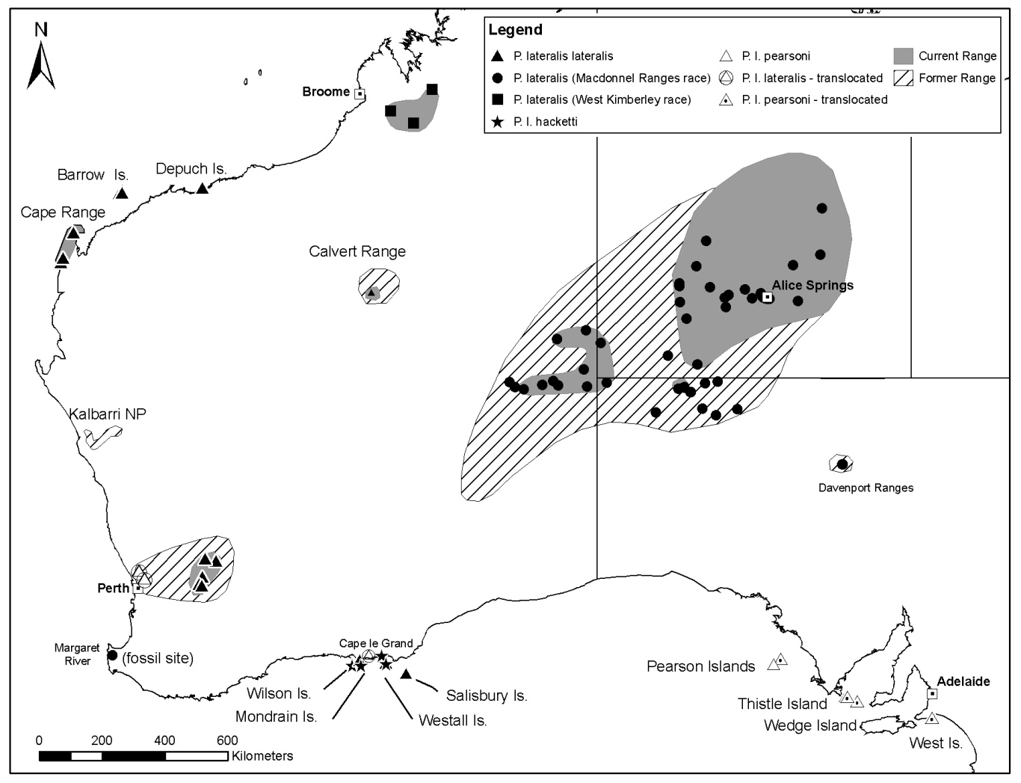

**Figure 1: The distribution of the various subspecies and races of the black-footed rock wallaby (*P. lateralis*)*.* Solid colour represents extant range and hatched areas the former range. [The Depuch Island population is now extinct. The Margaret River fossil record is presumably *P. l. lateralis*]**

**Black-footed rock wallaby ▪ Black-flanked rock wallaby**

*Petrogale lateralis lateralis* (Macropodidae)

Warru (Calvert Range population), Moororong/bokal (Nyungar)

***Conservation status***

IUCN Red List 2011: **Near threatened**

EPBC Act: **Vulnerable**

WA Wildlife Conservation Act 1950: **Fauna that is rare or is likely to become extinct**

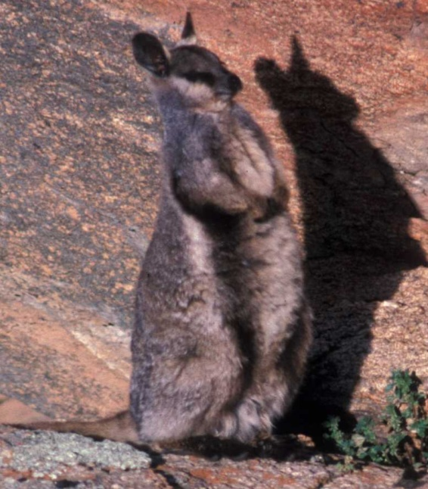

Photo: David Pearson - DPaW

***Description***

Adult males of *P. l. lateralis* weigh 4.1-5.0kg and females 3.1-3.8kg (Eldridge and Pearson 2008). It has dark grey-brown dorsal fur, with a paler chest which grades to dark brown on the belly. There are prominent black and white lateral stripes extending from the armpit to the hip. The coat is thick especially about the rump, flanks and tail. The face is dark-grey with a prominent white cheek stripe extending to the ear and edged by a dark-brown to black stripe from the snout through the eye and to the ear. There is a variably developed dark-brown to black stripe running along the midline of the head from between the eyes and ears, down the neck and onto the back. The feet and forearms are sandy yellow, darker below with dark brown to black paws. The tail is grey-brown grading to black at the distal end with a slight terminal brush (Eldridge and Pearson 2008).

***Biology and ecology***

They are primarily crepuscular and nocturnal emerging from their shelters to feed on grasses, forbs, browse and occasionally seeds and fruits such as figs. Typically they forage close to their rocky refuges to allow rapid retreat from predators. Known predators include foxes, dingoes/dogs, feral cats, eagles, pythons and large goannas (Eldridge and Pearson 2008). Body condition is linked to rainfall and females in good body condition tend to breed more frequently. In WA Wheatbelt populations, births are distributed throughout the year but with peaks in autumn and late winter/spring (Willers *et al.* 2011).

***Distribution***

At the time of colonial settlement, *P. lateralis* was distributed patchily across much of the western half of Australia. Despite this vast distribution, populations were scattered and restricted to sites where suitable rocky habitat existed. The widely disjunct current distribution suggests that there must have been intervening populations, a proposition supported by sub-fossil records from south-west WA.

The northern-most records of this subspecies are from Depuch Island on the northern margin of the Pilbara. This population is now extinct. East of the Pilbara Region in the Little Sandy Desert, *P. l. lateralis* formerly occurred in a number of ranges including the Durba Hills (Pearson 1992), Sir Fowell Headland (Burbidge and Pearson 1989), the Carnarvon Ranges (Eldridge and Pearson 2008) and the Calvert Range (Burbidge and Pearson 1989, Hall and Kinnear 1991). They are only known to still be extant in the Calvert Range (Fig. 1).

A north-western outlier of *P. l. lateralis* extends south from North-west Cape through Cape Range NP, including the Learmonth Air Weapons Range and into Ningaloo Station. Extant populations occur in several gorges through this area where suitable caves and crevices exist.

In the WA Wheatbelt, it is still extant at a total of seven sites: Nangeen Hill, Sales Rock Mount Caroline, Mount Stirling and Gundaring NRs; it was translocated to Querekin Rock; and independently dispersed to establish populations at Gardiner’s Rock (now extinct) and Kokerbin NR.

To the west of the Wheatbelt populations, *P. l. lateralis* formerly occurred along the Avon Valley behind Perth (where the type specimen was collected by John Gilbert).

*P. l. lateralis* is known to have occurred on the southern coastline of WA (Baynes 1987) perhaps as far east as Mount Ragged (Pearson and Kinnear 1997) and there are sub-fossil records from Devil’s Lair Cave near Margaret River (Dortch and Merrilees 1971, Merrilees 1979), although there are no records from this area since colonial settlement. There is also evidence (old scats) from several Wheatbelt rocks near Mukinbudin and at Knungajin Hill, 35km north-west of Merredin.

This taxon is also found on Salisbury Island (368ha) in the Recherche Archipelago, and on Barrow Island (23,483ha).

***Populations***

*Barrow Island:* Off the Pilbara coast, this island has a small population living along its west coast. Butler (1970) estimated that there were more than 500 individual rock wallabies living in “multiple cliff colonies which extend over some eight miles of coast and in some places go two miles inland”. Hall and Kinnear (1991) estimated the Barrow Island population to be about 150-200 individuals. The population is probably limited by a lack of suitable diurnal shelter and the absence of surface water supplies. Suitable caves and crevices occur in limestone sea-cliffs along a limited section of the west coast and a few isolated limestone outcrops further inland.

*Cape Range:* A population of rock wallabies in Cape Range at Ningaloo Station was used by Kinnear (1995) as an unbaited control population in his studies on the impact of fox predation on rock wallabies. While numbers of rock wallabies were initially high, they declined during the study. By 2000, few rock wallabies were present (J. Kinnear pers. comm.). Inspection of these two gorges in 2008 found the rock wallabies to be numerous and conspicuous (D. Pearson pers. obs.); their persistence perhaps linked to honeycomb weathering of limestone resulting in extensive multi-layered caves. Ningaloo Station is a sheep property but also derives income from harvesting feral goats and tourism. Ningaloo Station remains privately owned and managed with no fox or goat control occurring on the property (M. Prophet pers. comm. 2011).

*Salisbury Island (Recherche Archipelago):*In 2006 rock wallabies were found to be abundant with many observed and large faecal pellet accumulations indicating a sizeable population (D. Pearson pers. obs).

*WA Wheatbelt:*Populations occur in five small NRs (Mount Caroline, Mount Stirling, Gundaring, Kokerbin and Nangeen Hill) in the WA Wheatbelt. Two populations are situated on private land at Querekin and Sales Rocks. A small number of wallabies were present on Gardiner’s Rock until 2007. Fox control around WA Wheatbelt populations has been very successful in increasing numbers from near-extinction levels. In more recent years, boom-bust cycles have raised concerns about the effectiveness of predator control (in particular feral cats), overgrazing and impacts on neighbouring farmers’ crops and threatened flora.

***Translocated populations***

*Avon Valley, Walyunga and Paruna:* Wheatbelt animals have been translocated into Avon Valley and Walyunga NPs and adjoining Paruna Sanctuary controlled by the Australian Wildlife Conservancy (Orell 2001). The species had been absent from the Avon Valley for a considerable but unknown time, an area that Gould (1842) had reported the species to be “very abundant”.

*Cape Le Grand NP:* A translocation of rock wallabies (*P. l. lateralis*) to Cape Le Grand NP east of Esperance was carried out in 2003, with animals from Mount Caroline and Querekin Rock in the Wheatbelt (Orell 2003). Cape Le Grand NP has an area of 31,578ha and is considered to be part of the historic range of the species (Baynes 1987). It contains a large area of granite and dolerite outcrops with numerous caves. Camera trapping, begun in 2011, has confirmed this population is still extant, with an un-tagged female with young at heel observed. It was proposed to supplement this translocation with further individuals in the future.

***Habitat***

*P. l. lateralis* in the WA Wheatbelt is found in a series of granite inselbergs separated by farmland. They shelter in caves and crevices between boulders and occasionally in machinery sheds and other buildings of nearby farms. The vegetation in their habitat is typically acaciashrubland or open eucalypt woodland with areas of native and introduced grasses providing the majority of feeding sites on the apron of colluvium around the base of the outcrops.

Along the Murchison River in Kalbarri NP, *P. l. lateralis* formerly occupied sandstone cliffs with caves and overhangs and boulder piles created by cliff collapses. The vegetation in the gorge is primarily eucalypts and *Melaleuca* spp. with seasonal grasses and herbs and on the gorge sides, open shrubland of a mixture of species dominated by *Acacia* spp. and *Allocasuarina* spp.

At Cape Range, rock wallabies occur in rugged and deeply dissected limestone outcrops and gullies. Caves are usually most extensive along seasonal watercourses and rock wallabies tend to be concentrated in these sites, especially where large sections of cliff have fallen leaving jumbled house-sized rock slabs. These provide numerous multi-entranced crevices, often shaded by large figs.

The Barrow Island population seeks daytime refuge in limestone caves and overhangs. One population is known to occur further inland, alongside an operating oil well, in a large outcrop of limestone. The limestone contains several caves and protected crevices under large boulders that have dropped from the cliff-line above. The vegetation comprises native fig (*Ficus platypoda)* and scattered shrubs over spinifex (D. Pearson pers. obs.).

Translocated populations of *P. l. lateralis* in the Avon Valley were released in an area of extensive granite and dolerite outcrops and cliffs on the eastern side of the Avon River. There are numerous caves and crevices within the outcrops with adjacent open grasslands and woodland (Orell and Dans 2002). Animals were reintroduced to Cape Le Grand NP on large granite exposures with overhangs and caves, surrounded by dense heathland and low shrublands in an area characterised by winter rainfall and relatively mild summers.

Habitat critical to the survival of *P. l. lateralis* includes: rocky substrates which have extensive development of multi-entranced caves, rock-piles and crevices that provide cool refuges from extremes of heat and protection from predators.

**Wheatbelt boom-bust cycles**

By September 1999, such was the recovery of rock wallaby populations as a result of fox baiting that they were causing crop damage in neighbouring farms. Fencing and translocations to other sites in south-western Australia were implemented. A study was made of the potential of contraceptive chemicals to slow the growth of the rock wallaby populations (Willers *et al.* 2011). Since 2010, there have been dramatic declines in rock wallaby populations at several outcrops for reasons that are not entirely apparent, but perhaps due to changes in baiting practices and the persistence of bait-shy foxes (N. Moore pers. comm.). Dramatic declines seen over summer 2011 are thought to be the result of overgrazing (a result of good fox control) of vegetation within about 20 metres of the best habitat (extensively fractured granite) due to a predator fear behaviour (Kinnear *et al* 2010) as some foxes were still present. Poor seasonal conditions have exacerbated this situation (N. Moore pers. comm. 2012).

***Threats***

* Predation by foxes, dingoes, wild dogs and feral cats
* Habitat degradation due to goats, weed invasion and rabbits
* Disturbance from mining/petroleum development
* Disturbance from tourism and recreational activities.

Fox predation was found to be the major threat to the persistence of WA Wheatbelt rock wallabies (Kinnear *et al.* 1988, 1998) and it is thought to be a critical issue for *P. l. lateralis* populations in the Calvert Range and Cape Range and a primary factor in their disappearance from Kalbarri NP (in concert with feral goats) (Pearson and Kinnear 1997).

Barrow Island populations have low levels of genetic variation, and are potentially threatened by disturbance from oil and gas extraction operations or fire.

***Recovery actions***

* Continue existing fox and cat control operations, monitor their effectiveness and modify as required.
* Construct a predator proof fence around Nangeen Hill NR to preserve this population.
* Control goats in Kalbarri, Cape Range and Avon Valley NPs.
* Prevent exotic introductions onto Salisbury Island.
* Translocate to areas of their former distribution.
* Undertake weed control, especially iceplant (*Mesembryanthemum* spp*.*) and cape weed (*Arctotheca calendula)* around populations where required.
* Implement fire management around populations to reduce the likelihood of large fires and to enhance habitat.
* Research the viability of existing populations and the factors preventing successful recruitment and dispersal.
* Create a breeding catalogue of animals with known genetic details to improve management of small populations and to plan better founder populations for translocations.
* Involve land-owners including Aboriginal communities in survey and management.

***References***

BAYNES, A. (1987). The original mammal fauna of the Nullarbor and southern peripheral regions: Evidence from skeletal remains in superficial cave deposits. In: N.L. McKenzie and A.C. Robinson (eds.) *A Biological Survey of the Nullarbor region, South and Western Australia in 1984.* pp. 139-152. South Australian Department of Environment and Planning, Adelaide.

BURBIDGE, A.A. and PEARSON, D.J. (1989). *A search for the Rufous Hare-wallaby in the Great Sandy and Little Sandy Deserts, Western Australia, with notes on other mammals.* Technical Report No. 23, Department of Conservation and Land Management, Como, W.A.

BUTLER, H. (1970). A summary of the vertebrate fauna of Barrow Island. *Western Australian Naturalist* 11: 149-160.

DORTCH, C.E. and MERRILEES, D. (1971). A salvage excavation in Devil’s Lair, Western Australia. *Journal of the Royal Society of Western Australia* **54**: 103-113.

ELDRIDGE, M.D.B. and PEARSON, D.J. (2008). Black-footed Rock wallaby *Petrogale lateralis.* Pp. 376-379 In: S. van Dyck and R. Strahan (eds.) *The Mammals of Australia* 3rd Edition. Reed New Holland, Sydney.

GOULD, J. (1842). *A Monograph of the Macropodidae, or family of kangaroos. Part 2.* The Author: London.

HALL, G.P. and KINNEAR, J.E. (1991). *Recovery Plan for the Black-flanked Rock wallaby, Petrogale lateralis lateralis* (Gould). Department of Conservation and Land Management report to Australian NPs and Wildlife Service: Canberra.

KINNEAR, J. (1995). The Cape Range Black-flanked Rock wallaby (*Petrogale lateralis*): A report on the population status and response of remnant populations to twice yearly baiting. Unpublished report for the Department of Conservation and Land Management, DPaW Library.

KINNEAR, J.E., KREBS, C.J., PENTLAND, C., ORELL, P. HOLME, C. and KARVINEN, R. (2010). Predator-baiting experiments for the conservation of rock wallabies in Western Australia: a 25-year review with recent advances. *Wildlife Research* **37**: 57-67.

KINNEAR, J.E., ONUS, M.L. and BROMILOW, R.N. (1988). Fox control and rock wallaby population dynamics. *Australian Wildlife Research* **15**: 435-450.

KINNEAR, J.E., ONUS, M.L. and SUMNER, N.R. (1998). Fox control and rock wallaby dynamics- II. An update. *Wildlife Research* **25**: 81-88.

MERRILEES, D. (1979). Prehistoric rock wallabies (Marsupialia, Macropodidae, *Petrogale)* in the far south-west of Western Australia, *Journal of the Royal Society of Western Australia* **61**: 73-96.

ORELL, P. (2001). Translocation proposal: Reintroduction of Black-footed Rock wallaby (*Petrogale lateralis lateralis*) from Mount Caroline Nature Reserve to Paruna Sanctuary. Unpublished manuscript, Department of Conservation and Land Management, Perth.

ORELL, P. (2003). Translocation proposal: Reintroduction of Black-flanked Rock wallaby (*Petrogale lateralis lateralis*) from Mount Caroline Nature Reserve and Querekin Rock to Cape Le Grand NP. Unpublished manuscript, Department of Conservation and Land Management, Perth.

ORRELL, P. and DANS, P. (2002). Translocation proposal: Reintroduction of Black-flanked Rock wallaby (*Petrogale lateralis lateralis*) from Mount Caroline Nature Reserve and Querekin Rock to Walyunga NP. Unpublished manuscript, Department of Conservation and Land Management, Perth.

PEARSON, D.J. (1992). Past and present distribution and abundance of the Black-footed Rock wallaby in the Warburton region of Western Australia. *Wildlife Research* **19**: 605-622.

PEARSON, D.J. and KINNEAR, J.E., (1997). A review of the distribution, status and conservation of rock wallabies in Western Australia. *Australian Mammalogy* **19**: 137-152.

WILLERS, N., MAWSON, P., MORRIS, K. and BENCINI, R. (2011). Biology and population dynamics of the black-flanked rock wallaby (*Petrogale lateralis lateralis*) in the central Wheatbelt of Western Australia. *Australian Mammalogy* **33**: 117-227.

**Black-footed rock wallaby ▪ Recherche subspecies**

*Petrogale lateralis hacketti* (Macropodidae)

***Conservation status***

IUCN Red List 2011: **Near Threatened**

EPBC Act: **Vulnerable**

WA Wildlife Conservation Act 1950: **Fauna that is rare or is likely to become extinct**

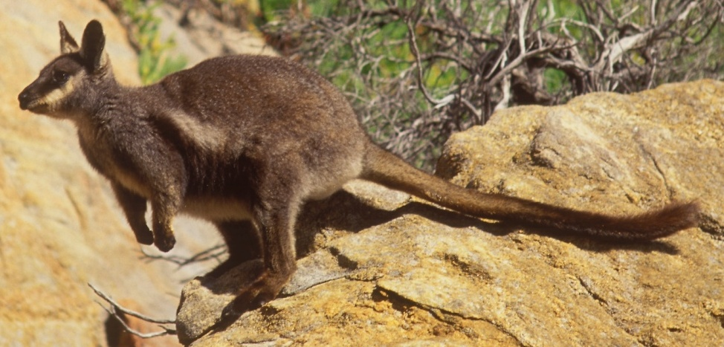

Photo: *Lochman Transparencies®*

***Description***

*P. l. hacketti* has a similar appearance to *P. l. lateralis* although it is slightly larger (4.8-5.3kg adult weight) and has a shaggier pelage. The dorsal fur is grey-brown with a paler chest. Prominent black and white lateral stripes extend to the hip. The tail is grey-brown grading to a black slightly brushed tip (Eldridge and Pearson 2008). It was originally described by Thomas (1905) from a specimen obtained by J.T. Tunney in 1904 on Mondrain Island. It had been collected 100 years earlier by Flinders but these specimens apparently have not survived (Eldridge 1997).

***Distribution***

*P. l. hacketti* occupies three windswept granite islands in the Recherche Archipelago off the southern coastline of WA: Mondrain (810ha), Westall (70ha); and Wilson Islands (90ha) (Pearson and Kinnear 1997, Fig. 1).

***Populations***

Serventy (1953) found that *P. l. hacketti* was “fairly plentiful” on Mondrain and Westall Islands. The Wilson Islands populations have been visited less frequently. In January 2006, Wilson and Westall Islands were visited for a day each and the rock wallabies were found to be abundant on both islands (D. Pearson pers. obs.). No regular monitoring of these populations has occurred, and as such there is no evidence of any decline in the distribution or abundance of this subspecies.

All three populations are considered important for the survival of this subspecies.

***Habitat***

The habitat of *P. l. hacketti* on the Recherche Archipelago consists of steep granitic islands with tors, rock-piles and deep crevices available for shelter. The islands rise abruptly from the Southern Ocean and have low wind-pruned communities of *Acacia, Allocasuarina* and *Melaleuca* spp. with large areas of skeletal soil covered by *Borya spp.* and succulents such as pigface (*Carpobrotus* spp.).

All habitat in which the subspecies currently occurs is considered habitat critical for their long-term survival.

***Biology and ecology***

The rock wallabies shelter in crevices and caves in the granite down to the water’s edge, especially where faulting of the granite results in multi-entranced radiating passages.

***Threats***

There are no immediate threats as the islands are remote and difficult to land on, discouraging visits by the public (D. Pearson pers. obs.). However, the introduction of foxes or cats or a large wildfire could conceivably result in an island extinction.

***Recovery actions***

* Prepare and implement island biosecurity protocols to prevent the introduction of exotic animals or weeds.
* Plan emergency responses to cope with the potential arrival of exotic animals or wildfire.
* Communicate to the public the need to maintain strict quarantine on the islands.

***References***

ELDRIDGE, M.D.B. (1997). Taxonomy of rock wallabies, *Petrogale* (Marsupialia: Macropodidae). II. An historical review. Australian Mammalogy **19**: 113-122.

ELDRIDGE, M.D.B. and PEARSON, D.J. (2008). Black-footed Rock wallaby *Petrogale lateralis.* Pp. 376-379. In: S. van Dyck and R. Strahan (eds.) *The Mammals of Australia* 3rd Edition. Reed New Holland, Sydney.

PEARSON, D.J. and KINNEAR, J.E., (1997). A review of the distribution, status and conservation of rock wallabies in Western Australia. *Australian Mammalogy* **19**: 137-152.

SERVENTY, V.N. (1953). Mammals. Pp. 40-48 in *The Archipelago of the Recherche: Part 4.* Australian Geographical Society: Melbourne.

THOMAS, O. (1905). On some Australasian Mammals. *Annals and Magazine of Natural History* **16**: 422-428.

**Black-footed rock wallaby ▪ MacDonnell Range race**

*Petrogale lateralis* MacDonnell Ranges race (Macropodidae)

(*Warru*- several desert Aboriginal languages and dialects)

***Conservation status***

IUCN Red List 2011: **Near threatened**

EPBC Act: **Vulnerable**

SA National Parks and Wildlife Act 1972: **Endangered**

WA Wildlife Conservation Act 1950: **Fauna that is rare or is likely to become extinct**

Territory Parks and Wildlife Conservation Act 2006: **Near Threatened**

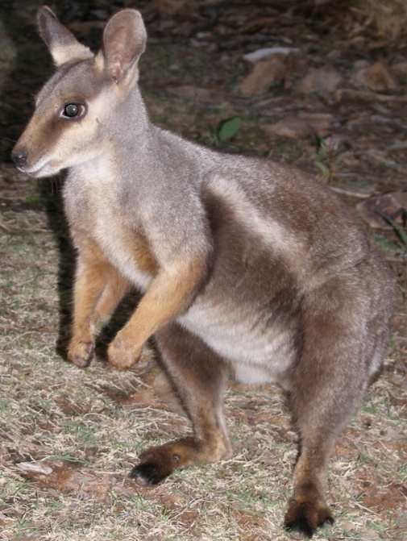

Photo: David Pearson - DPaW

***Description***

This race of *P. lateralis* was identified by Briscoe *et al.* (1982) and is generally considered an undescribed subspecies (Eldridge 1997). The appearance of this race is similar to *P. l. lateralis*, although the coat is shorter. It is dark grizzled brown on the back with grey shoulders. It changes to a predominantly sandy-brown pelage in summer. A stripe of dark brown to black runs from between the ears to below the shoulders. A white side-stripe bordered with a wider dark brown stripe extends from the axillary area to the thighs. The chest is paler and the belly is buff (Eldridge and Pearson 2008). The head is grey with a white cheek-stripe, the snout is brown while the ears are dark brown with a paler smoky brown base. The tail is dark grey, becoming browner distally with a black terminal brush which tends to be less distinct than that of *P. l. lateralis* (Eldridge and Pearson 2008).

***Distribution***

This taxon occurs in northern SA, the central-eastern portion of WA and southern NT. An accurate historic extent has been difficult to assess as much of the potential former range is remote and there have been limited surveys. Nonetheless, it is apparent that in SA (Ward *et al.* 2011) and WA (Pearson 1992), there has been dramatic declines in both the taxon’s range and abundance. At the time of colonial settlement, it was distributed across the northern section of SA, central western WA and a vast area of southern NT (Lundie-Jenkins and Findlay 1997, Gibson 2000) (Fig. 1).

*P. l.* MacDonnell Range race remains widespread and common in many places in the NT, with recent records from remote areas such as the Petermann Ranges, Bloods Range and Davenport Ranges. There are no recent records from Uluru or Kata Tjuta (last record mid-1980s), but they are considered extant at Mount Conner, Harts Range, Mount Windajong and the George Gill Range. In the MacDonnell Ranges, populations are known from Glen Helen to Loves Creek (Gibson 2000).

In SA, it has disappeared from 93 per cent of its former range and extant metapopulations are now only known to persist at two sites: the eastern Musgrave Range (Pukatja to New Well) and the Tomkinson/Hinckley Ranges (three sites). A population at Wamitjara in the eastern Musgrave Ranges disappeared around 2006 (Read and Ward 2011). An isolated population in the Davenport Ranges (SA) lapsed to extinction around 1998 (Moseby *et al.* 1998).

In WA, the race is now extinct across much of its former southern range and survives in isolated pockets in the Townsend Ridges, Cavenagh, Morgan, Bell Rock, Rawlinson and Walter James Ranges (Pearson 1992, Pearson and Kinnear 1997).

***Populations***

There have been no estimates reported for any populations in the NT. In WA this race can be described as abundant only at Pungkulpirri Rockhole in the Walter James Range. Elsewhere, individuals are rarely observed and populations are widely fragmented (Pearson 1992).

In SA, it is estimated that the eastern Musgrave Range metapopulation numbers 150-200 animals, while the Tomkinson Range populations total between 30 and 50 individuals (Read and Ward 2011, Ward *et al.* 2011).

All populations of *P. l.* MacDonnell Range race in SA and in WA are considered important to the survival of this taxon across its existing range. It is noteworthy that considerable genetic variation is apparent (Eldridge *et al.* 1992). The MacDonnell Ranges (NT) remains the stronghold for the taxon.

***Habitat***

This taxon occurs in numerous extensive ranges, especially the sedimentary MacDonnell Ranges, which contains huge cliffs, numerous caves, gorges and cliff collapses with a wealth of shelter sites. Other populations occur in granite boulder piles, metamorphic schists around Alice Springs, granophyre ranges in WA and many sedimentary (quartzite and sandstone) ranges and hills. The vegetation over most of these rocky sites consists of open low shrublands with spinifex and occasional figs, often with more diverse shrublands, grasslands or herbfields on the slopes and aprons below the outcrops. Where watercourses dissect the ranges, there may be permanent or semi-permanent water and seepages that give rise to more mesic vegetation including soft grasses and herbs.

Habitat features thought to be critical to survival of this taxon include areas of rocky habitat that have numerous caves, rock-piles and crevices. These areas provide cool shelter from temperature extremes during the day and sufficient ruggedness to permit escape from predators. Access to suitably palatable grasses, forbs, seeds and fruit close to their refuges is also required.

***Biology and ecology***

This taxon emerges from its daytime rocky refuges in the late afternoon or early evening and feeds on plants and shrubs on the outcrops and surrounding flats. They usually demonstrate high site fidelity but have the ability to move long distances (Ruykys *et al*. 2011). A peak in births in autumn-winter has been reported and juvenile survival has been correlated with winter rainfall (Ward *et al.* 2011)

***Threats***

Threats to *P. l.* MacDonnell Range race are thought to include:

* Predation by foxes, feral cats, wild dogs and dingoes
* Habitat degradation due to camels and grazing livestock
* Spread of weedy species, especially buffel grass.

Southern populations have declined dramatically (Pearson 1992, Read 2001), presumably due to fox predation. Further north, the decline of *P. lateralis* in the NT has not been as dramatic, perhaps reflecting lower fox densities as well as larger and more continuous areas of habitat. However, rock wallabies have disappeared from many areas, while in other areas of seemingly good habitat (e.g. MacDonnell Range), rock wallaby colonies are scattered and relatively small (Gibson 2000). Foxes, cats and/or dogs may have a strong role in restricting these populations.

***Recovery actions***

* Survey known, and search for new, populations and determine genetic variability and current conservation status.
* Expand existing fox and cat control operations and monitor their effectiveness.
* Control rabbits, camels and euros were these compete significantly with rock wallabies.
* Captive breed and translocate rock wallabies to vacant habitat.
* Undertake weed control (e.g. buffel grass) around populations where required.
* Implement fire management to reduce the likelihood of large fires and to enhance habitat condition.
* Research the viability of existing populations and the factors preventing successful recruitment and dispersal.
* Involve land-owners including Aboriginal communities in the survey and management of rock wallabies.

***References***

BRISCOE, D.A., CALABY, J.H., CLOSE, R.L., MAYNES, G.M., MURTAGH, C.E. and SHARMAN, G.B. (1982). Isolation, introgression and genetic variation in rock wallabies. In: R.H. Groves and W.D.L. Ride (eds.) *Species at Risk: Research in Australia*. Pp. 73-87. Australian Academy of Science: Canberra.

ELDRIDGE, M.D.B. (1997). Taxonomy of rock wallabies, *Petrogale* (Marsupialia: Macropodidae). II. An historical review. *Australian Mammalogy* **19**: 113-122.

ELDRIDGE, M.D.B., BELL, J.N., PEARSON, D.J. and CLOSE, R.L. (1992). Identification of rock wallabies from the Warburton region as *Petrogale lateralis* MacDonnell Ranges race. *Australian Mammalogy* **15**: 115-119.

ELDRIDGE, M.D.B. and PEARSON, D.J. (2008). Black-footed Rock wallaby *Petrogale lateralis.* Pp. 376-379. In: S. van Dyck and R. Strahan (eds.) *The Mammals of Australia* 3rd Edition. Reed New Holland, Sydney.

GIBSON, D.F. (2000). Distribution and conservation status of the Black-footed Rock wallaby, *Petrogale lateralis* (MacDonnell Ranges race), in the Northern Territory. *Australian Mammalogy* **21**: 213-236.

LUNDIE-JENKINS, G. and FINDLAY, E. (1997). Distribution and status of rock wallabies in the Northern Territory. *Australian Mammalogy* **19**: 175-182.

MOSEBY, K., READ, J., GEE, P. and GEE, I. (1998). *A study of the Davenport Range Black-footed Rock Wallaby colony and possible threatening processes*. Final Report to Wildlife Conservation Fund, Dept Environment and Heritage, Adelaide.

PARTRIDGE, T. (2011). Status of warru (*Petrogale lateralis* MacDonnell Ranges race) in the Anangu Pitjantjatjara Yankunytjatjara Lands of South Australia. 2. Population dynamics *Australian Mammalogy* **33:** 142-151.

PEARSON, D.J. (1992). Past and present distribution and abundance of the Black-footed Rock wallaby in the Warburton region of Western Australia. *Wildlife Research* **19**: 605-622.

PEARSON, D.J. and KINNEAR, J.E. (1997). A review of the distribution, status and conservation of rock wallabies in Western Australia. *Australian Mammalogy* **19**: 137-152.

READ, J. (2001). Status of the known Warru (Black-footed Rock wallaby) populations in the Anangu-Pitjantjatjara lands of South Australia; August 2001. Unpublished report to SA Department of Environment and Heritage.

READ, J. and WARD, M. (2011). *Warru Recovery Plan.: Recovery of Petrogale lateralis MacDonnell Ranges race in South Australia, 2010-2020*. Department of Environment and Natural Resources, Adelaide, S.A.

RUYKYS, L., WARD, M.J., TAGGART, D.A. and BREED, W.G. (2011). Preliminary spatial behaviour of warru (*Petrogale lateralis* MacDonnell Ranges race) in the Anangu Pitjantjatjara Yankunytjatjara Lands, South Australia. *Australian Mammalogy* **33:** 181-188.

WARD, M.J., URBAN, R., READ, J.L., DENT, A., PARTRIDGE, T., CLARKE, A. and VAN WEENEN, J. (2011). Status of warru (*Petrogale lateralis* MacDonnell Ranges race) in the Anangu Pitjantjatjara Yankunytjatjara Lands of South Australia. 1. Distribution and decline. *Australian Mammalogy* **33:** 135-141.

**Black-footed rock wallaby ▪ Pearson Island rock wallaby**

*Petrogale lateralis pearsoni* (Macropodidae)

***Conservation status***

IUCN Red List 2011: **Near threatened**

EPBC Act: **Not Listed**

SA National Parks and Wildlife Act 1972: **Not Listed**

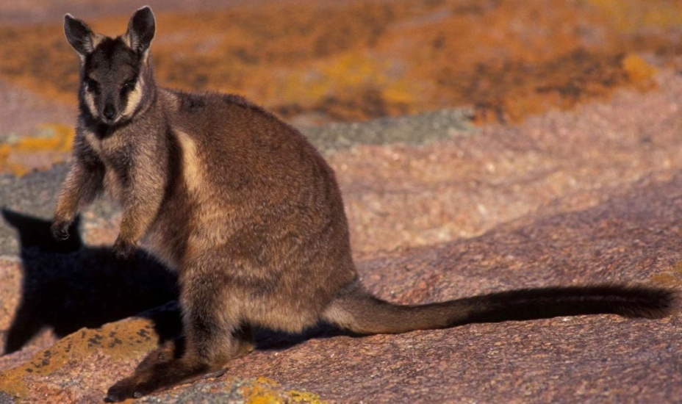

Photo: David Pearson - DPaW

***Description***

Thomas (1922) described *P. l. pearsoni* as “comparatively small”, about the same size as *P.* *l. lateralis,* but smaller than *P. l.* *hacketti*. Adult males and females on Pearson Island are smaller (mean weights 4.08kg and 3.43kg respectively) than the translocated animals on Wedge Island (males 4.48kg and females 4.05kg) (McIlwee and Jones 2010).

It is dark grizzled grey on the back with grey-silver fur on the shoulders and neck. The coat is generally thicker and ‘woollier’ than *P. l. lateralis.* The chest and belly are pale yellow to buff. A distinct dark brown dorsal stripe runs from between the ears over the head and down the back to below the shoulders. There is a prominent white side-stripe running from the axillary region of the foreleg to the thigh, with a wider dark brown stripe on its distal edge. The face is dark grey-brown with a wide buff cheek stripe and a dark stripe through the eye. Ears are dark with a paler section across the base. The forearms are off-white to buff with dark brown or black paws. The digits on the feet are black or dark brown. The tail is light brown, grading to black at the distal end and there is a slight terminal brush (Eldridge and Close 1995, Eldridge and Pearson 2008).

***Biology and ecology***

The partly diurnal habits of *P. l. pearsoni* were noted by Wood Jones (1968) who remarked “it is a conspicuous creature readily seen from the deck of a ship passing under shelter of the eastern side of the group”. He described its apparently awkward forward-leaning gait when bounding through level saltbush areas, but found it to be “a very different creature when seen upon the huge, fantastic, granite boulders. Here its movements are astonishing; there seems to be no leap it will not take, no chink between boulders into which it will not hurl itself”.

***Distribution***

Historically, this subspecies only occurred on the northern islet of the Pearson Islands in the Investigator Group, off Elliston on the southern coastline of SA (Robinson 1980). Fossil material has been found on St Peters Island off Ceduna, but it appears to have been extinct there prior to colonial settlement (Robinson 1989, Robinson *et al.* 1996). During an expedition in 1960, although unplanned, six rock wallabies were accidentally released on the southern islet of Pearson Island. They increased in number to about 150 individuals (Copley and Alexander 1997). The total area of North and South Pearson Islands is 213ha (Fig. 1).

***Populations***

Two translocations of 15 *P. l. pearsoni* were undertaken to Thistle Island (3,925ha) in 1974 and 1975. The rock wallabies spread across the island and by 1979 were estimated to number over 350, making it the largest population of the taxon (Armstrong pers. comm. in Copley and Alexander 1979).

In 1975, 11 *P. l. pearsoni* were translocated to Wedge Island (947ha). By 1997, they were estimated to number 100-200 individuals (Copley and Alexander 1997). Another translocation attempt to move rock wallabies from North Pearson Island to West Island (14ha) off the Fleurieu Peninsula in 1974 was unsuccessful (Copley and Alexander 1997).

All populations are considered important to the survival of *P. l. pearsoni.*

***Habitat***

The habitat of *P. l. pearsoni* on the Pearson Islands is similar to that of *P. l. hacketti*, consisting of steep granitic islands with deep faults and crevices available for shelter. The vegetation is primarily low wind-swept shrubland of *Atriplex* sp. with some areas of deeper soil with *Acacia sp.*

***Threats***

* Introductions to the islands of foxes, feral cats or dogs
* Small population size and perturbations linked to drought or fire.

***Recovery actions***

* Prepare and implement biosecurity protocols for islands to prevent the introduction of exotic animals or weeds.
* Plan emergency responses to the potential arrival of exotic animals and wildfire.
* Monitor populations and islands to allow early detection of any disease or pest introduction and to determine population trends.
* Communicate to the public the need to maintain strict quarantine on the islands.

***References***

COPLEY, P.B. and ALEXANDER, P.J. (1997). Overview of the status of rock wallabies in South Australia. *Australian Mammalogy* **19**: 153-162.

ELDRIDGE, M.D.B. and CLOSE, R.L. (1995). Black-footed Rock wallaby, *Petrogale lateralis.* Pp. 377-381. In: R. Strahan (ed.). *The Mammals of Australia.* Australian Museum/ Reed Books: Sydney.

ELDRIDGE, M.D.B. and PEARSON, D.J. (2008). Black-footed Rock wallaby *Petrogale lateralis.* Pp. 376-379. In: S. van Dyck and R. Strahan (eds.) *The Mammals of Australia.* 3rd Edition. Reed New Holland, Sydney.

McILWEE, A. and JONES, M. (2010). *Petrogale lateralis pearsoni*. Species Profiles and Threats (SPRAT) database. [www.environment.gov.au/sprat](http://www.environment.gov.au/sprat) Department of Environment and Heritage, Canberra.

ROBINSON, A.C. (1980). Notes on the mammals and reptiles of Pearson, Dorothee and Greenly Islands, South Australia. *Transactions of the Royal Society of South Australia* **104**: 93-99.

ROBINSON, A.C. (1989). Island management in South Australia. In: A.A. Burbidge (ed.). *Australia and New Zealand Islands: Nature and Conservation Values and Management.* Dept. of Conservation and Land Management, Perth, W.A.

ROBINSON, A., CANTY, P., MOONEY, T. and RUDDUCK, P. (1996). *South Australia’s Offshore Islands*. Australian Heritage Commission, Australian Government Publishing Service: Canberra, Australia.

Thomas J. 1922. The bandicoots of Nuyts Archipelago, S. Australia and of Cape York, northern Queensland. *The Annals and Magazine of Natural History (ninth series)* 9, 677-679

WOOD JONES, F. (1968). *The Mammals of South Australia. Parts I-III 1923-1925.* Photolitho reprint, South Australian Museum, Adelaide.

**Black-footed rock wallaby ▪ West Kimberley race**

*Petrogale lateralis* West Kimberley race (Macropodidae)

***Conservation status***

IUCN Red List 2011: N**ear threatened**

EPBC Act: **Vulnerable**

WA Wildlife Conservation Act 1950: **Fauna that is rare or is likely to become extinct**

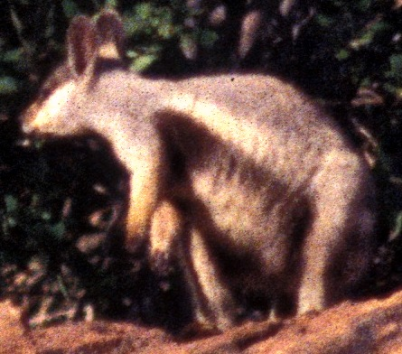

Photo: David Pearson - DPaW

***Description***

This taxon was identified on genetic grounds by Briscoe *et al.* (1982) and is considered an undescribed subspecies of *P. lateralis* (Eldridge 1997). It is of similar size to *P. l. lateralis* with adult males ranging from 3.5 to 6.5kg and adult females 3.3 to 4.2kg. The markings are similar to that of *P. l. lateralis*, but it is generally paler and distinctly yellowish (Eldridge and Pearson 2008).

***Distribution***

This taxon is known from comparatively few scattered ranges and rock outcrops and only one conservation reserve in the West Kimberley Region of WA. There is little available information on the historic range. Known historic sites include Mount Wynne (1901) Mount Anderson (undated), Mount Alexander (1911), Edgar Range (1961, 1976, 1977) (Pearson and Kinnear 1997, Youngson *et al.* 1981, M. Eldridge pers. comm.). Current sites include Erskine Range (Pearson and Kinnear 1997), Edgar Range, Grant Range, Dogspike Hill and Done Hill (Fig. 1).

***Populations***

The Erskine and Edgar Ranges are important to this taxon’s survival due to the large area of habitat, their location at the northern and southern ends of the distribution and the likely size of the populations. There is limited information on the number and size of populations and on possible population trends. Populations exist on pastoral leases and Aboriginal reserves.

***Habitat***

The West Kimberley race of *P. lateralis* is known from comparatively few scattered ranges and rock outcrops. Populations occur on low flat-topped sedimentary hills and shelter in caves and crevices below boulders that have fallen from the cliffs above. The climate is arid-tropical with a strong summer bias in rainfall and the vegetation is primarily acaciashrubland or boab woodland with spinifex, but in wetter pockets there may be pandanusand eucalypts lining creeklines through rock-piles.

Features of habitat critical to survival of this species are thought to include extensive areas of rocky habitat with caves, crevices and cliff collapses that provide multi-entranced shelters from extreme daytime temperatures and predators. Suitable palatable grasses and forbs in close proximity to these shelters are also required.

***Biology and ecology***

There have been no specific studies of this taxon.

***Threats***

Foxes are known to occur infrequently along the southern side of the Edgar Ranges but their potential impact on the rock wallabies is unknown. Predation by feral cats, dingoes and wild dogs is likely. One local land-holder burns areas around the Erskine Range close to the highway (frequency unknown) but this appears to have little obvious impact on rock wallaby numbers.

Habitat degradation due to stock is probable especially around Logues Spring in the Edgar Ranges.

***Recovery actions***

* Resurvey known populations for any changes to regional and local rock wallaby distribution in southern Kimberley (Erskine and Edgar Ranges, Mt Alexander).
* Conduct research on the impacts of predation and fire on the species.
* Work with land-holders to implement a patch burn strategy to reduced likelihood of large fires in the Edgar and Erskine Ranges.

***References***

BRISCOE, D.A., CALABY, J.H., CLOSE, R.L., MAYNES, G.M., MURTAGH, C.E. and SHARMAN, G.B. (1982). Isolation, introgression and genetic variation in rock wallabies. Pp. 73-87. In: R.H. Groves and W.D.L. Ride (ed.). *Species at Risk: Research in Australia* Australian Academy of Science: Canberra.

ELDRIDGE, M.D.B. (1997). Taxonomy of rock wallabies, *Petrogale* (Marsupialia: Macropodidae). II. An historical review. *Australian Mammalogy* **19**: 113-122.

ELDRIDGE, M.D.B. and PEARSON, D.J. (2008). Black-footed Rock wallaby Petrogale lateralis. Pp. 376-379. In: S. van Dyck and R. Strahan (eds.) The Mammals of Australia. 3rd Edition. Reed New Holland, Sydney.

PEARSON, D.J. and KINNEAR, J.E., (1997). A review of the distribution, status and conservation of rock wallabies in Western Australia. *Australian Mammalogy* **19**: 137-152.

YOUNGSON, W.K., HENRY. J. and McKENZIE, N.L. (1981). Mammals. Pp. 39-45 In: N.L. McKenzie (ed.).*Wildlife of the Edgar Ranges area, South- west Kimberley, Western Australia* Wildlife Research Bulletin 10, Department of Fisheries and Wildlife: Perth.

**Short-eared rock wallaby ▪** *Petrogale brachyotis* (Macropodidae)

***Conservation status***

IUCN Red List 2011: **Least Concern**

EPBC Act: **Not listed**

WA Wildlife Conservation Act 1950: **Not listed**

*Territory Parks and Wildlife Act 2006*: **Least Concern**

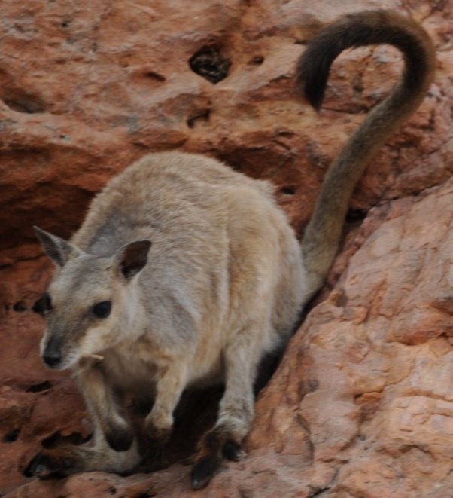

Photo: David Pearson - DPaW

***Description***

The short-eared rock wallaby is a moderately-sized macropod with average adult male weights of 4.4kg (range 3.2-5.6kg) and females 3.7kg (range 2.2-4.7kg). It is very variable in colour and size. Generally, the fur is fine, short and uniform greyish-brown, flecked with silver-grey hairs which may give it a “glistening appearance” (Menkhorst and Knight 2004). The legs and hips are cinnamon brown, the underparts grey and the ends of the feet black. The head is grey and the snout brownish with a white jaw stripe. The ears are less than half the length of the head, being proportionately shorter than the ears of *P. concinna* and *P. burbidgei.*

While two subspecies are currently recognized (*P. b. brachyotis* and *P. b. signata*), Sharman *et al.* (1995) questioned the validity of the latter subspecies and instead favoured the division of *brachyotis* into three interim geographic races. The ‘Kimberley race’ covers those populations in Western Australia, for which *P. b. brachyotis* is the appropriate name*.* The ‘Victoria River’ race includes those populations in the Victoria River district of the western Northern Territory. The ‘Arnhem Land’ race encompasses variable populations formerly ascribed to the three species of Thomas (1926) and extends from the Alligator Rivers region, through Arnhem Land to the western Gulf of Carpentaria including Groote Eylandt (Sharman *et al.* 1995).

Kimberley race animals have pale grey-brown backs with white to greyish-white on the belly. Markings are subtle with a small dark brown stripe from the neck to the shoulder; a white axillary patch but no side stripe, and in some individuals a faint hip-stripe (Sharman *et al.* 1995). Victoria River race animals have almost no markings with just a short white neck stripe and small axillary patch. Arnhem Land race animals are dark grey or brown on the back, with a prominent white side-stripe, a distinct dark-brown to black stripe on the midline of the neck and down the back and sometimes with a black axillary patch and pale hip-stripe. In some populations of this race, the forearms and legs are pale to bright cinnamon (Eldridge and Telfer 2008, Sharman *et al.* 1995).

***Distribution***

*P. brachyotis* is widespread, though patchily distributed across north-western and central northern tropical regions from Windjana Gorge near Broome in WA to the NT-Queensland border on the Gulf of Carpentaria. It extends further south into lower rainfall zones than *P. burbidgei* and *P. concinna* to about the 600mm mean rainfall isohyet (Sharman *et al.* 1995, Pearson and Kinnear 1997, Eldridge and Telfer 2008).

While it is commonly observed at several locations in the Kimberley Region, such as Mirima NP alongside the town of Kununurra, Windjana Gorge and around Lake Argyle, there have been no systematic surveys of the species in WA. It is not known on any WA islands, except those formed by the flooding of Lake Argyle (Abbott and Burbidge 1995, D. Pearson unpublished data).

In the NT, *P. brachyotis* has been recorded across the Top End from the WA border to at least the Queensland border (see Fig. 2). While there are few records from central and eastern Arnhem Land, this is probably related to limited survey work rather than rarity (Lundie-Jenkins and Findlay 1997). In contrast, surveys in Kakadu NP on the western edge of Arnhem Land have resulted in many records from this area (Press 1988). It is known from 19 NT islands (see Table 8).

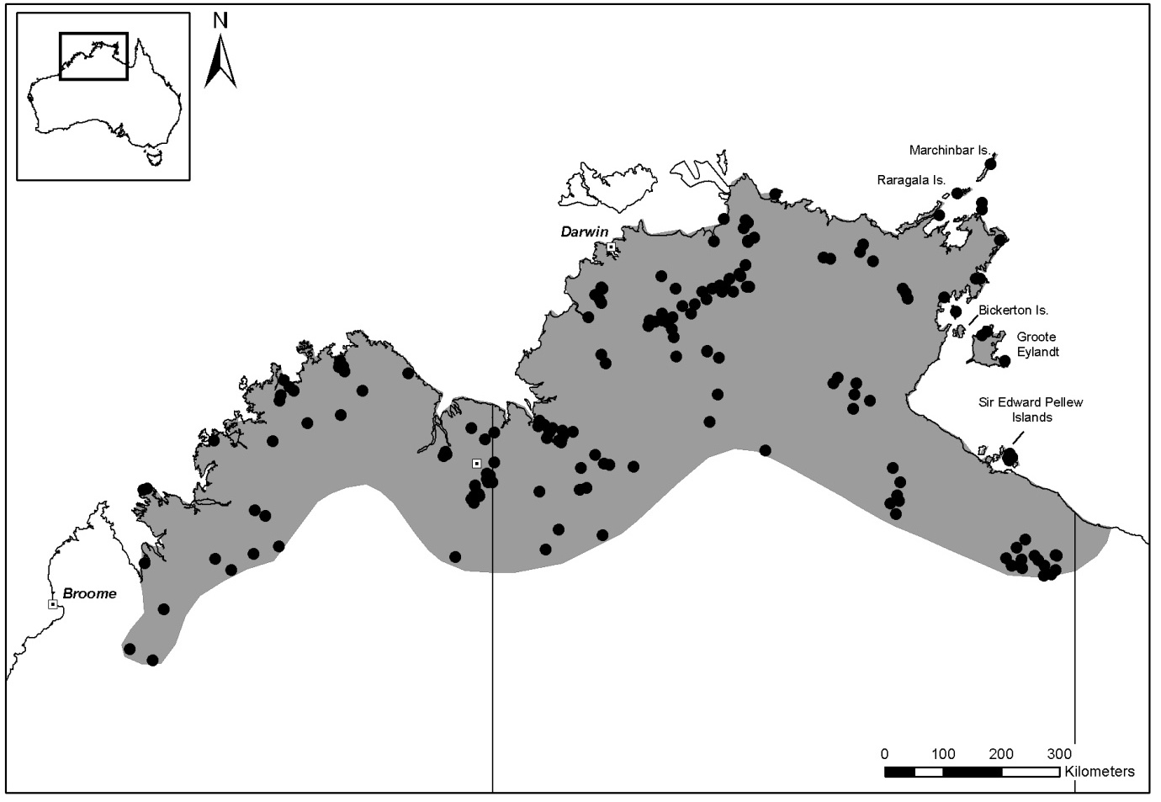

**Figure 2: The distribution of the short-eared rock wallaby (*P. brachyotis*) from records in the NT and WA museum databases (dots show the locations of museum specimens).**

**Table 8: Islands with populations of *P. brachyotis* (information from Johnson and Kerle 1991 unpublished, Lundie-Jenkins and Findlay 1997, Menkhorst and Knight 2001, Abbott 1980, Abbott and Burbidge 1995, Woinarski *et al.* 1999). All these islands are in the NT**

|  |  |  |
| --- | --- | --- |
| **Island** | **Area (ha)** | **Location** |
| Alger | 778 | Wessel Islands |
| Astell | 1,143 | English Company Islands |
| unnamed | 1.3 | west of Astell Island |
| Bickerton | 22,592 | 15 km NW of Groote Eylandt |
| Bumaga | 333 | Cunningham Islands |
| Centre | 9,222 | Sir Edward Pellew group |
| Cotton | 1,974 | English Company Islands |
| Djeergaree | 290 | Wessel Islands |
| Drysdale | 5,450 | Wessel Islands |
| Graham | 784 | 2km NE of Elcho Island |
| Groote Eylandt | 228,520 |  |
| Guluwuru | 7,625 | Wessel Islands |
| Inglis | 8,830 | English Company Islands |
| Jirrgarri | 701 | Cunningham Islands |
| Marchinbar | 20,973 | Wessel Islands |
| North | 5,778 | Sir Edward Pellew group |
| South | 42 | Wessel Islands |
| Raragala | 9,399 | Wessel Islands |
| unnamed | 8.7 | southern end of Raragala Island |
| Rimbija | 211 | Wessel Islands |
| Vanderlin | 27,690 | Sir Edward Pellew group |
| Warnawi | 194 | Cunningham Islands |
| Wigram | 2,283 | English Company Islands |
| unnamed | 0.6 | just west of Wigram Island |

***Populations***

Due to its wide and apparently fragmented distribution, difficult field identification, remote and rugged habitat, and a tendency to occur in localised populations, the abundance of *P. brachyotis* is difficult to estimate. In WA, *P. brachyotis* is generally considered to be widespread and to have stable populations, but there are no published data to support this position. In the NT, localized extinctions of populations in the southern (arid and semi-arid) parts of the range appear to be occurring (Woinarski *et al.* 2008).

Populations that may be important to the long-term survival of this species have not yet been identified.

***Habitat***

The broad geographic range suggests this species has wide habitat preferences (Menkhorst and Knight 2004). It has been recorded on a range of geological surfaces including sandstone, quartzite, limestone, granite and “Carson Volcanics” comprising basalts and dolerites (Kitchener *et al.* 1981, Eldridge and Telfer 2008). Landforms include areas of continuous cliff lines, gorges, rocky hills and isolated boulder piles (Lundie-Jenkins and Findlay 1997).

The vegetation in and around its rocky haunts includes savannah woodland, monsoon rainforest, acacia shrubland, sandstone heath and spinifex grassland (Eldridge and Telfer 2008).

Habitat features which may be critical to the survival of this species include rocky substrates with well-developed caves and crevices that provide shelter from predators and hot daytime temperatures.

***Biology and ecology***

*P. brachyotis* shelters in caves, crevices in boulder piles and in cliff collapses during the day; emerging at dusk to forage in nearby vegetation. Their shelters possess a range of vertical and horizontal crevices, but there is no preference for aspect (Telfer and Griffiths 2006), contrasting with temperate rock wallabies that often prefer north-facing shelters.

They display strong fidelity to refuge sites resulting in relatively small recorded home ranges of about 18ha during the dry season (Eldridge and Telfer 2008). Dietary items include grasses, browse, fruit, seeds and yams. Recorded predators include eagles, pythons and dingoes (Eldridge and Telfer 2008).

***Threats***

Potential threats include:

* Introduced predators - Fox predation may occur at the southern edge of its range, although there is no evidence of this yet. Feral cats may also potentially prey on juveniles and sub-adults. Dingoes/dogs may accelerate the disappearance of small populations.
* Habitat degradation due to the activities of cattle.
* Altered fire regimes resulting in changes to food plants and shelter from predators.

***Conservation actions***

* Survey of the distribution and conservation status across its range in northern Australia.
* Prepare and distribute biosecurity protocols for islands with *P. brachyotis* to reduce the risk of introduction of exotic species especially predators.
* Monitor changes in regional and local rock wallaby distribution.
* Develop strategies to deal with an incursion of exotic animals onto islands or the incidence of large wildfires.
* Undertake a landscape scale project to understand the impacts of fire on habitat, predation risks and population parameters.
* Carry out genetic typing to document variation and so guide the conservation of populations.
* Provide interpretative materials to tour guides in areas with *P. brachyotis*as well as interpretive material for information boards.

***References***

ABBOTT, I. (1980). Aboriginal Man as an Exterminator of Wallaby and Kangaroo Populations on Islands round Australia. *Oecologia (Berl.)* **44**: 347-354.

ABBOTT, I. and BURBIDGE, A.A. (1995). The occurrence of mammal species on the islands of Australia: A summary of existing information. *CALMScience* **1**: 259-324.

ELDRIDGE, M.D.B. and TELFER, W.R. (2008). Short-eared Rock wallaby *Petrogale brachyotis* Pp. 365-366. In: S. van Dyck and R. Strahan (eds.) *The Mammals of Australia* 3rd Edition. Reed New Holland, Sydney.

JOHNSON, K.A. and KERLE, J.A. (1991). Flora and vertebrate fauna of the Sir Edward Pellew Group of Islands, Northern Territory. Unpublished report to the Australian Heritage Commission and Conservation Commission of the NT; Conservation Commission of the NT, Alice Springs.

KITCHENER, D.J., KELLER, L.E., CHAPMAN, A., McKENZIE, N.L., START, A.N. and KENNEALLY, K.F. (1981). Observations on the mammals of the Mitchell Plateau area, Kimberley, Western Australia. Pp. 123-165. In: *Biological Survey of Mitchell Plateau and Admiralty Gulf, Kimberley, Western Australia.* Western Australian Museum: Perth.

LUNDIE-JENKINS, G. and FINDLAY, E. (1997). Distribution and status of rock wallabies in the Northern Territory. *Australian Mammalogy* **19**: 175-182.

MENKHORST, P. and KNIGHT, F. (2004). *A Field Guide to the Mammals of Australia*. Oxford University Press: Melbourne.

PEARSON, D.J. and KINNEAR, J.E. (1997). A review of the distribution, status and conservation of rock wallabies in Western Australia. *Australian Mammalogy* **19**: 137-152.

PRESS, A. J. (1988).The distribution and status of macropods (Marsupialia: Macropodidae) in Kakadu NP, Northern Territory. *Australian Mammalogy* **11**: 103-108.

SHARMAN, G.B., MAYNES, G.M., ELDRIDGE, M.D.B. and CLOSE, R.L. (1995). Short-eared Rock wallaby, *Petrogale brachyotis.* Pp. 367-368 in *The Mammals of Australia* ed by R. Strahan. Australian Museum/ Reed Books: Sydney.

TELFER, W.R. and GRIFFITHS, A.D. (2006) Dry-season use of space, habitats and shelters by the short-eared rock wallaby (*Petrogale brachyotis)* in the monsoon tropics. *Wildlife Research* **33**: 207-214.

WOINARSKI, J.C.Z., PALMER, C., FISHER, A., SOUTHGATE, R., MASTERS, p. and BRENNAN, K. (1999). Distributional patterning of mammals on the Wessel and English Company Islands, Arnhem Land, Northern Territory, Australia. *Australian Journal of Zoology* **47**: 87-111.

Woinarski, J., Telfer, W. & Burbidge, A. (2008). [*Petrogale brachyotis*](http://www.iucnredlist.org/apps/redlist/details/40570). In: [IUCN](http://en.wikipedia.org/wiki/IUCN_Red_List) 2008. IUCN Red List of Threatened Species. Downloaded on 5 January 2008.

**Monjon ▪** *Petrogale burbidgei* (Macropodidae)

*(Monjon)*

***Conservation status***

IUCN Red List 2011: **Near Threatened**

EPBC Act: **Not listed**

WA Wildlife Conservation Act 1950: **Not listed**

DPaW Priority Fauna List: **Priority 4** (taxa in need of monitoring)

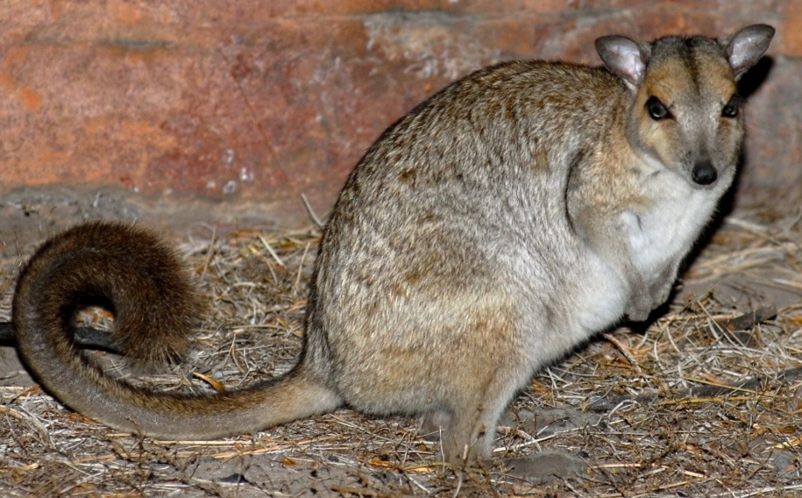

Photo: David Pearson - DPaW

***Description***

The Monjon is the smallest member of the genus *Petrogale*, with adult weights about 1 to 1.5kg. The ears (< 35mm long) and hind feet (pes length < 93mm) are short. The pelage colouration is subdued and lacks strongly contrasting markings (Kitchener and Sanson 1978).

The back colouration is generally olive with tawny and blackish marbling; a rufous wash on the forelegs and dark grey axillary patches. The flanks are dark olive and the undersurface is ivory-yellow. The flanks are a darker olive than the back, while the paws and feet are light greyish-olive with black undersurfaces. The tail is tawny with longer black-tipped hairs on the distal third which forms a conspicuous brush (Kitchener and Sanson 1978, Kitchener 1995, Menkhorst and Knight 2004).

The face has a rufous “clay-coloured” patch around the eye extending to the jaw. There is a light horizontal stripe from the snout, through the eye to the base of the ear. An indistinct stripe of greyish-olive runs from between the eyes along the midline of the head and onto the neck. The chin is white and the snout and ears are black (Kitchener and Sanson 1978, Kitchener 1995, Pearson *et al. 2008*).

***Biology and ecology***

Nothing is known about the site fidelity of Monjons. Apart from vacating daytime refuges when disturbed, they are nocturnal, emerging after dusk.

The diet has not been studied, but individuals have been observed eating dry leaves. They are rarely seen during daylight hours, only if startled in their daytime refuges. Soon after dark they begin to forage close to their refuges and then venture onto small lens of sand between rock outcrops. On Bigge Island, they were observed foraging up to 40m from rock outcrops in spinifex grassland and eucalypt woodland (D. Pearson pers. obs.).

***Distribution***

The Monjon is restricted to rugged sandstone ranges in the north-west Kimberley Region where it is known from Mitchell Plateau south to the Prince Regent River (Fig. 3). It is also known to occur on at least three islands in the Bonaparte Archipelago; Bigge (18,000ha), Boongaree (4,935ha) and Katers (1,775ha). Possible sightings on Wollaston (798ha) Island need to be investigated (Maxwell *et al*. 1996, A. Burbidge pers. comm.). Further surveys are required to assess its distribution.

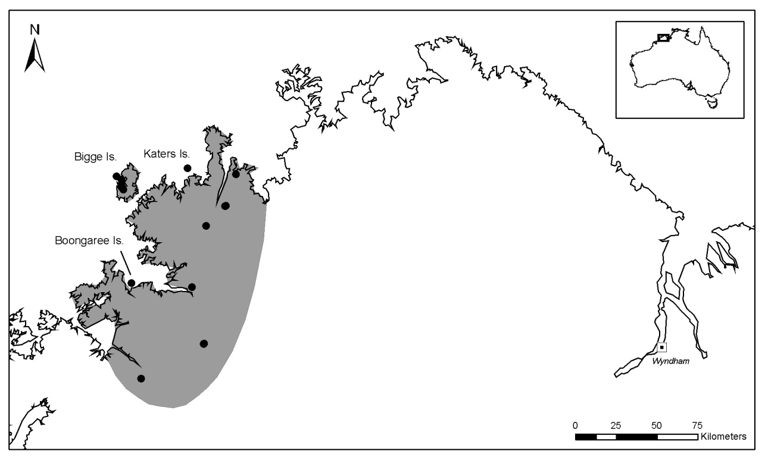

**Figure 3: The distribution of Monjon, *P. burbidgei* based on museum data**

***Populations***

Monjons are locally abundant on Bigge Island. It is possible to observe more than 10 per hour in the evening at Wary Bay on the western coast. They readily enter cage traps when present at high densities on Bigge Island (D. Pearson pers. obs.). Elsewhere, its past and present abundance are unknown due to its cryptic habits and the lack of potential observers; and on the mainland, difficulty in differentiating Monjons from *P. concinna* or juvenile *P. brachyotis* when sympatric.

Important populations occur on Bigge Island (the largest island it occupies) as well as Boongaree and Katers Islands (Pearson *et al.* 2008). Populations in the Mitchell River NP and in the Prince Regent River NR are also important for its conservation.

***Habitat***

Monjons occur in some of the most rocky and rugged country in the north Kimberley. They appear to favour highly fractured King Leopold sandstone with abundant multi-entranced and shaded caves and crevices. The vegetation in such areas is typically a mixture of low eucalypt woodland or shrubland with acacia, figs, *Terminalia* spp.and *Owenia* sp.or monsoon vine thicket scrambling across boulders (Pearson *et al*. 2008).

Rocky crevices seem to be essential for shelter. Monjons can squeeze down narrow vertical crevices characteristic of the regular rectilinear faulting of King Leopold sandstones. These interlink to form complex three-dimensional tight crevices and small caves. Apart from rocky crevices, other features of habitat critical to the survival of Monjons are unknown.

***Threats***

* Predation from feral cats may be a significant conservation threat for mainland populations.
* The introduction of feral cats or dogs could potentially threaten island populations.
* Fire regimes that lead to frequent or extensive burns may change the availability of food plants and shelter from predators.
* Future development of bauxite deposits on Mitchell Plateau, while not within its preferred habitat, could have impacts (Burbidge *et al.* 2008).

***Recovery actions***

* Survey to clarify distribution, conservation status and genetic diversity.
* Establish monitoring sites on Kimberley islands and mainland.
* Prepare and disseminate biosecurity protocols to prevent the introduction of exotic species to Kimberley islands with Monjons.
* Build networks to improve surveillance of islands and plan responses to any incursion by exotic species.
* Plan, implement and monitor precautionary fire management around mainland populations to reduce the impact of large wildfires.
* Undertake research into its biology and ecology especially in relation to the effects of fire and possible cat predation.

***References***

BURBIDGE, A.A., MCKENZIE, N.L. and START, T. (2008). *Petrogale burbidgei*. In: IUCN 2011. IUCN Red List of Threatened Species. Version 2011.2 [www.iucnredlist.org](http://www.icunredlist.org). Downloaded February 5 2012.

KITCHENER, D.J. (1995). Monjon, *Petrogale burbidgei.* Pp. 369 In: R. Strahan *The Mammals of Australia*. Australian Museum/ Reed Books: Sydney.

KITCHENER, D.J. and SANSON, G. (1978). *Petrogale burbidgei* (Marsupialia, Macropodidae) a new rock wallaby from the Kimberley, Western Australia. *Records of the Western Australian Museum* **6**: 269-285.

MAXWELL, S., BURBIDGE, A.A. and MORRIS, K.D. (1996). Action Plan for Australian Marsupials and Monotremes. IUCN/ Species Survival Commission, Australasian Marsupial and Monotreme Specialist Group.

MENKHORST, P. and KNIGHT, F. (2004). *A Field Guide to the Mammals of Australia*. Oxford University Press: Melbourne.

PEARSON, D.J., BURBIDGE, A.A., LOCHMANN, J. and START, T. (2008). Monjon, *Petrogale burbidgei*. In S. van Dyck and R. Strahan (eds.) *The Mammals of Australia* 3rd Edition. Reed New Holland, Sydney.

**Nabarlek ▪** *Petrogale concinna* (Macropodidae)

*(Nabarlek)*

***Conservation status***

IUCN Red List 2011: **Data Deficient**

EPBC Act: **Not listed**

*Territory Parks and Wildlife Act 2006*: **Near Threatened**

WA Wildlife Conservation Act 1950: **Not listed**

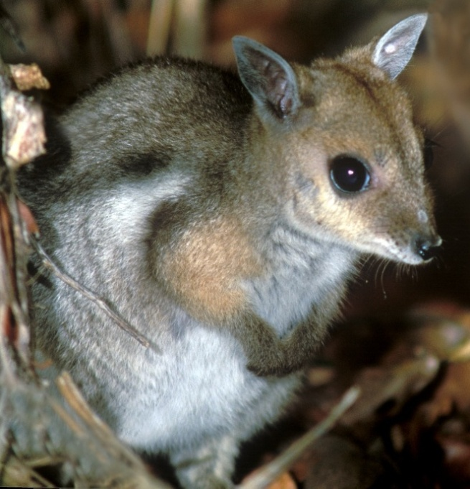

Photo: *Lochman Transparencies®*

***Description***

Three subspecies are currently recognized based on the geographic distribution of the species (Eldridge 1997). *Petrogale c. concinna* is only known from the type locality near Timber Creek in the NT; *P. c. monastria* occurs in the north-west Kimberley and *P. c. canescens* in eastern Arnhem Land. The validity of these subspecies requires further study. It is a small species, with adults weighing 1.2-1.6kg (Menkhorst and Knight 2004). The upper pelage is a dull rufous colour with marbling of light grey and black; in *P. c. concinna*, the marbling includes a “brilliant rust-red colour” on the lower back (Sanson and Churchill 2008). The lower thigh and base of the tail is rufous. There is no stripe on the thigh. The belly is greyish-white, sometimes paler between the forelegs. A dark grey to black axillary patch may be apparent.

The head has a prominent white stripe along the upper jaw, bordered by a dark stripe running along the snout from nose to the eye. A dark-brown stripe is usually present running from between the eyes over the head and onto the neck. The tail is slightly shorter than the head-body length with a black brush tip (Sanson 1995) that has more lightly coloured hairs on its tip than *P. burbidgei* (Kitchener and Sanson 1978).

***Distribution***

The Nabarlek has a tropical distribution, occurring in rocky habitat in the Kimberley Region of WA and the Top End of the NT in two discrete regions (Fig. 4). Difficulties observing this species and distinguishing it in the field from other small rock wallabies has limited understanding of its distribution and status (Churchill 1997).

*Petrogale c. canescens* occurs in granite and sandstone ranges in the north-western portion of the Top End of the NT from near the mouth of the Victoria River; west in an arc through the Pine Creek-Litchfield area below Darwin, into Arnhem Land from the eastern edge of Kakadu NP, as far east as the Arafura Swamp (Fig. 3, Woinarski 2002). The distribution of the species where the type specimen was collected near Timber Creek/Victoria River (NT) requires clarification. It is also reported to occur on Milingimbi (5,236ha) and Wigram (2,061ha) Islands (Abbott and Burbidge 1995).

Nabarlek populations in Arnhem Land and Kakadu NP appear to have declined markedly over at least the last two decades. There have been no recent sightings of Nabarleks in Litchfield NP. In Kakadu NP, a survey of macropods found no signs of the species, including in sites where Aboriginal informants considered it to have been common (Press 1988). It has been listed as occurring on Groote Eylandt, but there are no museum specimens and discussions with local Aboriginal people in 2006 (Pearson unpublished) suggest it was never present.

Collection of Aboriginal ecological knowledge of the distribution of the species in the NT is made more difficult by the common name for the species – Nabarlek – which means rock wallaby in several local Aboriginal languages. This can easily lead to confusion between *P. brachyotis* and *P. concinna*.

In WA, *P. c. monastria* occurs in the north-west Kimberley from Yampi Peninsula north to near Kalumburu. It is known to occur on several islands off the Kimberley coast: Long (1,356ha) and Hidden (1,974ha) in the Buccaneer Archipelago; and Augustus (19023ha) and probably Jungulu (4,925ha) in the Bonaparte Archipelago; and Borda (728ha) in the Admiralty Gulf (Maxwell *et al.* 1996). There are also populations in the Prince Regent NR and Mitchell River NP. The species formerly occurred on Sunday Island in the Buccaneer Archipelago, but was extinct by around 1940 (Abbott and Burbidge 1995).

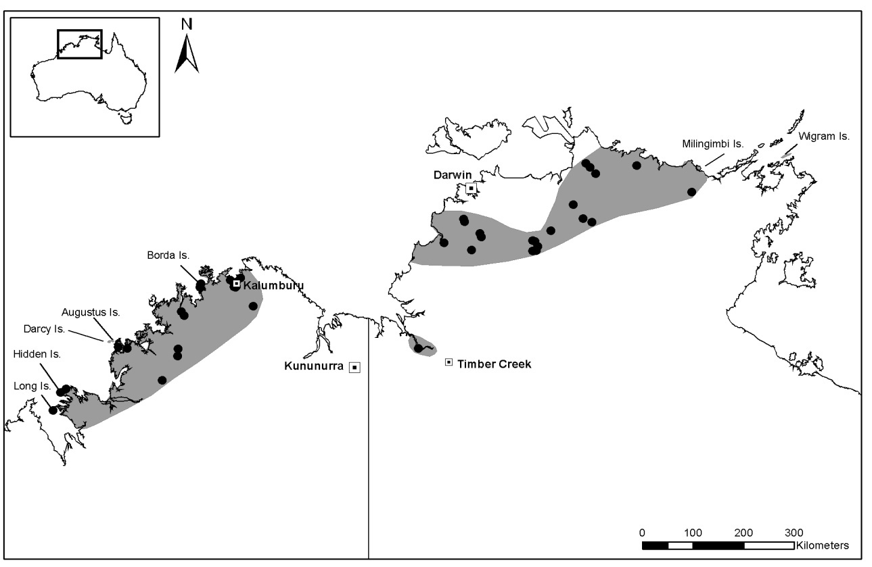

**Figure 4: The distribution of the Nabarlek (*P. concinna*) based on museum data**

***Populations***

The number and size of populations of *P. concinna* is unknown. Populations in the NT appear to have declined in the last two to three decades (Pearson in prep.). Nabarleks around Timber Creek have not been observed since the collection of the type specimen. The relative importance of populations is also unknown. In WA the populations on Long, Hidden and Augustus Islands are considered important, as is the population in the Prince Regent NR and Mitchell River NP. Populations in western Arnhem Land are also important as those to the east in the NT appear to have declined.

***Habitat***

The habitat preferences of the Nabarlek appear broad; ranging from low granite boulder hills in the Mary River area; lateritic breakaways in the Murwangie escarpment; steep sandstone cliffs and scree slopes in the Arnhem Land escarpment (Churchill 1997), to dissected and rugged sandstones of the north-west Kimberley (McKenzie *et al.* 1978). Churchill (1997) found that the presence of *P. c. canescens* was correlated primarily with steep slopes and numerous caves. Rock crevices, boulder piles and caves are used for shelter during the day and at night, *P. c. canescens* may move considerable distances away from rock shelters to graze (Nelson and Goldstone 1986).

The vegetation of areas occupied by Nabarleks varies substantially and includes outcrops on the edge of seasonally inundated wetlands, spinifex grasslands, monsoon vine thickets and acacia shrublands.

Habitat which is critical to the survival of the Nabarlek is not well understood, but presumably is linked to suitably complex caves and crevices to provide relief from daytime temperatures and shelter from predators.

***Biology and ecology***

Nabarleks are predominantly nocturnal, rarely appearing outside shelter sites until dusk and returning to refugia before dawn. However, during the wet season at Mount Borrodaile (western Arnhem Land), they were observed to be active for several hours before dusk and after dawn, grazing at these times on plants in the rock outcrops (Sanson *et al.* 1985, Churchill 1997). In the dry season Nabarleks moved up to several hundred metres away from their refugia onto the surrounding black soil plains to forage. In the wet season when the plains are inundated, the wallabies were restricted to the rock outcrops and the margins of the floodplain (Sanson *et al.* 1985).

Diet of the Nabarlek includes ferns, sedges, *Cyperus* spp. seeds, *Terminalia* spp.seeds and leaf material and small amounts of *Triodia* sp. and *Solanum* sp. (Sanson *et al.* 1985). Comparisons with the diet of *P. brachyotis* indicate clear dietary differentiation during the dry season, but in the wet season there was considerable overlap in food items (Sanson *et al.* 1985).

***Threats***

* Possible predation by cats
* Potential introduction of feral cats and dogs on islands occupied by *P. concinna*
* Small population sizes increasing the risk of local extinctions
* Fire regimes that lead to frequent or large scale fires changing food resources or cover from predators.

***Recovery actions***

* Survey the current distribution and genetic diversity to determine the conservation status of regional populations.
* Prepare and disseminate island biosecurity protocols.
* Search for populations and monitor changes in regional and local rock wallaby distribution, specifically western Arnhem Land (Kakadu NP, Nabarlek minesite and Mt Borrodaile); Mt Bundey area/Litchfield NP; Timber Creek (NT) area - Gregory NP and Bradshaw Defence training area; Mitchell River NP, Kimberley islands, Prince Regent NR.
* Plan, implement and monitor prescribed patch burning to reduce the risk of large wildfires.
* Carry out research into the biology and ecology of the species, especially the role of fire and possible predation by feral cats in affecting population parameters.
* Involve Aboriginal communities in survey and management.

***References***

ABBOTT, I. and BURBIDGE, A.A. (1995). The occurrence of mammal species on the islands of Australia: A summary of existing information. *CALMScience* **1**: 259-324.

CHURCHILL, S. (1997). Habitat use, distribution and conservation status of the Nabarlek, *Petrogale concinna*, and sympatric rock-dwelling mammals, in the Northern Territory. *Australian Mammalogy* **19**: 297-308.

KITCHENER, D.J. and SANSON, G. (1978). *Petrogale burbidgei* (Marsupialia, Macropodidae) a new rock wallaby from Kimberley, Western Australia. *Records of the Western Australian Museum* **6**: 269-285.

MAXWELL, S., BURBRIDGE, A.A. and MORRIS, K.D. (1996). *Action Plan for Australian Marsupials and Monotremes.* IUCN/ Species Survival Commission, Australasian Marsupial and Monotreme Specialist Group.

McKENZIE, N.L., BURBIDGE, A.A., CHAPMAN, A. and YOUNGSON, W.K. (1978). Mammals. Pp. 22-28. In: A.A. Burbidge and N.L. McKenzie (eds.).*The Islands of the North-west Kimberley, Western Australia*. Wildlife Research Bulletin 7, Department of Fisheries and Wildlife, Perth.

MENKHORST, P. and KNIGHT, F. (2004). *A Field Guide to the Mammals of Australia*. Oxford University Press: Melbourne.

NELSON, J.E. and GOLDSTONE, A. (1986). Reproduction in *Peradorcas concinna* (Marsupilia: Macropodidae). *Australian Wildlife Research* **13**: 501-505.

PRESS, A. J. (1988). The distribution and status of macropods (Marsupialia: Macropodidae) in Kakadu NP, Northern Territory. *Australian Mammalogy* **11**: 103-108.

SANSON, G.D. (1995). Nabarlek *Peradorcas concinna.* Pp. 371-2 In:R*.* Strahan(ed.) *The Mammals of Australia.* Reed New Holland, Sydney.

SANSON, G.D. and CHURCHILL, S. (2008). Nabarlek, *Petrogale concinna.* Pp. 370-371.In: S. van Dyck and R. Strahan (eds.) *The Mammals of Australia* 3rd Edition. Reed New Holland, Sydney.

SANSON, G.D., NELSON, J.E. and FELL, P. (1985). Ecology of *Peradorcas concinna* in Arnhem Land in a wet and dry season. *Proceedings of the Ecological Society of Australia* **13**: 69-72.

TELFER, W.R. and BOWMAN, D.M.J.S. (2006). The diet of four rock-dwelling macropods in the Australian monsoon tropics. *Austral Ecology* **31**: 817-827.

WOINARSKI, J. (2002). Nabarlek. Threatened Species Information Sheet, Department of Natural Resources, Environment and the Arts, Northern Territory.

**Rothschild’s rock wallaby ▪** *Petrogale rothschildi* (Macropodidae)

***Conservation status***

IUCN Red List 2011: **Least Concern**

EPBC Act: **Not listed**

WA Wildlife Conservation Act 1950: **Not listed**

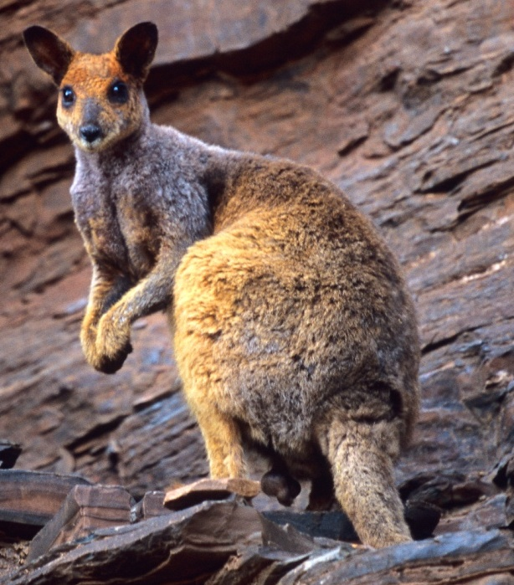

Photo: *Lochman Transparencies®*

***Description***

*P. rothschildi* is a large rock wallaby with adult weights on the mainland from 5.0 to 6.6kg for males and 3.7 to 5.3kg for females. Individuals from the Dampier Archipelago islands are smaller; weight for sexes combined ranged from 2.6 to 3.9kg (Pearson and Eldridge 2008).

Its dorsal fur is greyish to golden-brown with grey shoulders. The belly is buff to dull brown. There are no neck, dorsal or side-stripes, although a dark brown axillary patch may be present. At times, the fur on the shoulders may have a purplish hue (Menkhorst and Knight 2004). The face is grey on top with a pronounced grey-white jaw stripe which extends up to the uniformly brown ears. The tail is long and brown, becoming darker towards the tip which has brush for the last 30 to 40 per cent of its length (Pearson and Eldridge 2008).

***Distribution***

*P. rothschildi* is endemic to the Pilbara and Ashburton Regions of WA. There is little information on the extent of the historic distribution and recent sightings continue to extend its known distribution to the east and south. The species occupies major ranges such as the Hamersley and Chichester Ranges, as well as scattered smaller ranges and outcrops (Fig. 5). It extends north at least as far as Woodstock Station and as far east as a line from Marble Bar, to Nullagine and the Oakover River on the edge of the Little Sandy Desert. Southern-most records are from Barlee Range and Wanna Station and then the distribution continues eastwards to Newman. The location and nature of its historical boundary with *P. l. lateralis* on the eastern edge of the Pilbara remains unclear.

*P. rothschildi* occurs on the Burrup Peninsula and nearby islands of the Dampier Archipelago; Dolphin (3,203ha), Enderby (3,190ha) and Rosemary (1,152ha) (Pearson and Kinnear 1997, Pearson and Eldridge 2008).

In response to the threat of sand mining on Enderby Island, *P. rothschildi* were translocated from Enderby Island to West Lewis Island in 1982. This population has subsequently thrived (Abbott and Burbidge 1995).

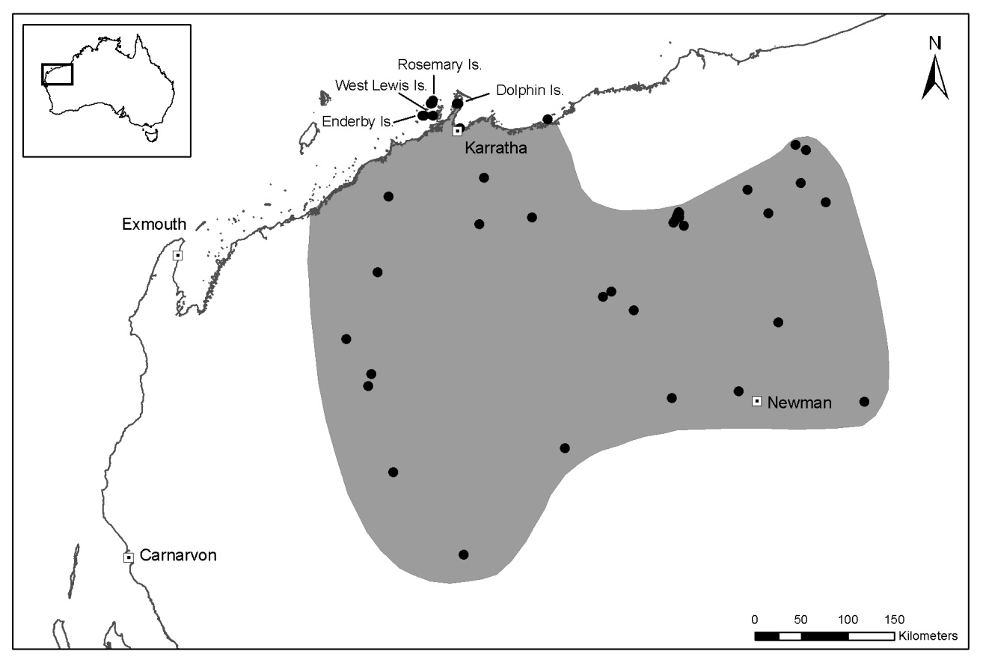**Figure 5: The distribution of Rothschild’s rock wallaby (*P. rothschildi*). Dots show the location of museum specimens.**

***Populations***

Knowledge of the number and size of populations, along with potential changes in abundance, is limited.

During the 1960s, populations on East and West Intercourse Island were driven to extinction, presumably by fox predation (J. Kinnear pers. comm.). The Dolphin Island population was at very low numbers in the mid-1980s and faced extinction prior to fox control. On the Burrup Peninsula, fox predation has greatly reduced the abundance of *P. rothschildi*. Fox baiting operations to the northern Burrup have since led to a strong increase in rock wallabies, but south of Withnell Bay outside the baited area, *P. rothschildi* are now very rare or absent.

***Habitat***

This species occurs on a wide range of rock types, including granophyres, granite tors, and dissected sediments. While *P. rothschildi* tends to shelter in caves, cliff-collapses and rock-piles, it may also use rocky sites around iron-ore mining activity, such as the edge of overburden dumps or railway embankments. Deep, cool shelter is important in the Pilbara which experiences hot day-time temperatures for much of the year (Pearson and Eldridge 2008).

Pilbara rock-piles have low and often sparse vegetation dominated by spinifex, kurrajongs, *Terminalia* spp., snappy gums and figs. Creeklines are lined with gums and have more diverse vegetation communities with a variety of grasses and low shrubs. On the Dampier Archipelago islands, rock-piles with sparse or negligible vegetation are interspersed by areas of spinifex or small areas of soft grasses (native species and buffel grass) around beaches and occasional basins with deeper soil (D. Pearson pers. obs.).

Habitat features critical to the survival of *P. rothschildi* include rocky shelter sites with deep caves or crevices to escape extreme daytime temperatures and predators, and suitable palatable plants in close proximity to shelter sites.

***Biology and ecology***

Rothschild’s rock wallabies are strongly nocturnal and generally secretive. They tend to forage close to their shelter sites, descending onto the flats below rock outcrops to feed or to drink along watercourses.

The diet is believed to include soft grasses, herbs and fruit when available (such as native figs, *Ficus* spp.). Observations suggest they do not forage far from rock-piles. On West Lewis Island, they appear to eat buffel grass and were observed eating prickly pear fruits (G. Kregor pers. comm.).

***Threats***

Foxes appear to be absent in the central Pilbara, possibly due to the extreme temperatures experienced in summer. However, foxes are relatively abundant in coastal Pilbara areas, and the close proximity of islands to the mainland, large tidal ranges, extensive mudflats and shallow intervening water has allowed foxes to access several islands, resulting in periodic predation events.

Populations around Newman and Pannawonica will be impacted by the removal of entire hills and mesas for iron ore. Translocation programs have moved affected rock wallabies (J. Short pers. comm.). Although the areas impacted are currently small and localised, many more areas are proposed for iron ore extraction in the Pilbara. Gas infrastructure and associated industries on the Burrup Peninsula have reduced habitat in this area and have resulted in increased road kills.

***Recovery actions***

* Surveys of the Dampier Archipelago islands and mainland Pilbara to determine the current conservation status and potential threats.
* Continue baiting operations on the Burrup Peninsula and the Dampier Archipelago.
* Ensure biosecurity of Dampier Archipelago, by preparing quarantine protocols and signage on boat ramps.
* Monitor rock wallabies on Dampier Archipelago and Burrup Peninsula to assess the effectiveness of fox baiting.
* Analyse the genetic variability of *P. rothschildi* to aid conservation planning.
* Ensure the involvement of Aboriginal people, mining companies and other land-holders in the management of this species.
* Undertake research on the biology and ecology of *P. rothschildi*, especially the impact of fire and predation on its populations.

***References***

ABBOTT, I. and BURBIDGE, A.A. (1995). The occurrence of mammal species on the islands of Australia: A summary of existing information. *CALMScience* **1**: 259-324.

HALL, G.P. and KINNEAR, J.E. (1991). *Recovery Plan for the Black-flanked Rock wallaby, Petrogale lateralis lateralis* (Gould). Department of Conservation and Land Management report to Australian NPs and Wildlife Service: Canberra.

MENKHORST, P. and KNIGHT, F. (2004) *A Field Guide to the Mammals of Australia*. Oxford University Press: Melbourne.

PEARSON, D.J. and KINNEAR, J.E., (1997). A review of the distribution, status and conservation of rock wallabies in Western Australia. *Australian Mammalogy* **19**: 137-152.

PEARSON, D.J. and ELDRIDGE, M.D.B. (2008). Rothschild’s Rock wallaby *Petrogale rothschildi.* Pp.389-390 In S. van Dyck and R. Strahan (eds.) *The Mammals of Australia* 3rd Edition. Reed New Holland, Sydney.