How do I check the status of my lodgement?

This task card demonstrates how to check the status of lodgements submitted for Approved Arrangement Class 14.4 rural tailgate and external container inspection outcomes in the Biosecurity Portal.

*NOTE: The Portal works best with the latest version of Google Chrome, Safari and Microsoft Edge. Internet Explorer and Mozilla Firefox are not supported. You must allow pop-ups on your browser before proceeding.*

Lodgement Status

Biosecurity Portal Landing Page

**Browse** to [biosecurity.awe.gov.au](https://biosecurity.awe.gov.au/)

Login by using your myGovID digital identity. If you have not registered refer to “How do I register to use the Biosecurity Portal?” task card.

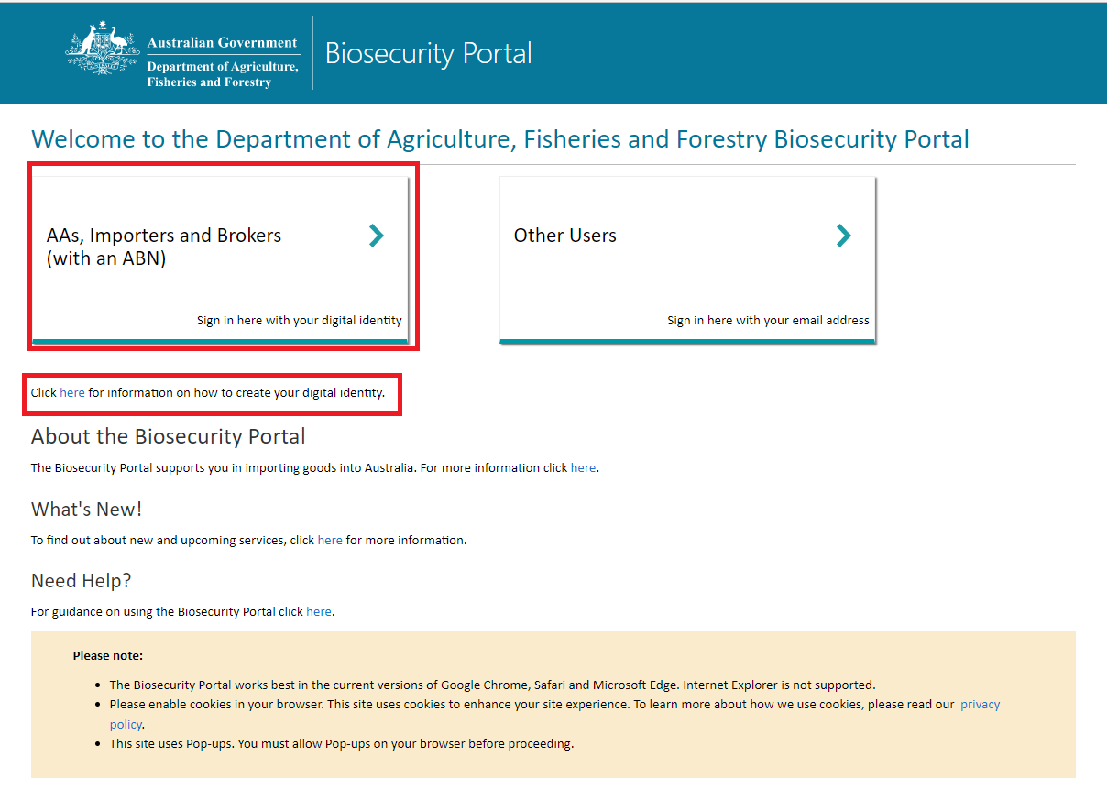

Figure 1: Biosecurity Portal Landing Page

Biosecurity Portal Home Page

Select **Approved Arrangement outcomes.**

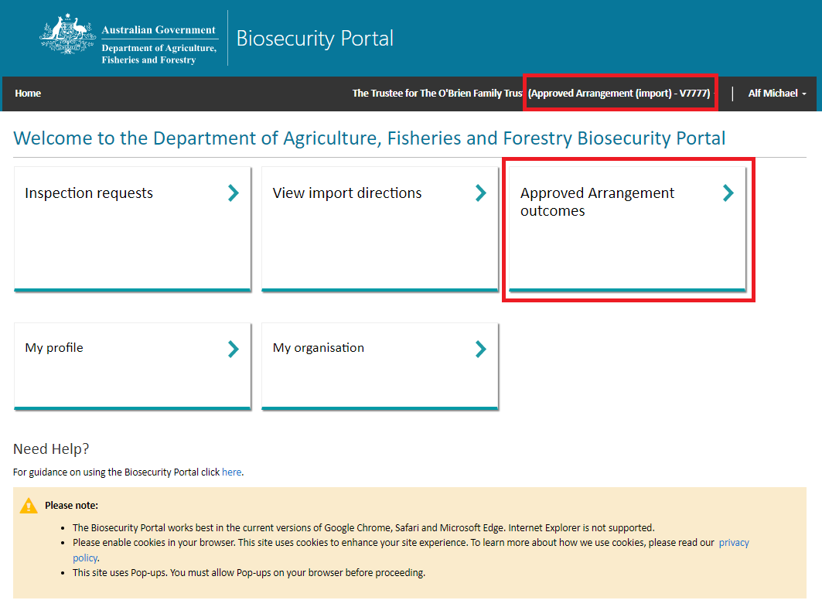

Figure 2: Biosecurity Portal Home Page

*Note: This tile will only be visible if you are logged in as an Approved Arrangement. Refer to “How do I set up my organisational profile in the Biosecurity Portal?”*

Select **Class 14.4 inspection outcomes**

Figure 3: Approved Arrangement outcomes

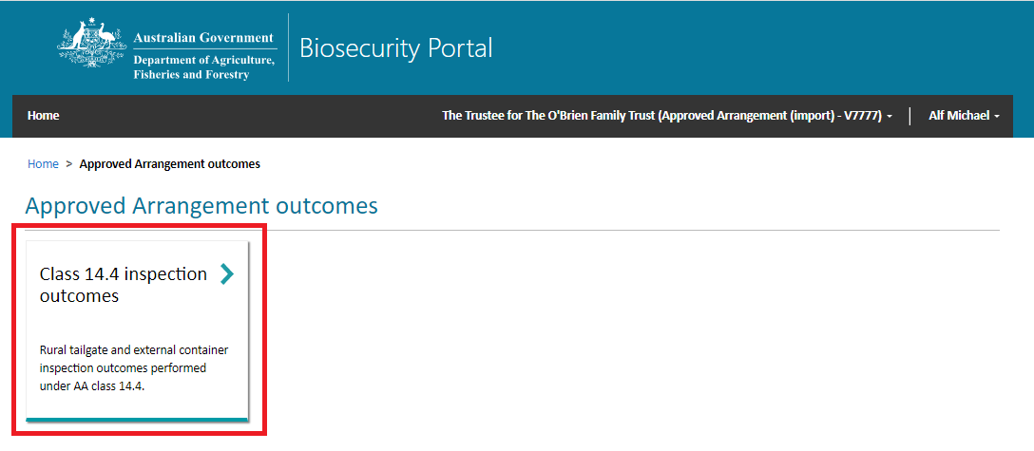

Entry ID

Select an **Entry ID** or use the search option to find your Entry ID.

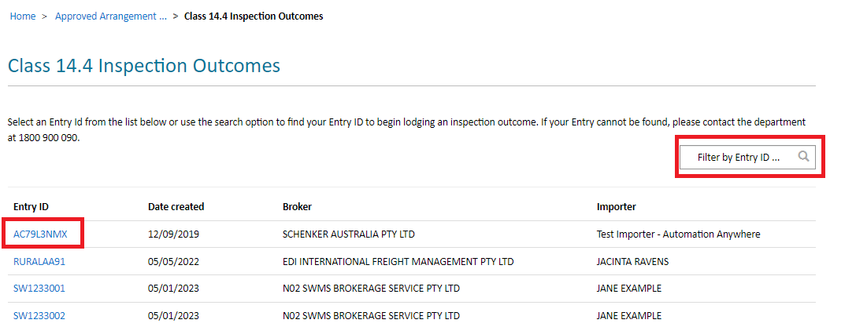

Figure 4: Select an Entry Id to view lines

*Note: Only active Entry IDs with an open direction ie: AA Rural Tailgate Inspection and the location specified for that direction matching your AA number in the departments AIMS will be visible for selection.*

Status

Each **Line** has a status recorded. An *Open* status is available for selection and lodgement of an outcome. A *Submitted* status is not available for lodgement, as a request has already been entered for this Line and been submitted to the department.

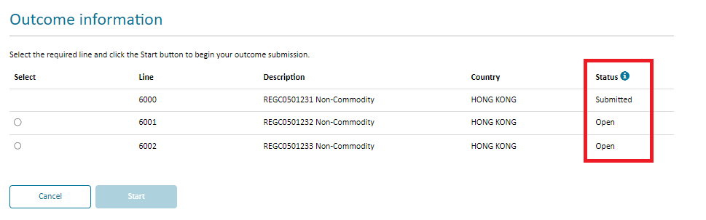

Figure 5: Outcome information status

*Note: An Entry ID will no longer be visible in this view once the Entry ID is no longer active and/or all AA Rural Tailgate Inspection Directions have been actioned and closed by the department.*