How do I view my historical lodgements?

This task card demonstrates how to view lodgements submitted for Approved Arrangement Class 14.4 rural tailgate and external container inspection outcomes in the Biosecurity Portal.

*NOTE: The Portal works best with the latest version of Google Chrome, Safari and Microsoft Edge. Internet Explorer is not supported.*

*Make sure pop-ups and cookies are enabled.*

Historical lodgement

Biosecurity Portal Landing Page

**Browse** to https:// [biosecurity@.awe.gov.au](mailto:biosecurity@.awe.gov.au)

Login using your myGovID digital identity. If you have not registered refer to “How do I register to use the Biosecurity Portal?” task card.

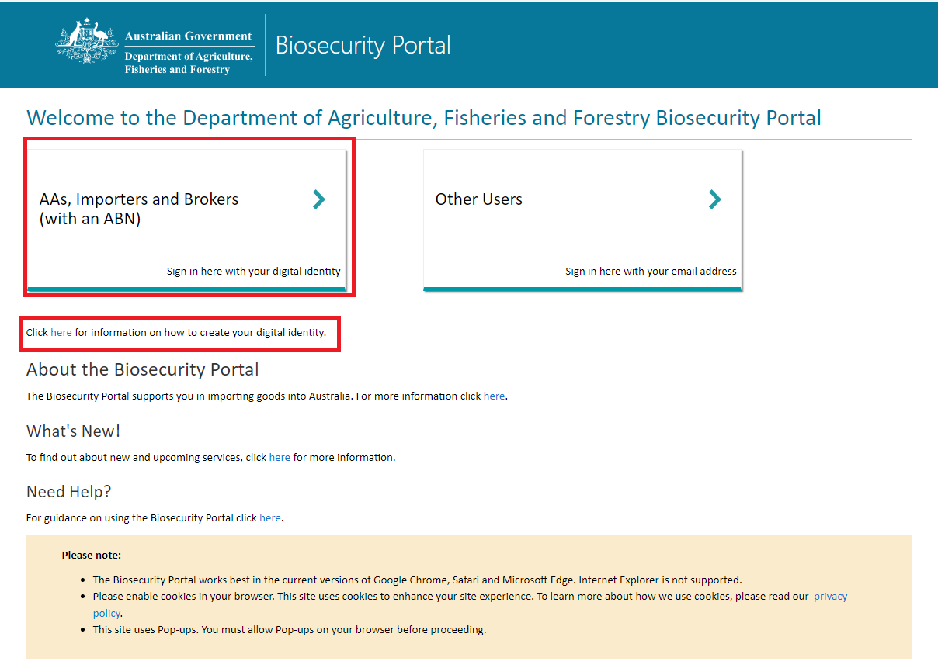

Figure 1: Biosecurity Portal Landing Page

Biosecurity Portal Home Page

Select **Approved Arrangement outcomes.**

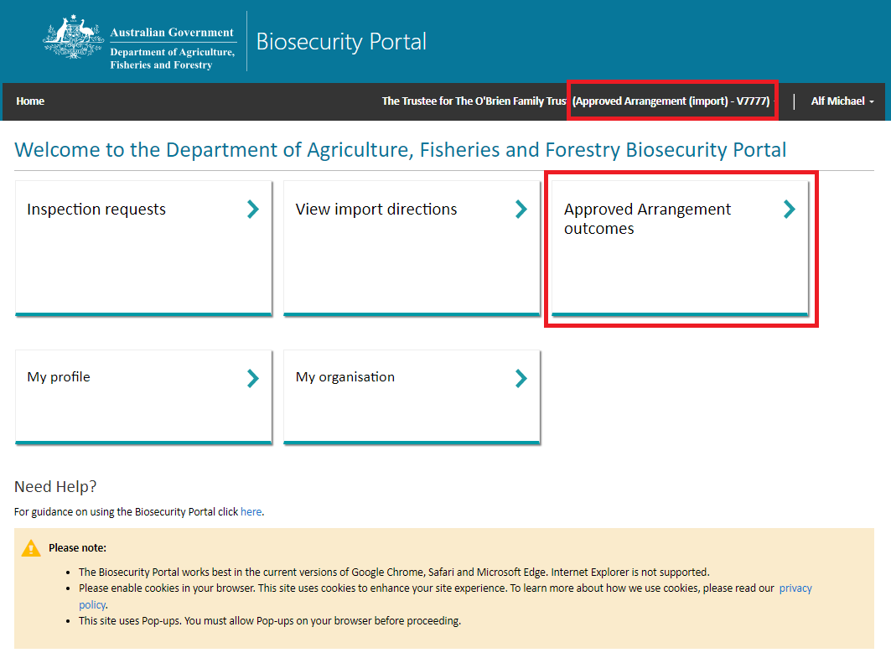

Figure 2: Biosecurity Portal Home Page

*Note: This tile will only be visible if you are logged in as an Approved Arrangement.*

Historical inspection outcomes lodged on behalf of your AA will be visible under “**Historical inspection outcomes**” with a status of “Submitted”.

*Tip: All lodgements for an AA are visible via this View, not just lodgements you have entered.*

*Tip: If an Entry ID is not visible, type the Entry ID in the Search bar and hit* ***enter****.*

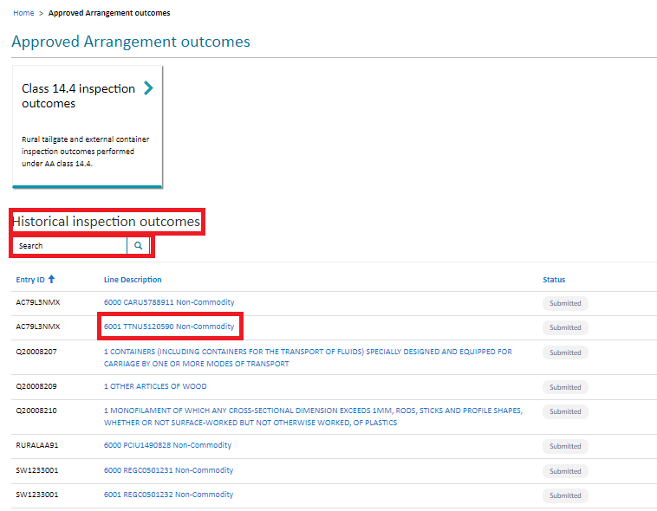

Figure 3: Historical inspection outcomes

To view a historical lodgement, click on the **Line Description**. This will display the submitted outcome form with information supplied to the department.

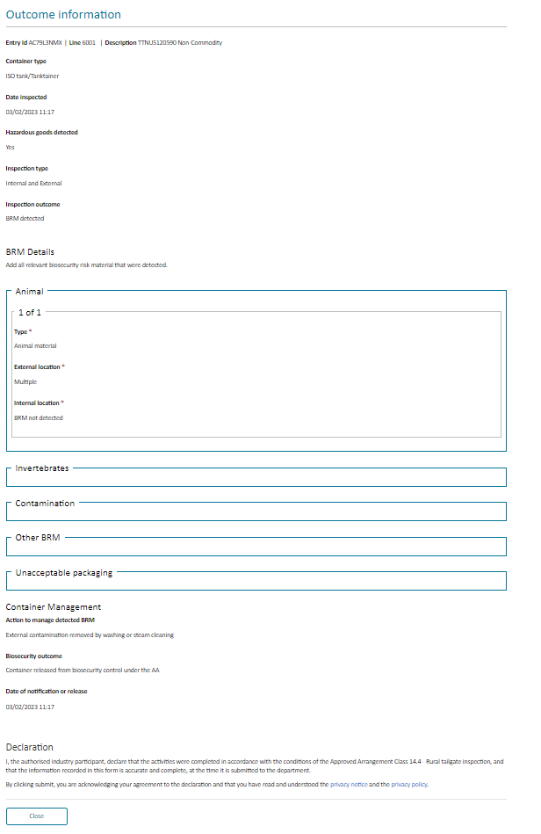

Figure 4: Historical inspection outcome

**Select** Close to return to the previous screen.