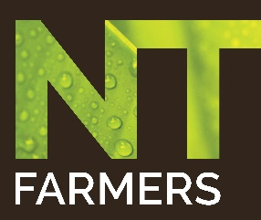
Biosecurity Champions
Julie-Ann Murphy and Alan Petersen - Rum Jungle Organics
English

Welcome to Rum Jungle Organics.

Julie-Ann and Al here.

We've been growing certified organic regenerative papayas and bananas on this farm for 20 years.

In 2013 Banana Freckle was discovered again in the Top End, Rum Jungle Organics was identified as an infected property.

Our farm was closed and all bananas on the property destroyed.

We decided to replant and rebuild our farm.

This gave us the opportunity to review our biosecurity practices and the time to document these practices in a biosecurity plan.

We use regenerative farming methods that constantly improve the fertility of our soil, foster biodiversity and recycle essential nutrients.

We are certified organic and our biosecurity protocols must adhere to national standards for organic and biodynamic produce.

Our biosecurity plan is based on a template designed by the national farm biosecurity team.

This plan details how we control farm inputs, farm outputs, people, vehicles and equipment, production practices, feral animals, weeds and the records we keep. Designing a plan that's easy to follow does not cost much and supports clear simple recordkeeping making it possible for all farmers, service providers, farm suppliers and visitors to be involved.

We rely on production practices to maintain soil and plant health.

These practices help us control disease, weeds and pests.

Our detailed biosecurity plan is updated annually and or as necessary. In 2018 we won the national farm biosecurity producer of the year for our simple cost effective plan.

Biosecurity is important locally, regionally and nationally. Biosecurity protects our industry, our livelihoods and our landscape.

Biosecurity is everyone's business.

Come clean go clean.

You can be a champion too.

Department of Agriculture, Water and the Environment
Top Watch Biosecurity
Biosecurity – its everyone’s business

