**Ecological assessment of the South Australian Marine Scalefish Fishery**

Re-assessment report prepared for the Department of Agriculture, Water and the Environment

May 2022

**Ecological assessment of the South Australian Marine Scalefish Fishery – Re-assessment report prepared for the Department of Agriculture, Water and the Environment**

Information current as of 26 May 2022

© Government of South Australia 2022

**Disclaimer**

Department of Primary Industries and Regions and its employees do not warrant or make any representation regarding the use, or results of the use, of the information contained herein as regards to its correctness, accuracy, reliability and currency or otherwise. Department of Primary Industries and Regions and its employees expressly disclaim all liability or responsibility to any person using the information or advice.

**All Enquiries**

Department of Primary Industries and Regions

Sam Stone  
2 Hamra Ave, West Beach SA 5024

GPO Box 1625, Adelaide SA 5001  
T 08 8429 2101 M 0439 728 643  
E [sam.stone@sa.gov.au](mailto:sam.stone@sa.gov.au)

# Purpose

The purpose of this report is to provide an assessment of the commercial South Australian Marine Scalefish Fishery (MSF) for the purposes of Part 13 and 13(A) under the *Environment Protection and Biodiversity Conservation Act 1999* (EPBC Act). This report updates information provided to the then Australian Government Department of the Environment and Energy in 2019.

The report has been prepared by the Fisheries and Aquaculture Division of the Department of Primary Industries and Regions (PIRSA) in accordance with the Guidelines for the Ecologically Sustainable Management of Fisheries 2nd Edition, and particularly addresses the level of change that has occurred since the 2019 assessment.

# Level of assessment

The South Australian MSF was assessed as an approved Wildlife Trade Operation in 2019. Since the last assessment, there have been changes in some areas of interest or particular issues as outlined in the Guidelines for the Ecologically Sustainable Management of Fisheries. These have been reported in the annual fishery reports to the Department of Agriculture, Water and the Environment (DAWE).

Table 1: Level of assessment required by South Australian MSF

|  |  |  |  |
| --- | --- | --- | --- |
| Issue | Area of Interest | Yes | No |
| Fishery | Has there been any change to management arrangements, and/ or fishing practices? | X |  |
| External Influences | Has there been any change to an environmental issue/influence outside of the fishery management agencies control? |  | X |
| Interaction with protected species | Has there been any change in the nature, scale, intensity of impact, and/or management response? |  | X |
| Ecosystem impact | Has there been any change in the nature, scale or intensity of impact, and/or subsequent management response? |  | X |
| Target Stock Status | Has there been any change in the target stock status? | X |  |
| Byproduct/ bycatch status. | Has there been any change in the by-product and/or bycatch stock status? |  | X |

Considering the above, the level of submission requirement for the South Australian MSF is ‘Standard’.

# Background

The regulations that govern the management of the Marine Scalefish Fishery (MSF) are the *Fisheries Management Act 2007,* the *Fisheries Management (Marine Scalefish Fisheries) Regulations 2017*, the *Fisheries Management (General) Regulations 2017* and *the Fisheries Management (Fish Processor) Regulations 2017*.

The current *Management Plan for the* *South Australian Commercial Marine Scalefish Fishery* (MSF Management Plan) was adopted in 2013 and applies for a period of 10 years. A review of this management plan for the purpose of determining whether the plan should be amended, replaced or reinstated without amendment, is currently underway and should be completed prior to the end of 2022.

The MSF Management Plan, and other MSF documents can be found at: <https://pir.sa.gov.au/fishing/commercial_fishing/fisheries/marine_scalefish_fishery>

# Fishery

The MSF includes the take of most marine species of fish, molluscs, crustaceans, annelids and sharks that occur in South Australia, but excludes rock lobster, prawns, abalone, and freshwater fish species, all of which are managed separately. There are more than 60 species permitted to be taken in the MSF, however, for the purpose of this report the main target species will be considered in three categories (primary, secondary and tertiary – see appendix A), as identified in the MSF Management Plan (PIRSA 2013).

## Commercial Fishery

The total commercial catch of marine scalefish species in South Australia 2020/21 was 1,689 tonnes, valued at around $19 million (gross value of production). The MSF was responsible for the employment of around 540 full-time equivalent jobs through direct employment and jobs in flow-on businesses (BDO Econsearch, 2022).

As of 26 May 2022 there were 205 MSF licences. A number of other separately managed fisheries maintain some level of access to marine scalefish species. The level of access and restrictions on access varies between each fishery and, as with the MSF, these restrictions are implemented through a mix of regulations, licence conditions and other legal instruments. Further details on this access can be found in the MSF Management Plan (PIRSA 2013).

The number of licences in the MSF has decreased significantly from 865 licences in 1984. A Voluntary Licence Surrender Program (VLSP) was a significant component of a reform of the commercial MSF that began in 2018/19 and concluded on 1 July 2021. This program resulted in the surrender of 100 licences and the gear endorsements associated with those licences.

The MSF is a multi-gear fishery that has 30 specific types of fishing gear permitted for use which can be grouped into four main categories: traps/pots, lines, nets, and ‘others’ consisting of hand held devices including crab and cockle rakes, bait spade/forks and dab nets. In 2020, the majority of fishing effort (57%) was attributed to the line gear category including longlines, rod and lines, handlines and squid jigs. In the same year, netting accounted for approximately 31% of effort in the fishery, with the overwhelming majority of this attributed to haul netting (Smart et al. in prep).

The MSF commercial fishery is primarily managed through input controls, however a number of output controls are also used – in particular for the primary species which moved to quota management from 1 July 2021. A heterogeneous mixture of participants, fishing devices and licence conditions, make the task of managing this fishery complex. The large number of licence holders, the large number of species being targeted and variations and permutations of licence endorsements compounds the complexity of the management arrangements.

## Recreational Fishery

The South Australian recreational fishery is primarily managed through output controls in the form of daily bag and boat limits, and minimum and/or maximum size limits for all key species as well as a number of spatial and temporal closures that apply to both commercial and recreational fishers.

The most up to date information regarding the participation rates and demographics among recreational fishers is derived from the ‘*South Australian Recreational Fishing Survey 2013/14*’ (Giri and Hall, 2015). The survey estimated that approximately 277,000 South Australians recreational fished in 2013/14. This represented a participation rate of 18.3% of the South Australian population. A total of 89 individual species or species groups were reported as caught by recreational fishers in the survey period. The survey provided statistically robust estimates of recreational fish catch and effort for key species including King George Whiting, Snapper, Southern Garfish and Blue Swimmer Crabs among other species. These data are considered in stock assessments and other reports used in managing the commercial fishery. The full report is available at:

[www.pir.sa.gov.au/fishing/publications/rec_fishing_survey](http://www.pir.sa.gov.au/fishing/publications/rec_fishing_survey)

Further details on the recreational fishing rules are available at: <http://www.pir.sa.gov.au/fishing/recreational_fishing>

A survey of recreational fishing was undertaken in 2021/22 by the South Australian Research and Development Institute (SARDI) in partnership with the University of Tasmania and funding from the Fisheries Research and Development Corporation. Collection methods adopted through the survey included telephone surveys and on-site sampling, reporting via a SA Fishing Ap and a Goolwa Pipi survey. More information about this survey can be found at: <https://www.pir.sa.gov.au/fishing/publications/rec_fishing_survey>

## Management changes in the fishery

There have been several changes in the management of the MSF since the 2019 assessment, as outlined following.

### MSF Reform Measures

The MSF reform resulted in significant improvements to the management of the MSF that were implemented from 1 July 2021. Key elements of the reform included:

* Establishment of four fishing zones – West Coast, Spencer Gulf, Gulf St Vincent & Kangaroo Island, and South East.
* Establishment of individual transferable quota (ITQ) and total allowable commercial catch (TACC) management systems for the four primary species: King George Whiting, Snapper, Southern Garfish and Southern Calamari for the MSF and the Rock Lobster Fisheries (Table 2).
* Separation of the commercial taking of Vongole and Sardine from the MSF and the creation of new fisheries for these species under their own regulations: *Fisheries Management (Sardine Fishery) Regulations 2021* and *Fisheries Management (Vongole Fishery) Regulations 2021*.

Table 2: 2021/22 TACCs for MSF primary ‘Tier 1’ species in tonnes

|  |  |  |  |  |
| --- | --- | --- | --- | --- |
| **Fishing Zone** | **King George Whiting TACC (T)** | **Southern Garfish TACC (T)** | **Calamari TACC (T)** | **Snapper TACC (T)** |
| **West Coast** | 473 | N/A | N/A | 0 |
| **Spencer Gulf** | 111.3 | 100 | 204 | 0 |
| **Gulf St Vincent / Kangaroo Island** | 46 | 71 | 162 | 0 |
| **South East** | N/A | N/A | N/A | 36 |

Other elements of the reform included amendment or removal of various management measures that were no longer considered necessary, including:

* Permitted licence holders in the West Coast Fishing Zone to take up to 150 razorfish (for bait) over a three-day period.
* Removed requirement to attend longlines.
* Permitted nets and lines to be carried on board a fishing vessel and used at the same time.
* Added permitted species to the fishery, including: Conger Eel, Sergeant Baker, Silver Drummer, Weedy Whiting, Knifejaw, Rock Crab and Spider Crab (West of 135 degrees East). These species were added following an ecologically sustainable development (ESD) risk assessment stakeholder workshop and process based on AS 4360 / ISO 31000, modified from Fletcher et al. (2011) and Fletcher (2015).
* Removed seasonal closures for Snapper in the South East Fishing Zone and Southern Garfish now these stocks were managed under ITQ/TACC.

### Snapper

In November 2018, a stock assessment report provided by the South Australian Research and Development Institute (SARDI) identified the Snapper stock in Spencer Gulf/West Coast had declined to the point of being classified as ‘depleted’ meaning biomass had been reduced through catch and/or non-fishing effects, such that recruitment of young fish into the fishable stock was impaired.

Updated information on Snapper biomass estimates in 2019 then classified the Gulf St Vincent stock as ‘depleting’ meaning biomass was not yet depleted and recruitment was not yet impaired, but fishing mortality was too high (overfishing was occurring) and moving the stock in the direction of becoming recruitment impaired.

In response to the scientific information and comprehensive multi-sector stakeholder consultation, Snapper fishing was closed to all sectors in the Spencer Gulf/West Coast and Gulf St Vincent regions from 1 November 2019 until 31 January 2023. The potential reopening of the fishery in February 2023 will be guided by a new stock assessment expected for release late in 2022.

The Snapper stock in the South East is classified as ‘sustainable’. The Snapper caught in the South East originate from Port Phillip Bay in Victoria, and migrate to South Australian waters. Recruitment success of Snapper in Port Phillip Bay is monitored with a very strong recruitment year recorded in 2018. The Snapper produced through this recruitment pulse is now being seen in the South East.

The South East Fishing Zone (SEFZ) remains open with strict restrictions. Fishing for Snapper in the SEFZ is managed through:

* A TACC and ITQ for commercial fishers
* A total allowable recreational catch (TARC) which applies to the recreational and charter sectors
* Mandatory catch reporting for the commercial, recreational and charter fishers taking Snapper
* A daily bag limit of one Snapper per person, and a daily boat limit of three Snapper per boat (when three or more persons are fishing on board) for recreational fishers
* A daily passenger bag limit of one large and 3 small Snapper per person for the charter sector
* Minimum size limit: 38 cm.

### Giant Australian Cuttlefish

Each year the State Government consults with stakeholders regarding the latest cuttlefish science and management. Giant Australian Cuttlefish have been protected through a permanent Cephalopod Fishing Closure in an area near Point Lowly near Whyalla. In this area, the take of all cephalopods including cuttlefish, squid and octopus is prohibited. In response to a 2013 decline in Giant Australian Cuttlefish, PIRSA has implemented a number of temporary spatial closures prohibiting the taking of cuttlefish based on the most recent cuttlefish science and population surveys. More recently an upper Spencer Gulf closure has been implemented for the take of all cuttlefish species.

### King George Whiting

A King George Whiting spawning spatial closure had been implemented since 2017 following a review of management arrangements in 2016. The closure was part of a package of measures including a size limit increase and a recreational bag limit reduction implemented in response to stock concerns in both Spencer Gulf and Gulf St Vincent. The management measures were in place until 2020. The King George Whiting stocks in all areas have now recovered to a sustainable position and the spawning closure has been removed.

### Southern Garfish

In response to the previous ‘overfished’ and ‘recovering’ statuses of the Southern Garfish stocks in the North Gulf St Vincent and North Spencer Gulf, PIRSA had implemented various effort and gear-based management strategies to achieve the harvest fraction and egg production targets outlined in the MSF Management Plan.

In advance of the introduction of ITQ/TACC management for Southern Garfish on 1 July 2021, a review of the existing input controls was undertaken. This identified that the most effective measure to support ongoing stock recovery for the North Gulf St Vincent and North Spencer Gulf stocks was the maintenance of a 36 mm minimum mesh size in the pockets of haul nets – responsible for ~90% of the catch. Consequently the following management changes were implemented:

* Minimum mesh of 36 mm in the pocket of haul nets used in the Spencer Gulf and Gulf St. Vincent/Kangaroo Is. Fishing Zones. A minimum mesh of 32 mm in all other areas.
* Reversion of the minimum legal length from 25 cm to 23 cm
* Removal of the seasonal closures

# Target stock status

SARDI provide an annual report of the dynamics of the MSF assigning stock status of 20 species or taxonomic groups across 30 management units (stocks) harvested in the fishery. The most recent report assesses the fishery in 2020 (Smart et al. in prep).

In the five years during 2016–2020, the combined catch of primary species (Snapper, King George Whiting, Southern Calamari and Southern Garfish) decreased, while other species showed increasing catch trends (Figure 1). Declines in catch of Snapper, King George Whiting and Southern Garfish have contributed to the diversification of the MSF fleet, with many fishers switching their effort from Snapper, King George Whiting and Southern Garfish to other species (Smart et al. in prep).

For Snapper, State-wide catch has declined from 1,035 tonnes in 2010 to 252 tonnes in 2019 (Smart et al. in prep). In 2020, the State-wide catch was constrained by the Snapper fishing closures for the waters of the west coast of Eyre Peninsula, Spencer Gulf and Gulf St. Vincent from 1 November 2019; and the TACC for the South East region of 60.75 t. For Southern Garfish, the State-wide catch has been relatively stable since 2016 and was 172 tonnes in 2020. For King George Whiting, there has been a long-term declining trend in total commercial catch – from 776 tonnes in 1992 to 202 tonnes in 2020. For Southern Calamari, recent State-wide catches have been relatively stable and have ranged from 398 t in 2016 to 374 t in 2020.

Of the 30 stocks assessed by Smart et al (in prep), 23 stocks were classified as ‘sustainable’, two were classified as ‘depleted’, two classified as ‘recovering’ and three classified as ‘undefined’ (Table 3).

The latest stock assessment of Snapper completed in September 2020 indicated the Snapper stock in the Gulf St Vincent had moved from a status of ‘depleting’ to ‘depleted’, and the Spencer Gulf/West Coast Stock remained ‘depleted’ (Fowler et al. 2020). The stock in the South East region (part of the Western Victorian Stock) remained classified as ‘sustainable’. These status classifications were retained in the 2020 fishery assessment report (Smart et al. in prep).

In the most recent fishery assessment report (Smart et al. in prep), sustainable statuses were assigned to all three King George Whiting stocks and the State-wide Southern Calamari stock. For Southern Garfish, the North Gulf St Vincent and North Spencer Gulf stocks were classified as recovering, while the West Coast stock, Southern Gulf St Vincent stock, Southern Spencer Gulf stock, and South East stock were all classified as sustainable (Smart et al. in prep).

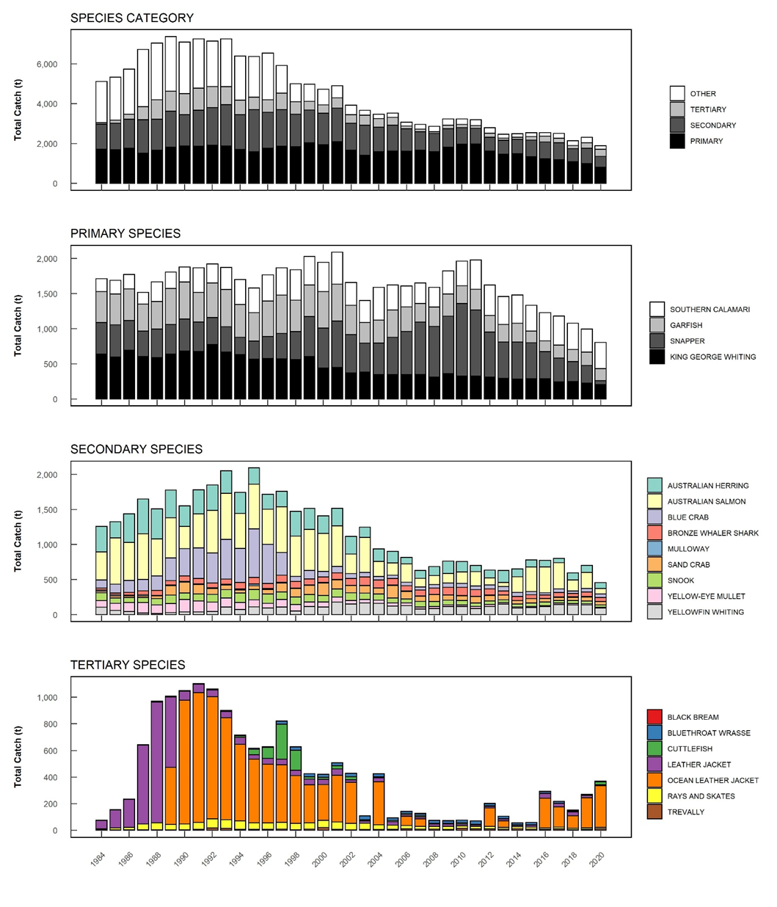

Figure 1: Catch trends for the commercial Marine Scalefish Fishery. Note: catch estimates for 2020 are provisional. From Smart et al. (in prep).

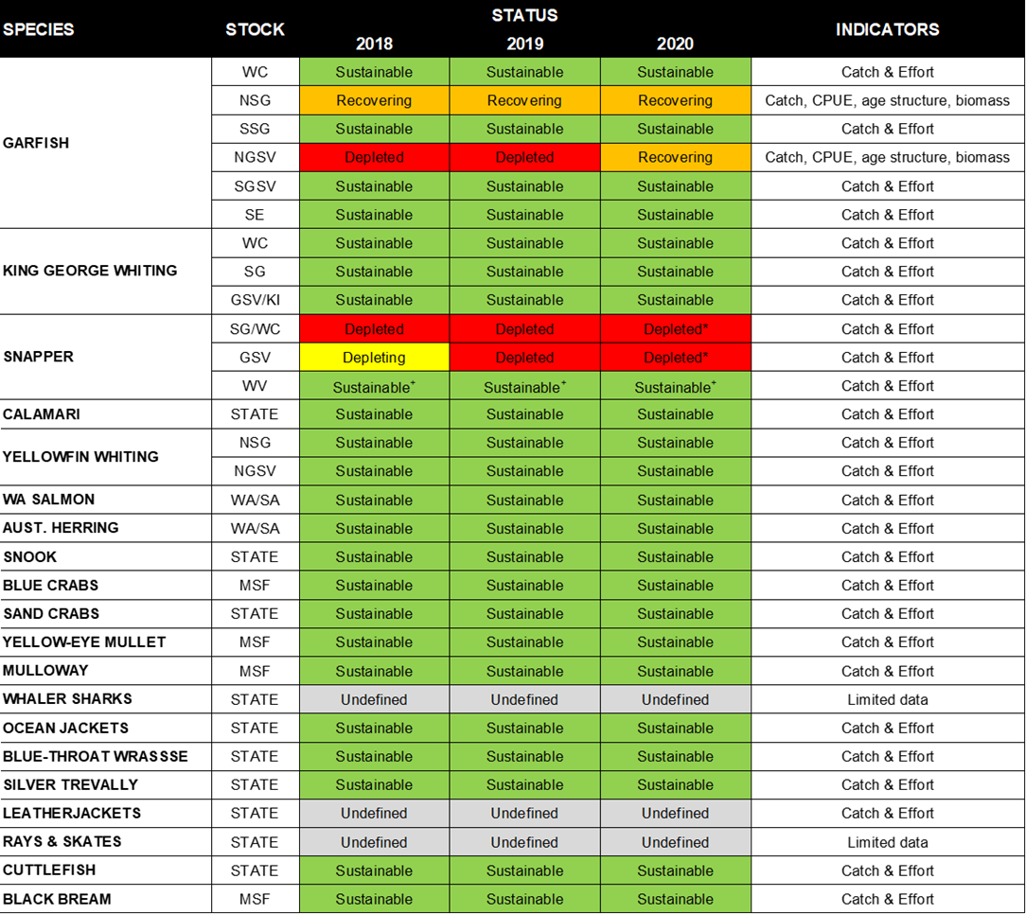*Table 3: Stock status for key MSF species. Note: status classifications for 2020 are provisional. From Smart et al. (in prep*

# Interactions with protected species

Licence holders from all South Australian commercial fisheries, including MSF, complete a wildlife interaction logbook each time an interaction occurs with a threatened, endangered or protected species and provide the returns to SARDI Aquatic Sciences with their monthly catch logbook returns. SARDI assess and report on these interactions annually. Interactions include capture, entanglement and collision.

The most recent report provides data up from 2007/08 to 2020/21 and indicates low levels of interactions since around 2010. There have been no reported interactions with protected species in the MSF in the past five years to 2020/21 (SARDI 2022).

PIRSA has introduced management arrangements to monitor the use of large mesh nets, which may include fishery area closures if effort levels in marine fisheries areas breach triggers. These arrangements have been implemented to address risk of Australian Sea Lions interacting with the MSF. No breaches of these trigger limits have occurred since implementation.

## Byproduct and bycatch stock status

As there are over 60 permitted species in the MSF, there are a wide range of species that may be considered as 'byproduct' and retained. Stock status is assessed for the key byproduct species (Smart et al. in prep) and at present, there are no sustainability concerns for any species considered to be by-product.

Bycatch includes:

* undersized fish
* legal sized fish that are legislatively required to be returned to the water, e.g. non-permitted species or fish that are caught during closed seasons or in closed areas
* unwanted catch (marketing reasons) such as Weeping Toadfish

The ecological impacts associated with the bycatch in the fishery were identified through an ESD risk assessment (PIRSA 2011) which assessed the risk to bycatch species as negligible. Given the reduction in catch and effort in the fishery since this time, it is unlikely that this risk would have increased.

# External influences

An ESD risk assessment of the MSF was conducted by PIRSA in 2011. The outcomes of this assessment identified medium risk of the following environmental factors: removal of/or damage to organisms by fishing, addition of introduced marine pests and aquatic diseases. Strategies related to these risks were adopted in the MSF Management Plan and will be assessed during the review against identified performance indicators.

There are not considered to be significant changes to environmental issues of relevance to the MSF since 2019, although environmental factors are likely to have influenced Snapper recruitment (Fowler et al. 2020; SARDI, pers. comm. 2022).

# Recommendations and Conditions

|  |  |  |  |
| --- | --- | --- | --- |
| **No** | **Recommendations** | **Actions** | **Progress** |
| R1 | PIRSA to advise the Department of Agriculture, Water and the Environment of:   1. any proposed changes to management arrangements for smooth hammerhead sharks (*S.zygaena*); 2. any changes to harvest levels of *S.zygaena*, particularly following the NDF review in 2017; 3. any additional CITES or EPBC Act listed species being, likely to be, or able to be, harvested in the fishery; and   The Department is to be advised prior to such changes being implemented. | Reduced by-catch limits for school and gummy shark have been maintained and a new licence condition requiring prior to landing reporting of school and gummy shark catches was introduced in January 2020. This condition has been monitored and audited. | Ongoing |
| R2 | PIRSA to continue to work with industry to develop and implement a statistically robust monitoring and reporting regime for the fishery that will collect sufficient data to allow evaluation of the effectiveness of the fishery’s management measures. | A new stock assessment for Snapper was undertaken by SARDI in 2020; an ESD risk assessment of ‘lesser known’ species to inform the structural reform of the MSF was undertaken by SARDI in 2020. PIRSA has a number of other FRDC projects that are supporting independent assessment of key species (Snapper, King George Whiting and Garfish). A new compliance and monitoring regime has been developed in consultation with the industry as part of the reform of the MSF and the move to quota management for the key species - Snapper, King George Whiting, Calamari and Garfish from 1 July 2021. An application for FRDC funding has been submitted to develop a Southern Calamari stock assessment program to support TACC setting and evaluation of performance against management objectives. | Ongoing |
| **No** | **Conditions** | **Actions** |  |
| **C1** | PIRSA to:   1. maintain management measures directed toward reducing and managing the impact of fishing activity on Australian Sea Lions; 2. continue to monitor and review the adequacy of its Australian Sea Lion interaction mitigation management measures, in consultation with relevant stakeholders; and   include an effort report within the annual reports, outlining effort using large mesh nets, particularly in ‘high risk blocks’ of the fishery. | In 2016, PIRSA implemented management arrangements measures directed at managing the impact of fishing activity on Australian Sea Lions.  For the 2020/21 financial year, there were no reported large mesh nets used in a ‘high risk block’ and there were 10 boat days using a large mesh net across 4 ‘low risk blocks’ (6 being the highest in fishing block 21). Given this, no triggers were breached. PIRSA is continuing to monitor the use of large mesh nets. It is noted that some licences that were previously actively using large mesh nets have been removed from the MSF through the voluntary licence surrender program, as part of the reform of the fishery. | Achieved |

## References

BDO Econsearch (in press). Economic and Social Indicators for the South Australian Marine Scalefish Fishery 2020/21. A report for the Department of Primary Industries and Regions. Prepared by BDO Econsearch. 13 May 2022. Adelaide, South Australia.

Fletcher, W.J. (2015). Review and refinement of an existing qualitative risk assessment method for application within an ecosystem-based management framework. *ICES Journal of Marine Science* 72(3): 1043-1056.

Fletcher, W.J., Shaw, J., Gaughan, D.J. and Metcalf, S.J. (2011). Ecosystem Based Fisheries Management case study report – West Coast Bioregion. Fisheries Research Report No. 225. Department of Fisheries, Western Australia. 116 pp.

Fowler, A.J., Smart, J., McGarvey, R., Feenstra, J., Buss, J.J., Drew, M., Matthews, D., Matthews, J. and Rogers, T. (2020) Snapper (*Chrysophrys auratus*) Fishery. South Australian Research and Development Institute (Aquatic Sciences), Adelaide. SARDI Publication No. F2007/000523-6. SARDI Research Report Series No. 1072. <https://pir.sa.gov.au/__data/assets/pdf_file/0020/372143/Snapper_Chrysophrys_auratus_Fishery_Assessment.pdf>

Giri, K. and Hall, K. (2015) South Australian Recreational Fishing Survey. Fisheries Victoria Internal Report Series No. 62.

Smart, J.J., Earl, J., Drew, M. J., Bailleul, F., Fowler, A. J., McGarvey, R., Feenstra, J., Matthews, D., Chaplin, G., Matthews, J. M., Freeling, B., Rogers, T. A., Beckman C.L. and Tsolos, A. (in prep). Assessment of the South Australian commercial Marine Scalefish Fishery in 2020. Report to PIRSA Fisheries and Aquaculture. South Australian Research and Development Institute (Aquatic Sciences), Adelaide. SARDI Publication No. F2017/000427-4. SARDI Research Report Series No. 10XX.

PIRSA (2011). [Ecologically Sustainable Development (ESD) risk assessment of the South Australian Commercial Marine Scalefish Fisher](http://www.pir.sa.gov.au/__data/assets/pdf_file/0010/217666/ESD_Risk_Assessment_Report_for_the_South_Australian_Commercial_Marine_Scalefish_Fishery_-_July_2011.pdf)y.

PIRSA (2013). [Management Plan for the South Australian Commercial Marine Scalefish Fishery](http://www.pir.sa.gov.au/__data/assets/pdf_file/0014/12920/Final_Commercial_MSF_Management_Plan_2013.pdf). The South Australian Fisheries Management Series Paper Number 59.

SARDI (2022) Wildlife Interaction Reporting across South Australian Fisheries 2020/21. <https://www.pir.sa.gov.au/__data/assets/pdf_file/0007/398743/SARDI-advice-note-wildlife-interaction-reporting.pdf>

## Appendices

### Appendix A – Categories of Marine Scalefish

1. Primary:
   * King George Whiting (*Sillaginodes punctata*)
   * Snapper (*Chrysophrys auratus*)
   * Southern Garfish (*Hyporhamphus melanochir*)
   * Southern Calamari (*Sepioteuthis australis*)
2. Secondary:
   * Yellowfin Whiting (*Sillago schomburgkii*)
   * Western Australian Salmon (*Arripis truttacea)*
   * Australian Herring (*Arripis georgianus)*
   * Snook (*Sphyraena novaehollandiae)*
   * Yellow-eye Mullet (*Aldrichetta forsteri)*
   * Mulloway (*Argyrosomus japonicus*)
   * Bronze and Dusky Whalers (*Carcharhinus spp.*)
   * Sand Crabs (*Ovalipes australiensis*)
   * Blue Swimmer Crabs (*Portunus armatus)* (only permitted West of 135 degrees East)
   * Mud Cockles (*Katelysia spp*.)[1]
3. Tertiary:
   * Ocean and Leather Jacket (Monacanthidae*)*
   * Trevally (*Pseudocaranx spp.)*
   * Gummy Shark (*Mustelus antarticus*)
   * School Shark (G*aleorhinus galeus)*
   * Cuttlefish (*Sepia spp*.)
   * Octopus (*Octopus spp*.)
   * Yellowtail Kingfish (*Seriola lalandi*)
   * Wrasse ((Family Labridae) (other than Western Blue Groper (*Achoerodus gouldii*)
   * Black Bream (*Acanthopagrus butcheri)*
   * Redfish spp. (*Centroberyx spp.*)
   * Scallops (Pectinidae)
   * Razorfish (Centriscidae)

1. Mud cockles (Vongole) were constituted as a separate commercial fishery from the MSF on 1 July 2021 and are no longer commercially taken in the MSF