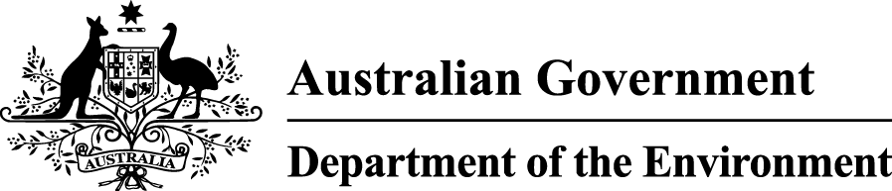

**Sawfish and River Sharks**

**Multispecies Recovery Plan**

**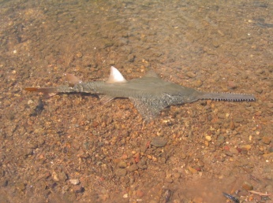**

2015

The issues paper linked to this plan is obtainable from: http://www.environment.gov.au/resource/recovery-plan-sawfish-and-river-sharks

© Copyright Commonwealth of Australia 2015

creative_commons_licence.jpg

Sawfish and River Sharks Multispecies Recovery Plan is licensed by the Commonwealth of Australia for use under a Creative Commons Attribution 4.0 licence with the exception of the Coat of Arms of the Commonwealth of Australia, the logo of the agency responsible for publishing the report, content supplied by third parties, and any images depicting people. For licence conditions see: <https://creativecommons.org/licenses/by/4.0/>.

This report should be attributed as ‘Sawfish and River Sharks Multispecies Recovery Plan, Commonwealth of Australia 2015’.

The Commonwealth of Australia has made all reasonable efforts to identify content supplied by third parties using the following format ‘© Copyright, [*name of third party*] ’.

**Disclaimer**

The views and opinions expressed in this publication are those of the authors and do not necessarily reflect those of the Australian Government or the Minister for the Environment.

While reasonable efforts have been made to ensure that the contents of this publication are factually correct, the Commonwealth does not accept responsibility for the accuracy or completeness of the contents, and shall not be liable for any loss or damage that may be occasioned directly or indirectly through the use of, or reliance on, the contents of this publication.

**Image Credits**

Front Cover:

Largetooth sawfish (*Pristis pristis*) in the Daly River (© Copyright, Richard Pillans).

Back Cover:

Green sawfish (*Pristis zijsron*)juvenile from Pilbara (© Copyright, Richard Pillans).

Contents

[1 Summary 1](#_Toc434481637)

[2 Background 2](#_Toc434481638)

[2.1 Species description 2](#_Toc434481639)

[2.2 Distribution in Australian waters 2](#_Toc434481640)

[2.3 Habitat use and diet 6](#_Toc434481641)

[2.4 Breeding ecology 7](#_Toc434481642)

[2.5 Population structure in Australian waters 7](#_Toc434481643)

[2.6 Population trends 8](#_Toc434481644)

[3 Conservation status 8](#_Toc434481645)

[3.1 Australian Government 8](#_Toc434481646)

[3.2 State and Territory status 9](#_Toc434481647)

[3.3 Non-legislative listing 10](#_Toc434481648)

[4 Reasons for listing under the EPBC Act 10](#_Toc434481649)

[5 Threats 11](#_Toc434481650)

[6 Populations that require protective measures 11](#_Toc434481651)

[7 Habitats that are critical to the survival of the species 12](#_Toc434481652)

[8 Objectives 12](#_Toc434481653)

[8.1 Criteria for success 13](#_Toc434481654)

[9 Actions to achieve the specific objectives 13](#_Toc434481655)

[10 Current management practices 23](#_Toc434481656)

[10.1 Management practices 23](#_Toc434481657)

[10.2 Marine bioregional plans 25](#_Toc434481658)

[10.3 Commonwealth marine reserves 25](#_Toc434481659)

[11 Effects on other native species or ecological communities 26](#_Toc434481660)

[12 Biodiversity benefits 26](#_Toc434481661)

[13 Social and economic considerations 27](#_Toc434481662)

[13.1 Commercial and recreational fishing 27](#_Toc434481663)

[13.2 Agriculture and industry 27](#_Toc434481664)

[13.3 Indigenous Australians 28](#_Toc434481665)

[14 Duration and cost of the recovery process 28](#_Toc434481666)

[15 Affected interests 28](#_Toc434481667)

[16 Efficient and effective use of resources 29](#_Toc434481668)

[17 Consultation 29](#_Toc434481669)

[18 Organisations/persons involved in evaluating the performance of the plan 29](#_Toc434481670)

[19 References 31](#_Toc434481671)

**List of Figures**

[Figure 1. Australian distributions of the three sawfish and two river shark species (a) largetooth sawfish, (b) green sawfish, (c) dwarf sawfish, (d) speartooth shark, (e) northern river shark. 6](#_Toc434481690)

**List of Tables**

[Table 1. Species status under the *Environment Protection and Biodiversity Conservation Act 1999* 8](#_Toc434481696)

[Table 2. Protected species status in the states and the Northern Territory 9](#_Toc434481697)

[Table 3. International protection under IUCN, CITES and CMS 10](#_Toc434481698)

**Abbreviations**

|  |  |
| --- | --- |
| AFMA | Australian Fisheries Management Authority |
| CITES | Convention on International Trade in Endangered Species of Wild Fauna and Flora |
| CMS | Convention on the Conservation of Migratory Species |
| DAFF | Department of Agriculture, Forestry and Fisheries, Commonwealth |
| DoA | Department of Agriculture, Commonwealth |
| DoE | Department of the Environment, Commonwealth |
| DSEWPaC | Department of Sustainability, Environment, Water, Populations and Communities, Commonwealth |
| EPBC Act | *Environment Protection and Biodiversity Conservation Act 1999* |
| ESP Act | *Endangered Species Protection Act 1992* |
| IUCN | International Union for Conservation of Nature |
| MNES | Matter of National Environmental Significance |
| NAILSMA | North Australian Indigenous Land and Sea Management Alliance |
| NGO | Non-government organisation |
| TAP | Threat Abatement Plan |
| TSSC | Threatened Species Scientific Committee |

# Summary

This document constitutes the Australian National Recovery Plan for the largetooth sawfish (formerly known as the freshwater sawfish), green sawfish, dwarf sawfish, speartooth shark and the northern river shark (Sawfish and River Sharks Multispecies Recovery Plan). This recovery plan considers the conservation requirements of these species across their range, identifies the actions to be taken to ensure their long-term viability in nature and the parties that will undertake those actions. The document outlines: the basic biology and ecology of these species; details the known threats; presents the key conservation objectives; and includes performance criteria to measure the achievement of these objectives.

The three sawfish species are listed as vulnerable under the Commonwealth *Environment Protection and Biodiversity Conservation Act 1999* (EPBC Act). Northern river sharks are listed as endangered and speartooth sharks as critically endangered. All five species also receive protection through state-based legislation. This is the first national recovery plan for these species and this recovery plan will be reviewed after a five-year period.

These species have been grouped together in a single recovery plan because of similarity in habitat use, distribution and threats to recovery. All of these species predominantly inhabit the rivers, estuaries and inshore marine habitats of northern Australia (). The largetooth sawfish is known to occur in four distinct regional populations globally. The green sawfish and dwarf sawfish were once known to occur across the Indo-west Pacific region but the dwarf sawfish is now possibly limited to Australia. The two river shark species are only found in Australia and Papua New Guinea.

There is little information on current population sizes or long-term rates of population change for any of the five species included in this recovery plan. However, the information that is available suggests that they have experienced substantial population declines within a few generations and some populations are considered to be extirpated from former parts of their range. Remaining populations are often isolated, raising concerns about their viability. For those species recorded outside Australia, the populations found within Australian waters are thought to represent substantial proportions of the remaining global population.

The principal threats to these sawfish and river shark species come from: commercial fishing activities; recreational fishing; Indigenous fishing; illegal, unreported and unregulated fishing; and habitat degradation and modification. Other potential threats to the species include the collection of animals for display in public aquaria and marine debris.

This recovery plan sets out the research and management actions necessary to stop the decline of, and support the recovery of, these five species in Australian waters. The overarching objective of this recovery plan is to assist the recovery of these species in the wild throughout their range in Australian waters by increasing their total population size, with a view to:

* improving the population status leading to the removal of these species from the protected species list of the EPBC Act
* ensuring that anthropogenic activities do not hinder recovery in the near future, or impact on the conservation status of the species in the future.

This recovery plan should be read in conjunction with the accompanying issues paper which has been developed to provide background information on the biology, population status and threats to the species. The issues paper and this recovery plan are available for download from the department’s website at:

http://www.environment.gov.au/resource/recovery‑plan‑sawfish-and-river-sharks

# Background

## Species description

The five species of tropical riverine, estuarine and marine elasmobranchs (sharks and rays) covered by this plan are:

* Largetooth sawfish (*Pristis pristis)* [previously known as the freshwater sawfish, *Pristis microdon*]
* Green sawfish (*Pristis zijsron)*
* Dwarf sawfish (*Pristis clavata*)
* Speartooth shark (*Glyphis glyphis*)
* Northern river shark (*Glyphis garricki*).

The three sawfish species are all members of the family Pristidae. These species are characterised by their slender shark-like body, flattened head and elongated saw-like snouts, or rostrums, which have varying numbers of teeth along each side depending on species, sex and region. Largetooth sawfish and green sawfish grow to a maximum length of approximately 700 centimetres (cm), with dwarf sawfish reaching a maximum length of approximately 310 cm. Further detail on these species, including differentiating characteristics between each and the recent change in taxonomy from freshwater sawfish (*Pristis microdon*) to largetooth sawfish (*Pristis pristis)*, is included in the issues paper.

The two river shark species are morphologically very similar with separation into distinct species based on dentition, vertebral counts, and subtle coloration and morphological differences. Speartooth sharks are estimated to reach well over two metres at maturity; the maximum recorded size for northern river sharks in Australia is approximately 250 cm for a female and 150 cm for a male; maximum size at maturity is unknown. Together, these two sharks are characterised by: a short, broadly rounded snout, somewhat flattened; tall second dorsal fin; triangular, blade-like upper teeth and tall narrow lower teeth; and slate greyish coloration along the back and abruptly white below, with tonal junction below the eye.

## Distribution in Australian waters

The majority of records for largetooth sawfish in Australia are of juvenile and sub-adult animals from rivers. They have been recorded in numerous drainage systems in northern Australia in fresh and saline water including the Fitzroy, Durack, Robinson and Ord rivers (Western Australia), the Adelaide, Victoria, Daly, East and South Alligator, Goomadeer, Roper, McArthur, Wearyan and Robinson rivers (Northern Territory), and the Gilbert, Mitchell, Normanby, Wenlock, Mission, Embley and Leichhardt rivers (Queensland).

Green sawfish are currently distributed from about the Whitsundays (Harry et al., 2011) in Queensland across northern Australian waters to Shark Bay in Western Australia. Individuals have been recorded in inshore coastal environments and estuaries but the species does not penetrate into freshwater. There are also records of green sawfish hundreds of kilometres offshore in relatively deep water (Stevens et al., 2005).

Since European settlement, the dwarf sawfish’s Australian distribution has been considered to extend from the Pilbara coast in Western Australia across northern Australia and into the Gulf of Carpentaria (Last & Stevens, 1994; Stevens et al., 2008). Distribution on the east coast of the Cape York Peninsula is contested (Kyne et al., 2013a).

Based on available data from immature animals, there are three geographically distinct locations in which speartooth sharks occur or did occur. These are: Van Diemen Gulf drainage in the Northern Territory, including the Adelaide River, South, East and West Alligator Rivers and Murganella Creek; Port Musgrave in Queensland, including the Wenlock and Ducie Rivers; and the Princess Charlotte Bay area of Eastern Cape York in Queensland, though the species has not been recorded on the east coast since the mid-1980’s (Pillans et al., 2009). Photographs of one specimen captured in the Ord River in Western Australia resemble this species, however the specimen was released and this record cannot be verified (R. Pillans, pers. comm).

Northern river sharks have been recorded in rivers and estuaries, as well as the marine environment, within Western Australia and the Northern Territory. In Western Australia, records have come from both the west and east Kimberley, including King Sound, the Ord and King Rivers, the west arm of Cambridge Gulf and also from Joseph Bonaparte Gulf (Thorburn & Morgan, 2004; Stevens et al., 2005; Thorburn, 2006; Field et al., 2008; Pillans et al., 2008; Whitty et al., 2008; Wynen et al., 2009). In the Northern Territory, records have come from the Adelaide, South and East Alligator Rivers, and the Wessel Islands.

The largetooth and green sawfish have suffered severe global declines since the 1960s and are considered to be locally extinct throughout much of their former range. The dwarf sawfish is now possibly restricted to Australia. The two river shark species are only found in Australia and Papua New Guinea (Compagno et al., 2008).

Australia probably represents the last secure populations of green sawfish, dwarf sawfish, speartooth sharks and northern river sharks across their global ranges (Stevens et al., 2005; Phillips, 2012). For largetooth sawfish in the Indo-west Pacific region, Australia may represent the last viable population stronghold and may be a globally important population centre (Kyne et al., 2013b).

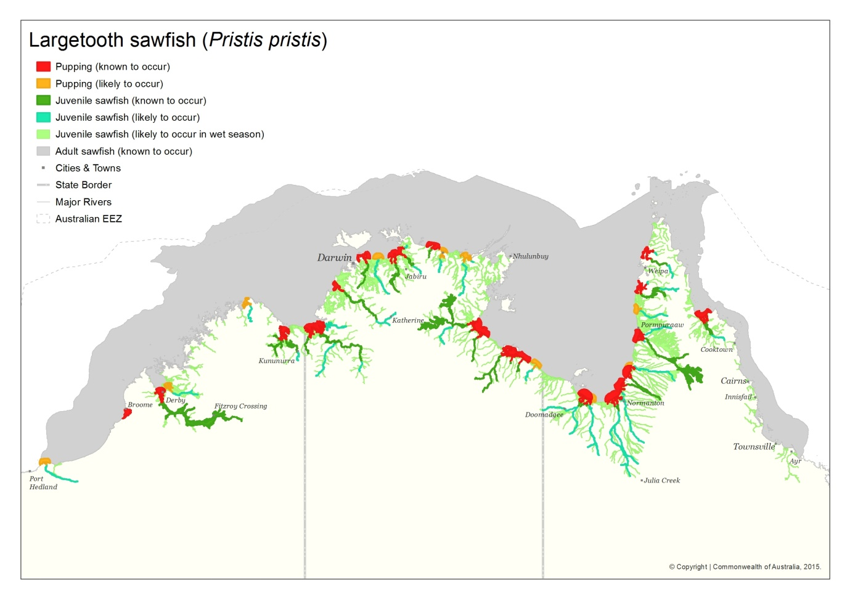

Figure 1a

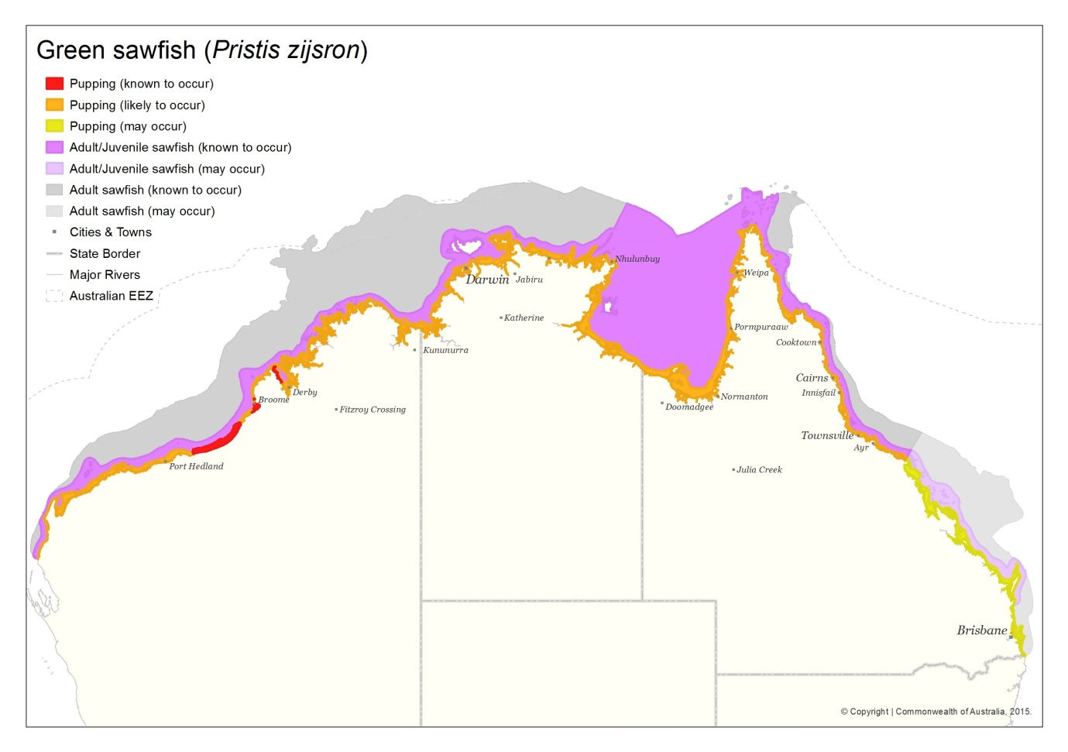

Figure 1b

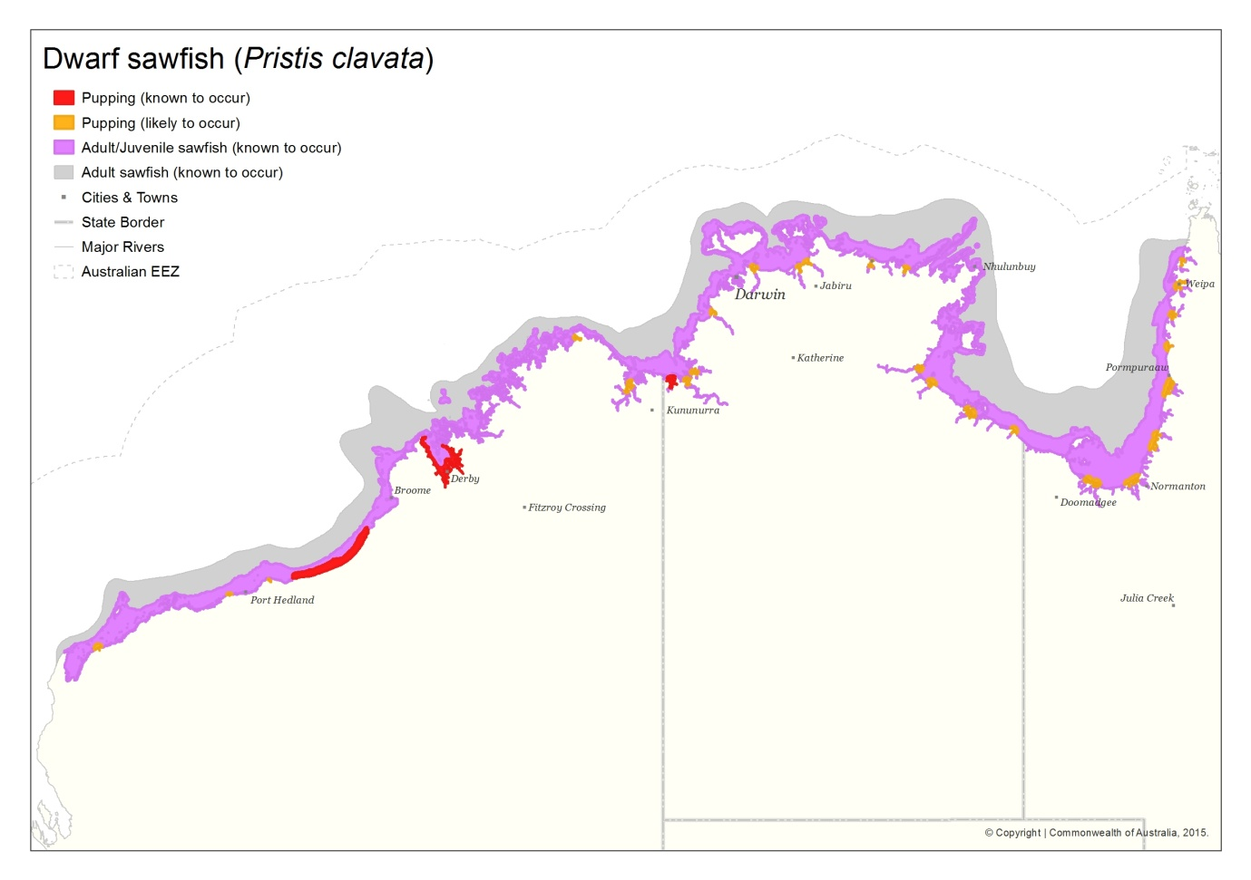

Figure 1c

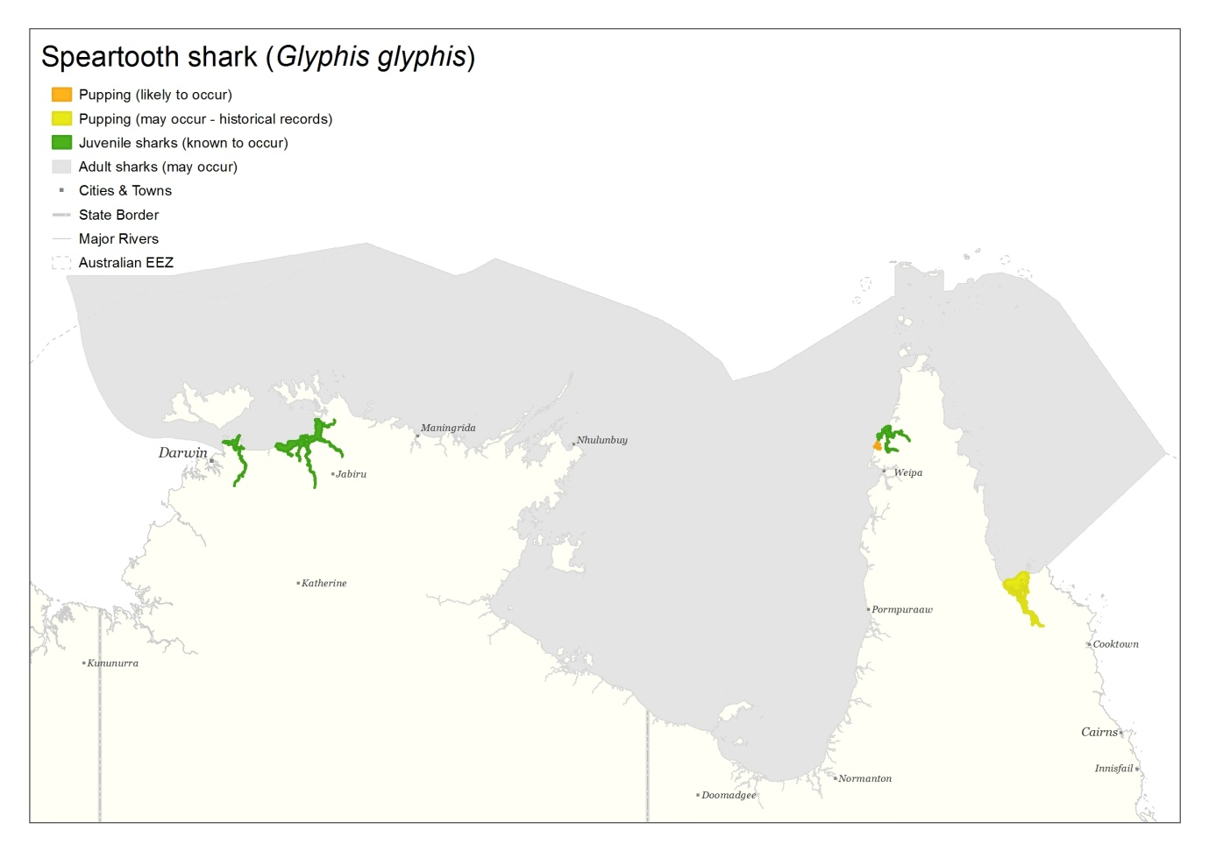

Figure 1d

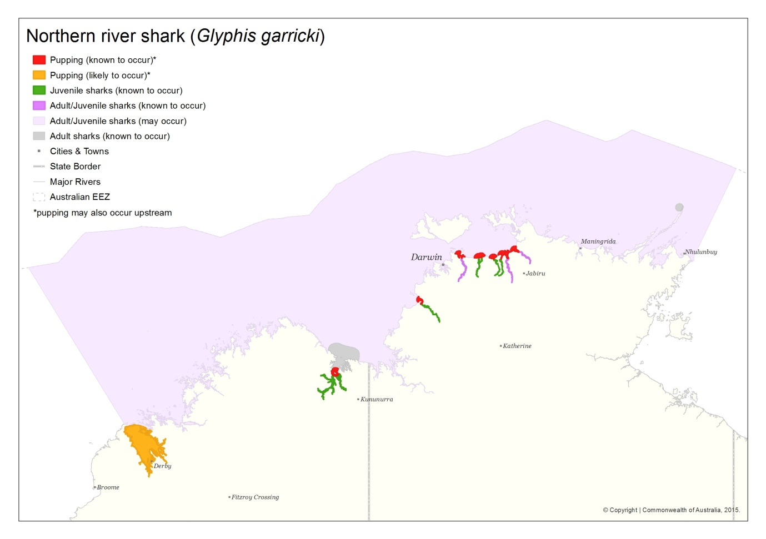

Figure 1e

Figure . Australian distributions of the three sawfish and two river shark species (a) largetooth sawfish, (b) green sawfish, (c) dwarf sawfish, (d) speartooth shark, (e) northern river shark.

## Habitat use and diet

All of these species inhabit inshore coastal areas including rivers and estuaries. Largetooth sawfish live in freshwater rivers and upper estuarine areas as juveniles, before moving into estuarine and marine areas as adults. The other four species spend much of their lives in estuarine and inshore areas. Adults of all five species are thought to also utilise deepwater habitats, though this is unconfirmed for dwarf sawfish and speartooth sharks. Little is known about adult habitat use for any of the species.

Largetooth sawfish inhabit the sandy or muddy bottoms of shallow coastal waters, estuaries, river mouths and freshwater rivers, and isolated water holes. The species has been recorded up to 400 km inland (Witty et al., 2008). Largetooth sawfish have a shift in habitat utilisation with neonate and juvenile animals primarily occurring in the freshwater reaches of rivers and estuaries and adult animals being found in marine and estuarine environments.

Green sawfish occur in inshore coastal environments including estuaries, river mouths, embayments and along sandy and muddy beaches, as well as offshore marine habitat (Stevens et al., 2005; Thorburn et al., 2003). They have been recorded in very shallow water (less than one metre) and in offshore trawl grounds in over 70 m of water (Stevens et al., 2005). Green sawfish do not utilise freshwater environments.

Dwarf sawfish usually inhabit shallow (two to three metres) coastal waters and estuarine habitats, almost into freshwater (Thorburn et al., 2007b; Last & Stevens, 2009). A study in north-western Western Australia found that estuarine habitats are used as nursery areas, with juveniles remaining in these areas up until three years of age (Thorburn et al., 2007b). Adults are thought to occupy a range within the coastal fringe of only a few square kilometres and show site fidelity (Stevens et al., 2008).

Juvenile and sub-adult speartooth sharks utilise large tropical river systems as their primary habitat (Stevens et al., 2005). Based on physiological and life history similarities with bull sharks (*Carcharhinus leucas*), it is assumed adult speartooth sharks live outside of rivers in the coastal marine environment (Stevens et al., 2005; Pillans et al., 2008).

Northern river sharks utilise rivers, tidal sections of large tropical estuarine systems and macrotidal embayments, as well as inshore and offshore marine habitats (Pillans et al., 2009; Thorburn & Morgan, 2004). Adults have been recorded only in marine environments, whereas neonates, juveniles and subadults have been recorded in freshwater, estuarine, and marine environments (Pillans et al., 2009).

All five species are considered to be top order predators and their diet consists mostly of a variety of fish and crustaceans (Stevens et al., 2005). Each of the species likely has its own prey preferences, which would also vary depending on where the animals are found. The diets of these species would also change depending on age, as larger more mature animals are thought to spend more time in the marine environment.

## Breeding ecology

Little is known about the growth rates and breeding ecology of these species. It is presumed that like other large elasmobranch species they have slow growth rates, are long lived and have low reproductive capacity. These life history patterns limit their ability to recover once populations have been depleted. There are critical gaps in our understanding of fecundity (number of pups, reproductive periodicity) as well as age at maturity for females of all five species.

## Population structure in Australian waters

Recent genetic analysis on the three sawfish species has enhanced knowledge of their population structures. This information is useful in helping assess the relative importance of each population in terms of its conservation value.

It is thought that female largetooth sawfish may return to their natal river systems to give birth and that males disperse between geographic regions to breed. An alternate explanation is that there are breeding aggregations where largetooth sawfish gather, with females returning to their natal areas to pup (Phillips et al., 2011; Phillips, 2012). The evidence supports a level of paternal mixing between populations from the west and north coast regions, and the Gulf of Carpentaria region, but highly restricted maternal gene flow. The genetic results also suggest that the east coast population may be genetically distinct – at least maternally – but sample sizes from that region are limited. Faria et al. (2013) also found two distinct haplotypes in the Australian population of largetooth sawfish. The presence of female philopatry in largetooth sawfish has implications for the conservation of this species because if local populations become diminished they may not be repopulated, at least in the short to medium term, through immigration.

Green and dwarf sawfish populations are genetically structured in northern Australian waters. Distinct green sawfish populations have been identified from the west coast, the Gulf of Carpentaria and the east coast. Distinct dwarf sawfish populations are thought to occur on the west coast, the north coast and the Gulf of Carpentaria, with no migration between these locations (Phillips et al., 2011; Phillips, 2012). Unlike the largetooth sawfish, neither the green sawfish nor dwarf sawfish exhibit large-scale sex-biased dispersal in Australian waters. Although the locations and the nature of the boundaries of these population regions remain unknown, the implication is that local population declines or extinctions will not be replenished in the short to medium term through immigration.

There has been no genetic research into the population structure of the river sharks, which makes it difficult to determine if the identified populations mix, and if they do the extent of their mixing.

## Population trends

There is limited information on current population sizes or trends in Australian waters for these species, but there is evidence that all species have experienced recent population declines and some species are considered to have been extirpated from former parts of their range. Remaining populations are often isolated, raising concerns about their viability (DSEWPaC, 2011; DoE, 2015).

# Conservation status

## Australian Government

The five species covered by this recovery plan are all listed either as vulnerable, endangered, or critically endangered under the EPBC Act (Table 1).

Table . Species status under the *Environment Protection and Biodiversity Conservation Act 1999*

|  |  |  |  |
| --- | --- | --- | --- |
| ***Species common name*** | ***Scientific name*** | ***EPBC Status*** | ***Date of listing*** |
| \*Largetooth sawfish | Pristis pristis | Vulnerable | 16 July 2000 |
| Green sawfish | Pristis zijsron | Vulnerable | 7 March 2008 |
| Dwarf sawfish | Pristis clavata | Vulnerable | 20 October 2009 |
| Speartooth shark | *Glyphis* *glyphis* | Critically endangered | 16 October 2001 |
| Northern river shark | *Glyphis* *garricki* | Endangered | 16 October 2001 |

\*The freshwater sawfish (*Pristis microdon*) was relisted under its new name, the largetooth sawfish (*Pristis pristis*) on the threatened species list established under the EPBC Act on 3 October 2013

## State and Territory status

All sawfish and river shark species covered in this recovery plan are also protected under state and territory legislation (Table 2). In state and territory jurisdictions, the taxonomy freshwater sawfish (*Pristis microdon)* is still used. *Pristis microdon* is a synonym for *Pristis pristis* in the Australian Faunal Directory, therefore state protection is still complementary to and not in contradiction with national legislation.

Table . Protected species status in the states and the Northern Territory

|  |  |  |
| --- | --- | --- |
| **Jurisdiction** | **Species** | **Status** |
| Northern Territory | Freshwater sawfish  Green sawfish  Dwarf sawfish  Speartooth shark  Northern river shark | Vulnerable under NT *Parks and Wildlife Conservation Act 2000*  'no take' species under the NT *Fisheries Act* *1988* and Fisheries Regulations  Endangered under *NT Parks and Wildlife Conservation Act 2000*  'no take' species under the NT *Fisheries Act* *1988* and Fisheries Regulations |
| Queensland | Freshwater sawfish  Green sawfish  Dwarf sawfish  Speartooth shark  (*Northern river sharks not present in Queensland waters*) | Protected (‘no take’) species under the Queensland *Fisheries Act 1994* and Fisheries Regulation 2008  All species also listed as ‘High priority’ under Queensland Back on Track species prioritisation framework |
| Western Australia | Green sawfish  Freshwater sawfish  Dwarf sawfish  Northern river shark  (*Speartooth shark not confirmed in Western Australian waters*) | Totally Protected Fish under the *Fish Resources Management Act 1994*  Protected fauna under the *Wildlife Conservation Act 1950*  Threatened under the *Wildlife Conservation Act 1950,* and ranked as Vulnerable  Totally Protected Fish under the *Fish Resources Management Act 1994*  Protected fauna under the *Wildlife Conservation Act 1950* |
| New South Wales | Green sawfish  (*other species not present in New South Wales waters*) | Presumed Extinct under *Fisheries Management Act 1994* |

## Non-legislative listing

The species covered under this recovery plan are also listed internationally under the International Union for Conservation of Nature (IUCN) Red List, the Convention on International Trade in Endangered Species of Wild Fauna and Flora (CITES) and the Convention on the Conservation of Migratory Species (CMS). *Pristis microdon* is a synonym *for Pristis pristis*, therefore international protection is still complementary and not in contrast to national legislation.

Table . International protection under IUCN, CITES and CMS

|  |  |  |
| --- | --- | --- |
| **Species** | **Agency** | **Status** |
| Largetooth sawfish  Green sawfish  Northern river shark  Dwarf sawfish  Speartooth shark | IUCN | Critically Endangered – Red List  Endangered – Red List |
| Largetooth sawfish  Green sawfish  Dwarf sawfish | CITES | Appendix I |
| Largetooth sawfish  Green sawfish  Dwarf sawfish | CMS | Appendix I and II |

# Reasons for listing under the EPBC Act

The freshwater sawfish was transferred from the *Endangered Species Protection Act 1992* (ESP Act) to the vulnerable list of the EPBC Act when it came into force in July 2000. For a species to be considered as vulnerable under the ESP Act, the Minister must have been satisfied that the species was likely to become endangered within the next 25 years. Recommendations for listing species under the ESP Act were made to the Minister by the then Endangered Species Advisory Committee. The name change on the threatened species list, from freshwater sawfish (*Pristis microdon*) to largetooth sawfish (*Pristis pristis*), was endorsed by the Threatened Species Scientific Committee (TSSC) and the species was subsequently relisted under its new name on the threatened species list established under the EPBC Act on 3 October 2013. This direct name change was possible as the biology, abundance and population status in Australian waters did not change as a result of the taxonomic reclassification.

The dwarf sawfish was listed as vulnerable under the EPBC Act in 2009. The dwarf sawfish was recommended for listing by the TSSC as it satisfied Criterion 1 (decline in numbers) of the eligibility requirements. Specifically, the TSSC considered that the species may have undergone a range contraction and was highly susceptible to bycatch in inshore gillnet fishing, as well as being subject to other forms of fishing pressure throughout its range. Therefore, the TSSC judged that the species may have undergone a substantial reduction in numbers within the last three generation lengths and was highly susceptible to future declines.

The green sawfish was listed as vulnerable under the EPBC Act in 2008. The green sawfish was recommended for listing by the TSSC as it satisfied Criterion 1 (decline in numbers) of the eligibility requirements. Specifically, the TSSC considered the green sawfish had experienced a decline in numbers and a range reduction of around 30%, with the species becoming extirpated from NSW and southern Queensland, a region where it was once considered common.

Speartooth sharks and northern river sharks were listed as critically endangered and endangered, respectively under the EPBC Act in 2001. These species were recommended for listing by the TSSC as they satisfied Criteria 2 (geographic distribution), 3 (population size and decline in numbers or distribution) and 4 (population size) of the eligibility criteria. The current listing of the two species of rivershark as critically endangered or endangered is based on their limited geographic distribution and the estimated total number of mature individuals being either very (northern river sharks) or extremely (speartooth sharks) low and likely to continue to decline.

Full details of the listing advice for all of the species covered by this recovery plan can be found at: <http://www.environment.gov.au/cgi-bin/sprat/public/sprat.pl>

# Threats

The principal threats to these sawfish and river shark species come from:

* fishing activities including: being caught as by-catch in the commercial and recreational sectors; through Indigenous fishing; and illegal, unreported and unregulated fishing;
* habitat degradation and modification.

Other potential threats to the species include the collection of animals for display in public aquaria and marine debris.

# Populations that require protective measures

All populations of the sawfish and river shark species covered by this recovery plan are considered to be of high conservation value and hence the actions described are designed to provide ongoing protection for them throughout their Australian ranges.

# Habitats that are critical to the survival of the species

All of these species rely on the inshore coastal areas, including the major rivers and estuarine regions of northern Australia, as described in Section 2.2 and 2.3 and displayed in . Largetooth sawfish live in freshwater rivers and upper estuarine areas as juveniles, before moving into estuarine and marine areas as adults. The other four species spend much of their lives in estuarine and inshore areas. Adults of all five species are thought to also utilise deepwater habitats, though this is unconfirmed for dwarf sawfish and speartooth sharks. Given the declines in these species’ populations and the lack of detailed information on their distribution, all areas where aggregations of individuals have been recorded displaying biologically important behaviour such as breeding, foraging, resting or migrating, are considered critical to the survival of the species unless population survey data suggests otherwise.

# Objectives

The primary objective of this recovery plan is to assist the recovery of sawfish and river sharks in Australian waters with a view to:

* improving the population status leading to the removal of the sawfish and river shark species from the threatened species list of the EPBC Act
* ensuring that anthropogenic activities do not hinder recovery in the near future, or impact on the conservation status of the species in the future.

The specific objectives of the recovery plan are to:

Objective 1: Reduce and, where possible, eliminate adverse impacts of commercial fishing on sawfish and river shark species.

Objective 2: Reduce and, where possible, eliminate adverse impacts of recreational fishing on sawfish and river shark species.

Objective 3: Reduce and, where possible, eliminate adverse impacts of Indigenous fishing on sawfish and river shark species.

Objective 4: Reduce and, where possible, eliminate the impact of illegal, unregulated and unreported fishing (IUU) on sawfish and river shark species.

Objective 5: Reduce and, where possible, eliminate adverse impacts of habitat degradation and modification on sawfish and river shark species.

Objective 6: Reduce and, where possible, eliminate any adverse impacts of marine debris on sawfish and river shark species noting the linkages with the Threat Abatement Plan for the Impact of Marine Debris on Vertebrate Marine Life.

Objective 7: Reduce and, where possible, eliminate any adverse impacts of collection for public aquaria on sawfish and river shark species.

Objective 8: Improve the information base to allow the development of a quantitative framework to assess the recovery of, and inform management options for, sawfish and river shark species.

Objective 9: Develop research programs to assist conservation of sawfish and river shark species.

Objective 10: Improve community understanding and awareness in relation to sawfish and river shark conservation and management.

## Criteria for success

This recovery plan will be deemed successful if, within 10 years, all of the following have been achieved:

* Interactions with, and mortality of, sawfish and river sharks are accurately measured and significantly reduced in commercial and recreational fisheries.
* An empirical monitoring programme(s) is established to measure population trends with a view to assessing recovery in the long term (i.e. 10 or more years).
* An upward trend in population size is demonstrated through an empirical monitoring programme(s) in the long term (i.e. 10 or more years).
* Habitat critical to the survival of each species of sawfish and river shark has been identified and mapped.
* Appropriate measures have been put in place to manage key threats to all sawfish and river sharks included in this plan.

# Actions to achieve the specific objectives

Actions identified for the recovery of the species covered by this plan are described below. Some of the objectives are long-term and may not be achieved during the life time of this recovery plan. Reported costings represent a minimum amount required to undertake the action(s). Priorities assigned to actions should be interpreted as follows:

Priority 1: Taking prompt action is necessary in order to mitigate the key threats to these species and also provide valuable information to help identify long-term population trends.

Priority 2: Action would provide a more informed basis for the long-term management and recovery of these species.

Priority 3: Action is desirable, but not critical to the recovery of these species or assessment of trends in recovery.

***Objective 1:*** *Reduce and, where possible, eliminate adverse impacts of commercial fishing on sawfish and river shark species*

|  |  |  |  |  |  |
| --- | --- | --- | --- | --- | --- |
|  | **Action** | **Priority** | **Performance Criteria** | **Responsible agencies[[1]](#footnote-1)** and potential partners | **Indicative costing** *Only Priority 1 actions are costed* |
| 1a | Ensure actions (for example, changes to management arrangements and fishing practices) to reduce levels of interaction with, and mortality of, sawfish and river shark species are adopted and evaluated in commercial fisheries. | 1 | * Full compliance by commercial fishers with any management measures specified in fisheries management plans and jointly rolled out with the fishing industry. * Breaches documented and reported on with reports made available to stakeholders. * New management measures reviewed after implementation to ensure efficiency and effectiveness. | **Australian Government**  **State and territory governments**  **Commercial fishers**  Relevant non-government organisations (NGOs) | Core government business |
| 1b | Consider new management arrangements to reduce bycatch rates by commercial fishers. | 1 | * Spatial and cumulative risk assessments developed for fisheries that interact with sawfish and river sharks. * New management actions considered to reduce bycatch (seasonal and spatial closures, gear types, targeted license buybacks etc). | **Australian Government**  **State and territory governments**  Commercial fishers  Researchers | Core government business |
| 1c | Improve the ability of fishery monitoring programs to provide accurate (validated) data on the nature and extent of fishery interactions with sawfish and river shark species. (Linked to action 1a) | 1 | * Current monitoring and reporting protocols and requirements for fisheries that interact with river shark and sawfish species reviewed. Recommendations made to ensure requirements are adequate to accurately assess the full nature and extent of fishery interactions with these species. * Observer program, or other validated technique, used to assess accuracy of logbook data and estimate interaction numbers and locations (minimum number of observer visits per annum/fishery). * Observer program data, logbook data and any other relevant information compiled and made available in a public database (connected to objective 9). | **Australian Government**  **State and territory governments**  Commercial fishers | Core government business  A minimum of $30,000 for consultancy to assess monitoring and reporting requirements |

|  |  |  |  |  |  |
| --- | --- | --- | --- | --- | --- |
| 1d | Promote cooperation and understanding between agencies and commercial operators to improve recovery efforts for sawfish and river sharkspecies through, for example, strategic education processes and facilitating research. | 2 | * Educational materials provided to commercial fishers to improve understanding of sawfish and river shark recovery plan actions and objectives (related to objective 10). * Commercial fishers aware of and, where appropriate, involved in recovery plan actions (i.e. assisting scientific research projects). * Information and training, where appropriate, provided to commercial fishers on the identification of threatened sawfish and river sharks. | **Australian Government**  **State and territory governments**  **Commercial fishing associations**  **Relevant nongovernment organisations (NGOs)** | A minimum of $25,000 for development and dissemination of information |

***Objective 2:*** *Reduce and, where possible, eliminate adverse impacts of recreational fishing on sawfish and river shark species*

|  |  |  |  |  |  |
| --- | --- | --- | --- | --- | --- |
|  | **Action** | **Priority** | **Performance Criteria** | **Responsible agencies** and potential partners | **Indicative costing** *Only Priority 1 actions are costed* |
| 2a | Enhance the capabilities of enforcement and compliance agencies for sawfish and river shark species. | 1 | * Compliance agencies aware of and using techniques (morphological and genetic) to identify sawfish and river shark species from part or whole specimens. * Enforcement and compliance agencies are aware of current measures to manage sawfish and river shark species in Australian waters. | **Australian Government**  State and territory governments  Relevant non-government organisations (NGOs) | A minimum of  $25 000 across 2a, 2b, and 2c |
| 2b | Encourage and educate recreational fishers to identify sawfish and river shark species to species level and report any interactions, thus enabling an estimation of the level of interaction with, and mortality of, these species in recreational fisheries. | 1 | * Practical identification materials provided to recreational fishers in hard copy form and via the web. * Information provided to recreational fishers on protected species reporting requirements. * Accidental recreational catch of sawfish and river shark species is monitored and reported annually. | **Australian Government**  **State and territory governments**  **Recreational fishing groups**  **Researchers**  **Relevant non-government organisations (NGOs)** | A minimum of  $25 000 across 2a, 2b, and 2c |
| 2c | Promote cooperation and understanding between government agencies and recreational fishers to improve recovery efforts for sawfish and river sharksthrough, for example,strategic education processes and facilitation of collaborative research. | 2 | * Educational materials up to date and provided to recreational fishers to improve understanding of the sawfish and river sharks recovery plan actions and objectives (related to Objective 10). * Recreational fishers aware of and, where appropriate, involved in recovery plan actions (i.e. assisting scientific research projects). | **Australian Government**  **State and territory governments**  **Recreational fishing groups**  **Researchers**  **Relevant non-government organisations (NGOs)** | A minimum of  $25 000 across 2a, 2b, and 2c |

***Objective 3:*** *Reduce and, where possible, eliminate adverse impacts of Indigenous fishing on sawfish and river shark species*

|  |  |  |  |  |  |
| --- | --- | --- | --- | --- | --- |
|  | **Action** | **Priority** | **Performance Criteria** | **Responsible agencies** and potential partners | **Indicative costing** *Only Priority 1 actions are costed* |
| 3a | In collaboration with Indigenous communities, develop and implement a community level program to promote sawfish and river shark conservation and enhance cooperation and understanding between government agencies and Indigenous communities. | 1 | * Program developed and implemented with Indigenous communities to promote sawfish and river shark conservation.   Program should include:   * Advocacy of protection. * A way to quantify the historical changes in abundance of the species using local knowledge. * A way to quantify the current take of species at a community level. * An exploration of the possibility of setting limits on take and gear. * Consideration of how to develop links with research programs and communities. * Best practice handling techniques for release of animals unharmed. | **Australian Government**  **State and territory governments**  **Indigenous communities and Indigenous land and sea management organisations**  Relevant non-government organisations (NGOs) | A minimum of $100,000 for program development and implementation |

***Objective 4****:* *Reduce and, where possible, eliminate the impact of illegal, unregulated and unreported fishing (IUU) on sawfish and river shark species*

|  |  |  |  |  |  |
| --- | --- | --- | --- | --- | --- |
|  | **Action** | **Priority** | **Performance Criteria** | **Responsible agencies** and potential partners | **Indicative costing** *Only Priority 1 actions are costed* |
| 4a | Investigate and quantify the impact of illegal, unregulated and unreported fishing on sawfish and river shark species. | 1 | * Desktop analysis undertaken to determine the extent of information available on the illegal, unregulated and unreported take of sawfish and river shark species in Australian waters. * Experts consulted to estimate the extent and potential impacts of IUU interactions with sawfish and river shark species. * Report made available. | **Australian Government**  State and territory governments  Indigenous communities and Indigenous land and sea management organisations | Core government business |
| 4b | Enhance the capabilities of enforcement and compliance agencies for sawfish and river shark species. | 1 | * Compliance agencies aware of and using techniques (morphological and genetic) to identify sawfish and river shark species from parts or whole specimens. * Enforcement and compliance agencies aware of current measures to manage sawfish and river shark species in Australian waters. | **Australian Government**  State and territory governments  Relevant non-government organisations (NGOs) | Core government business |
| 4c | Refine and implement techniques (including genetic and morphological) to identify sawfish and river shark species’ products. | 3 | * Genetic and morphological techniques to assist in the identification of sawfish and river shark species from both whole animals and from animal parts (e.g., fins) are refined and used by enforcement authorities. | **Researchers**  Australian Government  State and territory governments |  |
| 4d | Investigate and quantify the extent of trade, both domestic and international, in product from protected sawfish and river shark species. | 3 | * Desktop analysis undertaken to determine the extent of trade in product from protected sawfish and river shark species, utilising information available through agencies such as CITES, Customs and DoA. * Report made available. | **Australian Government**  State and territory governments  Relevant nongovernment organisations (NGOs) |  |

***Objective 5:*** *Reduce and, where possible, eliminate adverse impacts of habitat degradation and modification on sawfish and river shark species*

|  |  |  |  |  |  |
| --- | --- | --- | --- | --- | --- |
|  | **Action** | **Priority** | **Performance Criteria** | **Responsible agencies** and potential partners | **Indicative costing** *Only Priority 1 actions are costed* |
| 5a | Ensure all future developments will not significantly impact upon sawfish and river shark habitats critical to the survival of the species, or impede upon the migration of individual sawfish or river sharks. | 1 | * All future assessments of proposed developments are undertaken in accordance with:   + The EPBC Act , and the associated guidelines and policy documents   + The protocols for surveying and tagging sawfishes and river sharks (Kyne & Pillans, 2014)   + The sawfish and river shark recovery plan, issues paper and other sources of information. * Advice on likely impacts and potential mitigation measures is sought from sawfish and river shark experts for all developments proposed to occur in habitat critical to survival of the species. | **Australian Government**  **State and territory governments** | Core government business |
| 5b | Determine the effect of river and estuarine barriers on the movements of sawfish and river sharks and undertake an audit of barriers to establish whether removal or modification is feasible to allow for the riverine migration of sawfish and river sharks. | 1 | * An audit of barriers that impact on the movement of sawfish and river shark species is undertaken and an assessment is provided on the feasibility of their modification or removal. | **Australian Government**  State and territory governments  Researchers  Local government | A minimum of $30,000 |
| 5c | Identify risks to important sawfish and river shark habitat and measures needed to reduce those risks. | 2 | * Report/s produced identifying risks to important habitat and recommendations on mitigation actions, including spatial protection (linked to 9c). | **Australian Government**  **State and territory governments**  **Researchers**  **Proponents of development activities** |  |
| 5d | Implement measures to reduce adverse impacts of habitat degradation and/or modification. | 2 | * Implement measures such as:   + Removal of barriers impeding species movement, as identified in 5b; and   + Implementation of spatial protection measures, for areas identified in 5c. | **Australian Government**  **State and territory governments** |  |

***Objective 6:*** *Reduce and, where possible, eliminate any adverse impacts of marine debris on sawfish and river shark species, noting the linkages with the Threat Abatement Plan for the Impact of Marine Debris on Vertebrate Marine Life*

|  |  |  |  |  |  |
| --- | --- | --- | --- | --- | --- |
|  | **Action** | **Priority** | **Performance Criteria** | **Responsible agencies** and potential partners | **Indicative costing** *Only Priority 1 actions are costed* |
| 6a | Assess the impacts of marine debris including ghost nets, fishing gear and plastics on sawfish and river shark species. | 1 | * Undertake research to identify the level of threat marine debris presents for sawfish and river shark species. | **Australian Government**  **State and territory governments**  Indigenous communities and Indigenous land and sea management organisations  Relevant non-government organisations (NGOs)  Researchers | A minimum of $30,000 |
| 6b | Partner with marine debris organisations to support initiatives that reduce marine debris likely to impact on sawfish and river sharks. | 2 | * Work in collaboration with key organisations to support the reduction of marine debris in habitats utilised by sawfish and river sharks. | **Australian Government**  **Ghost Nets Australia**  **NAILSMA**  **Landcare Australia** |  |

***Objective 7****: Reduce and, where possible, eliminate any adverse impacts of collection for public aquaria on sawfish and river shark species*

|  |  |  |  |  |  |
| --- | --- | --- | --- | --- | --- |
|  | **Action** | **Priority** | **Performance Criteria** | **Responsible agencies** and potential partners | **Indicative costing** *Only Priority 1 actions are costed* |
| 7a | Measure the conservation benefits derived from aquaria display of sawfish and river sharks. | 1 | * Empirical survey undertaken to measure visitor knowledge of sawfish and river shark species, the threats they face and the conservation actions that may benefit their survival, before and after (both short-term and long-term) an aquarium visit. * Assess potential benefit of improved visitor knowledge to the conservation of the species. | **Public aquaria** Australian Government  State and territory governments | A minimum of $10,000 |
| 7b | Partner with state governments and the aquaria industry to set strict requirements for take from the wild, including a moratorium on collection until full extent of risks to local populations is better understood. | 1 | * Strict guidelines developed and implemented for the collection of sawfish and river shark species. * Strict harvest quotas developed and implemented and compliance measures undertaken. * All captures of sawfish and river shark species reported and recorded and data relevant to research addressing recovery of the species provided to relevant agencies. | **Australian Government**  **State and territory governments**  **Public aquaria** | Core government business |
| 7c | Facilitate research into long-term captive breeding opportunities by encouraging the development of stud book processes. | 3 | * Stud book processes have been initiated. | **Public aquaria**  World Association of Zoos and Aquariums |  |
| 7d | Develop and contribute to a conservation-oriented education program in those public aquaria with captive sawfish and river sharks. | 3 | * Conservation oriented education program developed and in place in aquaria that have sawfish and river shark species (related to Objective 10). | **Public aquaria**  Australian Government |  |

***Objective 8****:* *Improve the information base to allow the development of a quantitative framework to assess the recovery of, and inform management options for, sawfish and river shark species.*

*(Research and data collection actions under other objectives of this Plan will contribute to this objective).*

|  |  |  |  |  |  |
| --- | --- | --- | --- | --- | --- |
|  | **Action** | **Priority** | **Performance Criteria** | **Responsible agencies** and potential partners | **Indicative costing** *Only Priority 1 actions are costed* |
| 8a | Design and implement a cost-effective monitoring program for sawfish and river shark species that takes account of their biology and population structure. | 1 | * A monitoring program aimed at establishing medium to long-term population trends is designed and implemented. Monitoring program also considers the fundamental research needs, as set out in Objective 9. | **Australian Government**  **State and territory governments**  Indigenous communities and Indigenous land and sea management organisations  Researchers | A minimum of $200,000 per annum (for all species) |
| 8b | Develop a portal for the synthesis of information on sawfish and river shark species to ensure that decision-makers and resource managers have the best and most up-to-date information available. | 1 | * Sawfish and River Shark Recovery Plan Portal is used as a key communication tool. * The Department of the Environment sawfish and river sharks website is regularly updated with the latest research developments, including any reports of entanglement with marine debris. | **Australian Government**  **State and territory governments**  Researchers  Relevant non-government organisations (NGOs)  Indigenous communities and Indigenous land and sea management organisations | Core government business |
| 8c | Update and refine information on existing biologically important areas (BIAs)[[2]](#footnote-2) identified as part of DoE’s marine bioregional plans, and seek to identify new BIAs as information from research and other processes becomes available. | 2 | * Scientific information on sawfish and river sharks behaviour and distribution is improved to allow new biologically important areas to be defined, particularly habitat critical to the survival of sawfish and river sharks. * Currency of BIA maps in the Conservation Atlas is maintained. | **Australian Government** | Core government business |

|  |  |  |  |  |  |
| --- | --- | --- | --- | --- | --- |
| 8d | Use BIAs to help inform the development of appropriate conservation measures, including through the application of advice in DoE’s marine bioregional plans on the types of actions which are likely to have a significant impact on the species and updating such conservation measures as new information becomes available. | 1 | * BIAs for sawfish and river sharks are adequately taken into account when assessing the impact of proposed activities in the marine environment and adequately protected. | **Australian Government** | Core government business |

**Objective 9**: *Develop research programs to assist conservation of sawfish and river shark species*

|  |  |  |  |  |  |
| --- | --- | --- | --- | --- | --- |
|  | **Action** | **Priority** | **Performance Criteria** | **Responsible agencies** and potential partners | **Indicative costing** *Only Priority 1 actions are costed* |
| 9a | Improve knowledge of the life history, distribution, population structure and dynamics, and mortality parameters of sawfish and river shark species. | 1 | * Research undertaken on life history, distribution, population structure and dynamics, and mortality of sawfish and river shark species. | **Australian Government**  **State and territory governments**  **Researchers**  Commercial, recreational and Indigenous fishers  Indigenous communities and Indigenous land and sea management organisations | A minimum of $100,000 per annum to support research |
| 9b | Identify important habitats for all life stages of sawfish and river shark species, including connectivity between regions and, where possible, produce habitat maps detailing pupping, nursery, feeding and aggregation areas in Australia. | 1 | * Important habitats identified for sawfish and river shark species. * Detailed habitat maps produced for each of the five protected species. * Research undertaken on habitat use, movement and connectivity, including through the use of genetic techniques. | **Australian Government**  **State and territory governments**  **Researchers**  Indigenous communities and Indigenous land and sea management organisations | A minimum of $150,000 per annum |
| 9c | Investigate the effects of capture and release on the health and survival of sawfish and river shark species. | 1 | * Improved understanding of the effects of capture and release on sawfish and river shark species. * Information on effects of capture and release used when considering management plans. | **Australian Government**  **State and territory governments**  **Researchers**  Commercial, recreational and Indigenous fishers  Indigenous communities and Indigenous land and sea management organisations | A minimum of  $80,000 |
| 9d | Determine how sawfish and river sharks respond to environmental conditions in habitats in which they occur and develop tools to predict the species’ response to changes in environmental conditions. | 1 | * Research undertaken into effects of habitat disturbance. * Tools developed to predict responses to changes in environmental conditions. | **Australian Government**  **State and territory governments**  Researchers | A minimum of  $50,000 |
| 9e | Regularly review research needs to achieve desired conservation outcomes for sawfish and river shark species and develop and distribute a list of research priorities to research providers and research funders. | 1 | * Sawfish and River Shark Recovery Team review, through workshops or teleconferences held on at least an annual basis, the research needed to achieve desired conservation outcomes. * Identified conservation priorities and research needs communicated to research providers and funders. | **Australian Government**  **State and territory governments**  **Researchers**  Relevant nongovernment organisations (NGOs) | Core government business |
| 9f | Disseminate outcomes of research projects on sawfish and river shark species (refer to 8b). | 2 | * Outcomes of research projects quickly and effectively disseminated through such sources as the recovery team, the internet and scientific journals and conferences. | **Australian Government**  **State and territory governments**  Researchers  Relevant non-government organisations (NGOs)  Indigenous communities |  |
| 9g | Facilitate coordination of research and collaborative research on sawfish and river shark species, including the storage and sharing of genetic and life history samples, data and research outputs. | 2 | * Sawfish and River Shark Recovery Team manage and coordinate research and collaboration, meeting on an annual basis. * Protocols developed for the storage and sharing of genetic material. | **Australian Government**  **State and territory governments**  Researchers  Commercial, recreational and Indigenous fishers  Indigenous communities and Indigenous land and sea management organisations |  |

***Objective 10****: Improve community understanding and awareness in relation to sawfish and river shark conservation and management\**

|  |  |  |  |  |  |
| --- | --- | --- | --- | --- | --- |
|  | **Action** | **Priority** | **Performance Criteria** | **Responsible agencies** and potential partners | **Indicative costing** *Only Priority 1 actions are costed* |
| 10a | Undertake coordinated community education programs, with priority given to those communities where greatest conservation outcomes are likely to be achieved. | 3 | * Community education programs and initiatives implemented, particularly in communities that have high levels of interaction with sawfish and river shark species. | **Australian Government**  **State and territory governments**  Researchers  Relevant non-government organisations (NGOs)  Indigenous communities and Indigenous land and sea management organisations  Commercial, recreational and Indigenous fishers |  |

\*Educational activities also included under Objectives 1d, 2c, 3a and 7d.

# Current management practices

## Management practices

Management practices and measures other than those contained in this plan have been developed and are being implemented through a number of agencies and programs. These include Australian Fisheries Management Authority (AFMA) procedures and protocols, Department of Agriculture (DoA) policies and programs, and state and territory government programs. These measures include area and seasonal closures, the compulsory use of logbooks by commercial fishers to record incidental capture, and mechanisms to encourage recreational fishers to report interactions. There are also a number of observer programs in operation designed to provide fisheries independent measures of mortality in state and Commonwealth waters, noting that the capacity of observer programs to provide such data has been reduced with a loss of observer programs and/or reduction in numbers of observers in some fisheries.

In July 2012 the ‘National Plan of Action for the Conservation and Management of Sharks 2012’ (Shark-plan 2) was released (DAFF, 2012). Shark-plan 2 identifies how Australia will manage and conserve sharks, and ensure that Australia meets international conservation and management obligations. The plan identifies research and management actions across Australia for the long-term sustainability of sharks, including actions to help minimise the impacts of fishing on sharks. Shark-plan 2 can be accessed at the following website: <http://www.agriculture.gov.au/SiteCollectionDocuments/fisheries/environment/sharks/sharkplan2-final/sharkplan2-action.pdf>. Shark-plan 2 was developed in conjunction with state, Northern Territory and Australian Government agencies, and has been endorsed by the Shark-plan Implementation and Review Committee and the Australian Fisheries Management Forum.

As the five species of sawfish and river sharks are protected under the EPBC Act, it is an offence to kill, injure, take, trade, keep, or move any individual without a permit in Commonwealth waters. In addition, all listed threatened species are considered matters of national environmental significance (MNES), and any action that may have an impact on MNES must be referred to the Minister of the Environment for approval. The Department of the Environment, as the Australian Government department responsible for administering the EPBC Act, maintains a suite of interactive tools that allow users to search, find and generate reports on information and data describing matters of national environmental significance, including sawfish and river sharks. The conservation values atlas shows the location and spatial extent of conservation values (where sufficient information exists) and is available at: [www.environment.gov.au/coasts/marineplans/cva/index.html](http://www.environment.gov.au/coasts/marineplans/cva/index.html).

The environmental performance of Commonwealth, state and Northern Territory-managed wild harvest fisheries is assessed under the EPBC Act. The EPBC Act requires that:

* All Commonwealth-managed and state wild capture marine fisheries with an export component be assessed to ensure they are being managed in an ecologically sustainable way;
* All Commonwealth-managed fisheries are also assessed to determine the impact of actions taken under a fishery management plan on matters of national environmental significance; and
* All Commonwealth-managed fisheries and any state-managed fisheries that operate in Commonwealth waters must also be assessed to determine the impacts of fishing operations on cetaceans, listed threatened species and ecological communities, migratory species, and listed marine species under the EPBC Act.

The assessments consider the impacts of the fishery on target and non-target species caught and the impacts of fishing on the broader marine environment. As listed threatened species, sawfish and river sharks cannot be taken in fisheries in Commonwealth or state waters. Interactions are required to be recorded in threatened species interaction logbooks in Commonwealth fisheries, the state fisheries of Western Australia, Queensland, New South Wales and Northern Territory fisheries. Interactions with sawfish and river sharks, as well as the life status of the animal when it is captured (e.g. whether it is released alive), are considered in the assessment of fisheries operating in Commonwealth waters.

The Commonwealth Threat Abatement Plan for the Impact of Marine Debris on Vertebrate Marine Life also has the potential to contribute to reducing the impact of marine debris on sawfish and river sharks. Although the implementation of the plan is intended to directly contribute to the protection of marine species described in the key threatening process listing, the plan will have broader benefits for marine species – such as sawfish and river sharks – impacted by marine debris. The marine debris threat abatement plan is available on the department’s website at: [www.environment.gov.au/biodiversity/threatened/publications/tap/marine-debris.html](http://www.environment.gov.au/biodiversity/threatened/publications/tap/marine-debris.html)

Other relevant management practices include management planning processes for areas which contain breeding and/or aggregation sites for these species, and the incorporation of important sites into marine reserves, both at the Commonwealth and state and territory level.

Kakadu National Park provides habitat for speartooth sharks, northern river sharks, dwarf sawfish and largetooth sawfish. The Kakadu National Park Draft Management Plan 2014, expected to come into effect before the end of 2015, is currently being used to guide the management of the National Park, with the aim of working with local traditional owners to ensure the cultural and natural resources of the coastal and marine environment and islands within the Park are recognised, protected and maintained. Further information is available on the department’s website at: <http://www.environment.gov.au/resource/kakadu-draft-management-plan>

The three sawfish and two river shark species are also protected across their range in state waters and in the Northern Territory. Details of protection measures afforded to these species in each jurisdiction, including state marine parks that afford protection, can be obtained from the relevant state or territory agency; the classifications of these species in state legislation are summarised in .

## Marine bioregional plans

Marine bioregional plans have been prepared under section 176 of the EPBC Act for the South-west, North-west, North and Temperate East marine regions in Commonwealth waters around Australia. Each marine bioregional plan describes the conservation values of the region, identifies and characterises the pressures affecting these conservation values and identifies regional priorities and outlines strategies to address them. As part of the marine bioregional planning process, sawfish and river sharks have been identified as ‘conservation values’ in both the North and the North-west marine regions (DSEWPaC, 2012a, b). The pressures affecting sawfish and river sharks have been identified and characterised for these regions. In addition, Schedule 2 of both the North and North-West marine bioregional plans include guidance for people planning to undertake actions that have the potential to impact on sawfish and river sharks within these regions. Further information on marine bioregional planning is available on the department’s website at: [www.environment.gov.au/coasts/marineplans/index.html](http://www.environment.gov.au/coasts/marineplans/index.html).

As part of the marine bioregional planning process biologically important areas have been identified for a number of species, including sawfish and river sharks. Biologically important areas are areas that are particularly important for the conservation of protected species and where aggregations of individuals display biologically important behaviour such as breeding, foraging, resting or migration. The presence of the observed behaviour is assumed to indicate that the habitat required for the behaviour is also present. Biologically important areas for sawfish have been identified in the North West Marine Bioregional Plan, and are available in the conservation values atlas at: [www.environment.gov.au/coasts/marineplans/cva/index.html](http://www.environment.gov.au/coasts/marineplans/cva/index.html)

## Commonwealth marine reserves

Marine reserves (also known as marine protected areas or marine parks) are parts of the ocean that are managed primarily for the conservation of their ecosystems, habitats and the marine life they support, and ecologically sustainable use. Forty new Commonwealth marine reserves were declared around Australia in November 2012. The new Commonwealth marine reserves network includes examples of all of Australia’s marine ecosystems. Management plans will be developed for each regional marine reserves network and for the Coral Sea Commonwealth Marine Reserve in accordance with the *Environment Protection and Biodiversity Conservation Act 1999* (EPBC Act). Transitional management arrangements are in place until new management plans are developed and come into effect. Information on transitional arrangements is available at: [www.environment.gov.au/marinereserves/index.html](http://www.environment.gov.au/marinereserves/index.html).

The Commonwealth marine reserves network protects habitats important for threatened species. Their location outside of state waters (3 nautical miles off the coast) means they relate to solely marine environments and therefore would support adult sawfish and river sharks once they mature and utilise offshore areas. There are 21 Commonwealth Marine Reserves in the North and North-west Commonwealth Marine Reserve Network that sawfish and river shark species may utilise. More information on the Commonwealth Marine Reserve Network is available at: [www.environment.gov.au/coasts/marineplans/cva/index.html](http://www.environment.gov.au/coasts/marineplans/cva/index.html).

Similarly, adult sawfish and river sharks may use parts of the Great Barrier Reef Marine Park. Further information on the Great Barrier Reef Marine Park and interaction with sawfish and river sharkscan be found at: [www.gbrmpa.gov.au](http://www.gbrmpa.gov.au). Complementary management is provided in state waters under the Queensland coastal management plan. The Queensland coastal management plan is available at: <http://www.ehp.qld.gov.au/coastalplan/>.

# Effects on other native species or ecological communities

Reducing anthropogenic impacts from activities such as fishing may benefit other threatened species, such as other shark species, sea birds, marine turtles and marine mammals. The consequences for other native species should the numbers of sawfish and river sharks substantially increase as an outcome of this plan are unknown, but it is unlikely that they will cause adverse consequences for other native species at the population scale.

# Biodiversity benefits

The implementation of this plan will provide a variety of biodiversity benefits for other native species which live within the same regions. Actions in the plan will:

* Better manage legal fishing activities to ensure greater sustainability of take;
* Reduce illegal, unreported and unregulated fishing, which likely impacts on a broad range of fish stocks;
* Support the Commonwealth Threat Abatement Plan for the Impact of Marine Debris on Vertebrate Marine Life to reduce the impacts of marine debris within the broader ecosystem; and
* Investigate the impact of habitat modification, with the aim of minimising any future disturbances and possibly reversing some of the changes already made (i.e., reducing the number of barrages that block migration in river systems).

Any benefits accruing to sawfish and river shark species from these actions will also benefit other species living in the area.

# Social and economic considerations

The five species of sawfish and river sharks protected by this recovery plan are all found in areas that overlap with commercial and recreational fishing activities and the species are also taken by Indigenous Australians for food and ceremonial purposes. These species also occur in areas which are used for other purposes, such as agriculture and industry. Therefore, any actions undertaken as a result of this recovery plan will have social and economic consequences.

## Commercial and recreational fishing

The incidental capture of sawfish and river shark species by the commercial fishing sector is considered to be a threat to these species and it is likely that commercial fishers will experience negative consequences as a result of enacting this plan. Although it is illegal to target sawfish and river shark species in Australian waters, fishers do accidently catch these species as part of their regular activities. This plan will require them to undertake reporting of these catches, where it is not already routinely done, and also spend time in identifying and releasing captured individuals (see Kyne & Pillans, 2014 for methods on identifying and releasing sawfish and river sharks). The plan may also require changes in fishing methods to avoid capture or increase the chances of survival of captured animals as well as possible area and seasonal closures. While it is not expected that this plan will significantly impact on the commercial fishing sector as a whole, there may be some limited localised impacts due to new measures put in place. Any action in the plan that has economic impacts on fishers should be undertaken in consultation with the fishing industry and should be designed to minimise hardship.

Recreational fishers have generally been supportive of measures designed to ensure their sport is sustainable. However, the recreational sector does catch sawfish and river shark species and recreational fishing is still considered to be of concern to these species. The actions outlined in this recovery plan focus on ensuring compliance with reporting requirements and ensuring reporting mechanisms are in place to adequately assess the impact of recreational fishing on these species. Implementation of these actions will have minimal economic impact on recreational fishers, however changes in gear types may become necessary. Regular contact and consultation with fishers will be a key strategy in encouraging awareness, support and involvement in the recovery effort.

## Agriculture and industry

The agricultural and industrial sectors may also suffer negative economic and social consequences. When considering referred actions, the Minister for the Environment must not act inconsistently with any existing recovery plan. This, in effect, means that actions likely to have a significant impact on sawfish and river shark populations need to consider the objectives and actions included in this Recovery Plan and may need to undertake mitigation actions in order to gain approval under the EPBC Act. Mitigation actions may include controls on timing, consideration of alternative development sites, undertaking remedial work to minimise habitat degradation, or the provision of some type of offset (e.g., securing an additional site for long-term conservation purposes and/or undertaking/ supporting research programs to help manage the long-term survival in the wild for the species in question).

## Indigenous Australians

Indigenous people have rights to access and manage much of the sparsely populated landscape of north Australia where sawfish and river sharks occur, and catch sawfish and river shark species for food and for ceremonial purposes (Thorburn et al., 2007a). This recovery plan seeks to ensure that Indigenous take is sustainable, balancing the cultural significance of fishing for these species against modern fishing techniques that make fishing efforts more successful. Efforts to improve the sustainability of Indigenous take may result in education and outreach programs which encourage voluntary limits on harvest and collaborative research initiatives. Any actions that are implemented to manage Indigenous fishing will be developed in close collaboration with the relevant communities and Indigenous groups, including land and sea management groups and Indigenous rangers.

# Duration and cost of the recovery process

It is anticipated that the recovery process will not be achieved prior to the scheduled five year review of the recovery plan, therefore this recovery plan will remain in place until such time that the Australian populations of the five protected species covered by this plan have improved to the point that the species no longer meets threatened species status within Australia under the EPBC Act.

The cost of implementation of this plan should be incorporated into the core business expenditure of the affected organisations and through additional funds obtained for the explicit purpose of implementing this recovery plan. It is expected that state, territory and Commonwealth agencies will use this plan to prioritise actions to protect the species and enhance their recovery, and that projects will be undertaken according to agency priorities and available resources. Actions which cross jurisdictional boundaries should be coordinated and may be funded jointly on agreement by relevant parties.

# Affected interests

Organisations likely to be affected by the actions proposed in this plan include: government agencies (Commonwealth, state and territory), particularly those involved with environmental and fisheries concerns; commercial and recreational fishers; local Indigenous communities; researchers; tourism operators; conservation groups; wildlife interest groups; aquarium operators, aquarium collectors and proponents of coastal development in the vicinity of important habitat areas. This list should not be considered exhaustive, as there may be other interest groups that would like to be included in the future or need to be considered when specialised tasks are required.

# Efficient and effective use of resources

In order to maximise the conservation outcomes and cost effectiveness of this plan, the actions proposed complement those of other threatened species recovery plans, both at the national and state and territory level, and of a number of threat abatement plans (e.g., the Threat Abatement Plan for the Impact of Marine Debris on Vertebrate Marine Life).

# Consultation

The Sawfish and River Sharks Multispecies Recovery Plan and Issues Paper have been developed through extensive consultation with a broad range of stakeholders.

An issues paper was originally disseminated to stakeholders and comments were provided. That paper then formed the basis of a broad stakeholder workshop that helped finalise the issues paper and developed the conservation actions that would form the basis of the recovery plan. This two day stakeholder workshop was held in October 2011. The workshop was attended by relevant scientists and representatives from state governments and the Northern Territory, the commercial and recreational fishing sectors, conservation groups and Indigenous organisations.

Based on the comments received, the issues paper and the recovery plan were re-drafted and sent again to the stakeholder group for final comments. The documents were then submitted to the 54th TSSC meeting, where it was agreed they would recommend to the Minister he make the draft plan available for a three month public comment period. This public comment period was from 29 January until 29 April 2014.

All comments received were considered and changes made where necessary. Final endorsement from the TSSC was given at the 58th TSSC meeting on 3-4 November 2014.

# Organisations/persons involved in evaluating the performance of the plan

This plan should be reviewed no later than five years from when it was endorsed and made publicly available. The review will determine the performance of the plan; whether the plan continues unchanged; whether the plan is varied to remove completed actions and include new conservation priorities; or whether a recovery plan is no longer necessary for the species as either conservation advice will suffice or the species is removed from the threatened species list.

The review will be coordinated by the Department of the Environment in association with relevant Commonwealth government and state agencies and key stakeholder groups such as the commercial and recreational fishing sectors, non-government organisations, tourism operators, aquarium operators, Indigenous organisations and scientific research organisations.

Key stakeholders who may be involved in the review of the performance of this recovery plan:

Australian Government

Australian Fisheries Management Authority  
Australian Institute of Marine Science

Commonwealth Scientific and industrial Research Organisation

Department of Agriculture  
Department of the Environment  
Department of Industry  
Great Barrier Reef Marine Park Authority  
Indigenous Land Corporation

Industry and Non-Government Organisations

Zoo and Aquarium Association of Australia

Aquarium industry

Commercial fishers and associations  
Conservation groups  
Indigenous Land Councils

Indigenous communities and Indigenous land and sea management organisations  
Local communities  
Nature-based tourism industry  
Marine/Ocean energy industry  
Recreational fishers and associations  
Universities and other research organisations  
Recreational boating

State / Territory Governments

Department of Parks and Wildlife, WA

Department of Fisheries, WA

Department of Agriculture and Fisheries, QLD

Department of Environment and Heritage Protection, QLD

Department of Lands, Planning and the Environment, NT

Parks and Wildlife Commission of the Northern Territory

Department of Primary Industry and Fisheries, NT

Museums

Natural Resource Management Bodies/ Catchment Management Authorities in coastal regions

Local Government in coastal regions

# References

Compagno, L. J. V., White, W. T. & Last, P. R. (2008). *Glyphis* *garrick* sp. nov., a new species of river shark (Carcharhiniformes: Carcharhinidae) from northern Australia and Papua New Guinea, with a redescription of *Glyphis glyphis* (Müller and Henle, 1839). *CSIRO Marine and Atmospheric Research Paper 22*, 203–225.

DAFF. (2012). *National Plan of Action for the Conservation and Management of Sharks 2012 (Shark-plan 2)*. Department of Agriculture, Fisheries and Forestry, Canberra.  
Available on the internet at:  
<http://www.agriculture.gov.au/fisheries/environment/sharks/sharkplan2>

DoE. (2015). *Draft Issues Paper for Sawfish and River Sharks – Largetooth Sawfish (*Pristis pristis*), Green Sawfish (*Pristis zijsron*), Dwarf Sawfish (*Pristis clavata*), Speartooth Shark (*Glyphis glyphis*), Northern River Shark (*Glyphis garricki*)*. Department of the Environment. Canberra. 57 pp.

DSEWPaC. (2011). *Non-detriment finding for the Freshwater Sawfish,* Pristis microdon. Department of Sustainability, Environment, Water, Population and Communities. Canberra. 21 pp.

DSEWPaC. (2012a). *Species group report card – sharks and sawfishes. Supporting the marine bioregional plan for the North-west Marine Region*. Department of Sustainability, Environment, Water, Population and Communities.   
Available on the Internet at:   
[http://www.environment.gov.au/coasts/marineplans/north‑west/index.html](http://www.environment.gov.au/coasts/marineplans/northwest/index.html)

DSEWPaC. (2012b). *Species group report card – sawfishes and river sharks. Supporting the marine bioregional plan for the North Marine Region*. The Department of Sustainability, Environment, Water, Population and Communities.  
Available on the internet at:  
<http://www.environment.gov.au/coasts/marineplans/north/index.html>

Faria, V. V., McDavitt, M. T., Charvet, P., Wiley, T. R., Simpendorfer, C. A. & Naylor, G. J. P. (2013). Species delineation and global population structure of Critically Endangered sawfishes (Pristidae). *Zoological Journal of the Linnean Society* *167*, 136–164.

Field, I. C., Charters, R., Buckworth, R. C., Meekan, M. G. & Bradshaw, C. J. A. (2008). *Distribution and abundance of Glyphis and sawfishes in northern Australia and their potential interactions with commercial fisheries.* Report to Australian Government, Department of the Environment, Water, Heritage and the Arts. Canberra. 39 pp.

Harry, A. V., Tobin, A. J., Simpfendorfer, C. A., Welch, D. J., Mapleston, A., White, J., Williams, A. J. & Stapley, J. (2011). Evaluating catch and mitigating risk in a multi-species, tropical, inshore shark fishery within the Great Barrier Reef World Heritage Area. *Marine and Freshwater Research* *62*, 710–721.

Kyne, P. M., Carlson, J. & Smith, K. (2013b). *Pristis pristis*. In: IUCN 2013*. IUCN Red List of Threatened Species*. *Version 2013.1.*   
Viewed on 16 July 2013  
Available on the Internet at:   
[www.iucnredlist.org](http://www.iucnredlist.org)

Kyne, P. M. & Pillans, R. D. (2014). Protocols for surveying and tagging sawfishes and River Sharks. CSIRO Brisbane and CDU Darwin.

Kyne, P. M., Rigby, C. & Simpfendorfer, C. (2013a). *Pristis clavata*. In: IUCN 2013. *IUCN Red List of Threatened Species. Version 2013.1.*   
Viewed on 16 July 2013  
Available on the Internet at:  
www.iucnredlist.org

Last, P. R., & Stevens, J. D. (1994). *Sharks and rays of Australia*. Commonwealth Scientific and Industrial Research Organisation (CSIRO). Australia. 513 pp + 84 colour plates.

Last, P. R, & Stevens, J. D. (2009). *Sharks and rays of Australia*. second edition. Commonwealth Scientific and Industrial Research Organisation (CSIRO). Australia.

Phillips, N. (2012). *Conservation genetics of Pristis sawfishes in Australian waters*. PhD Thesis. Murdoch University. 247 pp.

Phillips, N., Chaplin, J. A., Morgan, D. L. & Peverell, S. C. (2011). Population genetic structure and genetic diversity of three critically endangered Pristis sawfishes in Australian waters. *Marine Biology 158*, 903–915.

Pillans, R. D., Stevens, J. D., Kyne, P. M. & Salini, J. (2009) Observations on the distribution, biology, short-term movements and habitat requirements of river sharks Glyphis spp. in northern Australia, *Endangered Species Research* *10,* 321–332.

Pillans, R. D., Stevens, J. D., Peverell, S. & Edgar. S. (2008). *Spatial distribution and habitat utilisation of the speartooth shark* Glyphis glyphis *in relation to fishing in Northern Australia*. Department of the Environment, Water, Heritage and the Arts, Canberra. 47 pp.

Stevens, J. D., McAuley, R. B., Simpfendorfer, C. A. & Pillans, R. D. (2008) *Spatial distribution and habitat utilisation of sawfish (*Pristis spp*) in relation to fishing in northern Australia.* A report to Department of the Environment, Water, Heritage and the Arts, CSIRO and Western Australian Government Department of Fisheries. 26 pp.  
Available on the internet at:  
<http://www.environment.gov.au/resource/spatial-distribution-and-habitat-utilisation-sawfish-pristis-spp-relation-fishing-northern>

Stevens, J. D., Pillans, R. D. & Salini, J. P. (2005). *Conservation assessment of* Glyphis glyphis *(speartooth shark),* Glyphis garicki *(northern river shark),* Pristis microdon *(freshwater sawfish) and* Pristis zijsron *(green sawfish)*. Report to Department of Environment and Heritage. Canberra. Australia. 84 pp.  
Available on the internet at:  
<http://www.environment.gov.au/resource/conservation-assessment-glyphis-sp-speartooth-shark-glyphis-sp-c-northern-river-shark>

Thorburn, D. C. (2006). *Biology, ecology and trophic interactions of elasmobranchs and other fishes in riverine waters of northern Australia*. PhD Thesis, Murdoch University, Perth, Western Australia.

Thorburn, D. C. & Morgan, D. L. (2004). The northern river shark *Glyphis* sp. C. (Carcharhinidae) discovered in Western Australia. *Zootaxa* *685,* 1–8.  
Available on the internet at:  
<http://www.mapress.com/zootaxa/2004f/zt00685.pdf>

Thorburn, D. C., Morgan, D. L., Rowland, A. J. & Gill, H. S. (2007a). Freshwater sawfish *Pristis* *microdon* (Chondrichthyes: Pristidae) in the Kimberley region of Western Australia. *Zootaxa* *1471*, 27–41.

Thorburn, D. C., Morgan, D. L. Rowland, A. J., Gill, H. S. & Paling, E. (2007b). Life history notes of the critically endangered dwarf sawfish, *Pristis clavata*, Garman 1906 from the Kimberley region of Western Australia. *Environmental Biology of Fishes* *83*, 139–145.

Thorburn, D. C., Peverell, S. C., Stevens, J. D., Last, P. R. & Rowland, A. J. (2003). *Status of freshwater and estuarine elasmobranchs in Northern Australia*. Final Report to the Natural Heritage Trust, pp. 1–75.

Whitty, J. M., Phillips, N. M., Morgan, D. L., Chaplin, J. A., Thorburn, D. C. & Peverell, S. C. (2008). *Habitat associations of Freshwater Sawfish (*Pristis microdon*) and Northern River Sharks (*Glyphis garricki*): including genetic analysis of freshwater sawfish across northern Australia.* Report to Australian Government, Department of the Environment, Water, Heritage and the Arts. Murdoch University Centre for Fish and Fisheries Research. Perth, Western Australia. 75 pp.

Wynen. L., Larson, H., Thorburn, D., Peverell, S., Morgan, D., Field, I. & Gibb, K. (2009). Mitochondrial DNA supports the identification of two endangered river sharks (*Glyphis glyphis* and *Glyphis garricki*) across northern Australia. *Marine and Freshwater Research* *60*, 554–562.

1. Lead agencies are identified in bold type. [↑](#footnote-ref-1)
2. Further information regarding BIAs is provided in Section 10.2: Marine Bioregional Plans. [↑](#footnote-ref-2)