# Sea Country Indigenous Protected Areas Program

# Grant opportunity 2021-2023

## New funding for Sea Country Indigenous Protected Areas

The Australian Government is providing $9.7 million in grants to Indigenous organisations to add areas of sea into Indigenous Protected Areas (IPAs). This will be done by creating new Sea Country IPAs and expanding existing IPAs to include sea. The funding will support Indigenous organisations to consult with Traditional Owners and other stakeholders about setting up a Sea Country IPA and undertake planning. It will also create jobs for Indigenous people to carry out on-ground/sea activities, like managing pests and weeds, turtle surveys, beach clean-ups, and sea patrols.

## What is a Sea Country IPA?

A Sea Country IPA is sea or land and sea managed by Indigenous people in partnership with others to conserve and protect the environmental and cultural values. It involves a voluntary agreement between an Indigenous organisation and the Australian Government.

Sea Country IPAs allow Indigenous Australians to partner with stakeholders, community groups and government agencies, to collaboratively manage shared marine and coastal resources for the benefit of all Australians.

The Sea Country IPA program also provides cultural, social, health and wellbeing and economic benefits to Indigenous communities, including employment, education and training opportunities. Through their work, Indigenous land and sea managers can be important role models, engaging with youth in their communities.

Sea Country is ….

… the sea and coastal environments.

Sea covers Commonwealth waters and state and territory coastal waters

Coastal environment includes mangroves, saltmarshes, seagrass beds, beaches, dunes, estuaries, gulfs, bays and coastal wetlands

Image Umagar Island, Masig Islands Consultation IPA

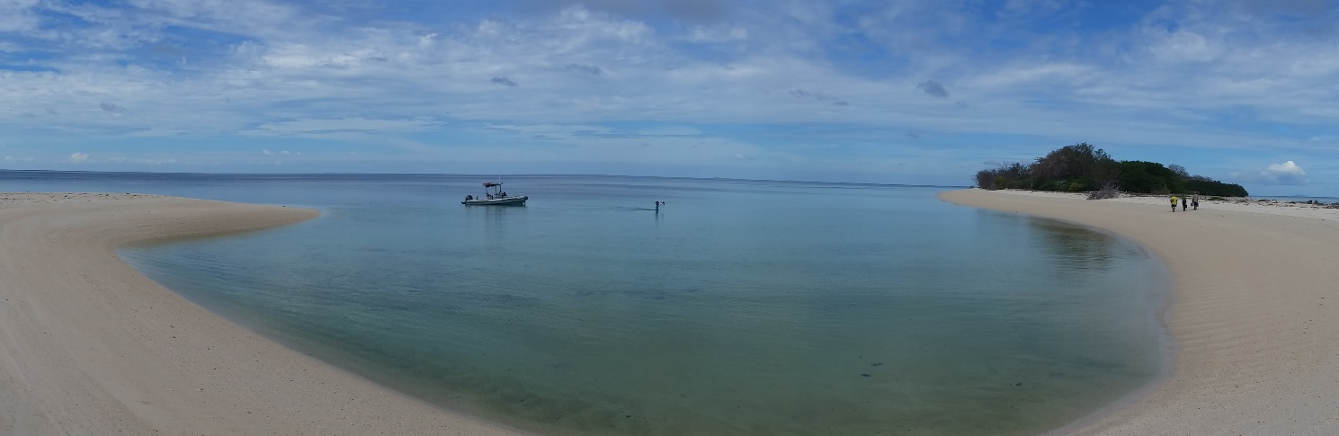

## How is a Sea Country IPA developed?

### Step 1. Consultation and planning

The first step is an Indigenous-led consultation process, where Traditional Owners - local Indigenous people with responsibilities to care for country - and key stakeholders who have rights and interests in the area are consulted and involved in planning. This includes stakeholders such as government agencies, commercial operators, scientists and recreational groups.

An IPA management plan is developed describing how Traditional Owners and key stakeholders will work together to manage the natural and cultural values of an area, while also considering social, economic and research/education needs. The management plan also identifies potential partnerships with other stakeholders that can support management. It must identify an International Union for Conservation of Nature (IUCN) management category to ensure that the management is in line with international standards.

These plans usually complement, rather than replace, existing management arrangements.

### Step 2. Dedicating the IPA

The second step is to formally dedicate the area as a Sea Country IPA. The Australian Government makes sure Traditional Owners for the area provide their free, prior and informed consent to the dedication, and that the rights and interests of all relevant parties have been considered before a marine area is dedicated as an IPA. For example, a proposal to dedicate an IPA over an area of state or territory waters must have support from the relevant state/territory government and industries.

Dedication of a Sea Country IPA is not legally binding and does not give Traditional Owners additional authority to make changes to rights that existed before dedication, such as closing fishing grounds, changing bag limits, changing commercial fishing boundaries, restricting mining or oil and gas exploration or limiting tourism operations.

A dedicated Sea Country IPA:

* allows Indigenous Australians to partner with others to collaboratively conserve, protect and manage shared marine and coastal resources
* has no legal force or effect
* does not change ownership or tenure of any coastal land
* does not impact existing agreements or rights of any parties, for example to access fish resources, carry out tourism or undertake mining

## Managing a Sea Country IPA

Sea Country IPA managers and staff look after their sea country using a combination of Indigenous knowledge and western science. Activities can include:

* Coastal and island management, including weed and feral animal control, fire management and foreshore debris removal
* Protection of marine plant and animal habitats, such as turtle nesting areas
* Wildlife research, such as fish surveys
* Maintenance of important cultural places
* Biosecurity surveillance
* Recording and sharing Indigenous knowledge with young people.

Activities may be undertaken in partnership with statutory management agencies and research organisations, with permits needed for some work, like tagging turtles or collecting marine plants.

## Expanding the Sea Country IPA network

There are currently 78 dedicated IPAs across Australia. The first IPA with sea was dedicated in 2001 in the Northern Territory. There are now eight IPAs protecting over 4 million hectares of sea country:

* Dhimurru, NT
* Anindilyakwa, NT
* Thuwathu/Bujimulla, QLD
* Girringun, QLD
* Eastern Kuku Yalanji, QLD
* Mandingalbay Yidinji, QLD
* Nyangumarta Warrarn, WA
* Yawuru, WA

For more information and a map of IPAs, visit the National Indigenous Australians Agency [website](https://www.niaa.gov.au/indigenous-affairs/environment/indigenous-protected-areas-ipas).

## How to apply for Sea Country IPA funds

Grants will be awarded through a targeted competitive grant opportunity held in October – November 2021. Grants are expected to be between $800,000 and $1.3 million and will only be available to Indigenous organisations. Projects are expected to start in early 2022 and finish by June 2023. Projects funded through the program are not required to reach the dedication stage by the end of the grant period.

Information on when the grant round opens is available on the Department of Agriculture, Water and Environment’s [website](https://www.environment.gov.au/land/indigenous-protected-areas/sea-country-grant-opportunity). The grant opportunity guidelines and application forms will be available through [GrantConnect](https://www.grants.gov.au/).