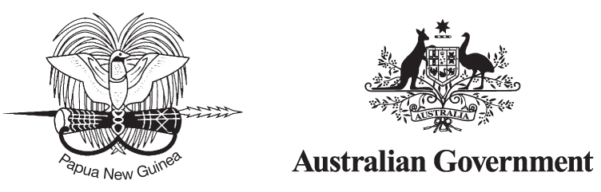

Second Joint Understanding
2010–2015
between Papua New Guinea and Australia on the
Owen Stanley Ranges, Brown River Catchment
and Kokoda Track Region

Our Vision
Sustainable development of the Owen Stanley Ranges, Brown River Catchment and Kokoda Track Region and protection of its special natural, cultural and historic values.
This vision brings together Papua New Guinea and Australia’s national interests, promoting the economic and social development of Papua New Guinea while protecting the important natural, cultural and historic values of this region. This vision reflects the objectives of the Papua New Guinea Development Strategic Plan 2010–2030 (March 2010) and is consistent with the principles of the Partnership for Development between the Government of Australia and the Government of Papua New Guinea of 20 August 2008.

Our goals
1. A safe and well-managed Kokoda Track, which honours its wartime historical significance and protects and promotes its special values.
2. Enhanced quality of life for landowners and communities through improved delivery of basic services, income generation and community development activities.
3. The wise use and conservation of the catchment protection area, including the Kokoda Track, and its natural and cultural resources and values.
4. Building national and international tourism potential of the Owen Stanley Ranges and Kokoda Track Region, supported by a possible future World Heritage nomination.
5. Working with communities, landowners, industry and all levels of government to ensure that activities established under the Kokoda Initiative are sustained into
the future.

Our shared interests
The Kokoda Track is one of the vital battlegrounds of the Second World War. Through dense rainforest, ‘Fuzzy Wuzzy Angels’ guided Australian troops in an act of dedication and courage, helping to protect our region during a time of war. Today, the Track symbolises the lasting bond of friendship and mutual understanding between the people of Papua New Guinea and Australia.
The past decade has seen a remarkable increase in the number of Australians visiting the Kokoda Track, bringing significant economic opportunities for the Track’s communities and transforming it into Papua New Guinea’s premier tourism location. This reflects a generation who recognise the Track and the region’s historic significance, its exceptional biodiversity and natural landscape, and the unique experience it offers in connecting the people and culture of Papua New Guinea and Australia.
The Owen Stanley Ranges, within which the Track is located, includes the critically important Brown River catchment which has been identified as a potential source of clean water and energy for the rapidly growing national capital, Port Moresby. Recognising the special values of the Track and the catchment area, as well as the pressure on these values from higher levels of use by trekkers and potential alternative land uses, such as mining and forestry, the PNG and Australian governments have been working together to promote the sustainable development of the area and preserve its important natural resources and heritage values.
Through the Kokoda Initiative, established in April 2008, the PNG Government has made excellent progress in defining a broad Area of Interest for the Initiative and an Interim Protection Zone (IPZ) (see map). The IPZ considers the interests in the area and manages competing land uses. It is a major new mechanism for protecting the core Brown River Catchment area and the Kokoda Track.
While this is a very significant achievement that will help to assure the long term protection of the Kokoda Track and the catchment, the area of interest of the Kokoda Initiative is broader than the identified Interim Protection Zone. The wider Owen Stanley Ranges region provides significant opportunities in areas such as tourism and possibly World Heritage. In the next five years, the Kokoda Initiative will continue to investigate the natural, cultural and historic values as well as sustainable economic opportunities in this broader area. This may result in an extended protection area for future integrated land use planning.
The Owen Stanley Ranges and Kokoda Track Region is proving to be a very successful pilot initiative for the PNG and Australian governments that is demonstrating how a balance between competing pressures can be achieved for the long term benefit of all Papua New Guineans. It also has the potential to be a model for collaboration in the delivery of basic services, for development of economic opportunities, for the managed growth of sustainable tourism, for integrated land use planning and for constructive cooperation between the PNG and Australian Governments.
Both governments are committed to working together to ensure the Kokoda Track and broader Owen Stanley Ranges Region retain their special qualities, while also making a significant contribution to PNG’s long term sustainable development.
The initiative brings together Papua New Guinea and Australian stakeholders, including all levels of government, local communities and landowners, the tourism industry and non-government organisations to support the wise use and economic development of the region consistent with this vision.
This program is implemented by the Government of Papua New Guinea with the support of the Australian Government through this Joint Understanding.

Area of Interest
The Kokoda Initiative Area of Interest (map) is the area which will be subject to a broad assessment of natural, cultural and historic values and within which a regional tourism strategy will be developed, and potentially other economic development opportunities. This process, which will take several years, may result in a recommendation for a World Heritage nomination covering outstanding values in the region, and would enhance tourism potential through identifying places of truly global significance.

Interim Protection Zone
The Interim Protection Zone (IPZ) is identified by the yellow line on the map. This represents the core area for possible legal protection of the Brown River Catchment area and most of the Kokoda Track. The IPZ incorporates the Brown, Naoro and Goldie Rivers – the priority areas in Central Province for future development of hydro-power and water supply for Port Moresby. It also extends into Oro Province to provide a buffer zone which protects the historic values of the Kokoda Track and maintains its potential as PNG’s premier tourist destination.

Kokoda Track
While the northern end of the Kokoda Track is not currently included in the Interim Protection Zone, through the Kokoda Initiative, the PNG and Australian Governments are committed to ensuring the entire Kokoda Track is looked after and well-managed into the future and that the lives of Track communities are improved.

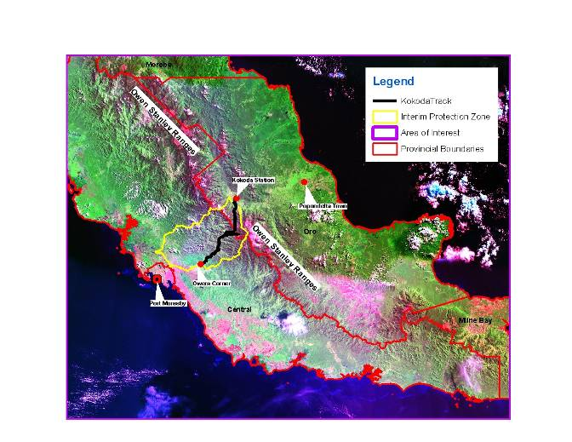

Key areas for cooperation
Under the first Joint Understanding, signed in 2008, governments have made unprecedented effort to protect the values of the Kokoda Track and improve the quality of life of the men, women and children living along it.
This second Joint Understanding will continue the good progress by focussing on:
Goal 1: A safe and well-managed Kokoda Track, which honours its wartime historical significance and protects and promotes its special values.
• Further supporting and enhancing the Kokoda Track Authority’s management of the track and trekking operations.
• Working with local communities and tourism operators to improve the trekking experience and track facilities.
• Working with regulatory authorities to improve safety for local communities living along the track and tourists visiting the region.
Goal 2: Enhanced quality of life for landowners and communities through improved delivery of basic services, income generation and community development activities.
• Continuing to sustainably improve the standard of health, education, water, sanitation and infrastructure services for communities along the Track.
• Facilitating access to benefit streams, income generation and other community development projects for communities in the interim protection zone, including potential opportunities through development of renewable resources particularly hydropower and water, forest carbon, and tourism.
• Enabling communities and landowners to manage development opportunities and income streams generated through this initiative.
• Nurturing the alliance between all levels of government, tourism operators and not-for-profit organisations to provide strong and coordinated support for the sustainable development of the region and the well-being of its people.
Goal 3: The wise use and conservation of the catchment protection area, including the Kokoda Track and its natural and cultural resources and values.
• Developing an integrated land use plan for the catchment protection area in partnership with key National, Provincial and Local Government stakeholders which provides an effective balance between environment conservation and development.
• Identifying and conserving the key natural, cultural and historic values of the Owen Stanley Ranges for heritage conservation, protection and tourism development purposes.
Goal 4: Building national and international tourism potential of the Owen Stanley Ranges and Kokoda Track Region, supported by a possible future World Heritage nomination.
• Promoting the natural, cultural and historic military values of the Track.
• Developing a strategic tourism plan and associated marketing activities.
• Exploring the heritage conservation values and conducting a feasibility study for possible World Heritage nomination, consistent with its inclusion in the PNG Government World Heritage Tentative List (2006).
Goal 5: Working with communities, landowners, industry and all levels of government to ensure that activities established under the Kokoda Initiative are sustained into the future.
• Maximising the delivery and maintenance of services and activities through the responsible PNG provincial and local level governments.
• Building capacity within key PNG and Australian Government agencies to ensure the goals of this initiative can be delivered and are sustainable.

implementation
A program of work will be developed annually between the governments of Papua New Guinea and Australia based on mutually agreed priorities and available resources.
An annual report will be produced and publicly released which communicates the outcomes of the program.
The Kokoda Initiative under this Joint Understanding will be implemented by the Papua New Guinean Kokoda Taskforce (led by the Department of Environment and Conservation) and the Australian Kokoda Taskforce (led by the Department of the Environment, Water, Heritage and the Arts) and overseen by both governments. The Joint Understanding will be reviewed after three years (2013).

