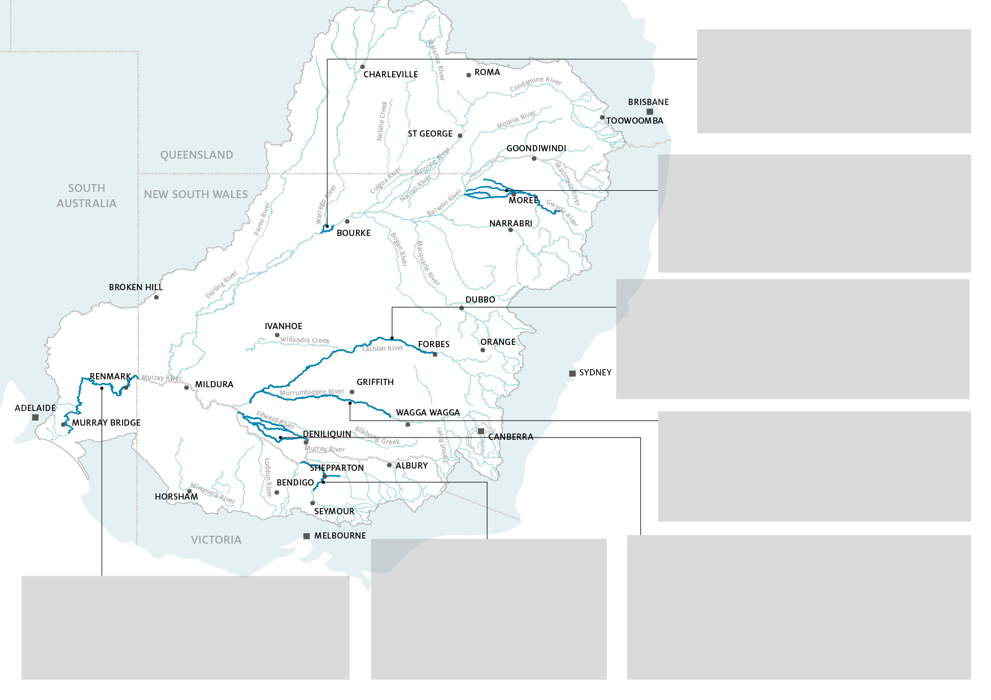

**Goulburn River** [*Link to newsletters*](http://www.environment.gov.au/water/cewo/publications/goulburn-mer-quarterly-newsletters)

|  |  |
| --- | --- |
|  | Recent analysis shows how monitoring has changed the ways flows are managed to achieve stable bank condition and provide more food and habitat for water bugs and native fish. |
|  | Annual surveys have found 9 species of native fish that live in the river, including the nationally threatened Trout Cod and, for the first time in LTIM/MER surveys, Unspecked Hardyhead. |

**Edward/Kolety−Wakool river system** [*Link to newsletters*](http://www.environment.gov.au/water/cewo/publications/edward-kolety-wakool-mer-newsletters)

|  |  |
| --- | --- |
|  | Environmental water was delivered to provide refuges for native fish, crayfish and other aquatic animals from ‘blackwater’ – carbon rich water that can have low oxygen levels. So far so good, with oxygen levels still in the safe zone. |
|  | A survey into what the community of the Edward/Kolety-Wakool area think and feel about water for the environment has garnered 60 responses. Check out the Newsletter for results. |
|  | The team is creating a hydrological model of the Werai Forest which will aid in targeting the delivery of environmental water to help protect the forest ecosystem. |
|  |  |

**Murrumbidgee River System** [*Link to newsletters*](http://www.environment.gov.au/water/cewo/publications/murrumbidgee-mer-quarterly-outcomes-newsletters-field-reports)

|  |  |
| --- | --- |
|  | In the hope of catching a glance of local rakali (water rats), motion-triggered cameras have been set up in various positions alongside and floating on platforms in the water of the Yanco Creek System. |
|  | Call recorders have been deployed at 10 sites across the Yanco Creek system so that frog and bat activity can be monitored over the year. |

**Junction of Warrego and Darling** [*Link to newsletters*](http://www.environment.gov.au/water/cewo/publications/warrego-darling-mer-newsletters)

|  |  |
| --- | --- |
|  | The vegetation of the Warrego-Darling is the best observed since LTIM/MER monitoring began, in part thanks to vegetation maintained by CEW over successive years.. |
|  | Nine species of frogs were spotted over the course of the 2020-21 water year, including, for the first time in the history of the LTIM/MER Project, the broad palmed rocket frog. |
|  |  |

**Lower Murray River** [*Link to newsletters*](http://www.environment.gov.au/water/cewo/publications/lower-murray-mer-quarterly-outcomes-newsletters)

|  |  |
| --- | --- |
|  | Analysis of the otolith (ear bones) of 56 silver perch and five golden perch is underway. Determining the ‘when’ and ‘where’ these fish spawned will help researchers evaluate the spawning response of these flow-cued fish to water flows, including CEW. |
|  | The field season is officially open. Stream metabolism data loggers have been deployed and zooplankton and fish larvae sampling has started. |

**Gwydir River System** [*Link to newsletters*](http://www.environment.gov.au/water/cewo/publications/gwydir-mer-newsletters)

|  |  |
| --- | --- |
|  | Groundcover extent is at its highest since the commencement of LTIM/MER project, with wetland plants dominating. Using CEW to maintain wetland vegetation during dry times has allowed these communities to boom this water year. |
|  | Surveys have found widespread evidence of waterbird breeding. 11 species of waterbird showed evidence of breeding in autumn 2021 – mainly swans, ducks, rails and cormorants. |
|  |  |

**Lachlan River System** [*Link to newsletters*](http://www.environment.gov.au/water/cewo/publications/lachlan-mer-quarterly-reports)

|  |  |
| --- | --- |
|  | Lake Tarwong received water for the first time since 2017 thanks to wet conditions and environmental water, helping to support wetland ecosystems that are the only places some of the rarer amphibious plants of the lower Lachlan can be found. |
|  | Fish-sampling has yielded hundreds of bony herring, a hugely important food source for the predators of the food chain of the Murray–Darling Basin. |
|  | Environmental water helped maintain connectivity between the floodplain and important wetlands of Lake Bullogal, Baconian Swamp and lignum shrublands. |

**Selected Area Highlights**Outcomes Newsletters   
*Issue 9 (Jul-Sept 2021)*[*www.flow-mer.org.au*](http://www.flow-mer.org.au)