

Sensitive Ecological Data—

Access and Management Policy V1.0

Prepared by Environmental Resources Information Network (ERIN)

January 2016

| **DOCUMENT NAME** | Sensitive Ecological Data—Access and Management Policy |
| --- | --- |
| **VERSION** | 1.0 |
| **PREPARED BY** | Environmental Resources Information Network (ERIN) /  Landscape Analysis Section |
| **ENDORSED BY** | Dep Sec, Strategy and Operations Group  Date: 21 Jan 2016 FAS, Science Division Date: 19 Jan 2016 |
| **LAST AMENDED** |  |
| **DATE OF NEXT REVIEW** | 30 Jan 2018 |
| **LICENCE**  With the exception of the Commonwealth Coat of Arms and where otherwise noted, Australian Government Department of the Environment information policies and guidelines are licensed under Creative Commons Attribution International licence.  This policy should be attributed to “Australian Government Department of the Environment (2016) Sensitive Ecological Data Access and Management Policy”.  Use of the Coat of Arms: The terms under which the Coat of Arms can be used are detailed on the It’s an Honour website. | |

Overview

The Australian Government ‘is committed to open government based on a culture of engagement, built on better access to and use of government held information, and sustained by the innovative use of technology’.[1]

This policy on sensitive ecological data forms part of the Australian Government’s approach to making data more accessible, discoverable and re-useable. It provides a consistent, accountable and transparent approach to classifying and managing sensitive ecological data.

The Department of the Environment maintains many datasets containing species observation records and information on ecological communities of Australia. The intent of this policy is to enable the broader release of this ecological data, and provide parameters for decision making on the data. This is particularly where that data may be sensitive, so it does not result in significant negative impacts to species or ecological communities. It also provides a more informed departmental position to make assessments concerning the management of ecological data or information in accordance with the Australian Privacy Principles[2].

The most effective approach to managing sensitive data is to have a consistent methodology that is applied by all organisations with the same or similar information. Once data is in the public domain it is difficult to enforce restricted access[3]. For this reason the policy is available for use under a [Creative Commons—Attribution licence](http://www.ausgoal.gov.au/creative-commons-v4.0) to provide maximum access and use by other government agencies, organisations and private companies that collect and manage sensitive ecological data. Successful long term management and sharing of sensitive ecological data is about trust, risk management, the credibility of the participating organisations and the desire to disseminate the best available data to inform management of the environment.[4]

Glossary

access Includes any circumstance where a person is given the means or opportunity to review or obtain information or data which is the subject of this policy.

ALA Atlas of Living Australia.

ANDS Australian National Data Service.

Data Custodian A person who holds and maintains information on behalf of a group or community of users.

data store A repository of a set of data objects such as a database or flat file.

ecological community A naturally occurring group of native plants, animals and other organisms that are interacting in a unique habitat. A threatened ecological community is an EPBC-listed ecological community.

EPBC Act Environment Protection and Biodiversity Conservation Act 1999.

ERIN Environmental Resources Information Network.

listed matter Broadly, any of the nine matters of national environmental significance protected under the EPBC Act[5], and specifically for this document any EPBC-listed species or ecological community.

managing The classification, storage, transfer, distribution, archiving and disposal of the data that is the subject of this policy.

Sensitive Ecological Data Any data on species or ecological communities which are required under this policy to be characterised as sensitive.

sensitivity list A list of species or ecological communities deemed sensitive in some aspect (location, life cycle).

species Includes EPBC-listed and non-listed species, infraspecific taxa and undescribed or unpublished taxa.

SPRAT Species profile and threats database[6].

Scope

This policy relates to EPBC-listed and non-listed species and ecological community data owned, held or managed by the Department of the Environment. It covers decisions about access to and the release of data to the public, as well as data released under any restrictive licence. Future versions may also address heritage assessment, Indigenous matters or culturally significant site data.

The policy does not address the issue of managing biosecurity sensitivity where this is already captured under biosecurity policies or processes of the Department of Agriculture and Water Resources, Department of Industry, Innovation and Science, Plant Health Australia, Atlas of Living Australia’s Plant Biosecurity Sensitive Data Service, this Department (with regard to the keeping of exotic birds) and relevant State and Territory biosecurity authorities.

This policy is to be read concurrently with other Departmental policies that relate to the dissemination, management and storage of information or data, including the Department’s policies on Information Storage and Access, Privacy and Intellectual Property.

Risk Management

The classification of any sensitive data and its distribution may carry risk. The release of potentially sensitive ecological data should only be undertaken after a risk assessment which considers the risks of misuse, intended or unintended, and unintentional perverse outcomes from the release of the data. Any subsequent release of such data must be consistent with the Department’s policies in relation to the access and management of information.

Purpose

This policy provides a process for identifying and managing sensitive ecological data to avoid negative outcomes. In some circumstances, releasing sensitive ecological data may result in an ‘adverse effect’ on the taxon or ecological community in question. However, having readily accessible ecological data brings many benefits. Publicly available information can provide greater protection for a species or habitat through improved quality of the data or products, broader awareness, or more timely access to data. Publicly available information enhances the value of research findings and products that rely on comprehensive species observation data. Research that has relied on detailed species location data in one region and generalised information in another region may develop products or analyses that may not be appropriate, particularly if the researcher is not aware data has been generalised or denatured.

Timely access to sensitive data can be important in emergency management situations, for example where rapid decisions need to be made about the location of fire breaks, whilst broad accessibility to data may reduce risk to areas likely to be subject to inadvertent clearing, such as roadside vegetation.

Determining the degree of data sensitivity requires consideration of the type of threatening process that may impact on it. Degree of sensitivity also requires consideration of the level of threat to a species or ecological community, the vulnerability of the taxon or community to the threat, the type of information, whether the data is already publicly available and the potential value to be gained from making the data publicly available.[7]

Examples of the type of ecological data that, if more widely released, may result in adverse effects include:

* Locational information for highly desirable, collectable or commercially valuable taxa such as aquarium fish, reptiles, cycads, ferns, birds, orchids or invertebrates vulnerable to illegal or excessive collection to the extent a taxon’s population may be affected.
* The location of a rare species where it may be particularly vulnerable to disease or a feral species being introduced e.g. by collectors, photographers or bushwalkers.
* Releasing the location of a sensitive listed matter may result in interference with or its removal for commercial opportunity.

Principles of sensitive ecological data management

The approach to managing ecological data in this policy document is based on the following principles:[8]

Open Access by Default

Data should be freely available, with all sensitivities addressed using targeted treatment methods. If identical data is publicly available through other sources, it cannot be considered sensitive.

Be accountable

The decision to restrict access to data needs to be justifiable, consistent and repeatable and abide by relevant legislation, regulations or policy.

Decisions made closest to source

The Data Custodian should have responsibility for determining whether ecological data should be classified as sensitive.

Retain the original data

Data Custodians must retain an unaltered original version of the ecological data and safeguard this original version using best practice information management procedures.[9]

Transparency

Documentation should be linked to the data and must be available to all users of the data. Documentation ensures potential data users understand what data exists, why it was classed as sensitive and how it has been altered or protected.

Respect dataset restrictions

Data Custodians should not release data that has not been processed in accordance with this policy.

Review over time

Data Custodians should do regular reviews (every 2-5 years) on datasets to determine if their context has changed over time. What is currently considered sensitive data may not be sensitive in the future.

Managing sensitive ecological data

A general process to help guide Data Custodians to manage the sensitive aspects of species and ecological community observation data is described below.

1. Privacy, confidentiality and liability issues may have implications for the Department and should be considered when determining data accessibility. A disclaimer over published information will usually be required to manage these issues.
   1. It is essential that any perceived risk to the Department (legal or reputational) by the public release of data be managed. This may require Data Custodians to seek further guidance from the Department’s legal branch, including in relation to the use of appropriate disclaimers.
2. Is data on the particular sensitivities identified (e.g. location) already publicly available? If yes, it is unlikely that data can be considered sensitive. If sensitivity concerns remain, consider what options there are to manage post-publication risk.
3. Are there any sensitivities about the data on a particular species or ecological community?
   1. Is the species or community referred to already on a departmental sensitivity list? (A ‘sensitivity list’ would typically be created by a data custodian).
   2. Is the species known to be at risk due to commercial take, or otherwise highly desirable/collectable (e.g. orchids or prize fish)?
   3. Does the species show attributes similar to known commercially vulnerable species that suggests there is a considered risk?
   4. Is the species’ population or ecological community at risk of disturbance, e.g. the location is sufficiently valuable, and it is possible to deliberately remove (or drive out) the listed matter to enable development?
   5. Is the species population or community particularly vulnerable to a disease or feral species being introduced e.g. by bushwalkers or photographers?
4. Identify ‘response actions’ that could potentially manage the range of sensitive data issues. Target the ‘sensitive’ component of the dataset.
   1. Consider whether withholding specific fields or attributes will manage the risk (for example, remove any reference to breeding, or amend a species name to genus only).
   2. Release information at a broader scale through generalising or truncating coordinate values.
   3. Where populations are small, and the decision is to release location data, notify the state or territory agency that has an interest in protecting the population/species.
   4. Where populations are small, and the decision is not to release location data, consider restricted release (e.g. state or territory agencies, or local councils) to reduce risk of inadvertent clearing such as for emergency fire breaks.
   5. Not releasing the whole dataset is a last resort option and assumes all fields are sensitive if no other actions effectively manage the risk.
   6. Consider if there is secondary information that needs to be restricted to ensure primary sensitive data are protected. For example, consideration may need to be given to information such as the name of a data collector, or a discrete locality name that could be matched to other data and identify the location of the sensitive species. If so, take appropriate ‘response action’.
5. Document the nature, impact and reason for any modification of data. Mark/identify data that is ‘sensitive’ by documenting the nature of the sensitivity, the response actions to be applied and the manner and form the data will be released (e.g. if data has been denatured to allow public release). This documentation must be linked to and follow the data.
   1. Restricted text fields need to be replaced with appropriate codes and explanations, and comments given for data that is denatured. Information related to sensitivity should accompany the data and be included in any associated metadata. Ideally, sensitivity information would be included as record-level metadata that is supported by Darwin Core[10], and ISO 19115 -1:2014[11]. Consideration should also be given to linked data solutions under development (see ANDS[12] for examples).
   2. Data not yet assessed should be clearly annotated as such when it is first added to the data store.
6. Determine an appropriate timeframe to regularly review decisions on the sensitive classification of particular data.

Figure 1. Decision tree to determine sensitivity of ecological data.

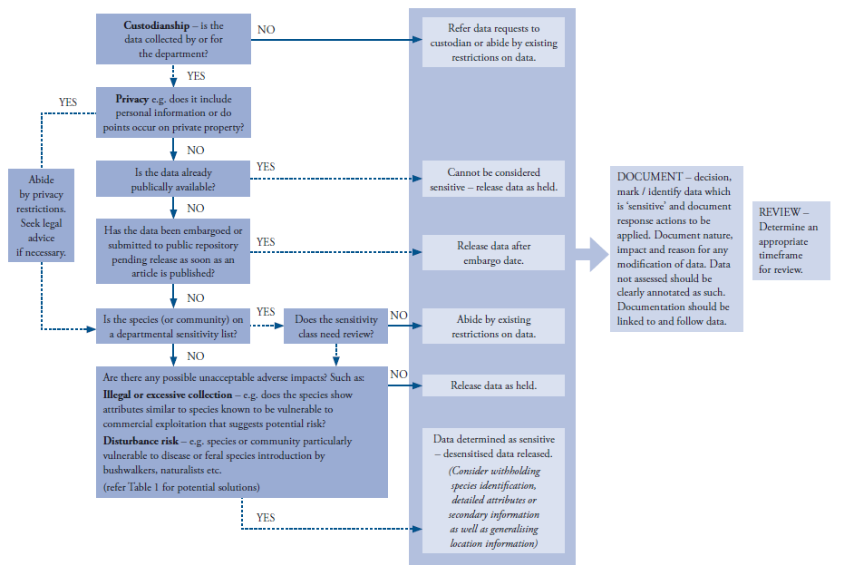

The policy process should also be reassessed every five years from the date the policy is adopted. For example, changes in environmental legislation could have implications for the approach used to determine ecological data sensitivity.

As this is the first version of the Department’s Sensitive Ecological Data Management Policy, this policy should be reviewed two years from the date the policy is adopted. The review should also consider how the policy is being shared and used more broadly.

Storage

Sensitive ecological data must be stored in accordance with the Department’s relevant information management and storage policies.

Table 1. Worked examples of sensitive ecological data assessment

The solutions identified below are suggestions only to help formulate rule sets around sensitivity. The data used in the example table are from a variety of sources and use of the data is not to be construed as the Department being the Data Custodian. It is not expected that datasets necessarily have every single record annotated in detail; indeed a majority of ecological data will probably be released ‘as held’ to the public and automatically annotated as such. This table provides a guide to dealing with a sensitive ecological data record.

The coordinate values below were originally more precise and available at up to 5 decimal places. They have been desensitised where necessary for use in this public document.

| COMMON NAME | LOCALITY | FINAL LAT | FINAL LONG | OBS DATE | AGE | COLLECTOR | DATA SOURCE | SENSITIVITY | MANAGEMENT APPROACH | Rationale |
| --- | --- | --- | --- | --- | --- | --- | --- | --- | --- | --- |
| Orange-bellied Parrot | Melaleuca:  TAS | -43.4 | 146.1 | Jan-14 | NESTLING | DPIPWE OBP MGMT GRP | ABBBS | High | Truncate (or round) coordinate values to 0.1 decimal degrees. | Although many records for OBP (CE) are publicly available (via ALA) with coordinate values to 5 decimal places, this particular record refers to a nestling (and is not included in the ALA dataset for the species). This solution has been applied, based on the species’ listing as ‘Critically Endangered’. Another possible alternative is to release the data ‘as held’ and redact the AGE field. This decision would be made by the Data Custodian, and is preferred over spatial generalisation. |
| Swift Parrot | Meehan Range National Park:TAS | -42.82 | 147.38 | 11-Dec-14 | NESTLING | DR RG HEINSOHN | ABBBS | Medium | Truncate (or round) coordinate values to 0.01 decimal degrees | Although there are close to 200 post-2010 records publicly available for Swift Parrot in TAS with most having coordinate values to 4 decimal places, this recent record refers to a nestling/nest site. |
| Night Parrot | Central Desert(S): NT | -22.7167 | 131.1167 | 30-Nov-99 | UNK | MR JOHN SMITH | ALA | None | Release ‘as held’ | Data publicly available to a precision of 4 decimal places. |
| Night Parrot | Diamantina National Park:QLD | -23.0 | 141.0 | 15-Jun-06 | FIRST YEAR | MR BILL BROWN | SOS | High | Truncate (or round) coordinate values to 1.0 decimal degree | Although record NOT publicly available, the locality of the observation (Diamantina NP) has been discussed extensively in the literature and other media. |

|  |  |  |  |  |  |  |  |  |  |  |
| --- | --- | --- | --- | --- | --- | --- | --- | --- | --- | --- |
| Kilsyth South Spider-orchid | Maroondah (C):VIC | -37.8 | 145.3 | 15-Oct-04 | N/A | G.S. LORIMER | SOS | High | Truncate (or round) coordinate values to 0.1 decimal degrees | Critically endangered. Record publicly available at 0.1 decimal degrees. |
| Bare-rumped Sheathtail Bat | 45 Wetherby Road, Howard Springs, Darwin: NT | -12.5195 | 131.0935 | 31-Dec-06 | UNK | N/A | SOS | None | Release ‘as held’ | Full coordinate values and street name publicly available from ALA. Could consider redacting street number to address any privacy concerns. |
| Baited Remote Underwater Video (BRUV) Surveys of Prize Fish | Great Barrier Reef | -18.7 | 147.2 | 2006 | N/A | DR ERIC LAWREY | AIMS | High | Truncate the reef’s centroid value to 0.1 decimal degrees for all individual BRUV sites on that reef. | There is a risk of increased (legal) pressure from recreational or commercial fishers at sites with a high density of prize fish (Coral Trout and Red Emperor) at particular BRUV sites. |

|  |  |  |  |  |  |  |  |  |  |  |
| --- | --- | --- | --- | --- | --- | --- | --- | --- | --- | --- |
| King’s Lomatia | Lower southern slopes of Bathurst Range: TAS | Null | Null | 1-Jan-90 | N/A | N/A | SOS | Extreme | Release at bioregion scale (e.g. southern foothills of the Bathurst Range, near Cox Bight, South-west Tasmania) | No coordinate values in publicly available ALA data at all. Tasmanian DPIPWE, the Data Custodian, has requested records NOT be released. General description of location publicly available. |

1. Department of Finance. Declaration of Open Government <http://www.finance.gov.au/blog/2010/07/16/declaration-open-government/> [Accessed 2 Dec 2014].
2. <https://www.oaic.gov.au/privacy-law/privacy-act/australian-privacy-principles>
3. <http://www.ala.org.au/wp-content/uploads/2010/07/ALA-sensitive-data-report-and-proposed-policy-v1.1.pdf> [Accessed 3 Dec 2014].
4. AMEC Earth & Environmental. 2010. Best practices for sharing sensitive environmental geospatial data.
5. http://www.environment.gov.au/epbc/what-is-protected
6. http://www.environment.gov.au/cgi-bin/sprat/public/sprat.pl
7. Chapman, A. D. and O. Grafton. 2008. Guide to Best Practices for Generalising Primary Species-Occurrence Data, version 1.0. Copenhagen: Global Biodiversity Information Facility, 27 pp. ISBN: 87-92020-06-2.
8. Modelled on: AMEC Earth & Environmental. 2010. Best practices for sharing sensitive environmental geospatial data.
9. <http://www.asd.gov.au/infosec/ism/> (and in particular the Controls Manual).
10. <http://rs.tdwg.org/dwc/terms/history/index.htm#dataGeneralizations-2009-04-24> and <http://rs.tdwg.org/dwc/terms/history/index.htm#informationWithheld-2009-04-24>
11. <http://www.iso.org/iso/home/store/catalogue_tc/catalogue_detail.htm?csnumber=53798>
12. <http://ands.org.au/guides/metadata-stores-solutions.html>