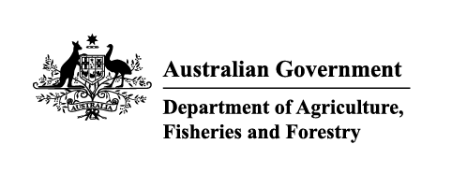

Instrument revoking a holding order under section 15(2) of the Imported Food Control Act 1992
The listed holding orders, having satisfied the circumstances under which the orders will be revoked, are revoked under section 15(2) of the Imported Food Control Act 1992 (the Act).
The circumstances being that the Secretary or delegate is satisfied that the basis for the order no longer applies.
Holding order number | Date revoked
17736 | 31/08/2025
13941 | 31/08/2025
13500 | 31/08/2025
REC20014 | 31/08/2025
18142 | 31/08/2025
18578 | 31/08/2025
16180 | 31/08/2025
18596 | 31/08/2025
15631 | 31/08/2025
17757 | 31/08/2025
18053 | 31/08/2025
18561 | 31/08/2025
18597 | 31/08/2025
17771 | 31/08/2025
17780 | 31/08/2025
18177 | 31/08/2025
18598 | 31/08/2025
18139 | 31/08/2025
17919 | 31/08/2025
18590 | 31/08/2025
18585 | 31/08/2025
18586 | 31/08/2025
18610 | 31/08/2025
18611 | 31/08/2025
18558 | 31/08/2025
18577 | 31/08/2025
18473 | 31/08/2025
18594 | 31/08/2025
18572 | 31/08/2025
18622 | 31/08/2025
18565 | 31/08/2025
18595 | 31/08/2025
18562 | 31/08/2025
18566 | 31/08/2025
18567 | 31/08/2025
19819 | 05/09/2025
13064 | 05/09/2025
19640 | 05/09/2025
19505 | 05/09/2025
18466 | 05/09/2025
19567 | 05/09/2025
16799 | 05/09/2025
19031 | 19/09/2025
19915 | 19/09/2025
19593 | 19/09/2025
18699 | 19/09/2025
19738 | 19/09/2025
19550 | 19/09/2025
18805 | 25/09/2025
19887 | 25/09/2025
18595 | 31/08/2025
18562 | 31/08/2025
18566 | 31/08/2025
18567 | 31/08/2025
19819 | 05/09/2025
13064 | 05/09/2025
19640 | 05/09/2025
19505 | 05/09/2025
18466 | 05/09/2025
19567 | 05/09/2025
16799 | 05/09/2025
19031 | 19/09/2025
19915 | 19/09/2025
19593 | 19/09/2025
18699 | 19/09/2025
19738 | 19/09/2025
19550 | 19/09/2025
18805 | 25/09/2025
19887 | 25/09/2025
Delegate position number | Date
100091 | 7/10/2025
Delegate of the secretary for the purposes of section 15(2) of the Act.

