**Short-term intervention monitoring associated with the translocation of Murray Hardyhead into Little Frenchmans Creek, Wingillie Station NSW.**

Monitoring Report

June 2020

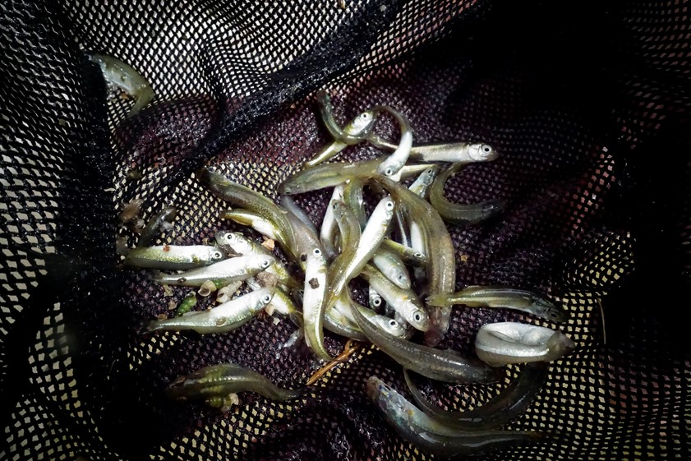

**Iain Ellis, Nick Whiterod and Deb Nias**



|  |
| --- |
| © Copyright Commonwealth of Australia, 2020.    Short-term intervention monitoring associated with the translocation of the Murray Hardyhead into LFC, Wingillie Station NSW is licensed by the Commonwealth of Australia for use under a Creative Commons Attribution 4.0 International licence with the exception of the Coat of Arms of the Commonwealth of Australia, the logo of the agency responsible for publishing the report, content supplied by third parties, and any images depicting people.  For licence conditions see [Creative Commons website - Attribution 4.0 International page](https://creativecommons.org/licenses/by/4.0/)  This report should be attributed as:  *Ellis, I. Whiterod, N. and Nias, D. (June 2020). Short-term intervention monitoring associated with the translocation of Murray Hardyhead into Little Frenchmans Creek, Wingillie Station NSW. Technical report to The Commonwealth Environmental Water Office.*  The Commonwealth of Australia has made all reasonable efforts to identify content supplied by third parties using the following format ‘© Copyright’, noting the third party.  The views and opinions expressed in this publication are those of the authors and do not necessarily reflect those of the Australian Government or the Minister for the Environment.  While reasonable efforts have been made to ensure that the contents of this publication are factually correct, the Commonwealth does not accept responsibility for the accuracy or completeness of the contents, and shall not be liable for any loss or damage that may be occasioned directly or indirectly through the use of, or reliance on, the contents of this publication.    More information  Iain Ellis / DPI Fisheries – Murray-Darling Unit / Buronga  Deb Nias/Murray-Darling Wetlands Working Group  Acknowledgments  This project was funded by the Commonwealth Environmental Water Office and the Department of Agriculture, Water and the Environment. The Murray-Darling Wetlands Working Group conducted the project in collaboration with NSW Department of Primary Industries-Fisheries, the Hazel L Henry Nature Refuges Trust, and Aquasave–Nature Glenelg Trust. Thanks to Ken and Anne Warren.    Cover photo Murray Hardyhead in LFC (N. Whiterod) |

# Foreword

This project represents the second component in a collaborative program to promote the recovery of the threatened Murray Hardyhead in the Lower Murray region of the Murray­-Darling Basin. The Western Local Land Services (WLLS) funded the first component which entailed the reintroduction of Murray Hardyhead into LFC on Wingillie Station in far-west New South Wales (NSW) (see Ellis et al. 2019).

The project will improve knowledge and will inform future decision making in relation to both fish translocations and environmental water management. It is anticipated collaborations established, or reinforced, during the program will promote renewed interest and attention to the conservation of threatened fish species in the Murray-Darling Basin.

# Summary

The primary aim of this project was establishing a recruiting subpopulation of a threatened small-bodied native fish, the Murray Hardyhead, in an environmentally watered floodplain wetland in far-west NSW. Source fish were translocated from managed wild locations in the Riverland region of South Australia (Ellis et al. 2019). Successful establishment of a self-sustaining population would address several key objectives for the species under the Draft National Recovery Plan for the species (see DELWP 20217). The objectives of this project are also consistent with the *Murray-Darling Basin Plan 2012* and the Basin-wide Environmental Watering Strategy (2019), both of which guide and place obligations on how environmental water holders; Basin state governments and local waterway managers plan and manage environmental water. Murray Hardyhead is listed in the Basin-wide Environmental Watering Strategy as a key species with candidate sites for expanded distribution in the Lower and mid-Murray being a priority.

The translocation site is the LFC (LFC), a natural wetland system located on private property (Wingillie Station) in far-west NSW. Works to ensure environmental water could be delivered via gravity fed pipes were completed in 2018. An additional surrogate refuge dam was constructed adjacent to LFC to maintain an in-situ backup population of Murray Hardyhead as an added contingency in the event of the site flooding (a positive result in terms of natural dispersal), and as a source of fish for subsequent re-introduction efforts.

Delivery of environmental water to the LFC (and surrogate refuge dam) commenced in October 2018 and continued until March 2020 in line with a seasonal hydrological regime recommended by expert fish ecologists. A prescribed seasonal watering regime was implemented to maximise ephemeral wetland processes and promote the development of preferred food and breeding habitat for Murray Hardyhead.

In November 2018, some 780 Murray Hardyhead were successfully translocated from the Disher Creek population in South Australia into the LFC and its associated surrogate refuge dam on Wingillie station. Sampling during 2019–20 regularly captured more Murray Hardyhead than were initially translocated and included both adults and juveniles. These results indicate successful breeding and recruitment following their release to LFC. This translocation represents the first attempt in NSW to reestablish a regionally extinct native fish (with no detections of Murray Hardyhead in NSW since 2005).

Key recommendations to minimise risk to the viability of this population include:

1. Ongoing monitoring of the population (at least quarterly) to identify potential declines in the abundance of the species (outside normal seasonal fluctuations)
2. Installation of water level and salinity sensors that transfer real time data via telemetry, thus minimising the potential for perverse outcomes in the event staff are unable to monitor the site regularly.

# 

# Contents

Foreword iii

Summary iii

Contents iv

Introduction 5

Translocation of Murray Hardyhead, November 2018 6

Objectives 7

Site description 7

Monitoring of the translocated Murray Hardyhead population 11

Methods 11

Results 13

Discussion 18

References 20

# Introduction

As a result of habitat loss, river regulation and pest species, several species of native small-bodied fish species have diminished in distribution such that they are currently absent across much of their former range (Hammer et al. 2013). The Murray Darling Wetlands Working Group (MDWWG) is working closely with NSW DPI Fisheries, the Hazel L Henry Farmland Nature Refuges Trust (HLH Trust), and Aquasave–NGT ecologists to provide opportunities for reintroducing threatened small-bodied native fish species into areas in which they are locally extinct or rare.

The Murray Hardyhead (*Craterocephalus fluviatilis*) is a small (<10cm) and short-lived (1–1.5-year maximum) native fish, which is considered threatened across much of its former range. It is listed as Endangered under the federal *Environmental Protection and Biodiversity Conservation Act 1999* and Critically Endangered globally under the International Union for the Conservation of Nature (IUCN) Red List for Threatened Species. The species has remained undetected in NSW waters for over a decade, but persists as several fragmented subpopulations in north-west Victoria, the mid-Murray Riverland region of South Australia (SA), and the lower reaches of the Murray River, including the Lower Lakes (Ellis et al 2013; Ellis and Kavanagh 2014)(Whiterod et al. 2019). Recent genetic analysis has identified that these subpopulations are distributed across two metapopulations (Lower Murray and mid-Murray); conservation translocations are recommended to only occur within (but not between) the metapopulations (Thiele et al. in press).

Murray Hardyhead is a batch-spawning species with the potential for repeat spawning throughout a prolonged spawning season from September to March (spring and summer), with peak larval abundance occurring in late October to early November (Ellis 2005). The abundance of adults generally declines at the end of the breeding peak season (January-February), with replacement by the maturing young of the year cohort. However, Ellis (2006) identified the potential for productive wetland systems to support breeding through summer and into autumn (at least through March), by either 1+ aged adults, or 0+ young adults that reach sexual maturity between spring and autumn (i.e. in the same breeding year in which they were born). Nevertheless, the species is considered to be largely annual (populations dominated by 0+ individuals) and dependent on annual recruitment.

As such, when managing a site for Murray Hardyhead, a seasonal watering regime is generally recommended to support ephemeral wetland processes and promote the development of food and breeding habitat (submerged vegetation/structure) (see Ellis 2005). This watering regime allows for water level decrease through summer to concentrate salts and reduce competition by other less salt-tolerant fish species. This watering regime was recently supported by salinity tolerance trials, which identified thresholds for early life and adult survival, with a recommended range of 12-45 ppt (~15,000 – 70,000 uS.cm-1) form the maintenance of managed populations (Stoessel et al. 2020). Figure 1 conceptualises the seasonal change in abundance of Murray Hardyhead within a productive wetland population where annual variation in water level promotes productivity, food and habitat availability for different life history stages of Murray Hardyhead, as well as increase in salinity through summer to reduce the prevalence of competing species.

To reduce the risk of extinction of Murray Hardyhead, multiple activities have been conducted over the last 20 years including environmental watering of sites containing the species, captive breeding during the Millennium Drought, and establishment of translocated and surrogate populations (see Ellis et al. 2013).

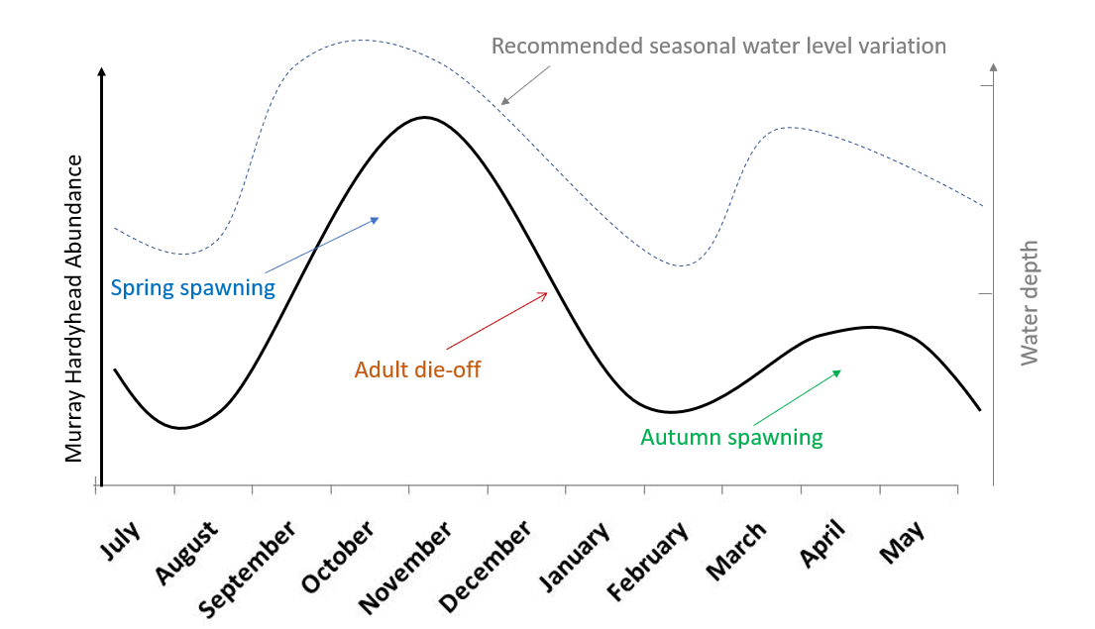

**Figure 1**. Conceptualised trend in Murray Hardyhead abundance and breeding activity in a productive system. To promote breeding and recruitment outcomes a recommended seasonal hydrological regime (using depth as a quantifier) is included as a grey dotted line.

The objective of this project was to monitor the survival and subsequent population structure of a population of Murray Hardyhead established following translocation from managed wild populations in the Riverland region of SA to an environmentally watered floodplain wetland in far-west NSW in late 2018. As well as generating this report, the monitoring allowed near real-time management of water levels, habitat availability and water quality in the receiving wetland to enhance the potential for the newly established population to thrive.

## Translocation of Murray Hardyhead, November 2018

Baseline surveys of the LFC in 2017-18 identified it as a candidate for supporting Murray Hardyhead if water level (and associated water quality) could be maintained and managed (Ellis et al. 2019). Delivery of Commonwealth environmental water (by MDWWG) to the LFC commenced in October 2018 and continued throughout the translocation event (12‒15 November 2018) and into 2020 as required to maintain surface water habitat up to 2m deep. As LFC is contained within the mid-Murray metapopulation of the species, fish for the translocations were sourced from within a thriving subpopulation (determined through field surveys) in the mid-Murray metapopulation. As such, approximately 780 Murray Hardyhead were sourced from the Disher Creek subpopulation in the South Australian Riverland and translocated to the LFC in November 2018 (see Ellis et al. 2019). The transfer of fish to NSW and release into NSW waters was conducted under permit issued by NSW DPI (Permit number OUT18/17791). Ministerial Exemption (ME9903006) for the collection of Murray Hardyhead from SA was granted by the South Australian Government in August 2018.

This report documents the results and findings from monitoring of the water quality and fish community in LFC since Murray Hardyhead were released in November 2018.

# Objectives

The key objectives in achieving this aim were to:

1. Use environmental water to prepare and maintain suitable habitat for the translocation of Murray Hardyhead from an appropriate existing population within the same conservation or management unit.
2. Translocate a sub-population of Murray Hardyhead from existing ‘wild’ sites located in the S.A. Riverland to the prepared site (LFC, Wingilli Station).
3. Manage watering regime to promote survival and ongoing recruitment within the subpopulation.

Objectives 1 and 2 were met in 2018/19. For detailed reporting on these efforts see Ellis et al. 2019.

This report documents monitoring to determine the subsequent breeding success and viability of the re-introduced Murray Hardyhead population in LFC.

## Site description

Little Frenchmans Creek in far-west NSW is a meander of the Frenchman’s Creek that was disconnected by earthworks in the early decades of the 1900s (Figure 2). Today the LFC is located on private property (Wingillie and ‘The Occupation’ stations) in far-west NSW, both currently owned and managed by the HLH Trust which has been working in collaboration with the MDWWG to improve the environmental value of floodplain and wetland habitats on the property for several years.

The LFC receives environmental water to create permanent surface water, which exhibits elevated salinity (expressed as electrical conductivity; EC ∼15,000–70,000 uS.cm-1) due to local groundwater discharge into low lying areas of the floodplain, low turbidity, and seasonally inundated terrestrial vegetation. It was proposed that an appropriate watering regime (facilitated by delivery of environmental water) would promote survival and recruitment of Murray Hardyhead to establish a robust, self-sustaining population if translocation efforts were successful. Given the location of the LFC, once established, a resident population would be anticipated to provide natural dispersal during future flooding events, as well as a source for subsequent translocation efforts to suitable wetland sites in the region.

In 2018, staff from MDWWG and HLH Trust conducted works to ensure environmental water could be delivered to the LFC ‘as needs’ via gravity fed pipes at the eastern end of the LFC. In 2020, DPI Fisheries funded the installation of meters to permit use of the existing licensed syphons (from the Frenchmans Creek to the LFC) to facilitate watering of the wetland in drought situations whereby use of the primary watering infrastructure was precluded by insufficient water level in the Frenchmans Creek water source.

An additional surrogate refuge dam (approximately 5m x 12m; depth 1–1.5m) was constructed in 2018 by the HLH Trust, adjacent to the LFC release site at an elevation above the 2016 Murray River flood event (Figure 4). The dam was fitted with a solar powered pump to fill it from the LFC and maintain it at a depth of between ~1m and 1.5m via a float valve and switch. The surrogate dam was also fitted with bird netting to minimize predation, and dead lignum and saltbush were collected from the nearby floodplain and placed within the dam in March 2019 to provide breeding substrate and additional cover (Figure 3).

A sub sample of the translocated population was released in the surrogate dam as a contingency measure to:

1. provide a source for re-establishing an LFC population in the event flooding occurs in the next 1–3 years during which the population disperses from LFC or is extirpated (i.e. contingency).
2. provide a source for establishing additional populations in appropriate far-west NSW wetlands (without the need to take fish from the new LFC population itself).

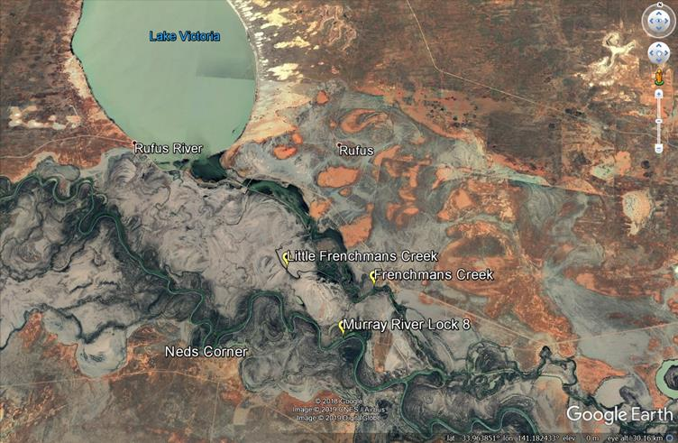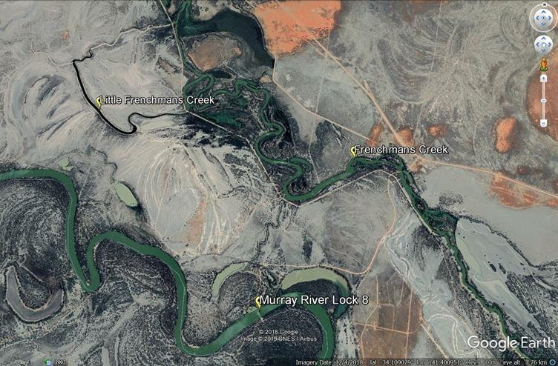

**Figure 2**. Location of LFC, Wingillie Station (images courtesy Google Earth April 2019).

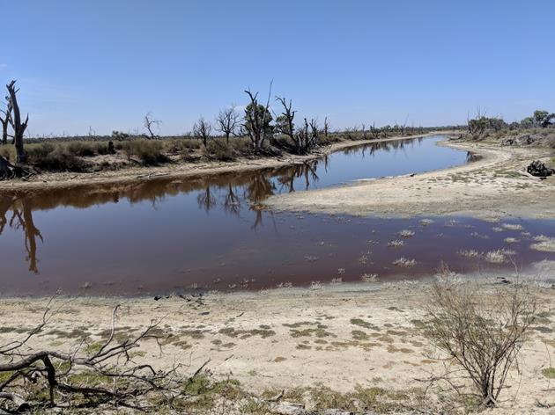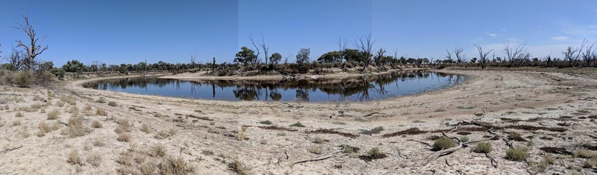

**Figure 3**. Residual pools in LFC in March 2018, prior to delivery of environmental water (photos I. Ellis).

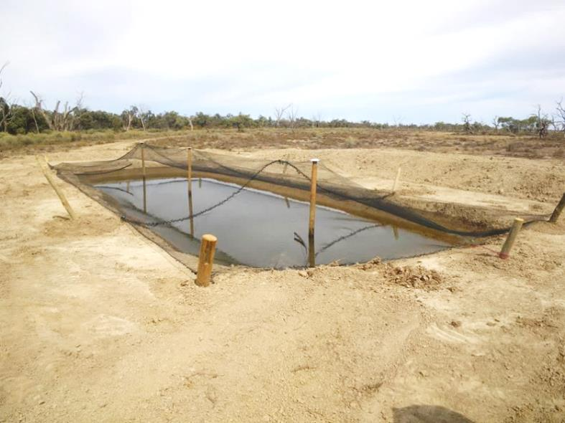

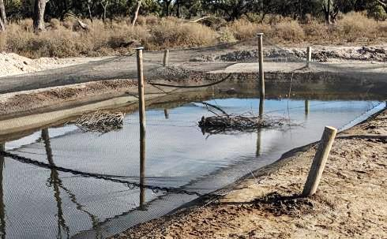

**Figure 4**. Surrogate refuge dam constructed on higher ground adjacent to LFC (photos I. Ellis).

**Seasonal watering regime in Little Frenchmans Creek**

A seasonal watering regime was proposed for implementation in LFC via delivery of environmental water (beginning in October 2018) to support ephemeral wetland processes and promote the development of food and breeding habitat (submerged vegetation/structure) for Murray Hardyhead (see Figure 1). The watering regime allows for water level decrease through summer to concentrate salts and reduce competition by other less salt-tolerant fish species. The recommended regime is intended to be implemented on an annual ongoing basis to support the viability of the translocated population of Murray Hardyhead.

The proposed seasonal watering regime in LFC includes:

* Top the site up (to >1.5m depth in deeper pools) in August-September to induce productivity boost and associated zooplankton emergence (food), and also sufficiently inundate terrestrial structure as breeding substrate for Murray Hardyhead to utilise throughout the primary annual October-November season. It is also expected that larval Murray Hardhead are not as tolerant of high salinity as adults, and hence some reduction in salinity in spring (EC ∼15,000–30,000 uS.cm-1) is proposed.
* Allow natural drawdown through mid- summer (retaining at least 1m maximum depth in deeper sections) to concentrate salts and increase electrical conductivity to EC of 35,000–60,000 uS.cm-1).
* If required, top up in late January-February to maintain adequate depth through to winter (>1m in deeper pools), maintain salinity below an EC of 60,000 uS.cm-1 (upper limit targeted by fish ecologists) and to induce a second productivity boost and food production (which may in turn support prolonged or secondary breeding event in to Autumn).
* Natural drawdown through autumn-winter.

Delivery of environmental water to the LFC began in October 2018 and, in general, was supplemented as per the above proposed seasonal watering regime to maximize habitat availability and productivity for Murray Hardyhead until March 2020. Although water level variation in the surrogate refuge dam was not as important as in the wetland itself (given food generated by variable hydrology in the wetland would also be pumped in to the refuge), the use of a solar pump and float valve ensured the refuge dam does not dry out and provided some moderate water level variability.

Limitations were experienced regarding water delivery during late 2019 when extreme drought meant there was insufficient depth in the source waterbody (Frenchmans Creek) to allow delivery via the primary gravity fed inlet system. Temporary alternate delivery mechanisms were established to deliver freshwater in February 20220, and permeant refinement of water delivery mechanisms is currently underway to mitigate the risk of similar source water limitations in future.

Given the success of this program to date the regime of environmental watering above should continue on an annual ongoing basis.

# Monitoring of the translocated Murray Hardyhead population

## Methods

**Water Quality**

Since late 2017, water quality parameters were measured routinely (i.e. 4 occasions prior and 13 occasions post translocation) at multiple sites throughout LFC. Some of these occasions coincided with netting surveys for fish. Water quality parameters monitored include pH, electrical conductivity (EC, uS.cm-1) as a surrogate for salinity, turbidity (NTU, collected since November 2018 where possible), dissolved oxygen concentration (mg. L-1) and temperature (°C). We present the average for these parameters across 3–4 sites in LFC for each sampling occasion, as well as data for Site 4 (the surrogate dam) separately (Table 1). Note that when water levels are low one of the designated sampling sites (Site 1) does not contain sufficient depth of water to allow data collection. Sampling sites are indicated in Figure 5.

Site 1 is located towards the terminal (northern) end of the wetland, and as such is subject to more extreme water variability than the other sites. On several occasions surface water at Site 1 was absent or too shallow to allow collection of water quality data or netting of fish. On these occasions, water quality data was instead collected at Site 5 where conditions permitted. Site 2 is located in the deepest and most permanent section of the wetland, while Site 3 is located near the inlet source for water delivery.

Site 4 represents the surrogate dam (approximately 5m x 12m; depth 1–1.5m located on high ground adjacent to Site 2. The dam is fitted with a solar powered pump to fill it from the LFC and maintain it at a depth of between ~1m and 1.5m via a float valve and switch. The surrogate dam was also fitted with bird netting to minimize predation, and dead lignum and saltbush were collected from the nearby floodplain and placed within the dam to provide breeding substrate and additional cover (Figure 4).

**Fish netting surveys**

A pre-translocation sampling event was conducted in June 2018, with six post-translocation netting surveys completed since the November 2018 translocation efforts. These sampling events were conducted to document ongoing presence/absence of Murray Hardyhead and to detect breeding/recruitment within the translocated population. Sample sites were the same as those selected for the water quality monitoring.

Dates of these sampling events are indicated in Table 1 with grey shading. On each occasion three small mesh fyke nets were set at each of three sites (two if Site 1 was dry) in LFC itself, and one additional net was deployed in the surrogate dam (Site 4). Nets were deployed overnight with all captured fish counted upon retrieval the next morning (and returned to the water alive, except for non‑native species). Where catch numbers permitted, a sub-sample of at least 50 Murray Hardyhead (incorporating observable size classes across multiple sites in the LFC) were measured (total length) to assess changes population structure.

Fish catch data was standardized for presentation here as ‘catch per net per hour’ to allow comparison of relative abundance through time. Length data collected for a sub-sample of the Murray Hardyhead catch is presented as a length-frequency plot to show the spread of lengths present within the population at a given time, allowing the identification of multiple adult/juvenile cohorts. We present and compare data averaged for sites within LFC itself (Sites 1-3), as well as separate data for the surrogate dam (Site 4).

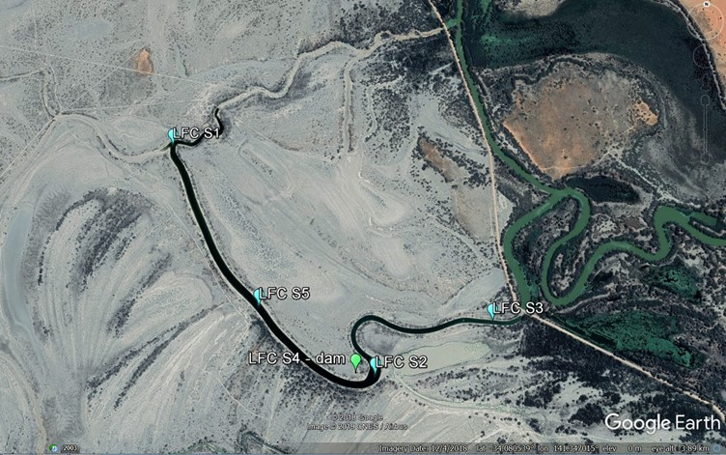

**Figure 5**. Location of sampling sites in LFC. Site 4 (S4) is the surrogate refuge dam serving as a back up to the primary population in the LFC itself.

## Results

**Water Quality**

Mean water quality (across all sites, including the surrogate dam) recorded in LFC since late 2017 is presented in Table 1. Water quality in the Surrogate dam (site 4) typically reflected water quality at Site 2, and as such data for each parameter measured show only minor deviation from the mean data for sites LFC (Figure 6). Delivery of environmental water (by MDWWG and CEWO) to the LFC commenced on 23 October 2018 and continued to March 2020 to maximise habitat availability.

**Table 1**: Mean water quality data collected pre and post environmental water (and translocation of Murray Hardyhead). Dates on which Murray Hardyhead were released are shaded yellow. Water Quality data collection dates that coincided with fish community netting surveys are shaded grey. Blank cells indicate non-collection of certain parameters.

|  |  |  |  |  |  |  |
| --- | --- | --- | --- | --- | --- | --- |
| **Date** | **Trip number** | **Electrical conductivity (uS.cm-1)** | **pH** | **Temperature (°C)** | **Turbidity (NTU)** | **Dissolved oxygen (mg. L-1)** |
| 19-Dec-2017 | Pre translocation 1 | 13,871 | 10.2 | 28.0 |  | 12.2 |
| 26-Mar-2018 | Pre translocation 2 | 32,725 | 9.9 | 21.6 |  | 7.0 |
| 15-Jun-2018 | Pre translocation 3 | 59,000 |  |  |  |  |
| 27-Sep-2018 | Pre translocation 4 | 58,667 | 8.8 | 19.9 | 38.3 | 18.7 |
| 12-Nov-2018 | Post Translocation 1 | 31,000 | 7.5 |  |  |  |
| 15-Nov-2018 | Post Translocation 2 | 36,250 | 8.6 | 25.3 | 29.0 | 6.7 |
| 23-Jan-2019 | Post Translocation 3 | 15,590 | 8.7 | 32.7 |  | 8.3 |
| 2-Mar-2019 | Post Translocation 4 | 25,050 | 9.8 | 30.1 |  | 12.2 |
| 27-Mar-2019 | Post Translocation 5 | 29,640 | 9.0 | 22.3 | 71.8 | 8.6 |
| 23-May-2019 | Post Translocation 6 | 37,300 | 9.0 | 20.0 | 103.2 | 10.5 |
| 25-Jun-2019 | Post Translocation 7 | 40,050 | 8.6 | 8.5 | 62.8 | 6.7 |
| 24-Jul-2019 | Post Translocation 8 | 42,350 | 9.1 | 15.8 | 118.3 | 9.6 |
| 6-Nov-2019 | Post Translocation 9 | 31,700 | 9.1 | 22.1 | 56.8 | 9.8 |
| 10-Dec-2019 | Post Translocation 10 | 31,150 | 8.2 | 25.1 | 41.2 | 4.0 |
| 26-Feb-2020 | Post Translocation 11 | 67,513 | 8.5 | 22.3 |  | 3.2 |
| 20-Apr-2020 | Post Translocation 12 | 50,775 | 9.3 | 19.7 | 36.5 | 7.8 |
| 21-May-2020 | Post Translocation 13 | 52,700 | 9.2 | 16.7 | 69.8 | 9.6 |

In December 2017, mean EC across the LFC was 13,900 uS.cm-1 due to concentration of salts and saline groundwater intrusion since the system was last flooded in late 2016 (see Figure 6). By June 2018, EC had increased to 59,000 uS.cm-1 due to further evaporative concentration (and possibly some ground water influence). Mean EC in LFC on at the time of translocation in November 2018 (two weeks after delivery of environmental water had commenced) had decreased to 36,250 µS.cm-1 due to the addition of approximately 150-200 ML of low salinity environmental water sourced from the Frenchman’s Creek (generally 100-200 uS.cm-1). Water deliveries continued through to January 2019 to maximise habitat availability prior to summer 2018‒19, leading to a further reduction in EC to 15,590 uS.cm-1. After delivery of water ceased, EC increased, reaching 42,350 uS.cm-1 in July 2019. Environmental water delivery again saw the EC reduce during spring 2019 to promote favorable spawning conditions and food production before evaporative concentration again saw EC increase through summer of 2019-20. As EC approached 70,000 mS.cm-1 in February 2020, emergency delivery of water was facilitated to limit further increase in EC to levels which may have impacted on Murray Hardyhead survival.

As with most inland saline water bodies, pH in the LFC is relatively high (alkaline). Lowest pH was recorded during periods of delivery of environmental water to the system. All recorded pH values to date are within the known tolerance limits of Murray Hardyhead. Turbidity was relatively low in the LFC, again typical of saline habitats. Higher incidences of turbidity may indicate increased wind driven turbulence at the edges of the wetland. Daytime DO were moderate and well above the tolerances of Murray Hardyhead, and water temperature fluctuated seasonally.



**Figure 6**. Mean water quality parameters for sites in LFC (red points indicated EC prior to commencement of environmental water delivery to the site, green points indicate dates on which translocation of Murray Hardyhead occurred) and in the Surrogate refuge dam (blue dots).

**Post- translocation fish surveys**

In Spring 2018 around 780 Murray Hardyhead were released in to the LFC. Prior to this release, the species was absent from LFC. The catch data clearly shows that Murray Hardyhead have not only survived reintroduction to the site but have undergone substantial in-situ reproduction and recruitment, which has resulted in increased numbers.

For instance, on 27–28 March (2019), some four months after release, a total of 1,079 Murray Hardyhead were collected from the three wetland sites, with another 91 collected in the single net in the surrogate dam (1,170 in total – more than the total number released four months earlier). Many collected in LFC were clearly in breeding condition with eggs and milt extruding from multiple captured individuals. The detection of juvenile fish (< 30mm long) in wetland (Sites 1-3), and the presence of ripe adults in the March 2019 and May 2019 surveys (Figure 7), indicated breeding by Murray Hardyhead in LFC had occurred between late November 2018 through to April 2019. We suggest progeny from fish translocated to the site in November 2018 had themselves matured and bred within their first year of life (a life history strategy postulated by Ellis 2006). However, only adult fish (>40mm) were captured in the Surrogate dam (site 4) during the March and May 2019 surveys (see Figure 10) suggesting a lack of breeding success in the previous six months. Breeding substrate in the form of dead lignum and saltbush was not added to the dam until March 2019, thus it is possible a lack of substrate in the dam impacted breeding success.

In the March 2019 survey Mosquitofish, or Eastern Gambusia (*Gambusia holbrooki*) were more abundant than Murray Hardyhead throughout LFC (Sites 1-3), although they were not detected in the surrogate dam (Site 4) (see Figure 9). Low abundances of several other native small-bodied species were also captured throughout LFC including Carp gudgeon (*Hypseleotris sp*.), Flathead Gudgeon (*Philypnodon grandiceps*), Dwarf Flathead Gudgeon (*Philypnodon macrostomus*), Unspecked Hardyhead (*Craterocephalus stercusmuscarum fulvus*) and small Bony Herring (*Nematalosa erebi*). Two juvenile Silver perch (*Bidyanus bidyanus*), a threatened species, were also captured during the survey. Except for Eastern Gambusia and Carp Gudgeon, each of these species were absent in the surveys conducted prior to addition of environmental water, and hence are assumed to have entered the LFC during addition of water (either as adults or juveniles) and were persisting at the lower EC of ~30,000 uS.cm-1. Only Murray Hardyhead and Mosquitofish have been detected in the surrogate dam (Site 4).

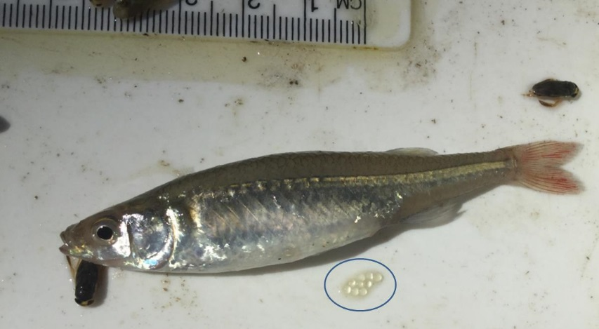

**Figure 7.** Large female Murray Hardyhead which exuded several eggs while being measured, 28 March 2019 (Photo I. Ellis).

Subsequent surveys in May and June 2019 identified ongoing increase in catch per net per hour for Murray Hardyhead in LFC (Figure 8), although catch in the surrogate dam had decreased with no indication of breeding success. decreasing abundance of Gambusia and other competing small-bodied species (most likely to be related to increasing EC). The reduction in abundance of competing species supports the objective of allowing saline increase annually. In November 2019, the abundance of Murray Hardyhead increased in both the LFC and in the surrogate dam (Figures 8 and 9), consistent with the annual spring breeding season for the species (see Figure 1). Juveniles were detected in both the LFC and the surrogate dam (Figure 10), suggesting the addition of lignum for breeding structure supported successful breeding and recruitment (in the dam).

Unfortunately, in the summer of 2019–20 protracted drought in the Southern Murray-Darling Basin meant operational flows in the Murray River were very low. As such, flow in the Frenchmans Creek also remained low, precluding delivery of water to the LFC via the primary gravity-fed inlet mechanism. Hence the water level in the LFC decreased substantially through summer 2019-20 and in association, EC in the LFC increased to over 60,000 uS.cm-1. Whilst Murray Hardyhead were still present in February 2020, their abundance was substantially decreased compared to the previous year, and EC was approaching their assumed upper tolerance limits. In response, environmental water was pumped via the existing inlet gate (from the Frenchman's Creek to the LFC) in early March 2020. This allowed a minor watering of the wetland to occur, resulting in a reduction in EC to ~50,000 uS.cm-1.

Subsequent sampling in May 2020 captured a range of size classes of Murray Hardyhead in the LFC in good condition (including juveniles) indicating recent breeding events following addition of water indicating the increased inundation in the LFC generated a productivity boost that cued breeding. Some adults were still in breeding condition with egg batches noted on some of the nets, again indicating the species is capable of breeding from spring through to autumn if conditions are appropriate. However, juveniles were not detected in the surrogate dam in May 2020 (Figure 10), suggesting he productivity increase was not effectively transferred to the dam.



**Figure 8.** Standardised catch in netting surveys of LFC including the pre-translocation baseline survey (June 2018) and six post-translocation surveys.



**Figure 9.** Comparison of standardised catch across Sites 1-3 in LFC and within the surrogate dam (Site 4). Data presented as catch per net per hour and includes the pre-translocation baseline survey (June 2018) and six post-translocation surveys.

**Population Structure**

Assessment of the population structure (length-frequency) in LFC indicated fish ranged in size from 24 to 80 mm in March 2019, and 28 to 76 mm in May 2019. On both sampling occasions at least three age cohorts were present in the LFC, including juveniles (<30mm), small adults (∼35–55 mm) and mature adults (>60mm) (Figure 10). Only adult fish (>40mm) were captured in the Surrogate dam (site 4) during the March and May 2019 surveys (likely translocated fish), suggesting a lack of breeding success in the previous six months. Breeding substrate in the form of dead lignum and saltbush was not added to the dam until March 2019, thus it is possible a lack of substrate in the dam following the release of fish precluded breeding success.

Multiple cohorts were again present in November 2019, this time in both the LFC and the surrogate dam, with adults as large as 91mm captured. Small juveniles (<20mm) were captured indicating breeding had occurred in the weeks prior (i.e. September-October 2019), which is consistent with the annual spring breeding season for the species (see Figure 1).

In February 2020, larger adults (>75mm) were mostly absent from the population, and few juveniles were detected. This is likely due to both the annual die-off of older adults (making way in the population for younger 0+ cohorts to thrive) in line with water level contraction and salinity increase (see Figure 1). Following a small addition of fresh water to the LFC in March 2020, sampling in May detected a new cohort of juveniles (<30mm) in LFC, but not in the surrogate dam. It is likely that the small increase in water level generated an autumn pulse in productivity and hence food availability, as well as an increase in habitat availability which supported a second peak in breeding by the resident Murray Hardyhead population (as depicted in Figure 1).



**Figure 10.** Length structure of reintroduced Murray Hardyhead population in LFC over time (March 2019–May 2020). Black bars represent size distribution across all sites (1-4), red bars represent size distribution of fish captured within the surrogate dam only (Site 4). Juvenile and adult cohorts are present throughout the monitoring period indicating repeat breeding and recruitment in 2018–19, and 2019–20.

# Discussion

In November 2018, approximately 780 Murray Hardyhead were successfully translocated from the Disher Creek population into LFC (and its associated surrogate refuge dam) on Wingillie Station. The reintroduction of Murray Hardyhead represents the first attempt in NSW to reestablish a freshwater fish species that is likely to have been locally extinct (no detections since 2005).

The first post-translocation monitoring survey conducted in LFC (28 March 2019) captured more Murray Hardyhead than had been released in November 2018 and detected both adults and juveniles. The second third and fourth post-translocation monitoring surveys detected further increases in the abundance of Murray Hardyhead, with young cohorts identified in Autumn and Spring 2019, and again in Autumn 2020. These results indicate repeated breeding success over a protracted 18 months period within the translocated population following their release to LFC.

Although decreasing water level and escalating EC saw a reduction in abundance of Murray Hardyhead through the 2019-20 summer, a small addition of fresh environmental water in March 2020 from the Frenchmans Creek ultimately led to a second period of breeding by the population through Autumn 2020. This means the population consists of multiple size cohorts leading into winter and is as such in a strong position for further breeding success in spring 2020, should water delivery to the site continue as recommended.

These monitoring outcomes are encouraging but continued active and collaborative management of the site is required to ensure the long-term viability of the population at LFC. The example of low flow in the Frenchmans Creek in late 2019, which precluded delivery of environmental water to the site and increasing salinity to potentially dangerous levels, only serves to highlight the need for active real-time monitoring to enable timely management intervention.

DPI Fisheries have recently funded the installation of water delivery meters on the existing syphons located near the primary water delivery point (funded under the NSW DPI Emergency drought program). These will facilitate pumped emergency water delivery in future should conditions again result in an inability to transfer fresh environmental water from the Frenchmans Creek via the primary gravity-fed delivery system.

The ongoing supply of environmental water to the LFC in coming years is imperative to support this population and should be accompanied by ongoing population and water quality monitoring. Water delivery should be timed to maximise productivity and spawning (in spring) and provide top up and habitat inundation (if necessary) over late summer and autumn following a period of saline increase in summer to reduce competition and predation (as per the recommended annual watering regime above).

If future monitoring indicates the new population becomes self-sustaining, the LFC population may itself be utilised as a donor population to increase the area of occupancy for the species in the Lower Murray region of NSW. Fish could also be sourced from the surrogate refuge dam for this purpose, to be replaced with fish from LFC to maintain a contingency sub-population in the refuge dam.

The collaborations established in the development and conduct of this project will promote renewed interest and attention to the conservation of Murray Hardyhead in the southern Murray-Darling Basin, and threatened fish recovery in general. Longer term aspirations include establishment of additional wetland and surrogate refuge populations of Murray Hardyhead as well as other threatened species (e.g., Southern Purple-spotted Gudgeon, Southern Pygmy Perch and possibly Freshwater Catfish) at Wingillie Station and/or other suitable sites.

The project teams’ commitment to careful site preparation and timely water addition (to provide and maintain suitable habitat and water quality for the target species) serve as a precedent for planning future translocations of threatened fish and associated environmental water management.

# Recommendations

To minimise the risk of repeated events where water availability and quality threatens the viability of the translocated population, we recommend the following to support the environmental watering arrangements at the site.

* Continued monitoring of the population (at least quarterly) to track population status and identify potential declines in the abundance of the species (outside normal seasonal fluctuations).
* installation of water level and salinity sensors that transfer real time data remotely via telemetry, thus minimising the potential for negative outcomes in the event staff are unable to visit the site.
* Annual mixing of stocks between the LFC and the surrogate dam to maintain genetic diversity (only when transfer will not endanger fish).
* If future monitoring indicates the new population becomes self-sustaining, the LFC population may itself be utilised as a donor population to increase the area of occupancy for the species in the Lower Murray region of NSW. Candidate sites include Tareena Billabong and areas within Salt Creek (near the SA border), or Brilka Creek to the west of Wingilli Station. Recent genetic analysis has identified that Murray Hardyhead subpopulations are distributed across two metapopulations (Lower Murray and mid-Murray. Known populations in both north-west Victoria and the South Australian Riverland fall within the mid-Murray metapopulation. Conservation translocations are recommended to only occur within (but not between) the metapopulations (Thiele et al. in press). The suggested sites for further relocation also fall within the geographical range of the mid-Murray metapopulation.

# References

DELWP (2017). Draft National Recovery Plan for the Murray Hardyhead Craterocephalus fluviatilis. Victorian Department of Environment, Land, Water and Planning for the Australian Government Department of the Environment and Energy, Canberra.

Ellis, I. Whiterod, N. Webster, R. Nias, D. Hardy, S. J. Keating and Warren, K. (2018). Threatened fish recovery: Reintroducing the Endangered Murray Hardyhead into LFC, NSW. Completed for the Western LLS by NSW Department of Primary Industries - Fisheries, Buronga.

Ellis I, Stoessel D, Hammer M, Wedderburn S, Suitor L, Hall A (2013.) Conservation of an inauspicious endangered freshwater fish, Murray Hardyhead (Craterocephalus fluviatilis), during drought and competing water demands in the Murray–Darling Basin, Australia. Marine and Freshwater Research 64 (9), 792-806.

Ellis I and Kavanagh M (2014). A review of the biology and status of the endangered Murray Hardyhead: streamlining recovery processes. Final Report prepared for the Murray-Darling Basin Authority by The Murray-Darling Freshwater Research Centre, MDFRC Publication 19/2014, June, 66pp.

Ellis I, Wood D (2015). Monitoring of Murray Hardyhead populations and potential translocation sites in the Victorian Mallee, 2014–15. Final Report prepared for the Mallee Catchment Management Authority by The Murray–Darling Freshwater Research Centre, MDFRC Publication 81/2015, June, 34 pp.

Ellis, I. (2006) Age structure and dietary analysis of the Murray Hardyhead Craterocephalus fluviatilis (McCulloch), Family Etheriidae, in two lakes near Mildura, Victoria. Murray Darling Freshwater Research Centre, Mildura.

Ellis, I. (2005) Ecology and breeding seasonality of the Murray Hardyhead *Craterocephalus fluviatilis* McCulloch), Family Etheriidae, in two lakes near Mildura, Victoria. Murray Darling Freshwater Research Centre, Mildura.

Hammer, M.P., Bice, C.M., Hall, A., Frears, A., Watt, A., Whiterod, N.S., Beheregaray, L.B., Harris, J.O., Zampatti, B., (2013). Freshwater fish conservation in the face of critical water shortages in the southern Murray–Darling Basin, Australia. Marine and Freshwater Research 64, 807821.

MDBA (2014). Basin-wide environmental watering strategy. Murray – Darling Basin Authority, Canberra.

Stoessel D, Fairbrother P, Fanson B et al (2020) Salinity tolerance during early development of threatened Murray Hardyhead (*Craterocephalus fluviatilis*) to guide environmental watering. Aquatic Conservation: Marine and Freshwater Ecosystems 30:173182Thiele S, Adams M, Hammer M, Wedderburn S, Whiterod N, Unmack PJ, Beheregaray LB (in press) Range-wide population genetics study informs on conservation translocations for the endangered Murray Hardyhead (*Craterocephalus fluviatilis*). Aquatic Conservation: Marine and Freshwater Ecosystems

Whiterod N. (2019). A translocation strategy to ensure the long-term future of threatened small-bodied freshwater fishes in the South Australian section of the Murray-Darling Basin. A report to Natural Resources, SA Murray-Darling Basin and the Riverine Recovery Project. Aquasave-Nature Glenelg Trust, Goolwa Beach.

Whiterod N, Zukowski S, Ellis I et al. (2019) The present status of key small-bodied threatened freshwater fishes in the southern Murray-Darling Basin, 2019. A report to the Tri-State Murray NRM Regional Alliance. AquasaveNature Glenelg Trust, Goolwa Beach

**More information**

Iain Ellis - Fisheries Manager, Aquatic Habitat Rehabilitation, DPI Fisheries

PH: 0429 300 486 email: iain.ellis@dpi.nsw.gov.au web: www.dpi.nsw.gov.au