December 2025

Smart Farms program 2017–18 to 2022–23: final report
The Smart Farms program was funded by the Natural Heritage Trust, which is the Australian Government’s key investment platform in sustainable agriculture, natural resource management and environmental protection.
The program was funded (Table 1) as part of the Trust’s National Landcare Program Phase 2 (NLP2) from 2017-18 to 2022-23.
Smart Farms supported projects across Australia to:
- improve soil health, farm productivity and profitability
- manage pests, weeds, climate and market risk.
The program funded:
- innovative technologies and practices
- the adoption of sustainable agricultural practices by farmers and land managers
- engagement and mutual learning with First Nations’ organisations.
Table 1 Smart Farms funding
Subprogram | Description | Average grant ($) | Projects (no.) | Funding ($m, GST excl.) | Smart Farms funding (%)
Smart Farming Partnerships | In a consortium, develop, trial and implement technologies and practices that protect natural resources and support sustainable production. | 2,213,000 | 26 | 57.5 | 40.5
Building Landcare Community and Capacity | Support the sharing of knowledge, achievements and community leadership in adopting sustainable agricultural practices. | 738,000 | 53 | 44.6 | 31.5
Smart Farms Small Grants | Increase farming, forestry and fishing communities’ awareness, knowledge, skills and capacity to adopt sustainable agriculture. | 108,000 | 416 | 39.3 | 28
Total |  |  | 495 | 141.4 a | 100
a the original allocation for Smart Farms was $136 million. Final expenditure was $141 million, which included an additional $5.1million for 6 additional Building Landcare Community and Capacity projects funded from Regional Land Partnerships program underspends and the Natural Heritage Trust Special Account.
Smart Farms delivered its policy objective of supporting a more productive and profitable agricultural industry while protecting Australian biodiversity and preserving natural resources. The program increased primary producers’ knowledge and acceptance of new sustainable agricultural tools and practices, and helped strengthen networks between researchers, land managers and farmers.
The Climate-Smart Agriculture Program (funded through the Natural Heritage Trust over 5 years from 2023–24 to 2027–28) has built on Smart Farms and NLP2 by incentivising partnerships and building knowledge, awareness and capability.

Case studies

Smart Farming Partnerships

Case study 1: Farm-scale natural capital accounting, La Trobe University ($2.5 million)
Natural capital refers to natural assets, such as soil, water, vegetation and biodiversity, present on a farm (Figure 1). Healthy natural capital is essential to primary production and underpins the long-term sustainability of farm businesses. Farm-scale Natural Capital Accounting (NCA) is a tool that:
- provides farmers and their stakeholders with robust, repeatable, transparent and verifiable information about the natural capital on their farm
- helps farmers understand how natural capital affects their financial performance and the extent to which their activities or investments either improve or degrade the condition of their land.
This information allows farmers to make more informed decisions about their farm management and leverage their sustainable farm practices for commercial benefit when engaging with investors, buyers and lenders.
Figure 1 Natural capital assets
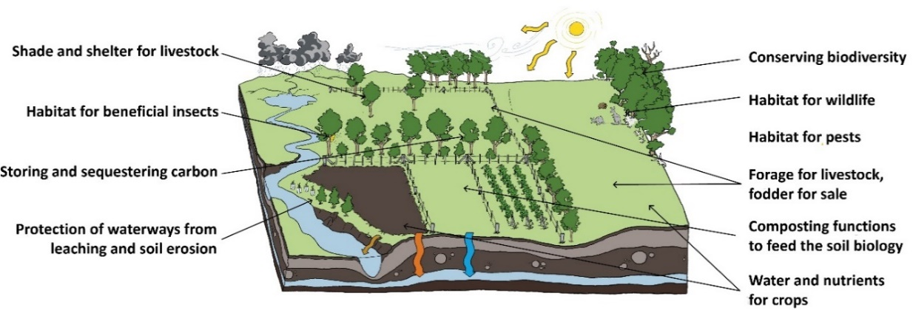
Source: © La Trobe University
The NCA project was led by La Trobe University, with a consortium of nine industry partners, and in close collaboration with 50 farmers across New South Wales, Victoria and Tasmania.
The results of the project include a:
- methodology for farmers and their stakeholders to measure and communicate farm-scale environmental performance and natural capital management
- user-friendly web platform that conveys information in a format that reflects internationally recognised standards for environmental-economic accounting
- pathway for farmers to set and achieve their financial, environmental and social goals and to help communicate their environmental performance to their stakeholders.
Since project completion, La Trobe University has reported that the processes developed have been used by Farming for the Future and have been included in Australian Wool Innovation’s Nature Positive Farming framework.
Learn more about Latrobe University’s farm-scale natural capital accounting.

Case study 2: Djandak Dja Kunditja (Country Healing its Home), Dja Dja Wurrung Clans Aboriginal Corporation ($1.82 million)
The project developed and trialled new tools and farming practices to explore kangaroo grass (Themedia triandra) as a commercial crop and its potential broadacre application.
Kangaroo grass is a native perennial grass species that is highly adapted to Australian climatic conditions. It can be harvested, milled into flour and used similarly to wheat.
The project team worked with La Trobe University to study the germination, performance and economic viability of kangaroo grass in broadacre cultivation systems. The team planted a commercially harvestable quantity of seed (over 100,000 seeds) at 3 trial sites in Victoria to support research and develop the species and related farming practices (Figure 2).
In delivering the project, the Dja Dja Wurrung Clans Aboriginal Corporation members (in Victoria’s Bendigo region) developed capacity, partnerships and leadership skills. The project set an example to align kangaroo grass–related information management solutions with the CARE principles for Indigenous data knowledge, which reinforced the corporation’s rights in the agricultural economy to control and protect Indigenous data.
The project also delivered:
- academic publications that culminated in a PhD thesis project
- a kangaroo grass plant guide and crop management guide
- a video documenting crop management practices
- field days, information sessions and demonstrations.
Learn more about kangaroo grass, as a crop to heal Country.
Figure 2 Kangaroo grass in pots on project site, Bendigo region, Victoria
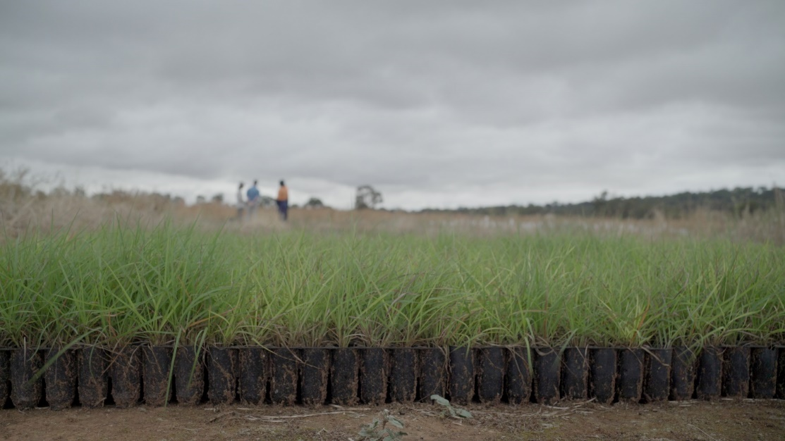
Photo: © Dja Dja Wurrung Clans Aboriginal Corporation

Building Landcare Community and Capacity

Case study 3: Quantifying the benefits of regenerative agricultural practices in restoring degraded soil, Southern Cross University ($2.5 million)
The project was a collaboration with industry partners to support 8 projects across New South Wales, Victoria and Western Australia to develop an evidence-based resource on best-practice regenerative farming and soil management (Figure 3). The project topics were as diverse as increasing biomass, using multispecies crops, increasing soil carbon and using a bioreactor to lower levels of pesticide in soil.
The project team produced findings, tools and resources, which they shared with local growers, practitioners and students through:
- field days
- conferences
- newsletters
- blog posts and social media.
The project team also produced peer-reviewed papers to expand the evidence base for sustainable management practices.
Learn more about the Regenerative Agriculture Alliance.
Figure 3 Southern Cross University staff examine soil samples at project site, Ebor, Northern Tablelands, NSW
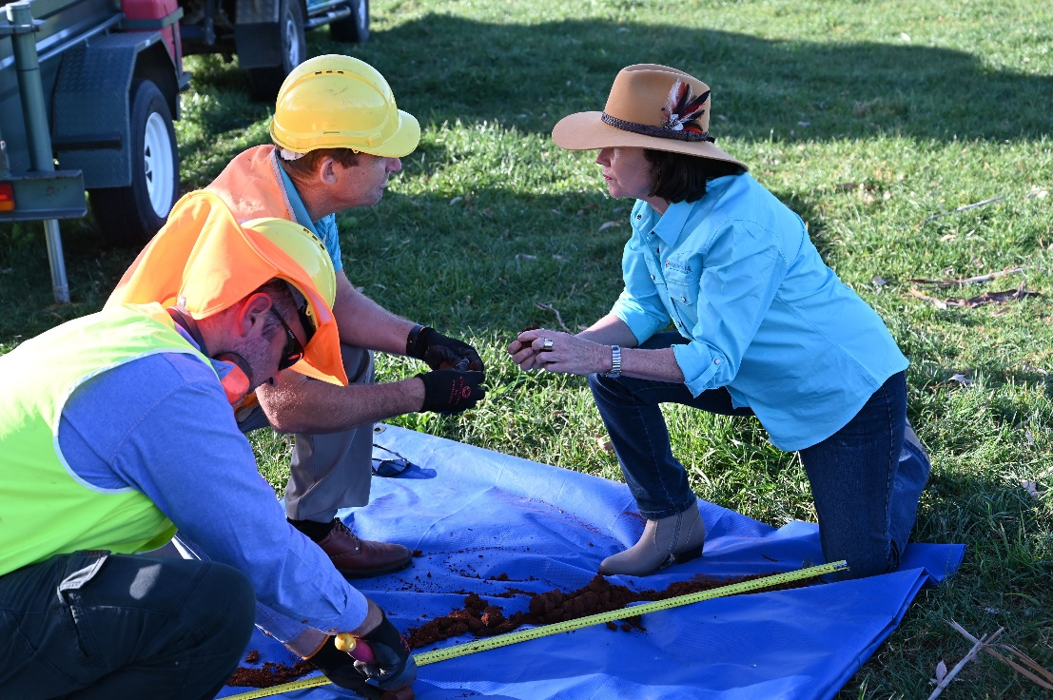
Photo: © Southern Cross University

More information
Learn more about the Climate-Smart Agriculture Program.
Email NHTprograms@aff.gov.au.
Acknowledgement of Country
We acknowledge the continuous connection of First Nations Traditional Owners and Custodians to the lands, seas and waters of Australia. We recognise their care for and cultivation of Country. We pay respect to Elders past and present, and recognise their knowledge and contribution to the productivity, innovation and sustainability of Australia’s agriculture, fisheries and forestry industries.
© Commonwealth of Australia 2025
Unless otherwise noted, copyright (and any other intellectual property rights) in this publication is owned by the Commonwealth of Australia (referred to as the Commonwealth).
All material in this publication is licensed under a Creative Commons Attribution 4.0 International Licence except content supplied by third parties, logos and the Commonwealth Coat of Arms.
The Australian Government acting through the Department of Agriculture, Fisheries and Forestry has exercised due care and skill in preparing and compiling the information and data in this publication. Notwithstanding, the Department of Agriculture, Fisheries and Forestry, its employees and advisers disclaim all liability, including liability for negligence and for any loss, damage, injury, expense or cost incurred by any person as a result of accessing, using or relying on any of the information or data in this publication to the maximum extent permitted by law.

