Snapshot – The impact of energy prices on agricultural inputs

**May 2023**

Global energy prices have fallen from record high levels in mid-2022. This has led to reduced prices for agricultural inputs, including fertiliser and diesel. Despite recent falls, costs for producers are expected to remain relatively high in 2023.



Energy prices have fallen from record highs

* Unexpectedly high-demand after the initial phase of the COVID-19 and Russia’s invasion of Ukraine led to surging energy prices (Figure 1).
* Falling energy prices since mid-2022 have been caused by a range of factors, including:
  + supply chains recovering from COVID-19 related disruptions
  + the re-organisation of trade following Russia’s invasion of Ukraine
  + reduced global economic activity
  + a warm European winter.

Figure 1 – Energy spot price index

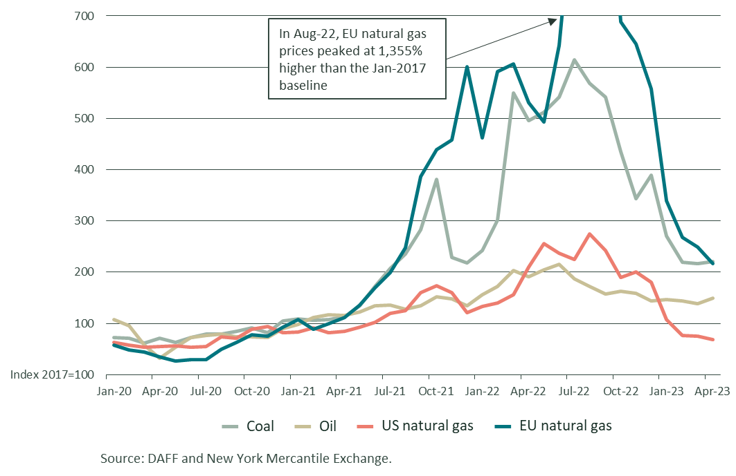

How do energy prices affect agricultural producers?

* Key production inputs such as fertiliser, agricultural chemicals and diesel are produced using natural gas and oil.
* In 2022, fertiliser and fuel accounted for a record 27.7% of total farm cash costs for cropping business. This is expected to grow to 34% in 2023 (Figure 2).
* Energy prices also affect the cost of freight and processing, which also influences the total cost of food production.
* Rising input prices contributed to spikes in global food prices in 2021 and 2022 and are evident in higher grocery prices in Australia.

Figure 2 – Average fertiliser and fuel costs as a share of total farm cash costs for Australian cropping farms

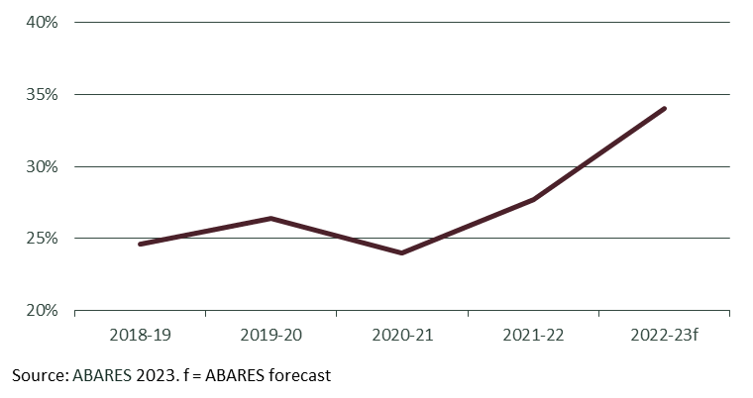

## How have high prices and disrupted supplies affected Australian fertiliser imports?

* Between February 2020 and July 2022, the average import price of Australian fertiliser increased by 153%.
* Disrupted supply chains and export restrictions altered Australia’s usual sources of fertiliser imports.
* The volume of imports from major suppliers, including China (-36%), Qatar (-18%) and the United Arab Emirates (-31%), fell in 2022.
* Imports from Bahrain (+195%), Morocco (+96%) and the USA (+31%) increased.
* High prices caused the total value of fertiliser imports to rise by 73%, despite an 11% fall in fertiliser import volumes.

**Figure 3: Australian fertiliser import volumes by exporter (LHS) and total import value (RHS)**

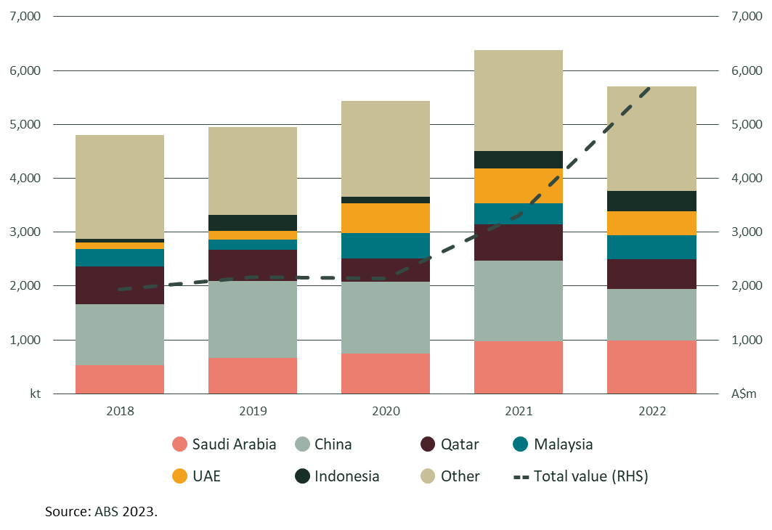

## Fertiliser price outlook

* International price indicators have been falling since mid-2022. Australian prices have also fallen, but at a slightly slower rate.
* Futures markets indicate that fertiliser prices may settle at approximately 30% higher than the January 2020 price.