

—

**Commonwealth Environmental Water Office**

Monitoring, Evaluation and Research Program

SOP Physical Habitat

Standard Operating Procedures  
Physical Habitat- UAV Drone surveys for bank conditions v 1.0

23 June 2019

1. Objective and Hypotheses

Bank condition is explicitly linked to the CEWH (Commonwealth Environmental Water Holder) and other variable flows. The risk to biota from changes in bank morphology and sediment liberated from erosion make bank condition an important, and explanatory variable for assessing the value of these water delivery patterns for achieving ecosystem objectives.

Riverbank vegetation richness and diversity are also impacted by flows, including due to flow characteristics such as prolonged inundation, high velocities, and smothering. These vegetation changes can be independent of bank condition, or extricable linked.

The main objectives of the riverbank vegetation and riverbank condition protocol are to:   
1) determine links between flow operations and bank erosion or deposition;

2) determine links between flow operations and vegetation changes;  
3) identify how bank erosion/deposition and/or vegetation changes might be linked;

4) explain how bank erosion/deposition and/or vegetation changes might explain other ecological responses (e.g. for fish or macroinvertebrates); and

5) better inform management of the pattern and timing of delivery of environmental flows to reduce bank instability, maintain/improve vegetation, and achieve ecological objectives.

An opportunity exists to monitor riverbank vegetation and riverbank condition using Unmanned Aerial Vehicles (UAVs). This approach is explained in this Standard Operating Procedure.

***Evaluation Questions***

This monitoring protocol addresses the following evaluation questions at a landscape and catchment scale:

* **Short-term (one-year) and long-term (three-year) questions:**
  + How do CEWH environmental/variable flows contribute to sustaining bank condition? The process for evaluating these questions is illustrated below, with components covered by this protocol are illustrated in Table 1.
* **Selected Area specific questions:**
* Are CEWH environmental/variable flows adversely impacting the banks of the rivers?
* How do timing and delivery of CEWH environmental/variable flows affect bank condition of rivers?
* What timing and delivery of CEWH environmental/variable flows best sustain or improve bank condition for vegetation growth?
* How do vegetation responses to CEWH environmental/variable flows vary between sites with different channel features and different bank condition?
* Are bank erosion rates and processes impacting macroinvertebrate communities?

**Table 1 Key elements of the MER Plan: Bank Condition and Vegetation Assessment.**

|  |  |
| --- | --- |
| Field Measurement Phase | Quantitative assessment by performing UAV flights over sites, collecting both nadir and oblique imagery depicting bank condition and vegetation cover.  Repeated visits are necessary pre- and post- CEWH environmental/variable flows. |
| Analysis Phase | Photogrammetric analysis of UAV data to develop **1. digital elevation models (DEMs) of difference** comparing the bank condition of each site visit and 2. **classified vegetation maps** comparing vegetation change pre-and post CEWH environmental/variable flows. |
| Evaluation Phase | Develop explicit links between flow events and bank condition through developing keys based on the outputs of the analysis phase. |
| Reporting Phase | What did CEWH environmental/variable flows contribute to sustaining bank condition as a result of flow management? |

1. Indicators

The use of UAVs to assess bank condition is a new and exciting tool, which provides greater accuracy and more extensive coverage than erosion pins. This protocol provides quantitative data tracking bank recession (erosion) or accretion (deposition) over the lengths of this project, and will provide critical information regarding the impact of environmental or variable flows (especially unseasonal flows) on bank response and vegetation regrowth. The monitoring of bank condition may also enable us to evaluate how bank erosion affects macroinvertebrate communities, by providing a possible explanatory variable for the observed trends.

Use of drones meets all relevant legislative requirements. Streamology hold an Aviation Reference Number (ARN number 1058370) for drone operations in the sub 2kg class.

This protocol will also complement the Vegetation Diversity indicator, generating both bank condition and vegetation response data from each site. Co-locating bank condition and vegetation field work will not only save on cost but will enhance our analytic power to understand observed trends and growth in multiple domains.

**Figure 1 Inter-relationship between physical form, vegetation ecology and entomology, as measured by MER protocol and Category indicators.**

***Complementary Monitoring and Data***

Hydraulic models developed for other monitoring or environmental flow programs are valuable tools to demonstrate inundation of banks (e.g. models developed for the Victorian Environmental Flow Monitoring and Assessment Program). Existing data may also be gleaned from photo points (e.g. fixed cameras to assess bank slumping).

1. Locations for Monitoring

Locations for UAV monitoring should be based on:

* Sites directly influenced by environmental flow deliveries as assessed by a geomorphologist.
* Sites where nearby gauging stations exist.
* Sites with appropriate access, but limited public access.

1. Timing and frequency of sampling

UAV bank and vegetation assessments should be undertaken a minimum of three times per year (per site) to enable capture a minimum of change in two flow periods. This is recommended for the three year MER period. The timing of UAV image collection should always be scheduled to coordinate with low flow deliveries so as to gain as much insight into the condition of the otherwise submerged banks. As an example, Figure 2 illustrates the timing of past site visits measuring bank condition on the Goulburn river at the site ‘McCoy’s Bridge’. Site visits were coordinated with low flow deliveries.

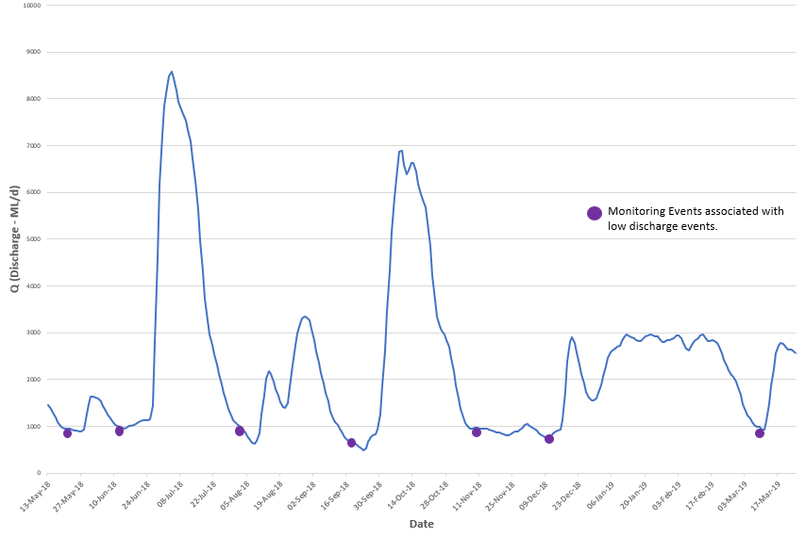

**Figure 2 Hydrograph illustrating flow and the timing of past monitoring project at McCoy's Bridge (Goulburn River) between 2018 and 2019.**

1. Responsibilities and identifying key staff

***Field Program***

A Streamology staff member will be responsible for capturing UAV data in consecutive visits during times of low flow. Other Streamology staff members will provide field assistance and UAV support. Geomorphic input is required to verify findings and infer changes. Ecological input is required to generate initial maps of vegetation communities within the survey sites. On past projects, one initial visit by an ecologist specialising in waterway flora was required to generate annotated vegetation maps. This was followed by desktop input to verify the vegetation species used as training data in the supervised image classification.

***Laboratory Requirements (if any)***  
N/A

***Procedure for transferring knowledge to new team members***

The data from the UAV will is stored online in a dedicated folder within the Streamology spatial drive. It is available to current staff members. Access to this data can also be provided to external staff by sharing password-protected links.

1. Monitoring Methods

***Equipment List***

* RTK Drone with Base Station (Fig. 3) - Streamology uses a DJI Phantom 4 RTK with Mobile Station
* Ground Control Points (Fig. 4)
* Photogrammetry software - Streamology uses Pix4D Mapper  
    
  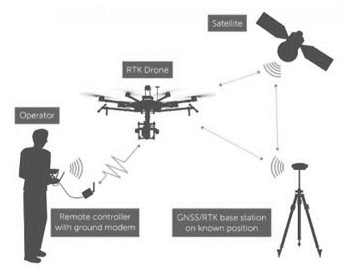

**Figure 3 Diagram illustrating relationship between operator, RTK drone, base station and satellite for photogrammetry applications.**

**Field Monitoring Protocol**

1. **Sites are identified as suitable by fulfilling the following criteria**🡪Sites directly influenced by environmental flow deliveries.  
   🡪Sites where nearby gauging stations exist.  
   🡪Sites with appropriate access, but limited public access.
2. **Sites are visited during times of low flow**🡪This is to be coordinated with relevant CMA.  
   🡪Using hydrographs to forecast flow is an important step in ensuring the sites will be visited at the optimal time. These are generated by modelling flow from the weirs upstream and estimating lag time between these weirs and the survey sites.
3. **Drone pilot must notify CASA of intention to fly 5 days prior to deployment**🡪 The online form can be located at the following hyperlink  
   <https://forms.casa.gov.au/Public/wizard/1b396e81-f96a-433c-b377-05e5aa11cba2/?portal=1&id=%7B1b396e81-f96a-433c-b377-05e5aa11cba2%7D&Form=RPAS&prepared=true&logGuid=a7c7f050-38e6-41dc-96d1-decde147d269>
4. **Ground Control Points are distributed**  
   🡪Ground control points (approximately 10 per site) are distributed along river banks, evenly spread on both river banks, and located in areas which are not constrained by canopy cover or hidden by obstructions.   
   🡪Use bright objects such as orange traffic cones and bright yellow disks with a black ‘x’ in the centre. They should be easy to locate in imagery, and easy to precisely mark (Fig 5).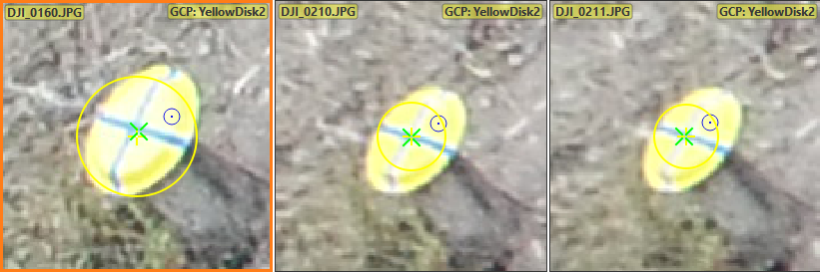  
   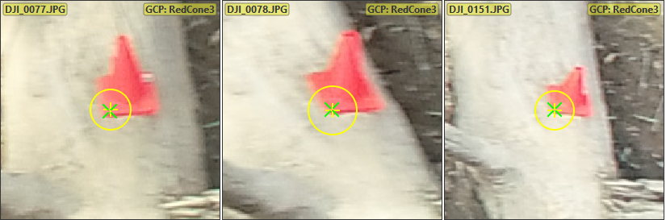

**Figure 4 Marked 3D GCPs in Pix4D photogrammetry software. These GCPs were located on a subsection of the Goulburn River (Loch Garry) in April 2019.**

1. **UAV data collection**  
   🡪 The UAV (drone) is used to obtain both nadir and oblique imagery.   
   🡪 The nadir flight is often an ‘aerial grid flight’ and is flown at an approximate altitude of 60m, and the oblique imagery is a freestyle flight obtained at lower altitudes (approx. 5-25m above water). Figure 5 illustrates the overlap of multiple flights within a subsection of the Goulburn river.

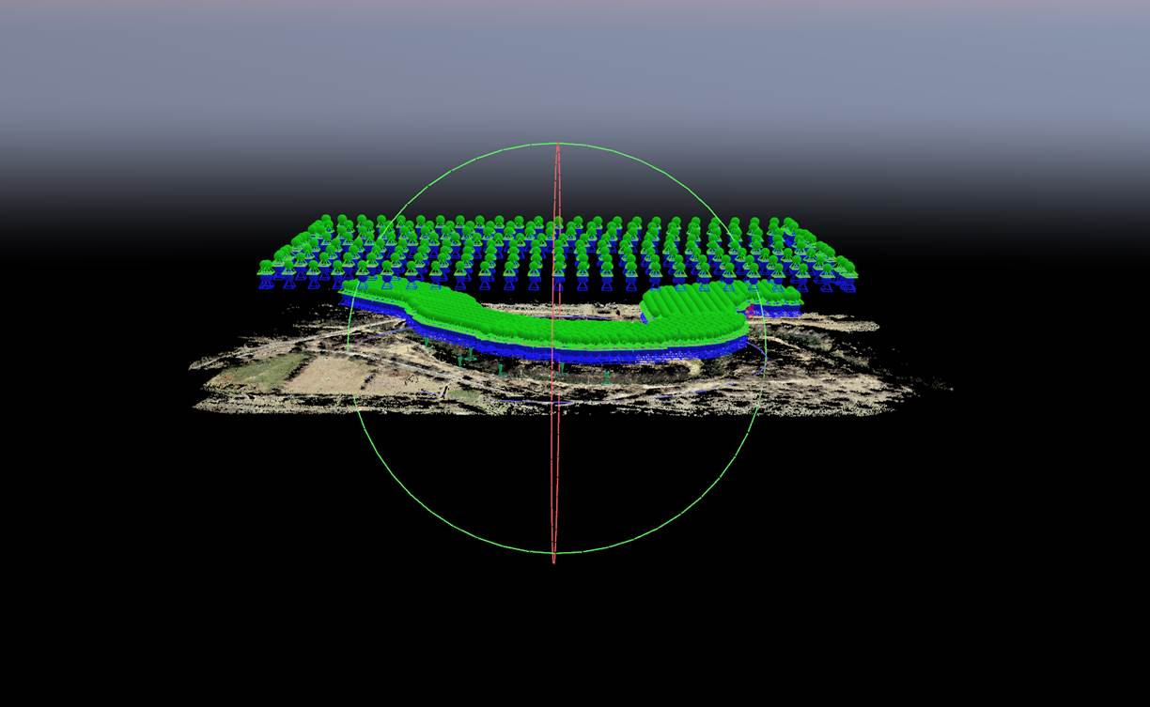

**Figure 5 Overlapping flight paths of two heights of nadir imagery for a subsection of the Goulburn River (2019).**

1. **Return visits are necessary to obtain data for comparison of bank condition and vegetation c**h**anges.**🡪Return visits are scheduled for periods of low flow _4_ times per year over the course of _3_ years for the 2019-2022 period.

**Desktop Monitoring Protocol**

1. **UAV data is transferred to a secure location**Data is segmented into nadir and oblique imagery folders.
2. **Preferred photogrammetry software is used to generate:**a. **Densified point cloud** (from nadir and oblique imagery) (Fig 6)  
   A densified point cloud is a series of 3D points which are used to generate a reconstructed model of a scene captured via UAV. The position of colour information is stored as X, Y and Z coordinates, and these coordinates are illustrated in 3D space to generate an explorable model of the scene (river bank).   
   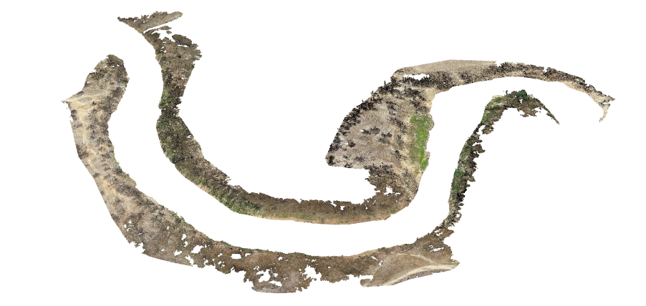

**Figure 6 Densified point cloud of a subsection of the Goulburn river (McCoy’s Bridge). Surveyed using RTK drone in December 2018.**

b. **Orthomosaic** (generated from nadir imagery only) (Fig 7). An orthomosaic is a 2D map, stitched together by correcting camera perspective from nadir imagery to display a map of uniform scale.

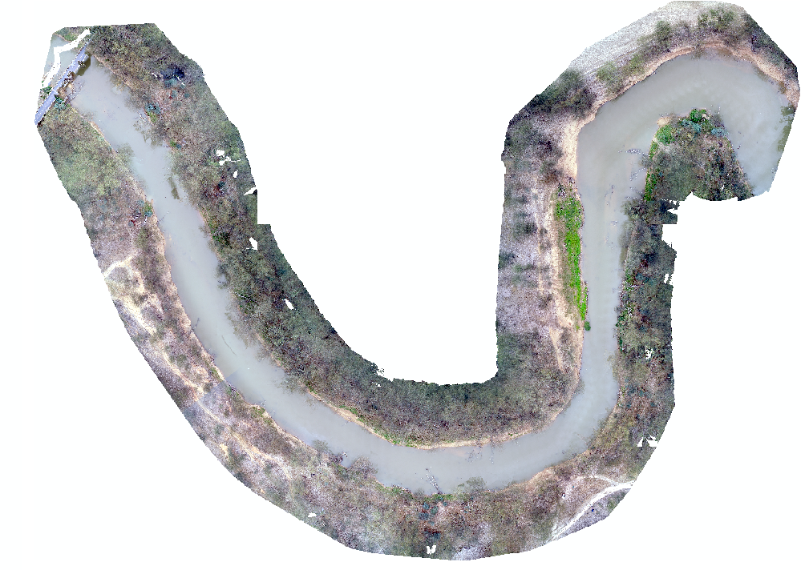

**Figure 7 Orthomosaic of a subsection of the Goulburn river (McCoy's Bridge). Surveyed using RTK drone in December, 2018.**

1. **Preferred spatial mapping software is used to generate a Digital elevation models of difference**   
   Multiple densified point clouds from repeated visits are compared for their minimum ‘z’ value for each coordinate. The minimum elevation point is selected for each coordinate because there may be many points occupying the same location, but at different heights (i.e. vegetation canopies overhanging banks). The minimum point provides a more realistic picture of the surface elevation. A decrease in minimum elevation value indicates erosion, and an increasing value indicates deposition. This should then be spatially represented, e.g. colour coded in a digital elevation model of difference where blue = deposition, red = erosion.
2. **Preferred image classification software is used to generate a Classified map of changing vegetation abundance**Orthomosaics are imported into preferred image classification software, with a supervised image classification performed to distinguish between vegetation classes, bare ground, woody debris etc.   
   The classified images are then compared over the consecutive site visits, and are classified into a final map which illustrates the percentage of change of different vegetation classes as a result of the CEWH environmental flows.
3. Quality assurance/ quality control

Quality control and quality assurance protocols are documented in the Quality Plan developed as part of the MER for all Selected Areas. To ensure quality assurance and quality control, repeated flights of the UAV should be undertaken under the following conditions:

* Consistent time of day for UAV flying (shadows can impact the generation of point clouds and orthomosaics)
* Consistent flight path and altitude for aerial grid flights (nadir)
* Consistent camera and calibration methods
* Consistent placement of Ground Control Points

1. Data analysis and Reporting

Qualitative assessments of bank erosion processes will also be assessed at each site by the suitably experienced UAV pilot, and will consider bank erosion activity visibly for both banks. This will be incorporated into inferring changes from UAV data.



angus.webb@unimelb.edu.au