South-east marine region profile

A description of the ecosystems, conservation values and uses of the South-east Marine Region

June 2015

© Commonwealth of Australia 2015
This work is copyright. You may download, display, print and reproduce this material in unaltered form only (retaining this notice) for your personal, non-commercial use or use within your organisation. Apart from any use as permitted under the Copyright Act 1968, all other rights are reserved. Requests and enquiries concerning reproduction and rights should be addressed to Department of the Environment, Public Affairs, GPO Box 787 Canberra ACT 2601 or email public.affairs@environment.gov.au.

Contents
Figures 5
Tables 5
Executive Summary 7
The marine environment of the South-east Marine Region 7
Provincial bioregions of the South-east Marine Region 7
Conservation values of the South-east Marine Region 8
Human activities and the marine environment 9
1. Introduction 10
1.1 Introduction to Australia’s Marine Regions 10
1.2 The South-east Marine Region 1
2. The marine environment of the South-east Marine Region 3
2.1 Geomorphology 3
2.2 Oceanography 4
2.3 Primary production 7
2.4 Biodiversity and endemism 8
2.5 Provincial bioregions of the South-east Marine Region 8
2.6 Supporting information 11
3. Conservation values of the South-east Marine Region 13
3.1 Key ecological features of the marine environment 13
3.2 Protected species 16
3.2.1 Biologically important areas 17
3.2.3 Sharks of the South-east Marine Region 18
3.2.4 Seahorses/seadragons/pipefish of the South-east Marine Region 21
3.2.5 Cetaceans of the South-east Marine Region 21
3.2.6 Pinnipeds of the South-east Marine Region 24
3.2.7 Seabirds of the South-east Marine Region 26
3.2.8 Marine turtles of the South-east Marine Region 32
3.3 Protected places 32
3.3.1 Marine reserves 33
3.3.2 World and national heritage places 34
3.3.3 Historic shipwrecks 35
3.4 Supporting information 36
4. Human activities in the South-east Marine Region 47
4.1 The human dimension: an overview 48
4.1.1 Indigenous history in the South-east Marine Region 49
4.1.2 European Settlement 50
4.2 Marine activities 50
4.2.1 Commercial fishing 51
4.2.2 Recreational fishing 57
4.2.3 Aquaculture 58
4.2.4 Marine-based tourism and recreation 59
4.2.5 Ports and shipping 59
4.2.6 Defence activities 60
4.2.7 Offshore oil and gas exploration and production 61
4.2.8 Offshore mineral exploration 63
4.2.9 Sea Dumping 64
4.2.10 Submarine cables and pipelines 64
4.2.11 Emerging industries and research 64
4.2.12 Indigenous activities 65
4.3 Supporting information 65
Abbreviations and acronyms 68
Glossary 70
Map data sources 78
Appendix A Nationally protected species in the South-east Marine Region 79

Figures

Figure 1 Australia's Marine Regions 1
Figure 2 South-east Marine Region 2
Figure 3 Australia's maritime zones 3
Figure 4 Seafloor features of the South-east Marine Region 4
Figure 5 Depth bathomes of the South-east Marine Region 5
Figure 6 Major ocean currents in south-eastern Australian waters summer 6
Figure 7 Major ocean currents in south-eastern Australian waters winter 7
Figure 8 Provincial bioregions of the South-east Marine Region 9
Figure 9 Key ecological features of the South-east Marine Region 14
Figure 10 Protected places (shipwrecks and World Heritage Areas) in the South-east Marine Region 33
Figure 11 Commonwealth marine reserves in the South-east Marine Region 34
Figure 12 Population growth in areas adjacent to the South-east Marine Region 2001-2009 48
Figure 13 Distribution of Aboriginal coastal language groups in the South-east 49
Figure 14 Distribution of recreational fishing catch (2001) 58
Figure 15 Shipping routes, major ports and indicative ship locations in the South-east Marine Region (2010) 60
Figure 16 Defence training areas within and adjacent to the Region 61
Figure 17 Oil and gas activity in the South-east Marine Region. 62
Figure 18 Oil and gas activity in Bass Strait. 62

Tables

Table 1 Overview of Provincial Bioregions in the South-east Marine Region 9
Table 2 Overview of key ecological features of the South-east Marine Region 14
Table 3 Major population centres adjacent to the South-east Marine Region (ABS 2011) 49
Table 4 Total of measurable Industry Value of Production from marine-related activities in 2009–10 (AIMS 2012) 51
Table 5 Commonwealth fisheries active primarily in the South-east Marine Region in 2013-14 - (adapted from Georgeson et al. 2014) 52
Table 6 Victorian fisheries active in the South-east Marine Region (drawn from Victorian Fishery Status Reports 2013 and ABARE-BRS 2010) 55
Table 7 Tasmanian fisheries active in the South-east Marine Region (drawn from Department of Primary Industries, Parks, Water and Environment – Commercial Fishing 2013 and ABARE-BRS 2010) 56

Executive Summary
This document sets out a profile of the ecological and biophysical features and socio-economic characteristics of the South-east Marine Region. This Region incorporates Commonwealth waters extending from the far south of New South Wales, around Tasmania and as far west as Kangaroo Island in South Australia. It includes the Commonwealth waters of Bass Strait and those surrounding Macquarie Island in the Southern Ocean (Figure 2).
This profile describes the major ecosystems and processes of the Region as well as some of the species for which the Region is important. It also identifies and describes the key ecological features of the Region and those places which are already protected under legislation.

The marine environment of the South-east Marine Region
The South-east Marine Region spans approximately 1 632 402 km², from the warm temperate waters in the north of the Region, through the cool temperate waters around Tasmania, to the subantarctic Southern Ocean waters around Macquarie Island.
While the South-east Marine Region is relatively low in nutrients and primary productivity, localised areas of relatively high productivity, combined with significant variation in water depth and seafloor features, contribute to its recognition as a major marine biogeographic region.
Areas of localised high productivity include the Bonney Upwelling in south eastern South Australia, the Bass Strait Water Cascade on the shelf break east of Bass Strait and the flow of the East Australian Current along the eastern edge of the Region. The waters around Macquarie Island to the south of Tasmania are in the path of the Antarctic Circumpolar Current, which is the largest single current in the world and is considered a major driver of global climate. The South-east Marine Region is also characterised by significant variation in water depth (varying from the vast shallow expanse of Bass Strait, averaging 60 m deep, to the Hjort Trench, near Macquarie Island, where the sea floor lies 6700 m below the surface). The shallowness of the waters of Bass Strait means that these waters more rapidly warm in summer and cool in winter than other waters of the Region while the shelf break, which includes the edges of the continental shelf and the upper slope, serves to intensify currents, eddies and upwellings, creating a rich and productive area for biodiversity, including species that are fished commercially and recreationally.
Sections of the continental shelf, including Bass Strait, have a mosaic of rocky reefs and soft sediments. The shelf habitats support a diverse range of species from a broad range of taxonomic groups. Sea-floor canyons along the continental margin have been identified as important ecological features in the Region. Canyons can intensify local currents and the concentration of nutrients to enhance productivity and biodiversity. South and east of Tasmania, groupings of seamounts rise from the abyssal plain to a height of 2000–4000 m. Seamounts may act as obstacles to deep ocean currents by restricting and intensifying their flow, which helps to inhibit the build up of sediment. This creates ideal and unique environments for corals and other filter-feeding, bottom-dwelling species, and provides habitat for many different fish species.
In addition, the geological and climatic history of the South-east Marine Region has promoted the development of a variety of flora and fauna species that have evolved, adapted and spread in isolation. The relative stability of the climate has created favourable conditions for marine life over long geological timescales. The repeated submergence and emergence of Bass Strait has strongly shaped the present-day composition and distribution of species. Over millennia, the warm and cool currents of the Region have prevented the migration of species and created an environment where new species have been able to evolve.

Provincial bioregions of the South-east Marine Region

The South-east Marine Region contains 11 provincial bioregions (Figure 8), stretching across a broad range of temperate and subantarctic environments. Provincial bioregions can be either provinces or transitions. Provinces are areas of ocean with similar fauna, flora and ocean conditions. Transition bioregions are regions of overlap between provinces.

Conservation values of the South-east Marine Region
This document identifies a range of conservation values in the South-east Marine Region. Conservation values are defined as those elements of the region that are:
key ecological features of the Commonwealth marine environment
species listed under Part 13 of the Environment Protection and Biodiversity Conservation Act 1999 (EPBC Act) that live in the Commonwealth marine area or for which the Commonwealth marine area is necessary for a part of their life cycle
protected places including marine reserves, heritage places and historic shipwrecks in the Commonwealth marine area.

Key ecological features
Key ecological features define areas and features of ecological importance in the Commonwealth marine environment. They are elements of the region that, based on current scientific understanding, are considered to be of regional importance for either biodiversity or ecosystem function and integrity. As new data and knowledge about the ecology of the region becomes available, the role of these and other features in the biodiversity and ecosystem functioning of the region will become clearer.
Eight key ecological features have been identified for the South-east Marine Region. These are:
Bonney coast upwelling
East Tasmania subtropical convergence zone
Bass cascade
Upwelling east of Eden
Big horseshoe canyon
West Tasmania canyons
Seamounts south and east of Tasmania
Shelf rocky reefs and hard substrates.

Protected species
Protected species are those listed under the EPBC Act as threatened species (critically endangered, endangered, vulnerable and conservation dependent), migratory species, cetaceans and marine species. An individual species may be listed under more than one category.
There are 46 species protected under the EPBC Act that are known or likely to occur in the South-east Marine Region. There are 94 protected species that may occur in the Region. Of the 46 species known or likely to occur in the South-east Marine Region, 21 species are listed as threatened, 23 as migratory, five as cetaceans and 28 listed as marine. A full list of protected species that are known, likely or may occur in the South-east Marine Region is provided at Appendix A.

Protected places
Protected places are those places protected under the EPBC Act as matters of national environmental significance—places listed as World Heritage, National Heritage, or wetlands of international importance. Protected places may also include Commonwealth marine reserves and those deemed to have heritage value in the Commonwealth marine environment such as places on the Commonwealth heritage list or shipwrecks listed under the Historic Shipwrecks Act 1976.
There are many historic shipwrecks within Commonwealth waters in the South-east Marine Region (Figure 10). There are 14 Commonwealth marine reserves (Figure 11) within the Region. The World Heritage Listed Macquarie Island is also within the Region, supporting vast congregations of wildlife and providing the only example on earth of exposed rocks from the Earth’s mantle.

Human activities and the marine environment
More than four million people live along the coastline adjacent to the South-east Marine Region, including one of the largest cities in Australia as well as many small coastal towns and settlements from Eden in New South Wales to Kingston in the South-east of South Australia. Many people depend economically on the sea, directly or indirectly. Indigenous occupation of coastal areas adjacent to the Region dates back to at least 40 000 years. The Region supports over 20 commercial fisheries, recreational fishing, aquaculture, offshore oil and gas production, shipping transport and port activities.

1. Introduction

1.1 Introduction to Australia’s Marine Regions
Australia has one of the largest marine jurisdictions of any nation in the world. Australian waters cover 14.7 million square kilometres, including waters around the external territories of Cocos (Keeling), Christmas, Heard and McDonald Islands as well as waters adjacent to Australia’s Antarctic Territory. Within that area, Commonwealth waters surrounding the Australian continent and Tasmania cover 7.4 million square kilometres. The biodiversity of Australia’s vast marine jurisdiction has been recognised as globally significant. Australia’s oceans support a diverse array of marine species including marine mammals and reptiles, more than 4000 species of fish and tens of thousands of species of invertebrates, plants and micro-organisms. Many of Australia’s marine species are endemic, and therefore occur nowhere else in the world. Others utilise Australian waters as part of their global migrations.
As well as being home to an amazing diversity of marine environments, Australia’s oceans support a range of marine industries, providing a significant contribution to the national economy. These industries include commercial fishing and aquaculture, petroleum and mineral exploration and production, shipping, ports, recreational and charter fishing, and tourism.
With 80 per cent of Australia’s population living in the coastal zone, the marine environment has important social and cultural values, including recreational opportunities, amenity, cultural heritage, conservation and scientific significance. Many Aboriginal and Torres Strait Islander peoples have a close, long-standing relationship with coastal and marine environments and continue to rely on these environments and resources for their cultural identity, health and wellbeing, as well as their domestic and commercial economies.
Six marine regions have been identified in Commonwealth waters around Australia (Figure 1). Marine bioregional plans have been prepared for four of these regions under section 176 of the EPBC Act. This Profile for the South-east Marine Region presents information on conservation values in the Region to assist decision-making under the EPBC Act. By providing detail on protected species, places and key ecological features, this Profile supports efficient administration of the EPBC Act to promote the conservation and ecologically sustainable use of the marine environment and its resources.

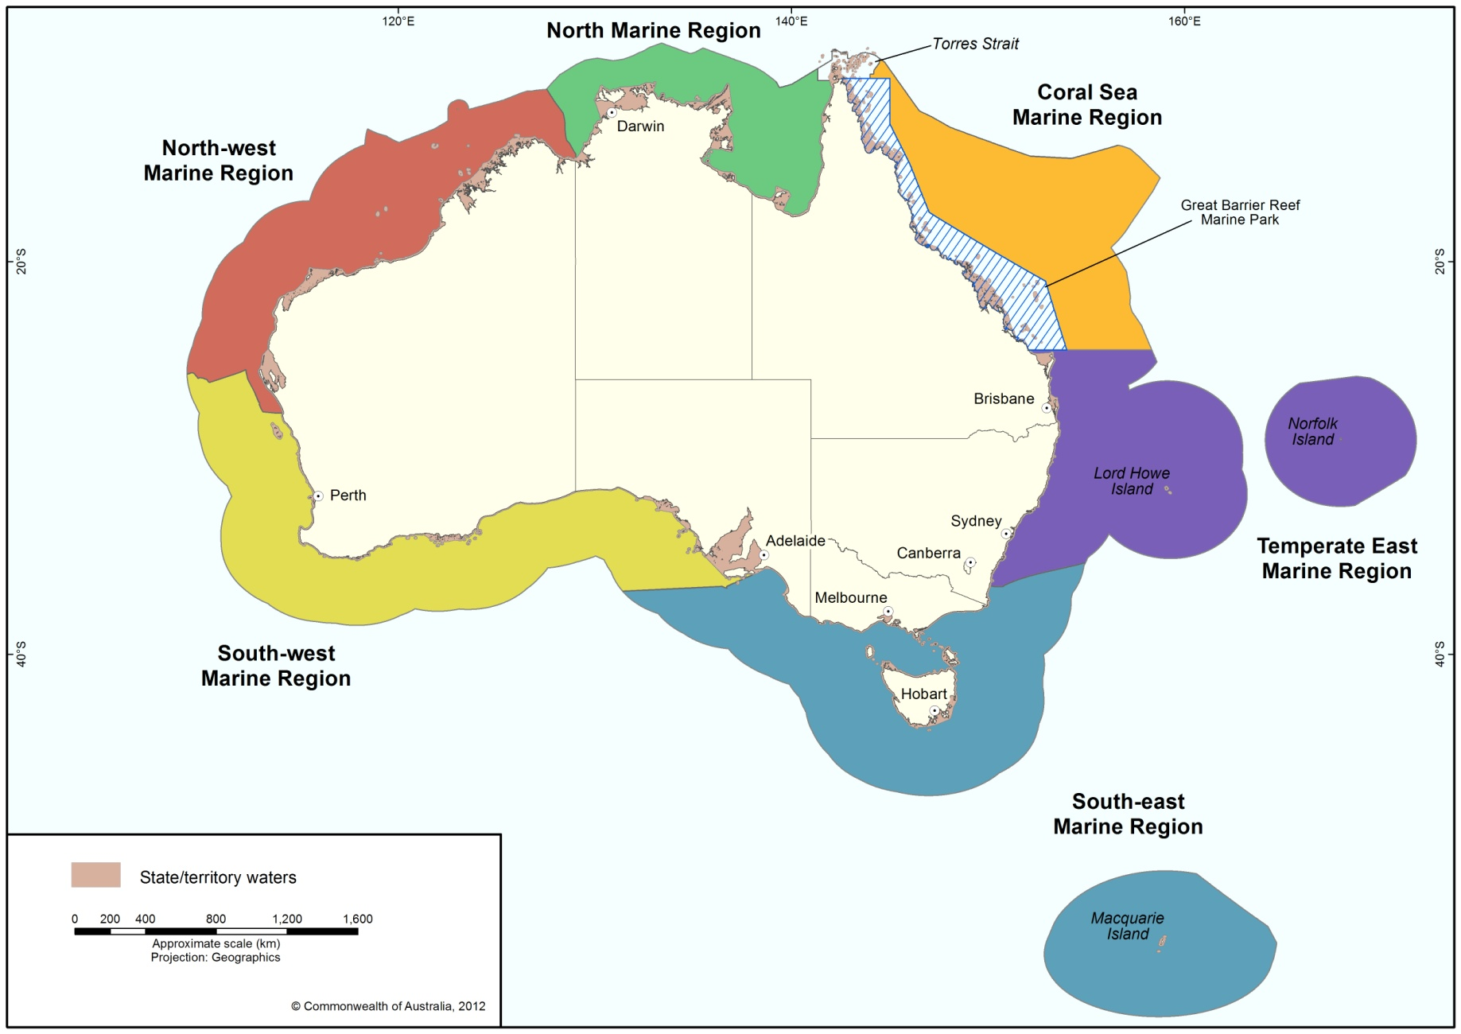
Figure 1 Australia’s marine regions

1.2 The South-east Marine Region

The South-east Marine Region incorporates Commonwealth waters extending from near the far south coast of New South Wales, around Tasmania and as far west as Kangaroo Island in South Australia. It includes the Commonwealth waters of Bass Strait and those surrounding Macquarie Island in the Southern Ocean (Figure 2). The region spans approximately 1 632 402 km², from the warm temperate waters in the north of the region, through the cool temperate waters around Tasmania, to the subantarctic Southern Ocean waters around Macquarie Island. The region is described in more detail in Chapter 2. The Commonwealth marine area starts at the outer edge of state waters, usually 3 nautical miles (5.5 km) from the shore (territorial sea baseline), and extends to the outer boundary of Australia’s exclusive economic zone, some 200 nautical miles from the territorial sea baseline (Figure 3).
In this Profile, the terms the Region and the South-east Marine Region are used to refer to the Commonwealth waters defined above.

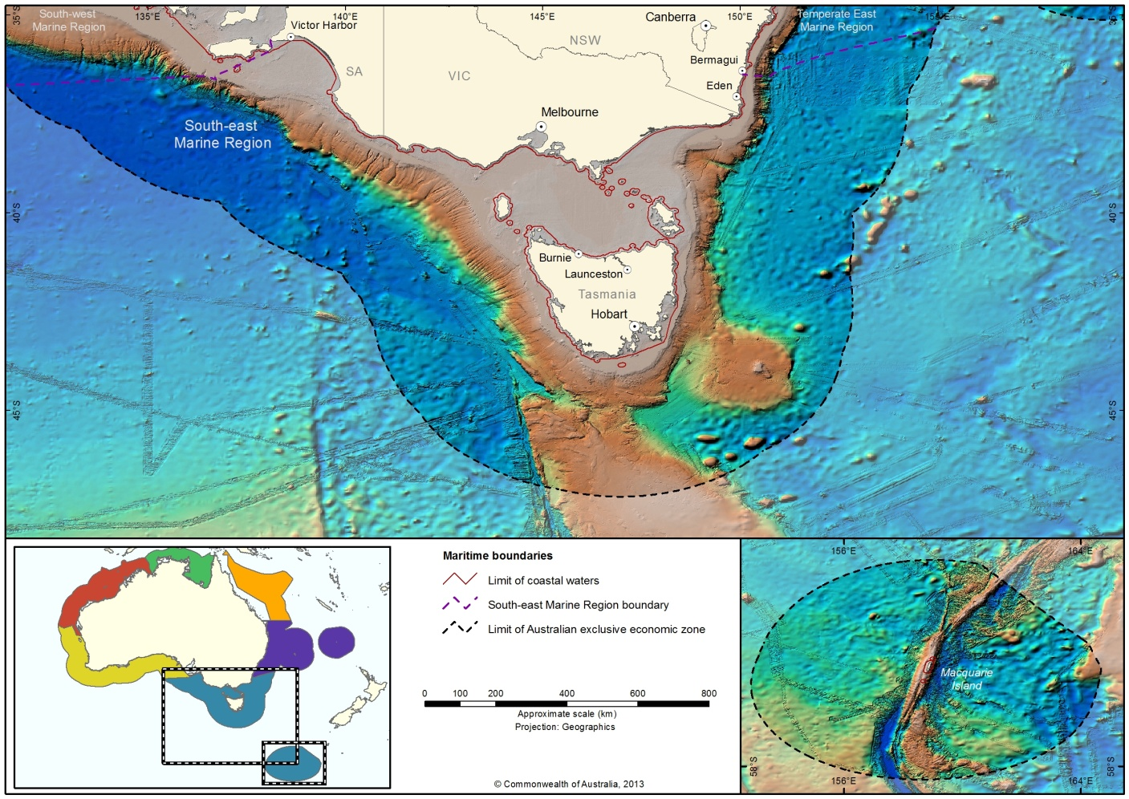
Figure 2 South-east Marine Region
The objectives of the South-east Marine Profile are to describe:
the ecological and biophysical features of the South-east Marine Region including major ecosystems
the marine species, communities and places already specifically protected under legislation
the key ecological features
human activities in the region.
The South-east Profile includes four chapters and one appendix:
Chapter 1 – Introduction and objectives
Chapter 2 – The marine environment of the South-east Marine Region describes the biophysical and ecological characteristics of the region, with particular focus on ecosystem structure and functioning within provincial bioregions.
Chapter 3 – Conservation values of the South-east Marine Region summarises and describes the biodiversity and heritage values of the region.
Chapter 4 – Human activities of the South-east Marine Region outlines the human activities that take place in the region. It also provides a short overview of the population and elements of the Victorian and Tasmanian economies adjacent to the region.
Appendix A – Nationally protected species in the South-east Marine Region lists all the species known to occur and those that may occur in the region that are protected under the EPBC Act.

2. The marine environment of the South-east Marine Region
The South-east Marine Region incorporates Commonwealth waters extending from the far south coast of New South Wales, around Tasmania and as far west as Kangaroo Island in South Australia. It includes the Commonwealth waters of Bass Strait and those surrounding Macquarie Island in the Southern Ocean. Commonwealth waters extends beyond the outer edge of state/territory waters, generally some 3 nautical miles (or 5.5 km) from the coast, to the boundary of Australia’s exclusive economic zone, generally around 200 nautical miles (or 370 km) from shore (Figure 3). The Region is adjacent to, but does not include, state waters of New South Wales, Victoria, Tasmania and South Australia.
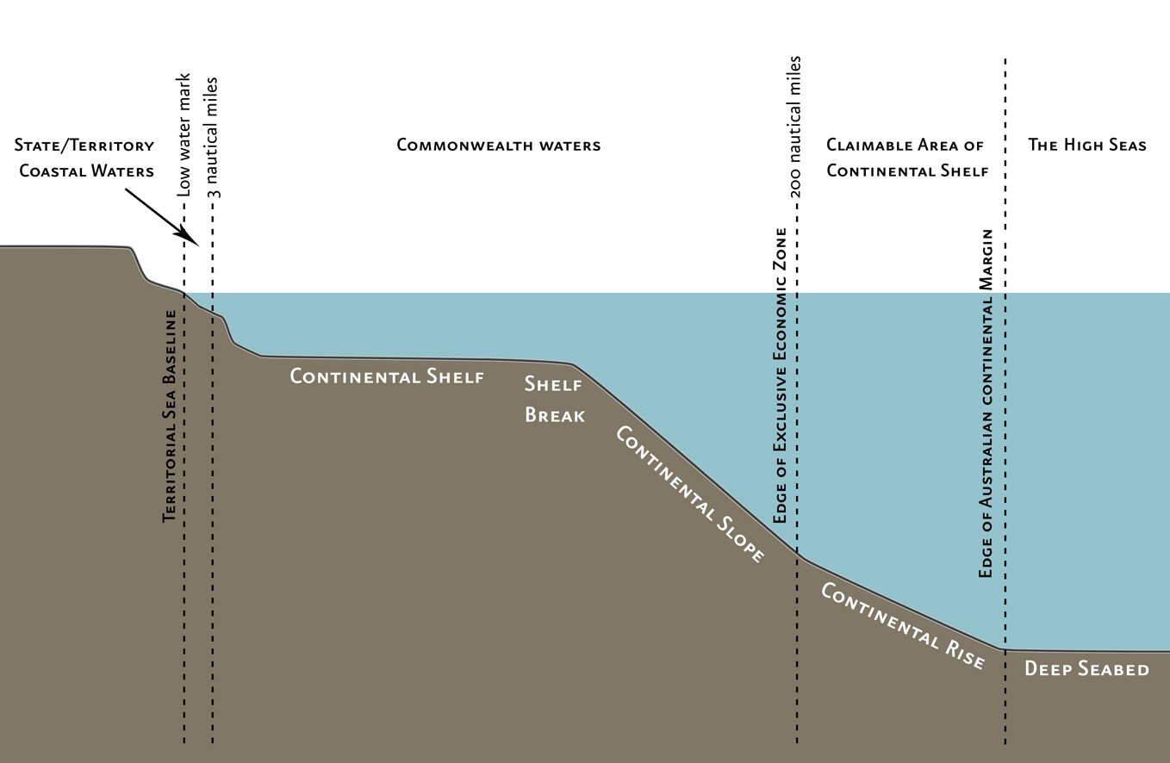

Figure 3 Australia's maritime zones

2.1 Geomorphology
Significant variation in sea-floor features (Figure 4) and water depth (Figure 5) found throughout the South-east Marine Region contribute to the high level of species diversity in the Region. Sections of the continental shelf, including Bass Strait, are characterised by a mosaic of rocky reefs and soft sediments. The shelf habitats support a diverse range of species from a broad range of taxonomic groups. The shelf break (which includes the edges of the continental shelf and the upper slope) serves to intensify currents, eddies and upwellings, creating a rich and productive area for biodiversity, including species that are fished commercially and recreationally. The continental shelf is narrow (10–25 km wide) in most parts of the South-east Marine Region (with the exception of Bass Strait).
Sea-floor canyons along the continental margin have been identified as important ecological features in the Region. Canyons can have steep or rugged topography that provide habitat for sessile invertebrates, such as corals, which in turn attract other organisms and higher order species. Depending on their size and shape, canyons can intensify local currents and the concentration of nutrients to enhance productivity and biodiversity.
South and east of Tasmania, groupings of seamounts rise from the abyssal plain to a height of
2000–4000 m. One group rises up from the South Tasman Rise where the sea floor is approximately 1500 m below the surface; the tops of these mountains rise to depths of approximately 750 m below the surface. These seamounts may act as obstacles to deep ocean currents by restricting and intensifying their flow, and may help to inhibit the build up of sediment. This creates ideal and unique environments for corals and other filter-feeding, bottom-dwelling species to live, and provides habitat for many different fish species.

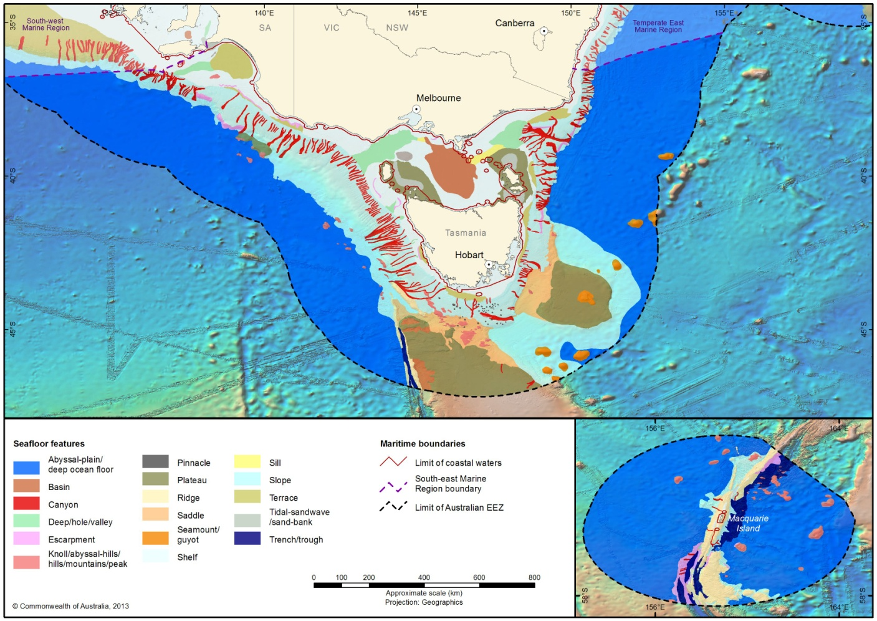
Figure 4 Seafloor features of the South-east Marine Region

2.2 Oceanography
Currents and oceanic properties, such as temperature and nutrients, play a vital role in the ecosystems of the Region. Ocean currents link marine systems, while fronts and upwellings drive the productivity of open ocean environments. Compared to other marine areas, Australia’s South-east Marine Region is relatively low in nutrients and primary productivity; however, in some locations, water bodies converge and mix to create areas of relatively high biological productivity.
The South-east Marine Region is oceanographically complex, with subtropical influences from the north and subpolar influences from the south (Hosack & Dambacher 2012). The Leeuwin Current transports warm, subtropical water southward along the Western Australian coast and then eastward into the Great Australian Bight where it mixes with the cool waters from the Zeehan Current running along the west coast of Tasmania. These currents are stronger in winter than in summer (Figures 6 and 7).
The eastern parts of the Region are strongly influenced by the East Australian Current (EAC) that flows southward adjacent to the east coast of New South Wales, Victoria and Tasmania, carrying warm equatorial waters. The EAC is up to 500 m deep and 100 km wide, and is strongest in summer when it can flow at up to 5 knots. In winter it flows at 2–3 knots as the oceanographic and climatic drivers in the Coral Sea diminish.
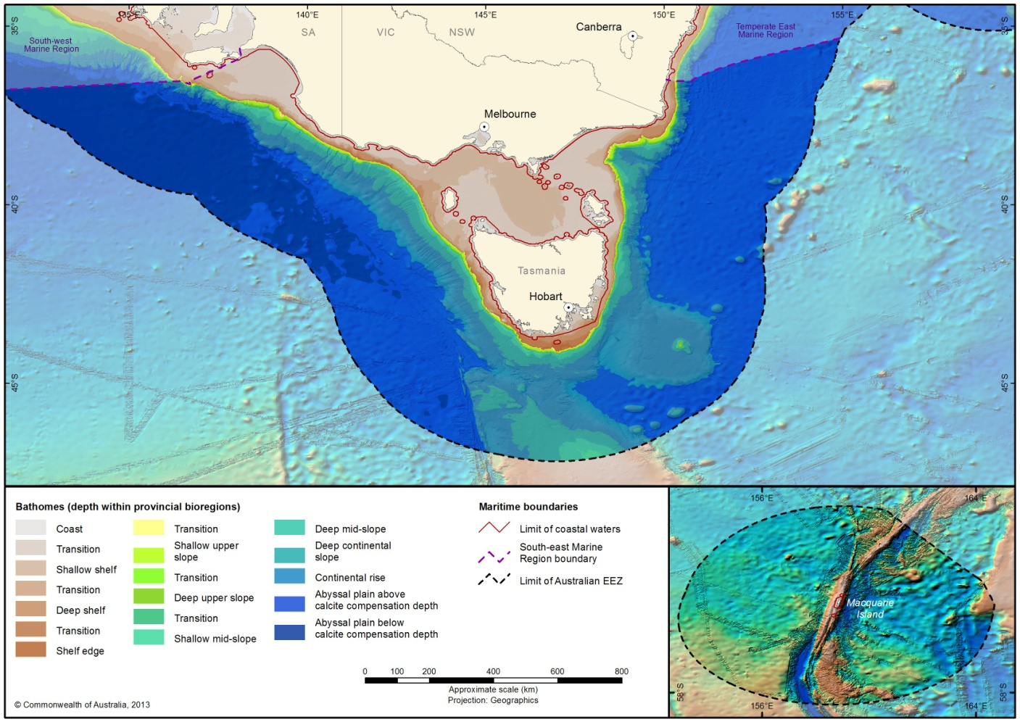

Figure 5 Depth bathomes of the South-east Marine Region
The EAC tends to form ocean eddies that rotate around warm, central cores that can be up to 200 km across, and may persist for months. The eddies can cross the continental shelf, and when mixing with shelf break waters, create upwellings that form isolated areas of enhanced productivity 200–300 km in diameter. Eddies form more frequently off the south coast of New South Wales than other areas, but are also common along the east coast of Tasmania. The EAC affects sea surface temperatures on the eastern Tasmanian shelf, which can vary substantially among years depending on the relative influence of subtropical waters.
The waters around Macquarie Island to the south of Tasmania are in the path of the Antarctic Circumpolar Current (ACC), which is the largest single current in the world and is considered a major driver of global climate. It connects the Atlantic, Pacific and Indian oceans in an eastward flow. The ACC contains a series of jets that continuously combine and separate, acting as a buffer between different masses of water. The boundaries between water masses are called fronts and are often important places for feeding aggregations of species.
In summer the ACC is south of Tasmania, which allows the EAC to extend its flow around southern Tasmania. In winter the ACC passes closer to Tasmania and its comparative strength prohibits a weakened EAC from flowing further southward. The interaction of these currents, fronts and sea-floor features influence species composition, distribution and dispersal, controlling the movement of sediments and nutrients and the seasonal variations in salinity and temperature.
Seasonal and transient upwellings are important ecological features of the Region. The Bonney Upwelling in south eastern South Australia is active during autumn and summer. At the shelf break east of Bass Strait, nutrient-rich waters rise to the surface in winter as part of the processes of the Bass Strait Water Cascade, where the eastward flushing of the shallow waters of the strait over the continental shelf mix with cooler, deeper nutrient-rich water.
Bass Strait is characterised by shallow water and tidal currents. While there is a slow easterly flow of waters in Bass Strait, there is also a large anticlockwise circulation. The shallowness of the water means that these waters more rapidly warm in summer and cool in winter than other waters of the Region.
Changes to ocean currents are anticipated in response to climate change. The strength of the Leeuwin Current has decreased slightly since the 1970s. This weakening is expected to continue, although this prediction currently has low confidence (Feng et al. 2009). Concurrently, studies indicate that the EAC has been strengthening, pushing warmer, saltier water up to 350 kilometres further southward along the east coast (Ridgway & Hill 2009). This could potentially lead to changes in upwelling current direction, changes to upwelling events, increased thermal stratification, increased eddy activity and a shift in the thermocline depth (Chin et al. 2010).

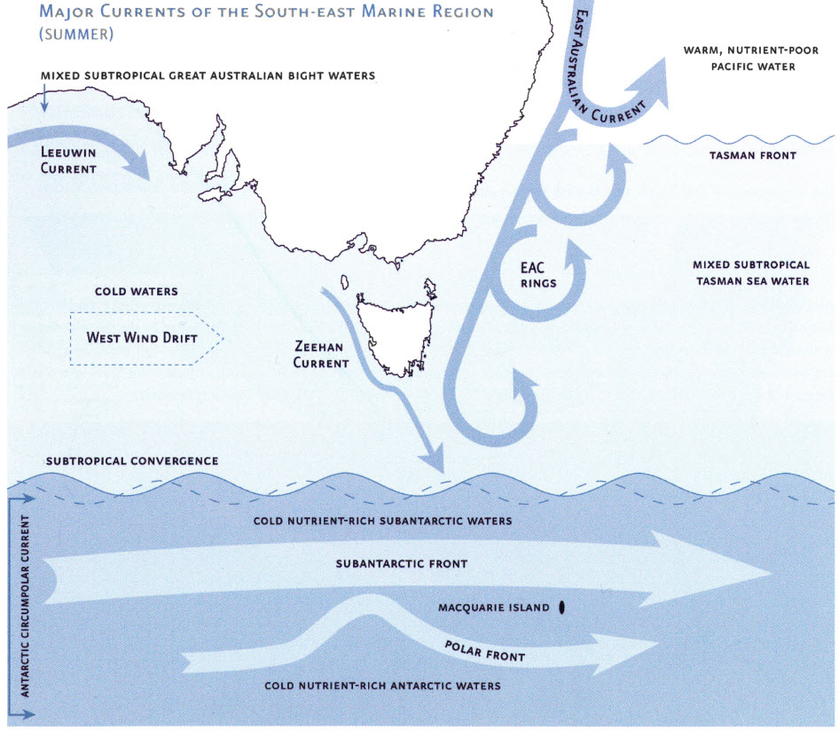
Figure 6 Major ocean currents in south-eastern Australian waters summer
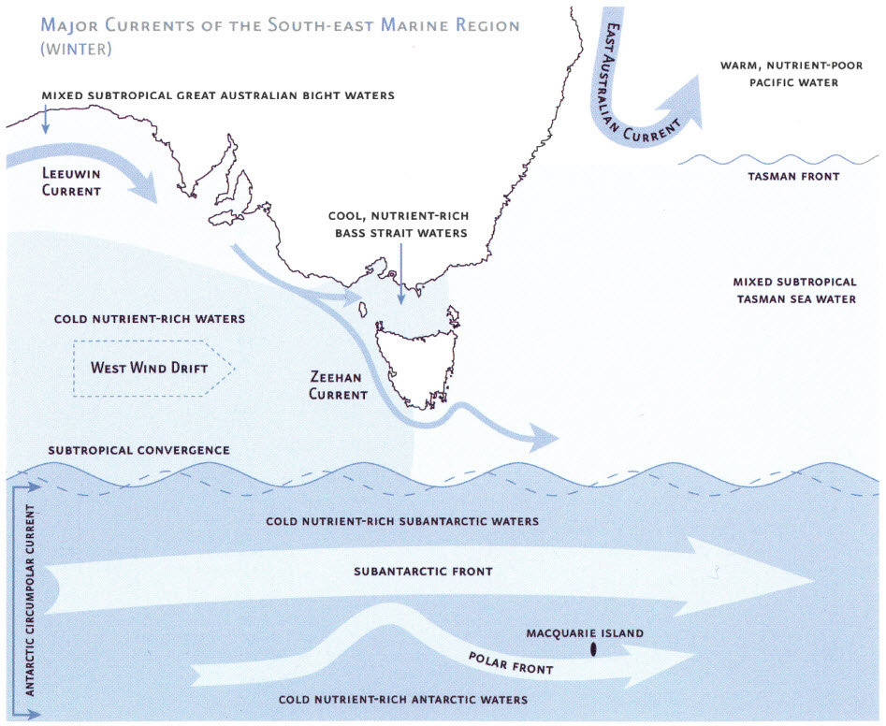
Figure 7 Major ocean currents in south-eastern Australian waters winter

2.3 Primary production
The oceanography of the South-east Marine Region contributes to enhanced areas of primary productivity, including:
- spring and autumn phytoplankton blooms in the Subtropical Convergence Zone (south of Tasmania). This Zone is an area of high productivity, sustained by nutrient rich subantarctic waters in the summer months (Jitts 1965)
- primary productivity associated with the Bass Cascade and upwelling of cool nutrient-rich waters along the mainland coast north-east of Bass Strait
- localised seasonal upwellings along the Bonney Coast.
Each of these regions of productivity are associated with aggregations of pelagic marine life (Hosack & Dambacher 2012).
More detailed descriptions of primary productivity within the South-east Marine Region are provided in Hosack and Dambacher (2012) and Condie and Dunn (2006).

2.4 Biodiversity and endemism
The South-east Marine Region is recognised as a major marine biogeographic region. When compared to most of the world’s marine environments, the marine environments of temperate Australia display an enormous diversity of plant and animal species and are believed to have the most diverse marine floral assemblage in the world (Director of National Parks 2013).
Plant and animal communities display a high level of species diversity. In addition to high diversity, the Region has large numbers of endemic species, that is, species found nowhere else in the world. The fish fauna of southern temperate Australia includes around 600 species, of which 85 per cent are thought to be endemic and 11 per cent are common only to waters of neighbouring New Zealand. Up to 95 per cent of molluscs, approximately 90 per cent of echinoderms and up to 62 per cent of macroalgae (seaweed) species are only found in these waters. Such high diversity and endemism in the South-east Marine Region is a result of the complex interaction of evolutionary, geological and biological processes, as well as the interactions among organisms (Director of National Parks 2013).
The geological and climatic history of the South-east Marine Region has promoted the development of a variety of flora and fauna species that have evolved, adapted and spread in isolation. The relative stability of the climate, due to the steady northward movement of the Australian tectonic plate, has created favourable conditions for marine life over long geological timescales. The repeated submergence and emergence of Bass Strait has strongly influenced the present-day composition and distribution of species. Over millennia, the warm and cool currents of the Region have prevented the migration of species and created an environment where new species have been able to evolve. In addition, the variety in water depth and seafloor features has contributed to the high level of diversity in the Region (Director of National Parks 2013).

2.5 Provincial bioregions of the South-east Marine Region
The Integrated Marine and Coastal Regionalisation of Australia (IMCRA v4.0) is a spatial framework for classifying Australia’s marine environment into bioregions that make sense ecologically and are at a scale useful for regional planning (CoA 2005). It was developed through the collaborative efforts of state, territory and Commonwealth marine management and research agencies. The purpose of regionalisation is to assist in simplifying the complex relationship between environment and species distributions, and to capture spatial patterns in the distribution of species and habitats at differing scales. IMCRA v4.0 has a structure that incorporates information about patterns and processes which occur at different spatial scales. IMCRA v4.0 consists of two separate regionalisations: a benthic bioregionalisation based on biogeography of fish supplemented with a geophysical classification; and a pelagic regionalisation based on oceanographic characteristics of water bodies (CoA 2005).
The South-east Marine Region contains 11 provincial bioregions under IMCRA v4.0 (Figure 8), and includes a broad range of temperate and subantarctic environments (Table 1). Provincial bioregions can be either provinces or transitions. Provinces are areas of ocean with similar fauna, flora and ocean conditions. Transition bioregions are regions of overlap between provinces.

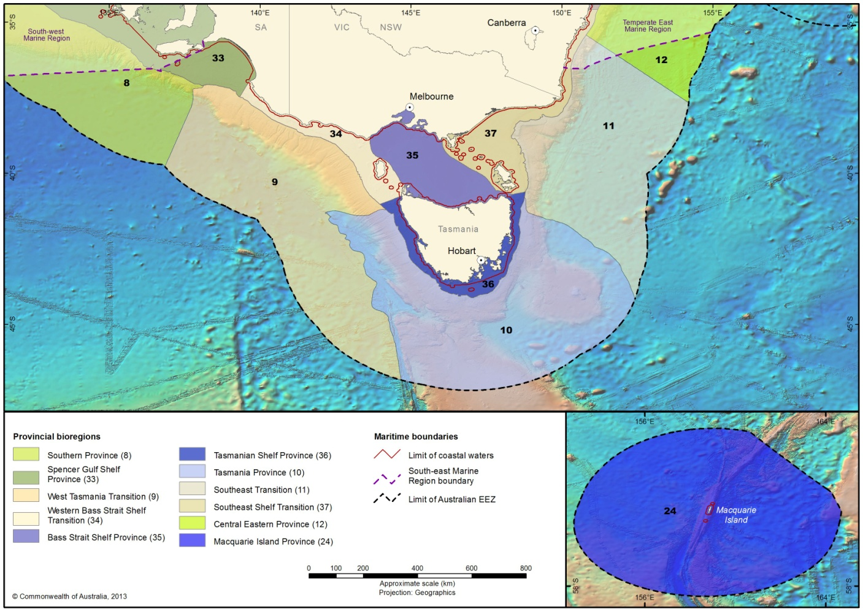
Figure 8 Provincial bioregions of the South-east Marine Region

Table 1 Overview of Provincial Bioregions in the South-east Marine Region

Name | Brief description | Area | Max depth | proportion in  the South-east Marine Region (per cent)
Central Eastern Province | This strongly defined provincial bioregion is located on the eastern margin of Australia. Only the southern-most tip of this bioregion falls within the South-east Marine Region. This bioregion has 639 demersal fish species, with 56 endemic species. The fauna of this bioregion consists mainly of eastern warm temperate/subtropical species. It is penetrated by tropical eastern Australian elements, many of which occur extralimitally as juveniles at the southern margin of the Province. The Central Eastern Province also acts as the north-eastern limit of large suite of widespread southern temperate species (IMCRA Tech Group 1998). | 268 850 km² | 5590 m | 12.29
Southeast Transition | This transitional bioregion is located on the southeast margin of Australia. | 241 940 km² | 5534 m | 96.36
Southeast Shelf Transition | This transitional bioregion is located on the southeast margin of Australia. | 175 540 km² | 359 m | 73.43
Macquarie Island | This bioregion surrounds Macquarie Island in the Southern Ocean, southeast of Australia. Macquarie represent an extremely isolated fragment of mid-oceanic ridge (Macquarie Rise) uplifted above sea level in the Miocene. The bioregion has a distinctive subantarctic flora and fauna with a high proportion of endemic algal and invertebrate species. The deep-water fauna is closely allied biogeographically to the fauna of the New Zealand subantarctic islands and has probably migrated to the island along the Macquarie Ridge. | 477 430 km² | 6737 m | 99.83
Tasmania Province | This strongly defined bioregion is located south of Tasmania on the southeast margin of Australia. It has 486 demersal fish species, with 52 endemic species. This bioregion is characterised by a large number of seamounts that contain endemic fishes.  The Cascade Seamount is included because its fauna is more closely associated with fauna found on other seamounts in the Southern Ocean. Because of its shallow depth, the South Tasman Rise contains species of fish otherwise found on the upper slope of the Tasmanian margin. Studies have shown that the benthic fauna at the foot of the slope and the abyssal plain in this bioregion are similar and distinct from benthic fauna on the top of the Cascade Plateau (DEH 2005). | 300 190 km² | 5584 m | 100
Tasmanian Shelf Province | This bioregion is located on the shelf regions of eastern, southern and western Tasmania. | 59 300 km² | 834 m | 63.89
Bass Strait Shelf Province | This bioregion is located on the shelf region of northern Tasmania and the Bass Strait. | 96 670 km² | 90 m | 87.8
West Tasmania Transition | This transitional bioregion is located west of Tasmania on the southeast margin of the Australian mainland, on deeper offshore waters. | 289 850 km² | 5645 m | 100
Western Bass Strait Shelf Transition | This transitional bioregion is located west of Tasmania on the southeast margin of the Australian mainland, in inshore shelf regions. | 37 130 km² | 272 m | 85.41
Southern Province | This strongly defined bioregion is located on the southern margin of Australia. It contains the Diamantina Fracture Zone, a region of very rugged seabed comprising numerous deep-sea ridges and troughs. This is a unique region of deep-sea habitats (CoA 2005), with 463 demersal fish species and 26 endemic species. The central distribution of demersal fishes is located in the Great Australian Bight (Last et al. 2005). | 774 120 km² | not calculated | 15.51
Spencer Gulf Province | This bioregion is located on inshore regions of Spencer Gulf on the southern margin of Australia. | 132 860 km² | 603 m | 22.02

2.6 Supporting information
Butler A, Althaus F, Furlani D and Ridgway K (2002) Assessment of the conservation values of the bonney upwelling area: A component of the commonwealth Marine Conservation Assessment Program 2002-2004. Technical report, Environment Australia, CSIRO Marine Research.
Chin, A, Kyne, PM, Walker, TI & McAuley, RB (2010) ‘An integrated risk assessment for climate change: analysing the vulnerability of sharks and rays on Australia’s Great Barrier Reef’, Global Change Biology, vol. 16, pp. 1936–1953.
Condie SA and Dunn JR (2006) Seasonal characteristics of the surface mixed layer in the Australasian region: implications for primary production regimes and biogeography. Marine and Freshwater Research, 57:569-590
Commonwealth of Australia (CoA) (2005). A Guide to the Integrated Marine and Coastal Regionalisation of Australia Version 4.0. Department of the Environment and Heritage, Canberra
Department of the Environment and Heritage (DEH 2005) National Marine Bioregionalisation of Australia Benthic Fact Sheets (various) [available online] http://www.environment.gov.au/coasts/mbp/publications/general/benthic-factsheets.html Accessed 6.5.2014
Director of National Parks (2013) South-east Commonwealth Marine Reserves Network management plan 2013-23, Director of National Parks, Canberra (in press)
Feng, M, Weller, E and Hill, K (2009). ‘The Leeuwin Current’, in A Marine Climate Change Impacts and Adaptation Report Card for Australia 2009 (Eds. ES Poloczanska, AJ Hobday and AJ Richardson), NCCARF Publication 05/09.
Gill PC (2002). A blue whale (Balaenoptera musculus) feeding ground in a southern Australian coastal upwelling zone. Journal of Cetacean Research and Management. 4:179-184.
Hosack GR and Dambacher JM (2012). Ecological Indicators for the Exclusive Economic Zone of Australia’s South East Marine Region. A report prepared for the Australian Government Department of Sustainability, Environment, Water, Population and Communities. CSIRO Wealth from Oceans Flagship, Hobart.
Interim Marine and Coastal Regionalisation for Australia Technical Group (1998). Interim Marine and Coastal Regionalisation for Australia: an ecosystem-based classification for marine and coastal environments. Version 3.3. Environment Australia, Commonwealth Department of the Environment. Canberra.
Jitts HR (1965) The summer characteristics of primary productivity in the Tasman and Coral Seas. Australian Journal of Marine and Freshwater Research, 16:151-162
Last P, Lyne V, Yearsley G, Gledhill D, Gomon M, Rees T and White W (2005). Validation of National Demersal Fish Datasets for the Regionalisation of the Australian Continental Slope and Outer Shelf. CSIRO Report to the National Oceans Office. CSIRO Marine Research, Hobart.
National Oceans Office (2004) South-east Regional Marine Plan, Implementing Australia's Oceans policy in the South-east Marine Region. Available online at: www.environment.gov.au/coasts/mbp/publications/south-east/sermp.html.
Ridgway, KR & Hill, K (2009) ‘The East Australian Current’, in ES Poloczanska, AJ Hobday & AJ Richardson (eds), A marine climate change impacts and adaptation report card for Australia, National Climate Change Adaptation Research Facility, viewed 9 March 2011, <www.oceanclimatechange.org.au>.

3. Conservation values of the South-east Marine Region
A range of conservation values have been identified in the South-east Marine Region.
Conservation values are defined as those elements of the Region that are:
• key ecological features of the Commonwealth marine area
• species listed under Part 13 of the EPBC Act that live in the Commonwealth marine area or for which the Commonwealth marine area is necessary for a part of their life cycle
• protected places including marine reserves, heritage places and historic shipwrecks in the Commonwealth marine area.

3.1 Key ecological features of the marine environment
Key ecological features (KEFs) are elements of the Commonwealth marine environment in the region that, based on current scientific understanding, are considered to be of regional importance for either the region’s biodiversity or ecosystem function and integrity.
The criteria used to identify KEFs in the region are:
a species, group of species or community with a regionally important ecological role, where there is specific knowledge about why the species or species group is important to the ecology of the region, and the spatial and temporal occurrence of the species or species group is known
a species, group of species or community that is nationally or regionally important for biodiversity, where there is specific knowledge about why the species or species group is regionally or nationally important for biodiversity, and the spatial and temporal occurrence of the species or species group is known
an area or habitat that is nationally or regionally important for
  - enhanced or high biological productivity
  - aggregations of marine life
  - biodiversity and endemism
a unique seafloor feature with ecological properties of regional significance.
Eight key ecological features have been identified in the South-east Marine Region (Table 2) and five of these are possible to map (Figure 9). Understanding of KEFs may evolve as new scientific information emerges.

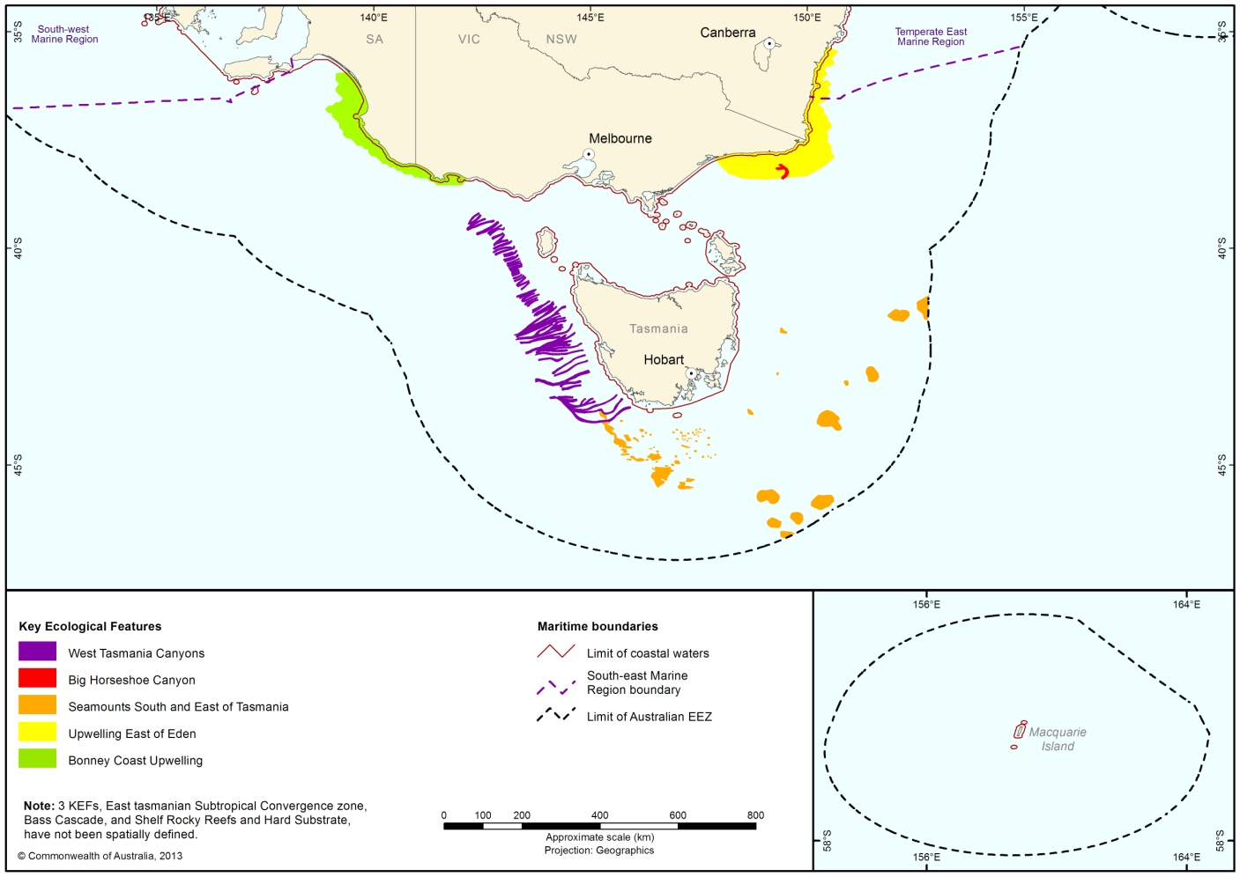

Figure 9 Key ecological features of the South-east Marine Region

Table 2 Overview of key ecological features of the South-east Marine Region

Feature | Description
Bonney Coast upwelling | High productivity, aggregations of marine life  The Bonney Coast Upwelling is a predictable, seasonal upwelling bringing cold nutrient rich water to the sea surface and supporting regionally high productivity and high species diversity in an area where such sites are relatively rare and mostly of smaller scale.  It is one of 12 widely recognised and well-known areas worldwide where blue whales are known to feed in relatively high numbers.  The area is significant as one of the largest and most predictable upwellings in south-eastern Australia. This is not the only upwelling in southeast Australia driven by the prevailing south-easterly winds, but it is the most prominent. In addition to whales, many endangered and listed species frequent the area, possibly also relying on the abundance of krill that provide a food source to many seabirds and fish. The high productivity of the Bonney Upwelling is also capitalised on by other higher predator species such as little penguins and Australian fur seals feeding on baitfish.
East Tasmania subtropical convergence zone | High productivity, aggregations of marine life  This zone of enhanced pelagic productivity occurs where eddies of the East Australian Current interact with subantarctic waters driven by westerly winds. The northern and southern extent of the feature are approximately level with the north-east tip of Tasmania and the Tasman Peninsula.  This is a complex feature that is characterised by autumn and spring phytoplankton blooms that form the basis of a productive food chain which supports cetaceans, seals, sharks and seabirds.  The phytoplankton blooms also attract migratory commercial fish stocks such as Southern bluefin tuna, barracouta, and jack mackerel. Phytoplankton blooms are important for krill, which in turn form an important component of the diet of many pelagic species.
Bass Cascade | High productivity  The Bass Cascade refers to the “underwater waterfall” effect brought about by the northward flow of Bass Strait waters in winter which are more saline and slightly warmer than surrounding Tasman Sea waters. As the water approaches the mainland in the area of the Bass Canyon group it forms an undercurrent that flows down the continental slope. The cascading water has a displacing effect causing nutrient rich waters to rise, which in turn leads to increased primary productivity in those areas. The cascading water also concentrates nutrients and some fish and whales are known to aggregate along its leading edge.  The Bass Cascade occurs during winter months only.
Upwelling east of Eden | High productivity, aggregations of marine life  Dynamic eddies of the East Australian Current cause episodic productivity events when they interact with the continental shelf and headlands. The episodic mixing and nutrient enrichment events drive phytoplankton blooms that are the basis of productive food chains including zooplankton, copepods, krill and small pelagic fish.  The upwelling supports regionally high primary productivity that supports fisheries and biodiversity, including top order predators, marine mammals and seabirds. This area is one of two feeding areas for blue whales and humpback whales, known to arrive when significant krill aggregations form. The area is also important for seals, other cetaceans, sharks and seabirds.
Big Horseshoe Canyon | High productivity, aggregations of marine life  The Big Horseshoe Canyon is the easternmost arm of the Bass Canyon systems. The steep, rocky slopes provide hard substrate habitat for attached large megafauna. Sponges and other habitat forming species provide structural refuges for benthic fishes, including the commercially important pink ling. It is the only known temperate location of the stalked crinoid Metacrinus cyaneu.
West Tasmania canyons | High productivity, aggregations of marine life  The West Tasmania Canyons are located on the edge of the continental shelf offshore of the north-west corner of Tasmania and as far south as Macquarie Harbour. These canyons can influence currents, act as sinks for rich organic sediments and debris, and can trap waters or create upwellings that result in productivity and biodiversity hotspots. For example, plumes of sediment and nutrient-rich water can be seen at or near the heads of canyons.  Sponges are concentrated near the canyon heads, with the greatest diversity between 200 m and 350 m depth. Sponges are associated with abundance of fishes and the canyons support a diversity of sponges comparable to that of seamounts.
Seamounts south and east of Tasmania | High productivity, aggregations of marine life  These seamounts are a chain or cluster of seamounts rising from the abyssal plain, continental rise or plateau situated 200 km or more from shore (east of Flinders Island to south east of southern Tasmania).  Seamounts can sometimes influence and intensify currents, creating localised upwelling and turbulent mixing. Accelerated water flows are thought to create upwellings of nutrient rich waters from the seafloor.  Seamounts with hard substrate summits and slopes provide attachment points for sessile invertebrates, while the soft sediments can be habitat for species that burrow into the sediments.
Shelf rocky reefs and hard substrates | High productivity, aggregations of marine life  Rocky reefs and hard grounds are located in all areas of the South-east Marine Region continental shelf including Bass Strait, from the sub-tidal zone shore to the continental shelf break. The continental shelf break generally occurs in 50 m to 150–220 m water depth. The shallowest depth at which the rocky reefs occur in Commonwealth waters is approximately 50 m.  On the continental shelf, rocky reefs and hard grounds provide attachment sites for macroalgae and sessile invertebrates, increasing the structural diversity of shelf ecosystems. The reefs provide habitat and shelter for fish and are important for aggregations of biodiversity and enhanced productivity.

3.2 Protected species
The South-east Marine Region is an important area for protected species, including those listed under the EPBC Act as threatened species (critically endangered, endangered, vulnerable or conservation dependent), migratory species, cetaceans and marine species. An individual species may be listed under more than one category.
There are 46 species protected under the EPBC Act that are known or likely to occur in the South-east Marine Region. There are 94 protected species that may occur in the Region (Appendix A). Of the 46 species known or likely to occur in the South-east Marine Region, 21 species are listed as threatened, 23 as migratory, five as cetaceans and 28 listed as marine.
Appendix A lists all species protected under the EPBC Act that are known, likely or may occur in the South-east Marine Region. A number of species on Macquarie Island have been listed extinct, including the Red-crowned Parakeet (Macquarie Island) which was last recorded in 1890. Another species, endemic to Macquarie Island, the Buff-banded Rail (Macquarie Island), is presumed to have become extinct by 1894, following introduction of predators (such as rats and wekas) and modification of habitat by rabbits. For more information on conservation listings under the EPBC Act, and related management objectives and protection measures, visit the following site:
http://www.environment.gov.au/legislation/environment-protection-and-biodiversity-conservation-act/about-epbc-act/epbc-act-lists

3.2.1 Biologically important areas
Biologically important areas have been identified for some of the region’s protected species. These are areas that are particularly important for the conservation of protected species and where aggregations of individuals display biologically important behaviour such as breeding, foraging, resting or migration. They have been identified using expert scientific knowledge about species’ distribution, abundance and behaviour in the region. The presence of the observed behaviour is assumed to indicate that the habitat required for the behaviour is also present. The selection of species for which biologically important areas have been identified was informed by the availability of scientific information, the conservation status of listed species and the importance of the region for the species. The range of species for which biologically important areas are identified will continue to expand as reliable spatial and scientific information becomes available.
The process for identifying biologically important areas involves mapping proposed areas digitally, based on expert advice and published literature, then obtaining independent scientific review of the maps and descriptions of the proposed areas.
Biologically important area maps and descriptions are available in the Conservation Values Atlas (www.environment.gov.au/cva).

3.2.2 Bony fishes of the South-east Marine Region
Seven species of bony fish, listed under the EPBC Act, occur in the South-east Marine Region. Three species are listed conservation dependent under the EPBC Act, a status that allows for some commercial catch. Further information on bony fishes can be found on the department’s species profile and threats database (www.environment.gov.au/sprat).
Gemfish (Rexea solandri), also known as silver gemfish and king couta, are a slender, silvery fish similar to barracouta in appearance. They can reach 116 cm in length but are typically substantially smaller. The species occurs from southern Queensland around to the central western Australian coast, including Tasmania, and is also found in New Zealand waters (DSEWPaC 2009; TSSC 2009). Genetic studies have indicated the existence of two distinct populations in Australia—one in eastern Australian waters (referred to as the eastern gemfish) and another west of Bass Strait (Colgan & Paxton, 1997). Gemfish are mesopelagic, inhabiting oceanic waters around the continental shelf and upper slope. They are known to feed near the ocean floor at depths of 100–800 m. There are nationally significant populations of eastern gemfish in the South-east Marine Region, which form pre-spawning aggregations in east Bass Strait in early June and migrate up the south east coast to spawn. Eastern gemfish are listed as conservation dependent under the EPBC Act – a category that allows some commercial catch (DSEWPaC 2009; TSSC 2009; DSEWPaC 2012).
Orange Roughy (Hoplostethus atlanticus), also known as deep sea perch, orange ruff and red roughy, are a deep-bodied, bright-red demersal fish with large rough scales. They reach 60 cm in length but are typically 35–45 cm. They are found in the cold, deep waters of the Atlantic, Pacific and Indian oceans. In Australia, the species is widely distributed in temperate waters between southern Western Australia and central New South Wales, including Tasmania (Kailola et al. 1993). They are a demersal species, most commonly found on the continental slope at depths between 500 and 1400 m (Gomon et al. 2008). They also aggregate around remote seamounts. Sea mounts in the South-east Marine Region such as the South Tasman Rise and Cascade Plateau are important habitats for the species (Kailola et al. 1993). The species is noted for its advanced age at sexual maturity (estimates between 25–32 years) and extraordinary longevity (maximum estimated ages 125–149 years), which render it extremely vulnerable to overfishing (Fenton et al. 1991; Smith et al. 1995). Orange roughy are listed as conservation dependent under the EPBC Act – a category that allows some commercial catch (DSEWPaC 2006; DSEWPaC 2012).
Southern bluefin tuna (Thunnus maccoyii) are deep-bodied streamlined fish that are dark blue-black on the dorsal surface and silvery white on the lower sides and belly. Southern bluefin tuna can grow to 225 cm in length and 200 kg in weight, however adults are more commonly recorded at around 160 cm (Carpenter & Niem 2001; Phillips et al. 2009). The species is warm blooded, maintaining body temperature above ambient water temperatures via counter-current heat exchangers (Carpenter & Niem 2001).
Southern bluefin tuna are highly migratory, occurring globally in waters between 30–50° S, though the species is mainly found in the eastern Indian Ocean and in the south-west Pacific Ocean (Caton 1991; CCSBT 2009; Honda et al. 2010; TSSC 2010). Adult southern bluefin tuna in Australian waters range widely from Western Australia to New South Wales, and are often found in the South-east Marine Region around western Victoria and Tasmania (Caton 1991; NSWFSC 2004; CCSBT 2009; Honda et al. 2010). Juveniles of one to two years of age inhabit inshore waters in Western Australia and South Australia (Honda et al. 2010).
Southern bluefin tuna are a high-level apex predators preying on a wide variety of fishes, crustaceans, cephalopods, salps, and other marine animals. A large proportion of juveniles’ diet consists of sardines (Ward et al. 2006). Smaller adult southern bluefin tuna feed mainly on crustaceans, and larger adults feed on fish in deeper, colder waters (Caton 1991; Davis & Farley 2001).
Southern bluefin tuna are slow-growing and long-lived (NSWFSC 2004). A single spawning ground is known for southern bluefin tuna, in the Indian Ocean between northern Western Australia and Java (70–20° S) (Caton 1991; NSWFSC 2004; TSSC 2010).
Southern bluefin tuna are listed as conservation dependent under the EPBC Act – a category that allows some commercial catch (TSSC 2010).

3.2.3 Sharks of the South-east Marine Region
In Australia, most sharks can be legally caught by commercial and recreational fishers. However, due to declines in numbers, some species are now listed as threatened under the EPBC Act. In addition, some species are listed as migratory under the EPBC Act.

Information on shark species which are known to occur in the South-east Marine Region is presented below. Other shark species that have been reported in the Region are listed at Appendix A. Further information is also available on the species profile and threats database on the department’s website (http://www.environment.gov.au/cgi-bin/sprat/public/sprat.pl).
The white shark (Carcharodon carcharias) is a large torpedo-shaped shark, coloured grey-brown or bronze on the upper surface and white below. They have a relatively short and bluntly conical snout and a large mouth with large, triangular, serrated teeth (Last & Stevens 2009). The species is a large apex predator that grows to at least 6 m and can weigh up to 3000 kg (Last & Stevens 2009; Mollet & Cailliet 1996).
White sharks are active, fast-swimming sharks that have counter-current heat-exchangers in their circulatory system, allowing them to maintain body temperatures up to 14 °C above that of the surrounding seawater. This enables individuals to tolerate a wide range of temperatures (Goldman 1997).
White sharks are widely distributed throughout temperate and subtropical regions (Bruce et al., 2006; Last & Stevens 2009). They are typically found from close inshore habitats (e.g. rocky reefs and shallow coastal bays) to the outer continental shelf and slope areas (Bruce 1992; Bruce et al. 2006; Bruce & Bradford 2008).
The South-east Marine Region supports a white shark population that is thought to move seasonally along the southern and eastern Australian coasts, moving north along the east coast during autumn and winter, and returning to southern Australian waters by early summer (Bruce et al. 2006).
White sharks eat a variety of prey, including fish, other sharks and rays, marine mammals, squid and crustaceans (DEWHA 2009a). Juvenile white sharks feed on finfish, rays and other sharks and shift to include marine mammals when they reach approximately 3.4 m (Estrada et al. 2006). A recent study has found that the energy requirements of adult white sharks may be several times higher than previously estimated, and that seasonal feeding on seal colonies is important in meeting these energy needs (Semmens et al. 2013).
A number of biologically important areas are identified for the white shark in the South-east Marine Region. These include a nursery area on a large stretch of the Victorian coastline east of Wilson’s Promontory, and foraging areas on sections of the eastern, central and western Victorian coastline, Bass Strait islands, and eastern, southern and western Tasmania (www.environment.gov.au/cva).
The white shark is listed as vulnerable and migratory under the EPBC Act.
The shortfin mako (Isurus oxyrinchus) is a large pelagic shark coloured dark blue on the upper surface, and white below. The species grows to a maximum length of 4 m. The species is characterised by its relatively streamlined, slender body and long, pointed snout (Last & Stevens 2009). Shortfin makos have counter-current heat-exchangers in their circulatory system, allowing them to maintain body temperatures well above that of the surrounding seawater. Shortfin makos are fast, active predators capable of spectacular leaping and are considered the fastest swimmers of all shark species (Last & Stevens 2009).
Shortfin mako sharks have a circum-global distribution inhabiting tropical and temperate waters, but are rarely encountered in waters with temperatures below 16 °C (Last & Stevens 2009). In Australian waters, the shortfin mako has been recorded in offshore waters all around the continent’s coastline (except for the Arafura Sea, the Gulf of Carpentaria and Torres Strait). It has been recorded regularly in the South-east Marine Region. The species primarily occurs in offshore, oceanic waters and is pelagic (has no habitat associations with the seafloor) (Last & Stevens 2009). Shortfin makos are highly migratory and can travel large distances in and out of Australian waters (Rogers et al. 2009).
Recent research has shown the species to be far slower-growing and longer-lived than previously thought (Bishop et al. 2006; Natanson et al. 2006). The shortfin mako is the apex predator in its environment (Revill et al. 2009) and its diet consists mainly of fish and cephalopods (such as squid) (Last & Stevens 2009).
The shortfin mako was listed as migratory under the EPBC Act in January 2010, thus prohibiting targeted fishing of the species in Commonwealth waters. Following this listing, new management arrangements were introduced that permit commercial fishers to retain shortfin mako individuals that are captured dead, but require any live sharks be returned to the water unharmed. An amendment to the EPBC Act was made in July 2010 to allow recreational fishermen to continue to target and retain shortfin makos in Commonwealth waters.
The porbeagle (Lamna nasus) is a wide-ranging shark inhabiting the subtropical and temperate waters of the North Atlantic and Southern Hemisphere. It has been recorded up to 3.24 m in length but may have a smaller maximum size in Australia (Last & Stevens 2009).
In Australia, porbeagle sharks occur from southern Queensland to south-west Australia and throughout the South-east Marine Region (except around Macquarie Island). It is typically found in oceanic waters on the continental shelf, although it is occasionally found in coastal waters. The species undertakes extensive seasonal migrations (Last & Stevens 2009).
Porbeagles have counter-current heat-exchangers in their circulatory system, allowing them to maintain body temperatures well above that of the surrounding seawater (Last & Stevens 2009). Porbeagles are fast, active predators and feed mainly on teleost fish and squid (Last & Stevens 2009).
The porbeagle was listed as migratory under the EPBC Act in January 2010, thus prohibiting targeted fishing of the species in Commonwealth waters. Following this listing, new management arrangements were introduced that permit commercial fishers to retain porbeagle individuals that are captured dead, but require any live sharks be returned to the water unharmed. An amendment to the EPBC Act was made in July 2010 to allow recreational fishermen to continue to target and retain porbeagles in Commonwealth waters.
The grey nurse shark (Carcharias taurus) is a stout, sluggish shark that is bronzish-brown in colour with a mouth of distinctive, thin, ragged teeth. It grows to a maximum length of 3.18 m (Last & Stevens 2009).
Grey nurse sharks are found primarily in warm temperate (from subtropical to cool temperate) inshore waters around rocky reefs and islands, and is occasionally found in the surf zone and in shallow bays. They have been recorded at varying depths down to 230 m, but are most commonly found between 15–40 m (Otway & Parker 2000).
Grey nurse shark is listed as two separate populations under the EPBC Act: the east coast population is found between central Queensland and Narooma in southern New South Wales, although records from locations further north and south do exist. The species likely occurs as rare vagrants in the northern section of the South-east Marine Region (TSSC 2001).
Adult grey nurse sharks feed on a wide range of fish, other sharks and rays, squids, crabs and lobsters (Compagno 1984; Otway et al. 2003; Smale 2005).
Shark aging efforts suggest grey nurse longevity may be substantially greater than previously thought (Goldman et al. 2006; Natanson et al. 2006).
The grey nurse shark east coast population is listed as critically endangered under the EPBC Act.

The school shark (Galeorhinus galeus) is a slender bronzy-grey shark. It has a distinguishing large lobe on its tail giving it a ‘double-tailed’ appearance. In Australia, school sharks are about 30 cm long at birth and can attain lengths of 175 cm (Last & Stevens 1994).

School shark is primarily a deep water demersal (bottom-dwelling) species, found in depths between 100 and 500 m (McLoughlin 2007). Females and juveniles utilise inshore coastal areas around Victoria, Tasmania and parts of South Australia for nursery areas (Pogonoski et al. 2002).

School shark is a predatory species that feeds primarily on bony fish and cephalopods (squid) (Pogonoski et al. 2002). School sharks are highly migratory, with individual migrations of up to 1400 km recorded in southern Australia, including in the South-east Marine Region. These migrations appear to be associated with reproduction (Last & Stevens 1994).
School shark are listed as conservation dependent under the EPBC Act – a category that allows some commercial catch.
Southern dogfish (Centrophorus zeehaanii) are a small, demersal, deepwater shark species with large green eyes and a uniformly light greyish-brown colour. The species grows to a maximum length of 112 cm, and has life history characteristics that make it vulnerable to overfishing including slow growth, late age at maturity, low fecundity and low natural mortality (Last & Stevens 2009; Stobutzki et al. 2011; TSSC 2013b).
Southern dogfish are endemic to southern Australia and are found on the upper-slope of the continental shelf between 180–900 m throughout most of the South-east Marine Region (except Macquarie Island) (Williams et al. 2012). They have a core range off the east coast of Australia from Newcastle (New South Wales) to Banks Strait Gullies (Tasmania) (Williams et al. 2012). They also occur off the southern Australian coast from Warrnambool (Victoria) to Ceduna (South Australia), and from the western side of the Great Australian Bight (South Australia) to Mandurah (Western Australia).
The distances that southern dogfish can travel are not known, but acoustic tagging found 70 per cent of southern dogfish have a home range larger than ten nautical miles and estimated foraging range up to 50 nm (Williams et al. 2012).
The diet of southern dogfish consists mainly of fish and invertebrates. Research investigating the stomach contents of captured specimens identified mesopelagic prey such as lanternfish and squid as the primary prey (Daley et al. 2002; Graham & Daley 2011).
Southern dogfish are listed as conservation dependent under the EPBC Act – a category that allows some commercial catch.
Harrisson’s dogfish (Centrophorus harrissoni) are a small, demersal, deepwater shark species with large green eyes and a uniform light grey colour. The species grows to a maximum length of 114 cm, and has life history characteristics that make it vulnerable to overfishing including slow growth, late age at maturity, low fecundity and low natural mortality (Last & Stevens 2009; Stobutzki et al. 2011; TSSC 2013a).

Harrisson’s dogfish are found on the upper-slope of the continental shelf between 200–650 m, but occasionally down to 1050 m throughout the South-east Marine Region (except Macquarie Island) (Daley et al. 2002; Last & Stevens 2009). They have a core range from north of Evans Head (New South Wales) through waters off the coast of Victoria, to Cape Hauy (Tasmania). The species is also known from the Tasman Seamount Chain, including the Fraser, Recorder, Queensland, Britannia, Derwent, Barcoo, Taupo and Gascoyne seamounts (Williams et al. 2012).

The diet of Harrisson’s dogfish consists mainly of fish and invertebrates. Research investigating the stomach contents of captured specimens identified mesopelagic prey such as lanternfish and squid as their primary prey item (Daley et al. 2002; Graham & Daley 2011). The foraging range of this species is estimated to be up to 50 nautical miles based on acoustic tagging data (Williams et al. 2012).
Harrisson’s Dogfish are listed as conservation dependent under the EPBC Act – a category that allows some commercial catch.

3.2.4 Seahorses/seadragons/pipefish of the South-east Marine Region
The family Syngnathidae is a group of bony fishes that includes seahorses, pipefishes, pipehorses and sea dragons. A diverse group, they occupy a wide range of habitats, from near-shore and inner-shelf areas in shallow, coastal, tropical and temperate waters (Dawson 1985; Lourie et al. 1999; Vincent 1996; Lourie et al. 2004) to deeper reefs and sponge gardens, pelagic waters and kelp rafts. Some 40 species may occur in the South-east Marine Region (Appendix A). The deepwater species are most relevant to the South-east Marine Region. More information about seahorses, pipefishes, pipehorses and sea dragons known to occur in the South-east Marine Region is available at the species profile and threats database on the department’s website (www.environment.gov.au/sprat).
Seahorses, pipehorses and seadragons are listed as marine under the EPBC Act.

3.2.5 Cetaceans of the South-east Marine Region
All cetaceans are protected under the EPBC Act and by virtue of the Australian Whale Sanctuary. Information on whale and dolphin species which are known to occur in the South-east Marine Region is presented below. More information about other whale and dolphin species known to occur in the South-east Marine Region is available at the species profile and threats database on the department’s website (www.environment.gov.au/sprat).
Southern right whales (Eubalaena australis) are large baleen whales that grow to a maximum length of 17.5 m and weight of 80 tonnes, with mature females often slightly larger than males (Bannister et al. 1996). Southern right whales have been recorded in all coastal Australian waters, except the Northern Territory (Bannister et al. 1996). They migrate from their summer feeding grounds in the Southern Ocean to calve and breed in warmer coastal waters, and are present on the Australian coast between May and October (occasionally as early as April and as late as November).
Southern right whales regularly aggregate for breeding and calving off Warrnambool, Victoria, with calving areas tending to be very close to the shore. The known calving and aggregation areas in the south-east region are Warrnambool, Port Fairy, Port Campbell and Portland (Victoria), and Encounter Bay (South Australia). The south-eastern coast of Tasmania was historically a high use area where significant numbers of southern right whales occurred in pre-whaling time. This area may become more heavily used as the southern right whale population increases.
Calving aggregations occur over a wide environmental range, but habitat providing some degree of protection from prevailing weather conditions is generally preferred. Southern right whales vary their habitat use according to local environmental conditions, optimising their distribution within aggregation areas on high energy coastlines to minimise exposure to rough sea conditions. Depth is the most influential determinant of habitat selection at a fine-scale within aggregation areas, with whales preferentially occupying water less than 10 m deep. Habitat selection at a fine-scale is also affected by internal population factors, with differential use of habitat according to breeding status and behaviour. Biologically important areas, including calving and aggregation areas, within the South-east Marine Region have been identified (www.environment.gov.au/cva).
Incidental sighting records suggest a number of biologically important areas for the south-eastern population of southern right whales are emerging, mostly within historic high use areas. These are areas of importance, where small but growing numbers of mostly non-calving southern right whales regularly aggregate for short periods of time such as Peterborough, Port Campbell, Port Fairy and Portland in Victoria, east coast and southern Tasmania including Great Oyster Bay, Frederick Henry Bay and Storm Bay, Sleaford Bay in South Australia, and Twofold Bay in New South Wales (Gales 2012, pers. comm.; Kumar 2012, pers. comm.; Ross 2012, pers. comm.; Watson 2012, pers. comm.).
The southern right whale is listed as endangered, migratory and cetacean under the EPBC Act.
Humpback whales (Megaptera novaeangliae) are moderately large baleen whales that reach up to 17.4 m. Females are generally 1.0–1.5 m longer than males (Chittleborough 1965).
Humpback whales migrate north from their Antarctic feeding grounds, reaching the waters of the South-east Marine Region in April and May (DSEWPaC 2013c). Immature individuals and lactating females arrive first, followed by non-pregnant females arriving last. Breeding and calving takes place between mid-August and early September when the southern migration starts. The southern migration occurs in the South-east Marine Region from October to December (DSEWPaC 2013c). In Australian waters, migration occurs in close proximity to the coast (Cato 1991; Paterson et al. 1994; Noad & Cato 2001; Noad et al. 2005). This species tends to migrate further offshore during their northward migration (Paterson et al. 1994; Noad & Cato 2001).
Although feeding is primarily undertaken in their Antarctic feeding grounds, there is growing evidence that humpback whales may feed on migration. Some feeding has been observed in Australia's coastal waters. This is thought to primarily be opportunistic and forms only a small portion of their nutritional requirements (Thiele et al. 2004). Feeding has been observed close to shore off Eden, New South Wales, from late September until late November (SPRAT 2013a). Humpback whales have been observed feeding off Tasmania's east coast (December 1995), in the Derwent River near Hobart (October 1996) and near Cape Bougainville (November 1996) (Gill et al. 1998).
In South Australia, humpback whales have been observed every month and it is thought that they are from both the east and west coast populations (C. Kemper 2006, pers. comm.). In Victoria, there are reports of humpback whales in all months except February (Warneke 1995a).
Humpback whales are listed as vulnerable, migratory and cetacean under the EPBC Act.
Blue whales (Balaenoptera musculus) comprise two recognised subspecies in the Southern Hemisphere: the Antarctic blue whale (B. m. intermedia) and the pygmy blue whale (B. m. brevicauda).The Antarctic blue whale may exceed 33 m and 180 tonnes in weight (Yochem & Leatherwood 1985). Pygmy blue whales are shorter and grow to 25 m in length (Bannister 2008).
Blue whales have a cosmopolitan distribution. As with other baleen whales, they generally migrate between breeding grounds at lower latitudes where both mating and calving take place during the winter, and feeding grounds at higher latitudes during the summer. This means the distribution and habitat occupancy of populations and subspecies shifts in an annual cycle. During the better-defined feeding season, pygmy blue whales and Antarctic blue whales are found predominately north and south respectively of 52º S, possibly bounded by the Antarctic Polar Front (DSEWPAC 2011b).
The South-east Marine Region is an important migratory area for the pygmy blue whale and also provides one of the most significant feeding aggregation areas for blue whales in Australian waters. The Bonney Upwelling and adjacent waters off South Australia and Victoria (Gill 2002; Gill et al. 2011) are the most important feeding areas. This area is inhabited from November to May each year. Pygmy blue whales predominately occupy the western area of the Bonney Upwelling from November to December, and then expand south-east during January to April, though the within-season distribution trends in Bass Strait are unknown (Gill 2002; Gill et al. 2011). Antarctic blue whales have been recorded off Tasmania predominately from May to December.
Blue whales are listed vulnerable, migratory and cetacean under the EPBC Act.
Fin whales (Balaenoptera physalus) are the second-largest whale species after the blue whale. Adult whales range between 20 and 27 m long and weigh more than 70 tonnes. As with other baleen whales, female fin whales grow to a larger size than males (Aguilar & Lockyer 1987). The fin whale is very streamlined in appearance, with a distinct ridge along the back behind the dorsal fin. The dorsal fin is set two-thirds of the way along the back, and is up to 60 cm tall, falcate (curved) and often slopes backwards (Leatherwood & Reeves 1983).
Fin whales are found throughout the world’s oceans, predominantly in deep offshore waters. They were depleted worldwide by commercial whaling in the 20th century, but have been protected in the Southern Hemisphere since 1975 (Reilly et al. 2008).
Fin whale distribution in Australian waters is known primarily from stranding events and whaling records. Fin whale strandings have been reported in small numbers from South Australia, Victoria and Tasmania (Bannister et al. 1996). One fin whale was reported stranded in Victoria in 1956 (Larcombe et al. 2002). There are three records of fin whale strandings in Tasmania (McManus et al. 1984).
Fin whales have been sighted inshore in the proximity of the Bonney Upwelling, Victoria, in the summer and autumn months during aerial surveys (Gill 2002). Outside of the Region, fin whale acoustics have been heard off the Rottnest Trench, Western Australia, between January and April (McCauley et al. 2000) and several fin whales have been sighted off Australia's Antarctic Territory (south of 55° S) during whale survey cruises (Ensor et al. 2002). The distribution of fin whales appears to be complex. In the Antarctic Circle and the subantarctic, this species is often found in areas of complex and steep bathymetry (sea floor topography), such as deep ravines where fish and other prey species are also known to concentrate (D. Thiele 2004, pers. comm).
Fin whales are listed as vulnerable, migratory and cetacean under the EPBC Act.
Sei whales (Balaenoptera borealis) are approximately 12–16 m long at sexual maturity, although they can reach lengths of 17.7 m in males and 21 m in females (Gambell 1985). Adult females are about 0.5–0.6 m longer than males, and sei whales of the Southern Hemisphere are larger than those of the Northern Hemisphere (Horwood 1987). Sei whales are found throughout the world’s oceans but prefer temperate waters and offshore rather than inshore areas (Harrison et al. 2009).
Sei whales have been sighted 20–60 km offshore on the continental shelf in the Bonney Upwelling between December and April 2000–2003, presumably feeding (Gill 2002; P. Gill 2004, pers. comm). Sei whales have been reported 200 nm south-west of Port Lincoln in December and a concentration of sei whales has also been reported at the western end of Bass Strait (Kato et al. 1996). Surveys passing through Commonwealth waters during the 2001–2002 and 2002–2003 International Whaling Commission Southern Ocean Whale and Ecosystem Research cruises found a small number of sei whales, including cows with calves, about 40 km south of Hobart, Tasmania (Ensor et al. 2002). Seven sei whales were seen apparently feeding about 65 km south of Tasmania in January, and a sei whale was seen close inshore off Tasman Peninsula, south-east Tasmania, in June (P. Gill 2004, pers. comm).
Sei whales are listed as vulnerable, migratory and cetacean under the EPBC Act.
High numbers of strandings of Gray’s, Strap-toothed and Cuvier’s beaked whales, long-finned pilot, minke, pygmy right, false killer and killer whales, bottlenose, Risso’s and common dolphins suggest regionally significant populations of these species may be found in the South-east Marine Region.

3.2.6 Pinnipeds of the South-east Marine Region
Australian sea lions (Neophoca cinerea) have a blunt snout, with small tightly rolled external ears. Males have dark blackish to chocolate brown fur with a whitish crown of the head and nape of the neck, whilst females are more silvery-grey above and yellow to cream below. Males can become very large, 185–225 cm in length and weighing 180–250 kg. Females are smaller at 130–185 cm in length and weighing 65–100 kg. Pups are chocolate brown in colour with a pale fawn crown until they moult at about two months of age. After moulting, a juvenile's coat is similar to that of an adult female (Van Dyck & Strahan 2008).
The Australian sea lion is the only endemic, and least abundant, pinniped that breeds in Australia. Breeding populations are currently found from the Abrolhos Islands (Western Australia) to the Pages Islands (South Australia), although their historic range was more extensive. The range of the Australian sea lion is almost entirely confined to the South-west Marine Region but Pages Islands, adjacent to Kangaroo Island lies within the South-east Marine Region.
Breeding colonies occur on islands or remote sections of coastline. Lone or small numbers of animals regularly visit known haul-out sites and occasionally visit other locations. There are approximately 76 known breeding colonies throughout the range of the Australian sea lion, and an additional 151 locations have been identified as haul out sites, although the total number is likely to be more (DSEWPAC 2013h). They are known to feed on a wide variety of prey, including fish, cephalopods, sharks, rock lobsters and sea birds. Tracking studies on this species indicates that, on average, animals forage between 30–190 km from their breeding colony and typically feed on the bottom, at depths ranging between 17–110 m (DSEWPAC 2013h, 2013j).
The Australian sea lion is listed as vulnerable and marine under the EPBC Act.
Seals
Fur seals are the smallest seals and closely related to sea lions. Antarctic fur seals, subantarctic fur seals, Australian fur seals and New Zealand fur seals have teeth, whiskers and thick fur similar to the coat of a dog. They do not have layers of fat like other seals but rely on their thick fur coat to keep them warm. Adult males can weigh up to 200 kg, adult females weigh about 40 kg, and pups weigh between 3–7 kg at birth (AAD 2013a).
Subantarctic fur seals (Arctocephalus tropicalis) breed, moult and haul out mainly on Macquarie Island but individuals range widely and occasionally reach the beaches of Tasmania and mainland Australia. Subantarctic fur seals are known to forage at oceanographic frontal zones where food is expected to be most abundant.
The subantarctic fur seal is listed as vulnerable and marine under the EPBC Act.
Antarctic fur seal (Arctocephalus gazella) males are uniform silver-grey to brown in colour, with dark brown belly fur, a well-developed mane, powerful chest and shoulders. They weigh between 125–200 kg and are 170–200 cm in length. Adult females are variable in colour, being silver-grey to brown dorsally, paler cream to white fur ventrally and with a dark brown abdomen. Females weigh between 25–40 kg, and are 105–135 cm in length. Juveniles have an ash-grey natal coat with grizzled fur around the head and neck, with a pale cream muzzle and belly, weigh between 4–6 kg, and are 60–70 cm in length (Goldsworthy & Shaughnessy 1995; Strahan 1995).
This species breeds within the South-east Marine Region at two locations on Macquarie Island. These breeding sites are on open cobble-stone beaches. Non-breeding animals utilise the tussock slopes above the colonies (Shaughnessy et al. 1988). Despite being capable of travelling large distances, the species has only been reported once close to the Australian mainland at Kangaroo Island (Strahan 1995).
The Antarctic fur seal is listed as marine under the EPBC Act.
Australian fur seal (Arctocephalus pusillus) females (cows) average 125–170 cm in length and weigh between 50–120 kg. Cows are slender, silvery-grey on the back, with a creamy-yellow throat and chest, and a chocolate brown belly (DPIWE 2005). Adult male Australian fur-seals (bulls) are significantly larger than females, growing 200–225 cm and weighing 220–360 kg. Bulls are usually dark grey/brown, and have a mane of coarse hair on their neck and shoulders. Newborn pups are almost black on the back and grey/light-brown on the belly, and moult after three months (DPIWE 2005). Their dense coat consists of woolly underfur and long, coarse outer hairs that trap air, which waterproof and insulate the animal. Like all seals, Australian fur-seals moult each year, replacing their old fur with a new layer. A layer of fat beneath the skin assists with warmth and streamlining (DPIWE 2005). Australian fur-seals have similar dentition (arrangement, number and type of teeth) to dogs or bears. Like all members of the family Otariidae (fur-seals and sea lions) they can raise their body onto their front flippers to move around on land (Australian Museum 2003).
There are 10 established breeding colonies of the Australian fur-seal which are restricted to islands in the Bass Strait; six occurring off the coast of Victoria and four off the coast of Tasmania (Kirkwood et al. 2010; Pemberton & Kirkwood 1994; Warneke 1995b). The largest of the established colonies occur at Lady Julia Percy Island (25.9 per cent of the breeding population) and at Seal Rocks (25.5 per cent of the breeding population), both of which occur in Victoria (Kirkwood et al. 2010; Shaughnessy et al. 2002). Kirkwood and colleagues (2010) identify three additional developing breeding colonies, specifically: Wright Rocks (Tasmania), Double Island (Tasmania) and North Casuarina Island (South Australia). Historically, Australian fur-seal breeding colonies were more widespread, but several islands have not been occupied since their populations were removed by early commercial sealing (Warneke & Shaughnessy 1985).
The Australian fur-seal is listed as marine under the EPBC Act.
The New Zealand fur seal (Arctocephalus forster) has a grey-brown coat which is paler underneath. Adult males generally have a relatively long pointed nose with a conspicuous black tip. The head of the New Zealand fur seal is concave which distinguishes it from the Australian fur seal which has a more triangular shaped head. The New Zealand fur seal grows to a maximum length of approximately 2 m (DEH 2012).
Although New Zealand fur seals are native to Australia, they also occur at several other islands in the Southern Ocean and around the South Island of New Zealand, where they were first described. Adjacent to the South-east Marine Region, breeding populations are found on Kangaroo Island. In Tasmania, they mainly occur on the west and south coasts. Only a small number of New Zealand fur seals breed on remote islands off the south coast of Tasmania (DPIPWE 2012).
New Zealand fur seals feed on fish, squid and also seabirds in pelagic waters along the continental shelf, although adult male fur seals also forage in deeper waters (Goldsworthy & Page 2009).
The New Zealand fur seal is listed as marine under the EPBC Act.
Southern elephant seals (Mirounga leonina) are named after the large proboscis (nose) of the adult males, which is used to make loud roaring sounds, especially during the mating season. They are large ocean-going mammals with adult males weighing up to 3000 kg and adult females between 300 and 900 kg just prior to giving birth. Pups weigh about 40 kg at birth and are weaned after 24 days by which time they weigh on average 120 kg. A large weaner may weigh in excess of 220 kg. They are big and cumbersome on land, but are superb swimmers and divers. Biologists have recorded them diving up to 2 km deep and holding their breath under water for up to two hours (AAD 2013b).
In Australian waters southern elephant seals breed, moult and haul out mainly on Macquarie and Heard Islands, but individuals range widely and occasionally reach the beaches of Tasmania and mainland Australia. To breed or moult the southern elephant seal prefers sand or cobble stone beaches where it can easily come ashore. It often settles among Poa tussocks, but at more southerly locations lies on ice and snow. At Macquarie Island, moulting individuals lie in deep mud wallows (Ling & Bryden 1981). The species breeds mainly on the northern part of Macquarie Island on the most extensive beach areas.
The southern elephant seal is listed as vulnerable and marine under the EPBC Act.

3.2.7 Seabirds of the South-east Marine Region
All seabirds are protected as listed marine species under s248 of the EPBC Act. Information on seabird species which are known to breed and/or forage in the South-east Marine Region is presented below. A list of other seabird species that have been observed foraging in the Region are listed at Appendix A. Further information is also available on the species profile and threats database on the department’s website (www.environment.gov.au/cgi-bin/sprat/public/sprat.pl).

Albatross
Five species of albatross listed under the EPBC Act (black-browed, grey-headed, light-mantled, shy, and wandering albatross) breed in or adjacent to the South-east Marine Region. There are four breeding sites in or adjacent to the Region: Macquarie Island, Albatross Island, Pedra Branca, and the Mewstone. Other than the endemic shy albatross, the breeding populations represent a small portion of the global population for each species. Nine species of albatross also forage in the South-east Marine Region (antipodean albatross, black-browed albatross, Campbell albatross, indian yellow-nosed albatross, wandering albatross, white-capped albatross and Buller’s albatross). Note that the taxonomy of albatross is complex. This summary presents albatross taxonomy following ABRS (2009), Christidis and Boles (2008) and Dickinson (2003).
The antipodean albatross (Diomedea exulans antipodensis) is a sub-species of the wandering albatross (Diomedea exulans). It is smaller than the wandering albatross, and predominantly breeds in brown plumage, but otherwise is difficult to distinguish (Brooke 2004).
The antipodean albatross breeds on islands in the New Zealand subantarctic with egg-laying during the austral summer and fledging from December–March (ACAP 2009a). The species forages in all areas of the South-east Marine Region, excluding Bass Strait, and feeds primarily on cephalopods, fish and crustaceans (BirdLife International 2009; Gales 1998). The South-east Marine Region, excluding Bass Strait, is recognised as a biologically important area for foraging for the species (www.environment.gov.au/cva).
The antipodean albatross is listed as vulnerable, migratory and marine under the EPBC Act.
The black-browed albatross (Thalassarche melanophris) is a medium-sized albatross, characterised by a white head and neck, a bright yellow-orange bill and a neat black eyebrow, which gives it a frowning look. The species has a circumpolar distribution and is found over Antarctic, subantarctic and sub-tropical waters.
A small breeding population occurs on Macquarie Island and the adjacent Bishop and Clerk Islets (approximately 33 km south of Macquarie Island). This population has probably remained relatively stable since 1978 (Terauds et al. 2005, ACAP 2010e). Other breeding locations outside the Region occur at Heard Island and McDonald Islands (Australian external territory). Black-browed albatross breed annually, with the breeding season beginning in September and fledging in April to May (DSEWPAC 2013b).
In southern Australia, black-browed albatrosses mainly forage along the southern coasts from Perth to Sydney (Blakers et al. 1984; Marchant & Higgins 1990; Reid et al. 2002). The majority of black-browed albatrosses seen in south-eastern Asutralian waters between October and January are immature birds (Reid et al. 2002), probably emanating from Indian Ocean and Southern Georgian breeding colonies. Satellite tracking shows that incubating black-browed albatross from Macquarie Island forage principally in the exclusive economic zone around the island with some foraging also extending southwards to waters adjacent to the Antarctic ice edge (Terauds et al. 2006a). The distribution of black-browed albatross overlaps with a number of major fisheries, and consequently it is one of the most common bycatch species in many fisheries operations across its range (ACAP 2010e). Sub-adults are observed in Australian waters all year round. The entire South-east Marine Region is recognised as a biologically important area for foraging for the species (www.environment.gov.au/cva).
The black-browed albatross is listed as vulnerable, migratory and marine under the EPBC Act.
Buller’s albatross (Thalassarche bulleri) is a small, grey-headed, white-and-black albatross (Brooke 2004).
Buller’s albatross is a breeding endemic to New Zealand but forages across the South Pacific: in general, adults forage between 40–50° S from Tasmania eastwards to the Chatham Rise, while juveniles and non-breeding adults disperse across the South Pacific Ocean to the coast of South America (BirdLife International 2004; DSEWPaC 2011a).
This species is mainly present around Tasmania from January to July (Stahl et al. 1998). Satellite tracking studies of this species from the Snares and Solander Islands (Sagar & Weimerskirch 1996; Stahl & Sagar 2006) have shown that during much of the breeding season birds forage in New Zealand waters. However, both breeding adults and juveniles and non-breeding adults also forage around Tasmania. An important foraging area is recognised for the species in the South-east Marine Region, from south of latitude 38° S and north of latitude 45° S and bounded to the west at longitude 140° E. This area is recognised as a biologically important area for the species (www.environment.gov.au/cva).
This species is listed as vulnerable, migratory and marine under the EPBC Act.
The Campbell albatross (Thalassarche melanophris impavida) is a sub-species of black-browed albatross (Thalassarche melanophris). It is a medium sized albatross, with a wingspan of 210–250 cm, and adults are very similar in appearance to the black-browed albatross.
The Campbell albatross is endemic to Campbell Island (New Zealand subantarctic) and breeds annually from early August to May (ACAP 2009d). Juveniles appear to migrate north and disperse through the subtropics in winter, including along the eastern coast of Australia (ACAP 2009d). Sub-adults appear to be confined to 28° S–43° S, but have a wide longitudinal range, between 115° E–174° W in summer and 115° E–146° W in winter (Waugh et al. 1999a).
During winter, adults are found widely dispersed around the Tasman Sea and the south-western Pacific Ocean east of New Zealand, whereas in summer the distribution of both breeding and non-breeding birds is more restricted and southerly (32° S to 44° S) (Waugh et al. 1999a). The Campbell albatross feeds on krill and fish, with some cephalopods, salps and jellyfish. They are enthusiastic scavengers, and often follow fishing boats (Marchant & Higgins 1990). Based on band recoveries (Waugh et al. 1999b), the entire South-east Marine Region is recognised as a biologically important area for foraging for the species (www.environment.gov.au/cva).
The Campbell albatross is listed as vulnerable, migratory and marine under the EPBC Act.
The Indian yellow-nosed albatross (Thalassarche chlororhynchos bassi) is a black-and-white albatross with a distinctive, narrow bright yellow strip on its glossy black bill (Marchant & Higgins 1990).
The Indian yellow-nosed albatross breeds on the French subantarctic islands and on South Africa’s Prince Edward Islands (ACAP 2009b). Eggs are laid in September-October with fledging in March-April (ACAP 2009b). At-sea records indicate that, for the non-breeding range, birds disperse from their breeding islands and commonly occur off southern Africa and Australia (ACAP 2009b). Recent satellite tracking data shows that, during the winter months this species occurs throughout the South-east Marine Region as far south as latitude 45º S (Delord & Weimerskirch 2011) during winter months. This is recognised as a biologically important area (foraging) for the species (www.environment.gov.au/cva).
This sub-species is listed as vulnerable, marine and migratory under the EPBC Act.
The Shy albatross (Thalassarche cauta) is a medium sized albatross that is one of the largest of the "mollymawks" (small albatrosses) (Brooke 2004).
The shy albatross is the only endemic Australian albatross species, and breeds on Albatross Island, Bass Strait, and the Mewstone and Pedra Branca, off southern Tasmania in the Tasmanian Wilderness World Heritage Area (Gales 1998; Alderman et al. 2010). They breed annually, laying eggs in September and fledging chicks in April (Gales 1998).
The shy albatross ranges across Australian coastal waters below 25° S, and is most commonly observed over the shelf waters around Tasmania and south eastern Australia (DSEWPaC 2013e). Band recoveries, satellite tracking and genetic identification of birds killed in fishing operations show that although shy albatross are most frequently found around Tasmania and southern Australia, its range extends to southern Africa (Brothers et al. 1998; Hedd et al. 1997; Abbott et al. 2006; Alderman et al. 2010). Breeding locations on Albatross Island, Bass Strait, and the Mewstone and Pedra Branca are recognised as biologically important areas as is a substantial foraging area around Albatross Island (www.environment.gov.au/cva).
The shy albatross is listed as vulnerable, migratory and marine under the EPBC Act.
The wandering albatross (Diomedea exulans) is the largest of all the albatrosses and has the longest wing-span of any living bird, spanning 2.5–3.5 m (DSEWPaC 2013g).
The wandering albatross breeds on six subantarctic island groups (Environment Australia 2001; Marchant & Higgins 1990; ACAP 2010d). The wandering albatross breeds biennially, laying eggs in December and fledging chicks between mid-November and late February. In Australian waters, a very small population breeds on Macquarie Island where it is monitored annually (Terauds et al 2006b, DSEWPaC 2013g, ACAP 2010d). Limited satellite tracking of wandering albatross from Macquarie Island shows that breeding females forage north of the Island in waters off southern Tasmania, while males forage in open waters of the Southern Ocean, south of 50° S, reflecting a spatial segregation seen in other populations of this species. Juveniles are concentrated in lower latitudes north and east of Macquarie Island in Pacific waters, off the south east coast of Australia and in New Zealand waters. One non-breeding adult showed a circumpolar distribution (DPIPWE unpublished data; ACAP 2010d).
Wandering albatross feed in the Southern Ocean (Nicholls et al. 1997) mainly on squid and fish but also crustaceans and carrion (Marchant & Higgins 1990). Foraging trips by breeding wandering albatross have exceeded 15 200 km between incubation bouts (Jouventin & Weimerskirch 1990).
Southern Australia is an important wintering ground for non-breeding and juvenile birds from the Atlantic and Indian Ocean breeding colonies. Non-breeding and juvenile birds remain north of 50° S. During the non-breeding season, birds disperse more widely with females generally foraging in more northerly latitudes of the southern hemisphere and males generally foraging further south (Baker & Hamilton 2013). The entire South-east Marine Region north of 50° S is recognised as a biologically important area for foraging for the species (www.environment.gov.au/cva).
The wandering albatross is listed as vulnerable, migratory and marine under the EPBC Act.
The white-capped albatross (Thalassarche cauta steadi) is a medium sized black, slate grey, and white albatross and is a sub-species of the shy albatross (Thalassarche cauta).
The white-capped albatross breeds on the subantarctic islands of New Zealand. Eggs are usually laid in mid-November and hatch in February (ACAP 2011). Tracking data reveal that white-capped albatross forage extensively across the Tasman Sea, around south-eastern Australia, during incubation and chick-rearing, with birds moving as far west as Tasmania and south-eastern Australia, and further westwards to southern and south-western Australia during non-breeding (Thompson et al. 2011). The white-capped albatross is thought to have a diet of inshore cephalopods (squid) and fish (Gales 1993; Marchant & Higgins 1990). The entire South-east Marine Region as far south as latitude 50° S is recognised as a biologically important area for foraging for the species (www.environment.gov.au/cva).
The white-capped albatross is listed as vulnerable, migratory and marine under the EPBC Act.
The grey-headed albatross (Thalassarche chrysostoma) is a medium sized albatross with a wingspan of 1.8–2.05 m. Adults have a distinct combination of a wholly grey head, neck and mantle, and a black bill with narrow yellow stripes along the culmen and the bottom of the lower mandible (Marchant & Higgins 1990; ACAP 2010b).
The grey-headed albatross breeds on the southern and western flanks of Petrel Peak, Macquarie Island (Copson 1988). The grey-headed albatross has bred in this same restricted area on Macquarie Island for at least the past 30 years (Terauds et al. 2005). The population is not likely to interbreed with other populations and is not considered to be genetically distinct from the global population. They are biennial breeders, returning to the breeding grounds from early September to early October. Their diet varies geographically and includes fish, squid, crustaceans, penguin carrion and lampreys (Cherel & Klages 1998; Reid et al. 1996; Rodhouse et al. 1990; DSEWPaC 2013d).
The grey-headed albatross is listed as endangered, migratory and marine under the EPBC Act.
The light-mantled albatross (Phoebetria palpebrata) is a medium sized albatross with a wingspan 1.8–2.2 m, and sooty-brown plumage except for a white crescent around each eye (Brooke 2004; Marchant & Higgins 1990; ACAP 2010c).
The light-mantled albatross breeds in Australia at Macquarie Island within the South-east Marine Region and at Heard Island and the McDonald Islands, however breeding populations have not been well surveyed. They nest biennially and forage entirely at sea on fish, cephalopods (for example squid and octopus), crustaceans and carrion (for example penguins and seals) (Cherel & Klages 1998; Green et al. 1998; DSEWPaC 2013bf). Satellite tracking shows that breeding birds from Macquarie Island forage in the surrounding shelf waters, as well as subantarctic and Antarctic waters (Weimerskirch & Roberson 1994).
The light-mantled albatross is listed as migratory and marine under the EPBC Act.
Petrels
The following petrel species are highlighted because they breed in the South-east Marine Region, they are listed under the EPBC Act and/or a significant proportion of their global population occurs in the region. Appendix A lists all species listed under the EPBC Act which occur in the region.
The blue petrel (Halobaena caerulea) is found throughout the Southern Ocean and breeds on subantarctic islands, including offshore stacks near Macquarie Island (Garnett et al. 2011). The blue petrel breeds in colonies, laying eggs in mid to late October and fledging in January-February. The birds occur predominantly between July and September in Australia, including throughout the South-east Marine Region (DOE 2015c). They forage for pelagic crustaceans, fish, cephalopods and insects (Marchant and Higgins 1990).
The blue petrel is listed as vulnerable and marine under the EPBC Act.
Common diving petrels (Pelecanoides urinatrix) are dark to black above and white below, with short, rounded wings, a stubby black bill, short cobalt-blue feet and legs. The feet and legs of adults become brighter during the breeding season (AAD 2013c). Common diving petrels have been recorded from waters ranging from the subtropics to the subantarctic, usually between 35–55° S. They are widely distributed over southern Australian and New Zealand waters.
The estimated size of the Australian population of common diving petrels is 127 000–184 000 (mainly located in Victoria and Tasmania) which is approximately 5 per cent of the global population (Baker et al. 2002). The species breeds only on islands of south-east Australia, Tasmania, New Zealand and Cook Strait. The subspecies P. u. exsul breeds on Macquarie Island and Heard Island (Garnett et al. 2011). There are 30 sites with significant breeding colonies (more than 1000 breeding pairs) known from Tasmania. There are 12 known breeding sites in Victoria, including Seal Island, Notch Island, Cliffy Island, Rag Island, Citadel Island, Dannevig Island, McHugh Island, Wilson’s Promontory, Wattle Island, Kanowna Island, Lady Julia Percy Island and Lawrence Rocks (Marchant & Higgins 1990), though the current status of some of these colonies is uncertain. These breeding sites are recognised as biologically important areas for the species (www.environment.gov.au/cva).
The common diving petrel is listed as marine under the EPBC Act.
The grey petrel (Procellaria cinerea) breeds in winter on a number of sub-Antarctic islands including Macquarie Island. Colonies nest annually in burrows with breeding extending from February to December. Eggs are laid in March-April and chicks hatch between late May and early June (ACAP 2009e). The species occurs at sea mostly between 32-58°S, including in the South-east Marine Region to the west and south of Tasmania (Garnett et al. 2011). Grey petrels feed individually and in small groups on cephalopods and fish.
The grey petrel is listed as migratory and marine under the EPBC Act.
The northern giant-petrel (Macronectes halli) occupies the Antarctic Polar Front, occurring predominantly in sub-Antarctic to Antarctic waters in summer and extending into subtropical waters in winter/early spring. It breeds on subantarctic islands, including Macquarie Island (ACAP 2010f). This bird visits areas off the Australian mainland during May-October with immature and some adult birds commonly seen during this period in offshore and inshore southern waters from around Fremantle to Sydney (DOE 2015b). The northern giant-petrel will scavenge for mammal and bird carrion and also eats krill, other crustaceans, cephalopods and fish (Marchant and Higgins 1990).
The northern giant-petrel is listed as vulnerable, migratory and marine under the EPBC Act.
Soft-plumaged petrels (Pterodroma mollis) have a whitish forehead with darker mottling, and a broad blackish eye-mark. The back is blue-grey, wings similar, but with dark brownish slate 'M' shaped band, and the tail is grey. The bill is black and the legs are flesh-pink with black tipped webs (Pizzey & Knight 1999).
The soft-plumaged petrel is often seen in small parties flying fast near the surface of the water. Sightings of this species off south-east Australia are mostly south of Tasmania, between September and April (Marchant & Higgins 1990; Reid et al. 2002). A small breeding population is present on Maatsuyker Island, south of Tasmania and biologically important areas have been identified in the South-east Marine Region (www.environment.gov.au/cva). A small number of soft-plumaged petrels have also been recorded breeding at Macquarie Island (Garnett et al. 2011).
The soft-plumaged petrel is listed as vulnerable and marine under the EPBC Act.
The southern giant-petrel (Macronectes giganteus) (the largest of the petrels), is widespread throughout the Southern Ocean and breeds on the Antarctic continent, peninsula and islands, as well as subantarctic islands, including Macquarie Island. In winter it is common above 50°S, occurring in both pelagic and inshore waters. At sea, the southern giant-petrel forages largely by surface-seizing. It also scavenges on land and regularly follows ships, including fishing vessels (DOE 2015a). The waters off southeastern Australia may be particularly important wintering grounds (Marchant and Higgins 1990). In southeastern Australia, birds (mostly immatures) have been recorded in all months except February, with the majority of records occurring between June and December (DOE 2015a).
The southern giant-petrel is listed as endangered, migratory and marine under the EPBC Act.
White-faced storm petrel (Pelagodroma marina) – the Australian population estimate for this species is 430 000–505 000 which is estimated to be about 25 per cent of the global population (Baker et al. 2002). This species is migratory, moving from temperate breeding sites to tropical and subtropical waters in the non-breeding season. In Australia, the species returns to colonies in late September to early October, with egg laying beginning in early summer and fledging occurring mid-February to mid-March. This species is known to feed on pelagic crustaceans, small fish and other surface plankton (Marchant & Higgins 1990).
There are 15 sites with significant breeding colonies (more than 1000 breeding pairs) in Tasmania and three sites with significant breeding colonies in Port Phillip Bay in Victoria: Tullaberga Island, Mud Island and South Channel Island (Marchant & Higgins 1990; Menkhorst et al. 1984; Menkhorst 2010). These breeding and foraging areas are recognised as biologically important areas (www.environment.gov.au/cva).
The white-faced storm petrel is listed as marine under the EPBC Act.
Other seabirds
Australasian gannets (Morus serrator) are 84–95 cm in size, with the plumage of mature birds white, with dark tips on the major wing feathers and the inner tail feathers. The head is buff-yellow and the bill pale blue-grey with striking black borders to the bill sheaths (Australian Museum 2010). In immature birds, the head and upperparts are mostly brown with scattered amounts of white spotting.
The Australasian Gannet generally feeds over continental shelves or inshore waters, seldom far from land. Its diet is comprised mainly of pelagic fish, especially pilchard, anchovies and jack mackerel, but also squid and garfish. Prey is caught mainly by plunge-diving, but it is also seen regularly attending trawlers. Breeding is highly seasonal (October–May), nesting on the ground in small but dense colonies. Adults tend to stay within the vicinity of the colony after breeding with young birds dispersing (del Hoyo et al. 1992).
The South-east Marine Region supports breeding sites for approximately 20 per cent of the global population and all of the Australian breeding population (Baker & Hamilton 2013). Important breeding locations include Pedra Branca, Eddystone and Sidmouth Rocks, Black Pyramid and Lawrence Rocks. These and associated foraging areas are recognised as biologically important areas (www.environment.gov.au/cva) in the South-east Marine Region.
The Australasian gannet is listed as marine under the EPBC Act.
Black-faced cormorants (Phalacrocorax fuscescens) are large black and white birds with a naked black face. The upper parts are also black, the underparts are white, with a black mark on each thigh. The bill is dark grey, and the eyes are blue-green. The legs and feet are black (Birdlife Australia 2013). It is endemic to southern Australia. The black-faced cormorant feeds in coastal waters, sometimes in sheltered places such as bays and islets and can be found entering rivers along the coast. Its diet is comprised of a variety of fish which it catches mainly by pursuit-diving, sometimes in flocks of up to several thousand individuals. There are 40 significant breeding sites (more than 10 breeding pairs) known for the species, recognised as biologically important areas (www.environment.gov.au). Breeding usually occurs on rocky islands, but also on stacks, slopes and sea cliffs in colonies of up to 2500 individuals (del Hoyo et al. 1992).
The black-faced cormorant is listed as marine under the EPBC Act.
Fairy prions (Pachyptila turtur turtur) are mainly found offshore, but may move inshore during stormy weather. The species diet is comprised mostly of crustaceans (especially krill), but occasionally includes some fish and squid. It feeds mainly by surface-seizing and dipping, but can also catch prey by surface-plunging or pattering. It often associates with other prions and storm-petrels when feeding around boats. The breeding season starts in September and the species is highly colonial, creating burrows in coastal sites on oceanic islands (del Hoyo et al. 1992). The global population of the species has been conservatively estimated at five million birds (Brooke 2004). Australia is thought to contain 50 per cent of the global population with most colonies located in Victoria and Tasmania (Brooke 2004).
Some 36 significant breeding colonies (more than 1000 breeding pairs) are known from Tasmania (Baker & Hamilton 2013). Biologically important areas (breeding) have been identified (www.environment.gov.au/cva), including 36 sites (with over 1000 breeding pairs) in Tasmania. Breeding colonies are also known or suspected on a range of sites in Victoria, including Seal Island, Notch Island, Wattle Island, Anser Island, Kanowna Island, McHugh Island, Citadel Island, Dannevig Island, Shelback Island, Lawrence Rocks, Lady Julia Percy Island (1000 pairs) and Moncour (Marchant & Higgins 1990).
The fairy prion is listed as marine under the EPBC Act.
The EPBC Act also recognises a sub-species, the southern fairy prion (Pachyptila turtur subantarctica), which is listed as vulnerable. Within Australian territory, it is only known to breed on Macquarie, Bishop and Clerk Islands.
Short-tailed shearwaters (Ardenna tenuirostris) (formerly Puffinus tenuirostris) have a blunt tail, black bill and a wing span of 1 m. These birds migrate to the northern hemisphere for the austral winter i.e. they generally only present in Australian waters from September–May (Baker & Hamilton 2013).
They are common in the South-east Marine Region. The majority of the population is found on numerous islands off Victoria and Tasmania (for example, the third largest Australian colony is on Maatsuyker Island) (Baker & Hamilton 2013). Biologically important areas within the South-east Marine Region have been identified (www.environment.gov.au/cva).
Breeding occurs mainly on coastal islands, typically in areas of grassland or other vegetation, but sometimes cliffs or bare ground (del Hoyo et al. 1992). The short-tailed shearwater conducts a bimodal feeding strategy whilst breeding, alternating short foraging trips to local waters with long foraging trips (up to 17 days) to the Polar Frontal Zone. Short trips allow greater chick provisioning at the sacrifice of body condition, which is then recovered in richer subantarctic waters. Diet includes fish (particularly mycotphids), crustaceans and squid (Weimerskirch & Cherel 1998). Feeding occurs in flocks of up to 20 000 birds, and it has been seen associated with cetaceans. This species is one of several shearwater species known as ‘muttonbird’ and harvested by humans.
This species is listed as migratory and marine under the EPBC Act.
Sooty shearwaters (Ardenna grisea) (formerly Puffinus griseus) nest on islands and headlands in large colonies. Burrows are dug for breeding under tussock grass and low scrub. Birds typically do not return to their natal colonies until age four. They feed on fish, crustacea and cephalopods, caught while diving. Short (1–3 days) and long (5–15 days) provisioning trips are made by parents; longer trips allow foraging along the Antarctic Polar Front, reducing competition close to breeding grounds and allowing vast colonies to persist (Birdlife International 2013).
The Australian total population is now estimated to be less than 1000 pairs (Garnett et al. 2011). Breeding populations are known on Tasman Island, Hippolyte Rock, Maatsuyker Island and Courts Island. These and associated substantial foraging areas are recognised as biologically important areas for the species (www.environment.gov.au/cva).
Sooty shearwaters are listed as migratory and marine under the EPBC Act.
White-fronted terns (Sterna striata) can be found in coastal areas, nesting on rocky or sandy beaches and shingle islands in rivers, also on coastal cliffs and deserted barges, often close to the surf. It feeds along the shore and in bays, and over oceanic waters in winter. It feeds almost exclusively on fish but will also take shrimp. A 20 km foraging area out from its nesting sites has been recommended (Baker & Hamilton 2013). It often feeds in flocks, plunge-diving from 7–10 m with or without hovering. It lays from October to December with most colonies containing 100–500 pairs, although solitary pairs are recorded at the edges of its range (del Hoyo et al. 1996).
The total Australian breeding population was estimated at 30 pairs in 1982, 53 pairs in 1986 and 45 in 1996 (Higgins & Davies 1996; Garnett et al. 2011). Brothers et al. (2001) recorded 35 breeding pairs at six different locations on Bass Strait islands. These and associated foraging areas are recognised as biologically important areas (www.environment.gov.au/cva).
This species is listed as marine under the EPBC Act.
Little penguins (Eudyptula minor) are the smallest of all penguins. Standing about 30 to 35 cm in height, they weigh approximately 1 kg when fully grown. The upper body and flippers of little penguins are slate blue or blue-grey in colour, with the underside and throat being white. The little penguin's bill is black, its feet are pale pink, and its eyes are silvery-grey. The males of the species are slightly bigger than the females, and have a deeper bill and larger head (NSW DEH 2013).
The little penguin is not endemic to the South-east Marine Region but Bass Strait, with around 60 per cent of the known breeding populations is the stronghold for the species in Australia (Dann 2013).
The Australian population is large but not thought to exceed 1 million birds (Marchant & Higgins 1990; BirdLife International 2013). There are 37 colonies with over 1000 breeding pairs identified as biologically important areas (www.environment.gov.au/cva) within the South-east Marine Region.
The little penguin is listed as marine under the EPBC Act.

The royal penguin (Eudyptes schlegeli) breeds only on Macquarie Island. It is not listed under the EPBC Act but information on the biology of this species can be found on the species profile and threats database (www.environment.gov.au/cgi-bin/sprat/public/sprat.pl).

3.2.8 Marine turtles of the South-east Marine Region
In Australia, all six species of marine turtles that occur in Australian waters are protected under the EPBC Act. Four of these, the leatherback (Dermochelys coriacea), green (Chelonia mydas), hawksbill (Eretmochelys imbricata) and loggerhead (Caretta caretta) turtles occur in southern Australian waters. The region is an important feeding area for the leatherback turtle which is a pelagic feeder that is regularly found in the high latitudes of all oceans.
No major nesting has been recorded in Australia, but the species is regularly seen and known to forage in the waters of the South-east Marine Region. Further information on this and other marine turtles is available on the species profile and threats database (www.environment.gov.au/sprat).
The leatherback turtle is listed as endangered, migratory and marine under the EPBC Act.

3.3 Protected places
Protected places are those protected under the EPBC Act as matters of national environmental significance—places listed as World Heritage, National Heritage, or wetlands of international importance. They may also include Commonwealth marine reserves and places deemed to have heritage value in the Commonwealth marine environment such as those on the Commonwealth heritage list or shipwrecks under the Historic Shipwrecks Act 1976.
Cultural and heritage features of the South-east Marine Region include shipwrecks, sites of Aboriginal significance and built European heritage (Figure 10). The majority of these features are located close to shore and along the coastal area of south-eastern Australia.

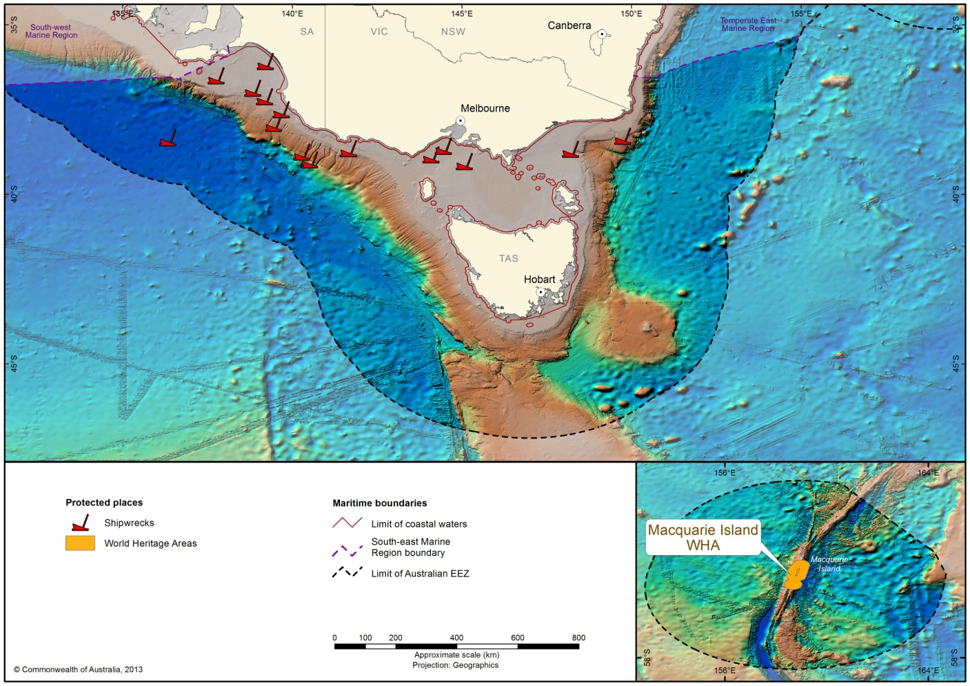
Figure 10 Protected places (shipwrecks and World Heritage Areas) in the South-east Marine Region

3.3.1 Marine reserves
Australia's South-east Commonwealth Marine Reserves Network stretches from the far south coast of New South Wales, around Tasmania and Victoria and west to Kangaroo Island off South Australia. The reserves include striking features such as underwater canyons and mountains, and the diverse marine life associated with them, some of which is new to science and found nowhere else in the world. The activities allowed in the South-east Commonwealth Marine Reserves Network are based on a system of zones which permit and restrict certain activities. Six different zones are used in the network: 39 per cent of the total area is highly protected, consisting of sanctuary and marine national park zones managed primarily for scientific research, monitoring and, where appropriate, passive uses. Some 21 per cent of the network is special purpose zone closed to commercial fishing while 12 per cent of the network is classified multiple use where low-impact fishing methods and other activities are permitted. The remaining area is made up of two specialised zones called the habitat protection zone and the recreational use zone. All Commonwealth marine reserves are managed primarily for biodiversity conservation (Director of National Parks 2013).
Fourteen Commonwealth Marine Reserves are located in the South-east Marine Region (Figure 11). Further information on the Network can be found at www.environment.gov.au/marinereserves.
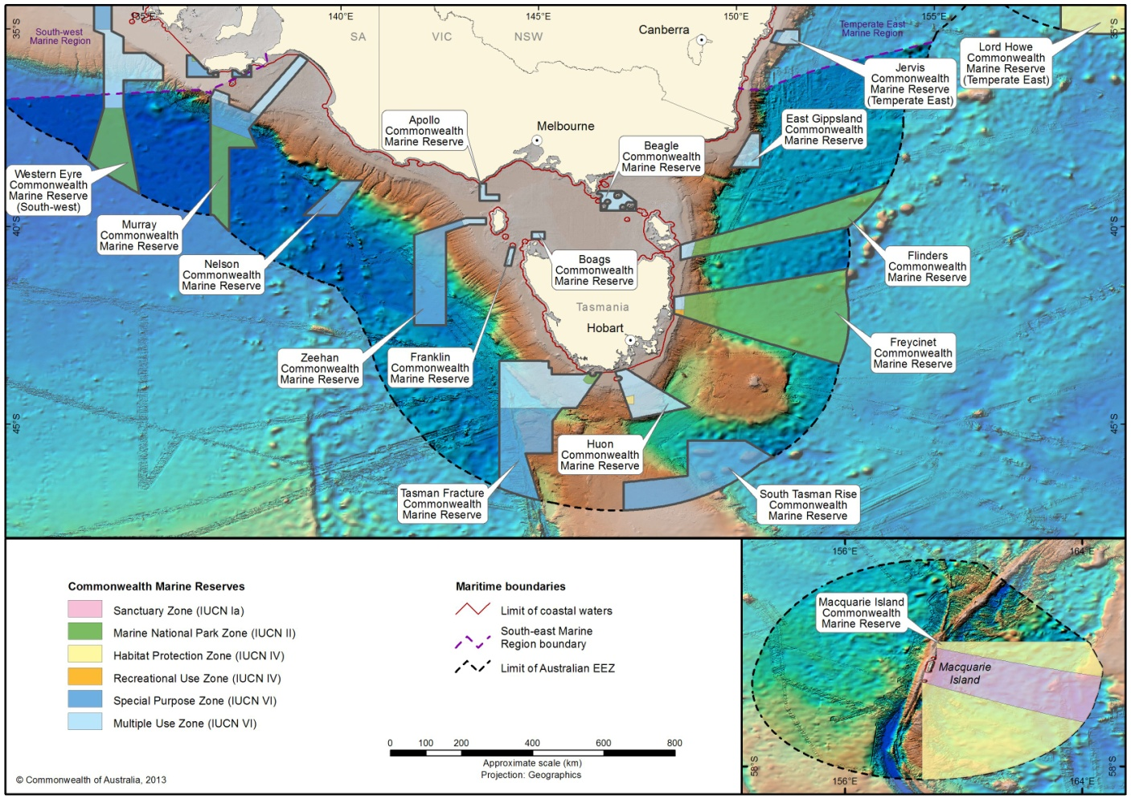

Figure 11 Commonwealth marine reserves in the South-east Marine Region

3.3.2 World and national heritage places
Macquarie Island
Macquarie Island is situated about 1500 km south-south-east of Tasmania, half way between Tasmania and Antarctica at around 55⁰ south. The island is approximately 34 km long and 5.5 km wide at its broadest point.
Macquarie Island was inscribed on the World Heritage List in 1997. Macquarie Island provides evidence of the rock types found at great depths in the earth's crust and of plate tectonics and continental drift, the geological processes that have dominated the earth's surface for many millions of years. It is an island of unique natural diversity, a site of major geoconservation significance and one of the truly remarkable places on earth. The island’s orientation and the submerged Macquarie Ridge together act as a major barrier to the Antarctic Circumpolar Current, the Earth’s largest and most important oceanic current.
Macquarie Island, the adjacent islets of Judge and Clerk and Bishop and Clerk, and all surrounding waters out to three nautical miles, is managed as a nature reserve by the Tasmanian Parks and Wildlife Service. Management of the reserve is guided by the Macquarie Island Nature Reserve and World Heritage Area Management Plan 2006. Most of the waters out to 200 nautical miles to the east of the reserve are within the Macquarie Island Commonwealth Marine Reserve, which is managed by the Australian Government in cooperation with the Tasmanian Parks and Wildlife Service.
The Macquarie Island region is important for seabirds and seals that breed on the island and forage in the reserve. The reserve includes two habitat protection zones that were established to protect the habitat of seabirds and seals, and the benthic and pelagic fauna that depend on the area. The northern habitat protection zone includes a foraging area for fur seals (New Zealand, Antarctic and subantarctic fur seals). The southern habitat protection zone includes foraging area for penguins during the breeding season, and it is used by many penguin species to transit to and from more southerly waters. A number of species found in the Macquarie Island region, including five albatross species, four penguin species and two seal species, are under local or global threat, and because most of these species require extremely large migratory or foraging ranges, protection of their critical feeding and migratory areas has international significance.

3.3.3 Historic shipwrecks
The coastline, reefs and seabed of waters adjacent to the South-east Marine Region are the resting places of many shipwrecks, including wooden sailing ships, early whaling ships, passenger ships and fishing vessels. Hundreds of shipwrecks have been recorded in the waters of south-eastern Australia.
Historic shipwrecks are recognised and protected under the Historic Shipwrecks Act 1976 that protects historic wrecks and associated relics found in waters from the low water mark to the edge of the continental shelf. Under the Act, all wrecks more than 75 years old are protected, together with their associated relics regardless of whether their actual locations are known. The Commonwealth minister responsible for the environment can also make a declaration to protect any historically significant wrecks or articles and relics that are less than 75 years old.
The Act aims to ensure that historic shipwrecks are protected and maintained for their heritage values, and for recreational and educational purposes. It also regulates activities that may result in the damage, interference, removal or destruction of an historic shipwreck or associated relic. Under the Act:
anyone who finds a shipwreck or relics associated with a shipwreck is required to give notification of the location as soon as practicable to the Minister for the Environment
historic relics must not be removed, or the physical fabric of a wreck disturbed, unless a permit has been obtained.
The Act also provides for protected zones to be declared around wrecks that are at particular risk of interference. Permits are required to enter protected zones, which can extend up to a radius of 800 m from the site of the wreck. Further information about historic shipwrecks can be found at www.environment.gov.au/heritage/shipwrecks/index.html
There are three historic shipwrecks that lie within the South-east Commonwealth Marine Reserves network, as well as many historic shipwrecks in the South-east Marine Region outside the marine reserves.

3.4 Supporting information

Abbott CA, Double MC, Baker GB, Gales R, Lashko A, Robertson CJR and Ryan PG (2006). Molecular provenance analysis of shy and white-capped albatrosses killed by fisheries interactions in Australia, New Zealand and South Africa. Conservation Genetics 7: 531–542.
Agreement on the Conservation of Albatrosses and Petrels (ACAP) (2009a). ACAP Species assessment: Antipodean Albatross, Diomedea antipodensis. Viewed 18 May 2013. Available online at: www.acap.aq.
Agreement on the Conservation of Albatrosses and Petrels (ACAP) (2009b). ACAP Species assessments: Indian Yellow-nosed Albatross, Thalassarche carteri. Viewed 18 May 2013. Available online at: www.acap.aq.
Agreement on the Conservation of Albatrosses and Petrels (ACAP) (2009c). ACAP Species assessment: Buller’s Albatross, Thalassarche bulleri. Viewed 18 May 2013. Available online at: www.acap.aq.
Agreement on the Conservation of Albatrosses and Petrels (ACAP) (2009d). ACAP Species assessments: Campbell Albatross, Thalassarche impavida. Viewed 18 May 2013. Available online at: www.acap.aq.
Agreement on the Conservation of Albatrosses and Petrels (ACAP) (2009e). ACAP Species assessments: Grey Petrel Procellaria cinerea. Viewed 26 March 2015. Available online at www.acap.aq.
Agreement on the Conservation of Albatrosses and Petrels (ACAP) (2010a). ACAP Species Assessment: Black-browed albatross, Thalassarche melanophris. Viewed October 2010. Available online at: www.acap.aq.
Agreement on the Conservation of Albatrosses and Petrels (ACAP) (2010b). ACAP Species Assessment: Grey-headed albatross, Thalassarche chrysostoma. Viewed October 2010. Available online at: www.acap.aq.
Agreement on the Conservation of Albatrosses and Petrels (ACAP) (2010c). ACAP Species Assessment: Light-mantled albatross, Phoebetria palpebrata. Viewed October 2010. Available online at: www.acap.aq.
Agreement on the Conservation of Albatrosses and Petrels (ACAP) (2010d). ACAP Species Assessment: Wandering albatross, Diomedea exulans. Viewed October 2010. Available online at: www.acap.aq.
Agreement on the Conservation of Albatrosses and Petrels (ACAP) (2010e). ACAP Species assessment: Black-browed Albatross, Thalassarche melanophris. Viewed 18 May 2013. Available online at: www.acap.aq.
Agreement on the Conservation of Albatrosses and Petrels (ACAP) (2010f). ACAP Species assessments: Northern Giant Petrel Macronectes halli. Viewed 26 March 2015. Available online at www.acap.aq.
Agreement on the Conservation of Albatrosses and Petrels (ACAP) (2011). ACAP Species assessment: White-capped Albatross, Thalassarche steadi. Viewed 18 May 2013. Available online at: www.acap.aq.
Aguilar A and Lockyer C (1987). Growth, physical maturity, and mortality of fin whales (Balaenoptera physalus) inhabiting the temperate waters of the northeast Atlantic. Canadian Journal of Zoology. 65: 253–264.
Alderman R, Gales R, Hobday AJ and Candy S (2010). Post-fledging survival and dispersal of shy albatrosses from three breeding colonies in Tasmania. Marine Ecology Progress Series 405: 271–285.
Australian Antarctic Division (AAD) (2013a). Fur seal. [Available online] http://www.antarctica.gov.au/about-antarctica/wildlife/animals/seals-and-sea-lions/antarctic-fur-seals Accessed 06/06/2013
Australian Antarctic Division (AAD) (2013b). Elephant seals. [Available online] http://www.antarctica.gov.au/about-antarctica/wildlife/animals/seals-and-sea-lions/elephant-seals Accessed 06/06/2013
Australian Antarctic Division (AAD) (2013c) Common diving petrel [available online] http://www.antarctica.gov.au/about-antarctica/wildlife/animals/flying-birds/common-diving-petrel Accessed 4.5.2013.
Australian Biological Resources Study (ABRS) (2009). Australian Faunal Directory. ABRS, Canberra. Viewed 31 May 2013. Available online at: http://www.environment.gov.au/biodiversity/abrs/online-resources/fauna/afd/index.html.
Australian Museum (2003). Australian Fur Seal [Arctocephalus pusillus]. Viewed 4 June 2013. Available online at: http://www.amonline.net.au/factsheets/fur_seal.htm.
Australian Museum (2010) Australasian Gannet [Morus serrator]. Viewed 4 May 2013. Available online at: http://australianmuseum.net.au/Australasian-Gannet/.
Baker B and Hamilton S (2013). South-east Marine Region — Review of Biologically Important Areas [for EPBC-listed seabirds]. Reports I and II. Unpublished reports to the Department of Sustainability, Environment, Water, Population and Communities. Latitude 42 Environmental Consultants Pty Ltd, Hobart.
Baker GB, Gales R, Hamilton S and Wilkinson V (2002). Albatrosses and petrels in Australia: a review of their conservation and management. Emu 102: 71–97.
Bannister J (2008). Great Whales. CSIRO Publishing.
Bannister JL, Kemper CM and Warneke RM (1996). The Action Plan for Australian Cetaceans. Australian Nature Conservation Agency, Canberra. Available online at: http://www.environment.gov.au/resource/action-plan-australian-cetaceans
BirdLife Australia (2013). Black-faced Cormorant [Phalacrocorax fuscescens]. Viewed 4 May 2013. Available online at: http://www.birdlife.org.
BirdLife International (2004). Tracking ocean wanderers: the global distribution of albatrosses and petrels. Results from the Global Procellariiform Tracking Workshop, 1–5 September, 2003, Gordon’s Bay, South Africa. Birdlife International, Cambridge, UK.
BirdLife International (2009). Antipodean albatross [Diomedea antipodensis]. Viewed 4 May 2013. Available online at: http://www.birdlife.org.
BirdLife International (2013). Sooty shearwater [Puffinus griseus]. Viewed 19 April 2013. Available online at: http://www.birdlife.org.
Bishop SDH, Francis MP, Duffy C and Montgomery JC (2006). Age, growth, maturity, longevity and natural mortality of shortfin mako (Isurus oxyrinchus) in New Zealand waters. Marine and Freshwater Research 57: 143–154.
Brooke M (2004). ‘Procellariidae’. In: Albatrosses and Petrels Across the World. Oxford University Press, Oxford, UK.
Brothers N, Gales R, Hedd A and Robertson G (1998). Foraging movements of the shy albatross Diomedea cauta breeding in Australia — implications for interactions with longline fisheries. Ibis 140: 446–457.
Brothers N, Pemberton D, Pryor H and Halley V (2001). Tasmania’s offshore islands: seabirds and other natural features. Tasmanian Museum and Art Gallery, Hobart.
Bruce BD (1992). Preliminary observations on the biology of the white shark, Carcharodon carcharias, in South Australian Waters. Australian Journal of Marine and Freshwater Research 43: 1–11.
Bruce BD (2008). The biology and ecology of the white shark (Carcharodon carcharias). In: Camhi M and Pikitch EK (eds.) (2008). Sharks of the open ocean. Blackwell Scientific, Oxford, pp. 69–81.
Bruce BD and Bradford RW (2008). Spatial dynamics and habitat preferences of juvenile white sharks — identifying critical habitat and options for monitoring recruitment. Final report to Department of the Environment, Water, Heritage and the Arts, Canberra.
Bruce BD, Stevens JD and Malcolm H (2006). Movements and swimming behaviour of white sharks (Carcharodon carcharias) in Australian waters. Marine Biology 150: 161–172.
Carpenter KE and Niem VH (eds.) (2001). FAO species identification guide for fishery purposes. The living marine resources of the Western Central Pacific. Volume 6. Bony fishes. Food and Agriculture Organization (FAO), United Nations, Rome.
Cato DH (1991) Songs of humpback whales: the Australian perspective, in: Memoirs of the Queensland Museum 30(2): 277-290.
Caton AE (1991). Review of aspects of southern bluefin tuna biology, population and fisheries. In: Shomura RS, Majkowski J and Langi S (eds.). Proceedings of the First FAO Organization Expert Consultation on interactions of Pacific Tuna Fisheries. [Online]. Food and Agriculture Organization (FAO), United Nations. Available online at: http://www.fao.org/docrep/005/t1817e/t1817e15.htm.
Cherel Y and Klages N (1998). A review of the food of albatrosses. In: Robertson G and Gales R (eds.) The Albatross: Biology and Conservation. Pp. 113–136. Surrey Beatty and Sons, Chipping Norton, NSW.
Chittleborough RG (1965). Dynamics of two populations of the humpback whale, Megaptera novaeangliae (Borowski). Australian Journal of Marine and Freshwater Research 16: 33–128.
Christidis L and Boles WE (2008). Systematics and Taxonomy of Australian Birds. CSIRO Publishing, Collingwood, Victoria.
Colgan DJ and Paxton JR (1997). Biochemical genetics and recognition of a western stock of the common gemfish, Rexea solandri (Scombroidea: Gempylidae), in Australia. Marine and Freshwater Research 48: 103–118.
Commission for the Conservation of Southern Bluefin Tuna (CCSBT) (2009). Report of the Extended Commission of the Sixteenth Annual Meeting of the Commission. 20–23 October 2009, Republic of Korea.
Compagno LJV (1984). Sharks of the world. An annotated and illustrated catalogue of shark species known to date, Vol. II, Carcharhiniformes, Fisheries and Agriculture Organization (FAO) Fisheries Synopsis, FAO Species Catalogue. Rome.
Copson GR (1988). The status of black-browed and grey-headed albatrosses on Macquarie Island. Papers of the Proceedings of the Royal Society of Tasmania 122: 137–141
Daley RK, Stevens JD and Graham KJ (2002). Catch analysis and productivity of the deepwater dogfish resource in southern Australia. FRDC Final Report 1998/108. CSIRO Marine Research, Fisheries Research and Development Cooperation and NSW Fisheries, Australia.
Dann P (2013). Little (Blue or Fairy) Penguin. International Penguin Conservation Work Group fact sheet. Viewed 20 April 2013. Available online at: http://www.penguins.cl/little-penguins.htm on 20/04/2013.
Davis TLO and Farley JH (2001). Size distribution of southern bluefin tuna (Thunnus maccoyii) by depth on their spawning ground. Fisheries Bulletin 99: 381–386.
Dawson CE (1985). Indo-Pacific pipehorses (Red Sea to the Americas). Gulf Coast Research Laboratory, Ocean Springs, USA.
del Hoyo J, Elliot A and Sargatal J (1992). Handbook of the Birds of the World, Vol. 1: Ostrich to Ducks. Lynx Edicions, Barcelona, Spain.
del Hoyo J, Elliott A and Sargatal J (1996). Handbook of the Birds of the World, vol. 3: Hoatzin to Auks. Lynx Edicions, Barcelona, Spain.
Delord K and Weimerskirch H (2011). Conserving pelagic habitats: seascape modelling of an oceanic top predator. Journal of Applied Ecology 48: 121–132.
Department of Environment and Heritage (DEH) (2012). New Zealand fur-seal [Arctocephalus forsteri]. Viewed 4 June 2013. Available online at: http://www.environment.nsw.gov.au/threatenedspeciesapp/profile.aspx?id=10903.
Department of Environment and Heritage (DEH) (2013). Little penguin [Eudyptula minor]. Viewed 6 May 2013. Available online at: http://www.environment.nsw.gov.au/animals/TheLittlePenguin.htm
Department of Primary Industries, Water and Environment (DPIWE) (2005). Australian Fur Seal. Viewed 4 June 2013. Available online at: http://www.dpiwe.tas.gov.au/inter.nsf/WebPages/BHAN-53K77E?open.
Department of Primary Industries, Parks, Water and Environment (DPIPWE) (2012). New Zealand Fur Seal. Viewed 4 June 2013. Available online at: http://www.dpiw.tas.gov.au/inter.nsf/WebPages/BHAN-53K7C8?open
Department of Sustainability, Environment, Water, Population and Communities (DSEWPAC) (2006). ‘Hoplostethus atlanticus (orange roughy)’ in Species Profile and Threats Database, DSEWPAC, Canberra. Viewed 31 May 2013. Available online at: http://www.environment.gov.au/cgi-bin/sprat/public/publicspecies.pl?taxon_id=68455
Department of Sustainability, Environment, Water, Population and Communities (DSEWPAC) (2009). ‘Rexea solandri (gemfish (eastern Australia population))’ in Species Profile and Threats Database, DSEWPAC, Canberra. Viewed 31 May 2013. Available online at: http://www.environment.gov.au/cgi-bin/sprat/public/publicspecies.pl?taxon_id=76339
Department of Sustainability, Environment, Water, Population and Communities (DSEWPaC) (2011a). Background Paper: Population Status and Threats to Albatrosses and Giant Petrels Listed as Threatened under the Environment Protection and Biodiversity Conservation Act 1999. Commonwealth of Australia, Hobart.
Department of Sustainability, Environment, Water, Population and Communities (DSEWPAC)(2011b). Draft National Recovery Plan for the Blue Whale (Balaenoptera musculus) — Draft for public comment. Available online at http://www.environment.gov.au/biodiversity/threatened/publications/recovery/draft-for-comment-blue-whale.html
Department of Sustainability, Environment, Water, Population and Communities (DSEWPAC) (2012a) Conservation Management Plan for the Southern Right Whale: A Recovery Plan under the Environment Protection and Biodiversity Conservation Act 1999 2011–2021. Available online at: www.environment.gov.au/biodiversity/threatened/publications/recovery/e-australis/index.html
Department of Sustainability, Environment, Water, Population and Communities (2012b). Temperate East Marine Region Report Card (2012a). Available online at: http://www.environment.gov.au/coasts/marineplans/temperate-east/index.html.
Department of Sustainability, Environment, Water, Population and Communities (DSEWPAC) (2013a). ‘Prototroctes maraena (Australian grayling)’ in Species Profile and Threats Database, DSEWPAC, Canberra. Viewed 31 May 2013. Available online at: http://www.environment.gov.au/cgi-bin/sprat/public/publicspecies.pl?taxon_id=26179
Department of Sustainability, Environment, Water, Population and Communities (DSEWPAC) (2013b). ‘Thalassarche melanophris (black-browed albatross)’ in Species Profile and Threats Database, DSEWPAC, Canberra. Viewed 31 May 2013. Available online at: http://www.environment.gov.au/cgi-bin/sprat/public/publicspecies.pl?taxon_id=66472
Department of Sustainability, Environment, Water, Population and Communities (DSEWPAC) (2013c). ‘Megaptera novaeangliae (humpback whale)’ in Species Profile and Threats Database, DSEWPAC, Canberra. Viewed 31 May 2013. Available online at: http://www.environment.gov.au/cgi-bin/sprat/public/publicspecies.pl?taxon_id=38
Department of Sustainability, Environment, Water, Population and Communities (DSEWPAC) (2013d). ‘Thalassarche chrysostoma (grey-headed albatross)’ in Species Profile and Threats Database, DSEWPAC, Canberra. Viewed 31 May 2013. Available online at: http://www.environment.gov.au/cgi-bin/sprat/public/publicspecies.pl?taxon_id=66491
Department of Sustainability, Environment, Water, Population and Communities (DSEWPAC) (2013e). ‘Thalassarche cauta (shy albatross)’ in Species Profile and Threats Database, DSEWPAC, Canberra. Viewed 31 May 2013. Available online at: http://www.environment.gov.au/cgi-bin/sprat/public/publicspecies.pl?taxon_id=82345
Department of Sustainability, Environment, Water, Population and Communities (DSEWPAC) (2013f). ‘Phoebetria palpebrata (light-mantled albatross)’ in Species Profile and Threats Database, DSEWPAC, Canberra. Viewed 31 May 2013. Available online at: http://www.environment.gov.au/cgi-bin/sprat/public/publicspecies.pl?taxon_id=1076
Department of Sustainability, Environment, Water, Population and Communities (DSEWPAC) (2013g). ‘Diomedea exulans (sensu lato) (wandering albatross)’ in Species Profile and Threats Database, DSEWPAC, Canberra. Viewed 31 May 2013. Available online at: http://www.environment.gov.au/cgi-bin/sprat/public/publicspecies.pl?taxon_id=1073
Department of Sustainability, Environment, Water, Population and Communities (DSEWPAC) (2013h). Issues Paper for the Australian Sea Lion (Neophoca cinerea).
Department of Sustainability, Environment, Water, Population and Communites (DSEWPAC) (2013i) Recovery plan for the White Shark (Carcharodon carcharias)
Department of Sustainability, Environment, Water, Population and Communites (DSEWPAC) (2013j) Recovery plan for the Australian Sea Lion (Neophoca cinerea)Department of the Environment and Heritage. (2003). Sub-Antarctic Fur Seal and Southern Elephant Seal Recovery Plan Recovery Plan. Available online at: http://www.environment.gov.au/biodiversity/threatened/publications/pubs/seals.pdf
Department of the Environment (DOE) (2015a). ‘Macronectes giganteus’ in Species Profile and Threats Database, DOE, Canberra. Viewed 26 March 2015. Available online at http://www.environment.gov.au/cgi-bin/sprat/public/publicspecies.pl?taxon_id=1060
Department of the Environment (DOE) (2015b). ‘Macronectes halli’ in Species Profile and Threats Database, DOE, Canberra. Viewed 26 March 2015. Available online at http://www.environment.gov.au/cgi-bin/sprat/public/publicspecies.pl?taxon_id=1061
Department of the Environment (DOE) (2015c). ‘Halobaena caerulea’ in Species Profile and Threats Database, DOE, Canberra. Viewed 26 March 2015. Available online at http://www.environment.gov.au/cgi-bin/sprat/public/publicspecies.pl?taxon_id=1059
Department of the Environment, Water, Heritage and the Arts (DEWHA) (2009). White Shark Issues Paper. Available online at:
http://www.environment.gov.au/biodiversity/threatened/publications/recovery/pubs/white-shark-issues-paper.pdf
Dickinson EC (ed.) (2003). The Howard and Moore Complete Checklist of the Birds of the World. Page 1039. Christopher Helm, London.
Director of National Parks (2013) South-east Commonwealth Marine Reserves Network management plan 2013-23, Director of National Parks, Canberra (in press)
Ensor P, Sekiguchi K, Cotton J, Hucke-Gaete R, Kariya T, Komiya H, Ljungblad D, Marite H, Olson P and Rankin S (2002). 2001–2002 IWC-Southern Ocean Whale and Ecosystem Research (IWC-SOWER) Circumpolar Cruises, Area V. Unpublished. Available from the IWC secretariat. Cambridge, UK.
Environment Australia (2001). National Recovery Plan for Albatrosses and Giant-Petrels 2001–2005. Environment Australia, Canberra. Available online at: http://www.environment.gov.au/archive/biodiversity/threatened/publications/recovery/albatross/index.html
Estrada JA, Rice AN, Natanson LJ and Skomal GB (2006). Use of isotopic analysis of vertebrae in reconstructing ontogenetic feeding ecology in white sharks. Ecology 87: 829–834.
Fenton GE, Short SA and Ritz DA (1991). Age determination of orange roughy, Hoplostethus atlanticus (Pisces: Trachichthyidae) using ²¹⁰Pb:²²⁶Ra disequilibria. Marine Biology 109: 197–202.
Gales R (1993). Cooperative Mechanisms for the Conservation of Albatrosses. Australian Nature Conservation Agency, Hobart.
Gales R (1998). Albatross populations: status and threats. In: Robertson G. and Gales R (eds.). The Albatross: Biology and Conservation. Pp. 20–45. Surrey Beatty and Sons Chipping Norton, NSW.
Gales R (2012). Personal communication. Department of Primary Industries, Parks, Water and Environment, Tasmanian Government in Department of Sustainability, Environment, Water, Population and Communities (2012) Conservation Management Plan for the Southern Right Whale A Recovery Plan under the Environment Protection and Biodiversity Conservation Act 1999 2011–2021
Gambell R (1985). Sei Whale Balaenoptera borealis. In: Ridgway SH and Harrison R (eds.). Handbook of Marine Mammals, Vol. 3: The Sirenians and Baleen Whales. Page 326. Academic Press Inc, Orlando, Florida.
Garnett S, Szabo J and Dutson G (2011). The Action Plan for Australian Birds 2010. CSIRO Publishing, Melbourne.
Gill P (2004). Personal communication. In: Department of Sustainability, Environment, Water, Population and Communities (DSEWPaC) (2012). ‘Balaenoptera borealis (sei whale)’ in Species Profile and Threats Database, DSEWPAC, Canberra. Viewed 24 May 2012. Available online at: http://www.environment.gov.au/cgi-bin/sprat/public/publicspecies.pl?taxon_id=34.
Gill PC (2002). A blue whale (Balaenoptera musculus) feeding ground in a southern Australian coastal upwelling zone. Journal of Cetacean Research and Management 4:179–184.
Gill PC, Evans KJ and Wapstra H (1998). Feeding by humpback whales in Tasmanian waters. Records of the Queen Victoria Museum, Launceston 107: 452–459.
Gill PC, Morrice MG, Page B, Pirzl R, Levings AH and Coyne M (2011). Blue whale habitat selection and within-season distribution in a regional upwelling system off southern Australia. Marine Ecology Progress Series 421: 243–263.
Goldman KJ (1997). Regulation of body temperature in the white shark, Carcharodon carcharias. Journal of Comparative Physiology B. Biochemical Systemic and Environmental Physiology 167: 423–429.
Goldman KJ; Branstetter S and Musick JA (2006). A re-examination of the age and growth of sand tiger sharks, Carcharias taurus, in the western North Atlantic: the importance of ageing protocols and use of multiple back-calculation techniques. Environmental Biology of Fishes 77: 241–252.
Goldsworthy SD and Page B (2009). A Review of the Distribution of Seals in South Australia. South Australian Research and Development Institute (Aquatic Sciences), Adelaide, SARDI Publication No. F2009/000368-1, 21 pp.
Goldsworthy SD and Shaughnessy PD (1995). Antarctic fur-seal Arctocephalus gazella (Peters, 1875). In: Strahan R. (ed.). The mammals of Australia. Page(s) 678–680. Reed Books, Chatswood.
Gomon MF, Bray DJ and Kuiter R (2008). Fishes of Australia’s southern coast. Reed New Holland, Australia.
Graham KJ and Daley RK (2011). Distribution, reproduction and population structure of thee gulper sharks (Centrophorus, Centrophoridae) in south-eastern Australian waters. Marine and Freshwater Research 62: 583–595.
Green K, Kerry KR, Disney T and Clarke MR (1998). Dietary studies of light-mantled sooty albatrosses Phoebetria palpebrata from Macquarie and Heard Islands. Marine Ornithology. 26:19–26.
Harrison P, Burns D, Fury C and Luker GO (2009). Conservation and values: global cetacean summary report. Department of the Environment, Water, Heritage and the Arts, Canberra.
Hedd A and Gales R (2001). The diet of shy albatrosses (Thalasarche cauta) at Albatross Island, Tasmania. Journal of Zoology 253: 69-90.
Hedd A, Gales R, Brothers N and Robertson G (1997). Diving behaviour of the shy albatross Diomedea cauta in Tasmania — initial findings and dive recorder assessment. Ibis 139: 452–460.
Higgins PJ and Davies SJJF (1996). Handbook of Australian, New Zealand and Antarctic Birds. Volume 3: Snipe to Pigeons. Oxford University Press, Oxford, UK.
Honda K, Hobday AJ, Kawabe R, Tojo N, Fujioka K, Takao Y and Miyashita K (2010). Age-dependent distribution of juvenile southern bluefin tuna (Thunnus maccoyii) on the continental shelf off southwest Australia determined by acoustic monitoring. Fisheries Oceanography 19:151–158.
Horwood JW (1987). The sei whale. Population biology, ecology and management. Croom Helm, New York.
Jouventin P and Weimerskirch H (1990). Satellite tracking of wandering albatrosses. Nature 343: 746–748.
Kailola PJ, Willams MJ, Stewart PC, Reichelt RE, McNee A and Grieve C (1993). Australian fisheries resources. Bureau of Resource Sciences, Australian Government Department of Primary Industries and Energy, Canberra.
Kato H, Bannister J, Burton C, Ljungblad D, Matsuoka K and Shimada H (1996). Report on the Japan/IWC Blue Whale Cruise 1995-96 off the Southern Coast of Australia. Paper SC/48/SH9 presented to the IWC Scientific Committee. Unpublished.
Kemper C (2006). Personal communication. SA Museum. In: Department of Sustainability, Environment, Water, Population and Communities (DSEWPAC) (2013c). ‘Megaptera novaeangliae (humpback whale)’ in Species Profile and Threats Database, DSEWPAC, Canberra. Available online at: http://www.environment.gov.au/cgi-bin/sprat/public/publicspecies.pl?taxon_id=38
Kirkwood R, Pemberton D, Gales R, Hoskins AJ, Mitchell T, Shaughnessy PD and Arnould JPY (2010). Continued population recovery by Australian fur seals. Marine and Freshwater Research 61: pp 695–701.
Kumar S (2012). Personal communication. Department of Environment, Water, and Natural Resources, South Australian Government in Department of Sustainability, Environment, Water, Population and Communities (2012) Conservation Management Plan for the Southern Right Whale A Recovery Plan under the Environment Protection and Biodiversity Conservation Act 1999 2011–2021
Larcombe J, Brooks K, Charalambou C, Fenton M and Fisher M (2002). Marine Matters — Atlas of marine activities and coastal communities in Australia's South East Region. Bureau of Rural Sciences, Canberra.
Last PR and Stevens JD (1994). Sharks and Rays of Australia. First Edition. CSIRO Publishing, Collingwood.
Last PR and Stevens JD (2009). Sharks and Rays of Australia. Second Edition. CSIRO Publishing, Collingwood.
Leatherwood S and Reeves RR (1983). The Sierra Club Handbook of Whales and Dolphins. Sierra Club Books, San Francisco.
Ling JK and Bryden MM (1981). Southern elephant seal Mirounga leonina Linnaeus, 1758. In: Ridway SH and Harrison RJ (eds.). Handbook of Marine Mammals, Vol. 2: Seals. pp 297–327. Academic Press, London.
Lourie A, Foster SJ, Cooper EWT and Vincent ACJ (2004). A Guide to the Identification of Seahorses. Project Seahorse and TRAFFIC North America.
Lourie AL, Vincent ACJ and Hall HJ (1999). Seahorses: an identification guide to the world’s species and their conservation. Project Seahorse, London.
Marchant S and Higgins PJ (eds.) (1990). Handbook of Australian, New Zealand and Antarctic Birds. Volume One — Ratites to Ducks. Oxford University Press, Melbourne.
McCauley RD, Jenner C, Bannister JL, Cato DH and Duncan A (2000). Blue whale calling in the Rottnest Trench, Western Australia, and low frequency sea noise. Paper presented at the Australian Acoustical Society Conference, Joondalup, Australia. Unpublished.
McLoughlin K (2007). Shark Gillnet and Hook Sectors, pp. 174–186. In: Larcombe J and McLoughlin K (eds.). Fishery Status Reports 2006: Status of Fish Stocks Managed by the Australian Government. Bureau of Rural Sciences, Canberra.
McManus TJ, Wapstra JE, Guiler ER, Munday BL and Obendorf DL (1984). Cetacean Strandings in Tasmania from February 1978 to May 1983. Papers and Proceedings of the Royal Society of Tasmania 118: 117–135.
Menkhorst P (2010). A Survey of Colonially-breeding Birds on Mud Islands, Port Phillip, Victoria; with an annotated list of all terrestrial vertebrates. Department of Sustainability and Environment.
Menkhorst PW, Pescott TW and Gaynor GF (1984). Results of Banding White-faced Storm-Petrels, Pelagodroma marina at Mud Islands, Victoria. Corella 8: 53–60.
Mollet HF and Cailliet GM (1996). Using allometry to predict body mass from linear measurements of the white shark. In: Klimley AP and Aimley DG (eds.). Great White Sharks: The Biology of Carcharodon carcharias. Pp. 81–89. United States of America: Academic Press. Available online at: http://www.jostimages.de/haiartikel/mollet_cailliet_1996cha9.pdf.
Natanson LJ, Kohler NE, Ardizzone D, Calliet GM, Wintner SP and Mollet HF (2006). Validated age and growth estimates for the shortfin mako, Isurus oxyrinchus, in the North Atlantic Ocean. Environmental Biology of Fishes 77: 367–383.
National Oceans Office (2004) South-east Regional Marine Plan, Implementing Australia's oceans policy in the South-east Marine Region. Available online at: www.environment.gov.au/coasts/mbp/publications/south-east/sermp.html.
New South Wales Fisheries Scientific Committee (NSWFSC) (2004). Final Recommendation Thunnus maccoyii — Southern Bluefin Tuna. Viewed 6 June 2013. Available online at: http://www.dpi.nsw.gov.au/__data/assets/pdf_file/0008/208268/FR26-southern-bluefin-tuna.pdf.
Nicholls DG, Murray D, Butcher E and Moors P (1997). Weather systems determine the non-breeding distribution of wandering albatrosses over southern oceans. Emu 97: 240–244
Noad MJ and Cato DH (2001). A combined acoustic and visual survey of humpback whales off southeast Queensland. Memoirs of the Queensland Museum 47: 507–523.
Noad MJ, Cato DH and Paton D (2005). Absolute and relative abundance estimate of Australian east coast humpback whales (Megaptera novaeangliae). Report to the International Whaling Commission (IWC), SC/57/SH.
Otway NM and Parker PC (2000). The biology, ecology, distribution, abundance and identification of marine protected areas for the conservation of threatened grey nurse sharks in south east Australia waters, NSW Fisheries Office of Conservation, Port Stephens.
Otway NM, Burke AL, Morrison NS and Parker PC (2003). Monitoring and identification of NSW critical habitat sites for conservation of grey nurse sharks. Final Report Series No. 47. NSW Fisheries Office of Conservation, Nelson Bay.

Paterson R, Paterson P and Cato DH (1994). The status of humpback whales Megaptera novaeangliae in east Australia thirty years after whaling. Australian Biological Conservation 70: 135–142
Pemberton D and Kirkwood RJ (1994). Pup production and distribution of the Australian fur seal, Arctocephalus pusillus doriferus, in Tasmania. Wildlife Research 21: 341–352.
Phillips K, Begg G and Curtotti R (2009). Southern Bluefin Tuna Fishery. In: Wilson D, Curtotti R, Begg G and Phillips K (eds.). Fishery Status Reports 2008: status of fish stocks and fisheries managed by the Australian Government. pp. 314–323. Canberra: Bureau of Rural Sciences and Australian Bureau of Agricultural and Resource Economics.
Pizzey G and Knight F (1999). The Graham Pizzey and Frank Knight Field Guide to the Birds of Australia. Pymble, Sydney: Angus and Robertson.
Pogonoski JJ, Pollard DA and Paxton JR (2002). Conservation overview and action plan for threatened and potentially threatened marine and estuarine fishes. Environment Australia, Canberra.
Reid K, Croxall JP and Prince PA (1996). The fish diet of black-browed albatross Diomedea melanophris and grey-headed albatrosses D. chrysostoma at South Georgia. Polar Biology 16: 469–477.
Reid TA, Hindell MA, Eades DW and Newman N (2002). Atlas of the Seabirds of Southeast Australia. Monograph 4, Birds Australia, Melbourne.
Reilly SB, Bannister JL, Best PB, Brown M, Brownell Jr RL, Butterworth DS, Clapham PJ, Cooke J, Donovan GP, Urbán J and Zerbini AN (2008). Balaenoptera physalus [fin whale]. In: IUCN 2012. IUCN Red List of Threatened Species. Version 2012.2. Viewed 6 June 2013. Available online at: www.iucnredlist.org.
Revill AT, Young JW and Lansdell M (2009). Stable isotope evidence for trophic groupings and bio-regionalization of predators and their prey in oceanic waters off eastern Australia. Marine Biology 156: 1241–1253.
Rodhouse PG, Prince PA, Clarke MR, Murray MR and AWA (1990). Cephalopod prey of the grey-headed albatross Diomedea chrysostoma. Marine Biology 104: 353–62.
Rogers PJ, Huveneers C, Page B and Goldsworthy SG (2009). Movement patterns of pelagic sharks in the Southern and Indian Oceans: determining critical habitats and migration paths. Final Report to Nature Foundation SA Inc. South Australian Research and Development Institute (Aquatic Sciences), Adelaide, 36 pp. SARDI Publication Number F2009/000167–1.
Ross G (2012). Personal communication. National Parks and Wildlife Service, New South Wales Government in Department of Sustainability, Environment, Water, Population and Communities (2012) Conservation Management Plan for the Southern Right Whale A Recovery Plan under the Environment Protection and Biodiversity Conservation Act 1999 2011–2021
Sagar PM and Weimerskirch H (1996). Satellite tracking of southern buller's albatrosses from the Snares, New Zealand. Condor 98: 649–652.
Schmidt DJ, Crook DA, O’Connor JP and Hughes JM (2011). Genetic analysis of threatened Australian grayling Prototroctes maraena suggests recruitment to coastal rivers from an unstructured marine larval source population. Journal of Fish Biology 78: 98–111.
Semmens JM, Payne NL, Huveneers C, Sims DW and Bruce BD (2013). Feeding requirements of white sharks may be higher than originally thought. Scientific Reports, Vol. 3, Article No. 1471. Viewed May 2013. Available online at: http://www.nature.com/srep/2013/130318/srep01471/full/srep01471.html.
Shaughnessy PD, Kirkwood RJ and Warneke RM (2002). Australian fur seals, Arctocephalus pusillus doriferus pup numbers at Lady Julia Percy Island, Victoria, and a synthesis of the species population status. Wildlife Research 29: 185–192.
Shaughnessy PD, Shaughnessy GL and Fletcher L (1988). Recovery of the fur seal population at Macquarie Island. Papers and Proceedings of the Royal Society of Tasmania 122: 177–187.
Smale MJ (2005). The diet of the ragged-tooth shark Carcharias taurus Rafinesque 1810 in the Eastern Cape, South Africa. African Journal of Marine Science 27: 331–335.
Smith DC, Robertson SG, Fenton GE and Short SA (1995). Age determination and growth of orange roughy (Hoplostethus atlanticus): a comparison of annulus counts with radiometric ageing. Canadian Journal of Fisheries and Aquatic Sciences 52: 391–401.
Stahl JC and Sagar PM (2006). Long and short trips in non-breeding Buller's albatrosses: relationships with colony attendance and body mass. Condor 108: 348–365.
Stahl JC, Bartle JA, Cheshire NG, Petyt C and Sagar PM (1998). Distribution and movements of Buller's albatross (Diomedea bulleri) in Australasian seas. New Zealand Journal of Zoology 25: 109–137.
Stobutzki I, Ward P, Vieira S, Moore A, Sahlqvist P, Leatherbarrow A, Patterson H, Barnes B, Noriega R and Rodgers M (2011). Commonwealth Trawl and Scalefish Hook Sectors. In: Woodhams J, Stobutzki I, Vieira S, Curtotti R and Begg GA (eds.). Fishery status reports 2010: status of fish stocks and fisheries managed by the Australian Government. Australian Bureau of Agricultural and Resource Economics and Sciences, Canberra. Pp. 125–191.
Strahan R (ed.) (1995). The Mammals of Australia, Second Edition. Reed Books, Syndey.
Terauds A, Gales R and Alderman R (2005). Trends in numbers and survival of black-browed (Thalassarche melanophrys) and grey-headed (T. chrysostoma) albatrosses breeding on Macquarie Island. Emu 105:159–167
Terauds A, Gales R, Baker GB and Alderman R (2006a). Foraging areas of black-browed and grey-headed albatrosses breeding on Macquarie Island in relation to marine protected areas. Aquatic Conservation: Marine and Freshwater Ecosystems 16: 133–146.
Terauds A, Gales R, Baker GB and Alderman R (2006b). Population and survival trends of Wandering Albatrosses (Diomedea exulans) breeding on Macquarie Island. Emu 106: 211–218.
Thiele D (2004). Personal communication. In: Department of Sustainability, Environment, Water, Population and Communities (DSEWPAC) (2013). ‘Balaenoptera physalus (Fin Whale)’ in Species Profile and Threats Database, DSEWPAC, Canberra. Viewed 31 May 2013. Available online at: http://www.environment.gov.au/cgi-bin/sprat/public/publicspecies.pl?taxon_id=37#profile_references
Thiele D, Chester E, Moore S, Sirovic A, Friedlaender A and Hildebrand J (2004). Seasonal variability in whale encounters in the Western Antarctic Peninsula. Deep Sea Research II 51: 2311–2325.
Thompson D, Sagar P and Torres L (2011). A population and distributional study of white-capped albatross (Auckland Islands) Contract Number: POP 2005/02. Report prepared for the Conservation Services Programme, Department of Conservation, New Zealand.
Threatened Species Scientific Committee (TSSC) (2001). Listing advice on grey nurse shark (Carcharias taurus) (east coast population). Available online at: http://www.environment.gov.au/biodiversity/threatened/species/c-taurus.html.
Threatened Species Scientific Committee (TSSC) (2009). Listing advice on gemfish (Rexea solandri) (eastern Australian population). Available online at: http://www.environment.gov.au/biodiversity/threatened/species/pubs/76339-listing-advice.pdf
Threatened Species Scientific Committee (TSSC) (2010). Listing advice on southern bluefin tuna (Thunnus maccoyii). Available online at: http://www.environment.gov.au/biodiversity/threatened/species/pubs/69402-listing-advice.pdf.
Threatened Species Scientific Committee (TSSC) (2012a). Listing advice on Neophoca cinerea (Australian sea-lion). Available online at: http://www.environment.gov.au/cgi-bin/sprat/public/publicspecies.pl?taxon_id=22
Threatened Species Scientific Committee (TSSC) (2013a). Conservation advice on Harrisson’s dogfish (Centrophorus harrissoni). Available online at: http://www.environment.gov.au/cgi-bin/sprat/public/publicspecies.pl?taxon_id=68444
Threatened Species Scientific Committee (TSSC) (2013b). Conservation advice on southern dogfish (Centrophorus zeehaanii). Available online at: http://www.environment.gov.au/cgi-bin/sprat/public/publicspecies.pl?taxon_id=82679
Van Dyck S and Strahan R (2008). The Mammals of Australia, Third Edition. Page 880. Reed New Holland, Sydney.
Ward TM, McLeay LJ, Dimmlich WF, Rogers PJ, McClatchie S, Matthews R, Kämpf J and van Ruth PD (2006). Pelagic ecology of a northern boundary current system: effects of upwelling on the production and distribution of sardine (S. sagax), anchovy (E. australis) and southern bluefin tuna (Thunnus maccoyii) in the Great Australian Bight. Fisheries Oceanography 15: 191–207.
Warneke RM (1995a). Humpback whale. In: Menkhorst PW (ed.). Mammals of Victoria; distribution, ecology and conservation. Oxford University Press, Oxford, UK.
Warneke RM (1995b). Family Otariidae. In: Mammals of Victoria; distribution, ecology and conservation. pp. 251–256. Oxford University Press, Oxford, UK.
Warneke RM and Shaughnessy PD (1985). Arctocephalus pusillus, the South African and Australian fur seal: taxonomy, evolution, biogeography and life history. In: Ling JK and Bryden MM (eds.). Studies of Sea Mammals in South Latitudes. pp 53–77. South Australian Museum, Adelaide.
Watson M (2012). Personnel communication. Department of Sustainability and Environment, Victorian Government in Department of Sustainability, Environment, Water, Population and Communities (2012) Conservation Management Plan for the Southern Right Whale A Recovery Plan under the Environment Protection and Biodiversity Conservation Act 1999 2011–2021.
Waugh SM, Sagar PM and Cossee RO (1999a). New Zealand black-browed albatross Diomedea melanophrys impavida and greyheaded albatross D. chrysostoma banded at Campbell Island: Recoveries from the South Pacific region. Emu 99: 29–35.
Waugh SM, Weimerskirch H, Cherel Y, Shankar U, Prince PA and Sagar PM (1999b). Exploitation of the marine environment by two sympatric albatrosses in the Pacific Southern Ocean. Marine Ecology Progress Series 177: 243–254.
Weimerskirch H and Cherel Y (1998). Feeding ecology of short-tailed shearwaters: breeding in Tasmania and foraging in Antarctica? Marine Ecology Progress Series 167: 261–234.
Weimerskirch H and Robertson G (1998). Satellite tracking of light-mantled sooty albatrosses. Polar Biology 14: 123–126.
Williams A, Althaus F, Smith T, Daley R, Barker B, Fuller M (2012). Developing and applying a spatially-based seascape analysis (the “habitat proxy” method) to inform management of gulper sharks. Compendium of Discussion Papers. Report to the Australian Fisheries Management Authority. CSIRO, Australia.

4. Human activities in the South-east Marine Region
Indigenous people settled in Australia at least 60 000 years ago. The coastal areas adjacent to the South-east Marine Region were amongst the most densely populated regions in pre-colonial Australia. The relationship between Indigenous people and the Region began when sea levels were much lower – a land bridge allowed movement of people between “mainland” Australia and Tasmania, and local Indigenous people were able to harvest species and utilise parts of the region that are now covered by deeper offshore waters.
As sea levels rose – approximately 13 000 years ago – the land bridge that joined Victoria and Tasmania was inundated and Tasmania, and its people, flora and fauna, was isolated from the mainland. Matthew Flinders and George Bass sailed their ship, the Norfolk, through Bass Strait and around “Van Diemen’s Land” in 1798 and established that Van Diemen's Land was indeed an island. The advent of European fisheries in south-eastern Australia, beginning soon after the exploration of Bass Strait, led to a much higher demand on marine resources. The first commercial ventures focused on harvesting the abundant whales and seals of the South-east Marine Region. In 1810 sealers landed on Macquarie Island and within 18 months 120 000 seal skins had been returned to Sydney. The sealing industry rapidly expanded throughout Bass Strait, but it was short-lived and was in decline by 1825.
The Davidson Whaling Station near Eden, New South Wales, is considered by some to be the first industrial complex in Australia. It began operation in 1828. Whales were hunted primarily for whale oil, an important fuel at the time. Other whaling stations were set up in Tasmania, Victoria and South Australia. Over-exploitation resulted in decline, although whaling continued well into the twentieth century.
The waters of the South-east Marine Region were the first impression of the new home for many people who immigrated to south eastern Australia during the first one hundred years of settlement. Wild weather conditions often welcomed newcomers on their final leg of the long journey from Britain. Many ships were wrecked and lives were lost when boats were pounded into the rugged coastline by the sometimes treacherous sea conditions.
After the Second World War rapid advances in technology allowed for the expansion of deepwater commercial fishing. Today there are over 20 fisheries operating in the South-east Marine Region, targeting some of the world's most prized seafood, such as rock lobster. The Region provides much of the table fish for the large population centres of south-eastern Australia.
The South-east Marine Region has been significant for Australia's international and coastal shipping since the early days of settlement. Today 40 per cent of Australia's coastal trade either originates from areas adjacent to the Region or has travelled through the Region. In the 1950s commercial oil and gas exploration began, and identified four major basins in the Region: the Gippsland, Sorrell, Otway and Bass basins. Extraction is currently being undertaken in the Gippsland, Otway and Bass Basins. More recently industries such as tourism, telecommunications and aquaculture have rapidly expanded. Biotechnology and renewable energy sources are also emerging as potentially significant industries.

4.1 The human dimension: an overview
Approximately 85 per cent of Australians live within 50 km of the coast and two-thirds of Australians live in coastal towns and cities. The coastal zone is important to most Australians for leisure, a place of residence, employment and enjoyment of the natural environment – the coast has a key place in Australian culture. As a result of increased coastal development (in part from the ‘seachange’ phenomenon) there is increasing pressure on coastal and marine resources. In recent years, sustainable development strategies have been developed by governments and management agencies in the South-east Marine Region (for example, the Victorian Coastal Strategy 2014).
More than four million people live along the coastline of south-eastern Australia: this includes several major population centres (see Table 3) and many small coastal towns and settlements from Eden in New South Wales to Kingston in the South-east of South Australia. Many people depend economically on the sea, directly or indirectly. Many new residents (or ‘seachangers’) have moved from the large cities to the smaller coastal settlements and there is also growing number of tourists visiting the Region.
In 2011–12, Melbourne recorded the largest growth of any capital city in Australia. Outside of capital cities, the largest population growth generally occurred along the Australian coast in 2011–12. Adjacent to the South-east Marine Region rapid population growth is evident on the southern coast of New South Wales, the southern coasts of Victoria and South Australia, and the eastern coast of Tasmania, as shown in Figure 12. Fast population growth continues to occur along the Victorian coast (ABS 2013).

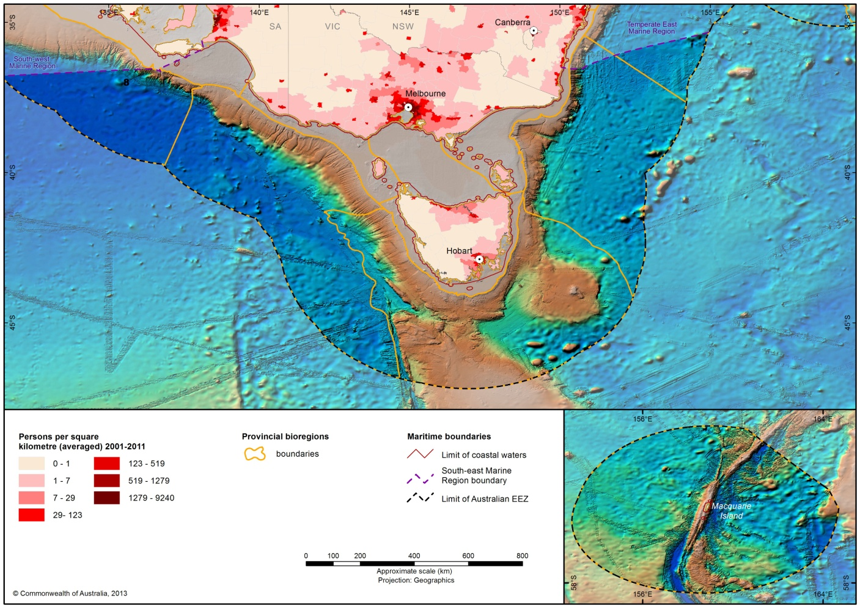

Figure 12 Population growth in areas adjacent to the South-east Marine Region 2001-2009

Table 3 Major population centres adjacent to the South-east Marine Region (ABS 2011)

City/urban centre | Population
Melbourne, Victoria | 3 999 982
Greater Hobart, Tasmania | 211 656
Geelong, Victoria | 250 651
Warrnambool, Victoria | 28 413

4.1.1 Indigenous history in the South-east Marine Region

Indigenous occupation of coastal areas adjacent to the South-east Marine Region dates back at least 40 000 years. At least 17 distinct Aboriginal language groups owned, occupied and used coastal land and seas in and adjacent to the Region (Figure 13). For most of this period sea levels were much lower than they are today, allowing movement by land between Victoria and Tasmania. It has been estimated that between 5000 and 10 000 Indigenous Australians occupied Tasmania prior to European settlement. Indigenous peoples in the area fished and collected shellfish, and seals and mutton birds were also important sources of food. In some places along the Victorian coastline, nodules of marine chert (a kind of flint) which were washed ashore provided raw material for stone tools. In the Coorong area of South Australia, mesh nets, woven fish traps, spears and canoes were developed to exploit marine resources. Indigenous peoples’ connections with ‘sea country’ are as elemental as connections with the land (National Oceans Office 2002a).
Indigenous communities of the South-east Marine Region continue to have a strong cultural and spiritual connection to the ocean, and to use ocean resources for food, traditional purposes and income.

Figure 13 Distribution of Aboriginal coastal language groups in the South-east

4.1.2 European Settlement
The first white settlers in south-eastern Australia were colonists and convicts. More than 70 000 convicts were sent to Tasmania over a period of 50 years. Penal settlements such as Port Arthur, Sarah Island (Macquarie Harbour) and Maria Island were set up specifically as areas where escape was virtually impossible.
Progressively, the South-east Marine Region became more important for the resources it provided, leading to further settlement throughout the nineteenth century. Given the sometimes extreme weather conditions in Bass Strait and along the west coast of Tasmania, shipwrecks and lighthouses constitute a major part of the southern Australia’s marine cultural heritage. More information about shipwrecks in the South-east Marine Region can be found in Section 3.3.3 and on the department’s website (www.environment.gov.au/heritage/shipwrecks/index.html.
The advent of European fisheries in the Region, which began soon after the exploration of Bass Strait in 1797, led to a higher demand on marine resources. The first commercial ventures focused on harvesting seals and whales. In 1798, fur seal harvesting began on Cape Barren Island and the industry rapidly expanded to other parts of Bass Strait. By 1825, the industry was in decline although it continued on a reduced basis until the 1850s, by which time the resource was overexploited and seal populations plummeted. In 1810, sealing began on Macquarie Island and within 18 months, more than 120 000 seal skins had been shipped back to Sydney. However, 20 years later, the fur seal population had been decimated and the elephant seal population reduced to about 30 percent of its original numbers.
Sealing was succeeded by whaling. The Davidson Whaling Station near Eden, New South Wales, considered by some to be the first industrial complex in Australia, began operations in 1828. Whales were hunted primarily for oil, an important fuel at the time. Other whaling stations were set up at places such as Portland and Port Fairy in Victoria, Victor Harbour in South Australia, Recherche Bay and Southport in Tasmania. Over-exploitation resulted in whaling decline, although it continued well into the 1900s.
After the Second World War rapid advances in technology allowed for consistent deepwater commercial fishing. There are now more than 20 fisheries operating in the South-east Marine Region, including twelve Commonwealth-managed fisheries. The Region provides much of the table fish for the large population centres of south-eastern Australia.
The south-east corner has been significant for Australia’s international and coastal shipping since the early days of settlement. Melbourne is Australia’s largest container port and is expected to remain so into the future. Regional ports are a substantial player in terms of containerised coastal freight, predominantly ports in Northern Tasmania (Burnie, Bell Bay and Devonport) which are vital hubs for trade and transport across Bass Strait.
In the 1950s, commercial oil and gas exploration began and identified four major basins in the South-east Marine Region: the Gippsland, Sorrell, Otway and Bass basins. More recently, industries such as tourism, telecommunications and aquaculture have rapidly expanded. Biotechnology and renewable energy sources are also emerging as potentially significant industries.

4.2 Marine activities
The total value of economic activity from Australia’s marine environment has been measured at $42.3 billion in 2009–10, compared to $39.6 billion for agricultural production (AIMS 2012). Seafood production (including wild-catch and aquaculture), offshore oil and gas exploration, boat and ship building and associated industry, and tourism all contribute to this, as outlined in Table 4. This value, however, is not a complete figure – economic data is unavailable for many activities, and this does not include non-market values; for instance a recent study estimated the value of ecosystem services from Australia’s oceans at $25 billion (Centre for Policy Development 2011).
The South-east Marine Region contains some of Australia’s most productive fisheries. It is also home to some of the fastest growing aquaculture industries in the country. The Region contains vast oil and gas reserves and long-standing production facilities. It also has some of Australia’s most important cultural relics in the form of shipwrecks and evidence of historic Indigenous occupation.

Table 4 Total of measurable Industry Value of Production from marine-related activities in 2009–10 (AIMS 2012)
Sector | Value of production 2009–10 ($ million)
Fishing
Marine-based aquaculture | 870.4
Commercial fishing (wild capture fisheries) | 1343.7
Offshore oil & gas exploration and extraction
Oil exploration | 2745.5
Oil production | 10 187.5
LPG | 1105.1*
Natural gas | 7788.7*
Boat/ship building, repair & maintenance services and infrastructure
Boatbuilding & repair (including recreational vessels) | 1221
Shipbuilding & repair (civil and defence) | 2637
Marine equipment retailing | 2794
Marine tourism and recreational activities
Domestic consumption of tourism goods and services | 9869.6
International consumption of tourism goods and services | 1750.3
TOTAL | 42 312.6
* export revenue only

4.2.1 Commercial fishing
Management responsibilities for individual fisheries within the Region are based upon the Offshore Constitutional Settlement (OCS). Under the OCS, individual fisheries can, by agreement, be managed by either the Commonwealth or the relevant state government. More than 20 Commonwealth and state managed open ocean fisheries operate in the South-east Marine Region using a range of fishing methods.
Commercial fishing in south-eastern Australia is concentrated in inshore coastal waters and, within Commonwealth waters, along the continental slope. The Region’s waters are accessible to bottom-fishing gear such as demersal longline and trawl, as well as pelagic fishing gear that operate in the water column, such as purse seine and pelagic longline. Commercial fishing is an important component of the Region’s coastal economy. Associated activities such as repair yards, dock handling, transportation, boat construction, fish processing and commercial trade and the supply of marine gear such as nets and rigging, add significantly to the Region’s employment and economic activity (Gooday et al. 2001).
Commonwealth managed fisheries
There are seven Commonwealth-managed fisheries active in the waters of the South-east Marine Region. The Southern and Eastern Scalefish and Shark Fishery, which is comprised of four primary sectors using multiple gear methods to target a range of species was the most significant fishery in the Region in 2013/14, with an annual catch of over 10 000 tonnes and a gross value of production of more than $90 million (Georgeson et al. 2014).
Table 5 provides more information on Commonwealth-managed fisheries active in the South-east Marine Region; this information is drawn from the Fishery Status Reports 2013/14 (Georgeson et al. 2014). The Eastern Tuna and Billfish Fishery management area extends across the South-east Marine Region, however the fishery’s effort in the Region is limited to waters adjacent to the south coast of New South Wales.
The management area for the Southern Bluefin Tuna Fishery includes the South-east Marine Region. The majority of catch in the fishery occurs via purse seine outside the Region but there is some catch via line methods (longline and trolling) that occurs within the South-east Marine Region.
Management areas of two other Commonwealth managed fisheries overlap with the South-east Marine Region, but these fisheries are not active in the region: the Skipjack Tuna Fishery (not active in Australian waters in 2012 and 2013) and the South Tasman Rise Trawl Fishery (closed since 2007).

Table 5 Commonwealth fisheries active primarily in the South-east Marine Region in 2013/14 - (adapted from Georgeson et al. 2014)
Fishery | Area of fishery (in the South-east Marine Region) | Main species targeted | Method | 2013 Catch (t) | Number of active vessels/licenses | Real Value  ($ million) | Status of stock
Bass Strait Central Zone Scallop Fishery | Effort in 2013 concentrated in eastern part of Bass Strait | Commercial Scallop | Scallop dredge | 244 (2012) | 12 vessels | 0.5 (2012) | Not overfished, uncertain if overfishing occurring
Small Pelagic Fishery | Fishery includes all waters of South-east Marine Region. Effort in 2012-13 concentrated in Spencer Gulf South Australia, and in waters adjacent to northern New South Wales | Australian Sardine, Blue Mackerel, Jack Mackerel, Redbait | Purse seine, midwater trawl | 16 (2012-13) | Purse seine: 2 vessels (2012-13) | Not available | All stocks not overfished or overfishing, except western stock of Redbait which is uncertain if overfished but overfishing not occurring
Southern and Eastern Scalefish and Shark Fishery:  Commonwealth Trawl Sector and Scalefish Hook Sector | Throughout South-east Marine Region (excl. Macquarie Island) | Mixed fish species, particularly Blue Grenadier, Flathead, Whiting and Dory | Trawl, hook (dropline, demersal longline), Danish seine | 9 736 | No. vessels:  Trawl: 33  Danish seine: 14  Hook: 15  (2012-13) | 57.6 (2012-13) | Biomass:  5 stocks overfished, 4 stocks uncertain, 19 stocks not overfished  Fishing mortality:  5 stocks uncertain, 23 stocks not overfishing
Southern and Eastern Scalefish and Shark Fishery:  Shark Gillnet and Shark Hook Sectors | Bass Strait and waters adjacent to Victoria and eastern South Australia | Elephantfish, Gummy Shark, Sawshark, School Shark | Demersal gillnet, demersal longline | 1 876 (2012-13) | No. vessels:  Gillnet: 46  Hook: 23 (2012-13) | 17.4 (2012-13) | Elephantfish sawshark and gummy shark: not overfished or overfishing  School shark: overfished and uncertain if overfishing occurring
Southern Bluefin Tuna Fishery (line fishing only) | Waters adjacent to southern NSW and Tasmania | Southern Bluefin Tuna | Longline, trolling | 34 (2012-13) | 20 vessels (2012-13) | 1.4 (2012-13) | Overfished; uncertain if overfishing occurring
Southern Squid Jig Fishery | Bass Strait and waters adjacent to western Victoria (plus incidental Squid catch from Commonwealth Trawl Sector throughout South-east Marine Region excl. Macquarie Island) | Gould’s Squid | Squid Jig, otter trawl | Jig: 166  Trawl: 724 (2013) | 8 vessels (2013) | Jig: 0.24  Trawl: 1.1 (2012-13) | Not overfished or overfishing
Macquarie Island Toothfish Fishery | Waters around Macquarie Island (excluding highly protected zone) | Patagonian Toothfish | Demersal longline, demersal trawl, pot | 405 (2013-14) | 1 vessel (2013-14) | Not available | Not overfished or overfishing
Eastern Tuna and Billfish Fishery | Throughout South-east Marine Region (excl. Macquarie Island)  NOTE: effort in this Region has historically been restricted to waters adjacent to New South Wales and eastern Victoria | Striped Marlin, Swordfish, Albacore, Bigeye Tuna, Yellowfin Tuna | Pelagic longline, minor line (trolling, rod and reel, handline) | 3915* (2013) | Longline: 41 vessels  Minor line: 7 vessels (2013) | 23.9* (2013) | Swordfish: not overfished, overfishing uncertain  Striped marlin, albacore, yellowfin tuna: not overfished or overfishing  Bigeye tuna: overfished and overfishing occurring
* values for catch and real value are for the whole fishery. Breakdown of catch and value from the South-east Marine Region alone is not available.
State-managed fisheries
Under an Offshore Constitutional Settlement with the Commonwealth government, state governments can enter into agreements with the Commonwealth to manage fish species whose range extends beyond state waters. In terms of state management, Tasmanian fisheries are managed by the Department of Primary Industries, Parks, Water and Environment under the Living Marine Resources Management Act 1995, and in Victoria they are managed by the Department of Economic Development, Jobs, Transport and Resources under the Fisheries Act 1995. The New South Wales Department of Primary Industries manages fisheries under the Fisheries Management Act 1994, while Primary Industries and Resources South Australia manage fisheries in South Australia under the Fisheries Management Act 2007.
Victorian managed fisheries
Under an Offshore Constitutional Settlement with the Commonwealth government, the Victorian government has jurisdiction over three fisheries active in the South-east Marine Region and adjacent state waters. These are the Giant Crab Fishery, the Rock Lobster Fishery and the Scallop Fishery. Table 6 provides information on Victorian managed fisheries active in the South-east Marine Region. While the boundary of other Victorian fisheries extend into Commonwealth waters they have not been included here as they record nil or insignificant catches within the South-east Marine Region.

Table 6 Victorian fisheries active in the South-east Marine Region (drawn from Victorian Fishery Status Reports 2013 and ABARE-BRS 2014)
Fishery | Area of fishery | Main species targeted | Method (s) | 2011–12 Catch (t) | 2011–12 Value ($ million)
Giant Crab Fishery | Victorian state waters and adjacent Commonwealth waters | Giant Crab | Pot | 12.6* | 0.60*
Rock Lobster Fishery | Victorian state waters and adjacent Commonwealth waters | Southern Rock Lobster | Pot | 295 | 17.87
Scallop Fishery | Victorian state waters and adjacent Commonwealth Waters to 20 nautical miles. | Commercial Scallop | Scallop Dredge | 0 TACC | 0
* statistics for king crab catch are not separated from total crab catch.
Tasmanian managed fisheries
There are four Tasmanian managed fisheries that are active in the South-east Marine Region. These are Rock Lobster Fishery, Scalefish Fishery, Giant Crab Fishery and Scallop Fishery. Table 7 provides information on Tasmanian Government-managed fisheries active in the South-east Marine Region.

Table 7 Tasmanian fisheries active in the South-east Marine Region (drawn from Tasmanian Scalefish Fishery Assessment 2010/12 and ABARE-BRS 2014)
Fishery | Area of fishery | Main species targeted | Method (s) | 2011–12 Catch (t) | 2011–12 Value ($ million)
Giant Crab Fishery | Tasmanian state waters and adjacent Commonwealth waters | Giant Crab | Pot | 38 | 1.75
Rock Lobster Fishery | Tasmanian state waters and adjacent Commonwealth waters | Southern Rock Lobster | Pot | 1098 | 63.42
Scalefish Fishery | Tasmanian state waters and adjacent Commonwealth waters | Mixed fish species | Gillnet, hook and line, longline, jig, seine, trap | 515 | 1.94
Scallop Fishery | Tasmanian state waters and adjacent Commonwealth waters | Commercial Scallop | Scallop Dredge | 85 | 0.17

New South Wales fisheries
There are two fisheries managed by the New South Wales Government which are active in the South-east Marine Region. These are the Ocean Trap and Line Fishery, and the Lobster Fishery. There are also some New South Wales Government managed fisheries which may operate in coastal waters adjacent to the region, including the Southern Fish Trawl Restricted Fishery, the Ocean Hauling Fishery, the Abalone Fishery and the Sea Urchin and Turban Shell Restricted Fishery.
For all of these fisheries, only a small part of the management area falls within the South-east Marine Region; the majority of management area and effort is within the Temperate East Marine Region.
South Australian fisheries
There are four South Australian managed fisheries that are active in the South-east Marine Region. These are the Rock Lobster Fishery, Scalefish Fishery, Giant Crab Fishery and Sardine Fishery.
For all of these fisheries, only a small part of the management area falls within the South-east Marine Region; the majority of management area is within the South-west Marine Region.
Fisheries and the environment of the South-east Marine Region
Fisheries are known to interact with some of the Region’s conservation values, including cetaceans, marine reptiles, sharks, seals and seabirds. Interactions between fisheries and conservation values are governed by a range of regulations and codes of conduct. The Australian Government assesses fisheries under the EPBC Act against criteria that may include progress in implementing practices to minimise impacts on the marine environment and protected species. Further information on fisheries assessments can be found at www.environment.gov.au/coasts/fisheries.
Both Australian and state Government fisheries agencies have a range of initiatives in place to reduce the potential for adverse environmental impacts by fisheries. The sustainable management of fisheries by the Australian Government is undertaken through the Fisheries Management Act 1991. Supporting initiatives include the Commonwealth Harvest Strategy Policy and Guidelines 2007 which provides guidance on how to manage fish stocks sustainably and profitably through harvest strategies, and the National Policy on Fisheries Bycatch 2000 which sets a requirement for by-catch actions in each major Commonwealth fishery to improve the protection of threatened species and minimise adverse impacts upon the marine environment. Similarly, state fisheries agencies use a range of measures to minimise adverse impacts on both target and non-target species. Measures include output controls to limit the amount of target species landed, and input controls such as gear restrictions and seasonal or area closures, to avoid wider impacts on the marine environment, protected species and/or the target species itself.

4.2.2 Recreational fishing
Recreational fishing in Australia is a multi-billion dollar a year industry, and an important leisure activity for over 3.4 million Australians (Henry & Lyle 2003). The bulk of recreational fishing occurs inland, near the coast, in bays and estuaries. In Tasmania, for instance, only two per cent of recreational fishing is undertaken offshore (greater than 5 km from shore) (Lyle et al. 2009) while nationally this figure is around four per cent (Henry & Lyle 2003).
Some 721 000 Victorians participated in recreational fishing in 2008–09 though the majority of recreational fishing took place within inland and estuarine environments (Ernst & Young 2009). Figure 14 shows the distribution of recreational fishing catch in 2001.
Popular recreational fishing species include tiger flathead, bream, snapper, Australian salmon and lobster (National Oceans Office 2002b).
State/territory governments are responsible for the day-to-day management of recreational fisheries. This includes the recreational components of some Commonwealth managed commercial fisheries – for example game fishing.

Figure 14 Distribution of recreational fishing catch (2001)

4.2.3 Aquaculture
Aquaculture is defined by the United Nations Food and Agriculture Organization as “the farming of aquatic organisms including fish, molluscs, crustaceans and aquatic plants with some sort of intervention in the rearing process to enhance production, such as regular stocking, feeding, protection from predators, etc. Farming also implies individual or corporate ownership of the stock being cultivated” (FAO 2002). Aquaculture is the fastest growing primary industry in Australia and, in the face of a diminishing of the world wild caught fisheries, it is the fastest growing food production sector in the world. The gross value of Australian aquaculture production was valued at $1.05b in 2011–12 (ABARE-BRS 2013). Many of the aquaculture species in Australia are high value species aiming for export markets (ABARE–BRS 2013).
Aquaculture is now one of Tasmania’s major industries. In 2011-12 the value of Tasmanian aquaculture production increased to $537 million, up from approximately $100 million in 1999-2000. Driving this increase has been a significant increase in the volume of salmonid production, which in 2011–12 accounted for 94 per cent of the total value of Tasmania’s aquaculture industry and 98 per cent of Australia’s total salmonid production. Other species currently commercially farmed in Tasmania include abalone, mussels and oysters. The value of aquaculture production in Victoria was $17.5 million in 2011-12 (ABARE-BRS 2013).
State and territory governments regulate aquaculture in Australia. However, the Commonwealth addresses national issues and is responsible for developing a management framework for offshore aquaculture. Aquaculture operations within the South-east Marine Region are concentrated in inshore coastal waters but there is likely to be an expansion of offshore aquaculture. Increased sea surface temperatures may present challenges for the production of cool-water farmed aquaculture species, such as Atlantic salmon.

4.2.4 Marine-based tourism and recreation
The South-east Marine Region offers a wide and diverse range of opportunities, with visitors participating in activities including diving, charter boat cruises, whale and wildlife watching, sailing, snorkelling, scuba diving, surfing, and kayaking. Popular tourist destinations adjacent to the South-east Marine Region include Phillip Island, the Great Ocean Road (Victoria); Robe, Beachport (South Australia); Merimbula, Bermagui (New South Wales); and Strahan and the Freycinet Peninsula (Tasmania).
Cruise shipping is also an important activity within the region. In the 2010–11 season there were 47 cruise ship visits to Tasmania (primarily visiting Hobart and Burnie), bringing 60 600 passengers and crew who spent an estimated $5.8 million (Tourism Tasmania 2011). These numbers indicate a decrease in cruise ship tourism compared to previous years, a trend that was reflected in national cruise ship statistics. Hobart is also Australia’s Antarctic gateway with cruise ships and supply and scientific vessels regularly departing during the summer season. The Region is world-renowned for blue water sailing and racing. The Sydney to Hobart Yacht Race and the Melbourne to Hobart Yacht Race are two of the biggest of these, taking place every year over the Christmas/New Year period and attracting competitors and spectators from around the world.
Within state waters, marine tourism activities are the responsibility of state agencies. In the case of the growing offshore charter boat fishing sector, most activity occurs in Commonwealth waters.

4.2.5 Ports and shipping
Australia relies on sea transport for 99 per cent of exports and a substantial proportion of domestic freight also depends on coastal shipping.
The South-east Marine Region is one of Australia’s busiest in terms of shipping activity and shipping volumes (see Figure 15). Strong growth of this industry is expected to continue, driving further port expansion in the Region. Shipping activities in the Region encompass cargo shipping, passenger shipping, and ship/boat building and repair activities. The Region is home to some of Australia’s busiest shipping routes: Bass Strait, and east-west and west-east international trading routes. This traffic includes international and coastal cargo trade, passenger services, and cargo and vehicular ferry services across Bass Strait.
Ports and marinas adjacent to the Region support many marine-based industries, including shipping, fishing, and petroleum production, as well as recreational activities. Major ports include Melbourne, Geelong, Western Port, Portland, Bell Bay, Hobart, Devonport, and Burnie. There are also numerous minor ports that are important to commercial and recreation fishing vessels, yachts and other pleasure crafts. Important fishing ports adjacent to the South-east Marine Region include: Strahan (Tasmania), Lakes Entrance (Victoria), Eden (New South Wales) and Robe (South Australia).
The day-to-day management of ports is a state responsibility. However, both national and international standards and agreements affect the operation of ports. These may include requirements for pollution control, the safe disposal of ballast water and general ship safety.

Figure 15 Shipping routes, major ports and indicative ship locations in the South-east Marine Region (2010)

4.2.6 Defence activities
During the second half of the nineteenth century, the Bass Strait area was instrumental in the maritime defence of the colonies. The region contains numerous historical sites associated with colonial defence infrastructure. The waters of the Region are still important for a range of defence activities, particularly training exercises (see Figure 16). Large areas are utilised for military activity and training.
The Region is host to HMAS Cerberus, the Navy's premier training establishment, in Western Port Bay near Melbourne. A multi-purpose wharf at Twofold Bay, Eden, was opened in 2003 to support naval operations. Australian Defence Force activities in the Region include transit of naval vessels, training exercises, shipbuilding and repairs, hydrographic survey, surveillance and enforcement, and search and rescue.
The Maritime Activities Environmental Management Plan was developed to ensure that Royal Australian Navy activities meet legislative obligations. Of all the environmental issues affecting Navy, the issue of increasing whale populations that migrate and congregate around the Australia coastline has required the greatest attention in recent years. Significant whale populations migrate annually through key defence offshore exercise areas on the east coast. The Navy employs mitigation measures to minimise its impact on marine mammals. For example, if marine mammals are detected in close proximity to a Navy ship during an activity that might involve emission of high levels of underwater sound, either from sonar or underwater explosions, the ship or personnel concerned will relocate or delay the activity.

Figure 16 Defence training areas within and adjacent to the Region

4.2.7 Offshore oil and gas exploration and production
The South-east Marine Region contains large deposits of oil and gas which are of major importance to the national economy. These basins were formed though the break-up of the ancient continent of Gondwana. As the landmasses drifted apart rifts formed in the earth’s crust into which coals and coaly shales were deposited over 100 million years ago. In the 1960s the first offshore exploration for oil and gas yielded giant field discoveries in the Gippsland Basin. Production has so far centred on this basin, a world class oil province which is still a significant resource. In 2011, the waters adjacent to Victoria contributed the second largest (after Western Australia) production of both oil/condensate (greater than 10 per cent of annual production) and gas (greater than 15 per cent) (APPEA 2012). The Region will continue to be an important petroleum region for Australia, with ongoing acreage release and petroleum exploration and production activity. Figure 17 shows the total area of oil and gas activity in the South-east Marine Region and Figure 18 focuses on oil and gas activity in Bass Strait, highlighting production areas in the Gippsland Basin.

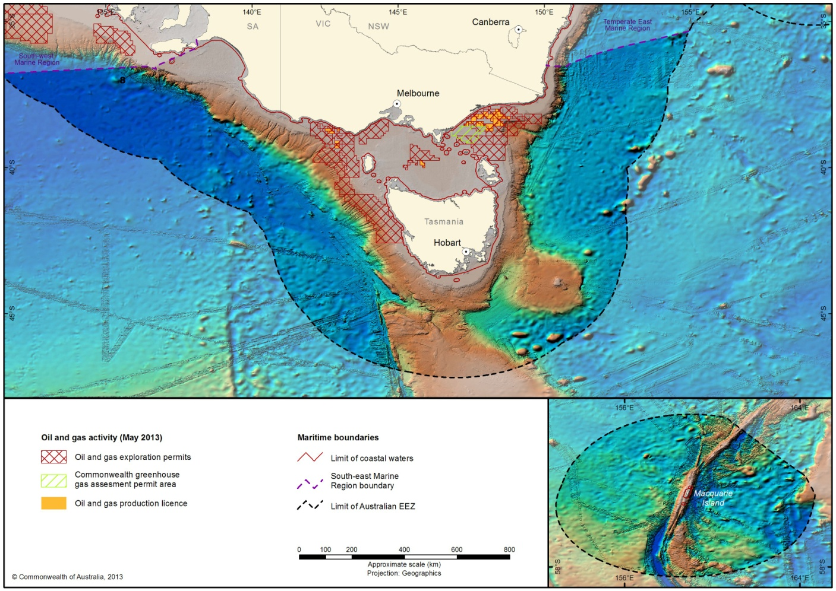
Figure 17 Oil and gas activity in the South-east Marine Region.

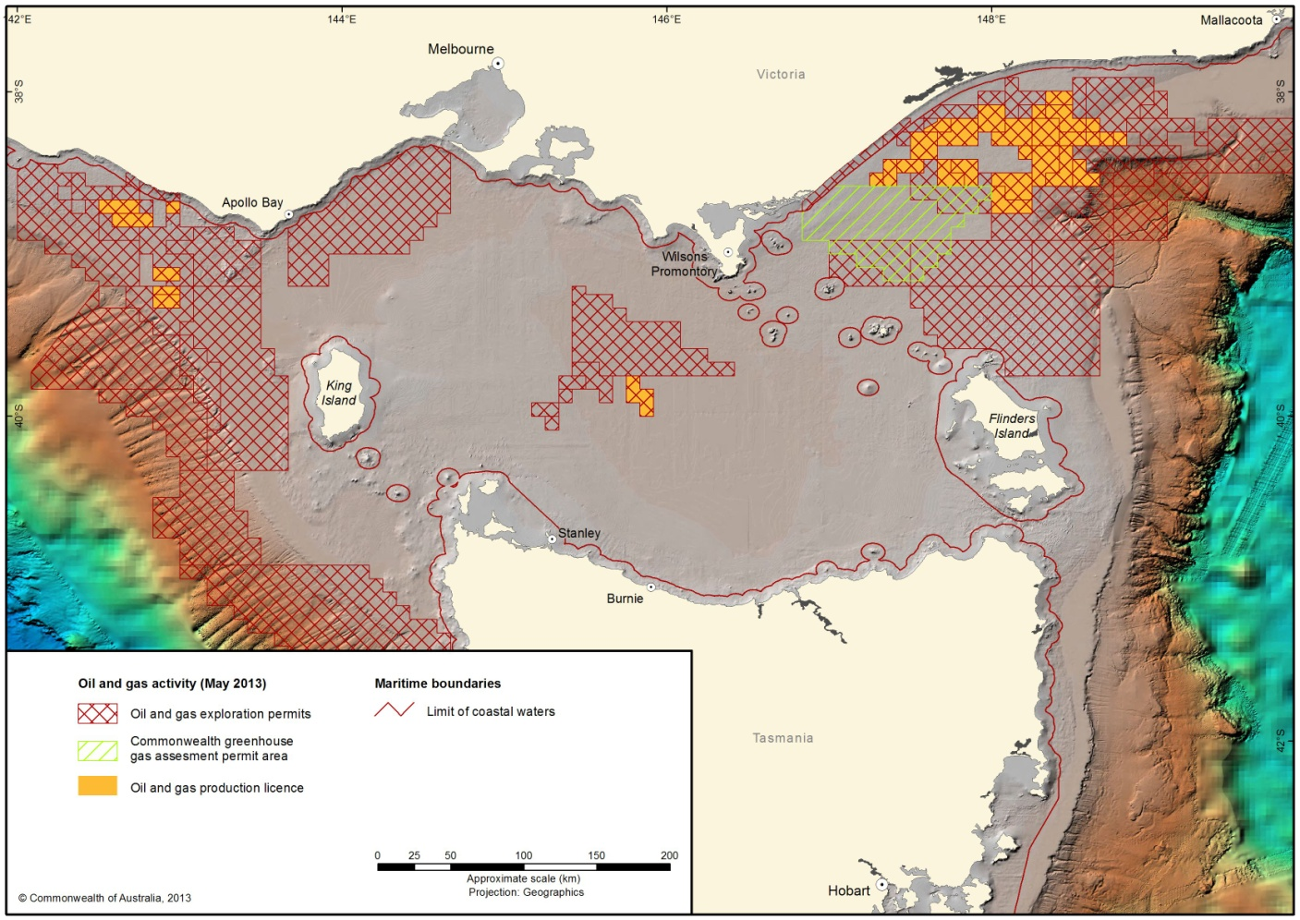
Figure 18 Oil and gas activity in Bass Strait.
In Australia, offshore petroleum operations beyond designated state and territory coastal waters are governed by the Commonwealth Offshore Petroleum and Greenhouse Gas Storage Act 2006 (OPGGSA). Within this legal framework, Australian Government entities administer the regulatory regime together with state and Northern Territory government involvement through Joint Authority arrangements.
Two additional Australian Government bodies—the National Offshore Petroleum Titles Administrator (NOPTA) and the National Offshore Petroleum Safety and Environmental Management Authority (NOPSEMA)—also perform regulatory functions under the OPGGSA and related Acts and regulations.
The offshore legislation, regulations and guidelines provide for the orderly exploration for and production of petroleum and greenhouse gas resources, and sets out a framework of rights, entitlements and responsibilities of government and industry.
In February 2014, NOPSEMA became the sole designated assessor of petroleum and greenhouse gas activities in Commonwealth waters in accordance with the Minister for the Environment’s endorsement of NOPSEMA’s environmental authorisation process under Part 10, section 146 of the EPBC Act. Under the streamlined arrangements, impacts on the following matters protected under Part 3 of the EPBC Act will be assessed solely through NOPSEMA:
• World Heritage properties
• National Heritage places
• wetlands of international importance
• listed threatened species and ecological communities
• listed migratory species
• Commonwealth marine area.
If conducted in accordance with the Program, petroleum activities such as seismic, drilling and production accepted under NOPSEMA’s processes no longer require assessment and approval under the EPBC Act. There are some areas or activities that are not included in the streamlined arrangements, including the Great Barrier Reef Marine Park and injection/ storage of greenhouse gas.
Offshore and gas exploration and extraction in Australia was valued at $21.8 billion in 2009–10 (AIMS 2012). Future years may see some expansion in oil and gas exploration and new gas production facilities in the South-east Marine Region, however it will also see the decommissioning of petroleum production facilities in the Gippsland Basin as production winds down in that area.

4.2.8 Offshore mineral exploration
One of the possible emerging industries in the Region is the undersea gathering of minerals, with deposits including coal and manganese known to occur there (Geoscience Australia 2006). Australia, through the United Nations Convention on the Law of the Sea, has the right to explore and exploit non-living resources to the limit of the Exclusive Economic Zone and additional areas of claimable continental shelf. There has been limited exploration for minerals in the Region since the 1960s. Exploration licences have been granted in the past for areas in Tasmania but only one mineral resource has been quantified, a tin deposit offshore from Ringarooma Bay, north east Tasmania (Geoscience Australia 2012).
The Commonwealth Offshore Minerals Act 1994 provides the statutory framework for the exploration for and production of minerals over the continental shelf outside state waters.

4.2.9 Sea Dumping
Materials that have been dumped in the South-east Marine Region include chemicals, ammunition and industrial waste, as well as vessels that have been abandoned or deliberately scuttled. Dumping of about six million tonnes of jarosite occurred from Pasminco’s zinc smelter in Hobart from 1966 to 1997 (National Oceans Office 2002b).
Dumping at sea in Australia is now highly regulated and permits are required. Following ratification of the London Convention of 1972, the Australian Government enacted the Environment Protection (Sea Dumping) Act 1981 to fulfil its obligations as a signatory to convention. In 1996, the Sea Dumping Act was amended to implement the 1996 Protocol to the London Convention (ratified by Australia in 2000). Under the Protocol, Australia prohibits ocean disposal of waste materials considered harmful to the marine environment, and regulates dumping of waste at sea to minimise environmental impacts.
A permit is required under the Sea Dumping Act to authorise the dumping, and the loading for the purposes of dumping, of any wastes or other matter into Australian waters, or from an Australian vessel or platform, anywhere at sea. Further information on sea dumping and legislative requirements is available at www.environment.gov.au/coasts/pollution/dumping.

4.2.10 Submarine cables and pipelines
Submarine cables in the Region are limited to the subsea floor of Bass Strait between Tasmania and the Australian mainland. The first submarine communications cable across Bass Strait was laid in 1859. There are now two operational submarine transmission line cables in Bass Strait (both Telstra fibre optic cable) as well as several obsolete telegraph and telephone cables. The Bass Strait natural gas transmission pipeline project, owned by Alinta Energy, features a 744 km subsea and underground pipeline that transports natural gas from Victoria across Bass Strait. Basslink, completed in 2006, joins the Tasmanian and national electricity grids by means of a subsea and terrestrial interconnector between Tasmania and Victoria. The Basslink interconnector is the world's second longest undersea electricity cable. Basslink also has a number of fibre optic cables which are capable of carrying high speed telecommunication and broadband voice/data.
There are a range of regulations governing the laying and protection of cables, however the EPBC Act is the main legislative instrument concerned with the environmental impact of cables. Under the EPBC Act, any proposals for submarine cables must be referred to the Minister for the Environment, for assessment and approval if they are considered likely to have a significant impact on the Commonwealth marine environment or other matters of national environmental significance.

4.2.11 Emerging industries and research
Marine biotechnology
Because of the diverse and unique species within the Region there is increasing interest in the flora and fauna for their genetic material and chemical compounds. Biotechnology is a broad term for a group of technologies based on applied biological science and includes any technique that uses living organisms (or parts of organisms) to make or modify products, to improve plants and animals, or to develop micro-organisms for specific uses. It has diverse existing and potential applications in medicine, agriculture, food processing, manufacturing, energy production and environmental management. There is likely to be increasing use of marine species as inputs in biotechnology research.
Geo-sequestration
A geo-sequestration project is currently underway on land in south-western Victoria (the C02CRC Otway Project) and there is potential to exploit depleted gas basins across the region.
Renewable energy
The renewable energy industry is growing within the South-east Marine Region and adjacent areas, including wave and wind power. Since 2004, wind energy has been rapidly exploited. Ocean energy – wave, tide and ocean thermal energy sources – is an underdeveloped but potentially substantial renewable energy source. Australia has world-class wave energy resources along its western and southern coastline, especially in Tasmania. Wave energy technologies are at early stages of commercialisation and ocean thermal technologies are still at development stage. Adoption of ocean energy in Australia depends on technologies for tidal or wave energy proving commercially viable. The cost of access to the transmission grid may also be an impediment for many sites.
Research activities
A broad range of field science is carried out in the Region aboard a diverse array of research vessels. Australian Government and state government research agencies, museums, universities and industries are active in the Region, undertaking inshore surveys, offshore biological research, climate change research, seafloor mapping and physical oceanography.
The Marine National Facility, RV Southern Surveyor, is operated by the Commonwealth Scientific and Industrial Research Organisation (CSIRO) and based out of Hobart. In 2009, the Australian Government commissioned a new ocean-going research vessel to replace the Southern Surveyor. The new vessel, RV Investigator, has commenced operation and, as with its predecessor, has its home port in Hobart.

4.2.12 Indigenous activities
Most parts of coastal Australia are of continuing cultural and spiritual significance to Indigenous people, many of whom engage in subsistence hunting, fishing and gathering and depend directly on marine resources for food. Through their involvement in commercial activities, many Indigenous people also depend on marine resources for their income.
Fishing is an important part of Indigenous culture, and a variety of methods and equipment are used, including hand gathering, lines, rods and reels, nets, traps and spears. Indigenous fishing targets a range of species of fish, shellfish, crabs and worms that are used for food, medicine or bait. Abalone, crab and lobster harvesting are important Indigenous fisheries. Indigenous people in south-eastern Australia engage in fishing and shellfish collecting on a regular basis and are involved in commercial fishing activities.
The High Court decision in the Croker Island Case (also referred to as Yarmirr) under the Native Title Act 1993 confirmed the existence of non-exclusive native title in the territorial sea. Indigenous people in the South-east Marine Region have articulated particular aspirations in terms of access rights and traditional use of marine resources, participation in management processes, and participation in the fishing sector (National Oceans Office 2002a).

4.3 Supporting information
Department of Primary Industries, Parks, Water and Environment – Commercial Fishing (2013) Available at: www.dpiw.tas.gov.au/inter/nsf/Topics/HMUY-67P723?open. Accessed 20/05/2013
Director of National Parks (2012) Draft South-east Commonwealth Marine Reserves Network management plan, Director of National Parks available online at www.environment.gov.au/marinereserves/south-east/publications/pubs/se-draft-management-plan.pdf
Victorian Fishery Status Reports. (2013) Available at: http://www.dpi.vic.gov.au/fisheries/commercial-fishing/fishery-status-report . Accessed 20/05/2013
ABARE–BRS (2013) Australian fisheries statistics 2012. ABARE-BRS, Canberra.
Andre, J, Lyle J & Hartmann K (2014) Tasmanian Scalefish Fishery Assessment 2010/12, Institute for Marine and Antarctic Studies, Hobart.
Australian Bureau of Statistics (2011) 2011 Census Quickstats. Available at www.censusdata.abs.gov.au/census_services/getproduct/census/2011/quickstat/0, Accessed 25/05/2013
Australian Bureau of Statistics (2013) 3218.0 - Regional Population Growth, Australia, 2011-12. Available at: www.abs.gov.au/ausstats/abs@.nsf/Latestproducts/3218.0Main%20Features12011-12?opendocument&tabname=Summary&prodno=3218.0&issue=2011-12&num=&view Accessed 20/05/2013
Australian Institute of Marine Science (AIMS) (2012) The AIMS Index of Marine Industry 2012. Australian Institute of Marine Science, Townsville.
Australian Petroleum Production & Exploration Association (APPEA) (2012) Key Statistics 2012. APPEA, Canberra.
Centre for Policy Development (2011) Stocking Up: Securing our marine economy. Available at: http://cpd.org.au/2011/09/stocking-up/
Ernst and Young (2009) Economic Study of Recreational Fishing in Victoria. VRFish.
FAO (2002) CWP Handbook of Fishery Statistical Standards. Section J: AQUACULTURE. CWP Data Collection. FAO Fisheries and Aquaculture Department, Rome.
Georgeson L, Stobutzki I & Curtotti R (eds) 2014, Fishery status reports 2013–14, Australian Bureau of Agricultural and Resource Economics and Sciences, Canberra.
Geoscience Australia (2006) Australian Offshore Mineral Locations Map, August 2006. available at: https://www.ga.gov.au/products/servlet/controller?event=GEOCAT_DETAILS&catno=64757. Accessed 31/05/2013
Geoscience Australia (2012) Australian Mines Atlas, available at: http://www.australianminesatlas.gov.au/index.html. Accessed 31/05/2013
Gooday P, Galeano D, Brown D and Grist P (2001) Economic value of commercial fishing in Australia’s southeast. ABARE report to the Fisheries Resources Research Fund, Canberra.
Henry GW and Lyle JM (eds) (2003) The National Recreational and Indigenous Fishing Survey. Australian Government Department of Agriculture, Fisheries and Forestry, Canberra
Linnane, A, Chick, RC, Walker, T, Trinnie, F & Reilly, D (2013) Victorian Rock Lobster and Giant Crab Fisheries Fishery Status Report – 2-11/2012 Fishing Year, Fishery status report to Fisheries Victoria, South Australian Research and Development Institute (Aquatic Sciences), Adelaide, SARDI Publication No. F2012/000434-2, SARDI research report series no. 744 pp.36
Lyle JM, Tracey SR, Stark KE and Wotherspoon S (2009) 2007-08 survey of recreational fishing in Tasmania, Tasmanian Aquaculture and Fisheries Institute, University of Tasmania. Available online at www.dpiw.tas.gov.au/inter.nsf/Attachments/VWAS-8FQ4A2/$FILE/TAS_recsurvey0708report.pdf
National Oceans Office (2002a) Sea Country: An Indigenous Perspective – The South-east Regional Marine Plan Assessment Reports. National Oceans Office, Hobart
National Oceans Office (2002b) Resources – using the ocean, The South-east Regional Marine Plan Assessment Reports. National Oceans Office, Hobart
National Oceans Office (2004) South-east Regional Marine Plan Implementing Australia's oceans policy in the South-east Marine Region available online at: www.environment.gov.au/coasts/mbp/publications/south-east/sermp.html.
Tourism Tasmania (2011) 2010-11 Tasmanian Cruise Ship Survey. Tourism Tasmania, Hobart.
Victorian Coastal Council (2014) Victorian Coastal Strategy 2014. Victorian Coastal Council, Melbourne

Abbreviations and acronyms
ABS Australian Bureau of Statistics
ACAP The Agreement on the Conservation of Albatross and Petrels
AFMA Australian Fisheries Management Authority
AFZ Australian Fishing Zone
AMSA Australian Maritime Safety Authority
APEC Australian Pacific Economic Cooperation
BIA biologically important area
CAMBA Agreement between the Government of Australia and the Government of the People’s Republic of China for the Protection of Migratory Birds and their Environment 1986
CBD The Convention on Biological Diversity
CCAMLR Commission for the Conservation of Antarctic Marine Living Resources
CCSBT Commission for the Conservation of Southern Bluefin Tuna
CITES Convention on International Trade in Endangered Species of Wild Fauna and Flora
CMS Convention on Migratory Species (also known as the Convention on the Conservation of Migratory Species of Wild Animals or the Bonn Convention)
CSIRO Commonwealth Scientific and Industrial Research Organisation
EPBC Act Environment Protection and Biodiversity Conservation Act 1999
EEZ Exclusive Economic Zone
FAO Food and Agricultural Organisation
KEF key ecological feature
IMCRA Integrated Marine and Coastal Regionalisation of Australia
IMO International Maritime Organisation
IUCN International Union for the Conservation of Nature and Natural Resources (World Conservation Union)
IUU Illegal, unregulated and unreported (fishing)
IWC International Whaling Commission
JAMBA Agreement between the Government of Australia and the Government of Japan for the Protection of Migratory Birds in Danger of Extinction and their Environment 1974
MARPOL International Convention for the Prevention of Marine Pollution from Ships, 1973, as modified by the Protocol of 1978 relating thereto
NTA Native Title Act
OPGGS Act Offshore Petroleum and Greenhouse Gas Storage Act 2006
Ramsar Convention on Wetlands of International Importance (Ramsar Convention 1971)
ROKAMBA Agreement between the Government of Australia and the Government of the Republic of Korea – on the Protection of Migratory Birds, 2007
UN United Nations
UNCLOS United Nations Convention on the Law of the Sea
UNFCCC United Nations Framework Convention on Climate Change

Glossary
Anthropogenic
Of human origin or resulting from human activity.
Australian Whale Sanctuary
The Australian Whale Sanctuary was established under the EPBC Act to protect all whales and dolphins in Australian waters. The Australian Whale Sanctuary comprises the Commonwealth marine area and covers all of Australia’s Exclusive Economic Zone which generally extends out to 200 nm from the coast and includes the waters surrounding Australia’s external territories such as Christmas, Cocos (Keeling), Norfolk, Heard and Macdonald Islands. Within the Australian Whale Sanctuary it is an offence to kill, injure or interfere with a cetacean. Severe penalties apply to anyone convicted of such offences. More information about the Australian Whale Sanctuary can be found at www.environment.gov.au/coasts/species/cetaceans/conservation/sanctuary.html
ballast water
Water carried in tanks to maintain stability when a ship is lightly loaded. It is normally discharged to the marine environment when the ship is loaded with cargo.
biodiversity
Biodiversity is defined under the EPBC Act as the variability among living organisms from all sources (including terrestrial, marine and other ecosystems and ecological complexes they are part of). This includes diversity within species and between species, and diversity of ecosystems.
biofouling
Undesirable growth of marine organisms on underwater surfaces such as ship hulls and man-made infrastructure.
biogeographic
Relating to large, geographic regions with distinct fauna and flora.
biologically important areas
These are areas that are particularly important for the conservation of protected species and where aggregations of individuals display biologically important behaviour such as breeding, foraging, resting or migration. The presence of the observed behaviour is assumed to indicate that the habitat required for the behaviour is also present. Regional advice (Schedule 2) has been developed for biologically important areas due to their relevance to a protected species. However, regional advice focused on these areas should not be construed to mean that legislative obligations do not apply outside these areas. Biologically important areas should not be confused with 'critical habitat' as defined in the EPBC Act.
bioregion
A large area that has similar types of plants, animals and ocean conditions within its boundaries, but different from other similarly sized areas. In this document, ‘bioregion’ means provincial bioregion as defined in the Integrated Marine and Coastal Regionalisation of Australia Version 4.0.
breeding area
In the context of BIA mapping, a breeding area is an area that encompasses breeding sites and areas where the species is likely to forage to provision young.
bycatch
All non-targeted catch from fishing operations, including by-product, discards and gear interactions. By-product refers to the unintended catch that may be kept or sold by the fisher. Discards refer to the product that is returned to the sea. Gear interactions refer to all species and habitat affected by the fishing gear (includes hooking and entanglement).
cetaceans
Marine mammals of the suborder Cetacea – including whales, dolphins and porpoises. All are protected under the EPBC Act in the Australian Whale Sanctuary and, to some extent, beyond its outer limits.
Commonwealth marine area
Also known as Commonwealth waters. As defined under section 24 of the EPBC Act:
Each of the following is a Commonwealth marine area:
(a) any waters of the sea inside the seaward boundary of the exclusive economic zone, except:
(i) waters, rights in respect of which have been vested in a State by section 4 of the Coastal Waters (State Title) Act 1980 or in the Northern Territory by section 4 of the Coastal Waters (Northern Territory Title) Act 1980; and
(ii) waters within the limits of a State or the Northern Territory;
(b) the seabed under waters covered by paragraph (a);
(c) airspace over waters covered by paragraph (a);
(d) any waters over the continental shelf, except:
(i) waters, rights in respect of which have been vested in a State by section 4 of the Coastal Waters (State Title) Act 1980 or in the Northern Territory by section 4 of the Coastal Waters (Northern Territory Title) Act 1980; and
(ii) waters within the limits of a State or the Northern Territory; and
(iii) waters covered by paragraph (a);
(e) any seabed under waters covered by paragraph (d);
(f) any airspace over waters covered by paragraph (d);
(g) any other area of sea or seabed that is included in a Commonwealth reserve.
conservation dependent
As defined under the EPBC Act (section 179): A native species is eligible to be included in the conservation dependent category at a particular time if, at that time:
(a) the species is the focus of a specific conservation program the cessation of which would result in the species becoming vulnerable, endangered or critically endangered; or
(b) the following subparagraphs are satisfied:
(i) the species is a species of fish;
(ii) the species is the focus of a plan of management that provides for management actions necessary to stop the decline of, and support the recovery of, the species so that its chances of long term survival in nature are maximised;
(iii) the plan of management is in force under a law of the Commonwealth or of a State or Territory;
(iv) cessation of the plan of management would adversely affect the conservation status of the species.
conservation values
For the purpose of marine bioregional planning, conservation values are defined as those elements of the region that are either specifically protected under the EPBC Act (such as species or places), have heritage values for the purposes of the EPBC Act or have been identified through the planning process as key ecological features in the Commonwealth marine environment. Although key ecological features are not specifically protected under the EPBC Act, the marine environment as a whole is a matter of national environmental significance under the Act.
critical habitat
A register of critical habitat is maintained under the EPBC Act. The register lists habitats considered critical to the survival of a listed threatened species or listed threatened ecological community. If a habitat occurs in or on a Commonwealth area and is listed in the register, it is an offence under the EPBC Act to take an action when it is known that the action significantly damages the critical habitat.
critically endangered
As defined under the EPBC Act (section 179): A native species is eligible to be included in the critically endangered category at a particular time if, at that time, it is facing an extremely high risk of extinction in the wild in the immediate future, as determined in accordance with the prescribed criteria.
ecological community
As defined under the EPBC Act, an ecological community is an assemblage of native species that: (a) inhabits a particular area in nature; and (b) meets the additional criteria specified in the regulations (if any) made for the purposes of this definition. More broadly, an ecological community is a group of species that commonly occur together in a way that is recognisably different from other groups.
ecologically significant population
This term applies to protected species listed as migratory. In accordance with Policy Statement 1.1: Significant impact guidelines—matters of national environmental significance (2009), for migratory listed species, consideration should be given to whether an ecologically significant proportion of a population is found in an area. Whether the species in an area represents an ecologically significant population needs to be determined on a case-by-case basis, as different species have different life histories and populations. Some key factors that should be considered include the species’ population status, genetic distinctiveness and species-specific behavioural patterns (for example, site fidelity and dispersal rates).
ecosystem approach
The ecosystem approach is one of the most important principles of sustainable environmental management. Essentially, it recognises that all elements of an ecosystem are interconnected and requires that the effects of actions on the different elements of an ecosystem be taken into consideration in decision-making.
Ecosystems are complex and interconnected—what affects one species or habitat will have cascading and possibly unpredictable implications for other species or habitats. In addition, different activities within a marine environment may affect different parts of the interconnected whole or amplify the impacts on particular parts of the natural system.
In order to prevent problems rather than react to them, the ecosystem approach seeks to address the drivers of biodiversity loss, rather than their symptoms. A focus on building and maintaining the resilience of ecosystems is more efficient and effective than addressing problems after they have occurred.
ecosystem services
The functioning of natural ecosystems provides services essential to human survival and well-being. Natural ecosystems maintain the atmosphere; provide clean water; control soil erosion, pollution and pests; pollinate plants; and provide many other essential processes.
endangered species
As defined under the EPBC Act (Section 179): A native species is eligible to be included in the endangered category at a particular time if, at that time:
(a) it is not critically endangered; and
(b) it is facing a very high risk of extinction in the wild in the near future, as determined in accordance with the prescribed criteria.
Environment minister/environment department:
The minister and department administering the Environment Protection and Biodiversity Conservation Act 1999.
exclusive economic zone
The sovereign waters of a nation, recognised internationally under the United Nations Convention on the Law of the Sea as extending from the edge of the Territorial Sea (12 nautical miles from shore) out to 200 nautical miles from shore.
extinct
As defined under the EPBC Act (Section 179): A native species is eligible to be included in the extinct category at a particular time if, at that time, there is no reasonable doubt that the last member of the species has died.
extinct in the wild
As defined under the EPBC Act (Section 179): A native species is eligible to be included in the extinct in the wild category at a particular time if, at that time:
It is known only to survive in cultivation, in captivity or as an naturalised population well outside its past range; or
It has not been recorded in its known and/or expected habitat, at appropriate seasons, anywhere in its past range, despite exhaustive surveys over a time frame appropriate to its life cycle and form
extraction of living resources
Extraction of living resources includes the removal of target and byproduct species via a number of sources: commercial fishing; recreational and charter fishing; illegal, unregulated and unreported (IUU) fishing; Indigenous harvest; Commercial fishing – prey depletion; Commercial, recreational and charter fishing – fisheries discards.
feeding areas
In the context of biologically important area (BIA) mapping, feeding areas are distinguished from foraging areas because feeding areas are frequently more spatially constrained areas and have a more significant value because the species actively feeds, rather than opportunistically searches for food, as its prey species are reliably available there, even if seasonally.
important population
This term relates to populations of threatened species that are categorised as vulnerable under the EPBC Act. An important population is a population that is necessary for a species’ long-term survival and recovery. This may include populations identified as such in recovery plans, and/or populations that are:
- key source populations either for breeding or dispersal
- necessary for maintaining genetic diversity
- near the limit of the species’ range.
key ecological features
Key ecological features are elements of the Commonwealth marine environment that, based on current scientific understanding, are considered to be of regional importance for either the region’s biodiversity or ecosystem function and integrity.
For the purpose of marine bioregional planning, key ecological features of the marine environment meet one or more of the following critieria:
a species, group of species or community with a regionally important ecological role, where there is specific knowledge about why the species of species group is important to the ecology of the region, and the spatial and temporal occurrence of the species or species group is known
a species, group of species or community that is nationally or regionally important for biodiversity, where there is specific knowledge about why the species or species group is regionally or nationally important for biodiversity, and the spatial and temporal occurrence of the species or species group is known
an area of habitat that is nationally or regionally important for:
enhanced or high biological productivity (see definition in glossary)
aggregations of marine life
biodiversity and endemism
a unique seafloor feature with ecological properties of regional significance
invasive species
A species occurring, as a result of human activities, beyond its accepted normal distribution and which threatens valued environmental, agricultural or other social resources by the damage it causes.
marine debris
Marine debris is defined in the Threat Abatement Plan for the impacts of marine debris on vertebrate marine life May 2009 and refers to ‘land-sourced plastic garbage, fishing gear from recreational and commercial fishing abandoned into the sea, and ship-sourced, solid non-biodegradable floating materials disposed at sea’. In concordance with International Convention for the Prevention of Pollution from Ships, 1973 as modified by the Protocol of 1978 (MARPOL 73/78), plastic material is defined as bags, bottles, strapping bands, sheeting synthetic ropes, synthetic fishing nets, floats, fibreglass, piping, insulation, paints and adhesives.
Matters of national environmental significance
The matters of national environmental significance protected under the EPBC Act are:
World heritage properties
National heritage places
Wetlands of international importance (listed under the Ramsar Convention)
Listed threatened species (except those listed as extinct or conservation dependent) and ecological communities (except those listed as vulnerable)
Migratory species protected under international agreements
The Commonwealth marine environment
The Great Barrier Reef Marine Park
Nuclear actions
marine pests
introduced marine pests are marine plants or animals that are not native to Australia but have been introduced by human activities such as shipping.
MoU Box
A Memorandum of Understanding (MoU) exists between Indonesia and Australia which provides for continued Indonesian traditional fishing activities in an area known as the MoU Box. The MoU Box is an area 50 000 km2 within the Australia’s Exclusive Economic Zone (EEZ). Six coral reef systems exist within the MoU Box including Ashmore and Cartier Reefs (in the north of the area) and the Scott and Seringapatam reefs.
nuisance species
Nuisance species are opportunistic native species (e.g. seagulls) whose populations boom when humans modify the ecosystem by increasing food supply.
population
A population of a species is defined under the EPBC Act as an occurrence of the species in a particular area. In relation to species that are categorised as critically endangered, endangered or vulnerable threatened species (ie matters of national environmental significance), occurrences include but are not limited to:
- a geographically distinct regional population or collection of local populations
- a population or collection of local populations that occurs within a particular bioregion
productivity
productivity (or biological productivity) is the process through which algae and seagrasses transform inorganic nutrients into organic matter through photosynthesis. This process is at the basis of the ocean’s food web, as phytoplankton and algae are consumed respectively by zooplankton and grazing organisms and these in turn are consumed by larger and larger predators. Nutrient-rich waters promote and support productivity.
proponent
In the context of the EPBC Act, this refers to the person who is proposing an action (as designated under Division 2 of Part 7 of the Act).
protected places
Protected places are those protected under the EPBC Act as matters of national environmental significance (places listed as world heritage properties, national heritage places or wetlands of international importance), Commonwealth marine reserves and places deemed to have heritage values in the Commonwealth marine environment (such as places on the Commonwealth Heritage List or shipwrecks under the Historic Shipwrecks Act 1976).
protected species
Species listed under the EPBC Act are commonly referred to as protected species. Under the Act, protected species may be listed as threatened, migratory or marine species. All cetaceans (whales, dolphins and porpoises) are protected under the EPBC Act in the Australian Whale Sanctuary (see definition above) (and, to some extent, beyond its outer limits). It is an offence to kill, injure, take, trade, keep or move a listed species without authorisation.
Protected species that are listed as threatened (other than those categorised as extinct or conservation dependent) and migratory species are matters of national environmental significance. Species listed under the EPBC Act that are not matters of national environmental significance include those species that are listed as:
marine (s. 248 of the EPBC Act)
cetaceans (whales, dolphins and porpoises) that are not otherwise categorised as critically endangered, endangered or vulnerable
threatened species categorised as extinct or conservation dependent
province
A large-scale biogeographic unit derived from evolutionary processes in which suites of endemic species coexist (see bioregion).
Ramsar-listed wetlands
The Convention on Wetlands of International Importance, known as the Ramsar Convention, was signed in 1971 in Ramsar, Iran, and is an intergovernmental treaty which provides the framework for national action and international cooperation for the conservation and wise use of wetlands and their resources.
seismic
Relating to earthquakes or other vibrations of the Earth and its crust. Also relates to geological surveying methods that involve vibrations produced artificially by explosions. A seismic source generates controlled seismic energy that is used in seismic surveys. A seismic source can be simple, such as dynamite, or it can use more sophisticated technology, such as a specialised air gun. The source provides a pulse of energy that generates seismic waves, which travel through a medium such as water or layers of rocks. Some of the waves then reflect and refract to receivers, such as geophones or hydrophones, providing information on structures and stratigraphy. This information can be used to locate potential mineral deposits or petroleum sources.
significant impact
The term ‘significant impact’ is relevant to the EPBC Act and is an impact which is important, notable, or of consequence, having regard to its context or intensity. Whether or not an action is likely to have a significant impact depends upon the sensitivity, value and quality of the environment which is impacted, and upon the intensity, duration, magnitude and geographic extent of the impacts.
State/Territory waters
State or Territory waters are a belt of water that extends from the territorial sea baseline for three nautical miles seawards, and are under the jurisdiction of the adjacent Australian State or Territory. The normal territorial sea baseline is the low water mark measured along the coast.
vulnerable species
As defined by the EPBC Act (Section 179): A native species is eligible to be included in the vulnerable category at a particular time if, at that time:
(a) it is not critically endangered or endangered; and
(b) it is facing a high risk of extinction in the wild in the medium-term future, as determined in accordance with the prescribed criteria.

Map data sources

DSEWPaC (2013): Key Ecological Features in the South-East Marine Region

DSEWPaC (2012): Australia’s Network of Commonwealth Marine Reserves

Encom Petroleum Information (2012): GPInfo Petroleum exploration database

DSEWPaC (2011): Australia, World Heritage Areas

DSEWPaC (2011): Bathomes in Australian waters

Australian Bureau of Statistics (2011): Estimated Resident Populations

Australian Maritime Safety Authority (2010): Australian Ship Reporting Records

DSEWPaC (2010): Historic Shipwrecks Register

National Native Title Tribunal (2010): Native Title Determinations

DSEWPaC (2007): Commonwealth Marine Protected Areas Managed by DSEWPaC

Australian Hydrographic Office (2007): Military Practice and Exercise Areas

DSEWPaC (2006): Integrated Marine and Coastal Regionalisation of Australia v4.0

DSEWPaC (2006): Commonwealth Marine Planning Regions

Geoscience Australia (2006): Australian Maritime Boundaries (AMB) v2.0

Geoscience Australia (2009): Australian Bathymetry and Topography

Geoscience Australia (2004): Gazetteer of Australia

Geoscience Australia (2004): Geomorphic features of the EEZ

Geoscience Australia (2003): Australia, TOPO-2.5M Topographic Data

Bureau of Resource Sciences (2001): Australian National Recreational and Indigenous Fishing Survey

DSEWPaC (1998): Sea dumped waste material off Australia and its territories

Aboriginal Studies Press, AIATSIS (1996): Aboriginal Australia Map

Appendix A Nationally protected species in the South-east Marine Region
Species listed under the Environment Protection and biodiversity Conservation Act 1999 (EPBC Act) are commonly referred to as protected species because it is an offence to kill, injure, take, trade, keep or move a listed species without authorisation. Under the EPBC Act, species can be listed as threatened, migratory, cetaceans, or as marine species:
Threatened species are those species that have been identified as being in danger of becoming extinct. Threatened species can be listed as being Extinct; Extinct in the Wild; Critically Endangered; Endangered, Vulnerable; or Conservation Dependant.
Migratory species are those species that are listed under:
- Convention on the Conservation of Migratory Species of Wild Animals 1979 (CMS or the Bonn convention)
- Agreement between the Government of Australia and the Government of Japan for the Protection of Migratory Birds in Danger of Extinction and their Environment 1974 (JAMBA)
- Agreement between the Government of Australia and the government of the People’s Republic of China for the Protection of Migratory Birds and their Environment 1986 (CAMBA)
- Agreement between the Government of Australia and the Government of the Republic of Korea on the Protection of Migratory Birds, 2007 (ROKAMBA)
- Any other international agreement, or instrument made under other international agreements approved by the Minister for the Environment.
Cetaceans – whales, dolphins, and porpoise – are protected under the EPBC Act to ensure their long-term conservation.
- Listed marine species are those species that the Australian Government recognises as requiring protection to ensure their long-term conservation (in accordance with Section 248 of the EPBC Act). Listed marine species occurring in the South-east Marine Region include:cetaceans
- seabirds (seabirds, shorebirds, waterbirds and a number of other coastal or migratory birds that occur naturally in marine environment)
- bony fish
- seahorses, pipehorses, pipefish and seadragons
- sharks
- marine turtles
In addition, the EPBC Act regulates the international movement of wildlife and wildlife products, including:
- export of Australian native species other than those identified as exempt
- export and import of species included in the Appendices to the Convention on International Trade in Endangered Species of Wild Fauna and Flora 1973 (CITES)
- import of live plants and animals that (if they became established in Australia) could adversely affect native species or their habitats.

Species Group | Scientific Name | Common Name | Conservation Status Under the EPBC Act | Use of South-east Marine Region
Bony fishes | Brachionichthys hirsutus | Spotted Handfish, Spotted-hand Fish | Critically Endangered | Species or species habitat likely to occur within area
Bony fishes | Epinephelus daemelii | Black Rockcod, Black Cod, Saddled Rockcod | Vulnerable | Species or species habitat may occur within area
Bony fishes | Hoplostethus atlanticus | Orange Roughy, Deep-sea Perch, Red Roughy | Conservation Dependent | Species or species habitat may occur within area
Bony fishes | Prototroctes maraena | Australian Grayling | Vulnerable | Species or species habitat may occur within area
Bony fishes | Rexea solandri | Eastern Gemfish | Conservation Dependent | Species or species habitat may occur within area
Bony fishes | Thunnus maccoyii | Southern Bluefin Tuna | Conservation Dependent | Species or species habitat likely to occur within area
Bony fishes | Thymichthys politus | Red Handfish | Critically Endangered | Species or species habitat may occur within area
Sharks | Carcharias taurus | Grey Nurse Shark (east coast population) | Critically Endangered | Species or species habitat may occur within area
Sharks | Carcharodon carcharias | Great White Shark | Vulnerable, Migratory | Species or species habitat likely to occur within area
Sharks | Centrophorus zeehaani | Southern Dogfish | Conservation Dependent | Species or species habitat known to occur within area
Sharks | Centrophorus harrissoni | Harrison’s Dogfish | Conservation Dependent | Species or species habitat known to occur within area
Sharks | Galeorhinus galeus | School Shark, Eastern School Shark, Snapper Shark, Tope, Soupfin Shark | Conservation Dependent | Species or species habitat may occur within area
Sharks | Isurus oxyrinchus | Shortfin Mako, Mako Shark | Migratory | Species or species habitat likely to occur within area
Sharks | Lamna nasus | Porbeagle, Mackerel Shark | Migratory | Species or species habitat likely to occur within area
Sharks | Rhincodon typus | Whale Shark | Vulnerable | Species or species habitat may occur within area
Pipefish and sea horses | Acentronura australe | Southern Pygmy Pipehorse | Marine | Species or species habitat may occur within area
Pipefish and sea horses | Acentronura tentaculata | Shortpouch Pygmy Pipehorse | Marine | Species or species habitat may occur within area
Pipefish and sea horses | Campichthys galei | Gale's Pipefish | Marine | Species or species habitat may occur within area
Pipefish and sea horses | Campichthys tryoni | Tryon's Pipefish | Marine | Species or species habitat may occur within area
Pipefish and sea horses | Cosmocampus howensis | Lord Howe Pipefish | Marine | Species or species habitat may occur within area
Pipefish and sea horses | Filicampus tigris | Tiger Pipefish | Marine | Species or species habitat may occur within area
Pipefish and sea horses | Heraldia nocturna | Upside-down Pipefish, Eastern Upside-down Pipefish | Marine | Species or species habitat may occur within area
Pipefish and sea horses | Hippocampus abdominalis | Big-belly Seahorse, Eastern Potbelly Seahorse, New Zealand Potbelly Seahorse | Marine | Species or species habitat may occur within area
Pipefish and sea horses | Hippocampus breviceps | Short-head Seahorse, Short-snouted Seahorse | Marine | Species or species habitat may occur within area
Pipefish and sea horses | Hippocampus minotaur | Bullneck Seahorse | Marine | Species or species habitat may occur within area
Pipefish and sea horses | Hippocampus whitei | White's Seahorse, Crowned Seahorse, Sydney Seahorse | Marine | Species or species habitat may occur within area
Pipefish and sea horses | Histiogamphelus briggsii | Crested Pipefish, Briggs' Crested Pipefish, Briggs' Pipefish | Marine | Species or species habitat may occur within area
Pipefish and sea horses | Histiogamphelus cristatus | Rhino Pipefish, Macleay's Crested Pipefish, Ring-back Pipefish | Marine | Species or species habitat may occur within area
Pipefish and sea horses | Hypselognathus horridus | Shaggy Pipefish, Prickly Pipefish | Marine | Species or species habitat may occur within area
Pipefish and sea horses | Hypselognathus rostratus | Knifesnout Pipefish, Knife-snouted Pipefish | Marine | Species or species habitat may occur within area
Pipefish and sea horses | Kaupus costatus | Deepbody Pipefish, Deep-bodied Pipefish | Marine | Species or species habitat may occur within area
Pipefish and sea horses | Kimblaeus bassensis | Trawl Pipefish, Bass Strait Pipefish | Marine | Species or species habitat may occur within area
Pipefish and sea horses | Leptoichthys fistularius | Brushtail Pipefish | Marine | Species or species habitat may occur within area
Pipefish and sea horses | Lissocampus caudalis | Australian Smooth Pipefish, Smooth Pipefish | Marine | Species or species habitat may occur within area
Pipefish and sea horses | Lissocampus runa | Javelin Pipefish | Marine | Species or species habitat may occur within area
Pipefish and sea horses | Maroubra perserrata | Sawtooth Pipefish | Marine | Species or species habitat may occur within area
Pipefish and sea horses | Mitotichthys mollisoni | Mollison's Pipefish | Marine | Species or species habitat may occur within area
Pipefish and sea horses | Mitotichthys semistriatus | Halfbanded Pipefish | Marine | Species or species habitat may occur within area
Pipefish and sea horses | Mitotichthys tuckeri | Tucker's Pipefish | Marine | Species or species habitat may occur within area
Pipefish and sea horses | Notiocampus ruber | Red Pipefish | Marine | Species or species habitat may occur within area
Pipefish and sea horses | Phycodurus eques | Leafy Seadragon | Marine | Species or species habitat may occur within area
Pipefish and sea horses | Phyllopteryx taeniolatus | Common Seadragon, Weedy Seadragon | Marine | Species or species habitat may occur within area
Pipefish and sea horses | Pugnaso curtirostris | Pugnose Pipefish, Pug-nosed Pipefish | Marine | Species or species habitat may occur within area
Pipefish and sea horses | Solegnathus robustus | Robust Pipehorse, Robust Spiny Pipehorse | Marine | Species or species habitat may occur within area
Pipefish and sea horses | Solegnathus spinosissimus | Spiny Pipehorse, Australian Spiny Pipehorse | Marine | Species or species habitat may occur within area
Pipefish and sea horses | Solenostomus paegnius | Rough-snout Ghost Pipefish | Marine | Species or species habitat may occur within area
Pipefish and sea horses | Stigmatopora argus | Spotted Pipefish, Gulf Pipefish | Marine | Species or species habitat may occur within area
Pipefish and sea horses | Stigmatopora nigra | Widebody Pipefish, Wide-bodied Pipefish, Black Pipefish | Marine | Species or species habitat may occur within area
Pipefish and sea horses | Stipecampus cristatus | Ringback Pipefish, Ring-backed Pipefish | Marine | Species or species habitat may occur within area
Pipefish and sea horses | Syngnathoides biaculeatus | Double-end Pipehorse, Double-ended Pipehorse, Alligator Pipefish | Marine | Species or species habitat may occur within area
Pipefish and sea horses | Urocampus carinirostris | Hairy Pipefish | Marine | Species or species habitat may occur within area
Pipefish and sea horses | Vanacampus margaritifer | Mother-of-pearl Pipefish | Marine | Species or species habitat may occur within area
Pipefish and sea horses | Vanacampus phillipi | Port Phillip Pipefish | Marine | Species or species habitat may occur within area
Pipefish and sea horses | Vanacampus poecilolaemus | Longsnout Pipefish, Australian Long-snout Pipefish, Long-snouted Pipefish | Marine | Species or species habitat may occur within area
Pipefish and sea horses | Vanacampus vercoi | Verco's Pipefish | Marine | Species or species habitat may occur within area
Whales and dolphins | Balaenoptera acutorostrata | Minke Whale | Cetacean | Species or species habitat may occur within area
Whales and dolphins | Balaenoptera bonaerensis | Antarctic Minke Whale, Dark-shoulder Minke Whale | Cetacean, Migratory | Species or species habitat may occur within area
Whales and dolphins | Balaenoptera borealis | Sei Whale | Vulnerable, Cetacean, Migratory | Species or species habitat may occur within area
Whales and dolphins | Balaenoptera edeni | Bryde's Whale | Cetacean, Migratory | Species or species habitat may occur within area
Whales and dolphins | Balaenoptera musculus | Blue Whale | Endangered, Cetacean, Migratory | Foraging, feeding or related behaviour known to occur within area
Whales and dolphins | Balaenoptera physalus | Fin Whale | Vulnerable, Cetacean, Migratory | Species or species habitat may occur within area
Whales and dolphins | Berardius arnuxii | Arnoux's Beaked Whale | Cetacean | Species or species habitat may occur within area
Whales and dolphins | Caperea marginata | Pygmy Right Whale | Cetacean, Migratory | Species or species habitat may occur within area
Whales and dolphins | Delphinus delphis | Common Dolphin, Short-beaked Common Dolphin | Cetacean | Species or species habitat may occur within area
Whales and dolphins | Eubalaena australis | Southern Right Whale | Endangered, Cetacean, Migratory | Breeding known to occur within area
Whales and dolphins | Globicephala macrorhynchus | Short-finned Pilot Whale | Cetacean | Species or species habitat may occur within area
Whales and dolphins | Globicephala melas | Long-finned Pilot Whale | Cetacean | Species or species habitat may occur within area
Whales and dolphins | Grampus griseus | Risso's Dolphin, Grampus | Cetacean | Species or species habitat may occur within area
Whales and dolphins | Hyperoodon planifrons | Southern Bottlenose Whale | Cetacean | Species or species habitat may occur within area
Whales and dolphins | Kogia breviceps | Pygmy Sperm Whale | Cetacean | Species or species habitat may occur within area
Whales and dolphins | Kogia simus | Dwarf Sperm Whale | Cetacean | Species or species habitat may occur within area
Whales and dolphins | Lagenorhynchus cruciger | Hourglass Dolphin | Cetacean | Species or species habitat may occur within area
Whales and dolphins | Lagenorhynchus obscurus | Dusky Dolphin | Cetacean, Migratory | Species or species habitat may occur within area
Whales and dolphins | Lissodelphis peronii | Southern Right Whale Dolphin | Cetacean | Species or species habitat may occur within area
Whales and dolphins | Megaptera novaeangliae | Humpback Whale | Vulnerable, Cetacean, Migratory | Congregation or aggregation known to occur within area
Whales and dolphins | Mesoplodon bowdoini | Andrew's Beaked Whale | Cetacean | Species or species habitat may occur within area
Whales and dolphins | Mesoplodon densirostris | Blainville's Beaked Whale, Dense-beaked Whale | Cetacean | Species or species habitat may occur within area
Whales and dolphins | Mesoplodon ginkgodens | Gingko-toothed Beaked Whale, Gingko-toothed Whale, Gingko Beaked Whale | Cetacean | Species or species habitat may occur within area
Whales and dolphins | Mesoplodon grayi | Gray's Beaked Whale, Scamperdown Whale | Cetacean | Species or species habitat may occur within area
Whales and dolphins | Mesoplodon hectori | Hector's Beaked Whale | Cetacean | Species or species habitat may occur within area
Whales and dolphins | Mesoplodon layardii | Strap-toothed Beaked Whale, Strap-toothed Whale, Layard's Beaked Whale | Cetacean | Species or species habitat may occur within area
Whales and dolphins | Mesoplodon mirus | True's Beaked Whale | Cetacean | Species or species habitat may occur within area
Whales and dolphins | Orcinus orca | Killer Whale, Orca | Cetacean, Migratory | Species or species habitat may occur within area
Whales and dolphins | Phocoena dioptrica | Spectacled Porpoise | Cetacean, Migratory | Species or species habitat may occur within area
Whales and dolphins | Physeter macrocephalus | Sperm Whale | Cetacean, Migratory | Foraging, feeding or related behaviour known to occur within area
Whales and dolphins | Pseudorca crassidens | False Killer Whale | Cetacean | Species or species habitat may occur within area
Whales and dolphins | Tasmacetus shepherdi | Shepherd's Beaked Whale, Tasman Beaked Whale | Cetacean | Species or species habitat may occur within area
Whales and dolphins | Tursiops aduncus | Indian Ocean Bottlenose Dolphin, Spotted Bottlenose Dolphin | Cetacean | Species or species habitat likely to occur within area
Whales and dolphins | Tursiops truncatus | Bottlenose Dolphin | Cetacean | Species or species habitat may occur within area
Whales and dolphins | Ziphius cavirostris | Cuvier's Beaked Whale, Goose-beaked Whale | Cetacean | Species or species habitat may occur within area
Pinnipeds | Arctocephalus forsteri | New Zealand Fur-seal | Marine | Species or species habitat likely to occur within area
Pinnipeds | Arctocephalus gazella | Antarctic Fur-seal | Marine | Species or species habitat known to occur within area
Pinnipeds | Arctocephalus pusillus | Australian Fur-seal, Australo-African Fur-seal | Marine | Species or species habitat likely to occur within area
Pinnipeds | Arctocephalus tropicalis | Subantarctic Fur-seal | Vulnerable, Marine | Species or species habitat may occur within area
Pinnipeds | Mirounga leonina | Southern Elephant Seal | Vulnerable, Marine | Species or species habitat likely to occur within area
Pinnipeds | Neophoca cinerea | Australian Sea-lion | Vulnerable, Marine | Foraging, feeding or related behaviour likely to occur within area
Birds | Apus pacificus | Fork-tailed Swift | Marine Overfly, Migratory | Species or species habitat likely to occur within area
Birds | Ardea alba | Great Egret, White Egret | Marine Overfly, Migratory | Breeding known to occur within area
Birds | Ardenna grisea | Sooty shearwater | Migratory, Marine | Species or species habitat known to occur within area
Birds | Ardenna tenuirostris | Short-tailed shearwater | Migratory, Marine | Species or species habitat known to occur within area
Birds | Botaurus poiciloptilus | Australasian Bittern | Endangered | Species or species habitat known to occur within area
Birds | Catharacta skua | Great Skua | Marine | Species or species habitat may occur within area
Birds | Daption capense | Cape Petrel | Marine | Species or species habitat may occur within area
Birds | Diomedea antipodensis | Antipodean Albatross | Marine, Migratory | Foraging, feeding or related behaviour likely to occur within area
Birds | Diomedea epomophora (sensu stricto) | Southern Royal Albatross | Marine, Migratory | Species or species habitat may occur within area
Birds | Diomedea exulans | Tristan Albatross | Endangered | Species or species habitat may occur within area
Birds | Diomedea exulans (sensu lato) | Wandering Albatross | Vulnerable, Marine, Migratory | Foraging, feeding or related behaviour likely to occur within area
Birds | Diomedea gibsoni | Gibson's Albatross | Marine, Migratory | Foraging, feeding or related behaviour likely to occur within area
Birds | Diomedea sanfordi | Northern Royal Albatross | Marine, Migratory | Species or species habitat may occur within area
Birds | Eudyptula minor | Little Penguin | Marine | Species or species habitat known to occur within area
Birds | Fregetta grallaria | White-bellied Storm-Petrel (Tasman Sea), White-bellied Storm-Petrel (Australasian) | Marine, Migratory | Foraging, feeding or related behaviour likely to occur within area
Birds | Fregetta tropica | Black-bellied Storm Petrel | Marine | Foraging, feeding or related behaviour likely to occur within area
Birds | Garrodia nereis | Grey-backed Storm Petrel | Marine | Breeding known to occur within area
Birds | Halobaena caerulea | Blue Petrel | Vulnerable, Marine | Species or species habitat may occur within area
Birds | Larus pacificus | Pacific Gull | Marine | Foraging, feeding or related behaviour known to occur within area
Birds | Lugensa brevirostris | Kerguelen Petrel | Marine | Foraging, feeding or related behaviour likely to occur within area
Birds | Macronectes giganteus | Southern Giant-Petrel | Endangered, Marine, Migratory | Species or species habitat may occur within area
Birds | Macronectes halli | Northern Giant-Petrel | Vulnerable, Marine, Migratory | Species or species habitat may occur within area
Birds | Morus serrator | Australasian gannet | Marine | Species or species habitat known to occur within area
Birds | Neophema chrysogaster | Orange-bellied Parrot | Critically Endangered, Marine Overfly, Migratory | Migration route known to occur within area
Birds | Oceanites oceanicus | Wilson’s Storm Petrel | Marine, Migratory | Foraging, feeding or related behaviour likely to occur within area
Birds | Pachyptila turtur | Fairy Prion (southern) | Vulnerable | Species or species habitat may occur within area
Birds | Pandion haliaetus | Osprey | Marine | Species or species habitat known to occur within area
Birds | Pelagodroma marina | White-faced storm petrel | Marine | Species or species habitat known to occur within area
Birds | Pelecanoides georgicus | South Georgian Diving Petrel | Marine | Breeding known to occur within area
Birds | Pelecanoides urinatrix | Common Diving Petrel | Marine | Species or species habitat known to occur within area
Birds | Phalacrocorax fuscescens | Black-faced Cormorant | Marine | Foraging, feeding or related behaviour likely to occur within area
Birds | Phoebetria fusca | Sooty Albatross | Vulnerable, Marine, Migratory | Species or species habitat may occur within area
Birds | Procellaria aequinoctialis | White-chinned Petrel | Marine, Migratory | Foraging, feeding or related behaviour likely to occur within area
Birds | Procellaria cinerea | Grey Petrel | Marine, Migratory | Breeding known to occur within area
Birds | Procellaria parkinsoni | Black Petrel | Marine, Migratory | Foraging, feeding or related behaviour likely to occur within area
Birds | Procellaria westlandica | Westland petrel | Marine, Migratory | Foraging, feeding or related behaviour likely to occur within area
Birds | Pterodroma macroptera | Great-winged Petrel | Marine | Foraging, feeding or related behaviour known to occur within area
Birds | Pterodroma inexpectata | Mottled Petrel | Marine, Migratory | Foraging, feeding or related behaviour likely to occur within area
Birds | Pterodroma lessonii | White-headed Petrel | Marine | Breeding known to occur within area
Birds | Pterodroma leucoptera | Gould’s Petrel | Marine | Foraging, feeding or related behaviour likely to occur within area
Birds | Pterodroma mollis | Soft-plumaged Petrel | Vulnerable, Marine | Foraging, feeding or related behaviour likely to occur within area
Birds | Pterodroma solandri | Providence Petrel | Marine, Migratory | Foraging, feeding or related behaviour likely to occur within area
Birds | Puffinus carneipes | Flesh-footed Shearwater, Fleshy-footed Shearwater | Marine, Migratory | Foraging, feeding or related behaviour likely to occur within area
Birds | Sterna caspia | Caspian Tern | Marine, Migratory | Foraging, feeding or related behaviour known to occur within area
Birds | Sterna striata | White-fronted tern | Marine | Species or species habitat known to occur within area
Birds | Sterna vittata | Antarctic Tern (New Zealand) | Endangered | Species or species habitat likely to occur within area
Birds | Sternula nereis | Australian Fairy Tern | Vulnerable | Species or species habitat known to occur within area
Birds | Thalassarche bulleri | Buller's Albatross | Vulnerable, Marine, Migratory | Species or species habitat may occur within area
Birds | Thalassarche cauta | White-capped Albatross | Vulnerable | Species or species habitat may occur within area
Birds | Thalassarche chrysostoma | Grey-headed Albatross | Endangered, Marine, Migratory | Species or species habitat may occur within area
Birds | Thalassarche eremita | Chatham Albatross | Endangered, Marine, Migratory | Foraging, feeding or related behaviour known to occur within area
Birds | Thalassarche melanophris | Black-browed Albatross | Vulnerable, Marine, Migratory | Species or species habitat may occur within area
Birds | Thalassarche salvini | Salvin's Albatross | Marine, Migratory | Species or species habitat may occur within area
Marine Turtles | Caretta caretta | Loggerhead Turtle | Endangered, Marine, Migratory | Species or species habitat known to occur within area
Marine Turtles | Chelonia mydas | Green Turtle | Vulnerable, Marine, Migratory | Foraging, feeding or related behaviour known to occur within area
Marine Turtles | Dermochelys coriacea | Leatherback Turtle, Leathery Turtle, Luth | Endangered, Marine, Migratory | Foraging, feeding or related behaviour known to occur within area
Marine Turtles | Eretmochelys imbricata | Hawksbill Turtle | Vulnerable, Marine, Migratory | Species or species habitat known to occur within area
Marine Turtles | Natator depressus | Flatback Turtle | Vulnerable, Marine, Migratory | Species or species habitat known to occur within area

Note: These categories are based on predicted distributions of listed species using ecological data and research information documents readily available to the department. Data include an extensive database of species observation records and national-scale environment data. Modelling software, such as Maxent, is used to develop maps of predicted distribution, which includes areas of potential habitat. These maps are indicative rather than definitive and constitute a starting point for further investigation rather than the outcome of a comprehensive scientific assessment. Where sufficient information exists, these distributions provide an indication of biological importance and the spatial certainty of the information by subdividing the distribution into a number of classes. Common classes include 'Known to occur', 'Likely to occur' and 'May occur'. For example, where a species is precisely mapped at a local scale, it would be mapped as Species or species habitat known to occur within area; for a species which only has a general distribution map derived by modelling national scale environmental layers, it would be mapped as Species or species habitat may occur within area.

