
Modelling connectivity for resilient protected area design among areas for further assessment identified by DEWHA for the development of a Commonwealth MPA Network in the South-west Marine Region

Phillip R. England, Scott Condie, Ming Feng & Dirk Slawinski

30th November 2009

CSIRO Marine & Atmospheric Research / CSIRO Wealth from Oceans Flagship

Report for Temperate West Marine Conservation, Marine Division, Department of the Environment, Water, Heritage & the Arts



© Commonwealth of Australia 2010

This work is copyright. You may download, display, print and reproduce this material in unaltered form only (retaining this notice) for your personal, non-commercial use or use within your organisation. Apart from any use as permitted under the Copyright Act 1968, all other rights are reserved. Requests and inquiries concerning reproduction and rights should be addressed to:

Commonwealth Copyright Administration
Attorney-General's Department
Robert Garran Offices
National Circuit
Barton ACT 2600

or posted at http://www.ag.gov.au/cca.

The Commonwealth Department of the Environment, Water, Heritage and the Arts
commissioned Phillip R. England, Scott Condie, Ming Feng & Dirk Slawinski, CSIRO Marine & Atmospheric Research / CSIRO Wealth from Oceans Flagship to produce this
publication.

The views and opinions expressed in this publication are those of the authors and do not necessarily reflect those of the Australian Government or the Minister for the Environment, Heritage and the Arts or the Minister for Climate Change and Water.

While reasonable efforts have been made to ensure that the contents of this publication are factually correct, the Commonwealth does not accept responsibility for the accuracy or completeness of the contents, and shall not be liable for any loss or damage that may be occasioned directly or indirectly through the use of, or reliance on, the contents of this publication.
Contents

1. Introduction 5
2. Methodology 6
2.1 Limitations of approach 7
3. Connectivity Patterns 9
3.1 Retention within AFAs 9
3.2 Cross-shore connectivity 10
3.3 Connectivity among AFAs 10
3.3.1 Abrolhos 12
3.3.2 Jurien 13
3.3.3 Perth 14
3.3.4 Southwest Corner 15
3.3.5 Recherche 16
3.3.6 Great Australian Bight 17
3.3.7 West Eyre 18
3.4 Connectivity at different depths 19
3.5 Source – sink dynamics 22
3.6 Seasonal and interannual variability 23
4. Discussion 24
5. References 26

Executive Summary

General findings

- The Leeuwin Current drives strong directional connectivity patterns between all Areas for Further Assessment (AFA) so that dispersal into AFAs or areas between them is most likely to occur from the closest northern or western AFA.
- Connectivity is stronger in autumn months and la Niña years when Leeuwin Current flow is maximal.
- Connectivity is greater in the west coast AFAs as a result of their closer proximity and higher energy of Leeuwin Current and associated eddy mixing.
- Coastal and upper slope waters (0 to 500m) show much greater connectivity between AFAs than deeper waters.
- Contrasting dispersal patterns can occur between shallow (0-100m) and upper slope (100-500m) waters.
- At 100-500m generally reduced connectivity relative to shallower waters was observed, although this contrast was weaker on the west coast.

Findings for individual Areas for Further Assessment

- The Abrolhos AFA supplies propagules to downstream AFAs as far as the Southwest Corner, especially in winter.
- The Jurien AFA is strongly connected northwards and southwards in spring due to eddy activity
- The Perth AFA potentially supplies long lived propagules to southern AFAs.
- The Southwest Corner AFA is likely to be an important source of propagules both north and eastwards.
- Increased seabed area at slope depths between 2000 and 3000 represented in the Southwest Corner AFA make this a potentially important source for slope biota especially on the southern coast AFAs.
- The Recherche AFA shows almost exclusively eastward connectivity.
- High connectivity between east and west Recherche AFAs..
- Highly clustered dispersal tragectories from eastern Recherche AFA onto the broad continental shelf continuous with Great Australian Bight.
- As with the Recherche AFA, there was highly clustered dispersal onto the broad GAB continental shelf.
- West Eyre AFA links strongly with Murray Canyon MPA and potentially supplies propagules as far as Bass Strait.
- Areas of high larval retention potential are found within Abrolhos, South Western Corner and Western Eyre AFAs, suggesting these areas may have important ecological qualities worthy of further investigation and protection.

1. Introduction

Understanding how widely marine organisms disperse and the spatial scale of connectivity within and among populations, species and ecosystems is critical to effective science-based spatial management of marine biodiversity. An important but neglected aspect of marine reserve design is how well they account for the spatial component of population and community diversity. The spatial extent of a population or ecological community has direct bearing on several key aspects of reserve design, namely how big they should be (to ensure adequate representation and viability of the organism) and how close together should they be (to ensure adequate opportunity for dispersal between reserves to prevent the effects of isolation including loss of viability and evolutionary divergence) (Shanks et al. 2003).

Marine ecological connectivity has been a relatively intractable research field due to the difficulty of observing marine biological systems as compared to terrestrial systems and the cryptic nature of the physical processes influencing connectivity. However, recent development of physical oceanographic tools aided by advances in satellite and in situ observation technologies and computer analysis has potential to provide unprecedented inferences about biological dispersal and connectivity.

Here we use oceanographic modelling and particle-tracking techniques to estimate potential levels of biological connectivity among areas being considered for further assessment as suitable areas to locate Commonwealth Marine Protected Areas (MPAs). This approach allows us to model marine larval dispersal in three dimensions under the influence of the hydrodynamic processes dominating oceanic and coastal waters around Australia. In the first instance we will evaluate the effectiveness of Areas for Further Assessment (AFAs) for providing connectivity throughout the South-west Marine Region dominated by the Leeuwin Current system (Fig. 1.1).

This work will aid the design of MPAs that are adequate and representative in a contemporary context, but also resilient in the face of the natural variation displayed by hydrodynamic dispersal processes. It will assist the design of observational programmes aimed at verifying hydrodynamic and biological connectivity among and within future MPAs and guide the design of monitoring programmes aimed at detecting future shifts in connectivity patterns. This is also a step towards development of a capacity to explore the potential impacts of climate change-induced shifts in connectivity on species range shifts and altered dispersal dynamics through preliminary development of approaches for predicting altered connectivity patterns under IPCC climate change scenarios. This work will provide much needed science-based information for decisions associated with marine conservation and planning.
Figure 1.1. Areas for Further Assessment for the development of a Commonwealth Marine Reserves Network in the South-west Marine Region.

2. Methodology

Larval dispersal was predicted using the BlueLINK Reanalysis (BRAN) model, consisting of a data-assimilating model of the three dimensional physical oceanographic patterns in the Australian region at 0.1 degree (~10km) horizontal resolution from 1992 – 2006 (Schiller et al. 2008). Larvae were modelled as neutrally buoyant particles passively dispersed by hydrodynamic flow patterns from the BRAN model simulation. Areas chosen as particle source sites were “seeded” with particles at all points on a 0.05 degree grid corresponding to the depth range of interest within each AFA The dispersal pattern was modelled and quantified using statistics of particle arrival at destination sites.

We examined connectivity at four depth ranges: 0-100m, 100-500m, 2000-3000m and 3000-4000m (Figure 2.1). These correspond approximately to coastal, upper slope, mid slope and lower slope zones respectively. Connectivity patterns were modelled during months of high and low Leeuwin Current strength in multiple years.

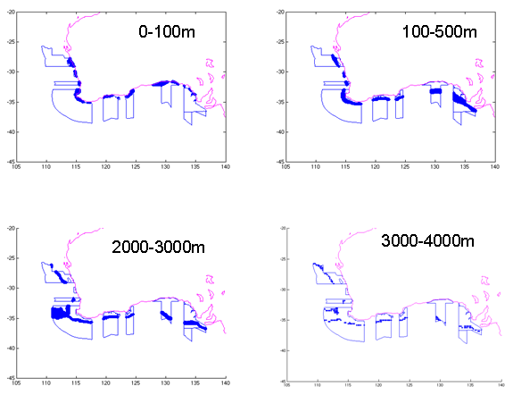
Figure 2.1. Sea floor depth zones within AFAs used as sources for particle seeding.

Connectivity statistics were derived by counting the proportion of released particles that reached a destination area after a specified time. Retention statistics represent the number of particles still within the area of release after a specified time.

2.1 Limitations of approach
Our approach considers only neutrally buoyant larvae models that are passively dispersed with no larval behaviour or mortality. This represents a very narrow range of possible larval types but is a useful idealised starting point from which to begin exploring the parameter space possible in nature. CSIRO is currently developing a more sophisticated version of this model (Connie2) that incorporates larval dispersal etc.

Accuracy of ocean hydrodynamic models tend to decline with depth as the density of observational data for model correction is reduced. Results from modelling in 0-100m depth zones are therefore likely to be the most reliable whereas results from modelling at 3000-4000m should be treated with the most caution.

How this modelled “single generation” dispersal relates to long-term, multigeneration spatial connectivity is yet to be investigated. Population connectivity across an entire species range will be mediated by dispersal, mortality and gene flow over many generations, extending well beyond that observed for a single cohort of larvae. Regions between AFAs will likely be important intermediate points for dispersal across populations of species and communities that span two or more AFAs. Short term and interannual variation of dispersal processes, easily observed with the approach we have used may in fact be relatively poor predictors of longer term mean dispersal. Patterns of genetic population structure are therefore a useful measure of realised long term mean dispersal that may be used to validate connectivity predictions.

The horizontal resolution of approximately 10km and complex hydrodynamics in shallow water reduces the accuracy of dispersal modelling in coastal waters relative to the open ocean, increasing the need for caution and further validation from multiple sources in these areas. Commonwealth waters such as those included in the AFAs in general avoid the most problematic depths and inshore areas so this is less of a concern than it might be for modelling of State waters.

3. Connectivity Patterns

Retention within AFAs

Rentention rates within individual AFAs tend to be much higher off the south coast than the west coast, peaking at 19% in the Great Australian Bight AFA after 50 days of dispersal (Figure 3.1 & 3.2). This contrasts with the South West Corner, which shows almost negligible retention despite being the largest AFA.

Retention rates are sensitive to the spatial scales of the analysis. For example, a finer-scale analysis of coastal waters (0-50 m) reveals high retention around Geographe Bay even though retention averaged across the broader South West Corner AFA is very low (Figure 3.13). In other respects the general pattern of coastal retention is comparable to that in the AFAs with relatively high rates around Abrolhos and the Great Australian Bight, and lower rates around Jurien and Perth.

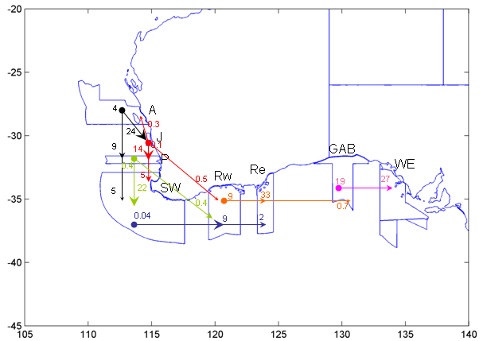

Figure 3.1 Connectivity and retention rates (%) among AFAs for 0-100m depth zone. Numbers refer to means of four years of 50 day larval dispersal from April 1 1995, 1997, 1998 & 2001. A, Abrolhos; J, Jurien; P, Perth; SW, South west Corner; Re, Recherche east; Rw, Recherche west; GAB, Great Australian Bight; WE, West Eyre.

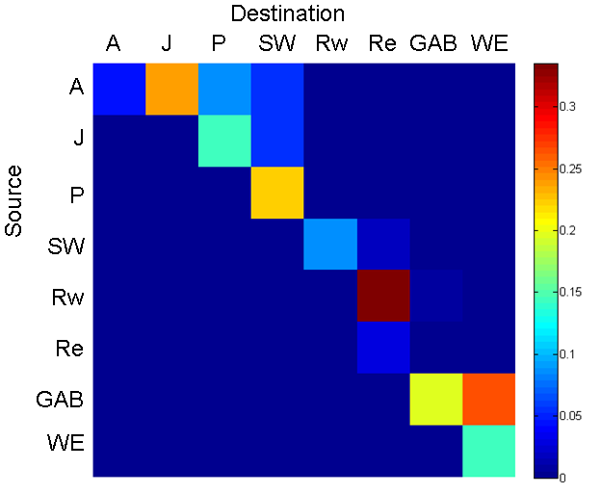

Figure 3.2 Matrix of pairwise connectivity between all AFAs as proportion of particles released from a source AFA in 0-100m reaching the destination AFA after 50 days. Diagonal represents the proportion of particles retained in the source AFA after 50 days. A, Abrolhos; J, Jurien; P, Perth; SW, South west Corner; Re, Recherche east; Rw, Recherche west; GAB, Great Australian Bight; WE, West Eyre.

3.2 Cross-shore connectivity

Eddy activity on the west coast appears to drive greater offshore transport than on the south coast where there is strong lateral flow and a broad continental shelf especially in the Bight. Without vertical migration possible in the model (beyond passive movement) the results show there is greater potential for dispersal off shore than on shore but for this to be realised, settlement would be required to deeper waters. Eddy dispersal may lead to higher rates of loss to deep ocean waters from west coast AFAs. This may have implications for recruitment potential.

3.3 Connectivity among AFAs

An animation showing 100 day larval dispersal from coastal and upper slope waters (0-500m) in all AFAs (SWbioregionAFAconnectivity_100day_hi_res.avi) can be viewed at ftp://ftp.csiro.au/Connectivity/ . Most dispersal follows the south and eastward Leeuwin Current flow, as the particles are seeded in April when the Leeuwin Current is at peak strength (Ridgeway and Condie 2004). The influence of major eddies is clearly visible especially off the west and southwest coasts with particles being entrained and moved off shore.

Mean autumn connectivity for four years (Figure 3.1 & 3.2) indicates this predominantly south and eastward dispersal that connects adjacent AFAs and in some cases adjacent plus one (e.g. SW to W- and E-Recherche AFAs). Northward dispersal, possibly mediated by eddies occurs to a limited extent among west coast AFAs (Abrolhos, Jurien, Perth and South West).

Larval duration obviously has a substantial effect on the degree of dispersal and connectivity. Examples of 30 day versus 100 day larval duration patterns of particles released in coastal waters (0-100m) highlights the lower transport rates in the Great Australian Bight and greater offshore dispersion to oceanic waters on the west coast. (Fig. 3.3). Substantial northward dispersal from Abrolhos AFA is also evident in 100 day dispersal tracks.

The longer dispersion periods also demonstrate the role of eddies in offshore transport. Eddy activity on west and southwest coast appears to drive greater offshore dispersal than in the Great Australian Bight where the flow is mainly directed along the broad continental shelf. Eddy dispersal may therefore lead to higher offshore losses from west coast AFAs with potential implications for coastal recruitment potential.

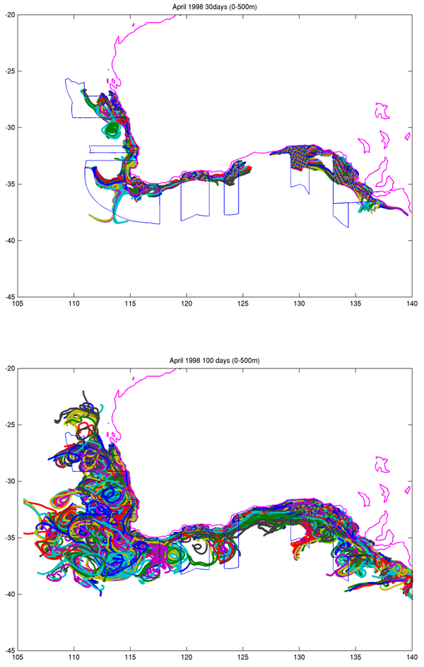

Figure 3.3 Illustrative example of the effect of dispersal duration (30 vs 100days) on connectivity for particles released in coastal (0-100m) and upper slope (100-500m) waters. Colours indicate individual particle tracks and are unrelated to particle source

3.3.1 Abrolhos
- Dispersal was strongly southward from Abrolhos at coastal and upper slope depths especially in autumn (e.g. Fig. 3.4).
- Persistent eddy activity in the vicinity of the Abrolhos Islands disperses offshore extensively, potentially losing a substantial fraction of larvae to open ocean.
- 50 day dispersal envelope reaches around the Capes to the south coast.
- 23% connectivity with the adjacent Jurien AFA was among the highest figure observed.
- Dispersal rate was lower below 100m and greater northward dispersal was observed in autumn than in spring.
- The highest autumn retention rates (mean 4.5%) for the west coast AFAs were observed in Abrolhos (Fig. 3.1).

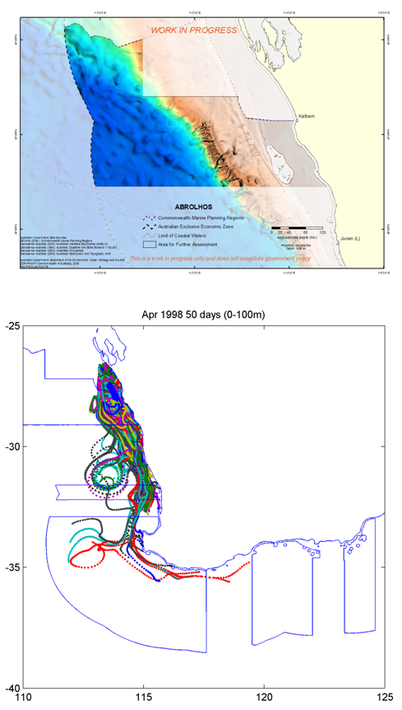

Figure 3.4 50 day dispersal tracks for particles released for 7 days in April 1998 in 0-100m depths from within the Abrolhos AFA.

3.3.2 Jurien
- Autumn flow is very strongly southward under the Leeuwin Current influence (eg Fig. 3.5).
- Mean connectivity with Perth, the adjacent AFA was 14% in autumn with connectivity observed as far as the Recherche East AFA (Fig. 3.1).
- The 50 day retention rate was below 1%.
- Spring patterns showed extensive northward dispersal.
- The Jurien AFA does not extend to deeper waters.

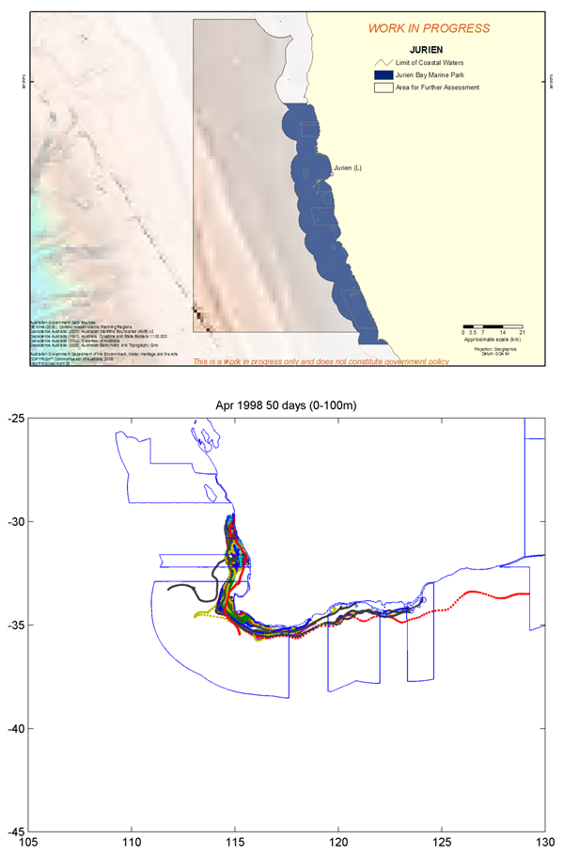

Figure 3.5 50 day dispersal tracks for particles released for 7 days in April 1998 in 0-100m depths from within the Jurien AFA.

3.3.3 Perth
- Autumn flow is very strongly southward under the Leeuwin Current influence (eg Fig. 3.6).
- There was high 50 day connectivity rates (mean 22.4%) with the adjacent southern Southwest Corner AFA (Fig. 3.1).
- The 50 day connectivity extends to Recherche East AFA in autumn.
- Extensive particle retention observed in Geographe Bay especially in spring.

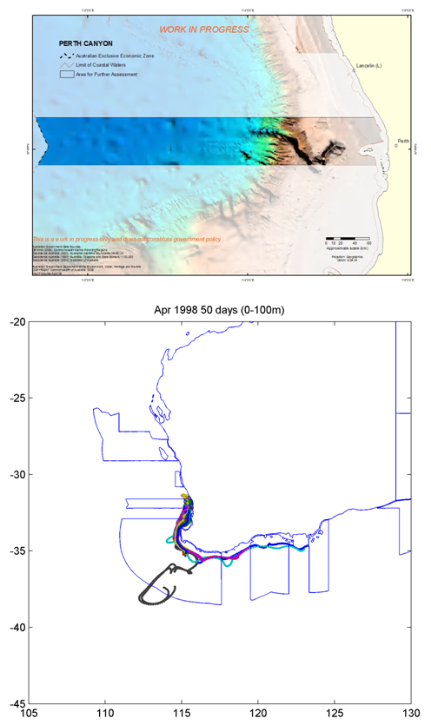

Figure 3.6 50 day dispersal tracks for particles released for 7 days in April 1998 in 0-100m depths from within the Perth AFA.

3.3.4 Southwest Corner
- Strong westward flow supported an autumn 50 day connectivity rate of 8.6% (Fig. 3.1).
- Eddies carried particles far offshore (Fig. 3.7) consistent with previous studies (Condie et al 2005).
- The extensive seabed area at slope depths between 2000 and 3000 on the Naturaliste Plateau in the Southwest Corner AFA make this a potentially important source for slope biota especially on the southern coast AFAs.

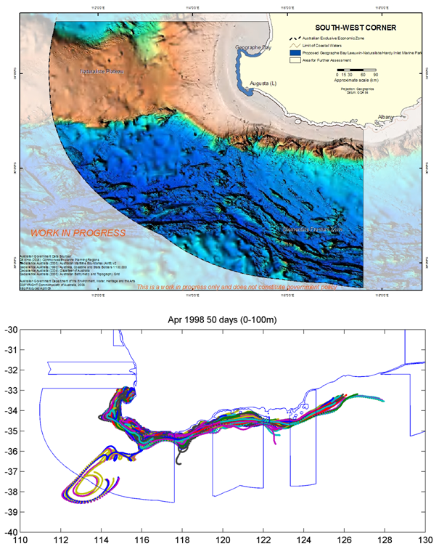

Figure 3.7 50 day dispersal tracks for particles released for 7 days in April 1998 in 0-100m depths from within the Southwest Corner AFA.

3.3.5 Recherche
- Almost exclusively eastward flow under Leeuwin Current influence in spring and autumn at shallower depths with some counter flow at mid to lower slope depths.
- Particles from the western area were often observed to disperse as far as those from the more eastern area (Fig 3.8).
- Animated 100 day dispersal indicates highly coherent eastward particle flows.
- Connectivity of east to west sections is very high (34% Fig 3.1) with no observed connectivity in the opposite direction.

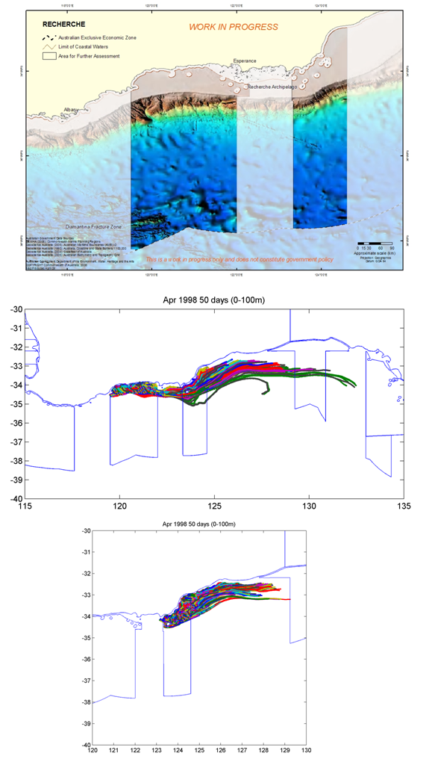
Figure 3.8 50 day dispersal tracks for particles released for 7 days in April 1998 in 0-100m depths from within the east and west components of the Recherche AFA

3.3.6 Great Australian Bight
- The extensive shelf directs coherent eastward flow of particles released above 100m (Fig 3.9 and animation).
- Particles from Recherche AFA had a tendency to overtake those from the GAB, due to their more rapid entrainment into the Leeuwin current at the shelf edge.

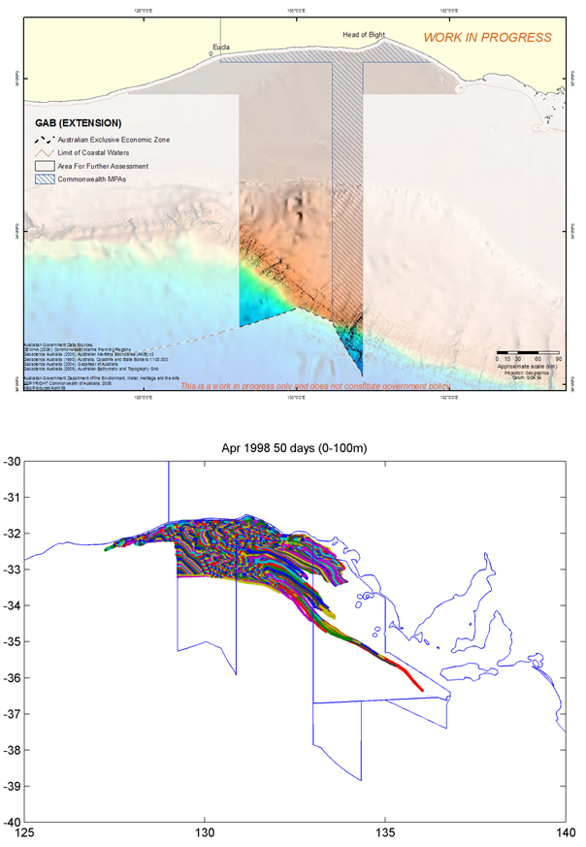

Figure 3.9 50 day dispersal tracks for particles released for 7 days in April 1998 in 0-100m depths from within the Great Australian Bight AFA.

3.3.7 West Eyre
- Strong eastward flow in coastal waters (0-100m) provided connection with the Murray Canyon MPA with some westward dispersal in slope waters.
- The 50 day connectivity envelope reaches Bass Strait for particles originating in shelf waters (0-100m) (Fig. 3.10)
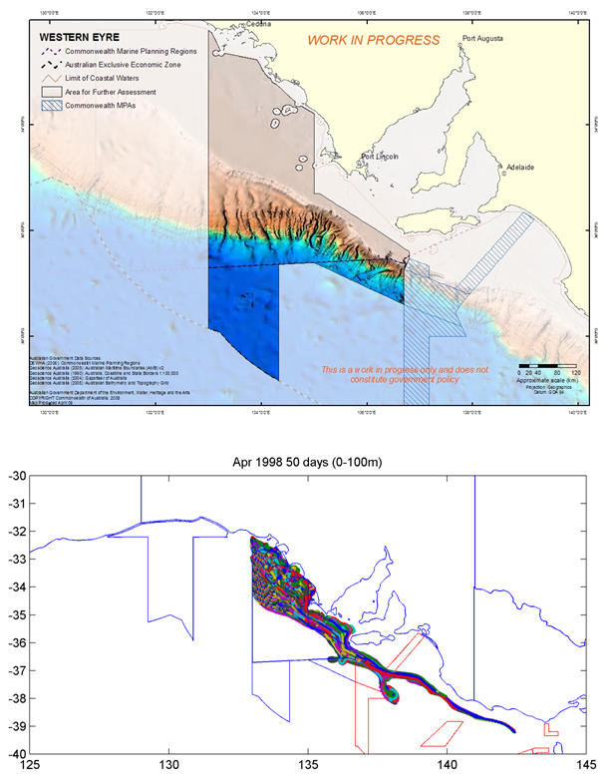

Figure 3.10 50 day dispersal tracks for particles released for 7 days in April 1998 in 0-100m depths from within the east and west components of the West Eyre AFA. South East Marine Protected Area boundaries in red.
3.4 Connectivity at different depths

Dispersal decreases with depth as the influence of the Leeuwin Current diminishes and counter currents such as the Flinders and Capes Currents play a greater role (Fig. 3.11, 3.12). Contrasting dispersal patterns can occur between shallow (0-100m) and upper slope (100-500m) waters. At 100-500m generally reduced connectivity relative to shallower waters was observed, although this contrast was weaker on the west coast (Fig. 3.11, Table 3.1 c.f. Fig 3.1). Below 500m, with the exception of the Southwest Corner AFA, no particles of 50 day duration reached an adjacent AFA. However, even at mid-slope depths of 2000-3000 m, particles were entrained in Leeuwin eddies in the Southwest.

Table 3.1. Connectivity among AFAs at 100-500m from an example period, April 1998 with 50 day larval duration

 | Abrol | Jurien | Perth | SW | RechW | RechE | GAB | WEyre
Abrol | 1.000 | 0.001 | 0.010 | 0.002 | 0.000 | 0.000 | 0.000 | 0.000
Jur | 0.000 | 1.000 | 0.009 | 0.005 | 0.000 | 0.000 | 0.000 | 0.000
Per | 0.000 | 0.000 | 1.000 | 0.059 | 0.000 | 0.000 | 0.000 | 0.000
SW | 0.000 | 0.000 | 0.011 | 1.000 | 0.013 | 0.003 | 0.000 | 0.000
RechW | 0.000 | 0.000 | 0.000 | 0.000 | 1.000 | 0.010 | 0.000 | 0.000
RechE | 0.000 | 0.000 | 0.000 | 0.000 | 0.000 | 1.000 | 0.002 | 0.000
GAB | 0.000 | 0.000 | 0.000 | 0.000 | 0.000 | 0.000 | 1.000 | 0.158
WEyre | 0.000 | 0.000 | 0.000 | 0.000 | 0.000 | 0.000 | 0.000 | 1.000

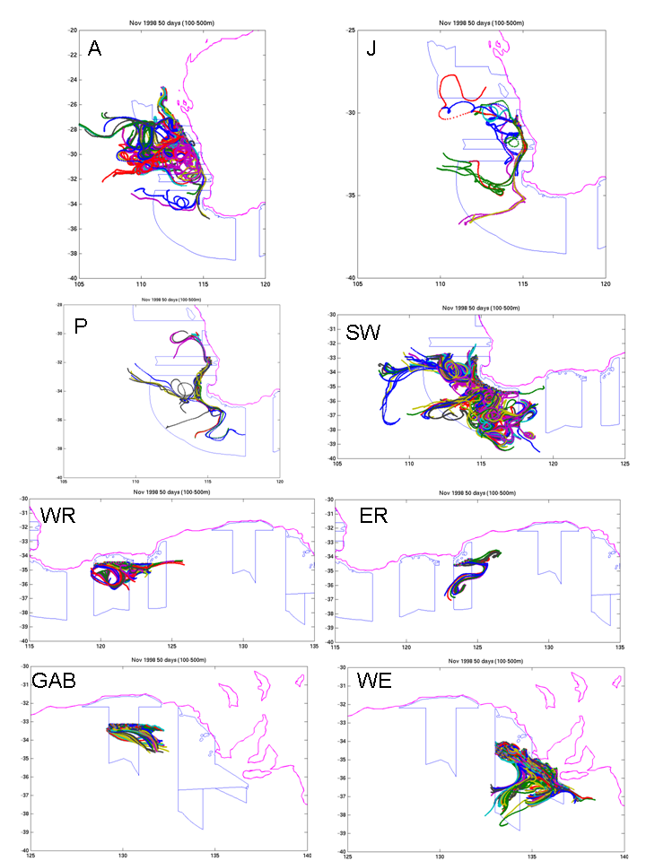

Fig 3.11 50 day dispersal tracks for particles released for 7 days in November 1998 at 100 – 500m in each AFA. A, Abrohlos; J, Jurien; P, Perth; SW, South-west; WR, West Recherche; ER, East Recherche; GAB, Great Australian Bite; WE, West Eyre.
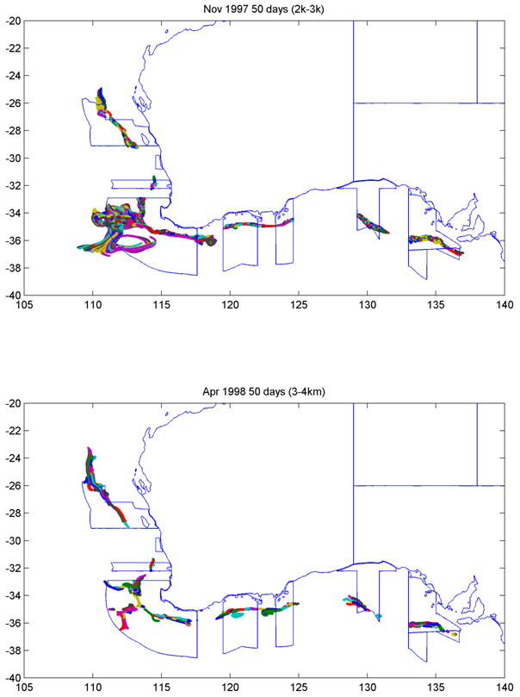

Fig 3.12 Dispersal at mid and lower slope depths

3.5 Source – sink dynamics

Without extensive modelling to thoroughly characterise potential source and sink dynamics, we have used particle retention as an indicator of possible sink locations. Comparison with modelling of larval retention in shelf waters (0-50m) on the west coast and some of the south coast reveals that Abrolhos, Perth, Southwest Corner and West Eyre, AFAs correspond to areas with high larval retention potential. Conversely, low retention rates (high flushing rates) were observed in Jurien, Southwest Corner and Great Australian Bight AFAs. The ecological significance of this is unclear but it could well have implications for source-sink dynamics, local endemicity and representativeness of protected areas. This warrants further investigation.

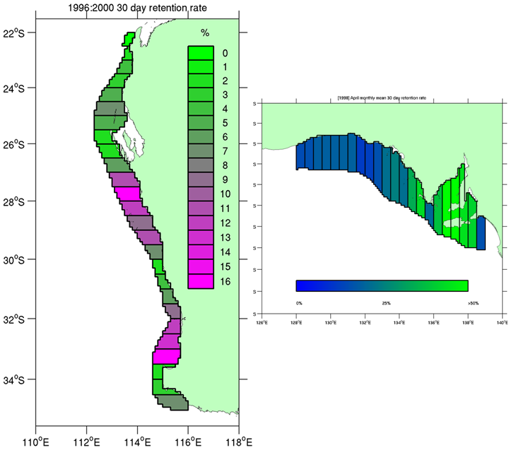

Figure 3.13 Larval retention rates in 0.5 degree-wide coastal cells (0-50m) based on counts of particles released at the surface layer and tracked for 30 days.

3.6 Seasonal and interannual variability

Most of the results described above have focused on the late autumn period when the Leeuwin Current is near peak strength. The resulting connectivity patterns tend to be unidirectional with transport to the south and west (figure 3.1). However, the Leeuwin weakens over spring and summer in the face of opposing winds and largely disappears from the south coast. Dispersal to the north and west then becomes more significant under the influence of wind-driven upwelling coastal currents and offshore eddies (Fig. 3.14).

Dispersal patterns also show substantial interannual variability due to differences in both current strength and eddy activity across years. Along-shore transport was enhanced in the autumn of strong la Niña years such as 1998, especially compared with el Niño years such as 1997 when the Leeuwin Current is at its weakest (Figure 3.14).

Predominant connectivity is “downstream” with some counter current connectivity on the west coast in summer when current flow is weaker and associated eddy activity is strongest (Fig. 3.14).

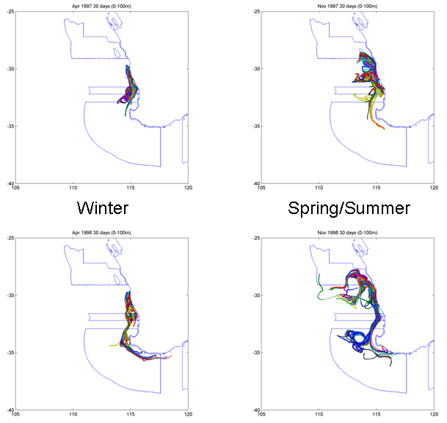

Figure 3.14 Seasonal and ENSO variation: dispersal patterns from coastal waters (0-100m) in the Jurien AFA in two different seasons and years.

4. Discussion

Connectivity among the Areas for Further Assessment in the South West Marine region reflects the dominance of the Leeuwin Current and associated oceanographic features including persistent eddies and counter currents such as the Flinders and Capes Currents.

At realistic larval dispersal durations (30-50 days), connectivity between adjacent AFAs is extensive in the euphotic zone and out to the upper edge of the continental slope, although there is strong directionality, especially over autumn when the Leeuwin Current flows most strongly. This directionality is most marked on the southern coast presumably due to the fact that stronger eddy and counter current activity on the west coast disperses particles northward and offshore, whereas the broader shelf in the GAB supports much less eddy activity.

The seasonality of the Leeuwin Current and its influence on dispersal makes it important to account for the species-specific seasonality of reproduction when inferring potential population connectivity among AFAs. For example, autumn winter spawners will likely yield strong connectivity to the south and east, while spring-summer spawners will likely yield more connectivity to the south, west and offshore, as well as higher local retention.

Geographical location is also an important determinant of the connectivity patterns in the Southwest Marine Region. The narrower shelf of the west coast and higher eddy activity may increase offshore dispersal and the proportion of larvae lost when compared to the south coast. The Southwest Corner AFA forms an important connecting region between the west and south coasts due to its location, size, and inclusion of important features such as the Naturaliste and Leeuwin Capes and Naturaliste Plateau.

Lower dispersivity and therefore lower connectivity among the south coast AFAs possibly increases the rate of turnover of intra and interspecific diversity (genetic and community diversity respectively). However, confirmation of this prediction requires detailed empirical studies.

While this work is preliminary in its exploration of connectivity patterns in the Southwest Marine Region, but it demonstrates the potential of using oceanographic modelling to make predictions about population connectivity in and among marine protected areas. The potential of the BlueLink model dataset to investigate dispersal and connectivity at fine spatiotemporal resolution between 1993 and 2006 and from there make generalisations about long-term mean patterns and trends is exciting. As well as aiding the evaluation and design of marine reserves this approach should assist the design of sampling and monitoring for observational studies of population connectivity that use ecological and genetic tools.

CSIRO is currently developing a publicly available, web-based version (Fig. 3.15) of the tool used here that incorporates more sophisticated modelling capability including larval behaviour such as vertical migration and free swimming. This tool, Connie2 is likely to be released in 2010 and will be available for the public and the research and management community at large to investigate questions similar to those touched upon in this report.
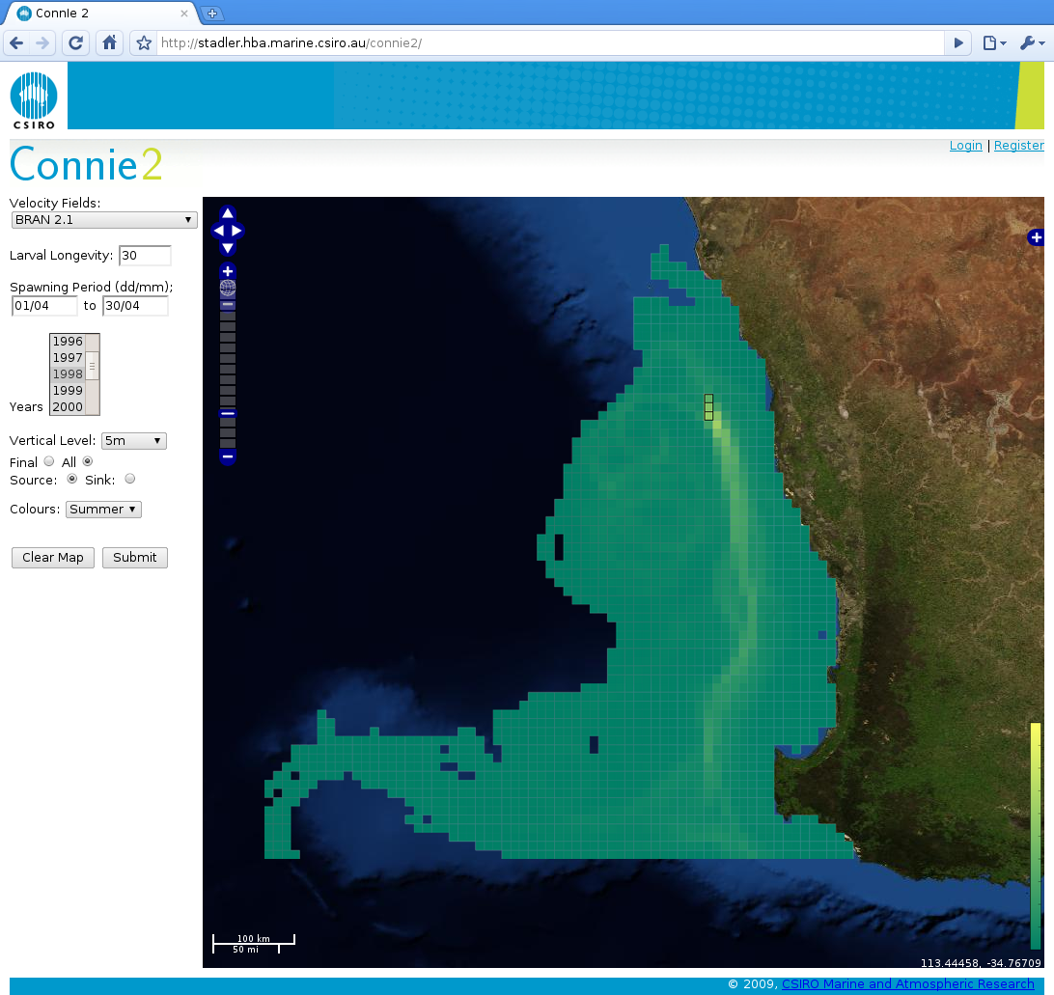

Fig. 3.15 Screen capture of a model scenario from Connie2 (beta version), a publicly available web-based connectivity modelling tool under development at CSIRO. Here “larvae” were released at the surface in three 10km grid cells at ~ 114.2 E, 29.6 S during April and tracked for 30 days.

5. References

Condie, SA, J Waring, JV Mansbridge & ML Cahill (2005) Marine connectivity patterns around the Australian continent. Environ. Mod. Software, 20, 1149-1157.

Ridgway, KR & SA Condie (2004) The 5500-km long boundary flow off western and southern Australia. J. Geophys. Res., 109, C04017, doi:10.1029/2003JC001921

Schiller, A., P. R. Oke, G. B. Brassington, M. Entel, R. Fiedler, D. A. Griffin, and J. Mansbridge, 2008: Eddy-resolving ocean circulation in the Asian-Australian region inferred from an ocean reanalysis effort. Progress in Oceanography, doi:10.1016/j.pocean.2008.01.003.

Shanks, A.L, Grantham, B.A., Carr, M.H. (2003) Propagule dispersal distance and the size and spacing of marine reserves. Ecological Applications, 13(1) Supplement pp. S159–S169


