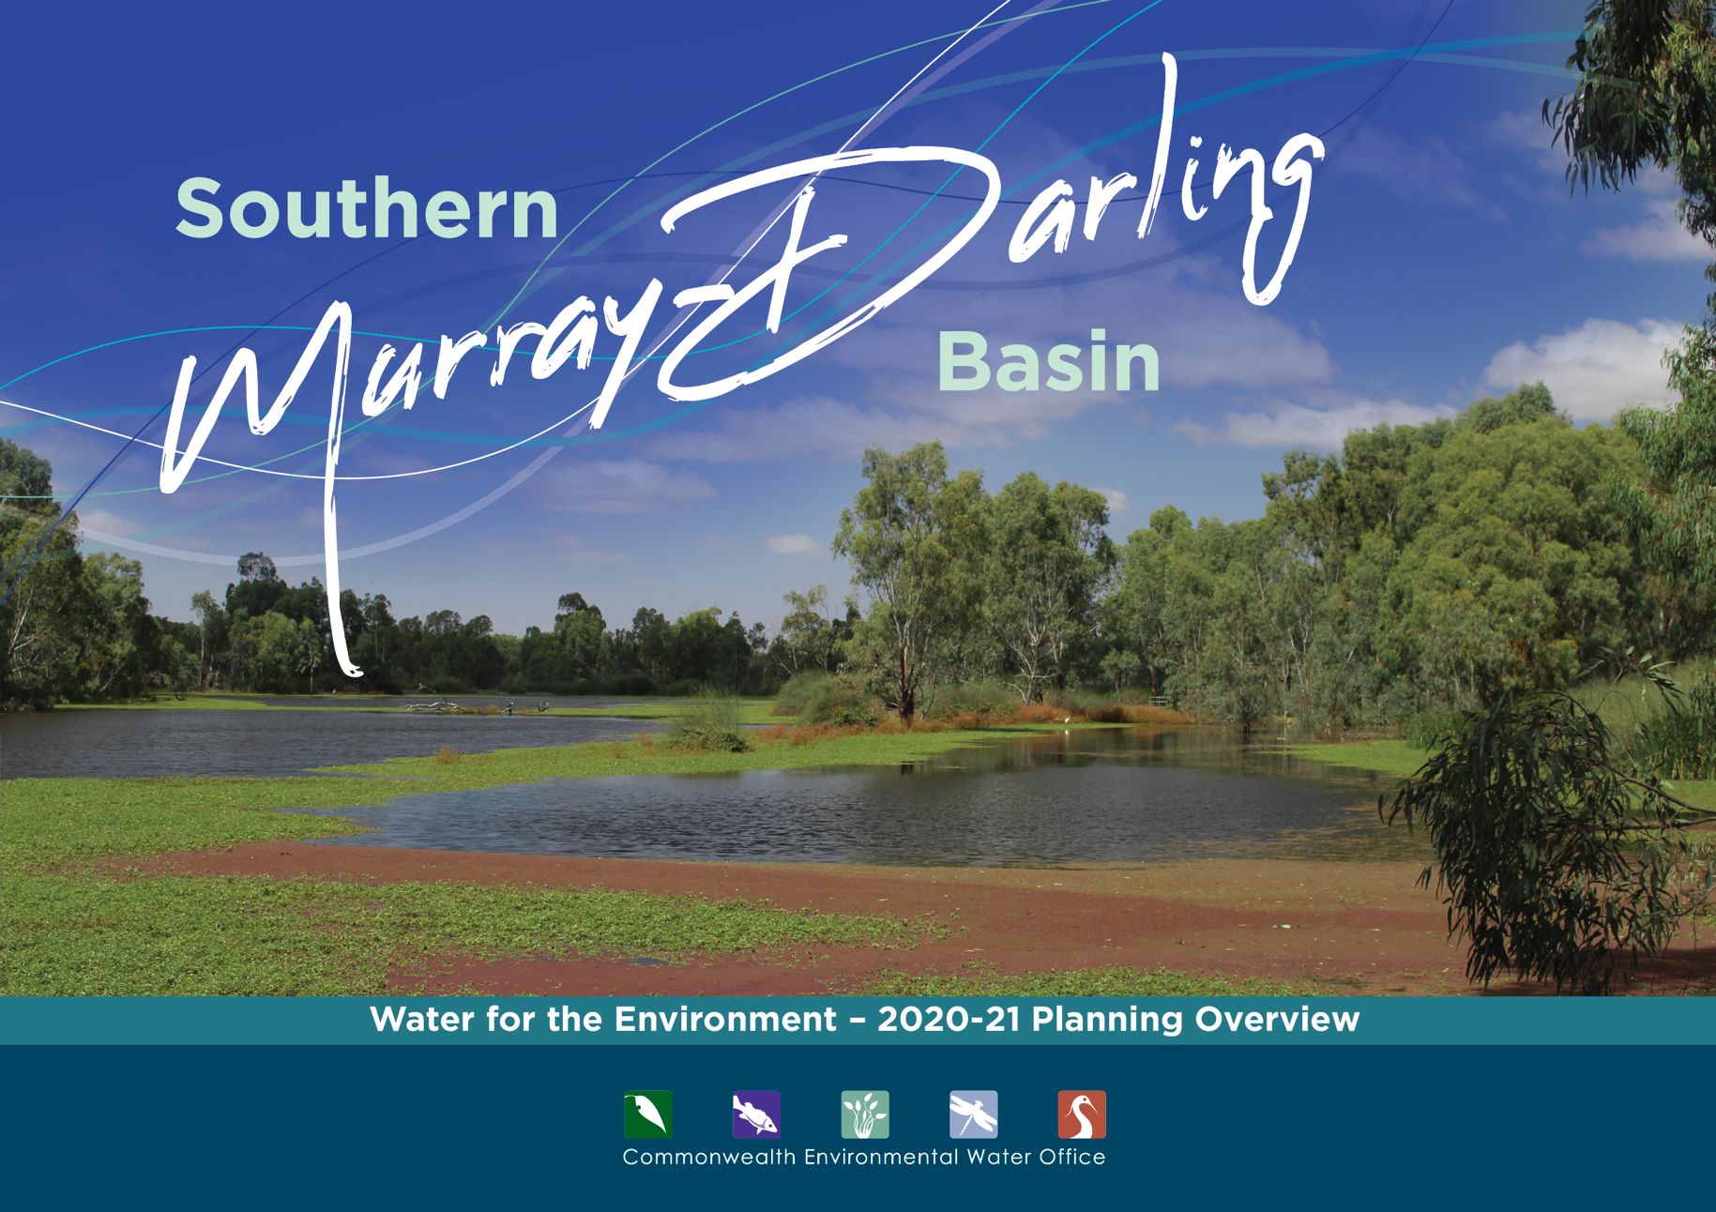

## A message from the Commonwealth Environmental Water Holder

Our planning for 2020–21 reflects the very dry conditions of the last three years. While the rainfall outlook for winter/early spring looks optimistic, we start the new water year with low storages and our lowest volume of carryover in a decade. Careful planning is critical to squeezing the most for the environment out of every drop of water available.

We will scale our water use as the season unfolds. Over winter, we will limit our use to maintaining river flow patterns to help native fish, then ideally, deliver larger flows in late spring across the northern Victorian tributaries, River Murray, Baaka/Lower Darling and the Edward/Kolety-Wakool.

I’m delighted this year’s planning includes formal input on First Nations’ environmental objectives from the Murray Lower Darling River Indigenous Nations. This is a significant step and complements the work we do locally with First Nations people.

We work closely with many people and organisations to plan our water use. We are grateful for their contributions and look forward to working together in the coming year to deliver water to keep our rivers flowing and healthy.

Jody Swirepik  
Commonwealth Environmental Water Holder

## Healthy rivers, healthy communities

### Many rivers of the Murray-Darling Basin have been changed to provide water for towns, industry and food production.

This has interrupted the natural flow of water that plants and animals need to survive. With natural runoff from rainfall now captured in dams, the pattern of flow in rivers needs to be actively managed to keep them healthy.

We deliver water for the environment when native plants and animals need it most. This is critical to keeping rivers healthy, so they continue to sustain healthy communities. It is also key to meeting our international obligations to conserve important listed wetlands.

To view our Water Management Plan 2020-21, or an overview of planning in the Northern Murray-Darling Basin, visit **environment.gov.au/water/cewo**

Our Local Engagement Officers are based in Berri, Mildura, Griffith and Wodonga. For more information contact:

• Berri, SA - Michelle Campbell, 0437 064 664

• Mildura, VIC - Richard Mintern, 0437 218 649

• Wodonga, VIC - Anthony Wilson, 0419 188 430

• Griffith, NSW - Michele Groat, 0427 682 309

## Working with First Nations

### The Commonwealth Environmental Water Office pays respect to the Traditional Owners and First Nations of the Murray-Darling Basin.

We acknowledge their enduring cultural, social, environmental, spiritual and economic connection to the rivers, wetlands and floodplains of the Basin.

We are committed to continuously improving how we work with First Nations across the Basin to manage water for the environment.

# Southern Murray-Darling Basin

## Planning our use of water for the environment in 2020-21

### Each year, planning the best use of Commonwealth water begins long before the water starts flowing.

We work with local water managers, scientists, First Nations peoples, river operators and landholders to prioritise critical sites and carefully plan where water for the environment will be delivered in the year ahead. Their advice ensures our water use is backed by science and meets local needs.

We prepare a Water Management Plan which considers:

* forecast water availability for the coming year
* seasonal rainfall outlook
* health of river and wetland plants and animals.

What we aim to achieve - when, where and how our water is delivered - depends on how much water is allocated to our entitlements by state governments. Every year is different.

We plan water use scenarios for a range of weather conditions (from dry to wet) so we can adapt to whatever seasonal conditions eventuate.

## 

## Forecast water available in 2020-21*

|  |  |  |
| --- | --- | --- |
|  | Carryover from previous year | Forecast allocations to Commonwealth entitlements |
| Southern-connected Basin** | 267GL | 1,539GL |
| Lachlan river valley | 16GL | 67GL |
| Wimmera river valley | 0GL | 0GL |

* Volumes based on Bureau of Meteorology forecasts for wetter than average conditions July to September 2020-21.

** Southern Connected Basin is the network of rivers that feed into the Murray River between the Hume Dam and the sea.

### We plan water use scenarios for very dry through to very wet conditions and adapt to whatever season eventuates.

Water managed for river health is used to benefit multiple sites as it flows down the river. It also creates positive social and economic benefits for communities along the way. With careful planning, we squeeze the most out of every drop.

**What we aim to achieve with water for the environment in 2020-21**

### A) Coorong Lower Lakes Murray Mouth

Keep Murray flowing through to the Coorong. Maintain water quality & habitat for native fish and wildlife. Allow fish to move between fresh & saltwater. Flush salt out of the Basin.

### B) Murray River

Maintain flowing riverine habitat. Link priority creeks, wetlands and forests with the main river channel to protect key habitat for native fish and wildlife, including threatened species.

### C) Baaka/Lower Darling River

Connect to Murray River to improve water quality and fish habitat and support breeding of Murray cod and golden perch.

### D) Edward/Kolety-Wakool

Support recovery of native fish and river plants following low-oxygen blackwater event in 2016. Maintain habitat in low-lying wetlands and ephemeral creeks.

### E) Northern Victorian Rivers

Improve vegetation along riverbanks and in river. Increase habitat and food for native fish and support fish migration and breeding.

### F) Lachlan River

Freshen river flows to support riverbank and aquatic vegetation. Maintain critical refuges for native fish and waterbirds.

### G) Murrumbidgee River

Maintain critical refuges for native fish and wildlife including threatened species. Support recovery of important wetlands. Link floodplain to main river channel.

