Spent pot lining project (feasibility of an agreement based approach to clear stockpiles) - Final National Summary Report issued October 2016

Peer Review Report

For: The Department of the Environment and Energy (DoEE)

DoEE Contact:
Paul Starr – Assistant Director Hazardous Waste Section Chemicals & Waste Branch
02 6274 1909
paul.starr@environment.gov.au

Author: Phil Black, Aluminium Process Consultant

Report Date: Revision 0 - January 24, 2017 First Issue
Revision 1 – March 6, 2017 Minor revisions

Report Disclaimer
This Peer Review report has been prepared for DoEE in accordance with terms and conditions set out in writing on 16 December, 2016. Phil Black accepts no liability or responsibility whatsoever for or in respect of any use of or reliance upon this report by any third party. Information furnished by others, upon which all or portions of this report are based, is believed to be reliable but has not been independently verified, unless otherwise indicated. Public information and industry and statistical data are from sources deemed to be reliable; however, no representations are made as to the accuracy or completeness of such information. The opinions expressed in this report are valid only for the purpose stated herein and as of the date of this report. No obligation is assumed to revise this report to reflect changes, events or conditions, which occur subsequent to the date hereof. All decisions in connection with the implementation or use of advice or recommendations contained in this report are the sole responsibility of DoEE.

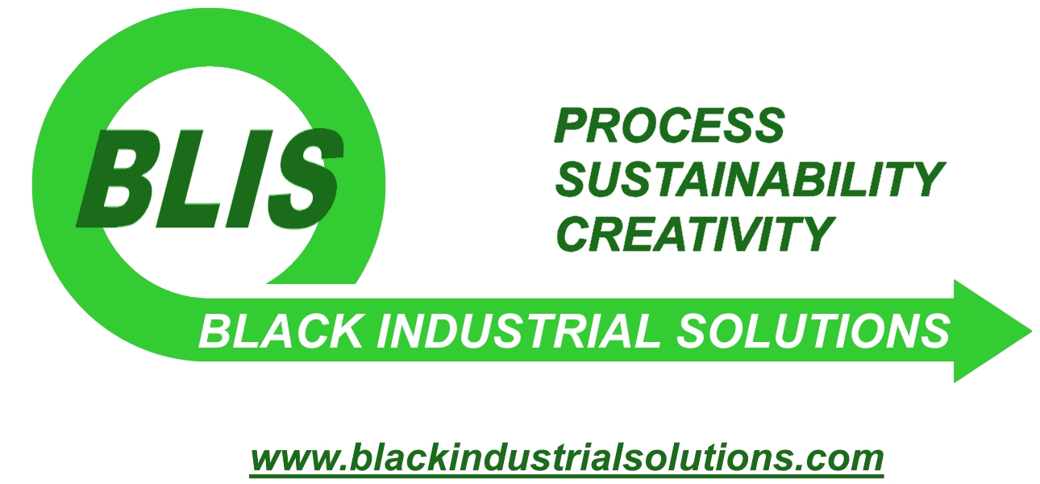
Phil Black B.Eng Met.Eng, Grad.Dip Al.Proc.Tech.
Black Industrial Solutions
ABN 71 856 314 119
phil@blackindustrialsolutions.com

Definitions

Author (“this author”) author of this Peer Review Report

Delining Pot lining removal in preparation for relining

DoEE Department of the Environment and Energy

DoEE Report PREC063 Spent pot lining project (feasibility of an agreement based approach to clear stockpiles) Final National Summary Report issued October 2016

Pot aluminium smelting reduction cell

SPL spent pot lining, also known in its untreated form as “raw SPL” or “run of pot SPL”

SPL WMPs SPL Waste Management Providers; organisations that are licensed to handle, transport, store and/or process SPL

“This report” Peer Review Report

About the author

Mr. Phil Black has 24 years of practical knowledge in metallurgical and aluminium production processes. He has a Bachelor of Metallurgy and post-graduate qualifications in aluminium smelting process technology. Phil has been employed in the aluminium industry since 1993 in R&D, commercial, customer relations, smelter development and smelter services including emissions and pot refurbishment. He has been a consulting engineer on large and small smelter projects globally and has delivered technical papers to international conferences. Most recently he held a senior role with an Australian spent potlining processing company. Phil has been working as an independent aluminium process consultant since February 2016.

Summary

It is good timing to consider an effective national approach to managing SPL stockpiles in Australia. An agreement based approach to drawing down SPL stockpiles is considered by this author to be a responsible and innovative action that is likely to set an important international precedent. Careful consideration is given in the DoEE Report to the effective, fair and enforceable implementation of the agreement based approach. This consideration is important if the approach is to garner support of all stakeholders: the aluminium industry in Australia, regulators, waste management providers (WMPs) and the community.
Based on consideration of the DoEE Report as published, in this author’s opinion the approach to the SPL project objectives is sound, and the information and assumptions used are generally appropriate. Overall this author’s view is that the investigation has been conducted to a high standard of rigour and that the analyses and conclusions in the DoEE Report are robust.
In this author’s opinion it is important that any implementation of a national policy or any agreement on SPL stockpile drawdown include consideration of both the safety of any treatment or disposal methods and the sustainable end use of any SPL-derived products, including their certification and traceability in Australia and overseas.
Detailed audit/analysis of SPL generation and stockpiles will be required initially to determine drawdown methodology, material balances and timing for co-funding purposes. In addition, early development of cost-effective methods of below-ground SPL stockpile assessment, extraction and management will be critical to the ability to address total SPL stockpile drawdown.
The DoEE Report establishes a sound reasoning and basis for co-funding model options. Some additional considerations are offered by this author for review. The DoEE Report conclusions and recommendations are supported by this author, in particular that the drawdown of SPL stockpiles over 10 years is feasible and should be implemented.

Summary of Recommendations
- It is recommended that historical SPL stockpile cleanup issues and costs be recognised in the development of any agreement and its funding.
- It is recommended that any agreement considers sustainable disposal or recycling of SPL or its derived products in drawing down SPL stockpiles.
- For below-ground stockpiles, it is recommended that additional tonnages of contaminated material are included in any SPL management agreement to ensure complete removal of legacy waste issues.
- It is recommended that the DoEE follow developments in the Aluminium Stewardship Initiative (ASI) implementation of Chain of Custody standards.
- It is recommended that an auditing and certification process be developed to manage the complex and hazardous SPL materials successfully to ethical and environmental standards.
- It is recommended that incentives such as research grants be set up to encourage investigation into the potential for landfilled SPL extraction and processing.

Introduction
This report (the Peer Review Report) provides constructive advice to validate and strengthen content of PREC063 Spent pot lining project (feasibility of an agreement based approach to clear stockpiles) Final National Summary Report issued October 2016 (“the DoEE Report”), based on the author’s technical and industry experience and knowledge of current SPL management practices and issues, with reference to published sources where appropriate (see Footnotes).
In this report the author offers commentary on specific approaches adopted and information or assumptions used in the DoEE Report. Recommendations and additional considerations are included to assist future work on the development of agreements. In general the author agrees with the detailed content of the report unless otherwise noted.

General Comments on Sections 1 - 2
An agreement based approach is an appropriate mechanism and the project methodology is sound
The aluminium industry is experiencing a prolonged period of low prices and rising energy costs. While most smelters are dealing with daily generation of hazardous by-products such as SPL, it is yet another cost burden to pay for disposal of historical stockpiles of SPL. However there is increasing awareness and concern about the extraordinary costs to the environment and to the community if these stockpiles are not managed properly. In this context it is appropriate to investigate the potential for government intervention and assistance (financial and policy) to implement a sustainable, cost-effective process to draw down long-term SPL stockpiles to a safe and manageable level.
Recent closure of two smelters in Australia has highlighted the potential cleanup effort that may be required for old SPL stockpiles. It is apparent from historical SPL stockpile incidents in the United States that a “do nothing” approach is no longer acceptable to smelters, regulators or the community, and that partial cleanups are met with serious opposition. At the same time there have been developments in re-processing and recycling SPL safely for use in other industries with no apparent legacy hazards. In this author’s opinion it is an appropriate time now to review the options available for Australia to manage SPL stockpiles.
The agreement based approach to drawdown of SPL stockpiles, as outlined in the DoEE Report, presents a sound basis for an efficient and cost-effective program to manage SPL fairly. In this author’s opinion it is an opportunity for a “win-win-win-win” for aluminium smelters, regulators, the community and the environment. The proposed approach is an innovative, practical and responsible action that is likely to set an important precedent for waste management in Australia and internationally.

Section 3 – What is SPL waste and how is it generated?
SPL is hazardous; but it doesn’t have to be a “waste”
Per DoEE Report statement: “When the pot lining fails – SPL waste is generated” (Section 3 p6)
The definition of SPL as a “waste” assumes that it has no value. Several processes have been developed on the basis that there is indeed value in SPL and a few have managed to capture that value. The DoEE Report addresses this concept in discussion of EU definition of SPL as waste or product (Section 7.4.2 p41). Consideration of recycling SPL and its by-products using the concepts of “circular economy” or “cradle to cradle” may be relevant in formulating an agreement model.
An explanation of pot lining failure may be useful. Pot lining failure means that molten aluminium metal has penetrated the carbon cathode and contacted the iron collector bars. Aluminium at 960 degrees C readily dissolves iron. If this penetration is allowed to continue, a “tap-out” can occur where metal and cryolite spill out onto the potline floor. This unsafe and potentially catastrophic uncontrolled event can damage other potline infrastructure including electricity supply to the rest of the potline. The pot is usually removed from service safely and as close to the end of its service life as possible, with a series of performance indicators used to predict the optimum timing. In newer smelters some early pot removals are scheduled which smooths out the delining campaign to manage manpower constraints.
While it has been assumed that no part of the spent lining can be re-used in the new lining, one smelting company has commenced trials of a sub-cathodic (bottom) lining material that is made from treated, crushed and compressed SPL.

All SPL is hazardous
It is an important point (DoEE Report Section 3, p7) that both 1st cut (carbon) and 2nd cut (refractory) components of SPL contain hazardous chemical compounds, and should therefore be classified as a hazardous material for storage, handling and transport risk evaluation.
Raw untreated SPL has indeed been shipped around the world without major reported incident since the disaster described in Quebec in 1990 (DoEE Report Section 3, p7). However while raw SPL is being transported any distance there is a risk of flammable gas evolution and ignition, this risk being reduced by strict adherence to transportation safety protocols.
While the report states correctly that Fluorides are “often around 10%” in bulk SPL volumes, measured Fluoride levels in various segments of the lining range from <5% to 30%, the higher values commonly found in the refractory layer under the cathode. Likewise cyanides may be concentrated in either carbon or refractory layers in the pot lining. Because of the highly manual nature of pot delining, newly-generated SPL can contain discreet volumes of concentrated Fluorides, Sodium salts, cyanides and heavy metals. This variable composition is one reason why raw SPL is a difficult feed material for sensitive treatment processes.

Sections 4 - 5 – Australian Smelters and their SPL Stockpiles
The DoEE Report gives a valuable overview of the current situation for Australian smelters and the total SPL stockpiles.
Section 4 – Australian Aluminium Smelters
The information provided is a valuable summary of Australian smelter activities concerning SPL. Apart from recent events concerning the Portland smelter (see this report Section 7) the information is suitable in the context of the DoEE Report and this author has no further comments.

Section 5 - Australian SPL waste stockpile profile
Per Table 4 – SPL waste stockpile tonnage profile
The missing data in this table (either redacted or intentionally left out) will need to be provided or calculated to a reasonable degree of accuracy for any meaningful agreement to be formulated. The total amount and form of SPL stockpiles in Australia is useful for estimating general effort required. Detailed audit/analysis of SPL generation and stockpiles will be required initially to determine drawdown methodology, SPL material balances and drawdown timing for agreement development and co-funding determination. In terms of drawdown timing, the site-specific SPL stockpile drawdown plans are discussed in the DoEE Report section 5.2.

Per Section 5.1 (Note 29 p19): There is a 22% discrepancy in 2015 reported landfilled SPL to 2016 assessment.
Reported composition estimates for SPL landfills (1st cut and 2nd cut) can only be based on general pot lining material composition, which is often compiled from limited sampling of delined pots. A reasonable knowledge of landfill contents is often retained by long term or retired employees. As noted in the DoEE Report Section 7.2.1 the composition of landfilled SPL is also complicated by historical mixing with other smelter wastes, which may account for some inaccuracy in stockpile accounting. The pot deline records together with accurate periods of landfill usage are required to estimate SPL volumes. See also discussion below.

Per Section 5.3 - Uncertainty in stockpile assessment
Figures for SPL generation from smelters typically operating today in the West range from 20-27 kg per tonne of aluminium production (0.020 – 0.027 t/t_{Al}). More modern smelters can exhibit SPL generation as low as 16 – 20 kg/t_{Al}. Generation of SPL is dependent on pot technology (design of linings, materials used, shell size) as well as operating methods (age of pot at delining, stripping and delining techniques). Accurate accounting of waste stockpiles is heavily dependent on good historical records. SPL “contamination” by alumina, aluminium metal, iron collector bars and cryolite is common. Smelters are under pressure to strip and prepare the steel pot shell ready for the next pot lining for use as quickly as possible, but weighing of SPL is normally part of standard procedure. It may also be possible that other potline wastes (burn-off anode butts, sodium-contaminated anodes, anode shot blast fines) have at some point been accounted for as SPL.
Additionally, the cyclic nature of SPL generation over many years is a key factor in stockpile fluctuations – unless the smelter is into the 4th or 5th phase of pot relining (25-30 years) there is a peak in delining activity every 6 - 8 years. This cycle results in smelters generating minimal SPL for 4-5 years and then stockpiling large amounts for the next 3 years during the accelerated delining campaign. Therefore older smelters are likely to have more stable stockpile additions, if they are not treating or exporting more SPL than they generate. Historical operations data is therefore important in predicting likely stockpile fluctuations due to varying SPL generation over time.

An accurate accounting for SPL generation and historical stockpiles is possible with:
- Data on pot replacements or “delining”
- Landfill/storage records where available
- Off-site disposal (e.g. export) records if available
- Material ordering history (for new pot linings)
- Long-term employees still on site.
(a) is considered to be the most effective indicator, particularly where historical lining design information is available.

Section 6 – SPL Management Options and WMPs
Australia is in a good position to manage SPL stockpiles with available WMPs

Per Table 5 – SPL WMP Options
The table is a useful summary. It is clear that existing local Australian SPL WMP capacity is sufficient for drawdown of above-ground stockpiles of “clean” SPL within the 10 year period, as well as handling SPL arisings. Additional information that may be included for comparison purposes is as follows:
- Actual capacity (t/yr)
- Process inputs (materials/energy)
- Offtake products for all processes
- Emissions and residues going to secondary processing or landfill
- Historical tonnages processed (related to proven capability).

Per Additional potential SPL management options
It is already noted in the DoEE Report that there is a limit to Australian cement kiln capacity to treat SPL due to existing high alkali content of available raw materials. Processes identified for SPL management may also be assessed for emissions, such as the requirement for gas scrubbing to remove Fluorides prior to release to atmosphere. This is in addition to safety requirements for SPL storage and handling.
For SPL used in steelmaking there can be cost benefits to replace the coke raw material, so that in some cases the steelmaker pays the smelter for SPL. From the author’s knowledge the 1st cut only can be used, normally in Direct Reduction of Iron (DRI) fed Electric Arc Furnaces and each application is typically developed separately (there is no technology for sale).
Another technology is the Oriens process (see website at www.oriens.ca) with a demonstration/semi-commercial plant located in Becancour, Canada and processing SPL for Alouette smelter. The process creates a cement additive called ADCIM that replaces 35-45% of Portland cement. The company has been operating for 2 years.

Per Section 6.2 Co-processing SPL with aluminium dross salt slags (export)
General considerations for export options to Europe (including Rockwool per below) are in trans-shipment of regulated hazardous wastes via multiple ports and consequential Basel Convention protocols (see DoEE Report Section 7.3.2).

Per Section 6.3 – Long Term Storage
Total capacity of any long term storage needs to be considered for both existing stockpiles and ongoing arisings of SPL. Deep storage would need to be assessed for risks of moisture ingress causing flammable gas generation where there may be limited ventilation.

Per Section 6.4 – Mineral wool - Rockwool
Some Western European smelters are well advanced in regular ongoing shipments of first-cut SPL to Rockwool. It is to be determined whether the capacity is available for regular shipments from Australia, or if a mineral wool plant might be established locally.

Per Section 6.5 – Plasma arc vitrification
For old landfilled SPL, where difficult contaminants such as asbestos are present, the vitrification process may be the most suitable treatment to encapsulate hazardous compounds at high temperature.

Per Section 6.6.1 – Regain
Additionally it may be noted that Regain has had their SPL-derived products approved by regulators for export from Australia and import into several countries.

Section 7 – Considerations for any agreement
Considerations as described in the DoEE Report are relevant and necessary
Per Section 7.1 – Aluminium smelting market conditions
Since the DoEE Report was written, the Portland smelter (Alcoa) is currently severely curtailed due to a power outage and its owners have successfully negotiated for government financial assistance for energy costs and to rebuild its damaged pots. This assistance may have implications for any SPL stockpile drawdown agreement.

Per Section 7.1.1 SPL Waste Management Costs
In discussing SPL management costs the potential future costs of cleanup are relevant. The mitigation of SPL cleanup costs is a central tenet of this project, alongside mitigating the environmental and community risks, and so it is recommended that historical SPL stockpile cleanup issues and costs be recognised in the development of any agreement and its funding mechanism.

Per Section 7.2.2 Impacts on local environment
The objective of reducing SPL stockpiles, as understood by this author, is to minimise future impact on the environment and communities. As is evident from other legacy cleanups, a current impact determination may not cover the future hazards, e.g. leachate in groundwater may only be detected after 20 years’ depositing of SPL in landfill. The CERCLA legislation in the United States attempts to value such time-based risk, although there are examples of significant under-estimation of the costs.

It should be noted that the recent “proximity principle” revision to NSW waste legislation is due to be repealed in its entirety from 1 March 2017 due to legal issues.

Per Section 7.4 International frameworks and legislation
This section is an appropriate discussion of US and European SPL issues and incentive programs for stockpile reduction or elimination.
The US EPA website is an important source however a large amount of information is available from local government Superfund operations websites.
Further important information on geophysical impacts of SPL landfills and exposure of groundwater to leachate plumes is given in Godin et al, “Combined use of life cycle assessment and groundwater transport modelling to support contaminated site management” in Human and Ecological Risk Assessment: An International Journal, 10(6), 2004, 1099-1116.

Additional Consideration: Identifying and auditing end use of treated SPL
Additionally, it is recommended that any agreement incorporates a requirement for “sustainable disposal” in drawing down SPL stockpiles. The safe and sustainable disposal of SPL includes end-use of the SPL-derived materials, in terms of traceability or risk assessment of material and where it will end up. The concept is identified in the DoEE Report as “SPL fate” – see Co-Funding Models Fig 9 and Fig 10 pp52-53. Environmentally sound management is outlined in terms of export of SPL in the Hazardous Waste Act Section 4E, p14. In this author’s opinion it is important that any implementation of a national policy or any agreement on SPL include safety of any treatment or disposal methods and the sustainable end use of any SPL-derived products, including their certification and traceability in Australia and overseas. Obtaining this clarity will require an auditing and traceability standard to be implemented as part of any agreement (see this report Section 10).
A similar “Chain of Custody” standard is currently being set up by the Aluminium Stewardship Initiative (ASI) for recycled aluminium. Basel Convention protocols (DoEE Report Section 7.3.2) may not assist here, because these only refer to materials classified as hazardous waste, while treated SPL may not be classified as such.

Section 8 - Analysis of stockpiles and drawdown capacity of WMPs
A nominal 10-year drawdown target is achievable for above-ground stockpiles
The conclusion that above-ground SPL stockpiles can be drawn down in a nominal 10 year period is consistent with this author’s assessment of viable SPL treatment options currently available, either locally (Australia) or for transport to an overseas disposal/processing facility. SPL WMP capacity has the potential to be significantly expanded if an attractive financial incentive is made available through an appropriate agreement structure. A 10-year fixed price processing agreement (indexed) is likely to be seen as an attractive incentive. It is relevant to this discussion that raw bulk SPL is an extremely difficult material to crush for treatment, and that existing equipment set up and proven to crush and grind SPL could be an important consideration in selecting a WMP, if crushing is required for the process. Testwork and development of a robust SPL crushing circuit typically takes several years.

In this author’s opinion, and that of leading SPL experts, leaving any SPL in existing landfills is a potential liability for the future. Even if mixed with other substances, SPL wastes do not break down (when in dry-tomb conditions) leading to ongoing re-interment ad infinitum, and SPL compounds such as sodium salts and cyanides will readily leach into groundwater if geological conditions are right. All landfills will leak after 20-30 years so that the ongoing annualised costs of landfilling including monitoring and re-interment are significant.
A detailed assessment of potential recovery of landfilled SPL stockpiles is beyond the scope of this report, however it suffices for this author to comment that the landfill recovery step is a significant hurdle that is yet to be overcome. It is understood by this author that effort has been made by some smelters and WMPs to address below-ground SPL stockpiles, but that there has been no technical method developed to do so. The major problem is that of contamination (refer this report Section 5). Old landfill sites are also commonly permeated with water, resulting in flammable gas generation where SPL is contacted by moisture.
It may therefore be extremely difficult to segregate landfilled SPL for processing. However it may be possible for existing treatment processes to accept a large proportion of this extremely varied excavated material. In theory a thorough core-drilling program would be required to assess the landfill contents followed by careful material extraction, segregation and crushing under controlled environmental conditions.
If below-ground stockpiles are able to be recovered as part of an agreement, it is recommended that additional tonnages of contaminated material are included in the SPL drawdown agreement to ensure complete removal of legacy waste issues. The amount of additional material is typically not known until the landfill has been excavated (refer DoEE Report p39 comment from Landau 2014).
Note that for asbestos-containing landfills the most appropriate treatment option may be the glass frit-producing (vitrification) processes, which can melt and “seal” the asbestos fibres in the glassy product.

Section 9 - SPL Drawdown Agreements
Generally this author agrees with the options for agreements as presented.
The SPL project represents an opportunity for smelters to proactively pursue stockpile drawdown voluntarily, utilising a preferred SPL WMP while reducing their direct costs to do so. There may also be benefits in the “build, own, operate” model (requiring smelters’ commitment to process SPL) chiefly in a common pricing mechanism. Incentivising smelters to take up the invitation will be the first challenge. The second challenge will be to get to the below-ground stockpiles.
Stockpile management on completion of drawdown to an agreed level is not in the scope of the DoEE Report. Ongoing SPL disposal would likely be the smelter’s responsibility, with potential legislation to control future maximum stockpile levels.

Section 10 - Co-funding models
A fair and equitable co-funding agreement can be implemented with certified and traceable material flows
It is agreed by this author that the waste management hierarchy should be used to incentivise sustainable disposal and/or treatment of SPL and end-use of SPL-derived products (“SPL fate” in Co-Funding Models Fig 9 and Fig 10 pp52-53). A useful SPL-specific hierarchy is presented below.
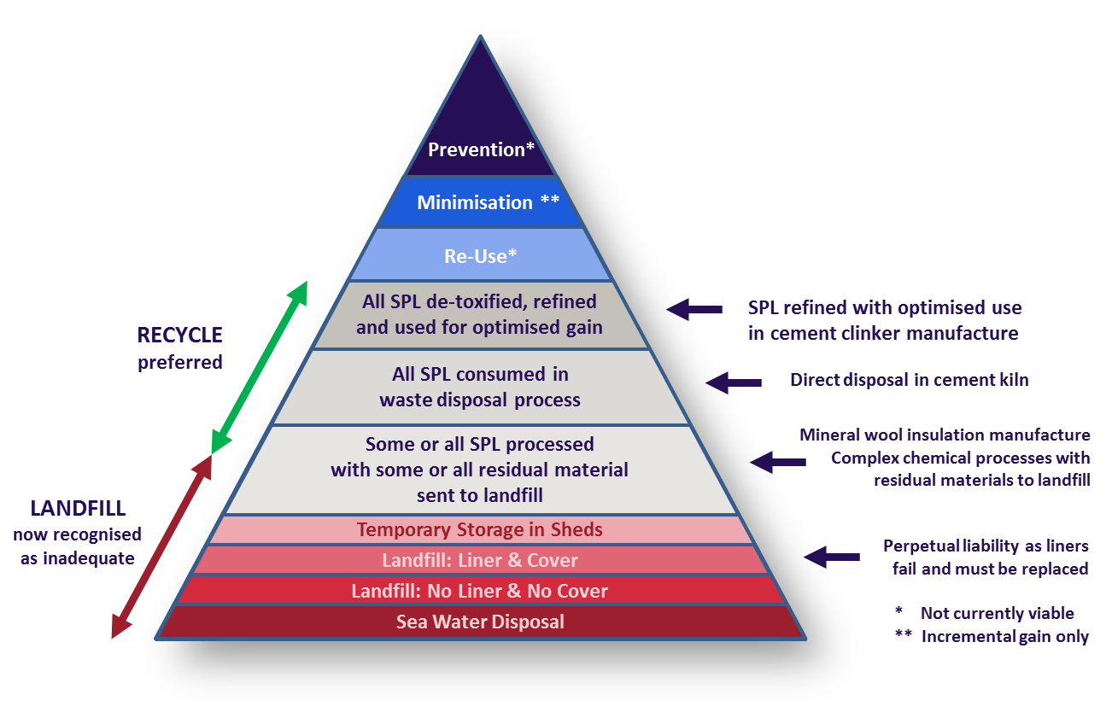
Figure 1 Example SPL Waste Management HierarchyError: Reference source not found

SPL Stockpile Auditing and Traceability of Disposal
Deciding what is SPL, what is contaminated by SPL and what is able to be separated out will be critical to SPL stockpile management, particularly for below-ground stockpiles.
It is recommended that an auditing and certification process be developed to manage the complex and hazardous SPL materials successfully to ethical and environmental standards. The waste streams would require correct identification, processing and classification, with an accurate mass balance, for audit purposes. An important element for accuracy and transparency would be to develop a certification scheme for SPL-derived products used in other industries and any secondary products requiring further treatment or storage. After certification would come a traceability standard to ensure that (a) all SPL identified in the stockpiles is accounted for and (b) all SPL-derived products and by-products are traced to their sustainable end-use.
A Chain of Custody standard is being developed by the Aluminium Stewardship Initiative (ASI) for aluminium metal production and recycling. Several global smelting organisations are involved in the ASI, including the owners of all Australian smelters. While there are currently no plans for a separate standard for SPL there is a potential to incorporate elements of sustainable waste processing in responsible aluminium production. It is recommended that the DoEE follow developments in the ASI accordingly.

Certification and Standardisation
Certification of SPL and its derivative by-products and standardisation of disposal and treatment methods will be important to the audit function for the execution of any SPL stockpile drawdown agreement. For this purpose, the following conceptual framework may be considered:
- SPL tonnages above ground to be assessed by an independent quantity surveyor
- SPL tonnages below ground to be assessed in consultation with smelters and by landfill core sampling where it is safe to do so
- Smelters to provide pot deline records to reconcile SPL current arisings and stockpile tonnages
- Segregation, crushing, treatment, transport and/or storage of stockpiled SPL to be undertaken under existing hazardous waste protocols
- Processed tonnes to be determined by mass balances based on WMP process parameters
- Final composition of SPL-derived materials to be assayed at each WMP facility
- Certification for final products to be developed for both local and export opportunities (as differentiated from hazwaste certification)
- Transport companies to provide documentation to independent auditors
- End user of final products to sign off on quantities received
- End user of final products to provide “final fate” declaration and agree to audit of end use
- Regular audit to be undertaken to assess ongoing (annual) revision of stockpile determinations.

Sections 11 & 12 - Conclusions and Recommendations
The DoEE Report conclusions and recommendations are generally supported by this author. Some additional considerations and supporting information are presented in this Peer Review report. The key conclusion from the DoEE report is to commence development of site-specific agreements to draw down above ground SPL stockpiles over the next 10 years. This author concurs with the limitation to above ground stockpiles, however it is recommended that incentives such as research grants be set up to encourage investigation into the potential for landfilled SPL extraction and processing.

Conclusion
It is good timing to consider an effective national approach to managing SPL stockpiles in Australia. An agreement based approach to drawing down SPL stockpiles is considered by this author to be a responsible and innovative action that is likely to set an important international precedent. Careful consideration is given in the DoEE Report to the effective, fair and enforceable implementation of the agreement based approach. This consideration is important if the approach is to garner support of all stakeholders: the aluminium industry in Australia, regulators, waste management providers (WMPs) and the community.
Based on consideration of the DoEE Report as published, in this author’s opinion the approach to the SPL project objectives is sound, and the information and assumptions used are generally appropriate. Overall this author’s view is that the investigation has been conducted to a high standard of rigour and that the analyses and conclusions in the DoEE Report are robust.
In this author’s opinion it is important that any implementation of a national policy or any agreement on SPL stockpile drawdown include consideration of both the safety of any treatment or disposal methods and the sustainable end use of any SPL-derived products, including their certification and traceability in Australia and overseas.
Detailed audit/analysis of SPL generation and stockpiles will be required initially to determine drawdown methodology, material balances and timing for co-funding purposes. In addition, early development of cost-effective methods of below-ground SPL stockpile assessment, extraction and management will be critical to the ability to address total SPL stockpile drawdown.
The DoEE Report establishes a sound reasoning and basis for co-funding model options. Some additional considerations are offered by this author for review. The DoEE Report conclusions and recommendations are supported by this author, in particular that the drawdown of SPL stockpiles over 10 years is feasible and should be implemented.

Example of smelter closure issues with summary of SPL stockpile issues at http://www.hydro.com/en/press-room/regrowth-kurri-kurri/Community-input/community-reference-group/ ; refer Hydro CRG Minutes – Meeting #2 21 August 2014 pp6-12
Refer for examples: http://www.thedalleschronicle.com/news/2016/aug/10/cleanup-complete-dallesport/ ; https://semspub.epa.gov/work/10/501000243.pdf ; https://semspub.epa.gov/work/04/11121342.pdf
Refer Comments Received on Former Reynolds Metals smelter site Remedial Investigation/Feasibility Study July 2014 https://www.google.com/url?q=https://fortress.wa.gov/ecy/gsp/DocViewer.ashx%3Fdid%3D29652&sa=U&ved=0ahUKEwig_JSGwrnRAhUBfbwKHWbXCzQQFggNMAQ&client=internal-uds-cse&usg=AFQjCNF47_TYb8alzXEanQLmvQ_AqNL63A
Mann, V et al, UC Rusal Advances New Technology in Improving Environmental Standards, Light Metal Age, February 2016 Vol74 No.1, pp34-36
M. Sørlie and H. Øye, Cathodes in aluminium electrolysis, Dusseldorf: Aluminium-Verlag Marketing and Kommunication, 2010.
Full pot autopsies are able to confirm in detail the amount and form of chemical components present in SPL as each layer is removed (eg cyanides of which there are many forms present) but these autopsies take several days and delay the pot delining process accordingly
Author’s private communications and experience. Some references (see Footnote Error: Reference source not found) cite up to 45 kg/t_{Al}
Author’s private communications and experience
Author’s experience, also Broek, S. What Options for Smelter Waste stream? An update on spent pot-lining treatment and disposal, Metal Bulletin 26th International Aluminium Conference, 7 - 9 September 2011, Paris
Refer http://www.regainmaterials.com/aluminium-smelting-industry/regain-spl-solution/validation
See examples in Footnote Error: Reference source not found
See examples in Footnote Error: Reference source not found and in the DoEE Report Section 7.4.1
http://www.nortonrosefulbright.com/knowledge/publications/143940/nsw-proximity-principle-repeal-environment-protection-authority-set-to-repeal-the-proximity-principle-as-part
Refer example at https://fortress.wa.gov/ecy/gsp/Sitepage.aspx?csid=11796
See further discussion in Section 10 – Co-funding models.
Author’s personal communication and experience
M. Sørlie and H. Øye, Cathodes in aluminium electrolysis, Dusseldorf: Aluminium-Verlag Marketing and Kommunication, 2010
Godin et al, Combined use of life cycle assessment and groundwater transport modelling to support contaminated site management, in Human and Ecological Risk Assessment: An International Journal, 10(6), 2004, 1099-1116
Stephen M. Testa, Geological Aspects of Hazardous Waste Management, CRC Press 1993
Refer DoEE Report Section 3 p7
Black, P., The Legacy of Spent Potliner – Cost or Opportunity? in Light Metal Age Vol.74 No.1 February 2016 pp80-81
Refer to http://aluminium-stewardship.org/wp-content/uploads/2015/05/ASI-Chain-of-Custody-Overview-September-2016.pdf

