# Sustainable Procurement in Action

Reef HQ Aquarium

Great Barrier Reef Marine Park Authority (GBRMPA)

Background

Reef HQ Aquarium is the National Education Centre for the Great Barrier Reef Marine Park Authority based in Townsville, Queensland. Reef HQ Aquarium plays a vital role in educating the community about the importance of protecting the Great Barrier Reef (Reef).

Reef HQ Aquarium features the world’s largest living coral reef aquarium exhibit, attracting over a hundred thousand guests each year.

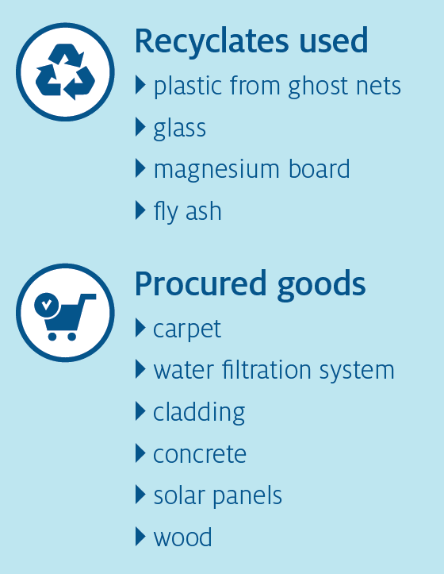Since opening its doors in Townsville in 1987, the Aquarium has made the Reef accessible to children and adults from across Australia and around the globe.

As the world’s largest living coral reef aquarium it is a showpiece of the treasures of the Reef, allowing us to demonstrate its compelling natural beauty, and introduce visitors to the importance of the Reef and the Marine Park as a natural wonder, and to ensure its conservation.

The Reef HQ Aquarium presents a living example of the Reef that is accessible to people of all ages and physical abilities, offering an opportunity to experience the Reef without getting wet.

### Sustainable procurement

Since 2011 Reef HQ Aquarium has undertaken several major refurbishments with a key focus on ensuring the changes adhere to sustainability principles. Upgrades have ranged from rectifying concrete structures and laying new flooring to installing new renewable energy and storage systems.

The refurbishments have been driven by product obsolescence, changes in safety standards or assets nearing end of life. The capital works offered opportunities for the Authority to consider environmental efficiencies, incorporate innovations and use sustainable materials whilst minimising waste.

### Procurement approach

To identify procurement needs, the Reef HQ Aquarium team conducted audits of their assets and developed plans to address the required changes. Considerations were

also informed by results from formal audits, the strategic infrastructure plan, and feasibility studies.

The team considered the components of ‘quality and sustainability’ as core criteria for purchasing of goods and services. Procurers consulted and undertook a market scan before approaching the market to identify sustainability solutions. This included identifying sustainable building materials and included whole of lifecycle considerations.

The budget varied across the purchases that were made. Some elements had a significant budget, such as the floor replacement which cost around $100,000. Other

measures had a smaller budget, which required innovative procurement approaches and operational changes.

The Reef HQ Aquarium kept procurement requirements simple and flexible to avoid creating unintended barriers for potential suppliers, particularly local businesses. Reef HQ Aquarium closely examined supplier offerings to identify direct and verifiable sustainability benefits, and also suppliers willing to try new products or methods.

### Sustainability outcomes

Through the refurbishment project, the following sustainability benefits were achieved:

* Using wood from sustainable forestry and sustainable wood alternatives
* Implemented extensive water filtration systems using 100% recycled glass, instead of sand
* New cladding using recycled magnesium board, which replaced fibre-cement sheeting in wet and salty areas
* Implemented solar panel system and battery systems with an end-of-life plan for recycling.

The Reef HQ Aquarium used concrete with at least 30% fly ash for a new concrete plantroom. Fly ash is waste by-product from coal power stations. Concrete made with fly ash can reduce emissions by at least 40% compared to concrete made from virgin materials. Using fly ash also reduced water use and corrosion of reinforcement steel. To verify sustainability outcomes, suppliers were required to certify the concrete’s recycled content and other environmental claims.

The new carpet made from 100% recycled plastic was cost-comparable to traditional carpet purchase and installation. The carpet tiles consisted of discarded fishing nets pulled from oceans around the Philippines and Cameroon. Lost and discarded nylon fishing nets known as "ghost nets" entangle and kill marine wildlife. Reef HQ worked with a local business to adapt to a new method of laying the carpet using no glues. The business was initially unfamiliar with recycled plastic carpet tiles and a no-glue laying method, however Reef HQ worked closely with the supplier to source and quality assure installation of the

product. The supplier responded well to the product’s ease of installation. Through procurement, Reef HQ was able to support local businesses and uplift their capability. Reef HQ also reduced marine waste impacts and could educate visitors on these issues.

### Learnings

* Research and early engagement with the supply chain is key.
* The market for sustainability products and suppliers is constantly growing. Explore alternative solutions and consult your networks about their experiences before you commit to a particular path. You may be surprised at the innovative products business can offer if you ask. While leading as a first adopter is challenging at times, the benefits are real and worthwhile.
* Sustainable materials tend to go hand in hand with quality, durability and longevity. Sustainable materials offer significant financial savings if whole of lifecycle impacts are considered.
* Strong stakeholder relationships are critical to strong sustainability outcomes. Reef HQ worked closely with suppliers and industry experts to overcome unexpected challenges. For example, some sustainability products were unavailable due to Townsville’s regional location. Reef HQ negotiated with businesses to source and trial new sustainable products, which benefited both parties and advanced those technologies.

Reef HQ delivered significant sustainable outcomes for the organisation and community. Suppliers expanded their expertise and range of products for sale.

Reef HQ will continue on their sustainable procurement journey through future capital works projects, over 2022 and beyond.

