Subcommittee on Plant Health Diagnostics Communiqué – SPHD40
The Subcommittee on Plant Health Diagnostics (SPHD) held its 40th meeting from 20-22 May 2025 in Adelaide. The meeting was chaired by Kath De Boer (Australian Government, Department of Agriculture, Fisheries and Forestry). This document provides an overview of the key topics discussed and associated outcomes that were agreed during the meeting.
Stakeholders may be interested in some of the following meeting topics and can contact the SPHD Secretariat – SPHD@aff.gov.au – for additional information.

National Diagnostic Protocols (NDPs)  National Diagnostic Protocols enable the definitive taxonomic identification of exotic pests and diseases. SPHD oversee the development and national endorsement of NDPs.  - Currently there are 54 endorsed NDPs, of which 19 NDPs are undergoing the five-year review process. There are also 72 draft NDPs, each at varying stages of development  - The Philaenus spumarius (Meadow spittlebug) NDP was nationally endorsed at the SPHD40 meeting.  - The revised Xylella species NDP and the Xylella exotic vectors draft NDP will be submitted to SPHD for national endorsement shortly. | National Plant Biosecurity Diagnostic Network (NPBDN)  The NPBDN is the nationally integrated network for plant diagnosticians in Australia.  NPBDN membership  A report on the NPBDN membership was provided, with the network membership increasing 11% since SPHD39 to 809 members (as 15 April 2025).  Revision of the NPBDN membership guidelines  SPHD agreed to changes in the NPBDN membership guidelines. Previously, membership was limited to Australasian and Pacific regions, with SPHD agreeing to expand international membership under a defined process.  Delivery of NPBDN professional development activities  The NPBDN delivered a virtual Annual Diagnostics Workshop seminar series between November 2024 to April 2025. The series covered topics on virology, entomology, mycology, and bacteriology.
Streamlining the NDP process  The SPHD continue to focus on streamlining the NDP endorsement process, with focus on Section 9 (Diagnostic procedures to support surveillance).  - SPHD agreed to refining the scope of Section 9 to be more focused on sampling requirements critical for diagnosis.  - SPHD also agreed to changes in the review process for Section 9 which will reduce the time taken to progress through SPHD processes by several months.  - The SPHD reference standards will be updated to reflect these changes. | High Throughput Sequencing  SPHD continue to support the implementation of Standards and Guidelines: Generation and Analysis of High Throughput Sequencing Data endorsed by the National Biosecurity Committee.  - SPHD continue to liaise with the National Biosecurity Committee HTS working group, around the development of a national policy to guide decision making when using HTS for biosecurity diagnostic purposes.  Discussions have commenced regarding the development of a framework for a HTS Proficiency Testing program that encompasses animals and plants.
Stakeholder engagement  SPHD continues to engage with a wide range of stakeholders involved in the national plant health diagnostics system, seeking opportunities to collaborate and exchange knowledge and information. At this meeting the following items were discussed:  - Plant Biosecurity Research Initiative discussed opportunities and priorities for investment in plant health diagnostics with SPHD. Potential areas for investment identified include new technologies for diagnostics, reference collections and diagnostic training.  - GRDC provided an update on the National Grains and Diagnostic Surveillance Initiative and ongoing engagement with SPHD.  - Agriculture Victoria facilitated a workshop with SPHD members seeking input into the development of the National Horticulture Action plan in relation to diagnostics components to be included. | Reference collections  SPHD continue to progress implementation of the National Plant Pest Reference Collections Strategy, with a focus on improving the coverage, quality and accessibility of plant biosecurity collections nationally.  - CSIRO have commenced work on a project to develop delivery and resourcing standards for plant biosecurity collections. This project, funded by the Australian Government, Department of Agriculture, Fisheries and Forestry, is being undertaken in consultation with SPHD and will support sustainable funding considerations for Australia’s plant biosecurity collections.  - Work has commenced on the development of a national specimen acquisition plan to address gaps in coverage for specimens of priority pests within our collections.

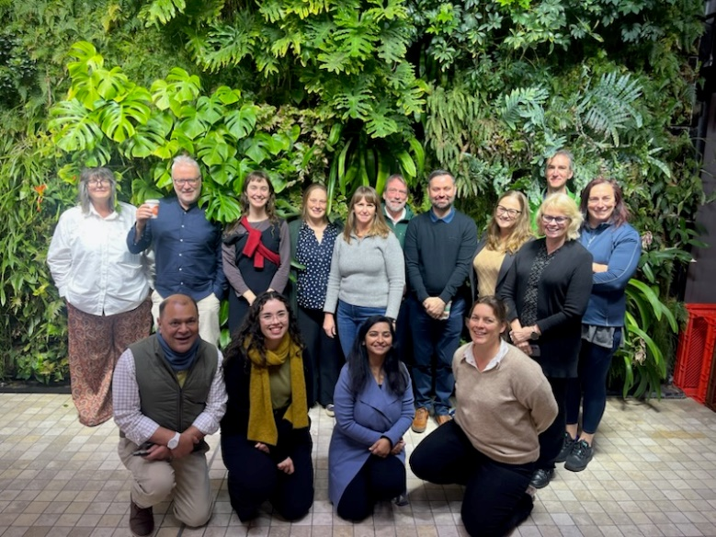
SPHD40 group photo (SPHD members, observers and invited guests)
Who are we?
The Subcommittee on Plant Health Diagnostics (SPHD) is a subcommittee of the Plant Health Committee. SPHD was established to focus on nationally coordinating the continual improvement of reliable and high-quality plant pest diagnostics in Australia. Members of the subcommittee include representatives from the Australian government, the state and territory governments with observers from Plant Health Australia, CSIRO and the New Zealand Ministry of Primary Industries as well as invited guests and technical experts.
The subcommittee meet on a regular basis to discuss and deliberate on issues, make decisions on presented items, and provide advice on all matters related to plant pest diagnostics. Key tasks for SPHD include:
- Coordinating development of National Diagnostic Protocols for priority plant pests
- Implementation of the National Plant Biosecurity Diagnostic Strategy within the framework of the National Plant Biosecurity Strategy and the Intergovernmental Agreement on Biosecurity
- Coordinating the National Plant Biosecurity Diagnostic Network
- Assisting the development of diagnostic tools and material
- Facilitating and coordinating delivery of training to diagnosticians

- Facilitating the progression of laboratory accreditation and proficiency testing
Date of Next Meeting
The next SPHD meeting will be on 4-6 November 2025, held in Canberra. Please contact the SPHD Secretariat for additional information.

C/o SPHD Secretariat
E SPHD@aff.gov.au
Australian Government Department of Agriculture
GPO Box 858
Canberra ACT 2601
www.agriculture.gov.au

