# Spring viraemia of carp (SVC)

Also known as infection with spring viraemia of carp virus (SVCV)

From Aquatic animal diseases significant to Australia: identification field guide, 5th edition

Figure 1 SVC in common carp (Cyprinus carpio)

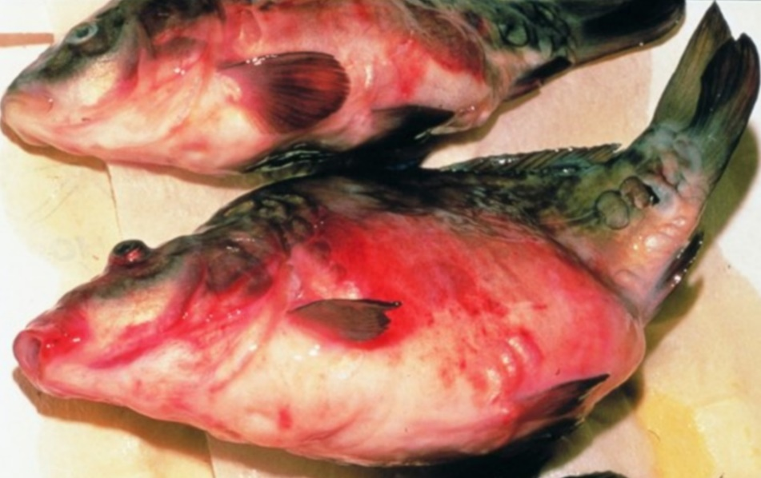

Note: Characteristic haemorrhagic skin, swollen stomach and exophthalmos (popeye).

Source: H J Schlotfeldt.

## Signs of disease

Important: Animals with this disease may show one or more of these signs, but the pathogen may still be present in the absence of any signs.

Disease signs at the farm, tank or pond level are:

* mortality rates of 30 to 100%
* lethargy
* separation from shoal
* lethargic swimming
* accumulation of fish at the water inlet and sides of the pond.

Gross pathological signs are:

* exophthalmos (popeye)
* swollen abdomen and a protruding vent
* possibly a trailing white or yellowish faecal cast
* petechial (pinpoint) haemorrhages of skin, gills and eyes
* haemorrhages on skin and base of fins and around the vent
* darker body colour, with pale gills
* diffuse swelling and haemorrhage of internal organs and degeneration of gill lamellae
* ascites (fluid in abdominal cavity)
* intestines containing mucous instead of food.

Microscopic pathological signs are:

* liver hyperaemia and oedematous perivasculitis
* pericarditis and infiltration of the myocardium
* hyaline degeneration and vacuolation of the renal tubules, which are clogged with casts
* inflammatory and hyperaemic changes in all major organs.

## Disease agent

SVC is caused by infection with spring viraemia of carp virus (SVCV), a rhabdovirus classified within the genus Sprivivirus. SVCV is closely related to infectious haematopoietic necrosis virus (IHNV) and viral haemorrhagic septicaemia virus (VHSV).

## Host range

SVCV infects a range of fish species and has been detected infecting amphibians (newts) imported from Asia into the USA, as well as on several non-fish carriers.

Table 1 Species known to be susceptible to SVCV

| Common name | Scientific name |
| --- | --- |
| Breama | Abramis brama |
| Bighead carpa | Hypophthalmichthys nobilis |
| Common carp and koi carpa | Cyprinus carpio (species most susceptible) |
| Common roach | Rutilus rutilus |
| Crucian carpa | Carassius carassius |
| Goldfisha | Carassius auratus |
| Grass carpa | Ctenopharyngodon idellus |
| Guppy | Poecilia reticulata |
| Ide or orfea | Leuciscus idus |
| Largemouth bass | Micropterus salmoides |
| Pikea | Esox lucius |
| Pumpkinseed | Lepomis gibbosus |
| Rainbow trouta | Oncorhynchus mykiss |
| Silver carpa | Hypophthalmichthys molitrix |
| Tencha | Tinca tinca |
| Wels catfish or sheatfisha | Silurus glanis |
| Zebrafish | Danio rerio |

**a** Naturally susceptible. Note: Other species have been shown to be experimentally susceptible.

Table 2 Non-fish carriers

| Common name | Scientific name |
| --- | --- |
| Chinese fire belly newt | Cynops orientalis |
| Salamanders, newts and sirens | Order Caudata |
| Fish louse | Argulus foliaceus |
| Grey heron | Ardea cinerea |
| Leeches | Piscicola spp. |
| Piscivorous birds | Various genera and species |

## Presence in Australia

Exotic disease—not recorded in Australia.

Map 1 Presence of SVCV, by jurisdiction

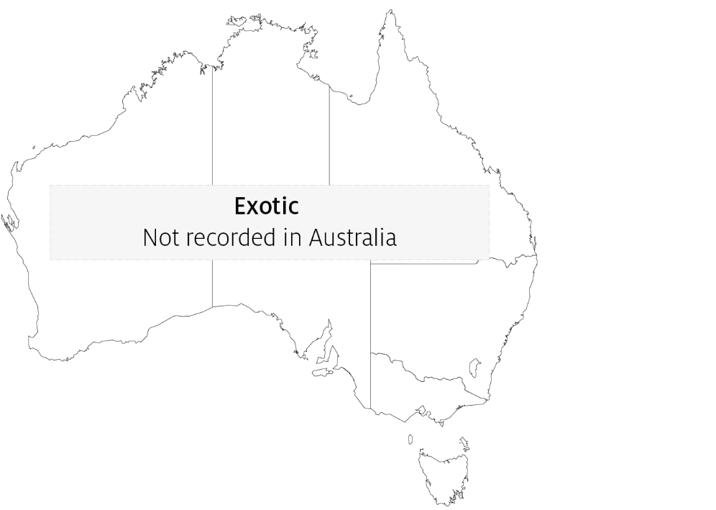

## Epidemiology

* SVC is very contagious among common carp.
* Clinical disease is linked closely to environmental disturbances.
* Mortality rate is usually less than 40% but can range from 5% to 100%, with younger fish less than 1 year old more susceptible.
* Fry are susceptible to disease at temperatures up to 23°C. However some SVCV strains from Asia replicate in-vitro at up to 28°C and can cause disease at water temperatures up to 26°C.
* Disease may also occur in older fish (greater than 1 year), usually when water temperatures are between 11°C and 17°C (associated with the stress of an abnormally cold spring in Europe, and possibly due to cold temperatures weakening the fish's immune system during the spring).
* Fish that survive SVC are presumed to carry the virus.
* Outbreaks are most likely to occur with increased stress levels, such as around the time of spawning, and coincide with increased levels of virus excreted with spawning fluids.
* Transmission of the virus to uninfected fish is horizontal, and the virus enters fish through the gills and skin.
* The virus enters the water in faeces, urine and spawning fluids. Transport of live infected fish, contaminated water and contaminated eggs of infected fish (suggestive of vertical transmission) contributes to disease spread.
* The virus also infects and causes disease in some salamanders.
* Blood-sucking parasites such as fish louse and leeches can transmit the virus from fish to fish. Piscivorous birds can also spread the disease.
* Stressors (such as overcrowding) can trigger an outbreak in apparently healthy populations.
* The virus can remain viable outside the host for 5 weeks in river water at 10°C or more than 6 weeks in pond mud at 4°C.

## Differential diagnosis

The list of similar diseases in the next section refers only to the diseases covered by this field guide. Gross pathological signs may also be representative of diseases not included in this guide. Do not rely on gross signs to provide a definitive diagnosis. Use them as a tool to help identify the listed diseases that most closely account for the observed signs.

## Similar diseases

Enteric redmouth disease (ERMD), enteric septicaemia of catfish, infection with Aeromonas salmonicida—atypical strains and koi herpesvirus disease (KHV).

## Sample collection

Only trained personnel should collect samples. Using only gross pathological signs to differentiate between diseases is not reliable, and some aquatic animal disease agents pose a risk to humans. If you are not appropriately trained, phone your state or territory hotline number and report your observations. If you have to collect samples, the agency taking your call will advise you on the appropriate course of action. Local or district fisheries or veterinary authorities may also advise on sampling.

## Emergency disease hotline

See something you think is this disease? Report it. Even if you’re not sure.

Call the Emergency Animal Disease Watch Hotline on **1800 675 888**. They will refer you to the right state or territory agency.

## Further reading

CEFAS International Database on Aquatic Animal Diseases [Spring Viraemia of Carp](https://www.cefas.co.uk/international-database-on-aquatic-animal-diseases/disease-data/?id=57)

World Organisation for Animal Health [Manual of diagnostic tests for aquatic animals](http://www.oie.int/en/international-standard-setting/aquatic-manual/access-online)

These hyperlinks were correct at the time of publication.

## Contact details

Emergency Animal Disease Watch Hotline 1800 675 888

Email [AAH@agriculture.gov.au](mailto:AAH@agriculture.gov.au)Website [agriculture.gov.au/pests-diseases-weeds/aquatic](http://www.agriculture.gov.au/pests-diseases-weeds/aquatic)

© Commonwealth of Australia 2020

This work is copyright. It may be reproduced in whole or in part subject to the inclusion of an acknowledgement of the source and no commercial usage or sale.