*supervising scientist report*

**194**



# A preliminary ecological risk assessment of the major weeds on the Magela Creek floodplain, Kakadu National Park



# D Walden, J Boyden, P Bayliss & K Ferdinands

# Project number – Res-2007-008

It is Supervising Scientist Division policy for reports in the SSR series to be reviewed as part of the publications process. This Supervising Scientist Report has been formally refereed by two external independent experts.

Authors

Dave Walden – Spatial Sciences and Data Integration Group , Environmental Research Institute of the Supervising Scientist, GPO Box 461, Darwin NT 0801, Australia

James Boyden – Sciences and Data Integration Group, Environmental Research Institute of the Supervising Scientist, GPO Box 461, Darwin NT 0801, Australia

Dr Peter Bayliss – CSIRO Marine and Atmospheric Research, PO Box 120, Cleveland Qld 4163; formerly Environmental Research Institute of the Supervising Scientist, GPO Box 461, Darwin NT 0801, Australia

Keith Ferdinands – Weeds Branch, Department of Natural Resources, Environment and the Arts, PO Box 30, Palmerston NT 0831, Australia

*This report should be cited as follows:*

Walden D, Boyden J, Bayliss P & Ferdinands K 2012. *A preliminary ecological risk assessment of the major weeds on the Magela Creek floodplain, Kakadu National Park Australia*. Supervising Scientist Report 194, Supervising Scientist, Darwin NT.

**The Supervising Scientist is part of the Australian Government Department of Sustainability, Environment, Water, Population and Communities**

© Commonwealth of Australia 2012

Supervising Scientist  
Department of Sustainability, Environment, Water, Population and Communities  
GPO Box 461, Darwin NT 0801 Australia

**ISSN 1325-1554**

**ISBN 978-1-921069-19-2**

This work is copyright. Apart from any use as permitted under the Copyright Act 1968, no part may be reproduced by any process without prior written permission from the Supervising Scientist. Requests and enquiries concerning reproduction and rights should be addressed to Publications Enquiries, ***Supervising Scientist***, GPO Box 461, Darwin NT 0801.

e-mail: publications_ssd@environment.gov.au

Internet: www.environment.gov.au/ssd (www.environment.gov.au/ssd/publications)

The views and opinions expressed in this report do not necessarily reflect those of the Commonwealth of Australia. While reasonable efforts have been made to ensure that the contents of this report are factually correct, some essential data rely on references cited and/or the data and/or information of other parties, and the Supervising Scientist and the Commonwealth of Australia do not accept responsibility for the accuracy, currency or completeness of the contents of this report, and shall not be liable for any loss or damage that may be occasioned directly or indirectly through the use of, or reliance on, the report. Readers should exercise their own skill and judgment with respect to their use of the material contained in this report.

Printed and bound in Darwin by Uniprint NT

#### For internal Supervising Scientist Division use:

Project number: Res-2007-008

Registry file number: SG2007/0092

Location of key data files: N:\G8025367\Projects\Weeds

Location of report in SSDX:  [Supervising Scientist Division > PublicationWork > Publications and Productions > Supervising Scientist Reports > SSR194_Weeds on Magela](http://nt01app01/PublicationWork/Forms/AllItems.aspx?RootFolder=%2fPublicationWork%2fPublications%20and%20Productions%2fSupervising%20Scientist%20Reports%2fSSR194%5fWeeds%20on%20Magela%20fl%2fFinal%20version%2fWord&FolderCTID=&SortField=LinkFilename&SortDir=Desc&View=%7bB33DDE98%2d325C%2d4F81%2dA334%2d628A1B8982DA%7d)

# 

# Contents

Executive summary vi

Acknowledgments ix

1 Introduction 1

1.1 Study area 2

1.2 Background 3

1.3 Project aims 4

1.4 Approach 4

2 Mimosa 10

2.1 Identification of the problem 10

2.2 The potential effects of mimosa 12

2.3 The potential extent of mimosa 15

2.4 Identification of the risks of mimosa 20

2.5 Uncertainty, information gaps and further research 21

2.6 Management implications of mimosa 22

3 Salvinia 25

3.1 Identification of the problem 25

3.2 The potential effects of salvinia 26

3.3 The potential extent of salvinia 28

3.4 Identification of the risks of salvinia 31

3.5 Uncertainty, information gaps and further research 31

3.6 Management implications of salvinia 31

4 Para grass 33

4.1 Identification of the problem 33

4.2 The potential effects of para grass 35

4.3 The potential extent of para grass 40

4.4 Identification of the risks of para grass 48

4.5 Uncertainty, information gaps and further research 61

4.6 Management implications of para grass 64

5 Species potentially vulnerable to para grass 68

6 Socio-economic effects of para grass 69

7 Conclusions 70

8 References 72

Appendix 1 Land unit codes and systems associated with the land unit classification of the Magela Creek floodplain 85

**Tables**

**Table 1** Mimosa control information over 22 years for Kakadu National Park 23

**Table 2** Summary of water depths recorded during wet season vegetation sampling in three vegetation types on the Magela floodplain 47

**Table 3** Chi-square results of para grass distribution versus random distribution 54

**Table 4** Results of z-tests showing statistical significance for predictor dataset attributes 55

**Table 5** Vegetation communities where the probability of para grass presence in the habitat suitability model was greater than 60% 60

**Table 6** The relative areas for different wetland vegetation identified as being at risk of para grass invasion based on the spread model 60

**Table 7**  Weed control data used to derive unit cost of control for para grass at Nourlangie (1992–1995) 65

**Table A.1** Description of land unit codes associated with the land unit classification of the Magela Creek floodplain 85

**Table A.2** Description of land systems associated with the land system classification of the Magela Creek floodplain 86

## Figures

**Figure 1** The Alligator Rivers Region in the ‘Top End’ of the Northern Territory, Kakadu National Park and the Magela floodplain 2

**Figure 2** Wetland risk assessment framework 5

**Figure 3** *Mimosa pigra* infestation on the Mary River floodplain, adult plants, flower heads and mature seed pods 10

**Figure 4**  Conceptual model of known information on *Mimosa pigra* 14

**Figure 5** Known mimosa locations on the Magela floodplain and surrounding areas 16

**Figure 6** Estimated control cost from 1991 to 1996 for large infestations of mimosa on the Gunbalanya floodplain, west Arnhem Land 22

**Figure 7** Estimated control effort – abundance curve for mimosa control in KNP from 1981 to 2002 24

**Figure 8** Salvinia molesta on Western plains on the Magela system and close-up showing the three growth forms 25

**Figure 9**  Conceptual model of known information *Salvinia molesta* 27

**Figure 10** *Urochloa mutica* – a large monoculture on the central Magela floodplain, an inflorescence and leaves and stems 33

**Figure 11** Conceptual model of known information on *Urochloa mutica* 39

**Figure 12** Para grass distribution on the Magela floodplain 41

**Figure 13** Supervised classification of QuickBird image using major vegetation communities and the airboat/helicopter survey data 42

**Figure 14** Para grass cover derived from supervised classification of the QuickBird image 43

**Figure 15** Linear regression between Loge extent (km2) of para grass and time (yrs) (R2=69%, n=5, P<0.04) 45

**Figure 16** Wetland vegetation on the Magela floodplain 50

**Figure 17** Land units describing soil types and typical associated vegetation 51

**Figure 18** Land systems describing broad areas of topography, underlying soils and rocks and typical associated vegetation 52

**Figure 19** Bayesian habitat suitability model derived probability surface 57

**Figure 20** Areas of floodplain where probability of para grass presence exceeded 60% 58

**Figure 21** Risk of para grass invasion 59

**Figure 22** Control cost curve for para grass on Nourlangie Creek, South Alligator River, Kakadu National Park (1996–1997), showing a negative exponential relationship 66

# Executive summary

## Background and approach

In the late 1990s, the World Heritage Commission expressed concern over possible impacts on environmental and cultural values of Kakadu National Park (KNP) resulting from the proposed Jabiluka uranium mine. A specially formed Independent Science Panel reviewed a Supervising Scientist report to the World Heritage Committee and made 17 principle recommendations. Amongst these recommendations was a need for more comprehensive ecosystem risk assessments at a landscape-catchment scale to differentiate between mining and non-mining impacts, primarily because the region is subject to changes other than those potentially related to mining. Weed invasions are perhaps the most significant non-mining threat to much of the Kakadu landscape including its wetlands.

Background information from existing literature is provided for three highly invasive wetland weed species, *Mimosa pigra* (mimosa), *Salvinia molesta* (salvinia) and *Urochloa mutica* (para grass). The primary focus of this assessment is the current and potential distribution of para grass with reference to its impacts. Field surveys and a remotely sensed QuickBird™ image were used to map para grass on the Magela Creek floodplain. These data were used to determine the current extent of para grass and the average spread rate of the past 20+ years. The data were also used in a Bayesian habitat suitability model to predict the native vegetation communities most susceptible to invasion and the potential extent of para grass on the Magela floodplain. No spatial risk modelling or habitat suitability modelling was conducted for mimosa and salvinia. The Magela floodplain remains under constant threat from mimosa and only a rigorous maintenance control regime prevents re-establishment from residual seed-banks and from new incursions. The spread and impacts of mimosa have been documented for a number of coastal floodplain systems in the Northern Territory. Salvinia, being a floating aquatic fern, is seasonal in its distribution and is subject to an ongoing biological control agent. There are scant data that quantify the impacts of salvinia.

This assessment follows the generic wetland risk assessment model recommended for the Ramsar Convention and comprises six fundamental procedures including: identification of the problem; identification of the effects; identification of the extent of the problem; identification of the risk; risk management and reduction; and monitoring and trend analysis.

## Identification of the problem

Mimosa, salvinia, and para grass are very different weeds and, for a variety of reasons, are subject to different management regimes. Since the early 1980s, the threat and consequences of widespread mimosa coverage in the Park were recognised and existing infestations were removed and/or fenced and monitored. A mimosa ‘team’ was also established to prevent new outbreaks through surveillance. Salvinia is already widespread in the Park with the potential for further spread. However, the density and coverage is greatly reduced via an introduced biological control agent, the weevil, *Cyrtobagous salviniae*. Salvinia will never be eradicated in the Park and is it now considered a permanent component of Kakadu’s flora. Presently, para grass covers a large area of the Magela floodplain. Access to expansive floodplains such as the Magela is often very difficult and the implementation of control and management strategies presents many challenges.

All three weed species possess many traits that make them highly invasive and successful. Some of these traits include; rapid growth; ready germination or resprouting from seed or small fragments distributed by floodwaters, birds and terrestrial animals; superior competition for resources compared with native species; few or no natural predators; and attributes attractive to humans that facilitate distribution to new areas often over vast distances. Environmental and socio-economic impacts are generally severe for large infestations. Control of all three weeds is usually very expensive and any chemical treatment has the potential to cause damage to non-target flora and in some cases to fauna.

## The potential effects

Mimosa and para grass form dense homogeneous shrubland and grassland respectively, greatly reducing flora and fauna biodiversity. With respect to the current para grass infestation on the Magela floodplain, perhaps the greatest concern is for the loss of the wild rice (*Oryza* spp) grassland which is recognised as an important foraging and nesting resource for magpie geese (*Anseranas semipalmata*). Salvinia dominates the surface of waterbodies forming dense mats that can alter water quality and nutrient status by effectively excluding light penetration, preventing oxygen transfer from the air and increasing dissolved oxygen consumption. These weeds have the potential to alter hydrological regimes and large infestations impede the access of humans and animals to floodplains and waterbodies, adversely affecting enterprises and activities such as pastoralism, tourism, recreation and traditional Indigenous practices such as hunting and gathering. Para grass can alter fire regimes with more intense and frequent fires that sometimes carry into more sensitive fringing forests. These weeds are also known to provide ideal habitats for pests such as pigs and mosquitoes.

## The potential extent

Since 1980, mimosa has been found at a number of sites on the Magela floodplain. Adult mimosa plants at these sites have been removed although seedlings continue to appear at some sites. New incursions are often located each year and these are destroyed and the site closely monitored. This scenario for mimosa occurs throughout the Park. If allowed to establish and spread, mimosa has the potential to dominate a major proportion of Kakadu’s floodplains. A map of the history of mimosa incursions since 1980 is presented for the Magela floodplain. However, no spatial analyses, risk modelling or habitat suitability modelling have been undertaken and no such maps are presented.

Salvinia was first discovered in the Magela system in 1983 and is now present in the East Alligator River system and Nourlangie Creek and elsewhere in the South Alligator River system. Salvinia’s rapid spread through Kakadu indicates that it could occupy all wetlands and waterbodies in a relatively short space of time. At the time of the QuickBird image capture (July 2004), para grass covered approximately 1250 ha of the central region of the Magela floodplain. Satellite infestations with the potential to spread rapidly exist in the north and south regions of the floodplain and along the north-western edge. Bayesian habitat suitability modelling has shown that para grass has the potential to invade about 6360 ha (34%) of the floodplain, displacing the *Oryza* spp grassland in particular.

## Identification of the risks

Risk is a combination of both the *effects* and *extent* (or *exposure* to) of a threatening entity. For mimosa, experience from coastal floodplains elsewhere in the Northern Territory has shown that the majority of land subject to inundation, except for perhaps the very deepest parts of the channels, could potentially be invaded by mimosa. The probability of incursion and establishment remains very high for KNP and continued vigilance is necessary to prevent repeated incursion or emergence from dormancy in existing seed banks. Potential weed vectors such as the high volume of park visitors (eg vehicular and boat traffic), and movements of feral and native animals exacerbate the risks.

Although the risks associated with salvinia infestation have been reduced by the salvinia weevil, research has shown that weevil populations can vary greatly from year to year with a subsequent variation in their efficacy. In the absence of any quantitative data on the effects of salvinia, the actual risks remain uncertain. The risks of salvinia invading other regions in the Park are managed in part by quarantine procedures.

Para grass currently infests large areas of the Magela floodplain and has therefore already displaced large areas of natural habitat. It is known to be spreading at an alarming rate. Habitat suitability modelling has demonstrated that a large proportion of the floodplain, yet to be colonised, is at high risk of infestation which could occur within two to three decades.

The adverse effects of widespread incursion of all three weeds have been acknowledged, although these effects are generally poorly understood with little quantitative information being available.

## Uncertainty, information gaps and further research

As the risk of mimosa invasion in Kakadu National Park remains high, a number of research endeavours that may assist managers have been identified. Some of these include: habitat suitability modelling; more detailed GIS assimilation of mimosa plots and new incursions with the possibility of developing remote sensing techniques to identify new outbreaks; documenting the seed stores following control; quantifying the competitive relationship between mimosa and native vegetation; and the precise role of wild and controlled fires.

For salvinia, there is very little quantitative data on the effects on water quality and flora and fauna. Remote sensing techniques could be explored to monitor salvinia distribution at the landscape scale. Continued monitoring of the persistence and success of the salvinia weevil is essential for the control of salvinia.

Some identified areas where further information could assist in the management of para grass include:

* Extent: further refinement of the habitat suitability model; more detailed mapping; salinity tolerance; the viability of para grass seeds and the persistence of the seed bank; competition with native species; modification of the floodplain habitat by para grass; tolerance of para grass to water depth and period of inundation; the efficacy of various herbicide treatments utilising trial plots whilst obtaining valuable cost of control data; and the role of fire in management.
* Effects: the real impacts upon native habitat displacement; fire (ie increased fuel loads); hydrology (eg reduced flow and increased sediment deposition); extent to which para grass is a physical barrier to larger animals; the effects of herbicides on non-target species.

## Management Implications

Ongoing preventative management of mimosa in Kakadu is a labour intensive and costly exercise. Resources are dedicated to i) revisiting old sites where mimosa has been present, in order to monitor and control regrowth from seeds in the seed bank and ii) surveys of suitable habitat to locate new incursions that occur on a regular basis. In the absence of current management strategies, the implication for the Magela and other floodplains of Kakadu is a landscape dominated by mimosa. Removal of mimosa at this scale would cost tens of millions of dollars with considerable and most likely indefinite follow-up control.

Prior to the establishment of the salvinia weevil, considerable resources were allocated to physical and chemical control of the weed, resulting only in short-term gains given the exponential regrowth. After establishment, a decline in weevil populations prompted an intensive study to determine the cause, which appeared to be related to the timing of the onset of the wet season rains and the timing and size of the main flood events. Weevils are sometimes harvested from the wild and distributed to new areas where appropriate.

It is acknowledged that eradication of the larger infestations of para grass is most likely unachievable. Some smaller infestations in the Park have been successfully eradicated and others are currently being targeted for control and/or eradication. Treatment is relatively expensive in floodplain environments as aerial herbicide spraying is often the only feasible method. This is complicated by factors of herbicide drift to non-target species and the uncertain effects on frogs and other fauna. Para grass also grows under paperbark and other fringing forests where aerial treatment is not practical. There has been varying success with past control efforts where some treatments are highly successful with little regrowth whilst other treatments have resulted in substantial regrowth even after multiple treatments over many years. The reasons for this variation in efficacy are not well understood. Initial cost of control modelling suggests that significant reduction in coverage could cost nearly $2 million with nearly $0.5 million per annum in follow-up control.

## Acknowledgments

The authors would like to thank all of the Kakadu National Park district staff who gave their time and access to their weed data. In particular, thanks to Ross (Buck) Salau (KNP weed officer) for assistance in the field, providing information and for sharing his extensive knowledge of KNP weed issues. To Freddy Hunter, Calvin Murakami, Solomon Cooper, and Dwayne Wauchope who also provided valuable assistance and knowledge in the field. Thanks to John Lowry, George Begg, Brian Smith and Alistair Cameron of ***eriss*** for their assistance in the field surveys. To Guy McSkimming, Steve Wingrave and Cameron Yates (Department of Natural Resources, Environment, the Arts and Sport - NRETAS) who have shared their knowledge of weeds in the region on several occasions and supplied data for the region. Thanks to Robert Graham from the Townsville Town Common Conservation Park for sharing his local knowledge and information on para grass. The authors are very grateful to Dr Peter Whitehead and Dr Penny Wurm for their extremely valuable review and comment on the manuscript. Renee Bartolo also provided valuable comments. Many thanks to Ann Webb for the final editing and production of the report.

*This page has been left blank intentionally.*

# 1 Introduction

The negative impact of invasive weeds on ecosystem services and biodiversity is probably the most significant threat facing tropical wetlands today. Across the tropics there are many wetland weed species – some of them, including *Mimosa pigra* (Linnaeus), *Salvinia molesta* (Mitchell) and *Urochloa mutica* (Forssk), being widely distributed, if not pan-tropical. These species have attracted a great deal of attention with the expenditure of large sums of money and effort on control techniques (Finlayson & Mitchell 1981, Storrs & Finlayson 1997, Douglas et al 1998). Fourteen of the top 18 environmental weeds in Australia invade wetlands (Humphries et al 1991), with 12 of these species currently found in the Northern Territory. For Kakadu National Park (KNP), Storrs (1996) lists 15 species of high priority weeds that exist in small to large infestations and which are capable of significant impacts. In 1996, Kakadu was thought to have up to 99 naturalised alien plant species (Brennan 1996) – species that have become accepted and have reproduced for several generations. This represents about 5.3% of the total flora but is relatively low when compared with an average of 21% in other Australian conservation areas (Lonsdale 1992a). The number of alien plant species in Kakadu has increased at the rate of 1.6 species per year since 1948, and is expected to continue as a result of increased tourism and development (Cowie & Werner 1993). For an area like Kakadu, apart from the problems of controlling existing weeds, there is the seemingly inexorable advance of major potential invaders (Storrs 1996).

The extent of invasion of wetlands by weeds has been described for some species, though often incompletely. In many instances, vital information on the ecological changes wrought by these species is often confined to a few isolated studies or to anecdotal evidence. Economic analyses of the losses caused by pest species are not common and studies on the social and cultural impacts of weeds have not generally been done (Finlayson & Spiers 1999).

A Global Biodiversity Forum held prior to the Ramsar Conference of Parties in 1999 addressed invasive species and agreed upon the following definition: ‘An invasive species is a species, often alien, which colonises natural or semi-natural ecosystems, is an agent of change, and threatens native biological diversity’ (Pittock et al 1999).

Given that weeds are an increasingly serious problem in tropical wetlands, there is a need for management prescriptions to be developed at several levels. These include prevention at a national or regional level, and more specific interventions in local situations. Critically, for managers and users of wetlands, practical techniques and options are required that take into account local differences in all other priorities and available resources. However, for localised effort to be effective a strategic framework is required that provides the necessary options and places particular weed infestations and their control into a regional perspective. A means of ensuring that the above aspects are not forgotten is through the adoption of ecological or wetland risk assessment procedures as the basis for effective and strategic weed management.

Within this context, information on the biology, ecology and management of *Mimosa pigra* (mimosa), *Salvinia molesta* (salvinia) and *Urochloa mutica* (para grass)[1] has been collated and analysed in a risk assessment of the weeds in the regional context of KNP, in particular, of para grass on the Magela Creek floodplain.

Kakadu National Park is recognised as a World Heritage area for its biodiversity of flora and fauna and its cultural significance. Though weed invasion is only one of many threats facing the Park, the risks to native vegetation are significant. With particular reference to this report, the risks to wetland vegetation threaten the maintenance of the full array of World Heritage values such as fauna habitat and ecological processes including changes to hydrological and fire regimes and carbon/nutrient cycling.

## 1.1 Study area

The Alligator Rivers Region (ARR) (Figure 1) lies in the middle of the ‘Top End’ of the Northern Territory. The Top End is a colloquial name and is used throughout this report. It describes the wet-dry tropical region of the north of the Northern Territory with annual rainfall greater than approximately 900 mm and above -15 degrees latitude. The coastal floodplains referred to in this report are found around the coastline of the Top End. They are seasonally inundated freshwater floodplains with a tidal brackish water component where they drain into the sea.

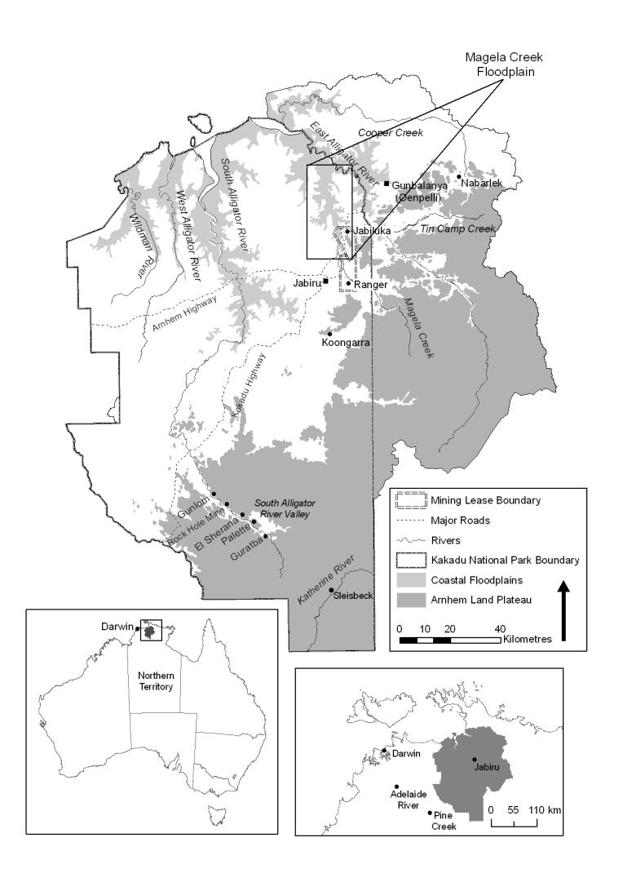

**Figure 1** The Alligator Rivers Region in the ‘Top End’ of the Northern Territory,   
Kakadu National Park and the Magela floodplain

The Alligator Rivers Region derives its name from the network of rivers that form the main hydrological components of the area, draining into the Van Diemen Gulf. Kakadu National Park occupies about 20 000 km2 of the ARR and despite in recent times having been modified by pastoral, mining and tourist activities and the introduction of exotic flora and fauna, the Park maintains its status as a World Heritage listed area. The floodplains of Kakadu occupy approximately 193 850 ha (Bayliss et al 1997) comprising around 10% of the total Park area.

The Magela Creek is in the East Alligator River system and has a catchment area of approximately 1600 km2 and an associated coastal floodplain of about 225 km2. The creek originates high on the Arnhem Land sandstone plateau and proceeds as a channel through the wooded lowland plains. Prior to entering the floodplain, the creek flows through the Ranger uranium mine lease, with the southern portion of the floodplain located on the Jabiluka uranium mine lease. The Magela floodplain, like other Kakadu floodplains, lies only 3–4 m above the Australian Height Datum (AHD) making it only 0.2–1.2 m above sea level. The entire length of the creek right down to the East Alligator River confluence is about 100 km.

## 1.2 Background

In October 1998 the World Heritage Committee (WHC) mission to the Kakadu National Park World Heritage site expressed concern over the possible impacts on natural and cultural values resulting from a proposal to mine uranium at Jabiluka (The Jabiluka Mill Alternative). At the request of the WHC, the Australian Supervising Scientist reported to the committee on the scientific concerns raised. The WHC obtained the support of the International Council of Science Union (ICSU) to form an Independent Science Panel (ISP) to review this Supervising Scientist report (ISP 2000).

The ISP concluded that the Supervising Scientist report had reduced the scientific uncertainties but that issues remained which needed additional analysis and/or clarification. The ISP made 17 principal recommendations but noted that its insights had been limited by lack of time and the need for both a site visit and further information. In July 1999 the WHC requested the ICSU to continue the work of the ISP in co-operation with the SS and the World Conservation Union (IUCN) in an attempt to resolve the remaining scientific issues (ISP 2000).

The ISP and IUCN stated that while impacts from the site-specific Jabiluka mine proposal were most likely negligible, a more comprehensive risk assessment of both the freshwater and terrestrial ecosystem at a *landscape-catchment* scale was needed. This was because the ARR is subject to major seasonal or long-term changes unrelated to those that may arise from mining impacts. For example, the impact of invasive weeds is probably the most significant non-mining threat facing the Magela Creek wetland system at the landscape scale (Bayliss et al 2006, Bayliss et al 2012). Hence, they suggested that comprehensive monitoring programmes and accompanying analyses (assessments) are needed to distinguish between impacts from these differing causes and any unforeseen problems arising from mining. The review panel invited Environment Australia’s (now Department of Sustainability, Environment, Water, Population and Communities) Environmental Research Institute of the Supervising Scientist (***eriss***) and Parks Australia North (now Parks Operation and Tourism Branch) to undertake inventory, assessment and monitoring activities at landscape scales in order to guide future ecosystem management.

Weed management is perhaps the single greatest challenge facing Kakadu National Park managers. In addition to the aquatic/floodplain weeds outlined in this assessment, threats have emerged in the terrestrial realm in the form of grasses like Mission (*Pennisetum* spp) and Gamba (*Andropogon gayanus*) for example. Considerable resources are already devoted to mimosa, para grass and salvinia but still the weeds persist and in some cases, spread.

## 1.3 Project aims

The three major weeds (mimosa, salvinia and para grass) that occur on the floodplains of the Magela Creek system were assessed using the wetlands risk assessment (WRA) framework proposed for wetlands by van Dam et al (1999). The WRA addressed four questions:

1. What areas/habitats of the seasonally inundated Magela Creek floodplain (in KNP) are at risk of invasion by each of the three weed species (ie current distribution and trend analysis where feasible)?
2. What are the likely consequences of these invasions (ie assessment of likely effects and pressures)?
3. What management scenarios are required to minimise the risks of further invasion?
4. How could the presence and spread of these species confound assessment of any mining-related pressures?[2]

The approach adopted to answer these questions is described below.

## 1.4 Approach

### 1.4.1 Wetland risk assessment framework

Over the last decade the concept of environmental risk assessment has developed and expanded from a narrow and precise analysis of quantitative ecotoxicological data to more general and qualitative/semi-quantitative analyses of environmental problems (eg Burgmann 2005). This has led to the Ramsar Convention on Wetlands recommending a model for wetland risk assessment (Fig 2), coupled with advice on the deployment of early warning systems for detecting adverse ecological change in wetlands. The Ramsar procedures are linked with a concurrent effort to espouse the values of wetlands and the maintenance of their ecological character. The former have been summarised by Finlayson (1996), as outlined below.

* *Functions* performed by wetlands are the result of the interactions between the biological, chemical and physical components of a wetland, such as soils, water, plants and animals, and include: water storage; storm protection and flood mitigation; shoreline stabilisation and erosion control; groundwater recharge; groundwater discharge; retention of nutrients, sediments and pollutants; and stabilisation of local climatic conditions, particularly rainfall and temperature.
* *Products* are generated by the interactions between the biological, chemical and physical components of a wetland, and include: wildlife resources; fisheries; forest resources; forage resources; agricultural resources; and water supply.
* *Attributes* of a wetland have value either because they induce certain uses or because they are valued themselves, and include the following: biological diversity; geomorphic features; and unique cultural and heritage features.

The combination of wetland *functions, products* and *attributes* give the wetland *benefits and**values* that make it important to society. The language used to describe these benefits and values has been reassessed in recent years and the terms *ecosystem goods and services* or *ecosystem services* are increasingly being used to describe the benefits and values derived from ecosystems, including wetlands.

In the context of the Ramsar Convention on Wetlands and the wise use of wetlands it is stressed that the use and management of a wetland and its resources should be done in a manner that is consistent with the maintenance of the ecological character of the wetland. Ecological character is now defined as (see <http://www.ramsar.org/key_res_vii.10e.htm>):

the sum of the biological, physical, and chemical components of the wetland ecosystem, and their interactions which maintain the wetlands and its products, functions and attributes.

And the change in ecological character as:

the impairment or imbalance in any biological, physical, or chemical components of the wetland ecosystem, or in their interactions, which maintain the wetland and its products, functions and attributes.

The generic wetland risk assessment model recommended for the Ramsar Convention (van Dam et al 1999, <http://www.ramsar.org/key_res_vii.10e.htm>) has been derived from those used for water pollution and ecotoxicological assessments (eg USEPA 1998) as well as the more general methods developed for assessing the vulnerability of wetlands to climate change and sea level rise. The model provides guidance for environmental managers and researchers to collate and assess relevant information and to use this as a basis for management decisions that will not result in adverse change to the ecological character of the wetland. As the objective was to provide a framework for informed decision-making, the model is not prescriptive.



**Figure 2** Wetland risk assessment framework (adapted from van Dam et al 1999)

The major steps in the wetland risk assessment (WRA) process presented in Figure 2 are briefly described below, and are adapted from the Ramsar Convention Bureau (2000) and van Dam et al (1999).

1 ***Identification of the problem:*** what is the nature of the problem and how do we plan for the remainder of the risk assessment based on this information. Define the objectives and scope of the risk assessment.

2 ***Identification of the effects:*** evaluate the likely extent of adverse change or impact on the wetland, including cultural values in consultation with Traditional Owners (eg sacred sites). Where possible, field studies will be used and are preferable for assessments of multiple impacts (as occurs on many wetlands). However, literature reviews of existing information may often be sufficient to identify some impacts.

3 ***Identification of the extent of the problem:*** estimate the likely extent of the problem on the wetland(s) of concern by using information gathered about its characteristics and extent of occurrence elsewhere. Map current distribution in order to estimate its potential distribution (and hence threat).

4 ***Identification of the risk:*** integrate results from the assessment of the likely effects with those from the assessment of the likely extent of the problem, in order to estimate the likely level of adverse ecological (and social) change within the Magela floodplain. A GIS-based approach can be a useful technique for characterising risks to wetlands (see below), by overlaying relevant information onto a map of the region of interest in order to link effects to extent/distribution. In addition to estimating risks, focus future assessments and/or monitoring on identified problem areas. The uncertainty and information gaps associated with the assessment will be described.

5 ***Risk management and reduction:*** the final decision-making process uses information obtained from the assessment processes described above, and in conjunction with other relevant information (eg political, social, economic, and engineering), and attempts to minimise the risks without compromising other societal, community or environmental values. It is a multidisciplinary task usually requiring coordination by resource managers and communication between stakeholders.

1 ***Monitoring and trend analysis:*** this is the last step in the overall risk assessment process and will be undertaken to verify the effectiveness of the risk management decisions. It will incorporate components that function as a reliable early warning system, detecting the failure or poor performance of risk management decisions prior to serious environmental harm occurring. The risk assessment will be of little value if effective monitoring is not undertaken. Trend analysis will likely require four or five years of further data on distribution and abundance of the three major weeds, and their annual rates of spread (using mapped vegetation types and spot GPS locations from historical data and/or more recent weed surveys).

It is important to note that this assessment addresses the first four steps of the WRA process, in order to provide important information for the risk management process, which is a separate undertaking that must be the responsibility of the relevant agencies. This assessment is largely a context-setting exercise that sometimes relies on incomplete and/or imperfect information. An effective risk management framework for weed control is based upon adaptive management principles, where strategic decisions regarding weed control are underpinned by effective monitoring of weed invasions and control efforts. This preliminary risk assessment attempts to provide some background information for these adaptive management principles including:

* aggregation of available information;
* analysis of its implications;
* identifying strengths and weaknesses in the knowledge base;
* identifying greatest risks and potential responses from existing documentation and new analysis;
* designing interventions and addressing greatest risks in ways that optimise learnings;
* obligations to engage stakeholders and managers if learning is to be optimised.

### 1.4.2 Information sources

#### Literature review

Published and unpublished reports were sourced and obtained through a comprehensive literature review process. Further relevant publications were then identified and obtained from within these sources.

#### Data sources and status of data

Where available, weed distribution and control data for each management district were obtained from Parks Australia North databases. Most spatial data were associated with Fugawi™ software as waypoint files and some additional data were available as hard copies. All data were converted or transcribed to spreadsheets and migrated to the ArcView™ desktop Geographic Information System (GIS). The KNP mimosa database, which has records from 1981, was also obtained and relevant information was extracted and entered into the GIS. Information from this database was also collated and used for preliminary cost of control modelling. KNP natural resource managers have a weeds database in development that will ultimately centralise all existing and future data for the entire Park, and will form the basis of a GIS. There were no records in this new database at the time of data acquisition for this project.

Additional weed distribution data were obtained from the Northern Territory Department of Natural Resources, Environment, the Arts and Sport (NRETAS).

For the Magela floodplain,historical para grass spatial data with contextual information on native vegetation was also acquired through an ***eriss***research project (Knerr 1998).

#### Ground data collection

With limited resources it was not possible to conduct a systematic survey of para grass for the entire Magela floodplain. However, in March 2003, as part of a broader floodplain vegetation mapping program, two rapid-assessment, mobile-airboat surveys were conducted by a trained observer/recorder, where vegetation types, including para grass, were ranked in order of cover dominance for about 1200 locations spanning the length of the floodplain. Using this information and historical information on para grass distribution (Knerr 1998), it was decided to focus further para grass-specific survey efforts within the region of the largest infestation located near the centre of the Magela floodplain where the aim was to obtain more detailed information on environmental and native plant associations of para grass across its range. Therefore in June 2004, another airboat survey of this region was completed, followed by a low level helicopter survey. For this airboat survey, the percentage cover of dominant plant species and open water were recorded in detail for some 80 sites located along four transverse (east-west orientated) transects (each approximately 3.5 km in length and spaced at about 1 km intervals) and two longitudinal adjoining transects. Sites observations were made in a 20 m radius from the bow of the stationary airboat at approximately 250 m intervals along the transect. Water depth measurements (with coincident measurement at the Jabiluka gauging station) and photographs were also taken at most 2004 sites. The main purpose of the accompanying helicopter survey was to delineate larger, homogeneous patches of para grass across a broader extent than could be achieved using the airboat alone. Larger patches of homogeneous vegetation were later used as training (and validation sites) for classification of a coincident remote sensing image capture, described below. For all the above-mentioned surveys, a handheld Garmin GPS unit[3] was used to record site locations.

#### Remotely sensed map information

One of the key issues facing weed managers is incomplete knowledge on the spatial distribution of weeds across extensive and remote landscapes. In this regard high resolution remote sensing imagery has shown potential in addressing knowledge gaps associated with managing para grass (and potentially other weeds) in tropical wetland environments of Australia (Catt & Thirarongnarong 1992, Boyden et al 2007). It appears that remote sensing has the potential to provide synoptic and quantitative information on para grass distribution and on the displacement of specific native vegetation communities of likely conservation concern, and therefore may form an important part of future monitoring and risk management strategies.

A pilot study aiming to assess the utility of very high resolution satellite imagery to map para grass distribution on the Magela floodplain was conducted in 2004. A QuickBird image was captured on 25 June 2004 for a 64 km2 area, covering the centre of the Magela floodplain and targeted the largest infestation of para grass on the floodplain. This image, interpreted using the June 2004 spatially referenced airboat and helicopter survey data, was of excellent quality, ie the image was cloud and smoke free, and the spectral discrimination of para grass from other major floodplain plant communities was pronounced at the time of image capture. The image also encompassed a range of native vegetation communities known to occur in the area that are potentially threatened by para grass, including the annual grass, *Oryza meridionalis,* and sedges *Eleocharis* spp, although the former was in its dormant phase at the time of capture (Boyden et al 2007, 2008).

A thematic map of para grass and major native vegetation communities was produced from this imagery using computerised image analysis techniques. It was concluded that the standard QuickBird product has suitably high spatial resolution and high potential interpretation accuracy for detecting relatively small patches of weeds when environmental conditions are suitable (Boyden et al 2007).[4]

Image classification was conducted in ENVI™[5] using the Maximum Likelihood Classifier Algorithm. Training-sites for classification were selected on the 2004 QuickBird image from larger homogeneous vegetation classes using spatially referenced field notes and photographs obtained during the 2003/04 field surveys.

Para grass varied in appearance from less green and more senescent, generally at drier floodplain margins and raised channel levees, to lush green in wetter areas, both of which were clearly discernable on the image. As such, two para grass sub-classes were nominated in the classification: wet-green, and dry-senescent. The spectrally distinct stages enabled an improved classification accuracy of para grass, where training areas were derived from within each of the growth forms. Further detail of the spectrally distinct ‘states’ of para grass are discussed in Boyden et al (2007). Accuracy assessment of the class map was performed by generating a confusion matrix using independent field validation sites. The two growth forms of para grass had the high classification accuracies of 90% (wetter) and 96% (drier), whilst the overall map accuracy was 86%; kappa coefficient 0.83 (see Congalton 1991 for methods and descriptions of terms). This relatively high classification accuracy indicates the potential of this imagery to effectively map para grass distribution across large areas of floodplain.

### 1.4.3 Bioeconomic modelling

The three basic aims of population management are control, sustainable harvesting and conservation. Regardless of the aim, however, there must be a good understanding (or conceptual model) of the dynamics of the pest population in order to manage them. Additionally, management decisions must be linked to socio-economic considerations or, put simply, the associated benefits and costs of any action or activity. Bioeconomic models help population managers bridge the gap between knowledge of the biology of the species being managed and knowledge of socio-economic consequences. Such models provide a powerful strategic framework, or Decision Support Tool (DST), for setting effective priorities for management of any natural resource. Implicitly, the modelling approach is based on information inputs relating to the above-mentioned factors and an effective monitoring program must therefore be in place if a DST is to be applied for routinely management operations.

With respect to the management of invasive species, the most useful bioeconomic model will encompass the following three key sub-models (or functions) which are explicitly linked: (1) a damage-abundance function (or suite of functions if multiple damage exists); (2) a population dynamics model; and (3) a cost of control function. In this assessment, available distribution, spread, impact and control-cost information from KNP and elsewhere in the Top End was used to determine these functions for mimosa and para grass only.

# 

# 2 Mimosa

Exactly how and when mimosa was introduced to Australia is unknown. Miller and Lonsdale (1987) concluded that it probably arrived in Darwin in the 20 years prior to 1891, either accidentally in seed samples introduced for the Darwin Botanic Gardens, intentionally as a curiosity because of its sensitive leaves, or in the intestines of livestock imported from Indonesia. Mimosa was not found outside the Darwin City area until 1952 when it was discovered upstream from the Adelaide River township about 100 km south of Darwin. By 1968 it had spread downstream along the Adelaide River to the Marrakai Crossing. (Miller et al 1981). Between 1980 and 1989 mimosa spread from 4000 to 80 000[6] ha in the Northern Territory (NT Government 1997).

## 2.1 Identification of the problem

A physical description and details of the biology and ecology of mimosa are available in a variety of literature (eg Harley 1992, Lonsdale 1988, Lonsdale et al 1988, Miller 1988, Lonsdale 1993a 1993b & Lonsdale et al 1995). Figure 3 shows various parts of the mimosa plant.

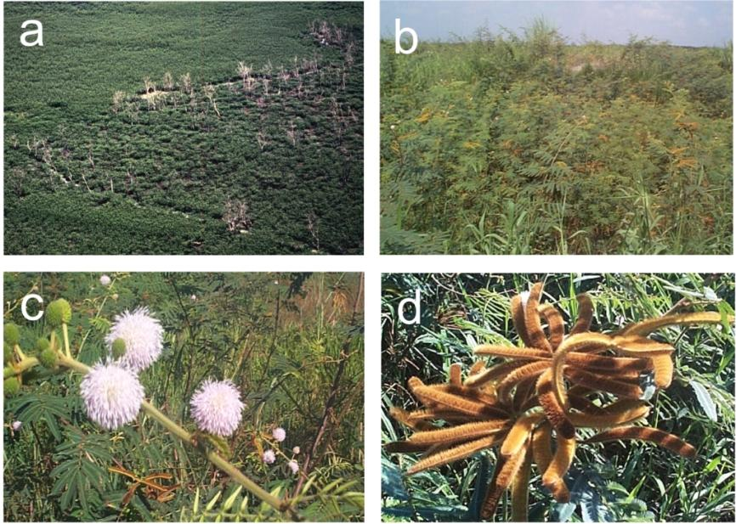

**Figure 3** *Mimosa pigra* (a) a large infestation on the Mary River floodplain, west of Kakadu National Park (b) adult plants, (c) flower heads, (d) mature seed pods (photographs – CM Finlayson)

### 2.1.1 Weediness

Mimosa has many features that enable it to thrive as a weed. Under the right conditions mimosa grows quickly at a rate of about 1 cm per day, and infestations can double in area in one year. It can also withstand droughts, so the extended dry season, although slowing the growth rate and thinning the canopy, does not kill mimosa (Lonsdale 1993a).

Typical of many flood tolerant species, mimosa is well adapted to growth in seasonally flooded habitats through its ability to produce adventitious roots which can take up oxygenated water when soil conditions become anaerobic (Miller et al 1981). Mimosa thickets can advance into waterbodies until little open water remains (Braithwaite et al 1989). Mimosa also has the potential to invade tidal zones (Miller 1983).

The plants mature quickly and can set seed in their first year of growth (Lonsdale et al 1985). The seeds of mimosa are well-designed for easy and rapid dispersal. The seedpods break into segments when mature, with each segment containing a single seed. These segments are covered with bristles that enable them to adhere to animals and clothing, and to float on water for extended periods (Miller et al 1981, Lonsdale 1993a). Seeds are also dispersed in soil and mud adhering to vehicles, machinery (Lonsdale et al 1985) and boats, and in the dung of livestock and native animals that sometimes graze on mimosa (Miller & Lonsdale 1987, Miller 1988).

Under certain conditions, seeds can remain dormant but viable for long periods. In sandy soils, observations suggest that seed lifespan may be as high as 23 years (Lonsdale 1992b). Seeds that are buried for long periods could eventually germinate if brought to the surface by cultivation or disturbance by animals (Lonsdale et al 1988). Dormancy of mimosa species can be ended when the hard seed-coats break via expansion and contraction due to soil temperature fluctuations from about 25 to 70°C. The deeper a seed lies in the soil, the less extreme is the temperature range and seeds buried deeper than 10 cm cannot successfully germinate (Lonsdale 1993b). For seeds in the upper soil layers, fire can either kill mimosa seed or increase the germination rate, depending on the fire intensity (Miller 1988).

Seed rate production is high being measured at between 9000 and 12 000 m-2 per year depending on the conditions (Lonsdale et al 1988). The most productive plant observed in the field in Australia had a crown of about 8 m2 and produced about 11 000 pods per year, equivalent to about 220 000 seeds (Lonsdale 1992b).

The compound leaves of mimosa, like those of several other species in the genus, close in response to electrical, mechanical, thermal and light stimuli and wounding (Simons 1981). This may protect the leaves from damage in certain circumstances. This feature has also promoted spread, as humans value this novelty and have translocated mimosa as a garden ornamental.

If chopped down mimosawill resprout from the stump (Wanichanantakul & Chinawong 1979). If mimosa is burnt, the foliage may become desiccated and fall, but up to 90% of mature plants and up to 50% of seedlings may regrow (Miller & Lonsdale 1992).

Mimosa has low nutrient requirements and can grow within a wide range of soil types including nutrient poor sands, alluvial red and yellow earths, silty loams and heavy black cracking clays (Miller 1983).

### 2.1.2 The history of mimosa invasion in Kakadu National Park

Mimosa was first discovered in KNP in 1981 (Skeat et al 1987) and by 1993 a total of 160 outbreaks were recorded in the Park (Cook et al 1996). The suspected seed source for the outbreaks in central KNP could have been either of the two large infestations to the east and west of the Park. The infestation on the Oenpelli (Gunbalanya) floodplain to the east was expanding rapidly and by 1991 covered approximately 6000 ha. At this time dense mimosa also covered approximately 40 km2 of the Mary River floodplain (Cook et al 1996). Many of the outbreaks in KNP could be attributed to movements of large mammals including feral pigs and buffalo, with subsequent dispersal by water (Lonsdale & Lane 1994). Waterbirds may have been responsible for dispersal of seeds to some of the more remote sites (Cook et al 1996).

The highest densities of mimosa outbreaks in KNP were found in the wetland margins that had been disturbed by feral animals, and in wetland habitats with a relatively long period of inundation, but where trees were absent (Cook et al 1996). A high level of ground disturbance caused by feral water buffalo and pigs probably facilitated the establishment and spread of mimosa in the Park. Water buffalo have been reduced in large numbers from the Park since 1990 (ANPWS 1991), yet substantial ground disturbance caused by feral pigs is still apparent (Boyden et al 2008).

## 2.2 The potential effects of mimosa

Mimosais an enormous problem for wetland conservation. Largely intact natural landscapes can be completely altered, with floodplains and swamp forests being covered by dense monospecific stands of mimosa, that have little understorey except for mimosa seedlings and suckers (Braithwaite et al 1989). This structural and floristic dominance greatly reduces the biodiversity of the structurally diverse native species.

Due to mimosa’s ability to sprout adventitious roots, it may even modify waterbodies. In the dry season, seedlings establish along the receding waterlines (Lonsdale & Abrecht 1989), and with the inundation of the next wet season, the natural water flows may be reduced by the adventitious roots, resulting in increased sediment deposition.

### 2.2.1 Effects of mimosa on native flora

Once established, mimosa is able to out-compete the native herbaceous layer vegetation for light moisture and nutrients, although the relative importance of these three factors has not been determined. In studies on the Finniss and Adelaide River floodplains, Braithwaite et al (1989) found that sedgeland sites, which carry no trees, received 100% of the incident light in the absence of mimosa, but only 62% (Finniss River sites) and 81% (Adelaide River sites) when it was present.

The Melaleuca dominated forests fringing the floodplains have a rather open canopy and mimosa has also penetrated this habitat, preventing seedlings of the native forest trees from establishing. Incident light measurements show that although 75% passed through the native tree canopy, only 26% reached the ground flora with the additional presence of a mimosa canopy (Braithwaite et al 1989). Due to the demonstrated exclusion of native tree seedlings, it is proposed that the mature native tree canopy would eventually die out, and these swamp forests, like the sedgelands would become mimosa-dominated shrubland (Braithwaite et al 1989).

Braithwaite et al (1989) suggest that the effect on the light regime at ground level, regardless of competition for moisture and nutrients, may be sufficient to account for the observed reduction in the number of tree seedlings, biomass and species diversity of the herbaceous layer. The above light measurements were taken during the dry season when the weed has a relatively sparse canopy. The impacts could possibly be exacerbated in the wet season, when the denser canopy of a lush mimosa thicket may prevent around 90% of the incident light from reaching the ground (Braithwaite et al 1989).

Cook (1992) compared vegetation sites with and without mimosa for three different communities on the Gunbalanya floodplain. Where mimosa was present in floodplain margin and back-swamp communities, the projected cover of native herbaceous species was less than one third and species diversity was less than one half of that where mimosa was absent. In the open floodplain communities, the cover of understorey species was similar and species richness was only slightly less where mimosa shrubs were present.

Studies and observations show that herbaceous vegetation does recolonise following the removal of mimosa (Cook 1992, Searle & Fell 2000, DPIF 1997). At the site of the Gunbalanya infestation, two years after the removal of mimosa, the diversity of herbaceous species had returned to levels similar to those found in the absence of mimosa. However, the actual cover density of these species did not respond as rapidly as the diversity, and remained well below that found in areas yet to be invaded by mimosa (Cook 1992). Field observation showed significant differences in the recolonisation rate of native vegetation between wetland areas. Recolonisation of native vegetation occurred within only two years on the Finniss River floodplain. In contrast, recolonisation of native floodplain vegetation in some areas of the Daly River was very poor and remained limited for four years following mimosa control. The degree of recolonisation of herbaceous species is dependent upon a variety of factors including, but not limited to: the amount of native seed importation; presence of viable native seed soil stores; rainfall and inundation events; the effects of on-site ecological disturbance such as fire or vegetation removal from animal grazing or trampling; and the accuracy of herbicide application rates in relation to different soil types and hydrology. Over-application of herbicide can cause soil scalds, where very little vegetation is able to establish (Cook 1996). An improved understanding of the persistent changes to floodplain habitat caused by mimosa (and control treatments) and the recolonisation process following mimosa control is critical to achieving sustainable and long-term management of mimosa.

### 2.2.2 Effects of mimosa on native fauna

Effects on native fauna result from the dramatic floristic and hydrological changes brought about by mimosa invasion. Braithwaite et al (1989) identified a number of species that were affected both adversely and favourably by mimosa invasion at the Finniss and Adelaide River study sites. Using these data they were also able to hypothesise on the general effects of mimosa on patterns of animal abundance and diversity in these and other areas.

It was found that the presence of mimosa appeared, in general, to result in an increase in abundance and species richness of terrestrial bird species. This corresponded with a decrease in abundance of sedgeland-, wet forest- and ground-dwelling species (Braithwaite et al 1989). (Cook 1992) also observed this phenomenon on the Gunbalanya floodplain where the disappearance of many species of ground-feeding birds and the appearance of birds with other forage zones, was clearly due to the conversion of the native grassland and sedgeland to a mimosa shrubland. The increase in diversity of terrestrial species was probably associated with the increased cover and nesting sites provided by the mimosa.

Waterbird abundance was lower in areas infested by mimosa where it has replaced the treeless, deep-water sedgeland which is the prime habitat for waterbird populations (Braithwaite et al 1989). Some species such as the magpie goose (*Anseranas semipalmata*) and the brolga (*Grus rubicundus*) have either disappeared or are now much less common in other parts of Australia. These species are increasingly utilising the wetlands of northern Australia as a refuge (Frith & Davies 1961), moving hundreds of kilometres to perennial swamps in the dry season (Bayliss & Yeomans 1990). In KNP, the aggregations of magpie geese are in proportion to areas of favoured sedgeland (*Eleocharis* spp) habitat, the preservation of which is critical for sustaining large magpie goose populations.

Small mammals appeared to favour the dense mimosa canopy, possibly due to protection from predators offered by the canopy and dense adventitious roots. However, it was hypothesised that this increase in abundance may be a short-term phenomenon only, as mimosa can dominate to the extent where the sedgelands, necessary for foraging, are completely replaced (Braithwaite & Lonsdale 1987).

Braithwaite et al (1989) captured mostly scincid lizards during their study. This group decreased in abundance at mimosa infested sites and they concluded that in general, mimosa appeared to provide an unsatisfactory microhabitat, as few lizards were found in the mimosa-dominated areas. Amphibians showed no distinct pattern with respect to mimosa and appeared to be little affected by its presence.

### 2.2.3 Conceptual model for mimosa

A conceptual model based on known information on mimosa, and the potential ecological cultural and socioeconomic impacts is shown in Figure 4. In some cases, the effects noted for native flora and fauna may apply to iconic and/or culturally significant species.

|  |  |  |  |  |  |
| --- | --- | --- | --- | --- | --- |
| **Pressure:** | |  | *Mimosa pigra* | | |
| ↓ | | | | | |
| **Major exposure pathways:** | |  | Water, wind, vehicles, water craft, animals, deliberate movements of earth and propagules | | |
| ↓ | | | | | |
| **Favoured wetland habitats:** | |  | Floodplains (land subject to inundation), freshwater ponds & swamps, creek and river banks – particularly disturbed habitats | | |
| ↓ | | | |
| **Ecological, socio-economic and cultural effects:** | | | | | * Competitive exclusion of native flora * Loss of suitable habitat for some native fauna * Creation of suitable habitat for some native fauna * Loss of suitable food resources for native fauna * Alteration of hydrological regimes * Decreased capacity to manage vertebrate pests * Competition with pasture grasses * Reduced development, and increased production costs of pastoral and agricultural enterprises * Reduced potential for sustainable utilisation of native wildlife * Diminished aesthetics and threatened income from tourism * Reduced access to recreational fishing * Restricted access to traditional Aboriginal hunting areas and important cultural/ceremonial areas * Reduced availability of other traditional natural resources (flora & fauna) * Diminished status as a nationally or internationally important wetland | |

**Figure 4**  Conceptual model of known information on *Mimosa pigra*

### 2.2.4 Beneficial uses of mimosa (see Miller 2004)

Mimosa has been of botanical interest for over one hundred years, largely for the novelty aspect of its touch-sensitive leaves that close when stimulated. In 1947 it was introduced into Thailand as a green manure and cover crop in tobacco plantations (Napometh 1983), and is also used for firewood, bean poles and temporary fences. Attempts at making fibreboard found that the product absorbed excessive moisture and was unsuitable for commercial use (Robert 1982). In Vietnam, processed, sterilised mimosa wood was trialled, with promising results, as a medium for growing mushrooms (Tran Triet Vietnam National University pers comm 2002). At high densities, it increases soil fertility and redistributes nutrients higher up in the soil profile (Miller 2004).

Due to its high protein content (20–30%), studies in Thailand have been conducted to assess the use of mimosa as a substitute for *Leucaena leucocephala* in animal feed (Vearasilp et al 1981a, Vearasilp et al 1981b). It is also heavily grazed in Nigeria by larger native herbivores such as elephants, antelope and buffalo (Geerling 1973). There are reports from Australia of browsing by horses, buffalo, cattle and goats (Miller 1988, Lonsdale et al 1995). Cattle and goats have also been observed browsing on mimosa in Thailand.

In Africa, it is reportedly used as a medicinal plant for colds, fever, toothaches, eye complaints (Horov’s Tropical Seeds 1980) and snake bite (Irvine 1961). In Sumatra, a mimosa infusion is used to treat weak heart and pulse (Grosvenor et al 1995), and in Mexico it was a traditional Mayan medicine for diarrhoea.

In the Northern Territory, the harvesting of mimosa to provide tannins (NT Government 1997) and electricity generation (Sharp 2001) has been proposed. Neither project has commenced, however, a number of feasibility and other studies have been completed by the Northern Territory Power and Water Corporation, the Department of Business, Industry and Resource Development (Now Department of Resources), Biomass Energy Services and Technology Pty Ltd and Enecon on behalf of the Australian Cooperative Research Centre for Renewable Energy (ACRE) (Enecon Pty Ltd 2001). In this context, concerns have been raised about spreading mimosa to new areas via the proposed harvesting and transport. Committees overseeing mimosa management have supported the proposal provided stringent safeguards are implemented. As a class ‘A’ noxious weed, mimosa cannot be viewed as a renewable crop (Miller 2004).

## 2.3 The potential extent of mimosa

### 2.3.1 Current distribution of mimosa on the Magela floodplain

Figure 5 shows the known locations of mimosa on the Magela floodplain and surrounding areas. The circles represent mimosa plots recorded in the Kakadu National Park mimosa and East Alligator district databases. Although the original incursion at each plot has been removed, mimosa seedlings are occasionally found each year at certain plots. Monitoring and treatment (if appropriate) has been ongoing at each plot since its discovery. The associated date of the site indicates when the plot was first located. The triangles represent mimosa locations recorded in the Northern Territory Government weeds database. The database records are from a variety of historical vegetation/weed surveys including: Wilson et al (1991); NT Department of Primary Industry, Fisheries and Mines noxious weeds database; and Conservation Commission of the Northern Territory vegetation survey data.

### 2.3.2 Invasion rates and pathways of mimosa

#### Invasion rates

Cook et al (1996) found that between 1981 and 1993 the number of new mimosa outbreaks in Kakadu National Park totalled about 160. The number of new outbreaks found each year fluctuated between 5 and 28 with a mean of 15 and no consistent trend over time. Data on mimosa spread rates for other Top End regions are briefly described below.

The calculated spread rate for the mimosa infestation on the Gunbalanya floodplains in western Arnhem Land, was a doubling in area every 1.4 years. This resulted in an increase from ~200 ha in 1984 to ~6000 ha by 1991 (Cook et al 1996).

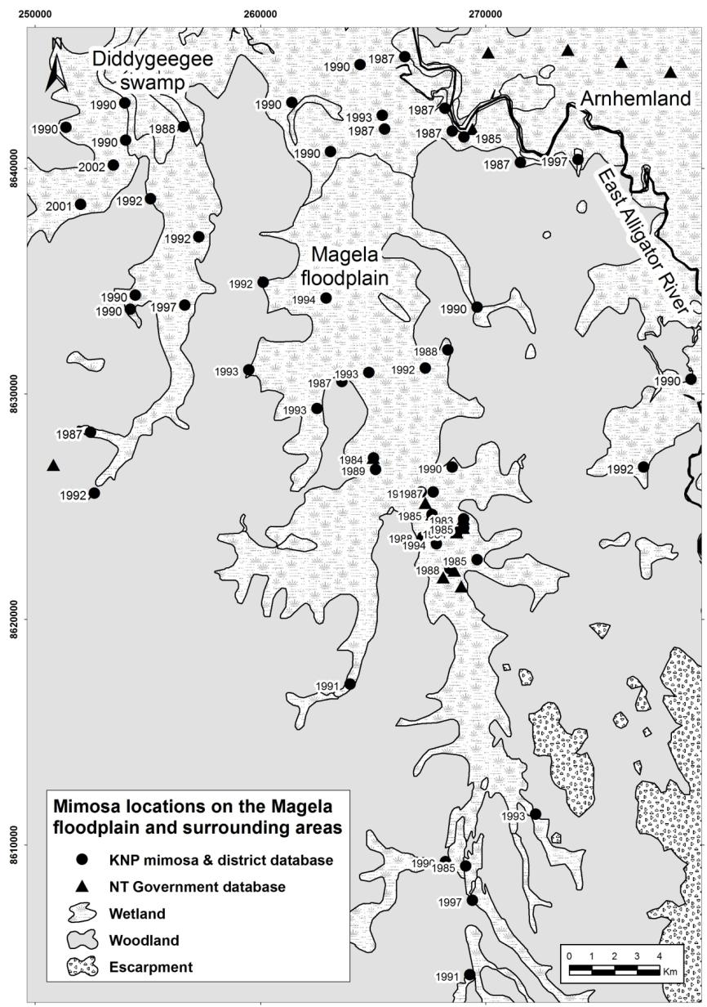

**Figure 5** Known mimosa locations on the Magela floodplain and surrounding areas. The dates shown are only for the KNP data and indicate the year mimosa was discovered at that site.

Lonsdale (1993a) examined wetland mimosa invasion at two scales: within a single wetland system on the Adelaide River floodplains, and across the entire western coastal region of the Northern Territory. The study investigated the rate of spread of a stand of mimosa within a wetland, based on seed dispersal by wind. This result was then compared to an observed spread rate based on aerial photographs from a region where either wind or water could be the dispersal mechanism. The results indicated that if wind was the only seed dispersal method, the most rapid linear increase of a mimosa stand would be 18.3 m per year.[7] Actual rates of spread determined from aerial photography were found to average 76 m per year or greater in five out of six years. This disparity implicates dispersal of seeds by flotation being responsible for the more rapid expansion of mimosa as observed in the region. The rate of spread was greatly influenced by climatic conditions in that there was a strong relationship between the rainfall during the wet season and the proportional increase in the area of the stand in the following year. Over the six year study period, the area of mimosa within the river system doubled every 1.2 years. Using maps prepared from reports of infestations across the western coastal region of the Northern Territory, the doubling time for a number of infestations was 6.7 years. It was hypothesised that the slower rate of expansion was due to separation by eucalypt savannas of the more suitable wetland habitats (ie between catchment spread) (Lonsdale 1993a).

#### Invasion pathways

The bristled seed pods float via surface tension and may be carried for extended periods of time over great distances particularly when maximum seed fall coincides with heavy flooding (Lonsdale 1993a). The seed pods adhere to clothing and animal fur, thus they may be spread both within and between catchments by humans and animals including buffalo, cattle, horses, pigs and wallabies (Miller et al 1981). Seeds may also be contained in the mud and debris that attaches to animals, vehicles, machinery and water craft, or be lodged in the crevices of vehicles etc. Livestock and native mammals sometimes graze on mimosa plants (Miller 1988), so seeds may be dispersed in the dung of these animals (Miller & Lonsdale 1987). Although spending up to 36 hours in the gut of an animal, mimosaseeds may still be 70−90% viable (Benyasut & Pitt 1992). Physical removal of seed contaminated sand for construction purposes is thought to be responsible for the spread from the Adelaide River to the Batchelor-Rum Jungle region and possibly other areas (Miller et al 1981). The rapid spread of mimosa in Thailand (Thamasara 1985) and Sri Lanka (Marambe et al 2004) is also thought to have been facilitated by movement of sand for landfill and construction work.

It is not known for certain if waterbirds are capable of dispersing mimosa seeds, although there is strong anecdotal evidence to suggest this may occur. Initial surveys of the Phelp River infestation discovered a large single mimosa plant, visually estimated to be approximately 5−7 years of age, positioned immediately beneath a Jabiru nesting site, while the remaining mimosa infestation consisted of plants in a single age cohort of approximately 2−3 years. The nesting site was positioned in small Melaleuca trees three metres above ground level and large quantities of Jabiru faeces occurred in the immediate vicinity of the larger mimosa plant, suggesting mimosa contaminated faeces may have resulted in the original seed importation (M Ashley pers comm 2001).[8] In 1996/97 a similar scenario of a new, isolated single plant infestation was observed at the Mirrngadja area of the Arafura Swamp in north-eastern Arnhem Land (G Flanagan pers comm 2002). The most westerly Northern Territory infestation at Legune Station, about 50 km from the Western Australian border, consisted of three separate small incursions totalling about half a hectare. Northern Territory Government weed officers could not identify the source of the infestation, but waterbirds were hypothesised (Mark Ashley pers comm 2001).

Humans value mimosa for the novelty of the touch sensitive leaves. This has increased the risk of deliberate introductions into new areas, even across interstate/international borders. It is possible that this scenario was the reason for the initial introduction of mimosa to Darwin (Miller & Lonsdale 1987).

### 2.3.3 Preferred habitats and environmental conditions of mimosa

Mimosahas been introduced into most tropical regions of the world where it grows in comparatively open, moist sites such as coastal floodplains and riverbanks (Miller et al 1981, Lonsdale et al 1985, Lonsdale 1992b). In the introduced range, mimosa infests naturally or anthropologically disturbed places such as reservoirs, canal and river banks, roadside ditches, agricultural land and floodplains. In its native range mimosa occupies similar habitats, especially in areas which have been disturbed, but usually occurs as small thickets or individual plants (Harley 1986). However, even in its native range, mimosa is now posing a threat in some areas. For example, in the republic of Costa Rica in Central America, mimosa is rapidly expanding in areas of rice cultivation, with many infestations now covering hundreds of hectares. The spread is often associated with the drainage channels that drain the rice fields. The infested areas are drier, with the frequency of flooding and the water depth greatly reduced. Mimosa has also become common in overgrazed areas in Costa Rica (Boucher et al 1983).

#### Rainfall and temperature

The most numerous and severe mimosa infestations in the Top End occur in the region of 1200 mm to 1800 mm annual rainfall. Some of the more southerly Top End infestations are in the 900–1200 mm rainfall zone, whilst the Phelp River infestation in the south-east of the Top End is in the 600–900 mm rainfall zone. Miller (1983) made the conservative prediction that except around dams and watercourses mimosa would probably not be a major problem in regions with less than 750 mm annual rainfall.

The temperature tolerance range of mimosa has not been quantified (Lonsdale et al 1985). The average annual minimum temperature of NT mimosa infested areas is between 18°C and 24°C, the average annual maximum temperature is between 30°C and 36°C.

#### Geomorphology and soils

The coastal wetlands of the Northern Territory are predominantly a depositional landscape of estuarine and riverine alluvial deposits with some beach ridge development (Isbell 1983). The floodplains of the northern flowing drainage systems show remarkably low gradients, and they respond strongly to the monsoonal climate, being inundated with freshwater during wet season floods (Woodroffe et al 1986).

Mimosais not restricted to any one soil type (Miller 1983). Most outbreaks of mimosa have occurred on the coastal floodplains which are dominated by black massive cracking clay soils (vertosols). Some infestations have occurred on yellow mottled duplex soils on the Adelaide River and also on the Daly and Moyle Rivers (Miller 1988, Northcote et al 1975). Miller (1983) has also reported the plant growing on alluvial red and yellow earths, silty loams, and coarse siliceous river sand. Vertosols are the most dominant soil type on the Magela floodplain (Wells 1979) and occur in about 9% of the Kakadu region (Lynch & Wilson 1998). Minor soils of the seasonally inundated areas include loams and sands on slightly elevated river levees and humic gley soils on the margins of floodplains, which frequently support paperbark forest. Mimosa also infests these lighter-textured soils, which occur in association with the more extensive cracking clay soils (Miller 1988).

A comparison of two sites in the Adelaide River found that seed production and seedling densities were generally higher in heavy black cracking clays, than in lighter sandy clay soils (Lonsdale et al 1988). The longevity of plants varies for different soil types, the half-life of plants on black cracking clays being somewhat greater than for plants growing on the lighter soil. This may be due to the greater moisture holding capacity of the heavier soil (Lonsdale 1992b). Seed longevity, by contrast was found to be greater in lighter soils (Lonsdale et al1988).

#### Inundation

Mimosa is very tolerant of seasonal inundation, using aerial or adventitious roots. Glasshouse experiments suggest that permanent inundation would prevent seedling recruitment (Shibayama et al 1983). However, if a permanently inundated area were to experience either several below average wet seasons or unusually prolonged dry seasons, seedlings could grow to maturity and colonise the area to some extent. In northern Australia, seedling densities have been found to vary greatly throughout the year, many being drowned by the floodwaters of the wet season (Lonsdale 1992b, Lonsdale & Abrecht 1989).

Several consecutive above average wet seasons can, to some extent, inhibit the germination of mimosa seeds. Whilst seeds need moist soil to germinate, excessive waterlogging or prolonged inundation reduces the rate of seed germination by rotting or from oxygen deprivation. This phenomenon has been observed in the Northern Territory in regions of the Arafura swamp and the Phelp River floodplain (M Ashley pers comm 2001).

Prolonged seasonal drought can result in very high seedling mortality (Lonsdale & Abrecht 1989). In support of this, Cook et al (1996) found that of all the wetland habitats in Kakadu National Park, the open plains, which have a relatively short period of inundation, had the lowest density of mimosa outbreaks. High densities of outbreaks were found in the billabong/channel and backswamp habitats, both of which are inundated for a relatively long period of time. Ground disturbance and plant competition can affect the success of mimosa despite the period of inundation (Cook et al 1996).

Artificially induced hydroperiod from structures such as dams and rice fields for example can facilitate the spread of mimosa. Examples of this come from the Kafue Flats of Zambia in southern Africa where mimosa was recorded from river levees as early as the late 1960s, but was scarce. Since 1983 mimosa colonised extensive areas in a national park on the Kafue Flats. In the 1970s, flooding on the flats was regulated by hydro-electric dams, resulting in the main mimosa infestation that was formerly on the mid-level floodplain appearing more vigorously on the edge of a permanent lagoon (Bob Douthwaite pers comm 2002, Musonda Mumba pers comm 2002). In Tram Chim National Park in the Mekong Delta region of Vietnam, mimosa doubled each year to reach 1900 hectares in 2002. The cause of the initial expansion was thought to be the regulation of water depth associated with rice cultivation (Triet et al 2004). The new germination of mimosa at Peter Faust Dam in Queensland was the result of receding water levels within the catchment due to extended dry periods (Chopping 2004). It is likely that the mimosa seed bank had been present for some time and only germinated when conditions were favourable.

#### Salinity

The precise relationship between the distribution of mimosa and salinity levels remains to be determined. Salinity near infestations on the lower Adelaide River can reach 18 000 ppm (~ 50% salinity) late in the dry season (Miller 1983). In 1968 it was thought that the Marrakai crossing would mark the lower limit of the spread of mimosa on the Adelaide River system, as the crossing represents the limit of tidal influences on the river. The subsequent downstream invasion to the floodplains has disproved this theory. This section of the river does not become saline until the mid-dry season, therefore seed washed down and deposited on the banks during the wet season can later germinate in the early dry season. After this period, little moisture is required to maintain mature plants (Miller et al 1981). Plants growing in saline areas appear to be stunted, but this may be due to continual waterlogging.

#### Fire

Mimosa habitats are often subject to fire. Green mimosa does not burn readily and fires, unless carried by strong winds, generally die out in dense infestations due to a lack of understorey vegetation and fuel in dense thickets, and if the infestation remain wet during the dry season. Fire will pass through scattered infestations where understorey fuel is present (Miller & Lonsdale 1992). When infestations are burnt, the impact on mature plants can vary with the season and weather conditions. In one study, only a small proportion of mature plants were killed and more than half of the seedlings regrew after fire (Miller 1988). Nguyen et al (2004) found that fire triggered the germination of seeds with an average five-fold increase in the number of seedlings per square metre. In KNP, Rangers have to be very alert after a floodplain fire as seedlings often appear in a plot area that may have been seedling free for a number of years (R Salau pers comm March 2007). Mimosa also has adaptive traits that stimulate regrowth from the stem base after fire (Miller & Lonsdale 1992).

#### Shade tolerance

Lonsdale & Abrecht (1989) explored the shade tolerance of mimosa using artificial shade treatments and the presence of a mimosa canopy. They found that in glasshouse experiments, increasing shade slowed the growth of mimosa seedlings. No seedlings survived beyond five weeks in 92% shade or beyond nine weeks in 77% shade. Seedlings growing in 60% shade continued growing throughout the eleven weeks of the experiment. In field experiments Lonsdale & Abrecht (1989) found that the presence of a mimosa canopy had no detectable effect on the survival and size of surviving plants. Even though the canopy provided a source of moisture competition, it also reduced the water loss from the soil, which was found to be the major cause of seedling mortality. When compared with treatments where the canopy was cleared, survival was significantly enhanced by artificial shade treatments, again because it reduced moisture loss but in this case did not compete with the seedlings for moisture.

### 2.3.4 Potential distribution of mimosa in Kakadu National Park

Experience from infested coastal floodplains in the Northern Territory has shown that mimosa has the potential for large-scale invasion of the majority of floodplain habitats except for perhaps the deeper perennial waterbodies. Habitat susceptibility to invasion, and the infestation density will vary depending on the hydroperiod, soil type, salinity, local topography, canopy density and levels of disturbance (Walden et al 2004). Most Kakadu National Park floodplain habitats, including the Magela are very similar to those of other Northern Territory coastal floodplains that have suffered extensive mimosa infestations (eg Gunbalanya, Mary, Adelaide, Daly and Finniss Rivers) and are therefore likely to be susceptible to similar levels of invasion. In this context, no habitat suitability modelling was performed for mimosa.

## 2.4 Identification of the risks of mimosa

The proximity of nearby mimosa infestations and the potential for propagule importation from waterbirds, animals, vehicles and boats all increase the risk of mimosa invasion to Kakadu National Park. Furthermore, seedlings have resprouted from 20+ year old and if any seedlings mature and set seed, then there may seeds in the area for at least a further 20 years. This means that a mimosa plot can never really be considered totally ‘inactive’ in terms of potential growth. Depending on a plant’s proximity to an existing plot, it is difficult to determine if the seed came from that plot or it is a new incursion from elsewhere. In general, a new plot is listed in the database if the new plant(s) occur more than 500 m from an existing plot. The exception to this is when the existing plot is in the upstream region of a floodplain pocket as over the years, seedlings may be scattered downstream for more than 500 m (R Salau pers comm March 2007).

A potential re-assessment of the current resource commitment for mimosa could occur if establishment was to ‘out-pace’ the monitoring and surveillance efforts. For example, following the 2006–07 extreme wet season floods, there was concern that if seeds of a few undiscovered plants were dispersed at that time, those seeds would likely be carried far greater distances and possibly into previously unsurveyed areas/habitats than would normally occur. Consequently, survey scope and resources would need to be increased to avoid missing any new plants. If the same scenario was repeated in subsequent years, then the risk of new incursions being established would be greatly increased (R Salau pers comm 2008).

The Magela floodplain is now largely closed to the general public, therefore minimising the risk of seed importation on vehicles and boats. Since buffalo were removed from the Park during the 1980s, feral pig densities and the associated ground disturbance and destruction of native vegetation cover has increased dramatically (Bayliss et al 2006) and this could potentially facilitate mimosa establishment. Fortunately, compared to the widespread ground disturbance by buffalo, pig damage on the Magela floodplain remains temporally and spatially patchy and the native vegetation has largely recovered since the removal of buffalo. The frequency of unmanaged fire could also alter the density and diversity of native vegetation and promote the invasion of mimosa and other weeds (Bayliss et al 2006).

## 2.5 Uncertainty, information gaps and further research

Aspects of uncertainty, information gaps and further research into mimosa and its management are discussed in Walden et al (2004). The tasks outlined below would become more relevant for KNP should mimosa establishment increase (see above) and/or any current management efforts be withdrawn.

### 2.5.1 Extent of mimosa

* Detailed site-specific assessments of wetland characteristics, eg habitat suitability modelling
* More precise data on growth and environmental requirements/tolerances of mimosa
* More detailed GIS assimilation of mimosa plots and new incursions with the possibility of developing remote sensing techniques at a scale of topographical map information that is finer than 1:250 000
* Document the seed stores following integrated control programs (Ashley 2003)
* Quantify the competitive relationship between mimosa and other wetland vegetation (Ashley 2003)
* Determine the factors that affect successful revegetation (G Flanagan pers comm 2002)
* Research on how to fine-tune the current best practice integrated management regimes
* The role, timing and impact of wildfires as opposed to controlled burning in relation to both mimosa and floodplain management (G Flanagan pers comm 2002, Ashley 2003)
* The relationship between native species recolonisation and the abundance of biological control agents (Quentin Paynter CSIRO pers comm 2003).

### 2.5.2 Effects of mimosa

* The ecological impacts of the herbicides, wetting agents and adjuvants (improvers of herbicide efficacy and/or application characteristics) used for mimosa control
* Vulnerable and endangered fauna and flora within the habitat range of mimosa
* Quantitative data on the environmental, economic, social and cultural impacts of mimosa.

## 2.6 Management implications of mimosa

Since the early 1980s, Kakadu National Park management have been aware of the implications of widespread mimosa infestation in the Park (Skeat et al 1987). Systematic surveys commenced in 1983 and prior to this, plants discovered fortuitously were destroyed (Cook et al 1996). Since that time, four ongoing staff are dedicated to undertake surveillance operations for any new incursions of mimosa, with the total mimosa control budget for the whole Park being approximately $500 000 per annum. An added advantage of staff dedicated to the control of mimosa is that during their surveillance operations they are also vigilant to incursions of other weed species.

This investment, though significant, cannot be underestimated. Cost of control figures derived for the Gunbalanya floodplain mimosa infestation during the 1990s were in the order of $1 000 000 (over about six years) per thousand hectares (Storrs et al 1999) (Fig 6). Early estimates of the cost of ongoing follow-up control of this infestation were over $100 000 per year (DPIF 1997). Using these data, large scale removal of mimosa on any large floodplain in KNP such as the Magela, would be in the order of tens of millions of dollars. The actual data used to derive the function in Figure 6 were obtained from the NT Department of Primary Industry, Fisheries and Mines annual reports relating to the Gunbalanya mimosa control project where a budget statement was issued for each year of operation, hence the figures are operational cost estimates only.

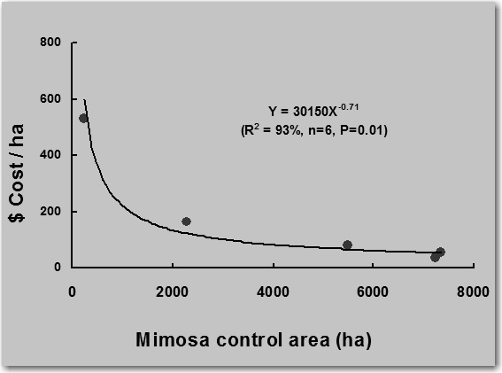

**Figure 6** Estimated control cost ($) from 1991 to 1996 (3 points are clustered at the base of the curve) for large infestations of mimosa on the Gunbalanya floodplain, west Arnhem Land. Operational costs only, and excludes salary and salary related on-costs, and large capital items (eg bulldozers).

### 2.6.1 Bioeconomic modelling

Information on effort expended to control patches of varying densities of mimosa across the Park was extracted from the KNP mimosa database (Table 1). A ‘first pass’ effort-abundance curve over 22 years of mimosa survey and control is represented in Figure 7.

This preliminary modelling exercise does not take into account factors such as the size and age of plants, plot size, travelling time and varying control methods. Further information on labour and operational costs specific to KNP mimosa management are needed to convert this function to a practical cost of control curve so that managers can simulate and compare various control options. If Kakadu were infested with large areas of mimosa, the model parameters could be set to determine the initial reduction and the subsequent maintenance control effort relative to a target density required each year *ad infinitum*. With the current mimosa situation in KNP, the control cost model can help managers minimise survey costs of existing and new sites based on the history of available data.

**Table 1** Mimosa control information over 22 years for Kakadu National Park, extracted and summarised from the Kakadu National Park mimosa database

|  |  |  |  |  |  |  |
| --- | --- | --- | --- | --- | --- | --- |
| **Year** | **No. of plots** | **Visits** | **Person (days)** | **Total plants** | **Days/plant** | **Plants/plot** |
| 1981 | 2 | 4 | 10.3 | 103 | 0.10 | 51.5 |
| 1982 | 1 | 5 | 10.7 | 15 | 0.71 | 15.0 |
| 1983 | 6 | 10 | 21.0 | 31197 | 0.00 | 5199.5 |
| 1984 | 17 | 152 | 326.3 | 19473 | 0.02 | 1145.5 |
| 1985 | 36 | 187 | 402.8 | 14275 | 0.03 | 396.5 |
| 1986 | 45 | 216 | 464.3 | 12163 | 0.04 | 270.3 |
| 1987 | 65 | 280 | 605.3 | 40363 | 0.01 | 621.0 |
| 1988 | 51 | 174 | 374.4 | 17250 | 0.02 | 338.2 |
| 1989 | 45 | 169 | 362.4 | 14859 | 0.02 | 330.2 |
| 1990 | 71 | 258 | 555.8 | 14789 | 0.04 | 208.3 |
| 1991 | 50 | 165 | 358.3 | 22440 | 0.02 | 448.8 |
| 1992 | 104 | 309 | 662.5 | 65316 | 0.01 | 628.0 |
| 1993 | 123 | 363 | 785.1 | 47206 | 0.02 | 383.8 |
| 1994 | 102 | 249 | 532.5 | 11329 | 0.05 | 111.1 |
| 1995 | 93 | 192 | 416.5 | 4048 | 0.10 | 43.5 |
| 1996 | 152 | 584 | 1277.1 | 54250 | 0.02 | 356.9 |
| 1997 | 162 | 663 | 1438.7 | 22138 | 0.06 | 136.7 |
| 1998 | 162 | 540 | 1135.3 | 9282 | 0.12 | 57.3 |
| 1999 | 167 | 473 | 1006.7 | 12228 | 0.08 | 73.2 |
| 2000 | 162 | 590 | 1252.1 | 10562 | 0.12 | 65.2 |
| 2001 | 167 | 446 | 930.7 | 3178 | 0.29 | 19.0 |
| 2002 | 38 | 41 | 85.4 | 1123 | 0.08 | 29.5 |



**Figure 7** Estimated control effort – abundance curve for mimosa control in KNP from 1981 to 2002.   
The data points are from Table 1.

## 

# 3 Salvinia

Salvinia was introduced to Australia in the 1950s as an ornamental aquatic plant. It was recorded in a natural water body in Luddenham in New South Wales in 1952 and in Brisbane in 1953. By 1973 it was recorded in farm dams, ponds and streams in coastal catchments from the NSW South Coast to north Queensland. In Western Australia infestations were found in Bunbury and Albany. It was first recorded in the Northern Territory in 1976 in a Darwin nursery, and later that year in a waterbody at Nhulunbuy on the Gove Peninsular some 650 km to the east of Darwin (van Oosterhout 2006). Salvinia is now widespread throughout the Top End of the NT.

## 3.1 Identification of the problem

A physical description and details of the biology and ecology of salvinia are available in a variety of literature (eg Cary & Weertz 1981, 1983a, 1983b, 1984, Mitchell & Tur 1975, Room & Julien 1995, Storrs & Julien 1996, Cowie et al 2000). Figure 8 shows a salvinia infestation on the Magela floodplain and the three growth forms of the plant, determined by nutrient availability and physical crowding.

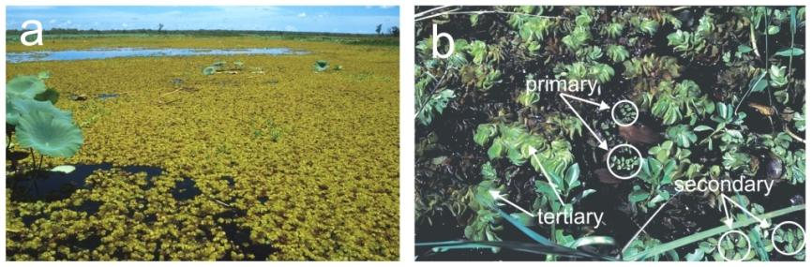

**Figure 8** Salvinia molesta (a) Western plains on the Magela system (b) close-up showing the three growth forms (see text) (photographs – M Finlayson & R Salau)

### 3.1.1 Weediness[9]

Like mimosa and para grass, salvinia is a species valued by humans. Its attraction as an aquarium and pond ornamental has resulted in far ranging movements. Once relocated, salvinia may enter the wild via deliberate or inadvertent releases.

Following separation from the parent plant, a number of branches can develop at each node and give rise to individual plants. Salvinia’s ability to grow from the smallest of fragments and its rapid growth rate make it an aggressive and competitive species. Under ideal conditions and away from natural enemies, salvinia is capable of doubling its biomass in 2–3 days (Mitchell & Tur 1975, Cary and Weerts 1983a). For Kakadu National Park, the fastest recorded growth rate was a doubling of dry weight every 5 days (Storrs & Julien 1996).

The leaf structure of salvinia makes the plant extremely buoyant and virtually impossible to sink unless the leaves are dying or severely damaged. This buoyancy enhances salvinia’s ability to spread as it remains afloat during rapid flooding and in turbulent flowing waters, opportunistically reaching uninfested areas during such events.

Salvinia exhibits a remarkable ability to regenerate after being severely damaged or desiccated. Green shoots may appear on plants that appear completely dead. For example, it can survive for several months on seasonally dry floodplains. Exposed plants on the surface may desiccate, but plants underneath or on the moist ground can survive. A similar scenario applies to occasional exposure to frost (not in KNP) where exposed floating leaves may die but leaves lower down in the mat survive, and the buds can remain viable as long as they are protected.

Comparisons between nutrient requirements in the laboratory and nutrient concentrations measured in the field, demonstrate that salvinia is almost always growing under conditions of limited nutrients. To offset this, the plant has become adapted to low ambient nutrient levels. It can mobilise nutrients from senescent tissues for use by growing points and can take up nutrients from ephemeral flushes carried in rainfall runoff, storing any excess for future growth.

### 3.1.2 The history of salvinia invasion in Kakadu National Park

Salvinia was first recorded in the Park on 5 September 1983 in several billabongs and interconnecting channels downstream of the Gunbalanya road crossing of Magela Creek, a southern tributary of the East Alligator River (Finlayson 1984a). The infestation covered approximately 7 km2, and observations on the distribution and presence of dead plants in the trees above the water line indicated that the weed was present during the previous wet season (Storrs & Julien 1996). A small infestation of water hyacinth (*Eichhornia crassipes*) was discovered close to the road at the same time, and fortunately this was removed and apparently eradicated (Finlayson 1984a).

The location and the presence of the two weeds together gave rise to speculation that the weed was introduced by humans (Finlayson 1984a), either deliberately or possibly by viable plant material being washed from a vehicle or boat. This was the third time in two years that that field infestations of the two weeds had been found together in the Northern Territory (Storrs & Julien 1996). Early attempts to remove salvinia failed and over 2–3 years it spread throughout the Magela floodplain and all the main billabongs were at different times at least partly, or even completely covered by floating plants (Finlayson et al 1994). By the late 1980s salvinia had spread upstream of the Magela Creek crossing into Mudginberri Billabong and surrounding swamplands, and in 1990 the entire Magela floodplain was quarantined (Storrs & Julien 1996).

Despite quarantine efforts a new infestation was discovered in the Mekinj Valley in Tin Camp Creek, a northern tributary of the East Alligator River. This infestation also escaped during ensuing wet seasons and spread downstream to waterbodies in western Arnhem Land and KNP (Storrs & Julien 1996). In August 1990, the weed jumped catchments and appeared at Danbandji on Nourlangie Creek, a tributary of the South Alligator River. Again attempts at eradication failed and the infestation spread to surrounding areas and further downstream during the wet season of 1992/93. By the following wet season it was being flushed into the main South Alligator River (Storrs & Julien 1996).

## 3.2 The potential effects of salvinia

Dense mats often completely blanket waterbodies and fringing vegetation habitats. These mats are sometimes invaded by other plant species that colonise and stabilise the mats to form extensive floating communities (Finlayson et al 1988). Under this scenario, light penetration into the water column can be almost non-existent, resulting in severely reduced algae and macrophyte growth. In conjunction with large volumes of decaying salvinia, this leads to lower oxygen levels and higher carbon dioxide, hydrogen sulphide, acidity and temperature levels than those of nearby open water (Mitchell 1978). The nutrient status of the water is also altered as salvinia depletes water of bio-available nitrogen and phosphorus and stores it as biomass. The maximum rate of nitrogen uptake has been calculated at about 6000 kg per hectare per year (Room 1986).

### 3.2.1 Effects of salvinia on native flora

Salvinia can out-compete submergent, emergent and other floating vegetation by effectively restricting the availability of light, degrading water quality and reducing nutrient levels, However, quantitative information on these effects in relation to the competitive exclusion of native plants is currently unavailable.

### 3.2.2 Effects of salvinia on native fauna

There is no published information that quantifies the effects of salvinia on fauna. Anecdotal evidence from Kakadu National Park suggested that numbers and species of waterbirds were fewer on billabongs with salvinia infestations (M Storrs & M Julien pers obs 1991–1994, B Hall pers comm 1994), presumably because the cover of the weed restricts the more open water habitat suitable for foraging for prey such as fish and aquatic insects. There was evidence of declines in numbers of small fish, such as catfish (*Neosilurus* spp), and a reduction in a file snake (*Acrochordus arafurae*) population in a severely infested billabong has been reported (T Madsen pers comm 1994) (Storrs & Julien 1996). Phytoplankton levels would likely be reduced as a result of light exclusion through the water column, thus reducing the food availability for plankton feeders (ie small fish and macroinvertebrates). Migrating birds may not recognise or stop at waterbodies covered with salvinia (Western Aquatic Plant Management Society 2004).

### 3.2.3 Conceptual model for salvinia

A conceptual model based on known information on salvinia, and the potential ecological cultural and socio-economic impacts is shown in Figure 9.

|  |  |
| --- | --- |
| **Pressure:** | *Salvinia molesta* |
| ↓ | |
| **Major exposure pathways:** | Water, wind, floating mats, vehicles, water craft, animals (usually short distances), deliberate movements of propagules |
| ↓ | |
| **Favoured wetland habitats:** | Floodplains (land subject to inundation), freshwater ponds and swamps, creeks and rivers – particularly during periods of reduced flow |
| ↓ | |
| **Ecological, socio-economic and cultural effects:** | * Competitive exclusion of native aquatic flora * Loss of suitable habitat for some native fauna * Loss of suitable food resources for some native fauna * Altered hydrological regimes * Altered nutrient status and water quality * Restricted access to waterways (humans, stock & wildlife) * Interference with irrigation systems * Reduced potential for sustainable utilisation of native wildlife * Reduced aesthetics and threatened income from tourism (particularly when areas are quarantined) * Restricted access to traditional Aboriginal hunting areas * Reduced availability of other traditional natural resources (flora & fauna) * Provides ideal habitat for mosquitoes * Damage to structures such as fences and bridges during high flows |

**Figure 9**  Conceptual model of known information on *Salvinia molesta*

### 3.2.4 Beneficial uses of salvinia

Salvinia is widely used and distributed as a pond and aquarium ornamental. It forms a satisfactory compost and mulch (Boyd 1974), and has been used as a supplement to fodder for livestock in some Asian countries (Oliver 1993). A limited number of studies have examined salvinia’s suitability for treating sewage effluent (Finlayson et al 1982), papermaking (Bhambie & Bhardwaj 1979), and the generation of biogas (Ramey 1983). However, none of these enterprises have resulted in commercial utilisation of salvinia probably due to high labour and machinery costs associated with moving the 96% water/weight content of the plant (Thomas & Room 1986).

## 3.3 The potential extent of salvinia

### 3.3.1 Current distribution of salvinia on the Magela floodplain

Only a few years after the initial discovery of salvinia in 1983, it spread downstream to all corners of the Magela floodplain including neighbouring areas such as Didygeegee swamp to the west (Finlayson et al 1994). Over time it has also spread upstream of its original source location and invaded Mudginberri Billabong and the surrounding swamplands (Storrs & Julien 1996). At present the upstream limit of spread is Corndorl (Gurndurrk) Billabong, a backflow billabong (with an adjoining small floodplain) on Corndorl Creek, a tributary of the Magela Creek. Corndorl is about 6–7 km upstream of where salvinia was first found on the Magela and about 3 km upstream of Mudginberri Billabong. It is not known how salvinia got this far upstream as there is no evidence of salvinia in the creek corridor between Corndorl and Mudginberri Billabongs (R Salau pers comm 2008).

Due to the dynamic nature of salvinia where it may exhibit rapid growth and decline, the actual coverage within the distribution shows considerable temporal and spatial variation. Salvinia mats that form on billabongs rarely persist for a complete annual cycle due wet season flushing and plant damage caused by the introduced biological control agent, the weevil, *Cyrtobagous salviniae* (Finlayson et al 1994). In the late wet season, the plant is at its most vigorous phase and may cover an entire waterbody. Toward the late dry season, the salvinia mats generally show dramatic symptoms of weevil damage and often sink prior to the wet season floods, usually in December or January (Storrs & Julien 1996, Julien & Storrs 1994). The most significant damage is caused by the weevil larvae as they burrow through the stem, destroying the root–shoot causing the plant to become friable and waterlogged, and to eventually sink link (Sands et al 1983, Forno et al 1983, Julien et al 1987). The strength of the wind and the subsequent degree of compaction of the mats can also greatly influence the area and distribution pattern of salvinia cover on a waterbody (Storrs & Julien 1996). Similarly, water flow eddies on the floodplain are also associated with the accumulation of dense floating salvinia mats.

In some years, either relatively little salvinia growth occurs, or the biomass can increase rapidly often blanketing an entire billabong. The rate of salvinia biomass accumulation, and the actual amount of growth is influenced by factors that are linked to the population dynamics of the weevil. The timing of the onset of the wet season rains and the timing and size of the main flood events appear to be the key variables affecting weevil numbers and salvinia growth. The initial flood of the wet season provides an influx of nutrients ideal for plant growth. If the wet season has follow-up floods that dilute the wetland system, this may markedly reduce nutrient levels, thus reducing salvinia’s growth potential. If the wet season floods arrive later in the season and are diminished in intensity, this may allow a ‘soup’ of nutrient rich waters to enter and remain in waterbodies thus creating a high plant growth potential. If weevil numbers are low at this time, the high growth potential is met. Naturally occurring fish kills (Bishop 1980, Bishop et al 1982), often involving many thousands of fish, can further increase nutrient levels in waterbodies thus boosting the potential growth rate and biomass of salvinia. Storrs & Julien (1996) found that weevils were generally successful in restricting the lower growth potential of salvinia with the early arrival of major wet season floods and associated flushing effect, provided that adequate weevil numbers had been sustained over the preceding dry season. Both weed and weevil populations increased, but salvinia growth rates were suppressed and biomass and cover restricted, as a result of the relative abundance of the weevil. They also found that a during a late and low intensity wet season scenario, salvinia grew rapidly for some time before any possible flushing occurred. At this time weevil numbers were very low and could not keep pace with the salvinia growth despite an increase in their numbers. Weevil numbers were found to be low due to population crashes that occurred late in the previous wet season. At that time, salvinia was severely damaged by weevil populations that had increased so rapidly, they had consumed virtually all of their food source.

### 3.3.2 Invasion rates and pathways of salvinia

#### Invasion rates

Salvinia is dependent on rapid growth and water-flows for its distribution within catchments. As each catchment has its own characteristic hydrological regimes, and different vegetation structural types, it is difficult to discuss salvinia distribution in terms of actual average spread rates[10]. In a free flowing system without obstruction, salvinia could in theory, be carried from one end of a catchment to the other end almost as rapidly as the rate of water flow. On the Magela Creek, it took some two to three years to spread throughout the entire floodplain. Native vegetation and the seasonal and meandering nature of the water flow across the floodplain would have slowed its progress. In more static waterbodies, salvinia’s rapid doubling rate enables it to completely cover a large waterbody in a matter of months or even weeks. A single plant has been observed to rapidly multiply in only three months, forming a thick mat covering some 65 km2 (Creogh 1991/92). The rate of coverage maybe slowed by factors including wind and wave action that cause plants to sink, flushing of the waterbody, obstructions (eg native vegetation) that impede surface flow, very low nutrient levels, and the presence of biological controls.

#### Invasion pathways

Salvinia is capable of floating on water for extended periods. Within catchments, this feature and water flows usually enable rapid spread. Spread between catchments is most likely by vehicles and boats (and boat trailers) that harbour vegetative material which may remain viable in moist conditions. It can be transported over short distances by animals such as feral water buffalo (Miller & Wilson 1989), and it is likely that it may also be spread by birds (Storrs & Julien 1996). Salvinia is valued as an attractive ornamental pond and aquarium plant. Distant incursions of the weed are caused by deliberate or inadvertent releases in the wild where aquaria have been emptied into drains, ponds and waterways (Storrs & Julien 1996). It is also suspected that in Queensland, some salvinia is ‘farmed’ in natural waterways for harvest and sale by irresponsible people (QDNRM 2003).

### 3.3.3 Preferred habitats and environmental conditions of salvinia

Salvinia has spread throughout the tropics and sub-tropics of the world, originally being exported from its native Brazil in South America probably as an aquarium or pond ornamental plant. It forms dense mats and grows best in still or slow-flowing fresh waters. It will grow in clear water and in waters subject to flooding, although it prefers more eutrophic water where nutrients are not limiting. In faster flowing waters, salvinia forms an understorey to other vegetation that anchors it in place (Storrs & Julien 1996).

#### Moisture and temperature

Irrespective of rainfall, salvinia will grow on waterbodies and wet soils provided other environmental factors (see below) are within tolerance. The best growth rates are achieved at a temperature range of about 22–30°C, with the optimum being 30°C (Mitchell & Tur 1975, Room 1986). Little growth occurs below 20°C (Cary & Weerts 1981) and no growth is thought to occur below 10°C or above 40°C (Room 1986). When exposed to temperatures below –3°C or above 43°C for >2 hours all buds die, effectively killing the plant (Whiteman & Room 1991). Plants may be killed by frost but protected parts and unfrozen buds survive.

#### Nutrients

Growth rates of salvinia are significantly affected by nutrient availability, particularly nitrogen and phosphorus. High nitrogen levels in particular increase both the rate of extension of existing branches and the rate of production of new branches (Room 1983, 1988, Julien & Bourne 1986). Laboratory studies have shown that growth of salvinia ceased to be limited by plant nutrient concentrations of 5% for nitrogen and 0.5% for phosphorus (Cary & Weerts 1983a, 1983b, Room 1986). The nitrogen content of salvinia ranges from 0.62–4.0% dry weight, whilst the phosphorus content is 0.03–1.07% dry weight (Room & Thomas 1986a, 1986b). Maximum rate of nitrogen uptake, calculated from rates of growth, is near 8 mg nitrogen/g dry weight of salvinia/day or about 6000 kg nitrogen/ha/year (Room 1986). Actual measurements at a sewage treatment lagoon indicated an uptake of 1580 kg nitrogen/ha/year (Finlayson et al 1982).

#### Salinity and conductivity

Salvinia is primarily a freshwater species. Growth is slower in brackish waters with a tolerance limit of up to about 0.6% or 20% salinity of sea water (Room & Julien 1995). Salvinia is unable to survive for more than 30 minutes in sea water even if the plants are re-placed in fresh water (Room & Julien 1995). A 25% reduction in growth rate occurs in water of 0.3% salinity, equivalent to a conductivity of 4800 μS cm-1 or 10% salinity of sea water (Divakaran et al 1980). Salvinia has formed thick mats in Australian waters with conductivities ranging from 200 to 900 μS cm-1 and in sewage lagoons with conductivities as high as 1400 μS cm-1 without signs of toxicity (Room & Gill 1985). Salvinia will cover waters with conductivities as low as 100 μS cm-1 (Mitchell et al 1980), though the leaves were often yellow, indicating a nitrogen deficiency.

#### pH

Salvinia produces the greatest biomass when grown in a nutrient solution with a pH of 6.0 (Cary & Weerts 1984). It grows well in the field in waters with a pH of between 6.0 and 7.4. (Mitchell et al 1980). Salvinia will tolerate a wider pH range than this, being found in waters with pH as low as 5.2 in Malaysia, and as high as pH 9.5 in some regions in Africa (Holm et al 1977, Mitchell et al 1980).

### 3.3.4 Potential distribution of salvinia on the Magela floodplain

On the Magela system the downstream limit of spread is the point where salinity from the tidal estuary region of the East Alligator River becomes too high for salvinia to maintain growth. The upstream limit of spread at Corndorl Billabong is a considerable distance upstream of where salvinia was first found on the Magela, indicating that there is potential for further upstream spread to billabongs such as Gulungul and Georgetown.

## 3.4 Identification of the risks of salvinia

The extent of salvinia in Kakadu National Park is reasonably well known and documented, though there is very little quantitative information of the effects. In the absence of this data, the real risks of salvinia infestation remain uncertain. Other than a few anecdotal observations, it is impossible to determine what real effects salvinia has on water quality and the biodiversity of aquatic fauna and flora. Salvinia is such an insidious weed, that the risk of infestation to clean areas in KNP remains a possibility despite the very best efforts of spread prevention and quarantine.

## 3.5 Uncertainty, information gaps and further research

### 3.5.1 Extent of salvinia

Perhaps the greatest uncertainty surrounding the future coverage of salvinia (compared to the geographical extent) is the persistence and success of the biological control weevil. During the 1980s there was concern that the biological control was becoming less effective as the salvinia mats were increasing in area and thickness to the extent that they supported the growth of other vegetation including small trees. The wet season flows failed to flush the mats from the billabongs, thus allowing the mats to further develop each year. The more the mats bound with other vegetation, the less likely they were to sink or be flushed out (Julien & Storrs 1994). Preliminary investigations suggested that high temperatures may have affected the success of the weevils (Skeat 1990). The Australian Nature Conservation Agency (ANCA) at the time contracted the Commonwealth Scientific and Industrial Research Organisation (CSIRO) to assess the problem (Julien 1993, Julien & Storrs 1994). The main cause of ineffective control turned out to be the crashing of weevil populations following destruction of the weed on which it relied for food. The timing of the onset of the wet season and these population crashes determined the number of weevils available to attack the new growth of salvinia and further research into this phenomenon was recommended (Julien & Storrs 1994).

### 3.5.2 Effects of salvinia

See sections 3.2.1, 3.2.2 and 3.4.

## 3.6 Management implications of salvinia

Initially, considerable resources were dedicated to mechanical and chemical control and later, to the distribution of the weevil, including monitoring its effectiveness. It is acknowledged that salvinia is now a permanent inclusion in Kakadu’s flora and that eradication of the larger, more persistent infestations is not possible due to a variety of factors (Storrs & Julien 1996).

The above sections outline the importance of the timing and level of flushing of waterbodies and the timing and extent of sinking of less dense (weevil damaged) and less bound up (with other vegetation) salvinia mats. These phenomena are necessary to maintain an open water surface, which is largely the natural state of Kakadu’s waterbodies. If circumstances preventing the removal of salvinia mats[11] prevail, then it is likely that management intervention would be required to maintain open water and ensure that salvinia coverage is limited at least to a predetermined acceptable level. Although there are scarce data available, it is likely that consecutive years of 100% dense salvinia coverage would have a major detrimental effect on aquatic flora and fauna and the ecosystem as a whole. Recommended management strategies in conjunction with bio-control include: the application of herbicide shortly after peak flow (flood) to restrict build-up of salvinia and reduce its recovery rate; application during the early to mid dry season to limit cover; and strip spraying of herbicide onto dense, bound-up mats at the end of the year to loosen them up to assist in sinking. The particular timing of these applications would vary to conserve weevil populations for ongoing control. In some situations, weevil refuge areas may need to be left unsprayed. Furthermore, the strategies and their timing would be determined by different management requirements for individual waterbodies. Further details of these recommendations, the history of salvinia control and other issues regarding research into salvinia control and management in KNP are detailed in Julien (1993), Julien & Storrs (1994) & Storrs & Julien (1996).

Salvinia matts infested with weevils can visibly differ from healthy salvinia mats. In this context it has been suggested that remote sensing might be applied to assess the distribution of weevil populations at a landscape scale. Remote sensing therefore could potentially be applied as a means of assessing where weevils should be introduced, or where weevils can potentially be harvested for culturing. However, a dedicated study to assess the potential of this management strategy is yet to be conducted.

### 3.6.1 Bioeconomic modelling

There are insufficient data available on the cost of the control efforts for salvinia, hence no bioeconomic modelling is presented. The associated costs of exploratory research into biocontrol, such as that outlined in section 3.5.1 above, are known, but these figures are insufficient for derivation of control cost functions.

## 

# 4 Para grass

Para grass is most likely a native of tropical Africa but was first described from specimens from Brazil. It was introduced into Australia in 1880, and into the Northern Territory between 1905 and 1910 as a buffalo and cattle fodder species (Cameron & Lemcke 2008). It is now considered a serious weed in three countries (including Australia), a principle weed in nine countries and behaves as a weed at some level in a further 19 countries (Holm et al 1991). It is also reported as an agricultural weed in 23 crops in 34 countries (Langeland & Burks 1998).

## 4.1 Identification of the problem

A physical description and details of the biology and ecology of para grass are available in a variety of literature (eg Anning & Hyde 1987, Knerr 1998, Cowie et al 2000, Douglas et al 2001). Figure 10 shows a para grass infestation on the Magela floodplain and parts of the plant.

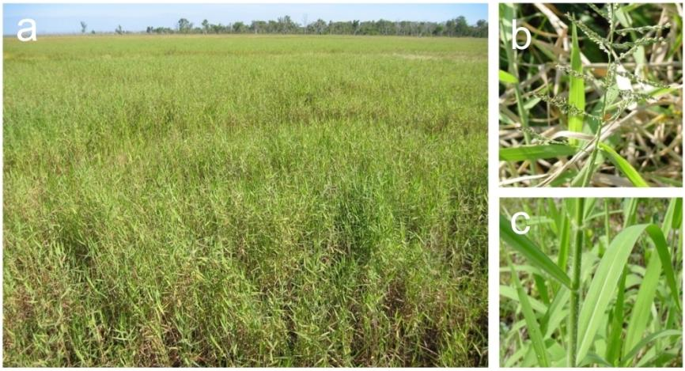

**Figure 10** *Urochloa mutica* (a) a large monoculture on the central Magela floodplain, (b) an inflorescence and (c) leaves and stems (photographs – A Cameron)

### 4.1.1 Weediness

Para grass is well-suited to the wet-dry tropics where it thrives in warm, seasonally inundated wetlands. It can grow in a wide range of water depths and can occupy many habitats, from the Melaleuca woodland and swamp forests that fringe the floodplain to the edges of permanent floodplain waterbodies (Knerr 1998, Douglas et al 2001).

Para grass is tolerant of drought provided adequate soil moisture is available. It will tolerate brackish water and is relatively shade tolerant (Smith 2002). The leaves are susceptible to frost (Holm et al1977) but plants can recover.

Its ability to invade the floating vegetation mats found in many Top End billabongs means that vegetative reproduction can occur over greater distances. These mats (or even individual para grass stolons), often break away and float to new areas where they establish from roots at the nodes (Hill & Webb 1982, Hill et al 1987, Sainty & Jacobs 1981). It has also been observed that para grass seed readily floats (initially), hence dispersal may be facilitated by wind drift on the water surface or in flowing water.

Para grass is able to recover rapidly from disturbance such as grazing by animals (Clarkson 1991). In the 1980s, Cowie and Werner (1987) observed on the floodplains of Kakadu, that para grass appeared to be responding to the reduction of trampling and grazing disturbance faster than native species as the buffalo population reduced. The greater biomass of para grass can change fuel dynamics in such a way as to facilitate its spread. Native grasses may be susceptible to hot fires (Whitehead & McGuffog 1997) and the spread of para grass may be aided by its ability to re-shoot and recover rapidly from hot fires and thus invade other grassy habitats (Knerr 1998, Douglas et al 2001).

In the wet season, para grass has a greater leaf to stem surface area ratio compared with other native floodplain grasses that occupy a similar niche. The greater proportion of leaf area gives para grass the potential to more efficiently convert solar energy to biomass, possibly increasing its invasive potential (Douglas et al 2001).

The value of para grass as an animal fodder species has greatly assisted its spread. Humans have moved it over great distances to areas where under normal circumstances of spread, invasion would not have occurred. This has the attendant risk of carrying other aquatic weeds, pathogens or animal pests between catchments (Clarkson 1995).

It has been reported that para grass possesses mild allelopathic abilities (the release of chemicals into the soil, that inhibit growth and germination of other plants) (Chang-Hung 1977, Langeland & Burks 1998). However, nursery studies have shown that a species of wild rice, *Oryza rufipogon* will germinate and grow within established para grass, suggesting there is no allelopathic effect on this species (Wurm & Bellairs unpublished data 2007). It has been demonstrated that para grass can suppress the germination of *Oryza meridionalis* via habitat modification, by preventing cues that would normally stimulate germination (Wurm et al 2006, Wurm 2007) (see sections 4.2.1 & 4.6.1 for further information/implications on this topic).

### 4.1.2 The history of para grass invasion in Kakadu National Park

Prior to the declaration of Kakadu National Park in 1979, pastoralists and Federal Government departments planted para grass as a buffalo and cattle fodder species in several areas in the Alligator Rivers Region (Wesley-Smith 1973, Miller 1970). The first introduction was in 1922 when ‘a couple of acres’ were planted at Mission Billabong near Oenpelli (Gunbalanya). By 1960 an estimated 3100 ha of the Oenpelli floodplains was infested (Letts 1960).

Para grass was well established on the Cannon Hill floodplain (East Alligator catchment) by 1946 having been planted many years prior. At the time when shooting of buffalo for their hides ceased, the grass was almost eaten out but recovered when buffalo harvesting for pet meat production recommenced (Christian & Aldrick 1977). Para grass now covers a large area of the surrounding floodplains of this region. On the Magela floodplain it was first observed in the 1950s (pers comms in Salau 1995).

In 1961, a pastoralist collected para grass runners from the Botanical Gardens in Darwin and planted them around the Munmarlary area in the South Alligator River catchment. The same Federal Government department that conducted the trials at Mudginberri in 1968/69, also trialled the grasses at Munmarlary (Salau 1995). Para grass has since expanded from this small area to cover larger areas of the South Alligator floodplains.

In 1968/69 the planting of a number of pasture grasses was investigated at Mudginberri (Magela system), with para grass being one of these species (Miller 1970). While the origin of all infestations on the Magela floodplain is unknown,[12] it is now widespread downstream and on the floodplain with various sized infestations from Mudginberri right through to the East Alligator River bank at the Magela Creek outflow. The largest infestation is situated around the Nankeen Billabong area of the central Magela floodplain.[13]

To the west, a few para grass runners were planted at the bottom crossing of Four-mile hole on the Wildman River (1972). The infestation has expanded over the years and as of 1995, satellite infestations were scattered for approximately two kilometres down the floodplain (Salau 1995). Further spread or possibly contamination from a new source, have resulted in numerous scattered plants now occurring at Benbunga some 20 km downstream of Four-mile hole (R Salau pers comm July 2005).

In the Nourlangie area, para grass was planted at No. 2 Goose Camp sometime in the 1970s (Salau 1995). Spread occurred until there were four separate para grass sites in the Goose Camp area. Some sites have been successfully controlled whilst others require continuing treatment (R Salau pers comm July 2005).

Other infestations around the Park have been located in Didygeegee swamp (Magela catchment), Boggy Plain (South Alligator catchment), Jono’s Jungle (East Alligator catchment) and in Stage 3 in the South Alligator River bed upstream from the Sleisbeck road crossing. Many of the above infestations have been treated with varying degrees of success and are being closely monitored (Salau 1995).

## 4.2 The potential effects of para grass

Like mimosa, para grass also dominates other vegetation and often forms a monospecific habitat. As the density of para grass is usually greater than that of native vegetation, hydrological regimes may be altered resulting in reduced flows and greater deposition of sediment ultimately resulting in reduced water quality and marked changes in habitat including shoaling or sometimes the complete elimination of waterbodies. Examples of this come from northern Queensland where stream catchments have been cleared for sugar cane, and in the absence of riparian vegetation, excessive growth of para grass, and other pasture grasses choke the stream channels (Bunn et al 1998). Douglas et al (2001) noted that para grass has the potential to alter vegetation breakdown rates on floodplains. In shallower areas, it decomposes faster than the native wild rice it displaces but more slowly than native Hymenachne in deeper waters. The latter would contribute to the higher para grass biomass in such habitats. The greater productivity of para grass is evident in the shallow habitats, in that a higher biomass of the weed actually accrues despite breaking down faster than the wild rice. Douglas et al (2001) acknowledge that the consequences of change in decomposition rates on floodplains are difficult to predict, but could include changes in decomposer communities, effects on water quality (specifically dissolved oxygen levels) and possibly altered rates of ecosystem processes such as nutrient cycling.

### 4.2.1 Effects of para grass on native flora

Evidence shows that para grass has the capacity to modify landscapes by displacing some native plant communities of Top End wetlands. These communities are important ecologically, even though they may not support many endemic or rare plants. Two studies have investigated the effects of para grass on native flora on the Magela floodplain.

Knerr (1998) examined four Magela floodplain grassland communities (*Urochloa mutica, Hymenachne acutigluma, Oryza meridionalis* and *Pseudoraphis spinescens*) for species richness and diversity. Combined data for wet and dry seasons showed that *Urochloa* grassland had the lowest species richness of the four communities. However, this was not significantly different (p>0.05) to the species richness of the Pseudoraphis grassland. The *Urochloa* grassland had the lowest species diversity (combined seasons) and this was significantly different (p<0.05) to the species diversity of the other communities. Species richness did not change in the *Urochloa* grassland between seasons, in contrast to all other communities which showed significant changes. Although species diversity increased in the *Urochloa* grassland in the wet season, it was still much lower than the diversity found in other communities.

The increase in area of the *Urochloa* community coupled with a corresponding decrease in area of the Oryzacommunity from 1991 to 1996, as determined by Knerr (1998), suggests strongly that para grass has invaded the latter community. Hymenachnegrassland which often occurs in deeper water than Oryza, appears not to have been invaded during this time, although it is thought that this may be occurring but over a longer time scale. The Oryza community is perhaps more susceptible to invasion as it is the only annual of the four grass species, therefore relying entirely on the seed bank to persist over the dry season. It is during this dormant stage that perennials such as para grass can establish in Oryzahabitats. The allelopathic qualities of para grass (inhibiting the growth of native plant species) may be responsible for some of this displacement, though it is uncertain to what extent this phenomenon has an effect.

Once para grass is well established in an Oryza community, it is capable of suppressing the germination of the Oryza seeds. Wurm (2007) demonstrated that whilst ~76% of Oryza seeds germinated under Oryza cover, almost none germinated from beneath a well established cover of para grass. It is believed that the higher temperatures needed to break the dormancy mechanism of the Oryza seed are not achievable beneath the dense shading structure and greater litter volume of para grass. Temperatures under para grass were some 10ºC cooler than those under Oryza cover (Wurm et al 2006). If the Oryza seed remained unviable, this phenomenon may pose serious management challenges, as managers may not be able to rely on the natural regeneration of Oryza (and possibly other species) following the removal of para grass.

Douglas et al (2001) also examined the effects of para grass on Magela floodplain grassland communities (*Urochloa mutica, Hymenachne acutigluma, Oryza meridionalis* and a herbicide treated *U. mutica* grassland). Plant species richness and cover were measured for both dry and wet seasons. Plant biomass and surface area were measured during the wet season, and rates of breakdown and dry season fuel loads were also investigated. In the dry season, para grass was the only vegetation type that occurred in monospecific stands. The structurally similar Hymenachne community contained five plant species, while the rice and treated patches each had a total of 11 species. Species richness for these communities increased during the wet season and a pattern similar to that of the dry season was evident, where total richness was highest in the rice and treated habitats and lowest in the para grass habitat.

Douglas et al (2001) also found that para grass had a higher biomass than all of the other communities for both the wet and dry seasons. The invasion of other grass habitats leads to greater fuel loads, which would most likely increase the intensity and extent of floodplain fires, particularly in the late dry season (Douglas & O’Connor 2004). On the Magela floodplain there is possible evidence of this scenario with patches of dead, badly fire scarred Melaleuca trees with a para grass understorey (M Douglas pers obs). Parks Australia North staff have also reported that hot para grass fires have been responsible for damage to some monsoon vine forest patches (P Barrow pers comm).

Ferdinands et al (2005) investigated the effects of para grass on the native wetland flora of the Mary River floodplains some 130 km to the west of the Magela floodplain. They concluded that the ability of para grass to displace other flora and form monocultures over very large areas and across a diverse range of wetland vegetation types indicated a very broad environmental niche.

They found that when para grass was present there was markedly lower species diversity (mean number of taxa reduced by 50%) in 18 m2 plot samples. Where para grass was present in a sample it was usually the dominant vegetation with a median cover of 75–95%. In most cases there were no other emergent macrophytes where para grass was present, even where plots were located to sample varying densities of para grass.

Habitat suitability modelling by Ferdinands et al (2005) showed a number of vegetation communities that have a positive association with para grass, and therefore a higher risk of invasion. Those communities at greatest risk included; Oryza grassland with *Eleocharis dulcis* patches; *Cyperus scariosus* sedgeland; Melaleuca open woodland with Eleocharis sedgeland and mixed grassland in the understorey; Melaleuca woodland with Oryza and Eleocharis mixed grassland sedgeland understorey; *Hymenachne acutigluma*/*Leersia hexandra* grassland; mixed grassland/herbland and *Pseudoraphis spinescens* grassland. *Oryza meridionalis* was present in many of these habitats and is the species most likely to be affected by para grass.

### 4.2.2 Effects of para grass on native fauna

The greatest impacts on native fauna will most likely result from a reduction in the diversity, distribution and abundance of native plant species important for food and refuge resources. In particular, wild rice is perhaps the most important food resource for floodplain vertebrates and is the species most frequently replaced by para grass on the Magela floodplain (Knerr 1998, Cowie & Werner 1993). It is a prolific producer of seeds high in energy and protein, essential for pre-fledging magpie geese which need to grow quickly in time to flee breeding swamps before they dry (Frith & Davies 1961, Dawson et al 2000). The bulbs of the sedge or water chestnut(*Eleocharis* spp), which are more common in wild rice communities than in para grass monocultures (Douglas et al 2001), are another important high energy food source for magpie geese (Frith & Davies 1961, Dawson et al 2000). Such foods are essential for the birds to store fat and nutrients in order to survive the latter part of the dry season. Para grass as a food resource does not support the growth rates obtained from a diet of these native species (Dawson et al 2000). Some other waterbird species that visit the floodplains to feed on wild rice seeds include the grass whistling duck (*Dendrocygna eytoni*),brolga (*Grus rubicundus*), little whimbrel (*Numenius minutes*) and little corella (*Cacatua sanguinea*) (Whitehead 1992).

Magpie geese may be further detrimentally affected by para grass invasion as they preferentially nest in Eleocharis/Oryza communities (Corbett et al 1996). In the early 1980s magpie geese frequently nested in numbers in the vicinity of the road causeway at Munmarlary in the South Alligator catchment. By 1995 this area was dominated by para grass and only one magpie goose nest was present. Approximately 500 nests were counted in the general vicinity, and only one was located in para grass (Salau 1995).

Since 1981, magpie geese numbers on the Magela floodplain have decreased on average by 7% per year and fish eating egrets on average by 9% per year. The reasons for this are not entirely certain and para grass may be one of many pressures faced by the fauna of aquatic systems in northern Australia. Analysis at increasing spatial scales show that trends in the late dry season abundance of magpie geese on Magela floodplain were highly concordant with similar trends for the same time period across the Alligator Rivers Region and the Top End of the Northern Territory (Bayliss et al 2006).

In addition to investigating the impacts of para grass on the native flora of the Mary River floodplains, Ferdinands et al (2005) also investigated the effects of para grass on the native avifauna over a variety of floodplain habitats, recording 13421 individuals represented by 50 bird species. For each survey point, high bird counts (>50) were scarce in para grass invaded habitats and species richness was generally lower in both dense and mixed para grass communities, when compared with species richness in natural habitats. For common species like the magpie goose, the importance of open water, sedges and Oryza grassland was apparent with very high abundance recorded only in these habitats. Similarly, no common[14] species preferred the weed invaded habitats with only 8% of the total bird numbers recorded there, whilst twenty seven species of the 46 uncommon bird species were never recorded in the weed habitats. Eleocharis sedgeland, mixed grassland/herbland/sedgeland, bare ground and open water were the most important habitats with the highest mean counts of 39 of the 50 bird species recorded there. No single plant species was usually dominant in these mixed habitats, although *Oryza meridionalis* and *Eleocharis* spp were well represented. The overall finding was that most bird species avoid dense para grass and very few benefited from it. The authors proposed that this lack of utilisation by birds of para grass habitats was because monocultures formed by para grass, lack the floristic and structural diversity of the natural habitats. Para grass produces little edible seed, and compared to most native floodplain vegetation, it tends to be denser and more matted, thus impeding access to resources such as Eleocharis bulbs, macrophytes, fish and invertebrates found in the soil and water.

Douglas et al (2001) examined the effects of para grass on aquatic benthic and epiphytic macroinvertebrates (see also Douglas & O’Connor 2003), terrestrial invertebrates and fish communities on the Magela floodplain. For the aquatic macroinvertebrates they concluded that para grass invasion had little or no impact. Richness was generally lower in the Hymenachne sites, probably due to the anoxic nature of the benthic zone in this habitat. There was evidence of adverse effects of para grass on terrestrial invertebrates in the dry season, but only when para grass displaced Hymenachne. Total richness and abundance of terrestrial invertebrates were lower in para grass than in Hymenachne, thus widespread displacement of the native floodplain vegetation could reduce the biodiversity and abundance of this fauna. Results for the wet season showed the potential (if para grass replaces Hymenachne) for a reduction in terrestrial invertebrate biodiversity. In contrast to the dry season results, however, invertebrate abundance did not appear to decline.

Although Douglas et al (2001) found no significant differences in the number of fish species or total fish abundance among the four vegetation types, they did suggest that the absence of adverse effects was because infestation conditions at the time of sampling still represented a mosaic of vegetation communities. They proposed that if para grass infestation was very widespread and formed dense monocultures, resulting in a much lower structural diversity, then some reduction in diversity and/or abundance of fishes and fish communities might be expected. The potential for reduced dissolved oxygen (DO) levels resulting from dense para grass infestation may have negative consequences for some fish species. Fish must either be highly tolerant of low DO conditions or move to areas of open water where the DO levels are elevated (Douglas et al 2001).

As a result of long-term monitoring of the Ranger uranium mine, ***eriss*** research has determined that between 1989 and 2005 the chequered rainbow fish (*Melanotaenia splendida inornata*) and two species of glass fish (*Ambassis* spp) at the Mudginberri monitoring site downstream of Ranger exhibited long-term declines in abundance (13% pa on average) that are apparently unrelated to potential mining impacts. Hypotheses for this decline include: (i) increases in mean wet season flow leading to lower water solute concentrations known to be harmful to larval rainbowfishes; (ii) decreases in the period of annual drying of the floodplain potentially leading to reduced release of nutrients upon floodplain re-wetting, and thereby reducing fish production in this important breeding and recruitment zone; and (iii) increases in the extent of floodplain grasses, including para grass, thereby reducing habitat availability and pathways for upstream migration of fish recruits (Humphrey et al 2006).

The greater wet season biomass of para grass leads to a greater density of vegetation in the water column and this may impede movement of larger aquatic animals such as turtles and water monitors (Douglas et al 2001). The greater dry season biomass leads to hotter fires and changes in fire regimes, possibly affecting amphibian, reptile and mammal species living amongst the grasses or sheltering (within the cracks) or aestivating (eg long-neck turtles) in the cracking clays (Douglas et al 2001).

Native grasses have also been shown to be an important source of seeds for granivorous rodents such as the dusky plains rat (*Rattus colletti*). Wild rice and sedges both form an important component of the diet of this species (Redhead 1979). Dusky plains rats consume abundant wild rice seed during the late-wet and early dry season (Redhead 1979, Wurm 1998a), when they are themselves an important prey item for vertebrate predators, such as reptiles (Madsen & Shine 1996, 1999, Shine & Madsen 1997).

### 4.2.3 Conceptual model for para grass

A conceptual model based on known information on para grass, and the potential ecological cultural and socio-economic impacts is shown in Figure 11. In some cases, the effects noted for native flora and fauna may apply to iconic and/or culturally significant species

|  |  |  |
| --- | --- | --- |
| **Pressure:** | | *Urochloa mutica* |
| ↓ | | |
| **Major exposure pathways:** | | Vegetative, waterbirds, floating mats, animals (usually short distances), water craft, deliberate movements of propagules |
| ↓ | | |
| **Favoured wetland habitats:** | | Floodplains (land subject to inundation) and fringing margins, freshwater ponds and swamps, riparian zones – particularly if these habitats have been disturbed |
| ↓ | | |
| **Ecological, socio-economic and cultural effects:** | * Competitive exclusion of native flora * Loss of suitable habitat for some native fauna * Loss of suitable food resources for some native vertebrate fauna * Altered hydrological regimes * Altered fire regimes (leading to loss of riparian and monsoon forest) * Impeded movement of larger aquatic animals * Reduced potential for sustainable utilisation of native wildlife * Reduced aesthetics and threatened income from tourism * Restricted access to traditional aboriginal hunting areas and important cultural/ceremonial areas * Reduced availability of other traditional natural resources (flora & fauna) |

**Figure 11** Conceptual model of known information on *Urochloa mutica*

### 4.2.4 Beneficial uses of para grass

Para grass is prized as a high yield, highly palatable and nutritious livestock fodder crop that is tolerant to a number of environmental stressors (eg Miller & van der List 1977, Anning & Hyde 1987). Para grass does produce a high yield and is a hardy floodplain grass, however, the nutrient value is actually less than that of the native *Hymenachne acutigluma* (Cameron & Lemcke 1998). With regard to palatability, cattle on the Mary River floodplain have been observed to bypass para grass to graze on the wild rice *Oryza rufipogon* (D Liddle pers comm in Whitehead 1992) and cattlemen consider wild rice to be a highly palatable cattle fodder (Bob Townsend pers comm in Whitehead 1992). Protein levels in native Hymenachne have also been reported as being greater than those of para grass (Calder 1982).

In south-eastern Florida, para grass was used for camouflage around military installations in World War II (Austin 1978), and in Hawaii it has been used to remove nitrogen from domestic effluent, favoured for its rapid, dense growth (Handley & Ekern 1981).

## 4.3 The potential extent of para grass

### 4.3.1 Current distribution of para grass on the Magela floodplain

Figure 12 shows the locations of para grass from two sources: the study by Knerr (1998) that mapped the increase in area of para grass (132 ha to 422 ha from 1991 and 1996) on the central Magela floodplain; and waypoints recorded during airboat and helicopter surveys by eriss in 2003−2004. Although the surveys were very comprehensive, it was not possible to systematically survey the entire Magela floodplain (see also section 1.4.2 for further details).

A vegetation class map (Figure 13) was derived from this survey data and a supervised classification of a high-resolution multispectral QuickBird satellite image captured in June 2004. Classification accuracy for para grass was 90% and 96% respectively for the wetter and drier growth forms and the overall map classification accuracy was 86% (kappa coefficient = 0.83) (see Congalton 1991 for methods and descriptions of terms) (see also section 1.4.2 for further details).

The resulting class map was resampled to 5 m pixels in ENVI™ using nearest neighbour resampling. From this map a raster layer was produced for para grass only (other map classes removed). Using this map (and a 250 m zone-grid overlay of the coverage area), the percentage cover of the para grass classes within each 250 m grid cell was estimated using the Zone Statistics feature of Spatial Analyst in ArcGIS™. That is the total number of 5 m ‘para grass’ classed pixels falling within each 250 m grid cell was divided by the total area of each grid cell to derive a percentage cover (Figure 14).

Calculation of the para grass cover within each of the 250 m x 250 m grid cells showed that para grass within the region of the image capture (as of 2004) covered approximately 1250 ha and had displaced about 10% of the native vegetation. Coupled with field survey data outside of the capture region, results indicate that at the time of the image capture, para grass was distributed over approximately 35% of the Magela Creek floodplain with satellite outbreaks to the north and south of the main infestation in the central region[15].

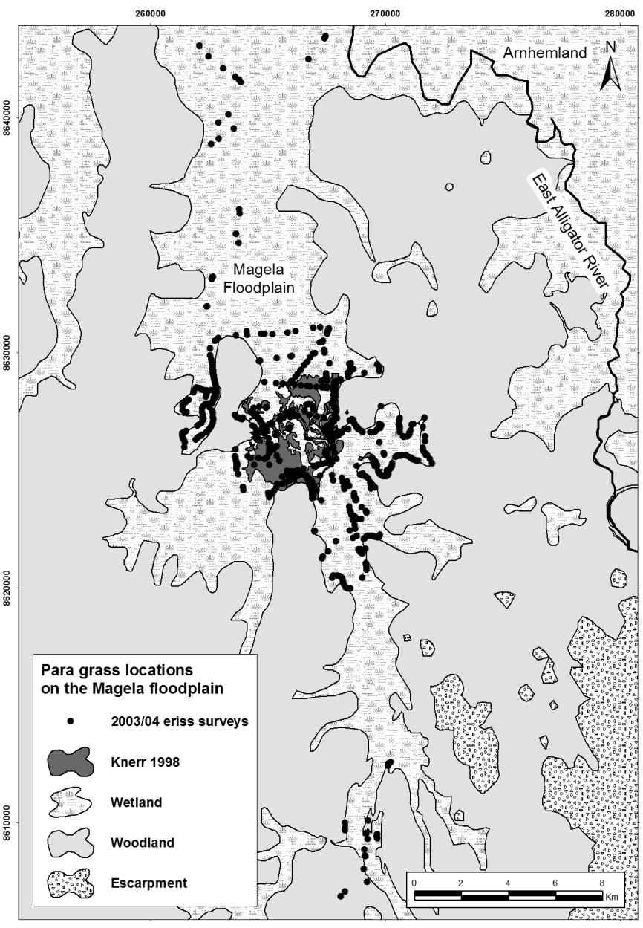

**Figure 12** Para grass distribution on the Magela floodplain from an earlier ***eriss*** mapping study (Knerr 1998) and ***eriss*** airboat and helicopter surveys in 2003−2004

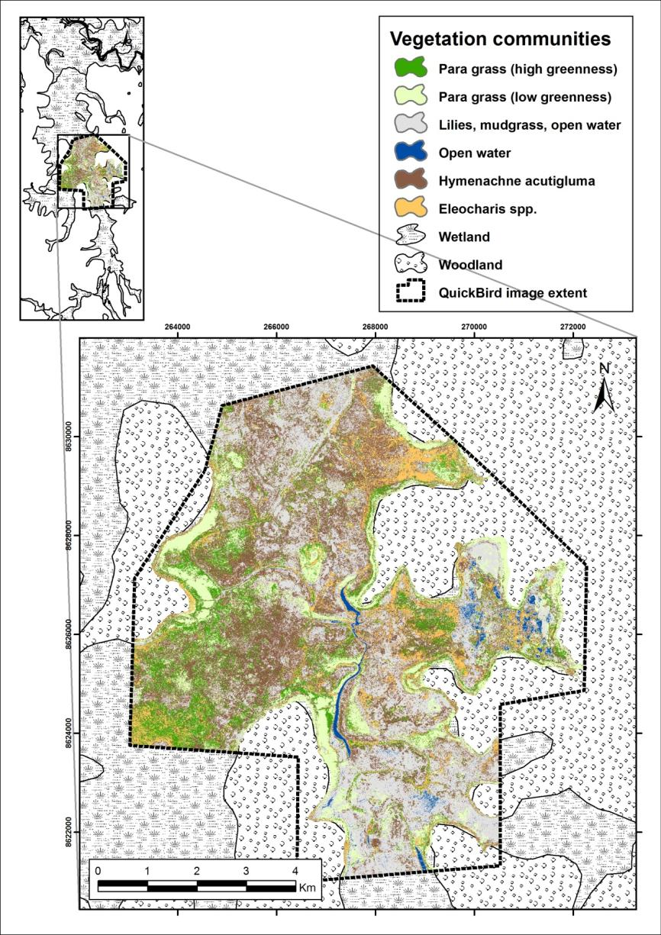

**Figure 13** Supervised classification of QuickBird image using major vegetation communities and the airboat/helicopter survey data. The inset shows the position of the image area on the floodplain.

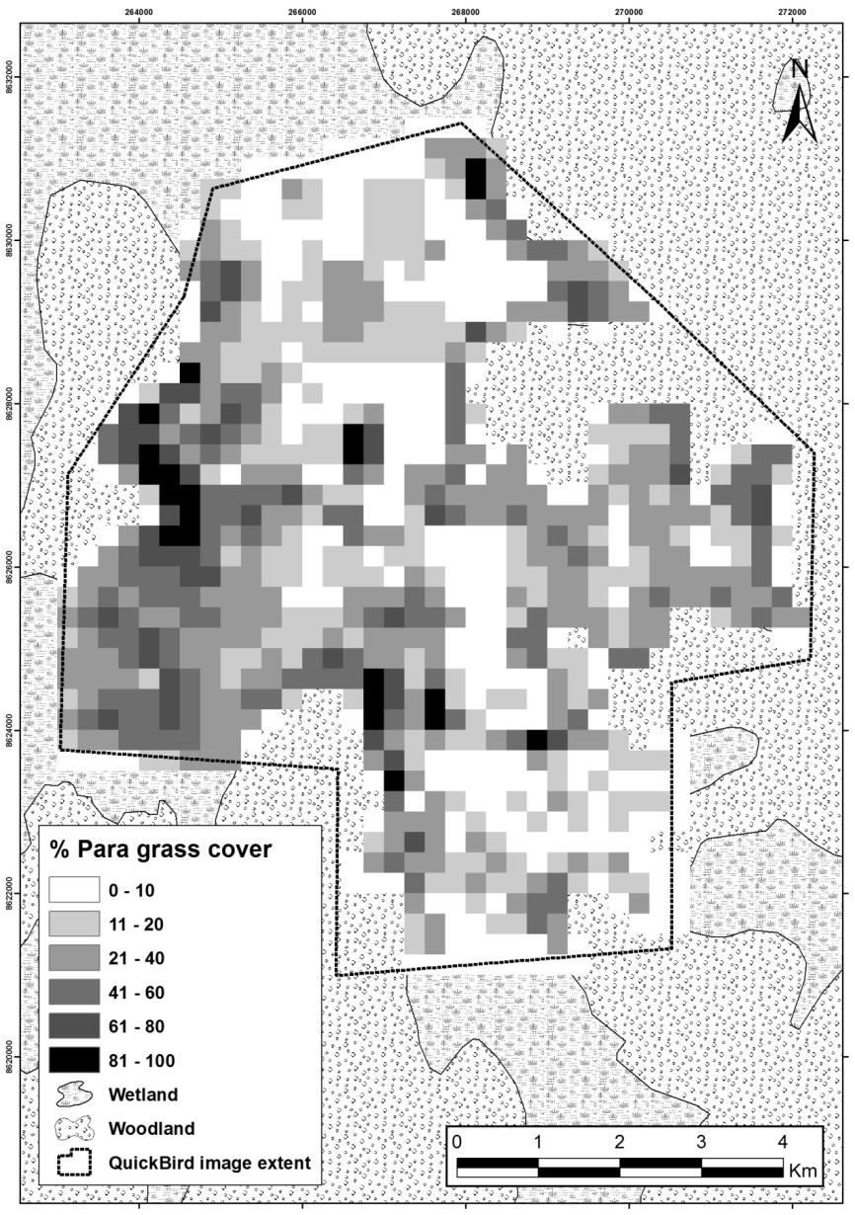

**Figure 14** Para grass cover (%) derived from supervised classification of the QuickBird image

### 4.3.2 Invasion rates and pathways of para grass

#### Invasion rates

The most heavily infested area of para grass on the Magela floodplain expanded by 290 ha (132 ha to 422 ha) in the five years between 1991 and 1996 (Knerr 1998). On the Oenpelli (Gunbalanya) floodplain, a ‘couple of acres’ planted at Mission Billabong increased to an infestation of 3100 ha in the 38 years between 1922 and 1960 (Letts 1960). A few para grass runners planted at Munmarlary on the South Alligator River system in 1961 had spread to 200 ha by 1996. Runners planted at No. 2 Goose Camp on the Nourlangie Creek system in 1974 spread to approximately two hectares by 1992, and runners planted at Four Mile hole on the Wildman River system in 1972 had spread to between 8 and 10 ha by 1993 (R Salau pers comm). The marginal rate of spread of an infestation in the Munmarlary area was estimated at approximately 10 m over one year (I Cowie pers comm).

At selected sites within the large infestation on the Magela floodplain, Douglas et al (2001) measured the rates of para grass re-invasion in herbicide treated plots over a period of one year, 11 months after herbicide application. The experiments were designed to determine the rate of expansion of individual plants within the herbicide treated patches that had re-sprouted after treatment (clumps), and to measure the rate at which mature para grass forming the boundary of treated patches grew back into the treated area. Measurement of mature para grass was only done at sites where a distinct front at least 10 m in length existed at the margin of the sprayed patch. The rationale behind these measurements was to see how quickly a clear patch within established para grass would be reinvaded. Measurements of the new outbreaks of para grass during the dry season showed that over a one-year period, the length and width of clumps within the treated area had increased, on average, by a factor of 3.7 (± 1.0). The measurement of established para grass spreading into bare areas previously treated with herbicide showed that re-invasion occurred at an average rate of 3.2 m year-1 (± 0.8 m).

The historical distribution maps of para grass published by Knerr (1998) were converted to ArcGIS shapefiles to estimate maximum spread rate over the time period of rapid colonisation (1991–1996) and, to determine whether or not a threshold *in situ* abundance level (via percentage cover) of para grass needs to be reached in existing patches before it will colonise adjacent weed free areas. The shape files were converted to raster files with a 250 m x 250 m cell size, and a multiple regression model was used to predict final (1996) cell value as a function of starting (1991) cell value and a range of threshold values before spread is initiated. The multiple regression R2 value was used to choose the best model subset and associated parameter values for maximum spread rate and threshold for spread. Maximum spread rate was estimated at 23% pa for the intensive study area chosen for simulation. This may be an underestimate, however, as an estimate of 33% pa was derived when the full extent of the distribution data in 1991 and 1996 is used. Nevertheless, the 1991 and 1996 data that lies outside the intensive smaller study area chosen to simulate spatial spread dynamics is considered here to be much less accurate (Bayliss et al 2006, Bayliss et al 2012).

Linear regression analysis (Ln area km2 vs time years) indicated that para grass has been spreading on average at 14% per annum, or doubling in extent every five years (Fig 15) Bayliss et al 2006). As an average spread rate only, factors such as differing spread rates through different habitats were not used in the analysis. The two parameters chosen to characterise the dynamics of para grass spread (maximum rate and threshold level to trigger spread) were used to develop a spatial-temporal model to simulate para grass spread across the floodplain under different management control scenarios, including no control (see Bayliss et al 2012 for further refinement of analysis and predictions of para grass spread).

fig 16 spread rate.tif

**Figure 15** Linear regression between Loge extent (km2) of para grass and time (yrs) (R2=69%, n=5, P<0.04) derived from: early observations of para grass in the 1980s; the study by Knerr (1998) who measured spread between 1991 and 1996; and the present study.

#### Invasion pathways

It has long been asserted that para grass is a poor seed producer and reproduces primarily through vegetative means (Wesley-Smith 1973, Holm et al 1977). In contrast, Knerr (1998) found that compared to many other grasses on the Magela floodplain, para grass is capable of high seed yields and the sediment seed bank can contain relatively high numbers of viable seed. Despite this, reproduction and spread of para grass appears to be predominantly vegetative, given the tendency for the aerial shape of colonies to be rounded. On the other hand, the importance of the seed banks to the persistence of para grass in established areas, following control, or in the dispersal and establishment of new colonies (floating seeds) remains unclear. Existing infestations expand mainly by the stolons spreading out from the perimeter across open water, bare ground or into other plant communities. Spread over greater distances occurs when para grass colonises floating vegetation mats and portions of these mats or even the entire mat, break away and float downstream (Hill & Webb 1982, Hill et al 1987). It is thought that animals may move stolon fragments over shorter distances (Cowie & Werner 1988). Magpie geese are known to introduced viable para grass stolons into areas of native vegetation when nest building (D. Liddle pers comm in Whitehead 1992). Humans have likely been responsible for most para grass infestations in Kakadu (prior to declaration of the Park) and elsewhere, having transplanted it from other areas for its value as a pasture crop for grazing animals. On the Magela floodplain, para grass seed was actually dispersed aerially, though it would appear that possibly most or all of this seed failed to establish, otherwise any infestations would have been far larger and more numerous (Cowie & Werner 1987).

Cowie and Werner (1988) transplanted para grass stolons back into established para grass communities and also into other vegetation types including Pseudoraphis, Eleocharis, Hymenachne and Oryza communities. Para grass stolons were poor competitors when transplanted into an established para grass community, with 90% stolon mortality. Para grass could establish successfully in the other communities. However, the ability of para grass to persist in these communities for longer than a few months was not determined during the study.

Observations by Cowie and Werner (1988) suggested that para grass may be at a competitive advantage during the early wet season before flooding occurs, because at this time, the para grass community appeared more vigorous and healthy than after flooding. At the limited scale of the study, disturbance did not appear to be important for establishment of para grass stolons after flooding in the early wet season. However, field observations suggested that the early wet season before flooding occurs may be an important period for colonisation by para grass of ground left bare by fire.

### 4.3.3 Preferred habitats and environmental conditions of para grass

Para grass has been introduced to most tropical and subtropical regions of the world, primarily as a pasture fodder grass or for erosion control and rehabilitation. Its latitudinal limit is approximately 27 deg south in areas of suitable habitat. Para grass thrives on flat, open coastal floodplains but also grows well along creek and river banks and artificial structures such as irrigation channels, ponds and dams. Like most weeds, para grass has a preference for disturbed sites.

#### Rainfall and temperature

Para grass is adapted to hot wet conditions. Annual rainfall should be greater than 1000 mm per year (Cameron & Lemcke 2008) but in protected areas with residual soil moisture, it can persist with rainfall as low as 900 mm per year (Skerman & Riveros 1990). Para grass is very drought tolerant (Holm et al 1977) and can survive long dry spells due to preference for swampy environments, being maintained by residual soil moisture from the wet season. The optimum mean annual temperature for growth is reported to be 21°C (Russell & Webb 1976) and the minimum temperature for growth is 15°C (Allen & Cowdry 1961).

#### Geomorphology and soils

Para grass generally prefers alluvial and hydromorphic soils. These include solodic and cracking clays usually associated with coastal floodplains. Para grass will grow on a range of soil types, but its adaptability to a range of water conditions is its most important characteristic (Cameron & Lemcke 2008). Hydromorphic soils are typically ‘wetland’ or groundwater soils and must have signs of wetness within 50 cm of the soil surface. Like mimosa, most large infestations of para grass in the Northern Territory have occurred on the coastal floodplains.

#### Inundation

In the pastoral industry, para grass is known as a ‘ponded pasture’ grass, where it is planted within artificial ponds constructed to capture run-off water in times of rain. This standing water can then persist in times of drought and maintain a supply of para grass for cattle fodder. Para grass is ideally suited to shallow swamps and will also grow well in running water.

On the Mary River floodplain, Ferdinands et al (2005) found para grass most commonly on areas of slightly greater elevation. These shallower areas tend to drain earlier at the end of the wet season with an estimated average inundation period of five to six months in most years. The average mid wet season depths for these areas was 55 cm, although depths ranged between 10−200 cm across all sites where para grass was present. They concluded that para grass is suited to shallower wetland areas but can tolerate, at least temporarily, inundation across a broader range of depths.

These findings are supported by Douglas et al (2001) who recorded para grass on the Magela floodplain growing most vigorously in water depths up to about 60 cm, but also growing in water as deep as 2.2 m (Table 2). During field work for this study, observations were that para grass appears to form denser colonies in drier floodplain margins, and shallower seasonally inundated habitats (James Boyden pers comm March 2008).

Anecdotal evidence suggests that it is possible to kill para grass by drowning. Whilst this has not been the experience in Kakadu National Park, it may occur with a rapid rise in water levels and if the grass was already reduced or weakened by grazing,[16] burning or spraying for example (Piers Barrow pers comm, Anning & Hyde 1987, Wesley-Smith & Lemcke 1992). The prediction is that if the inundation is rapid enough, the plants may not be able to re-shoot fast enough to maintain growth above the water level (Knerr 1998).

**Table 2** Summary of water depths (cm) recorded during wet season vegetation sampling in three vegetation types on the Magela floodplain

|  |  |  |  |  |
| --- | --- | --- | --- | --- |
| **Vegetation type** | **Mean (s.e.)** | **Min** | **Max** | **Range** |
| Hymenachne | 181 (5) | 100 | 273 | 173 |
| Wild rice | 96 (5) | 40 | 193 | 153 |
| Para grass | 126 (5) | 48 | 220 | 172 |

Source: (Douglas et al 2001)

#### Salinity

There is little quantitative information on the salinity tolerance of para grass. It is reported to be tolerant of saline soils and brackish water (Anning & Hyde 1987, Sainty & Jacobs 1981, Langeland & Burks 1998). In south-east Queensland it grows on deep loamy soils overlying saline clays and merges with saline grasses on marine floodplains (Cameron & Kelly 1970). In Kakadu National Park a small stand of para grass grows on a sand spit along the bank of the East Alligator River in the vicinity of the area colloquially known as ‘Jono’s Jungle’ which is located on Point Farewell. This area is close to the mouth of the East Alligator River, and is thus a relatively brackish environment, although the salinity has not been measured. Prior to its control, there was also a small infestation of para grass on the bank of the East Alligator River near the Magela Creek outflow (Salau 1995), which is a somewhat brackish environment subject to tidal influence. In the Townsville Town Common Conservation Park in northern Queensland an attempt to control para grass by flooding with saltwater failed to have any affect as the infestation was already on reasonably saline soils (Robert Graham pers comm Nov 2004).

#### Fire

Para grass will burn readily in most circumstances. Knerr (1998) observed that para grass would re-shoot vigorously after being burnt and hypothesised that a more frequent fire regime in years prior to the study appeared to favour para grass. Around the drier floodplain margins, established para grass has almost twice the fuel load of the native annual *Oryza* spp, which it has displaced (Douglas & O’Connor 2004). It has been postulated by Douglas et al (2001) that this change in fuel dynamics may actually facilitate the spread of para grass (). They state that this may have already occurred on the Magela Creek floodplain, where in the more northern region (where para grass is abundant) the fire sensitive native Hymenachne was present only adjacent to permanent water. Further south on the floodplain where para grass is more sparse, Hymenachne occurs in large stands that dry out seasonally. Unlike many native floodplain species, the exposed portion of leaves and stems of para grass above the water line can maintain a fire despite the lower portion of the plant being submerged.

Cameron and Lemcke (2008) state that a hot fire can render para grass vulnerable to drought, overgrazing and flooding, and stands that have been dramatically thinned by hot fire are very slow to regenerate. Preliminary results from a research project by CSIRO and Queensland Parks and Wildlife, exploring the use of fire and grazing to control para grass in the Townsville Town Common Conservation Park, suggest that grazing, in combination with fire, is the most effective method of reducing para grass cover in this situation (Williams et al 2005, Grice et al 2010). The fire opens up the canopy and allows the reestablishment of native floodplain species (Williams et al 2011). These conflicting observations may be due to varying regional factors such as soil type, nutrient and moisture availability and different native vegetation species.

#### Shade tolerance

Para grass grows best in full sunlight, but will tolerate partial shade. The latter is evident where para grass is abundant beneath the fringing Melaleuca trees around the Magela floodplain. Heavier shading has an increasingly negative effect on the growth of para grass. In far north Queensland, Bunn et al (1998) used two shade cloth treatments to assess potential control options by mimicking the effect of shading by riparian vegetation. They found that after three months of a 90% shade treatment, the biomass of the upper layer of the stand was only 22% (mean of 48%) of that in the open controls. Little of the remaining biomass consisted of green shoots, and dead stems dominated the lower layer of the stand.

#### pH

The soil pH range for para grass is reported to be broadly between 4.3 and 7.7 (Holm et al 1977).

### 4.3.4 Potential distribution of para grass on the Magela floodplain

Habitat suitability modelling (see next section) and spread modelling (see section 4.3.2) have indicated that para grass has the potential to further invade native plant communities on the Magela floodplain in a relatively short time frame. However, it is important to note that the habitat suitability for para grass and the estimated invasion times presented here are based on a number of untested assumptions (see *Assessing the risk of para grass invasion* in section 4.4.2 below), thus the results may vary markedly as uncertainties are reduced.

## 4.4 Identification of the risks of para grass

This section is the result of a consultancy report by Dr Keith Ferdinands examining the habitat suitability for para grass on the Magela floodplain.

### 4.4.1 Summary

A spatially explicit Bayesian habitat suitability model was derived for para grass in the Magela Creek wetlands of Kakadu National Park. The modelling was implemented within a Geographic Information System (GIS) to generate a surface showing the probability of the presence of para grass. Probability of presence was derived from the conditional probabilities of para grass presence/absence combined using Bayes’s theorem (see Carlin & Louis 1997 for details of Bayes’s methods).[17] A high probability of presence is interpreted as indicating high habitat suitability, hence susceptibility to invasion. However, as the risk of invasion by plants is a product of both habitat suitability and the proximity to existing infestations, the final assessment of ‘risk’ incorporates the distance between invasion propagules in addition to habitat suitability. This assessment was derived by simulating the spread of para grass from current locations through the wetlands and measuring the amount of impedance (derived from the habitat suitability model) to spread in different directions. This modelling of spread based on different degrees of impedance was also performed within a GIS and is known as cost-distance modelling.

### 4.4.2 Methods

#### Datasets used in the habitat suitability model analysis

The datasets used to derive the Bayesian habitat suitability model include: para grass distribution derived from ***eriss*** field surveys; the study by Knerr (1998); and the remotely sensed vegetation QuickBird image. These point and polygon datasets were combined into a single dataset and converted to a raster format (20 m x 20 m cell). It was assumed, in the absence of reports to the contrary, that the para grass extent mapped by Knerr (1998) had not decreased. Three environmental variables were analysed including a 2004 vegetation map (Fig 16), land units (Fig 17) and land systems (Fig 18), all converted to the 20 m x 20 m raster format. Water depth collected as point records during July 2004 was also examined. However, the limited number of points coupled with the time of sampling (dry season) resulted in this dataset being excluded from analyses.

#### Bayesian habitat suitability modelling

The analysis was carried out in seven steps, following the procedure outlined by Aspinall (1992):

1. Para grass distribution classes were identified (presence and random).
2. The frequency of association between variables in each predictor dataset and the two classes identified above were calculated. The relative frequencies were the conditional probabilities for discriminating between presence of para grass and random points. Specifically, the conditional probabilities were calculated from the area of overlap between the categories in the target distribution and each of the classes in the predictor dataset.
3. Conditional probabilities for presence were calculated as the proportion of total area of presence (ie total area of cells occupied by para grass) for each class in the predictor dataset. Conditional probabilities for the random dataset were calculated as the proportion of the study area in each class of the predictor dataset.
4. The association of classes in the predictor datasets with para grass distribution classes (presence of para grass versus random cells) was tested through analysis of frequencies (cell count), using the chi-square test.
5. The statistical significance of each class in each predictor dataset for discriminating between para grass distribution classes was tested using the Z – test.
6. An initial assumption of equal probability of presence/absence was made. That is, *a priori* probabilities were set at 0.5.
7. Environmental predictor datasets were selected, based on the above analyses. Conditional probabilities for each variable in each predictor dataset that showed significant association with para grass distribution classes were combined using Bayes’s theorem.

Output from the habitat suitability model is a surface (grid) with cell values, expressed as a percentage (0–100), estimating the probability of para grass being present (or absent) given the combination of environmental variables characterising that cell. Cell size for the analysis was 20 m x 20 m.

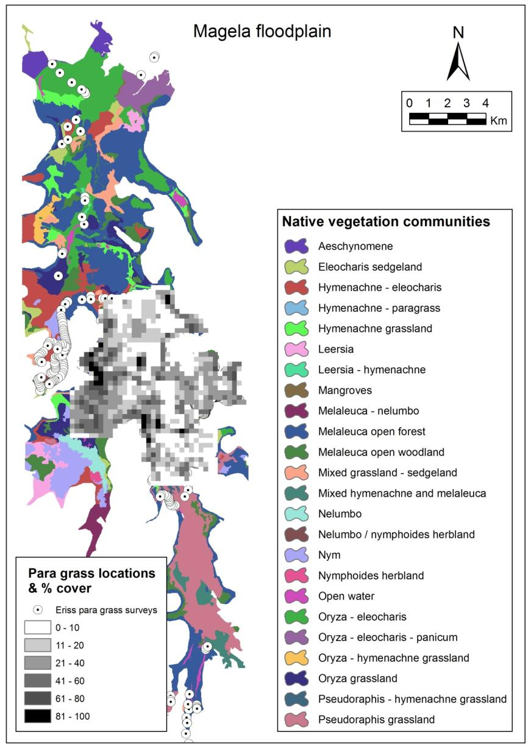

**Figure 16** Wetland vegetation on the Magela floodplain based on data from Finlayson et al (1989), the 2003/2004 ***eriss*** survey data and the QuickBird image. The native vegetation communities represent the dominant species within each mapped area. The central region is overlayed with the % para grass cover as determined from the QuickBird image. Para grass locations from ***eriss*** surveys are represented by the white dotted circles.

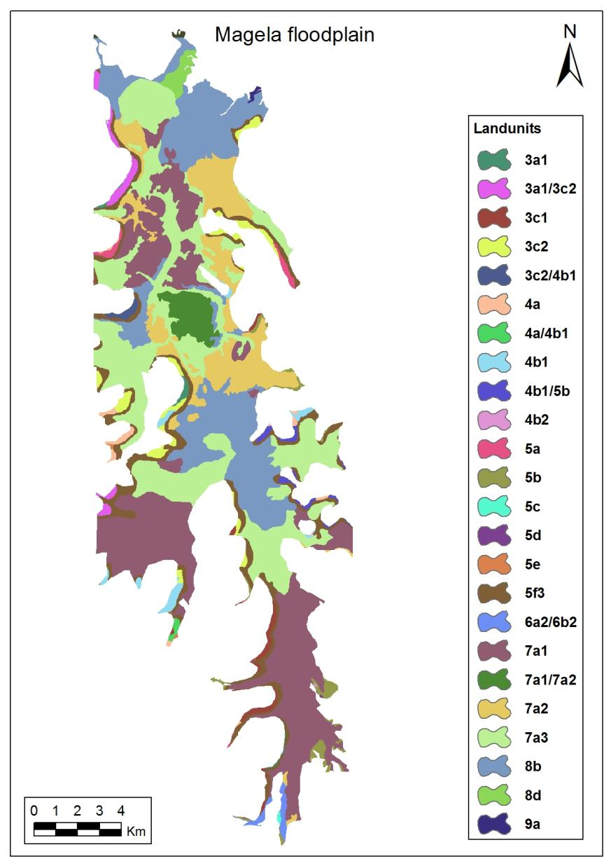

**Figure 17** Land units from Wells (1979). Land units describe the various soil types and typical associated vegetation (see appendix for land unit descriptions).

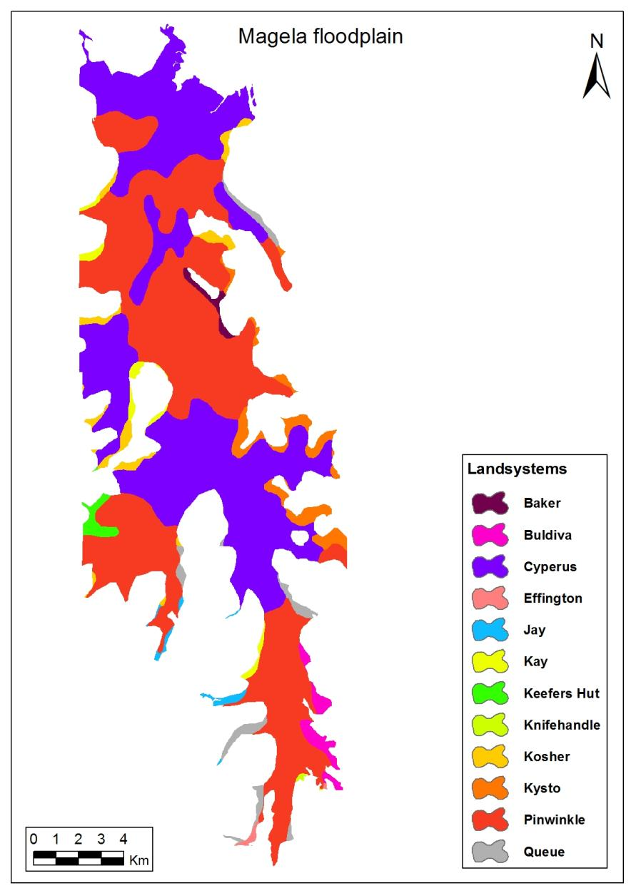

**Figure 18** Land systems from Wells (1979). Land systems describe broad areas of topography including slope and elevation, also underlying soils and rocks and typical associated vegetation   
(see appendix for land system descriptions).

#### Identifying habitats susceptible to para grass invasion using the Bayesian habitat suitability model

Sites susceptible to invasion were deemed to be those with a >60% probability of para grass presence. This lower limit for the identification of susceptible habitats was adopted to reflect a risk-averse approach to weed management, ie an approach that minimises the failure to detect satellite infestations and tolerating a 40% probability of false positives. This risk-averse criterion is justifiable using both theoretical (eg Moody and Mack 1988) and practical models of weed management (eg Wittenberg & Cock 2001). To determine the relative susceptibility of different wetland habitats to invasion by para grass, the areas deemed susceptible to invasion were intersected with the wetland vegetation dataset. The total area of each vegetation community, within these susceptible areas, was then calculated. The vegetation dataset was selected because, as well as being an important component of biodiversity, plants reflect the physical environment, are the primary environmental feature at risk from many of the threatening processes within the wetlands, and are relatively amenable to measurement. Additionally, measurements based on vegetation have considerable potential to be efficient indicators of the response of biodiversity within an environment to land use (Landsberg & Crowley 2004). This approach has been successfully used in the Mary River wetlands to assess the relative susceptibility of wetland habitats to para grass invasion (Beggs et al 2003, Ferdinands et al 2005).

#### Assessing the risk of para grass invasion

Assessing the risk of para grass invasion was completed in two stages. First, the habitat suitability model was created as described above. The habitat suitability model was then used to create a friction or impedance surface; that is, a surface where movement in different directions is subject to varying levels of impedance. Impedance was assumed to be inversely proportional to habitat suitability, therefore, 100 subtracted from the absolute value of the probability of presence of para grass in each cell in the habitat suitability model surface produces the impedance surface. Thus, cells of high suitability for para grass were assigned low impedance and cells of low habitat suitability were assigned high impedance. The resultant surface was combined with a surface showing para grass locations (source points). Para grass was then ‘grown out’ through this surface through each cell and then to its adjoining neighbours. The cost accumulated to move through the surface from the ‘seed points’ was calculated for each cell using a cost-distance algorithm (McCoy & Johnston 2001). Where the estimated probability of occurrence was less than 10% in the habitat suitability model, these cells were classified as an impermeable barrier in the impedance surface, forcing the simulated spread to grow around them. As output from this process, a grid of 20 m x 20 m cells was used in which each cell was assigned the minimum accumulated cost of ‘invasion’ from any source. This grid was treated as a spatially-explicit summary of risk of invasion in which cells with low accumulated cost are at greatest risk.

From this description it will be apparent that the model of para grass invasion presented here depends on the following assumptions:

* spread is exclusively from the edges of existing populations(*via* stoloniferous growth) and propagules cannot bypass intervening cells;
* invasion paths that take the invader through areas of low suitability habitat will be occupied more slowly, if at all;
* proximity to existing populations of para grass increases the risk of invasion; and
* there is no effective management of para grass taking place.

The conceptual base is similar to Harper’s (1977) ‘safe site’ hypothesis or the extension of this idea, Johnstone’s (1986) ‘invasion window’.

It will also be apparent that unless confronted by continuous impermeable barriers, application of such a model produces the trivial prediction that all contiguous habitats capable of supporting the species at all will eventually be invaded. To provide more meaningful predictions of relative risk of para grass invasion in the near future, the analysis was performed with an upper limit on the cost which was allowed to accumulate as para grass spread through the wetlands. For this study this upper accumulated cost limit was set at 20 000.

### 4.4.3 Results

#### Bayesian habitat suitability model

Preliminary analysis of existing para grass distribution showed that it had a significant association with three variables, ie distribution was significantly different from that expected if distribution was random (Table 3). The results suggest these environmental datasets are useful predictors of para grass distribution.

**Table 3** Chi-square results of para grass distribution versus random distribution

|  |  |  |  |
| --- | --- | --- | --- |
| **Environmental variable** | **Chi-square** | **Df** | **P** |
| Land units | 87.02 | 22 | <0.005 |
| Land systems | 99.90 | 10 | <0.005 |
| Vegetation | 4865.83 | 24 | <0.001 |

#### Para grass association with attributes of the predictor datasets

##### Land systems

Para grass showed a significant positive association with two land systems - Cyperus and Kysto (Table 4). The Cyperus land system contains the seasonally flooded coastal plains characterised by freshwater over black cracking clays over calcic estuarine muds (Wells 1979). Kysto is a constituent of the Koolpinyah surface and is characterised by low rises and swales and minor isolated low strike ridges and is present on the eastern edge of the floodplain. Soils are gradational red and red-yellow, shallow and gravely and uniform red soils. Bands of tall open woodland and forest are noted from this land system (Wells 1979). Oryza grassland is present within this land system; therefore, the vegetation results (see below) are consistent with this result.

Para grass showed a significant negative association with the Pinwinkle land system, also part of the coastal plains, but characterised by swampy depressions, longer inundation periods, and where the dominant vegetation tends to be paperbark forest (Wells 1979). Deeper water and greater length of inundation in the swampy parts of the floodplain and possibly shading associated with the presence of paperbark forest may all be contributing to this finding.

##### Land units

Para grass showed a significant positive association with two land units 7a3 & 8b (Table 4). Land unit 8b is found in higher seasonally dry clay plains and is part of the Cyperus land system. These areas are poorly drained, inundated for 6–8 months of the year and dominated by grasses and sedges. The soils are black and grey cracking clays over alkaline, saline estuarine mud (Wells 1979). Land unit 7a3 is part of both the Pinwinkle and Cyperus land systems and is found on seasonally inundated alluvial clay plains, which are generally flat with scattered depressions and billabongs. Drainage is poor and these areas tend to be inundated for slightly longer periods than land unit 8b. Dominant soils are uniform medium-heavy clays and less commonly duplex loams to medium-heavy clays. Vegetation in this land unit is dominated by grasses (Wells 1979).

Para grass showed a significant negative association with land unit 7a1 which despite having some characteristics similar to the above land units 7a3 & 8b is part of the Pinwinkle land system which experiences longer periods of inundation due to poor drainage. Dominant soils are uniform, cracking, medium-heavy clays and less commonly duplex loams to medium-heavy clays. Alluvial soils are uniform loams or clay loams over sands. Vegetation is dominated by grasslands (eg *Pseudoraphis spinescens*) with emergent clumps of *Melaleuca leucadendra. Pseudoraphis spinescens* is the dominant grass in the deeper parts of the Magela floodplain (Finlayson et al 1990) suggesting that this land unit is inundated to a greater depth than the similar land units 7a3 and 8b.

**Table 4** Results of z-tests showing statistical significance for predictor dataset attributes. Negative z-scores (highlighted) indicate a significant negative association with this predictor dataset attribute

|  |  |  |
| --- | --- | --- |
| **Predictor *dataset* & attribute** | **z-score** | **P** |
| ***Land units*** |  |  |
| 7a3 | 65.85 | <0.01 |
| 8b | 31.74 | <0.01 |
| 7a1 | -35.08 | <0.01 |
|  |  |  |
| ***Land systems*** |  |  |
| Cyperus | 155.23 | <0.01 |
| Kysto | 15.77 | <0.01 |
| Pinwinkle | -79.73 | <0.01 |
|  |  |  |
| ***Vegetation*** |  |  |
| Oryza grassland | 98.55 | <0.01 |
| *Hymenachne acutigluma* grassland | 9.28 | <0.01 |
| Melaleuca open woodland | 8.68 | <0.01 |
| Mixed grassland – sedgeland | 8.63 | <0.01 |
| Oryza – Hymenachne grassland | 6.48 | <0.01 |
| Eleocharis sedgeland | -2.12 | <0.01 |
| Hymenachne *–* Eleocharis | -7.21 | <0.01 |
| Oryza *–* Eleocharis | -9.14 | <0.01 |
| *Pseudoraphis spinescens* grassland | -10.45 | <0.01 |
| Melaleuca open forest | -30.62 | <0.01 |

##### Vegetation

Para grass distribution showed a significant positive association with Oryza grasslands and vegetation communities which commonly contain this species (Table 4). A significant positive association was also found for *Hymenachne acutigluma* grassland and mixed grassland sedgeland. A significant negative association was found for five vegetation communities, many of which are dominated by or contain Eleocharis sedgeland including Oryza/Eleocharis habitat (Table 4). The negative association with this community, despite the presence of Oryza, may reflect differences in water depth and possibly the presence of two species of *Oryza* – *meridionalis* and *rufipogon*. In the Mary River catchment *O. rufipogon* has been observed in deeper waters, with *O. meridionalis* more commonly found in shallow to intermediate depths (K Ferdinands unpublished data). It is easy to confuse these two species in the field, unless inflorescences at anthesis (the period during which a flower is fully open and functional) are present (Cowie et al 2000).

#### Susceptible wetland habitats

By combining the probability of association with each of the attributes in each predictor datasets using Bayes’s theory, a surface showing probability of para grass presence was derived. Wetland habitats where the predicted probability of para grass presence was greater than 60% were deemed susceptible to para grass invasion. The majority of wetland communities, described in terms of dominant vegetation, showed a low probability of para grass presence (Fig 19). It is inferred from this that these habitats have a very low susceptibility to para grass invasion. Approximately 6000 hectares (32%) of the Magela Creek wetland, including that already occupied by para grass (1250 hectares), was identified as susceptible to para grass invasion (Fig 20; Table 5). These habitats comprise fourteen vegetation communities. For two of these vegetation communities the area identified as susceptible was small (<1 ha). The remaining twelve communities accounted for 95% of the area identified as susceptible to invasion (Table 6). Based on area measures in tables 5 and 6, it appears that one vegetation community (*Oryza* spp grassland) is particularly susceptible to para grass invasion. *Oryza* spp as grassland or as a dominant part of other vegetation communities accounted for 65% of the total wetland area identified as susceptible to para grass invasion. These findings are consistent with available published studies (Knerr 1998, Whitehead & Wilson 2000, Ferdinands et al 2005) showing that para grass demonstrated a strong association with a limited number of vegetation communities.

#### Environmental niche for para grass

Based on the above results the environmental niche for para grass can be described as habitats within the floodplain that are inundated for approximately 6–8 months each year. These areas are typically the coastal floodplains with black and grey cracking clay soils. The dominant vegetation in these habitats is grasses and sedges, providing little or no canopy cover. The vegetation results suggest some communities which dominate these parts of the floodplain eg Oryza*,* are particularly susceptible to para grass invasion.

#### Modelling the future spread of para grass to assess the risk of invasion

Given the parameters specified for the spread model approximately 6360 ha (34%) of the floodplain were identified as being at risk of para grass invasion (Fig 21). This roughly equates to all the areas of floodplain identified as susceptible to invasion. Based on an estimated rate of spread of 14% per annum (Bayliss et al 2006, Bayliss et al 2012), this area could potentially be invaded by para grass in the in the next 9–10 years. However, the lower suitability of parts of the identified ‘high risk’ habitat, and the smaller size of existing para grass populations in areas away from the main infestation, may slow invasion of these habitats.

In the para grass spread scenario modelled – no management action and spread modelled over an estimated six year period – *Oryza* spp was identified as the habitat at greatest risk of para grass invasion (Table 6). Communities where *Oryza* spp is the dominant or co-dominant species (highlighted in Table 6) represented 64% of the area at risk of para grass invasion. This result is the product of the combined effects of existing para grass populations within, or in close proximity to *Oryza* spp grasslands and the lower impedance/higher suitability associated with these habitats.

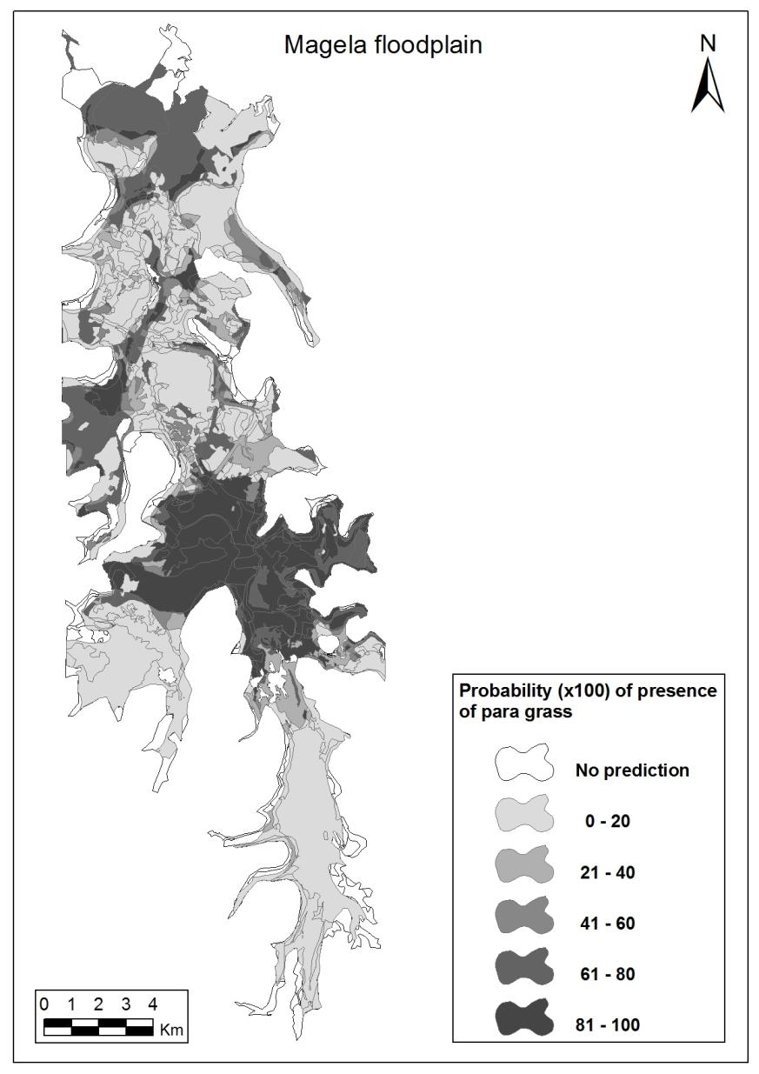

**Figure 19** Bayesian habitat suitability model derived probability surface. Darker areas have a high probability of para grass being present, or already contain para grass. Lighter areas have a lower probability of para grass being present. White areas are those for which predictions could not be made because para grass had not been observed in these habitats and therefore no conditional probabilities could be calculated.

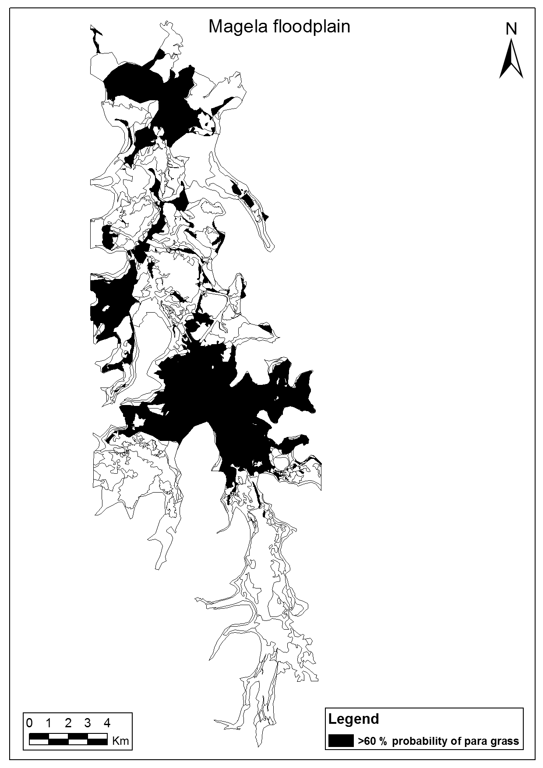

**Figure 20** Areas of floodplain where probability of para grass presence exceeded 60%. Areas where habitat suitability exceeded 60% (black) were identified as susceptible to para grass invasion.

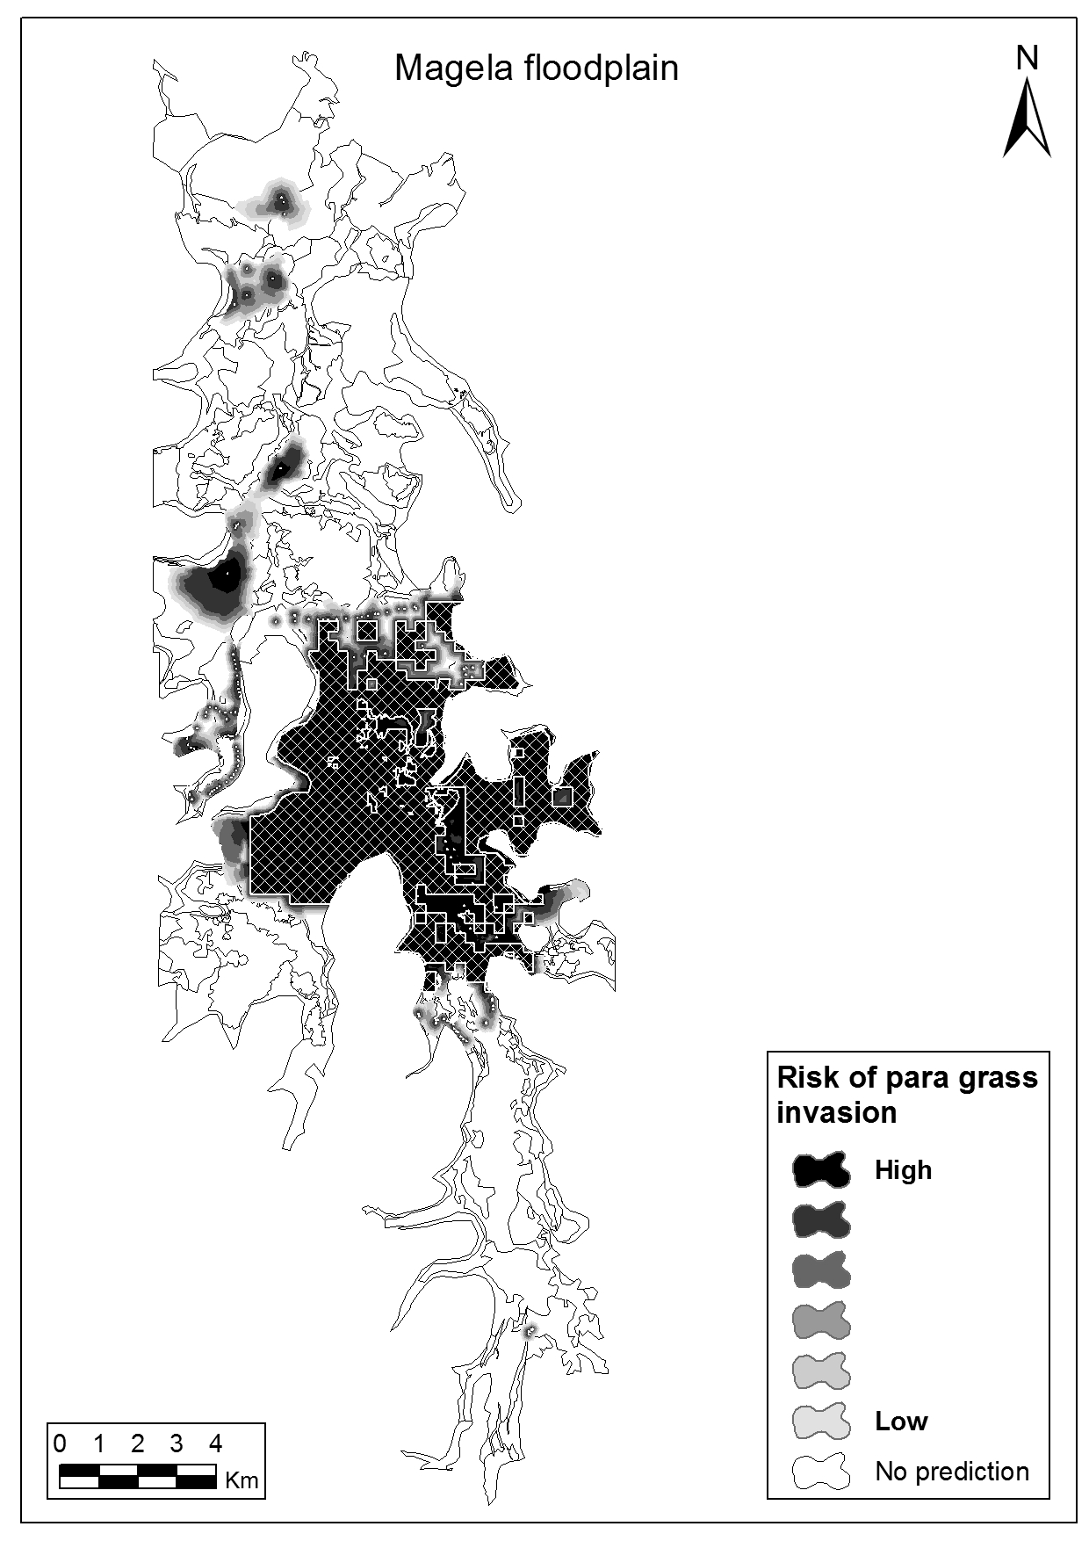

**Figure 21** Risk of para grass invasion. The risk of invasion was modelled as a product of habitat suitability and proximity. The darker areas are those which are identified as being at highest risk of para grass invasion. The lighter areas are at risk of invasion, but the likelihood is lower for the scenario modelled – potential spread over the next 6 years; where rate of spread was based on unpublished ***eriss*** data on para grass extent on the floodplain (1983–2004). Cross-hatch areas are existing para grass populations; white areas are unlikely to be invaded in the time period modelled.

**Table 5** Vegetation communities where the probability of para grass presence in the habitat suitability model was greater than 60%

|  |  |  |  |  |
| --- | --- | --- | --- | --- |
| **Vegetation community** | **Total area of veg community (ha)** | **Potential area invaded (ha)** | **% of total veg  community** | **% of total potential area invaded** |
| Oryza grassland * | 2406 | 2039 | 85 | 32.81 |
| Oryza – Eleocharis * | 2292 | 1167 | 51 | 18.78 |
| Hymenachne *–* Eleocharis | 1292 | 580 | 45 | 9.33 |
| Hymenachne grassland | 897 | 481 | 54 | 7.74 |
| Melaleuca open woodland * | 1547 | 422 | 27 | 6.79 |
| Mixed grassland – sedgeland | 711 | 402 | 57 | 6.47 |
| Oryza *–* Hymenachne grassland * | 389 | 306 | 79 | 4.92 |
| Eleocharis sedgeland | 369 | 240 | 65 | 3.86 |
| Melaleuca open forest * | 4328 | 136 | 3 | 2.19 |
| Open water | 226 | 104 | 46 | 1.67 |
| **Total** | **14 457** | **5949** |  |  |

A high percentage of a given vegetation community being identified as suitable for para grass, suggests that a high proportion of this habitat has already been successfully invaded by para grass. Vegetation dominated by or containing Oryza as co-dominant or understorey species is highlighted.

**Table 6** The relative areas for different wetland vegetation identified as being at risk of para grass invasion based on the spread model

|  |  |  |
| --- | --- | --- |
| **Vegetation community** | **Area at risk (ha)** | **% of total area at risk** |
| Oryza grassland* | 2062 | 31.11 |
| Melaleuca open woodland* | 695 | 10.48 |
| Melaleuca open forest* | 655 | 9.88 |
| Hymenachne – Eleocharis | 556 | 8.39 |
| Oryza *–* Eleocharis grassland* | 553 | 8.34 |
| Hymenachne grassland | 540 | 8.15 |
| Mixed grassland – sedgeland | 388 | 5.85 |
| Oryza *–* Hymenachne grassland* | 261 | 3.94 |
| Pseudoraphis grassland | 195 | 2.94 |
| Eleocharis sedgeland | 161 | 2.43 |
| *Nelumbo / Nymphoides* communities | 153 | 2.31 |
| Open water | 107 | 1.61 |
| Pseudoraphis *–* Hymenachne grassland | 23 | 0.35 |
| Mixed Hymenachne and Melaleuca | 11 | 0.17 |
| **Total** | **6360** |  |

Vegetation dominated by or containing Oryza as co-dominant or understorey species are highlighted

### 4.4.4 Discussion

#### An assessment of the relative risk of para grass invasion

Approximately 34% (6360 ha) of the Magela floodplain was identified as being at risk of para grass invasion, based on current distribution and inferred habitat preferences. Based on estimated rate of spread, this area could potentially be invaded within the next 9–10 years. The habitats within the floodplain that are at greatest risk tend to be dominated by grasses and sedges. *Oryza* spp, occurring either as grasslands, a grassland or an understorey species in woodlands and forest, was assessed as having a very high risk of para grass invasion. This risk is a product of the characteristics of parts of the floodplain inhabited by Oryza and the presence of para grass within or close to most Oryza populations. This finding is consistent with previous studies in the Mary River (Ferdinands et al 2005) and is interpreted as suggesting that para grass and Oryza are competing for a similar ecological niche on the floodplains.

The reduction in area at risk within a given vegetation community versus the area estimate from the habitat suitability model eg 85% versus 31% (Tables 5 & 6) highlights the importance of taking into account the distribution of susceptible habitat in relation to para grass distribution. The finding suggesting that there are areas of Oryza grassland where para grass is absent, distant or is surrounded by low susceptibility habitat. Relying on the habitat suitability model alone may therefore misinform assessments of the risk that para grass poses and which areas are at greatest risk.

It should be noted that given the assumptions and rules used in this spread modelling, spread into low suitability habitats is not prevented. Rather, the rapid accumulation of cost when para grass spreads into these habitats results in only small areas of these habitats being identified as ‘high risk’.

Satellite infestations within or in close proximity to high susceptibility habitats were responsible for large areas of the floodplain away from the main infestation being identified as high risk of invasion. The spread modelling results suggest that eradication or control of these populations would markedly reduce the risk of para grass invasion.

The importance of satellite populations also highlights the need for i) monitoring programs capable of detecting small outbreaks, particularly within or nearby susceptible habitat and ii) the potential for new satellite populations to alter predictions of risk of invasion. The effect of new satellite populations on predictions of risk can be easily modelled by adding additional source points to the analysis.

## 4.5 Uncertainty, information gaps and further research

### 4.5.1 Extent of para grass

#### Limitations of the Bayesian habitat suitability model

Habitat suitability modelling was performed using only three predictor datasets; two of which are closely related (land units and land systems). The habitat suitability model would be improved by the inclusion of further environmental predictor datasets as they become available including a water depth surface. This could be created based on stratified point-based sampling, preferably in the mid-wet season and geostatistical techniques eg kriging[18], used to create a depth surface. Depth is a primary determinant of the distribution of wetland flora (Finlayson et al 1990, Cowie et al 2000) and its absence from the model reduces the accuracy of predictions. For example, in the Mary River floodplain, depth varies considerably across *Oryza* spp grasslands in the mid-wet season (Ferdinands et al 2005). At depths less than 60 cm the risk of invasion was much greater than areas deeper than 60 cm.

The assessment of habitat suitability is made based on the assumption that current distribution is indicative of all the habitats that para grass is capable of successfully invading. Future monitoring will determine whether this assumption is valid and highlights the need to repeat this risk assessment as new para grass distribution data is collected.

Seasonality will influence the results of this risk assessment, as wetland flora may exhibit some variation in distribution based on inter-annual variation in rainfall, although this variation may be less likely for established and resilient perennials like para grass.

#### Recommendations for improving the Bayesian habitat suitability model risk assessment

1. Selectively monitor the distribution of para grass, with a focus on areas identified as being at high risk of invasion and known existing populations of para grass. Monitoring results can be used to test the model predictions, refine/modify predictions and management responses over time. Monitoring should be capable of detecting satellite populations, because of their contribution to increase the invasion risk.
2. Using field survey, verify the accuracy of QuickBird derived para grass mapping (distribution and percentage cover) for the area surrounding the main infestation. The Bayesian habitat suitability model uses area measures to derive conditional probabilities, which can be biased by inaccurate mapping of distribution.
3. Use stratified (by vegetation community), geo-referenced, point-based sampling of wet season depth across the floodplain, over several wet seasons to model the relationship between depth and para grass distribution. A depth surface for the Magela floodplain would greatly improve the predictive power of the habitat suitability model[19]. A surrogate depth map may be acquired by mapping the pattern of receding inundation area across the dry season using multi-temporal remote sensing.
4. Experimental studies to further examine the relationship between para grass and the determinants of its distribution and its effects on wetland flora and fauna could be used to test the predictions of this study.
5. Explore the potential for chemical control of para grass where risk of invasion is high and/or where chances of eradication are high eg satellite infestations. The spread modelling approach can be used to perform ‘what-if’ scenario testing prior to implementation of a management response to inform decision making.
6. If priority habitats/areas within the floodplain can be identified, the spread modelling results (which optionally include a direction surface) can be used to predict invasion paths between priority areas and closest para grass population. This can be used to refine/prioritise para grass control strategies.

Most of the following issues for which further information could help in manage para grass and determine the relationships between native vegetation and para grass on the Magela floodplain are from Knerr (1998):

#### Salinity tolerance

Although there are some para grass infestations in the saline estuary regions, it is uncertain to what extent this habitat can be colonised by the weed and what the impacts would be. Seeds and cuttings could be germinated and grown in a range of different salinity regimes to better assess its invasive potential into the more saline habitats.

#### Detailed mapping

Past and recent surveys have improved our knowledge of the extent of para grass on the floodplain. However, the entire floodplain has not been systematically surveyed in detail, nor are there much data on the occurrence of satellite infestations and their rate of spread. Satellite infestations need to marked out and their growth monitored both spatially and temporally. Where possible, field monitoring studies should be complemented with acquisition of high resolution remote sensing.[20]

#### Seed and seed bank experiments *(*from Knerr 1998*)*

The vegetative reproduction of para grass is well documented, however, to what extent para grass recruits from the seed bank is uncertain. Such information could help indicate which plant communities are susceptible to invasion. Seed bank studies over successive years would help determine the size and rate of depletion of para grass seed banks. Field plot observations of seedling emergence over successive years could provide a valuable insight into the role that seedling recruitment, as opposed to vegetative propagation play in establishment of para grass stands. Seed input into the soil could be assessed using seed exclusion and seed rain experiments, and the discrepancy between the high seed production and relatively low seed numbers that germinate from the seed banks might be determined using seed bait experiments, as predation has been hypothesised as one such reason for seed loss.

#### Competition, water depth and inundation

Further investigation into the factors that affect successful recolonisation of native vegetation following the removal of para grass are required. Assessment of the competitive nature of para grass with other native vegetation, particularly *Hymenachne acutigluma* would help to determine the potential of para grass to colonise and exclude native species other than Oryza. In addition to seedbank issues, the assessment needs to examine competition between seedlings, cuttings and adult plants. It is also suggested that the trials use a variety of water depth treatments as this is known to influence the establishment of para grass cuttings (Calder 1982). Period of inundation appears to be an important factor in the distribution of para grass. A more precise understanding of this relationship may help to identify areas of high habitat suitability.

#### Fire

There is conflicting anecdotal information in the literature regarding the tolerance of and response to fire, although the majority seems to presume that para grass responds well to fire. There are many variables to consider such as the surrounding native vegetation, the timing of the fire, weather conditions and the seedbank. As fire is frequently used as a management tool on the floodplains of Kakadu, it is important to fully understand the relationship between fire and para grass.

### 4.5.2 Effects of para grass

Knerr (1998), Douglas et al (2001), Ferdinands et al (2005) and Wurm (2007) have yielded some information of these effects on the Magela Creek and Mary River floodplains. Some of these authors acknowledge the limitations associated with their studies. Some uncertainties identified from the available literature and anecdotal information include the following.

#### Hydrology

Whilst there have been studies on the effects of para grass on channel morphology and hydrology of small streams in northern Queensland (Bunn et al 1998), no such information is available for an expansive floodplain such as the Magela. Bunn et al (1998) found that para grass greatly increased the sediment deposition of streams and dramatically reduced channel capacity and discharge. Although para grass is structurally similar to the native Hymenachne, it is considerably denser than other plant communities which it invades (Douglas et al 2001), thus it may increase rates of sediment deposition.

#### Fire

It is acknowledged that para grass has greater fuel loads than native vegetation (Douglas et al 2001, Douglas & O’Connor 2004) and it is predicted that it carries more intense fires, but the precise effects of this on flora and fauna are uncertain. Anecdotal evidence suggests that hot para grass fuelled fires have destroyed Melaleuca trees on the floodplain and damaged monsoon vine forest areas. Similar evidence suggests the demise of aestivating turtles due to excessive ground heat from intense fires (assuming they *can* aestivate – see below). In relation to hot fires, the fate of fauna such as frogs, reptiles and mammals living within the grasses is also uncertain.

#### Physical barrier

It has been hypothesised that the dense structure and greater biomass of para grass may impede the movements of larger aquatic animals such as turtles, water monitors and crocodiles. It may also prevent turtles from penetrating through to the mud where they aestivate for the dry season. The degree to which this occurs could warrant further investigation as turtle harvesting is an important social activity and food source for Aboriginal people.

#### Herbicides

There is little knowledge of the ecological impacts of the herbicides, wetting agents and adjuvants used for para grass control. Glyphosate is the herbicide of preference for para grass control, however many formulations of Glyphosate contain surfactants that are toxic in aquatic environments (Douglas et al 2001, Guy McSkimming pers comm October 2004). Roundup Biactive™ is one formulation that is registered for such use and is reportedly non-toxic to frogs (Mann & Bidwell 1999). However, Professor Mike Tyler from Adelaide University believes that these ‘frog-friendly’ formulations are still harmful to frogs.

Douglas et al (2001) examined the effects of a variety of concentrations of Roundup Biactive™ on invertebrates and fish communities and found no deleterious effects on these taxa. They do however advise caution when extrapolating the results more generally as other taxa such as frogs were not examined and the spatial scale of the study was relatively small, examining ‘patches’ of para grass and native vegetation. This phenomenon may have allowed migration of fauna from untreated areas, thus masking possible ill effects to aquatic organisms of the herbicide (Douglas et al 2001). Over 90% kill rates of para grass were achieved across a range of herbicide concentrations, thus more research is required to determine the most cost-effective minimum application rate(s), further reducing the risk to the aquatic fauna (Douglas et al 2001). Another problem with this herbicide is that it is non-selective and kills actively growing woody and herbaceous plants.

## 4.6 Management implications of para grass

As with the management of most invasive species, decisions must be made about what response is most appropriate (eg eradication, control, and containment) and where such a response should occur. This assessment provides some of the information required to inform this decision making process, by identifying the location of high risk habitats based on the habitat preferences and current distribution of para grass.

The spread modelling highlights the role played by satellite populations in increasing the risk of para grass invasion. Satellite populations in the north and west of the Magela floodplain, away from the main infestation were responsible for the majority of floodplain identified as ‘at risk’ (Fig 21) and highlights the need to control or eradicate these satellite populations wherever possible. Treatment of infestations on open floodplains may be relatively easy (though expensive) using aerial or boom spraying equipment. However, such methods may not be appropriate or even possible for the considerable areas of para grass growing amongst the fringing forests of the floodplains, within paperbark swamps and around billabongs. Control in these habitats is still feasible but would most likely be very labour intensive. Because para grass grows in a wide variety of habitats including relatively deep water, control efforts can often be hampered by access and the onset of the wet season. For many infestations, there is a small window of opportunity between the ground being sufficiently dry to work on, and the onset of the rains and possible early flooding.

There is also concern regarding the application of large quantities of herbicides to World Heritage wetlands. At present, Glyphosate is the most effective herbicide for para grass but it is also non-selective and will kill other native vegetation.[21] There is concern over the effect of the herbicide on frog populations and its effect on other taxa is largely unknown. Given these ‘non-target’ effects and uncertainties, there may be considerable risks involved in using herbicides to attempt to eradicate large infestations of para grass on the floodplains.

### 4.6.1 Bioeconomic modelling

The unit cost ($/ha) of weed control varies predictably with the extent of the weed in the control zone. Control cost curves for most invasive species typically show unit costs increasing exponentially with decreasing abundance, reflecting the greater proportion of total costs allocated to search time with a corresponding lesser proportion allocated to killing (ie a standard predator-prey model) (Choquenot & Parkes 2001).

A standard control cost curve for para grass was developed (Fig 22) and is based on chemical spraying of weed plots at Nourlangie Creek in the South Alligator River catchment, using data collected by the Kakadu weeds team (Table 7). The area treated for each year was unavailable in the original data. However, the infestation that was reported as being 2 ha in size, reduced to 0 ha over the four years. Therefore, the area (ha) of para grass sprayed was estimated from the amount of herbicide used, assuming that 25.5 L/2 ha were used ie the mean of the usage for 1992 and 1993. Note that the x-axis for abundance (ha) in Figure 22 can be re-scaled to percentage cover if required for modelling purposes.

**Table 7**  Weed control data (extent of para grass, amount of chemical used & cost, control effort and labour cost) used to derive unit cost of control for para grass at Nourlangie (1992–1995)

|  |  |  |  |  |  |  |  |  |  |
| --- | --- | --- | --- | --- | --- | --- | --- | --- | --- |
| **Year** | **%Area of infestation** | **Area of infestation (ha)** | **Area treated (ha)** | **Glyphosate (L)** | **Chemical cost ($)** | **Staff time (hr)** | **Staff cost @ $30/hr ($)** | **Total cost for year ($)** | **costs/ha ($)** |
| 1992 | 84.1 | 2.0 | 1.827 | 23.3 | 233 | 30 | 900 | 1133 | 620 |
| 1993 | 100.0 |  | 2.173 | 27.7 | 277 | 20 | 600 | 877 | 404 |
| 1994 | 9.4 |  | 0.204 | 2.6 | 26 | 4 | 120 | 146 | 716 |
| 1995 | 0.7 | 0.0 | 0.016 | 0.2 | 2 | 3 | 90 | 92 | 5865 |

Assuming 25.5 L = 2 ha (mean 1992 & 1993)



**Figure 22** Control cost curve for para grass on Nourlangie Creek, South Alligator River, Kakadu National Park (1996–1997), showing a negative exponential relationship. Data provided by Kakadu staff.

For the Magela floodplain, model simulations suggest that containment and a strategy to reduce in situ cover to 20%, would initially cost $1.8 million and approximately $400K–500K per annum thereafter (maintenance control) (Walden & Gardener 2008, see also Bayliss et al 2012). Note that these estimates for annual maintenance costs are similar to actual annual maintenance costs of mimosa control in the Park. However, it should be stressed that these are ‘first-cut’ estimates only and should not be used for planning purposes. More appropriate cost estimates for para grass control on the Magela using the most effective combination of control methods need to be specifically determined and these estimates may vary somewhat from those presented here. For example, the Northern Territory Government chemically control para grass at a cost of $106/ha using an R44 helicopter (G McSkimming pers comm 2004) and, in Queensland, the comparable cost is $429/ha (c.f. the average cost of $564/ha from the Nourlangie data). However, helicopter spraying would be unsuitable over certain wooded habitats on the Magela floodplain. Chemical control of para grass by helicopter in open treeless wetland habitats on the Magela would cost less than using airboats in such habitat. The cost simulations presented here represent preliminary investigations only, and need to be calculated in detail using real control cost figures coupled to more precise estimates of habitat-specific spread rates for the Magela floodplain, for which information is currently unavailable.

Additionally, the cost estimates do not incorporate a rehabilitation component, a possibility that may need to be factored into future management planning. For example, patches of floodplain exposed to 100% para grass cover for 10–20+ years will have excluded native vegetation, hence there may be no viable seed bank in the soil. Wurm (2007) showed that re-colonisation of displaced native vegetation such as wild rice may not occur in 100% para grass cover because native seed germination is suppressed. Even if treated para grass is reseeded with wild rice seed, the rice may not re-establish, probably due to the extant para grass biomass. Furthermore if the habitat modification by para grass is more complex with significant lasting impacts, then simple re-seeding/planting may not be sufficient and additional management strategies may be needed (Wurm 2007). The logistic difficulties of rehabilitation extend well beyond costs of reintroduction of native species. Importantly, they include constraints on methods for further para grass control. Any future ‘adaptive experimental management’ should be designed to account for these factors and acquire this knowledge.

We recommend strongly that an ‘adaptive management’ (systematic learning by doing) approach be adopted from the start as part of any long-term control program. Large experimental plot trials would need to be established in different wetland habitats to gain essential control and recovery knowledge specific to the Magela. Key information needs are:

* the most appropriate control method for particular habitats – eg chemical, burning and mechanical; burning and chemical; the timing and frequency of control; contrasts between Melaleuca woodland/forests vs open floodplains; potential to integrate with other control programs in order to reduce costs;
* the current distribution of key habitats of conservation significance – eg *Eleocharis* and *Oryza* spp) – at risk to para grass invasion;
* associated costs of control – ie determination of what benefits for what costs; realised recovery rates of native wetland vegetation; if necessary re-seeding/re-planting costs and success; determination of robust and defensible target control levels; and further research and development of cost-effective monitoring methods, such as multispectral remotely sensed satellite captures.

With respect to these information needs, ***eriss*** and Parks have had ongoing collaborative projects in place at Boggy Plain and Magela wetlands since 2002. Mapping vegetation on the Magela floodplain continues as more imagery is acquired and analysis techniques improve. This information will add to our knowledge of spread rates and habitat suitability to further enhance risk assessments and management strategies.

# 

# 5 Species potentially vulnerable to para grass

The aquatic biota of the Magela floodplain, whilst diverse, commonly occur elsewhere in the Alligator Rivers Region (Humphrey & Dostine 1994), if not across the tropics of the Northern Territory. The high seasonality of the floodplain environment has generally selected for animals and plants that are readily dispersed. Moreover, the freshwater ecosystems of the lowlands are relatively young in geological terms. The floodplains are of the order of ~1500 years old (Woodroffe et al 1989, Wasson 1992), a feature which, together with high seasonality and species vagility, has probably mitigated against endemism at regional and smaller catchment scales. Extensive surveys by various agencies over the years have found no species of aquatic or semi-aquatic vertebrate (fishes, frogs, reptiles, birds) and aquatic macrophyte endemic to the Magela floodplain. This is likely to be true also for aquatic invertebrates found on the floodplain (Humphrey 1999).

It is to be noted that dramatic declines have nevertheless occurred at national and global scales for many waterbird species known to be ‘commonly’ distributed across the Top End (eg the magpie goose). Declines in the range of these species have been attributed to the habitat transformation such as that caused by invasive species. The conservation value of the Magela and Kakadu wetlands arises from their capacity to provide seasonal refugia and breeding habitat for nomadic or migratory species. Therefore waterbird species such as the magpie goose may still be vulnerable through the incremental and insidious decline of resources over much broader scales than the Magela floodplain (Bayliss et al 2006).

The wild rice populations of northern Australia comprise a globally significant genetic resource as they have not been subject to the introgression and genetic erosion experienced by wild rices occurring in regions where cultivated rice is grown (T Sato & I Nakamura pers comm 2007). These populations provide a potential genetic resource for rice breeding programs and have been collected by staff from International Rice Research Institute over many years. They also provide a basis for research into the phylogeny of wild rice species, genetic barriers between species and the role of gene flow among populations in maintaining population viability (R Ishikawa pers comm 2006). Given that para grass occurs on most/many north Australian floodplains, conservation reserves such as Kakadu National Park have a specific role in maintaining the integrity of wild rice populations.

## 

# 6 Socio-economic effects of para grass

When in large infestations, all three weed species have the potential to impact upon human activities. They interfere with stock watering, irrigation projects, tourism, recreational use of waterways, commercial fishing and the traditional lifestyles of Indigenous peoples. As there are no current pastoral activities on the Magela floodplain and it is unlikely to be re-opened for recreational fishing, the most likely impacts will be upon Indigenous lifestyles. Practices such as hunting and foraging not only provide people with food, but are closely tied to spiritual beliefs and traditional law, and allow each generation to share extensive environmental knowledge with succeeding generations (NLC & ***eriss*** 1997). Wetlands are the major traditional source of food for part of the year (Altman 1987) and the invasion of weeds physically impedes access to traditional hunting grounds and reduces the availability of foods such as magpie geese, file snakes, goannas, turtles and water lilies due to loss of native habitat. Sacred sites and other sites of cultural significance can also be changed and their access impeded. See also the conceptual models in sections 2.2.3, 3.2.3 & 4.2.3 and for more detail on the socio-economic effects of mimosa see Walden et al (2004).

## 

# 7 Conclusions

Mimosa and salvinia are already the focus of extensive risk management programs in Kakadu National Park. Prevention of establishment and spread of mimosa, and the reduction of salvinia populations by the salvinia weevil (in conjunction with access restrictions and quarantine procedures) ensure that the risks of these weeds remain relatively low, particularly when compared to the much greater extent and impacts found on other Northern Territory coastal floodplains and rivers. However, with regard to salvinia, there still is an ongoing management issue in ensuring that weevil populations are maintained.

It is beyond the scope of this report to discuss control options for the weeds. The information presented in this assessment is designed to outline the current and potential distribution of para grass in particular and highlight some of the likely consequences of widespread distribution. This knowledge can be employed to inform the decision making process prior to the implementation of any management strategies.

There is good evidence to suggest a significant proportion of the Magela floodplain (~35–50%) could potentially be invaded by para grass (Bayliss et al 2012). Where this occurs, a negative impact on the physical and ecological characteristics of these habitats is expected given the demonstrated impact of para grass in this catchment (eg Douglas et al 2001, Douglas and O'Connor 2004) and other similar floodplains, eg those of the Mary River (Ferdinands et al 2005). Ferdinands et al (2005) has shown that in a vegetation survey of communities invaded by para grass in the Mary River the most common finding (the mode) was that no other taxa were present. Similarly*, Hymenachne acutigluma* grassland, also identified as a high risk habitat within the floodplains, was noted by Knerr (1998) as having the highest species diversity in the grasslands he surveyed on the Magela floodplain.

This assessment has highlighted the risk to a key wetland habitat, the Oryza grassland, which appears to share a similar ecological niche to that of para grass. The large area of floodplain occupied by Oryza grassland and the recognised importance of this habitat in the wetland food chain (Whitehead 1998, Wurm 1998b) means the threat posed by para grass invasion also supports the conclusion that management intervention is required. The potential for para grass control using herbicide has been demonstrated (Douglas et al 2001) and should be explored for controlling the future spread of para grass into areas identified as being at high risk of invasion.

Since the time of the satellite image capture and analysis in 2004, para has spread from about 1250 ha to just over 3500 ha in 2009 (Aaron Petty Charles Darwin University, pers comm Feb 2009), ie an increase of 2250 ha, which is considerably greater than the doubling in area every 5 years as predicted by the spread model. However, it is acknowledged that this original spread rate may have been conservative (Bayliss et al 2012).

There is a great deal of work to be done to understand and quantify the true impacts of para grass invasion. In addition to the biodiversity impacts, there are potential impacts on ecological processes, such as the fire regime in para grass infested areas (eg altered intensity & frequency of burns, loss of carbon and nutrients to the atmosphere etc); the locking up of carbon/nutrients in para grass biomass and changes to chemical cycling, and the possibility of altered hydrology/flow regimes. Many of the knowledge gaps outlined for para grass represent significant research committment and will most likely require a considerable resource investment in addition to any control/management resources.

As to how the presence and spread of these species could confound assessment of any mining-related pressures is difficult to assess without longer term data. The decline in rainbowfish numbers in Mudginberri Billabong over the period 1989 to 2005 does not appear to be related to any change in water quality associated with mine wastewater discharges from Ranger (Humphrey et al 2006). Over time, with further monitoring and analysis, it may be possible to distinguish and identify natural stream water quality, discharge and/or floodplain habitat factors responsible for changes to fish populations in Magela Creek billabongs. These causal factors may then be modelled to account for variation in monitoring response variable(s). (see Bayliss et 2006 and Bayliss et al 2012 for further analysis and discussion on this topic).

The decline in numbers of magpie geese and egrets appear to be linked to irregular cycles of abundance over decadal time scales (15–25 year periods). Despite this, para grass may still be having an adverse effect on some waterbird populations. Magpie geese in particular are known to avoid para grass for feeding and nesting and with an ever increasing coverage of para grass and other weeds across the Top End floodplains, the expected recovery of population abundance may at some point fail to eventuate. Basically, it is difficult to interpret long-term changes in the abundance of highly mobile waterbird species in isolation from regional and national trends, particularly in relation to anthropogenic changes such as invasive species and mining (Bayliss et al 2006). No systematic monitoring data are available across Top End wetlands that provide quantitative regional scale assessment of specific habitat modification from weeds or other factors (see Bayliss et al 2006, 2012 for further analysis and discussion on this topic).

The overall findings of the landscape environmental risk assessment to date strongly imply that non-mining landscape-scale risks to Magela floodplain should now receive the same level of scrutiny as that applied to uranium mining risks, including an assessment of what appropriate level of investment would be needed to manage these risks. Diffuse landscape-scale risks are currently several orders of magnitude greater than point source risks to Magela surface waters from the Ranger Uranium Mine, with para grass contributing most to the overall landscape risk (Bayliss et 2006, Supervising Scientist 2006, Bayliss et al 2012).

## 

# 8 References

Allen GH & Cowdry WAR 1961. Yield from irrigated pasture in Burdekin. *Queensland Agricultural Journal* 87, 207–213.

Altman JC 1987. *Hunter-gatherers today: an Aboriginal economy in north Australia*. Australian Institute of Aboriginal Studies, Canberra.

Anning P & Hyde R 1987. Ponded para grass in North Queensland. *Queensland Agricultural Journal* 113 (May–June), 171–180.

ANPWS (Australian National Parks and Wildlife Service)/KNPBM (Kakadu National Park Board of Management) 1991. *Kakadu National Park: Plan of management*. Australian National Parks and Wildlife Service, Canberra.

Ashley M 2003. *Mimosa pigra* – practical solutions to an economic problem. In *Proceedings of a workshop held in Darwin: Wise use of wetlands in* *northern Australia: Grazing management in wetlands and riparian habitats,* eds Myers B, McKaige M, Whitehead P & Douglas M. Northern Territory, Australia, 2–4 October 2001, Centre for Tropical Wetlands Management, Northern Territory University, Darwin, 52–54.

Aspinall R 1992 An inductive modelling procedure based on Bayes Theorem for analysis of pattern in spatial data. *International Journal of Geographical Information Systems* 6, 105–121.

Austin DF 1978. Exotic plants and their effects in southeastern Florida. *Environmental Conservation* 5(1), 25–34.

Bayliss B, Brennan K, Eliot I, Finlayson CM, Hall R, House T, Pidgeon R, Walden D & Waterman P 1997. *Vulnerability assessment of predicted climate change and sea level rise in the Alligator Rivers Region, Northern Territory Australia*. Supervising Scientist Report 123, Supervising Scientist, Canberra.

Bayliss P & Yeomans KM 1990. Seasonal distribution and abundance of magpie geese, *Anseranas Semipalmata* (Latham) in the Northern Territory, and their relation to habitat 1983–1986. *Australian Wildlife Research* 17, 15–38.

Bayliss P, van Dam R, Boyden J & Walden D 2006. Ecological risk assessment of Magela floodplain to differentiate mining and non-mining impacts. In ***eriss*** *research summary 2004–2005*, eds Evans KG, Rovis-Hermann J, Webb A & Jones DR, Supervising Scientist Report 189, Supervising Scientist, Darwin NT, 172–185.

Bayliss P, van Dam RA & Bartolo RE 2012. Quantitative ecological risk assessment of the Magela Creek Floodplain in Kakadu National Park, Australia: Comparing point source risks from the Ranger uranium mine to diffuse landscape-scale risks*. Human and Ecological Risk Assessment* 18(1), 115–151.

Beggs K, Ferdinands K, Whitehead P & Woinarski J 2003. Balancing wildlife conservation and pastoralism: An adaptive management case study on multiple land use, from northern Australia's Mary River region. In *Proceedings of the 3rd International Wildlife Management Congress*, 1–5 December 2003, Christchurch, New Zealand.

Benyasut P & Pitt JL 1992. Preventing the introduction and spread *of Mimosa pigra*. In *A guide to the management of Mimosa pigra*, ed KLS Harley, Commonwealth Scientific and Industrial Research Organisation, Canberra 107−108.

Bhambie S & Bhardwaj KR 1979. Studies in Pteridophytes XVIII. Use of *Salvinia auriculata* Aublet – an obnoxious weed – in paper industry. *Hydrobiologia* 65, 209–211.

Bishop KA 1980. Fish kills in relation to physical and chemical changes in Magela Creek (East Alligator River system, Northern Territory) at the beginning of the tropical wet season. *Australian Zoologist* 20, 485–500.

Bishop KA, Baker LA & Noller BN 1982. Naturally occurring ichthyocides and a report on *Owenia vernicosa* F. Muell. (Family Meliacae), from the Magela Creek system, Northern Territory. *Search* 13, 150–153.

Boucher DH, Hansen M, Risch S & Vandermeer JH 1983. Introduction to Section 6: Agriculture. In *Costa Rican natural history*, ed DH Janzen, University of Chicago Press, Chicago, 66–73.

Boyd CE 1974. Utilization of aquatic plants. In *Aquatic vegetation and its use and control*. ed Mitchell DS, UNESCO, Paris, 107–115.

Boyden J (in prep) Landscape assessment of the environmental weed, para grass (*Urochloa* *mutica* (Forssk.) TQ Nguyen), on the Magela Creek floodplain, Kakadu National Park. PhD thesis, Charles Darwin University.

Boyden J, Walden D, Bartolo R & Bayliss P 2007. Utility of VHR remote sensing data for landscape scale assessment of the environmental weed Para grass [*Urochloa mutica*, (FORSSK), Nguyen] on a tropical floodplain. *28th Asian remote sensing conference*. 12–16 November 2008, Kuala Lumpur.

Boyden J, Walden D, Bayliss P & Saalfeld K 2008. *A GIS compendium for landscape-scale risk assessment of the Magela Creek floodplain and broader Alligator Rivers Region, NT*. Supervising Scientist Report 192, Supervising Scientist, Darwin NT.

Braithwaite RW & Lonsdale WM 1987. The rarity of *Sminthopsis virginiae* (Marsupialia: Dasyuridae) in relation to natural and unnatural habitats. *Conservation Biology* 1(4), 341–3.

Braithwaite RW, Lonsdale WM & Estbergs JA 1989. Alien vegetation and native biota: The spread and impact of *Mimosa pigra*. *Biological Conservation* 48, 189–210.

Brennan K 1996. *An annotated checklist of the vascular plants of the Alligator Rivers Region, Northern Territory, Australia*. Supervising Scientist Report 109, Supervising Scientist, Canberra.

Bunn SE, Davies PM, Kellaway DM & Prosser IP 1998. Influence of invasive macrophytes on channel morphology and hydrology in an open tropical lowland stream, and potential control by riparian shading. *Freshwater Biology* 39, 171–178.

Burgman MA 2005. Risks and decisions for conservation and environmental management. Cambridge University Press, Cambridge.

Calder GJ 1982. *Hymenachne acutigluma* in the Northern Territory. Department of Primary Production Technical Bulletin No. 46.

Cameron AG & Lemcke B 1998. A comparison of the nutrient concentrations and digestibilities of four flood plain grasses. Northern Territory Department of Business, Industry and Resource Development Technote 101. (Agdex 138/08). Northern Territory Government, Darwin.

Cameron AG & Lemcke B 2008. Para grass: A pasture grass for wet and flooded soils. Northern Territory Department of Business, Industry and Resource Development Agnote No. E30. Northern Territory Government, Darwin.

Cameron DG & Kelly TK 1970. Para grass for wetter country. *Queensland Agricultural Journal* 96, 386–390.

Carlin PB & Louis TA 1997. Bayes and empirical bayes methods for data analysis. *Statistics and Computing* 7(2), 153–154.

Cary PR & Weerts PGJ 1981. Growth of *Salvinia molesta* as affected by nutrition and temperature. In *Proc. V Int. Symp. Biol. Control Weeds*, Brisbane, Australia, 35–46.

Cary PR & Weerts PGJ 1983a. Growth of *Salvinia molesta* as affected by water temperature and nutrition I. Effects of nitrogen level and nitrogen compounds. *Aquatic Botany* Vol 16, Elsevier Science Publishers, Amsterdam, 163–172.

Cary PR & Weerts PGJ 1983b. Growth of *Salvinia molesta* as affected by water temperature and nutrition II. Effects of phosphorus level. *Aquatic Botany* Vol 17, Elsevier Science Publishers, Amsterdam, 61–70.

Cary PR & Weerts PGJ 1984. Growth of *Salvinia molesta* as affected by water temperature and nutrition III. Nitrogen-phosphorus interactions and effect of pH. *Aquatic Botany* Vol 19, Elsevier Science Publishers, Amsterdam, 171–182.

Catt P & Thirarongnarong K 1992. An evaluation of remote sensing techniques for the detection, mapping, and monitoring of invasive plant species in coastal wetlands: A case study of para grass (*Brachiaria mutica*), *6th Australasian Remote Sensing Conference*, 2−6 November, Wellington, New Zealand, 200–203.

Chang-Hung C 1977. Phytotoxic substances in twelve subtropical grasses I. Additional evidences of phytotoxicity in the aqueous fractions of grass extracts. *Botanical Bulletin of the Academia Sinica* 18, 131–141.

Chopping C 2004. *Mimosa pigra* at Peter Faust Dam, Proserpine, Queensland Australia. In *Research and management of* *Mimosa pigra*,eds Julien M, Flanagan G, Heard T, Hennecke B, Paynter Q & Wilson C, CSIRO Entomology, Canberra, 102–105.

Choquenot D & Parkes J 2001. Setting thresholds for pest control: how does pest density affect resource viability? *Biological Conservation* 99, 29–46.

Christian CS & Aldrick JM 1977. *Alligator Rivers Study – A review report of the Alligator Rivers Region environmental fact-finding study.* AGPS, Canberra.

Clarkson JR 1991. The spread of pondage species beyond the pasture system – the risk and associated ecological consequences. In *Proceedings of a workshop: Probing Ponded Pastures*, July 1991, University of Central Queensland, Rockhampton, Department of Primary Industries & Department of Environment and Heritage, 16–18.

Clarkson JR 1995. Ponded pastures: A threat to wetland biodiversity. In *Wetland research in the wet-dry tropics of Australia*. Workshop, Jabiru NT 22–24 March 1995, ed Finlayson CM, Supervising Scientist Report 101, Supervising Scientist, Canberra, 206–211.

Congalton RG 1991. A review of assessing the accuracy of classifications of remotely sensed data, *Remote Sensing of Environment* 37, 35–46.

Cook GD 1992. Control of Mimosa pigra at Oenpelli: Research and monitoring program. Preliminary Report to the Steering Committee of the program to control mimosa on Aboriginal Lands in the Northern Territory. Unpublished report. Division of Wildlife and Ecology, Commonwealth Scientific and Industrial Research Organisation, Canberra.

Cook GD, Setterfield SA & Maddison JP 1996. Shrub invasion of a tropical wetland: implications for weed management. *Ecological Applications* 6(2), 531–537.

Cook, GD 1996. The program to control *Mimosa pigra* on Aboriginal Land in the Northern Territory by chemical and mechanical methods: An assessment. Unpublished report to the Mimosa Steering Committee.

Corbett L, Hertog AL & Muller WJ 1996. An experimental study of the impact of feral swamp buffalo *Bubalus bubalis* on the breeding habitat and nesting success of the magpie goose *Anseranas semipalmata* in Kakadu National Park. *Biological Conservation* 76, 227–287.

Cowie ID & Werner PA 1987. Weeds in Kakadu National Park – A survey of alien plants. (unpublished report to ANPWS, Canberra). CSIRO Division of Wildlife and Rangelands Research, Tropical Ecosystems Research Centre, Darwin.

Cowie ID & Werner PA 1988. Weeds in Kakadu National Park – A Survey of Alien Plants, Phase II. (unpublished report to ANPWS, Canberra). CSIRO Division of Wildlife and Ecology, Tropical Ecosystems Research Centre, Darwin.

Cowie ID & Werner PA 1993. Alien plant species invasive in Kakadu National Park, tropical northern Australia. *Biological Conservation* 63, 127–135.

Cowie ID, Short PS & Osterkamp Madsen M 2000. *Floodplain flora: Flora of the coastal floodplains of the Northern Territory*. Australian Biological Resources Study, ABRS, Canberra.

Creogh C 1991/1992. A marauding weed in check. *Ecos* 70 (Austral.) 26–29.

Dawson TJ, Whitehead PJ , McLean A, Fanning FD & Dawson WR 2000. Digestive function in the magpie goose (*Anseranas semipalmata*). *Australian Journal of Zoology* 48, 265–279.

Department of Primary Industry and Fisheries, Northern Territory (DPIF) 1997. Reports on the chemical and mechanical Mimosa control program on Aboriginal land 1996–1997. Department of Primary Industry and Fisheries Resource Protection Division, Weeds Branch, Darwin, Northern Territory.

Divakaran O, Arunachalam M & Nair NB 1980. Growth rates of *Salvinia molesta* (Mitchell) with special reference to salinity. In *Proceedings of the Indian Acadamy of science* (*plant science*) 89, 161–168.

Douglas MM & O’Connor RA 2003. Effects of the exotic macrophyte, para grass (*Urochloa mutica*), on benthic and epiphytic macroinvertebrates of a tropical floodplain. *Freshwater Biology* 48, 962–971.

Douglas MM & O'Connor RA 2004. Weed invasion changes fuel characteristics: Para grass (*Urochloa mutica* (Forssk.) TQ Nguyen) on a tropical floodplain. *Ecological Management & Restoration* 5(2), 143–5.

Douglas MM, Bunn SE, Pidgeon RJW, Davies PE, Barrow P, O’Connor RA & Winning M 2001. Weed management and the biodiversity and ecological processes of tropical wetlands. Draft final report. National Wetlands R & D Program, Environment Australia & Land and Water Australia.

Douglas MM, Finlayson CM & Storrs MJ 1998. Weed management in tropical wetlands of the Northern Territory, Australia. In *Wetlands in a dry land: Understanding for management*. Environment Australia Biodiversity Group, Canberra ACT, 239–251.

Enecon Pty Ltd 2001. Energy from *Mimosa pigra* in the Northern Territory. Final scoping study report for the Australian CRC for Renewable Energy. January 2001.

Ferdinands K, Beggs K & Whitehead P 2005. Biodiversity and invasive grass species: Multiple-use or monoculture? *Wildlife Research* 32, 447–457.

Finlayson CM & Mitchell DS 1981. Aquatic plants and reservoir hydrobiology. In *Burdekin project ecological study*. eds PM Fleming, RJ Gunn, AM Reece & JR McAlpine. Australian Government Publishing Service, Canberra ACT, 111–126.

Finlayson CM & Spiers AG (eds) 1999. *A compendium of information for managing and monitoring wetlands in tropical Australia*. Supervising Scientist Report 148, Supervising Scientist, Canberra.

Finlayson CM 1984a. *Salvinia*, water hyacinth and *mimosa* in the Alligator Rivers Region, *Australian Weeds* 3(2), 83.

Finlayson CM 1984b. Growth rates of *Salvinia molesta* in Lake Moondarra, Mount Isa, Australia. *Aquatic Botany* 18, 257–262.

Finlayson CM 1996. The Montreux Record: A mechanism for supporting the wise use of wetlands. *Proceedings of the 6th Meeting of the Conference of the Contracting Parties of the Convention on Wetlands* (*Ramsar Convention Bureau, Gland, Switzerland*)*. Technical Sessions: Reports and presentations*, Brisbane, Australia, Vol. 10/12 B, 32–37.

Finlayson CM, Bailey BJ & Cowie ID 1989. *Macrophyte vegetation of the Magela Creek flood plain, Alligator Rivers Region, Northern Territory*. Research report 5, Supervising Scientist for the Alligator Rivers Region, AGPS, Canberra.

Finlayson CM, Bailey BJ, Freeland WJ & Fleming MR 1988. Wetlands of the Northern Territory.In *The conservation of Australian wetlands*. eds McComb AJ & Lake PS, Chipping Norton, NSW, Surrey Beatty and Sons, 103–126.

Finlayson CM, Cowie ID & Bailey BJ 1990. Characteristics of a seasonally flooded freshwater system in monsoonal Australia. In *Wetland ecology and management: case studies*. eds DF Whigham, RE Good & J Kvet, Kluwer Academic Publishers, Dordrecht, 141–162.

Finlayson CM, Farrell TP & Griffiths DJ 1982. Treatment of sewage effluent using the water fern *Salvinia*. Water Research Foundation of Australia, Technical Report No. 57.

Finlayson CM, Julien MH, Russell-Smith J & Storrs MJ 1994. Summary of a workshop on *Salvinia molesta* in Kakadu National Park, Northern Territory, Australia. *Plant Protection Quarterly* 9(3), 114–116.

Forno IW, Sands DPA & Sexton W 1983. Distribution, biology and host specificity of *Cyrtobagous singularis* Hustache [Coleoptera: Curculionidae] for the biological control of *Salvinia molesta*. *Bulletin of Entomological Research* 73, 85–95.

Frith HJ & Davies SJJF 1961. Ecology of the magpie goose, *Anseranas semipalmata* (Latham) (Anatidae). CSIRO, *Wildlife Research* 6, 91–141.

Gaudet JJ 1973. Growth of a floating aquatic weed, Salvinia, under standard conditions. *Hydrobiologia* 41(1), 77–106.

Geerling C 1973. *The vegetation of Yankari Game Reserve: its utilization and condition*. Department of Forestry Bulletin 3, University of Ibadan, Nigeria.

Grice T, Nicholas M, Williams P & Collins E 2010. Using fire to manage para grass in wetlands: a Queensland case study. In Kakadu National Park Landscape Symposia Series 2007–2009. Symposium 3: Fire management, 23–24 April 2008, Aurora Kakadu (South Alligator), Kakadu National Park. Internal Report 566, February, Supervising Scientist, Darwin. Unpublished paper, 14–18.

Grosvenor PW, Gothard PK, McWilliam NC, Supriono A & Gray DO 1995. Medicinal plants from Riau Province, Sumatra, Indonesia. Part I: Uses. *Journal of Ethnopharmacology* 45(2), 75–95.

Handley LL & Ekern PC 1981. Irrigation of California grass with domestic sewage effluent: water and nitrogen budgets and crop productivity. Unpublished report, University of Hawaii at Manda.

Harley KLS 1986. Suppression of reproduction of woody weeds using insects which destroy flowers or seeds. In *Proceedings of the VI International Symposium on Biological Control of Weeds*, ed Delfosse ES, 19–25 August 1984, Vancouver, Canada, Agriculture Canada, 749–756.

Harley KLS 1992 (ed). *A guide to the management of Mimosa pigra. Proceedings of an international workshop*, Darwin, Australia 11–15 May 1992. Commonwealth Scientific and Industrial Research Organisation, Canberra.

Harper JL 1977. *Population biology of plants*. Academic Press, London.

Hill R & Webb G 1982. Floating grass mats of the Northern Territory floodplains – an endangered habitat? *Wetlands* 2, 45–50.

Hill R, Webb GJW & Smith AMA 1987. Floating vegetation mats on a floodplain billabong in the Northern Territory of Australia. *Hydrobiologia* 150, 153–164.

Holm LG, Pancho JV, Herberger JP, & Plucknett DL 1991. A geographical atlas of world weeds. John Wiley, New York USA.

Holm LG, Pluckett DL, Pancho JV & Herberger JP 1977. The world’s worst weeds: distribution and biology. East-West Centre and University Press of Hawaii, Honolulu.

Horov’s Tropical Seeds 1980. *Indoor Exotics*. Catalogue no 29, Horov’s Tropical Seeds, Honolulu, Hawaii, USA.

Humphrey C, Buckle D & Pidgeon R 2006. Fish communities in channel billabongs. In ***eriss*** *research summary 2004–2005*. eds Evans KG, Rovis-Hermann J, Webb A & Jones DR, Supervising Scientist Report 189, Supervising Scientist, Darwin NT, 48–53.

Humphrey CL & Dostine PL 1994. Development of biological monitoring programs to detect mining waste impacts upon aquatic ecosystems of the Alligator Rivers Region, Northern Territory, Australia, *Mitteilungen Internationalis Vereinigung Limnologiae* 24, 293–314.

Humphrey CL 1999. Potential effects of the Jabiluka Mine upon the biodiversity of Kakadu National Park. *Response to the ICSU review of the Supervising Scientist’s report to the World Heritage Committee,* 46–53.

Humphries SE, Groves RH & Mitchell DS 1991. Plant invasions of Australian ecosystems – A status review and management directions. *Kowari* 2, Australian National Parks and Wildlife Service, Canberra.

Independent Science Panel (ISP) 2000. ISP Report No. 3 (Final report) (September 2000) Unpublished report.

Irvine FR 1961. *Woody plants of Ghana with special reference to their uses*. Oxford University Press, London.

Isbell RF 1983. Kimberley – Arnhem – Cape York. In *Soils: an Australian viewpoint*, CSIRO Division of Soils, CSIRO Melbourne & Academic Press London, 189–200.

Johnstone IM 1986. Plant invasion windows: A time-based classification of invasion potential. *Biological Reviews* 61, 369–394.

Julien MH & Bourne AS 1986. Compensatory branching and changes in nitrogen content in the aquatic weed *Salvinia molesta* in response to disbudding. *Oecologia* 70, 250–257.

Julien MH & Storrs M J 1994. Control of Salvinia molesta in Kakadu National Park. Final report for the 1993–1994 consultancy to Australian Nature Conservation Agency. Project No. SM46. CSIRO Division of Entomology.

Julien MH 1993. Control of Salvinia molesta in Kakadu National Park. Final report for the 1991–1993 consultancy to Australian Nature Conservation Agency. Project No. 97. CSIRO Division of Entomology.

Julien MH, Bourne AS & Chan RR 1987. Effects of adult and larval *Cyrtobagous salviniae* on the floating weed *Salvinia molesta*. *Journal of Applied Ecology* 24, 935–944.

Knerr NJA 1998. Grassland community dynamics of a freshwater tropical floodplain: Invasion of *Brachiaria mutica* (para grass) on the Magela Floodplain, Kakadu National Park. Internal report 275, Supervising Scientist, Canberra. Unpublished paper.

Landsberg J & Crowley G 2004. Monitoring rangeland biodiversity: Plants as indicators. *Austral Ecology* 29, 59–77.

Langeland KA & Burks KC 1998. Identification and biology of non-native plants in Florida’s natural areas. University of Florida, Gainesville, Florida.

Letts GA 1960. Cattle management and pasture improvement in the high rainfall belt of the NT – an historical review of the establishment and spread of para grass at Oenpelli mission. Unpublished report, Animal Industry Branch.

Lonsdale WM & Abrecht DG 1989. Seedling mortality in *Mimosa pigra*, an invasive tropical shrub. *Journal of Ecology* 77, 371–385.

Lonsdale WM & Lane AM 1994. Tourist vehicles as vectors of weed seeds in Kakadu National Park, Northern Australia. *Biological Conservation* 69, 277–283.

Lonsdale WM 1988. Litterfall in Australian populations of *Mimosa pigra*, an invasive tropical shrub. *Journal of Tropical Ecology* 4, 381–392.

Lonsdale WM 1992a. The impact of weeds in national parks. In *The Proceedings of the International Weed Control Congress,* Vol 1, eds Combellak JH, Levick KJ, Parsons J & Richardson RG, Weed Science Society of Victoria, 145–149.

Lonsdale WM 1992b. The biology of *Mimosa pigra L*. In *A guide to the management of Mimosa pigra*, ed KLS Harley, Commonwealth Scientific and Industrial Research Organisation, Canberra, 8−32.

Lonsdale WM 1993a. Rates of spread of an invading species – *Mimosa pigra* in northern Australia. *Journal of Ecology* 81, 513–521.

Lonsdale WM 1993b. Losses from the seed bank of *Mimosa pigra*: soil micro-organisms vs. temperature fluctuations. *Journal of Applied Ecology* 30, 654–660.

Lonsdale WM, Harley KLS & Gillett JD 1988. Seed bank dynamics of *Mimosa pigra*, an invasive tropical shrub. *Journal of Applied Ecology* 25, 963–976.

Lonsdale WM, Harley KLS & Miller IL 1985. The biology of *Mimosa pigra*. *Proceedings* (*2*)*, 10th Asian Pacific Weed Science Society Conference*, Chiang Mai Thailand, 484–490.

Lonsdale WM, Miller IL & Forno IW. 1995. *Mimosa pigra.* In *The biology of Australian weeds*, eds RH Groves, RCH Shepherd & RG Richardson, Melbourne, Vol 1, 169−188.

Lynch BT & Wilson PL 1998. *Land Systems of Arnhem Land, Technical Report No R97/1,* Departmentof Lands, Planning and Environment, Darwin, Northern Territory.

Madsen T & Shine R 1996. Seasonal migration of predators and prey - a study of pythons and rats in tropical Australia. *Ecology* 77, 149–156.

Madsen T & Shine R 1999. Rainfall and rats: Climatically driven dynamics of a tropical rodent population. *Australian Journal of Ecology* 24, 80–89.

Mann RM & Bidwell JR 1999. The toxicity of glyphosate and several glyphosate formulations to four species of southwestern Australian frogs. *Archives of Environmental Contamination and Toxicology* 36, 193–199.

Marambe B, Amarasinghe L, Silva K, Gamage G, Dissanayake S & Seneviratne A 2004. Distribution, biology and management of *Mimosa pigra* L. in Sri Lanka. In *Research and management of Mimosa pigra*,eds Julien M, Flanagan G, Heard T, Hennecke B, Paynter Q & Wilson C, CSIRO Entomology, Canberra, 85–90.

McCoy J & Johnston K 2001. Using ArcGIS spatial analyst: Redlands, CA, ESRI.

Miller CP & van der List JT 1977. Yield, nitrogen uptake and liveweight gains from irrigated grass-legume pasture on a Queensland tropical highland. *Australian Journal of Experimental Agriculture and Animal Husbandry* 17(89), 949–960.

Miller IL & Lonsdale WM 1987. Early records of *Mimosa pigra* in the Northern Territory. *Plant Protection Quarterly* Vol 2(3), 140–142.

Miller IL & Lonsdale WM 1992. The use of fire and competitive pastures to control *Mimosa pigra*. In *A guide to the management of Mimosa pigra*, ed KLS Harley, Division of Entomology, Commonwealth Scientific and Industrial Research Organisation, Canberra, Australia, 104–106.

Miller IL & Wilson CG 1989. Management of salvinia in the Northern Territory. *Journal of Aquatic Plant Management* 27, 40–46.

Miller IL 1970. Para grass. Northern Territory Administration. Turnoff 2: 2. Parliamentary papers South Australia, 1891 and 1907.

Miller IL 1983. The distribution and threat of *Mimosa pigra* in Australia. *Proceedings international Symposium Mimosa pigra Management,* Chiang Mai, Thailand 38–50. International Plant Protection Centre, Corvallis.

Miller IL 1988. Aspects of the biology and control of *Mimosa pigra* L.MScAgr thesis, University of Sydney, Australia.

Miller IL 2004. Uses for *Mimosa pigra*. In *Research and management of* *Mimosa pigra*,eds Julien M, Flanagan G, Heard T, Hennecke B, Paynter Q & Wilson C, CSIRO Entomology, Canberra, 63–67.

Miller IL, Nemestothy L & Pickering SE 1981. *Mimosa pigra* *in the Northern Territory*. Technical Bulletin No 51, Northern Territory Department of Primary Production, Darwin.

Mitchell DS & Tur NM 1975. The rate of growth of *Salvinia molesta* (*S. auriculata auct.*) In laboratory and natural conditions. *Journal of Applied Ecology* Vol 12 Blackwell Scientific Publications, Oxford London Edinburgh Melbourne, 213–225.

Mitchell DS 1978. *Aquatic weeds in Australian inland waters*. Australian Government Publishing Service, Canberra.

Mitchell DS, Petr T & Viner AB 1980. The water fern *Salvinia molesta* in the Sepik River, Papua New Guinea. *Environmental Conservation* 7, 115–122.

Moody ME & Mack RN 1988. Controlling the spread of plant invasions: the importance of nascent foci. *Journal of Applied Ecology* 25, 1009–1021.

Napometh B 1983. Background, threat and distribution of *Mimosa pigra* L in Thailand. *Proceedings International symposium Mimosa pigra management*, eds GL Robert & DH Habeck, Chiang Mai, Thailand, 1982, International Plant Protection Centre, Corvallis USA, 15–26.

Nguyen TLT, Triet T, Storrs M & Ashley M 2004. Determining suitable methods for the control of *Mimosa pigra* L. in Tram Chim National Park, Vietnam. In *Research and management of Mimosa pigra*. eds Julien M, Flanagan G, Heard T, Hennecke B, Paynter Q & Wilson C, CSIRO Entomology, Canberra, 91–95.

NLC & eriss 1997. A joint submission on the future management of *Mimosa pigra* by the Northern Land Council and the Environmental Research Institute of the Supervising Scientist. Internal report 236, Supervising Scientist, Canberra. Unpublished paper.

Northcote HK, Hubble GD, Isbell RF, Thompson CH & Bettenay E 1975. *A* *description of Australian soils*. CSIRO, Australia.

Northern Territory Government 1997. Report of inquiry into matters relating to the occurrence, spread, impact and future management of *Mimosa pigra* in the Northern Territory Sessional Committee on the Environment, Legislative Assembly of the Northern Territory, Darwin, April 1997.

Oliver JD 1993. A review of the biology of giant salvinia (*Salvinia molesta* Mitchell). *Journal of Aquatic Plant Management* 31, 227–231.

Pittock, J, De Poorter, M & Finlayson CM 1999. Workshop on mitigating the impacts of alien/invasive species. In: *IUCN-The World Conservation Union, Report of the Thirteenth Global Biodiversity Forum*, San Jose, Costa Rica. IUCN, Gland, Switzerland and Cambridge UK, 15–21.

Queensland Department of Natural Resources and Mines 2003. Salvinia. NRM pest series factsheet. [www.nrm.qld.gov.au/factssheets/pdf/pest/pp12.pdf](http://www.nrm.qld.gov.au/factssheets/pdf/pest/pp12.pdf).

Ramey V 1983 (ed). *Aquaphyte* 3(2), 67–73, University of Florida, Gainesville, Florida.

Ramsar Convention Bureau (2000). *Ramsar handbooks for the wise use of wetlands*. Ramsar Convention Bureau, Gland, Switzerland.

Redhead TD 1979. On the demography of *Rattus sordidus colletti* in monsoonal Australia. *Australian Journal of Ecology* 4, 115–136.

Robert GL 1982. Economic returns to investment in control of *Mimosa pigra* in Thailand. Document No. 42–A–82, International Plant Protection Centre, Corvalis USA.

Room PM & Gill 1985. The chemical environment of *Salvinia molesta* Mitchell: ionic concentrations of infested waters. *Aquatic Botany* 23, 127–135.

Room PM & Julien MH 1995. *Salvinia molesta* D.S. Mitchell. In *The biology of Australian weeds, Volume 1*, eds RH Groves, RCH Shepherd & RG Richardson, RG & FJ Richardson, Melbourne, 217– 230.

Room PM & Thomas PA 1986a. Nitrogen, phosphorus and potassium in *Salvinia molesta* Mitchell in the field: effects of weather, insect damage, fertilizers and age. *Aquatic Botany* 24, 213–232.

Room PM & Thomas PA 1986b. Population growth of the floating weed *Salvinia molesta*: field observation and a global model based on temperature and nitrogen. *Journal of Applied Ecology* 23, No. 3, (Dec 1986), 1013–1028.

Room PM 1983. Falling-apart as a lifestyle – the rhizome architecture and population growth of *Salvinia molesta*. *Journal of Ecology* 17, 349–365.

Room PM 1986. Equations relating to growth and uptake of nitrogen by *Salvinia molesta* to temperature and the availability of nitrogen. *Aquatic Botany* 24, 43–59.

Room PM 1988. Effects of temperature, nutrients and a beetle on branch architecture of the floating weed *Salvinia molesta* and simulations of biological control. *Journal of Ecology* 76, 826–848.

Russell JS & Webb HR 1976. Climatic range of grasses and legumes used in pastures. Result of a survey conducted at the 11th International Grassland Congress. *Journal of the Australian Institute of Agricultural Science* 42, 156–163.

Sainty GR & Jacobs SWL 1981. Waterplants of New South Wales. Water Resources Commission of New South Wales.

Salau R 1995. Para grass in Kakadu National Park. Unpublished paper presented to Natural Resource Management, Australian Nature Conservation Agency.

Sands DPA, Schotz M & Bourne AS 1983. A comparative study on the intrinsic rate if increase of *Cyrtobagous singularis* and *Cyrtobagous salviniae* on the water weed *Salvinia molesta*. *Entomologia Experimentalis et Applicata* 42, 231–238.

Searle T & Fell R 2000. Native grass species for revegetation. Weeds in tropical savannas. Tropical Savannas Cooperative Research Centre information sheet. CRC Australia.

Sharp K 2001. Alternative green solution. *Territory Business*, third quarter 2001.

Shibayama H, Kittipong P, Premasthira C, Sangtong T & Supatanakul C 1983. Habitats, seed germination and growth of *Mimosa pigra* L. *Proceedings of an International Symposium Mimosa pigra management*, Chiang Mai Thailand, International Plant Protection Centre, Corvalis USA, 56–62.

Shine R & Madsen T 1997. Prey abundance and predator reproduction: rats and pythons on a tropical Australian floodplain. *Ecology* 78, 1078–1086.

Simons PJ 1981. The role of electricity in plant movements. *The New Phytologist* 87, 11–37.

Skeat A 1990. Biological control of *Salvinia molesta* in Kakadu National Park, Northern Territory. *Proceedings of the 19th Australian Weeds Conference*, Adelaide, August 1990, 130–133.

Skeat AJ, von Oertzen I & Maddison J 1987. Control of *Mimosa pigra* in Kakadu National Park. In *Proceedings of the Eighth Australian Weeds Conference*, ed D lemerle & AR Leys. Weeds Society of New South Wales, Sydney, 464–466.

Skerman PJ & F Riveros 1990. Tropical grasses. FAO Plant Production and Protection Series 23. Food and Agriculture Organization of the United Nations, Rome, 249−253.

Smith, Nicholas M 2002. Weeds of the wet/dry tropics of Australia – a field guide. Environment Centre Northern Territory Inc.

Storrs MJ & Finlayson CM 1997. *Overview of the conservation status of wetlands of the Northern Territory*. Supervising Scientist Report 116, Supervising Scientist, Canberra.

Storrs MJ & Julien MH 1996. *Salvinia*: A handbook for the integrated control of *Salvinia molesta* in Kakadu National Park. Northern Landscapes Occasional Papers, Paper No. 1, Australian Nature Conservation Agency, Darwin.

Storrs MJ 1996. A weed management strategy for Kakadu National Park 1996–2001. A strategy to stop and reverse alien plant incursions and the consequent degradation of the Kakadu Region. Unpublished report to the Australian Nature Conservation Agency.

Storrs MJ, Ashley M & Brown M 1999. Aboriginal community involvement in the management of Mimosa (*Mimosa pigra*) on the wetlands of the Northern Territory’s ‘Top End’. In *Proceedings of the 12th Australian Weed Society Conference*, eds Bishop AC, Boersma M & Barnes CD, 12–16 September 1999, Weed Society of Tasmanian, Hobart Tasmania, 562–565.

Story R, Galloway RW, McAlpine JR, Aldrick JM, & Williams MAJ 1976. *Lands of the Alligator Rivers Area, Northern Territory*. Land Research Series No. 38, CSIRO, Melbourne, Australia.

Supervising Scientist 2006. *Annual Report 2005–2006*. Supervising Scientist, Darwin.

Thamasara S 1985. *Mimosa pigra* L. In *Proceedings of the Tenth Conference of the Asian-Pacific Weeds Science Society 1985*. Chiang Mai, Thailand, Asian-Pacific Weeds Science Society, Department of Agriculture, Bangkok, Thailand, 7–12.

Thomas PA & Room PM 1986. Taxonomy and control of *Salvinia molesta*. *Nature* 320, 581–584.

Toerien DF, Cary PR, Finlayson CM, Mitchell DS & Weerts PGJ 1983. Growth models for *Salvinia molesta*, *Aquatic Botany* Vol 16, 173–179.

Triet T, Kiet C, Thi NTL & Dan PQ 2004. The invasion by *Mimosa pigra* of the wetlands of the Mekong Delta, Vietnam. In *Research and management of Mimosa pigra*, eds Julien M, Flanagan G, Heard T, Hennecke B, Paynter Q & Wilson C, CSIRO Entomology, Canberra, 45–51.

US Environmental Protection Agency (USEPA) 1998. Guidelines for ecological risk assessment. EPA/630/R-95/002F. Risk Assessment Forum, Washington DC.

van Dam RA, Finlayson CM & Humphrey CL 1999. Wetland risk assessment: A framework and methods for predicting and assessing change in ecological character. In *Techniques for enhanced wetland inventory and monitoring*. eds CM Finlayson & AG Spiers,Supervising Scientist Report 147, Supervising Scientist, Canberra, 83–118.

van Oosterhout E 2006 (ed). Salvinia control manual: Management and control options for salvinia (*Salvinia molesta*) in Australia, NSW Department of Primary Industry. [www.dpi.nsw.gov.au/agriculture/pests-weeds/weeds/profiles/salvinia/salvinia-control-manual](http://www.dpi.nsw.gov.au/agriculture/pests-weeds/weeds/profiles/salvinia/salvinia-control-manual)

Vearasilp T, Phuagphong B & Ruengpaibul S 1981a. A comparison of *Leucaena leucocephala* and *Mimosa pigra* L. in pig diets. *Thai Journal of Agricultural Science* 14, 311–317.

Vearasilp T, Potikanond N & Rajja-Apai P 1981b. *Mimosa pigra* in sheep rations. *Thai Journal of Agricultural Science* 14, 59–64.

Walden D & Gardener M 2008. Invasive species. Weed management in Kakadu National Park. In Kakadu National Park Landscape Symposia Series 2007–2009. Symposium 1: Landscape Change Overview, 17–18 April 2007, South Alligator Inn, Kakadu National Park. Internal Report 532, April, Supervising Scientist, Darwin. Unpublished paper, 66–83.

Walden D, van Dam R, Finlayson M, Storrs M, Lowry J & Kriticos D 2004. *A risk assessment of the tropical wetland weed Mimosa pigra in northern Australia*. Supervising Scientist Report 177, Supervising Scientist, Darwin NT.

Wanichanantakul P & Chinawong S 1979. Some aspects of the biology of *Mimosa pigra* in northern Thailand. In *Proceedings of the Seventh Asian-Pacific Weed Science Society Conference*, Sydney, 381–383.

Wasson RJ (ed) 1992. *Modern sedimentation and late quaternary evolution of the Magela Creek Plain*. Research report 6, Supervising Scientist for the Alligator Rivers Region, AGPS, Canberra.

Wells MR 1979. Soil studies in the Magela Creek catchment 1978: part 1. Land Conservation Unit, Northern Territory Parks & Wildlife Commission, Darwin NT.

Wesley-Smith R & Lemcke B 1992. Nutrition and management of stock in coastal regions of the Northern Territory. Agnote 517, No. J48, Agdex No. 400/50 ISSN No. 0157-8243. Department of Primary Industry and Fisheries, Darwin, Northern Territory.

Wesley-Smith RN 1973. Para grass in the Northern Territory – parentage and propagation. *Tropical Grasslands* 7(2), 249–250.

Western Aquatic Plant Management Society 2004. *Salvinia molesta –* giant Salvinia*.* Western Aquatic Plant Management Society, 14 July 2004, www.wapms.org/plants/salvinia.html; http://wapms.org/.Whitehead P & Wilson C 2000. Exotic grasses in northern Australia: species that should be sent home In *Proceedings of the Northern Grassy Landscapes*. Key Centre for Tropical Wildlife Management, Katherine, Northern Territory, 1–7.

Whitehead PJ & McGuffog 1997. Fire and vegetation pattern in a tropical floodplain grassland: a description from the Mary River floodplain. *Biological Conservation* 52, 58–111.

Whitehead PJ 1992. The problem with para grass. Presentation at a meeting of the Lower Mary River Landcare Group, Opium Creek, March 1992.

Whitehead PJ 1998. Dynamics of habitat use by the magpie goose *Anseranas semipalmata*: implications for conservation management. PhD thesis, Northern Territory University.

Whiteman JB & Room PM 1991. Temperatures lethal to *Salvinia molesta* Mitchell. *Aquatic Botany* 40, 27–35.

Whiteside TG, Bartolo RE, & Staben GW 2012. A rule-based approach to segment and classify floodplain vegetation from WorldView-2 imagery, in *Proceedings of the 16th Australasian Remote Sensing and Photogrammetry Conference*, Melbourne, 25 August–1 September 2012.

Williams PR, Collins EM, Grice AC, Nicholas DM & Perry JJ 2011. The role of fire in germinating Wild Rice (*Oryza meridionalis*), an annual grass of northern Australian wetlands threatened by exotic grass invasion. *Ecological Management & Restoration* 12(1), 74–76.

Williams PR, Collins EM & Grice AC 2005. Cattle grazing for para grass management in a mixed species wetland of north-eastern Australia. *Ecological Management and Restoration* 6, 75–76.

Wilson BA, Brocklehurst P & Whitehead PJ 1991. Classification, distribution and environmental relationships of coastal floodplain vegetation, Northern Territory, Australia. Conservation Commission of the Northern Territory Technical Memorandum 91/2, Darwin.

Wittenberg R & Cock MJW (eds) 2001 Invasive alien species: A toolkit of best prevention and management practices. CAB International, Wallingford, Oxon.

Woodroffe CD, Chappell JMA, Thom BG & Wallensky E 1986. *Geomorphological dynamics and evolution of the South Alligator tidal river and plains, Northern Territory*. Australian National University, North Australia Research Unit, Darwin NT.

Woodroffe CD, Chappell JMA, Thom BG & Wallensky E 1989. Depositional model of a macrotidal estuary and floodplain, South Alligator River, Northern Australia. *Sedimentology 36*, 737–756.

Wurm PAS 1998a. A surplus of seeds: High rates of post-dispersal seed predation in a flooded grassland in monsoonal Australia. *Australian Journal of Ecology* 23, 385–392.

Wurm PAS 1998b. The population ecology of *Oryza meridionalis* Ng on the South Alligator River floodplain, Kakadu National park, Monsoonal Australia. Doctor of Philosophy thesis, Charles Darwin University, Darwin, Australia.

Wurm PAS 2007.  Suppression of germination and establishment of native annul rice by introduced para grass on an Australian monsoonal floodplain. *Plant Protection Quarterly* 22(3), 106–112.

Wurm PAS, Bellairs SM & Kernich B 2006. Suppression of native wild rice germination by exotic para grass. In *Proceedings of the 15th Australian Weeds Conference.* eds Preston C, Watts JH & Crossman ND, 24–28 September 2006, Adelaide Convention Centre, Weed Management Society of South Australia, Adelaide, 823–26.

### Appendix 1 Land unit codes and systems associated with the land unit classification of the Magela Creek floodplain

**Table A.1** Description of land unit codes associated with the land unit classification of the Magela Creek floodplain (Wells 1979)

| **Surface features** | **Code** | **Description** | **Typical Vegetation** |
| --- | --- | --- | --- |
| Undulating upland terrain | 3a1 | Deep sandy red massive earths & minor gravelly red massive earths | Tall open woodland to open forest |
| 3b | Moderately deep to deep red earth soils | Tall open woodland to open forest |
| 3c1 | Moderately deep to deep gravelly red massive earths | Tall open woodland to open forest |
| 3c2 | Shallow to moderately deep gravelly red massive earths & minor red earthy sands | Woodland to open forest community with dense scrub under-storey |
| 4a | Shallow to moderately deep gravelly yellow massive earths & minor brownish sands | Open forest |
| 4b1 | Shallow to moderately deep gravelly yellow & brown massive earths & minor brownish sands | Woodland to low open woodland |
| 4b2 | Shallow gravelly yellow & brown massive earths | Dense scrub with emergent trees |
| Low lying drainage floors, slopes & creeks | 5a | Deep earthy sands, brownish sands & pale sands with colour B horizons | Woodland to open forest |
| 5b | Variable depth siliceous sands, pale sands with a colour B horizons & brownish sands | Woodland intermixed with areas of grassland |
| 5c | Moderately deep to deep brownish sands or earthy sands & alluvial soils (clay loams over sand) | Grassland with patches low open woodland |
| 5d | Deep colluvial siliceous sands & brownish sands with minor pale sands of colour B horizons | Tall open woodland to scrubland |
| 5e | Alluvial soils (sand over clays) siliceous sands & minor brownish sands | Grassland with scattered trees |
| 5f3 | Alluvial soils siliceous sands & earthy sands frequently occurring on upland margins to alluvial clay plains | Closed Melaleuca forest with areas of grassland |
| Alluvial plains on freshwater sediments | 6a2 | Grey cracking clays | Grassland |
| 6b2 | Hard pedal & apedal mottled yellow duplex soils & gley duplex soils (solodised solonetz solodic soils & gleyed podsolics) rare structured earths with rough ped fabric | Grassland with scattered trees |
| Alluvial clay plains | 7a1 | Black cracking clays & hard pedal black duplex soils (acid swamp soils) with minor mottled yellow duplex soils | Grassland with emergent Melaleuca, occasionally in clumps |
| 7a2 | Black cracking clays, non cracking clays (acid swamp soils) & alluvial soils | Closed Melaleuca forest |
| 7a3 | Black cracking clays, non cracking clays & hard pedal black duplex soil | Grassland |
| 8b | Alkaline black & grey cracking clay | Grass & sedgeland |
| 8d | Alkaline black & grey cracking clay in ill-drained areas | Sedge & grassland |
| 9a | Grey gleyed saline clays. | Saltwater mangroves |

**Table A.2** Description of land systems associated with the land system classification of the Magela Creek floodplain (Story et al 1976)

| **Land system** | **Description** | **Typical vegetation** |
| --- | --- | --- |
| Baker | Steep rocky strike ridges on resistant sediments; skeletal soils & shallow gravelly loams; increasingly heterogeneous downslope | Woodland of mainly *Eucalyptus dichromophloia* & *E. tectifica* with perennial grasses |
| Buldiva | Rugged dissected Arnhem Land plateau on quartz of Kombolgie Formation; regosols & bare areas, deeper sands in pockets & fissure floors | Mid high open woodland of *E. arnhemensis;* mostly sandstone scrub & sandstone woodland over about half the area, the rest bare rock |
| Cyperus | Seasonally flooded coastal plains, freshwater over estuarine clays; black cracking clays over mainly calcic estuarine muds | Grasslands & sedgelands |
| Effington | Floodplains of dominantly sandy alluvium; uniform, gradational, & texture-contrast sandy soils with a variety of site factors | Mid high open woodland of *Melaleuca viridiflora* & *E. polycarpa;* minor treeless areas |
| Jay | Dissected, rolling, deeply weathered lowlands; gradational loose grey sandy soils | Woodland (mixed) or tall open forest of *E. tetrodonta, E. miniata* |
| Kay | Level, deeply weathered lowlands; gradational & uniform loamy & sandy red gravelly soils | Tall open woodland of *E. miniata & E. tetrodonta* |
| Keefers Hut | Dissected, rolling, deeply weathered lowlands with frequent remnants of Kay land system; a variety of transitional soils, gradational yellow & red or, uniform red sands & loams over laterite, gradational yellow loamy soils derived from parent rock | Mid high to tall open woodland of *E. tetrodonta* |
| Knifehandle | Shallow valleys, was slopes, & coalescent valleys; uniform deep grey & yellow sands with sandy & gravelly gradational soils (red & yellow) on upper slopes, texture-contrast soils on alluvial flats | Mid high to tall open woodland of *E. tetrodonta, E. bleeseri, E. tectifica, E. confertiflora, E. latifolia* or mixed scrub of dwarf paperbark, grevillea & shrubs |
| Kosher | Gentle sloping margins of deeply weathered lowlands; colluvial gravelly & stony red & yellow gradational soils & sandy derivatives of Queue & Kay land system soils | patchy grassland, pandanus scrub & mixed scrub |
| Kysto | Low rises & swales & minor isolated low strike ridges; shallow stony & gravelly gradational red & yellow-red soils, & uniform red soils | Bands of tall open forest/woodland of *E. miniata, E. tetrodonta*, woodlands of *E. latifolia* & *E. foelscheana*  very variable, often strike-aligned |
| Pinwinkle | Swampy depressions; black uniform cracking clays over gleyed estuarine muds & riverine sands, texture-contrast peaty loam over clay soils | Woodland of *Melaleuca nervosa* & *M. viridiflora* |
| Queue | Level sandy lowlands; uniform red sandy soils, uniform grey & yellow sands | Tall open woodland of *E. tetrodonta, E. miniata, E. bleeseri*, & *Callitris intratropica* |

1. Throughout the rest of this report, the three weeds will be referred to as mimosa, salvinia and para grass.
2. This topic is discussed in more detail in Bayliss et al (2012).
3. A positional accuracy of ± 15 m is known for the Garmin GPS equipment when used to collect point data whilst the unit is stationary. A greater error margin estimated to be ±50 m is introduced when points are logged while in transit via airboat or helicopter. See Boyden et al (2008) for further details.
4. The standard QuickBird™ product is a map registered, high-resolution multispectral (RGB-visible and Near-Infrared bands at 2.4 m pixel resolution) and panchromatic (0.6m pixel resolution) bundle. The spatial accuracy of the image was checked against differential GPS (sub-metre accuracy) locations taken at ground control points (GCPs). All GCPs were identified on the image to within 1 to 2 pixels (2.4 to 4.8 m) of the dGPS coordinates which is well within the 15 m specification of the imagery supplier. Technically, the smallest detectable para grass patch size for pan-sharpened imagery, given suitable environmental conditions and good spectral contrast with neighbouring vegetation, is in order of 1 to 2.5 m2. However relative image classification error will be higher for patches of this size due to pixel mixing effects at edges of patches with non-target species.
5. ENVI is a software package used for remote sensing image analysis.
6. Estimates vary, but this is believed to be the current approximate coverage of mimosa in the NT.
7. While wind is not considered to be a major cause of spread, tropical cyclones could contribute. High intensity winds and flooding associated with cyclones may carry seed over long distances (Benyasut & Pitt 1992).
8. The Jabiru is a carnivore with a predominantly fish diet. However, mimosa seeds may be mixed with aquatic vegetation which is often incidentally ingested.
9. adapted from Cowie et al 2000, Room & Julien 1995, Storrs & Julien 1996
10. There are many studies that have addressed the growth rates of salvinia for different regions and varying conditions (eg Gaudet 1973, Mitchell & Tur 1975, Cary & Weerts 1983a&b and 1984, Toerien et al 1983, Finlayson 1984b).
11. ie consecutive low rainfall wet seasons and consecutive years of low weevil populations, and isolated waterbodies that do not generally receive sufficient wet season flushing.
12. Para grass seed was even dispersed over the floodpain from the air, though it is not known how much of this was successful in germinating (Cowie & Werner 1987).
13. Para grass was first noticed here in relatively shallow water amongst the native *Hymenachne acutigluma* in 1982–83 (Cowie & Werner 1987)
14. Other than the magpie goose, these include the Australian pratincole, little curlew and intermediate egret.
15. As of early 2009, there were an estimated 3513 ha of para grass over the whole Magela floodplain (Aaron Petty Charles Darwin University, pers comm Feb 2009).
16. It is suggested that for very short para grass in a ponded pasture environment, the rapid inundation be in the order of 0.9 meters deep and maintained for more than one week (Anning & Hyde 1987).
17. For a brief explanation of Bayes’s theorem see also <http://www.trinity.edu/cbrown/bayesweb/index.html>
18. Kriging is a group of geostatistical techniques to interpolate the value of a random field (eg the elevation, z, of the landscape as a function of the geographic location) at an unobserved location from observations of its value at nearby locations.
19. As of 2012, Energy Resources of Australia Ltd now have a Digital Elevation Model (DEM) for their mineral lease which covers part of the southern Magela floodplain. A collaborative project of various agencies is also underway to obtain a DEM of the remaining floodplain area which includes the para grass infestations. With this information it will be possible to map a depth surface of considerable accuracy.
20. Aside from remote sensing information in this report, further WorldView-2 imagery has been obtained by ***eriss*** for the floodplain and more detailed para grass and native vegetation maps are being produced for the entire floodplain (Boyden in prep, Whiteside et al 2012).
21. It is most likely that para grass will be the first to colonise a treated area if there are other infestations in the vicinity.